Assessing the Anxiety and Sleep Quality among Caregivers of Children with Cerebral Palsy at Ubad Gargaar Special Needs Center, Somaliland: A Mixed-Methods Design

Supplementary Data 1: Recruitment and Sampling Flow Diagram

Registered Population
Children with CP >4 years, N=62
Recruited Participants
N=49 (no dropouts)
Excluded
N=13 (no attendance and no confirmation)
Subject for Qualitative Analysis
Group 1
Low anxiety and good sleep quality, N=21
Group 2
High anxiety and poor sleep quality, N=12
Group 3
Moderate-severe anxiety and good sleep quality, N=16
Interviewed, N=10
Interviewed, N=10
Interviewed, N=10

Supplementary 2:
Demographic Observation
Indho indhaynta dadka
- Caregiver Data/xogta daryeelaha
- Age/da’da : ………..
- Relationship to the Child : ………..
Xidhiidhka uu la leeyahay ilmaha
- Marital Status
Xaaladda guurka :
- Married/guursaday
- Divorced/la furay
- Widowed/laga dhintay
- Occupation/shaqo :
- Employed/shaqeeya
- Unemployed/shaqo la’aan
- Presence of co-caregivers :
Wada jirka daryeelayaasha ilmaha
- Yes, they have/haa, way haystaan
- No, they don’t have/maya, ma haystaan

- Child Data/xogta ilmaha
- Age/da’da : …………
- Gender/jinsiga :
- Male/lab
- Female/dhedig
- Presence of Comorbidities
Jiritaanka cuduro :
- Epilepsy/suuxdin
- Visual impairment/aragga oo daciifa
- Hearing impairment/maqal la’aan
- Feeding difficulties/dhibaatooyinka quudinta
- CP subtypes :
- Spastic
- Ataxic
- Dyskinetic
- Hypotonic
- Mixed: …………..
- GMFCS Level :
- Level I
- Level II
- Level III
- Level IV
- Level V

Supplementary 3: GAD-7 Items
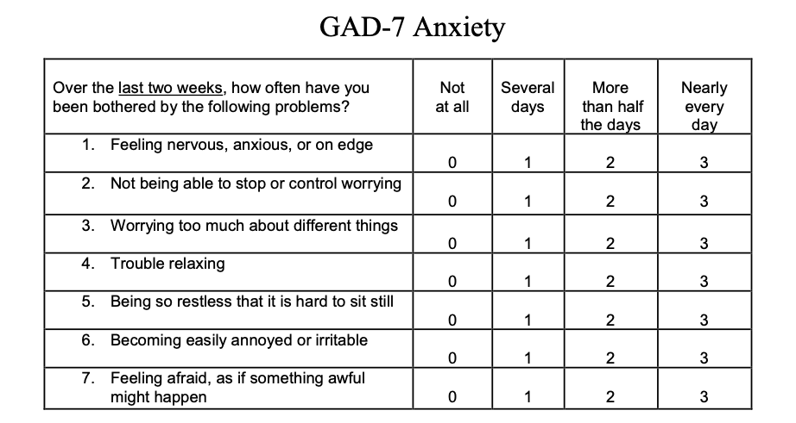

Supplementary 4: PROMIS Sleep Disturbance Short Form 4a plus one caregiver-specific item

In the past 7 days
 | Very Poor | Poor | Fair | Good | Very Good
My sleep quality was
In the past 7 days
 | Not at all | A little bit | Somewhat | Quite a bit | Very Much
My sleep was refreshing
I had a problem with my sleep
I had difficulty falling a sleep
My sleep was interrupted because of my child's needs

Supplementary 5: In-Depth Interview Guide-Caregiver Experience, Anxiety, and Sleep
Section A: Daily Caregiving Routine and Child Needs
- What are the most demanding parts of caring your child?
- How has your child’s condition affected your household routines, work, or other responsibilities?
- Tell me about your child’s sleep. How often do you need to wake up to help them at night, and for what reasons?

Section B: Sleep Experience and Impact
If suspected poor sleep quality
- How would you describe your own sleep in the past month? What makes it worse?
- What do you think are the main reasons you don’t get enough sleep?
- Have you tried anything to improve your sleep? How?

If have good sleep quality
- How would you describe your own sleep in the past month? What makes it better?
- What do you think are the main reasons you get good quality sleep?
- Have you tried anything to keep your sleep quality? How?

Section C: Emotional Well-being and Anxiety
If suspected high anxiety
- What kinds of things make you feel worried or anxious related to your child?
- Can you tell me about a recent time you felt very anxious? What was happening and how did you cope?
- How do you feel your mood or anxiety affects your ability to care for your child?

If suspected low anxiety
- What kinds of things make you feel relax related to your child?
- Can you tell me about a recent time you felt relax? What was happening and how did overcome that moment?
- How do you feel your good mood affects your ability to care for your child?

Section D: Coping Strategies and Support Systems
- What kind of support do you get from family, neighbors, religious groups, or the center?
- What activities, beliefs, or thoughts help you keep going on difficult days?

Supplementary 6: Cabbirka Welwelka ee GAD-7
Labadii toddobaad ee u dambeeyay, immisa jeer ayay ku dhibeen mid ka mid ah dhibaatooyinkan soo socda? | MA JIRTO GEBBI AHAANBA | DHOWR MAALMOOD | BADDI MAALMAHA OO DHAN | KU DHAWAAD MAALIN KASTA
- Dareen werwer, walaac ama xasillooni la'aan | 0 | 1 | 2 | 3
- Aanan awoodi karin inuu joojiyo ama uu xakameeyo welwelka | 0 | 1 | 2 | 3
- Ka welwelka badan ee waxyaalo kala duwan | 0 | 1 | 2 | 3
- Dhib ku qaba nasashada | 0 | 1 | 2 | 3
- Inaad noqoto qof nasasho la'aan ah oo ay adag tahay in aad si joogto u fadhiso meel | 0 | 1 | 2 | 3
- Si fudud inaad u xanaaqdo ama aad u cadhooto | 0 | 1 | 2 | 3
- Dareentid cabsi sida in wax xun ay dhici doonaan | 0 | 1 | 2 | 3

Supplementary 7: Sookoobid foom ka kooban 4qaybood oo ku saabsan hurdada qofka haya ilmaha leh xanuunka mamaskaxd

7di maalmood ee u danbeeyey
 | Aad u liidata | Liidata | Caadi ah | Wanaagsan | Aad u wanaagsan
Tayada hurdadaydu waxay ahayd
7di maalmood ee u danbeeyey
 | Haba yaraate maya | In yar | Waxooga | Waxooga badan | Aad u badan
Hurdadaydu way fiicnayd
Dhibaata ayaan ku qabay hurdadayda
Wan ku dhibanay inan seexdo
Hurdada wan ka kacaa marar waayo baahida ilmahayga

Supplementary 8: Waraysiga qofka haya ilmaha leh xanuunka maskaxda khibradiisa ku saabsan ilmaha, hurdadiisa, warwarka dhinaca ilmaha
QAYBTA A: Jadwalka Daryeelka Maalinlaha aha iyo Baahiyaha Ilmaha:
- Waa Maxay qaybaha daryeelka ugu adag ee ilmahaaga?
- Sidee xaalada ilmahaagu u saamaysay howlahaaga guriga, shaqada ama masuuliyadaha kale eed hayso ama qabato?
- İi sheeg siday tahay ilmahaaga hurdadiisu, imisa jeer ayuu u baahanyahay inad uso kacdo habenki si aad u caawiso, sababaha kiciyaa wa maxay intabadan?

QAYBTA B: Khibradda Hurdada iyo Saamaynta
Haddii laga shakiyo tayada hurdada oo liidata:
- Sideed ku sharixi lahayd hurdadaada bishii la soo dhaafay? Maxaa ka dhigaya inay sii xumaato?
- Maxaad u malaynaysaa inay yihiin sababaha ugu waaweyn ee aadan u helin hurdo ku filan?
- Ma isku dayday wax aad ku hagaajin karto hurdadaada? Sidee?

Haddii aad leedahay wanaagsan:
- Sideed u qeexi lahayd hurdadaada bishii la soo dhaafay? Maxaa ka dhigaya mid wanaagsan?
- Maxaad u malaynaysaa inay yihiin sababaha ugu waaweyn ee aad u hesho hurdo tayo wanaagsan leh?
- Ma isku dayday wax si aad u ilaaliso tayada hurdadaada?

QAYBTA C: Dareenka oo Wanaagsanaada iyo Hadii uu Jiro Warwar Badan:
Haddii laga shakiyo welwel sare:
- Maxay yihiin waxyaabaha kaa dhigaya inaad dareento warwar ama walaac la xidhiidha ilmahaaga?
- Ma ii sheegi kartaa waqti aad dhawaan dareentay walaac badan? Maxaa kugu keenay, sidee ayad u maaraysay?
- Sideed u dareemeysaa in niyaddaada ama warwarkaagu ay saameeyaan awooddaada aad ku daryeeli karto ilmahaaga?

Haddii uu jiro warwar yar:
- Maxa kaa dhigaya inad dareento nasasho ama degenaan warwarka kaaga yimi ilmahaaga?
- Ma ii sheegi kartaa waqti aad dhawaan dareentay nasasho iyo degenaan waxyaabaha ku dajiyey maxay ahaayeen ood warwarka ku ilawday?
- Sideed ayad isleedahay way u saamaynaysaa dareenkag ama farxadaada ilaalinta iyo inaad hayso ilmahaaga ?

QAYBTA D: Sababaha la Qabsiga iyo Habka Taageerada:
- Noocee taageero ah ayaad ka heshaa qoyska,jaarkaaga, culimada, ama xarunta? Taageero noocee ah ayaad jeclaan lahayd inaad hesho? Hawlo noocee ah, caqiidooyin, ama fikrado ayaa kaa caawinaya inaad sii wadato maalmaha adag sida caqiido, ama fikir aad haysato?

