Supplementary Materials of
Nontrivial spin and orbital textures in YbMn₂Ge₂
Xin Liang†, Weihang Liang†, Yutong Feng †, Zihan Lin†, Yuhao Wang, Fazhi Yang, Yu Mao, Tianhao Guo, Siyu Heng, Wenlong Lu, Shiyu Feng, Ming Shi, Tian Shang*, Yuanfeng Xu*, Junzhang Ma*

This document contains:
1, Supplementary figures 1-5.
2, Supplementary tables 1-2.

I. ARPES raw data for ultraviolet light measurements
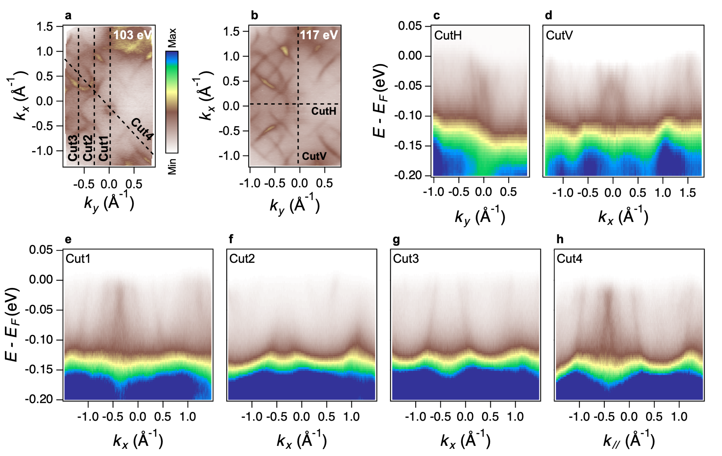
Fig. S1. Raw ARPES data without intensity normalization. a, b. Fermi surface maps measured at k_{z} = 0 and π plane, respectively. c-h. Corresponding energy-momentum dispersion along the high symmetry lines indicated in a and b.

II. Comparison between surface states and bulk states.
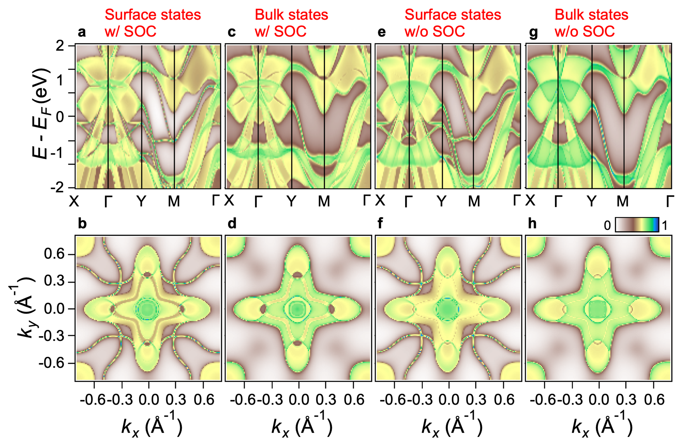
Fig. S2. Calculated bulk and surface electronic structures with and without SOC. a. Surface-projected band structure including spin–orbit coupling (SOC), showing the surface-state contribution superimposed on the bulk electronic structure. b. Corresponding Fermi surface including the surface-state contribution. c. Bulk band structure calculated with SOC. d. Corresponding bulk Fermi surface with SOC. e. Surface-projected band structure calculated without SOC. f. Corresponding Fermi surface including the surface-state contribution without SOC. g. Bulk band structure calculated without SOC. h. Corresponding bulk Fermi surface without SOC. The comparison between the surface-projected (a, b, e, f) and bulk (c, d, g, h) calculations highlights the emergence of additional surface-derived electronic states and their characteristic features in both the band dispersion and Fermi-surface.

III. Temperature-dependent Hall resistivity decomposition and field-induced anomalous Hall contribution.
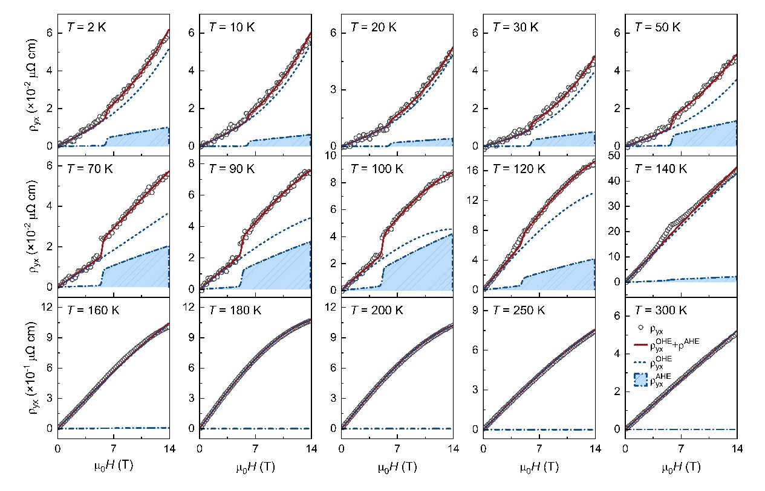
Fig. S3. Temperature-dependent Hall resistivity curves fitted with a two-channel model reveal a sharp, step-like onset of the anomalous Hall component above the metamagnetic critical field (μ₀H_{c} ≈ 5–6 T) below T_{N1} ≈ 165 K, which completely vanishes at higher temperatures.

IV. SYMMETRY ANALYSIS

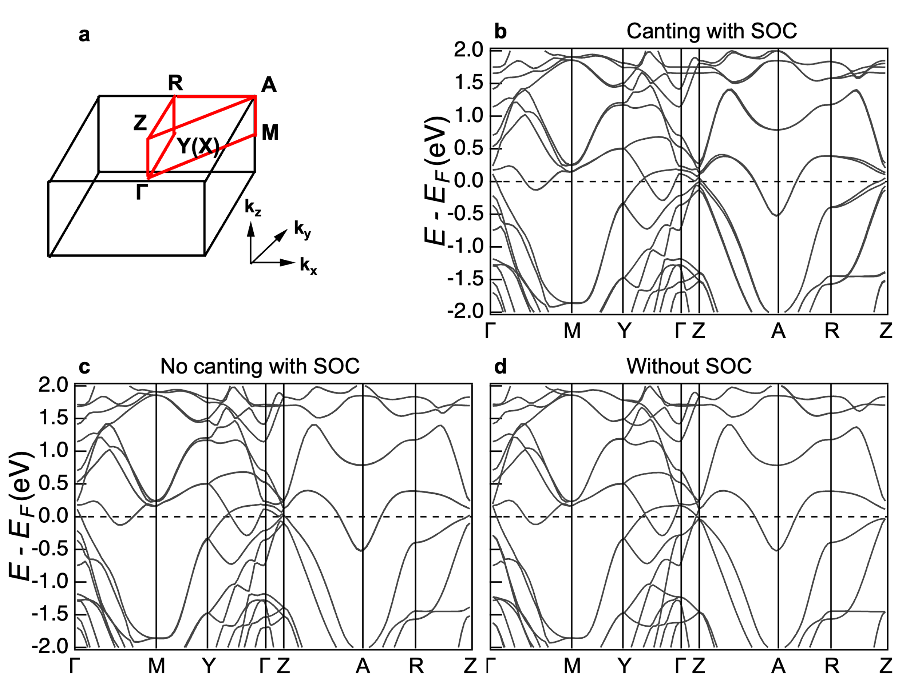
Fig. S4. Electronic band structure versus different magnetic moment alignment and the SOC effect. a. Bulk BZ and the high symmetry momentum path used for the band structure calculations. b. Calculated bulk band structure for the canted AFM II phase (θ < 90°) with considering SOC. c. Calculated bulk band structure for the planar AFM I phase (θ = 90°) with considering SOC. d. Calculated bulk band structure without considering SOC. The overall similarity among the three calculations indicates that magnetic moment canting, and SOC have only a minor influence on the low-energy electronic structure of YMG​.

Fig. S5. Calculated momentum-dependent orbital angular momentum ($L_{x}$, $L_{y}$, and their projection to 110 direction) and spin polarization ($S_{x}$) textures across Fermi surface contours of the AFM I phase without spin-orbit coupling a–d, the AFM I phase with spin-orbit coupling e–h, and the AFM II phase with spin-orbit coupling i–l.

Table SI. Symmetry-imposed relations for the spin and orbital angular momentum components in the AFM I and AFM II phases, with and without spin–orbit coupling (SOC).
SOC
AFM II | m_{y}T | L_{y}(k_{x}, k_{y}) = L_{x}(−k_{x}, k_{y}) | S_{x}(k_{x}, k_{y}) = S_{x}(−k_{x}, k_{y})
AFM II | m_{y}T | L_{y}(k_{x}, k_{y}) = −L_{y}(−k_{x}, k_{y}) | S_{y}(k_{x}, k_{y}) = −S_{y}(−k_{x}, k_{y})
AFM II | m_{y}T | L_{z}(k_{x}, k_{y}) = L_{z}(−k_{x}, k_{y}) | S_{z}(k_{x}, k_{y}) = S_{z}(−k_{x}, k_{y})
AFM I | m_{y}T | L_{x}(k_{x}, k_{y}) = L_{x}(−k_{x}, k_{y}) | S_{x}(k_{x}, k_{y}) = S_{x}(−k_{x}, k_{y})
AFM I | m_{y}T | L_{y}(k_{x}, k_{y}) = −L_{y}(−k_{x}, k_{y}) | S_{y}(k_{x}, k_{y}) = −S_{y}(−k_{x}, k_{y})
AFM I | C_{2z}T | L_{z} = 0 | Sz = 0
w/o SOC
AFM II | [C_{2y}||C_{2z}|0] T | L_{z} = 0 | S_{y} = 0
AFM II | [C_{2z}||C_{4z}|0] | L_{y}(k_{x}, k_{y}) = −L_{x}(−k_{y}, k_{x}) | S_{x}(k_{x}, k_{y}) = −S_{x}(−k_{y}, k_{x})
AFM II | [C_{2z}||C_{4z}|0] | L_{x}(k_{x}, k_{y}) = L_{y}(−k_{y}, k_{x}) | S_{z}(k_{x}, k_{y}) = −S_{z}(−k_{y}, k_{x})
AFM II | [1||m_{x}|0] | L_{x}(k_{x}, k_{y}) = L_{x}(−k_{x}, k_{y}) | S_{x}(k_{x}, k_{y}) = S_{x}(−k_{x}, k_{y})
AFM II | [1||m_{x}|0] | L_{y}(k_{x}, k_{y}) = −L_{y}(−k_{x}, k_{y}) | S_{z}(k_{x}, k_{y}) = S_{z}(−k_{x}, k_{y})
AFM I* | [−1||C_{2z}|0] T | L_{z} = 0
AFM I* | [−1||C_{4z}|0] | L_{y↑}(k_{x}, k_{y}) = −L_{x↓}(−k_{y}, k_{x}) | S(k_{x}, k_{y}) = −S(−k_{y}, k_{x})
AFM I* | [−1||C_{4z}|0] | L_{x↑}(k_{x}, k_{y}) = L_{y↓}(−k_{y}, k_{x}) | S(k_{x}, k_{y}) = −S(−k_{y}, k_{x})
AFM I* | [1||m_{x}|0] | L_{x↑}(k_{x}, k_{y}) = L_{x↑}(−k_{x}, k_{y}) | S(k_{x}, k_{y}) = S(−k_{x}, k_{y})
AFM I* | [1||m_{x}|0] | L_{y↑}(k_{x}, k_{y}) = −L_{y↑}(−k_{x}, k_{y}) | S(k_{x}, k_{y}) = S(−k_{x}, k_{y})
* The up and down notes indicate the two spin sublattices.

Table SII. Converged magnetic moments and corresponding canting angles obtained for different Hubbard U values.

U | μ_{x}/μ_{B} | μ_{z}/μ_{B} | θ
0 | 2.807 | 1.146 | 67.8
1 | 3.435 | 0.410 | 83.19
2 | 3.731 | 0.190 | 87.1
3 | 3.948 | 0.121 | 88.3
6 | 4.350 | 0.076 | 89.0
9 | 4.571 | 0.243 | 87.0

To determine the surface termination responsible for the experimental observed electronic states, Fermi surfaces were calculated for several representative (001) terminations. Comparison with the ARPES experimental data indicates that that the experimental data is best reproduced by the z = 0 termination.

