Supplementary Table 1.MRI scanning parameters
Institution | Scanner | Sequence | TR/TE(ms) | FOV(mm) | Matrix | Section Thickness(mm) | Section Gap(mm) | Slices | Flip Angle
Center A | PHILIPS Ingenia(3.0T) | T2WI | 3000/80 | 180×180 | 300×218 | 3.0 | 1 | 24 | 90
Center A | PHILIPS Ingenia(3.0T) | DWI | 3000/60 | 250×250 | 80×80 | 4.0 | 1.5 | 24 | 90
Center B | PHILIPS Ingenia CX | T2WI | 3000/80 | 180×180 | 300×218 | 3.0 | 1 | 24 | 90
Center B | PHILIPS Ingenia CX | DWI | 3000/60 | 250×250 | 80×80 | 4.0 | 1.5 | 24 | 90
Center C | United Imaging  uMR880(3.0T) | T2WI | 4707/137 | 180×180 | 352×352 | 3.0 | 0.3 | 30 | 90
Center C | United Imaging  uMR880(3.0T) | DWI | 2500/70 | 200×200 | 128×128 | 3.0 | 0.3 | 30 | 90

Supplementary Figure 1.Heatmaps of AUC values for six machine learning models developed with clinical features, ITH features, and fused features in the training, internal validation, and external validation cohorts
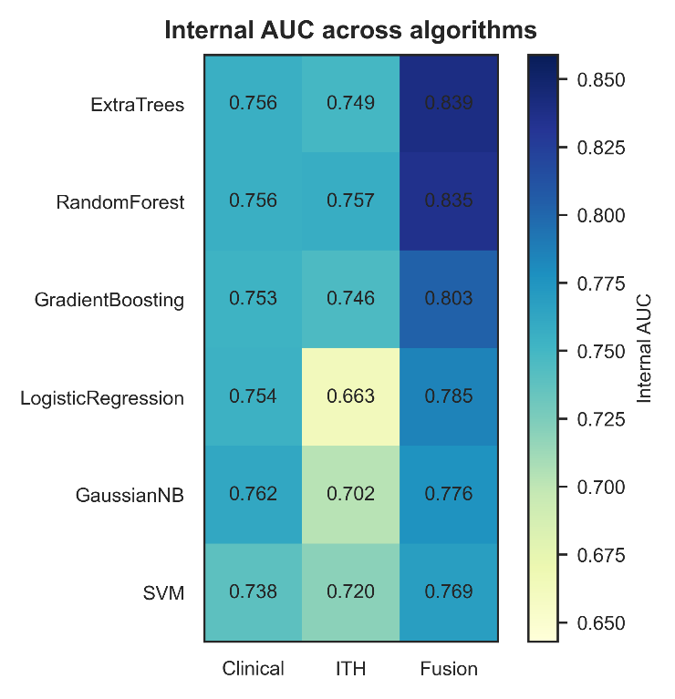
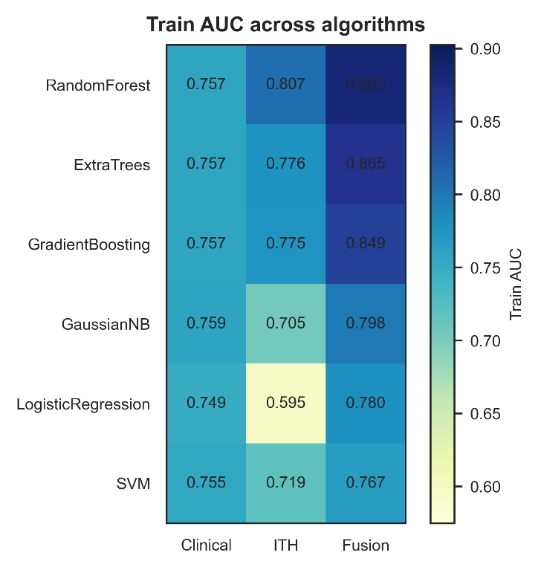

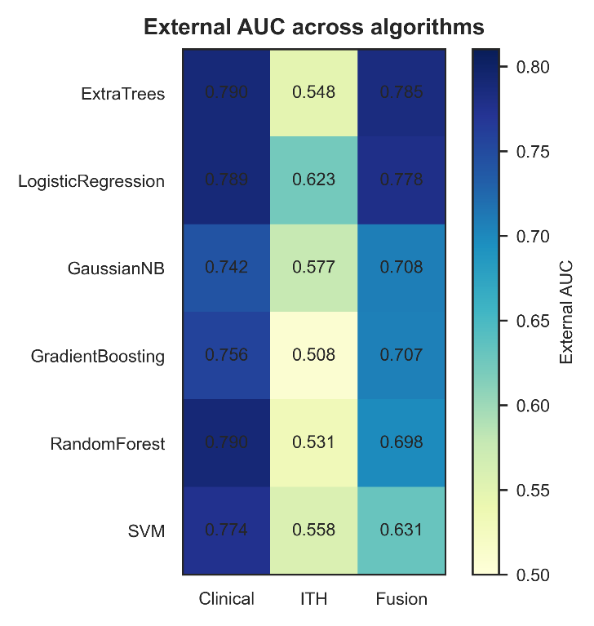

Figure 1: consists of three subplots that illustrate the predictive AUC of each model in the training, internal test, and external test cohorts. Rows correspond to six machine learning algorithms, including Random Forest, Extra Trees, Gradient Boosting, Gaussian Naive Bayes, Logistic Regression, and Support Vector Machine (SVM). Columns represent three feature input groups: clinical-only features, intratumoral heterogeneity (ITH) radiomic features, and fused clinical-ITH features. Darker color blocks indicate higher AUC values and superior predictive performance of the models.

