Normalising electromyograms without maximal voluntary contractions
Matthew Carrall-Worsey¹˒² and Claudio Pizzolato¹˒²*

Supplementary material

Regression-equation table and application notes
Supplementary Table 1 provides adoption-ready, side-pooled regression equations for the 13 anatomical-muscle models trained using the cycling cohort, including its countermovement-jump trials. Left- and right-side channels were pooled during fitting, while predictions remain channel-specific at application. The equations map standardised window variance and KDE FWHM from gain-calibrated bandpass EMG to a window-centre estimate of MVC normalised excitation amplitude. The interpolated model-prediction trace identifies the trial-level model-estimated peak, which scales the conventional linear envelope to produce the distribution-informed normalised envelope. The independent non-cycling dataset was not included in these model fits.
Supplementary Table 1. Muscle-specific regression equations trained on the cycling cohort. One side-pooled multiple linear regression model was fitted for each anatomical muscle using gain-calibrated, input-referred EMG from the cycling cohort, including countermovement-jump trials. Left- and right-side channels were pooled during model fitting but retain channel-specific predictions during application. Models estimate MVC normalised excitation amplitude at each window centre as ${\overset{ˆ}{y}}_{k} = β_{0} + β_{v}z_{v,k} + β_{ω}z_{ω,k}$, where zᵥ,ₖ and $z_{ω,k}$ are the standardised window variance and KDE FWHM, respectively. Feature means and SDs are provided in mV-based units to standardise new observations; β₀, βᵥ, and $β_{ω}$ are the corresponding intercept and standardised-feature coefficients. Window, step, and minimum-valid-duration values define the feature-extraction settings in seconds. The separate non-cycling dataset was not included in model fitting.
Muscle | β₀ | βᵥ | βω | Var. mean  (mV²) | Var. SD  (mV²) | FWHM mean  (mV) | FWHM SD  (mV) | Window  (s) | Step  (s) | Min. valid  (s)
VL | 0.0441 | -0.0148 | 0.1006 | 0.01093 | 0.056 | 0.08158 | 0.2034 | 0.100 | 0.025 | 0.030
VM | 0.0428 | -0.0059 | 0.0914 | 0.01049 | 0.05272 | 0.07976 | 0.1887 | 0.100 | 0.025 | 0.030
RF | 0.0502 | -0.0212 | 0.1107 | 0.006388 | 0.03375 | 0.06412 | 0.1374 | 0.100 | 0.025 | 0.030
ADD | 0.0706 | -0.0006 | 0.0880 | 0.0009178 | 0.005326 | 0.03812 | 0.05305 | 0.100 | 0.025 | 0.030
TA | 0.0602 | 0.0093 | 0.0874 | 0.003739 | 0.01461 | 0.05389 | 0.08967 | 0.100 | 0.025 | 0.030
ST | 0.0585 | -0.0450 | 0.1320 | 0.005332 | 0.03167 | 0.05947 | 0.1278 | 0.100 | 0.025 | 0.030
BFLH | 0.0593 | -0.0293 | 0.1213 | 0.002205 | 0.01117 | 0.04263 | 0.08242 | 0.100 | 0.025 | 0.030
LG | 0.0687 | -0.0203 | 0.1157 | 0.004052 | 0.01687 | 0.06141 | 0.1029 | 0.100 | 0.025 | 0.030
MG | 0.0795 | 0.0101 | 0.1018 | 0.00489 | 0.01539 | 0.06926 | 0.1048 | 0.100 | 0.025 | 0.030
SOL | 0.0495 | -0.0204 | 0.0940 | 0.007694 | 0.0444 | 0.07067 | 0.1413 | 0.100 | 0.025 | 0.030
GMax | 0.0436 | -0.0227 | 0.0948 | 0.0004604 | 0.003284 | 0.01867 | 0.04112 | 0.100 | 0.025 | 0.030
GMed | 0.0521 | -0.0541 | 0.1077 | 0.001448 | 0.01315 | 0.02991 | 0.0691 | 0.100 | 0.025 | 0.030
TFL | 0.0499 | -0.0399 | 0.1010 | 0.003761 | 0.03202 | 0.0486 | 0.1177 | 0.100 | 0.025 | 0.030

To apply a model to new EMG data, first remove any known amplification gain and express the input-referred EMG signal in mV. Match the study preprocessing using second-order, zero-phase 30–300 Hz bandpass filtering. At the study sampling frequency of 2000 Hz, calculate window variance and KDE FWHM using 200-sample windows advanced in 50-sample steps, retaining windows containing at least 60 valid samples. For data sampled at a different frequency, adjust the sample counts to preserve the equivalent durations: 100-ms windows, 25-ms steps (75% overlap), and at least 30 ms of valid signal per window. Standardise each feature using the corresponding anatomical-muscle means and SDs in Supplementary Table 1, then calculate the window-centre excitation estimate using the corresponding linear equation. Constrain window-centre estimates to 0–1 and interpolate them across the trial to obtain a continuous model-prediction trace, whose maximum represents the predicted trial peak. Independently, derive the conventional non-normalised linear envelope from the same bandpass signal using full-wave rectification and second-order, zero-phase 6-Hz low-pass filtering. Scale this envelope once per trial so that its maximum equals the model-estimated peak, thereby producing the distribution-informed normalised envelope while retaining the measured temporal profile. It should be noted that although preserving the time-based window definitions facilitates application at other sampling frequencies, such implementations should be validated because the number of samples within each window can affect KDE bandwidth and FWHM.

Model sensitivity analysis
A sequential sensitivity analysis examined feature definition before model form. Stage 1 used a matched 2 x 2 comparison in which variance was replaced by standard deviation and/or multiple linear regression was replaced by histogram gradient boosting. All variants used the same 4,512,263 quality-controlled windows, cycling-cohort leave-one-participant-out folds, reference maxima, channel exclusions, preprocessing, interpolation, and trial-peak scaling. Standard deviation was calculated as the square root of variance before training-fold standardisation. Replacing variance with standard deviation increased cycling absolute peak error for the linear model from 6.21% to 7.19%; therefore, Stage 2 retained variance and evaluated a broader set of nonlinear mappings. External non-cycling data were used only for evaluation and did not influence model selection.
Supplementary Table 2. Stage 1 of the sensitivity analysis: matched feature-definition and model-form comparison. Cycling values summarise the 17 condition-level means; external values summarise the four task-level means from the independent participant. Lower absolute peak error (APE) indicates closer amplitude agreement. All variants used identical observations and cycling-cohort leave-one-participant-out folds. Replacing variance with standard deviation reduced linear-model performance, so variance was retained for the extended nonlinear comparison in Supplementary Table 3.
Model variant | Cycling APE (%) | Cycling signed error (%) | External APE (%) | External signed error (%)
Linear + variance | 6.21 | 0.233 | 11.90 | -7.070
Linear + standard deviation | 7.19 | 3.508 | 11.44 | -6.947
Gradient boosting + variance | 7.37 | 4.202 | 10.54 | -4.082
Gradient boosting + standard deviation | 7.37 | 4.202 | 10.54 | -4.082

Stage 2 retained variance and compared the primary linear model with quadratic and cubic ridge regression, additive cubic splines, random forests, extremely randomised trees, histogram gradient boosting with squared- or absolute-error loss, and a compact multilayer perceptron. Quadratic ridge, random forest, and both gradient-boosting variants were evaluated using every eligible training window. The remaining exploratory candidates were screened on one deterministic target-stratified training subset shared across models, while every held-out test window was retained. Candidate selection used cycling-cohort leave-one-participant-out performance only; the external participant remained an independent evaluation.

Supplementary Table 3. Complete-data models were trained using every eligible window. More computationally demanding models were screened using the same smaller, representative sample of training windows, while performance was evaluated on all data from each held out cycling participant. Models were compared using cycling absolute peak error; external non-cycling data were used only for independent evaluation. None of the nonlinear models trained on the complete dataset outperformed the primary linear model.
Model | Training data | Cycling APE (%) | External APE (%)
Linear + variance | Complete | 6.21 | 11.90
Quadratic ridge | Complete | 6.74 | 10.53
Random forest | Complete | 6.95 | 10.86
Gradient boosting (squared loss) | Complete | 7.37 | 10.54
Gradient boosting (absolute loss) | Complete | 7.55 | 10.56
Linear regression | Screen subset | 6.91 | 13.46
Random forest | Screen subset | 7.10 | 12.33
Gradient boosting (absolute loss) | Screen subset | 7.15 | 12.48
Quadratic ridge | Screen subset | 7.40 | 12.40
Additive cubic splines | Screen subset | 7.49 | 12.49
Cubic ridge | Screen subset | 7.75 | 12.84
Compact multilayer perceptron | Screen subset | 7.85 | 13.08
Extremely randomised trees | Screen subset | 8.22 | 11.57

Across the sequential analysis, neither changing variance to standard deviation nor replacing the linear mapping with a nonlinear alternative improved the primary cycling outcome. Quadratic ridge was the closest complete-data nonlinear alternative (6.74% versus 6.21% cycling absolute peak error), but this did not constitute a substantial improvement. The primary linear variance model was therefore retained because it performed best on the prespecified cycling outcome and provides directly interpretable, adoption-ready coefficients. Complete model exports, predictions, and validation checks are retained in the parallel sensitivity-analysis directory.

Excitation proportionality
Muscle-specific cycle-level analyses showed positive relationships between MVC normalised and distribution-informed normalised peak excitation for most muscles (Supplementary Figure 1). Across the 13 muscles, mean cycle-level R² was 0.83, ranging from 0.67 for tensor fasciae latae to 0.95 for tibialis anterior. Peak-excitation agreement was also high for lateral gastrocnemius (R² = 0.95), medial gastrocnemius (R² = 0.90), gluteus maximus (R² = 0.89), rectus femoris (R² = 0.89), vastus lateralis (R² = 0.86), and vastus medialis (R² = 0.84).
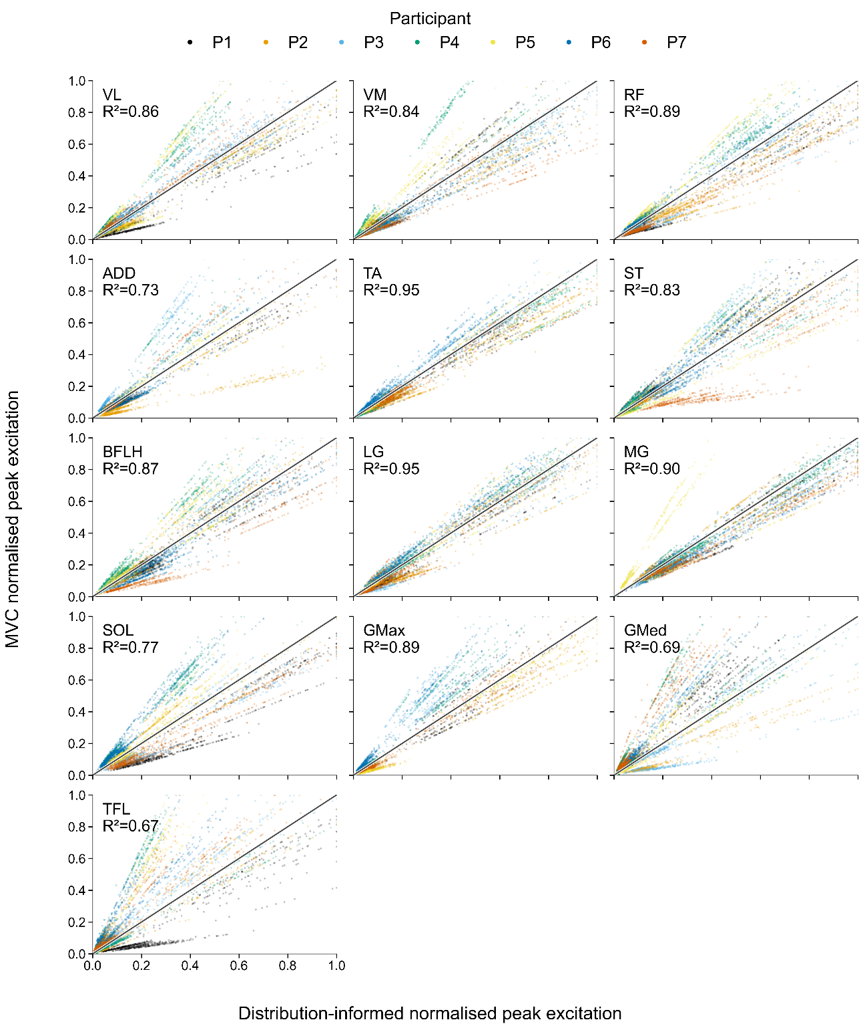
Supplementary Figure 1. Cycle-level peak-excitation proportionality during cycling. Each point represents one crank cycle, plotting the distribution-informed normalised peak excitation against the corresponding MVC normalised peak excitation for each anatomical muscle. Colours identify participants and the diagonal line denotes identity. Panel R² values quantify the association between distribution-informed normalised and MVC normalised peak excitation across all cycles; proximity to the identity line reflects agreement in excitation magnitude. Channels excluded during quality control were omitted.

Muscle-specific trial-level analyses showed positive relationships between MVC normalised and distribution-informed normalised peak excitation for most muscles in the non-cycling assessment (Supplementary Figure 2). Across the 13 muscles, mean trial-level R² was 0.85, ranging from 0.57 for gluteus medius to 0.98 for rectus femoris. Peak-excitation agreement was also high for medial gastrocnemius (R² = 0.95), lateral gastrocnemius (R² = 0.95), gluteus maximus (R² = 0.93), tensor fasciae latae (R² = 0.93), ADD (R² = 0.92), soleus (R² = 0.92), and vastus lateralis (R² = 0.91).
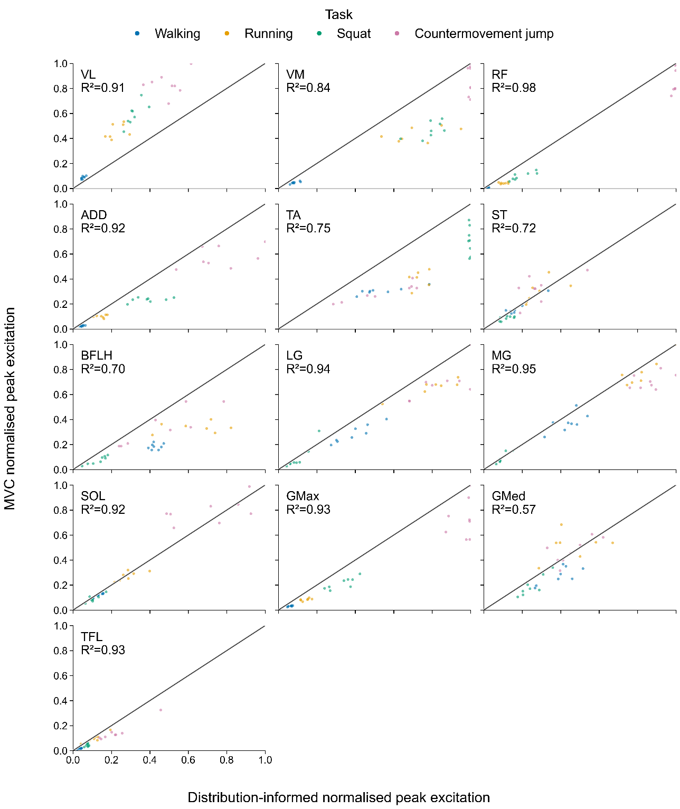
Supplementary Figure 2. Trial-level peak-excitation proportionality during the external non-cycling assessment. Each point represents one trial, plotting the distribution-informed normalised peak excitation against the corresponding MVC normalised peak excitation for each anatomical muscle across walking, running, squatting, and countermovement-jump tasks. Colours identify task groups and the diagonal line denotes identity. Panel R² values quantify the association between distribution-informed normalised and MVC normalised peak excitation; proximity to identity reflects agreement in excitation magnitude.

Supplementary Table 4. Peak-excitation identity-line bias summary for cycling and non-cycling data. Mean and median bias were calculated as MVC normalised peak excitation minus distribution-informed normalised peak excitation; positive values indicate underestimation and negative values indicate overestimation. Median absolute error is unsigned. Cycling summaries use individual crank cycles, whereas non-cycling summaries use individual trials.
Dataset | Level | Muscle | n | Mean bias | Median bias | Median abs. error | R²
Cycling | Cycle | VL | 5390 | 0.0088 | 0.0000 | 0.0284 | 0.86
Cycling | Cycle | VM | 5390 | -0.0042 | -0.0082 | 0.0297 | 0.84
Cycling | Cycle | RF | 5390 | -0.0182 | -0.0061 | 0.0333 | 0.89
Cycling | Cycle | ADD | 3557 | 0.0011 | -0.0034 | 0.0338 | 0.73
Cycling | Cycle | TA | 5390 | -0.0154 | -0.0090 | 0.0224 | 0.95
Cycling | Cycle | ST | 5390 | -0.0027 | 0.0036 | 0.0300 | 0.83
Cycling | Cycle | BFLH | 5390 | -0.0008 | -0.0036 | 0.0370 | 0.87
Cycling | Cycle | LG | 5390 | -0.0102 | -0.0034 | 0.0296 | 0.95
Cycling | Cycle | MG | 5390 | -0.0264 | -0.0260 | 0.0359 | 0.90
Cycling | Cycle | SOL | 5390 | -0.0013 | -0.0023 | 0.0510 | 0.77
Cycling | Cycle | GMax | 5390 | 0.0145 | 0.0000 | 0.0180 | 0.89
Cycling | Cycle | GMed | 5390 | 0.0410 | 0.0166 | 0.0359 | 0.69
Cycling | Cycle | TFL | 5390 | 0.0480 | 0.0194 | 0.0419 | 0.67
Non-cycling | Trial | VL | 31 | 0.2205 | 0.2490 | 0.2490 | 0.91
Non-cycling | Trial | VM | 31 | -0.1915 | -0.2080 | 0.2080 | 0.84
Non-cycling | Trial | RF | 31 | -0.0707 | -0.0553 | 0.0553 | 0.98
Non-cycling | Trial | ADD | 31 | -0.1055 | -0.0646 | 0.0646 | 0.92
Non-cycling | Trial | TA | 31 | -0.2626 | -0.2755 | 0.2755 | 0.75
Non-cycling | Trial | ST | 31 | 0.0017 | -0.0138 | 0.0331 | 0.72
Non-cycling | Trial | BFLH | 31 | -0.1756 | -0.1887 | 0.1887 | 0.70
Non-cycling | Trial | LG | 31 | -0.1013 | -0.0893 | 0.0975 | 0.94
Non-cycling | Trial | MG | 31 | -0.0678 | -0.0564 | 0.0564 | 0.95
Non-cycling | Trial | SOL | 31 | 0.0102 | -0.0117 | 0.0219 | 0.92
Non-cycling | Trial | GMax | 31 | -0.1111 | -0.0664 | 0.0664 | 0.93
Non-cycling | Trial | GMed | 31 | -0.0285 | -0.0437 | 0.0714 | 0.57
Non-cycling | Trial | TFL | 31 | -0.0359 | -0.0248 | 0.0248 | 0.93

