Supplementary Information
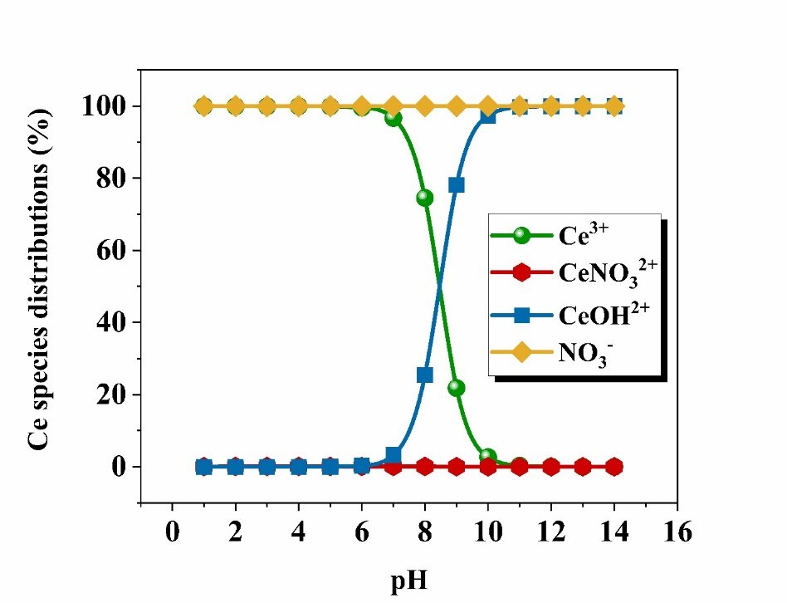
Fig. S1. Speciation diagram of cerium nitrate in aqueous solution generated using Visual MINTEQ software.
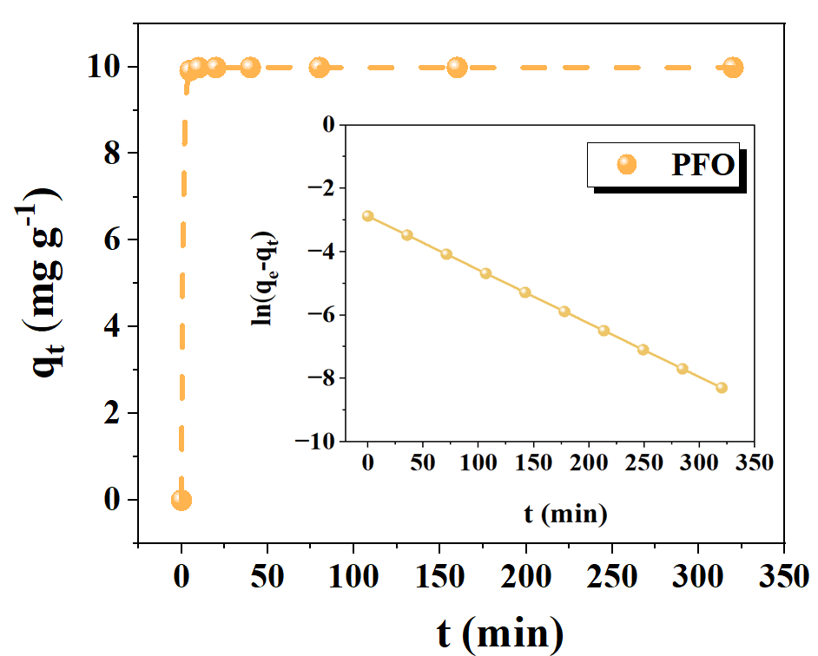 | 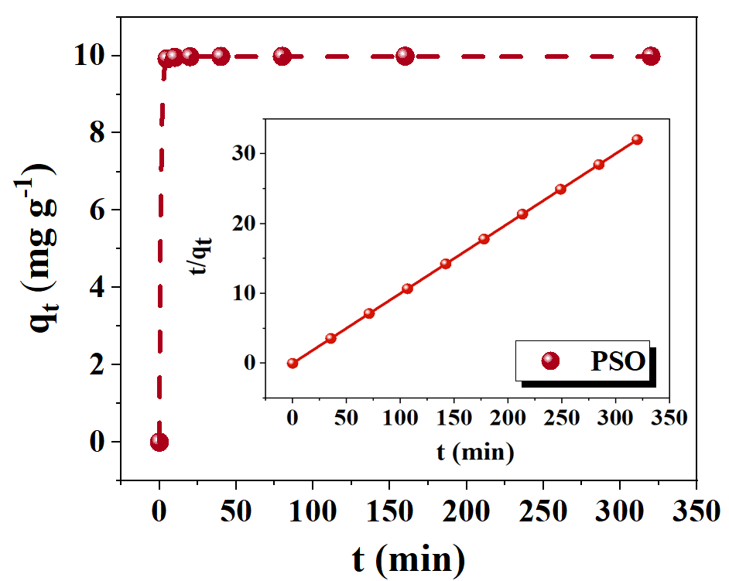
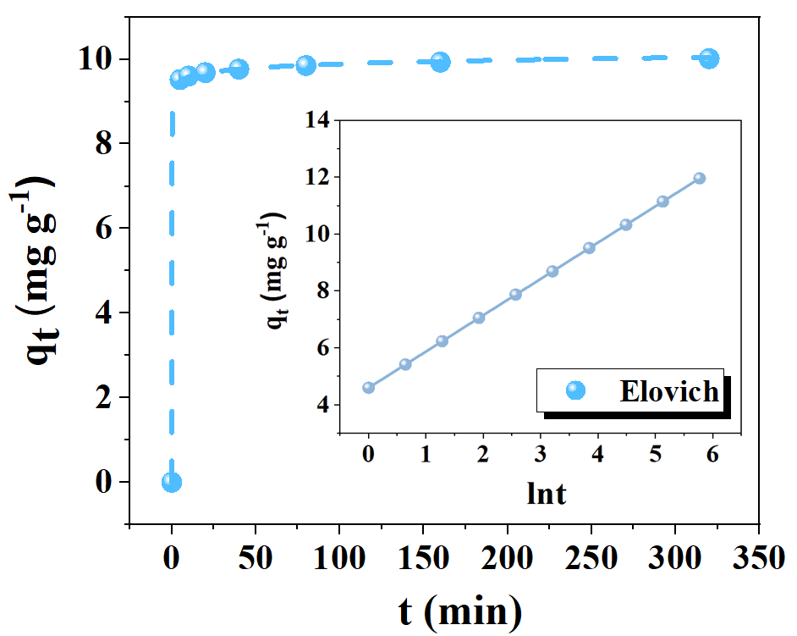 | 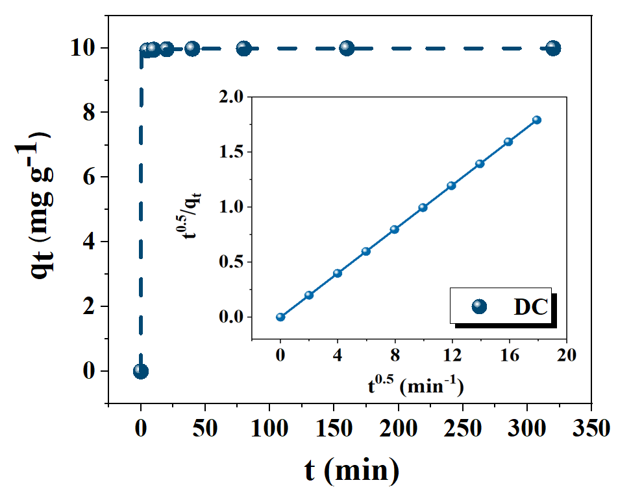
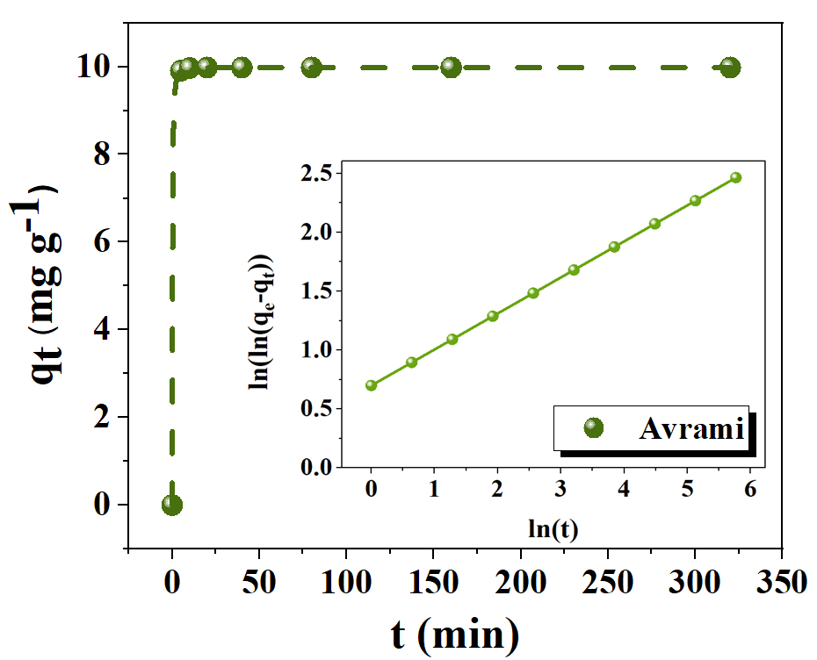 | 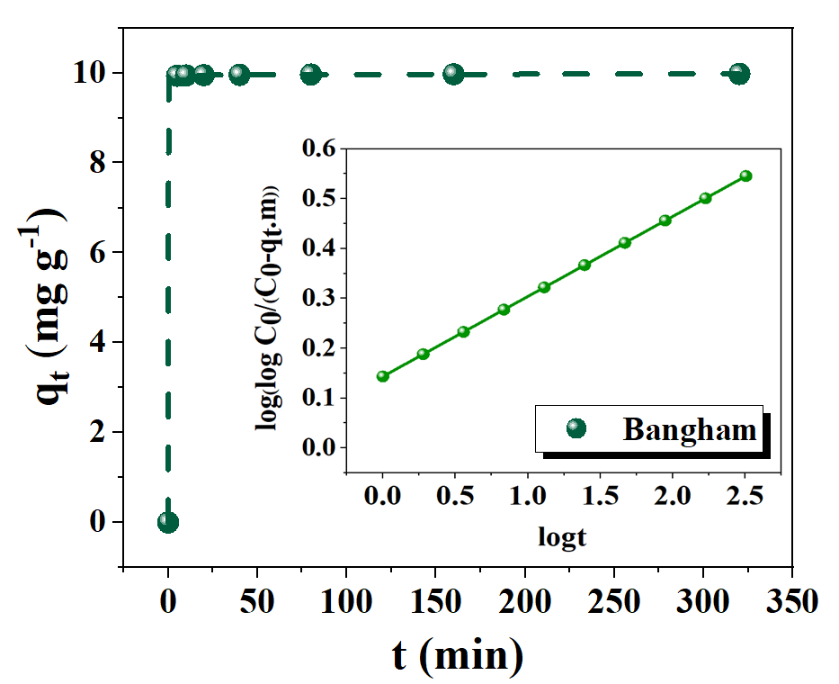

Fig. S2. Adsorption kinetics models of Ce (III) onto Na-bentonite: nonlinear fits are shown in the main plots, with corresponding linearized forms in the inset.

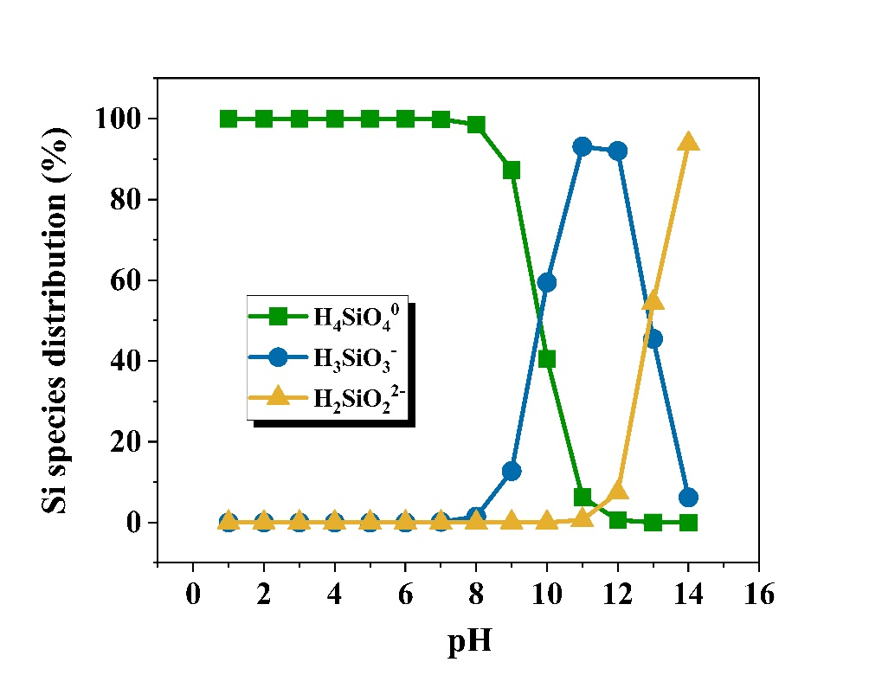
Fig. S3. Speciation of dissolved silicon (H₄SiO₄, H₃SiO₄⁻, H₂SiO₄²⁻) in aqueous solution over the studied pH range using visual MINTEQ.

Fig. S4. DLVO interaction energy profiles at different contact times

