Supplementary Material
Microbial community context shapes the evolutionary outcome of bacteria evolved on tomato plants

Tiffany N. Batarseh^{1,2,*}, Fiona J. Wagner¹, Rocelia Alvarez-Navarrete¹, Chuyu Wang¹, Jose O. Collado^{1,3}, Britt Koskella^{1,2}

¹ Department of Integrative Biology, University of California Berkeley, Berkeley, CA, USA
² San Francisco Chan Zuckerberg Biohub, San Francisco, CA, USA
³ Department of Nutrition, University of California Davis, Davis, CA, USA

*Corresponding author:
Tiffany N. Batarseh, Integrative Biology University of California Berkeley, 3060 Valley Life Sciences Building, Berkeley, CA, 94720, United States t.batarseh@berkeley.edu

Rifampicin-selective CFU quantification of P. rhodesiae SC25
At harvest, a single leaflet from each plant was homogenized and plated on King's B agar supplemented with rifampicin (100 μg/ml) after inoculation with either evolved or ancestral P. rhodesiae SC25, which selects for the rifampicin-resistant focal strain. Leaflets were cut with ethanol sterilized scissors, weighed, and homogenized with 7 ml MgCl₂ buffer with two sterile ceramic beads. Colony counts were converted to CFU per gram of leaf tissue. For visualization and analysis, counts were log10(x + 1)-transformed, where the +1 ensures that plants with no detectable colonies (zero counts) remain finite and appear at the axis floor. Treatment differences were assessed within each inoculation context (alone or with community) by Kruskal–Wallis (KW) tests with Dunn's post-hoc pairwise comparisons; focal treatments were compared against community-only control plants by Mann–Whitney U tests.

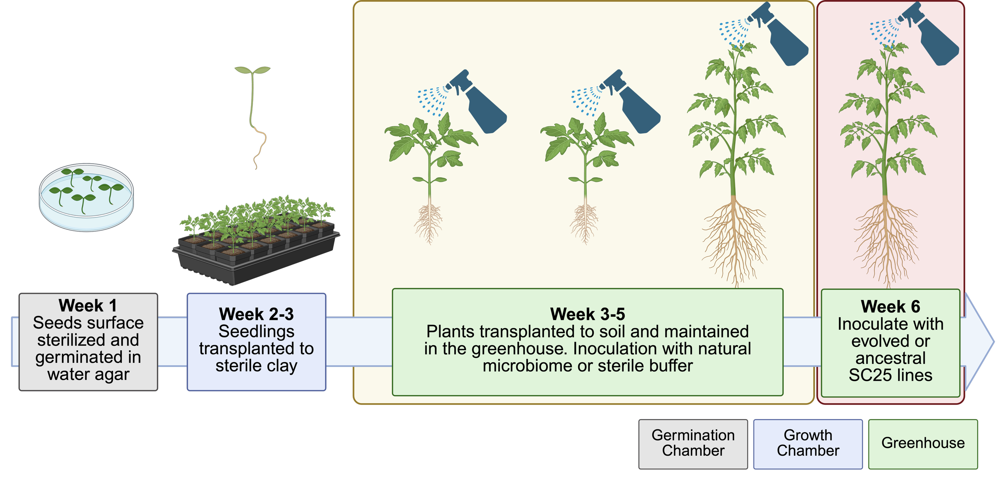
Supplementary Figure S1. Experimental design for the greenhouse assay of ancestral and evolved P. rhodesiae SC25 colonization on juvenile tomato plants. Plants were germinated on water agar, transplanted first to sterilized calcined clay and then to individual pots of soil, and maintained in the greenhouse at the Oxford Tract research facility, UC Berkeley. Plants were sprayed weekly for three weeks with either a natural phyllosphere community collected from tomato plants at the UC Davis Student Farm (community context) or with sterile buffer (alone context). Each plant then received a single ancestral, monoculture evolved, or polyculture evolved P. rhodesiae SC25 line at OD600 0.02 (n = 6 per evolution treatment per inoculation context), with six additional plants receiving the natural community and sterile buffer in place of SC25 as community only controls (42 plants total). At harvest, above ground tissue was collected for DNA extraction and rpoD qPCR quantification of Pseudomonas abundance, and a single leaflet per plant was homogenized and plated on rifampicin supplemented King's B agar for strain specific CFU counts. Created in BioRender (https://BioRender.com/1nbo29t).

Rifampicin-selective CFU colonization by P. rhodesiae SC25
Rifampicin-selective CFU counts provided a strain-specific measure of P. rhodesiae SC25 colonization but were low and highly variable across all groups, with 11 of 42 plants yielding no detectable colonies (CFU/g = 0). Because the natural phyllosphere community carries its own rifampicin-resistant members, community-only control plants also produced colonies (median 4,859 CFU/g), establishing a background against which focal colonization was compared.
No comparison reached significance. Among community-inoculated plants, polyculture-evolved lines reached the highest P. rhodesiae SC25 densities (median 12,754 CFU/g) relative to the ancestor (3,590 CFU/g) and monoculture-evolved lines (2,104 CFU/g), but this did not differ significantly (KW p = 0.26; ancestor vs. polyculture Dunn's p = 0.11). Among plants inoculated alone, no treatment differences were detected (KW p = 0.74), and no focal treatment differed significantly from the community background (Mann–Whitney all p > 0.14). The directional pattern in which polyculture-evolved lines colonized the best against an established community is consistent with the seedling density and qPCR results but is interpreted with caution given the limited statistical power (n = 6 per group) and zero-inflation in the data due to low microbial density in greenhouse grown tomato plants.

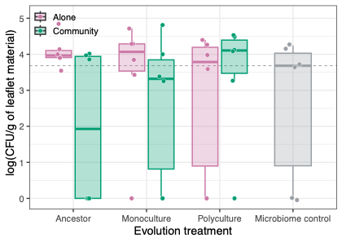
Supplementary Figure S2. Rifampicin-selective CFU quantification of P. rhodesiae SC25 on greenhouse tomato plants. Ancestral, monoculture-evolved, and polyculture-evolved lines were inoculated alone (red) or alongside a natural phyllosphere community (green); grey denotes community-only control plants (six UC Davis natural microbiomes). CFU per gram of leaf tissue is plotted on a log10 scale with dotted line marks the detection limit (~2,000 CFU/g). Boxes show median and interquartile range; points are individual plants (n = 6 per group).

Supplementary Table S1. Descriptive statistics for rifampicin-selective CFU counts
Treatment | n | Zeros | Median CFU/g | Mean CFU/g | log₁₀ mean ± SD
Ancestor (alone) | 6 | 0 | 9,268 | 18,957 | 4.06 ± 0.43
Monoculture (alone) | 6 | 1 | 13,222 | 16,739 | 3.43 ± 1.74
Polyculture (alone) | 6 | 2 | 6,717 | 9,476 | 2.71 ± 2.11
Community + Ancestor | 6 | 3 | 3,590 | 4,481 | 1.97 ± 2.16
Community + Monoculture | 6 | 2 | 2,104 | 13,201 | 2.58 ± 2.07
Community + Polyculture | 6 | 1 | 12,754 | 15,297 | 3.42 ± 1.73
Community only (no SC25) | 6 | 2 | 4,859 | 6,758 | 2.62 ± 2.04

Supplementary Table S2. Statistical results for rifampicin-selective CFU counts
Comparison | H / U | p (unadjusted) | Notes
KW within alone (Anc/Mono/Poly) | H = 0.61 | 0.737 | NS
KW within community (Anc/Mono/Poly) | H = 2.70 | 0.260 | NS
KW all 6 focal groups | H = 4.61 | 0.465 | NS
Dunn: community Anc vs Poly | — | 0.11 | Strongest signal; NS
Dunn: community Mono vs Poly | — | 0.259 | NS
Dunn: community Anc vs Mono | — | 0.64 | NS
All alone groups vs background (MW) | — | >0.147 | All NS
Comm + Poly vs background (MW) | — | 0.210 | NS
Alone vs community within each treatment (MW) | — | >0.126 | All NS

Whole genome sequencing of Passage 06 evolved populations
To characterize the temporal dynamics of mutation accumulation and early adaptive evolution, we performed whole-genome sequencing on all 36 evolved Pseudomonas populations at Passage 6 (P06, the experimental midpoint), in addition to the Passage 12 endpoint populations reported in the main text. Breseq was run in polymorphism mode against the relevant ancestral genome for each species. Mutations were filtered to ≥10% allele frequency and a sliding window filter was applied (≥5 mutations within 200 bp in a single isolate were excluded) consistent with the P12 analysis pipeline. A total of 3,435 mutations were retained across all 36 populations after filtering. The complete P06 mutation table (all 3,435 variants with frequency, mutation type, genomic position, and gene annotation) is provided as Supplementary Table S6.

Temporal dynamics: comparison of P06 and P12 mutation landscapes
Mutation accumulation increased substantially between P06 and P12 for all three species. For P. syringae, per-isolate mutation counts remained low and comparable between treatments at P06 (monoculture mean 25.8, polyculture mean 22.2), consistent with the generally low mutation rates observed in this established pathogen at P12. For P. rhodesiae and P. moraviensis, per-isolate counts were substantially higher, with P. moraviensis isolates already carrying a mean of ~200 mutations by P06.

A shift in mutation type composition occurred between timepoints. The proportion of genic mutations (nonsynonymous + synonymous + frameshift) was substantially lower at P06 than at P12 across all species and treatments (range 5.3–39.1% at P06 vs. 74.4% overall at P12). This pattern is consistent with selection progressively enriching adaptive genic mutations relative to background intergenic variation as the experiment proceeds. The fraction of fixed mutations (≥85% allele frequency) was similarly low at P06 (8 fixed mutations across all 36 populations, vs. 221 fixed mutations at P12), indicating that selective sweeps were predominantly incomplete at the midpoint.

Supplementary Table S3. Mutation counts at Passage 6 by species and treatment
Species | Treatment | n | Mean | Median | Range | Total | %NS | %Syn | %FS | %Genic | Fixed
P. moraviensis | Monoculture | 6 | 201.0 | 189.0 | 154–265 | 1206 | 6.3 | 1.3 | 0.0 | 7.6 | 0
P. moraviensis | Polyculture | 6 | 206.0 | 207.0 | 150–259 | 1236 | 3.9 | 1.4 | 0.1 | 5.3 | 1
P. rhodesiae | Monoculture | 6 | 64.5 | 66.0 | 55–73 | 387 | 12.4 | 8.8 | 4.9 | 26.1 | 2
P. rhodesiae | Polyculture | 6 | 53.0 | 47.5 | 37–76 | 318 | 12.9 | 8.8 | 6.0 | 27.7 | 3
P. syringae | Monoculture | 6 | 25.8 | 23.5 | 21–36 | 155 | 30.3 | 4.5 | 1.9 | 36.8 | 1
P. syringae | Polyculture | 6 | 22.2 | 21.5 | 21–25 | 133 | 33.1 | 6.0 | 0.0 | 39.1 | 1
Mutations filtered to ≥10% allele frequency. %NS = percent nonsynonymous; %Syn = percent synonymous; %FS = percent frameshift; %Genic = percent of total mutations in coding regions. Fixed = mutations at ≥85% allele frequency.

Supplementary Table S4. Genes under parallel evolution at Passage 6 (≥3 independent isolates)
Genes mutated independently in ≥3 of 12 isolates per species, based on filtered genic mutations only.
Gene / Locus tag | Species | Unique isolates (of 12) | Total mutations | % Fixed (≥85%) | Also detected at Passage 12
DDAHOALL_00468 | P. rhodesiae | 12/12 | 52 | 4% | Yes
DDAHOALL_03792 | P. rhodesiae | 12/12 | 36 | 0% | —
flhA | P. rhodesiae | 6/12 | 12 | 0% | Yes
DDAHOALL_02793 | P. rhodesiae | 6/12 | 6 | 0% | —
ycbX | P. rhodesiae | 5/12 | 5 | 0% | —
DDAHOALL_03051 | P. rhodesiae | 4/12 | 6 | 0% | —
DDAHOALL_00480 | P. rhodesiae | 3/12 | 11 | 0% | —
rpoB | P. rhodesiae | 3/12 | 6 | 17% | Yes
OPEHBMIK_02892 | P. syringae | 12/12 | 24 | 0% | Yes
OPEHBMIK_05550 | P. syringae | 10/12 | 20 | 0% | Yes
OPEHBMIK_00049 | P. syringae | 12/12 | 29 | 0% | —
dmlR_3 | P. syringae | 9/12 | 16 | 0% | —
carB_2 | P. moraviensis | 9/12 | 22 | 0% | —
DDIIGDGP_00594 | P. moraviensis | 8/12 | 12 | 0% | —
DDIIGDGP_02178 | P. moraviensis | 8/12 | 12 | 0% | —
DDIIGDGP_02245 | P. moraviensis | 8/12 | 9 | 0% | —
DDIIGDGP_00637 | P. moraviensis | 7/12 | 9 | 0% | —
DDIIGDGP_02974 | P. moraviensis | 6/12 | 12 | 0% | —
DDIIGDGP_04223 | P. moraviensis | 6/12 | 8 | 0% | —
DDIIGDGP_05300 | P. moraviensis | 5/12 | 8 | 0% | —
DDIIGDGP_02796 | P. moraviensis | 4/12 | 4 | 0% | —
DDIIGDGP_01510 | P. moraviensis | 4/12 | 4 | 0% | —
rpsC | P. moraviensis | 3/12 | 3 | 0% | —
kdgK_2 | P. moraviensis | 3/12 | 3 | 0% | —

Early establishment of adaptive targets
Several of the strongest parallel evolution targets identified at P12 were already present across multiple independent isolates by P06, demonstrating that key adaptive mutations were established early and maintained throughout the experiment. Most strikingly, in P. rhodesiae, DDAHOALL_00468 was independently mutated in all 12 isolates by P06 (52 total mutations, matching its status as the most recurrently mutated gene at P12), and flhA (flagellar biosynthesis) was already mutated in 6 of 12 isolates by the midpoint. Mutations in rpoB were detected in 3 P. rhodesiae isolates at P06, including one instance already fixed at 93.3% frequency, foreshadowing the dominant parallel sweep of rpoB documented at P12 (23 isolates, 97% fixed). In P. syringae, OPEHBMIK_02892 and OPEHBMIK_05550 were both already mutated across 12 and 10 isolates respectively by P06, at the same high frequencies seen at P12, suggesting these loci responded to selection very early in the experiment.

Notably, P. moraviensis parallel evolution targets at P06 show less overlap with P12 targets compared to the other two species. The genes most frequently mutated in P. moraviensis at P06 (carB_2, DDIIGDGP_00594, DDIIGDGP_02178) are largely distinct from the P12 top targets (rpoB, DDIIGDGP_01200, plsB), suggesting greater turnover in the selective landscape for this species between the two timepoints. This is consistent with the greater total mutation burden and phenotypic crypticity of P. moraviensis evolution described in the main text.

Supplementary Table S5. Mutations fixed (≥85% allele frequency) at Passage 6
POP. | Species | Treatment | Mutation | Effect | Gene / Annotation
P06_16_12 | P. moraviensis | Polyculture | C→T | Synonymous | DDIIGDGP_04535 (N2298N)
P06_25_01 | P. rhodesiae | Monoculture | C→T | Synonymous | DDAHOALL_00468 (T3028T)
P06_25_02 | P. rhodesiae | Monoculture | repeat expansion | Frameshift | rpoB (1618/4074 nt)
P06_25_07 | P. rhodesiae | Polyculture | G→A | Intergenic | DDAHOALL_03382 (+276/+970)
P06_25_10 | P. rhodesiae | Polyculture | C→G | Nonsynonymous | DDAHOALL_00436 (G61R)
P06_25_10 | P. rhodesiae | Polyculture | C→T | Synonymous | DDAHOALL_00468 (T3028T)
P06_DC_04 | P. syringae | Monoculture | repeat expansion | Frameshift | OPEHBMIK_02705 (181/294 nt)
P06_DC_12 | P. syringae | Polyculture | repeat expansion | Intergenic | OPEHBMIK_04610 (+31/−134)

