Supplementary Material

Two-level ultrasonographic assessment of aortomesenteric distances in relation to self-reported abdominal symptoms and body mass index: a single-centre exploratory cross-sectional study

Lívia Mojsza-Csernus, MSc, Gyöngyi Emese Juharosi, MD, Zita Bednárik, Tamás Schnabel, MD, Dániel Sándor Veres, MD, PhD, László Földvári-Nagy, PhD, Katalin Lenti, PhD

Contents

Supplementary Methods 3
Threshold-based and combined-criterion analyses 3
Receiver operating characteristic (ROC) analysis and threshold summaries 3
BMI-category, body-size, and unadjusted correlation analyses 4
Primary logistic regression specification and diagnostics 4
Statistical software 4
Supplementary Results 6
Technical feasibility and parameter availability 6
Supplementary Table S1. Technical feasibility and parameter availability for study-specific ultrasonographic measurements. 6
Relationship between the two distance measurements 6
Supplementary Figure S1. Relationship between the proximal and renal-artery-level distances in participants with both measurements available. 7
Sensitivity analyses of model form and small-sample bias. 8
Supplementary Figure S2. Adjusted cubic B-spline associations of ultrasonographic aortomesenteric parameters with self-reported abdominal symptom status. 9
Threshold-based symptom proportions 10
Supplementary Table S2. Symptom proportions for conventional and exploratory measurement criteria. 10
Adjusted threshold-based and combined-criterion associations 11
Supplementary Table S3. Firth-adjusted exploratory associations of threshold-based and combined measurement criteria with self-reported abdominal symptom status. 11
ROC-based apparent discrimination 12
Supplementary Table S4. Apparent receiver operating characteristic discrimination for the binary self-reported abdominal symptom endpoint. 12
Ultrasonographic parameters by BMI category 12
Supplementary Table S5. Ultrasonographic aortomesenteric measurements by body mass index category. 13
Unadjusted anthropometric correlations 13
Supplementary Table S6. Spearman correlations of age and anthropometric variables with ultrasonographic aortomesenteric measurements. 13
Prevalence of measurement criteria by BMI category 13
Supplementary Table S7. Prevalence of conventional and exploratory measurement criteria by body mass index category. 14
Full primary logistic regression models and diagnostics 14
Supplementary Table S8. Full coefficients from the three primary multivariable logistic regression models. 14
STROBE checklist for cross-sectional studies 16
References 19

Supplementary Methods
Analysis hierarchy. The primary analyses assessed associations of the three continuous ultrasound parameters with self-reported abdominal symptom status. Technical feasibility, the within-participant relationship between the two distance measurements, and associations with anthropometric variables were secondary analyses. Within the adjusted body-size analyses, BMI-based models were designated as the principal models and body-weight models as complementary sensitivity analyses. Threshold-based, combined-criterion, receiver operating characteristic, and cubic B-spline analyses were exploratory.

Threshold-based and combined-criterion analyses
The proximal distance was analysed using the literature-derived 8-mm threshold, and aortomesenteric angle thresholds of less than 22° and less than 25° were examined [1, 2]. Applying the 8-mm threshold to the distance measured at the origin of the left renal artery (renal-artery-level distance) was an exploratory extension of the conventional proximal threshold and was not considered a validated diagnostic cut-off for that anatomical level.
The combined criteria of angle less than 25° plus proximal distance less than 8 mm, at least one of the two distances less than 8 mm, and angle less than 25° plus at least one of the two distances less than 8 mm were exploratory. For the BMI-category prevalence analysis, the criterion of both distances less than 8 mm was additionally summarised. All threshold-based and combined criteria were evaluated as descriptive classifiers of the binary self-reported symptom response, not as diagnostic criteria for SMA syndrome.
Given the limited number of symptom-positive participants and sparse cells, threshold-based and combined criteria were analysed using Firth penalised logistic regression models adjusted for age, sex, and BMI. Firth penalisation reduces small-sample bias and provides finite estimates under separation [3, 4]. Profile-likelihood 95% confidence intervals and penalised likelihood-ratio p values were reported. Analysis N and the number of symptom-positive participants were based on complete observations for each model. Exploratory Firth sensitivity analyses were also performed for the three primary continuous symptom models.

Receiver operating characteristic (ROC) analysis and threshold summaries
ROC analysis assessed apparent discrimination of the binary post-examination abdominal symptom response for each individual ultrasonographic parameter. Lower distance and angle values were prespecified as the direction associated with symptoms. Areas under the receiver operating characteristic curves (AUCs) and 95% confidence intervals were calculated using DeLong’s non-parametric method (DeLong et al., 1988), which is implemented in the open-source pROC package for R [5]. No formal comparison of AUCs was performed.
For each threshold-based criterion, the number meeting the criterion and the symptom proportions among participants who did and did not meet it were calculated. These summaries referred only to the binary study endpoint and were not diagnostic-accuracy estimates for confirmed SMA syndrome.

BMI-category, body-size, and unadjusted correlation analyses
As secondary analyses, ultrasonographic parameters were compared across BMI categories using the Kruskal-Wallis test, and associations of BMI, body weight, height, and age with the ultrasonographic parameters were assessed using Spearman’s rank correlation. For adjusted body-size analyses, BMI-based ordinary least-squares models were designated as the principal models and were adjusted for age and sex. Body-weight models were treated as complementary sensitivity analyses and were adjusted for age, sex, and height. Heteroscedasticity-consistent type 3 (HC3) standard errors were used; confidence intervals and hypothesis tests were based on the t distribution with residual degrees of freedom. Exploratory comparisons of criterion prevalence across BMI categories used the Fisher-Freeman-Halton exact test [6]. Post hoc cubic B-spline analyses with three degrees of freedom were exploratory and assessed possible non-linearity in the primary symptom models and body-size models [7]. All tests were two-sided, and p < 0.05 was considered statistically significant. No multiplicity adjustment was applied to exploratory supplementary analyses.

Primary logistic regression specification and diagnostics
Each primary multivariable logistic regression model contained one ultrasonographic parameter together with age, sex, and BMI. BMI was treated as a potential confounder rather than a mediator because body habitus plausibly influences aortomesenteric anatomy and may also independently influence abdominal symptom reporting; the hypothesised causal direction did not include an effect of the ultrasound measurement on BMI. Female sex was the reference category. Distances were coded per 1-mm lower value and the angle per 10-degree lower value. Potential multicollinearity was assessed using variance inflation factors (VIFs), with values above 5 considered concerning. Possible separation was assessed from model convergence, finite maximum-likelihood coefficients and standard errors, and concordance with Firth penalised sensitivity estimates. Influence was examined using Cook’s distance and leave-one-out refitting of each model. No observation was excluded solely on the basis of these diagnostic measures. Full coefficients, including intercepts and adjustment-variable estimates, are reported in Supplementary Table S8.

Statistical software
Analyses were performed in the freely available R statistical environment [8]. RStudio provides a freely available, open-source integrated development environment for R-based analysis and reproducible reporting [9]. Open-source implementations suitable for reproducing the specified analyses include logistf for Firth penalised logistic regression [4], sandwich for HC3 robust covariance estimation [10], boot for bias-corrected and accelerated bootstrap confidence intervals [11, 12], pROC for ROC curves, AUCs, DeLong confidence intervals, and ROC graphics [5], and the splines package for cubic B-spline bases [7, 8]. Statistical graphics, including scatterplots, smoothed curves, confidence bands, and multi-panel figures, can be produced with ggplot2 [13]. A locally estimated scatterplot smoothing (LOESS) curve [14] was added to Supplementary Figure S1 for descriptive visualisation only; no inferential conclusions were based on this curve.

Supplementary Results

Technical feasibility and parameter availability
In the secondary technical-feasibility analysis, study-specific ultrasonographic measurement was attempted in 200 participants after seven consent withdrawals. Complete technical measurement failure occurred in four examinations because none of the three study-specific parameters could be obtained owing to excessive bowel gas. Parameter-specific availability among attempted examinations and within the final analysis cohort is summarised in Supplementary Table S1.

Supplementary Table S1. Technical feasibility and parameter availability for study-specific ultrasonographic measurements.
Measure | Attempted examinations,  N = 200 | Final analysis cohort,  N = 196
Complete technical measurement failure | 4/200 (2.0%) | Not applicable
At least one study-specific parameter measurable | 196/200 (98.0%) | 196/196 (100%)
Aortomesenteric angle measurable | 196/200 (98.0%) | 196/196 (100%)
Proximal distance measurable | 195/200 (97.5%) | 195/196 (99.5%)
Renal-artery-level distance measurable | 188/200 (94.0%) | 188/196 (95.9%)
Attempted examinations comprised the 200 participants remaining after seven consent withdrawals. The final analysis cohort excluded four complete technical failures. Percentages in the second and third columns therefore use different denominators.

Relationship between the two distance measurements
In a secondary analysis, the within-participant relationship between the proximal distance and the renal-artery-level distance is shown in Supplementary Figure S1.

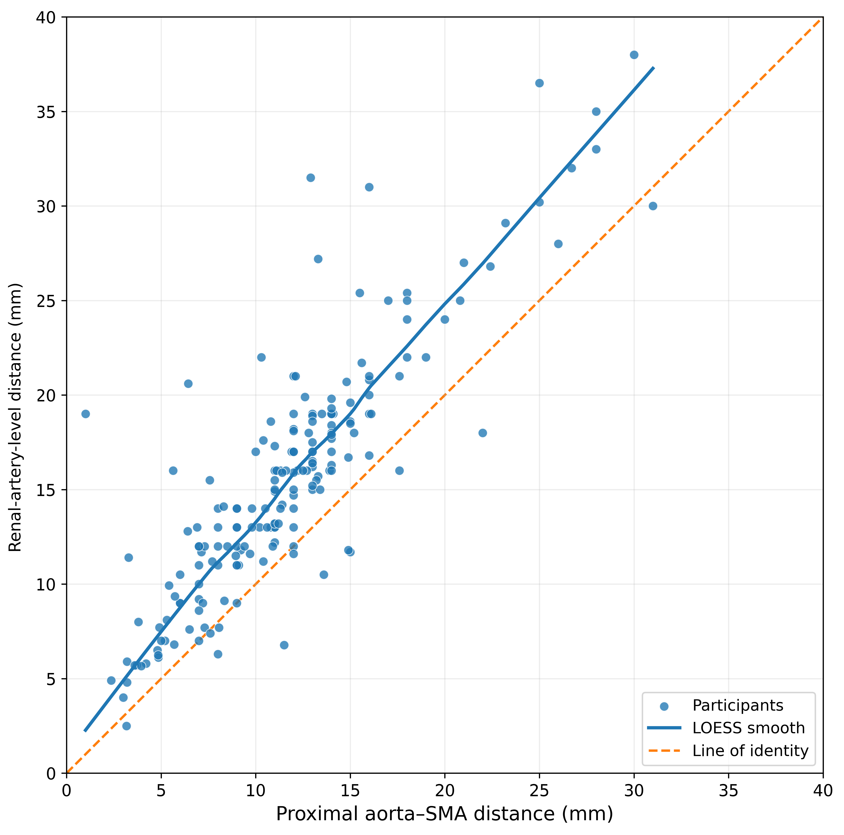

Supplementary Figure S1. Relationship between the proximal and renal-artery-level distances in participants with both measurements available.
Each point represents one participant. The solid curve shows a locally estimated scatterplot smoothing (LOESS) trend and is included for descriptive visualisation only. The dashed line represents the line of identity, along which the two measurements would be equal. The measurements showed a strong positive correlation (Spearman’s ρ = 0.839, 95% CI 0.756-0.892; p < 0.001). The median paired difference, calculated as the renal-artery-level distance minus the proximal distance, was 3.6 mm (IQR 2.0-5.0 mm). CI, confidence interval; IQR, interquartile range; LOESS, locally estimated scatterplot smoothing; ρ, Spearman’s rank correlation coefficient; SMA, superior mesenteric artery.

Sensitivity analyses of model form and small-sample bias.
Firth sensitivity analyses of the three continuous symptom models yielded estimates similar to standard logistic regression: adjusted OR 1.20 (95% profile-likelihood CI 1.07-1.36) per 1-mm lower proximal distance, 1.23 (1.10-1.40) per 1-mm lower renal-artery-level distance, and 0.94 (0.76-1.18) per 10-degree lower angle. Cubic B-spline analyses showed no evidence of non-linearity for the proximal distance (p = 0.824) or the renal-artery-level distance (p = 0.834), but suggested non-linearity for the angle (p = 0.005; global spline association p = 0.012). Because only 27 symptom-positive events were available, the angle spline result was considered hypothesis-generating (Supplementary Figure S2). In body-size models, cubic B-spline analyses suggested non-linearity for BMI associations with proximal distance (p = 0.007), renal-artery-level distance (p = 0.023), and angle (p = 0.024), but not for body-weight associations (p = 0.239, 0.658, and 0.184, respectively).

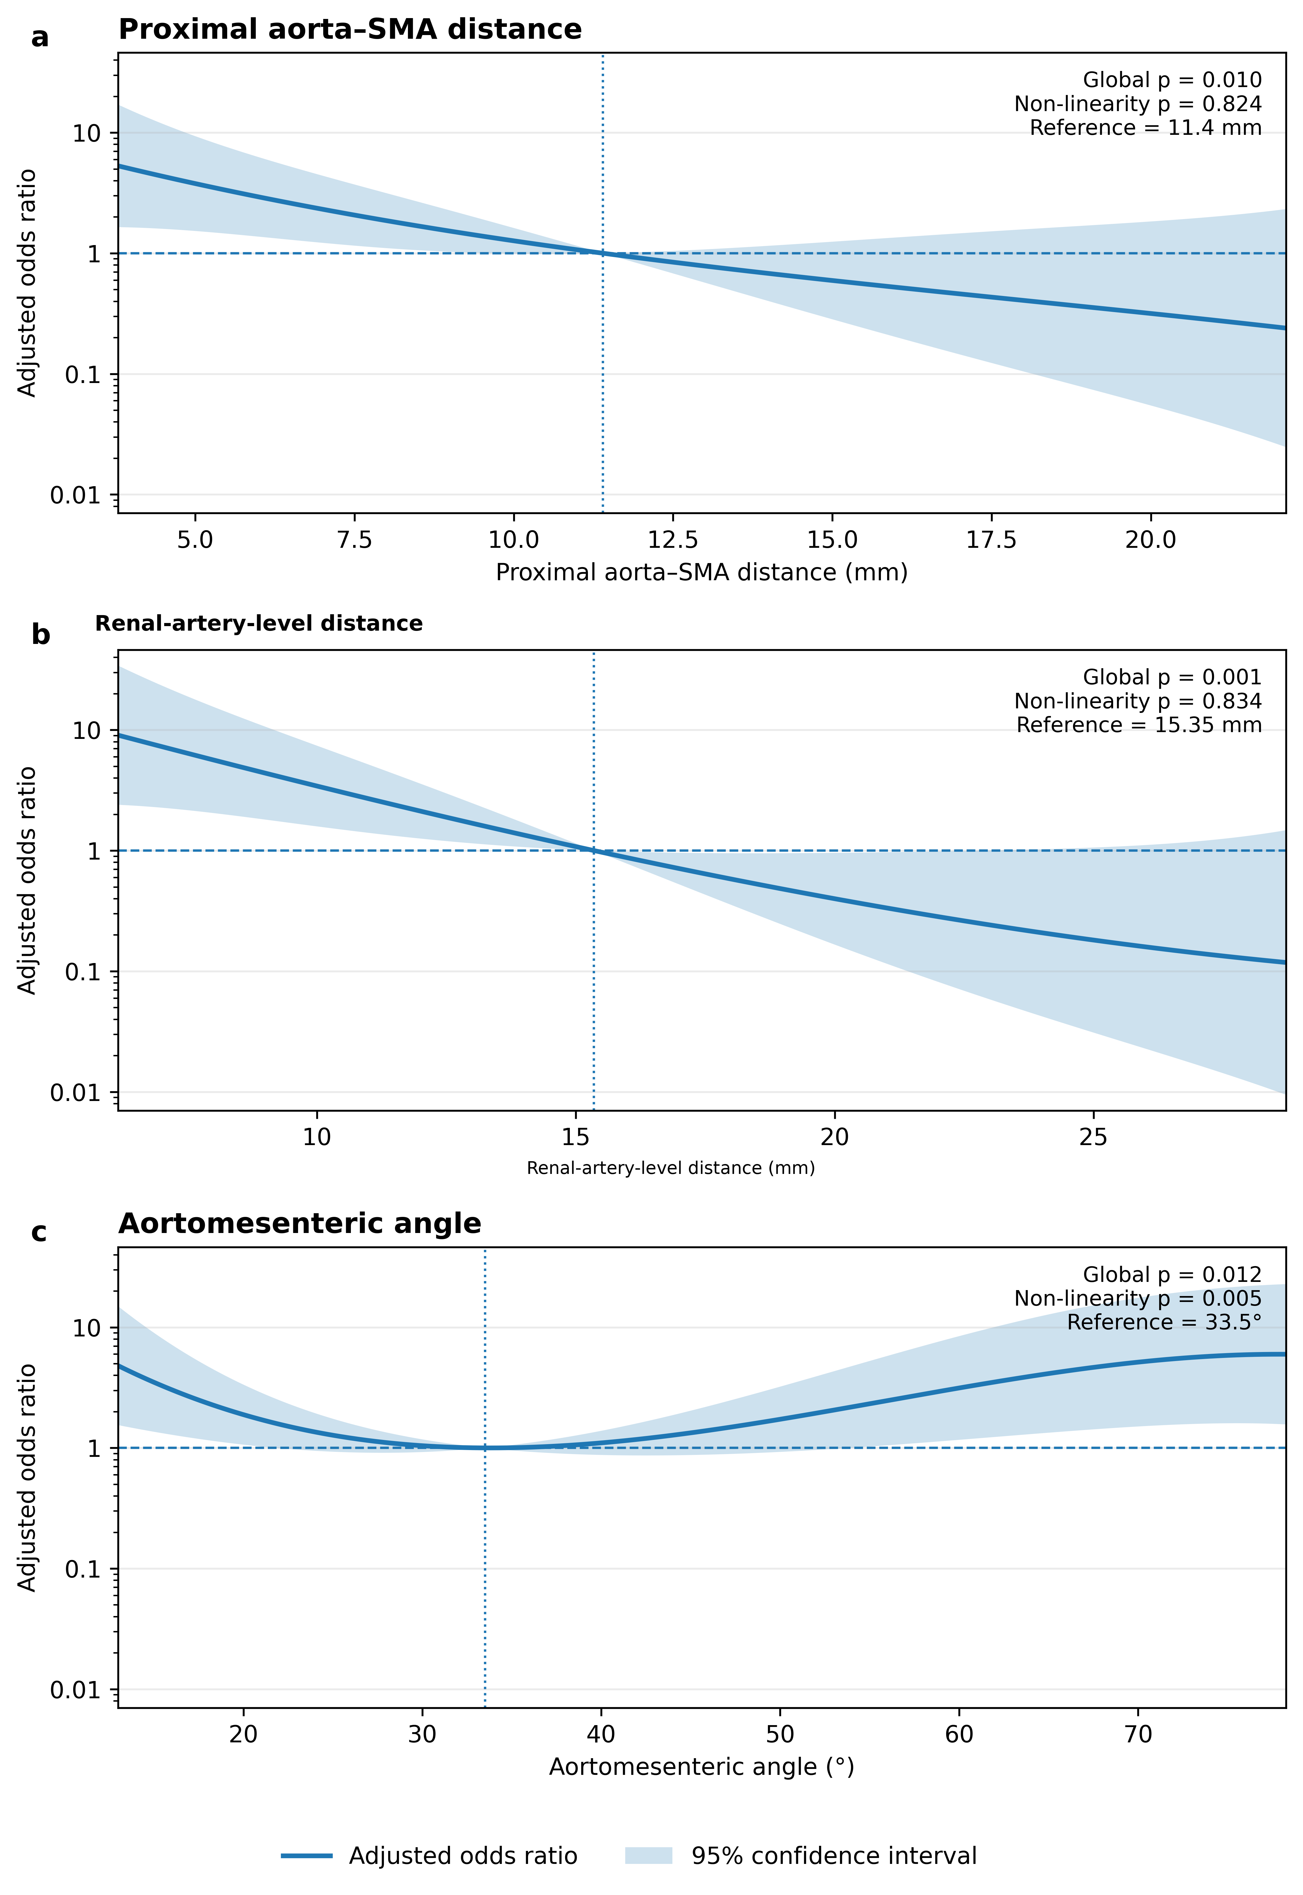
Supplementary Figure S2. Adjusted cubic B-spline associations of ultrasonographic aortomesenteric parameters with self-reported abdominal symptom status.

Supplementary Figure S2. Adjusted cubic B-spline associations of ultrasonographic aortomesenteric parameters with self-reported abdominal symptom status.
The solid curves show adjusted odds ratios (ORs) for reporting any abdominal symptom, estimated using separate multivariable logistic regression models containing cubic B-spline terms with three degrees of freedom. All models were adjusted for age, sex, and body mass index. Shaded areas represent 95% confidence intervals. ORs are expressed relative to the median value of the respective parameter: 11.4 mm for the proximal aorta-superior mesenteric artery (SMA) distance, 15.35 mm for the renal-artery-level aorta-SMA distance, and 33.5° for the aortomesenteric angle. Vertical dotted lines indicate these reference values, and horizontal dashed lines indicate an OR of 1. Curves are displayed between the 5th and 95th percentiles of the observed parameter distributions to limit visual overinterpretation of sparsely populated tails. Global p values were obtained by likelihood-ratio comparison of the spline model with the corresponding model containing adjustment variables only; non-linearity p values were obtained by comparison with the corresponding linear model. (a) Proximal aorta-SMA distance. (b) Renal-artery-level distance. (c) Aortomesenteric angle. The apparent non-linear angle association should be considered hypothesis-generating because only 27 participants reported abdominal symptoms. BMI, body mass index; CI, confidence interval; OR, odds ratio; SMA, superior mesenteric artery.

Threshold-based symptom proportions
A proximal distance below 8 mm was present in 45/195 participants (23.1%); 14/45 (31.1%) participants meeting the criterion reported symptoms compared with 13/150 (8.7%) among those not meeting it. A renal-artery-level distance below 8 mm was present in 23/188 participants (12.2%); symptom proportions were 7/23 (30.4%) and 17/165 (10.3%), respectively.
An angle below 22° was present in 42/196 participants (21.4%), with symptom proportions of 10/42 (23.8%) among those meeting and 17/154 (11.0%) among those not meeting the criterion. An angle below 25° was present in 54/196 participants (27.6%), with corresponding symptom proportions of 11/54 (20.4%) and 16/142 (11.3%). The combination of angle below 25° and proximal distance below 8 mm was present in 28/195 participants (14.4%), of whom 10/28 (35.7%) reported symptoms.

Supplementary Table S2. Symptom proportions for conventional and exploratory measurement criteria.
Criterion | Meeting criterion | Symptom proportion if met | Symptom proportion if not met
Proximal distance < 8 mm | 45/195 (23.1%) | 14/45 (31.1%) | 13/150 (8.7%)
Renal-artery-level distance < 8 mm | 23/188 (12.2%) | 7/23 (30.4%) | 17/165 (10.3%)
Angle < 22° | 42/196 (21.4%) | 10/42 (23.8%) | 17/154 (11.0%)
Angle < 25° | 54/196 (27.6%) | 11/54 (20.4%) | 16/142 (11.3%)
Angle < 25° + proximal distance < 8 mm | 28/195 (14.4%) | 10/28 (35.7%) | 17/167 (10.2%)
At least one of the two distances < 8 mm | 47/187 (25.1%) | 15/47 (31.9%) | 9/140 (6.4%)
Angle < 25° + at least one of the two distances < 8 mm | 27/187 (14.4%) | 10/27 (37.0%) | 14/160 (8.8%)
The proximal 8-mm threshold and the angle thresholds were literature based; application of 8 mm to the renal-artery-level distance and all combined criteria were exploratory. The proportions refer to the post-examination yes-or-no response to whether any abdominal symptom was present and are not diagnostic-accuracy estimates for confirmed SMA syndrome.

Adjusted threshold-based and combined-criterion associations
In Firth penalised models, proximal distance below 8 mm was associated with symptom status (adjusted OR 5.51, 95% profile-likelihood CI 2.16-14.84; p < 0.001). The threshold at the left renal artery origin below 8 mm had an adjusted OR of 3.99 (95% CI 1.23-12.96; p = 0.022). Angle thresholds below 22° and below 25° were not statistically significant.
Among combined criteria, angle below 25° plus proximal distance below 8 mm had an adjusted OR of 5.77 (95% CI 2.00-16.96; p = 0.001). At least one of the two distances below 8 mm had an adjusted OR of 8.91 (95% CI 3.24-27.43; p < 0.001), and angle below 25° plus at least one of the two distances below 8 mm had an adjusted OR of 8.04 (95% CI 2.63-25.90; p < 0.001). Profile-likelihood confidence intervals remained wide.

Supplementary Table S3. Firth-adjusted exploratory associations of threshold-based and combined measurement criteria with self-reported abdominal symptom status.
Variable/criterion | Adjusted OR | 95% profile-likelihood CI | p value | Analysis N | Symptom-positive N
Proximal distance < 8 mm | 5.51 | 2.16-14.84 | < 0.001 | 195 | 27
Renal-artery-level distance < 8 mm | 3.99 | 1.23-12.96 | 0.022 | 188 | 24
Angle < 22° | 2.46 | 0.97-6.12 | 0.058 | 196 | 27
Angle < 25° | 1.92 | 0.77-4.73 | 0.159 | 196 | 27
Angle < 25° + proximal distance < 8 mm | 5.77 | 2.00-16.96 | 0.001 | 195 | 27
At least one of the two distances < 8 mm | 8.91 | 3.24-27.43 | < 0.001 | 187 | 24
Angle < 25° + at least one of the two distances < 8 mm | 8.04 | 2.63-25.90 | < 0.001 | 187 | 24
Firth penalised logistic regression models were adjusted for age, sex, and BMI; 95% confidence intervals are profile-likelihood intervals. The proximal 8-mm threshold and the angle thresholds were literature based; application of 8 mm to the renal-artery-level distance and all combined criteria were exploratory. Symptom-positive N denotes participants who answered yes to the post-examination verbal question about the presence of any abdominal symptom. Analysis N and symptom-positive N refer to complete observations for each criterion.
BMI, body mass index; CI, confidence interval; OR, odds ratio

ROC-based apparent discrimination
Apparent discrimination was modest for the proximal distance (AUC 0.69, 95% CI 0.58-0.81) and the renal-artery-level distance (AUC 0.74, 95% CI 0.62-0.85), and close to chance for the angle alone (AUC 0.53, 95% CI 0.38-0.67).

Supplementary Table S4. Apparent receiver operating characteristic discrimination for the binary self-reported abdominal symptom endpoint.
Parameter | Analysis N | Symptom-positive N | AUC | 95% DeLong CI
Proximal distance | 195 | 27 | 0.69 | 0.58-0.81
Renal-artery-level distance | 188 | 24 | 0.74 | 0.62-0.85
Aortomesenteric angle | 196 | 27 | 0.53 | 0.38-0.67
Symptom-positive N denotes participants who answered yes to the post-examination verbal question about the presence of any abdominal symptom.
AUC, area under the receiver operating characteristic curve; CI, confidence interval; ROC, receiver operating characteristic

Ultrasonographic parameters by BMI category
In secondary analyses, median values of all three ultrasound parameters increased across the ordered BMI categories. Values were lowest in the underweight group and highest among participants with obesity. The underweight group contained only nine participants and should therefore be interpreted cautiously. Differences across BMI categories were significant for all three parameters (Kruskal-Wallis p < 0.001).

Supplementary Table S5. Ultrasonographic aortomesenteric measurements by body mass index category.
BMI category | N (proximal/left renal artery origin/angle) | Proximal distance, mm, median (IQR) | Renal-artery-level distance, mm, median (IQR) | Angle, degrees, median (IQR)
< 18.5 kg/m² | 9/9/9 | 5.3 (4.8-7.0) | 7.0 (6.5-8.1) | 15.0 (12.0-31.0)
18.5-24.9 kg/m² | 80/77/80 | 9.1 (6.3-12.8) | 13.0 (9.1-16.0) | 27.2 (18.8-39.1)
25.0-29.9 kg/m² | 61/57/62 | 12.0 (9.7-14.0) | 16.2 (13.0-19.0) | 35.0 (28.0-49.9)
≥ 30 kg/m² | 45/45/45 | 14.0 (11.9-17.0) | 18.0 (15.5-25.0) | 44.0 (31.0-68.0)
Values are median (IQR). The N column reports available observations for proximal distance/renal-artery-level distance/angle. Kruskal-Wallis p < 0.001 for all three parameters.
BMI, body mass index; IQR, interquartile range

Unadjusted anthropometric correlations
In secondary continuous analyses, BMI and body weight correlated positively with all three ultrasound parameters. The strongest association was between body weight and the renal-artery-level distance (Spearman’s ρ = 0.60; p < 0.001). Height showed weaker positive associations, whereas age was not materially associated with the ultrasound parameters.

Supplementary Table S6. Spearman correlations of age and anthropometric variables with ultrasonographic aortomesenteric measurements.
Anthropometric variable | Proximal distance | Renal-artery-level distance | Angle
BMI | ρ = 0.49; p < 0.001 | ρ = 0.50; p < 0.001 | ρ = 0.46; p < 0.001
Body weight | ρ = 0.53; p < 0.001 | ρ = 0.60; p < 0.001 | ρ = 0.46; p < 0.001
Height | ρ = 0.28; p < 0.001 | ρ = 0.37; p < 0.001 | ρ = 0.20; p = 0.005
Age | ρ = 0.05; p = 0.500 | ρ = 0.09; p = 0.225 | ρ = 0.13; p = 0.075
BMI, body mass index; ρ, Spearman’s rho

Prevalence of measurement criteria by BMI category
The prevalence of a proximal distance below 8 mm decreased from 77.8% in the underweight group to 2.2% among participants with obesity. Similar gradients were observed for the renal-artery-level distance, angle thresholds, and exploratory combined distance criteria. Exact Fisher-Freeman-Halton tests were significant for all criteria (all p < 0.001).

Supplementary Table S7. Prevalence of conventional and exploratory measurement criteria by body mass index category.
Criterion | < 18.5 kg/m² | 18.5-24.9 kg/m² | 25.0-29.9 kg/m² | ≥ 30 kg/m² | p value
Proximal distance < 8 mm | 7/9 (77.8%) | 30/80 (37.5%) | 7/61 (11.5%) | 1/45 (2.2%) | < 0.001
Renal-artery-level distance < 8 mm | 6/9 (66.7%) | 14/77 (18.2%) | 2/57 (3.5%) | 1/45 (2.2%) | < 0.001
Angle < 22° | 5/9 (55.6%) | 27/80 (33.8%) | 8/62 (12.9%) | 2/45 (4.4%) | < 0.001
Angle < 25° | 6/9 (66.7%) | 34/80 (42.5%) | 11/62 (17.7%) | 3/45 (6.7%) | < 0.001
At least one of the two distances < 8 mm | 7/9 (77.8%) | 30/77 (39.0%) | 8/56 (14.3%) | 2/45 (4.4%) | < 0.001
Both distances < 8 mm | 6/9 (66.7%) | 13/77 (16.9%) | 1/56 (1.8%) | 0/45 (0.0%) | < 0.001
The proximal 8-mm threshold and the angle thresholds were literature based. Application of the 8-mm threshold to the renal-artery-level distance and the combined distance criteria were exploratory. Different denominators reflect parameter-specific measurement availability. P values are from two-sided Fisher-Freeman-Halton exact tests.

Full primary logistic regression models and diagnostics
The full coefficients from the three primary standard logistic regression models are shown in Supplementary Table S8. The maximum VIF was 1.36 in the proximal-distance model, 1.54 in the renal-artery-level distance model, and 1.28 in the angle model, indicating no concerning multicollinearity. All models converged with finite maximum-likelihood estimates and standard errors and without separation warnings; Firth penalised sensitivity estimates were closely similar. Maximum Cook’s distances were 0.096, 0.090, and 0.140, respectively. Across leave-one-out refits, the adjusted odds ratio for the primary ultrasonographic parameter ranged from 1.18 to 1.25 in the proximal-distance model, from 1.22 to 1.29 in the renal-artery-level distance model, and from 0.91 to 1.01 in the angle model. No individual observation materially changed the direction or interpretation of the primary parameter estimate, and no observations were excluded on diagnostic grounds.

Supplementary Table S8. Full coefficients from the three primary multivariable logistic regression models.
Term | β | SE | OR | 95% CI | p value
Model 1: Proximal distance (analysis N = 195; symptom-positive N = 27)
Intercept | −0.690 | 1.077 | 0.502 | 0.061-4.140 | 0.522
Proximal distance, per 1-mm lower value | 0.190 | 0.063 | 1.209 | 1.069-1.369 | 0.003
Male sex (reference: female) | 0.019 | 0.475 | 1.019 | 0.402-2.583 | 0.968
Age, per 1-year higher value | −0.008 | 0.012 | 0.992 | 0.968-1.015 | 0.490
BMI, per 1 kg/m² higher value | 0.049 | 0.044 | 1.050 | 0.963-1.145 | 0.264
Model 2: Renal-artery-level distance (analysis N = 188; symptom-positive N = 24)
Intercept | −0.513 | 1.138 | 0.599 | 0.064-5.575 | 0.652
Renal-artery-level distance, per 1-mm lower value | 0.217 | 0.063 | 1.243 | 1.098-1.407 | <0.001
Male sex (reference: female) | 0.537 | 0.552 | 1.711 | 0.580-5.048 | 0.330
Age, per 1-year higher value | −0.010 | 0.013 | 0.990 | 0.965-1.015 | 0.424
BMI, per 1 kg/m² higher value | 0.072 | 0.046 | 1.075 | 0.981-1.178 | 0.120
Model 3: Aortomesenteric angle (analysis N = 196; symptom-positive N = 27)
Intercept | −0.855 | 1.133 | 0.425 | 0.046-3.916 | 0.450
Aortomesenteric angle, per 10-degree lower value | −0.057 | 0.113 | 0.945 | 0.757-1.179 | 0.614
Male sex (reference: female) | −0.364 | 0.457 | 0.695 | 0.284-1.702 | 0.426
Age, per 1-year higher value | −0.007 | 0.012 | 0.993 | 0.970-1.017 | 0.548
BMI, per 1 kg/m² higher value | −0.026 | 0.046 | 0.975 | 0.892-1.066 | 0.574
β values are logistic regression coefficients on the log-odds scale. ORs and 95% CIs were obtained by exponentiating the corresponding coefficient and Wald confidence limits. P values are unadjusted Wald p values; Holm-adjusted p values for the three ultrasonographic parameters are reported in Table 4 of the main manuscript. All models were adjusted for age, sex, and BMI. BMI, body mass index; CI, confidence interval; OR, odds ratio; SE, standard error.

STROBE checklist for cross-sectional studies
Completed STROBE Statement checklist of items that should be included in reports of cross-sectional studies (version 4). Page numbers refer to the main manuscript unless “Supplementary Material” is specified. “Not applicable” denotes an item that does not apply to this study design or analysis.
Section/topic | Item No. | Recommendation | Reported on page(s)
Title and abstract | 1(a) | Indicate the study’s design with a commonly used term in the title or the abstract | p. 1 (title); p. 2 (abstract)
Title and abstract | 1(b) | Provide in the abstract an informative and balanced summary of what was done and what was found | p. 2
Introduction
Background/rationale | 2 | Explain the scientific background and rationale for the investigation being reported | pp. 3-4
Objectives | 3 | State specific objectives, including any prespecified hypotheses | p. 4; primary, secondary, and exploratory analysis hierarchy stated explicitly
Methods
Study design | 4 | Present key elements of study design early in the paper | pp. 4-5
Setting | 5 | Describe the setting, locations, and relevant dates, including periods of recruitment, exposure, follow-up, and data collection | pp. 1, 4-5; no follow-up was applicable to this cross-sectional study
Participants | 6(a) | Give the eligibility criteria, and the sources and methods of selection of participants | p. 5; recruitment occurred on study days; reasons for non-participation were not systematically recorded
Variables | 7 | Clearly define all outcomes, exposures, predictors, potential confounders, and effect modifiers. Give diagnostic criteria, if applicable | pp. 6-9
Data sources/measurement | 8* | For each variable of interest, give sources of data and details of methods of assessment (measurement). Describe comparability of assessment methods if there is more than one group | pp. 6-8
Bias | 9 | Describe any efforts to address potential sources of bias | Main manuscript pp. 7-9; diagnostic results in Supplementary Table S8; limitations discussed in the main manuscript
Study size | 10 | Explain how the study size was arrived at | p. 5; no formal sample-size calculation was performed
Quantitative variables | 11 | Explain how quantitative variables were handled in the analyses. If applicable, describe which groupings were chosen and why | Main manuscript pp. 8-9; Supplementary Methods pp. 3-4
Statistical methods | 12(a) | Describe all statistical methods, including those used to control for confounding | Main manuscript pp. 8-9; Supplementary Methods pp. 3-4; Supplementary Table S8
Statistical methods | 12(b) | Describe any methods used to examine subgroups and interactions | Main manuscript p. 8; Supplementary Methods p. 3; Supplementary Tables S5 and S7 (pp. 11-12); no interaction analysis was performed
Statistical methods | 12(c) | Explain how missing data were addressed | p. 9
Statistical methods | 12(d) | If applicable, describe analytical methods taking account of sampling strategy | Not applicable; no complex sampling design or sampling weights were used
Statistical methods | 12(e) | Describe any sensitivity analyses | Main manuscript pp. 8-9; Supplementary Methods pp. 3-4; “Sensitivity analyses of model form and small-sample bias” (p. 7); Supplementary Figure S2 (p. 8)
Results
Participants | 13(a)* | Report numbers of individuals at each stage of study—eg numbers potentially eligible, examined for eligibility, confirmed eligible, included in the study, completing follow-up, and analysed | Main manuscript pp. 5-6 and 10; Figure 2; Supplementary Table S1 (p. 5)
Participants | 13(b)* | Give reasons for non-participation at each stage | Main manuscript pp. 5-6, 10 and 15-16; all 792 attendees were invited to participate, 585 declined participation and did not provide written informed consent, and reasons for declining were not requested or recorded
Participants | 13(c)* | Consider use of a flow diagram | p. 6, Figure 2
Descriptive data | 14(a)* | Give characteristics of study participants (eg demographic, clinical, social) and information on exposures and potential confounders | Main manuscript pp. 10-12; Tables 1-3
Descriptive data | 14(b)* | Indicate number of participants with missing data for each variable of interest | Main manuscript pp. 9-13; Figure 2 and Tables 1-4; Supplementary Table S1 (p. 5)
Outcome data | 15* | Report numbers of outcome events or summary measures | Main manuscript pp. 10-12; Tables 1, 3 and 4
Main results | 16(a) | Give unadjusted estimates and, if applicable, confounder-adjusted estimates and their precision (eg, 95% confidence interval). Make clear which confounders were adjusted for and why they were included | Main manuscript pp. 8-9 and 11-14; Tables 3-5; Supplementary Figure S2 (p. 8); Supplementary Tables S2-S7 (pp. 9-12)
Main results | 16(b) | Report category boundaries when continuous variables were categorized | Main manuscript pp. 3, 9 and 13; Supplementary Methods p. 3; Supplementary Tables S2, S5 and S7 (pp. 9, 11 and 12)
Main results | 16(c) | If relevant, consider translating estimates of relative risk into absolute risk for a meaningful time period | Not applicable; this cross-sectional study did not estimate time-based risks
Other analyses | 17 | Report other analyses done—eg analyses of subgroups and interactions, and sensitivity analyses | Main manuscript pp. 11-16; Supplementary Figure S1 (p. 6); Supplementary Figure S2 (p. 8); Supplementary Tables S1-S7 (pp. 5 and 9-12)
Discussion
Key results | 18 | Summarise key results with reference to study objectives | Main manuscript pp. 14-16
Limitations | 19 | Discuss limitations of the study, taking into account sources of potential bias or imprecision. Discuss both direction and magnitude of any potential bias | Main manuscript pp. 15-16
Interpretation | 20 | Give a cautious overall interpretation of results considering objectives, limitations, multiplicity of analyses, results from similar studies, and other relevant evidence | Main manuscript pp. 14-16
Generalisability | 21 | Discuss the generalisability (external validity) of the study results | Main manuscript pp. 14-16
Other information
Funding | 22 | Give the source of funding and the role of the funders for the present study and, if applicable, for the original study on which the present article is based | Main manuscript p. 16; no specific external funding was received
*Give information separately for exposed and unexposed groups where applicable.
Source: STROBE Statement—Checklist of items that should be included in reports of cross-sectional studies, version 4.

References

1. Ünal B, Aktaş A, Kemal G, Bilgili Y, Güliter S, Daphan Ç, et al. Superior mesenteric artery syndrome: CT and ultrasonography findings. Diagnostic and interventional radiology. 2005;11:90–5.
2. Neri S, Signorelli SS, Mondati E, Pulvirenti D, Campanile E, Di Pino L, et al. Ultrasound imaging in diagnosis of superior mesenteric artery syndrome. J Intern Med. 2005;257:346–51. https://doi.org/10.1111/j.1365-2796.2005.01456.x.
3. Firth D. Bias reduction of maximum likelihood estimates. Biometrika. 1993;80:27–38. https://doi.org/10.1093/BIOMET/80.1.27.
4. Heinze G, Schemper M. A solution to the problem of separation in logistic regression. Stat Med. 2002;21:2409–19. https://doi.org/10.1002/sim.1047.
5. Robin X, Turck N, Hainard A, Tiberti N, Lisacek F, Sanchez JC, et al. pROC: An open-source package for R and S+ to analyze and compare ROC curves. BMC Bioinformatics. 2011;12. https://doi.org/10.1186/1471-2105-12-77.
6. Freeman GH, Halton JH. Note on an exact treatment of contingency, goodness of fit and other problems of significance. Biometrika. 1951;38:141–9. https://doi.org/10.1093/BIOMET/38.1-2.141.
7. Perperoglou A, Sauerbrei W, Abrahamowicz M, Schmid M. A review of spline function procedures in R. BMC Medical Research Methodology. 2019;19. https://doi.org/10.1186/s12874-019-0666-3.
8. R Core Team. R: A language and environment for statistical computing. 2025.
9. Posit Team. RStudio: Integrated Development Environment for R. 2025.
10. Zeileis A, Köll S, Graham N. Various versatile variances: An object-oriented implementation of clustered covariances in r. J Stat Softw. 2020;95:1–36. https://doi.org/10.18637/jss.v095.i01.
11. Canty A, Ripley B. Package “boot.” 2025. https://doi.org/10.32614/CRAN.package.boot.
12. Efron B. Better bootstrap confidence intervals. J Am Stat Assoc. 1987;82:171–85. https://doi.org/10.1080/01621459.1987.10478410.
13. Wickham H, Chang W, Henry L. ggplot2: Create elegant data visualisations using the grammar of graphics. 2025 https://ggplot2.tidyverse.org. 2024;10.
14. Cleveland WS. Robust Locally Weighted Regression and Smoothing Scatterplots. J Am Stat Assoc. 1979;74:829–36. https://doi.org/10.1080/01621459.1979.10481038.

