Supplementary Information
Docking and Molecular Dynamics of the Natural Diterpenoid Dihydrotanshinone I in Human 15-PGDH Across Three Inhibitor-Bound Receptor Structures
Supplementary Methods
This reproducibility reference lists the software versions, docking parameters, and processing scripts used in the study. Values were read directly from the installed packages, the saved AutoDock Vina log files, and the configuration files.
Software and versions
Software | Version | Notes
AutoDock Vina | 1.2.7 | Official prebuilt Windows executable, confirmed with vina.exe --version
Python | 3.11.5
RDKit | 2026.3.4
Meeko | 0.7.1
PLIP | 3.0.0
gemmi | 0.7.5
Biopython | 1.87
Open Babel | 3.1.0 | Python bindings via openbabel-wheel 3.1.1.23
NumPy | 2.4.6
SciPy | 1.17.1
Operating system | Windows 11 Pro (build 26200)
Docking grid box, per structure
The search box is a cube centred on the centroid of that structure's own co-crystallized inhibitor. Values were transcribed from the configuration files and cross-checked against the grid centre and grid size that AutoDock Vina printed in the saved log files.
Structure | center_x | center_y | center_z | size_x | size_y | size_z
9PFL | 12.511 | -13.414 | -3.014 | 24 | 24 | 24
9PFM | 28.844 | -15.588 | 7.224 | 24 | 24 | 24
8CVN | 122.078 | 143.662 | 124.176 | 24 | 24 | 24
AutoDock Vina run settings
Setting | Value | Source
Scoring function | vina (default) | Printed in every log
Exhaustiveness | 32 | Printed in every log
Number of modes | 9 | Confirmed by nine ranked poses in every log
Seed, main docking runs | 42 | Printed as random seed: 42 in the docking, comparator, and redock logs
Seeds, seed-robustness check | 1 to 15 | Printed as random seed: N in each seed_N log
The seed-robustness check was run for dihydrotanshinone I only, against all three structures, using the same box and exhaustiveness of 32 as the main docking runs.
For full reproducibility, the exact command executed for each run was of the following form, shown for 9PFL with dihydrotanshinone I; the other runs differ only in the ligand file and the box file.
vina.exe --receptor receptor.pdbqt --ligand dihydrotanshinone_I.pdbqt --config box_9PFL.txt --exhaustiveness 32 --num_modes 9 --seed 42 --out RESULT.pdbqt
Processing scripts
A copy of every processing script is included in the archive, with a one-line description of each in the accompanying README. The pipeline stages are: receptor preparation from the downloaded mmCIF structures; ligand preparation from PubChem; docking with the AutoDock Vina executable from the command line; post-docking analysis (RMSD, the 4 Angstrom contact scan, PLIP, sequence alignment, cross-conformation superposition, and seed-robustness statistics); figure generation; and document assembly.
Scope and two documented recomputations
Almost all affinities, RMSD values, and contact analyses in this package were read from files already present in the project folder rather than recomputed while assembling it. Two exceptions were made afterwards and are documented in full below. The PLIP interaction breakdown for the 9PFM dihydrotanshinone I pose (Table S1) was regenerated by re-running PLIP, with unchanged settings, on the already-existing docked complex, because the original text report had been overwritten in an earlier session. The per-seed RMSD-to-consensus values (Table S3) were filled in by reusing the study's own RMSD functions against the fifteen already-existing seed poses per structure, printing values the analysis had computed internally but not written out individually. Neither exception re-ran any docking or introduced a new analysis method.
Supplementary Tables
Table S1. Receptor residues in contact with the dihydrotanshinone I top pose, per structure (PLIP).
The distance metric follows the PLIP convention for each interaction type: hydrophobic and halogen-bond distances are the atom-to-atom distance, hydrogen-bond distances are the donor-acceptor distance, and pi-stacking distances are the ring-centroid-to-centroid distance. These are not the same measurement as the closest-heavy-atom distances used for the flagged residues in Table 5 of the manuscript, which come from a separate 4 Angstrom scan; a numeric difference between the two for the same residue reflects the difference in method, as noted after the table. Interaction detection used PLIP 3.0.0 (Schake et al., 2025).
Structure | Residue | Interaction type (PLIP) | Distance (Angstrom)
9PFL | Ser138 | Hydrogen bond | 2.89
9PFL | Leu139 | Hydrogen bond | 3.59
9PFL | Val145 | Hydrophobic | 3.80
9PFL | Pro183 | Hydrogen bond | 3.96
9PFL | Phe185 | Hydrophobic | 3.01
9PFL | Ile190 | Hydrophobic | 3.36
9PFL | Ile194 | Hydrophobic | 2.84
9PFL | Ile210 | Hydrophobic | 3.61
9PFM | Ser138 | Hydrogen bond | 2.83
9PFM | Ala140 | Hydrogen bond | 3.17
9PFM | Val145 | Hydrophobic | 3.38
9PFM | Gln148 | Hydrogen bond | 3.11
9PFM | Tyr151 | Hydrophobic | 3.96
9PFM | Tyr151 | Hydrogen bond | 4.02
9PFM | Phe185 | Hydrophobic | 3.87
9PFM | Phe185 | Pi-stacking | 4.53
9PFM | Leu191 | Hydrophobic | 3.97
9PFM | Ile210 | Hydrophobic | 3.24
8CVN | Leu139 | Hydrophobic | 3.54
8CVN | Phe185 | Hydrophobic | 3.57
8CVN | Phe185 | Hydrogen bond | 3.16
8CVN | Tyr217 | Hydrophobic | 3.62
8CVN | Tyr217 | Hydrogen bond | 3.71
8CVN | Tyr217 | Pi-stacking | 3.67
Note. The 9PFM row was regenerated by re-running PLIP, unchanged, on the docked complex that was still on disk, because the original report had been overwritten when the same folder was reused to make a figure. The regenerated report finds the same interaction counts recorded for the original run, confirming a faithful reconstruction. Ser138 matches Table 5 exactly (donor-acceptor distance 2.83 Angstrom). Tyr151 and Phe185 differ numerically from Table 5 because Table 5 reports the closest heavy-atom pair from the 4 Angstrom scan, while PLIP selects a representative atom pair per interaction type; the same two-method difference is present for 9PFL and 8CVN and reflects the cross-checking described in the manuscript methods rather than an inconsistency.
Table S2. Contacts of the redocked reference inhibitor in 9PFL (PLIP).
Residue | Interaction type (PLIP) | Distance (Angstrom)
Ser138 | Hydrogen bond | 2.79
Tyr151 | Hydrogen bond | 2.69
Phe185 | Hydrophobic | 3.37
Phe185 | Pi-stacking | 4.18
Ile190 | Halogen bond | 3.14
Thr247 | Hydrogen bond | 4.01
Tyr217 | Pi-stacking | 3.57
Table S3. Per-seed results of the seed-robustness check (15 seeds per structure).
The best-affinity column is the top-ranked affinity for that seed. The consensus pose in every structure is the pose from seed 1, chosen as the cluster representative, so its RMSD to itself is zero. The RMSD column was filled by reusing the study's own RMSD functions on the fifteen saved seed poses per structure. As a consistency check, the maximum value in each structure matches the maximum distance from consensus already reported in the seed-robustness summary (0.074 Angstrom for 9PFL, 0.108 for 9PFM, 0.142 for 8CVN).
9PFL (consensus = seed 1)
Seed | Best affinity (kcal/mol) | RMSD to consensus (Angstrom)
1 | -8.925 | 0.000
2 | -8.882 | 0.074
3 | -8.957 | 0.031
4 | -8.936 | 0.033
5 | -8.935 | 0.040
6 | -8.932 | 0.042
7 | -8.926 | 0.007
8 | -8.934 | 0.034
9 | -8.932 | 0.041
10 | -8.931 | 0.042
11 | -8.929 | 0.039
12 | -8.931 | 0.041
13 | -8.938 | 0.037
14 | -8.939 | 0.037
15 | -8.936 | 0.048
9PFM (consensus = seed 1)
Seed | Best affinity (kcal/mol) | RMSD to consensus (Angstrom)
1 | -9.538 | 0.000
2 | -9.566 | 0.062
3 | -9.555 | 0.057
4 | -9.554 | 0.040
5 | -9.565 | 0.045
6 | -9.558 | 0.022
7 | -9.556 | 0.108
8 | -9.563 | 0.047
9 | -9.535 | 0.024
10 | -9.543 | 0.058
11 | -9.553 | 0.017
12 | -9.578 | 0.042
13 | -9.536 | 0.003
14 | -9.569 | 0.041
15 | -9.553 | 0.020
8CVN (consensus = seed 1)
Seed | Best affinity (kcal/mol) | RMSD to consensus (Angstrom)
1 | -10.510 | 0.000
2 | -10.540 | 0.077
3 | -10.510 | 0.079
4 | -10.530 | 0.092
5 | -10.520 | 0.053
6 | -10.500 | 0.051
7 | -10.490 | 0.053
8 | -10.520 | 0.096
9 | -10.510 | 0.108
10 | -10.500 | 0.105
11 | -10.520 | 0.047
12 | -10.520 | 0.099
13 | -10.540 | 0.061
14 | -10.520 | 0.142
15 | -10.500 | 0.050
Summary affinity statistics for each structure appear in Table 8 of the manuscript.
Supplementary Methods: molecular dynamics
Simulations were run with GROMACS 2026.3 on a dedicated GPU host. Systems were parameterised with AmberTools (antechamber, parmchk2, tleap) and converted to GROMACS format with acpype. Trajectory analysis used the GROMACS 2026.0 tool suite together with NumPy, SciPy and Matplotlib. Each system was simulated in three replicate trajectories of 100 ns, giving nine production trajectories in total; coordinates were written every 10 ps, giving 10,001 frames per trajectory. Full simulation parameters are given in Section 2.8 of the main text.
Table S4. Composition of the simulated systems and completion of the nine production runs.
System | Replica | Na+ | Cl- | Water molecules | Total atoms | Final step | Simulated time (ns) | Throughput (ns/day)
9PFL | 1 | 32 | 26 | 9457 | 32,448 | 50,000,000 | 100.000 | 861.1
9PFL | 2 | 32 | 26 | 9457 | 32,448 | 50,000,000 | 100.000 | 864.3
9PFL | 3 | 32 | 26 | 9457 | 32,448 | 50,000,000 | 100.000 | 863.8
9PFM | 1 | 36 | 29 | 10,627 | 36,016 | 50,000,000 | 100.000 | 796.3
9PFM | 2 | 36 | 29 | 10,627 | 36,016 | 50,000,000 | 100.000 | 807.3
9PFM | 3 | 36 | 29 | 10,627 | 36,016 | 50,000,000 | 100.000 | 805.6
8CVN | 1 | 35 | 28 | 10,198 | 34,694 | 50,000,000 | 100.000 | 822.0
8CVN | 2 | 35 | 28 | 10,198 | 34,694 | 50,000,000 | 100.000 | 824.0
8CVN | 3 | 35 | 28 | 10,198 | 34,694 | 50,000,000 | 100.000 | 822.0
Note. Ion and water counts are identical across the three replicas of each system. This was confirmed directly rather than inferred: the AMBER topology and coordinate files of the three replicas of a system are byte-identical by checksum, so each triplicate is the same built system re-run with fresh initial velocities rather than an independently rebuilt one. All nine runs reached the target step and exited normally, and frame-count checks confirmed 10,001 frames spanning 0 to 100,000 ps with no gaps or duplicates in every run. A small number of runs were resumed once from a checkpoint following job-level interruptions; the step series is continuous across every resumption and no trajectory was affected.
Table S5. Initial-velocity seeds used for the NVT stage of each replica.
System | Replica 1 | Replica 2 | Replica 3
9PFL | -2014336523 | 2111807451 | -268446729
9PFM | 782218973 | 265921887 | -79792403
8CVN | -18890914 | -9053221 | -536903955
Note. Seeds were generated afresh at each preparation step rather than set to fixed values. Independence was confirmed directly by comparing the initial velocities written into each replica's run input atom by atom, which differ throughout, rather than by relying on the seed values alone.
Table S6. Thermodynamic stability over the production run, mean and standard deviation.
System | Replica | Temperature (K) | Pressure (bar) | Density (kg per cubic m) | Potential energy (kJ per mol) | Volume (cubic nm)
9PFL | 1 | 300.00 ± 1.84 | -0.45 ± 163.7 | 1032 ± 2.7 | -429,400 ± 728 | 322.9 ± 0.85
9PFL | 2 | 300.00 ± 1.85 | 1.38 ± 162.0 | 1032 ± 2.7 | -429,400 ± 726 | 322.9 ± 0.84
9PFL | 3 | 300.00 ± 1.86 | 0.34 ± 161.0 | 1032 ± 2.7 | -429,400 ± 735 | 322.9 ± 0.84
9PFM | 1 | 300.01 ± 1.76 | -0.05 ± 150.2 | 1029 ± 2.5 | -479,700 ± 767 | 358.9 ± 0.89
9PFM | 2 | 300.00 ± 1.74 | 2.47 ± 151.1 | 1029 ± 2.6 | -479,600 ± 766 | 359.0 ± 0.90
9PFM | 3 | 300.00 ± 1.77 | 0.52 ± 151.0 | 1029 ± 2.5 | -479,700 ± 773 | 358.9 ± 0.89
8CVN | 1 | 300.00 ± 1.79 | 1.15 ± 154.8 | 1030 ± 2.6 | -461,000 ± 759 | 345.6 ± 0.89
8CVN | 2 | 300.00 ± 1.78 | 1.73 ± 153.7 | 1030 ± 2.6 | -461,000 ± 749 | 345.6 ± 0.86
8CVN | 3 | 300.00 ± 1.79 | 4.37 ± 155.2 | 1030 ± 2.6 | -460,900 ± 754 | 345.6 ± 0.88
Table S7. Checks specified before the simulations were run.
System | Replica | Cofactor C7N=O7N bond (Angstrom) | Ligand internal heavy-atom RMSD (Angstrom) | Quinone ring planarity (Angstrom)
9PFL | 1 | 1.2263 ± 0.0195 | 0.369 ± 0.072 | 0.153
9PFL | 2 | 1.2279 ± 0.0195 | 0.234 ± 0.062 | 0.143
9PFL | 3 | 1.2284 ± 0.0195 | 0.349 ± 0.106 | 0.124
9PFM | 1 | 1.2280 ± 0.0195 | 0.279 ± 0.096 | 0.162
9PFM | 2 | 1.2280 ± 0.0192 | 0.322 ± 0.069 | 0.159
9PFM | 3 | 1.2277 ± 0.0194 | 0.256 ± 0.086 | 0.151
8CVN | 1 | 1.2276 ± 0.0194 | 0.342 ± 0.104 | 0.147
8CVN | 2 | 1.2285 ± 0.0193 | 0.332 ± 0.089 | 0.128
8CVN | 3 | 1.2280 ± 0.0195 | 0.248 ± 0.086 | 0.127
Note. The cofactor amide bond had been flagged before production as stiff for a 2 fs timestep and cleared only on short test runs; across full production it sits at its equilibrium length in all nine trajectories with normal thermal fluctuation and no drift, and the spread between replicas is far smaller than the fluctuation within any one of them. The ligand's internal geometry and ring planarity likewise remain stable in all nine runs, indicating no problem with its parameterisation.
Table S8. Verification of periodic-boundary correction.
System | Replica | Raw maximum ligand jump (nm) | Raw frames above 0.5 nm | Corrected maximum jump (nm) | Corrected frames above 0.5 nm
9PFL | 1 | 7.01 | 84 of 10,000 | 0.29 | 0
9PFL | 2 | 7.08 | 100 of 10,000 | 0.31 | 0
9PFL | 3 | 7.09 | 115 of 10,000 | 0.30 | 0
9PFM | 1 | 9.81 | 76 of 10,000 | 0.34 | 0
9PFM | 2 | 7.47 | 394 of 10,000 | 0.32 | 0
9PFM | 3 | 7.12 | 34 of 10,000 | 0.36 | 0
8CVN | 1 | 6.70 | 101 of 10,000 | 0.39 | 0
8CVN | 2 | 6.73 | 98 of 10,000 | 0.41 | 0
8CVN | 3 | 6.73 | 29 of 10,000 | 0.39 | 0
Note. The uncorrected trajectories contain apparent ligand displacements of up to 9.8 nm, which are artefacts of molecules crossing the periodic box rather than real motion. The artefact appears in every run and is fully removed by the two-step correction described in Section 2.9 of the main text. This check was performed before any distance or occupancy was measured.
Table S9. Equilibration discard windows, chosen for each trajectory from its own backbone RMSD.
System | Replica | Discard (ns) | Basis
9PFL | 1 | 2 | Flat from the start, no transient to remove
9PFL | 2 | 15 | Rises over the first 15 ns, then fluctuates with no net trend
9PFL | 3 | 10 | Early bump settling by 10 ns; a slow secondary rise after 35 ns was retained, not discarded
9PFM | 1 | 20 | Fast initial relaxation; residual slower drift retained
9PFM | 2 | 30 | Overshoot peaking near 25 ns, settling into a fluctuation band by 30 ns
9PFM | 3 | 30 | Same overshoot and settling pattern; residual drift retained
8CVN | 1 | 10 | Flat to 45 ns, rising thereafter with the ligand repositioning
8CVN | 2 | 15 | Lower baseline over the first 15 ns only
8CVN | 3 | 15 | Lower baseline over the first 15 ns only
Note. No system shows a clean plateau in every replica. In particular 9PFM continues to drift beyond the chosen discard point in all three of its replicas, so 100 ns may be shorter than that system's full relaxation time; this is stated rather than concealed by discarding a longer window. Occupancies in Table S10 are reported both with and without the discarded window. The two agree closely for Lys155 and Phe185 but differ by up to 10.5 percentage points for the shallower contacts, so the sensitivity of every occupancy to this choice was tested systematically and is reported in Table S14.
Table S10. Occupancy of the flagged residues, full run and after discard, with mean distances.
System | Residue | Replica | Occupancy, full run (%) | Occupancy, after discard (%) | Mean distance (Angstrom)
9PFL | Ser138 | 1 | 99.8 | 99.8 | 2.92 ± 0.24
9PFL | Ser138 | 2 | 98.4 | 98.2 | 3.01 ± 0.32
9PFL | Ser138 | 3 | 89.6 | 88.5 | 3.44 ± 0.43
9PFL | Tyr151 | 1 | 72.7 | 73.0 | 3.83 ± 0.32
9PFL | Tyr151 | 2 | 62.3 | 60.8 | 3.93 ± 0.41
9PFL | Tyr151 | 3 | 29.0 | 22.5 | 4.85 ± 0.95
9PFL | Lys155 | 1 | 0.0 | 0.0 | 6.70 ± 0.38
9PFL | Lys155 | 2 | 0.0 | 0.0 | 6.87 ± 0.49
9PFL | Lys155 | 3 | 0.0 | 0.0 | 7.92 ± 0.70
9PFL | Phe185 | 1 | 100.0 | 100.0 | 3.27 ± 0.14
9PFL | Phe185 | 2 | 100.0 | 100.0 | 3.29 ± 0.15
9PFL | Phe185 | 3 | 100.0 | 100.0 | 3.22 ± 0.17
9PFL | Tyr217 | 1 | 84.2 | 84.1 | 3.74 ± 0.27
9PFL | Tyr217 | 2 | 88.9 | 89.8 | 3.69 ± 0.27
9PFL | Tyr217 | 3 | 81.1 | 81.2 | 3.77 ± 0.34
9PFM | Ser138 | 1 | 83.0 | 83.8 | 3.58 ± 0.45
9PFM | Ser138 | 2 | 79.8 | 83.1 | 3.51 ± 0.54
9PFM | Ser138 | 3 | 78.7 | 77.9 | 3.63 ± 0.46
9PFM | Tyr151 | 1 | 97.0 | 96.9 | 3.45 ± 0.27
9PFM | Tyr151 | 2 | 95.0 | 95.9 | 3.55 ± 0.25
9PFM | Tyr151 | 3 | 93.4 | 92.3 | 3.51 ± 0.32
9PFM | Lys155 | 1 | 0.0 | 0.0 | 7.56 ± 0.58
9PFM | Lys155 | 2 | 0.0 | 0.0 | 7.02 ± 0.36
9PFM | Lys155 | 3 | 0.0 | 0.0 | 7.71 ± 0.44
9PFM | Phe185 | 1 | 99.6 | 100.0 | 3.25 ± 0.18
9PFM | Phe185 | 2 | 100.0 | 99.9 | 3.27 ± 0.16
9PFM | Phe185 | 3 | 100.0 | 100.0 | 3.22 ± 0.14
9PFM | Tyr217 | 1 | 84.2 | 94.7 | 3.75 ± 0.80
9PFM | Tyr217 | 2 | 67.6 | 67.4 | 3.92 ± 0.63
9PFM | Tyr217 | 3 | 92.4 | 90.7 | 3.56 ± 0.34
8CVN | Ser138 | 1 | 45.6 | 50.6 | 4.69 ± 1.74
8CVN | Ser138 | 2 | 1.9 | 2.1 | 6.10 ± 0.82
8CVN | Ser138 | 3 | 3.0 | 2.7 | 5.85 ± 0.94
8CVN | Tyr151 | 1 | 45.7 | 50.8 | 5.07 ± 2.08
8CVN | Tyr151 | 2 | 0.2 | 0.2 | 7.93 ± 0.95
8CVN | Tyr151 | 3 | 0.0 | 0.0 | 7.35 ± 0.70
8CVN | Lys155 | 1 | 0.0 | 0.0 | 8.38 ± 1.68
8CVN | Lys155 | 2 | 0.0 | 0.0 | 10.12 ± 0.67
8CVN | Lys155 | 3 | 0.0 | 0.0 | 9.87 ± 0.54
8CVN | Phe185 | 1 | 98.3 | 98.5 | 3.27 ± 0.29
8CVN | Phe185 | 2 | 94.6 | 94.7 | 3.48 ± 0.32
8CVN | Phe185 | 3 | 97.4 | 97.5 | 3.45 ± 0.24
8CVN | Tyr217 | 1 | 98.5 | 98.4 | 3.34 ± 0.23
8CVN | Tyr217 | 2 | 100.0 | 100.0 | 3.23 ± 0.15
8CVN | Tyr217 | 3 | 100.0 | 100.0 | 3.22 ± 0.15
Table S11. Ser138 hydrogen-bond occupancy assessed with geometric criteria.
System | Replica 1 (%) | Replica 2 (%) | Replica 3 (%) | Mean ± SD (%)
9PFL | 55.4 | 41.8 | 9.1 | 35.4 ± 23.8
9PFM | 3.8 | 16.1 | 2.0 | 7.3 ± 7.6
8CVN | 4.5 | 0.0 | 0.0 | 1.5 ± 2.6
Note. Criteria were a donor-acceptor distance of 0.35 nm or less together with a deviation from linearity of 30 degrees or less. A hydrogen bond is present in all three 9PFL replicas, so its existence is consistent, but its occupancy varies more than sixfold and the spread across replicas exceeds the smallest individual value. The mean alone would therefore misrepresent the interaction, and the range is reported in the main text instead.
Table S12. Protein dynamics and fluctuation of the two lid residues.
System | Replica | Backbone RMSD (Angstrom) | Radius of gyration (Angstrom) | Overall RMSF (Angstrom) | Phe185 RMSF (Angstrom) | Tyr217 RMSF (Angstrom)
9PFL | 1 | 0.749 ± 0.061 | 17.938 ± 0.047 | 0.536 | 0.340 | 0.653
9PFL | 2 | 0.930 ± 0.077 | 17.919 ± 0.048 | 0.569 | 0.335 | 0.664
9PFL | 3 | 1.004 ± 0.109 | 17.910 ± 0.063 | 0.613 | 0.391 | 0.792
9PFM | 1 | 1.222 ± 0.211 | 18.119 ± 0.060 | 0.738 | 0.417 | 1.224
9PFM | 2 | 1.194 ± 0.207 | 18.060 ± 0.063 | 0.675 | 0.367 | 0.787
9PFM | 3 | 1.353 ± 0.237 | 18.132 ± 0.063 | 0.759 | 0.446 | 0.923
8CVN | 1 | 1.049 ± 0.174 | 18.065 ± 0.063 | 0.669 | 0.485 | 0.887
8CVN | 2 | 1.184 ± 0.149 | 18.046 ± 0.061 | 0.677 | 0.463 | 0.830
8CVN | 3 | 1.160 ± 0.151 | 18.041 ± 0.057 | 0.654 | 0.392 | 0.660
Note. Phe185 fluctuates less than the protein's own overall mean in all nine trajectories and Tyr217 fluctuates more in all nine, so the direction of both effects is fully reproducible. The magnitude varies: Tyr217's excess is most pronounced in the first 9PFM replica at about 1.7 times that replica's mean and more modest elsewhere, so the strength of the effect is not itself a reproducible quantity.
Table S13. Ligand position relative to the 9PFL docked pose after superposition on shared C-alpha atoms.
System | Replica | Heavy-atom RMSD (Angstrom) | Centroid distance (Angstrom) | Interpretation
9PFL | 1 | 0.97 ± 0.20 | 0.71 ± 0.22 | Remains in its own docked pose
9PFL | 2 | 1.01 ± 0.21 | 0.75 ± 0.23 | Remains in its own docked pose
9PFL | 3 | 1.36 ± 0.35 | 0.98 ± 0.28 | Remains in its own docked pose
9PFM | 1 | 5.88 ± 0.12 | 1.10 ± 0.48 | Stable in a distinct pose, no drift toward 9PFL
9PFM | 2 | 5.75 ± 0.12 | 1.06 ± 0.37 | Stable in a distinct pose, no drift toward 9PFL
9PFM | 3 | 5.90 ± 0.09 | 1.02 ± 0.52 | Stable in a distinct pose, no drift toward 9PFL
8CVN | 1 | 1.40 ± 0.21 after 65 ns | 0.96 ± 0.28 after 65 ns | Relocates near the 9PFL pose after about 60 ns
8CVN | 2 | 8.77 ± 0.44 over 90 to 100 ns | 8.46 ± 0.46 | Remains distant for the full run
8CVN | 3 | 8.62 ± 0.45 over 90 to 100 ns | 8.33 ± 0.50 | Remains distant for the full run
Note. The 9PFL replicas give the reading for a ligand that stays in its own pose, at roughly 1 Angstrom, and the 9PFM replicas give the reading for a ligand that is stable in a genuinely different pose, at roughly 5.8 Angstrom with no drift in any replica. Against that calibration, the first 8CVN replica moves to within the range associated with the 9PFL pose while the other two remain well beyond even the 9PFM separation. The lowest values reached at any single frame in those two replicas were 4.73 and 4.35 Angstrom, neither sustained for more than a few frames. The relocation is therefore reported as an observation from one trajectory of three rather than as a property of the system.
Table S14. Sensitivity of contact occupancy to the equilibration discard window.
System | Residue | Replica | 0 ns | 10 ns | 20 ns | 30 ns | 50 ns | Spread (pp)
9PFL | Ser138 | 1 | 99.80 | 99.78 | 99.75 | 99.71 | 99.60 | 0.20
9PFL | Ser138 | 2 | 98.43 | 98.30 | 98.25 | 98.06 | 97.90 | 0.53
9PFL | Ser138 | 3 | 89.79 | 88.72 | 88.06 | 87.06 | 87.26 | 2.73
9PFL | Tyr151 | 1 | 73.12 | 74.76 | 75.20 | 75.25 | 75.96 | 2.84
9PFL | Tyr151 | 2 | 62.70 | 63.10 | 59.76 | 60.21 | 59.17 | 3.93
9PFL | Tyr151 | 3 | 29.11 | 22.56 | 14.36 | 5.17 | 1.18 | 27.93
9PFL | Lys155 | 1 | 0.00 | 0.00 | 0.00 | 0.00 | 0.00 | 0.00
9PFL | Lys155 | 2 | 0.00 | 0.00 | 0.00 | 0.00 | 0.00 | 0.00
9PFL | Lys155 | 3 | 0.00 | 0.00 | 0.00 | 0.00 | 0.00 | 0.00
9PFL | Phe185 | 1 | 100.00 | 100.00 | 100.00 | 100.00 | 100.00 | 0.00
9PFL | Phe185 | 2 | 100.00 | 100.00 | 100.00 | 100.00 | 100.00 | 0.00
9PFL | Phe185 | 3 | 99.97 | 99.97 | 99.98 | 99.99 | 100.00 | 0.03
9PFL | Tyr217 | 1 | 84.52 | 84.27 | 84.29 | 83.90 | 83.40 | 1.12
9PFL | Tyr217 | 2 | 89.16 | 89.07 | 90.30 | 90.37 | 90.38 | 1.31
9PFL | Tyr217 | 3 | 81.42 | 81.44 | 81.68 | 81.32 | 78.48 | 3.20
9PFL | Ser138 H-bond | 1 | 55.41 | 55.27 | 54.29 | 53.69 | 51.51 | 3.90
9PFL | Ser138 H-bond | 2 | 41.82 | 41.61 | 42.79 | 41.98 | 41.53 | 1.26
9PFL | Ser138 H-bond | 3 | 9.11 | 6.05 | 3.74 | 0.86 | 0.04 | 9.07
9PFM | Ser138 | 1 | 83.27 | 82.16 | 83.94 | 85.86 | 85.82 | 3.70
9PFM | Ser138 | 2 | 80.04 | 79.82 | 81.69 | 83.35 | 91.16 | 11.34
9PFM | Ser138 | 3 | 78.99 | 80.71 | 79.99 | 78.19 | 72.45 | 8.26
9PFM | Tyr151 | 1 | 97.06 | 96.97 | 96.98 | 96.89 | 97.56 | 0.67
9PFM | Tyr151 | 2 | 95.13 | 95.19 | 95.50 | 96.06 | 97.40 | 2.27
9PFM | Tyr151 | 3 | 93.58 | 93.81 | 93.14 | 92.44 | 90.56 | 3.25
9PFM | Lys155 | 1 | 0.00 | 0.00 | 0.00 | 0.00 | 0.00 | 0.00
9PFM | Lys155 | 2 | 0.00 | 0.00 | 0.00 | 0.00 | 0.00 | 0.00
9PFM | Lys155 | 3 | 0.00 | 0.00 | 0.00 | 0.00 | 0.00 | 0.00
9PFM | Phe185 | 1 | 99.61 | 100.00 | 100.00 | 100.00 | 100.00 | 0.39
9PFM | Phe185 | 2 | 99.97 | 99.97 | 99.96 | 99.96 | 99.94 | 0.03
9PFM | Phe185 | 3 | 99.99 | 99.99 | 99.99 | 99.99 | 99.98 | 0.01
9PFM | Tyr217 | 1 | 84.30 | 92.30 | 94.80 | 95.83 | 97.62 | 13.32
9PFM | Tyr217 | 2 | 67.92 | 69.75 | 69.33 | 67.76 | 71.71 | 3.95
9PFM | Tyr217 | 3 | 92.50 | 92.08 | 91.61 | 90.77 | 88.36 | 4.14
9PFM | Ser138 H-bond | 1 | 3.81 | 3.19 | 3.32 | 3.59 | 2.72 | 1.09
9PFM | Ser138 H-bond | 2 | 16.06 | 17.11 | 19.02 | 21.70 | 26.55 | 10.49
9PFM | Ser138 H-bond | 3 | 2.00 | 2.18 | 1.79 | 1.80 | 2.02 | 0.39
8CVN | Ser138 | 1 | 45.70 | 50.73 | 57.06 | 61.43 | 75.30 | 29.60
8CVN | Ser138 | 2 | 1.93 | 2.07 | 2.32 | 2.44 | 2.16 | 0.51
8CVN | Ser138 | 3 | 3.00 | 2.57 | 2.81 | 3.21 | 1.98 | 1.23
8CVN | Tyr151 | 1 | 45.90 | 50.98 | 57.36 | 63.69 | 78.52 | 32.62
8CVN | Tyr151 | 2 | 0.18 | 0.20 | 0.22 | 0.26 | 0.36 | 0.18
8CVN | Tyr151 | 3 | 0.05 | 0.00 | 0.00 | 0.00 | 0.00 | 0.05
8CVN | Lys155 | 1 | 0.00 | 0.00 | 0.00 | 0.00 | 0.00 | 0.00
8CVN | Lys155 | 2 | 0.00 | 0.00 | 0.00 | 0.00 | 0.00 | 0.00
8CVN | Lys155 | 3 | 0.00 | 0.00 | 0.00 | 0.00 | 0.00 | 0.00
8CVN | Phe185 | 1 | 98.34 | 98.61 | 99.43 | 99.50 | 99.72 | 1.38
8CVN | Phe185 | 2 | 94.68 | 94.96 | 94.98 | 97.37 | 98.92 | 4.24
8CVN | Phe185 | 3 | 97.43 | 97.57 | 97.64 | 97.54 | 98.08 | 0.65
8CVN | Tyr217 | 1 | 98.52 | 98.36 | 98.16 | 97.90 | 97.06 | 1.46
8CVN | Tyr217 | 2 | 100.00 | 100.00 | 100.00 | 100.00 | 100.00 | 0.00
8CVN | Tyr217 | 3 | 99.99 | 99.99 | 99.99 | 99.99 | 99.98 | 0.01
8CVN | Ser138 H-bond | 1 | 4.50 | 5.00 | 5.62 | 6.43 | 9.00 | 4.50
8CVN | Ser138 H-bond | 2 | 0.00 | 0.00 | 0.00 | 0.00 | 0.00 | 0.00
8CVN | Ser138 H-bond | 3 | 0.00 | 0.00 | 0.00 | 0.00 | 0.00 | 0.00
Note. Occupancy recomputed at five discard windows for all nine trajectories, from the raw production trajectories with the periodic-boundary correction rebuilt independently. Spread is the difference between the largest and smallest value across the five windows within a single trajectory. Lys155 shows no spread at all and Phe185 at most 4.3 percentage points, never falling below 94 percent. Eight of the fifty-four series exceed 5 percentage points and every one of them is Ser138, Tyr151, Tyr217 or the Ser138 hydrogen bond, that is, the shallower entrance-region contacts. Three of those eight are directional rather than noise: 9PFL replica 3 Tyr151 and its Ser138 hydrogen bond both decline steadily across the run, 8CVN replica 1 Ser138 and Tyr151 rise with the ligand relocation described in Table S13, and 9PFM replica 1 Tyr217 rises with the continued backbone drift in that system. The three principal conclusions are unaffected: Phe185 stays above 94 percent at every window in all nine runs, lowest single value 94.68 percent; Lys155 is exactly zero in all forty-five values; Tyr217 stays above 65 percent at every window in all six X-ray trajectories, lowest single value 67.76 percent.
Table S15. Parameterisation quality checks for the ligand and the cofactor.
Item | Finding
Ligand bonded and non-bonded terms | All mass, bond, angle and non-bonded parameters matched GAFF2 directly, with no parameter generated by analogy
Ligand torsions assigned by analogy | Four, all at ring-fusion bonds, with penalty scores of 223.0, 232.0, 292.0 and 319.0
Ligand impropers | Nine in total: one exact match, three substituted with the general improper form at penalty 6.0, and five assigned parmchk2 default values with no numeric penalty printed
Ligand charge derivation | AM1-BCC; the AM1 optimisation converged; charges sum to -0.0010
Ligand internal geometry under dynamics | Internal heavy-atom RMSD 0.23 to 0.37 Angstrom, quinone planar, in all nine trajectories
Cofactor charge derivation | Restrained electrostatic potential fitting, from the published set, not AM1-BCC
Cofactor atom-name reconciliation | Graph isomorphism on element-typed connectivity; unique for every heavy atom except equivalent non-bridging phosphate oxygens; all 44 heavy atoms covered in each system
Cofactor library net charge | NAD+ -1.000102, NADH -2.000000
Cofactor terms absent from the set | Two nicotinamide carbon-hydrogen impropers, in the NAD systems only
Out-of-plane deviation at those centres | Mean 9.6 and 8.8 degrees, maximum 39.1 and 40.8 degrees
Same measurement at parameterised aromatic centres | Mean 5.3 and 5.6 degrees, maximum 25.4 and 25.6 degrees
Nicotinamide amide force constant | 860 kcal per mole per square Angstrom, against 570 to 590 typical of AMBER-family carbonyls
Total system charge | Exactly neutral in all nine systems
Note. Penalty scores are those reported by parmchk2 and indicate how far a parameter assigned by analogy sits from its nearest parent. The four flagged torsions lie inside fused rings and therefore cannot rotate; ring geometry there is governed by the bond and angle terms, all of which matched directly, and the ligand internal geometry confirms this held under dynamics. The two absent cofactor impropers and the stiff amide force constant are properties of the published parameter set rather than of this pipeline; both were monitored and the relevant geometries were stable throughout production. The out-of-plane comparison was made on the same trajectory using the same measurement, so the two rows are directly comparable.
Table S16. Scoring-function decomposition and rescoring of the top-ranked poses.
Receptor | Ligand | Heavy atoms | Rotatable bonds | Intermolecular | Torsional | Vina total | LE | Vinardo
9PFL | Dihydrotanshinone I | 21 | 0 | -8.94 | 0.00 | -8.94 | 0.43 | -5.37
9PFL | Panaxynol | 18 | 11 | -11.60 | 4.41 | -7.19 | 0.40 | -5.75
9PFL | A1CH2 (reference) | 31 | 2 | -15.21 | 1.59 | -13.61 | 0.44 | -8.99
9PFM | Dihydrotanshinone I | 21 | 0 | -9.56 | 0.00 | -9.56 | 0.46 | -5.70
9PFM | Panaxynol | 18 | 11 | -11.81 | 4.49 | -7.32 | 0.41 | -5.49
9PFM | SWL (reference) | 28 | 8 | -12.47 | 3.62 | -8.85 | 0.32 | -5.20
8CVN | Dihydrotanshinone I | 21 | 0 | -10.50 | 0.00 | -10.50 | 0.50 | -8.73
8CVN | Panaxynol | 18 | 11 | -10.55 | 4.01 | -6.54 | 0.36 | -5.57
8CVN | SWL (reference) | 28 | 8 | -12.44 | 3.61 | -8.82 | 0.32 | -6.06
Note. All energies in kcal/mol; ligand efficiency (LE) in kcal/mol per heavy atom, calculated as the absolute Vina total divided by the heavy-atom count. Top-ranked poses were rescored in score-only mode with AutoDock Vina 1.2.7 using the original search box, without re-docking, so the geometry is identical to that reported in Table 4; the Vina totals reproduce the docking values to within 0.01 kcal/mol. Heavy-atom counts agree with the molecular formulas in every case (21 for C18H14O3, 18 for C17H24O, 31 for C21H21F2N5O3, 28 for C19H23N5OS3). The reference inhibitor has the more favourable intermolecular energy in all three receptors; where dihydrotanshinone I attains the better total score, the difference is accounted for by the torsional term, which penalises the flexible reference ligands and not the rigid tricyclic scaffold. Because the poses were generated by the Vina search and held fixed, the Vinardo column tests whether the ranking survives a change of scoring function, not whether Vinardo would have located the same poses.
Supplementary Figures
The figures below comprise the interaction diagrams for the docked poses (Figures S1 to S3) and the equilibration and fluctuation analyses supporting Tables S9 and S12 (Figures S4 and S5).
The three panels below show the three-dimensional interaction geometry of the dihydrotanshinone I top pose in each receptor, generated with PLIP and annotated with residue labels. They complement the distance-based contact analysis in Table 5 and the full per-residue interaction lists in the supplementary tables by showing how the contacting residues are arranged in space around the ligand, including the relative positions of the lid-hinge residues, which is the aspect most relevant to the conformation-dependent binding examined in this study and which a two-dimensional schematic does not convey. In each panel only those flagged residues that PLIP identifies as interactions in that structure are labelled.
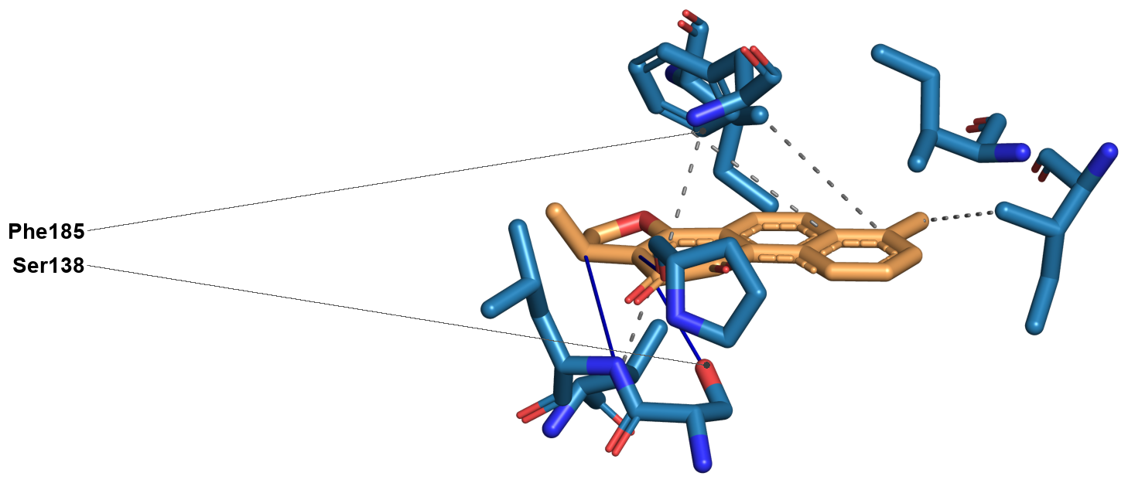
Figure S1. PLIP interaction diagram for the dihydrotanshinone I top pose in 9PFL. Orange, ligand; blue, interacting protein residues. PLIP draws hydrogen bonds as solid blue lines, hydrophobic contacts as grey dashed lines, and pi-stacking as green dashed lines. Leader lines mark, for each labelled residue, the visible side-chain heavy atom nearest the ligand. Ser138 and Phe185 are labelled as the flagged residues PLIP identifies as interactions in this structure, Ser138 through a side-chain hydrogen bond and Phe185 through two hydrophobic contacts; PLIP detects no pi-stacking for the ligand in 9PFL. Tyr151 lies within 4 Angstrom of the ligand by the distance scan reported in Table 5 but does not meet PLIP's geometric criteria for a formal interaction, and is therefore not labelled here.
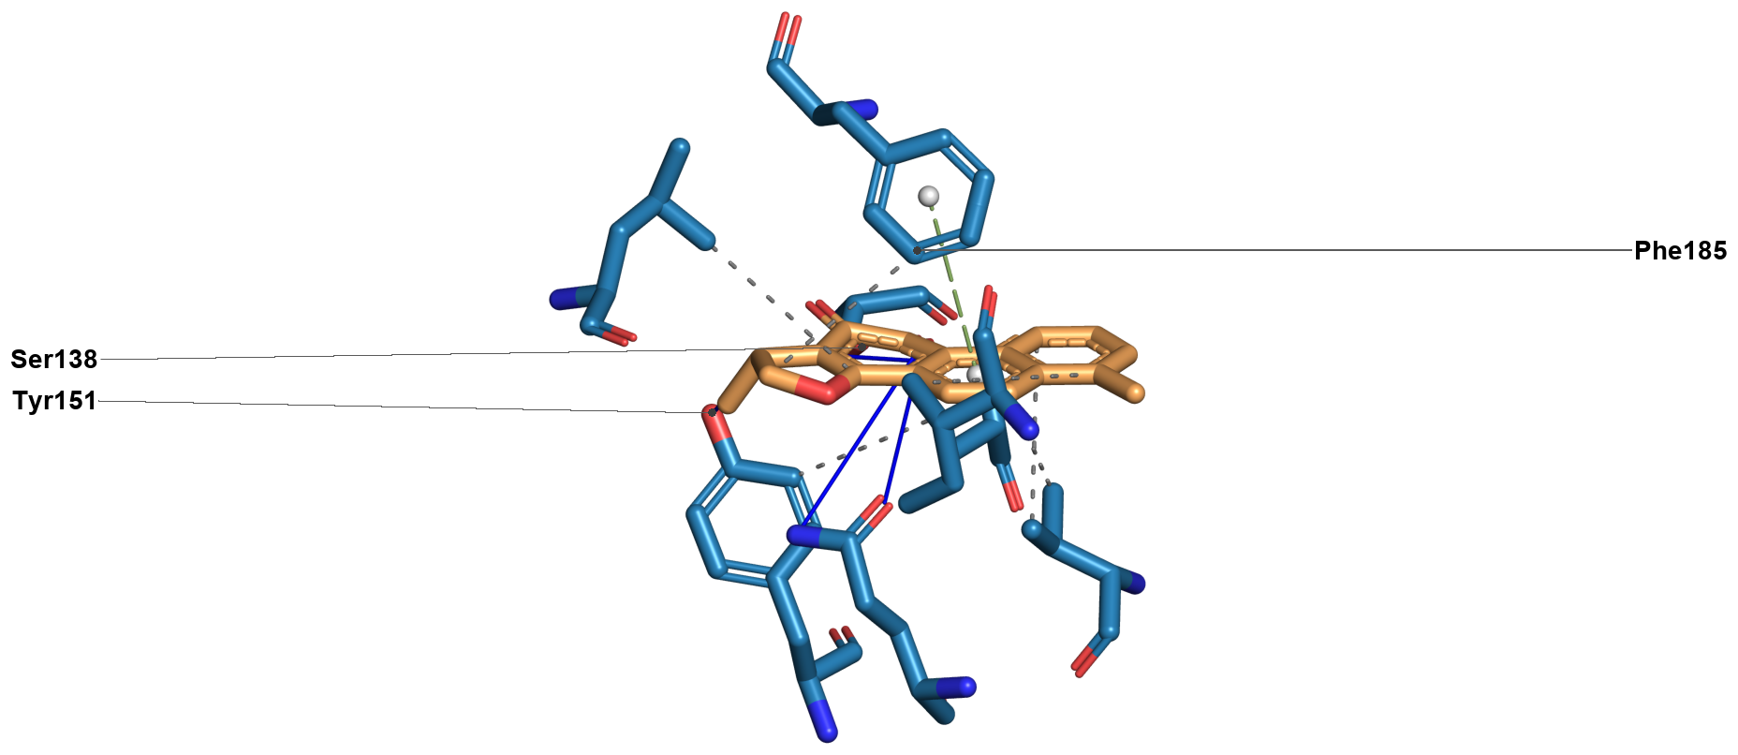
Figure S2. PLIP interaction diagram for the dihydrotanshinone I top pose in 9PFM. Orange, ligand; blue, interacting protein residues. PLIP draws hydrogen bonds as solid blue lines, hydrophobic contacts as grey dashed lines, and pi-stacking as green dashed lines. Leader lines mark, for each labelled residue, the visible side-chain heavy atom nearest the ligand. Ser138, Tyr151, and Phe185 are labelled: Ser138 through side-chain hydrogen bonds, Tyr151 through both a hydrophobic contact and a hydrogen bond, and Phe185 through a hydrophobic contact and T-shaped pi-stacking.
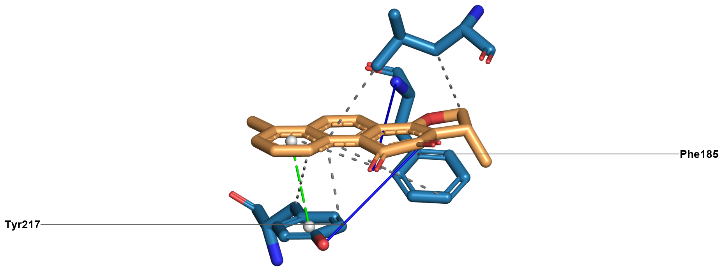
Figure S3. PLIP interaction diagram for the dihydrotanshinone I top pose in 8CVN. Orange, ligand; blue, interacting protein residues. PLIP draws hydrogen bonds as solid blue lines, hydrophobic contacts as grey dashed lines, and pi-stacking as green dashed lines. Leader lines mark, for each labelled residue, the visible side-chain heavy atom nearest the ligand. Phe185 and Tyr217 are labelled: Phe185 through two hydrophobic contacts and a backbone hydrogen bond, and Tyr217 through two hydrophobic contacts, a side-chain hydrogen bond and parallel pi-stacking. Ser138 and Tyr151 are not contacted in this conformation.
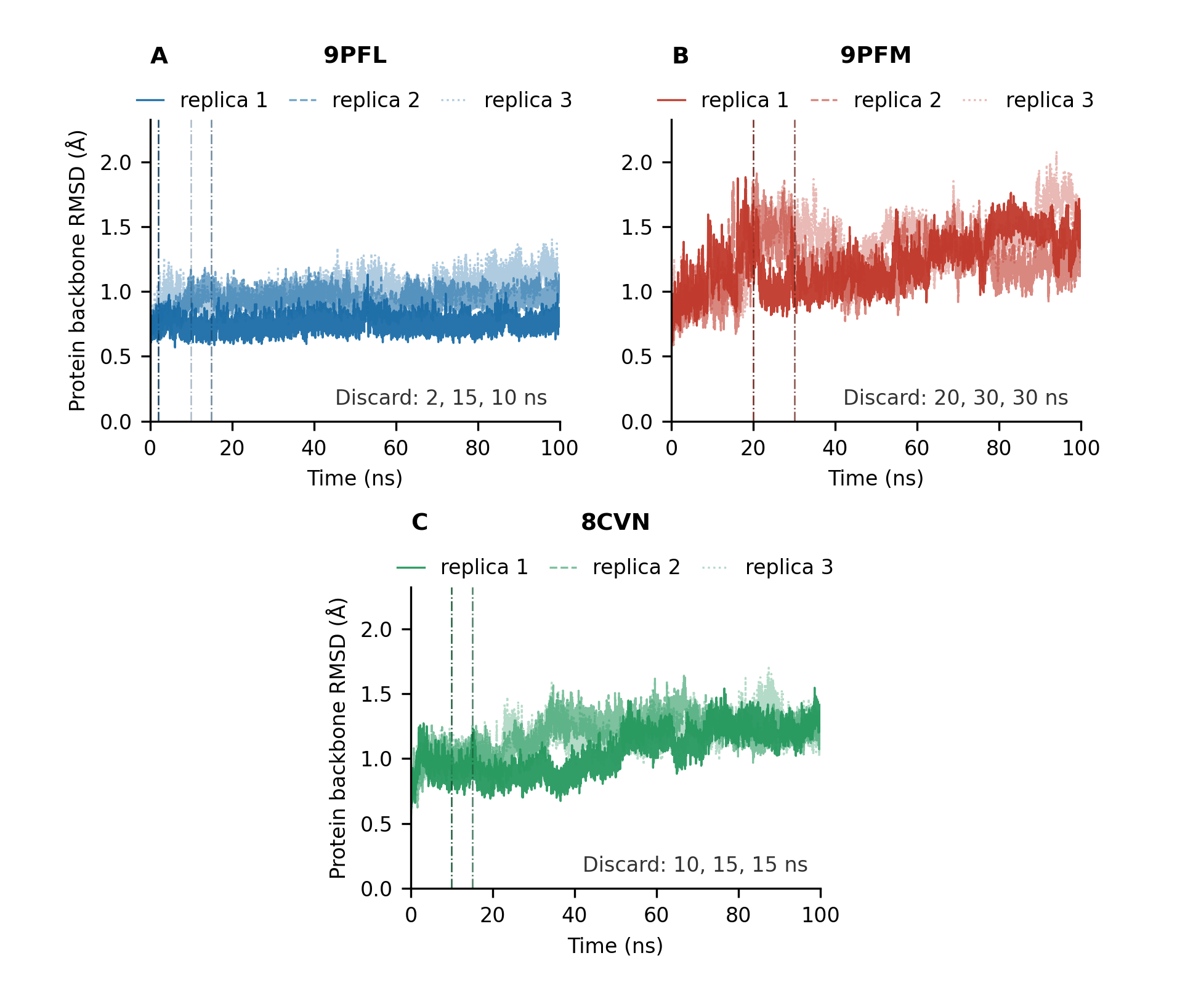
Figure S4. Protein backbone root-mean-square deviation over the production run for all nine trajectories, arranged as three panels of three replicas, one panel per system, with replicas 1 to 3 drawn solid, dashed and dotted. These are the traces from which the equilibration discard windows in Table S9 were determined; the dash-dot vertical lines mark each replica’s discard point, and the values printed in each panel are given in the order replica 1, replica 2, replica 3. The 9PFM panel shows the continued drift beyond the chosen discard point that is noted there, in all three of its replicas.
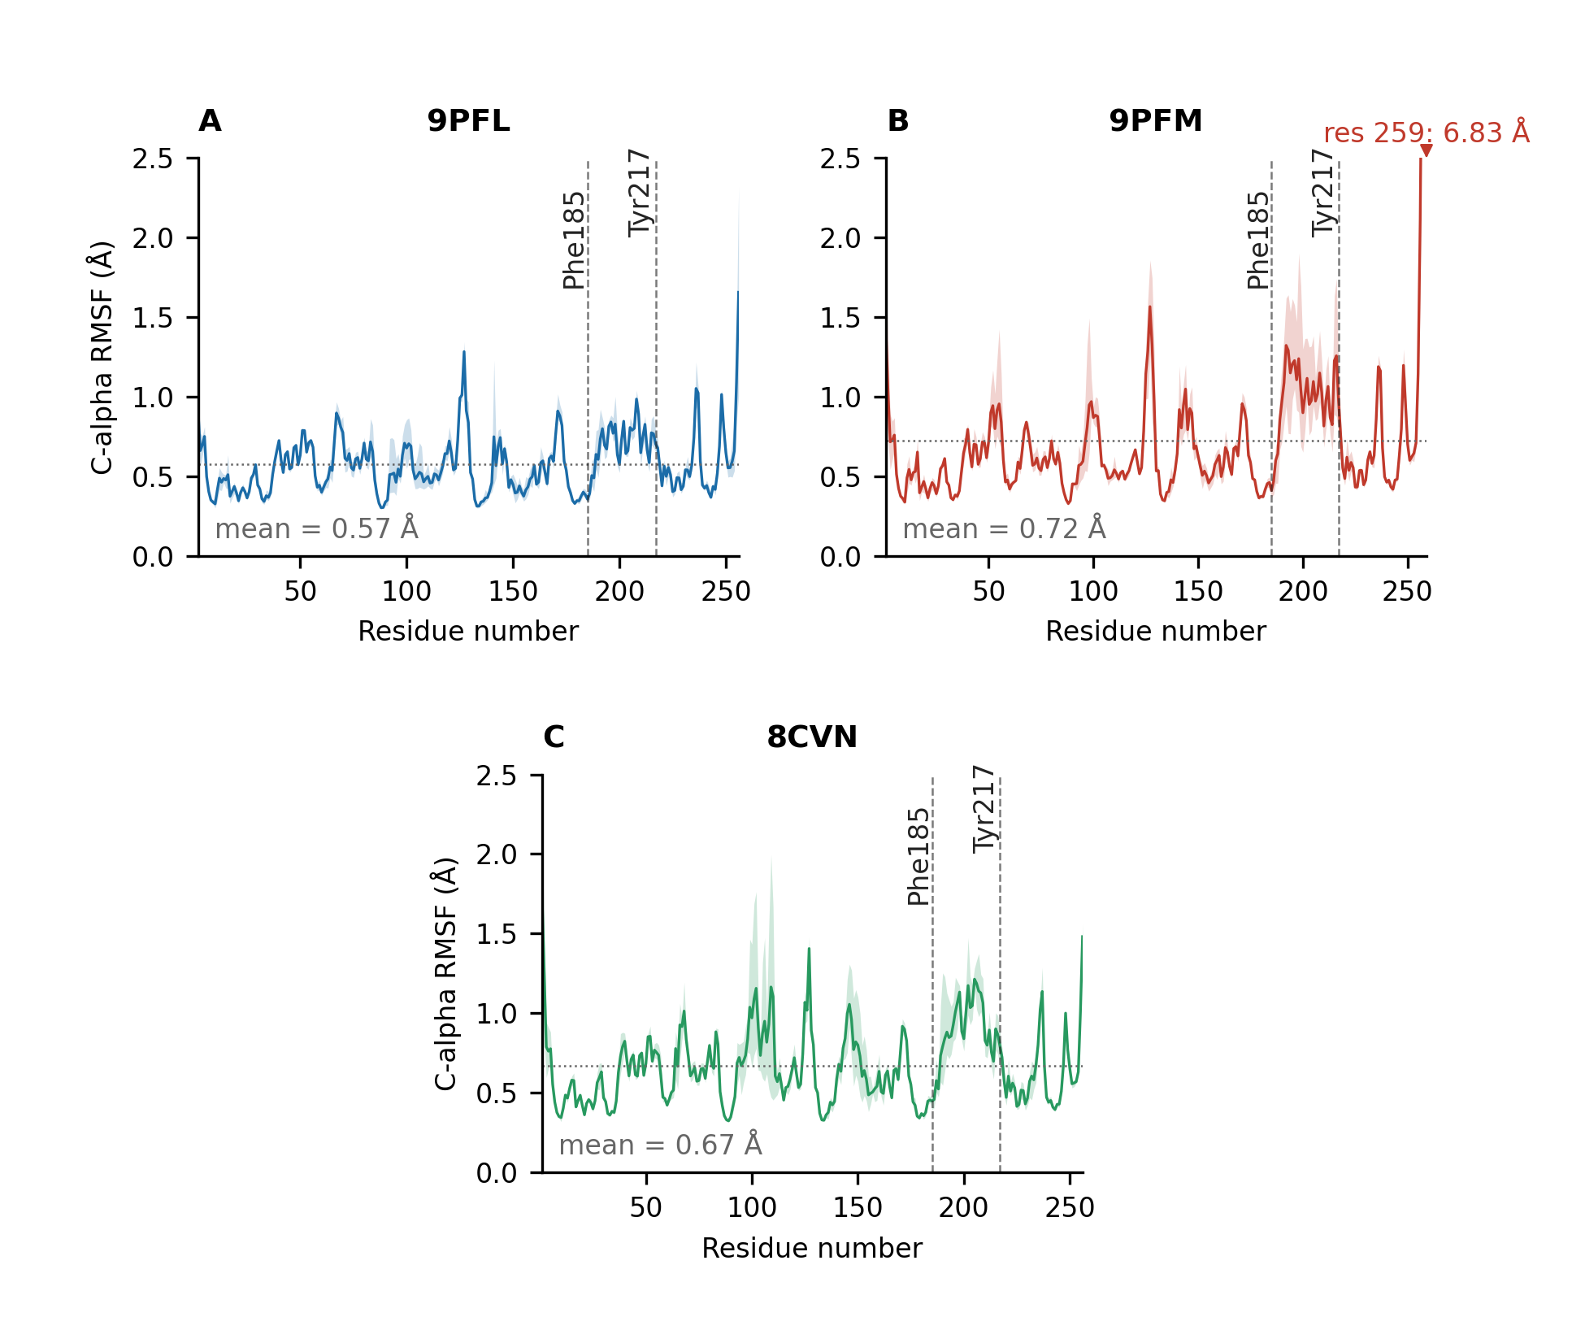
Figure S5. Per-residue root-mean-square fluctuation for each system, shown as the mean across the three replicas with the shaded band giving the range across them, with the protein-wide mean marked as a horizontal dotted line and the positions of Phe185 and Tyr217 indicated by vertical dashed lines. The vertical axis is capped at 2.5 Angstrom; the 9PFM chain-terminal peak at residue 259 exceeds this and is annotated with its true value. The profile places the two lid residues in the context of the whole chain: Phe185 sits below the protein mean in every trajectory and Tyr217 above it, as tabulated in Table S12.

