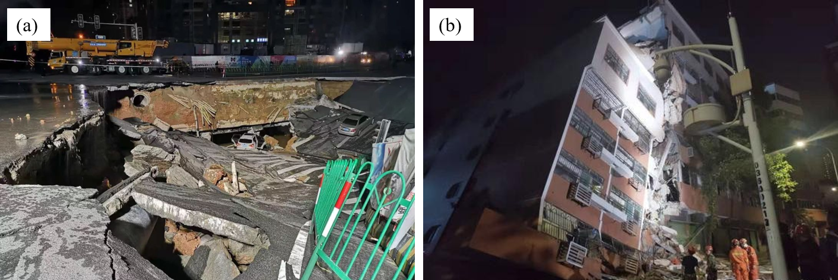
Figure 1 Ground and building collapse caused by tunnel excavation: (a) ground subsidence; (b) inclination deformation of adjacent structures.
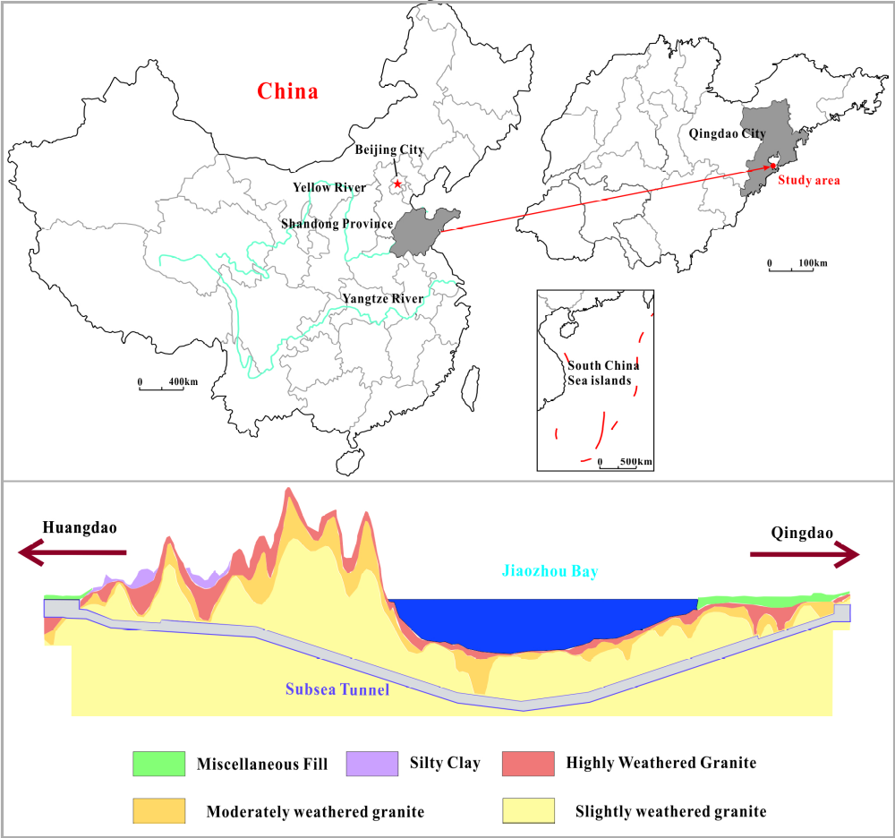
Figure 2 Geographical location and strata crossed by the Qingdao Jiaozhou Bay Subsea Tunnel.

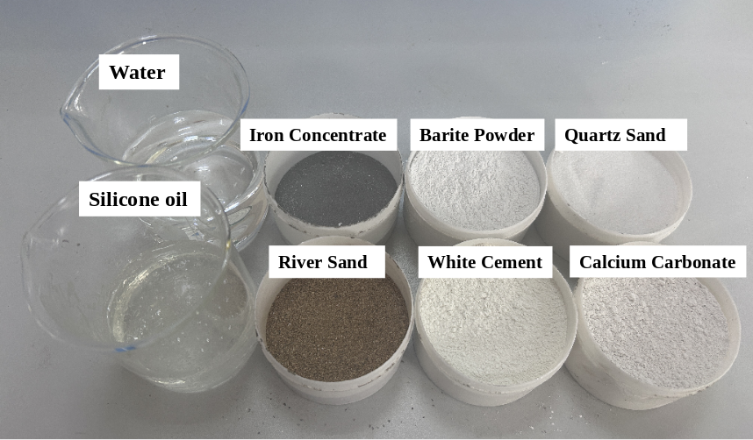
Figure 3 Components of the similarmaterial.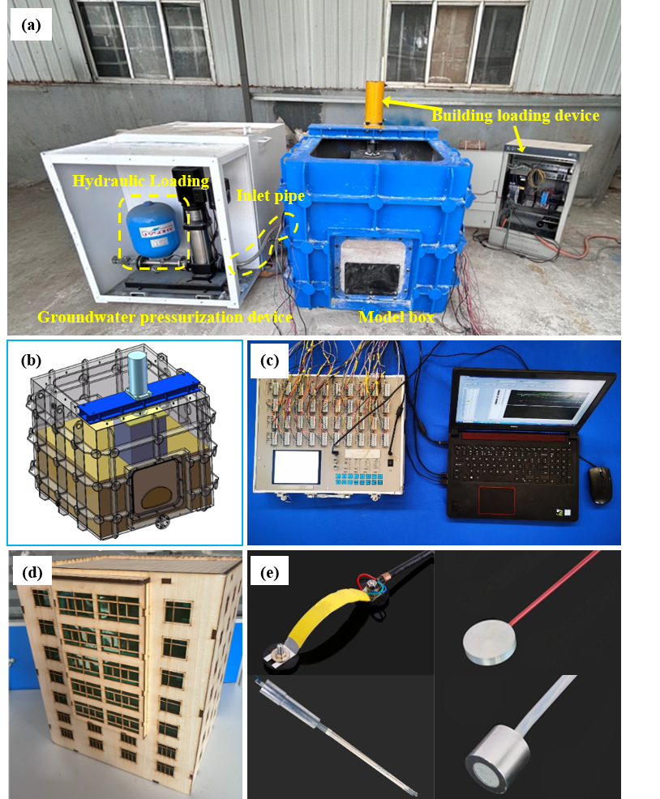
Figure 4 Geomechanical model test system: (a) model test system; (b) layout of the model box and stress-loading device; (c) data-acquisition system; (d) surface-building model; (e) sensors used in the model test.
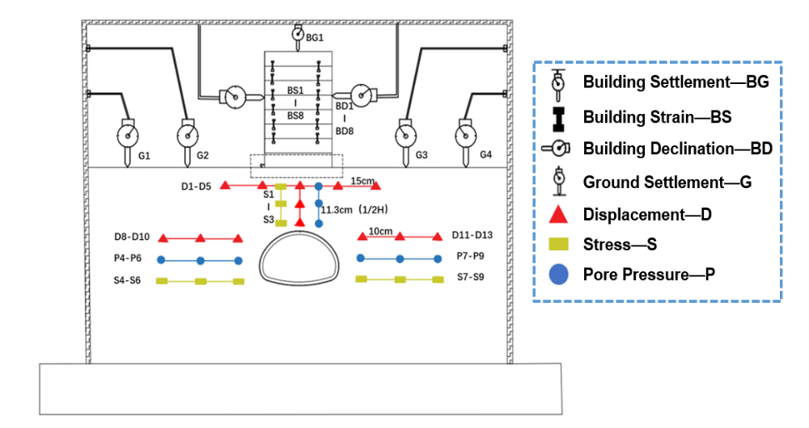
Figure 5 Layout of monitoring points in the geomechanical model test.
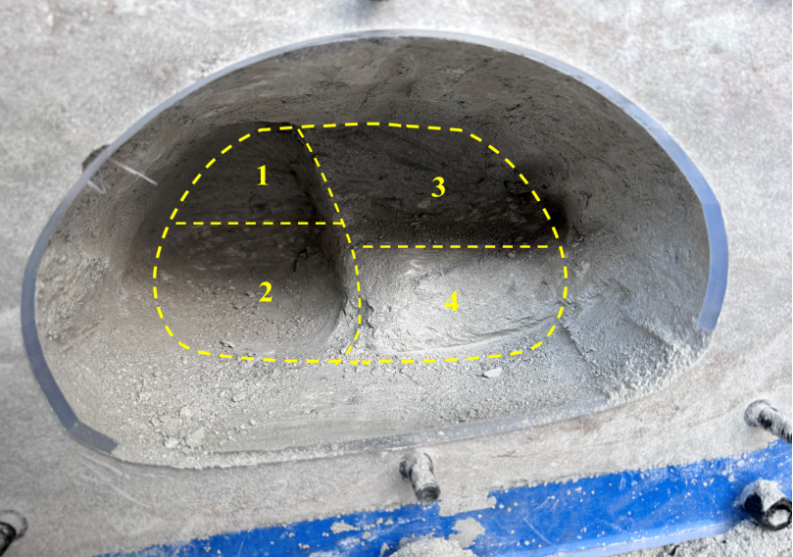
Figure 6 Simulated excavation sequence using the central diaphragm method.
Figure 7 Evolution of vertical displacement around the tunnel: (a) monitoring points at the tunnel crown; (b) monitoring points at the left springline; (c) monitoring points at the right springline.
Figure 8 Evolution of stress in the tunnel surrounding rock: (a) monitoring points at the tunnel crown; (b) monitoring points at the tunnel springline.
Figure 9 Evolution of seepage pressure in the surrounding rock.
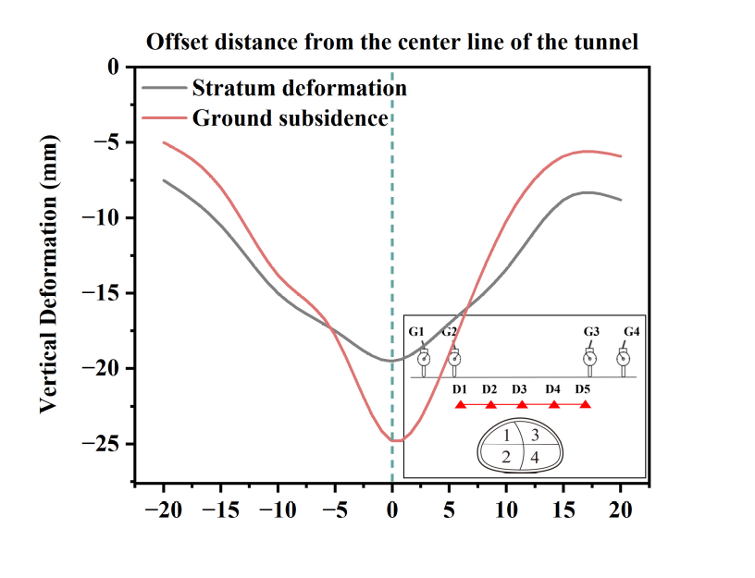
Figure 10 Ground-surface settlement-trough curves and stratum deformation.

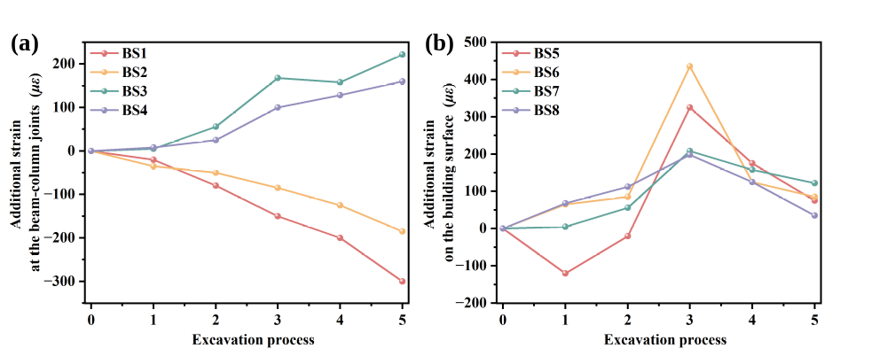
Figure 11 Strain evolution of the frame structure: (a) additional strain at the beam-column joints on the ground floor; (b) additional strain on the building surface.
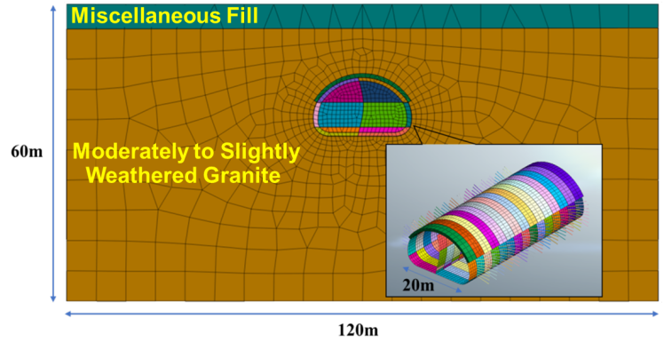
Figure 12 Schematic diagram of the numerical model.
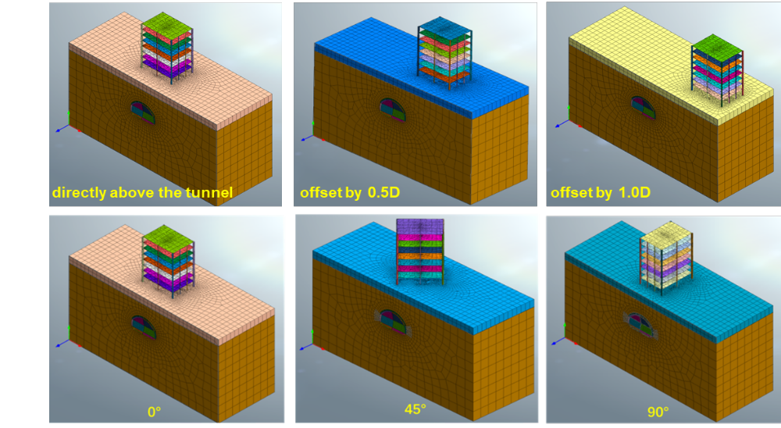
Figure 13 Relative position of the tunnel and the building.
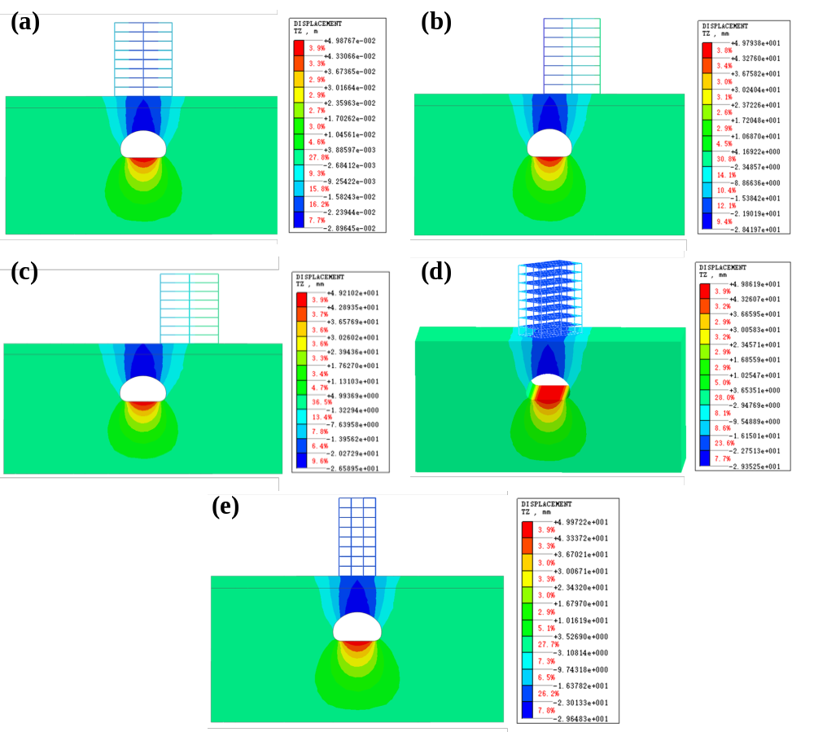
Figure 14 Contours of overall vertical displacement under different cases: (a) Case 1; (b) Case 2; (c) Case 3; (d) Case 4; (e) Case 5.
Figure 15 Comparison of deformation patterns under different cases: (a) crown displacement; (b) ground-surface settlement.
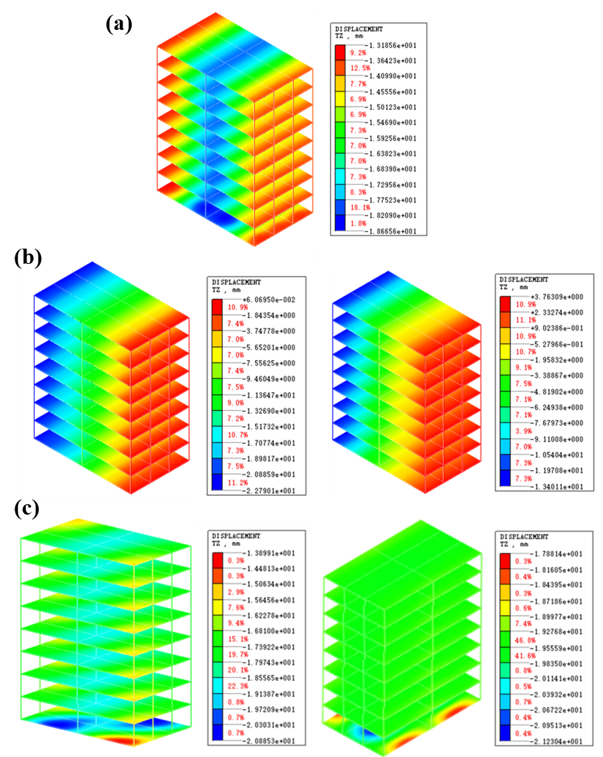
Figure 16 Structural settlement under different working conditions: (a) settlement of the structure directly above the tunnel; (b) settlement of the second and third structures at different tunnel-offset positions; (c) structural settlement at different tunnel-excavation angles.

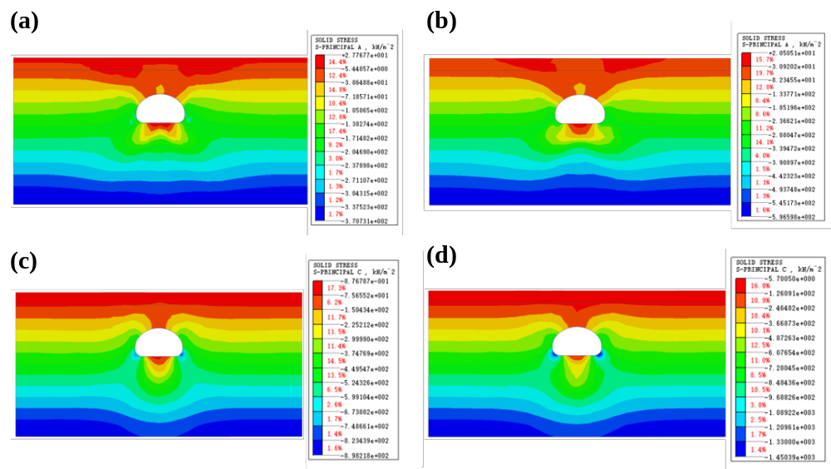
Figure 17 Principal-stress contours of the surrounding rock: (a) first principal stress before fluid-solid coupling; (b) first principal stress after fluid-solid coupling; (c) third principal stress before fluid-solid coupling; (d) third principal stress after fluid-solid coupling.

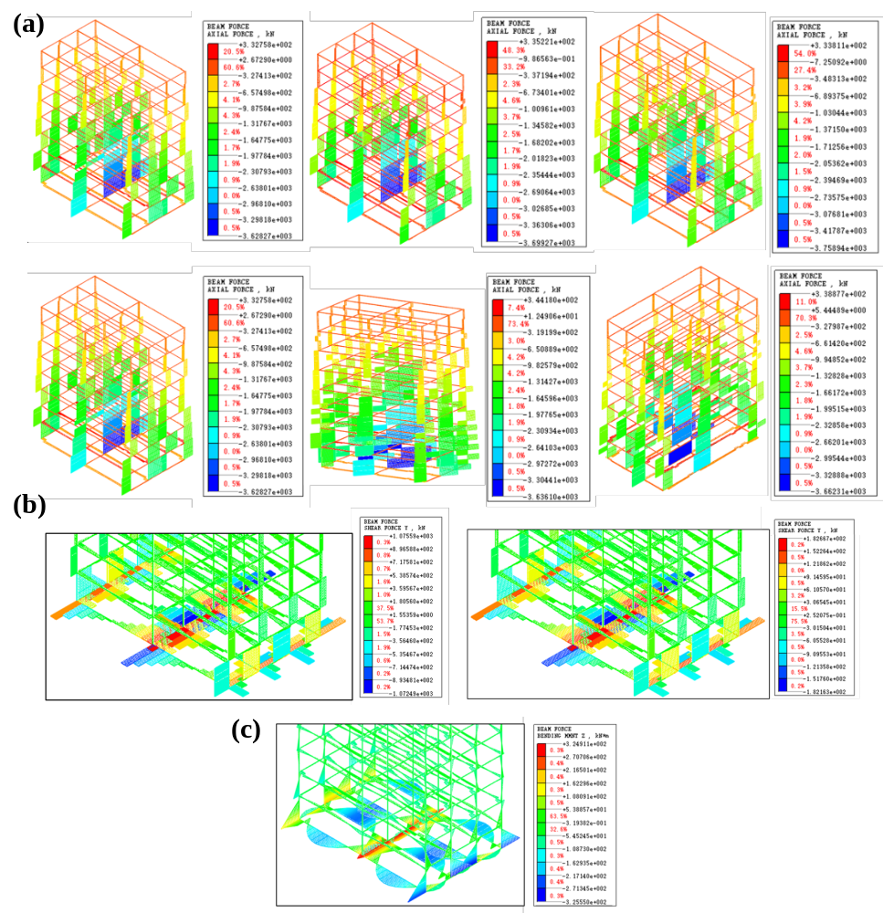
Figure 18 Structural internal-force diagrams under different working conditions: (a) axial force at different tunnel-offset positions beneath the building; (b) axial force for the tunnel passing beneath the building at different angles; (c) shear force of the building foundation before and after tunnel excavation.
.

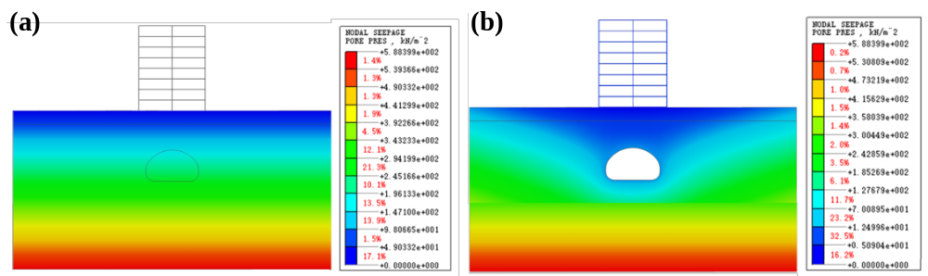
Figure 19 Distribution of pore water pressure in the surrounding rock: (a) before tunnel excavation; (b) after tunnel excavation.
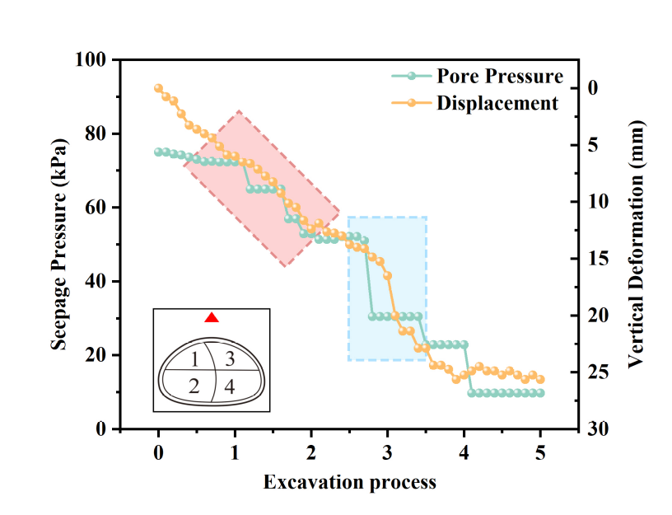
Figure 20 Comparison of seepage-pressure and displacement curves at the crown monitoring points.

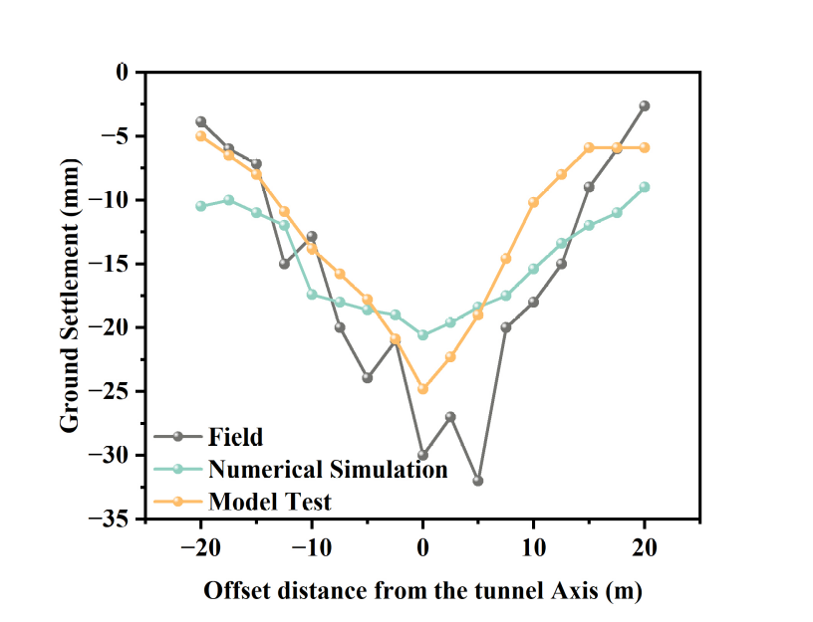
Figure 21 Comparison of surface settlement.
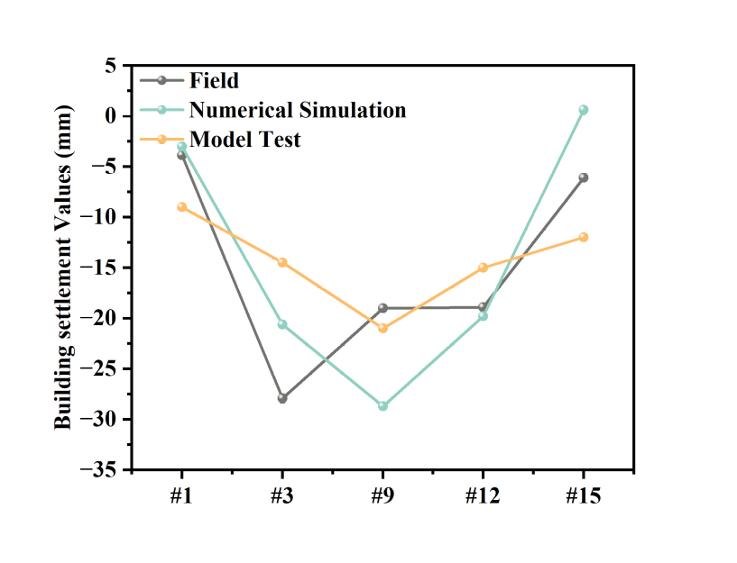
Figure 22 Settlement and layout of monitoring points for the overlying-building section.

