Supplementary File
Impact of Climate Change and Anthropogenic Stresses on the Spatio-Temporal Variability of River-Aquifer Exchanges

Table of Contents

1 Introduction 2
2 Groundwater flow in saturated media 3
3 Groundwater modelling 4
3.1 Discretization 6
3.2 Setting Boundaries 7
3.3 Recharge and Evapotranspiration (ET) 8
3.4 Rivers and Drains 8
3.5 Model Conceptualization 10
3.5.1 Geology 10
3.5.2 Aquifer properties 11
3.5.3 Groundwater extraction 12
3.5.4 Conceptual Model 14
3.6 Translation to Numerical Model 15
3.7 Calibration of groundwater model 17
4 Reference 21
5 Appendix A. Fitted Aquifer properties by pilot point method. 25
6 Appendix B. Calibrated River bed conductivities with PSO 29

Introduction
In this study, an integrated surface water – groundwater model has been used to simulate the climate and anthropogenic feedbacks on river aquifer exchanges. The hydrological modeling utilizes the Soil and Water Assessment Tool (SWAT) to simulate key hydrological processes, including overland flow, river flow, and groundwater fluxes. SWAT's ability to handle diverse land uses and climatic conditions makes it suitable for understanding watershed dynamics. The model operates through a well-defined input-output (I/O) structure and is calibrated using the Sequential Uncertainty Fitting algorithm (SUFI2) to reduce uncertainty and improve the accuracy of predictions. A three-dimensional groundwater flow equation is solved using the Finite Difference Method (FDM) with MODFLOW in GMS software for groundwater modeling. This approach captures the complexity of subsurface flow, accounting for heterogeneity in aquifer properties and interactions with surface water. The model's calibration is performed using a combined method using the Parameter ESTimation (PEST) tool for aquifer parameters and Particle Swarm Optimization (PSO) for stream bed conductivity, which helps fine-tune the parameters to achieve a better fit between observed and simulated data, thereby enhancing the model's reliability.
To complement these models, machine learning techniques, including Random Forest Regressor (RFR), Artificial Neural Networks (ANN), and Long Short-Term Memory (LSTM) networks, are integrated based on the application and relative accuracy achieved. These Machine learning (ML) models have been used for performing downscaling of climate variables (Temperature and Precipitation for four IPCC CMIP6 Scenarios i.e., SSP126, SSP245, SSP370, and SSP585) for climate change impact assessment in the Varuna River Basin (VRB). These ML models have also been used to predict hydrogeological variables (such as stage-discharge relationship, inlet discharges in the SWAT model, and groundwater heads at boundary cells) to build the forecasting MODFLOW model.
Here, we discuss the detailed GW modeling approach employed in VRB and its integration into the SWAT model outputs. Readers are advised to refer Kumar et al., (2024) for detailed SWAT modeling of VRB. The model used in the study is based on SSP245, which assumes the middle pathway between “green” and worst scenarios. The authors assume that this scenario represents the status quo, and the methodology can also be expanded for other climate scenarios.

Groundwater flow in saturated media

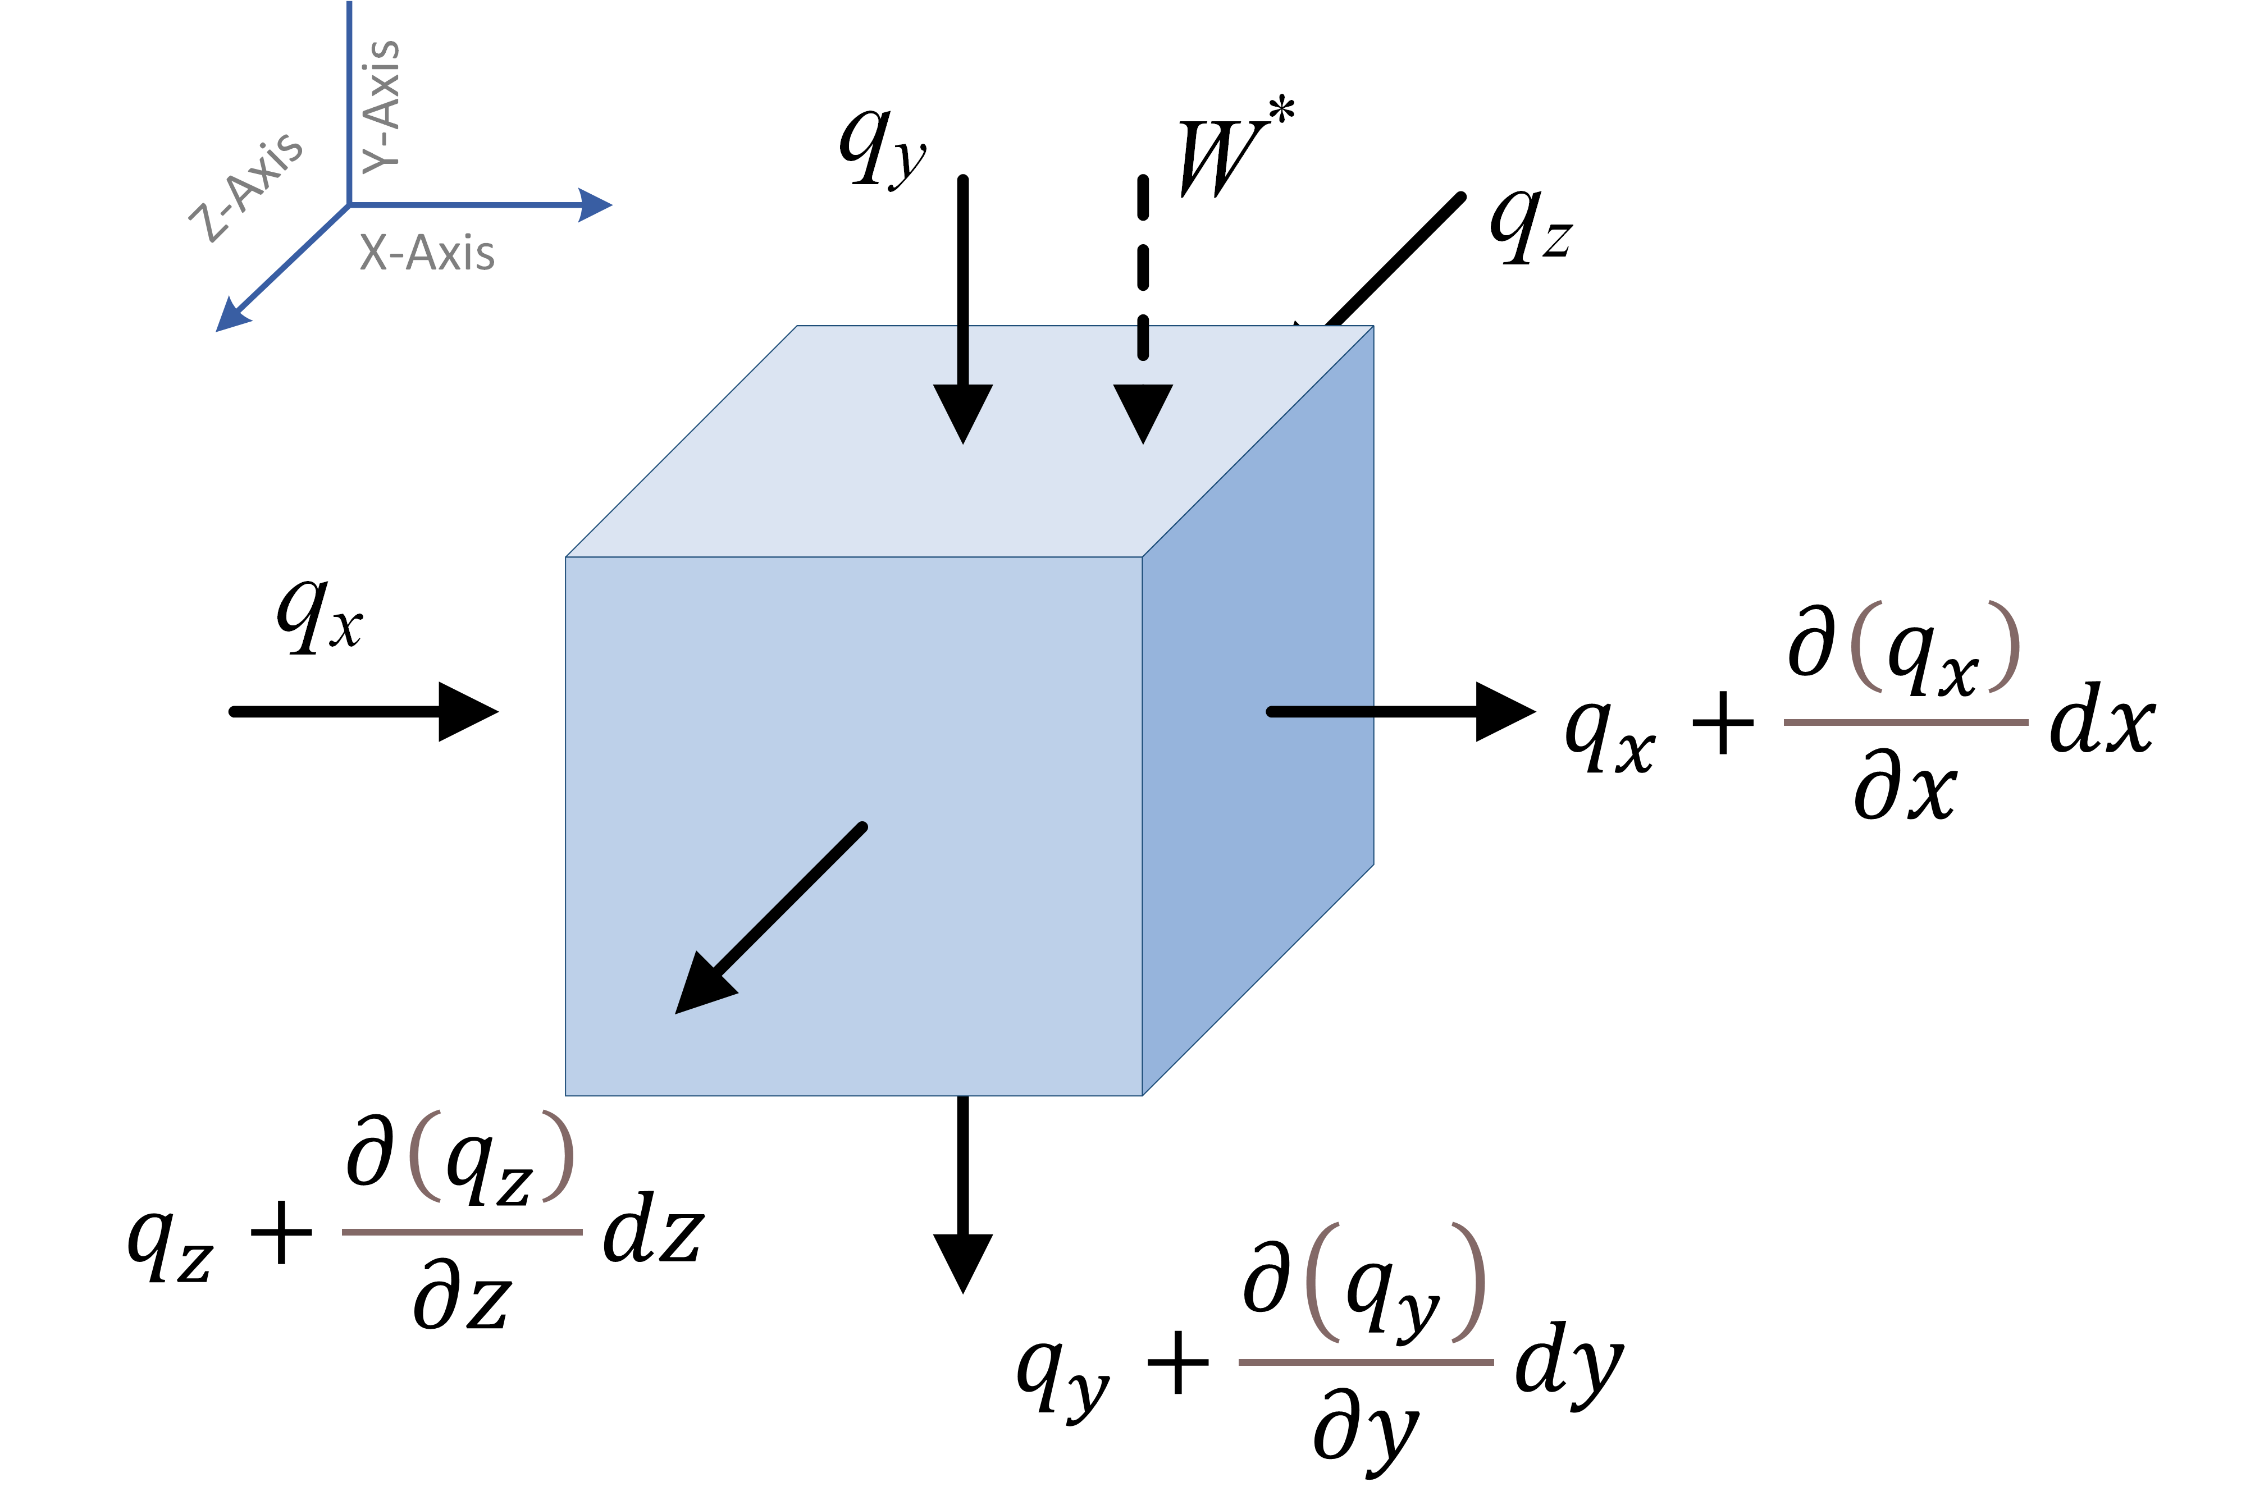
Figure 2.1. Representative elementary control volume of aquifer media

Groundwater flows through porous aquifer media under a variable hydraulic gradient and is generally described by Darcy’s Law (Darcy, 1856) for a constant density flow:
 | $$q=-K∇h=-\left[\begin{matrix}K_{xx} & K_{xy} & K_{xz} \\ K_{yx} & K_{yy} & K_{yz} \\ K_{zx} & K_{zy} & K_{zz}\end{matrix}\right]∇h$$ | 2.4
Where q is the specific discharge vector (LT⁻¹) and is given as:
 | $$q=\left[\begin{matrix}q_{x} & q_{y} & q_{z}\end{matrix}\right]$$ | 2.5
K is the hydraulic conductivity tensor (LT⁻¹); K_{xx}, K_{yy}, and K_{zz} are the hydraulic conductivity along major principal axes x, y and z, respectively; h is the groundwater head (L); and $∇h$ is the head gradient vector given as:
 | $$∇h={\left[\begin{matrix}\frac{∂h}{∂x} & \frac{∂h}{∂y} & \frac{∂h}{∂z}\end{matrix}\right]}^{'}$$ | 2.6
Considering an elementary control volume of the aquifer media (Figure 2.1), applying water mass balance yields the governing equation for transient flow through a porous heterogenous medium (Anderson et al., 2015):
 | $$\frac{∂q_{x}}{∂x}+\frac{∂q_{y}}{∂y}+\frac{∂q_{z}}{∂z}-W^{*}=-S_{s}\frac{∂h}{∂t}$$ | 2.4
Where, q_{x}, q_{y} and q_{z} are specific flux along x, y and z axis (LT⁻¹); Ss is the specific storage (L⁻¹), W* is the source or sink term depending upon the direction of flow (i.e. flow into or out of the system) (T⁻¹); and t is the time (T).

Groundwater modelling
Modeling groundwater dynamics in an area is crucial for assessing hydrogeological variables and understanding their response to climatic and anthropogenic disturbances (Anderson et al., 2015). Groundwater models, such as MODFLOW, employ numerical methods like the finite difference method (FDM) to solve groundwater flow equations, enabling the simulation of complex groundwater systems (Fetter, 2001). These models are widely used for water resource management, predicting the impact of human activities (e.g., pumping, irrigation)(Hodges, 2019; Leng et al., 2014; Pokhrel et al., 2015; Wada et al., 2017), assessing groundwater availability (Menció and Mas-Pla, 2008; Omar et al., 2020; Schwartz and Ibaraki, 2011), managing contamination (Clement et al., 1998; Mustafa et al., 2016; Panday and Huyakorn, 2008; Prommer et al., 2003; Simon et al., 2015), and evaluating the effects of climate change on groundwater resources (Ali et al., 2020; Atawneh et al., 2021; Vergnes et al., 2023). By simulating various scenarios, groundwater models provide critical insights for sustainable management and decision-making in environmental and hydrological studies (Anderson et al., 2015).

Unlike analytical solutions and the analytic element method (AEM), numerical models use an approximate version of the governing equation (Eq 2.4) to compute hydraulic heads at specified locations. Numerical solutions are not continuous throughout space or time; instead, the head is computed at discrete spatial positions (called nodes) and for specific time intervals (called time steps). However, numerical models can solve the whole transient, three-dimensional, heterogeneous, and anisotropic governing equation (Eq 2.4) with complex boundary and starting conditions (Anderson et al., 2015; Fetter, 2001). This makes the numerical method widely applicable, especially in the case of modelling a complex groundwater system such as a highly heterogeneous Gangetic alluvial plains (Das et al., 2021; Omar et al., 2020). The detailed concepts and applications of numerical models have been discussed by Anderson et al. (2015).
MODFLOW-NWT (Newton Formulation for MODFLOW)(Niswonger et al., 2011) is a robust version of the widely-used MODFLOW groundwater modelling software designed to handle complex, nonlinear groundwater flow problems. It incorporates a Newton-Raphson solver, making it particularly suitable for unconfined aquifers, where drying and rewetting of cells occur due to fluctuating water table levels (Langevin et al., 2021). This feature improves the model's stability and accuracy when simulating dynamic groundwater systems under varying hydrological conditions. MODFLOW-NWT is often used in applications that require modelling of surface-water/groundwater interactions (Feinstein et al., 2012; Sophocleous, 2002), highly heterogeneous aquifers (Kang-l, 2014; Ou et al., 2013), and challenging boundary conditions (Niswonger et al., 2011). Allowing the simulation of both steady-state and transient conditions provides valuable insights for water resource management, environmental assessments, and the prediction of groundwater responses to natural or anthropogenic changes.
Modeling with MODFLOW-NWT requires several steps, which eventually write the input files for the MODFLOW-NWT executable to be read. After defining the modeling purpose, the model conceptualization is performed. This step requires collecting all the important information and datasets to support the modeling objective. The data formats are generally classified as point, linear, or polygon datasets. The classification is related to the extent and uniqueness of data for the selected feature type. The general data used in modeling the groundwater flow system is summarized in Figure 2.2. The next step is to design the Groundwater model, translating the conceptual model into the numerical groundwater flow model. This step involves designing the grid (spatial discretization), setting boundary conditions, defining aquifer parameters (K, HANI, VANI, Ss, Sy), defining the hydrological stresses (pumping wells, Evapotranspiration), setting initial condition (starting head), and selecting time steps (temporal discretization). After mapping all the data to the MODFLOW grids, the model is run with an initial set of parameter values. Calibration is the most important step in modeling, and it helps reduce uncertainty related to data measurements and conceptualization (Anderson et al., 2015). The forecasting model requires forecasted data with arguably well-calibrated models (ML or statistical). The prediction for all the stresses and boundary conditions is required and has been performed using different sets of calibrated ML models in this study. It will be explained in the next section. The general modeling steps are illustrated in Figure 2.2, and the corresponding packages to define the stresses and boundary conditions are briefly explained below.

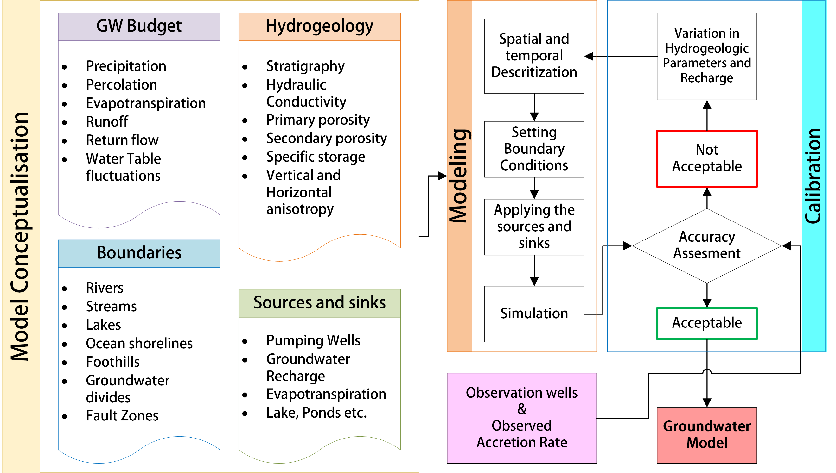
Figure 2.2. Groundwater modeling steps

Discretization
Discretization of space and time in the case of groundwater modeling refers to breaking down the continuous hydrogeological system (aquifer, river, drains, recharge areas, etc.) into grids of smaller cells and time steps, respectively. This facilitates the approximation of solutions to the complex equations governing groundwater flow. Discretization is an important step since the number of grid cells directly affects the accuracy of the simulated head (Anderson et al., 2015). The number of cells also affects the runtime and computational requirement as the large number of grid cells will require longer simulation time and large computational resources. The discretization in MODFLOW-NWT is defined by the structural discretization (DIS) package, and the cells are identified by their layer, row, and column position in the grid. The Discretization Packages contain information about cells, such as the cell top and bottom elevations and cell dimensions or areas (in plan view). The Discretization Packages also define cell connectivity. Cell connectivity describes how model cells are connected to one another and the geometric properties of the connections. For the DIS Package, cell connectivity is implicitly described by the grid structure, cell dimensions in the row and column directions, and cell top and cell bottom elevations.

Setting Boundaries
The boundary conditions in terms of groundwater flow models are generally subdivided into two types: 1. Perimeter boundary conditions and 2. Internal boundary conditions (Anderson et al., 2015). Boundary conditions that describe the hydraulic conditions at the edges of the model domain are known as perimeter boundary conditions. Additionally, groundwater flow models can include boundary conditions representing internal sources and sinks within the system, effectively functioning as internal boundary conditions. The perimeter boundary conditions in MODFLOW-NWT translate the physical groundwater boundaries, depending upon the flow behavior of groundwater across these boundaries. Three types of boundary conditions are generally defined;
- Specified Head Boundary (Dirichlet Conditions) where the head along the boundary is set at a known value. The boundary of large surface water bodies can act as specified head boundary (or constant head boundary (CHD) in MODFLOW-NWT) as their water level does not show major changes due to source and sinks for a given time step (Anderson et al., 2015).
- Specified flow boundary (SFB) (Neumann conditions) where the derivative of the head (i.e., q/K by Darcy’s law) at the boundary is specified. The no-flow boundary is the special case of this condition, where the specified flow is zero. The bottom boundary of most models is specified as a no-flow condition at contact with the bedrock, which is relatively impermeable. In MODFLOW-NWT, the Well packages (WEL or MNW2) and Recharge package (RCH) are specified flow boundaries.
- Head-dependent boundary (HDB) (Cauchy conditions) allows flow rates to depend on the difference between the head at the boundary and the head inside the model. These boundaries simulate dynamic interactions between the groundwater system and surface water bodies, such as rivers, lakes, or drains. The hydraulic head difference and the conductance of the boundary influence the amount of flow. In MODFLOW-NWT, Stream Packages (STR or SFR2) and River packages (RIV) are specified flow boundaries.

Recharge and Evapotranspiration (ET)
Sources and sinks in groundwater models refer to the flux from the external system, such as recharge, evapotranspiration, or groundwater extraction through pumping wells. The recharge due to the percolation of rainwater is a primary source of inflow into the aquifer, apart from the boundary flow coming from the upstream areas. The recharge amount primarily depends on the soil characteristics and land use types. However, the general topography of the area also influences the percolation rate of rainfall (Schiff, 1964). The MODFLOW-NWT recharges on the model's top layer or the topmost active cell, depending upon the modeler.
The Evapotranspiration (ET) Package simulates how water is removed from the groundwater system through plant transpiration and direct evaporation. It follows these key assumptions: (1) When the water table is at or above a certain level, known as the "ET surface", water is lost from the groundwater at a constant rate; (2) If the water table drops below a specified depth, called the "extinction depth" or "cutoff depth," evapotranspiration from the groundwater stops; and (3) Between these two limits, the rate of ET changes linearly based on the water table's depth. The ET surface is defined by the cell's top elevation and the extinction depth based on the plant root zones (Shah et al., 2007).

Rivers and Drains
Rivers act as sources and sinks in the groundwater flow system, while drains are exclusively modeled as sinks. The interaction of river and aquifer is termed river aquifer exchange (RAE), and this exchange can be spatially and temporally complex (Anderson et al., 2015). The RAE can be negative or positive based on the nature of the hydraulic gradient between the groundwater and river stage. The stream reach is called losing if the flow is strictly from the stream to the aquifer and the RAE is positive. The inverse of this phenomenon happens when the stream starts gaining water, and the RAE is negative. The gaining flux from the aquifer to the stream makes the baseflow of the river during the lean period when the contribution of runoff is low.
The rivers are generally modeled based on how they occupy the grid cell. The rivers that fully occupy the cell are simulated as specified head boundaries; however, most of the time, the modeled grid size is larger than the river width and depth. Therefore, the rivers are generally modeled using HDB conditions and conceptualized to be hydraulically connected to the aquifer but do not physically occupy space within the grid. The exchange of water occurs through the stream bed, and the exchanges from the banks are neglected. Several packages are available in MODFLOW-NWT to model rivers (such as River Package (RIV), Stream Package (STR), and Stream Flow Routing Package (SFR2) (Niswonger and Prudic, 2010)). Based on the river characteristics, we have utilized the RIV and SFR2 packages.
- RIV Package: The River (RIV) Package in MODFLOW simulates the interaction between a river and the groundwater system. This package models rivers as head-dependent boundaries, where the flow between the river and the aquifer (Q_{GW}) depends on the difference in hydraulic head between the river stage (h_{s}) and the groundwater table (h_{i,j,k}), as well as the conductance of the riverbed (C).
 | $$Q_{GW}=-K_{rz}\frac{h_{i,j,k}-h_{s}}{b_{r}}LW=C(h_{i,j,k}-h_{s})$$ | 3.1
Where K_{rz} is the hydraulic conductivity of the river bed, b_{r} is river bed thickness, L is the reach length, and W is the width within the grid cell. The inputs for the RIV package include the river stages, river bottom elevation, and river bed conductance.

- SFR2 package: The Streamflow-Routing (SFR2) in MODFLOW-NWT simulates the interaction between surface water (streams, rivers) and groundwater, as well as routing streamflow through a network of surface-water channels. The package replaces the older STR package and offers several improvements, including more flexible options for calculating stream depth and streambed conductance. The river cross-section is defined by an eight-point (Figure 3.2) or a wide rectangular channel as required.
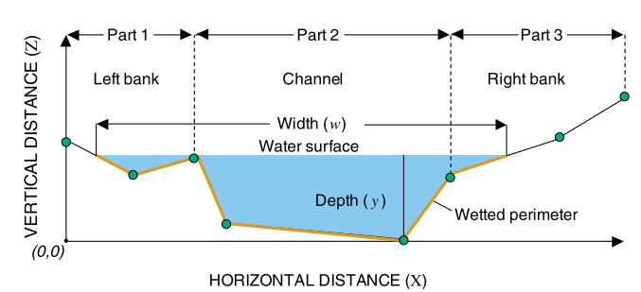
Figure 3.2. An eight-point cross-section is used to compute the depth, width, and wetted perimeter for a stream segment (Prudic et al., 2004)

The SFR2 package solves flow using a continuity equation, assuming steady, uniform flow over discrete time periods. It can simulate flow in streams under varying conditions, allowing for inputs like runoff, precipitation, and evapotranspiration to influence the streamflow within each reach. The package provides multiple methods for calculating stream depth, including Manning’s equation and empirical depth-discharge relationships, making it highly adaptable for different stream types. Additionally, it handles solute transport, tracking the movement of contaminants between the stream and aquifer. The SFR1 package is particularly useful for modeling long-term stream-aquifer interactions and the transport of solutes, making it a valuable tool in managing water resources and studying environmental impacts.

Model Conceptualization
The groundwater for the VRB has been modeled with MODFLOW-NWT using the conceptual model approach in GMS (Aquaveo). The modeling steps and data have been summarized below.

Geology
The VRB is characterized by quaternary older alluvium. The occurrence of newer alluvium is limited near Varanasi and along the Ganga River. According to the lithology, the older alluvium consists of Silty Sand, Clayey Silt, or Clayey Sand. The occurrence of calcrete (locally called Kanker) is also visible in different river reaches in the Varuna River.
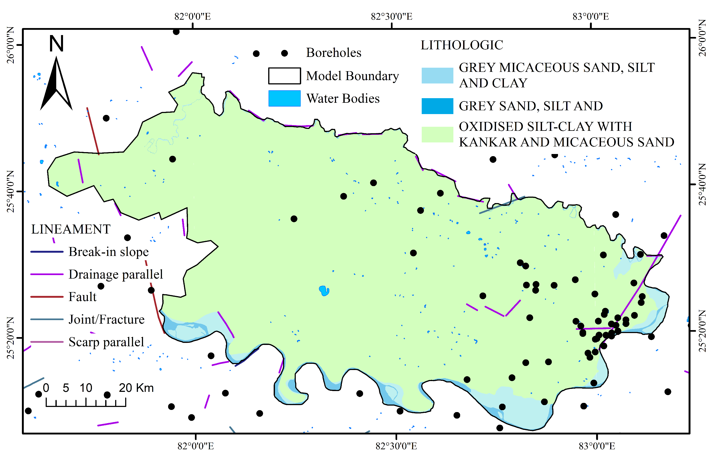
Figure 3.3. Lithological characterization of the modeled area

The alluvial deposits of the early to middle Pleistocene period, which were deposited by the Gangetic River system, underlie the Doab between the Ganga and Gomati rivers. Near the Ganga floodplain, newer Holocene alluvium has been deposited on the weathered basement of the Upper Vindhyan formation, consisting of sand, silt, clay, and calcrete in varying proportions. Similarly, the right side of the Ganga River is underlain by Quaternary alluvium up to the foothills of the northern Vindhyan plateau (GSI). The Kaimur sandstone/quartzite of the upper Vindhyan formation can be found in masses and isolated hillocks in the southern part of the River Ganga.

Aquifer properties
The groundwater occurs in the pore spaces of unconsolidated alluvial sediments. Shallow aquifers contain groundwater under water table conditions, while deeper aquifers contain groundwater under semi-confined to confined conditions. Four aquifer groups have been mapped with the borehole drilling data Figure 3.4. Additional layers in between these conductive aquifers have been added (based on the borehole logs and some interpolation) to add a leaky aquitard layer and to represent the vertical discretization in MODFLOW.
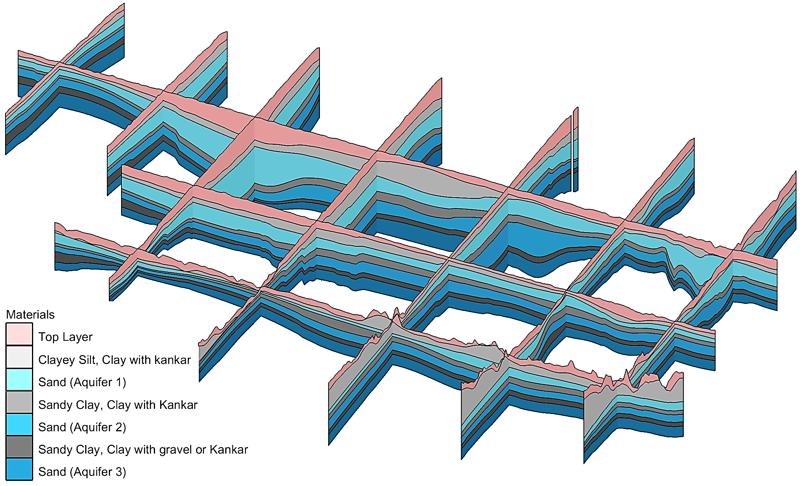
Figure 3.4. Lithological fence diagram of the modeled area

The top unconfined alluvium layer, which extends from 7.3 meters to 149.9 meters below ground level, generally consists of silty sand with kankar and has lower hydraulic conductivity. The clayey aquitard layers, with thickness varying from 4 meters to 114 meters, separate the aquifers. The aquifers are heterogeneous and have frequent occurrence of clay facies. Data from the NAQUIM report on the pumping test at around 30 sites suggests an average hydraulic conductivity (Kh) of 130.7 m/day, 128.4 m/day, and 152.8 m/day for the 2nd, 3rd, and 4th aquifer, respectively. The minimum HK value was as low as 1.08 m/day to as high as 1635.25 m/day, which manifests the high heterogeneity of the aquifer. The data of 18 test sites manifests average specific storage (Ss) of 0.00073, 0.00143, and 0.00166 for the 2nd, 3rd, and 4th aquifer, respectively. The minimum Ss is found to be 4.15 * 10⁻⁸ and the maximum of 0.0219.

Groundwater extraction
Groundwater extraction is a major contributor to the groundwater budget and needs accurate estimations, especially in areas where the pumping is not monitored (Meza-Gastelum et al., 2022). To tackle data scarcity, the consumptive use method was used in this study, combining crop water and industrial and domestic demands. Agricultural demand was calculated based on the total irrigated area and crop requirements. The domestic demands have been calculated based on the population and per capita demand based on the report of the groundwater resource estimation committee (Ministry of Water Resource, India). By integrating all demands, the total groundwater extraction from an area is given as:
 | $$Q_{i,t}=\left[\sum_{j}^{n}{{CF}_{j}{ IR}_{j,t}}\right]×TCA_{i}×δ_{t}+GW_{p,i}×{TP}_{i,t}+GW_{IN,i}$$ | 3.2
 | $$IR_{j,t}=Cu_{j,t}-R_{eff,t}$$ | 3.3
 | $$CF_{j}=\frac{Crop Area}{TCA_{i}}$$ | 3.4
Where Q_{i,t} is the total water extraction for an area i at time step t ; CF_{j} is the crop factor of crop type j within the area i; IR_{i,t} is the irrigation requirement of crop j at time t; TCA_{i} is the total cultivated area for i ; δ is the coefficient of irrigational dependency on groundwater at time t; GW_{p,i} is the per capita groundwater demand, TP_{i,t} is the total population for the area i during time step t; GW_{IN,i} is the industrial demand in area i; Cu_{j,t} is the consumptive use of the crop j at time t; and R_{eff,t} is the effective rainfall in the area at time step t.
The groundwater extraction in MODFLOW-NWT forms a specified flow boundary condition and is managed by the WELL or MNW2 package (Leonard F.Konikow, George Z. Hornberger, Keith J. Halford, 2009). The WELL package simulates the well in the given cell without any criteria of aquifer yield or well losses. The MNW2 package simulates the wells by incorporating the head loss due to well characteristics and aquifer formation. This results in more accurate head estimation in cells with respect to the standard WELL package. As Wells in MODFLOW are simulated as a specified flow boundary, the aquifer only interacts through Wells in terms of flow exchange. For an area with a large number of extraction wells, using MNW2 is not a good strategy since it will create additional complexities, resulting in larger computational time (Anderson et al., 2015). Therefore, the WELL package was used for groundwater extraction, and MNW2 was used to simulate injection wells.
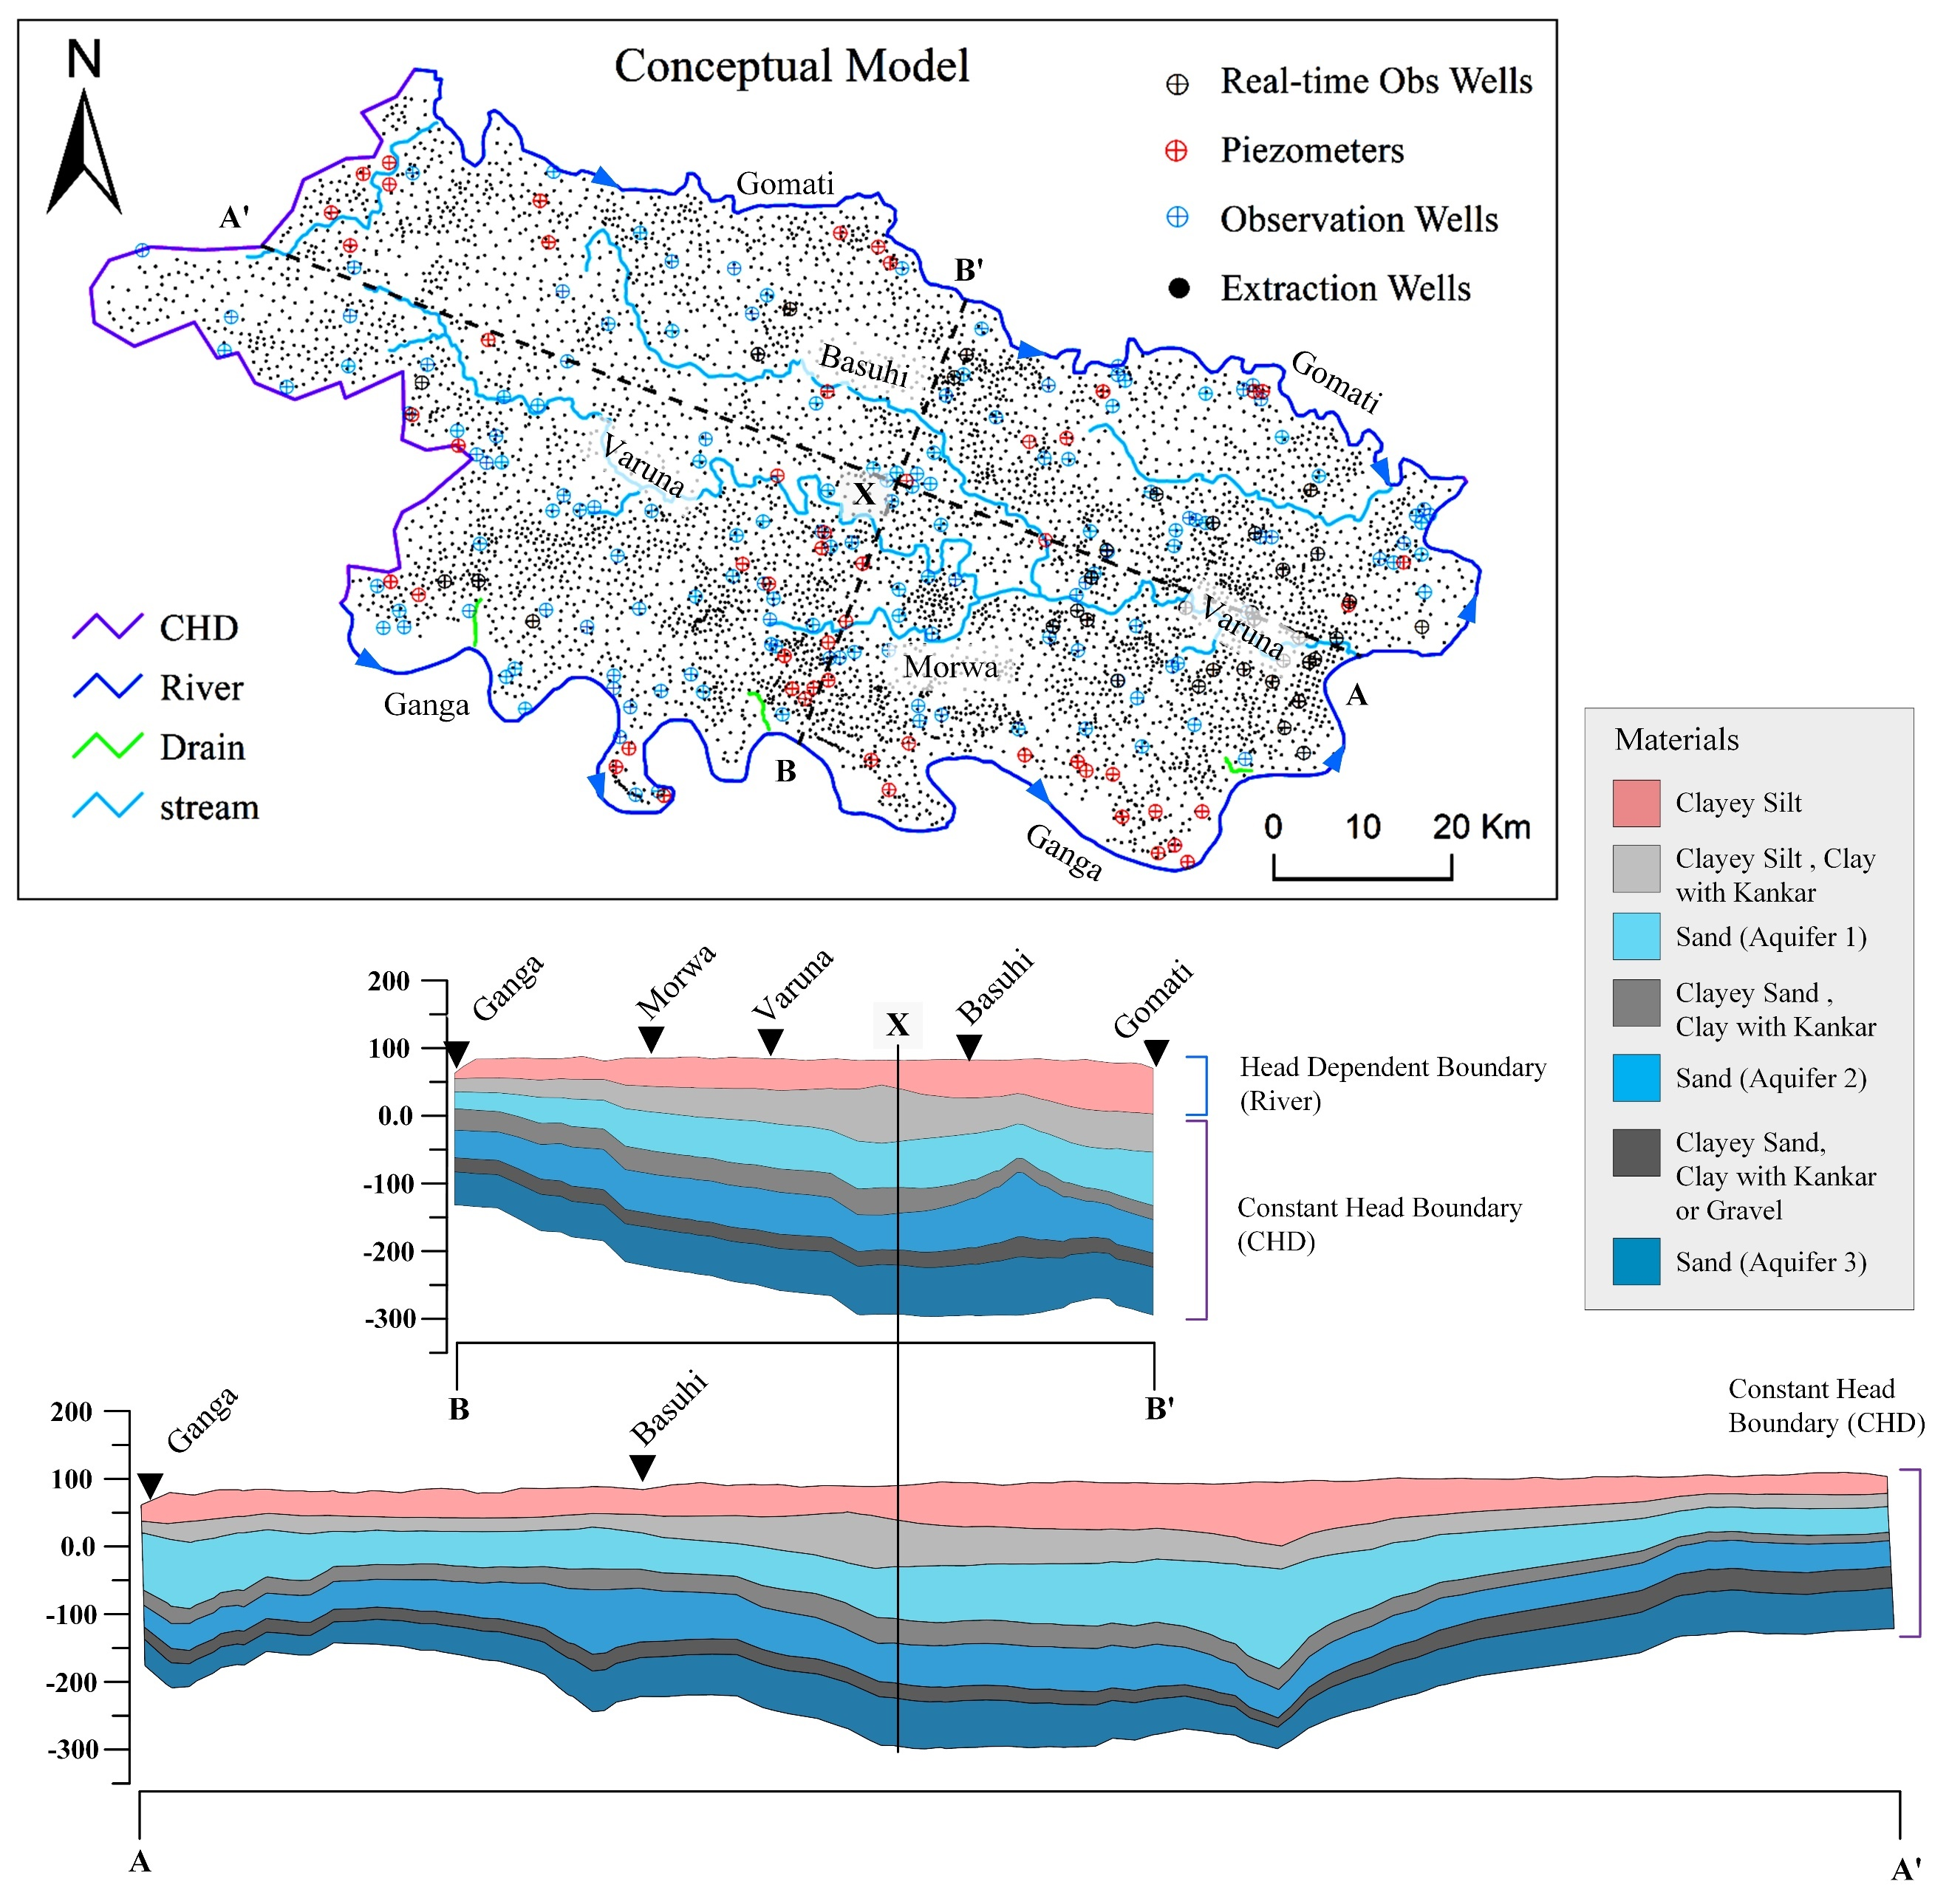
Figure 3.5. Conceptual model of the VRB with boundary conditions

Conceptual Model
The model has been conceptualized as a seven-layer system with different boundary conditions. Two types of perimeter boundary conditions have been employed, such that the Gomati River and Ganga River form the general head boundary (RIV package) in the top layer of the model. The rest of the perimeter in all layers has been conceptualized as specified head boundaries (CHD package). The measured stage data of Gomati and Ganga from gaging stations at a temporal interval of 10-30 days has been assigned as node data. The stages are linearly interpolated between two nodes. The CHD boundary nodes have been selected based on the area's location of adjacent observation wells. The daily groundwater level from digital water loggers (DWLR) from the groundwater department, Govt. of Uttar Pradesh, along with the seasonal groundwater table data from the WRIS portal, has been used to assign node data to the CHD package.
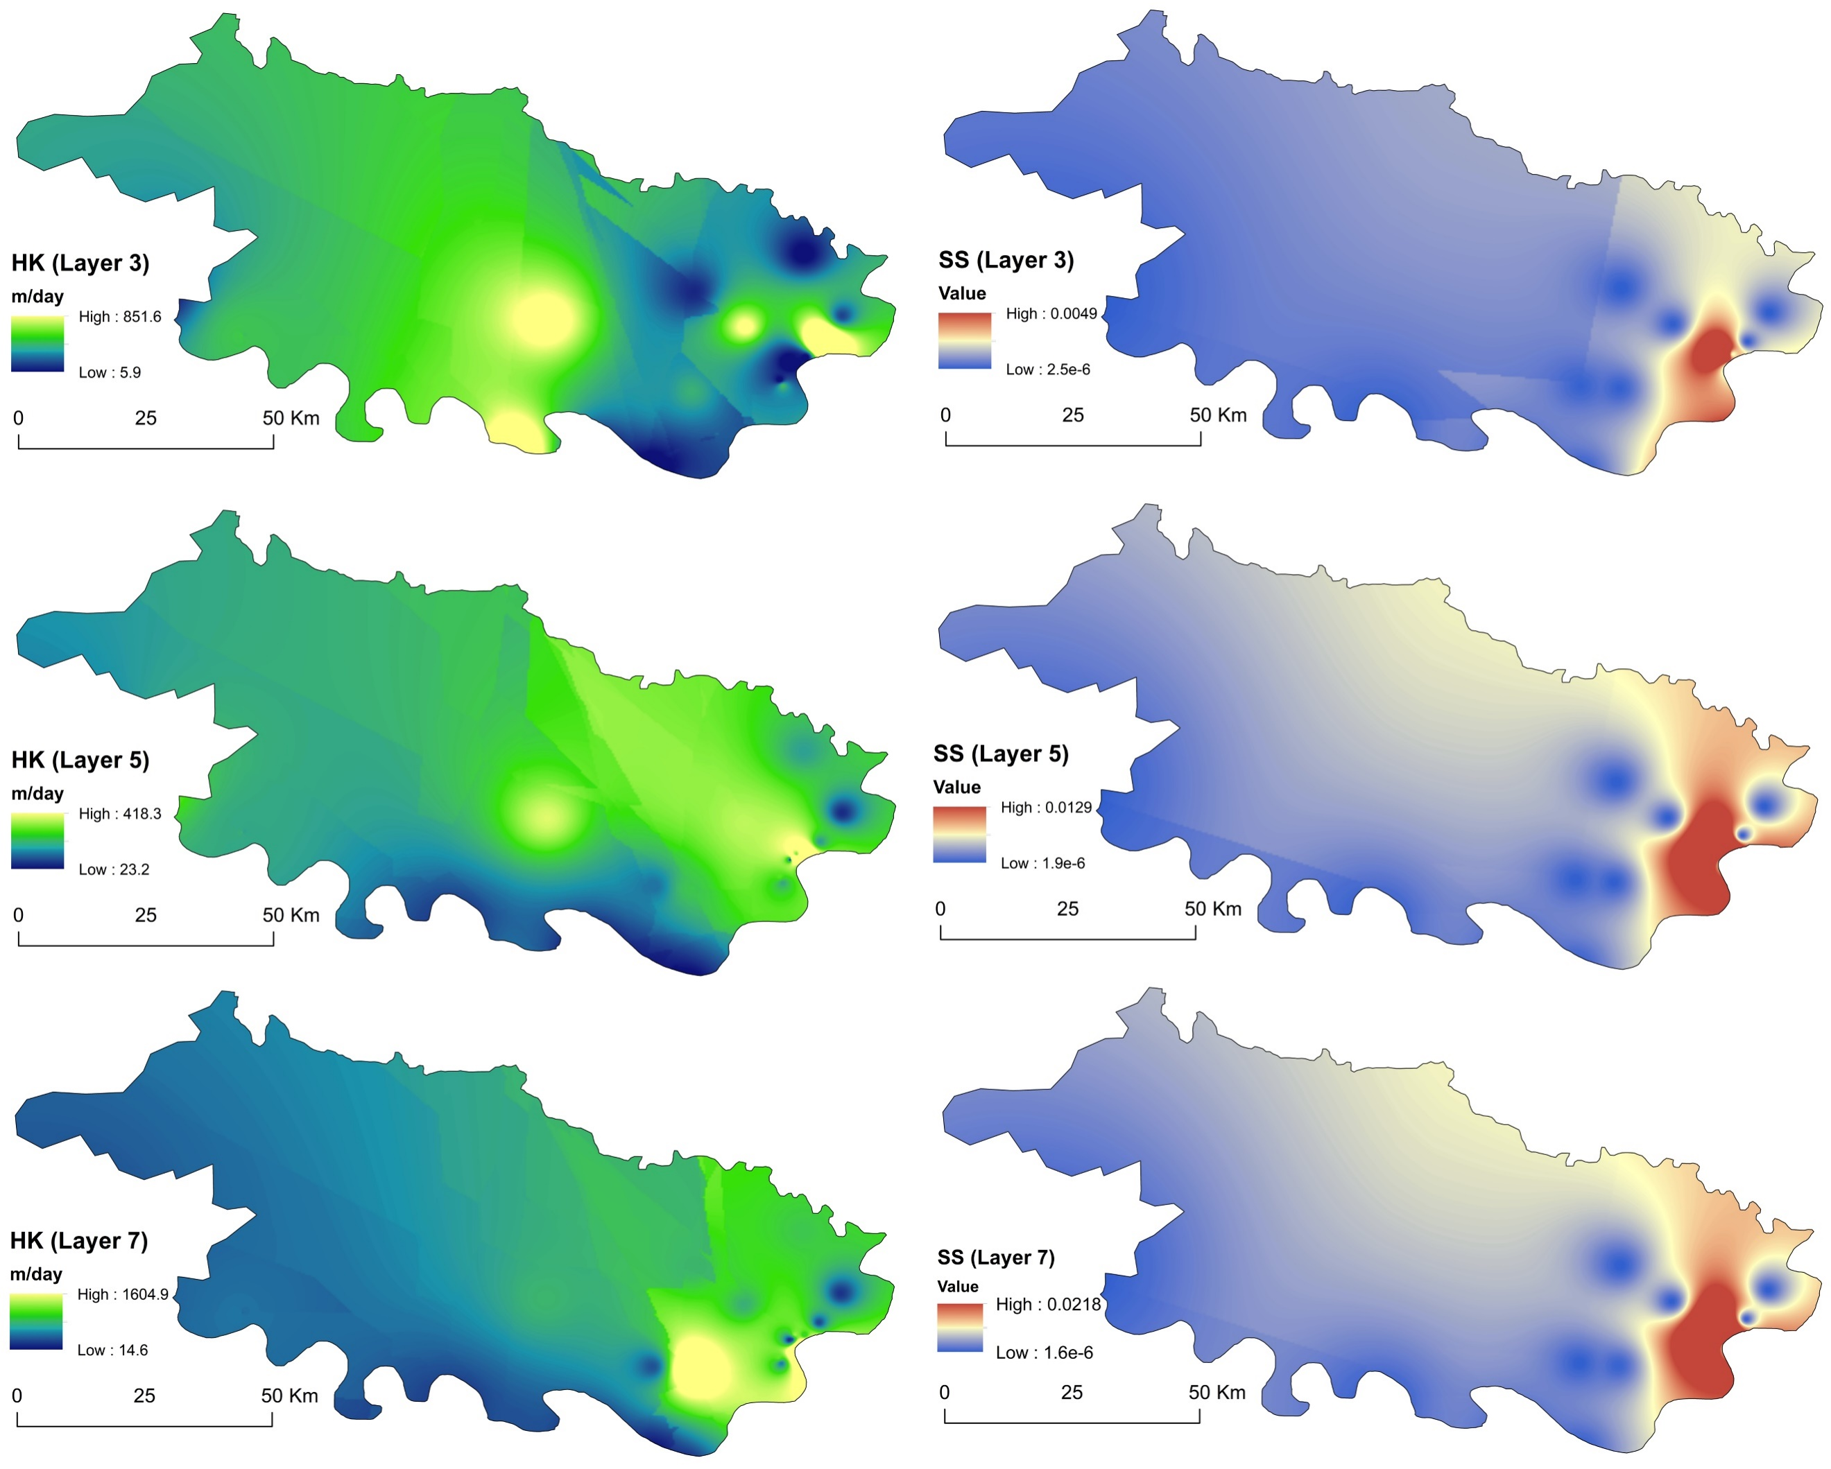
Figure 3.6. Observed aquifer properties

The sources, including the recharge and streams, and sinks, such as extraction wells, evapotranspiration, and streams, make the internal boundary conditions in the model. The Varuna River flows in the middle of the modeled area and is conceptualized with 57 segments based on the watershed outlets and DFG locations. The river bed elevations and river cross-section have been measured with DGPS and ADCP. The mean bed slope of Varuna River has been determined to be 0.43 m/Km for the longest reach. The bed slope of the Basuhi River was 0.2 m/Km. The bed has shown negative slopes in many reaches, including pools and riffles in the Varuna.
The GW extraction wells were determined based on the number of towns and villages in the area. The number of wells per village or town has been increased based on the spread of built-up areas. This is to ensure that individual wells do not extract a high volume of groundwater to avoid depleting the water table. After finalizing the demands based on the consumptive use method, a total of 5246 wells have been planned to address the water demand for domestic and irrigation uses (Figure 3.5). The wells has been assigned based on the location of town/villages. Apart from this, 49 seasonal observations and 18 monthly observation wells have been modeled, with a total of 556 observations.
The evapotranspiration and recharge have been taken subbasin-wise from the SWAT model of the study area and have been discussed in detail in Kumar et al.,(2024). The EVT package and RCH package inputs have been taken from the HRU Outputs of SWAT, which have been resampled using the weighted area method for the basin scale. The stream flow inflows, runoff, evaporation, and precipitation have been taken from the SWAT model's HRU output and RCH outputs based on defined reach lengths.

Translation to Numerical Model
The conceptual model has been translated to relevant packages in MODFLOW-NWT. The model has been divided into square grids measuring 750m and seven layers. Time has been divided into monthly time steps. Groundwater extraction has been simulated using the WELL package, with the screen locations set to the first confined aquifer (3rd layer), as most pumping wells are located in this aquifer.
The Varuna River has been modeled using the SFR2 package to estimate stream flow accurately. The GAGE package has been employed to monitor flow and stages during flow routing in SFR2. The stream cross-section from the confluence of Basuhi and Varuna has been modeled using the eight-point method, while the rest of the stream cross-section has been modeled as a wide rectangular channel. Stream flow inputs, such as precipitation, evaporation, runoff, and reach inflow, have been obtained from the simulation outputs of the SWAT model. The evapotranspiration (EVT package) and recharge (RCH Package) have been calculated on a subbasin basis using SWAT simulations. Drain package (DRT) has been used to model the small streams.

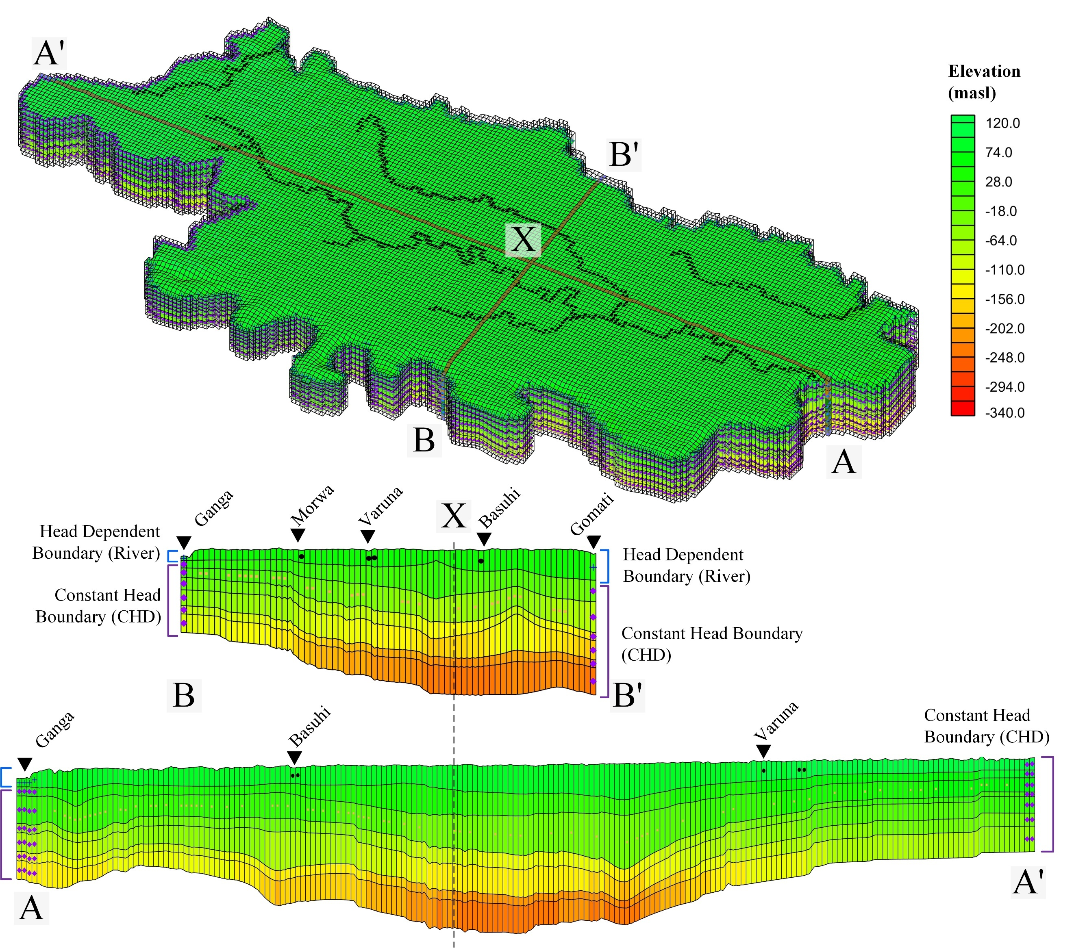
Figure 3.7. Numerical Model of the study area

Calibration of groundwater model

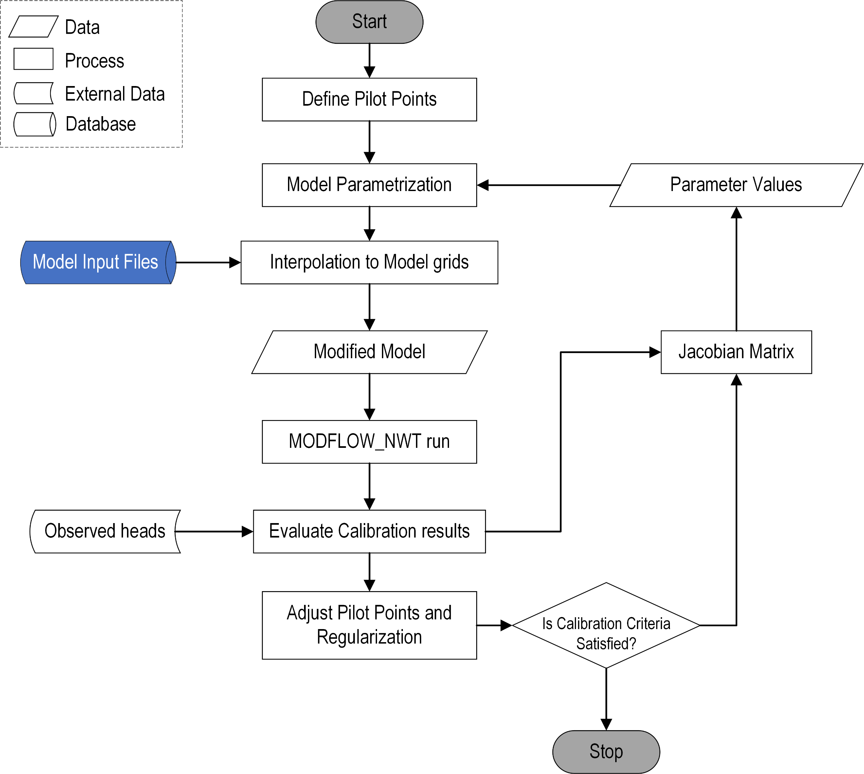
Figure 3.8. Parameter calibration with pilot points in PEST

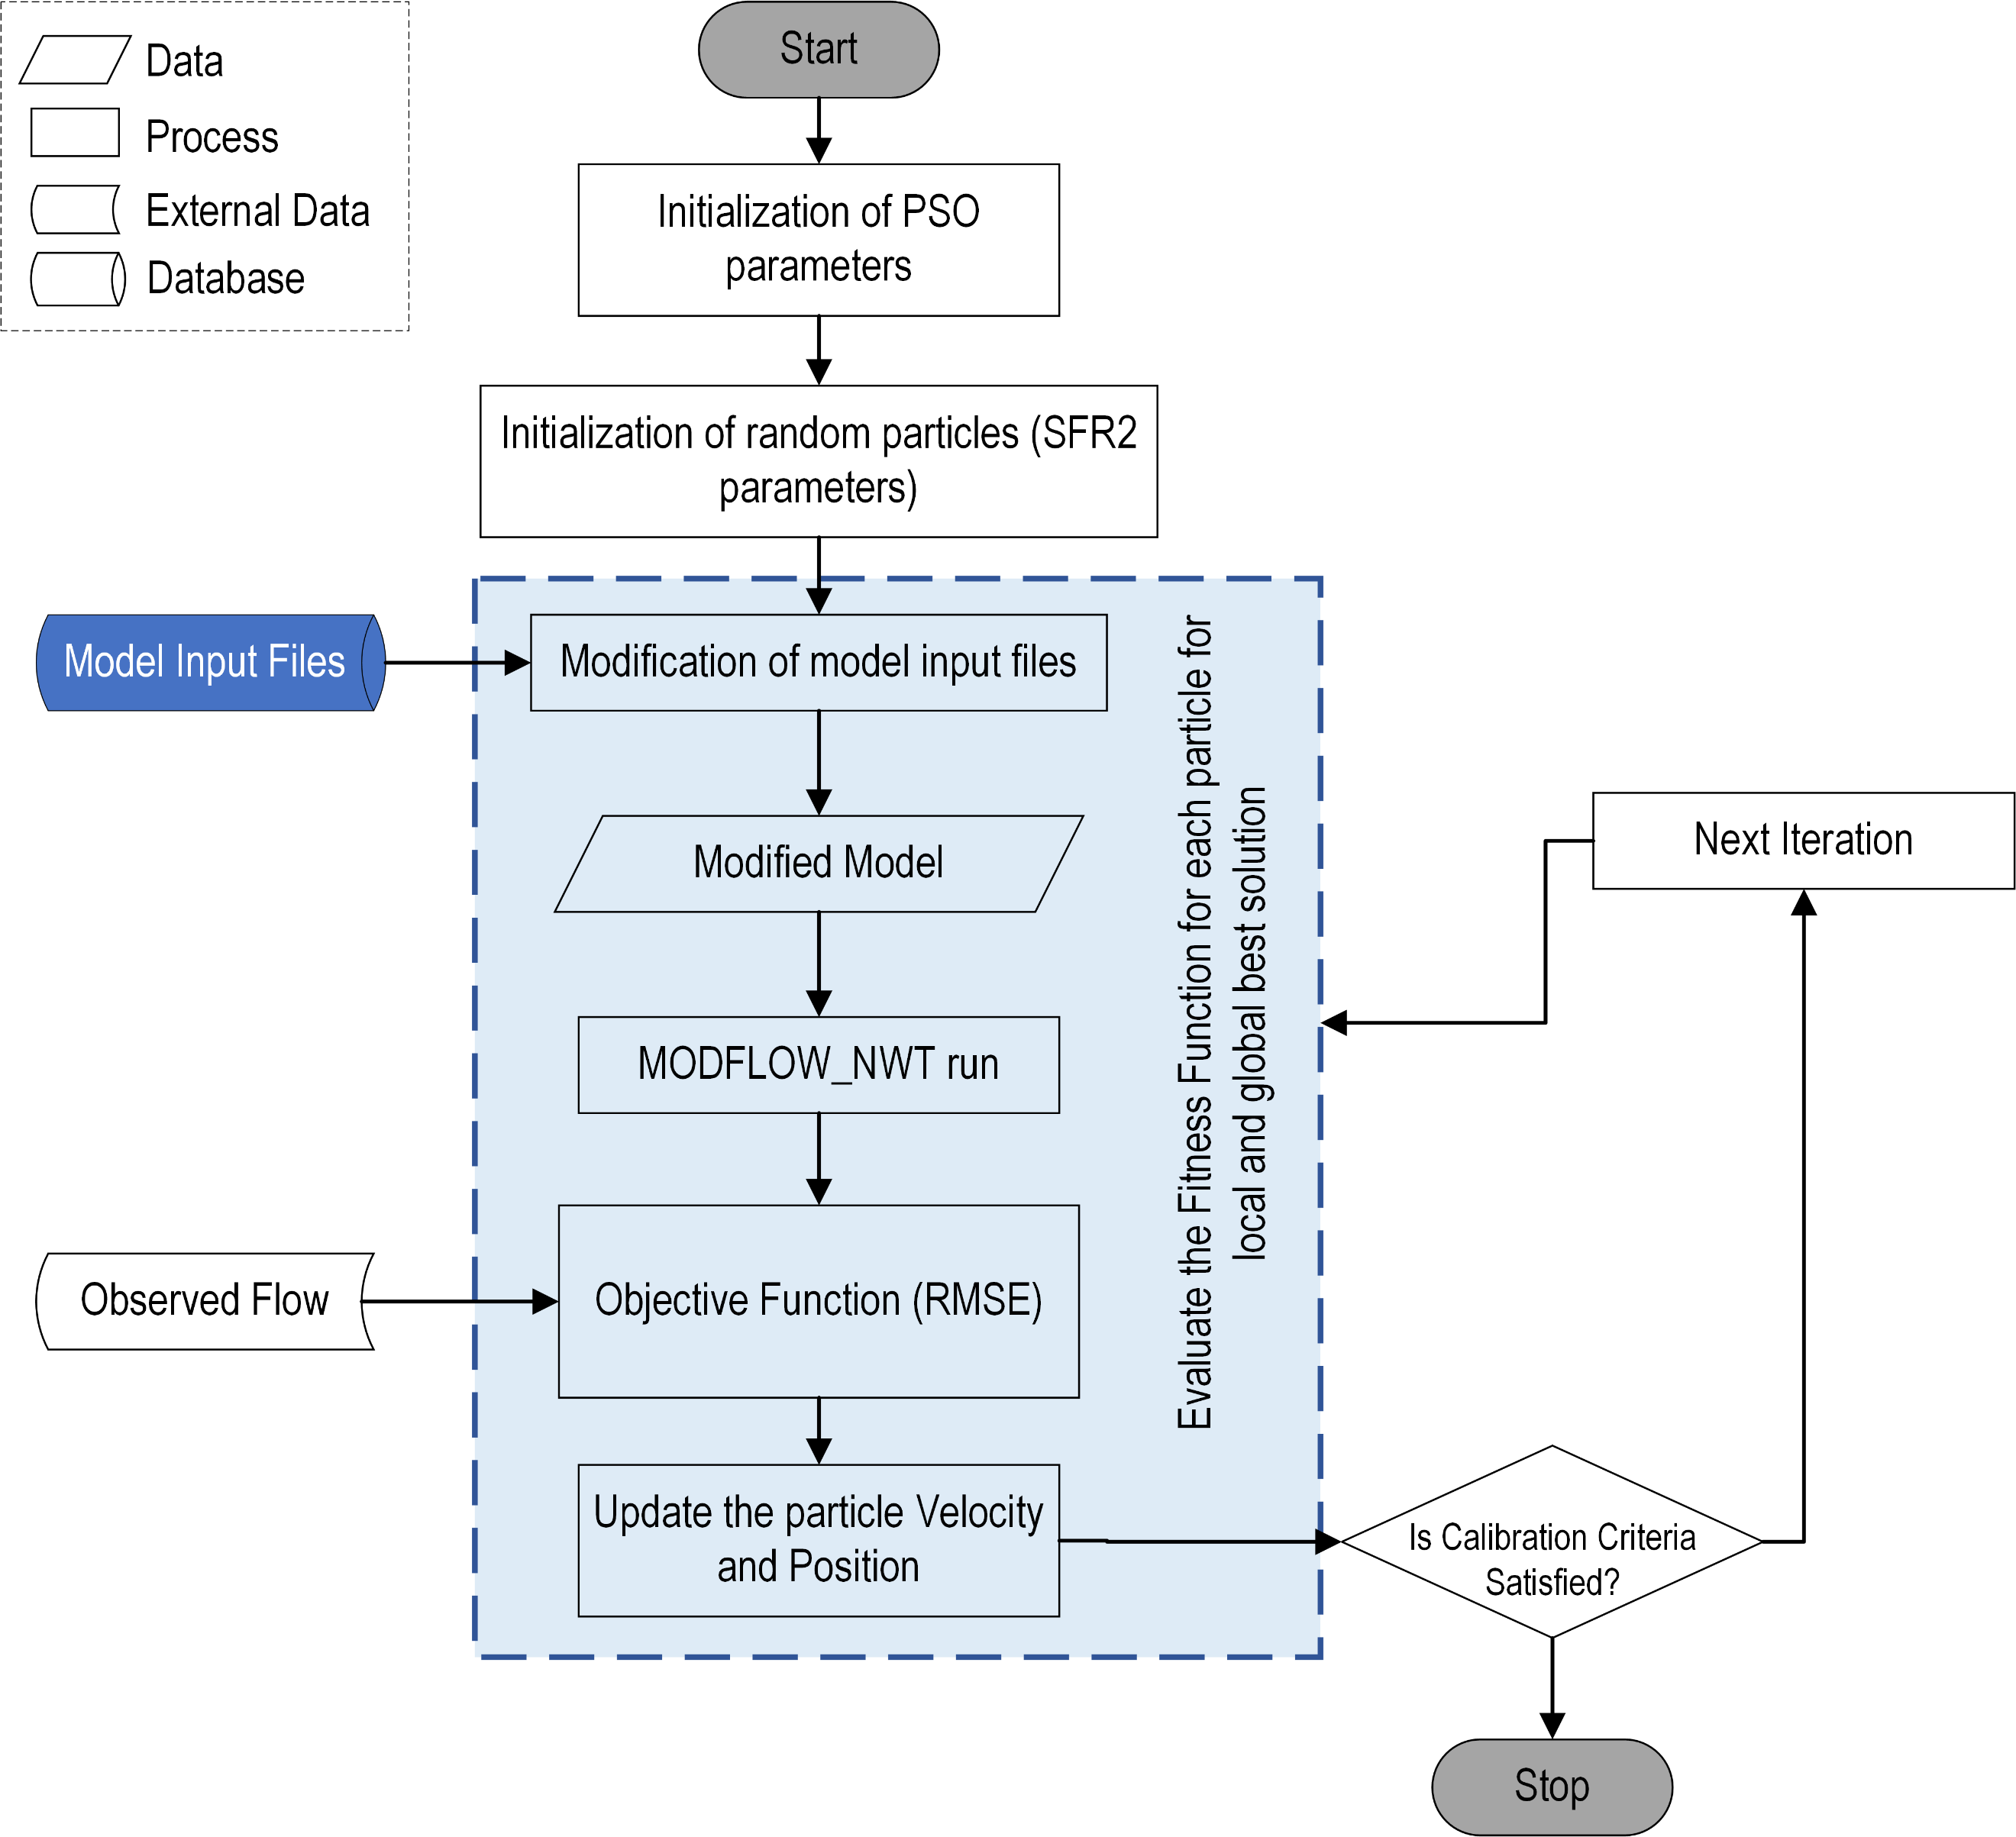
Figure 3.9. Parameter calibration of SFR2 with PSO

Calibration of groundwater models is adjusting model parameters to ensure that the simulated results closely match observed data from the field, such as water levels, flow rates, or contaminant concentrations. This process is crucial because it enhances the reliability and predictive accuracy of the model. Groundwater systems are inherently complex, with many uncertain variables like hydraulic conductivity, recharge rates, and boundary conditions (Mai, 2023). Proper calibration helps to reduce these uncertainties by fine-tuning parameters to reflect real-world conditions better (Anderson et al., 2015). Without accurate calibration, models could yield misleading results, potentially leading to poor management decisions, environmental degradation, or ineffective policy implementation (Mai, 2023). Calibration with discharge location data reduces differences in simulated discharge characteristics, improving predictions of groundwater discharge characteristics in river networks (Barclay et al., 2020; Rassam et al., 2013).
Parameter estimation (PEST) tool is a widely used approach for calibrating groundwater and surface water models to observed data. To map the complex heterogeneity of aquifer parameters, the pilot point method (White et al., 2020) and regularization techniques have been employed. The pilot point method involves defining a set of points within the model domain, where the parameter values are treated as optimization variables during the calibration process. Regularization techniques such as Tikhonov regularization are used to constrain the parameter values and avoid overfitting. As the current version of GMS does not support the calibration of parameters in SFR2, a PSO optimization tool has been developed to facilitate the calibration of the SFR2 parameters (Rafiei et al., 2022). The hydraulic conductivity of each segment of the river in the SFR2 package has been parameterized and calibrated such that in given hydrological inputs from the SWAT model, the SFR2 can better account for the baseflow to match the observed flow at different locations in the river. Calibrating the SFR2 parameters ensures reliable estimates of river aquifer exchanges. The overall flow chart for calibration of aquifer properties using the pilot point method and, later the PSO for SFR2 has been illustrated in Figure 3.9.
The groundwater model has been calibrated with the observed GW heads and DFG data. The PEST algorithm has been used with the pilot point method, which has offered significant advantages in estimating hydraulic properties like hydraulic conductivity (K) and specific storage (S_{s}). This approach enhanced model flexibility by allowing for spatially variable parameter estimation across the model grid, which had been crucial in heterogeneous aquifers. The pilot points have been uniformly distributed across the model grid with a distance of 5 Km. The known parameter values have been assigned, and those points have been fixed (parameter value has not been determined but is used for the interpolation). The parameter initial estimates have been taken from the observed data. By strategically placing pilot points, local variations were effectively captured. The iterative nature of PEST refined model predictions by minimizing RMSE between observed and simulated data, while regularization techniques (Tikhonov Regularization) stabilized the calibration process, making it possible to handle highly parameterized models without overfitting.
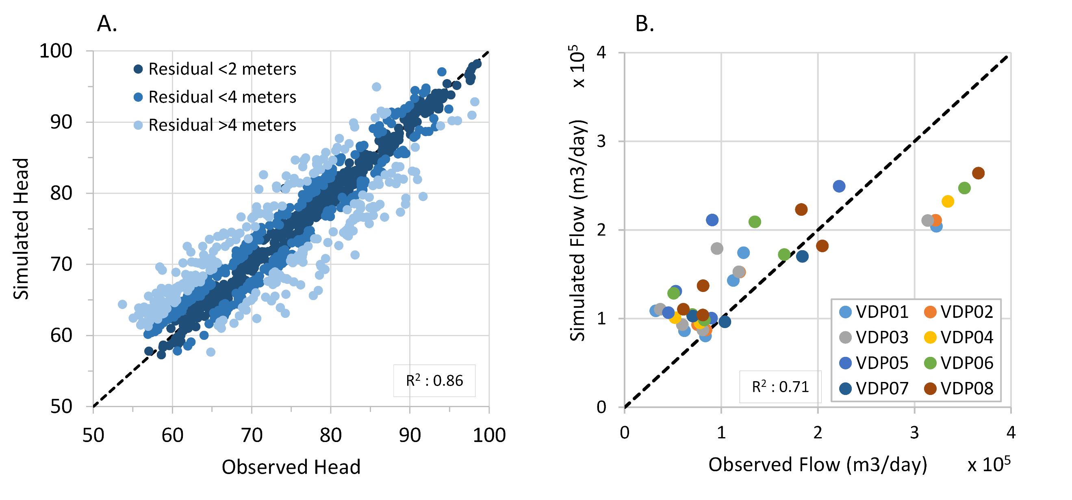
Figure 3.10. Simulated vs. calibrated scatter plot for A. observed heads and B. observed stream flow.

After the model was calibrated for the head, it was calibrated with DFG data to simulate the RAE accurately. A total of 57 stream reaches has been parameterized with the hydraulic conductivity of the river bed. The PSO algorithm has been applied to determine the optimal river bed conductivities to fit the observed DFG data (Figure 3.9). The calibration of aquifer parameters a and the river bed conductivity have been repeated until a satisfactory result has been achieved. A mean residual head of 1.05 meters, R² of 0.81, and RMSE of 2.88 have been achieved, representing a satisfactory calibration for the aquifer parameters (Figure 3.10). The calibrated aquifer parameters can be found in Appendix A. The fitted conductivity range can be observed in Figure 3.11. The calibrated co-relation coefficient of 0.71 (R²) has been achieved (Figure 5.16). The fitted hydraulic conductivity of the river bed has shown a variation from 4.59 *10⁻⁴m/day to 3.37 *10⁻³ m/day with a mean of 1.76 *10⁻³ m/day. The fitted river bed hydraulic conductivity has been plotted in Appendix B.
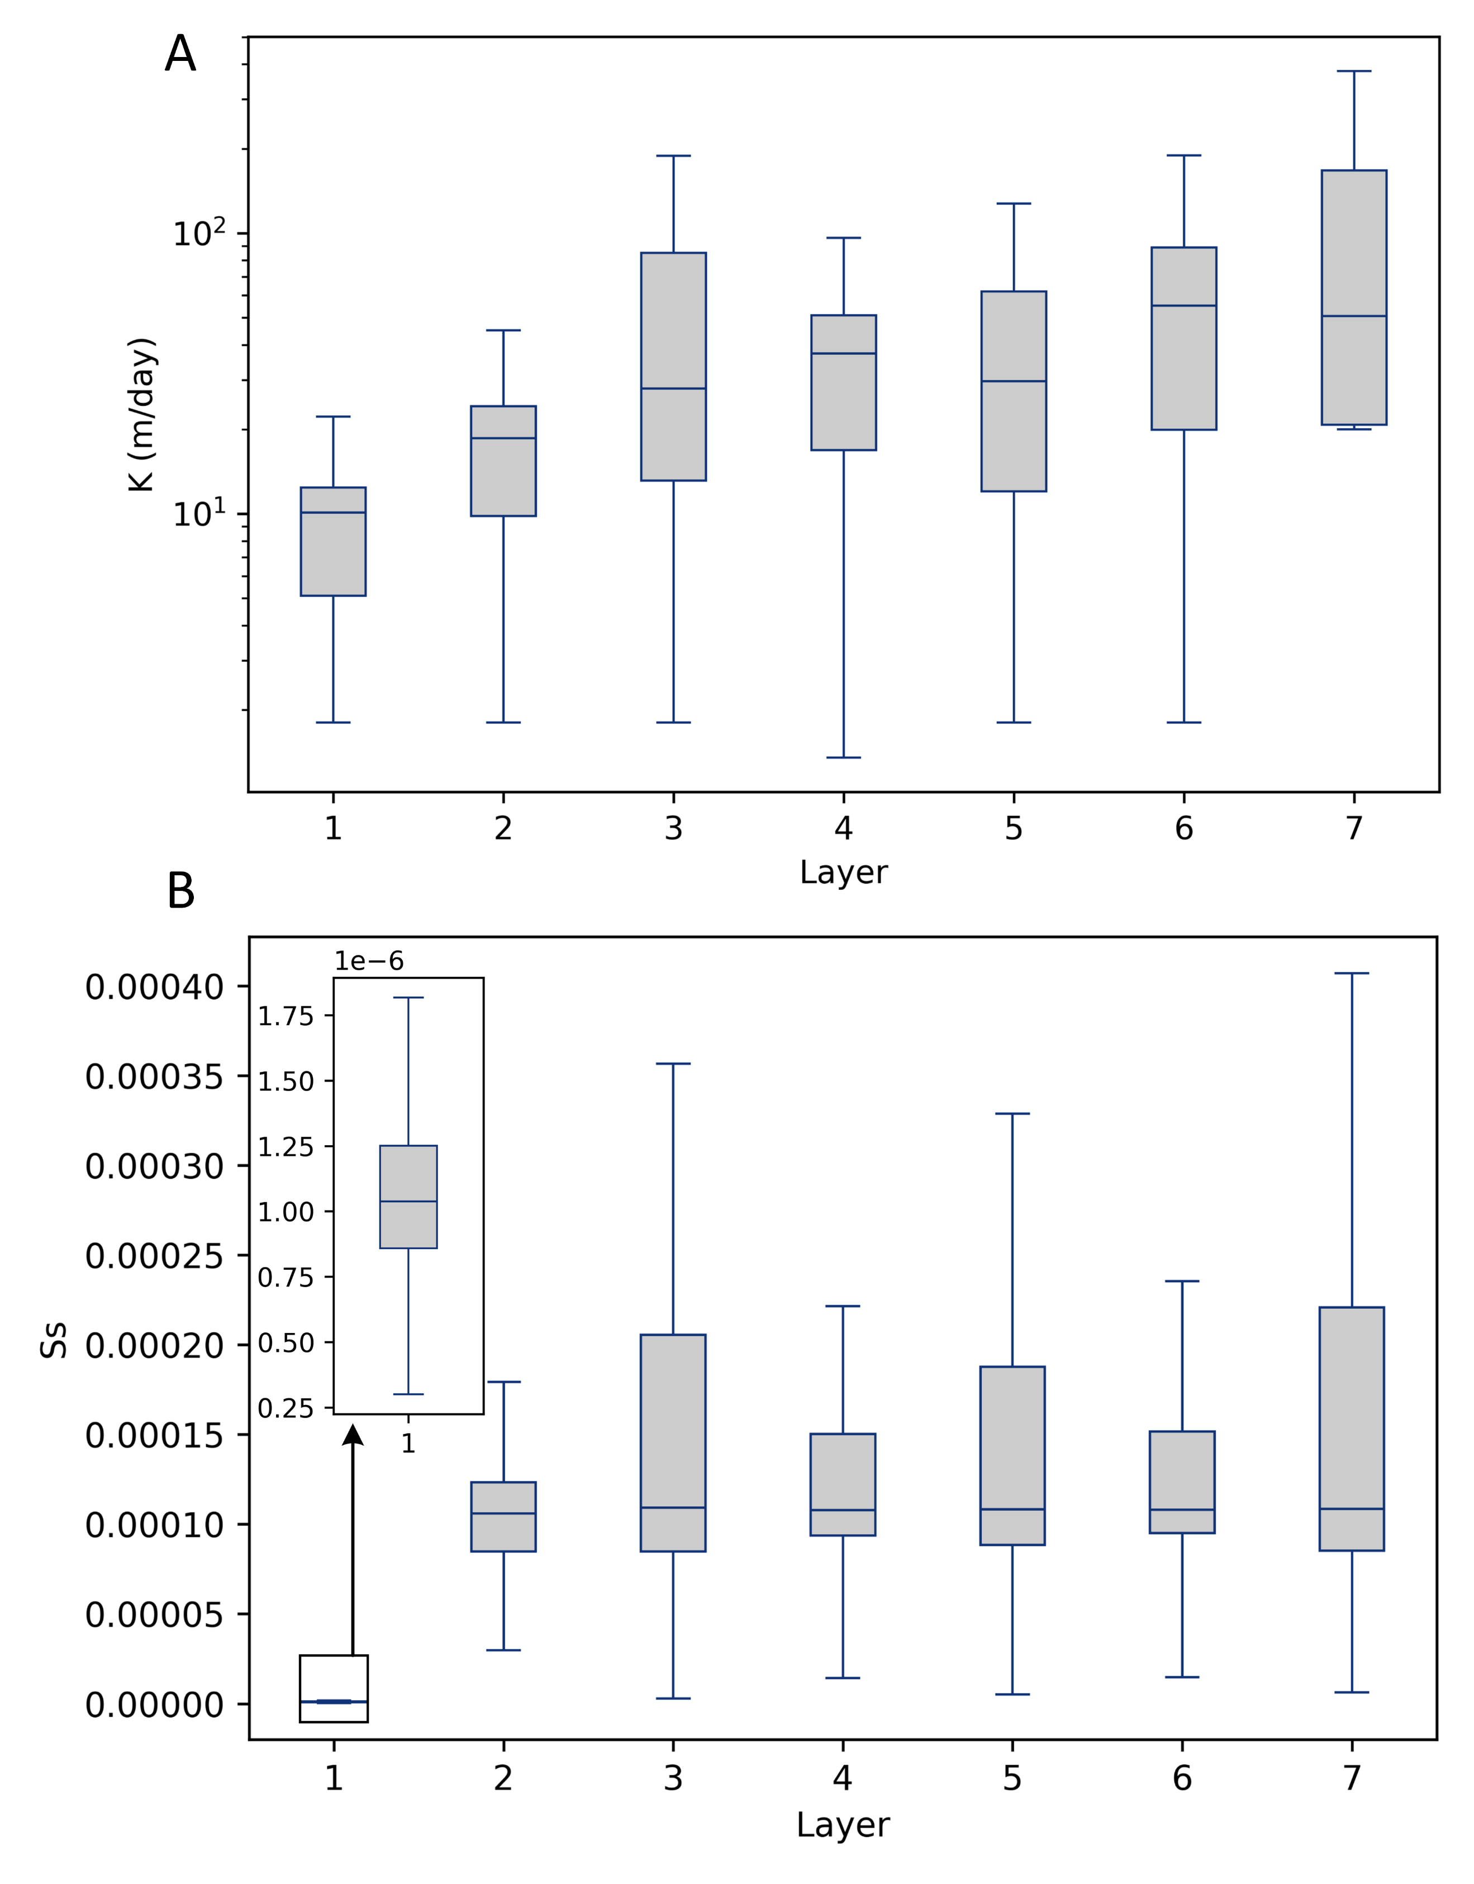
Figure 3.11. A. Boxplot of calibrated Hk values and B. Boxplot of calibrated Ss values

Reference
Ali, S.R., Khan, J.N., Pandey, Y., Dar, M.U.D., Shafi, M., Hassan, I., 2020. Modeling the Impacts of Climate Change on Groundwater Resources: A Review. International Journal of Environment and Climate Change 10, 61–76. https://doi.org/10.9734/ijecc/2020/v10i1030250
Anderson, M.G., Woessner, W.W., Hunt, R.J., 2015. Applied Groundwater Modeling: Simulation of Flow and Advective Transport, 2nd ed. Elsevier. https://doi.org/https://doi.org/10.1016/C2009-0-21563-7
Atawneh, D. Al, Cartwright, N., Bertone, E., 2021. Climate change and its impact on the projected values of groundwater recharge: A review. J Hydrol (Amst) 601, 126602. https://doi.org/10.1016/j.jhydrol.2021.126602
Barclay, J.R., Starn, J.J., Briggs, M.A., Helton, A.M., 2020. Improved Prediction of Management‐Relevant Groundwater Discharge Characteristics Throughout River Networks. Water Resour Res 56. https://doi.org/10.1029/2020WR028027
Clement, T., Sun, Y., Hooker, B.S., Petersen, J.N., 1998. Modeling Multispecies Reactive Transport in Ground Water. Groundwater Monitoring & Remediation 18. https://doi.org/10.1111/J.1745-6592.1998.TB00618.X
Darcy, H., 1856. Les Fontaines publiques de la ville de Dijon. V. Dalmont.
Das, P., Mukherjee, A., Lapworth, D.J., Das, K., Bhaumik, S., Layek, M.K., Shaw, A., Smith, M., Sengupta, P., MacDonald, A.M., Sen, J., 2021. Quantifying the dynamics of sub-daily to seasonal hydrological interactions of Ganges river with groundwater in a densely populated city: Implications to vulnerability of drinking water sources. J Environ Manage 288, 112384. https://doi.org/10.1016/j.jenvman.2021.112384
Feinstein, D.T., Fienen, M.N., Kennedy, J.L., Buchwald, C. a., Greenwood, M.M., 2012. Development and Application of a Groundwater / Surface-Water Flow Model using MODFLOW-NWT for the Upper Fox River Basin , Southeastern Wisconsin. U.S. Geological Survey 124.
Fetter, C.W., 2001. Applied Hydrogeology, 4th ed. Prentice Hall.
Hodges, K., 2019. Modeling groundwater depletion. Science (1979). https://doi.org/10.1126/SCIENCE.364.6446.1146-R
Kang-l, Q., 2014. Application of Visual MODFLOW in Ground Water Numerical Simulation. Coal and Chemical Industry.
Kumar, R., Bhattacharjee, R., Gaur, S., Ohri, A., 2024. Groundwater Sustainability in the Varuna River Basin: Impacts of Climate Change and Population Growth. https://doi.org/10.21203/rs.3.rs-5405452/v1
Langevin, C.D., Hughes, J.D., Banta, E.R., Provost, A.M., Niswonger, R.G., Panday, S., 2021. MODFLOW 6 Modular Hydrologic Model version 6.2.1: U.S. Geological Survey Software Release 200 p.
Leng, G., Huang, M., Tang, Q., Gao, H., Leung, L., 2014. Modeling the Effects of Groundwater-Fed Irrigation on Terrestrial Hydrology over the Conterminous United States. J Hydrometeorol 15, 957–972. https://doi.org/10.1175/JHM-D-13-049.1
Leonard F.Konikow, George Z. Hornberger, Keith J. Halford, R.T.H., 2009. Revised Multi-Node Well ( MNW2 ) Package for MODFLOW Ground-Water Flow Model Techniques and Methods 6 – A30. Methods 80.
Mai, J., 2023. Ten strategies towards successful calibration of environmental models. J Hydrol (Amst) 620, 129414. https://doi.org/10.1016/j.jhydrol.2023.129414
Menció, A., Mas-Pla, J., 2008. Assessment by multivariate analysis of groundwater-surface water interactions in urbanized Mediterranean streams. J Hydrol (Amst) 352, 355–366. https://doi.org/10.1016/j.jhydrol.2008.01.014
Meza-Gastelum, M.A., Campos-Gaytán, J.R., Ramírez-Hernández, J., Herrera-Oliva, C.S., Villegas-León, J.J., Figueroa-Núñez, A., 2022. Review of Groundwater Withdrawal Estimation Methods. Water (Switzerland) 14, 1–20. https://doi.org/10.3390/w14172762
Mustafa, S., Bahar, A., Aziz, Z.A., Suratman, S., 2016. Modelling contaminant transport for pumping wells in riverbank filtration systems. J Environ Manage 165, 159–166. https://doi.org/10.1016/j.jenvman.2015.09.026
Niswonger, R.G., Panday, S., Ibaraki, M., 2011. MODFLOW-NWT, a Newton formulation for MODFLOW-2005, Techniques and Methods. https://doi.org/10.3133/tm6A37
Niswonger, R.G., Prudic, D.E., 2010. Documentation of the Streamflow-Routing (SFR2) Package to Include Unsaturated Flow Beneath Streams—A Modification to SFR1: U.S. Geological Survey Techniques and Methods 6-A13. US Geological Survey Techniques and Methods 6 59.
Omar, P.J., Gaur, S., Dwivedi, S.B., Dikshit, P.K.S., 2020. A Modular Three-Dimensional Scenario-Based Numerical Modelling of Groundwater Flow. Water Resources Management 34, 1913–1932. https://doi.org/10.1007/s11269-020-02538-z
Ou, G., Chen, X., Kilic, A., Bartelt-Hunt, S., Li, Y., Samal, A., 2013. Development of a cross-section based streamflow routing package for MODFLOW. Environmental Modelling & Software 50, 132–143. https://doi.org/10.1016/j.envsoft.2013.09.012
Panday, S., Huyakorn, P., 2008. MODFLOW SURFACT: A State‐of‐the‐Art Use of Vadose Zone Flow and Transport Equations and Numerical Techniques for Environmental Evaluations. Vadose Zone Journal 7, 610–631. https://doi.org/10.2136/vzj2007.0052
Pokhrel, Y., Koirala, S., Yeh, P., Hanasaki, N., Longuevergne, L., Kanae, S., Oki, T., 2015. Incorporation of groundwater pumping in a global Land Surface Model with the representation of human impacts. Water Resour Res 51, 78–96. https://doi.org/10.1002/2014WR015602
Prommer, H., Prommer, H., Barry, D.A., Zheng, C., 2003. MODFLOW/MT3DMS‐Based Reactive Multicomponent Transport Modeling. Groundwater 41. https://doi.org/10.1111/J.1745-6584.2003.TB02588.X
Prudic, D.E., Konikow, L.F., Banta, E.R., 2004. A New Streamflow-Routing (SFR1) Packate to Simulate Stream-Aquifer Interaction with MODFLOW-2000. U.S. Geological Survey 104.
Rafiei, V., Nejadhashemi, A.P., Mushtaq, S., Bailey, R.T., An-Vo, D.-A., 2022. An improved calibration technique to address high dimensionality and non-linearity in integrated groundwater and surface water models. Environmental Modelling & Software 149, 105312. https://doi.org/10.1016/j.envsoft.2022.105312
Rassam, D.W., Peeters, L., Pickett, T., Jolly, I., Holz, L., 2013. Accounting for surface–groundwater interactions and their uncertainty in river and groundwater models: A case study in the Namoi River, Australia. Environmental Modelling & Software 50, 108–119. https://doi.org/10.1016/j.envsoft.2013.09.004
Schiff, L., 1964. Ground-Water Recharge Hydrology. Groundwater 2, 16–20. https://doi.org/https://doi.org/10.1111/j.1745-6584.1964.tb01766.x
Schwartz, F.W., Ibaraki, M., 2011. Groundwater: A Resource in Decline. Elements 7, 175–179. https://doi.org/10.2113/gselements.7.3.175
Shah, N., Nachabe, M., Ross, M., 2007. Extinction depth and evapotranspiration from ground water under selected land covers. Ground Water 45, 329–338. https://doi.org/10.1111/j.1745-6584.2007.00302.x
Simon, R. Ben, Bernard, S., Meurville, C., Rebour, V., 2015. Flow‐Through Stream Modeling with MODFLOW and MT3D: Certainties and Limitations. Groundwater 53. https://doi.org/10.1111/gwat.12312
Sophocleous, M., 2002. Interactions between groundwater and surface water: The state of the science. Hydrogeol J 10, 52–67. https://doi.org/10.1007/s10040-001-0170-8
Vergnes, J.P., Caballero, Y., Lanini, S., 2023. Assessing climate change impact on French groundwater resources using a spatially distributed hydrogeological model. Hydrological Sciences Journal 68, 209–227. https://doi.org/10.1080/02626667.2022.2150553
Wada, Y., Wada, Y., Bierkens, M., Roo, A., Dirmeyer, P., Famiglietti, J., Hanasaki, N., Konar, M., Liu, J., Liu, J., Schmied, H., Oki, T., Oki, T., Pokhrel, Y., Sivapalan, M., Troy, T., Dijk, A., Emmerik, T., Huijgevoort, M. V, Lanen, H. V, Vörösmarty, C., Vörösmarty, C., Wanders, N., Wanders, N., Wheater, H., 2017. Human–water interface in hydrological modelling : current status and future directions. Hydrol Earth Syst Sci 21, 4169–4193. https://doi.org/10.5194/HESS-21-4169-2017
White, J.T., Hunt, R.J., Fienen, M.N., Doherty, J.E., 2020. Approaches to highly parameterized inversion: PEST++ Version 5, a software suite for parameter estimation, uncertainty analysis, management optimization and sensitivity analysis, Techniques and Methods. Reston, VA. https://doi.org/10.3133/tm7C26

Appendix A. Fitted Aquifer properties by pilot point method.
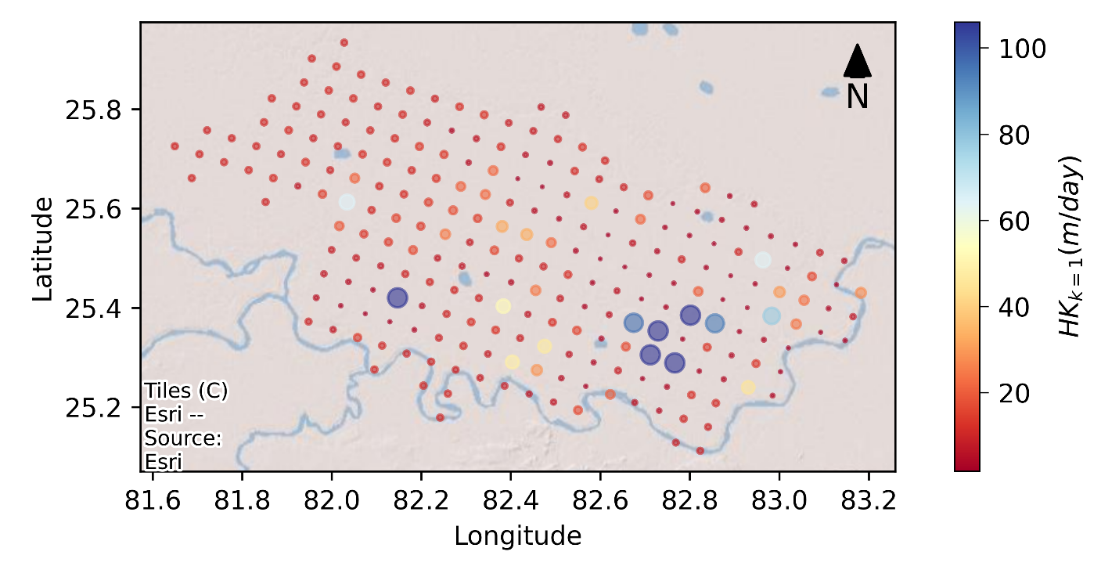 | 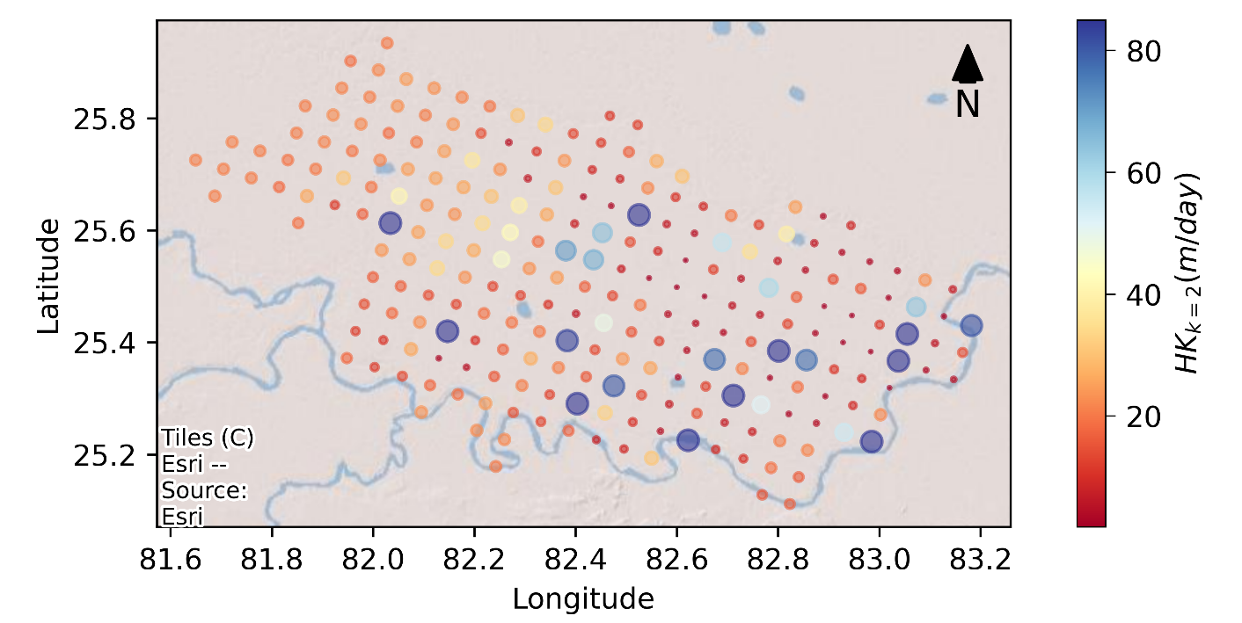
A 1. Calibrated Hk for Layer 1 | A 2. Calibrated Hk for layer 2
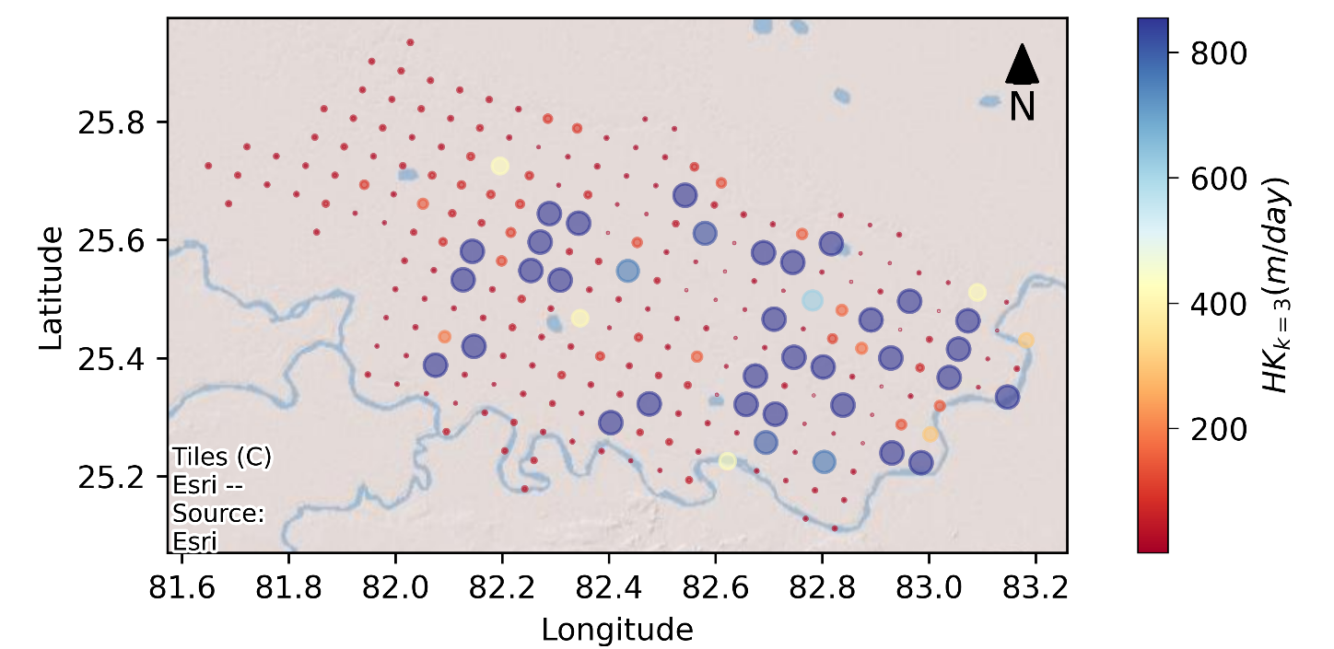 | 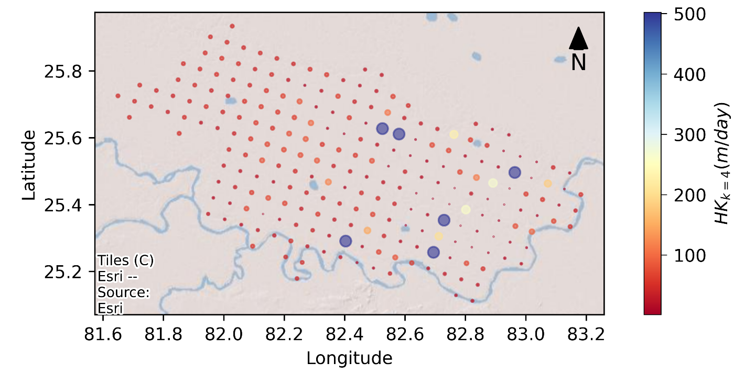
A 3. Calibrated Hk for layer 3 | A 4. Calibrated Hk for layer 4

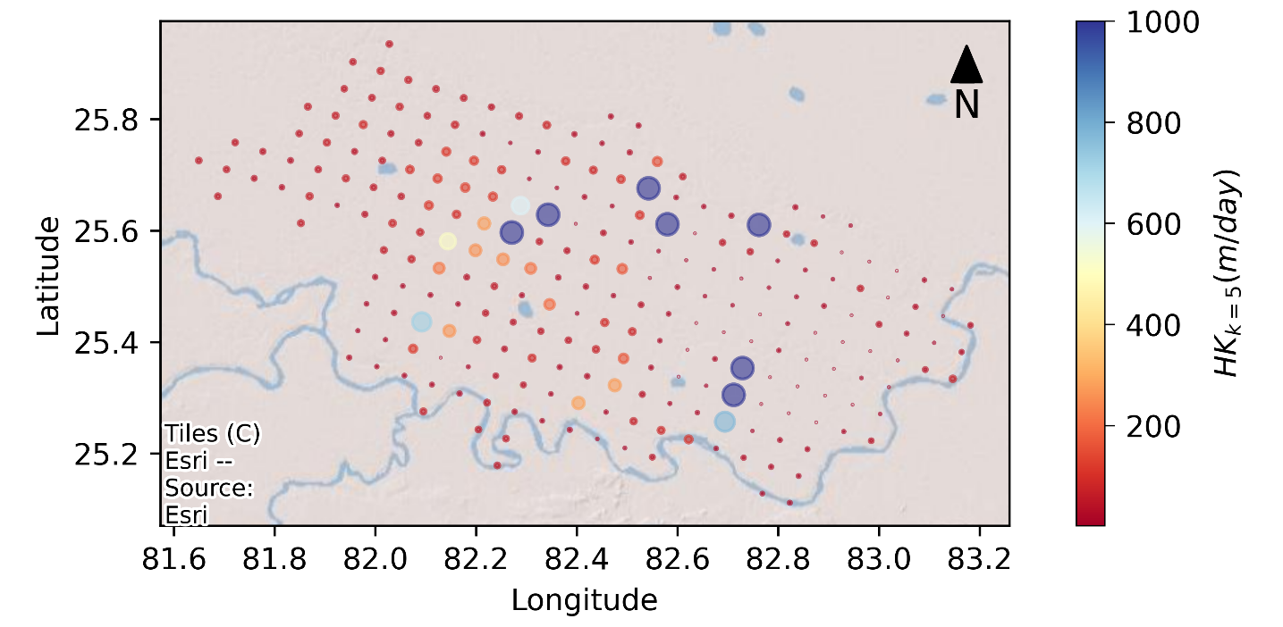 | 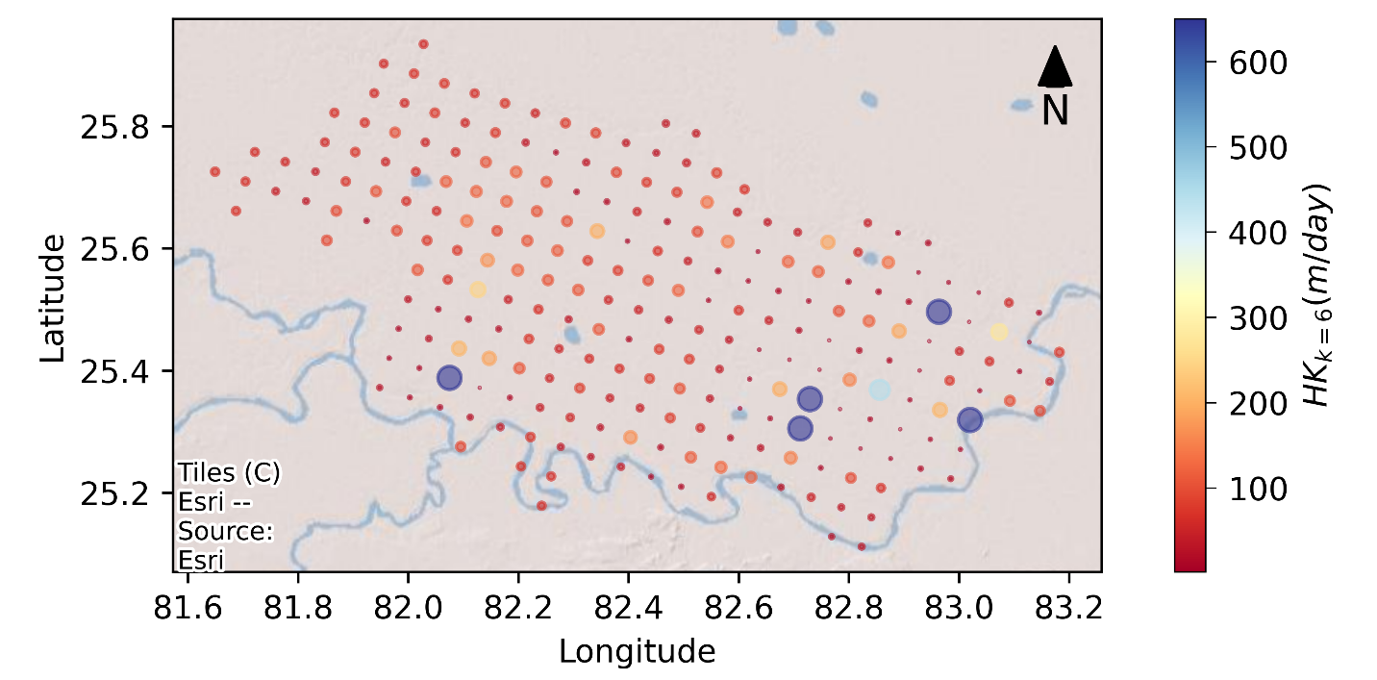
A 5. Calibrated Hk for layer 5 | A 6. Calibrated Hk for layer 6
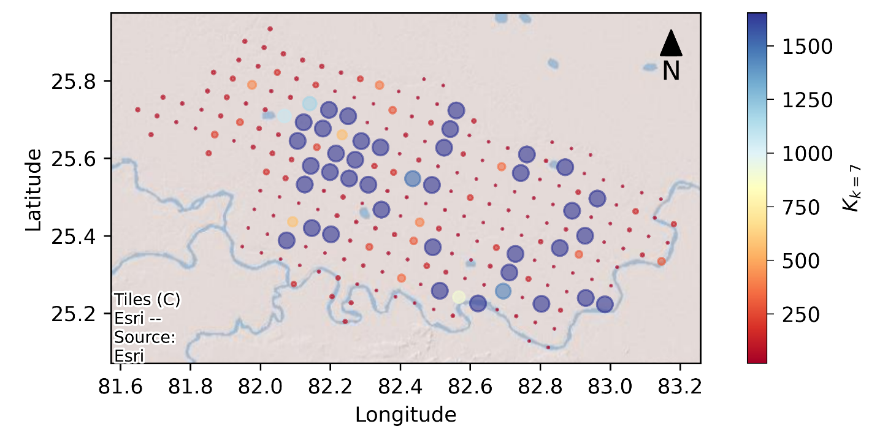
A 7. Calibrated Hk for layer 7

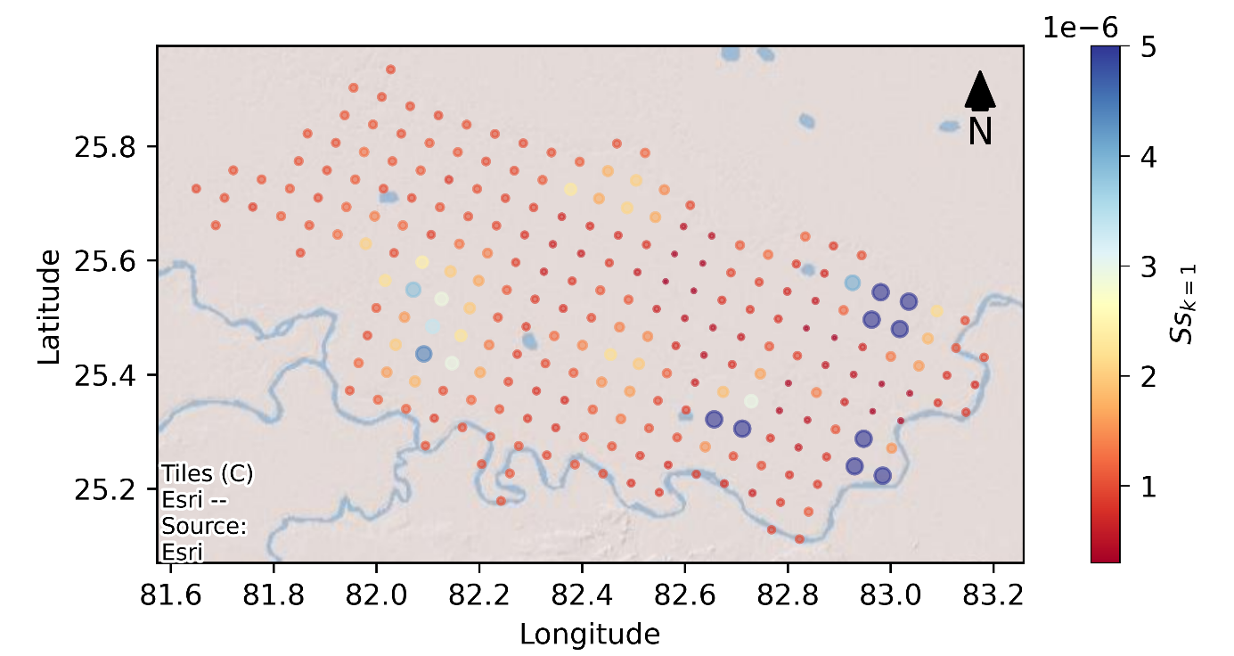 | 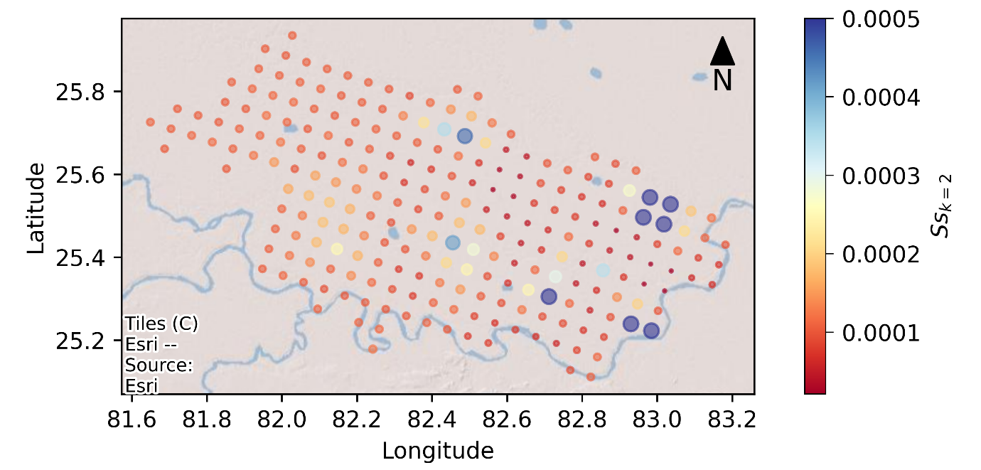
A 8. Calibrated Ss for layer 1 | A 9. Calibrated Ss for layer 2
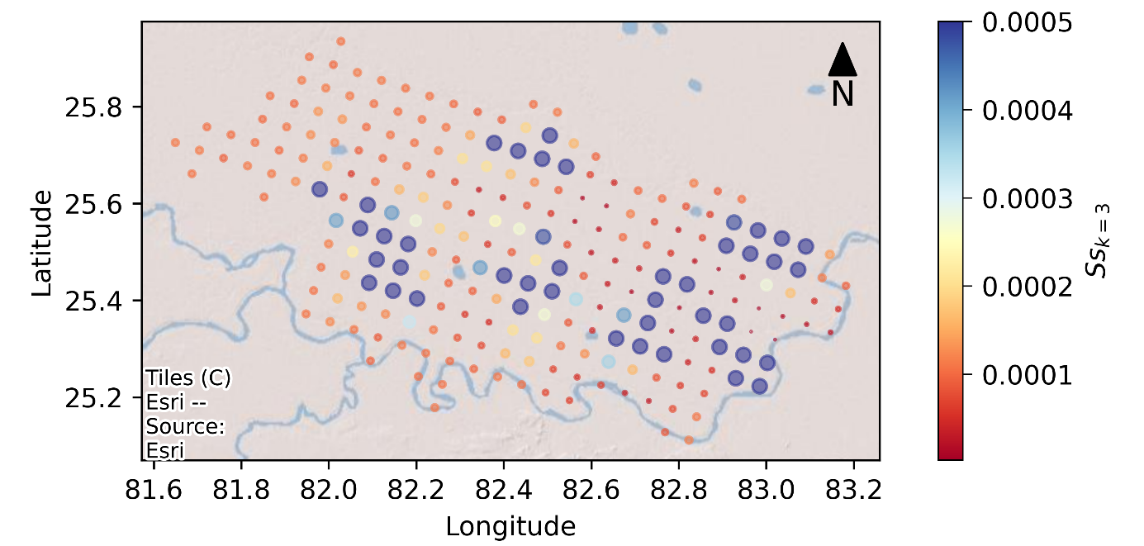 | 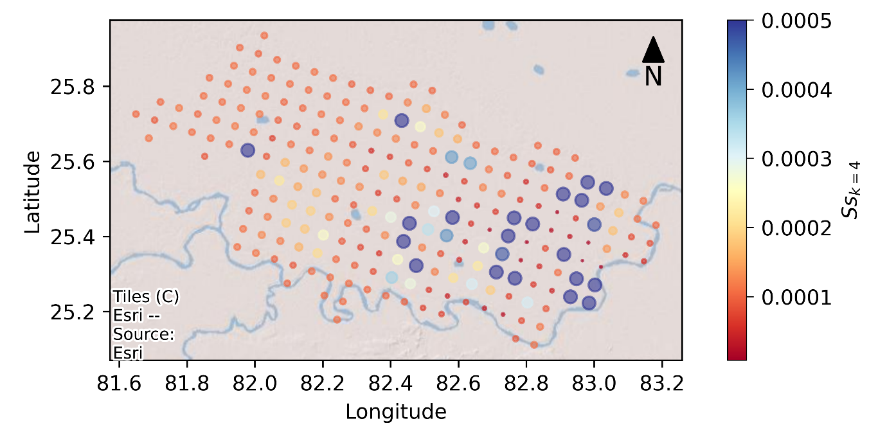
A 10. Calibrated Ss for layer 3 | A 11. Calibrated Ss for layer 4

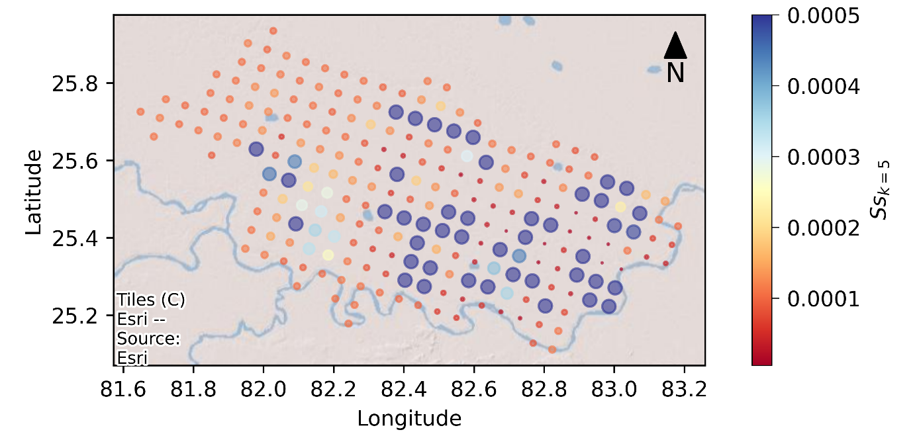 | 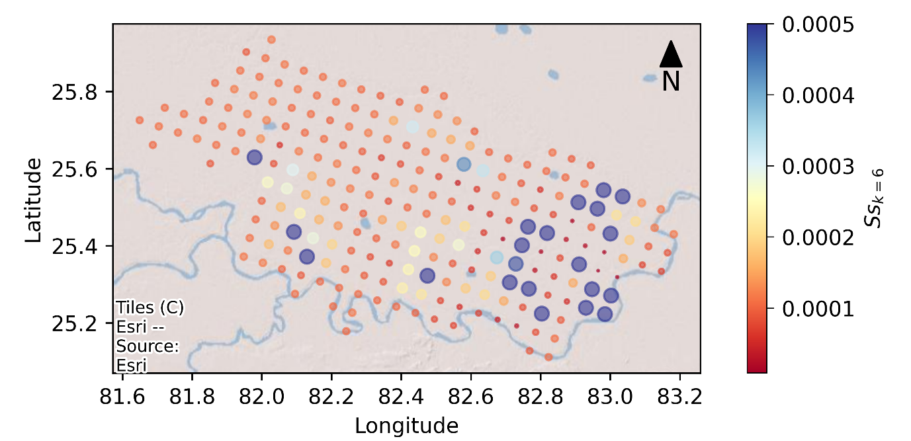
A 12. Calibrated Ss for layer 5 | A 13. Calibrated Ss for layer 6
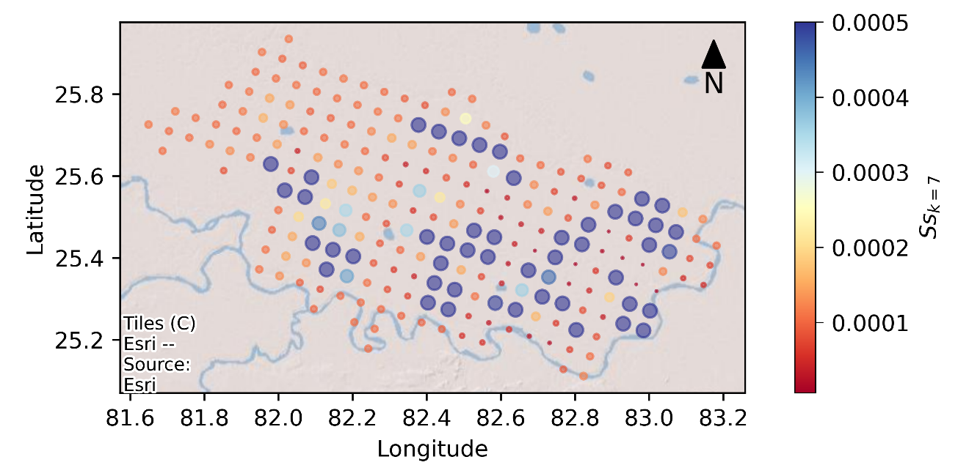
A 14. Calibrated Ss for layer 7

Appendix B. Calibrated River bed conductivities with PSO

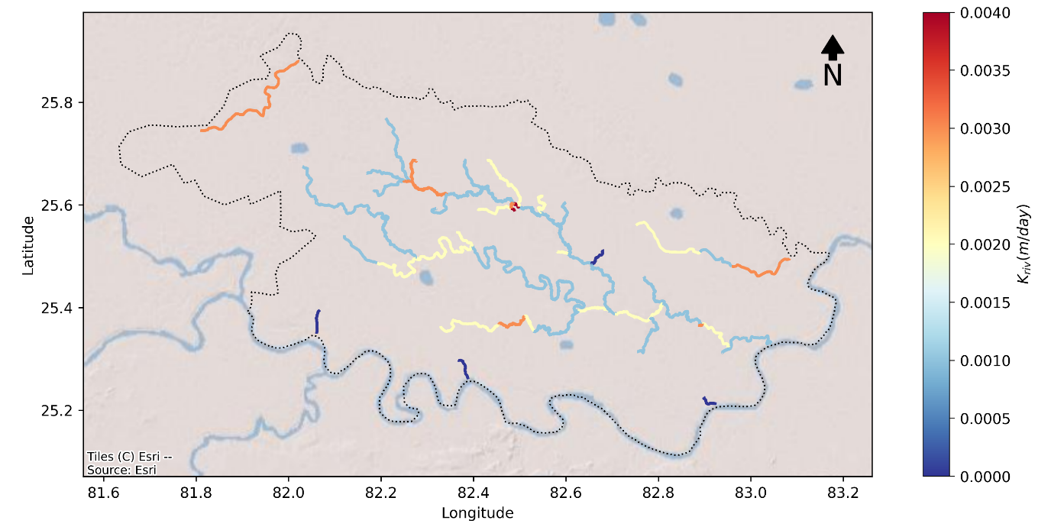
B 1. Calibrated river bed conductivities of Varuna River

https://upgwd.gov.in/StaticPages/WDMS_Login.aspx
https://indiawris.gov.in/wris/#/
Digital Geographic Positioning System
Acoustic Doppler Current Profiler

