Supplementary Fig 1 Decontamination and feature-selection workflow for plasma microbial cfRNA profiling
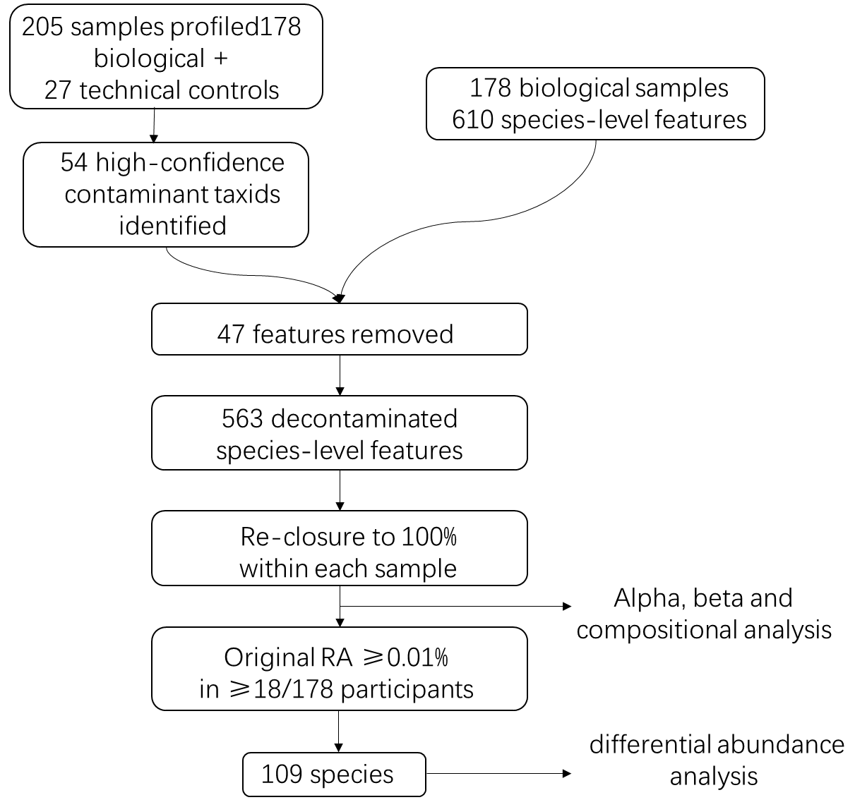
A total of 205 profiles, comprising 178 biological samples and 27 process controls, were analysed using MetaPhlAn and Kraken2. Fifty-four high-confidence contaminant taxids were identified, of which 47 corresponded to MetaPhlAn species-level features present in the biological-sample matrix. Removal of these 47 features reduced the matrix from 610 to 563 features, after which relative abundances were re-closed to 100% within each sample. The complete 563-feature matrix was used for alpha-diversity, beta-diversity and taxonomic-composition analyses. For differential-abundance analysis, 109 species with an original relative abundance ≥0.01% in at least 18 of the 178 participants were retained.

Supplementary Fig 2. Exploratory EC-level plasma cfRNA associations with PANSS dimensions
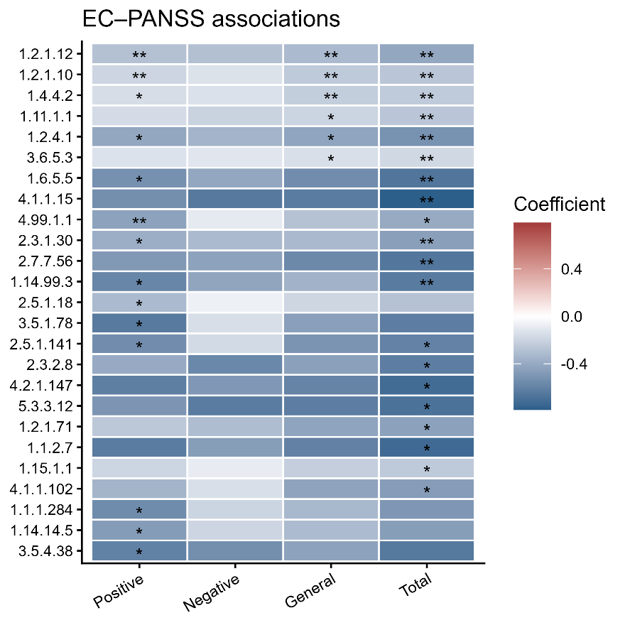
Heatmap of fitted MaAsLin3 abundance coefficients for 25 EC reactions reaching q <0.10 for at least one PANSS outcome in participants with schizophrenia. Sample sizes were 51for Positive, 50 for Negative, and 48 each for General Psychopathology and Total. Models adjusted for age, sex, BMI and log10 plasma clean reads; total-sum scaling, log transformation and 10% minimum prevalence were used. Blue and red indicate negative and positive coefficients. ** q < 0.05; *0.05 < q <0.10 from within-outcome BH-correctedmedian-comparison tests. No Negative-subscale association reached q < 0.10.

