Table S1. Risk stratification by the models of Cox regression and RSF
Risk | Event  No. (%) | HR  (95%CI) | Log-rank P value
Low risk | 26 (8.0%) | Ref. | < 0.001
Medium risk | 33 (27.5%) | 4.23 (2.53 -7.08) | < 0.001
High risk | 142 (44.1%) | 7.94 (5.22-12.09) | < 0.001
CI indicates confidence interval; HR, hazard ratio; Ref, reference; RSF, random survival forest.

Table S2. Subgroup analysis for concentric hypertrophy on the primary-outcome events
Stratification factors |  | HR (95% CI) | P for interaction
Age | ≥ 65  < 65 | 1.52 (1.09-2.11)  1.09 (0.60-1.98) | 0.318
Gender | Male  Female | 1.43 (0.97-2.11)  1.39 (0.91-2.12) | 0.763
Race | White  Non-white | 1.33 (0.95-1.86)  1.48 (0.84-2.61) | 0.933
Region | Americas  Russia and Georgia | 1.41 (1.04-1.90)  1.19 (0.44-3.20) | 0.849
ACEI or ARB | With  Without | 1.56 (1.13-2.13)  0.92 (0.45-1.89) | 0.182
Atrial fibrillation | With  Without | 1.32 (0.84-2.05)  1.34 (0.91-1.97) | 0.886
ACEI indicates angiotensin converting enzyme inhibitor; ARB, angiotensin receptor blocker; CI, confidence interval; HR, hazard ratio. HRs and P values were adjusted by age, gender, NYHA classification, smoking, heart rate, systolic blood pressure, diastolic blood pressure, serum creatinine, and haemoglobin levels. If a variable was used as a stratification factor, it was ignored for adjustment.

Table S3. Sensitivity analysis for the Cox model and the RSF model
Models | C-index  (95% CI) | AUC (95% CI)
Models | C-index  (95% CI) | 1-year | 3-year | 5-year
Exclusion of participants without the use of ACEI or ARB (n = 606)
Cox regression | 0.711  (0.669-0.753) | 0.692  (0.626-0.758) | 0.767  (0.717-0.817) | 0.811  (0.755-0. 868)
RSF | 0.808  (0.776-0.840) | 0.823  (0.773-0.874) | 0.864  (0.826-0.901) | 0.879  (0.831-0.927)
Exclusion of participants without hypertension (n = 696)
Cox regression | 0.709  (0.669-0.748) | 0.712  (0.653-0.771) | 0.755  (0.706-0.804) | 0.804  (0.750-0.859)
RSF | 0.807  (0.778-0.837) | 0.832  (0.787-0.877) | 0.860  (0.825-0.896) | 0.884  (0.839-0.929)
Inclusion of only white participants (n = 617)
Cox regression | 0.721  (0.677-0.765) | 0.720  (0.650-0.789) | 0.760  (0.706-0.814) | 0.814  (0.758-0.870)
RSF | 0.811  (0.777-0.845) | 0.836  (0.784-0.888) | 0.852  (0.810-0.893) | 0.889  (0.845-0.933)
ACEI indicates angiotensin converting enzyme inhibitor; ARB, angiotensin receptor blocker; AUC, the area under the receiver operating characteristic curve; C-index, concordance index; CI, confidence interval; RSF, random survival forest.

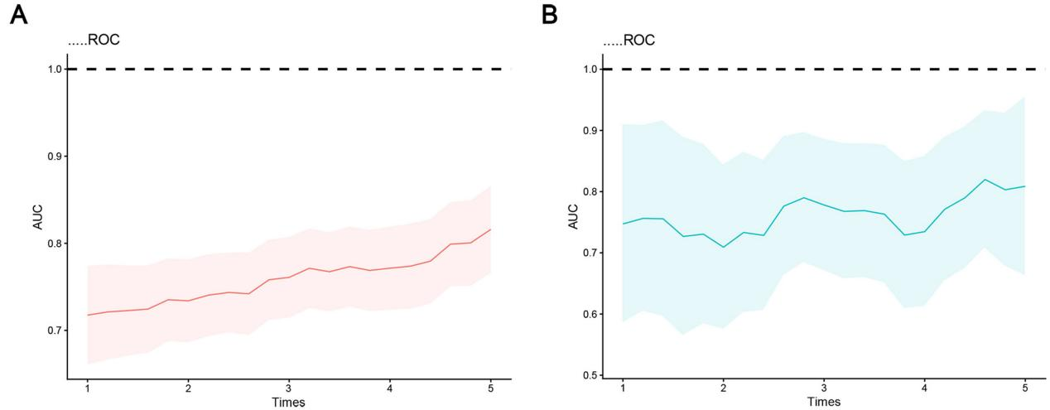
Figure S1. The time-dependent AUCs for the Cox model and the RSF model.
(A) The Cox model. (B) The RSF model. AUC indicated area under the curve; RSF, random survival forest.
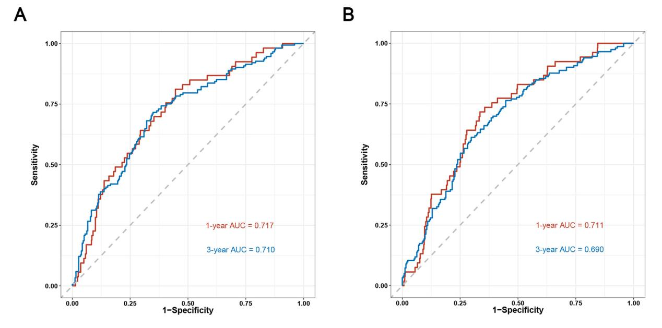
Figure S2. External validation for the prediction models.
(A) The ROC of the Cox model for predicting the primary-outcome events using the data from the PARAGON-HF trail. (B) The ROC of the RSF model for predicting the primary-outcome events using the data from the PARAGON-HF trail. RSF indicated random survival forest.

