Supplementary Material

Table S1: OPS procedure codes used to identify neck dissection
OPS code | Procedure description
5-403.00 | Radical cervical lymphadenectomy (neck dissection), selective (functional): 1 region
5-403.01 | Radical cervical lymphadenectomy (neck dissection), selective (functional): 2 regions
5-403.02 | Radical cervical lymphadenectomy (neck dissection), selective (functional): 3 regions
5-403.03 | Radical cervical lymphadenectomy (neck dissection), selective (functional): 4 regions
5-403.04 | Radical cervical lymphadenectomy (neck dissection), selective (functional): 5 regions
5-403.05 | Radical cervical lymphadenectomy (neck dissection), selective (functional): 6 regions
5-403.10 | Radical cervical lymphadenectomy (neck dissection), radical: 4 regions
5-403.11 | Radical cervical lymphadenectomy (neck dissection), radical: 5 regions
5-403.12 | Radical cervical lymphadenectomy (neck dissection), radical: 6 regions
5-403.20 | Radical cervical lymphadenectomy (neck dissection), modified radical: 4 regions
5-403.21 | Radical cervical lymphadenectomy (neck dissection), modified radical: 5 regions
5-403.22 | Radical cervical lymphadenectomy (neck dissection), modified radical: 6 regions
5-403.30 | Radical cervical lymphadenectomy (neck dissection), extended radical: 4 regions
5-403.31 | Radical cervical lymphadenectomy (neck dissection), extended radical: 5 regions
5-403.32 | Radical cervical lymphadenectomy (neck dissection), extended radical: 6 regions
5-403.x | Radical cervical lymphadenectomy (neck dissection): other specified
5-403.y | Radical cervical lymphadenectomy (neck dissection): not otherwise specified
OPS: German Operations and Procedures Classification.

Table S2: ICD-10-GM codes for malignant neoplasms of the head and neck used for exclusion in the control cohort
ICD-10-GM Code | ICD-10 term
C00 | Malignant neoplasm of the lip
C01 | Malignant neoplasm of the base of tongue
C02 | Malignant neoplasm of other and unspecified parts of the tongue
C03 | Malignant neoplasm of gum
C04 | Malignant neoplasm of floor of mouth
C05 | Malignant neoplasm of palate
C06 | Malignant neoplasm of other and unspecified parts of the mouth
C07 | Malignant neoplasm of parotid gland
C08 | Malignant neoplasm of other and unspecified major salivary glands
C09 | Malignant neoplasm of tonsil
C10 | Malignant neoplasm of oropharynx
C11 | Malignant neoplasm of nasopharynx
C12 | Malignant neoplasm of piriform sinus
C13 | Malignant neoplasm of hypopharynx
C14 | Malignant neoplasm of other and ill-defined sites in the lip, oral cavity and pharynx
C30 | Malignant neoplasm of nasal cavity and middle ear
C31 | Malignant neoplasm of accessory sinuses
C32 | Malignant neoplasm of larynx
C33 | Malignant neoplasm of trachea
C430 | Malignant melanoma of lip
C431 | Malignant melanoma of eyelid
C432 | Malignant melanoma of ear
C433 | Malignant melanoma of other face
C434 | Malignant melanoma of scalp and neck
C439 | Malignant melanoma, unspecified (possible mucosal origin)
C440 | Malignant neoplasm of lip, sebaceous skin types (PEC/BCC)
C441 | Malignant neoplasm of eyelid and canthus, sebaceous skin types (PEC/BCC)
C442 | Malignant neoplasm of ear, sebaceous skin types (PEC/BCC)
C443 | Malignant neoplasm of other face, sebaceous skin types (PEC/BCC)
C444 | Malignant neoplasm of scalp, sebaceous skin types (PEC/BCC)
C770 | Malignant neoplasm of lymph nodes of head, face and neck
ICD-10-GM Version 2025 was used to identify relevant head and neck malignancies for exclusion; see ICD-10-GM Version 2025 search tool provided by the German Federal Institute for Drugs and Medical Devices (BfArM).

Table S3: Descriptive Data on patients‘ most common documented diagnoses
ICD Code | Diagnosis | ND | Control | p-value
C32 | Malignant neoplasm of the larynx | 1222 (13.0%) | 0 (0.0%) | <0.001
C77 | Secondary and unspecified malignant neoplasm of lymph nodes | 1929 (20.6%) | 153 (1.6%) | <0.001
C80 | Malignant neoplasm without specification of site | 2003 (21.3%) | 190 (2.0%) | <0.001
E04 | Other nontoxic goiter | 2025 (21.6%) | 1581 (16.8%) | <0.001
E11 | Type 2 diabetes mellitus | 2070 (22.1%) | 2698 (28.7%) | <0.001
E78 | Disorders of lipoprotein metabolism and other lipidemias | 4044 (43.1%) | 4869 (51.9%) | <0.001
E79 | Disorders of purine and pyrimidine metabolism | 1338 (14.3%) | 1747 (18.6%) | <0.001
F32 | Depressive episode | 1706 (18.2%) | 1525 (16.2%) | <0.001
F45 | Somatoform disorders | 1374 (14.6%) | 1456 (15.5%) | <0.001
H52 | Disorders of refraction and accommodation | 3076 (32.8%) | 3839 (40.9%) | <0.001
I10 | Essential (primary) hypertension | 6145 (65.5%) | 7108 (75.7%) | <0.001
I25 | Chronic ischemic heart disease | 1909 (20.3%) | 2749 (29.3%) | <0.001
I50 | Heart failure | 818 (8.7%) | 1814 (19.3%) | <0.001
K76 | Other liver diseases | 1345 (14.3%) | 2503 (26.7%) | <0.001
M17 | Gonarthrosis [knee osteoarthritis] | 1387 (14.8%) | 1861 (19.8%) | <0.001
M47 | Spondylosis | 1523 (16.2%) | 2000 (21.3%) | <0.001
M54 | Back pain | 3088 (32.9%) | 3636 (38.7%) | <0.001
N40 | Prostatic hyperplasia | 1427 (15.2%) | 1944 (20.7%) | <0.001
N95 | Menopausal and perimenopausal disorders | 1096 (11.7%) | 1467 (15.6%) | <0.001

Table S4. ICD-10-GM codes recorded on the date of first documented dementia diagnosis during follow-up
ICD Code | ICD Term | Control | ND
F000 | Dementia in Alzheimer’s disease, early onset (type 2) | 4 | 2
F001 | Dementia in Alzheimer’s disease, late onset (type 1) | 57 | 45
F002 | Dementia in Alzheimer’s disease, atypical or mixed type | 26 | 14
F009 | Dementia in Alzheimer’s disease, unspecified | 31 | 31
F010 | Vascular dementia of acute onset | 7 | 2
F011 | Multi-infarct dementia | 25 | 11
F012 | Subcortical vascular dementia | 21 | 9
F013 | Mixed cortical and subcortical vascular dementia | 31 | 18
F018 | Other vascular dementia | 28 | 14
F019 | Vascular dementia, unspecified | 130 | 68
F020 | Dementia in Pick disease | 1 | 2
F022 | Dementia in Huntington disease | 0 | 1
F023 | Dementia in Parkinson disease | 27 | 9
F028 | Dementia in other diseases classified elsewhere | 7 | 4
F03 | Unspecified dementia | 571 | 401
F067 | Mild cognitive impairment | 213 | 111
Counts represent the number of patients with the respective ICD-10-GM code recorded on the date of their first documented dementia diagnosis during follow-up. Because more than one dementia code could be recorded on that date, patients may appear in more than one category. Accordingly, categories are not mutually exclusive and column totals should not be summed.

Figure S1: Overall survival after neck dissection compared with matched controls
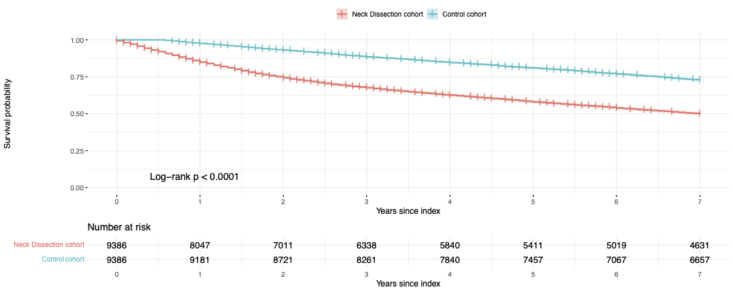
Kaplan-Meier estimates of all-cause survival in the neck dissection cohort and the propensity score-matched control cohort over 7 years of follow-up. Shaded areas indicate 95% confidence intervals. Numbers at risk are shown in the x-axis. Grouips were compared using the log-rank test.

Figure S2: Overall survival after neck dissection compared with matched controls in female patients
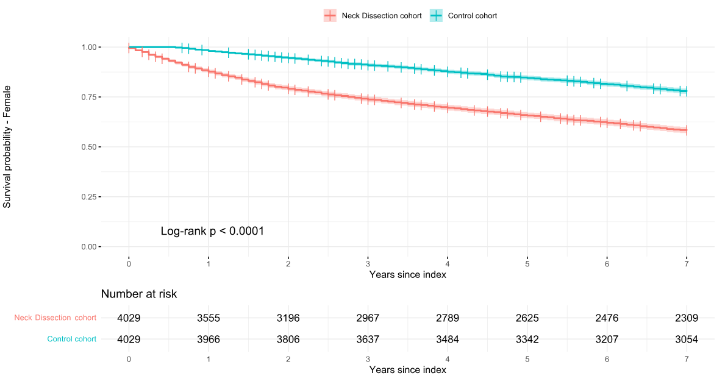
Kaplan–Meier estimates of all-cause survival among female patients in the neck dissection cohort and matched controls during 7 years of follow-up. Shaded areas represent 95% confidence intervals. Numbers at risk are shown below the x-axis. Group differences were assessed using the log-rank test.

Figure S3: Overall survival after neck dissection compared with matched controls in male patients

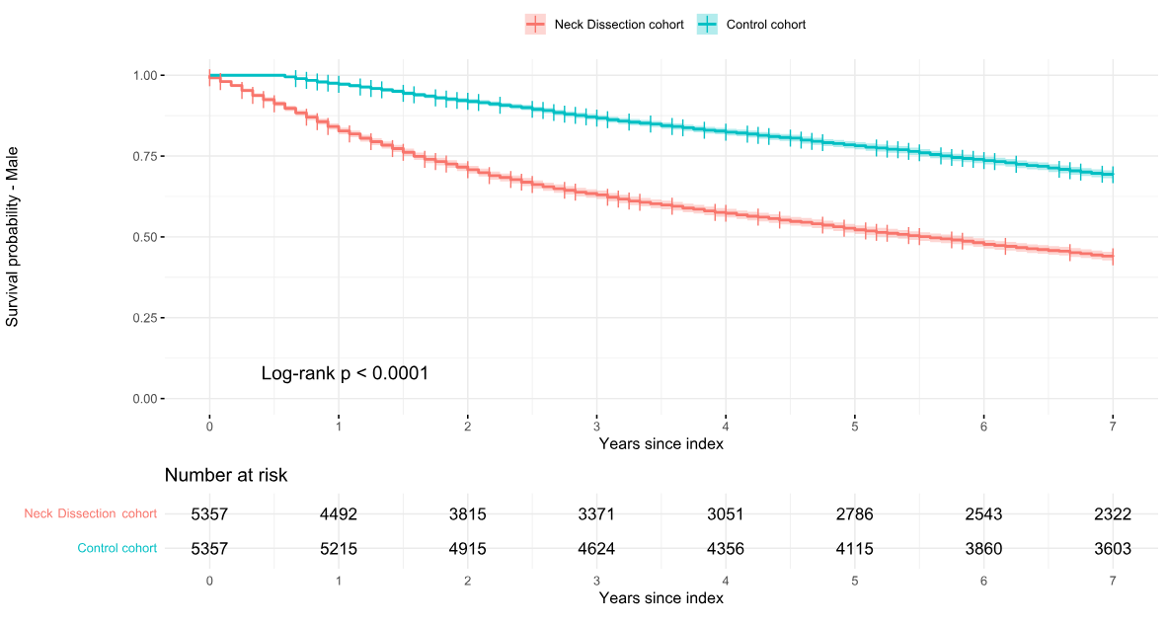
Kaplan–Meier estimates of all-cause survival among male patients in the neck dissection cohort and matched controls during 7 years of follow-up. Shaded areas indicate 95% confidence intervals. Numbers at risk are displayed below the x-axis. Survival curves were compared using the log-rank test.

Figure S4: Forest Plot of Adjusted Fine–Gray Subdistribution Hazard Ratios for Dementia Incidence

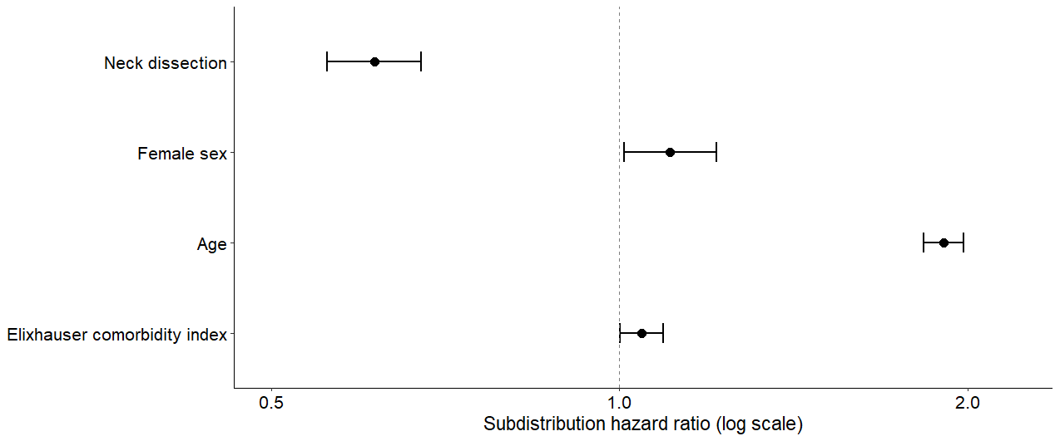

Adjusted Fine–Gray regression for dementia incidence, with death modelled as a competing event. Subdistribution hazard ratios (sHR) and 95 % confidence intervals are shown for neck dissection status, sex, age (z-score), and Elixhauser comorbidity Index. Age and Elixhauser comorbidity index were entered as z-standardised continous variables.

