Additional file 1
Supplementary Material
A Calibrated Glycaemic-Blind Machine-Learning Model for Opportunistic Prediabetes Screening in UK Biobank
This supplementary file supports the original 82-feature Stage-1 LightGBM analysis.
Supplementary Tables
Supplementary Table S1. Original 82-feature glycaemic-blind predictor set
Predictor order corresponds to the original fitted LightGBM input matrix; raw field names are retained for reproducibility.
Model order | feature | name
1 | p31 | Sex
2 | p6138 | Qualifications
3 | p21000 | Ethnic background
4 | p20116 | Smoking status
5 | p20117 | Alcohol drinker status
6 | p30710 | C-reactive Protein
7 | p30690 | Cholesterol
8 | p30700 | Creatinine
9 | p30680 | Calcium
10 | p30760 | HDL cholesterol
11 | p30780 | LDL Direct
12 | p30870 | Triglycerides
13 | p26223 | Standard PRS for cardiovascular disease (CVD)
14 | p21001 | BMI
15 | p26285 | Standard PRS for type 2 diabetes (T2D)
16 | p23400 | Total cholesterol
17 | p30880 | Urate
18 | p48 | Waist circumference
19 | p30790 | Lipoprotein A
20 | p30670 | Urea
21 | p30730 | Gamma glutamyltransferase
22 | p924 | Usual walking pace
23 | p874 | Duration of walks
24 | p1160 | Sleep duration
25 | p30630 | Apolipoprotein A
26 | p30890 | Vitamin D
27 | p4079_a0 | Diastolic BP (1st Reading)
28 | p4079_a1 | Diastolic BP (2nd Reading)
29 | p4080_a0 | Systolic BP (1st Reading)
30 | p4080_a1 | Systolic BP (2nd Reading)
31 | p22189 | Townsend deprivation index at recruitment
32 | p1558 | Alcohol intake frequency.
33 | p884 | Number of days/week of moderate physical activity 10+ minutes
34 | p904 | Number of days/week of vigorous physical activity 10+ minutes
35 | p1309 | Fresh fruit intake
36 | p1349 | Processed meat intake
37 | p21002 | Weight
38 | p23099 | Body fat percentage
39 | p49 | Hip circumference
40 | p30620 | Alanine aminotransferase
41 | p30650 | Aspartate aminotransferase
42 | p30720 | Cystatin C
43 | p23440 | Apolipoprotein A1
44 | p30640 | Apolipoprotein B
45 | age_at_assessment | Age at Assessment
46 | p23400_missing | Total Cholesterol (Missing)
47 | p30790_missing | Lipoprotein A (Missing)
48 | medication | Medication Use
49 | cvd_high_blood_pressure | CVD: Hypertension
50 | cvd_heart_attack | CVD: Heart Attack
51 | cvd_angina | CVD: Angina
52 | cvd_stroke | CVD: Stroke
53 | father_heart_disease | Father: Heart Disease
54 | father_high_blood_pressure | Father: Hypertension
55 | father_stroke | Father: Stroke
56 | father_lung_cancer | Father: Lung Cancer
57 | father_bowel_cancer | Father: Bowel Cancer
58 | mother_heart_disease | Mother: Heart Disease
59 | mother_high_blood_pressure | Mother: Hypertension
60 | mother_stroke | Mother: Stroke
61 | mother_lung_cancer | Mother: Lung Cancer
62 | mother_bowel_cancer | Mother: Bowel Cancer
63 | mother_breast_cancer | Mother: Breast Cancer
64 | leisure_activity_count | Leisure Activity Count
65 | sbp_final | Systolic BP (Final)
66 | dbp_final | Diastolic BP (Final)
67 | pulse_pressure | Pulse Pressure
68 | bmi_age | BMI × Age
69 | bmi_sleep | BMI × Sleep Duration
70 | sbp_bmi | SBP × BMI
71 | dbp_bmi | DBP × BMI
72 | walking_bmi | Walking Duration × BMI
73 | bmi_crp | BMI × CRP
74 | sbp_age | SBP × Age
75 | log1p_crp | log(CRP + 1)
76 | log1p_tg | log(Triglycerides + 1)
77 | remnant_chol | Remnant Cholesterol
78 | non_hdl_chol | Non-HDL Cholesterol
79 | tg_hdl_ratio | Triglyceride/HDL Ratio
80 | ldl_hdl_ratio | LDL/HDL Ratio
81 | chol_hdl_ratio | Total Cholesterol/HDL Ratio
82 | aip | Atherogenic Index (AIP)

Supplementary Table S2A. FINDRISC-like proxy construction
Extract-specific glycaemic-blind mapping. The history-of-high-glucose item was excluded to prevent glycaemic leakage.
Item | Original FINDRISC item | UK Biobank field used in this extract | Scoring rule used (points)
1 | Age | p21003_i0 (Age when attended assessment centre) | < 45 y: 0 | 45–54 y: 2 | 55–64 y: 3 | ≥ 65 y: 4
2 | BMI (kg/m²) | p21001_i0 (Body mass index) | < 25: 0 | 25 to ≤ 30: 1 | > 30: 3
3 | Waist circumference (cm), sex-specific | p48_i0 (Waist circumference); p31 (Sex) | Men: < 94: 0 | 94–102: 3 | > 102: 4. Women: < 80: 0 | 80–88: 3 | > 88: 4.
4 | Daily ≥ 30 min physical activity (work + leisure) | p884_i0 (Days/wk moderate activity ≥10 min); p904_i0 (Days/wk vigorous activity ≥10 min). NB: IPAQ MET-min/wk fields are not present in this extract. | Moderate ≥ 5 days/wk OR vigorous ≥ 3 days/wk: 0 | Otherwise (or missing): 2
5 | Daily vegetable, fruit, or berry consumption | p1309_i0 (Fresh fruit intake, portions/day). NB: cooked-vegetable (p1289), salad (p1299), and dried-fruit (p1319) fields are not present in this extract; the proxy is fresh-fruit-only. | Fresh fruit ≥ 1 portion/day: 0 | < 1 portion/day (or missing): 1
6 | Use of antihypertensive medication | p6177_i0 (men) / p6153_i0 (women) — value code "2" = Blood pressure medication | No: 0 | Yes: 2
7 | History of high blood glucose (any context) | EXCLUDED — would constitute glycaemic-history leakage in a glycaemic-blind comparator | n/a (item removed)
8 | Family history of type 2 diabetes | p20107_i0 (Illnesses of father); p20110_i0 (Illnesses of mother). Value code 9 = Diabetes. NB: p20111 (siblings) is not present in this extract, so the family-history score is parental-only. | Either parent has diabetes (code 9 in p20107_i0 or p20110_i0): 5 | Neither parent: 0. The original FINDRISC "2nd-degree only" branch (3 pts) is unreachable in this extract.

Supplementary Table S2B. ADA-like proxy construction
Extract-specific mapping; these scores are proxies rather than exact implementations of the original instruments.
Item | Original ADA Risk Test item | UK Biobank field used in this extract | Scoring rule used (points)
1 | Age | p21003_i0 (Age when attended assessment centre) | < 40 y: 0 | 40–49 y: 1 | 50–59 y: 2 | ≥ 60 y: 3
2 | Sex (male) | p31 (Sex) | Female: 0 | Male: 1
3 | Family history of diabetes (immediate) | p20107_i0 (father); p20110_i0 (mother). NB: p20111 (siblings) is not present in this extract; the proxy is parental-only. | Either parent has diabetes (code 9): 1 | Neither parent: 0
4 | Hypertension or antihypertensive medication | p4080_i0_a0 + p4080_i0_a1 (Systolic BP automated, both readings, averaged); p4079_i0_a0 + p4079_i0_a1 (Diastolic BP automated, averaged); p6153_i0 / p6177_i0 (medication codes) | Mean SBP ≥ 140 mmHg OR mean DBP ≥ 90 mmHg OR antihypertensive medication (code 2): 1 | Otherwise: 0
5 | Physically active | p884_i0 (moderate days/wk) and p904_i0 (vigorous days/wk). NB: IPAQ MET-min/wk fields are not present in this extract. | Moderate ≥ 5 days/wk OR vigorous ≥ 3 days/wk: 0 | Otherwise (or missing): 1
6 | BMI (kg/m²) | p21001_i0 (Body mass index) | < 25: 0 | 25 to < 30: 1 | 30 to < 40: 2 | ≥ 40: 3
7 | Race/ethnicity (non-White) | p21000_i0 (Ethnic background; UKB Data-Coding 1001) | Codes 1 (White) / 1001 (White-British) / 1002 (White-Irish) / 1003 (any other White background): 0 | All other ethnic backgrounds: 1

Supplementary Table S3A. Subgroup discrimination and probability accuracy
Bootstrap intervals use 1,000 resamples. Brier differences are prevalence-dependent and should be interpreted together with calibration parameters.
Grouping | Subgroup | n | Events | Prev | AUROC (95% interval) | PR-AUC (95% interval) | Brier
Sex | Female | 9,704 | 1,887 | 0.194 | 0.705 (0.693–0.717) | 0.349 (0.330–0.369) | 0.144
Sex | Male | 10,073 | 1,703 | 0.169 | 0.699 (0.686–0.712) | 0.312 (0.292–0.332) | 0.131
Age group | 40–54 | 3,866 | 442 | 0.114 | 0.738 (0.713–0.759) | 0.246 (0.216–0.279) | 0.094
Age group | 55–64 | 9,251 | 1,686 | 0.182 | 0.688 (0.673–0.702) | 0.330 (0.308–0.351) | 0.139
Age group | 65–70 | 6,660 | 1,462 | 0.220 | 0.679 (0.664–0.694) | 0.357 (0.335–0.379) | 0.160
Ethnicity | White | 18,162 | 3,046 | 0.168 | 0.696 (0.686–0.706) | 0.304 (0.289–0.320) | 0.130
Ethnicity | Asian | 573 | 196 | 0.342 | 0.662 (0.617–0.707) | 0.488 (0.424–0.554) | 0.213
Ethnicity | Black | 550 | 202 | 0.367 | 0.619 (0.573–0.665) | 0.459 (0.396–0.527) | 0.233
Ethnicity | Mixed | 129 | 31 | 0.240 | 0.705 (0.597–0.810) | 0.460 (0.305–0.629) | 0.167
Ethnicity | Other | 219 | 77 | 0.352 | 0.679 (0.604–0.745) | 0.526 (0.425–0.635) | 0.226
Ethnicity | Missing/Unknown | 144 | 38 | 0.264 | 0.697 (0.603–0.784) | 0.444 (0.314–0.608) | 0.180

Supplementary Table S3B. Subgroup calibration parameters
Calibration intercept and slope should be interpreted jointly with ECE and calibration curves.
Grouping | Subgroup | ECE | Calibration intercept | Calibration slope
Sex | Female | 0.007 | 0.056 | 1.029
Sex | Male | 0.015 | 0.063 | 1.128
Age group | 40–54 | 0.015 | 0.073 | 1.067
Age group | 55–64 | 0.011 | 0.069 | 1.094
Age group | 65–70 | 0.011 | 0.060 | 1.079
Ethnicity | White | 0.013 | -0.016 | 1.062
Ethnicity | Asian | 0.060 | 0.258 | 0.951
Ethnicity | Black | 0.097 | 0.093 | 0.632
Ethnicity | Mixed | 0.054 | 0.444 | 1.113
Ethnicity | Other | 0.127 | 0.527 | 0.875
Ethnicity | Missing/Unknown | 0.040 | 0.281 | 1.045

Supplementary Table S3C. Classification counts at threshold 0.1065
Counts use the locked overall sensitivity ≥0.90 threshold selected on VAL_pol.
Grouping | Subgroup | TN | FP | FN | TP
Sex | Female | 2,245 | 5,572 | 151 | 1,736
Sex | Male | 2,220 | 6,150 | 129 | 1,574
Age group | 40–54 | 2,026 | 1,398 | 99 | 343
Age group | 55–64 | 1,780 | 5,785 | 132 | 1,554
Age group | 65–70 | 659 | 4,539 | 49 | 1,413
Ethnicity | White | 4,323 | 10,793 | 259 | 2,787
Ethnicity | Asian | 32 | 345 | 5 | 191
Ethnicity | Black | 40 | 308 | 6 | 196
Ethnicity | Mixed | 25 | 73 | 3 | 28
Ethnicity | Other | 29 | 113 | 6 | 71
Ethnicity | Missing/Unknown | 16 | 90 | 1 | 37

Supplementary Table S3D. Threshold-specific subgroup rates at 0.1065
Intervals are 95% bootstrap intervals from 1,000 resamples.
Grouping | Subgroup | Sensitivity (95% interval) | FPR (95% interval) | PPV (95% interval) | Referral (95% interval)
Sex | Female | 0.920 (0.908–0.932) | 0.713 (0.703–0.723) | 0.238 (0.228–0.248) | 0.753 (0.745–0.762)
Sex | Male | 0.924 (0.912–0.936) | 0.735 (0.726–0.744) | 0.204 (0.195–0.212) | 0.767 (0.759–0.775)
Age group | 40–54 | 0.776 (0.735–0.814) | 0.408 (0.391–0.425) | 0.197 (0.180–0.217) | 0.450 (0.435–0.465)
Age group | 55–64 | 0.922 (0.909–0.934) | 0.765 (0.755–0.774) | 0.212 (0.203–0.222) | 0.793 (0.786–0.801)
Age group | 65–70 | 0.966 (0.956–0.975) | 0.873 (0.865–0.882) | 0.237 (0.227–0.248) | 0.894 (0.886–0.901)
Ethnicity | White | 0.915 (0.905–0.925) | 0.714 (0.707–0.721) | 0.205 (0.198–0.212) | 0.748 (0.742–0.754)
Ethnicity | Asian | 0.974 (0.950–0.995) | 0.915 (0.885–0.943) | 0.356 (0.315–0.398) | 0.935 (0.916–0.955)
Ethnicity | Black | 0.970 (0.944–0.991) | 0.885 (0.851–0.915) | 0.389 (0.343–0.431) | 0.916 (0.895–0.940)
Ethnicity | Mixed | 0.903 (0.778–1.000) | 0.745 (0.653–0.830) | 0.277 (0.190–0.356) | 0.783 (0.713–0.853)
Ethnicity | Other | 0.922 (0.857–0.974) | 0.796 (0.725–0.861) | 0.386 (0.317–0.452) | 0.840 (0.790–0.890)
Ethnicity | Missing/Unknown | 0.974 (0.915–1.000) | 0.849 (0.782–0.917) | 0.291 (0.215–0.375) | 0.882 (0.826–0.938)

Supplementary Table S4. Top 25 predictors by permutation importance
Importance is the decrease in test PR-AUC after permuting one feature. Repeat ranges are 2.5th–97.5th percentiles across ten permutations and are descriptive repeat ranges, not confidence intervals.
Rank | Feature | Mean ΔPR-AUC | Repeat range | Positive repeats | Mean ΔAUROC
1 | Ethnic background | 0.02906 | 0.02543–0.03216 | 10/10 | 0.02485
2 | Standard PRS for type 2 diabetes (T2D) | 0.02390 | 0.02212–0.02655 | 10/10 | 0.02473
3 | Medication Use | 0.01869 | 0.01599–0.02181 | 10/10 | 0.02065
4 | Smoking status | 0.01214 | 0.01067–0.01396 | 10/10 | 0.00981
5 | Age at Assessment | 0.01203 | 0.00909–0.01458 | 10/10 | 0.01492
6 | BMI × Age | 0.00810 | 0.00495–0.01032 | 10/10 | 0.00893
7 | Alcohol intake frequency. | 0.00736 | 0.00454–0.00947 | 10/10 | 0.00841
8 | Sex | 0.00630 | 0.00544–0.00696 | 10/10 | 0.00640
9 | Waist circumference | 0.00384 | 0.00117–0.00711 | 10/10 | 0.00396
10 | Gamma glutamyltransferase | 0.00314 | 0.00170–0.00476 | 10/10 | 0.00270
11 | BMI × CRP | 0.00237 | 0.00020–0.00409 | 9/10 | 0.00437
12 | Hip circumference | 0.00226 | 0.00080–0.00325 | 10/10 | 0.00246
13 | Body fat percentage | 0.00222 | -0.00001–0.00435 | 9/10 | 0.00211
14 | Urate | 0.00210 | 0.00084–0.00392 | 10/10 | 0.00114
15 | Apolipoprotein B | 0.00075 | -0.00018–0.00159 | 9/10 | 0.00050
16 | Weight | 0.00068 | 0.00034–0.00113 | 10/10 | 0.00066
17 | HDL cholesterol | 0.00064 | -0.00014–0.00136 | 8/10 | 0.00023
18 | Apolipoprotein A | 0.00057 | -0.00092–0.00183 | 7/10 | 0.00069
19 | Qualifications | 0.00055 | 0.00005–0.00133 | 10/10 | 0.00031
20 | Alcohol drinker status | 0.00051 | 0.00022–0.00069 | 10/10 | 0.00028
21 | Leisure Activity Count | 0.00045 | -0.00001–0.00087 | 9/10 | 0.00038
22 | Calcium | 0.00045 | -0.00043–0.00113 | 7/10 | 0.00017
23 | LDL/HDL Ratio | 0.00043 | 0.00026–0.00070 | 10/10 | 0.00016
24 | Cystatin C | 0.00043 | -0.00014–0.00094 | 8/10 | -0.00009
25 | Urea | 0.00039 | -0.00063–0.00111 | 7/10 | 0.00053

Supplementary Table S5. Sex-by-age operating characteristics
Intersectional analysis is descriptive and uses the locked threshold 0.1065. It was not used to derive subgroup-specific thresholds.
Subgroup | n | Events | Prev. | AUROC | Sens. | FPR | PPV | Referral
Female, 40–54 | 1,962 | 228 | 0.116 | 0.732 | 0.746 | 0.378 | 0.206 | 0.421
Female, 55–64 | 4,609 | 923 | 0.200 | 0.690 | 0.926 | 0.769 | 0.232 | 0.801
Female, 65–70 | 3,133 | 736 | 0.235 | 0.680 | 0.966 | 0.868 | 0.255 | 0.891
Male, 40–54 | 1,904 | 214 | 0.112 | 0.748 | 0.808 | 0.439 | 0.189 | 0.481
Male, 55–64 | 4,642 | 763 | 0.164 | 0.682 | 0.916 | 0.761 | 0.192 | 0.786
Male, 65–70 | 3,527 | 726 | 0.206 | 0.675 | 0.967 | 0.878 | 0.222 | 0.896

Supplementary Table S6. Recovered p21000 label-encoding map
The map is provided for reproducibility. Ethnicity is a nominal self-reported variable; encoded integers do not represent clinical ordering.
Raw p21000 category | Encoded value | Test n
African | 0 | 209
Any other Asian background | 1 | 105
Any other Black background | 2 | 4
Any other mixed background | 3 | 47
Any other white background | 4 | 682
Asian or Asian British | 5 | 3
Bangladeshi | 6 | 6
Black or Black British | 7 | 1
British | 8 | 16,790
Caribbean | 9 | 336
Chinese | 10 | 65
Indian | 11 | 341
Irish | 12 | 668
Mixed | 13 | 2
Other ethnic group | 14 | 219
Pakistani | 15 | 53
Missing/Unknown | 16 | 144
White | 17 | 22
White and Asian | 18 | 37
White and Black African | 19 | 16
White and Black Caribbean | 20 | 27

Supplementary Figures
Supplementary Figure S1. Additional SHAP dependence plots for secondary predictors.
SHAP values were calculated with TreeExplainer for the final original 82-feature LightGBM model on the held-out 2010 test cohort. Panels show gamma-glutamyl transferase (GGT), waist circumference, BMI × CRP, and body fat percentage. For visual legibility, plotted points are a fixed random subsample of 10,000 test participants.
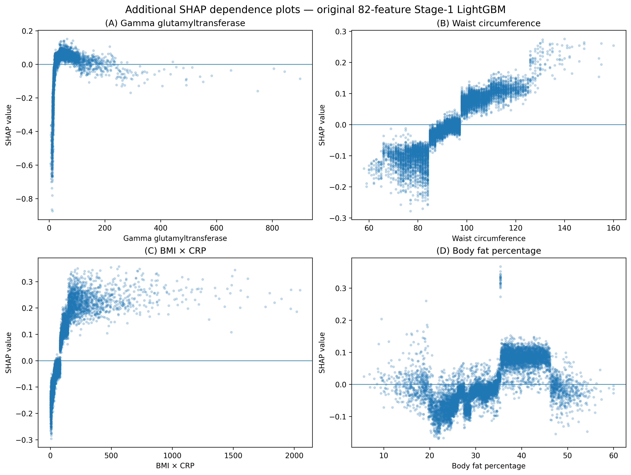
Supplementary Figure S2. Confusion matrices at the three locked operating thresholds.
Confusion matrices for the original 82-feature Stage-1 model at the Best-F1, sensitivity ≥0.90, and sensitivity ≥0.85 thresholds. All thresholds were locked before evaluation on the held-out 2010 test cohort.
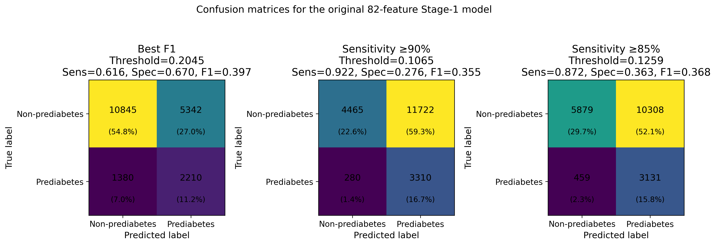
Supplementary Figure S3. Distribution of predicted probabilities by true outcome label.
Predicted probability distributions for the original 82-feature Stage-1 model. Vertical lines indicate the three locked operating thresholds.
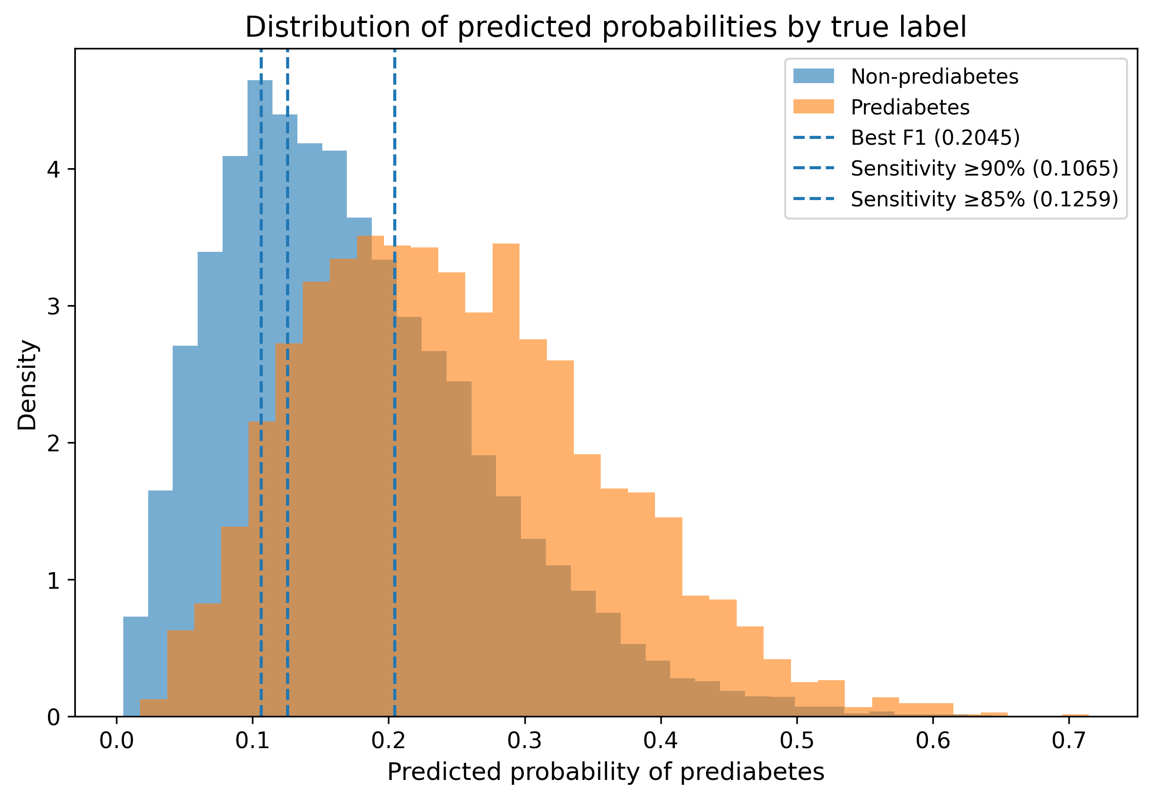
Supplementary Figure S4. Subgroup calibration of the original 82-feature model.
Calibration is shown by sex, age group, and broad ethnic group. Smaller ethnic groups have greater sampling uncertainty; subgroup calibration differences should be interpreted together with prevalence and sample size.
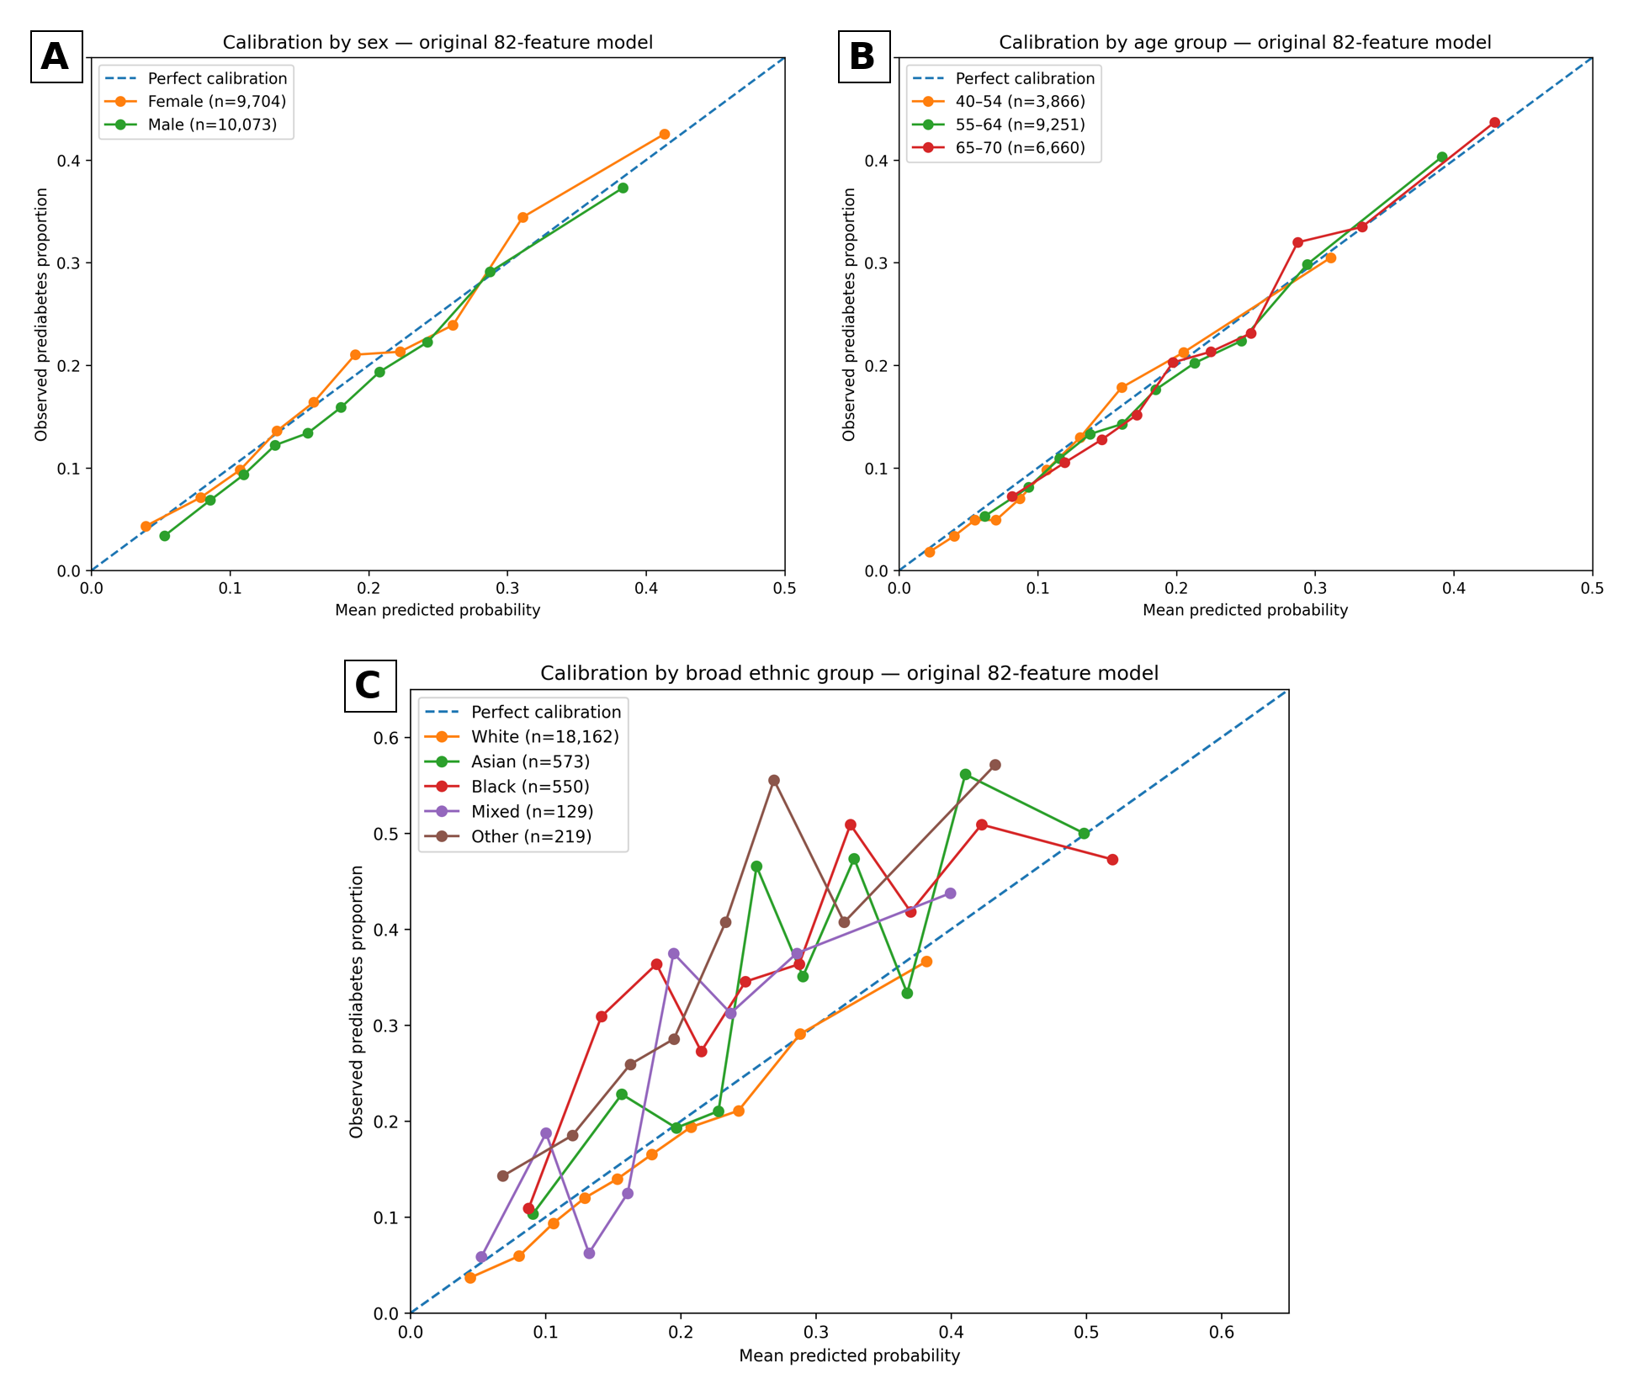
Supplementary Figure S5. Ethnicity subgroup fairness gaps relative to the White reference.
Differences at threshold 0.1065 are descriptive post-hoc operating-characteristic comparisons. Bootstrap intervals are reported in the supplementary subgroup tables.



