SUPPLEMENTAL MATERIAL FOR

Comparative Efficacy over time of the mRNA-1273 (Moderna) vaccine and the BNT162b2 (Pfizer-BioNTech) vaccine

Md Nazmul Islam, PhD, MBA
Natalie E. Sheils, PhD
Megan S. Jarvis, MS
Kenneth Cohen, MD

Figure S1. (A) Occupation probabilities of different states over time. Differences between first and second dose for (B) BNT-162b2 and (C) mRNA-1273.
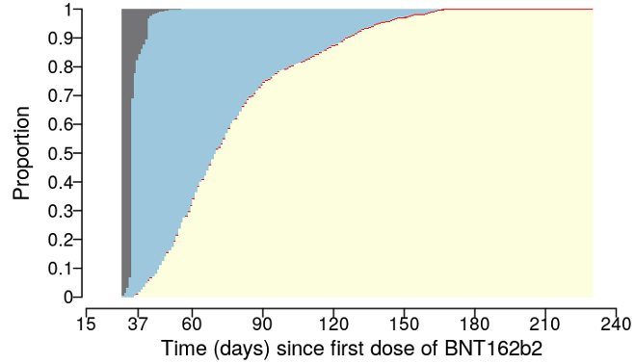
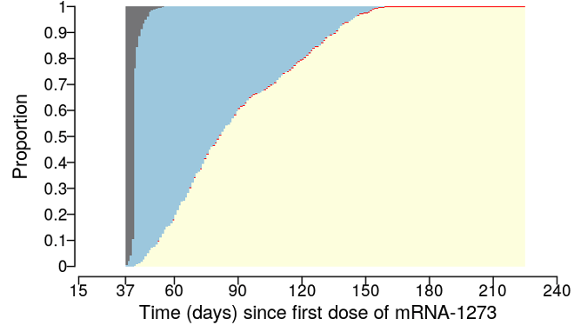
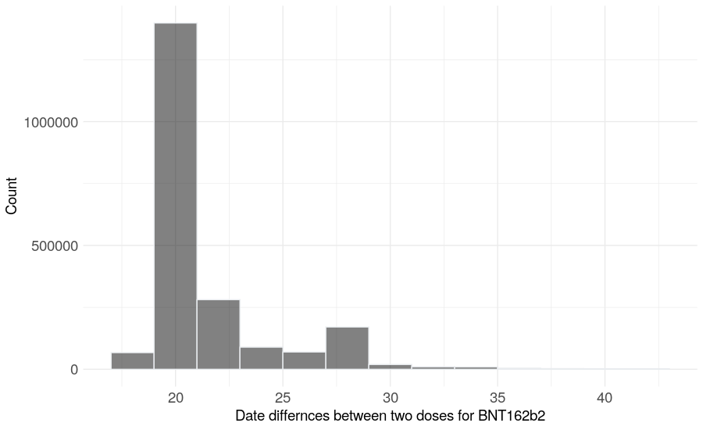
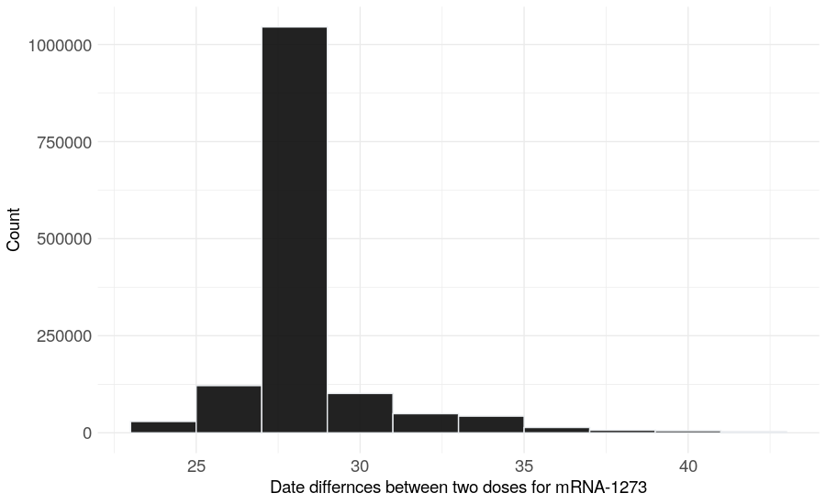
0.40%
84.09%
0.09%
15.42%
0.00%
0.00%
0.35%
99.65%
1.46%
91.30%
0.04%
7.20%
0.00%
0.00%
0.28%
99.72%
People to be fully vaccinated
People infected
People at risk
Censored

(B) (C)

Figure S2: The sample (fully vaccinated) is nationally representative with variation between the two mRNA vaccines.
Sample population (count) by state with mRNA-173 vaccine
Sample population (count) by state with BNT162b2 vaccine

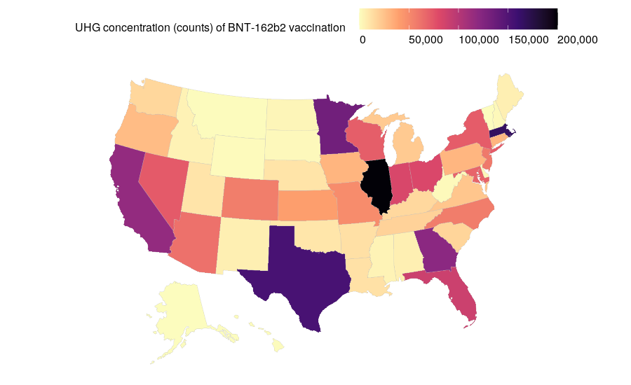
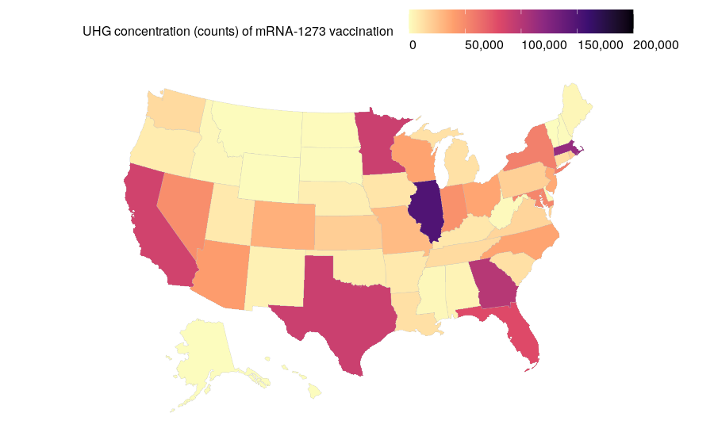

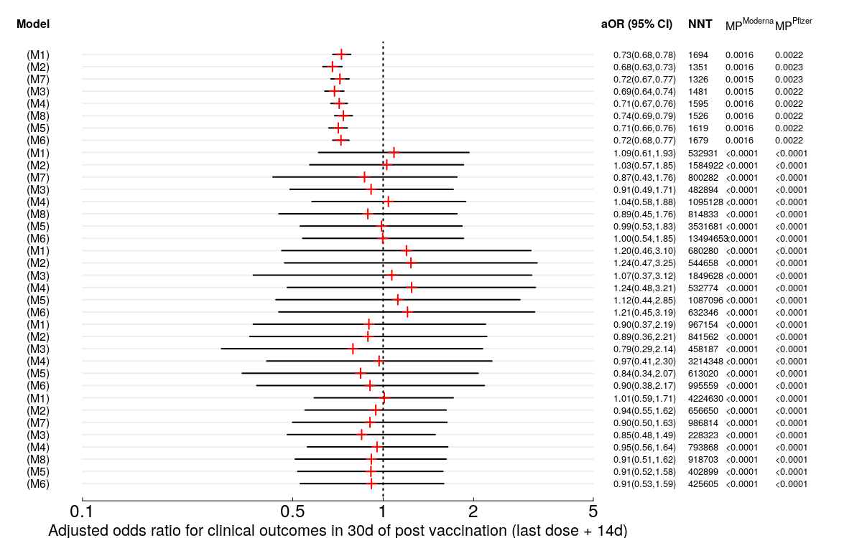
Figure S3: Adjusted odds ratio along with 95% confidence intervals, number needed to treat (NNT), and marginal probabilities (MP) of experiencing events within 30d post vaccination (last dose + 14d) for BNT162b2 (Pfizer) and mRNA-1273 (Moderna).
Unadjusted
Unadjusted with IPTW
Unadjusted & subclassification
Adjusted for imbalances
Adjusted for imbalances with IPTW
Adjusted for imbalances & subclassification
Adjusted for imbalances, prognostic factors
Adjusted for imbalances, prognostic factors with IPTW
Unadjusted
Unadjusted with IPTW
Unadjusted & subclassification
Adjusted for imbalances
Adjusted for imbalances with IPTW
Adjusted for imbalances & subclassification
Adjusted for imbalances, prognostic factors
Adjusted for imbalances, prognostic factors with IPTW
Unadjusted
Unadjusted with IPTW
Adjusted for imbalances
Adjusted for imbalances with IPTW
Adjusted for imbalances, prognostic factors
Adjusted for imbalances, prognostic factors with IPTW
Unadjusted
Unadjusted with IPTW
Adjusted for imbalances
Adjusted for imbalances with IPTW
Adjusted for imbalances, prognostic factors
Adjusted for imbalances, prognostic factors with IPTW
Unadjusted
Unadjusted with IPTW
Unadjusted & subclassification
Adjusted for imbalances
Adjusted for imbalances with IPTW
Adjusted for imbalances & subclassification
Adjusted for imbalances, prognostic factors
Adjusted for imbalances, prognostic factors with IPTW


Infection
Hospitalization


ICU


ICU/Death/
Hospice


Hospitalization/
ICU/Death/
Hospice
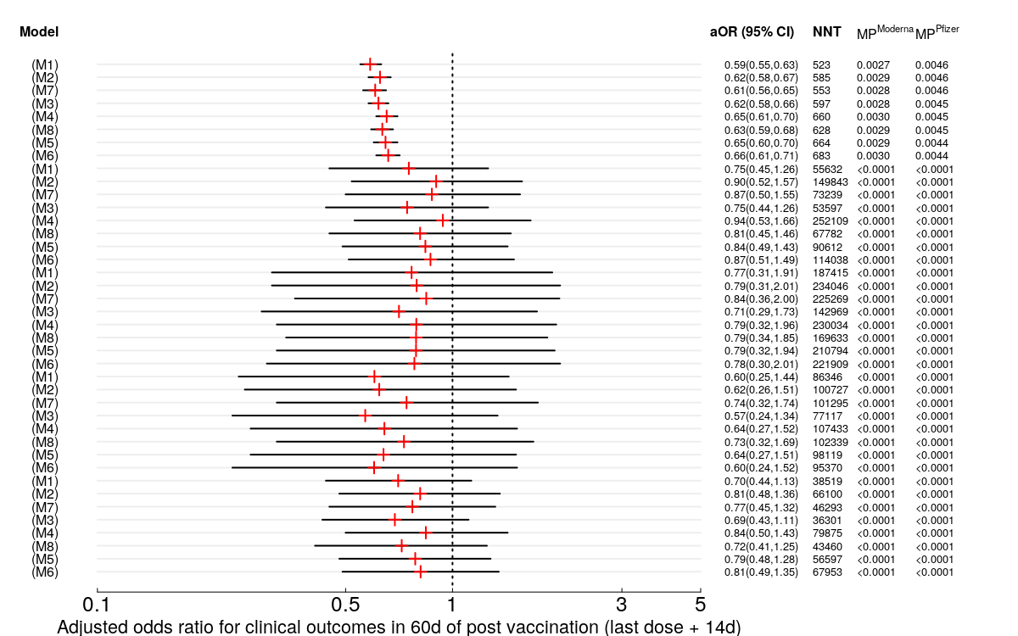
Figure S4: Adjusted odds ratio along with 95% confidence intervals, number needed to treat (NNT), and marginal probabilities (MP) of experiencing events within 60d post vaccination (last dose + 14d) for BNT162b2 (Pfizer) and mRNA-1273 (Moderna).
Unadjusted
Unadjusted with IPTW
Unadjusted & subclassification
Adjusted for imbalances
Adjusted for imbalances with IPTW
Adjusted for imbalances & subclassification
Adjusted for imbalances, prognostic factors
Adjusted for imbalances, prognostic factors with IPTW
Unadjusted
Unadjusted with IPTW
Unadjusted & subclassification
Adjusted for imbalances
Adjusted for imbalances with IPTW
Adjusted for imbalances & subclassification
Adjusted for imbalances, prognostic factors
Adjusted for imbalances, prognostic factors with IPTW
Unadjusted
Unadjusted with IPTW
Adjusted for imbalances
Adjusted for imbalances with IPTW
Adjusted for imbalances, prognostic factors
Adjusted for imbalances, prognostic factors with IPTW
Unadjusted
Unadjusted with IPTW
Adjusted for imbalances
Adjusted for imbalances with IPTW
Adjusted for imbalances, prognostic factors
Adjusted for imbalances, prognostic factors with IPTW
Unadjusted
Unadjusted with IPTW
Unadjusted & subclassification
Adjusted for imbalances
Adjusted for imbalances with IPTW
Adjusted for imbalances & subclassification
Adjusted for imbalances, prognostic factors
Adjusted for imbalances, prognostic factors with IPTW

Infection
Hospitalization

ICU

ICU/Death/
Hospice

Hospitalization/
ICU/Death/
Hospice

Figure S5: Adjusted odds ratio along with 95% confidence intervals, number needed to treat (NNT), and marginal probabilities (MP) of experiencing events within 90d post vaccination (last dose + 14d) for BNT162b2 (Pfizer) and mRNA-1273 (Moderna).
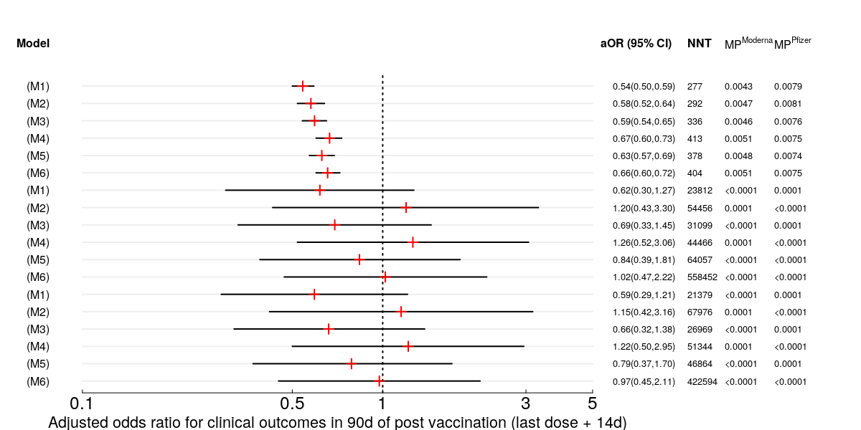
Unadjusted
Unadjusted & with IPTW
Adjusted for imbalances
Adjusted for imbalances & with IPTW
Adjusted for imbalances, prognostic factors
Adjusted for imbalances, prognostic factors & with IPTW
Unadjusted
Unadjusted & with IPTW
Adjusted for imbalances
Adjusted for imbalances & with IPTW
Adjusted for imbalances, prognostic factors
Adjusted for imbalances, prognostic factors & with IPTW
Unadjusted
Unadjusted & with IPTW
Adjusted for imbalances
Adjusted for imbalances & with IPTW
Adjusted for imbalances, prognostic factors
Adjusted for imbalances, prognostic factors & with IPTW

Infection
Hospitalization

Hospitalization/ ICU/Death/
Hospice

Figure S6: Heatmap showing adjusted hazard ratios for comorbidities considered in modeling. Gray boxes without numbers indicate the variable was either not selected in the variable screening step or not found to be statistically significant in the multivariable model.


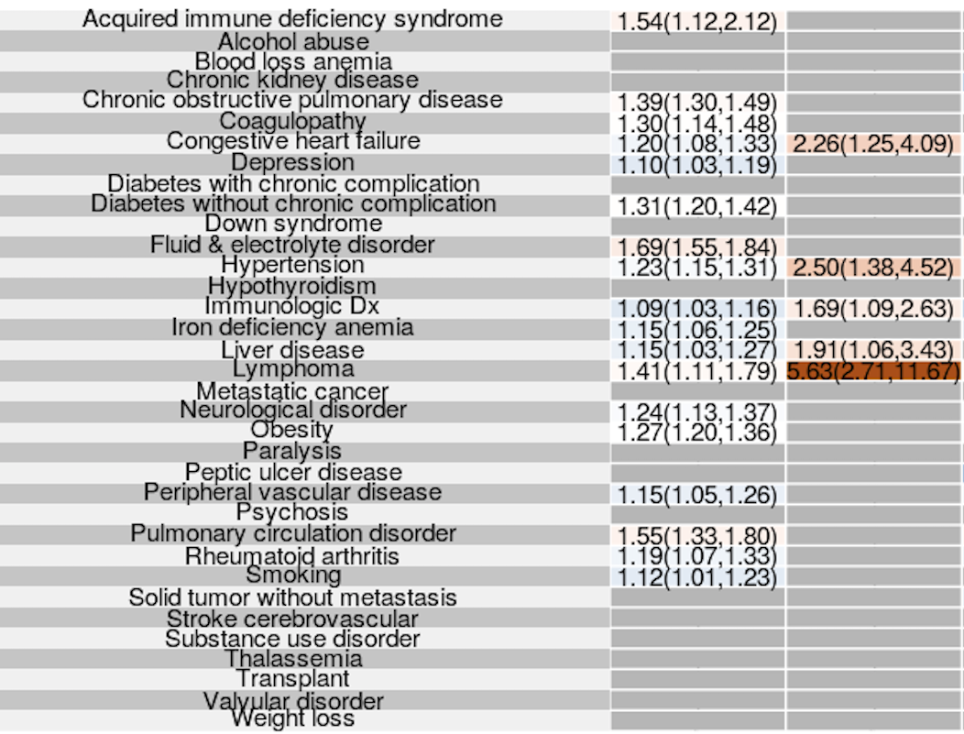
Adjusted hazard ratio (95% CI) for comorbidities
Time-to-event for infection
Time-to-event for hospitalization/ICU/death/hospice
Figure S7: Predicted survival probabilities of a typical (prediction at mode) patient based on the adjusted model for imbalances along with IPTW with respect to (A) SARS-CoV-2 infection and (B) hospitalization/ICU/death/hospice whichever occurring first.

Time-to-hospitalization, ICU, death, or discharge to hospice
Time-to-infection
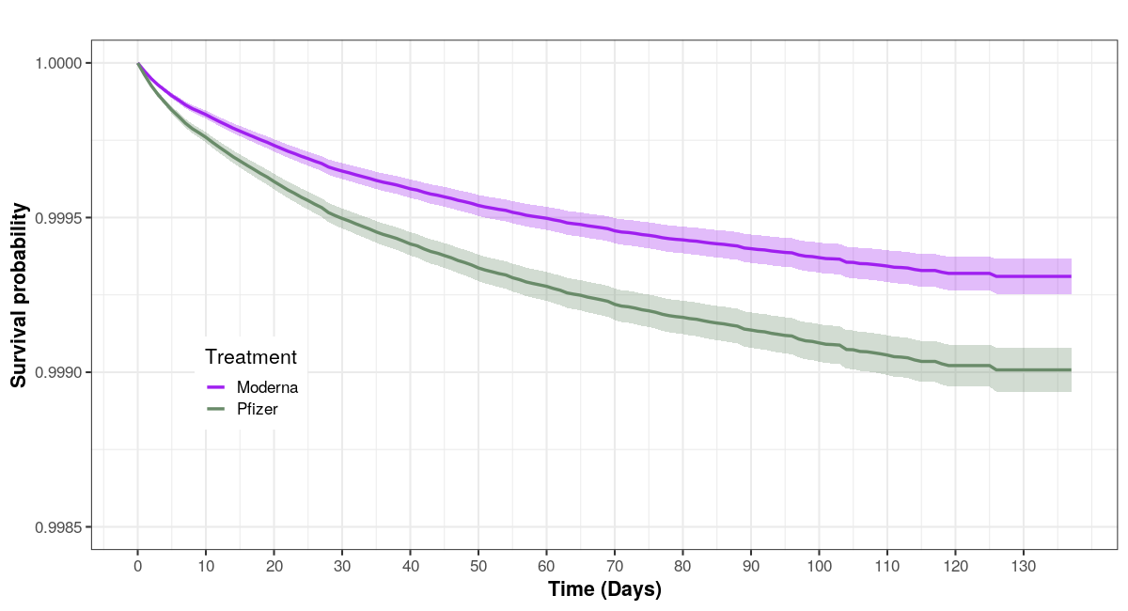
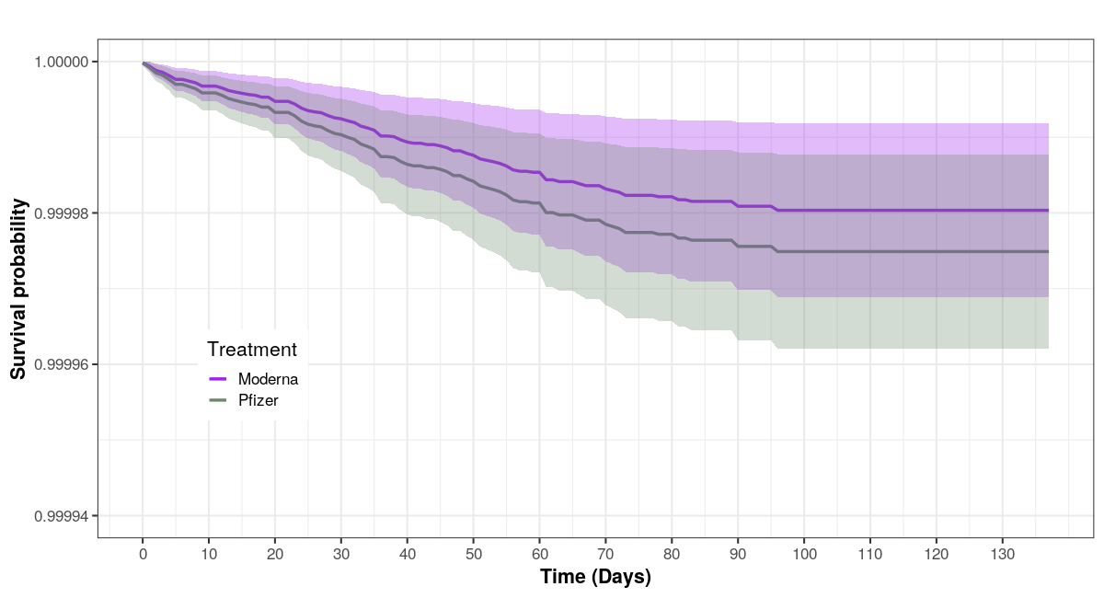
(A)
(B)

Table S1. Standardized mean differences of covariates in unweighted and weighted (IPTW) samples between BNT162b2 and mRNA-1273 vaccinated individuals.

 | 30d post-vaccination  binary outcome |  | 60d post-vaccination  binary outcome |  | 90d post-vaccination  binary outcome |  | Post-vaccination time-to-event
Standardized mean differences (SMD) | Unweighted | IPTW | Unweighted | IPTW | Unweighted | IPTW | Unweighted | IPTW
Age†¶‡ | 0.164 | 0.002 | 0.083 | <0.001 | 0.014 | 0.004 | 0.209 | 0.001
Acquired immune deficiency syndrome†‡ | 0.008 | <0.001 | 0.009 | <0.001 | 0.008 | 0.001 | 0.001 | <0.001
Alcohol abuse†‡ | 0.003 | <0.001 | 0.007 | <0.001 | 0.021 | 0.002 | 0.001 | <0.001
Iron deficiency anemia†‡ | 0.041 | <0.001 | 0.018 | <0.001 | 0.004 | 0.003 | 0.046 | <0.001
Rheumatoid arthritis†‡ | 0.021 | <0.001 | 0.014 | <0.001 | 0.011 | 0.001 | 0.030 | <0.001
Blood loss anemia†‡ | 0.005 | <0.001 | 0.001 | <0.001 | 0.001 | <0.001 | 0.004 | <0.001
Congestive heart failure†‡ | 0.042 | <0.001 | 0.015 | <0.001 | 0.026 | 0.006 | 0.049 | <0.001
Chronic obstructive pulmonary disease†‡ | 0.038 | <0.001 | 0.019 | 0.001 | 0.003 | 0.002 | 0.048 | <0.001
Coagulopathy†‡ | 0.015 | <0.001 | 0.003 | <0.001 | 0.004 | 0.001 | 0.018 | <0.001
Depression†‡ | <0.001 | <0.001 | 0.009 | 0.001 | 0.031 | 0.004 | 0.006 | <0.001
Diabetes without chronic complication†‡ | 0.059 | <0.001 | 0.041 | 0.001 | 0.016 | 0.004 | 0.078 | <0.001
Diabetes with chronic complication†‡ | 0.056 | <0.001 | 0.03 | 0.001 | 0.013 | 0.004 | 0.072 | <0.001
Substance use disorder† | 0.008 | <0.001 | 0.002 | <0.001 | 0.016 | 0.003 | 0.012 | <0.001
Hypertension†‡ | 0.097 | <0.001 | 0.062 | 0.001 | 0.019 | 0.004 | 0.128 | 0.001
Hypothyroidism†‡ | 0.036 | <0.001 | 0.019 | <0.001 | 0.007 | <0.001 | 0.046 | <0.001
Liver disease†‡ | 0.007 | <0.001 | 0.004 | <0.001 | 0.008 | 0.003 | 0.017 | <0.001
Lymphoma†‡ | 0.003 | <0.001 | 0.003 | <0.001 | <0.001 | <0.001 | 0.006 | <0.001
Fluid & electrolyte disorder†‡ | 0.028 | <0.001 | 0.005 | 0.001 | 0.026 | 0.004 | 0.036 | <0.001
Metastatic cancer†‡ | <0.001 | <0.001 | 0.004 | <0.001 | <0.001 | <0.001 | 0.006 | <0.001
Neurological disorder†‡ | 0.022 | <0.001 | 0.009 | 0.001 | 0.049 | 0.008 | 0.03 | <0.001
Obesity†‡ | 0.025 | <0.001 | 0.031 | 0.001 | 0.034 | 0.002 | 0.043 | <0.001
Paralysis†‡ | 0.008 | 0.001 | 0.009 | 0.001 | 0.034 | 0.007 | 0.013 | <0.001
Peripheral vascular disease†‡ | 0.052 | <0.001 | 0.007 | <0.001 | 0.038 | 0.006 | 0.062 | <0.001
Psychosis†‡ | 0.005 | <0.001 | 0.012 | <0.001 | 0.024 | 0.004 | 0.002 | <0.001
Pulmonary circulation disorder†‡ | 0.007 | <0.001 | <0.001 | <0.001 | 0.008 | 0.002 | 0.012 | <0.001
Chronic kidney disease†‡ | 0.061 | <0.001 | 0.023 | <0.001 | 0.01 | 0.004 | 0.068 | <0.001
Solid tumor without metastasis†‡ | 0.017 | <0.001 | 0.005 | <0.001 | 0.003 | 0.001 | 0.03 | <0.001
Peptic ulcer disease†‡ | 0.007 | <0.001 | 0.002 | <0.001 | 0.004 | 0.002 | 0.01 | <0.001
Valvular disorder†‡ | 0.045 | <0.001 | 0.024 | <0.001 | 0.013 | 0.003 | 0.05 | <0.001
Weight loss†‡ | 0.008 | <0.001 | 0.01 | 0.001 | 0.037 | 0.007 | 0.01 | <0.001
Stroke cerebrovascular† | 0.048 | <0.001 | 0.015 | <0.001 | 0.01 | 0.004 | 0.056 | <0.001
Down syndrome† | <0.001 | <0.001 | 0.003 | <0.001 | 0.005 | <0.001 | 0.001 | 0.004
Thalassemia† | 0.001 | <0.001 | 0.001 | <0.001 | 0.002 | 0.001 | 0.001 | <0.001
Smoking† | 0.021 | <0.001 | 0.015 | <0.001 | 0.004 | 0.002 | 0.03 | <0.001
Transplant† | 0.001 | <0.001 | 0.001 | <0.001 | 0.005 | <0.001 | 0.001 | <0.001
Elixhauser mortality score | 0.046 | <0.001 | 0.006 | 0.003 | 0.039 | 0.012 | 0.058 | <0.001
Elixhauser readmission score | 0.065 | <0.001 | 0.015 | <0.001 | 0.038 | 0.009 | 0.083 | 0.001
Nursing facility/SNF†‡ | 0.014 | 0.002 | 0.03 | 0.003 | 0.043 | 0.011 | 0.007 | 0.001
Immunologic Rx | 0.06 | 0.031 | 0.044 | 0.027 | 0.026 | 0.024 | 0.067 | 0.024
Immunologic Dx†‡ | 0.024 | 0.001 | 0.02 | <0.001 | 0.03 | 0.003 | 0.044 | 0.001
Gender†‡ | 0.018 | 0.001 | 0.028 | <0.001 | 0.055 | 0.002 | 0.018 | 0.001
Residence by state†¶‡ | 0.221 | 0.01 | 0.26 | 0.007 | 0.485 | 0.014 | 0.2 | 0.01
Residence by region* | 0.081 | 0.003 | 0.145 | 0.002 | 0.299 | 0.005 | 0.077 | 0.002
First dose administered before February 1, 2021†¶* | 0.228 | <0.001 | 0.153 | 0.004 | NA | NA | 0.211 | 0.001
First dose administered before January 10, 2021†¶** | NA | NA | NA | NA | 0.148 | 0.002 | NA | NA
SES index†¶‡ | 0.127 | 0.001 | 0.096 | 0.003 | 0.003 | 0.007 | 0.163 | 0.001
Prior any Covid Dx (ER/IP/ICU/Dx) †¶ | 0.025 | 0.001 | 0.044 | 0.002 | 0.063 | 0.006 | 0.015 | 0.001
Prior positive PCR | 0.010 | 0.007 | 0.013 | 0.014 | 0.015 | 0.020 | 0.006 | 0.006
†Adjusted in propensity score model. Variables are adjusted in outcome regression models (as in equation SM 7-8).
¶‡Variables are adjusted in outcome regression models (as in equation SM 4-6).
*Residence by region is used instead of residence by state in Cox-PH model.
**First dose administered before January 10, 2021 is adjusted for 90-day-outcome regression.
‡Variables are adjusted in negative outcome regression models (as in equation SM 7-8).

Table S2 (Top panel) Summary measures determining the overall strength of unmeasured confounder (E-value) and selection bias required to explain away the treatment effects (i.e., aOR of mRNA-1273 vs BNT-162b2) with respect to SARS-CoV-2 infection within 30-day, 60-day, and 90-day interval under different models (except subclassification models SM3 and SM6). Corresponding summary measures of the upper bounds of 95% CIs of aORs are reported in parenthesis. (Bottom panel) displays the empirical null distribution of bias estimated from the coefficient estimates of treatment effect using seven negative control outcomes.

 | 30DAY |  | 60DAY |  | 90DAY
Bounding values for unmeasured confounder and selection bias | E-value (CI) | Selection (CI) | E-value (CI) | Selection (CI) | E-value (CI) | Selection (CI)
Bounding values for unmeasured confounder and selection bias | 2.10(1.90) | 1.62(1.53) | 2.80(2.56) | 1.94(1.84) | 3.10(2.77) | 2.06(1.92)
Bounding values for unmeasured confounder and selection bias | 2.31(2.10) | 1.72(1.63) | 2.58(2.34) | 1.84(1.74) | 2.86(2.52) | 1.96(1.82)
Bounding values for unmeasured confounder and selection bias | 2.26(2.05) | 1.70(1.60) | 2.61(2.38) | 1.86(1.75) | 3.49(3.11) | 2.21(2.06)
Bounding values for unmeasured confounder and selection bias | 2.15(1.95) | 1.65(1.55) | 2.44(2.21) | 1.78(1.68) | 2.82(2.48) | 1.94(1.80)
Bounding values for unmeasured confounder and selection bias | 2.17(1.96) | 1.66(1.56) | 2.46(2.23) | 1.79(1.69) | 2.57(2.26) | 1.84(1.70)
Bounding values for unmeasured confounder and selection bias | 2.11(1.91) | 1.63(1.53) | 2.40(2.17) | 1.77(1.66) | 2.42(2.12) | 1.77(1.64)
Negative controls | -0.0042 (0.0269) |  | -0.0123 (0.0356) |  | -0.0065 (0.0441)

Figure S8. Adjusted hazard ratios (aHRs) along with 95% confidence intervals, number needed to treat (NNT), and marginal probabilities (in parenthesis) of experiencing events at 10d, 30d, 50d, 70d, and 90d post vaccination (last dose + 14d) for mRNA-1273 (Moderna) and BNT162b2 (Pfizer), respectively (separated by “/”). Time-to-event for adverse outcomes (top-panel) ICU/death/hospice and (bottom-panel) hospitalization/ICU/death/hospice whichever occurring first among vaccinated individuals aged ≥65.
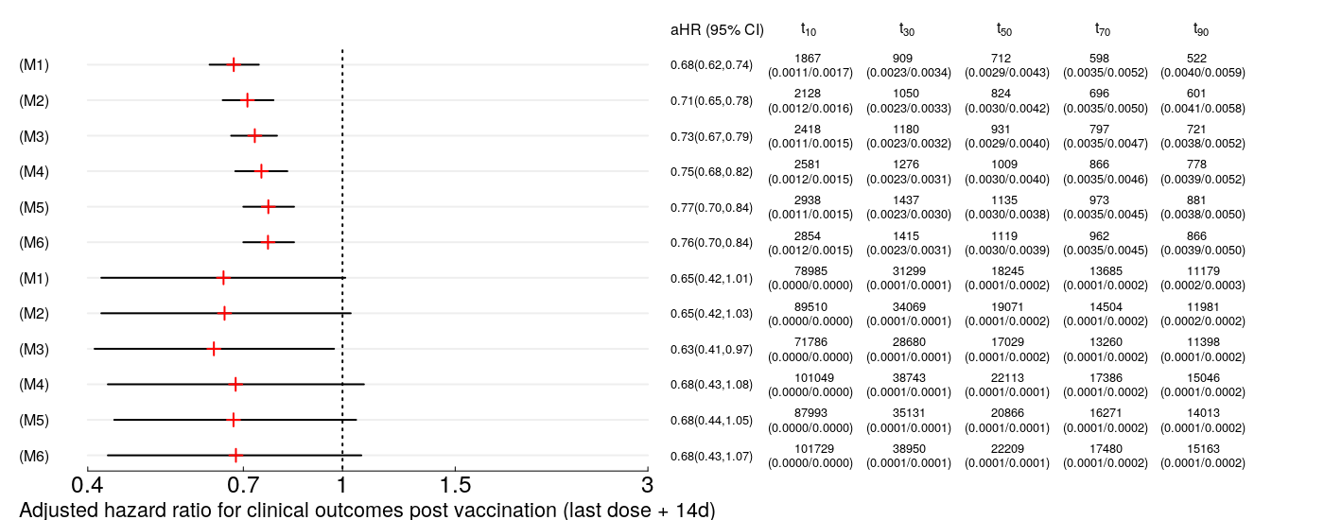
Unadjusted
Unadjusted & with IPTW
Adjusted for imbalances
Adjusted for imbalances & with IPTW
Adjusted for imbalances, prognostic factors
Adjusted for imbalances, prognostic factors & with IPTW
Unadjusted
Unadjusted & with IPTW
Adjusted for imbalances
Adjusted for imbalances & with IPTW
Adjusted for imbalances, prognostic factors
Adjusted for imbalances, prognostic factors & with IPTW

Infection

Hospitalization/
ICU/Death/
Hospice

Figure S9. Adjusted hazard ratios (aHRs) along with 95% confidence intervals, number needed to treat (NNT), and marginal probabilities (in parenthesis) of experiencing events at 10d, 30d, 50d, 70d, and 90d post vaccination (last dose + 14d) for mRNA-1273 (Moderna) and BNT162b2 (Pfizer), respectively (separated by “/”). Time-to-event for adverse outcomes (top-panel) ICU/death/hospice and (bottom-panel) hospitalization/ICU/death/hospice whichever occurring first among vaccinated individuals without prior diagnosis of Covid.

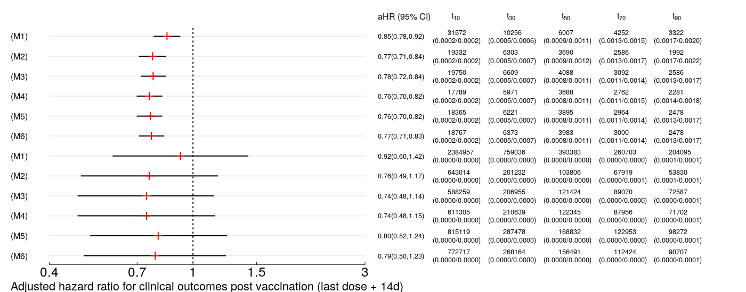
Unadjusted
Unadjusted & with IPTW
Adjusted for imbalances
Adjusted for imbalances & with IPTW
Adjusted for imbalances, prognostic factors
Adjusted for imbalances, prognostic factors & with IPTW
Unadjusted
Unadjusted & with IPTW
Adjusted for imbalances
Adjusted for imbalances & with IPTW
Adjusted for imbalances, prognostic factors
Adjusted for imbalances, prognostic factors & with IPTW

Infection

Hospitalization/
ICU/Death/
Hospice

Supplemental Material
Results for population of vaccinated people who became infected

Table S3 Descriptive statistics for baseline characteristics (demographics, socio-economic, comorbidities, negative controls, study outcomes, and other prognostic factors among fully vaccinated individuals by BNT162b2 and mRNA-1273 who became infected with Covid-19. Data are censored to June 1st, 2021.

Post-vaccination
time-to-event
among infected
 | BNT162b2 | mRNA-1273
N | 4153 | 2281
Age (mean (SD)) | 56.80 (17.84) | 58.26 (17.11)
Acquired immune deficiency syndrome (%) | 18 (0.4) | 22 (1.0)
Alcohol use disorder (%) | 62 (1.5) | 43 (1.9)
Iron deficiency anemia (%) | 712 (17.1) | 419 (18.4)
Rheumatoid arthritis (%) | 229 (5.5) | 169 (7.4)
Blood loss anemia (%) | 68 (1.6) | 49 (2.1)
Congestive heart failure (%) | 450 (10.8) | 265 (11.6)
Chronic obstructive pulmonary disease (%) | 880 (21.2) | 538 (23.6)
Coagulopathy (%) | 196 (4.7) | 116 (5.1)
Depression (%) | 738 (17.8) | 394 (17.3)
Diabetes without chronic complication (%) | 924 (22.2) | 570 (25.0)
Diabetes with chronic complication (%) | 699 (16.8) | 440 (19.3)
Substance use disorder (%) | 103 (2.5) | 46 (2.0)
Hypertension (%) | 1989 (47.9) | 1170 (51.3)
Hypothyroidism (%) | 626 (15.1) | 393 (17.2)
Liver disease (%) | 257 (6.2) | 176 (7.7)
Lymphoma (%) | 53 (1.3) | 21 (0.9)
Fluid & electrolyte disorder (%) | 725 (17.5) | 445 (19.5)
Metastatic cancer (%) | 55 (1.3) | 27 (1.2)
Neurological disorder (%) | 573 (13.8) | 270 (11.8)
Obesity (%) | 997 (24.0) | 591 (25.9)
Paralysis (%) | 124 (3.0) | 45 (2.0)
Peripheral vascular disease (%) | 562 (13.5) | 277 (12.1)
Psychosis (%) | 221 (5.3) | 105 (4.6)
Pulmonary circulation disorder (%) | 130 (3.1) | 76 (3.3)
Chronic kidney disease (%) | 421 (10.1) | 266 (11.7)
Solid tumor without metastasis (%) | 263 (6.3) | 183 (8.0)
Peptic ulcer disease (%) | 30 (0.7) | 26 (1.1)
Valvular disorder (%) | 377 (9.1) | 230 (10.1)
Weight loss (%) | 230 (5.5) | 122 (5.3)
Stroke cerebrovascular (%) | 432 (10.4) | 252 (11.0)
Down syndrome (%) | 0 (0.0) | 0 (0.0)
Thalassemia (%) | 7 (0.2) | 3 (0.1)
Smoking (%) | 331 (8.0) | 170 (7.5)
Transplant (%) | 6 (0.1) | 4 (0.2)
Elixhauser mortality score (mean (SD)) | 4.53 (8.56) | 4.73 (8.30)
Elixhauser readmission score (mean (SD)) | 13.80 (19.43) | 14.58 (19.04)
Transferred from Nursing facility/SNF (%) | 127 (3.1) | 47 (2.1)
Immunologic Rx (%) | 1445 (34.8) | 947 (41.5)
Immunologic Dx (%) | 1402 (33.8) | 842 (36.9)
Sex
Female (%) | 2597 (62.5) | 1352 (59.3)
Male (%) | 1556 (37.5) | 929 (40.7)
Residence by region (%)
Midwest | 1379 (33.2) | 660 (28.9)
Northeast | 1071 (25.8) | 525 (23.0)
South | 1076 (25.9) | 790 (34.6)
West | 627 (15.1) | 306 (13.4)
Vaccinated before February 1, 2021 (%) | 2016 (48.5) | 1093 (47.9)
SES index (mean (SD)) | 53.65 (3.05) | 53.23 (3.37)
Prior any Covid Dx (ER/IP/ICU/Dx) (%) | 2533 (61.0) | 1255 (55.0)
Prior positive PCR (%) | 268 (6.5) | 168 (7.4)
Negative outcomes
Bilateral prim osteoarthritis knee (%) | 90 (2.2) | 63 (2.8)
Dry eye syndrome (%) | 0 (0.0) | 0 (0.0)
Frequency of micturition (%) | 158 (3.8) | 87 (3.8)
Presbyopia (%) | 108 (2.6) | 62 (2.7)
Seborrheic keratosis (%) | 0 (0.0) | 0 (0.0)
Sensorineural hear loss bilateral (%) | 102 (2.5) | 55 (2.4)
Tinea unguium (%) | 342 (8.2) | 143 (6.3)
UTI site not specified (%) | 424 (10.2) | 214 (9.4)
Agerel nuclear cataract bilateral (%) | 186 (4.5) | 135 (5.9)

Figure S10. Kaplan-Meier curves for time-to-events without truncation for the event of (C) hospitalization/ ICU/death/hospice whichever occurs first among infected patients, and (D) ICU/death/hospice whichever occurs first among infected patients.
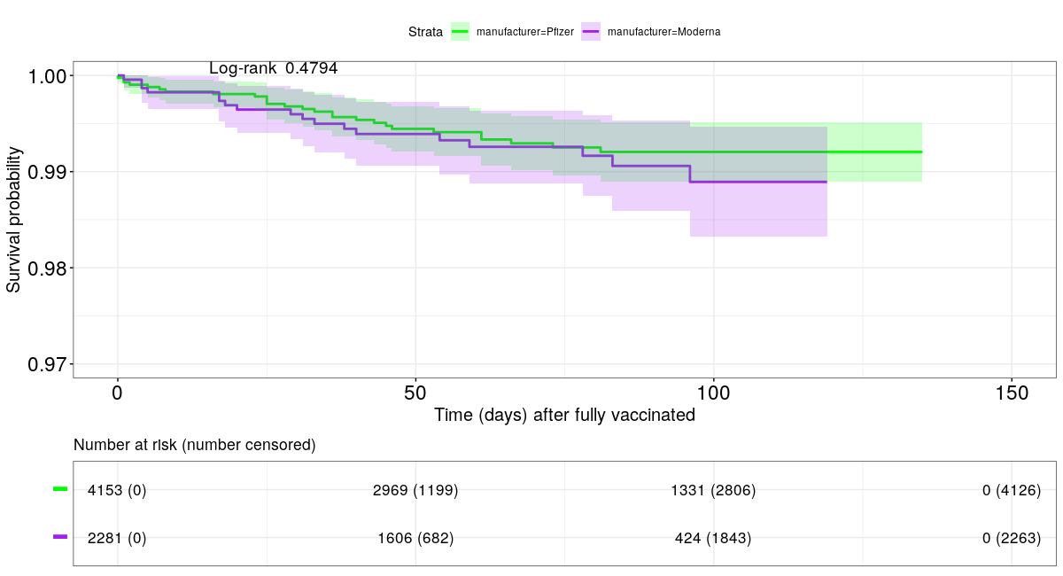
(B)
(A)
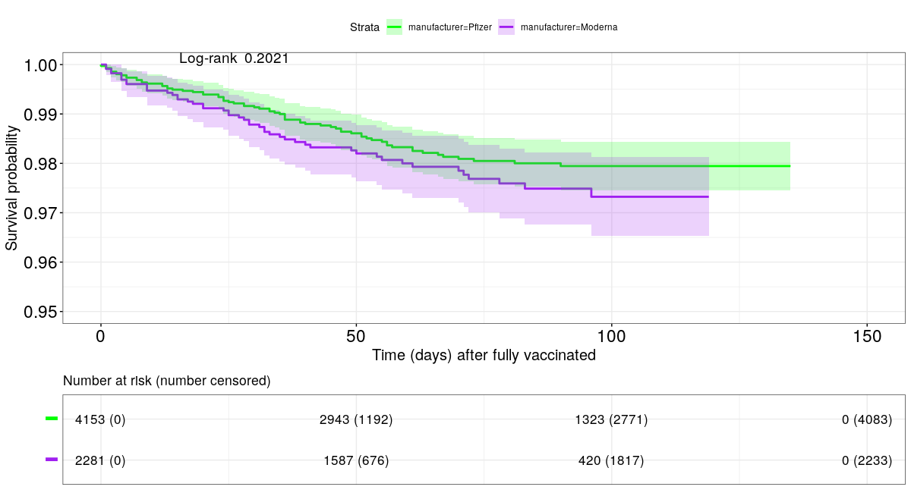

Table S4. Standardized mean differences of covariates in unweighted and weighted (IPTW) samples between BNT162b2 and mRNA-1273 vaccinated individuals.
Post-vaccination
time-to-adverse-event
among infected
Standardized mean differences (SMD) | Unweighted | IPTW
Age†¶‡ | 0.083 | 0.01
Acquired immune deficiency syndrome†‡ | 0.064 | <0.001
Alcohol abuse†‡ | 0.03 | 0.008
Iron deficiency anemia†‡ | 0.032 | 0.004
Rheumatoid arthritis†‡ | 0.077 | 0.002
Blood loss anemia†‡ | 0.037 | 0.006
Congestive heart failure†‡ | 0.025 | 0.001
Chronic obstructive pulmonary disease†‡ | 0.058 | 0.007
Coagulopathy†‡ | 0.017 | 0.003
Depression†‡ | 0.013 | 0.002
Diabetes without chronic complication†‡ | 0.065 | 0.004
Diabetes with chronic complication†‡ | 0.064 | 0.004
Substance use disorder† | 0.031 | 0.005
Hypertension†‡ | 0.068 | 0.004
Hypothyroidism†‡ | 0.059 | 0.01
Liver disease†‡ | 0.06 | 0.006
Lymphoma†‡ | 0.034 | 0.009
Fluid & electrolyte disorder†‡ | 0.053 | 0.002
Metastatic cancer†‡ | 0.013 | 0.013
Neurological disorder†‡ | 0.059 | 0.012
Obesity†‡ | 0.044 | 0.01
Paralysis†‡ | 0.065 | 0.014
Peripheral vascular disease†‡ | 0.042 | 0.009
Psychosis†‡ | 0.033 | 0.007
Pulmonary circulation disorder†‡ | 0.011 | 0.003
Chronic kidney disease†‡ | 0.049 | 0.002
Solid tumor without metastasis†‡ | 0.066 | 0.003
Peptic ulcer disease†‡ | 0.043 | 0.003
Valvular disorder†‡ | 0.034 | 0.008
Weight loss†‡ | 0.008 | 0.006
Stroke cerebrovascular† | 0.021 | 0.008
Down syndrome† | <0.001 | <0.001
Thalassemia† | 0.01 | 0.001
Smoking† | 0.019 | 0.001
Transplant† | 0.008 | 0.005
Elixhauser mortality score | 0.023 | 0.003
Elixhauser readmission score | 0.04 | 0.003
Nursing facility/SNF†‡ | 0.063 | 0.009
Immunologic Rx | 0.139 | 0.104
Immunologic Dx†‡ | 0.066 | 0.008
Gender†‡ | 0.067 | 0.01
Residence by state†¶‡ | 0.425 | 0.065
Residence by region* | 0.191 | 0.006
Vaccinated before February 1, 2021†¶ | 0.013 | 0.023
SES index†¶‡ | 0.13 | 0.008
Prior any Covid Dx (ER/IP/ICU/Dx) †¶ | 0.121 | 0.016
Prior positive PCR | 0.036 | 0.056

†Adjusted in propensity score model. Variables are adjusted in outcome regression models (as in equation SM 7-8).
¶‡Variables are adjusted in outcome regression models (as in equation SM 4-6).
*Residence by region is used instead of residence by state in Cox-PH model.
‡Variables are adjusted in negative outcome regression models (as in equation SM 4-6).

Figure S11. Adjusted hazard ratios (aHRs) along with 95% confidence intervals, number needed to treat (NNT), and marginal probabilities (in parenthesis) of experiencing events at 10d, 30d, 50d, 70d, and 90d post vaccination (last dose + 14d) for mRNA-1273 (Moderna) and BNT162b2 (Pfizer), respectively (separated by “/”). Time-to-event for adverse outcomes (top-panel) ICU/death/hospice and (bottom-panel) hospitalization/ICU/death/hospice whichever occurring first among infected-vaccinated individuals.
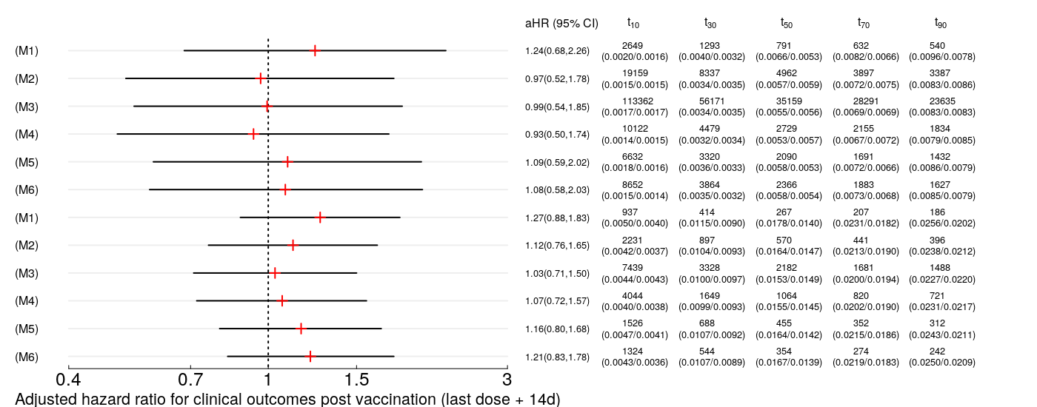
Unadjusted
Unadjusted & with IPTW
Adjusted for imbalances
Adjusted for imbalances & with IPTW
Adjusted for imbalances, prognostic factors
Adjusted for imbalances, prognostic factors & with IPTW
Unadjusted
Unadjusted & with IPTW
Adjusted for imbalances
Adjusted for imbalances & with IPTW
Adjusted for imbalances, prognostic factors
Adjusted for imbalances, prognostic factors & with IPTW

ICU/Death/Hospice

Hospitalization/
ICU/Death/Hospice

Figure S12. Predicted survival probabilities based on the univariate model with IPTW for (A) ICU/death/hospice and (B) hospitalization/ICU/death/hospice whichever occurring first among infected individuals. Predicted survival probabilities of a typical (prediction at mode) infected patient based on the adjusted model for imbalances along with IPTW with respect to (C) ICU/death/hospice and (D) hospitalization/ICU/death/hospice whichever occurring first.
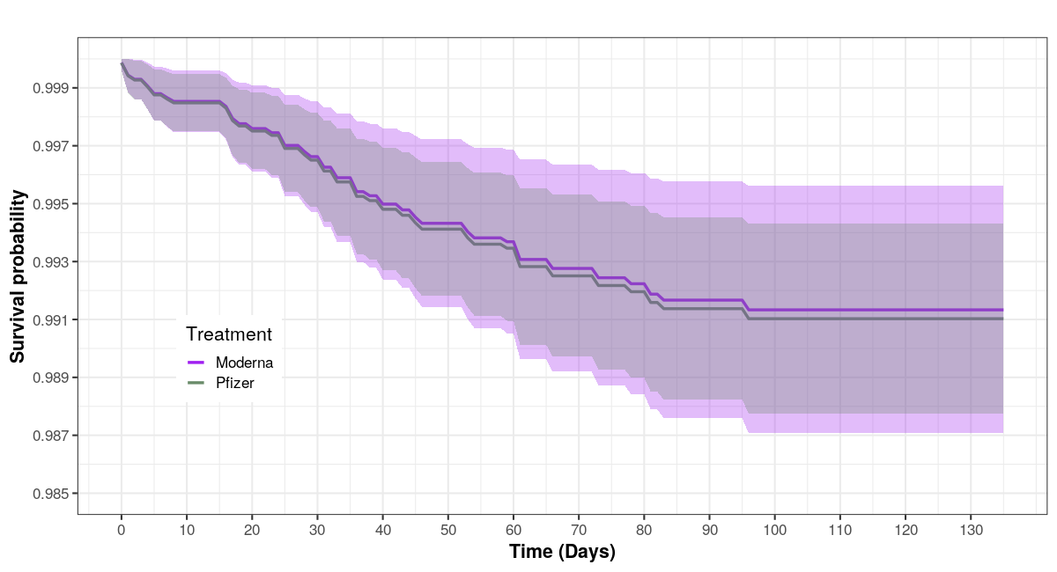
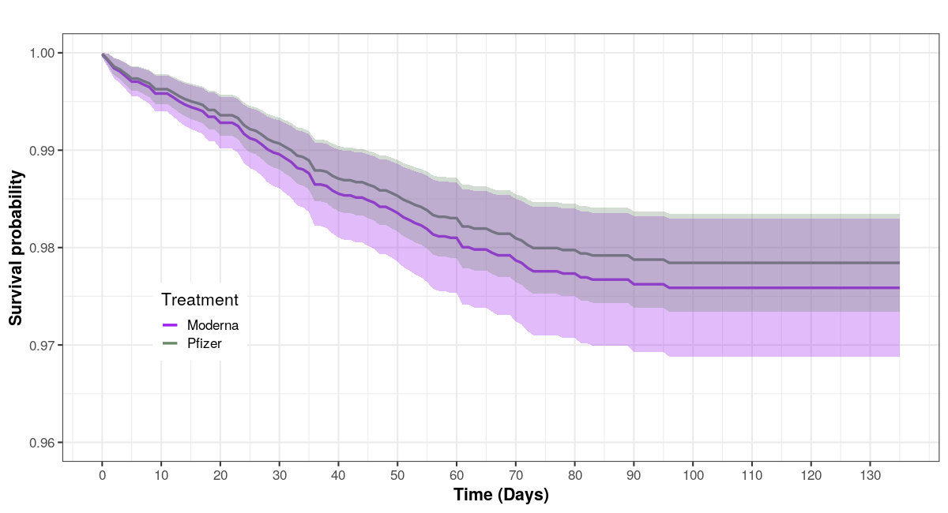
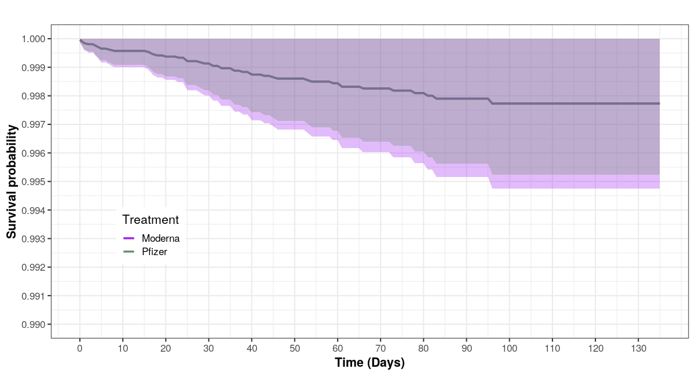
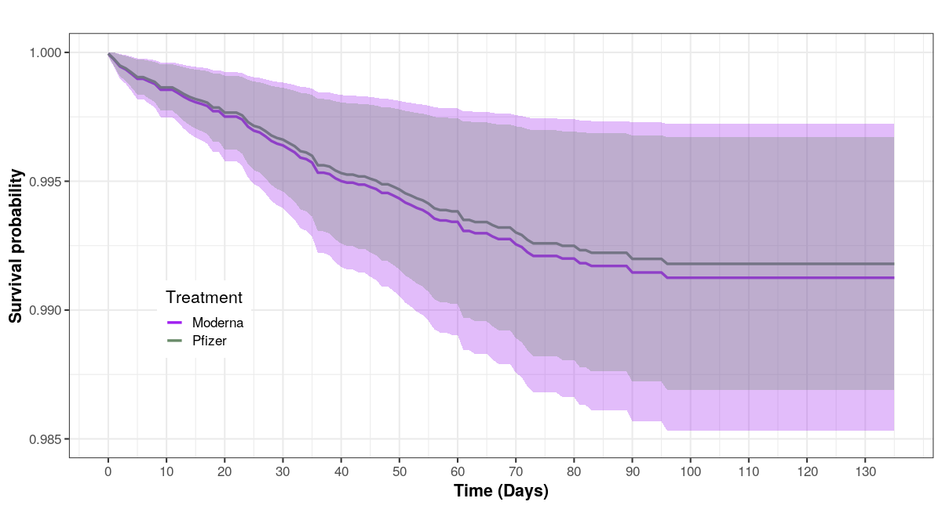
Time-to-ICU, death, or discharge to hospice
Time-to-hospitalization, ICU, death, or discharge to hospice
(B)
(A)
(C)
(D)

Supplement 3
Methods

Let $i$ denote vaccinated patients such that $i = 1, …, N$ and $N_{1}$ + $N_{2}=N$where $N_{1}$and $N_{2}$ are the total number of subjects vaccinated by mRNA-1273 (Moderna) and BNT162b2 (Pfizer), respectively. Let$Y_{i}$ refer to a Covid-related adverse outcome recorded for the $i$-th patient taking value of 1 if a patient experiences an event post vaccination date (last dose + 14day) or 0, otherwise. Here $Y_{i}$corresponds to (a) infection (associated with Covid diagnoses, hospitalization, intensive care unit (ICU) or emergency (ER) visit, mortality, and/or hospice-transfer whichever occurring first), (b) hospitalization, (c) composite event consisting of ICU, mortality, and transfer-to-hospice whichever occurring first and (d) composite event exploiting hospitalization, ICU, mortality, and transfer-to-hospice whichever occurring first. Denote by $U_{im}$the $m$-th socio-demographic variable (e.g., age, gender, socio-economic status (SES), residence of state) and $X_{il}$ the $l$-th comorbidity status (Elixhauser-based comorbidities, CDC reported risk factors that are not included in the Elixhauser readmission or mortality score (e.g., smoking)) associated with the $i$-th subject. In addition, we consider Covid specific covariates (i.e., timing of vaccination and prior history of Covid diagnoses) which are denoted by $T_{ir}$. Define by $U_{i}, X_{i}, and T_{i}$ as $M, L,$and $R$ dimensional vector of covariates for the $i$-the subject; where $M$ = |$M_{0}$|, $L= {|L}_{0}|,$ and $R= {|R}_{0}|$ are the cardinals of sets, $M_{0}, L_{0},$ and $R_{0}.$Let $V_{i}$ be a binary variable indicating the type of vaccines administered taking value 1 if a subject takes mRNA-1273 and 0 if a subject receives BNT162b2 vaccine within the recommended CDC time-interval (4-days earlier and 28-days later from the recommended second dose CITE CDC) between the first and second doses. The primary objective of this study is to assess the relative vaccine effectiveness between these two treatment arms with respect to morbidity and mortality. We use both logistic regression and Cox-proportional hazard (PH) model assuming right censoring. In contrast to logistic regression, Cox-PH exploits data available until May 31, 2021; see below. For logistic models, we truncate samples with respect to complete vaccination date (2nd dose + 14 days) on May 1, 2021, April 1, 2021, and March 2, 2021, for 30-day, 60-day, and 90-day outcome regression so that each subject had at-least 30, 60, and 90 day window of a follow-up period to experience events, respectively. For time-to-event data, we use June 1, 2021, as a censoring date. In the outcome regression, we categorize numeric variables (age, SES index, and timing of vaccines) to accommodate nonlinear relationship between the corresponding variable and the response,

A.1 Multivariable generalized linear model for outcome regression
We cast the following multivariable generalized linear model (GLM) to characterize the association between covariates and binary outcome.
$${logit Pr⁡(Y}_{i}=1)=α+\sum_{m=1}^{M}{U_{im}δ_{m}} +\sum_{l=1}^{L}{X_{il}}β_{l} + \sum_{r=1}^{R}{T_{ir}τ_{r}} + V_{i}θ.$$
Here $α, δ_{m}, β_{l}, τ_{r}, and θ$ correspond to the fixed parameters associated with intercept, socio-demographic, comorbidities, Covid-specific variables, and vaccination type, respectively. Note the above model is a saturated model and we fit a reduced model having a varying set of covariates as below with and without IPTW to assess how the inference of $θ$ changes under different model specifications and settings. With an abuse of notation, let $Y_{i}$ denote the binary response of interest in both unweighted and weighted samples. Denote by $M_{1}$ and $R_{1}$the set of baseline characteristics related to socio-demographic variables (age, SES index, residence by state or region) and Covid-related features (e.g., timing of vaccination, prior history of Covid diagnoses) that are imbalanced between two treatment arms; such that $M_{1}⊆M_{0}$ and $R_{1}⊆R_{0}.$Denote by $M_{2}, L_{2},$ and $R_{2}$ the set of covariates that are associated with the corresponding response of interests and are chosen empirically via univariate association filter approach to screen noise variables. Note a more formal approach based on a regularization (sparse) penalty may also be adopted; however, if such approach is used, the post-selection inference¹ is warranted. Here we fitted a series of univariate GLMs with a logit link function corresponding to each variable of interest based on the unweighted sample. We performed hypothesis tests for null effects via Wald test statistics, compared p-values, and selected the ones that are less than a prespecified threshold of 0.10. Let $M_{2}⊆M_{0}, L_{2}⊆M_{0}$ and $R_{2}⊆R_{0}.$ We fit GLM(s)² using the logit link function and estimate the parameters by the iteratively re-weighted least square (IRLS) algorithm; standard errors are estimated via robust, sandwich covariance estimator to account for the fact that weights are estimated and exploited.

 |  | Adjustment | IPTW | Subclassification
(SM1) | $${logit Pr⁡(Y}_{i}=1)=α+ V_{i}θ$$
(SM2) | $${logit Pr⁡(Y}_{i}=1)=α + V_{i}θ$$
(SM3) | $${logit Pr⁡(Y}_{ik}=1)=α_{k} + V_{ik}θ_{k}$$
(SM4) | $${logit Pr⁡(Y}_{i}=1)=α+\sum_{m∈M_{1}}{U_{im}δ_{m}} + \sum_{r∈R_{1}}{T_{ir}τ_{r}} + V_{i}θ$$
(SM5) | $${logit Pr⁡(Y}_{i}=1)=α+\sum_{m∈M_{1}}{U_{im}δ_{m}} + \sum_{r∈R_{1}}{T_{ir}τ_{r}} + V_{i}θ$$
(SM6) | $${logit Pr⁡(Y}_{ik}=1)=α_{k}+\sum_{m∈M_{1}}{U_{ikm}δ_{mk}} + \sum_{r∈R_{1}}{T_{ikr}τ_{rk}} + V_{ik}θ_{k}$$
(SM7) | $${logit Pr⁡(Y}_{i}=1)=α+\sum_{m∈M_{2}}{U_{im}δ_{m}} + \sum_{l∈L_{2}}{X_{il}β_{l}}+\sum_{r∈R_{2}}{T_{ir}τ_{r}} + V_{i}θ.$$
(SM8) | $${logit Pr⁡(Y}_{i}=1)=α+\sum_{m∈M_{2}}{U_{im}δ_{m}} + \sum_{l∈L_{2}}{X_{il}β_{l}}+\sum_{r∈R_{2}}{T_{ir}τ_{r}} + V_{i}θ.$$

A.2 Multivariable Cox-PH model for time-to-event outcome regression
In contrast to the discrete study endpoints analyses, we considered the time to the occurrence of a Covid-related event across the study period assuming right censoring. In this pursuit, we fitted semi-parametric Cox-PH model. Let $t_{i}$ be the event time for the $i$-th subject and $C_{i}$be the censoring time. Let $h(t\left|U_{i}, X_{i},T_{i},V_{i}\right)$ be the hazard rate for an individual at some time $t$ and $h_{0}\left(t\right)>0$ be the non-parametric part of the model signaling the baseline hazard function at the population-level. Cox-PH model assumes
$h(t\left|U_{i}, X_{i},T_{i},V_{i}\right)= h_{0}\left(t\right)e^{\sum_{m=1}^{M}{U_{im}δ_{m}} +\sum_{l=1}^{L}{X_{il}}β_{l} + \sum_{r=1}^{R}{T_{ir}τ_{r}} + V_{i}θ};$
the definition of all other terms remains as same as before. Using the similar intuition as above, we screen variables based on a series of univariate Cox-PH models where the nullity of effects is assessed by likelihood ratio test. We observed superior screening performance, especially for the variables with less cell frequencies, using the LRT approach relative to Wald based test statistic. We fit the univariate-and-multivariable models (similar to SM1-SM8) with and without adjustments by inverse probability of treatment weighting that is to be discussed in B.1. We estimate the parameters by maximizing the partial likelihood function and standard errors are estimated via robust, sandwich covariance estimator. Reported are the adjusted hazard ratios (aHRs) along with 95% CIs.

B. Estimation of propensity scores and covariate balances
Consider the following generalized linear model with log odds of receiving mRNA-1273. A logit link for the binary vaccine type depicting the conditional probability of receiving mRNA-1273 is used. Denote by $α_{\left(p\right)}, δ_{m\left(p\right)}, β_{l\left(p\right)}, and τ_{r\left(p\right)}$ the regression parameters quantifying the association between vaccine type and observed covariates; the subscript ‘(p)’ is used to differentiate the parameters of the propensity model from the outcome model.

$${logit Pr⁡(V}_{i}=1)=α_{\left(p\right)}+\sum_{m=1}^{M}{U_{im}δ_{m\left(p\right)}} +\sum_{l=1}^{L}{X_{il}}β_{l\left(p\right)} + \sum_{r=1}^{R}{T_{ir}τ_{r\left(p\right)}}$$

$${Pr⁡(V}_{i}=1\left|U_{i}, X_{i},T_{i}\right)=\frac{1}{1+\exp\left(-α_{\left(p\right)}-\sum_{m=1}^{M}{U_{im}δ_{m\left(p\right)}}-\sum_{l=1}^{L}{X_{il}}β_{l\left(p\right)}-\sum_{r=1}^{R}{T_{ir}τ_{r\left(p\right)}}\right)}$$

Let ${Pr⁡(V}_{i}=1{|U}_{i}= u_{i}, X_{i}= x_{i},T_{i}= t_{i})=e(u_{i},x_{i},t_{i})$ be the propensity score of the $i$-th subject. For the notational convenience, assume $e\left(u_{i},x_{i},t_{i}\right)$ = $e_{i}.$

B.1. Inverse probability of treatment weighting (IPTW)
We used inverse probability of treatment assignment as a weight in the multivariate outcome analyses; the main purpose of using IPTW analyses is to create a weighted sample in which the distribution of either the measured confounding variables or the prognostically important covariates is same between vaccinated people with respect to two treatment arms. Such propensity score based weighting approach takes a differential amount of information from each subject depending on one’s conditional likelihood of receiving mRNA-1273. This weighted method corrects and reduces the magnitude of selection bias balancing the observed differences between treatments (i.e., mRNA-1273 and BNT162b2 vaccinated people in our application) with respect to different risk factors in the sample.

Define the corresponding subject’s IPTW by $w_{i}=\frac{V_{i}}{e_{i}}+ \frac{{1- V}_{i}}{{1- e}_{i}}$. Note that vaccinated subjects with mRNA-1273 having a very low propensity score (close to zero) can result in a very large weight; similarly, a BNT-162b2 vaccinated subject with a very high propensity score (close to one) can result in a very large weight; such instability may increase variability of the estimated treatment effect. As a remedy, the stabilized weights $w_{i}=\frac{{Pr\left(V_{i}=1\right)V}_{i}}{e_{i}}+ \frac{{Pr\left(V_{i}=0\right)(1- V}_{i})}{{1- e}_{i}}$ are adopted; where $Pr\left(V_{i}=1\right)$and $Pr\left(V_{i}=0\right)$denote the marginal probabilities estimated as

$\frac{\sum_{i∈N_{1}}{e_{i}}}{N_{1}}$ and $\frac{\sum_{i∈N_{2}}{\left(1- e_{i}\right)}}{N_{2}}$,

for mRNA-1273 and BNT162b2, respectively.

Another alternative to address the problems arising from very large weights is to use trimmed or truncated weights; where we trim extreme probability values (i.e., less than 0.01 and greater than 0.99) and replace them with prespecified values such as 0.01 and 0.99, respectively.^{3,4}

B.2. Propensity score subclassification
We divide the sample into K strata using quartiles or quintiles of the estimated propensity scores, $e_{i}$ and evaluate the relative treatment efficacy in terms of aOR or RR within each stratum by running univariate and multivariable GLM. Let aOR for treatment effect be $θ_{k}$ at the$k$-th stratum. We aggregate the K estimates by using the weighted average and obtain the corresponding weighted standard error by aggregating variances over all strata; here weights being the total number of samples within each stratum. We check balances of covariates within each stratum in terms of SMD.

B.3. Enumerating covariate balances
We computed the standardized (mean) difference (SMD) as a measure of distance between two treatment groups in terms of each potential risk factors; this can be viewed as a measure of balance for each covariate before and after propensity score adjustments to ensure that weighting helps correct selection bias. A SMD value greater than 0.10 signals substantial difference between two treatment arms in terms of the corresponding covariate. We computed SMD for weighted data following Austin et al. (2015).⁵

In addition, we also performed a statistical significance testing approach based on univariate weighted regression. Here we run a weighted simple linear regression using a continuous covariate (e.g., age) as the dependent variable and $V_{i}$as the single independent variable with weight, $w_{i}$. Similarly, we run a weighted simple logistic regression for binary covariate and weighted multinomial regression for a covariate with more than two classes (e.g., residential state). We used Wald test statistics with standard error estimated by robust, sandwich covariance estimator. We acknowledge that failing to reject a null hypothesis in any test does not necessarily indicate balances on the sample as this procedure indeed tests about the nullity of the population parameter whereas we are more interested in inducing balances only on the analytical sample.

C. Marginal effects estimation
The mean predicted marginal probabilities of experiencing events by mRNA-1273 and BNT162b2 are calculated via “recycled predictions” based on each model.^{6,7} This approach is also known as marginal standardization in the literature where the idea is to calculate the marginal effect (instantaneous effect on the predicted probability of response due to a change from one vaccine to the other while keeping other variables constant) at each individual level and then calculate the sample average of individual marginal effects to obtain the overall marginal effect. Let $i^{*}$ and $i^{**}$ refer to subjects each, hypothetically, having mRNA-1273 and BNT162b2, respectively. This follows that

$$p_{i,mRNA}= {Pr⁡(Y}_{i^{*}}=1\left|U_{i}, X_{i},T_{i},V_{i^{*}}\right)=\frac{1}{1+\exp\left(-α-\sum_{m∈M_{2}}{U_{im}δ_{m}} - \sum_{l∈L_{2}}{X_{il}β_{l}}-\sum_{r∈R_{2}}{T_{ir}τ_{r}} - V_{i^{*}}θ\right)}$$

$$p_{i,BNT}= {Pr⁡(Y}_{i^{*}}=1\left|U_{i}, X_{i},T_{i},V_{i^{**}}\right)=\frac{1}{1+\exp\left(-α-\sum_{m∈M_{2}}{U_{im}δ_{m}} - \sum_{l∈L_{2}}{X_{il}β_{l}}-\sum_{r∈R_{2}}{T_{ir}τ_{r}}\right)}$$

The mean predicted marginal probabilities (risk) for mRNA-1273 and BNT162b2 are calculated as
$p_{mRNA} \text{=} \sum_{i=1}^{N}{ p_{i, mRNA}/ N}$ and $p_{BNT} \text{=} \sum_{i=1}^{N}{ p_{i, BNT}/ N}$, respectively. Number needed to treat is calculated as a reciprocal of the absolute risk difference, |$p_{mRNA}- p_{BNT}$|.^{8,9}

D. Model diagnostics
We assess the numerical performances of logistic regression by McFadden, Craig-Uhler’s pseudo $R$-squared values, Somer’s $D_{xy}$, and $C$-statistic; see below the summary measures for (SM8). In general, as we add more clinically relevant covariates, the model quantifies more variation in response reflected in better predictive performance. Collinearity between covariates is assessed by generalized variance inflation factor (GVIF); where all values are less than 4.00. The proportionality assumption for Cox-PH model is validated visually by plotting Schoenfeld residuals versus time and hypothesis testing.
 | Model | $C$-Statistic | Somer’s $D_{xy}$ | Pseudo$R$-squared McFadden  (Craig-Uhler)
A | Propensity model for day-30  (N = 2,088,797) | 0.61 | 0.22 | 0.03 (0.05)
B | Propensity model for day-60  (N = 935,797) | 0.60 | 0.20 | 0.02 (0.04)
C | Propensity model for day-90  (N = 371,232) | 0.64 | 0.28 | 0.05 (0.09)
C | Propensity model for time-to-adverse-event among infected  (N = 6,434) | 0.65 | 0.29 | 0.05 (0.08)
D | Propensity model for time-to-event among all vaccinated  (N = 3,543,438) | 0.60 | 0.21 | 0.03 (0.03)

E. Adjustment for unmeasured confounding and selection bias
As sensitivity analyses for unmeasured confounding, we report “E-values”¹⁰ of adjusted odds and hazard ratios for the vaccine type with respect to different models. Unlike p-values, E-values are not susceptible to large sample size and quantify the smallest strength of association in terms of risk ratio that an unmeasured confounder would need to have with both the treatment and the outcome variable to fully explain away a specific treatment-outcome association, conditional on the measured covariates.

We also adopt negative control approach where we pre-specify binary negative control outcomes within each cohort that are highly unlikely to be associated with Covid vaccines but might have an underlying association with observed confounding variables (e.g., age) at an extent. We select the list of potential negative outcomes following [¹¹] as below -
- Identify the 500 most common primary diagnosis codes in 2019 affecting individuals in each cohort, ignoring multiple diagnoses for the same condition for the same individual. Repeat for additional cohort.
- Filter the observed diagnoses to only retain diagnoses observed in both cohorts.
- Rank the diagnosis codes in each cohort and then sum the ranks for a composite rank sum (e.g., low back pain is #13 in BNT162b2and #15 in mRNA-1273 for a rank sum of 28).
- Order the diagnosis codes by rank sums from smallest to largest.
- Take the top 10/20/50/etc. outcomes that meet the criteria for negative control outcomes.

We fit multivariable GLMs with logit link functions with respect to each negative control outcomes adjusting for observed confounding variables excluding the ones that are linked to Covid-19 (e.g., previous history of SARS-CoV-2 infection) except vaccine type. We estimate the null distribution of systematic error and quantify the bias; a mean bias value close to 0 indicates that the analysis is not subject to major concern.¹² While the idea of using a reference set of negative controls to detect whether bias is likely to be a major concern has advantages, the calibration of p-values may be problematic due to the violation of assumptions. For an instance, it is likely that the Covid-19 vaccine-outcome analysis is not subject to the same sources of bias as the set of negative controls and the number of negative control to establish the parameters of the null distribution was not adequate (less than 25); see [¹³].

References for Supplement
1. Taylor J, Tibshirani R. Post-selection inference for ℓ1-penalized likelihood models. Can J Statistics. 2018;46(1):41-61. doi:10.1002/cjs.11313
2. McCullagh P, Nelder JA. Generalized Linear Models. 2nd ed. Routledge; 2019. doi:10.1201/9780203753736
3. Lee BK, Lessler J, Stuart EA. Weight Trimming and Propensity Score Weighting. Biondi-Zoccai G, ed. PLoS ONE. 2011;6(3):e18174. doi:10.1371/journal.pone.0018174
4. Cole SR, Hernan MA. Constructing Inverse Probability Weights for Marginal Structural Models. American Journal of Epidemiology. 2008;168(6):656-664. doi:10.1093/aje/kwn164
5. Austin PC, Stuart EA. Moving towards best practice when using inverse probability of treatment weighting (IPTW) using the propensity score to estimate causal treatment effects in observational studies. Statist Med. 2015;34(28):3661-3679. doi:10.1002/sim.6607
6. Muller CJ, MacLehose RF. Estimating predicted probabilities from logistic regression: different methods correspond to different target populations. International Journal of Epidemiology. 2014;43(3):962-970. doi:10.1093/ije/dyu029
7. Marginal Effects and Adjusted Predictions. In: SAGE Research Methods Foundations. SAGE Publications Ltd; 2020. doi:10.4135/9781526421036939917
8. Zhang Z, Ambrogi F, Bokov AF, Gu H, de Beurs E, Eskaf K. Estimate risk difference and number needed to treat in survival analysis. Ann Transl Med. 2018;6(7):120-120. doi:10.21037/atm.2018.01.36
9. Cook RJ, Sackett DL. The number needed to treat: a clinically useful measure of treatment effect. BMJ. 1995;310(6977):452-454. doi:10.1136/bmj.310.6977.452
10. VanderWeele TJ, Ding P. Sensitivity Analysis in Observational Research: Introducing the E-Value. Ann Intern Med. 2017;167(4):268. doi:10.7326/M16-2607
11. Khera R, Clark C, Lu Y, et al. Association of Angiotensin‐Converting Enzyme Inhibitors and Angiotensin Receptor Blockers With the Risk of Hospitalization and Death in Hypertensive Patients With COVID‐19. JAHA. 2021;10(13). doi:10.1161/JAHA.120.018086
12. Schuemie MJ, Ryan PB, DuMouchel W, Suchard MA, Madigan D. Interpreting observational studies: why empirical calibration is needed to correct p‐values. Statist Med. 2014;33(2):209-218. doi:10.1002/sim.5925
13. Gruber S, Tchetgen Tchetgen E. Limitations of empirical calibration of p-values using observational data: Limitations of p-value calibration. Statist Med. 2016;35(22):3869-3882. doi:10.1002/sim.6936

