SUPPLEMENTARY MATERIAL

S1. Sensitivity analysis excluding major referral-hospital cantons
To evaluate whether the AMI risk-cluster association was driven by transfer-related bias toward cantons hosting major national referral hospitals, the main panel model (Table 4) was re-estimated excluding Guayaquil and Quito.
Table S1. AMI panel model excluding Guayaquil and Quito, compared with the full-sample model.
Sample | Predictor | IRR | 95% CI
Full sample (n=1,526) | Year (per year) | 1.137 | 1.123 – 1.151
Full sample (n=1,526) | Risk cluster | 2.851 | 2.137 – 3.803
Excl. Guayaquil/Quito | Year (per year) | 1.138 | 1.123 – 1.153
Excl. Guayaquil/Quito | Risk cluster | 2.842 | 2.118 – 3.813
AMI, acute myocardial infarction; IRR, incidence rate ratio; CI, confidence interval. The near-identical estimates indicate that the risk-cluster association is not driven by transfer-related bias toward major referral centers.

S2. Euclidean distance to critical care capacity and mortality (2018 cross-section)
Canton-level Euclidean distance to the nearest ICU-equipped canton was calculated for 218 continental cantons and correlated with adjusted AMI and stroke mortality rates in two independent annual cross-sections (2018 and 2019, using each year's own ICU-equipped canton network as the distance reference). Contrary to the hypothesis that greater distance would predict higher mortality, a statistically significant negative correlation was found in both years and for both conditions: AMI (2018: r=-0.298, 95%CI -0.415 to -0.172, p<0.001; 2019: r=-0.199, 95%CI -0.323 to -0.068, p=0.003) and stroke (2018: r=-0.304, 95%CI -0.420 to -0.178, p<0.001; 2019: r=-0.297, 95%CI -0.414 to -0.171, p<0.001) — cantons farther from ICU-equipped centers tended to show lower, not higher, recorded mortality. The consistency of this direction and approximate magnitude across two independent years, particularly for stroke, indicates a structural rather than year-specific pattern.
Figure S1. AMI mortality rate vs. Euclidean distance to nearest ICU-equipped canton, 2018 cross-section (n=218).
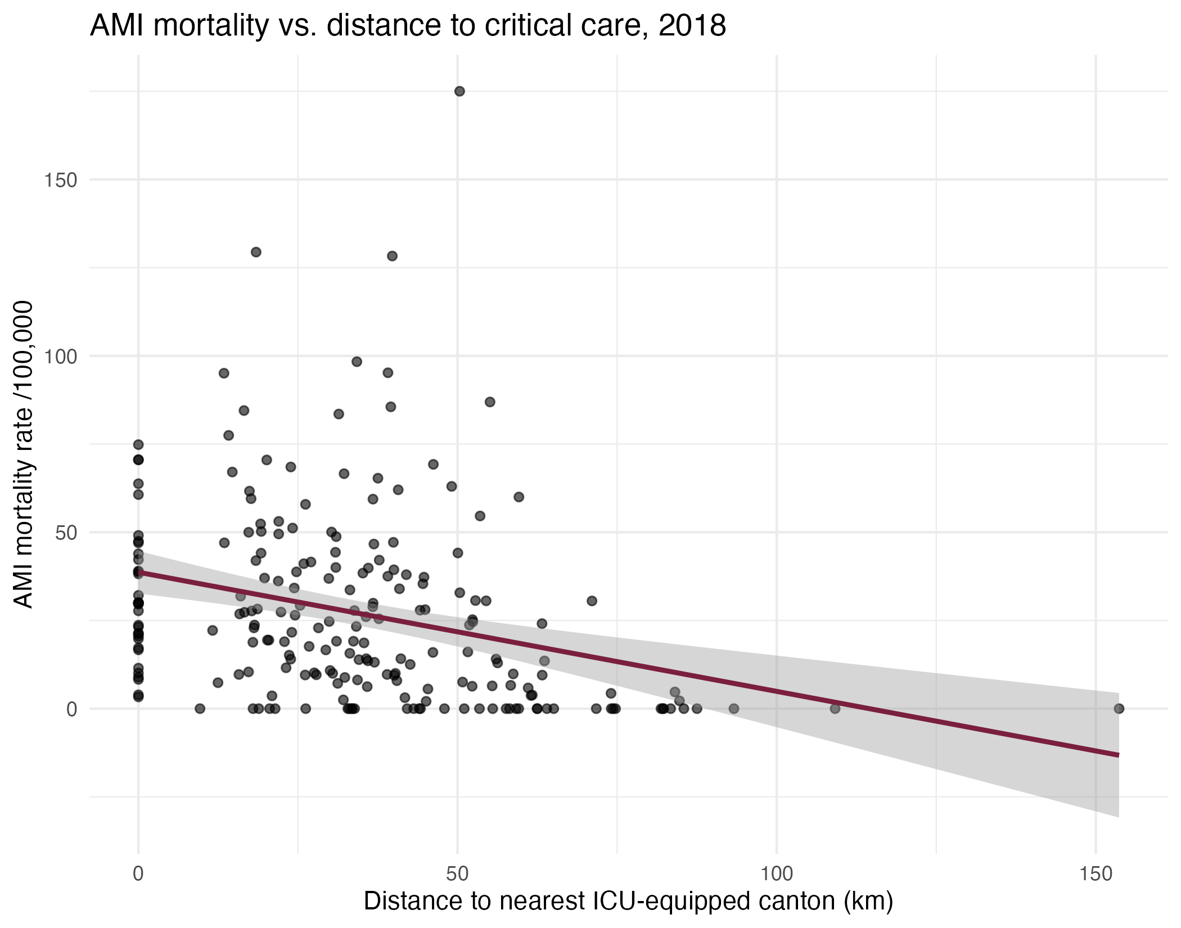
AMI, acute myocardial infarction; ICU, intensive care unit. Solid line: linear fit with 95% confidence band.
Figure S2. Stroke mortality rate vs. Euclidean distance to nearest ICU-equipped canton, 2018 cross-section (n=218).
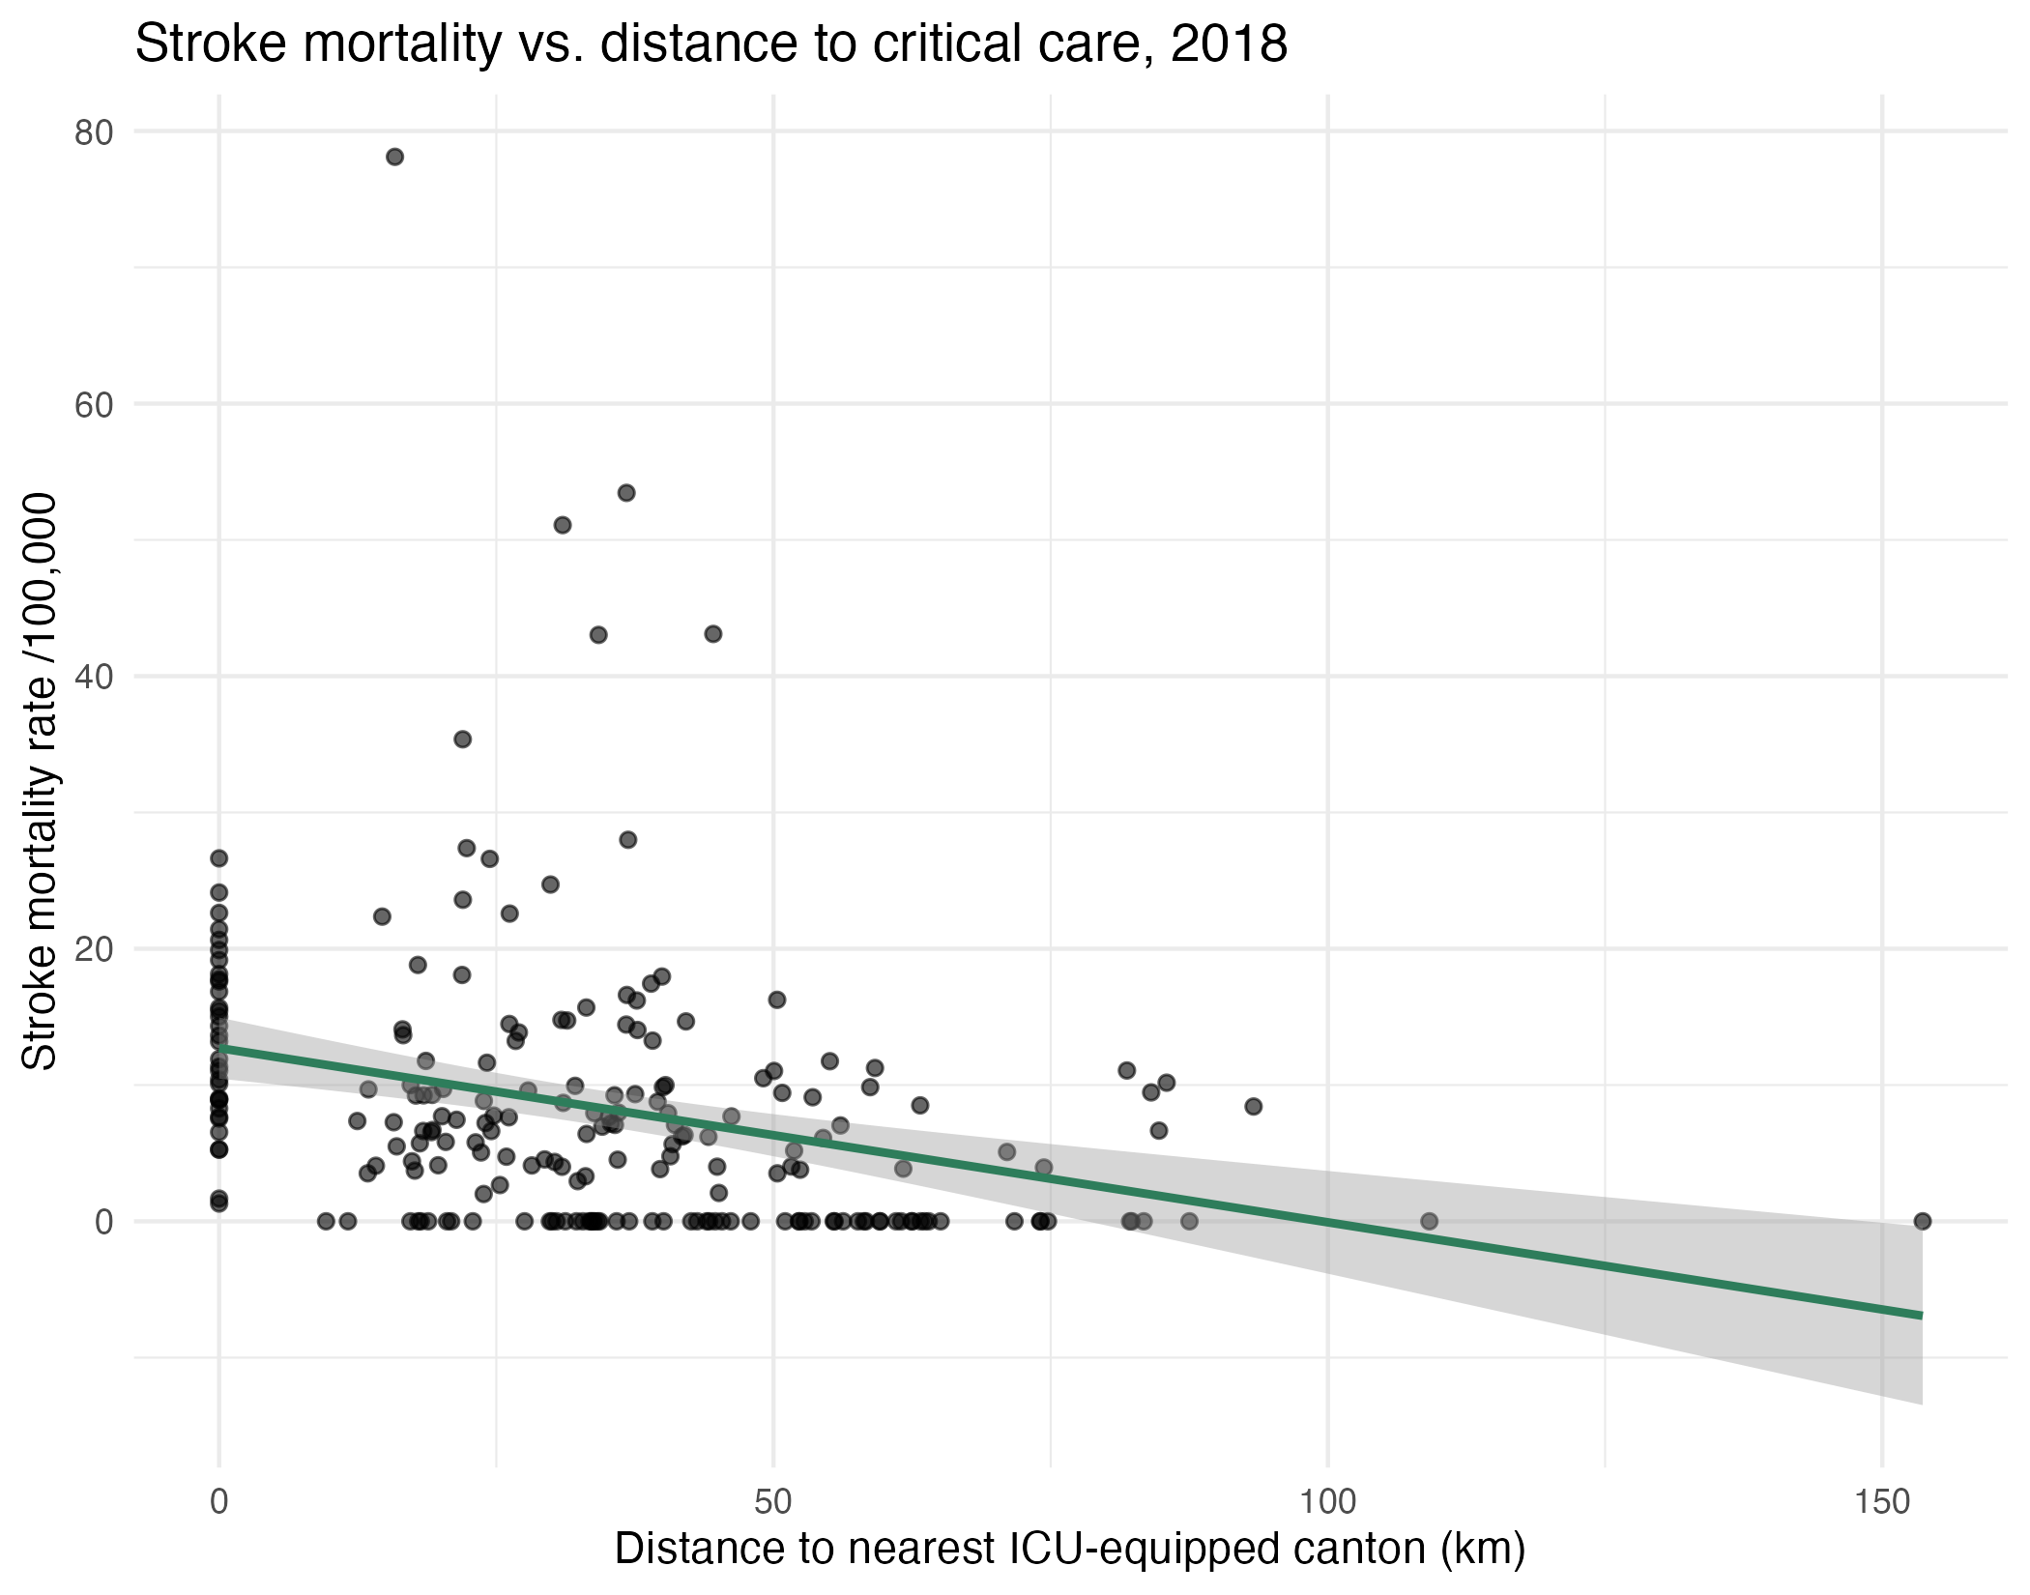
ICU, intensive care unit. Solid line: linear fit with 95% confidence band.
This counterintuitive direction, replicated across two independent years, is unlikely to reflect a genuine protective effect of distance. As shown in Figures S1-S2 (2018 cross-section), cantons farther than approximately 75 km are almost uniformly clustered near zero recorded mortality, a pattern consistent with small-area case-count instability and probable under-ascertainment of these diagnoses in remote, sparsely populated cantons —predominantly in the Amazon region, which recorded the lowest rates nationally throughout the full 2018-2024 series (section 3.11)— rather than with a true difference in underlying risk. Given this instability and the likelihood of differential ascertainment bias by remoteness, Euclidean distance was not incorporated as a predictor in the main panel model (section 2.6); the LISA cluster approach, which accounts for spatial dependence directly on observed rates rather than relying on a simple linear distance metric, was preferred as the primary spatial analytic strategy.

S3. Spatial autocorrelation of model residuals
To evaluate whether meaningful spatial structure remained unaccounted for after including cluster membership as a predictor, canton-level mean Pearson residuals from the main AMI and stroke panel models (Table 4) were computed (averaged across the seven study years per canton) and tested for spatial autocorrelation. For AMI, Moran's I on model residuals was 0.455 (p<0.001), close in magnitude to the unadjusted Moran's I on raw AMI mortality rates (I=0.466, section 3.3). For stroke, Moran's I on model residuals was 0.211 (p<0.001), similarly close to the unadjusted value (I=0.216). In both conditions, the panel model left substantial spatial structure unexplained by the cluster and year predictors alone.
Figure S3. Mean Pearson residuals from the main AMI panel model, by canton.
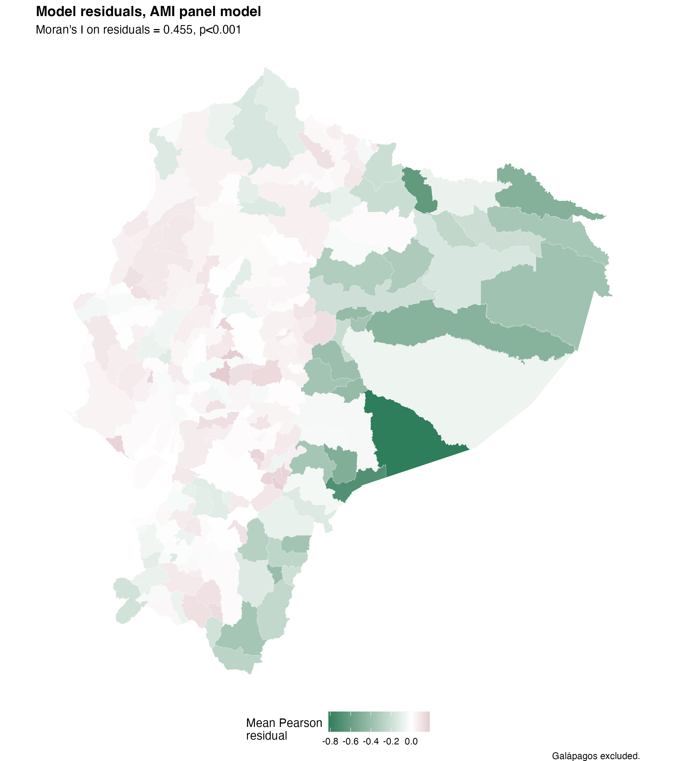
AMI, acute myocardial infarction. Galápagos province excluded. Residuals averaged across 2018-2024 per canton.
Figure S4. Mean Pearson residuals from the main stroke panel model, by canton.
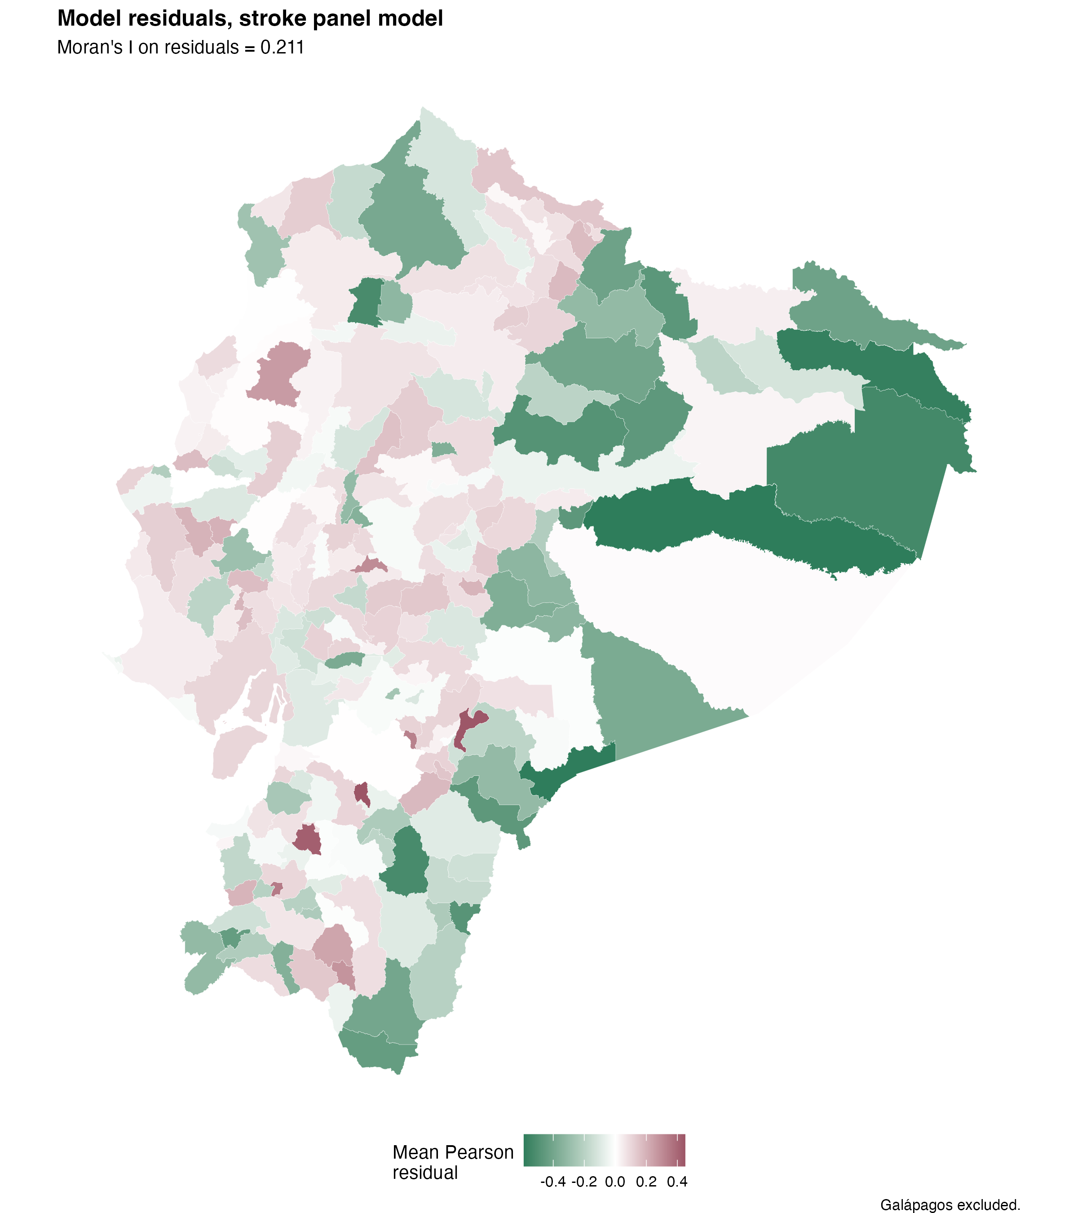
Galápagos province excluded. Residuals averaged across 2018-2024 per canton.
As shown in Figures S3-S4, residual spatial structure is concentrated predominantly in the Amazon region for both conditions, where cantons show consistently negative residuals (observed mortality lower than predicted), while coastal and highland cantons cluster closer to zero. This spatial pattern in the residuals coincides with the region identified in S2 as most affected by probable under-ascertainment, suggesting that the remaining spatial autocorrelation reflects systematic underreporting in the Amazon rather than an omitted risk factor within the identified risk clusters themselves. This finding is reported as a limitation of the binary cluster-membership specification (section 2.6): a continuous spatial structure (e.g., a conditional autoregressive or spatial lag term) would likely capture this residual dependence more fully than a single binary indicator, and represents a natural extension for future work.

S4. Sex and age differences in AMI and stroke mortality
AMI mortality was higher in men than in women across all age groups analyzed (2018-2024, cumulative person-years for the period), with no confidence interval of the relative risk (RR) crossing unity. The magnitude of the sex difference was not constant: the AMI RR reached its maximum value in young adults (20-29 years: RR 3.4; 95%CI 2.7-4.3) and declined progressively to a minimum in those over 85 (RR 1.18; 95%CI 1.16-1.21). For stroke, the sex gap was systematically smaller than for AMI across all age groups, and ceased to be statistically significant in the 15-19, 45-49, and 85-and-over groups (CI crossing 1), indicating a less pronounced and more heterogeneous sex differentiation than that observed for AMI.
Figure S5. Relative risk (RR) of AMI and stroke mortality in men relative to women, by age group. Ecuador, 2018-2024.
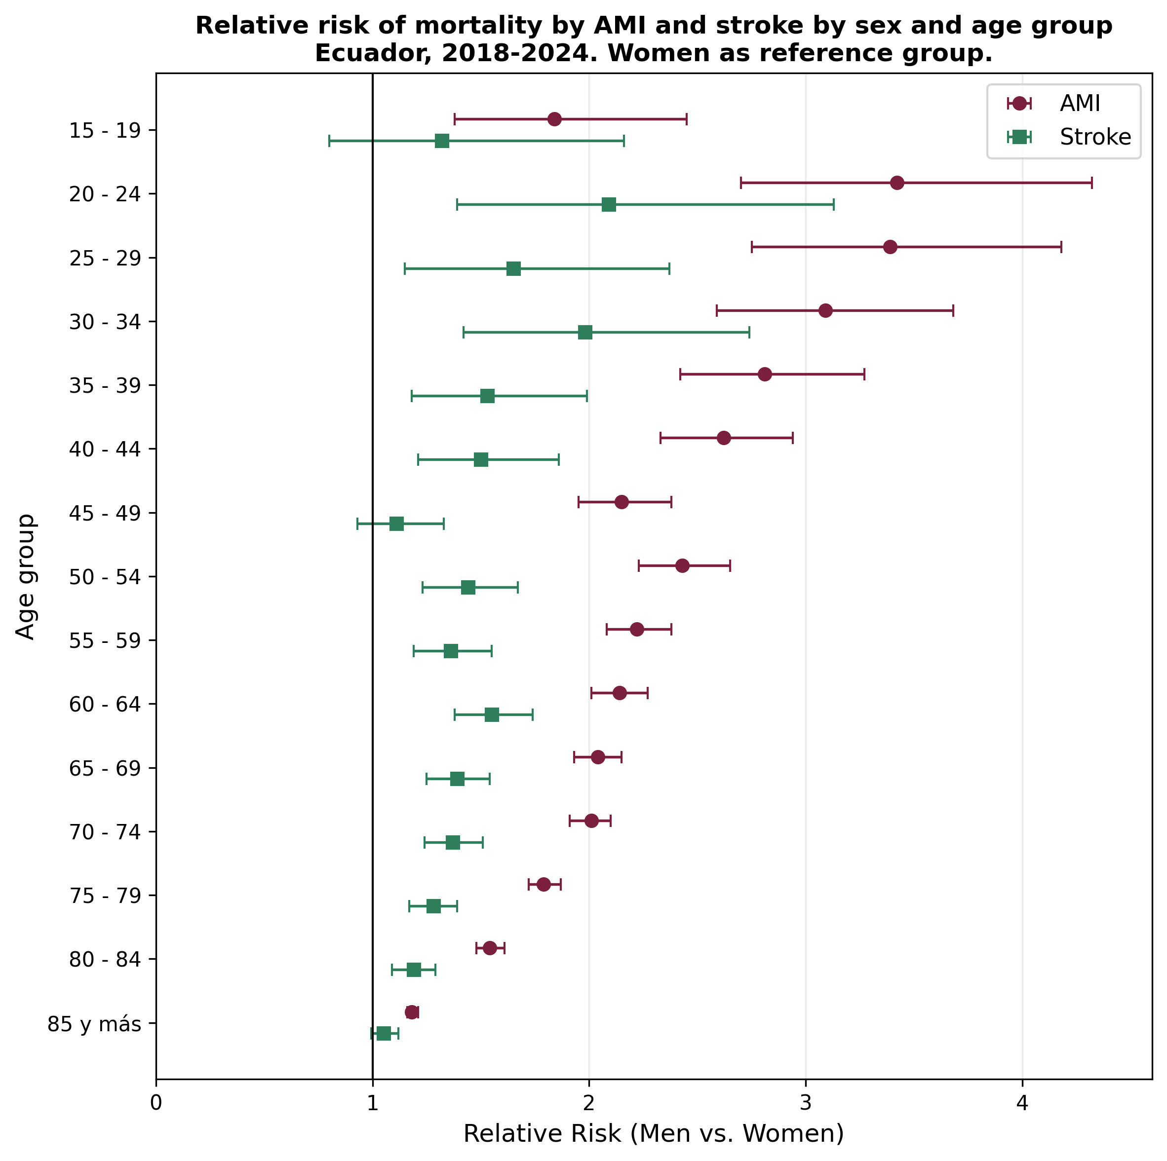
AMI, acute myocardial infarction; RR, relative risk; CI, confidence interval. Women used as reference group. Source: INEC — author's elaboration.
Figure S6. AMI and stroke mortality rate by age group and sex, logarithmic scale. Ecuador, 2018-2024.
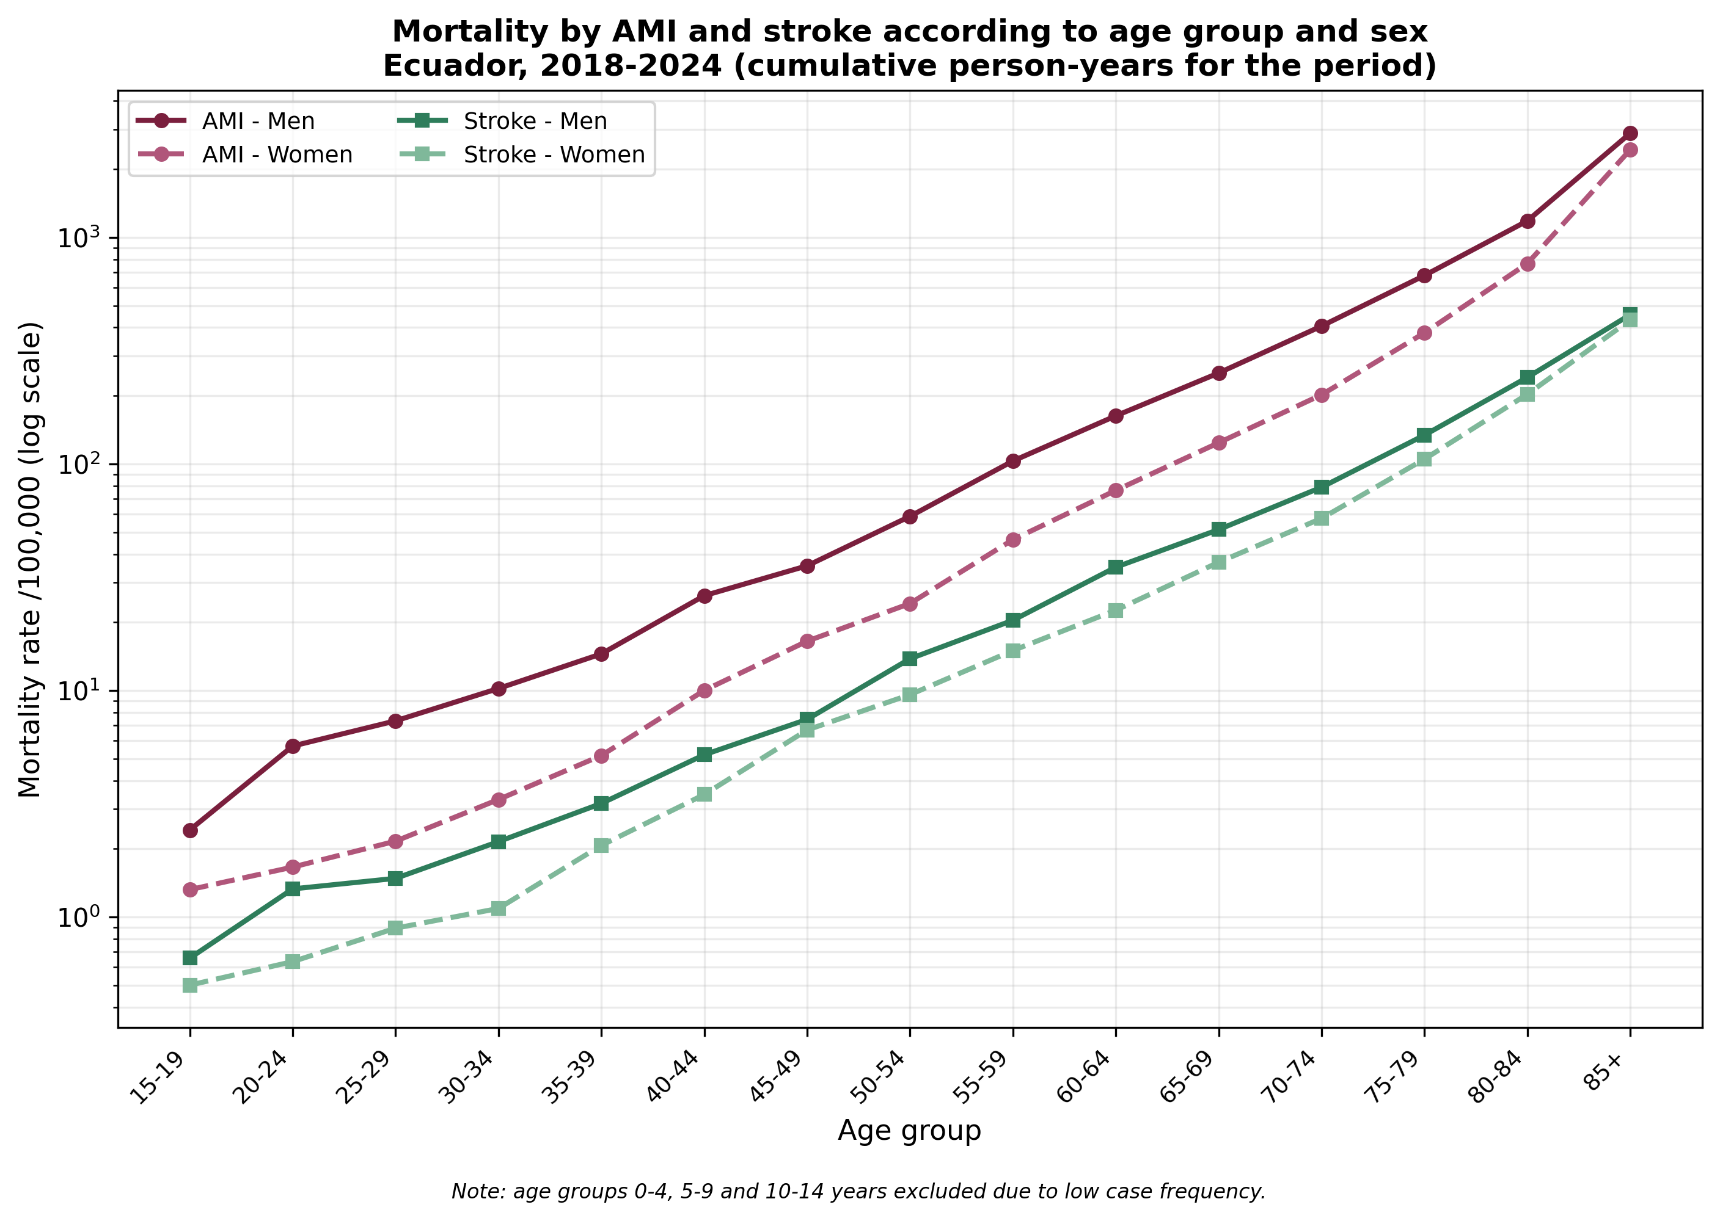
AMI, acute myocardial infarction. Rates expressed as cumulative person-years for the period; age groups 0-14 years excluded due to low case frequency. Source: INEC — author's elaboration.
For both conditions, age-specific rates show an approximately exponential rise, consistent with the expected cardiovascular mortality pattern. The AMI rate systematically exceeded the stroke rate across all age groups and for both sexes, and convergence between male and female rates at the upper end of the age distribution was more pronounced for stroke than for AMI, reflecting differential attenuation of the female protective effect between the two conditions.

S5. Provincial distribution
Aggregation at the provincial level confirms the pattern identified through cantonal-level LISA: Guayas, Los Ríos, and Manabí show the country's highest AMI mortality rates, with Guayas reaching a rate more than six times higher than the lowest-rate Amazonian provinces (Orellana, Napo, Zamora Chinchipe). For stroke, the provincial pattern is less concentrated: Carchi, Azuay, Manabí, and Bolívar lead the rate, a distribution combining coastal and highland provinces, consistent with the multiple discontinuous cores identified in the stroke LISA analysis (section 3.4 of the main text). Provincial aggregation partially disperses the finer territorial signal detected at the cantonal level, particularly for AMI, where Guayas combines very-high-risk cantons (Pedro Carbo, Salitre) with lower-risk ones, averaged into a single provincial rate; the cantonal level (LISA) and the panel model remain the primary evidence of this study, and the provincial table is presented as complementary context. Galápagos province is presented separately (section 3.9) given its low case volume and geographic discontinuity.

Table S2. AMI and stroke mortality by province of residence, Ecuador 2018-2024.
Province | AMI cases | AMI rate /100,000 (95% CI) | Stroke cases | Stroke rate /100,000 (95% CI)
Guayas | 32,179 | 100.0 (99.0 to 101.1) | 5,028 | 15.6 (15.2 to 16.1)
Los Ríos | 5,111 | 77.1 (75.0 to 79.2) | 776 | 11.7 (10.9 to 12.6)
Manabí | 7,868 | 67.8 (66.3 to 69.3) | 1,921 | 16.6 (15.8 to 17.3)
Pichincha | 12,211 | 54.4 (53.4 to 55.4) | 2,588 | 11.5 (11.1 to 12.0)
Cañar | 858 | 51.6 (48.2 to 55.1) | 201 | 12.1 (10.5 to 13.9)
Tungurahua | 1,981 | 49.5 (47.4 to 51.8) | 519 | 13.0 (11.9 to 14.1)
Chimborazo | 1,690 | 48.7 (46.4 to 51.1) | 441 | 12.7 (11.6 to 14.0)
El Oro | 2,360 | 45.8 (44.0 to 47.7) | 558 | 10.8 (9.9 to 11.8)
Bolívar | 628 | 43.4 (40.0 to 46.9) | 236 | 16.3 (14.3 to 18.5)
Loja | 1,498 | 43.0 (40.9 to 45.3) | 413 | 11.9 (10.8 to 13.1)
Cotopaxi | 1,359 | 40.8 (38.7 to 43.0) | 425 | 12.8 (11.6 to 14.0)
Santa Elena | 1,078 | 39.1 (36.8 to 41.5) | 229 | 8.3 (7.3 to 9.4)
Imbabura | 1,310 | 38.8 (36.8 to 41.0) | 440 | 13.0 (11.9 to 14.3)
Sto. Domingo Tsáchilas | 1,350 | 37.9 (35.9 to 40.0) | 476 | 13.4 (12.2 to 14.6)
Esmeraldas | 1,555 | 37.5 (35.6 to 39.4) | 531 | 12.8 (11.7 to 13.9)
Carchi | 466 | 36.7 (33.4 to 40.2) | 223 | 17.6 (15.3 to 20.0)
Azuay | 2,098 | 36.4 (34.8 to 38.0) | 971 | 16.8 (15.8 to 17.9)
Morona Santiago | 200 | 14.6 (12.6 to 16.7) | 72 | 5.2 (4.1 to 6.6)
Pastaza | 114 | 14.5 (11.9 to 17.4) | 53 | 6.7 (5.0 to 8.8)
Sucumbíos | 178 | 12.3 (10.6 to 14.3) | 102 | 7.1 (5.8 to 8.6)
Zamora Chinchipe | 85 | 10.7 (8.5 to 13.2) | 32 | 4.0 (2.7 to 5.7)
Napo | 94 | 10.1 (8.2 to 12.4) | 45 | 4.8 (3.5 to 6.5)
Orellana | 97 | 7.6 (6.2 to 9.3) | 78 | 6.1 (4.8 to 7.6)
AMI, acute myocardial infarction; CI, confidence interval. Rates expressed per 100,000 population, cumulative person-years for the period, sorted by descending AMI rate. Galápagos province excluded (presented separately in section 3.10). Source: INEC — author's elaboration.
This sex-based pattern is consistent with the cardiovascular protective effect attributed to estrogenic hormonal exposure in premenopausal women, which progressively attenuates after menopause —more markedly for stroke than for AMI—, a finding consistent with the international cardiovascular literature and one that had not previously been quantified for the Ecuadorian population using national registry data.

