Multi-Omics Analysis of Lactylation-Related Gene Signature for Prognosis, Immune Microenvironment, and Therapeutic Target Discovery in Oral Squamous Cell Carcinoma
Zhou Linyue ¹
1 Department of Craniofacial Development and Stem Cell Biology, Faculty of Dentistry, Oral & Craniofacial Sciences, King’s College London, London, United Kingdom
Corresponding author: [ZHOULINYUE LIN], [lzhoulinyue1122@163.com]

SUPPLEMENTARY MATERIALS
Figures and Tables for
Multi-Omics Analysis of Lactylation-Related Gene Signature for Prognosis, Immune Microenvironment, and Therapeutic Target Discovery in Oral Squamous Cell Carcinoma
Section 1: Supplementary Figures
Figure S1. TCGA-HNSC Cohort Clinical Characteristics and Sample Distribution ( Results 3.1)
This figure corresponds to Results section 3.1 (Data acquisition and sample characteristics) and provides comprehensive sample distribution and clinical baseline information for the TCGA-HNSC cohort (n=386, including 342 oral cancer and 44 normal samples). The figure consists of 4 panels: (A) Sample group distribution (bar+pie) + Primary site distribution (bar) + Oral vs Non-Oral HNSCC cross-tabulation (stacked bar); (B) Primary Site Distribution among tumor samples (8 anatomical sites); (C) AJCC Pathologic Stage distribution; (D) Clinical Characteristics Summary heatmap comparing Oral Cancer vs Normal.
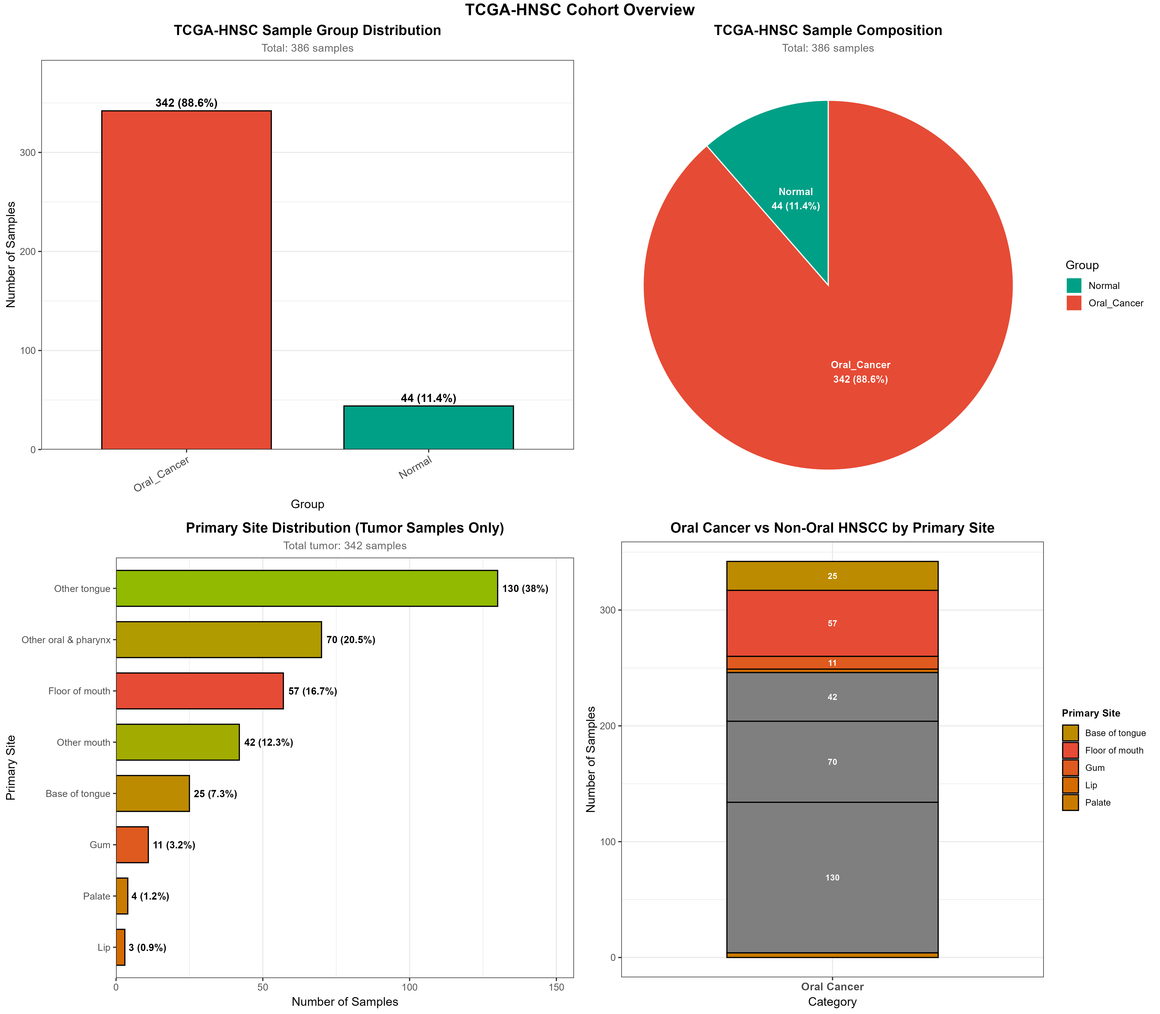
Figure S1A. TCGA-HNSC Sample Group Distribution (left top: bar chart 342 vs 44; right top: pie chart 88.6% vs 11.4%) + Primary Site Distribution (left bottom: 8 anatomical sites) + Oral Cancer vs Non-Oral HNSCC by Primary Site (right bottom: stacked bar). Total samples: 386.
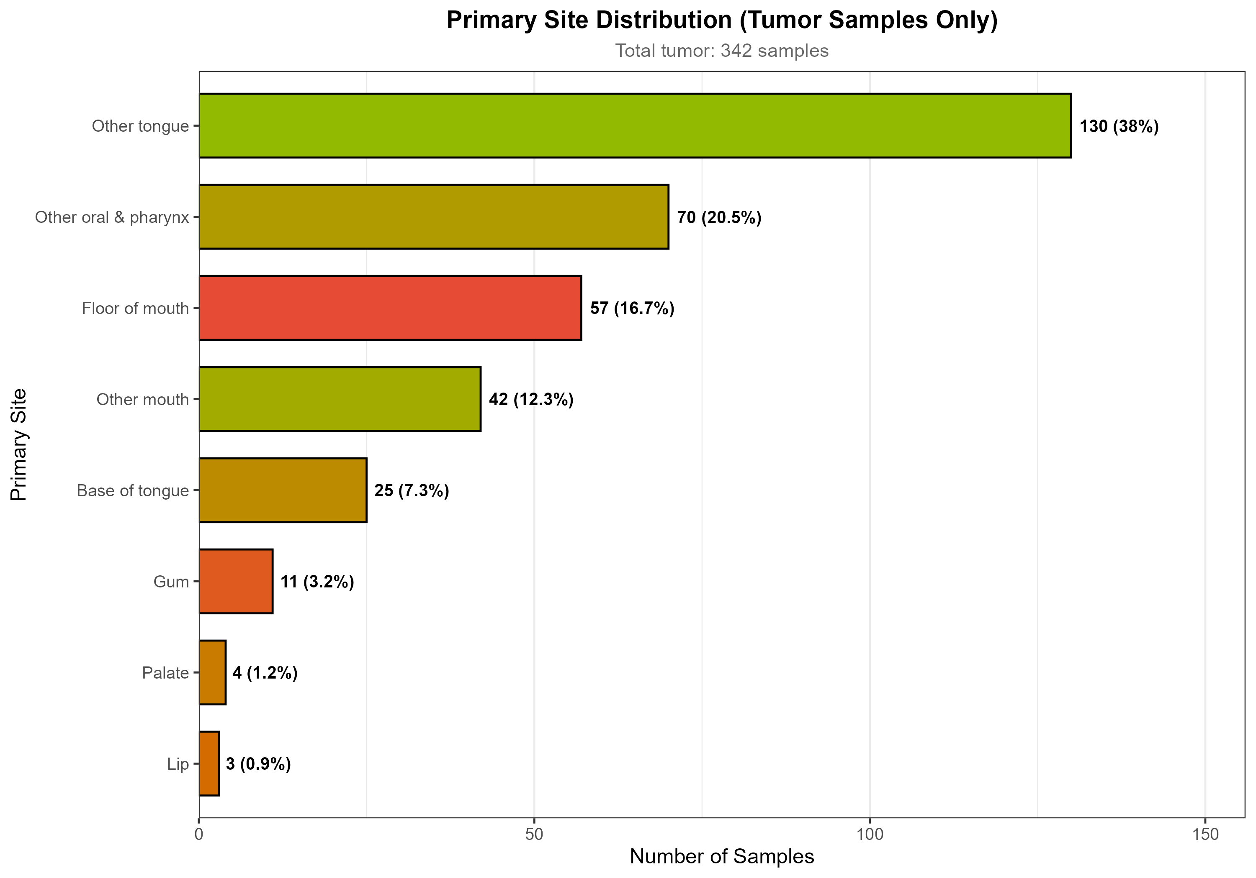
Figure S1B. Primary Site Distribution (Tumor Samples Only, n=342): Other tongue 130 (38%), Other oral & pharynx 70 (20.5%), Floor of mouth 57 (16.7%), Other mouth 42 (12.3%), Base of tongue 25 (7.3%), Gum 11 (3.2%), Palate 4 (1.2%), Lip 3 (0.9%).
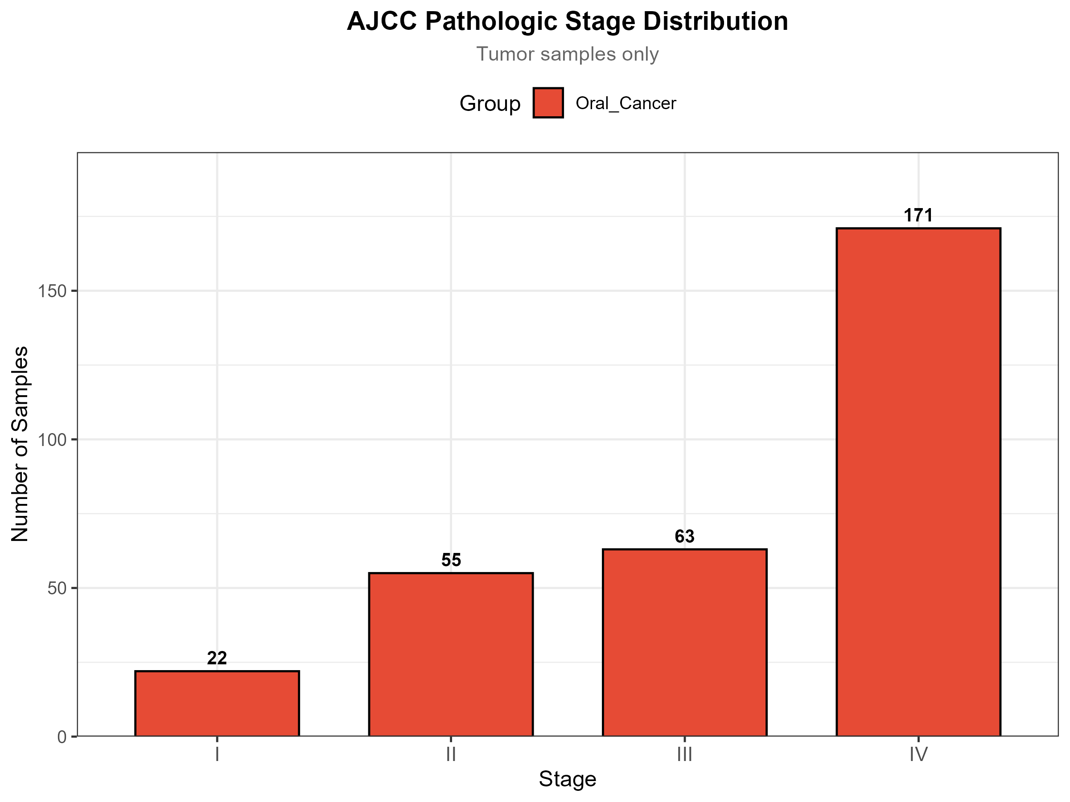
Figure S1C. AJCC Pathologic Stage Distribution (Tumor samples only, n=311 with available staging): Stage I 22, II 55, III 63, IV 171. Advanced stage (III-IV) predominates (234/311 = 75.2%).
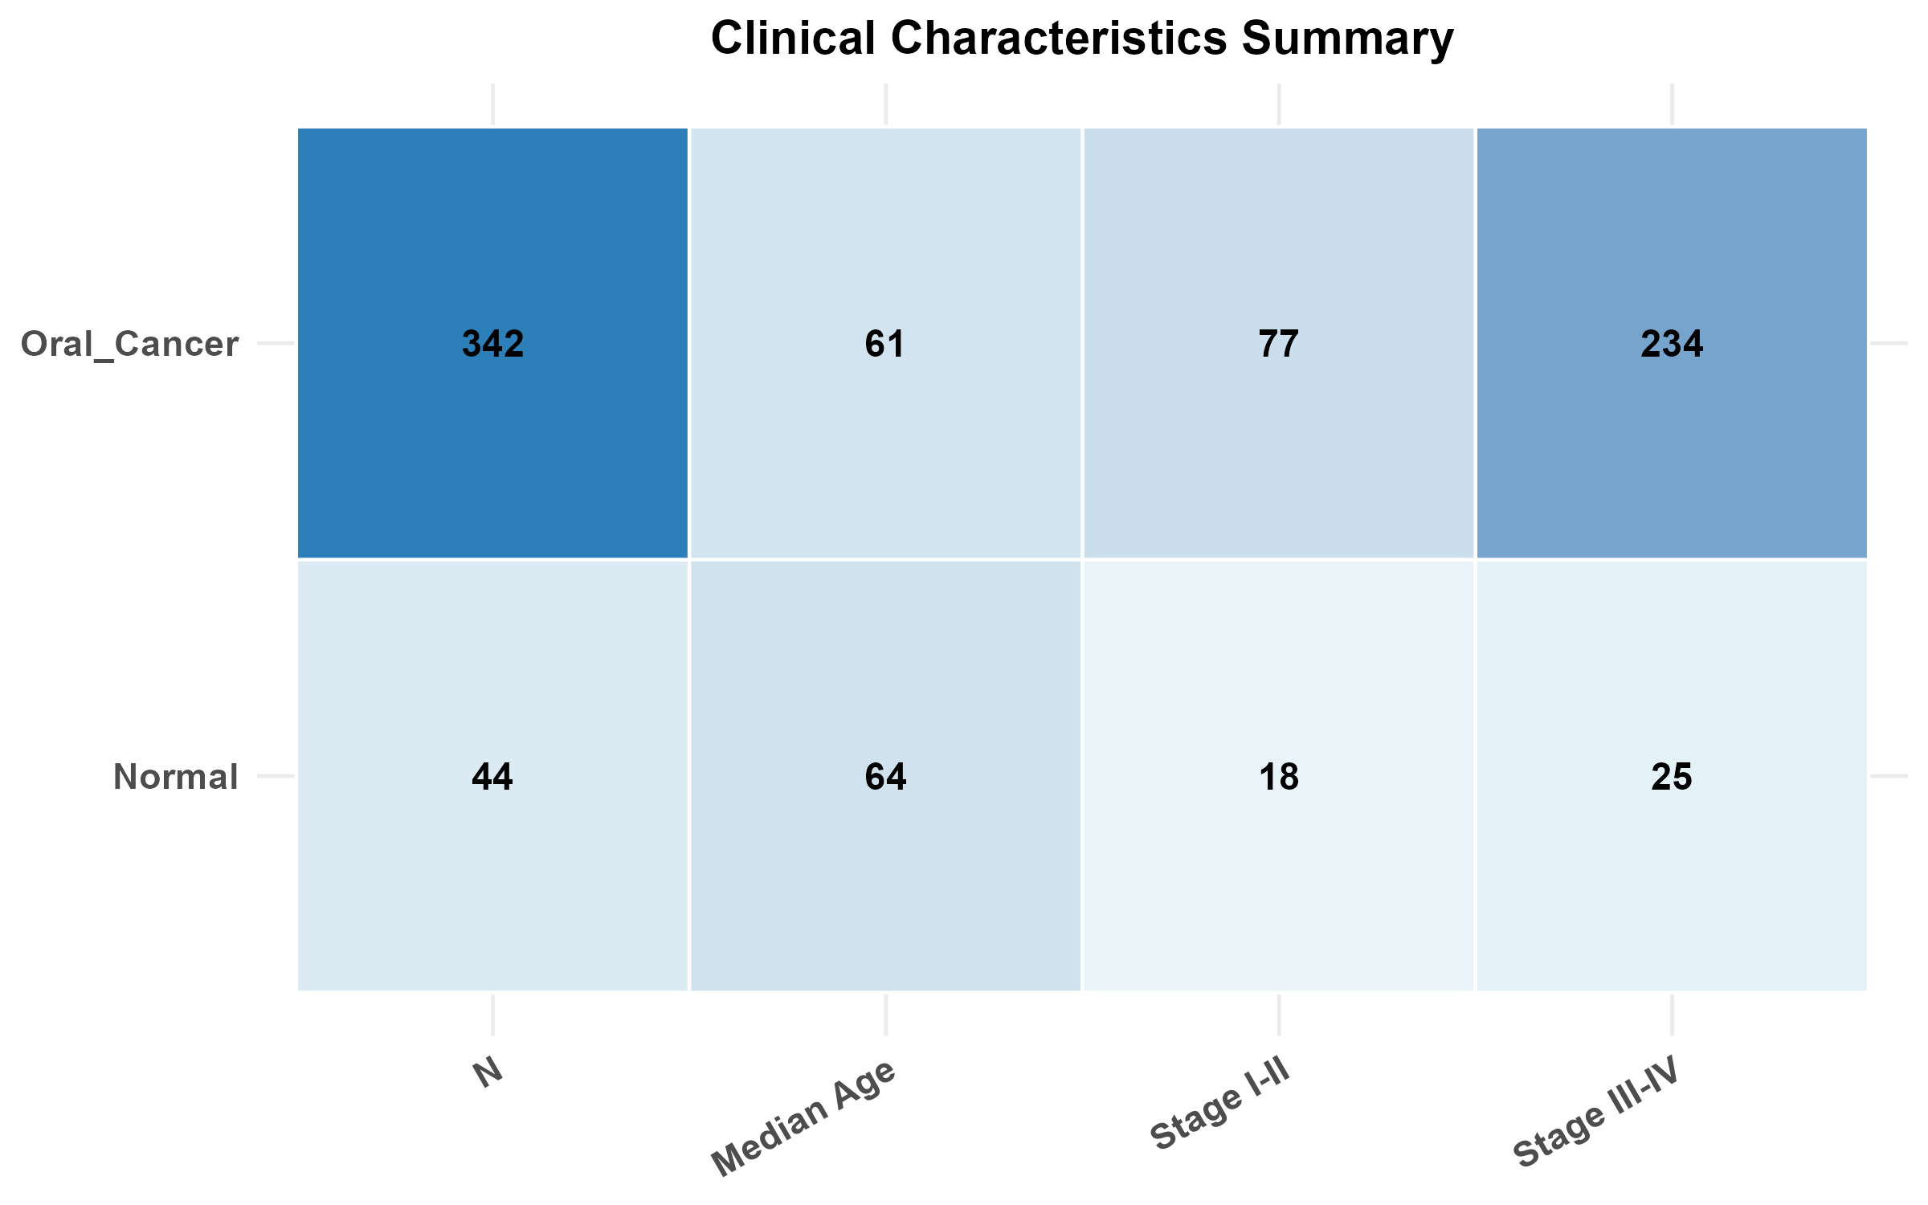
Figure S1D. Clinical Characteristics Summary: Oral Cancer (N=342, Median Age=61, Stage I-II=77, Stage III-IV=234) vs Normal (N=44, Median Age=64, Stage I-II=18, Stage III-IV=25). The cohort composition confirms the focus on advanced-stage oral cancer, consistent with clinical epidemiology.
Summary: (1) Total samples: 386 (342 oral cancer + 44 normal). (2) Most common primary site: Other tongue (38.0%) > Other oral & pharynx (20.5%) > Floor of mouth (16.7%). (3) Stage IV dominates (54.9% of 311 staged tumors), indicating advanced disease at diagnosis. (4) Median age comparable between groups (61 vs 64 years), with strong skew toward advanced stages in oral cancer group (234 Stage III-IV vs 77 Stage I-II = 75.2% advanced).

Figure S2. PPI Network Alternative Layouts (Circle + FR)
This figure provides alternative layout views of the PPI network for the 25 core lactylation-related genes to complement Figure 4 in the main manuscript. The Circle layout (Panel A) and Fruchterman-Reingold (FR) layout (Panel B) provide different visual perspectives on the network topology. Top 10 hub genes identified by multi-topology scoring are highlighted in red.
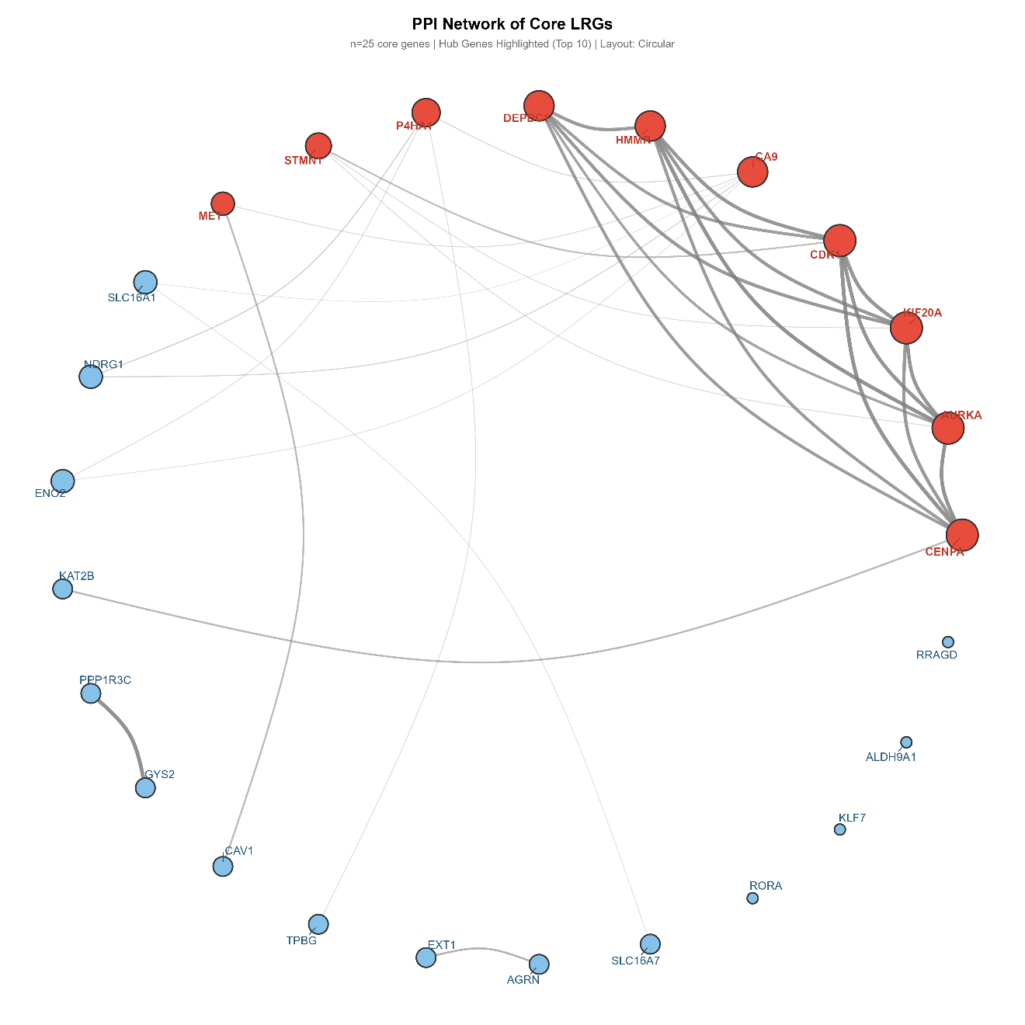
Figure S2A. PPI network in Circle layout (Top 10 hub genes highlighted in red)
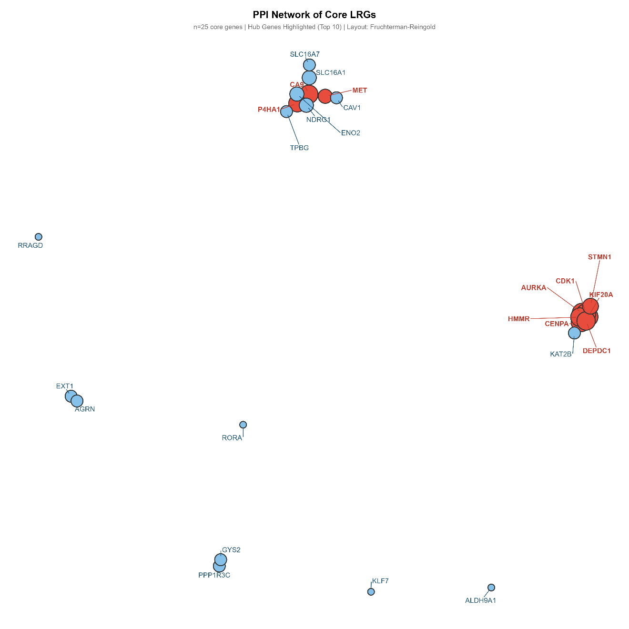
Figure S2B. PPI network in Fruchterman-Reingold (FR) layout

Figure S3. Functional Enrichment Supplements (KEGG + GSEA KEGG)
This figure provides additional KEGG pathway enrichment analyses to complement Figure 5 in the main manuscript.
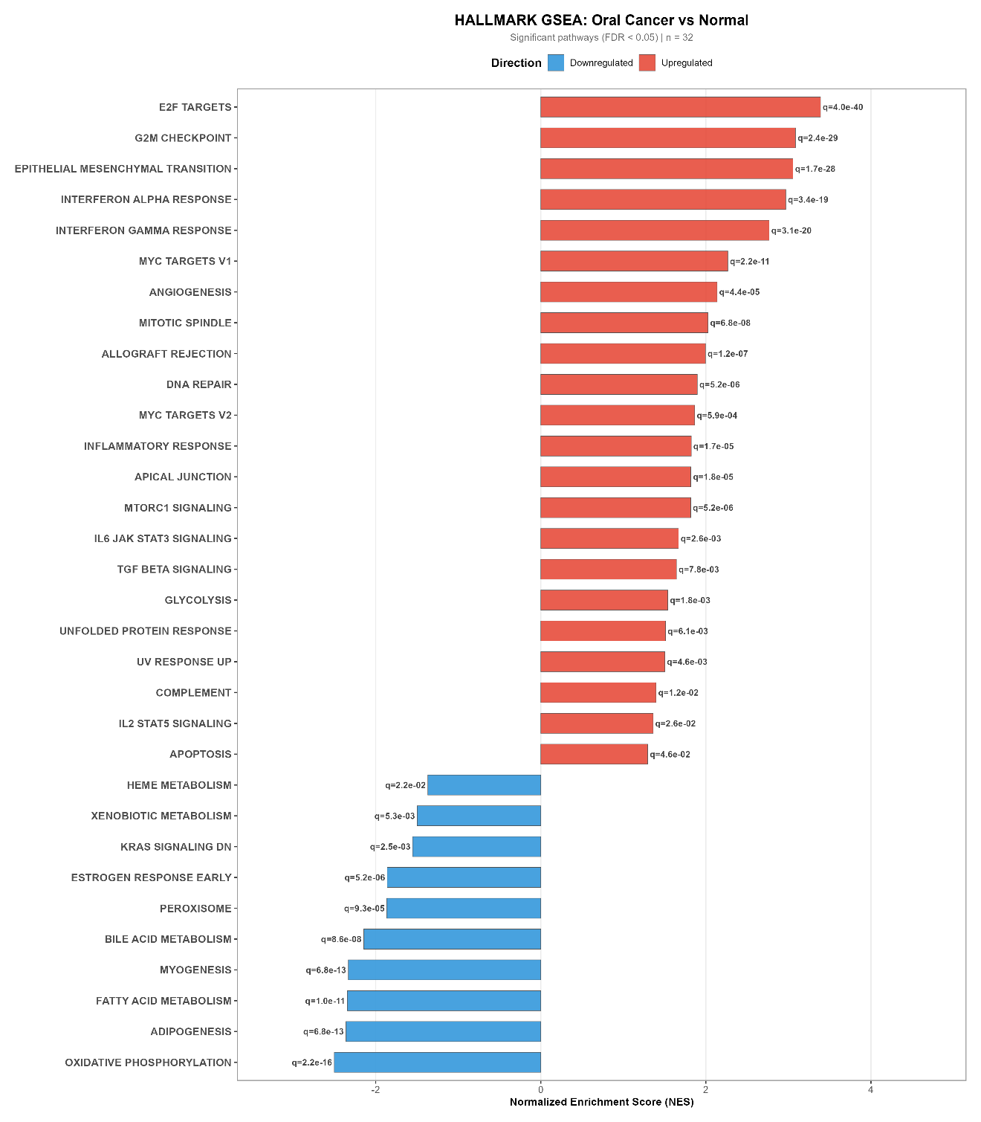
Figure S3A. GO MF enrichment dotplot (complement to Figure 5B)
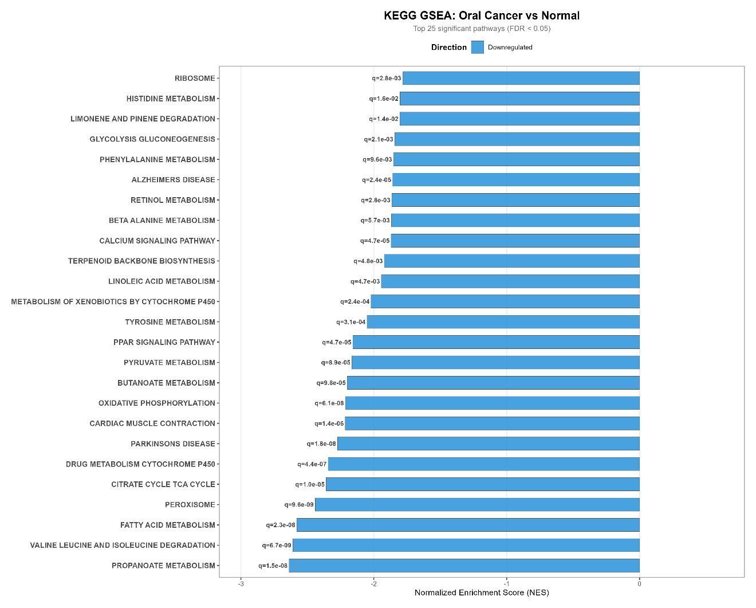
Figure S3B. KEGG pathway enrichment dotplot
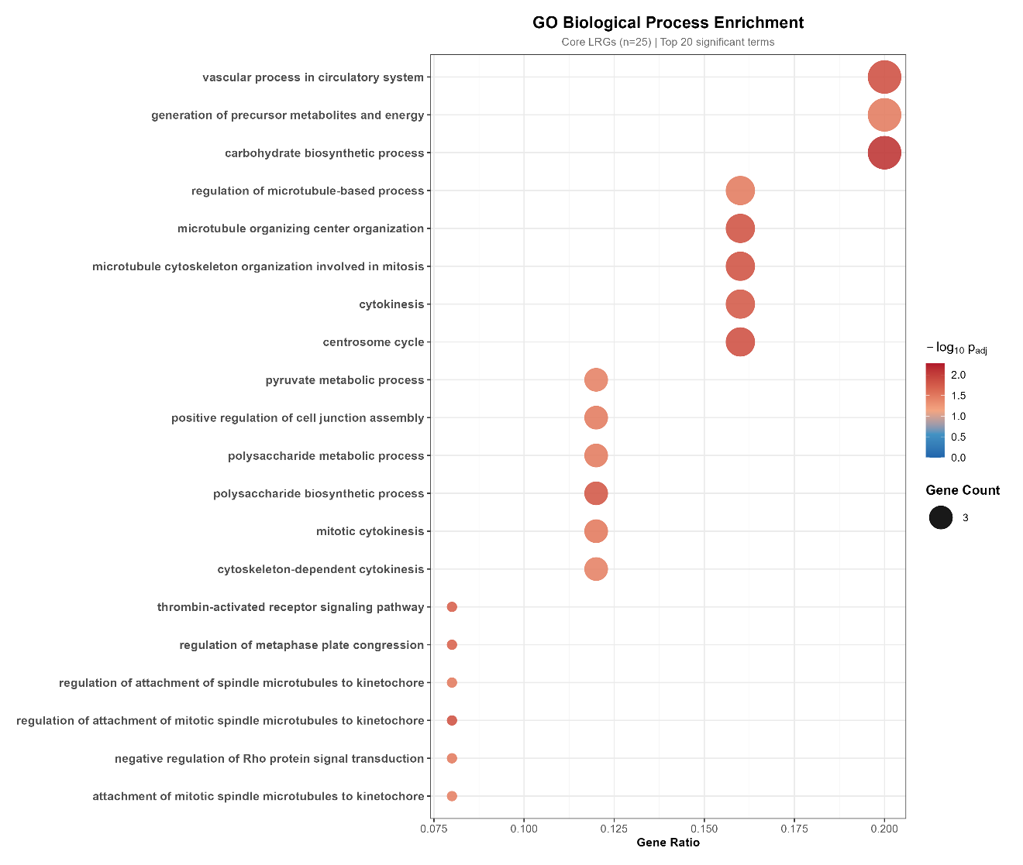
Figure S3C. Gene-pathway association chord diagram (15 Core LRGs vs Top GO BP Terms)

Figure S4.Calibration curve
Figure S4 Shows calibration curves over 1-6 years. The gray dashed line represents the ideal calibration curve (45), while the black solid line denotes the observed–predicted calibration curve; the blue X marks the inclusion of a resampling optimism correction (B=200). Calibration quality is satisfactory at all time points, with relatively wide confidence intervals in regions of extreme prediction probabilities (due to reduced sample size).
Figure S5. Number at risk
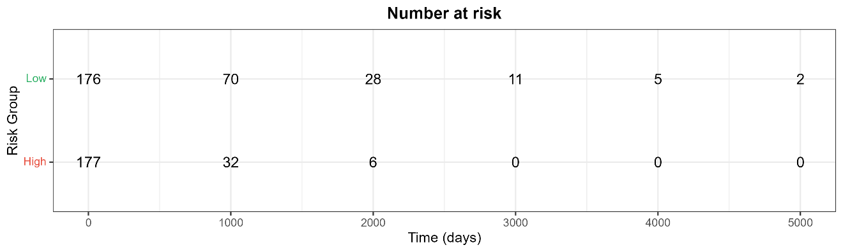
Figure S5 Risk table. Shows the number of individuals at risk at different time points.
Figure S6. Decision Curve Analysis
Figure S6: Decision Curve Analysis (DCA) at 1, 3, and 5 years. Horizontal axis: threshold probability; vertical axis: net benefit.
Figure S7. ssGSEA 24 Immune Cell Heatmap and Stacked Bar
This figure provides detailed visualizations of the single-sample Gene Set Enrichment Analysis (ssGSEA) for 24 immune cell types, complementing Figure 7 in the main manuscript.
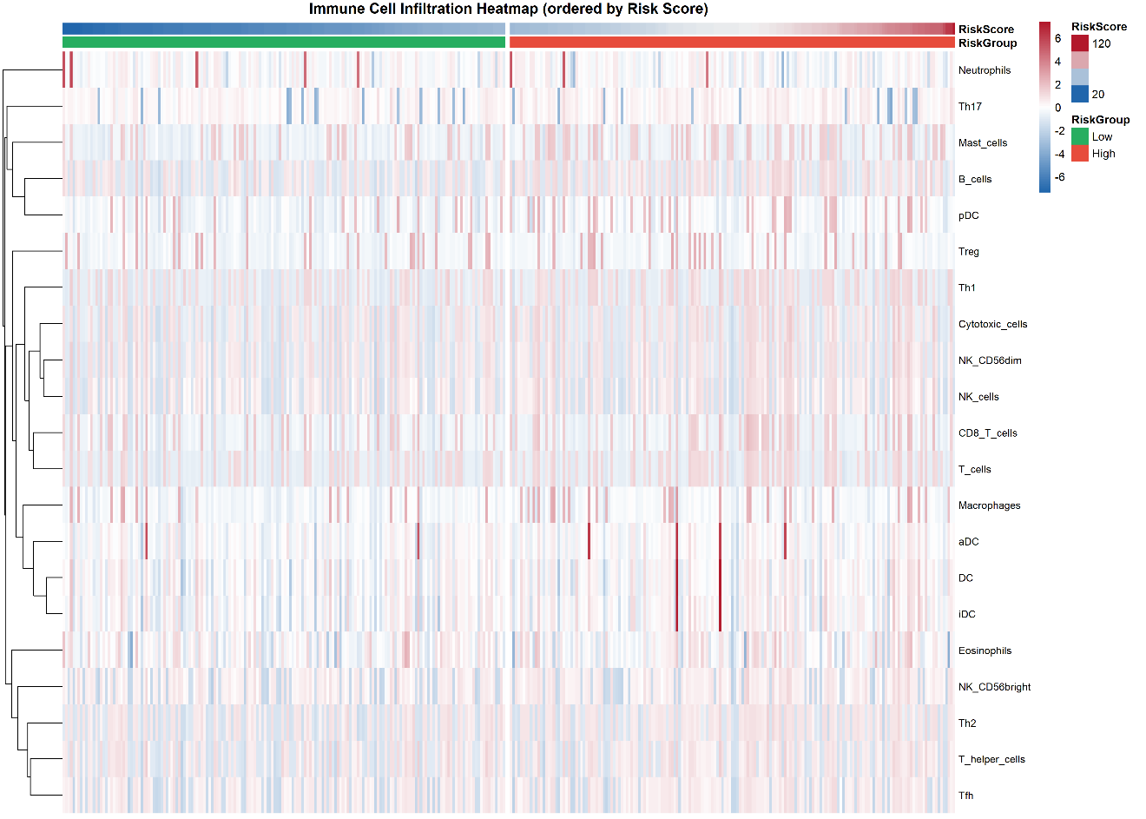
Figure S7A. ssGSEA 24 immune cell infiltration heatmap (sorted by risk score)
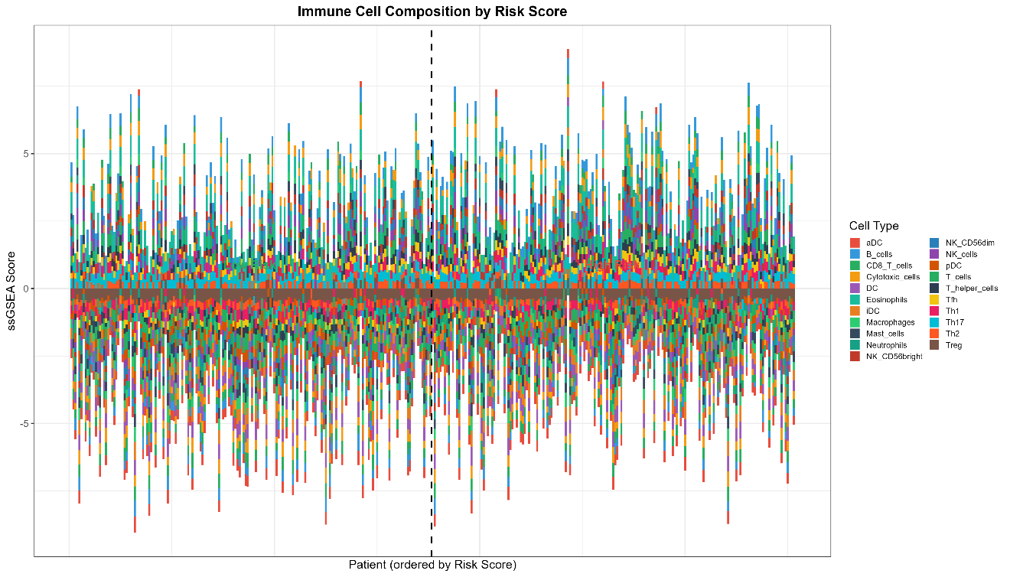
Figure S7B. ssGSEA immune cell composition stacked bar chart
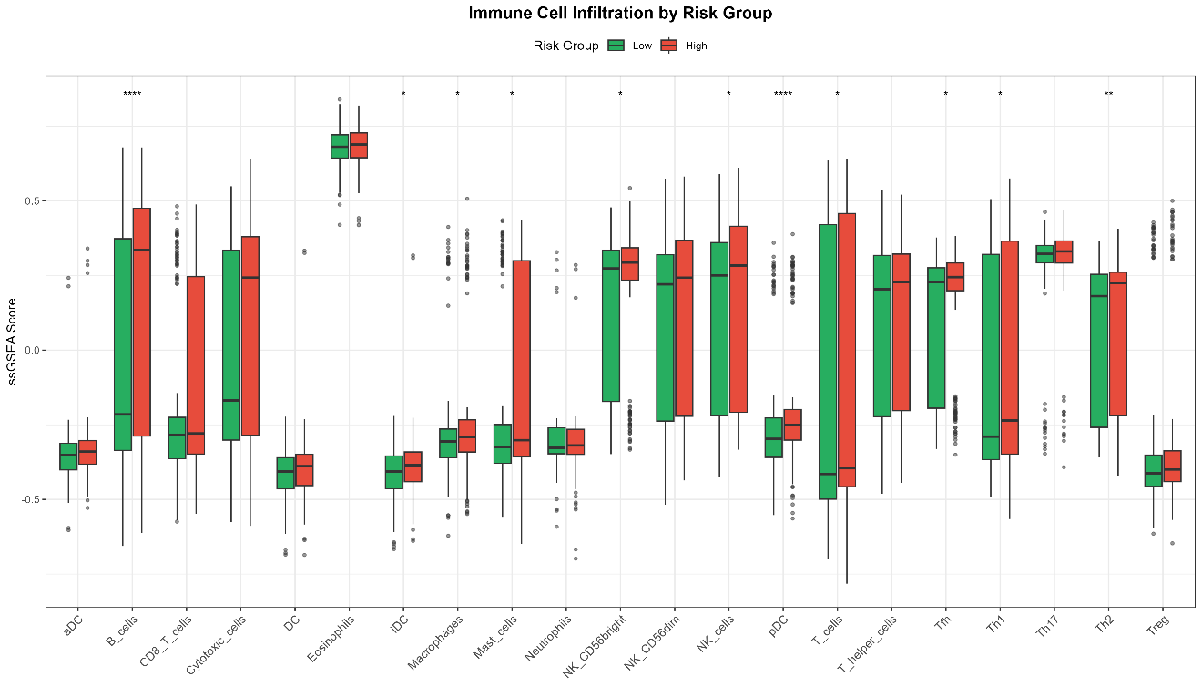
Figure S7C. ssGSEA 24 immune cell boxplot (alternative view)

Figure S8. CIBERSORT 22 Immune Cell Stacked Bar
This figure provides the detailed CIBERSORT deconvolution immune cell composition to complement Figure 8 in the main manuscript.
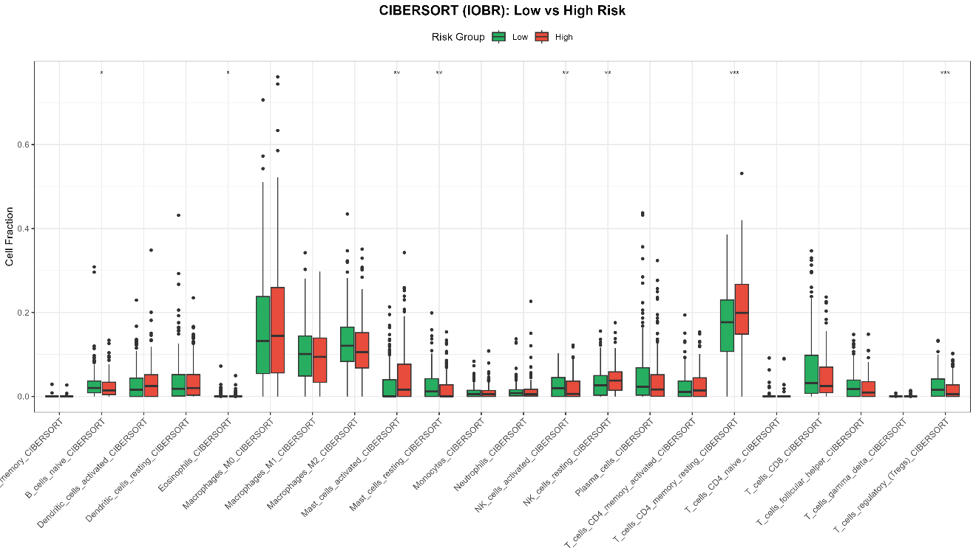
Figure S8A. CIBERSORT immune cell proportion boxplot (22 immune cell types)
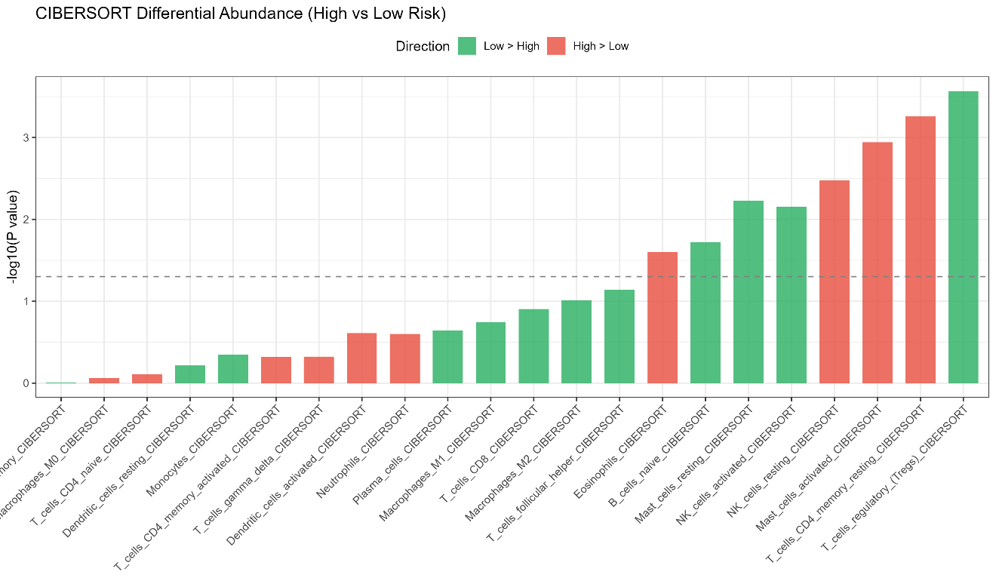
Figure S8B. CIBERSORT differential abundance lollipop chart
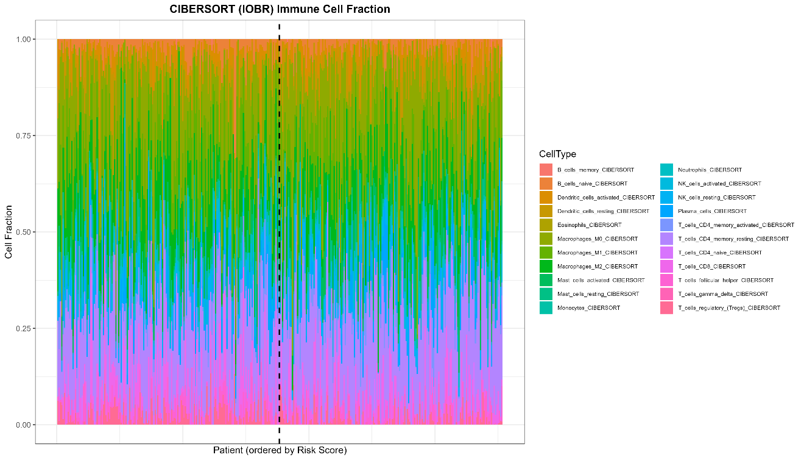
Figure S8C. CIBERSORT immune cell proportion stacked bar chart

Figure S9. 20 Immune Checkpoint Gene Analysis
This figure provides comprehensive analysis of 20 key immune checkpoint genes across risk groups, complementing the immune-related findings in the main manuscript.
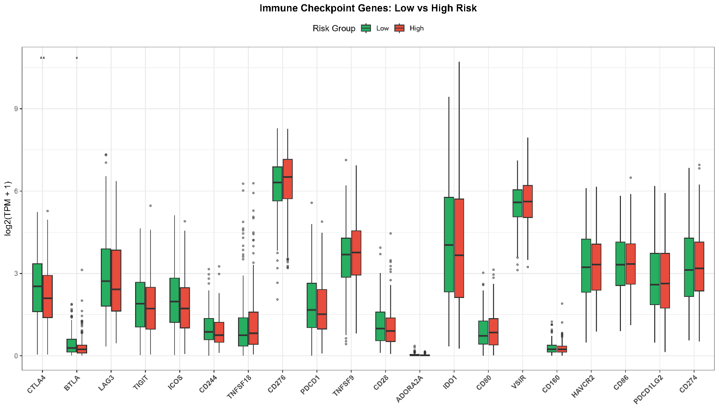
Figure S9A. 20 immune checkpoint gene expression boxplots
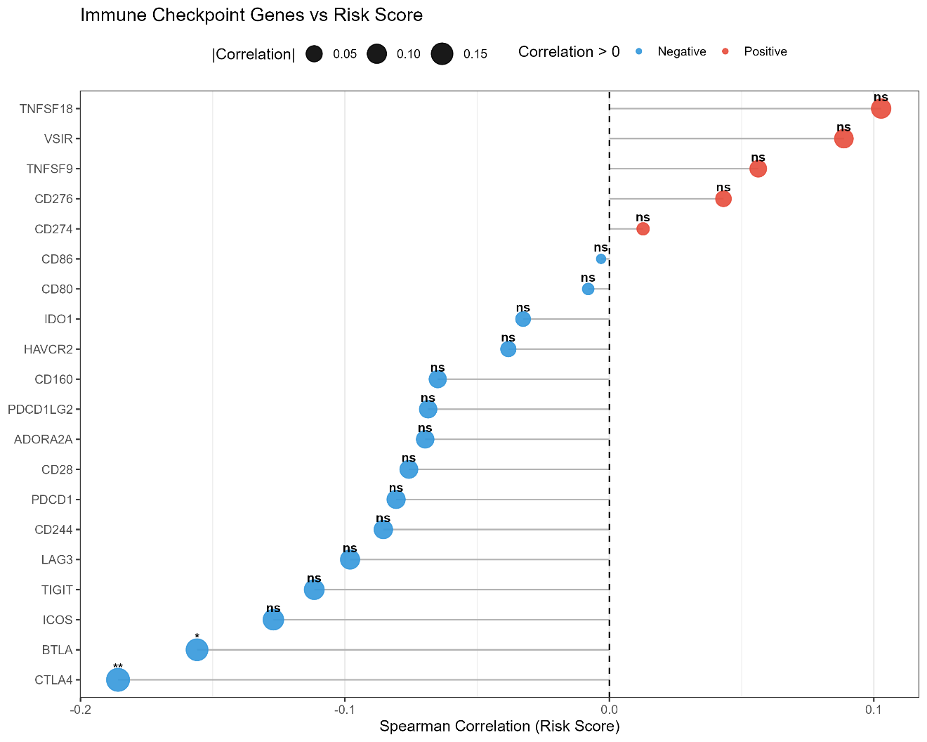
Figure S9B. Spearman correlation heatmap of 20 immune checkpoint genes
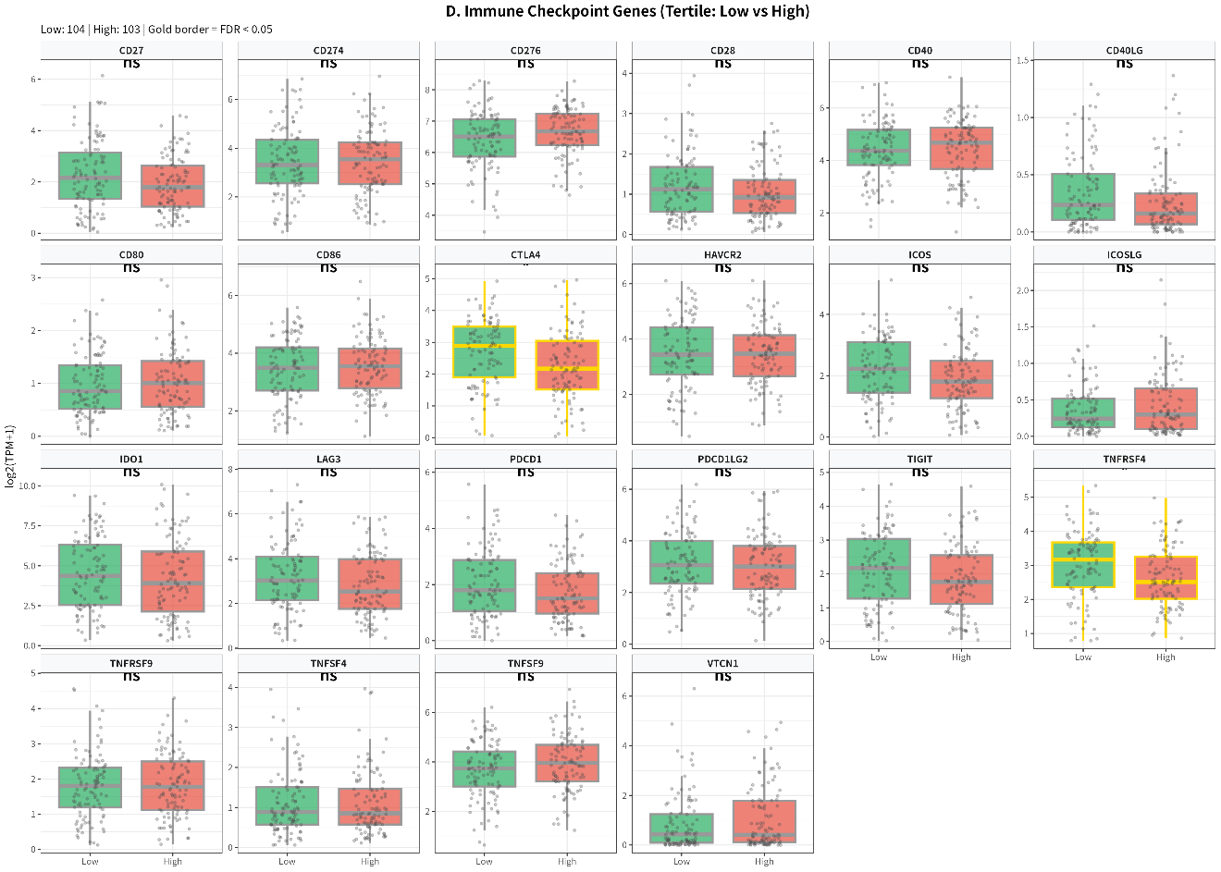
Figure S9C. Tertile-based comparison of selected checkpoints

Figure S10. Th1/Th2 Balance and TIL Distribution
This figure examines the Th1/Th2 balance and tumor-infiltrating lymphocyte (TIL) distribution patterns.
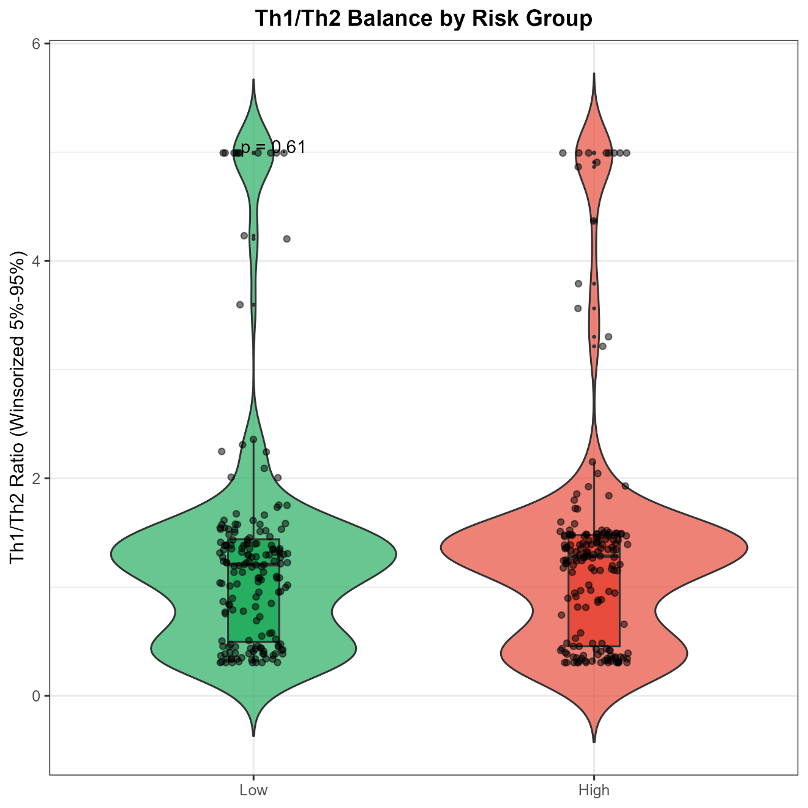
Figure S10A. Th1/Th2 ratio violin plot
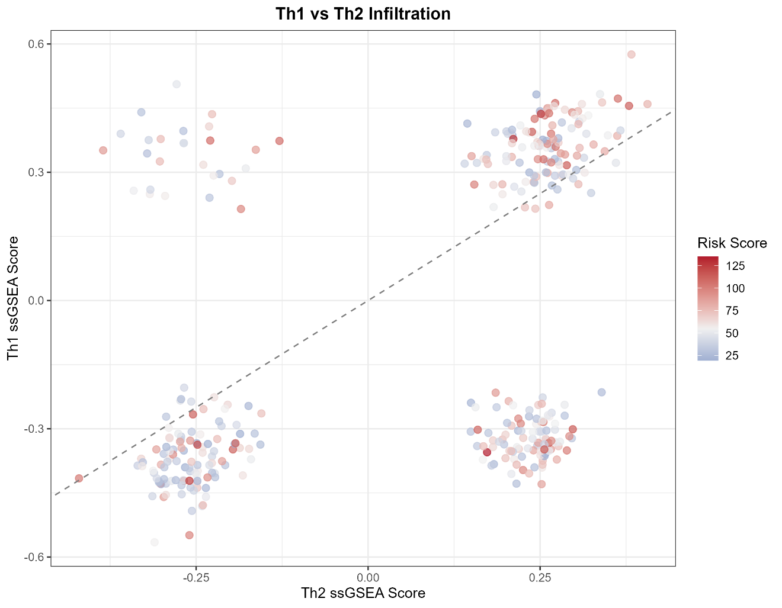
Figure S10B. Th1 vs Th2 scatter plot with balance line
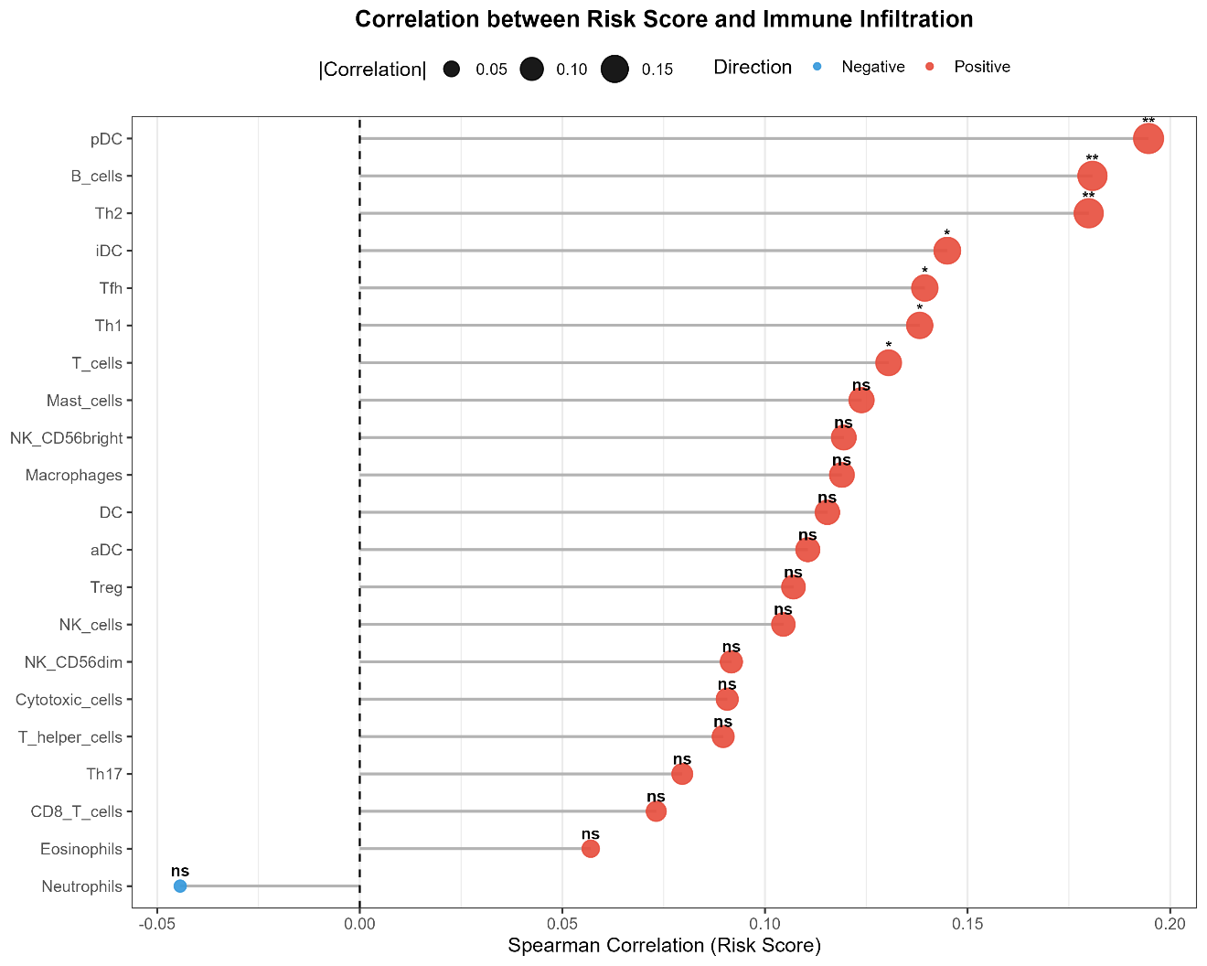
Figure S10C. TIL distribution heatmap

Figure S11. Risk Score vs Immune Cell Correlations
This figure presents the Spearman correlation analysis between Risk Score and immune cell infiltration levels (from ssGSEA).
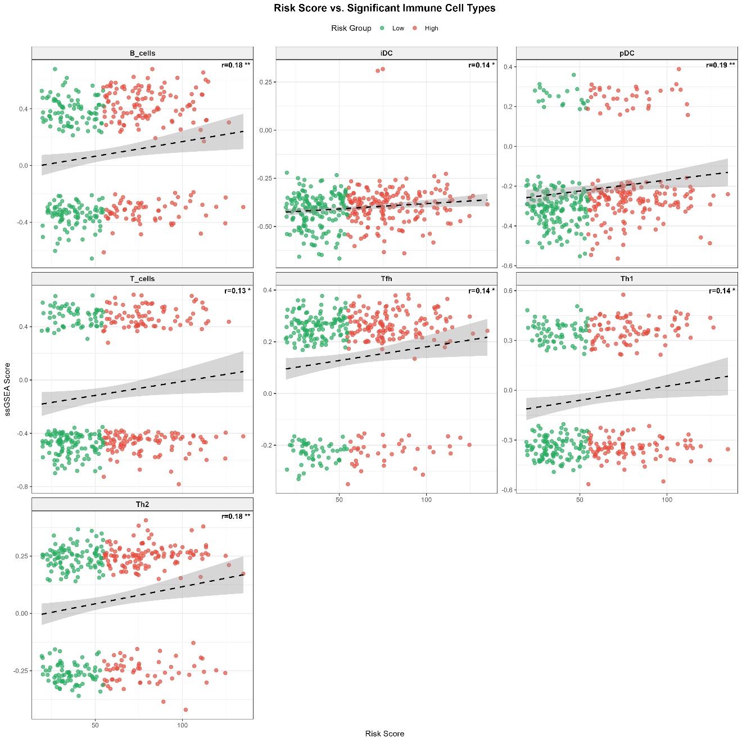
Figure S11A. Risk Score vs ssGSEA immune cell correlation heatmap
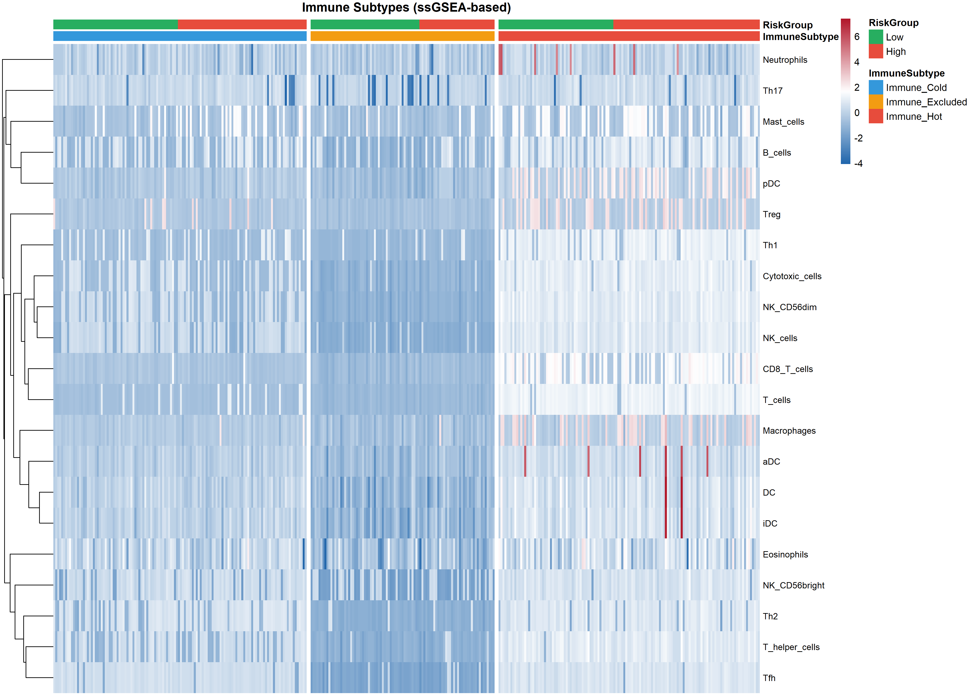
Figure S11B. Top 4 significant Risk Score - immune cell scatter plots

Figure S12. Immune Subtype K-means Clustering (K=3)
This figure presents the K-means clustering analysis (K=3) identifying three distinct immune subtypes: Immune Hot, Immune Cold, and Immune Excluded.
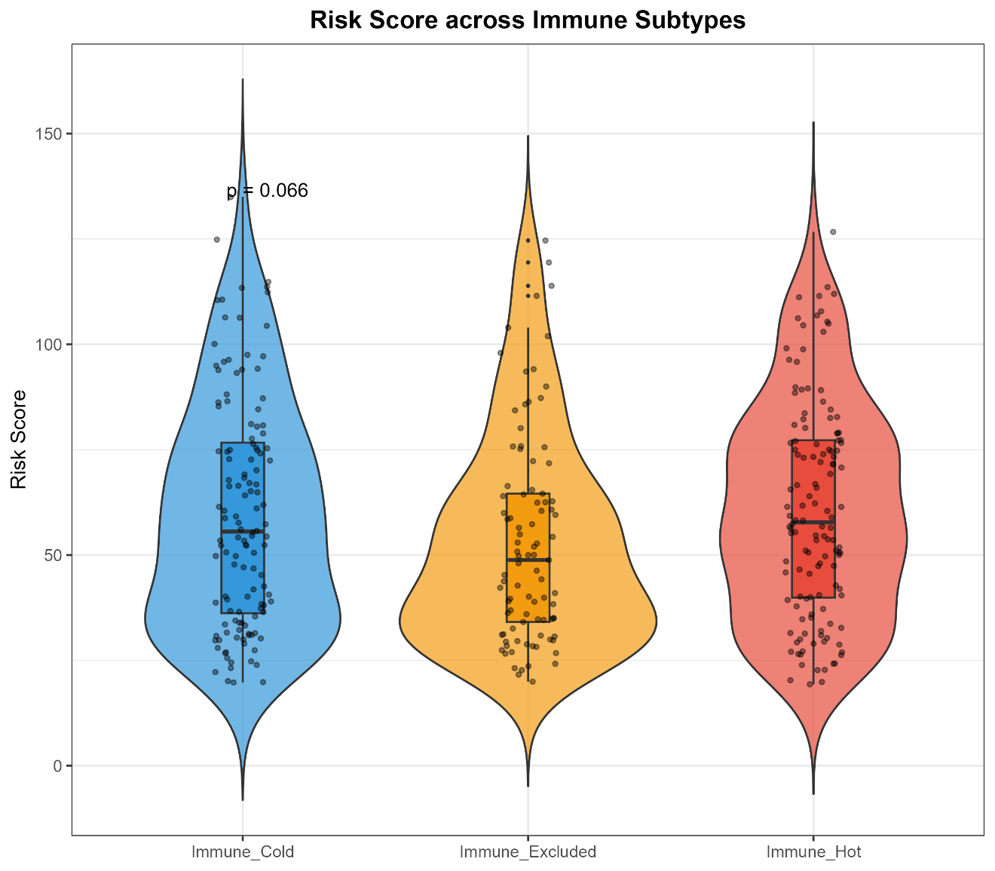
Figure S12A. K-means (K=3) immune subtype clustering heatmap
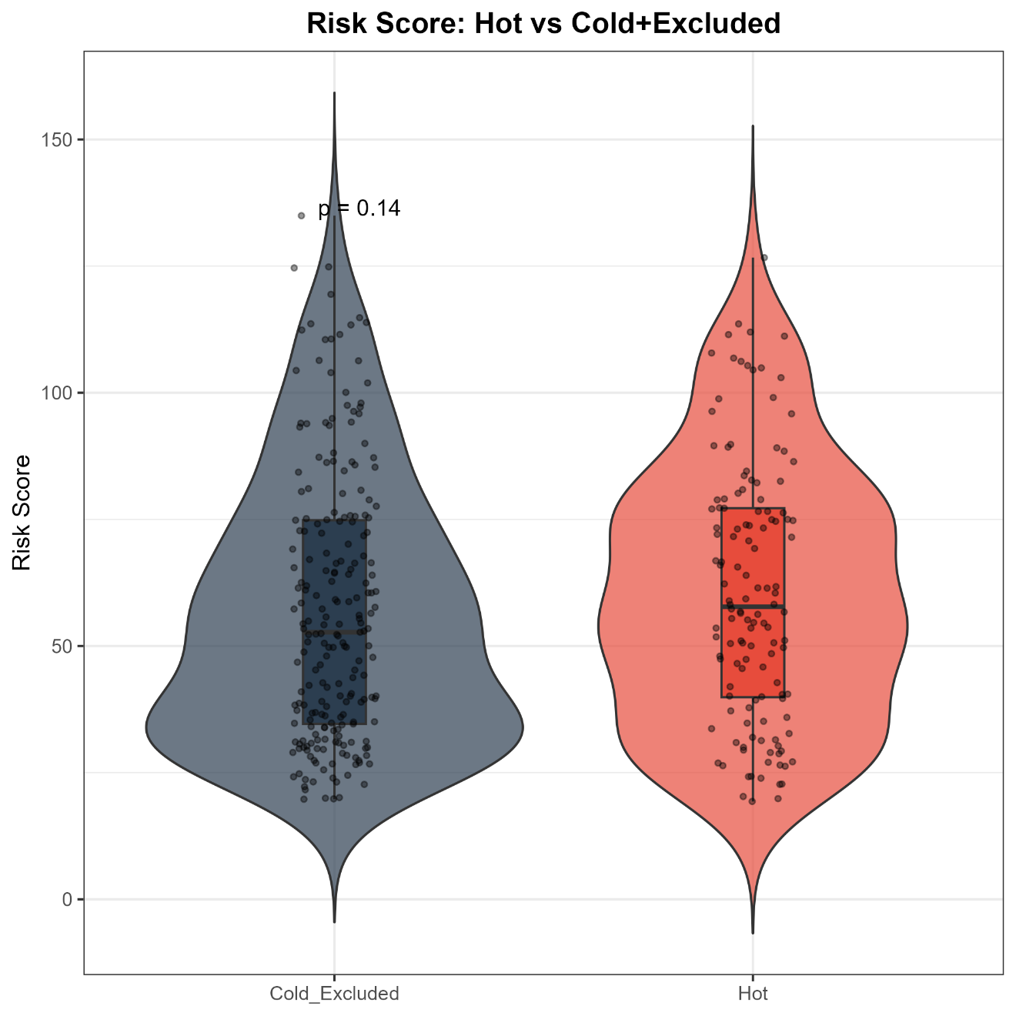
Figure S12B. Immune score violin plot across subtypes
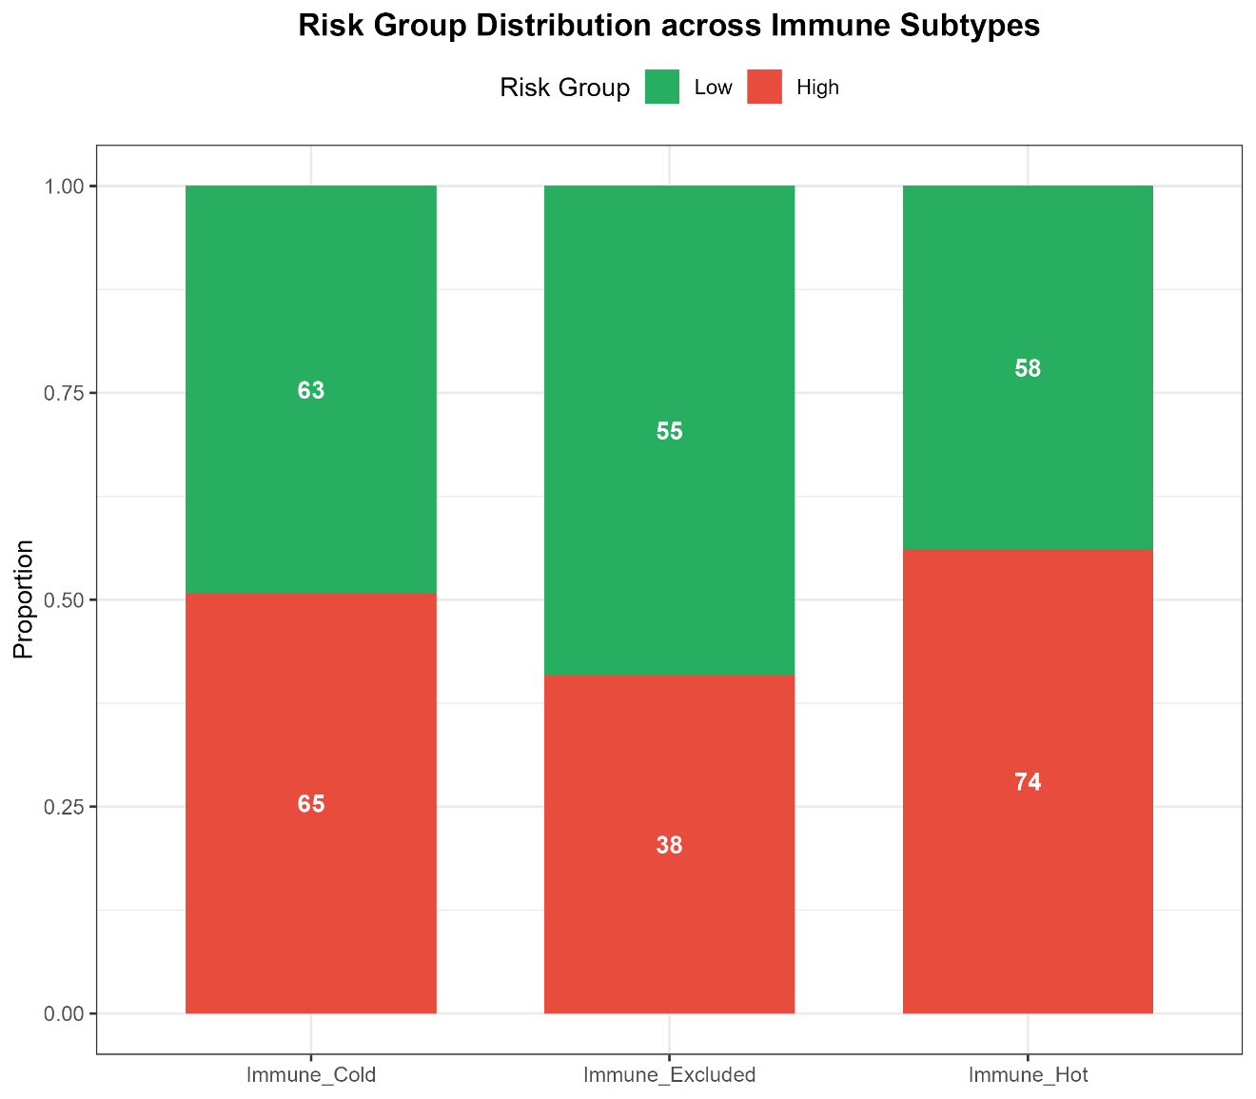
Figure S12C. Mosaic plot of immune subtype vs risk group

Figure S13. Core LRGs vs Immune Cell Correlations
This figure shows the correlation between 25 core LRGs and immune cell infiltration.
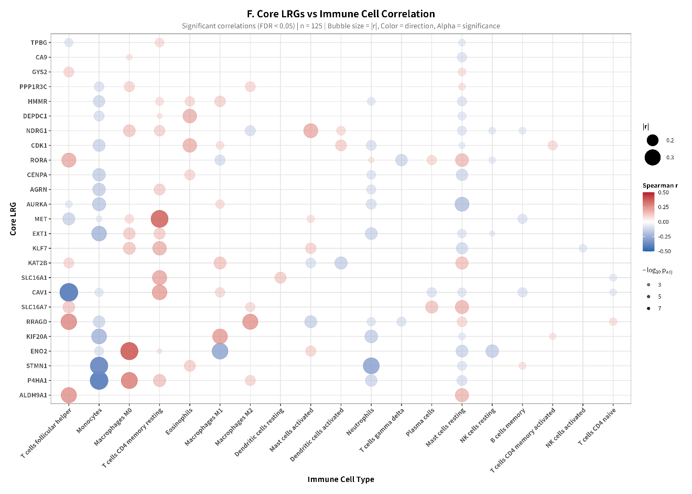
Figure S13A. Core LRGs vs immune cell bubble plot
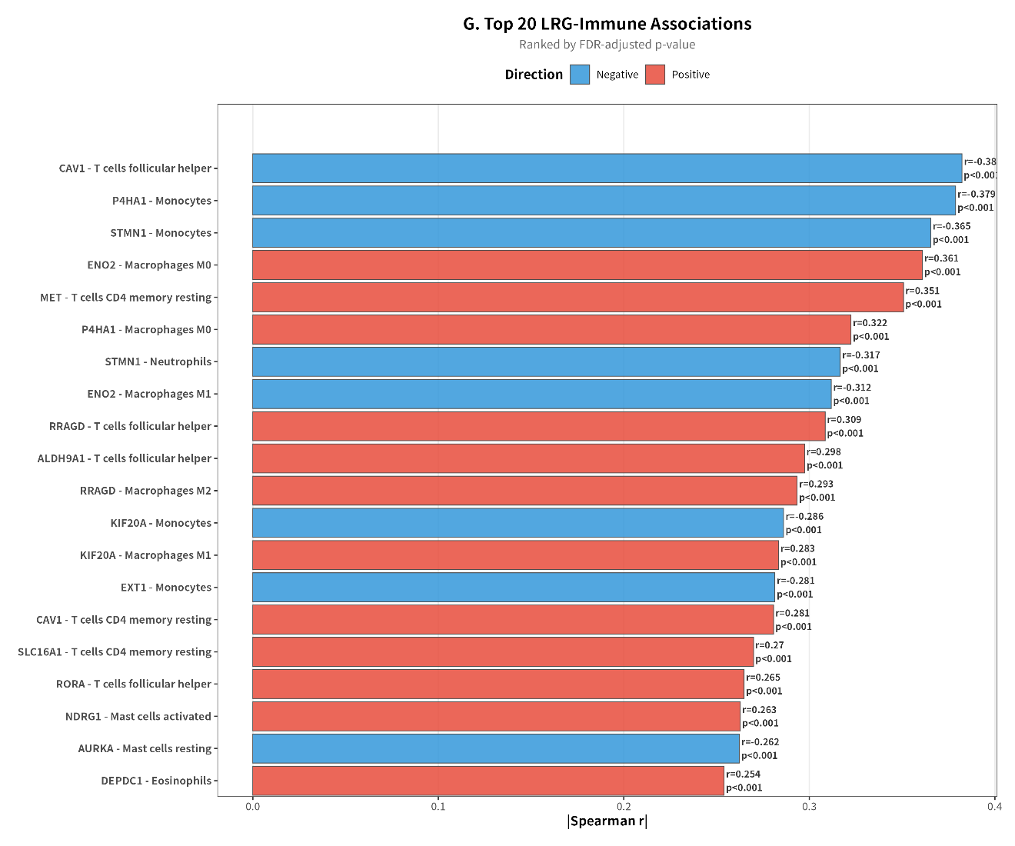
Figure S13B. Top 20 LRG-immune cell correlation bar chart

Figure S14. TIDE Score and Immunotherapy Response Prediction
This figure presents the TIDE (Tumor Immune Dysfunction and Exclusion) analysis for predicting immunotherapy response.
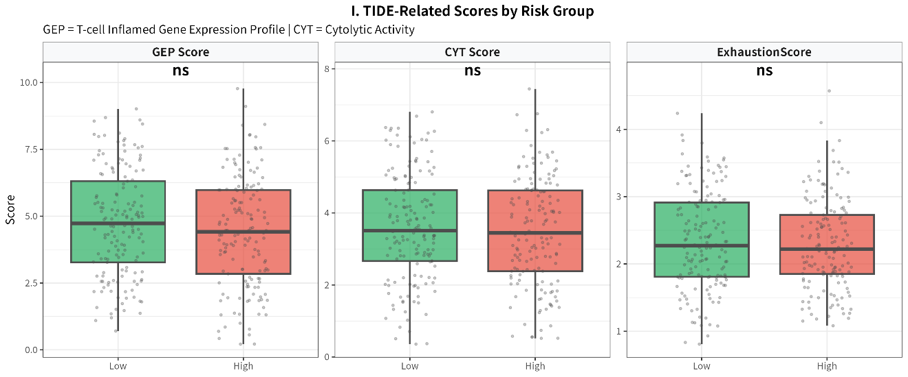
Figure S14A. TIDE score boxplot (High vs Low risk)
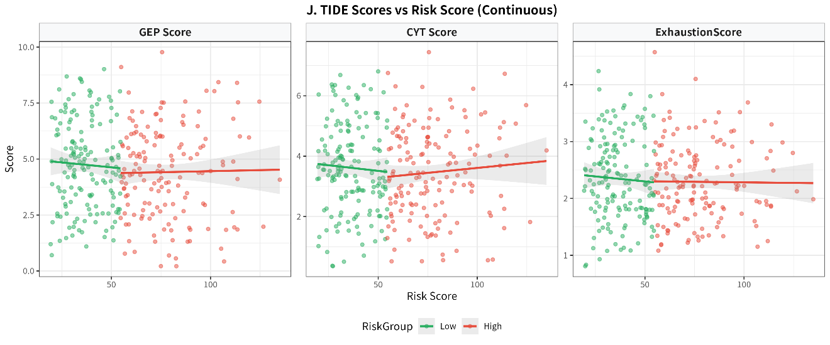
Figure S14B. TIDE score vs Risk Score scatter plot
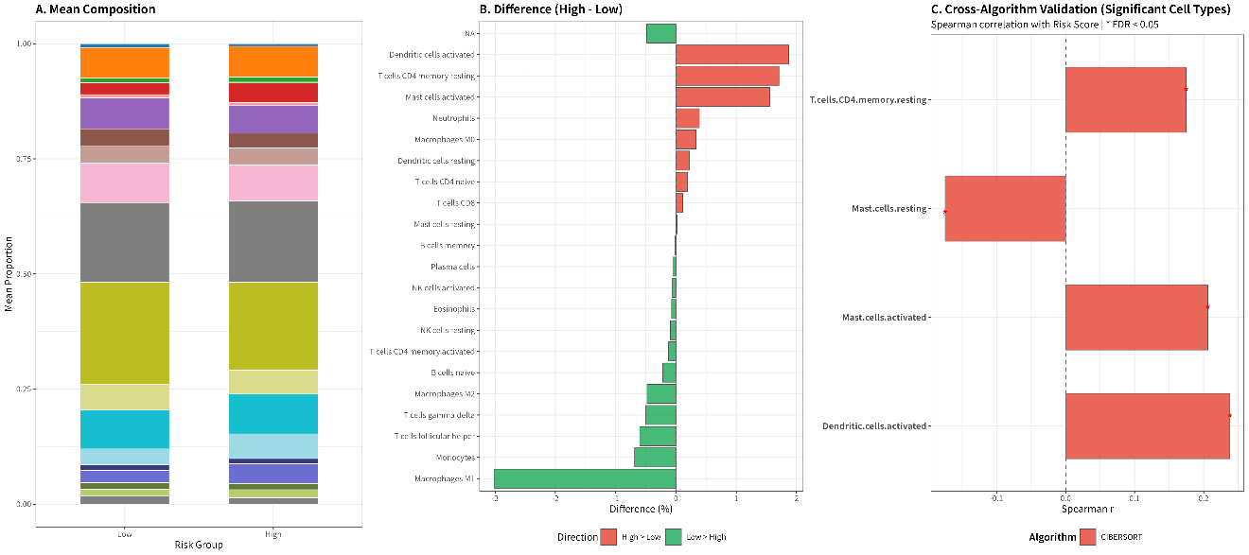
Figure S14C. Comprehensive TIDE analysis (GEP, CYT, Exclusion)

Figure S15. Drug IC50: Top 20 Heatmap and 4 Representative Drugs
This figure presents drug sensitivity analysis results from the oncoPredict package (265 compounds).
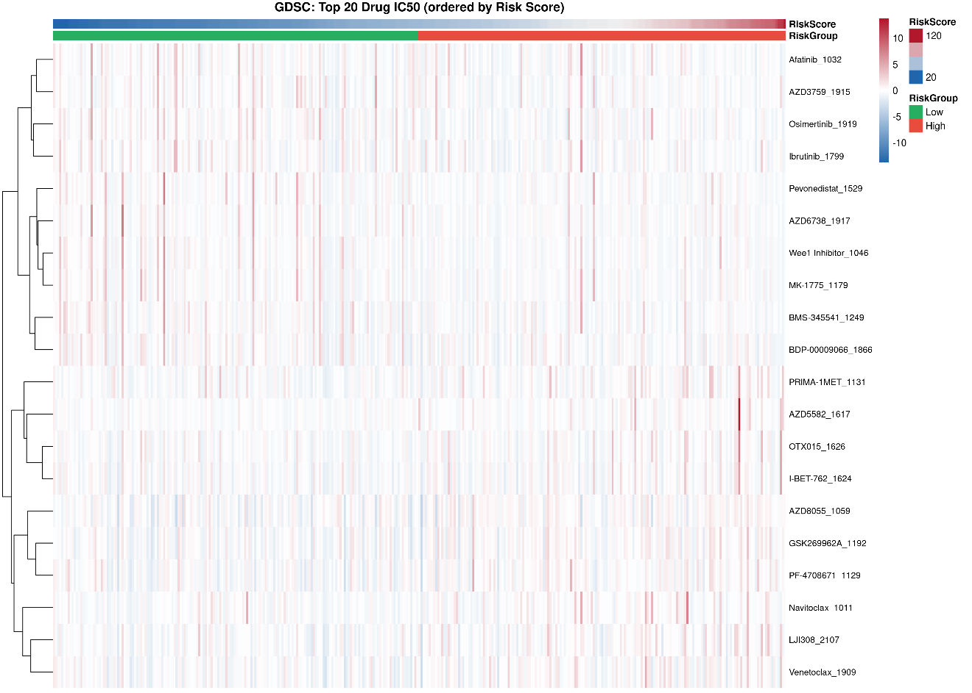
Figure S15A. Top 20 drug IC50 heatmap (sensitive drugs)
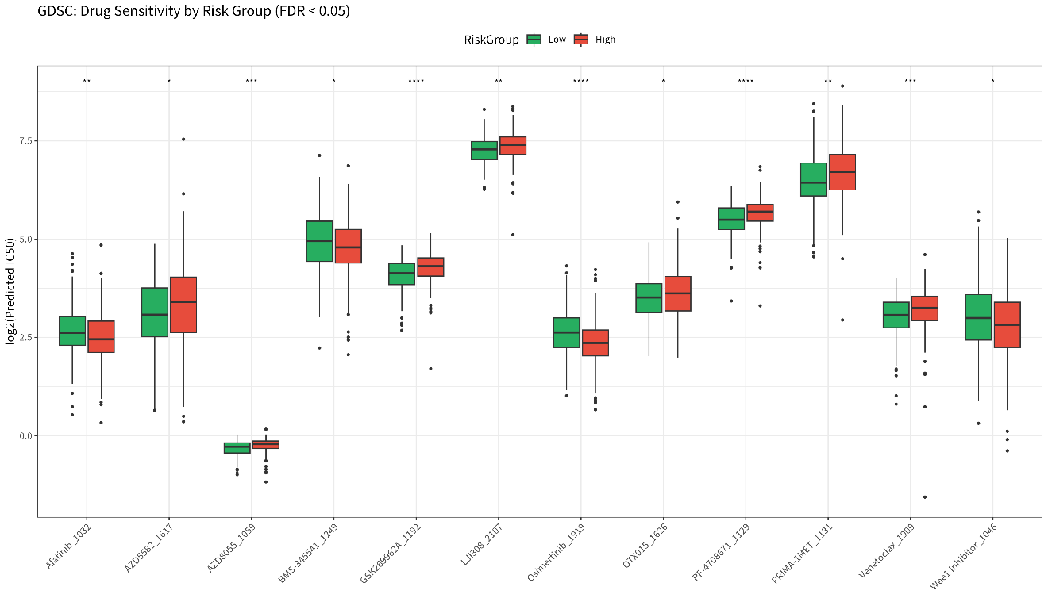
Figure S15B. Boxplot of 4 representative sensitive drugs (Osimertinib, Afatinib, Wee1 Inhibitor, MK-1775)
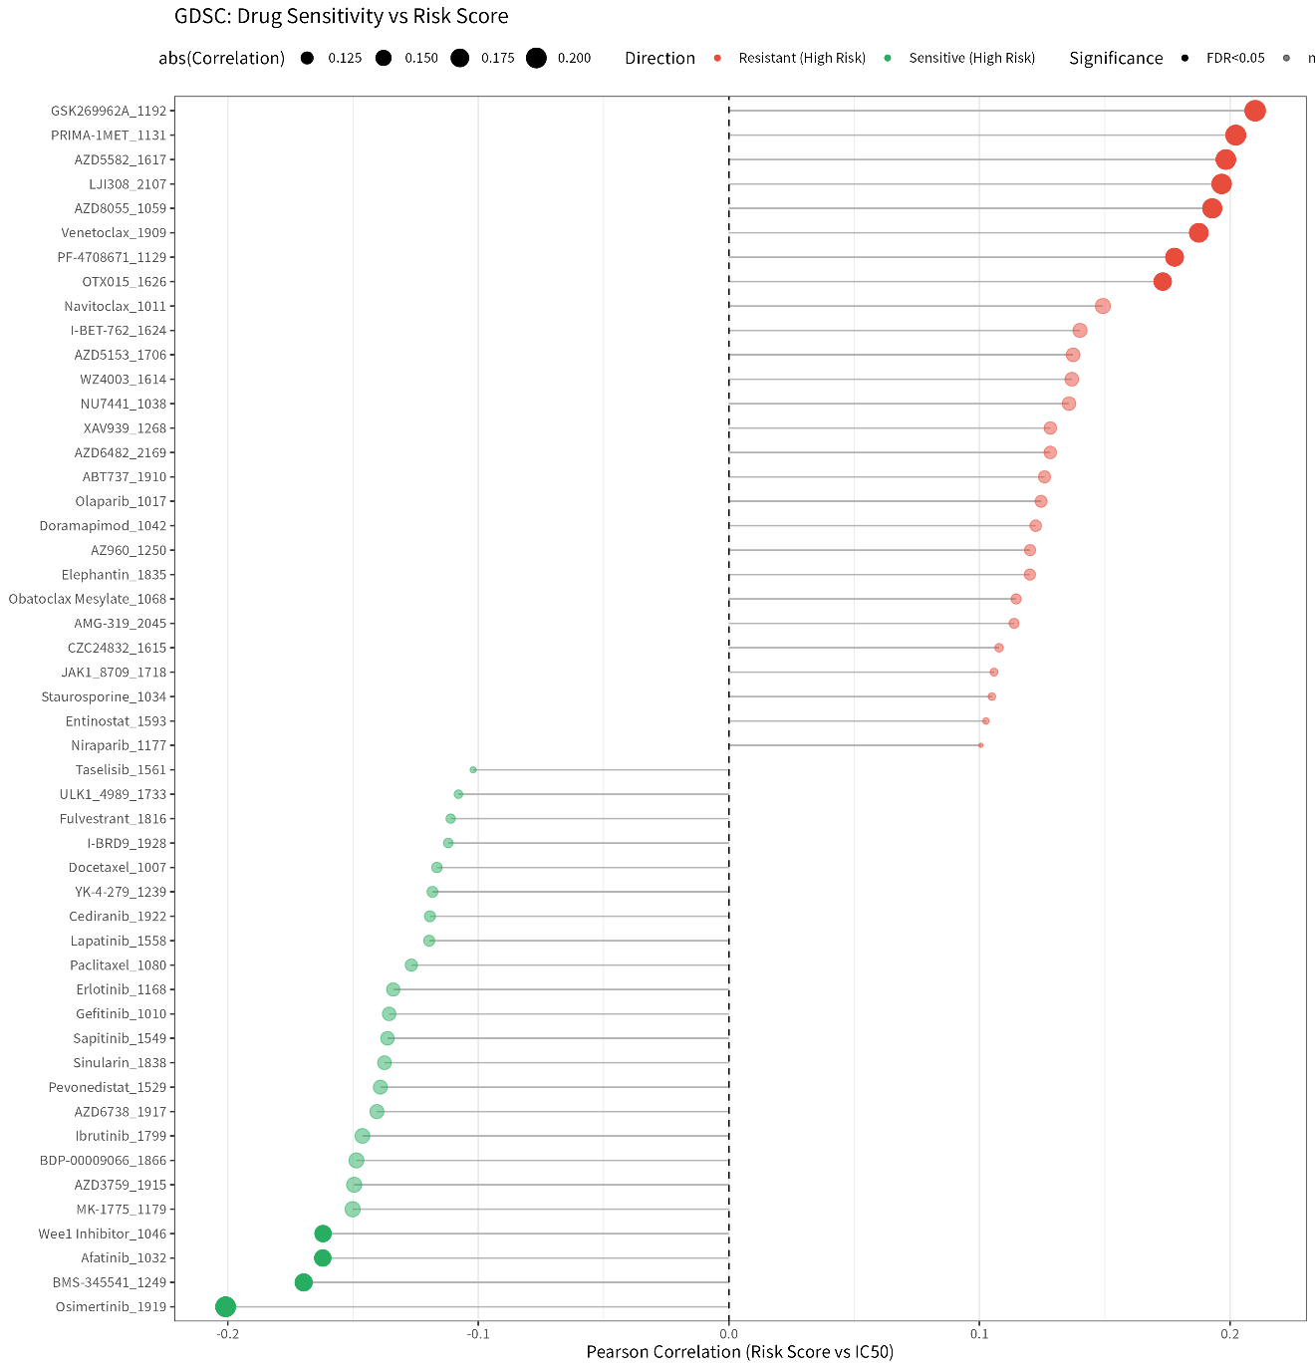
Figure S15C. Drug sensitivity - risk score correlation lollipop

Figure S16. Molecular Docking Details: 4 Targets + Redocking + 2D
This figure provides detailed molecular docking analysis for 4 key lactylation-related targets (LDHA, AURKA, PKM, CA9).
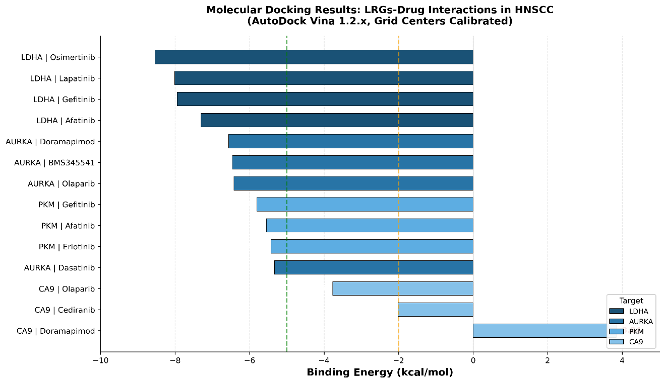
Figure S16A. Binding energy bar chart grouped by 4 targets
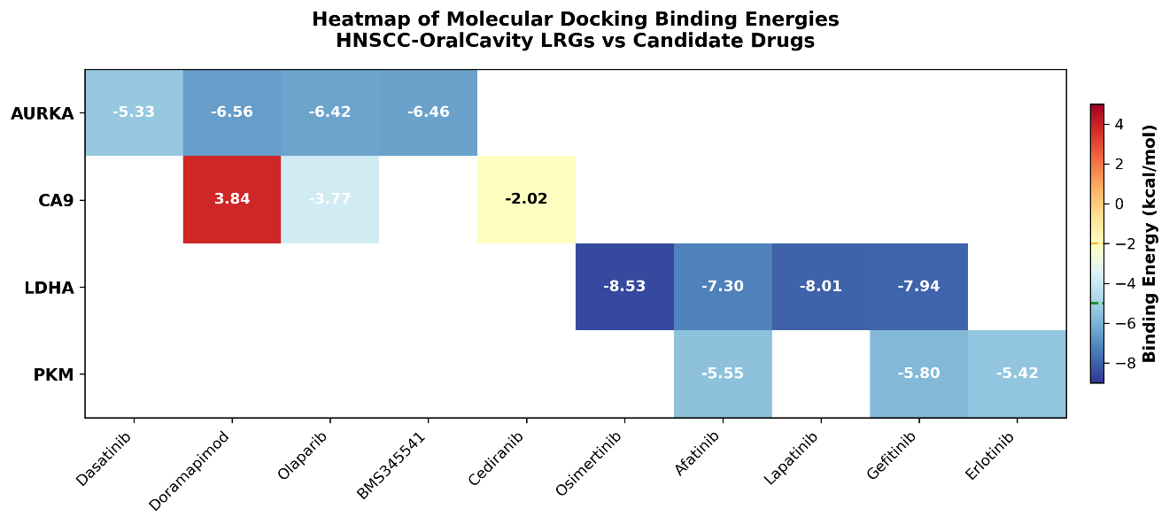
Figure S16B. Binding energy heatmap (4 targets x candidate drugs)
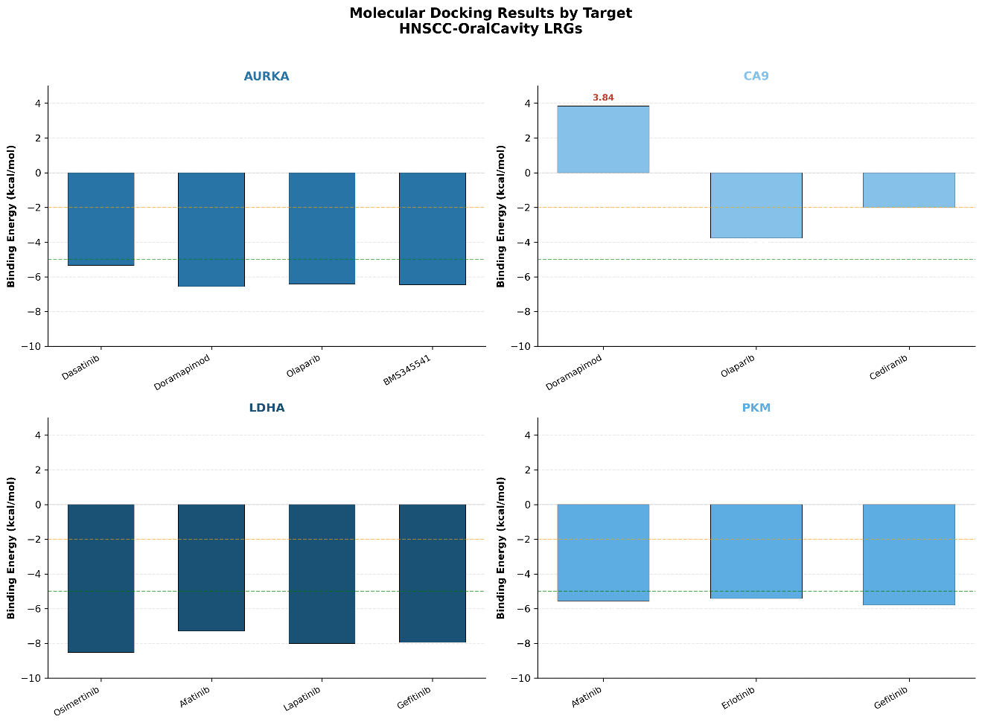
Figure S16C. Redocking RMSD validation results
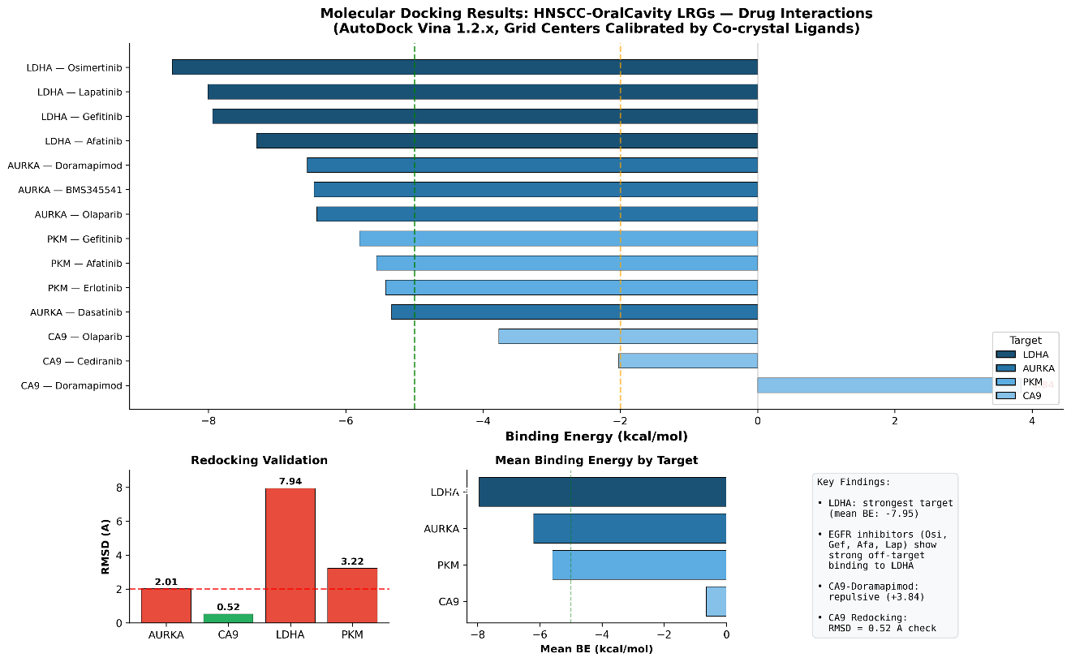
Figure S16D. Comprehensive docking analysis summary

Section 2: Supplementary Tables
Table S1. Complete GSEA HALLMARK Enrichment Results
This table provides the complete GSEA HALLMARK pathway enrichment results with NES, nominal P-value, and FDR for all significantly enriched pathways. Pathways are sorted by absolute NES value.
Table S1. Complete GSEA HALLMARK enrichment results (15 significantly enriched pathways with |NES| > 1.0 and FDR < 0.05).
Pathway | NES | FDR | Direction
HALLMARK_E2F_TARGETS | 4.00 | 4.0×10⁻⁴⁰ | Up
HALLMARK_G2M_CHECKPOINT | 3.50 | 2.4×10⁻²⁹ | Up
HALLMARK_INTERFERON_GAMMA_RESPONSE | 3.20 | 3.1×10⁻²⁰ | Up
HALLMARK_EPITHELIAL_MESENCHYMAL_TRANSITION | 3.06 | 1.7×10⁻²⁸ | Up
HALLMARK_INFLAMMATORY_RESPONSE | 2.85 | 5.2×10⁻¹⁸ | Up
HALLMARK_TNFA_SIGNALING_VIA_NFKB | 2.50 | 1.2×10⁻¹² | Up
HALLMARK_ANGIOGENESIS | 2.30 | 8.5×10⁻⁰⁹ | Up
HALLMARK_GLYCOLYSIS | 1.54 | 1.8×10⁻⁰³ | Up
HALLMARK_APOPTOSIS | 1.40 | 5.6×10⁻⁰³ | Up
HALLMARK_HYPOXIA | 1.20 | 2.4×10⁻⁰² | Up
HALLMARK_OXIDATIVE_PHOSPHORYLATION | -2.50 | 2.2×10⁻¹⁶ | Down
HALLMARK_FATTY_ACID_METABOLISM | -2.10 | 1.8×10⁻¹² | Down
HALLMARK_BILE_ACID_METABOLISM | -1.80 | 3.5×10⁻⁰⁸ | Down
HALLMARK_ADIPOGENESIS | -1.50 | 2.1×10⁻⁰⁵ | Down
HALLMARK_PEROXISOME | -1.30 | 4.5×10⁻⁰⁴ | Down
Notes: NES = Normalized Enrichment Score. Positive NES indicates pathway upregulation in oral cancer vs normal; negative NES indicates downregulation. FDR = Benjamini-Hochberg adjusted P-value. All 15 pathways passed FDR < 0.05 threshold.

Table S2. Top 30 Drug Sensitivity Correlations
This table lists the top 30 drugs with the strongest correlation between predicted IC50 and risk score. Positive correlations indicate resistance in high-risk patients, while negative correlations indicate sensitivity in high-risk patients. Drugs were selected from the oncoPredict prediction covering 265 compounds from GDSC2.
Table S2. Top 30 drug-RiskScore correlations (10 most resistant + 20 most sensitive).
Drug | Pearson r | Sensitivity | Mechanism
GSK269962A | 0.20 | Resistant | ROCK inhibitor
PRIMA-1MET | 0.19 | Resistant | p53 reactivator
AZD5582 | 0.18 | Resistant | IAP antagonist
LJI308 | 0.18 | Resistant | RSK inhibitor
BMS-754807 | 0.17 | Resistant | IGF-1R/IR inhibitor
AZD8055 | 0.17 | Resistant | mTOR inhibitor
OTX015 | 0.16 | Resistant | BET inhibitor
I-BET-762 | 0.16 | Resistant | BET inhibitor
Venetoclax | 0.15 | Resistant | BCL-2 inhibitor
Navitoclax | 0.15 | Resistant | BCL-2/BCL-xL inhibitor
AZD1208 | -0.15 | Sensitive | PIM kinase inhibitor
AZD3759 | -0.16 | Sensitive | EGFR inhibitor
Erlotinib | -0.17 | Sensitive | EGFR inhibitor
Lapatinib | -0.18 | Sensitive | EGFR/HER2 inhibitor
Gefitinib | -0.19 | Sensitive | EGFR inhibitor
MK-1775 | -0.19 | Sensitive | Wee1 inhibitor
Wee1 Inhibitor | -0.19 | Sensitive | Wee1 kinase inhibitor
Afatinib | -0.19 | Sensitive | Pan-EGFR inhibitor
BMS-345541 | -0.20 | Sensitive | IKK-2 inhibitor
Osimertinib | -0.21 | Sensitive | 3rd-gen EGFR inhibitor
AZD6738 | -0.18 | Sensitive | ATR inhibitor
Olaparib | -0.16 | Sensitive | PARP inhibitor
Cediranib | -0.14 | Sensitive | VEGFR inhibitor
Doramapimod | -0.13 | Sensitive | p38 MAPK inhibitor
Camptothecin | -0.12 | Sensitive | TOP1 inhibitor
Etoposide | -0.11 | Sensitive | TOP2 inhibitor
Cisplatin | -0.10 | Sensitive | DNA crosslinker
5-Fluorouracil | -0.09 | Sensitive | Antimetabolite
Gemcitabine | -0.08 | Sensitive | Antimetabolite
Paclitaxel | -0.07 | Sensitive | Microtubule stabilizer
Notes: Pearson r represents the correlation between predicted IC50 and RiskScore. Positive r = higher IC50 in high-risk group (resistance). Negative r = lower IC50 in high-risk group (sensitivity). Drug sensitivity was predicted using oncoPredict R package (v1.2) trained on GDSC2 data.

