Table 1: Binding Affinity of Top 20 Compounds and Their Structures

Serial No. | Compound Name | PubChem ID | Structure | Docking Score | MMGBSA | Smile ID
Control | Azeliragon | 11180124 | 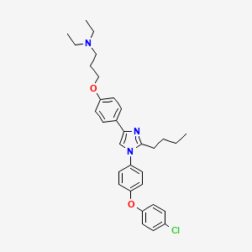 | -3.134 | -44.99 | CCCCC1=NC(=CN1C2=CC=C(C=C2)OC3=CC=C(C=C3)Cl)C4=CC=C(C=C4)OCCCN(CC)CC
01 | Cyanidin | 128861 | 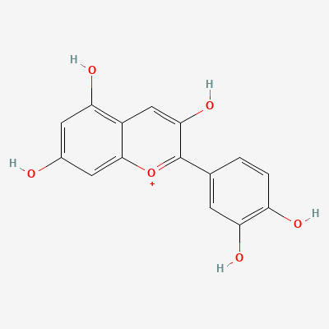 | -7.500 | -35.28 | C1=CC(=C(C=C1C2=[O+]C3=CC(=CC(=C3C=C2O)O)O)O)O
02 | Pelargonidin | 440832 | 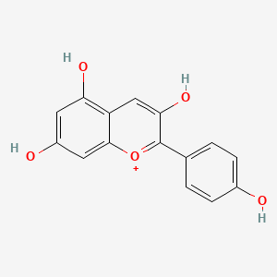 | -7.362 | -31.06 | C1=CC(=CC=C1C2=[O+]C3=CC(=CC(=C3C=C2O)O)O)O
03 | 2',4'-Dihydroxy-2''-(1-hydroxy-1-methylethyl)dihydrofuro[2,3-h]flavanone | 10291777 | 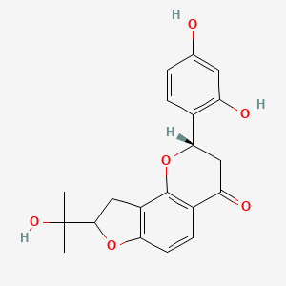 | -7.362 | -43.51 | CC(C)(C1CC2=C(O1)C=CC3=C2O[C@@H](CC3=O)C4=C(C=C(C=C4)O)O)O
04 | Oxyresveratrol | 5281717 | 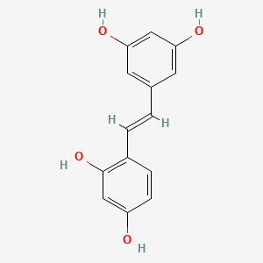 | -7.320 | -42.94 | C1=CC(=C(C=C1O)O)/C=C/C2=CC(=CC(=C2)O)O
05 | Gnetin C | 21633857 | 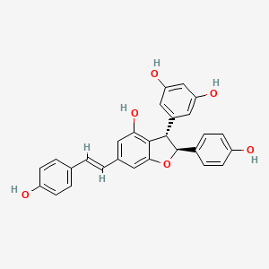 | -7.265 | -57.41 | C1=CC(=CC=C1/C=C/C2=CC(=C3[C@@H]([C@H](OC3=C2)C4=CC=C(C=C4)O)C5=CC(=CC(=C5)O)O)O)O
06 | Melannin | 442808 | 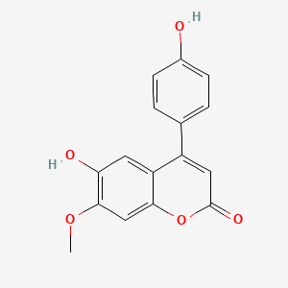 | -7.203 | -41.49 | COC1=C(C=C2C(=CC(=O)OC2=C1)C3=CC=C(C=C3)O)O
07 | Morusyunnansins D | 57333038 | 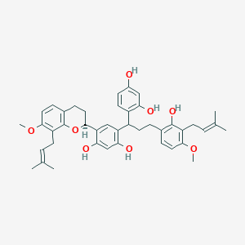 | -7.193 | -58.38 | CC(=CCC1=C(C=CC(=C1O)CCC(C2=C(C=C(C=C2)O)O)C3=C(C=C(C(=C3)[C@@H]4CCC5=C(O4)C(=C(C=C5)OC)CC=C(C)C)O)O)OC)C
08 | Butein | 5281222 | 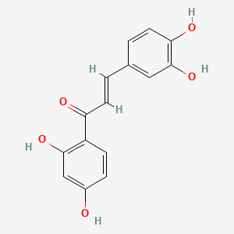 | -7.185 | -37.23 | C1=CC(=C(C=C1/C=C/C(=O)C2=C(C=C(C=C2)O)O)O)O
09 | 3,3',5-Trihydroxybibenzyl | 21574990 | 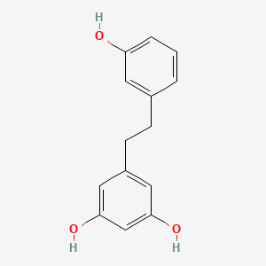 | -7.171 | -38.44 | C1=CC(=CC(=C1)O)CCC2=CC(=CC(=C2)O)O
10 | Daphnodorin A | 72426 | 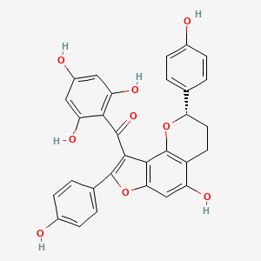 | -7.086 | -50.51 | C1CC2=C(C3=C(C=C2O)OC(=C3C(=O)C4=C(C=C(C=C4O)O)O)C5=CC=C(C=C5)O)O[C@@H]1C6=CC=C(C=C6)O
11 | 4'-O-Methylgallocatechin | 44257120 | 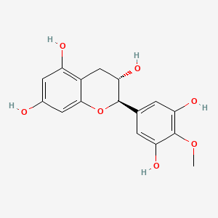 | -7.085 | -42.50 | COC1=C(C=C(C=C1O)[C@@H]2[C@H](CC3=C(C=C(C=C3O2)O)O)O)O
12 | Chalcones A-N-5 | 162517550 | 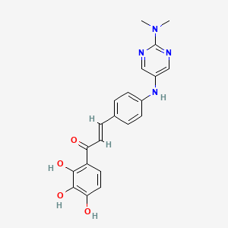 | -7.011 | -49.54 | CN(C)C1=NC=C(C=N1)NC2=CC=C(C=C2)/C=C/C(=O)C3=C(C(=C(C=C3)O)O)O
13 | Robinetinidol | 12314983 | 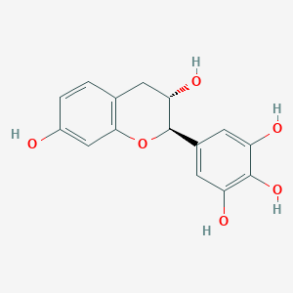 | -6.929 | -48.96 | C1[C@@H]([C@H](OC2=C1C=CC(=C2)O)C3=CC(=C(C(=C3)O)O)O)O
14 | Tricetin | 5281701 | 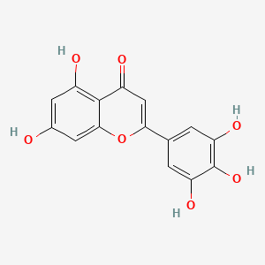 | -6.928 | -39.11 | C1=C(C=C(C(=C1O)O)O)C2=CC(=O)C3=C(C=C(C=C3O2)O)O
15 | 2',4',7-Trihydroxy-flavanone | 91557562 | 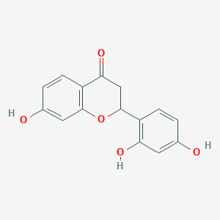 | -6.902 | -36.25 | C1C(OC2=C(C1=O)C=CC(=C2)O)C3=C(C=C(C=C3)O)O
16 | Quercetin | 5280343 | 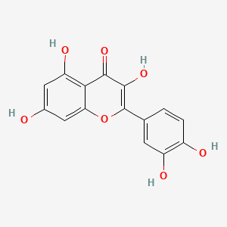 | -6.888 | -32.86 | C1=CC(=C(C=C1C2=C(C(=O)C3=C(C=C(C=C3O2)O)O)O)O)O
17 | 7-Hydroxy-3-[4-hydroxy-3-[2-hydroxy-5-(7-hydroxy-4-oxochromen-3-yl)phenyl]phenyl]chromen-4-one | 71618826 | 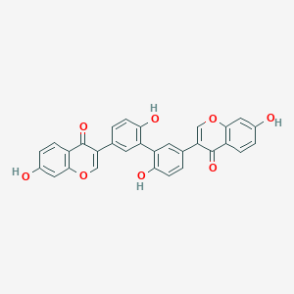 | -6.882 | -51.27 | C1=CC(=C(C=C1C2=COC3=C(C2=O)C=CC(=C3)O)C4=C(C=CC(=C4)C5=COC6=C(C5=O)C=CC(=C6)O)O)O
18 | Moracin O | 14539883 | 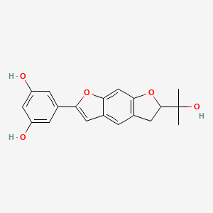 | -6.869 | -36.69 | CC(C)(C1CC2=C(O1)C=C3C(=C2)C=C(O3)C4=CC(=CC(=C4)O)O)O
19 | [(2S,3R,4R,5S)-5-[2-(3,4-dihydroxyphenyl)-5,7-dihydroxy-4-oxochromen-3-yl]oxy-3,4-dihydroxyoxolan-2-yl]methyl 3,4,5-trihydroxybenzoate | 11410680 | 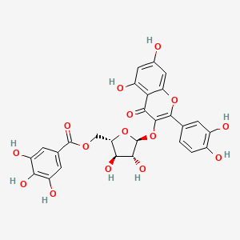 | -6.867 | -64.54 | C1=CC(=C(C=C1C2=C(C(=O)C3=C(C=C(C=C3O2)O)O)O[C@H]4[C@@H]([C@H]([C@@H](O4)COC(=O)C5=CC(=C(C(=C5)O)O)O)O)O)O)O
20 | 5-[(E)-2-(3,5-dihydroxyphenyl)ethenyl]benzene-1,2,3-triol | 9859982 | 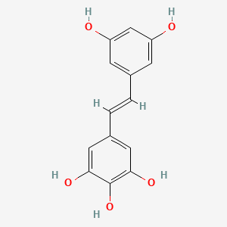 | -6.853 | -46.75 | C1=C(C=C(C=C1O)O)/C=C/C2=CC(=C(C(=C2)O)O)O

Table 2. Pharmacokinetics analysis of the Top six compounds, including Control.

Physico-chemical properties | Parameters | Azeliragon (Control) | CID-21633857 | CID-57333038 | CID-72426 | CID-71618826 | CID-11410680
Physico-chemical properties | MW (g/mol) | 532.12 | 454.47 | 680.83 | 526.49 | 506.46 | 586.45
Physico-chemical properties | Num. rot. | 14 | 4 | 12 | 4 | 3 | 7
Physico-chemical properties | HBD | 4 | 5 | 5 | 6 | 4 | 9
Physico-chemical properties | HBA | 0 | 6 | 8 | 9 | 8 | 15
Physico-chemical properties | logP | 6.38 | 2.84 | 4.89 | 2.38 | 3.09 | 1.74
Physico-chemical properties | L.V. | No | No | 2 | 2 | 1 | 3
Drug -likeness | TPSA (Å2) | 39.52 | 110.38 | 128.84 | 160.82 | 141.34 | 257.04
Drug -likeness | ESOL Log S | -7.90 | -6.32 | -9.95 | -6.91 | -6.33 | -4.40
Drug -likeness | B.S. | 0.17 | 0.55 | 0.17 | 0.17 | 0.55 | 0.17
Drug -likeness | S.A. | 4.28 | 4.42 | 6.16 | 4.81 | 3.98 | 5.61
Absorption Parameters | Consensus Log Po/w | 7.13 | 4.13 | 7.45 | 3.79 | 4.06 | 0.47
Absorption Parameters | Consensus log S | -11.58 | -6.87 | -10.65 | -7.47 | -9.89 | -2.95
Absorption Parameters | Solubility class | Poorly soluble | Poorly soluble | Insoluble | Poorly soluble | Poorly soluble | Soluble
Distribution Parameters | GI absorption | Low | High | Low | Low | Low | Low
Distribution Parameters | BBB permeant | No | No | No | No | No | No
Distribution Parameters | log Kp (cm/s) | -3.64 | -5.24 | -3.32 | -5.51 | -6.10 | -8.75
Metabolism Parameters | P-gp substrate | yes | No | Yes | No | No | No
Metabolism Parameters | CYP1A2 inhibitor | No | No | No | No | No | No
Metabolism Parameters | CYP2C19 inhibitor | No | No | No | No | No | No
Metabolism Parameters | CYP2C9 inhibitor | No | Yes | No | Yes | Yes | No
Metabolism Parameters | CYP2D6 inhibitor | Yes | No | No | No | No | No
Metabolism Parameters | CYP3A4 inhibitor | No | No | No | No | No | No
Toxicity | LD50 (mg/kg) | 910 | 500 | 2000 | 1000 | 350 | 5000
Toxicity | Toxicity class | 4 | 4 | 4 | 4 | 4 | 5
Toxicity | Hepatotoxicity | I | I | I | I | I | I
Toxicity | Immunotoxicity | A | I | A | I | A | A
Toxicity | Mutagenicity | I | I | I | I | I | I
Toxicity | Cytotoxicity | I | I | I | I | I | I
Toxicity | Carcinogenicity | I | I | I | I | I | I

Molecular weight (MW); number of rotatable bonds (Num. rot ); number of hydrogen bond donors (HBD); number of hydrogen bond acceptors (HBA); predicted octanol/water partition coefficient (Log P); Lipinski Violation (L.V.); topological polar surface area (TPSA); Bioavailability Score (B.S.); Synthetic Accessibility (S.A.); blood–brain barrier capacity (BBB); Poorly Soluble (P.S.); Insolunle (I.S.); Soluble (S.); Inactive (I); Active (A);

Table 3. Docking propensity scores indicate the biochemical interactions between the selected phytocompounds and the targeted protein complex RAGE (PDB ID: 4LP5).
 | CID | H Bond | Van der Waals | Pi-Sigma | Alkyl | C-H bond | Amide- Pi Stacked | Unfavorable Donor-Donor
 | 11180124 | ILE91 | LEU49, VAL78, GLN67, LEU79, PRO46, THR183, LYS44, LEU185, ILE90, GLY90, ARG57, GLN92 | PRO66 | PRO80, PRO45
A | 72426 | SER74, VAL78, GLN47 | VAL75, PRO87, LEU49, GLN67 |  | PRO45, PRO80, ALA88,  PRO66 | PRO46 | LUE79
B | 11410680 | LUE64, VAL78, GLN47 | SER74, PRO87, ARG77, GLN67, LEU79, GLY82, LEU49, TRP51, GLU50, PRO45, |  | PRO66, PRO80 | PRO46 | SER65
C | 21633857 | ASP73, SER74, ARG77, VAL78, GLN67, GLN47 | ARG77, PHE85, LEU79, ARG48, PRO46, PRO45, VAL75 |  | PRO87, LEU49, PRO66, PRO80, ALA88 |  |  | ARG57
D | 57333038 | SER74, ARG77 | PRO46, GLN67, ASP73, ARG73, ARG77, PHE85, LYS43, GLY31, ASN81, ILE30, GLY82 |  | LEU49, PRO66, PRO45, VAL78, PRO80, LYS44, ALA88, PRO87 | GLN47
E | 71618826 | ALA88, VAL78, GLN67 | ARG57, GLY90, VAL75, SER74, PRO87, LEU79, LEU49, GLN47, ARG48, PRO46 |  | PRO80, PRO45, PRO66

Literature References
- Dziadek, K., et al., Identification of polyphenolic compounds and determination of antioxidant activity in extracts and infusions of buckwheat leaves. European Food Research and Technology, 2018. 244: p. 333-343.
- Abbas, M., et al., Natural polyphenols: An overview. International Journal of Food Properties, 2017. 20(8): p. 1689-1699.
- Belščak-Cvitanović, A., et al., Overview of polyphenols and their properties, in Polyphenols: Properties, recovery, and applications. 2018, Elsevier. p. 3-44.
- Rasouli, H., M.H. Farzaei, and R. Khodarahmi, Polyphenols and their benefits: A review. International Journal of Food Properties, 2017. 20(sup2): p. 1700-1741.
- Pinto, T., et al., Bioactive (poly) phenols, volatile compounds from vegetables, medicinal and aromatic plants. Foods, 2021. 10(1): p. 106.
- Bravo, L., Polyphenols: chemistry, dietary sources, metabolism, and nutritional significance. Nutrition reviews, 1998. 56(11): p. 317-333.
- Ali, D.E., et al., In silico and in vitro anti-inflammatory study of phenolic compounds isolated from Eucalyptus maculata resin. Scientific Reports, 2023. 13(1): p. 2093.
- Alameen, A.A., et al., Potential Effect of Baobab’s Polyphenols as Antihyperlipidemic Agents: In Silico Study. Molecules, 2023. 28(16): p. 6112.
- Shahidi, F. and C.S. Dissanayaka, Phenolic-protein interactions: insight from in-silico analyses–a review. Food Production, Processing and Nutrition, 2023. 5(1): p. 1-21.
- Mandal, S.M., D. Chakraborty, and S. Dey, Phenolic acids act as signaling molecules in plant-microbe symbioses. Plant signaling & behavior, 2010. 5(4): p. 359-368.
- Abdel-Monem, N., et al., Assessment of secondary metabolites from marine-derived fungi as antioxidant. Open Journal of Medicinal Chemistry, 2013. 3(03): p. 60.
- El-Hawary, S.S., et al., Epigenetic modifiers induce bioactive phenolic metabolites in the marine-derived fungus Penicillium brevicompactum. Marine drugs, 2018. 16(8): p. 253.
- Jimenez-Lopez, C., et al., Main bioactive phenolic compounds in marine algae and their mechanisms of action supporting potential health benefits. Food chemistry, 2021. 341: p. 128262.
- Nurzyńska-Wierdak, R., Phenolic Compounds from New Natural Sources—Plant Genotype and Ontogenetic Variation. Molecules, 2023. 28(4): p. 1731.
- Goleniowski, M., et al., Phenolic acids. Natural products, 2013: p. 1951-1973.
- Tsimogiannis, D. and V. Oreopoulou, Classification of phenolic compounds in plants, in Polyphenols in plants. 2019, Elsevier. p. 263-284.
- Lafay, S. and A. Gil-Izquierdo, Bioavailability of phenolic acids. Phytochemistry Reviews, 2008. 7: p. 301-311.
- Huang, W.-Y., Y.-Z. Cai, and Y. Zhang, Natural phenolic compounds from medicinal herbs and dietary plants: potential use for cancer prevention. Nutrition and cancer, 2009. 62(1): p. 1-20.
- Shahidi, F. and C.-T. Ho, Phenolics in food and natural health products: an overview. 2005.
- Pilkington, L.I. and D. Barker, Synthesis and biology of 1, 4-benzodioxane lignan natural products. Natural product reports, 2015. 32(10): p. 1369-1388.
- Su, S., X. Cheng, and M. Wink, Natural lignans from Arctium lappa modulate P-glycoprotein efflux function in multidrug resistant cancer cells. Phytomedicine, 2015. 22(2): p. 301-307.
- Lee, M.-A., et al., Anti-proliferative activity of hydnocarpin, a natural lignan, is associated with the suppression of Wnt/β-catenin signaling pathway in colon cancer cells. Bioorganic & medicinal chemistry letters, 2013. 23(20): p. 5511-5514.
- Chen, R., et al., The ERF transcription factor LTF1 activates DIR1 to control stereoselective synthesis of antiviral lignans and stress defense in Isatis indigotica roots. Acta Pharmaceutica Sinica B, 2024. 14(1): p. 405-420.
- Yang, M.-J., et al., Defensive furofuran lignans localized to the oil cells of Neocinnamomum delavayi and their metabolism by a specialist insect. Phytochemistry, 2023. 215: p. 113852.
- Lv, X., et al., Effects and mechanism of natural phenolic acids/fatty acids on copigmentation of purple sweet potato anthocyanins. Current Research in Food Science, 2022. 5: p. 1243-1250.
- Buzzacchera, I., et al., Screening libraries of amphiphilic Janus dendrimers based on natural phenolic acids to discover monodisperse unilamellar dendrimersomes. Biomacromolecules, 2018. 20(2): p. 712-727.
- Xu, K., et al., Clinical development and informatics analysis of natural and semi-synthetic flavonoid drugs: a critical review. Journal of Advanced Research, 2023.
- Seleem, D., V. Pardi, and R.M. Murata, Review of flavonoids: A diverse group of natural compounds with anti-Candida albicans activity in vitro. Archives of oral biology, 2017. 76: p. 76-83.
- Wu, S., et al., A comprehensive review of natural products against atopic dermatitis: Flavonoids, alkaloids, terpenes, glycosides and other compounds. Biomedicine & Pharmacotherapy, 2021. 140: p. 111741.
- Rani, M., et al., Natural flavonoid pectolinarin computationally targeted as a promising drug candidate against SARS-CoV-2. Current Research in Structural Biology, 2024. 7: p. 100120.
- Bodoira, R. and D. Maestri, Phenolic compounds from nuts: extraction, chemical profiles, and bioactivity. Journal of Agricultural and Food Chemistry, 2020. 68(4): p. 927-942.
- Kurnia, D., et al., Potential of flavonol and sulfur compounds from Allium leaves as an antioxidant and xanthine oxidase inhibition in silico study. Food Chemistry Advances, 2023. 3: p. 100383.
- Bell, L., M.J. Oruna-Concha, and C. Wagstaff, Identification and quantification of glucosinolate and flavonol compounds in rocket salad (Eruca sativa, Eruca vesicaria and Diplotaxis tenuifolia) by LC–MS: Highlighting the Potential for improving nutritional value of rocket crops. Food Chemistry, 2015. 172: p. 852-861.
- Liu, P., H. Kallio, and B. Yang, Flavonol glycosides and other phenolic compounds in buds and leaves of different varieties of black currant (Ribes nigrum L.) and changes during growing season. Food chemistry, 2014. 160: p. 180-189.
- Brianceau, S., et al., High voltage electric discharges assisted extraction of phenolic compounds from grape stems: Effect of processing parameters on flavan-3-ols, flavonols and stilbenes recovery. Innovative Food Science & Emerging Technologies, 2016. 35: p. 67-74.
- Liang, N.-N., et al., Regional characteristics of anthocyanin and flavonol compounds from grapes of four Vitis vinifera varieties in five wine regions of China. Food Research International, 2014. 64: p. 264-274.
- Lee, J.-D., et al., Flavonol-rich RVHxR from Rhus verniciflua Stokes and its major compound fisetin inhibits inflammation-related cytokines and angiogenic factor in rheumatoid arthritic fibroblast-like synovial cells and in vivo models. International immunopharmacology, 2009. 9(3): p. 268-276.
- Jeszka-Skowron, M., A. Zgoła-Grześkowiak, and R. Frankowski, Cistus incanus a promising herbal tea rich in bioactive compounds: LC–MS/MS determination of catechins, flavonols, phenolic acids and alkaloids—A comparison with Camellia sinensis, Rooibos and Hoan Ngoc herbal tea. Journal of Food Composition and Analysis, 2018. 74: p. 71-81.
- Barbosa, P.d.P.M., et al., Enzyme-assisted extraction of flavanones from citrus pomace: Obtention of natural compounds with anti-virulence and anti-adhesive effect against Salmonella enterica subsp. enterica serovar Typhimurium. Food Control, 2021. 120: p. 107525.
- Laraoui, H., et al., A new flavanone sulfonate and other phenolic compounds from Fumana montana. Biochemical Systematics and Ecology, 2019. 86: p. 103927.
- de Oliveira Mendes, L.A., et al., The anti-Zika virus and anti-tumoral activity of the citrus flavanone lipophilic naringenin-based compounds. Chemico-Biological Interactions, 2020. 331: p. 109218.
- Soto, M., et al., Substrate‐Controlled Hydrogenation of Flavanones: Selective Synthesis of 2′‐Hydroxy‐1, 3‐Diarylpropanes and Flavans. European Journal of Organic Chemistry, 2023. 26(16): p. e202300139.
- Sigmon, A.J., et al., Computer-aided design, syntheses, and ITC binding data of novel flavanone derivatives for use as potential inhibitors of the papain-like protease of COVID-19. Results in Chemistry, 2023. 6: p. 101116.
- Witt, M. and P. Metz, Enantioselective synthesis of the bioactive flavanones lonchocarpol A and 6-(1, 1-dimethylallyl) naringenin by catalytic asymmetric transfer hydrogenation. Tetrahedron, 2023. 149: p. 133719.
- Ares, A.M., et al., Chiral and achiral separation of ten flavanones using supercritical fluid chromatography. Application to bee pollen analysis. Journal of Chromatography A, 2022. 1685: p. 463633.
- Alalaiwe, A., et al., Development of flavanone and its derivatives as topical agents against psoriasis: The prediction of therapeutic efficiency through skin permeation evaluation and cell-based assay. International Journal of Pharmaceutics, 2020. 581: p. 119256.
- Santi, M.D., et al., Neuroprotective effects of prenylated flavanones isolated from Dalea species, in vitro and in silico studies. European Journal of Medicinal Chemistry, 2020. 206: p. 112718.
- de Matos, I.L., et al., Stereoselective reduction of flavanones by marine-derived fungi. Molecular Catalysis, 2021. 513: p. 111734.
- Alenezi, S.S., et al., Novel flavanones with anti-trypanosomal activity isolated from Zambian and Tanzanian propolis samples. International Journal for Parasitology: Drugs and Drug Resistance, 2020. 14: p. 201-207.
- Fuguet, E., et al., Acidity constants of hydroxyl groups placed in several flavonoids: Two flavanones, two flavones and five flavonols. Talanta, 2023. 253: p. 124096.
- Saavedra, E., et al., The synthetic flavanone 6-methoxy-2-(naphthalen-1-yl) chroman-4-one induces apoptosis and activation of the MAPK pathway in human U-937 leukaemia cells. Bioorganic Chemistry, 2020. 94: p. 103450.
- Noleto-Dias, C., et al., Sulfated flavanones and dihydroflavonols from willow. Phytochemistry letters, 2020. 35: p. 88-93.
- Martin, M.Á. and S. Ramos, Impact of cocoa flavanols on human health. Food and Chemical Toxicology, 2021. 151: p. 112121.
- Cruz, B.G., et al., Chemical Composition, Antibacterial and Inhibitory Activity of the Efflux Pump of Essential Oils from Croton piauhiensis Müll. Nutraceuticals, 2023. 3(4): p. 591-604.
- Yücer, R., et al., Cytotoxicity of dioncophylline A and related naphthylisoquinolines in leukemia cells, mediated by NF-κB inhibition, angiogenesis suppression, G2/M cell cycle arrest, and autophagy induction. Phytomedicine, 2023: p. 155267.
- Vezza, T., et al., The Antioxidant Properties of Salvia verbenaca Extract Contribute to Its Intestinal Antiinflammatory Effects in Experimental Colitis in Rats. Antioxidants, 2023. 12(12): p. 2071.
- Alahmady, N.F., et al., Biochemical characterization of chamomile essential oil: Antioxidant, antibacterial, anticancer and neuroprotective activity and potential treatment for Alzheimer's disease. Saudi Journal of Biological Sciences, 2024. 31(2): p. 103912.
- Mostofa, M.G., et al., Apoptosis-inducing anti-proliferative and quantitative phytochemical profiling with in silico study of antioxidant-rich Leea aequata L. leaves. Heliyon, 2024. 10(1).
- Su, Y., et al., Combined metabolomic and transcriptomic analysis reveals the characteristics of the lignan in Isatis indigotica Fortune. Gene, 2023. 888: p. 147752.
- Li, Y.-Y., et al., Sonneralignan A, a new lignan from the fruit of mangrove Sonneratia apetala. Natural Product Research, 2023: p. 1-6.
- Ryu, H.W., et al., Polyphenols from Broussonetia papyrifera displaying potent α-glucosidase inhibition. Journal of agricultural and food chemistry, 2010. 58(1): p. 202-208.
- Yang, H., et al., New Bioactive Polyphenols from Theobroma g randiflorum (“Cupuaçu”). Journal of natural products, 2003. 66(11): p. 1501-1504.
- Schwarz, L.J., et al., Enrichment of (E)-resveratrol from peanut byproduct with molecularly imprinted polymers. Journal of agricultural and food chemistry, 2011. 59(8): p. 3539-3543.
- Zhang, S., et al., Novel theaflavin-type chlorogenic acid derivatives identified in black tea. Journal of agricultural and food chemistry, 2018. 66(13): p. 3402-3407.
- Ray, N.B., et al., Bioactive olive oil polyphenols in the promotion of health, in The role of functional food security in global health. 2019, Elsevier. p. 623-637.
- Zhao, Y., Y. Wu, and M. Wang, Bioactive substances of plant origin 30. Handbook of food chemistry, 2015. 967: p. 967-1008.
- Al-Khayri, J.M., et al., Stilbenes, a Versatile Class of Natural Metabolites for Inflammation—An Overview. Molecules, 2023. 28(9): p. 3786.
- Pandey, K.B. and S.I. Rizvi, Plant polyphenols as dietary antioxidants in human health and disease. Oxidative medicine and cellular longevity, 2009. 2: p. 270-278.
- Yang, H.-r., et al., Dimeric 2-(2-phenethyl) chromones from agarwood of Aquilaria filaria. Fitoterapia, 2023. 165: p. 105422.
- Fang, D.-S., et al., Diverse meroterpenoids with α-glucosidase inhibitory activity from Ganoderma cochlear. Fitoterapia, 2023. 165: p. 105420.
- Li, Y.-H., et al., Five new verrucosidin derivatives from Penicillium polonicum, a deep-sea cold-seep sediment isolated fungus. Fitoterapia, 2023. 165: p. 105387.
- Bao, X.-H., et al., Racemic Norneolignans from the resin of Ferula sinkiangensis and their Cox-2 inhibitory activity. Fitoterapia, 2023. 164: p. 105341.
- Chen, L., et al., Seven new 2-(2-phenethyl) chromone derivatives from agarwood of Aquilaria walla. Fitoterapia, 2023. 165: p. 105421.
- Li, X., et al., Unusual N-pyridinium amino acid-type alkaloids from roots and rhizomes of Sophora tonkinensis Gagnep. Fitoterapia, 2023. 165: p. 105388.
- Zhao, J., et al., Advances on Cyclocarya paliurus polyphenols: Extraction, structures, bioactivities and future perspectives. Food Chemistry, 2022: p. 133667.
- Gao, Y., et al., A green ultrasound-assisted enzymatic extraction method for efficient extraction of total polyphenols from Empetrum nigrum and determination of its bioactivities. Journal of Industrial and Engineering Chemistry, 2022. 109: p. 559-567.
- Li, N., et al., Application of nanoencapsulation technology to improve the stability and bioactivity of tea polyphenols. Food Bioscience, 2023. 55: p. 103076.
- Chen, J., et al., Bioactivity and influence on colonic microbiota of polyphenols from noni (Morinda citrifolia L.) fruit under simulated gastrointestinal digestion. Food Chemistry: X, 2024. 21: p. 101076.
- Wu, A., et al., Characterization and adsorption-release property of fermented porous starch as well as its bioactivity protection for guava leaf polyphenols. Food Bioscience, 2023. 53: p. 102535.
- Wei, L., et al., Characterization and potential bioactivity of polyphenols of Rosa rugosa. Food Bioscience, 2022. 50: p. 102108.
- Blagojević, B., et al., β-Cyclodextrin as a green booster for the extraction of polyphenols from blackthorn fruits: Bioactivity determination and molecular docking analysis. Food and Bioproducts Processing, 2023. 140: p. 84-98.
- Wang, W., et al., Development and optimization of green extraction of polyphenols in Michelia alba using natural deep eutectic solvents (NADES) and evaluation of bioactivity. Sustainable Chemistry and Pharmacy, 2024. 37: p. 101425.
- Shi, Y., et al., Encapsulation of bioactive polyphenols by starch and their impacts on gut microbiota. Current Opinion in Food Science, 2021. 38: p. 102-111.
- Domínguez-Rodríguez, G., M.L. Marina, and M. Plaza, Enzyme-assisted extraction of bioactive non-extractable polyphenols from sweet cherry (Prunus avium L.) pomace. Food Chemistry, 2021. 339: p. 128086.
- He, X., et al., Fruit and vegetable polyphenols as natural bioactive inhibitors of pancreatic lipase and cholesterol esterase: Inhibition mechanisms, polyphenol influences, application challenges. Food Bioscience, 2023: p. 103054.
- Nekkaa, A., et al., Green and innovative extraction of polyphenols from Rhamnus alaternus using natural deep eutectic solvents and evaluation of their bioactivities. Journal of Applied Research on Medicinal and Aromatic Plants, 2023. 35: p. 100503.
- Murakami, A., Novel mechanisms underlying bioactivities of polyphenols via hormesis. Current Opinion in Toxicology, 2022. 30: p. 100337.
- Rao, H., et al., Phytochemical analysis and bioactivity assessment of five medicinal plants from Pakistan: Exploring polyphenol contents, antioxidant potential, and antibacterial activities. Saudi Journal of Biological Sciences, 2023. 30(10): p. 103783.
- Awika, J.M. and K.G. Duodu, Bioactive polyphenols and peptides in cowpea (Vigna unguiculata) and their health promoting properties: A review. Journal of Functional Foods, 2017. 38: p. 686-697.
- Serra, D., L.M. Almeida, and T.C. Dinis, Polyphenols as food bioactive compounds in the context of Autism Spectrum Disorders: A critical mini-review. Neuroscience & Biobehavioral Reviews, 2019. 102: p. 290-298.
- Girard, A.L. and J.M. Awika, Sorghum polyphenols and other bioactive components as functional and health promoting food ingredients. Journal of Cereal Science, 2018. 84: p. 112-124.
- Blagojević, B., et al., An in vitro and in silico evaluation of bioactive Potential of cornelian cherry (Cornus mas L.) extracts rich in polyphenols and iridoids. Food chemistry, 2021. 335: p. 127619.
- Ray, N.B., et al., Olive fruit and olive oil bioactive polyphenols in the promotion of health, in Functional Foods and Nutraceuticals in Metabolic and Non-Communicable Diseases. 2022, Elsevier. p. 203-220.
- Popović, B., et al., Comparison between polyphenol profile and bioactive response in blackthorn (Prunus spinosa L.) genotypes from north Serbia-from raw data to PCA analysis. Food chemistry, 2020. 302: p. 125373.
- Makris, D.P., Green extraction processes for the efficient recovery of bioactive polyphenols from wine industry solid wastes–Recent progress. Current Opinion in Green and Sustainable Chemistry, 2018. 13: p. 50-55.
- Zhou, Z.-Q., et al., Polyphenols from wolfberry and their bioactivities. Food Chemistry, 2017. 214: p. 644-654.
- Álvarez, A., et al., Microwave pretreatment to improve extraction efficiency and polyphenol extract richness from grape pomace. Effect on antioxidant bioactivity. Food and Bioproducts Processing, 2017. 106: p. 162-170.
- Gómez-Mejía, E., et al., Citrus peels waste as a source of value-added compounds: Extraction and quantification of bioactive polyphenols. Food Chemistry, 2019. 295: p. 289-299.
- Burton-Freeman, B.M., A.K. Sandhu, and I. Edirisinghe, Red raspberries and their bioactive polyphenols: cardiometabolic and neuronal health links. Advances in Nutrition, 2016. 7(1): p. 44-65.
- Zhang, Y., et al., Bioactive diarylheptanoids and stilbenes from the rhizomes of Dioscorea septemloba Thunb. Fitoterapia, 2017. 117: p. 28-33.
- Hao, M., et al., Bioactive flavonoids and stilbenes from the leaf of Morus alba var. multicaulis. Fitoterapia, 2021. 154: p. 105018.
- Guerrero, R.F., et al., Grapevine cane’s waste is a source of bioactive stilbenes. Industrial Crops and Products, 2016. 94: p. 884-892.
- Fernández-Marín, M.I., et al., Isorhapontigenin: a novel bioactive stilbene from wine grapes. Food Chemistry, 2012. 135(3): p. 1353-1359.
- Lai, T.N.H., et al., Piceatannol, a potent bioactive stilbene, as major phenolic component in Rhodomyrtus tomentosa. Food Chemistry, 2013. 138(2-3): p. 1421-1430.
- Boccellino, M., et al., Protective effect of piceatannol and bioactive stilbene derivatives against hypoxia-induced toxicity in H9c2 cardiomyocytes and structural elucidation as 5-LOX inhibitors. European Journal of Medicinal Chemistry, 2019. 180: p. 637-647.
- Fu, Y.-H., et al., Six undescribed derivatives of stilbene isolated from Lindera reflexa Hemsl. and their anti-tumor and anti-inflammatory activities. Fitoterapia, 2022. 163: p. 105331.
- Benbouguerra, N., et al., Stilbenes in grape berries and wine and their potential role as anti-obesity agents: A review. Trends in Food Science & Technology, 2021. 112: p. 362-381.
- Yang, M.-Y., et al., Stilbenes with potent cytotoxicity from the seedcases of Paeonia suffruticosa Andrews. Phytochemistry, 2023. 205: p. 113515.
- Stockdale, D.P., J.A. Beutler, and D.F. Wiemer, Substitution of a triazole for the central olefin in biologically active stilbenes. Bioorganic & medicinal chemistry letters, 2022. 75: p. 128980.
- Yue, G.-L., et al., Extraction and separation characteristic stilbene compounds from pigeon pea leaves using V-type thymol-based natural deep eutectic solvent systems. Chemical Engineering Research and Design, 2023. 193: p. 600-612.
- Sabra, A., T. Netticadan, and C. Wijekoon, Grape bioactive molecules, and the potential health benefits in reducing the risk of heart diseases. Food Chemistry: X, 2021. 12: p. 100149.
- Tan, L.-X., et al., Stilbenes from the leaves of Cajanus cajan and their in vitro anti-inflammatory activities. Fitoterapia, 2022. 160: p. 105229.
- Cai, X., et al., Three stilbenes make difference to the antifungal effects on ochratoxin A and its precursor production of Aspergillus carbonarius. Food Microbiology, 2022. 103: p. 103967.
- Jyske, T., et al., Yield of stilbene glucosides from the bark of young and old Norway spruce stems. Biomass and bioenergy, 2014. 71: p. 216-227.
- Pel, P., et al., A stilbene dimer and flavonoids from the aerial parts of Chromolaena odorata with proprotein convertase subtilisin/kexin type 9 expression inhibitory activity. Bioorganic Chemistry, 2020. 99: p. 103869.
- Raut, G.K., et al., Imine stilbene analog ameliorate isoproterenol-induced cardiac hypertrophy and hydrogen peroxide-induced apoptosis. Free Radical Biology and Medicine, 2020. 153: p. 80-88.
- Kasiotis, K.M., et al., Resveratrol and related stilbenes: their anti-aging and anti-angiogenic properties. Food and Chemical Toxicology, 2013. 61: p. 112-120.
Zhang, S.-Y., et al., Stilbene dimer xylosides and flavanols from the roots of Lysidice rhodostegia and their antioxidant activities. Fitoterapia, 2021. 153: p. 104997.
- Zhou, D., et al., Stilbenes from the tubers of Bletilla striata with potential anti-neuroinflammatory activity. Bioorganic Chemistry, 2020. 97: p. 103715.
- Agarwal, N., et al., Stilbenes (Resveratrol and Pterostilbene) Alter Intestinal Functionality, Morphology and the Microbiome in-vivo (Gallus gallus). Current Developments in Nutrition, 2022. 6(Supplement_1): p. 262-262.
- Xie, L. and B.W. Bolling, Characterisation of stilbenes in California almonds (Prunus dulcis) by UHPLC–MS. Food chemistry, 2014. 148: p. 300-306.
- Patel, D.V., et al., Novel carbazole-stilbene hybrids as multifunctional anti-Alzheimer agents. Bioorganic Chemistry, 2020. 101: p. 103977.
- Li, L., et al., Flavonoids and a stilbene from Triadenum fraseri (Spach) Gleason. 2010.
- Banik, K., et al., Piceatannol: A natural stilbene for the prevention and treatment of cancer. Pharmacological research, 2020. 153: p. 104635.
- Zhao, S., et al., Recent research advances on oral colon-specific delivery system of nature bioactive components: A review. Food Research International, 2023: p. 113403.
- Heleno, S.A., et al., Bioactivity of phenolic acids: Metabolites versus parent compounds: A review. Food chemistry, 2015. 173: p. 501-513.
- Singh, P., et al., Evaluation of bioactive constituents of Garcinia indica (kokum) as a potential source of hydroxycitric acid, anthocyanin, and phenolic compounds. LWT, 2022. 156: p. 112999.
- Nguyen, T.H., et al., Evaluation of phenolics and bioactivities of Camellia quephongensis leaf extracts as affected by various extraction solvents. Journal of Agriculture and Food Research, 2023. 14: p. 100914.
- McKay, D.L., et al., Flavonoids and phenolic acids from cranberry juice are bioavailable and bioactive in healthy older adults. Food chemistry, 2015. 168: p. 233-240.
- Wei, J., et al., Phenolic acids from Balanophora involucrata and their bioactivities. Fitoterapia, 2017. 121: p. 129-135.
- Bodoira, R., et al., An overview on extraction, composition, bioactivity and food applications of peanut phenolics. Food chemistry, 2022. 381: p. 132250.
- Gao, L., et al., Bioactivity guided isolation and identification of phenolic compounds from Citrus aurantium L. with anti-colorectal cancer cells activity by UHPLC-Q-TOF/MS. Current Research in Food Science, 2022. 5: p. 2251-2260.
- Monagas, M., et al., Almond (Prunus dulcis (Mill.) DA Webb) skins as a potential source of bioactive polyphenols. Journal of agricultural and food chemistry, 2007. 55(21): p. 8498-8507.
- Li, Y., et al., New acylated phenolic glycosides with ROS-scavenging activity from Psidium guajava leaves. Journal of agricultural and food chemistry, 2019. 67(40): p. 11089-11098.
- Killday, K.B., et al., Bioactive A-type proanthocyanidins from Cinnamomum cassia. Journal of Natural Products, 2011. 74(9): p. 1833-1841.
- Kårlund, A., et al., Polyphenols in strawberry (Fragaria× ananassa) leaves induced by plant activators. Journal of agricultural and food chemistry, 2014. 62(20): p. 4592-4600.
- Lavola, A., R. Karjalainen, and R. Julkunen-Tiitto, Bioactive polyphenols in leaves, stems, and berries of Saskatoon (Amelanchier alnifolia Nutt.) cultivars. Journal of agricultural and food chemistry, 2012. 60(4): p. 1020-1027.
- Kolodziejczyk, P., L. Ozimek, and J. Kozłowska, The application of flax and hemp seeds in food, animal feed and cosmetics production, in Handbook of natural fibres. 2012, Elsevier. p. 329-366.
- Appendino, G., et al., Antimycobacterial coumarins from the sardinian giant fennel (ferula c ommunis). Journal of Natural Products, 2004. 67(12): p. 2108-2110.
- Macias, M.L., et al., Effect of selected coumarins on spinach chloroplast photosynthesis. Journal of agricultural and food chemistry, 1999. 47(5): p. 2137-2140.
- Stanley, W.L. and L. Jurd, Citrus coumarins. Journal of Agricultural and Food Chemistry, 1971. 19(6): p. 1106-1110.
- Cai, Y., et al., Inhibition and inactivation of murine hepatic ethoxy-and pentoxyresorufin O-dealkylase by naturally occurring coumarins. Chemical research in toxicology, 1993. 6(6): p. 872-879.
- Sharma, A. and S.B. Bharate, Synthesis and Biological Evaluation of Coumarin Triazoles as Dual Inhibitors of Cholinesterases and β-Secretase. ACS omega, 2023. 8(12): p. 11161-11176.
- Melliou, E., et al., Natural and synthetic 2, 2-dimethylpyranocoumarins with antibacterial activity. Journal of natural products, 2005. 68(1): p. 78-82.
- ABU-MUSTAFA, E.A. and M. Fayez, Natural Coumarins. I. Marmesin and Marmesinin, Further Products from the Fruits of Ammi majus L. The Journal of Organic Chemistry, 1961. 26(1): p. 161-166.
- Lin, T.-T., et al., Prenylated coumarins: natural phosphodiesterase-4 inhibitors from Toddalia asiatica. Journal of Natural Products, 2014. 77(4): p. 955-962.
- Ito, C., et al., Chemical constituents of Calophyllum brasiliense. 2. Structure of three new coumarins and cancer chemopreventive activity of 4-substituted coumarins. Journal of Natural Products, 2003. 66(3): p. 368-371.
- Silván, A.M., et al., Antiinflammatory activity of coumarins from Santolina oblongifolia. Journal of natural products, 1996. 59(12): p. 1183-1185.
- Zhu, S., et al., Spectroscopic and molecular docking study of three kinds of cinnamic acid interaction with pepsin. Spectrochimica Acta Part A: Molecular and Biomolecular Spectroscopy, 2023. 303: p. 123169.
- Dey, G. and S. Sireswar, Emerging functional beverages: Fruit wines and transgenic wines, in Alcoholic beverages. 2019, Elsevier. p. 471-514.
- Sharma, N., et al., Genomics approaches to synthesize plant-based biomolecules for therapeutic applications to combat SARS-CoV-2. Genomics, 2020. 112(6): p. 4322-4331.
- Jeevanandam, J., R. Madhumitha, and N. Saraswathi, Identification of potential phytochemical lead against diabetic cataract: An insilico approach. Journal of Molecular Structure, 2021. 1226: p. 129428.
- Zengin, G., et al., Network analysis, chemical characterization, antioxidant and enzyme inhibitory effects of foxglove (Digitalis cariensis Boiss. ex Jaub. & Spach): A novel raw material for pharmaceutical applications. Journal of Pharmaceutical and Biomedical Analysis, 2020. 191: p. 113614.
- Yáñez, J.A., et al., Polyphenols and flavonoids: an overview. Flavonoid Pharmacokinetics: Methods of Analysis, Preclinical and Clinical Pharmacokinetics, Safety, and Toxicology, 2012: p. 1-69.
- Rani, J.M.J., et al., Unravelling the influenza virus inhibitory Potential: Ligand-based docking, pharmacophore, MM-GBSA, and molecular dynamic simulation of phytochemicals and cyanobacteria metabolites. Intelligent Pharmacy, 2023.
- Karkola, S. and K. Wähälä, The binding of lignans, flavonoids and coumestrol to CYP450 aromatase: a molecular modelling study. Molecular and Cellular Endocrinology, 2009. 301(1-2): p. 235-244.
- Lakhera, S., et al., In silico investigation of phytoconstituents of medicinal herb ‘Piper Longum’against SARS-CoV-2 by molecular docking and molecular dynamics analysis. Results in chemistry, 2021. 3: p. 100199.
- Worawalai, W., et al., furofuran lignans as a new series of antidiabetic agents exerting α-glucosidase inhibition and radical scarvenging: Semisynthesis, kinetic study and molecular modeling. Bioorganic Chemistry, 2019. 87: p. 783-793.
- Aehle, E., et al., Lignans as food constituents with estrogen and antiestrogen activity. Phytochemistry, 2011. 72(18): p. 2396-2405.
- Zhang, H., et al., Screening and characterization of aldose reductase inhibitors from Traditional Chinese medicine based on ultrafiltration-liquid chromatography mass spectrometry and in silico molecular docking. Journal of Ethnopharmacology, 2021. 264: p. 113282.
- Thangavel, N. and M. Albratty, Benchmarked molecular docking integrated molecular dynamics stability analysis for prediction of SARS-CoV-2 papain-like protease inhibition by olive secoiridoids. Journal of King Saud University-Science, 2023. 35(1): p. 102402.
- Bhola, S., V. Jaiswal, and H.-J. Lee, Investigation of molecular mechanism of Ulmus davidiana against gastric cancer: A network pharmacology study incorporating gene expression data and molecular docking analysis. South African Journal of Botany, 2023. 159: p. 51-60.
- Wang, Y.-X., et al., Enantiomeric lignans with anti-β-amyloid aggregation activity from the twigs and leaves of Pithecellobium clypearia Benth. Bioorganic Chemistry, 2018. 77: p. 579-585.
- Moyo, B. and N.E. Madala, Appraisal of the anti-diabetic Potential of polyphenolic compounds from Viscum combreticola Engl.: In vitro α-glucosidase inhibition, LC-ESI-QTOF-MS coupled to pre-column DPPH antioxidative assay, network pharmacology and molecular docking analysis. South African Journal of Botany, 2024. 165: p. 1-13.
- Ogungbe, I.V., W.R. Erwin, and W.N. Setzer, Antileishmanial phytochemical phenolics: molecular docking to potential protein targets. Journal of Molecular Graphics and Modelling, 2014. 48: p. 105-117.
- Samy, M.N., et al., Phytochemical investigation of Amphilophium paniculatum; an underexplored Bignoniaceae species as a source of SARS-CoV-2 Mpro inhibitory metabolites: Isolation, identification, and molecular docking study. South African Journal of Botany, 2021. 141: p. 421-430.
- Zhou, Y., et al., Pharmacodynamic effects and molecular mechanisms of lignans from Schisandra chinensis Turcz.(Baill.), a current review. European Journal of Pharmacology, 2021. 892: p. 173796.
- Oikawa, D., et al., (+)-Sesamin, a sesame lignan, is a potent inhibitor of gut bacterial tryptophan indole-lyase that is a key enzyme in chronic kidney disease pathogenesis. Biochemical and biophysical research communications, 2022. 590: p. 158-162.
- Min, L., et al., A network pharmacology strategy to investigate the anti-osteoarthritis mechanism of main lignans components of Schisandrae Fructus. International Immunopharmacology, 2021. 98: p. 107873.
- Bobek, K.B., et al., Total Synthesis of Polysubstituted γ-Butyrolactone Lignans (−)-Hinokinin,(−)-Bicubebin B, and (−)-Isodeoxypodophyllotoxin via Oxime Carbonate Formation. Organic letters, 2022. 25(1): p. 31-36.
- Li, B., et al., Effects of diarylbutane lignans from Schisandra chinensis fruit on SARS-CoV-2 3CLpro and PLpro and their in vitro anti-inflammatory properties. Phytomedicine Plus, 2023. 3(2): p. 100432.
- Nga, T.T., et al., Two new lignan glycosides from Acanthus ilicifolius L. with their NO inhibition and cytotoxic activity. Natural Product Research, 2023: p. 1-9.
- Vu, V.-T., et al., Patulinervones A and B, two novel α-glucosidase inhibitory spiro-lignans from Melicope patulinervia (Merr. & Chun) CC Huang. Natural Product Research, 2023. 37(21): p. 3639-3646.
- Pereira, G.R., et al., Novel lignan-based compounds via click chemistry: paulownin isolation, structural modifications and cytotoxic activity evaluations. Natural Product Research, 2021. 35(21): p. 3820-3823.
- Wessig, P., et al., Total Synthesis of Arylnaphthalene Lignans through a Photochemical Key Step. European Journal of Organic Chemistry, 2023. 26(1): p. e202201234.
- Fan, X.-L., et al., Two new lignans from the herbaceous stems of Ephedra intermedia. Phytochemistry Letters, 2023. 53: p. 98-101.
- Sun, Y., et al., Lignans from the seed shells of Cerasus humilis (Bge.) Sok and their bioactivities. Fitoterapia, 2023. 170: p. 105651.
- Wang, X., et al., Amides and lignans from Solanum lyratum. Phytochemistry Letters, 2021. 45: p. 25-29.
- Hu, X.-P., et al., Isolation, structure elucidation and in-vitro evaluation of new trisubstituted Tetrahydrofuran Lignans from Rabdosia lophanthoides var. gerardiana as anti-inflammatory agents. Phytochemistry Letters, 2022. 52: p. 76-81.
- Péter, B., et al., Label-free biosensing of lignans for therapeutics using engineered model surfaces. International Journal of Biological Macromolecules, 2023. 233: p. 123528.
- Kamso, V.F.K., et al., New lignan glycosides from Justicia secunda Vahl (Acanthaceae) with antimicrobial and antiparasitic properties. Heliyon, 2023. 9(12).
- Tajuddeen, N., et al., Justicidin B and related lignans from two South African Monsonia species with potent activity against HeLa cervical cancer cells. Phytochemistry Letters, 2023.
- Qiang, T., et al., Transcriptome-wide analysis of PIP reductase gene family identified a phenylpropene synthase crucial for the biosynthesis of dibenzocyclooctadiene lignans in Schisandra chinensis. Synthetic and Systems Biotechnology, 2024. 9(1): p. 78-87.
- Li, J.-L., et al., Identification of lignans as ATP citrate lyase (ACLY) inhibitors from the roots of Pouzolzia zeylanica. Natural Product Research, 2023: p. 1-8.
- Wang, S., et al., Establishment of Agrobacterium rhizogenes-mediated RNAi of Phryma leptostachya accelerates the functional identification of key genes of the furofuran lignan biosynthetic pathway. Industrial Crops and Products, 2023. 204: p. 117260.
- Zhang, Y.-Q., et al., New triterpenoids and a dibenzocyclooctadiene lignan from the leaves of Schisandra chinensis. Phytochemistry Letters, 2023. 54: p. 57-62.
- Liu, S.-q., et al., Dibenzocyclooctadiene lignans from the family Schisandraceae: A review of phytochemistry, structure-activity relationship, and hepatoprotective effects. Pharmacological Research, 2023: p. 106872.
- Vijayakumar, S., et al., Novel ligand-based docking; molecular dynamic simulations; and absorption, distribution, metabolism, and excretion approach to analyzing potential acetylcholinesterase inhibitors for Alzheimer's disease. Journal of Pharmaceutical Analysis, 2018. 8(6): p. 413-420.

