Supplementary material
CD105 (endoglin)-assessed microvessel density in non–muscle-invasive bladder cancer: a precise null result for recurrence and an underpowered, grade-dependent signal for progression

Supplementary Methods

Proportional-hazards testing
The proportional-hazards assumption was tested for every covariate in every reported model by the Grambsch–Therneau method, correlating scaled Schoenfeld residuals with the rank of the event time. Because the residual matrix returned by the modelling library is unscaled, Schoenfeld residuals and the Grambsch–Therneau scaling were implemented directly; the implementation was validated by simulation, giving 5.0% rejection under true proportional hazards and 75% power against a known violation (300 replicates each). Models for this test were fitted with Breslow rather than Efron handling of ties, to match the residual definition.

Internal validation
External validation was not possible, so models were validated internally by bootstrap optimism correction of Harrell's C, with the model refitted in each resample and evaluated on both the resample and the original data. Five hundred resamples were drawn for the models reported in Tables 2 and 3 and 1 000 for the risk-group comparison. Resamples in which the progression model could not be fitted because fewer than three events were drawn are discarded, so the realised number of usable resamples is slightly below the nominal one (492–500 of 500); this is reported by the analysis code. The optimism-corrected value is reported alongside the apparent one. Median follow-up is given by the reverse Kaplan–Meier method as well as crudely.

Handling of complete separation
Where complete separation prevented a finite maximum-likelihood estimate, a Firth-penalised Cox model with profile-likelihood confidence limits was fitted alongside the likelihood-ratio test. Because the 42-vessel threshold was itself derived from these data, even that interval is optimistic.

Precision rather than post-hoc power
Precision is reported through confidence intervals rather than post-hoc power, which is a monotone function of the P value and adds nothing to it. The size of a confirmatory study is derived from the number of events needed to support an adjusted model at ten events per variable, and from the standard error observed here rescaled by the square root of the event ratio. Pairwise Holm adjustment was cross-checked against an independent implementation, and every replicate of the area-under-the-curve bootstrap was confirmed to contain at least one progression event. Quantiles are reported rounded half-up, so an exact half-integer bound is one unit above the value returned by software that rounds half-to-even. Random seeds are fixed in the analysis code.

Supplementary Results

Sensitivity analyses
Excluding the two patients whose progression date was imputed changed little (n = 155, 10 events; log-rank P = 0.014; hazard ratio per 10 vessels 1.17, 95% CI 1.01–1.37; P = 0.041). Bootstrapping the Youden cut-off gave a wide interval (42–86 vessels), confirming that the threshold is unstable at 12 events and should not be taken forward as a fixed decision rule. Within grade strata the direction of effect was preserved but neither subgroup reached significance (low grade: 3 events, AUC 0.730, P = 0.18; high grade: 9 events, AUC 0.667, P = 0.11).

Proportional hazards
Proportional hazards held for CD105-MVD in every model in which it appeared (Grambsch–Therneau P ≥ 0.31), and for every covariate of the primary progression model (CD105-MVD and grade; P ≥ 0.24) and of the multivariable recurrence model (P ≥ 0.10). The single exception was stage, which showed a borderline departure for progression (P = 0.031 univariably and P = 0.048 in the secondary CD105-MVD-plus-stage model); the corresponding stage hazard ratios should therefore be read as time-averaged effects, and the grade-adjusted model — in which proportional hazards held — is the one reported as primary.

Clustering by clinical team
Adding team of origin to the models did not materially alter any estimate or change any inference (CD105-MVD median 48 vs 47 vessels between teams, P = 0.87; team hazard ratio 1.14, 95% CI 0.68–1.89 for recurrence and 0.42, 95% CI 0.09–1.94 for progression).

Supplementary Tables
Table S1 CD105-assessed microvessel density by clinicopathological category and outcome
 | Reference category |  | Comparator category
Variable | n | Median (IQR) | n | Median (IQR) | P valueᵃ
Stage
Ta vs T1 | 94 | 39 (21–58) | 63 | 64 (42–76) | <0.001
Grade
Low vs high | 95 | 40 (22–59) | 62 | 59 (42–78) | <0.001
Tumour number
Solitary vs multiple | 85 | 42 (22–62) | 72 | 54 (37–75) | 0.009
Tumour diameter (solitary tumours)
<3 cm vs ≥3 cm | 31 | 33 (18–54) | 54 | 47 (29–71) | 0.011
Age
<65 vs ≥65 years | 81 | 46 (20–68) | 76 | 48 (36–69) | 0.046
Sex
Female vs male | 17 | 54 (36–72) | 140 | 47 (26–68) | 0.345
Recurrence
No vs yes | 79 | 46 (22–67) | 78 | 52 (31–72) | 0.263
Progression
No vs yes | 145 | 46 (26–68) | 12 | 67 (52–89) | 0.007

CD105-MVD expressed as vessels per ×200 field. Reference category is shown first in each pair. ᵃ Mann–Whitney U test, two-sided. IQR, interquartile range.

Table S2 Proxy clinical risk groups, CD105-assessed microvessel density and outcome
Proxy risk group | n | CD105-MVD, median (IQR) | Recurrence, n (%) | Progression, n (%)
Low | 46 | 28 (18–54) | 18 (39.1) | 1 (2.2)
Intermediate | 34 | 47 (32–56) | 21 (61.8) | 2 (5.9)
High | 77 | 56 (42–78) | 39 (50.6) | 9 (11.7)

Proxy risk groups were defined from the variables available in this cohort: low = Ta, low grade and solitary; high = T1 or high grade; intermediate = all others. They are not EORTC or EAU 2021 risk groups, which could not be computed because concomitant carcinoma in situ was not recorded, tumour diameter was available only for solitary tumours and WHO 1973 grade was unavailable. CD105-MVD differed across groups (Kruskal–Wallis P < 0.001), but the groups themselves did not separate progression significantly in this cohort (log-rank P = 0.13). With the groups entered as indicator variables, adding CD105-MVD raised Harrell’s C for progression from 0.713 to 0.780 (0.693 to 0.740 after bootstrap optimism correction; likelihood-ratio P = 0.19), and did not improve discrimination for recurrence (0.580 to 0.587; P = 0.98). IQR, interquartile range.

Supplementary Figure
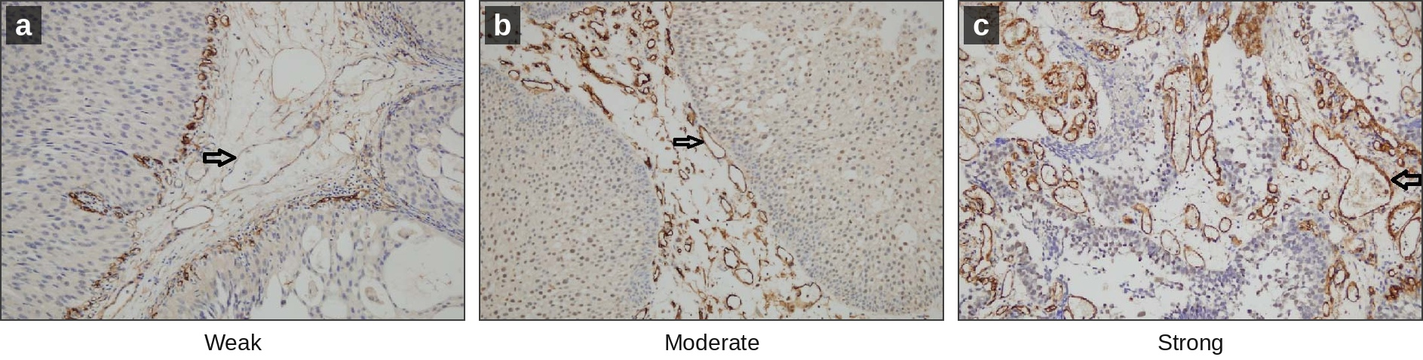
Fig. S1 Representative CD105 (endoglin) immunostaining of angiogenic areas in non–muscle-invasive urothelial carcinoma (original magnification ×200). a Weak, b moderate and c strong CD105 staining. Arrows indicate CD105-positive vascular endothelium. Microvessels were counted in the field of most intense staining; a discernible lumen was not required and the presence of erythrocytes was not used as a criterion. Panels are original photomicrographs from the study series, centre-cropped (≤9% of image area) to a common aspect ratio and rescaled to a common panel size of 617 × 426 pixels for alignment; no tonal, colour or sharpening adjustment was applied. The available archival images are of limited native resolution, so the panel is reproduced at ≈300 dpi

