SUPPLEMENTARY MATERIAL FOR ‘Resource Mobilization under Forced Migration: Development and Validation of the Refugee Resilience Scale (RRS-16)
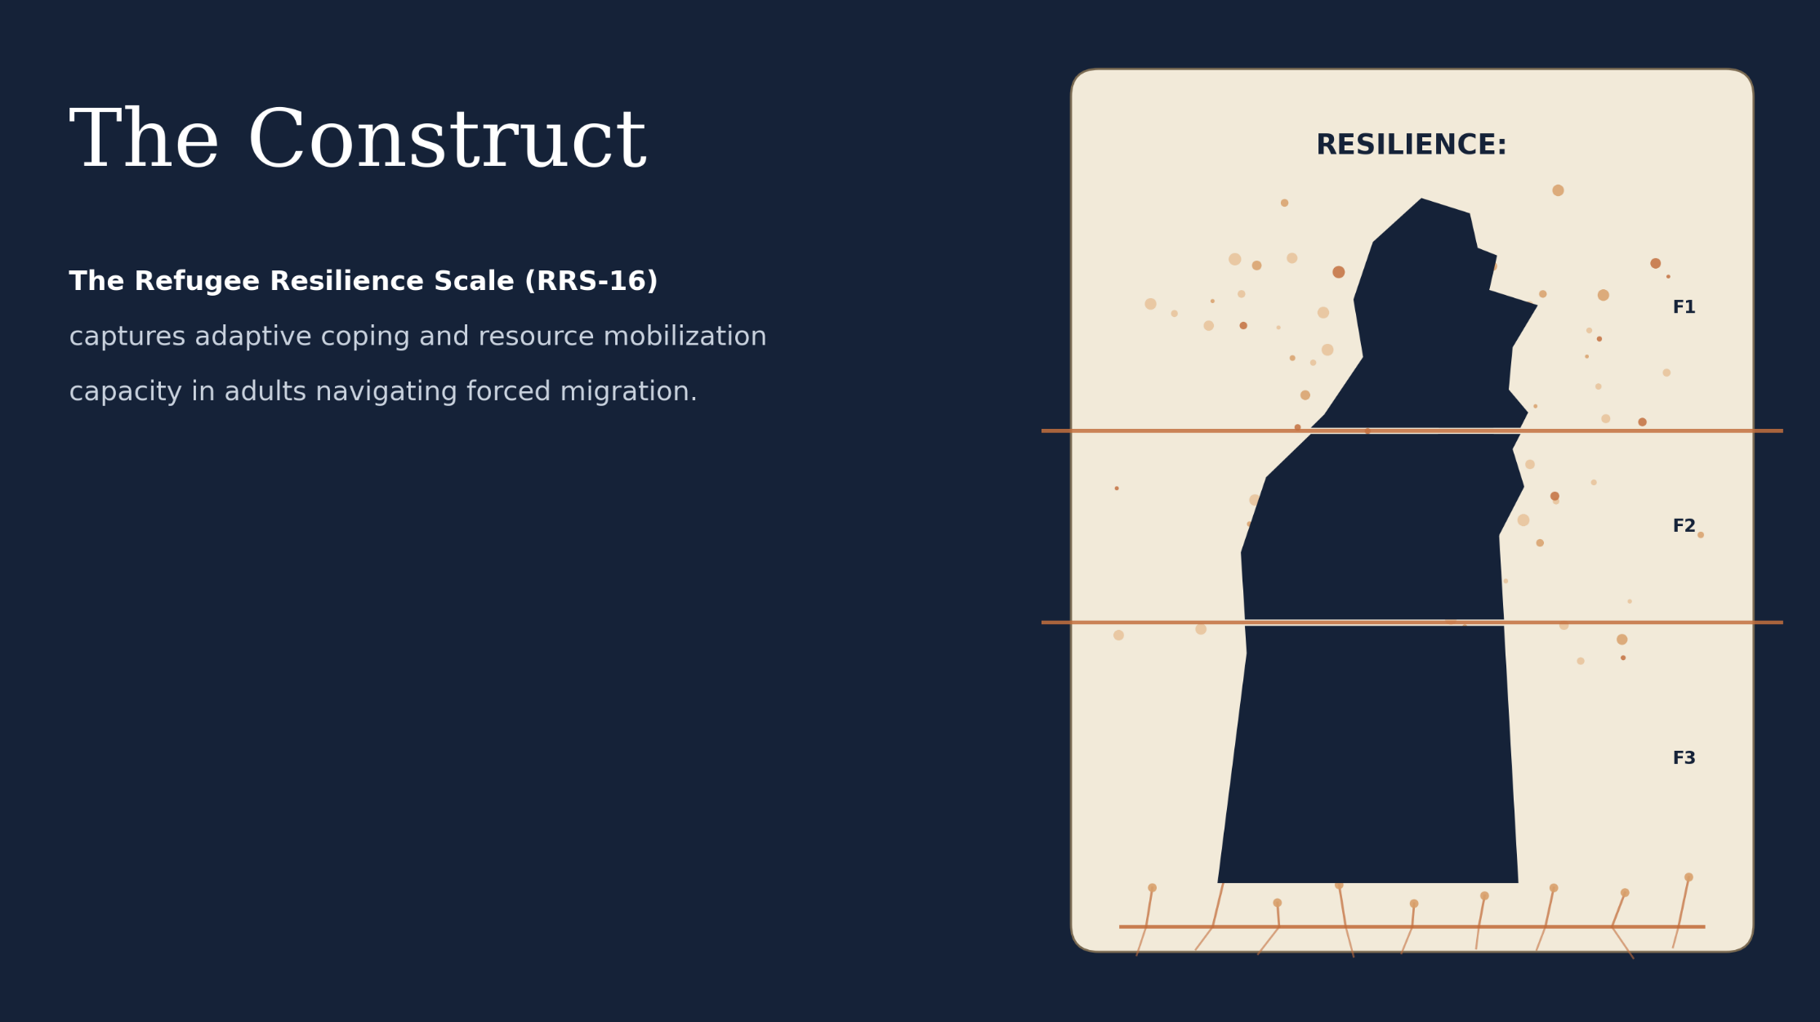
This material contains detailed results and interpretations of the analyses conducted within the scope of the research. The research packages, code, all datasets, and more detailed outputs of every analysis described here are archived at [OSF link:
https://osf.io/jv8mz/overview?view_only=635464c7dff343c2ad99a3e8cf7da7aa]
GRAPHICAL ABSTRACT
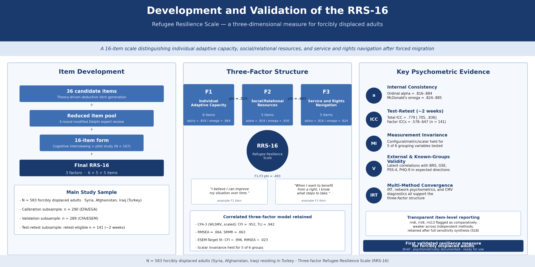

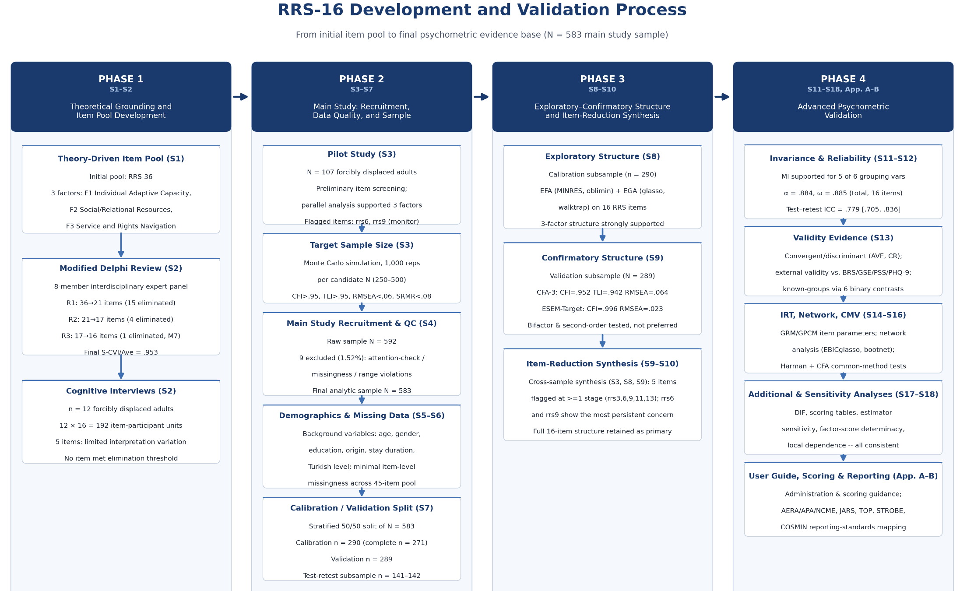
TABLE OF CONTENTS
S0. | Detailed Psychometric Methods | 5–10
S1. | Theoretical Framework, Construct Definition, and Initial Item Pool | 11–28
S2. | Content Validity and Response Process Evidence: Modified Delphi Review and Cognitive Interviews | 29–44
S3. | Pilot Study and Target Sample Size Justification | 45–51
S4. | Main Study Data Quality Control | 52–53
S5. | Main Study Sample Characteristics | 54–55
S6. | Main Study Missing Data Analysis | 56–62
S7. | Cross-Validation and Subsample Size / Stability Analyses | 63–72
S8. | Exploratory Factor and Graph Analyses — Calibration Subsample | 73–84
S9. | Confirmatory Factor Analysis and Exploratory Structural Equation Modeling — Validation Subsample | 85–101
S10. | Item-Reduction Synthesis: Integrating Pilot, Exploratory, and Confirmatory Evidence | 102–108
S11. | Measurement Invariance Analyses | 109–116
S12. | Reliability Analyses | 117–126
S13. | Validity Analyses | 127–134
S14. | Item Response Theory (IRT) Analyses | 137–150
S15. | Network Psychometrics Analyses | 151–168
S16. | Common Method Variance (CMV) Assessment Analyses | 169–172
S17. | Additional Analyses | 173–182
S18. | Sensitivity and Robustness Analyses | 183–189
Appendix A. | RRS-16 User Guide and Scoring | 190–195
Appendix B. | Mapping to Reporting and Measurement Standards (RRS-16) | 196–199

S0. DETAILED PSYCHOMETRIC METHODS
This table documents, script by script, the exact analytic pipeline used to develop and validate the RRS-16. Every entry (software, estimator, missing-data handling, and decision thresholds) was extracted directly from the analysis scripts archived on OSF; no entry summarizes or approximates code behavior not present in the corresponding script. Because the table is organized by script, Sections S1, S2, and S18 have no row of their own: they document, respectively, the a priori construct specification and item-pool generation, the modified Delphi and cognitive-interviewing procedures, and the narrative synthesis of results reported elsewhere, none of which involves an analysis script. The item-retention decision reported in S10 draws on the sensitivity script listed in the S9/S10 row.
Table S0.1. Detailed Psychometric Methods
Section / Script | Dataset and sample | Measures / variables | What was done (core steps) | How (software / estimator / key settings) | Missing-data handling (as coded) | Decision rules / thresholds used
S3 Pilot study -- demographics + item descriptives + reliability + factorability + dimensionality + EFA (RRS-16) [pilot.R] | pilot_raw.xlsx (pilot sample; N = 107, per Supplemental S3 text; N_total taken from nrow(df) in code, no hardcoded N). | Demographics: age, gender, education, origin, stay_duration, turkish_level (6 variables). Items rrs1-rrs16 (RRS-16); F1_IndividualAdaptiveCapacity = rrs1-rrs6, F2_SupportSeeking = rrs7-rrs11, F3_ServiceRightsNavigation = rrs12-rrs16 (3-factor theoretical structure used from the pilot stage onward). special_items = rrs6, rrs9 (tracked for monitoring; RRS-16 has no reverse-scored items). | (1) Demographic frequency tables; (2) item descriptives + item-total statistics + reliability (total and per-factor); (3) dimensionality (eigenvalues, parallel analysis); (4) factorability (KMO, Bartlett); (5) 3-factor ordinal EFA. | R (readxl, dplyr, janitor, tibble, purrr, tidyr, psych, ggplot2, stringr, rlang, writexl). psych::alpha(check.keys=FALSE) on a polychoric (with pairwise fallback on error) + cor.smooth()-ed correlation matrix; psych::omega(nfactors=3, plot=FALSE); psych::fa.parallel(fa="fa", fm="minres", n.iter=500); psych::KMO(); psych::cortest.bartlett(); psych::fa(nfactors=3, fm="minres", rotate="oblimin"). set.seed(20260716). | No explicit na.omit()/complete.cases() call on the 16-item block; item descriptives/alpha/omega computed via psych::polychoric() with its internal pairwise handling (Pearson pairwise fallback on error). | CITC < 0.30 flags an item (flag_citc_low). No hardcoded KMO/Bartlett/EFA-fit cutoff in this script (descriptive reporting only).
S3 Target sample size -- Monte Carlo feasibility simulation (RRS-16, 3-factor CFA) [target_sample_size.R] | Fully simulated data (no empirical file read); population model parameterized from pilot loadings (N=107 pilot; mean loading F1=.685/F2=.679/F3=.661 per code comments). | 16 simulated items rrs1-rrs16 (3-block loading structure: F1=rrs1-rrs6, F2=rrs7-rrs11, F3=rrs12-rrs16). | Population model defined (16 main loadings per item, 3 cross-loadings on rrs3/rrs6/rrs9 per pilot-EFA, 3 residual correlations [rrs1-rrs2, rrs7-rrs8, rrs12-rrs13], inter-factor phi = .17/.20/.19 (set to the mean between-block polychoric item correlations from the pilot, not to the rotated EFA factor correlations; see S3), mildly negative-skewed Likert thresholds); for n_range = {250,300,350,400,450,500}, n_sim = 500 replications per N; each replication fit as a deliberately misspecified ordinal WLSMV CFA (main loadings only; cross-loadings/residual correlations present in the data-generating model but omitted from the fitted model); % of replications meeting fit criteria tabulated to inform the recommended target N. | R (psych, lavaan, MASS). MASS::mvrnorm(n, mu=rep(0,3), Sigma=phi) for correlated factor scores, then continuous composite + shared-noise residual correlations, then ordinal transformation via skewed thresholds (qnorm(c(.15,.35,.60,.83))). CFA: lavaan::cfa(estimator="WLSMV", ordered=TRUE). lavaan::fitMeasures(fit.measures=c("cfi","tli","rmsea","srmr")). | Not applicable -- fully simulated data; no missingness generated or handled. | CFI_CUT = 0.95; TLI_CUT = 0.95; RMSEA_CUT = 0.060; SRMR_CUT = 0.080. Recommended N = lowest N in {250,...,500} at which the simulated CFA success rate reaches >=80% across the 500 replications.
S4 Main study data control and data quality control (RRS-16) [data_control-data_quality_control.R] | data_raw.xlsx (or data_rw.xlsx fallback) -> data_cleaned.xlsx; full main-study sample prior to any exclusion (N = 592 raw). | Demographics (id + 6 background variables: age, gender, education, origin, stay_duration, turkish_level); rrs1-rrs16 (RRS-16); brs1-brs6 (BRS); gse1-gse10 (GSE); pss1-pss4 (PSS-4); phq1-phq9 (PHQ-9); aci1-aci2 (attention-check items); time; it1-it16 (retest). | Header/column-order audit; range/integer spec check (spec_demo, spec_scales); ID checks (missing/duplicate/non-positive/non-integer); attention-check screen, missing-rate screen, straightlining screen, completion-time screen; combined exclusion; data_cleaned.xlsx exported. | R (readxl, dplyr, purrr, janitor, tibble, openxlsx). Custom is_non_integer() helper (tol=1e-8); janitor::clean_names(); openxlsx::write.xlsx(). | Missingness used as an exclusion criterion, not imputed: ordinal_missing_rate >= .10 across the 45 ordinal scale items (RRS+BRS+GSE+PSS+PHQ) -> fail_missing = TRUE (row excluded). | Range specs: age 1-4, gender 1-3, education 1-3, origin 1-3, stay_duration 1-3, turkish_level 1-3, aci1 1-5, aci2 1-5, time 5-90; rrs/brs items 1-5, gse items 1-4, pss items 0-4, phq items 0-3, it items 1-5. ACI correct codes: ACI1=1, ACI2=5; any deviation/missing on either item -> fail_aci. fail_missing: ordinal_missing_rate >= .10. Straightlining: min_answered = ceiling(.80 x 45 items) = 36; max_same_prop >= .80 AND n_answered >= 36 -> fail_straightline. Completion time: time_lo=5, time_hi=90 (outside or missing -> fail_time). exclude_any = fail_aci | fail_missing | fail_straightline | fail_time. Result: 9 of 592 excluded (1.52%), N = 583 retained.
S5 Main sample demographic and background characteristics [deomographic.R] | data_cleaned.xlsx (S4 output); N = 583. | age, gender, education, origin, stay_duration, turkish_level (same coding as S4). | make_block() helper builds a frequency/percent table per variable (category % computed among valid/non-missing responses; a separate row reports missing/total N); all blocks combined into one demographic table exported as CSV/XLSX. | R (readxl, dplyr, janitor, tibble, openxlsx). dplyr::recode() for category labels; write.csv() + openxlsx::write.xlsx(). | Missing values reported as an explicit "Missing" row per variable; no imputation. | No hardcoded statistical cutoff in this script (purely descriptive tabulation).
S6 Main study missing data analyses and handling (no imputation) [missing_data.R] | data_cleaned.xlsx; N = 583 (retained main-study sample). | rrs_items (rrs1-rrs16); brs_items (brs1-brs6); gse_items (gse1-gse10); pss_items (pss1-pss4); phq_items (phq1-phq9); items_45 (union of the five scales, 45 items total); retest_items (it1-it16); mech_predictors (6 demographic/background variables). | Variable-level and block-level missingness tables; complete-case counts; person-level missing-rate distribution; visualizations (naniar::gg_miss_var, vis_miss, gg_miss_upset, histograms); mice::md.pattern; Little's MCAR test on the 45-item pool; logistic-regression mechanism screen (miss_any_45 ~ demographics). | R (readxl, dplyr, janitor, tibble, ggplot2, naniar, mice). naniar::gg_miss_var(); naniar::vis_miss(); naniar::gg_miss_upset(nsets=10); mice::md.pattern(plot=FALSE); naniar::mcar_test(); glm(family=binomial()). | Explicit code-header statement: "No imputation was applied in this study." Documented strategy: pairwise/available-case handling for correlational/descriptive work; WLSMV for ordinal CFA (uses all available item-level information); complete-case analysis where specified. Little's MCAR test is skipped entirely if n_miss_total_45 == 0. | Little's MCAR decision: p < .05 -> "Reject MCAR"; p >= .05 -> "Fail to reject MCAR". Logistic-regression significance flags: p<.001 "***", p<.01 "**", p<.05 "*", p<.10 ".".
S7 Cross-validation and subsample size / stability (RRS-16 split-sample design) [split_sample-cross_validation-subsample_size.R] | data_cleaned.xlsx (N=583) -> calibration_sample.xlsx (n) + validation_sample.xlsx (n); stratified 50/50 split; set.seed(20240315); split_p=.50. Participants with missing age/gender were dropped before stratification (interaction(gender,age) requires both non-missing). | Strata: gender x age (interaction); items rrs1-rrs16; equivalence-test variables: ordinal_demo (age, education, stay_duration, turkish_level), nominal_demo (gender, origin); composite totals (rrs_total, brs_total, gse_total, pss_total, phq_total). | (1) Stratified split via caret::createDataPartition; (2) subsample equivalence tests (Wilcoxon + rank-biserial; chi-square + Cramer's V; Welch t + Cohen's d), Bonferroni-corrected; (3) calibration EFA (polychoric, MINRES+oblimin, K=3 factors); (4) validation CFA (WLSMV theta, scaled fit emphasized); (5) EFA-CFA congruence (Hungarian alignment); (6) bootstrap stability (EFA congruence and CFA fit/loading stability); (7) subsample-size sensitivity grid. | R (readxl, openxlsx, dplyr, janitor, tibble, purrr, psych, lavaan, caret, tidyr, ggplot2, clue, effectsize). caret::createDataPartition(p=.50). EFA: psych::fa.poly(nfactors=3, fm="minres", rotate="oblimin", smooth=TRUE). CFA: lavaan::cfa(estimator="WLSMV", parameterization="theta", std.lv=TRUE, missing="pairwise"). Congruence: psych::factor.congruence() + clue::solve_LSAP(). Tests: stats::wilcox.test(exact=FALSE); effectsize::rank_biserial(); stats::chisq.test(correct=FALSE); stats::t.test(var.equal=FALSE). | Ordinal EFA uses complete.cases() (listwise, calibration subset). CFA uses missing="pairwise". The EFA bootstrap resamples the complete-case calibration matrix; the CFA bootstrap and the subsample-size grid resample the unfiltered validation matrix. | K_FACTORS = 3; BOOT_R = 100; GRID_N = {150,200,250,300,350} as defined in the script, of which only {150,200,250} could be evaluated because 300 and 350 exceed the validation subsample size (see S7, Table S7.8); GRID_R = 100; K_BONF = 12, alpha_Bonf = .05/12; chi-square test skipped when any expected cell count < 5.
S8 Exploratory analyses -- calibration sample: 16-item EFA/EGA + item flagging [efa_ega1.R] | calibration_sample.xlsx (S7 output); N = nrow(dat); complete-case N = N_cc (used for EGA/bootstrap). | items_target = rrs1-rrs16 (full 16-item pool; no items removed -- see S10). | (A) EFA: polychoric correlation (safe_polychoric), KMO+Bartlett, factor-count retention (parallel analysis, MAP, scree elbow, Kaiser, Hull via EFAtools), model comparison across candidate k, primary k=3 EFA, two item-flagging passes (D0: pilot-consistent criteria primary<.40 OR cross>=.32, applied to rrs3/rrs6/rrs9; D1: stricter supplementary criteria), extraction x rotation sensitivity, bootstrap congruence stability (B=200). (B) EGA: GLASSO+cor_auto, walktrap (primary) + leiden (sensitivity), Hungarian-aligned agreement, bootstrap (B=200), EGAnet::bootEGA() (optional/supplementary). (C) EFA-EGA convergence table. | R (readxl, dplyr, tidyr, stringr, tibble, purrr, psych, GPArotation, ggplot2, clue, EFAtools, EGAnet, igraph, qgraph, readr, writexl). psych::polychoric(correct=.5) + cor.smooth(); psych::KMO(); psych::cortest.bartlett(); psych::fa.parallel(fa="fa", fm="minres", n.iter=200); psych::VSS(); EFAtools::N_FACTORS(cor="poly"); psych::fa(nfactors=k, fm="minres"/rotation per sensitivity grid); EGAnet::EGA(model="glasso", algorithm="walktrap"/"leiden", corr="cor_auto", gamma=.50); EGAnet::bootEGA(). Note: a separate set.seed(123) is used only for the scree-plot parallel-analysis visualization (Figure_EFA_parallel_analysis), not for the primary EFA/EGA estimates or bootstrap procedures. | Per code: pairwise deletion for polychoric correlation; listwise (complete-case) for EGA and all bootstrap procedures. | k_min=1, k_max=5, k_primary=3; fm_primary="minres", rot_primary="oblimin"; fm_sens={"minres","uls"}, rot_sens={"oblimin","promax"}; BOOT_REPS_EFA=200, BOOT_SEED_EFA=1234. Pilot-consistent flagging (D0): PILOT_PRIMARY_LOADING_CUT=.40, PILOT_CROSS_LOADING_CUT=.32. Supplementary strict flagging (D1): STRICT_PRIMARY_LOADING_CUT=.60, STRICT_H2_CUT=.42, STRICT_CROSS_LOADING_CUT=.32, STRICT_CROSS_DIFF_CUT=.20. EGA: model="glasso", corr="cor_auto", algo_primary="walktrap", algo_sens="leiden", ebic_gamma=.50, BOOT_REPS_EGA=200, BOOT_SEED_EGA=1234.
S9 Confirmatory analyses -- validation sample, 16-item pool (RRS-16) [CONFIRMATORY_ANALYSES1.R] | validation_sample.xlsx (S7 output); N = nrow(dat) = 289. | items = rrs1-rrs16; F1=rrs1-rrs6, F2=rrs7-rrs11, F3=rrs12-rrs16. | 4 competing ordinal CFA models (one-factor, 3-factor correlated, 3-factor second-order, bifactor) via WLSMV; same 4 models refit via MLR (descriptive AIC/BIC); Heywood check, residual-correlation summary, N/parameter ratio, latent-covariance PD check; standardized loadings + factor correlations; second-order loadings; bifactor diagnostics (ECV, omega-h, omega-s); HTMT (polychoric, 3-block, custom function); ESEM (Target + Geomin rotation) with cross-loading diagnostics; bootstrap (CFA-3 vs. ESEM-Target); SAFE residual correlations (observed polychoric minus model-implied). | R (lavaan, semTools, semPlot, readxl, dplyr, tidyr, stringr, tibble, purrr, ggplot2, reshape2, psych, readr). WLSMV: lavaan::cfa(estimator="WLSMV", parameterization="theta", std.lv=TRUE, missing="pairwise", warn=FALSE). MLR (descriptive): estimator="MLR", missing="fiml". ESEM: rotation="target" and rotation="geomin" (multiple rotation.args attempts on convergence failure). Custom compute_htmt() function. set.seed(12345) (primary CFA/ESEM models); a separate set.seed(24680) is used for the CFA-3 vs. ESEM-Target bootstrap (B=200). | Per code: WLSMV CFA/ESEM -> missing="pairwise"; MLR CFA (descriptive AIC/BIC only) -> missing="fiml"; polychoric/HTMT -> pairwise-complete; bootstrap resamples skip failed iterations. | dynamic_cutoffs(n): adj=.020 (n<150)/.010 (n<250)/.005 (n<500)/0 (else); cfi=.95-adj, rmsea=.06+adj, srmr=.08+adj. std_cut: cfi=.95, rmsea=.06, srmr=.08. HTMT: both <.85 and <.90 reported.
S9/S10 Item-exclusion sensitivity (rrs9 / rrs13 / both removed) [sensitivity.R] | validation_sample.xlsx (S7 output). | items_full = rrs1-rrs16; items_no9 (15 items, rrs9 removed); items_no13 (15 items, rrs13 removed); items_no9_13 (14 items, both removed). | For each of the 4 item sets (full 16-item baseline; rrs9 removed; rrs13 removed; both removed): 3-factor WLSMV CFA fit; reliability impact via factor omega (F2 with/without rrs9; F3 with/without rrs13); fit-index comparison relative to the 16-item baseline. | R (readxl, dplyr, lavaan). lavaan::cfa(estimator="WLSMV", parameterization="theta", ordered=[item set], std.lv=TRUE, missing="pairwise") for each of the 4 scenarios. | Explicitly coded: parameterization="theta", missing="pairwise" (sensitivity.R, fit_common_args). | No hardcoded accept/reject threshold; fit-index and omega deltas relative to the 16-item baseline are tabulated descriptively for the S10 item-retention decision.
S11 Measurement invariance analyses (RRS-16, main sample) [MI1.R] | data_cleaned.xlsx (main analytic sample, N=583). | items = rrs1-rrs16 (all 16 items; no items excluded). Grouping variables (6 total): age, gender, education, origin, stay_duration, turkish_level. | Per grouping variable: group-size report against a minimum-N threshold; configural CFA (theta), metric CFA (group.equal="loadings"), scalar CFA (group.equal=c("loadings","thresholds")); nested delta-fit table per variable; pass/fail decision per comparison; fit-trajectory and delta-CFI/delta-RMSEA heatmap figures across all variables; overall pass/fail summary per variable. | R (readxl, dplyr, tibble, tidyr, stringr, purrr, lavaan, semTools, ggplot2). lavaan::cfa(model=model_syntax [F1=~rrs1..rrs6; F2=~rrs7..rrs11; F3=~rrs12..rrs16], group=group_var, ordered=items, estimator="WLSMV", parameterization="theta", std.lv=TRUE, missing="pairwise", group.equal=group_equal, warn=FALSE). Fit indices extracted via lavInspect(fit,"fit") using the .scaled fields plus unscaled srmr. | WLSMV missing="pairwise"; rows missing on the grouping variable itself are excluded from that variable's invariance test only. | min_n_per_group = 50 (categories below this threshold flagged as below_min_n). Pass rule (directional): metric_vs_configural -- delta_CFI >= -.010, delta_RMSEA <= .015, delta_SRMR <= .030; scalar_vs_metric -- delta_CFI >= -.010, delta_RMSEA <= .015, delta_SRMR <= .010. A comparison is "Pass" only if all three criteria are met.
S12 Reliability analyses (RRS-16, main study sample) [reliability.R] | data_cleaned.xlsx; B_BOOT=200; set.seed(12345). Per code: data_cleaned.xlsx is the final dataset and no reverse coding is applied anywhere in this script (RRS-16 has no reverse-scored items). | 16 items (F1: rrs1-rrs6, 6 items; F2: rrs7-rrs11, 5 items; F3: rrs12-rrs16, 5 items); retest items_t2 = it1-it16 (only retest-eligible respondents with any T2 data used). | Item level: descriptives, floor/ceiling, polychoric CITC, alpha-if-deleted, upper/lower 27% discrimination (t-test + Cohen's d), mean inter-item correlation, composite problem flags. Scale level: ordinal alpha + bootstrap 95% CI (total and each factor), omega-total, CFA-based CR/AVE (3-factor model), bifactor indices (ECV, omega-h, omega-s), test-retest (ICC, Bland-Altman; Total/F1/F2/F3 scored as minimum-completeness means). | R (readxl, dplyr, tidyr, purrr, stringr, tibble, janitor, psych, lavaan, ggplot2, scales, Matrix, irr, readr, forcats). psych::polychoric(); psych::cor.smooth(); custom alpha_from_cor() and ordinal_alpha_boot(B=200, conf=.95). CFA: lavaan::cfa(estimator="WLSMV", parameterization="theta", std.lv=TRUE, missing="pairwise", warn=FALSE). irr::icc(model="twoway", type="agreement", unit="single"). | Per code: no imputation is applied to any reported item response. Item-level: WLSMV missing="pairwise"; alpha/omega/CITC via pairwise-complete polychoric correlations. Test-retest uses complete-case T1/T2 score pairs only. One disclosed exception (see S18): for the upper/lower-27% discrimination analysis only, missing item responses are replaced by the respondent's own row mean before ranking; this enters no other analysis and alters no reported item response. | B_BOOT=200. Discrimination groups: Flag_d_lt_0_80 = (Cohen's d < .80). CR/AVE flags: AVE_lt_0_50 = AVE<.50; CR_lt_0_70 = CR<.70. Alpha-if-deleted flag: Flag_increases_alpha = alpha_if_deleted > alpha_ord. Test-retest minimum-completeness rule (for the ICC/Bland-Altman analysis specifically): min_total=ceiling(16/2)=8; min_factor=ceiling(k/2) per factor (F1: 3/6, F2: 3/5, F3: 3/5) -- distinct from the stricter ~80% completeness rule used for general scoring in S17 Part 2 and Appendix A.
S13 Validity analyses (RRS-16, main study sample) -- construct, external, and known-groups validity [validity.R] | data_cleaned.xlsx; N = nrow(df) (583). | Part 1/2: rrs_items (16, F1/F2/F3 blocks); external convergent measures: brs_items (BRS, 6 items), gse_items (GSE, 10 items), pss_items (PSS-4, 4 items), phq_items (PHQ-9, 9 items). Part 3 (known-groups): 6 background variables each recoded into a binary contrast -- age_bin (Younger 18-50 vs. Older 51+ from age categories 1-2 vs. 3-4), gender_bin (Female vs. Male), educ_bin (Low vs. High, education=1 vs. 2-3), origin_bin (modal origin category vs. all others), stay_bin (median split on stay_duration), turkish_bin (median split on turkish_level). | Part 1 (Construct validity): 3-factor CFA, AVE & CR (Fornell & Larcker, 1981), latent correlations, Fornell-Larcker criterion. Part 2 (External validity): joint CFA of RRS-16 + BRS + GSE + PSS + PHQ (7 factors total), latent correlations between RRS-16 factors and external scales with SE/CI/p, semTools::compRelSEM() and semTools::AVE() on the joint model. Part 3 (Known-groups): per binary grouping variable, configural->metric->scalar multi-group CFA + latent mean differences (Cohen's d with 95% CI, computed from latent covariances/means relative to a specified reference group). Only turkish_bin was tested with an a priori directional hypothesis (higher Turkish proficiency -> higher RRS-16, based on Cinkara 2017 and related Türkiye/Syrian-refugee-context literature cited in-code); the other five grouping variables (age, gender, education, origin, stay duration) were tested non-directionally because the code's inline literature review found inconsistent or absent prior evidence for a specific direction in forced-migration samples. | R (readxl, dplyr, tidyr, tibble, lavaan, semTools, janitor). lavaan::cfa(estimator="WLSMV", parameterization="theta", std.lv=TRUE, missing="pairwise") for the 3-factor, joint-external, and each known-groups (configural/metric/scalar) model. Known-groups scalar model built via a custom build_scalar_model_syntax() that explicitly frees latent means per group (reference group fixed at 0). | All CFAs (Parts 1-3) use missing="pairwise" (WLSMV); known-groups models additionally drop rows missing on the specific grouping variable via filter(!is.na(.data[[group_var]])) before fitting. | Known-groups invariance pass rule (same directional logic as S11): metric -- (delta_CFI>=-.010) & (delta_RMSEA<=.015) & (delta_SRMR<=.030); scalar -- (delta_CFI>=-.010) & (delta_RMSEA<=.015) & (delta_SRMR<=.010). No hardcoded AVE/CR/Fornell-Larcker accept/reject threshold in this script (values reported descriptively for interpretation against conventional benchmarks in the main text).
S14 Item Response Theory analyses (RRS-16, by factor block) [ırt.R] | data_cleaned.xlsx (N=583); analyzed separately per factor block (F1, F2, F3). set.seed(1234). | rrs_items (16); blocks F1 (rrs1-rrs6, 6 items), F2 (rrs7-rrs11, 5 items), F3 (rrs12-rrs16, 5 items). Per code: no items excluded; full 16-item pool retained per S10. | Per block: (A) unidimensionality screen via single-factor ordinal CFA; (B) GRM vs. GPCM comparison (AIC/BIC, with SE-type fallback: sandwich -> Oakes -> none); (C) local-independence diagnostics (Q3 + LD residuals); (D) item parameters with robust SE; (E) model fit (M2, type "C2" with "M2" fallback); (F) TIF/SEM/conditional-reliability figure, ICC figure, Wright map; (G) Mokken AISP + IIO. | R (readxl, dplyr, tibble, tidyr, stringr, purrr, mirt, mokken, lavaan, psych, ggplot2, gridExtra, grid, scales, readr, writexl, Matrix). mirt::mirt(itemtype="graded"/"gpcm", SE=TRUE, SE.type="sandwich", with automatic fallback to SE.type="Oakes" then SE=FALSE if sandwich fails); best model chosen by AIC. mirt::M2(type="C2", calcNULL=FALSE) with type="M2" fallback. mokken::coefH(); mokken::check.monotonicity(); mokken::aisp(lowerbound=.30); mokken::check.iio(method="MIIO"). Unidimensional screen: lavaan::cfa(estimator="WLSMV", ordered=items, missing="pairwise"). | Per code: mirt -> full-information estimation (handles missing responses without imputing); lavaan (unidimensional CFA screen) -> pairwise deletion (WLSMV); mokken -> listwise within block (sub_complete <- na.omit(sub_data)). No imputation is performed at any stage. | Unidimensionality pass: CFI >= .95 AND RMSEA <= .08 AND mean explained variance >= 40%. Local independence: max|Q3| < .20 (per residual screen). Mokken AISP lowerbound=.30.
S15 Network psychometrics analyses (RRS-16) [network.R] | data_cleaned.xlsx (N=583); complete-case subset used for network estimation. set.seed(20240315). | rrs_items (16); blocks F1 (rrs1-rrs6), F2 (rrs7-rrs11), F3 (rrs12-rrs16) used as a priori communities for group coloring and bridge centrality. | (1) Primary EBICglasso network estimation; (2) node centrality (strength, closeness, betweenness, expected influence, z-scored); (3) bridge centrality (3 CFA-block communities); (4) bootstrap: nonparametric edge-weight bootstrap, case-dropping bootstrap (CS coefficients), centrality-difference bootstrap (B=200 for all three); (5) diagnostics: small-worldness, mgm categorical predictability (EBIC then CV fallback), goldbricker item-redundancy check; (6) sensitivity: EBICglasso gamma grid and split-half replication. | R (readxl, dplyr, tibble, tidyr, purrr, stringr, qgraph, bootnet, networktools, igraph, mgm, ggplot2, Matrix, writexl). bootnet::estimateNetwork(default="EBICglasso", corMethod="cor_auto", tuning=EBIC_GAMMA, threshold=FALSE); qgraph::centrality_auto(); bootnet::bootnet(nBoots=BOOT_R, type="nonparametric"/"case"); bootnet::corStability(); mgm::mgm(lambdaSel="EBIC", lambdaGam=.25, with lambdaSel="CV" fallback); networktools::goldbricker(method="hittner2003"). | Per code (network.R carries no comment header): no imputation is performed; the primary network, centrality, bridge, and bootstrap analyses use complete-case data only. | BOOT_R=200; EBIC_GAMMA=.50; THRESHOLD_NETWORK=FALSE; MIN_EDGE_PLOT=.03 (visualization only). CS-coefficient bands: >=.25 "stable (minimum)", >=.50 "preferred". Goldbricker: p=.05, threshold=.25, corMin=.50.
S16 Common method variance (CMV) assessment (RRS-16) [cmv.R] | data_cleaned.xlsx (no imputation; missing values left present). set.seed(20230206). | Test 1 (Harman) 45-item pool: rrs_items(16) + brs_items(6) + gse_items(10) + pss_items(4) + phq_items(9). Tests 2-4: rrs_items only (16 items, F1/F2/F3 blocks). | Test 1: Harman's single-factor test (unrotated PAF with MINRES fallback, polychoric, 45-item pool, listwise-complete). Test 2: CFA comparison (1-factor vs. 3-factor), WLSMV theta, pairwise. Test 3: CLF model (equal-loading common latent factor, orthogonal to F1/F2/F3) -- delta-fit, mean/max |delta-lambda|. Test 4: HTMT (polychoric, listwise-complete). | R (readxl, dplyr, tibble, tidyr, stringr, purrr, psych, lavaan, Matrix, writexl). Harman: psych::fa(nfactors=1, rotate="none", fm="pa") with fm="minres" fallback on error. CFA: lavaan::cfa(estimator="WLSMV", parameterization="theta", std.lv=TRUE, missing="pairwise"). CLF: equal-loading syntax (CLF =~ m*item1 + m*item2 + ...) constrained orthogonal to F1/F2/F3. | Per code: no imputation is performed; Tests 1 and 4 use listwise-complete cases, Tests 2 and 3 (WLSMV CFA/CLF) use pairwise-present missing data handling. | No hardcoded pass/fail cutoff for the Harman variance share in this script (percentage and eigenvalue reported descriptively only); delta-CFI, RMSEA decrease, mean/max |delta-lambda| reported descriptively against conventional CMV benchmarks in the main text.
S17 Part 1: Differential item functioning (DIF; ordinal logistic regression) [dif.R] | data_cleaned.xlsx (no imputation applied); item-specific complete-case subset per (group variable x item) test. | rrs_items (16, F1/F2/F3 blocks); grouping variables (6, each recoded to a binary contrast, same derivation as S13 Part 3): age_bin (Younger 18-50 vs. Older 51+), gender_bin (Female vs. Male), educ_bin (Low vs. High), origin_bin (modal origin vs. other), stay_bin (median split), turkish_bin (median split). | Per (group variable x item): 3 nested cumulative-link models (M0: item~matching; M1: item~matching+group [uniform DIF]; M2: item~matching*group [non-uniform DIF]), compared via LRT; Holm-adjusted p-values (uniform/non-uniform families adjusted separately within each grouping variable); McFadden delta-R^2 for practical DIF magnitude. | R (readxl, dplyr, ordinal). ordinal::clm(link="logit"); anova() for LRT p-values; stats::p.adjust(method="holm"); McFadden R^2 = 1 - ll_model/ll_null. | Item-specific complete-case rule per code comment: for each (group_var x item) test, subset to complete cases on group_var + the focal item + the other same-block items used for the matching score. | min_n_per_level = 30 (group-size minimum per category; smaller categories dropped for that test). practical_dR2_cut = .010. Holm correction applied separately within each grouping variable (uniform and non-uniform families).
S17 Part 2: User guide and scoring tables (percentile norms, SEM/MDC95) [USERGUIDE_SCORING_TABLES.R] | data_cleaned.xlsx (N=583; no imputation applied). | RRS-16 (16 items, all retained); F1 (rrs1-rrs6, 6 items), F2 (rrs7-rrs11, 5 items), F3 (rrs12-rrs16, 5 items); descriptive TOTAL (16 items). | Mean-metric (1-5) and sum-metric factor/total scores computed under a minimum-completeness rule; percentile tables (P10/Q1/Median/Q3/P90 + N/Mean/SD/Min/Max); SEM/MDC95 (ordinal-alpha-based, mean metric). | R (readxl, dplyr, tibble, psych, writexl). psych::polychoric() + psych::alpha(); quantile(probs=c(.10,.25,.50,.75,.90)). | Minimum-completeness rule applied to scoring (not imputed): mean_with_min()/sum_with_min() return NA if n_nonmiss < min_nonmiss. SEM/MDC95 alpha computed on complete.cases() (listwise). | min_req ("nearest attainable to 80% completeness"): F1 >= 5/6 items (83.3%), F2 >= 4/5 items (80.0%), F3 >= 4/5 items (80.0%), TOTAL >= 13/16 items (81.3%). MDC95 = 1.96 x sqrt(2) x SEM; SEM = SD(mean metric) x sqrt(1 - alpha).
S17 Part 3: Estimator sensitivity (WLSMV vs. MLR) [estimator_sensitivity_validation.R] | data_cleaned.xlsx (raw N; WLSMV and MLR each fit on the full sample under their own native missing-data handling). | rrs_items (16: rrs1-rrs16; all 16 items are part of the final scale -- no items excluded in this script). | Same 3-factor CFA model fit twice on the same raw data: once WLSMV (ordinal, theta, pairwise) and once MLR (continuous-treatment, robust, FIML); fit-index comparison table; item-level standardized loading comparison (delta-lambda = MLR - WLSMV), with automatic retry using looser optimizer settings if the primary MLR fit fails to converge. | R (readxl, dplyr, lavaan, readr, tibble). lavaan::cfa(estimator="WLSMV", ordered=rrs_items, parameterization="theta", std.lv=TRUE, missing="pairwise", warn=FALSE); lavaan::cfa(estimator="MLR", std.lv=TRUE, missing="fiml", warn=FALSE). | WLSMV missing="pairwise"; MLR missing="fiml"; each estimator uses its own native handling of the same raw sample. | Loading-difference counts reported: n(|delta-lambda|>.05), n(|delta-lambda|>.10), n(|delta-lambda|>.20), plus mean/median/max |delta-lambda| and the WLSMV-MLR loading correlation -- descriptive summary only, no hardcoded pass/fail cutoff.
S17 Part 4: Construct replicability and factor-score quality [Construct replicability & factor-score quality.R] | data_cleaned.xlsx. | rrs_items (16); blocks F1 (rrs1-rrs6), F2 (rrs7-rrs11), F3 (rrs12-rrs16). | CR, AVE, and H (Hancock & Mueller construct-reliability coefficient) computed from the MLR 3-factor CFA fit (the primary parameterization for this script, as reflected in the output file names); factor-score determinacy computed two ways (MLR primary, WLSMV sensitivity) via a custom calc_determinacy() function; IRT triangulation via a separate per-factor GRM (mirt) and EAP reliability. | R (readxl, lavaan, Matrix, MASS, mirt, writexl). WLSMV: lavaan::cfa(estimator="WLSMV", ordered=rrs_items, parameterization="theta", std.lv=TRUE, missing="pairwise"). MLR: estimator="MLR", missing="fiml". Custom calc_determinacy(Lambda, Phi, Sigma) function (solve(Sigma) with MASS::ginv() fallback). IRT: mirt::mirt(itemtype="graded") per factor block; mirt::fscores(method="EAP", full.scores.SE=TRUE); EAP reliability = 1 - mean(SE^2)/var(theta). | WLSMV missing="pairwise"; MLR missing="fiml". | No hardcoded accept/reject threshold in this script for CR, AVE, H, determinacy, or EAP reliability (values computed and reported descriptively; interpreted against conventional benchmarks in the main text).
S17 Part 5: Local dependence / residual covariance sensitivity (CFA; WLSMV-theta) [Local dependence_residual covariance sensitivity.R] | data_cleaned.xlsx. | rrs_items (16); blocks F1 (rrs1-rrs6), F2 (rrs7-rrs11), F3 (rrs12-rrs16). | Baseline 3-factor CFA (WLSMV theta) fit; observed-minus-model-implied residual correlations computed for all within-block item pairs (cross-block pairs not screened); pairs exceeding threshold screened via greedy selection (no item reused) up to K_FREE; if any pairs are flagged, a sensitivity model with freed residual covariances is fit and compared to baseline (fit and loading stability). | R (readxl, lavaan, writexl). lavaan::cfa(estimator="WLSMV", ordered=rrs_items, parameterization="theta", std.lv=TRUE, missing="pairwise", warn=FALSE). Residual correlations via lavInspect(fit,"sampstat") and lavInspect(fit,"implied"), converted with cov2cor(). | WLSMV missing="pairwise". | K_FREE = 3 (maximum residual covariances freed); ABS_R_MIN = .10 (within-block residual-correlation flagging threshold). Greedy selection: pairs sorted by |resid_r| descending; an item is not reused once selected for a pair, up to K_FREE pairs.
S1. Theoretical Framework, Construct Definition, and Initial Item Pool
Refugee Resilience Scale (RRS): Adaptive Coping and Resource Mobilization in Forced Migration
Note on tense and scope. This section documents the construct specification, measurement model hypotheses, and initial item pool as they were defined a priori, before the modified Delphi review (S2), the pilot study (S3), and all main-study data collection. The future tense is retained deliberately to preserve the chronological status of these statements as pre-specified plans rather than post hoc descriptions. Several items discussed here (e.g., M31, M32, M33, M34) were subsequently eliminated during the Delphi process and do not appear in the final 16-item form; the plans stated for those items were therefore superseded rather than executed. Results corresponding to the analyses anticipated in this section are reported in S8 through S18.
General Purpose and Construct Definition
This section describes the theoretical framework, construct domain, proposed dimensional model, and initial item pool generation process of the Refugee Resilience Scale (RRS; Turkish abbreviation: MDÖ [Mülteci Dayanıklılık Ölçeği]). The RRS was developed to measure adaptive coping and resource mobilization capacity in forcibly displaced adults; it was designed not as a diagnostic tool but as a dimensional psychometric assessment instrument (American Educational Research Association [AERA] et al., 2014; Boateng et al., 2018; DeVellis & Thorpe, 2022).
The RRS does not aim to measure refugee resilience as a holistic personality trait or a comprehensive psychological construct. The concept of resilience encompasses multiple dimensions, including meaning structures, identity continuity, psychological recovery, cultural identity, and community attachment, and representing all of these dimensions within a single scale is challenging from both psychometric and theoretical standpoints (Luthar et al., 2000; Southwick et al., 2014; Windle et al., 2011). Instead, the RRS focuses on the resource-based and context-sensitive operational core of resilience: in line with Hobfoll's (1989) COR Theory and Ungar's (2011) socio-ecological model, it measures the processes through which forcibly displaced individuals mobilize resources specific to forced migration conditions (individual capacity, relational support, and structural access). For this reason, the RRS is positioned as a domain-narrowed measurement tool within the resilience field; the "resilience" label has been retained both for conceptual continuity with existing conceptualizations in the literature and for recognizability in field use.
In this study, the concept of "adaptive coping and resource mobilization" is positioned as a context-specific construct that has been deliberately narrowed from the broader resilience conceptualizations in the forced migration literature. The roots of the adaptive coping concept lie in Lazarus and Folkman's (1984) cognitive appraisal and coping theory, which centers on how individuals appraise stressful conditions and which coping strategies they deploy in response to that appraisal. However, the RRS conceptually diverges from Lazarus and Folkman's individually oriented cognitive appraisal framework: the measured construct encompasses not only cognitive coping strategies but also the processes of mobilizing and preserving resources specific to forced migration conditions (individual capacity, relational support, and structural access). This framework is situated at the conceptual intersection of Hobfoll's (1989) COR Theory and Ungar's (2011) socio-ecological model.
In contrast to the concepts of "trait resilience" or "bounce-back capacity" that are frequently addressed in the general resilience literature (Smith et al., 2008), the construct measured here encompasses the processes of mobilizing, augmenting, and preserving the resources that individuals possess under conditions of uncertainty and change.
The phrase "forced migration context" determines not only the etiological framework of adverse conditions but also the content domain of the RRS items. The fundamental limitation of existing measurement tools is that scales developed for the general population do not represent stressors specific to the refugee experience (legal uncertainty, language barriers, barriers to accessing bureaucratic systems, discrimination, and disconnection from community) as a content domain (Ewunie et al., 2025; Miller & Rasmussen, 2010; Renbarger et al., 2020). A recent systematic review and meta-analysis reports that resilience is negatively associated with PTSD, depression, and anxiety in forcibly displaced populations; however, effect sizes show high heterogeneity and studies exhibit marked fragmentation in terms of measurement tools (Lane et al., 2025). Methodological reviews that systematically examine the psychometric properties of resilience scales also reveal that existing tools carry significant limitations in terms of conceptual consistency and cross-cultural comparability (Windle et al., 2011). The RRS aims to close this gap by embedding displacement-specific content into the structure of the measurement unit.
Background and Rationale of the Construct in the Existing Literature
Resilience in Forced Migration: The Evolution of Conceptual Frameworks
The concept of resilience has undergone a fundamental transformation over the past four decades. First-generation research, spanning from Werner and Smith's (1982) pioneering studies to Garmezy's (1983) protective factor models, primarily associated resilience with individual characteristics and personality variables. Rutter (1987) expanded this understanding by defining resilience as a dynamic mechanism operating through protective processes rather than a static trait. Luthar and colleagues (2000) clarified the two-component nature of the construct by emphasizing that resilience requires both the presence of a significant threat or adversity and positive adaptation despite that threat.
Masten's (2014) "ordinary magic" conceptualization and Southwick and colleagues' (2014) interdisciplinary synthesis powerfully demonstrate that resilience is a multilevel, dynamic, and context-sensitive process. Ungar (2011) made the most fundamental methodological contribution to this debate, arguing that resilience lies not solely in the individual's internal capacity but in how that capacity interacts with the resources that the social and physical environment offers the individual. This socio-ecological perspective positions resilience not as a single-centered individual trait but as a decentralized, culturally relative, and context-specific process shaped within the individual–environment–resource triad.
This debate takes on particular significance in the context of forced migration. Displaced individuals simultaneously experience both the long-term effects of previously encountered traumatic events and the chronic stressors brought by post-migration daily life (Miller & Rasmussen, 2010). Among these chronic stressors, legal status uncertainty, unemployment, housing insecurity, language barriers, discrimination, barriers to accessing services, and social exclusion are prominent (Silove et al., 1997; Steel et al., 2002). The World Health Organization's report on refugee and migrant health documents the determinative impact of post-migration conditions on mental health at a global scale (World Health Organization [WHO], 2022). In this context, defining resilience solely as the capacity to overcome a traumatic past is insufficient; rather, it must be understood as the process of mobilizing resources that enable coping with the ongoing challenges of daily life.
Conservation of Resources Theory and Its Implications for the Forced Migration Context
Hobfoll's (1989) COR Theory conceptualizes stress as the actual or threatened loss of resources that individuals value. The concept of resources is addressed in four main categories: objects (shelter, money), conditions (employment, social status, legal security), personal characteristics (self-efficacy, skills), and energies (time, information). In the updated formulation by Hobfoll and colleagues (2018), two fundamental principles of the theory were clarified: (1) the primacy of loss principle—the psychological weight of resource loss is disproportionately greater than the benefit of an equivalent gain; and (2) the resource investment principle—because individuals must use their existing resources to acquire new resources, individuals in a state of resource deprivation are more vulnerable to loss spirals.
COR Theory possesses particularly strong explanatory potential in the forced migration context (Hobfoll, 1989, 2001). The experience of forced displacement leads to simultaneous devastating losses across multiple resource categories: home and property (object resource), employment and social status (condition resource), community networks (relational condition resource), and legal security (condition resource). This multidimensional loss pattern makes it extremely difficult for the individual to initiate the resource gain cycle in the new context. However, a less-examined dimension within resilience research is how individuals strategically mobilize their limited resources and how this mobilization process can be measured.
Socio-Ecological Resilience Model and Cultural Context
Ungar (2011) defines resilience as "the capacity to navigate to and negotiate for culturally meaningful resources under conditions of significant adversity." This definition contains two critical emphases: (a) Resilience resources gain meaning within cultural context—a resource that serves a protective function in one context may not serve the same function in another. (b) The concept of "negotiation" implies that the individual does not merely passively access resources; rather, the individual actively interacts with the environment, moves between systems and institutions, and thereby mobilizes resources.
This perspective holds critical importance for the conceptual framework of the RRS in several respects. First, it demonstrates that the unit of measurement should not be reduced solely to individual psychological variables; context itself (access to services, social support networks, connection with community) is an integral part of the measurement domain. Second, among groups with different legal statuses (temporary protection, international protection) and different cultural backgrounds (Syrian, Afghan, Iraqi) in the Turkish context, the meaning and function of resilience resources may differ; this makes measurement invariance testing conceptually important (Millsap, 2011; Putnick & Bornstein, 2016; van de Vijver & Leung, 1997). Legal status was not recorded in the present study, so invariance across legal-status groups could not be tested and is noted as a limitation; invariance across the six recorded background variables is reported in S11.
Antonovsky's (1987) Salutogenesis theory and its central concept, Sense of Coherence (SOC), provide an important additional perspective that nourishes the conceptual foundation of the RRS. Salutogenesis investigates factors that protect and promote health rather than causes of disease; SOC refers to the individual's capacity to perceive the internal and external environment as comprehensible, manageable, and meaningful. In the forced migration context, the three components of SOC—comprehensibility, manageability, and meaningfulness—explain the cognitive and motivational infrastructure of the resource mobilization process. The RRS items were not written as operationalizations of these components, but a subset carries a manageability or meaningfulness attribution at the item level (see Table S1.5), and conceptual overlap between these themes and factor contents is observed.
Post-Migration Stressors Framework: The Contextual Foundation of Measurement
Miller and Rasmussen's (2010) ecological model has demonstrated that in refugee mental health research, daily stressors predict mental health as much as—and in some contexts more than—war experiences. This finding carries a critical implication for measurement: if daily stressors function as independent predictors, then the resources that enable coping with these stressors should also be treated as an independent unit of measurement.
Post-migration stressors have been extensively documented in the literature: uncertainty regarding legal status and rights, poor housing and working conditions, loss of social and occupational status, culture shock, dependence on others, communication difficulties, not knowing how to access needed services, discrimination and exclusion, and fear of deportation are among these stressors (Silove et al., 1997; Steel et al., 2002). Silove (1999) proposed an integrated framework (the ADAPT model) identifying five core adaptive systems that determine psychosocial adjustment in forcibly displaced individuals—safety, attachment, justice, identity-role, and existential meaning; this framework provides an important theoretical background for the conceptual foundation from which the RRS factor contents are derived. Under the pressure created by these stressors, the adaptive capacities possessed by the individual—system navigation, relational resource use, remaining functional under uncertainty—are among the most critical indicators of resilience from both theoretical and practical standpoints.
Social Support: The Relational Dimension of Resources
Cohen and Wills' (1985) buffering hypothesis has comprehensively documented the protective function of social support in attenuating the stress–health relationship. In the forced migration context, social support resources are under two distinct threats: during both the pre-migration trauma process and the displacement process, social networks are frequently fragmented, families are separated, and trust relationships are damaged (Miller & Rasmussen, 2010; Silove et al., 1997). For this reason, social support in the RRS context is conceptualized not only as an existing resource but also as a resource mobilization process that is actively sought and activated (Cohen & Wills, 1985; Hobfoll, 1989).
This distinction is important from a measurement standpoint. Tools that measure the presence of existing social support networks (e.g., OSSS-3; Kocalevent et al., 2018) are conceptually different from tools that measure the individual's capacity to reach and benefit from these networks. The F2 factor of the RRS (Support Seeking and Relational Resource Use) integrates both perspectives: it measures both the perceived accessibility of reliable resources and whether the individual can actively access these networks, seek support, and participate in reciprocal resource exchange processes. The possibility that these two components form separate constructs has been treated as an a priori hypothesis regarding the dimensionality of F2 and will be tested in a confirmatory manner at the psychometric stage (see Measurement Model Specification section).
The F2 factor of the RRS also draws on Putnam's (2000) conceptualization of social capital. Putnam distinguishes between ties within the same socioeconomic or cultural groups (bonding social capital) and ties that serve a bridging function across different groups (bridging social capital). For forcibly displaced individuals, this distinction is particularly meaningful: bonding ties provided by compatriot and kinship networks serve as a strong resource during acute crisis periods, whereas bridging ties established with the host community and with different groups are determinative for long-term adaptation and access to opportunities.
Discrimination Stress and Safe Coping
In the refugee experience, discrimination, social exclusion, and unfair treatment are commonly reported stressors. Pascoe and Richman's (2009) comprehensive meta-analysis demonstrates that perceived discrimination has distinct negative effects on both physical and mental health. In the forced migration context, this relationship carries an additional layer of complexity: individuals who encounter discrimination may need to balance their response patterns with safety concerns (risk of jeopardizing legal status, risk of exclusion from community, etc.). For this reason, indicators of the capacity for safe coping with discrimination stress are included in the F1 factor of the RRS (M11, self-advocacy) and the F2 factor (M21, intergroup bridging); these are the only two items carrying a discrimination-stress attribution in Tables S1.6-S1.8.
Psychological Flexibility, Self-Efficacy, and Hope: Three Components of Individual Capacity
The concept of psychological flexibility, developed within the framework of Hayes and colleagues' (2006) Acceptance and Commitment Therapy (ACT), refers to being open to negative thoughts and emotions while maintaining values-based actions, making contact with them, and remaining functional without needing to change them. In the forced migration context, psychological flexibility carries special significance: it describes individuals who can reorganize their plans, generate alternative pathways toward their goals under chronic uncertainty, ongoing losses, and constantly changing conditions. Although it is acknowledged that evidence for the application of ACT-based interventions to refugee populations currently rests on a limited number of studies, the theoretical validity of psychological flexibility under forced migration conditions can be strongly argued.
Bandura's (1977, 1997) self-efficacy theory centers on the individual's belief about whether they can successfully perform a specific behavior. For forcibly displaced individuals, self-efficacy acquires a displacement-specific quality rather than a general capacity: being able to learn new service systems, manage bureaucratic processes, communicate in a new language, and access legal rights. The point to be underscored here is that Bandura (2006) defines self-efficacy as a domain-specific and differentiated set of beliefs referring to different functional domains; this theoretical emphasis necessitates careful psychometric examination of both the boundary between F1 and F3 and the internal dimensionality of F3 itself. Snyder's (2002) hope theory addresses two components jointly: goal-directed energy (agency) and the capacity to generate alternative pathways toward goals (pathways). The joint operation of these two components serves a critical protective function, particularly in the process of confronting the obstacles and disruptions frequently experienced in the forced migration context.
These three theoretical frameworks—psychological flexibility (Hayes et al., 2006), self-efficacy (Bandura, 1977, 1997, 2006), and hope (Snyder, 2002)—are overlapping yet conceptually distinct components that feed the F1 factor of the RRS (Individual Adaptive Capacity). The common ground of the three theories is the emphasis on maintaining agentic capacity in the face of uncertainty and obstacles; this emphasis is in direct contact with the chronic uncertainty at the core of the forced migration experience.
Limitations of Existing Measurement Tools and the Unique Contribution of the RRS
The literature exhibits three fundamental limitations in measuring resilience in refugee populations.
First, the majority of existing tools were developed for the general population and have been applied to refugee samples; only a limited portion of these tools offers psychometric validation evidence in refugee populations (Ewunie et al., 2025; Windle et al., 2011). This problem is well documented for the CD-RISC specifically: the original five-factor structure could not be consistently replicated in studies conducted across different contexts; unidimensional solutions have been reported in numerous studies (Velickovic et al., 2020). Measurement invariance (MI) studies conducted by gender and age in the general population reveal that the 10-item unidimensional model passes MI tests (Pulido-Martos et al., 2020; Kavčič et al., 2023); however, this MI evidence remains largely limited to general population samples. When measurement invariance is examined in refugee and migrant samples, the evidence base is thinner and the results more qualified: in a study comparatively examining war refugees from diverse ethnic backgrounds (Ukrainian, Palestinian, Yemeni, Sudanese), full scalar invariance for the CD-RISC-10 was not attained, and cross-group comparison was supported only after partial scalar invariance was established through DIF and MIMIC modeling (Kovalenko et al., 2026). This finding indicates that the cultural and contextual heterogeneity of refugee samples seriously complicates full measurement invariance. Ewunie and colleagues' (2025) recent scoping review further reveals that only a limited portion of resilience tools used in refugee populations offer psychometric validation evidence, showing that the number of publications reporting systematic MI testing among refugee subgroups is extremely low.
Second, most refugee-focused tools have been developed as embedded in a specific ethnic/community context, limiting their comparability across different migration groups (Terrana et al., 2024). Panter-Brick and colleagues (2018) developed a brief, context-sensitive measure for Syrian refugee and Jordanian host-community adolescents; however, this tool is specific to the adolescent population and does not directly close the measurement gap for adult refugees.
Third, the factor structure of general health measurement tools in refugee samples also mostly does not support the original model. In a confirmatory factor analysis study conducted with Eritrean refugees, it was reported that a unidimensional model of the SoC-12—from which one item showing a nonsignificant loading was removed—demonstrated superior fit compared to the original three-factor structure of the SoC-13 (CFI = .982, RMSEA = .035; Getnet & Alem, 2019). These findings indicate that general measurement tools need to be reevaluated in the refugee context in terms of both factor structure and cultural equivalence.
Furthermore, it has been shown that measurement comparability in heterogeneous refugee samples depends not only on item and scale properties but also on data collection conditions and instrument design; respondents' differential interpretation of rating scales constitutes an important source of bias threatening cross-group comparability (Menold et al., 2023). This methodological finding provides an additional rationale for the necessity of MI testing among refugee subgroups.
This study aims to overcome these limitations through three strategic choices: (1) The scale content directly represents displacement-specific stressors and resources; rather than general self-efficacy or general social support, capacity forms embedded in the forced migration context are measured. (2) The three-factor structure—individual capacity, relational resource, structural navigation—is in conceptual alignment with resource categories in Hobfoll's (1989) COR Theory, and inter-factor boundaries are clearly defined. (3) The design encompassing three different forced migration groups (Syrians, Afghans, Iraqis) in the Turkish context provides the opportunity to test measurement invariance; this provides the necessary methodological foundation for cross-group comparability.
The comparison presented in Table S1.1 covers not only the tool level but also the evidence of application of these tools in refugee/migrant samples. Ewunie and colleagues' (2025) recent scoping review reveals that among tools measuring health assets in refugee populations, general population scales such as CD-RISC, BRS, SOC, and CYRM are widely used; however, only a limited portion of these tools offers psychometric validation evidence in refugee samples. The psychometric meta-analysis conducted by Renbarger and colleagues (2020) on the CYRM-28 highlights that this scale shows high heterogeneity across applications in different cultural contexts and that cross-community measurement invariance is not supported.
For the psychometric evaluation of the RS/WYRS in foreign-born populations, the defining reference is the study by Aroian and colleagues (1997): the Russian version of the RS was examined with 450 former Soviet immigrants; factor structure, internal consistency, and concurrent validity were tested, and Wagnild and Young's (1993) original 25-item two-factor solution was found to be unsupported by the immigrant data. Aroian and Norris (2000), with a different focus, examined the relationships among resilience, demands of immigration, and depression in the same immigrant sample. This study found no evidence that resilience either modified or mediated the effect of immigration demands on depression; however, it was also reported that individuals with high resilience levels had approximately twice the odds of not being depressed. This finding complicates the debate regarding the direct versus conditional protective function of resilience and demonstrates the limitations of attempting to capture this relationship with a single measurement tool in immigrant samples. Getnet and Alem (2019) documented a similar pattern for SOC in the refugee context, demonstrating that the unidimensional model of the SoC-12 showed superior fit compared to the original three-factor structure in Eritrean refugees.
These findings demonstrate that existing tools can be applied in refugee populations—albeit accompanied by limitations specific to each. The common denominator of these limitations is this: general scales do not directly represent the contextual content of the refugee experience (legal uncertainty, language barriers, access to bureaucratic systems, discrimination). This gap is clearly visible in the systematic comparison of scale coverage areas presented in Table S1.1; at the same time, Miller and Rasmussen's (2010) ecological model—in terms of revealing that daily stressors are an independent and determinative predictor in refugee mental health—provides the theoretical foundation for this content gap. Moreover, none of the existing tools offers a structure that systematically integrates COR Theory's resource categories (personal capacity, relational conditions, energy/systemic conditions) while simultaneously embedding displacement-specific content at the item level (Hobfoll, 1989; Windle et al., 2011). The RRS is positioned to close this gap.

Table S1.1. Related Measurement Tools, Applications in Refugee/Migrant Populations, and Comparison with the RRS
Scale | Original Population | Use in Refugee/Migrant Population | Identified Limitation | Difference from the RRS
CD-RISC (Campbell-Sills & Stein, 2007; Connor & Davidson, 2003) | General and clinical population | Applied to war refugees from diverse ethnic backgrounds (Ukrainian, Palestinian, Yemeni, Sudanese); various uses in refugee and migrant samples reported (Ewunie et al., 2025; Kovalenko et al., 2026) | Original five-factor structure could not be replicated across different contexts; unidimensional solutions reported in numerous studies (Velickovic et al., 2020). General population MI studies support the 10-item unidimensional model (Pulido-Martos et al., 2020); however, only partial scalar MI obtainable in refugee samples (Kovalenko et al., 2026). Psychometric validation evidence limited (Ewunie et al., 2025). Service navigation and rights access not represented as content | No displacement-specific content; system navigation dimension missing; insufficient full MI evidence among refugee subgroups
BRS (Smith et al., 2008) | General population | Used in migrant and refugee samples (Ewunie et al., 2025) | "Bounce-back capacity"–focused unidimensional structure; does not capture the resource mobilization process against forced migration's structural stressors and daily stressors (Miller & Rasmussen, 2010) | Bounce-back capacity only; no resource mobilization dimension
RS/WYRS (Wagnild & Young, 1993) | General population | Psychometrically evaluated in a Russian immigrant sample (Aroian et al., 1997); additional study focusing on resilience–stress–depression relationships in the same sample (Aroian & Norris, 2000) | Aroian et al. (1997) reported in their study with 450 former Soviet immigrants that Wagnild and Young's original two-factor solution was not supported by the immigrant data. Aroian and Norris (2000) found in the same sample that resilience neither modified nor mediated the immigration demand–depression relationship; however, they reported that resilience approximately doubled the odds of not being depressed. Relational and structural resource dimensions are not represented. | Social and structural resources out of scope; no displacement-specific content
SOC Scale (Antonovsky, 1987) | General population | Eritrean refugees (Getnet & Alem, 2019); various applications in refugee and asylum-seeker samples (Ewunie et al., 2025) | A unidimensional model of SoC-12—from which one item showing a nonsignificant loading was removed—was reported to demonstrate superior fit compared to the original three-factor structure (CFI = .982, RMSEA = .035; Getnet & Alem, 2019); risk of translation-induced measurement bias in "manageability" items | Does not directly represent displacement-specific stressors; measures cognitive orientation rather than the resource mobilization process
CYRM (Ungar & Liebenberg, 2011) | Child/adolescent | CYRM-12 validated with Syrian refugee and Jordanian adolescents (Panter-Brick et al., 2018); used in various samples of children and adolescents with refugee backgrounds | Limited evidence for the adult derivative (ARM) in refugee populations; psychometric meta-analysis of CYRM-28 reported high heterogeneity across applications in different cultural contexts and cross-community measurement invariance issues (Renbarger et al., 2020) | Child/adolescent focused; does not capture adult displacement experience; no service navigation and legal access content
SDRS (Terrana et al., 2024) | Somali refugee adults | Somali refugee/migrant sample | The tool contains two subscales for mental health symptoms (SDRS-MH) and resilience (SDRS-R); it emerged from qualitative demands of the Somali community, but measurement invariance has not been tested across different migration groups (Terrana et al., 2024). Addressing distress and resilience components within the same instrument may methodologically complicate modeling resilience independently from symptoms in some research designs | Specific to a single community; no cross-group MI evidence
SRI (Seff et al., 2021) | Displaced households in humanitarian contexts | Refugee households | Measures household-level economic functionality and is not at the same measurement level as individual-level psychological resilience (Seff et al., 2021) | Not individual psychological capacity; household-level indicator
RRS | — | Syrian, Afghan, Iraqi adults in Türkiye | — | In systematic alignment with COR Theory's resource categories (Hobfoll, 1989), integrates three resource levels with displacement-specific content; multi-group measurement invariance tested across three different forced migration groups
Note. CD-RISC = Connor–Davidson Resilience Scale; CD-RISC-10 = its 10-item version; BRS = Brief Resilience Scale; RS/WYRS = Resilience Scale / Wagnild & Young Resilience Scale; SOC = Sense of Coherence Scale; CYRM = Child and Youth Resilience Measure; CYRM-28 = 28-item full version; ARM = Adult Resilience Measure; SDRS = Somali Distress and Resilience Scale; SRI = Self-Reliance Index; RRS = Refugee Resilience Scale. The limitation claims in the table are based on the empirical findings of the relevant validation studies for each scale. The strong psychometric properties of each scale in the general population do not provide sufficient assurance for applicability in the refugee context (Windle et al., 2011).

Conceptual Boundaries of the Scale and Excluded Adjacent Constructs
The RRS is designed to measure "existing psychological capacity and resource access in forcibly displaced individuals." This definition necessitates that certain adjacent constructs be kept outside the measurement domain.
Distinction between adaptive coping and general coping. In Lazarus and Folkman's (1984) classic model, coping is conceptualized along two primary strategy axes—problem-focused and emotion-focused—and is grounded in the individual's cognitive appraisal. The construct measured by the RRS differs from this framework: it centers not on cognitive appraisal processes alone but on the mobilization of resource types specific to forced migration conditions (individual, relational, structural). Therefore, general coping scales do not overlap conceptually with the RRS and should be evaluated within a divergent validity framework.
Psychological distress and symptom burden. The RRS does not measure PTSD symptoms, depressive symptoms, or anxiety levels. The theoretical rationale for this conceptual distinction is clear: equating resilience with the absence of symptoms empties the concept (Luthar et al., 2000; Southwick et al., 2014). A high resilience score should reflect not the low level of symptoms but the individual's capacity to mobilize resources even when symptoms are present.
Post-traumatic growth (PTG). The RRS does not measure post-traumatic positive psychological change. PTG refers to positive transformations in an individual's interpersonal relationships, life philosophy, and self-perception following difficult life experiences. The focus of the RRS is not "transformation" but the capacity to remain functional with existing resources and to mobilize those resources.
General self-efficacy. Although the RRS draws on Bandura's self-efficacy theory, it is conceptually distinct from general self-efficacy scales. The focus of F1 items is not general achievement beliefs but the capacity to maintain agentic functioning in the face of uncertainty and obstacles specific to forced migration conditions. In line with Bandura's (2006) emphasis on domain-specific self-efficacy, the RRS does not envision any "general self-efficacy" factor; it operationalizes the self-efficacy theme in two separate context-specific domains (uncertainty/action in F1; bureaucratic navigation in F3).
General social support. The F2 factor of the RRS does not measure the mere presence of social support—this is the function of tools such as the OSSS-3 (Kocalevent et al., 2018). The measured construct also includes the individual's capacity to reach existing or potential social resources, seek support, and mobilize these resources (Cohen & Wills, 1985; Hobfoll, 1989).
Institutional trust and political attitudes. The F3 factor of the RRS (Service and Rights Navigation) does not measure general trust toward institutions or political attitudes. The measured construct is the individual's practical navigation capacity within health, legal, and humanitarian aid systems; attitude items of the type "I trust the government" are outside the scope.
Acculturation and identity adjustment. Cultural identity continuity and the acculturation process are outside the coverage area of the RRS. These constructs should be assessed with separate measurement tools (e.g., Vancouver Index of Acculturation; Ryder et al., 2000).
Socioeconomic status and objective resource level. Although COR Theory includes both objective and subjective resource dimensions (Hobfoll, 1989, 2001), the RRS measures only the subjective/perceptual dimension—the individual's perception of the extent to which they can mobilize their own resources. Objective income level, housing quality, or employment status should be addressed not through RRS items but as control variables through a sociodemographic form. This distinction is critical particularly in interpreting F3: F3 measures not objective access conditions but the subjective belief regarding the capacity to navigate within those conditions (see Measurement Model Specification).

Theoretical Model of the Scale
Primary Model: Three-Factor Structure
The theoretical model of the RRS consists of three correlated first-order factors. The fundamental distinction among these factors is based on resource level and reference point: F1 represents the individual's internal capacity level (individual), F2 represents the individual's access to relational resources (meso-relational), and F3 represents the individual's navigation capacity within structural systems (macro-structural). These three levels are in conceptual alignment with resource categories in Hobfoll's (1989) COR Theory: personal characteristics (F1), relational conditions (F2), and systemic energies/conditions (F3).
The selection of the three-factor structure is based on three rationales. First, the conceptual reference points are clear: F1 centers on the individual's own psychological processes, F2 on relationships with others, and F3 on relationships with institutions and systems. Second, items within each factor theoretically share similar sources of variance, meeting the expectation of psychometric homogeneity. Third, these three levels cover meaningful content across three different migration groups in the Turkish context, providing a structural foundation suitable for multi-group measurement invariance testing.
Alternative Models
The following models regarding factor structure will be compared at the psychometric stage:
a. Unidimensional model: A model in which all items load on a general adaptive coping/resource mobilization factor.
b. Three-factor correlated model: The primary theoretical model in which F1, F2, and F3 are represented as correlated but distinct factors.
c. Second-order model: A hierarchical model in which a single general resilience factor is positioned above the three first-order factors; general factor dominance will be evaluated.
d. Bifactor model: A model in which all items load on both a general factor and specific F1/F2/F3 factors; general factor dominance will be examined through omega hierarchical and ECV (explained common variance) values.
In addition to these factor-structure models, within-factor dimensionality hypotheses will also be tested at the confirmatory stage (see Measurement Model Specification): for F2, a unidimensional model versus a two-facet model consisting of "perceived accessibility" and "active mobilization" subdimensions; for F3, a unidimensional "bureaucratic self-efficacy" model versus a multi-facet model in which domain-specific facets (information/general, health, legal-administrative, language, document/procedure) are positioned as correlated subdimensions will be compared.
The three-factor structure is proposed as the primary theoretical model; however, unidimensional and bifactor models along with the above within-factor dimensionality models will be tested as alternative explanations at the psychometric stage. The final scoring structure (total score, subscale scores, or both) will be based on the results of these comparisons (Brown, 2015; Kline, 2016).
Measurement Model Specification and A Priori Dimensionality Hypotheses
The scale development literature emphasizes that measurement model specification (reflective vs. formative) should be determined both theoretically and empirically before data collection; otherwise, construct validity and structural relationships may be systematically misestimated (Bollen & Lennox, 1991; Diamantopoulos & Winklhofer, 2001; Edwards, 2011; Jarvis et al., 2003; MacKenzie et al., 2011). For this reason, the measurement model of the RRS is explicitly justified below, risky areas are flagged, and a commitment to empirical testing for those areas is provided.
Reflective specification and its rationale. All three factors of the RRS are conceptualized on the basis of a reflective measurement model: it is assumed that the latent construct (the relevant resource mobilization capacity) causes the items, that the items are interchangeable indicators of this capacity, and that positive intercorrelation is expected among items within the same factor. This specification is directly defensible for F1; however, it requires detailed justification and empirical testing for F3 and partially for F2.
Two competing measurement/dimensionality models for F3. The F3 items measure not the objective presence or access conditions of services but the individual's subjective belief regarding the capacity to move effectively within these systems ("I know / I can find / I can complete / I can reach"). This "can do" format is consistent with the reflective specification of self-efficacy measurement (Bandura, 2006). However, the content domain of F3 spans multiple competency areas that are acquired relatively independently (information/general, health, legal-administrative, language, document/procedure). Because Bandura (2006) defines self-efficacy as a domain-specific and differentiated set of beliefs, it has not been assumed from the outset that these heterogeneous domains can be reduced to a single undifferentiated latent belief. Accordingly, two competing models have been defined a priori for F3 and will be compared at the confirmatory stage: (i) a unidimensional displacement-specific bureaucratic self-efficacy model, and (ii) a multi-facet model in which domain-specific facets are positioned as correlated subdimensions. Furthermore, the empirical support for the reflective specification will be directly examined for the most heterogeneous F3 items: inter-item correlation patterns, standardized loadings, and loading significance will be evaluated; in patterns indicating that the reflective model is inadequate (e.g., systematically low inter-item correlations, content-differentiated items loading weakly on a single factor), a composite/formative (index) alternative specification will be considered in accordance with the measurement model misspecification literature (Diamantopoulos & Winklhofer, 2001; Edwards, 2011; Jarvis et al., 2003).
Risky items within F3. Within this framework, two F3 items have been flagged as priority monitoring and elimination candidates: M31 ("In an emergency, I have a support line or institution I can quickly reach") is closer in content to objective resource presence than to self-efficacy belief, and M32 ("I can generally manage my daily responsibilities") approaches functional outcome. The proximity of M32 to functional outcome carries tension with the principle of separating resilience from outcomes (Luthar et al., 2000). Both items will be evaluated as a priority during the cognitive interviewing and psychometric analysis stages due to their potential to weaken reflective model fit and the conceptual purity of F3; they will be removed from the pool if deemed necessary.
F3 measurement invariance and latent mean interpretation. Although F3 measures perceived capacity, this perception may be partly shaped by structural access conditions (city, legal status, NGO density). Measurement invariance across groups was therefore specified a priori as a necessary condition for interpreting F3 latent mean differences rather than as an optional robustness check. Should full (scalar) invariance not be attained, such a finding would indicate that some items do not function equivalently across groups at the same latent level; it would not, on its own, constitute evidence of a real difference in structural access, since measurement non-equivalence and true group differences are distinct inferences. In that case, partial invariance solutions would be reported, latent means would be interpreted only with appropriate anchor items and accompanying sensitivity analyses, and contextual variables (city, legal status, service density, language proficiency) would be modelled separately rather than inferred from the invariance results themselves, with attention throughout to the “capacity versus structural opportunity” distinction (Millsap, 2011; Putnick & Bornstein, 2016).
Two competing dimensionality models for F2. The F2 definition encompasses both the perceived accessibility of social resources (perceived availability; e.g., M13, M14, M16) and the active support-seeking and mobilization process (support mobilization; e.g., M15, M17, M21). In the social support literature, these two components are treated as separate constructs and, under certain conditions, a low or even negative relationship may be observed between them; for example, when accessibility is low, the individual may seek support more actively (Cohen & Wills, 1985). For this reason, (i) a unidimensional model versus (ii) a two-facet (correlated first-order or bifactor) model consisting of "perceived accessibility" and "active mobilization" subdimensions will be tested as competing models at the confirmatory stage for F2. If the two components do not merge into a single factor, F2 will be remodeled as a two-subdimensional structure and scoring will be adjusted accordingly.
F1–F3 cross-loading expectation. The presence of the self-efficacy theme in both F1 (M1, M2, M5, M8, M11, M12) and F3 (M30, M32) contents raises the possibility of cross-factor loadings for these items. A separate but related concern applies to M33 ("When I face a new problem, I can think about which institution or person to contact"), which is close in content to the problem-solving/orientation items of F1 (e.g., M1). This cross-loading possibility has been recorded not as a subsequently discovered problem but as an a priori expectation, and it will be directly tested at the EFA/CFA stage through the loading matrix and discriminant validity evidence (e.g., factor correlations, HTMT).

Methodological Framework for Scale Development
The development of the RRS has been grounded in a sequential multi-stage scale development approach, the principle of multiple sources of evidence for construct validity, and best practice recommendations in the measurement instrument development literature (AERA et al., 2014; Boateng et al., 2018; Clark & Watson, 1995, 2019; DeVellis & Thorpe, 2022; MacKenzie et al., 2011). In this process, construct definition, item generation, content validity, response process evidence, and psychometric testing have been organized as sequential stages.
This S1 section of the supplement serves the function of construct definition and initial item pool generation. The expert review, cognitive interviewing, and psychometric testing stages will be presented in subsequent sections. Cognitive interviews will be conducted to assess how items are understood by the target population, the cognitive processes employed during the response process, and potential conceptual misunderstandings (Willis, 2005).
Item Generation: Theoretical Mapping and Working Pool
Item generation for the RRS was conducted using a deductive approach. Items were composed not as direct adaptations of existing scales but as original statements derived from the theoretical subcomponents of each factor. The scale development literature recommends that the initial item pool be kept broader than the scale's final (psychometrically refined) form, thereby ensuring coverage preservation and enabling systematic elimination at subsequent stages (Boateng et al., 2018; Clark & Watson, 1995, 2019; DeVellis & Thorpe, 2022; Worthington & Whittaker, 2006).
The item pool was created through an iterative consensus process conducted within a joint decision-making mechanism by two authors. The authors jointly generated candidate statements using the theoretical sub-content areas of each factor as starting points; each candidate item was simultaneously evaluated against five criteria until full consensus was reached: (a) degree of alignment with the theoretical construct, (b) adherence to the single-idea principle, (c) linguistic simplicity and comprehensibility, (d) specificity to the target factor, and (e) risk of conceptual overlap with adjacent constructs. Statements that failed any one of these criteria were either rewritten or not included in the pool by joint decision of the authors; the decision-making unit was not two independent evaluations but a jointly agreed-upon judgment. The process concluded with the creation of a 36-item working pool (12 items per factor) that represented the sub-content areas of each factor in a balanced manner and was ready for expert review. This number was determined to allow the retention of a sufficient number of high-quality items per factor following the subsequent expert review, cognitive interviewing, and psychometric analysis stages.
Item Writing Principles
The following principles were adopted in creating the item pool:
• Each item should reflect a single core idea.
• Items should be written in the first person singular.
• Items should not name a specific country or ethnic group.
• Technical, clinical, or pathologizing language should not be used.
• Excessively absolute expressions (never, always) should be avoided.
• F1 items should not appear to measure general psychological hardiness or personality traits; context-specific flexibility and agency should be emphasized.
• F2 items should reflect both the perceived accessibility of social resources and the active support-seeking and mobilization process; the conceptual difference between passive support perception and active support mobilization should be preserved.
• F3 items should measure subjective belief regarding practical navigation capacity ("can do" format) rather than institutional trust; statements reporting objective resource presence should be avoided.
• Reverse-scored items were not included in the initial pool; this choice is acknowledged as a methodological limitation in the interpretation of psychometric analyses. The risk that unidirectional scoring poses for acquiescence and social desirability bias will be addressed by (i) direct examination of response processes during the cognitive interviewing stage (S2) and (ii) evaluation of a method factor solution in modeling when necessary (Clark & Watson, 2019; DeVellis & Thorpe, 2022).
• The forced migration context is defined through a common instruction rather than a recurring stem phrase in each item; this choice aims to reduce common-stem bias risk.
• Items were written to reflect the general pattern over the past four weeks rather than momentary situational states.
Response Format and Scoring
The RRS was initially designed with a five-category response format (0 = Not at all true, 1 = Slightly true, 2 = Somewhat true, 3 = Quite true, 4 = Completely true). All items are scored in the same direction. Higher scores indicate higher adaptive coping and resource mobilization capacity under forced migration conditions. The response window was initially set as "the past 4 weeks."
Note: The numbering range of the response categories (0–4 → 1–5), category labels, and the time window expression ("the past 4 weeks" → "approximately the past month") were revised during the Delphi expert review process. The rationale and final form of these changes are reported in detail in S2. The score ranges and labels in S1 reflect the initial design; the current and final version is presented in S2.
This choice was based on three rationales: (a) less susceptibility to short-term fluctuations, (b) limiting retrospective bias, and (c) alignment with established psychometric practices (Prinsen et al., 2018).
In consideration of the debate regarding the measurement level of Likert-type scales, polychoric correlation matrices and estimation methods appropriate for ordinal data (WLSMV) will be used in psychometric analyses (Brown, 2015; Kline, 2016).

Initial Item Pool: RRS-36
Common Instruction: Please read the following statements and, thinking about your experiences over the past 4 weeks, evaluate the extent to which each is true for you.
Table S1.2. F1: Individual Adaptive Capacity — 12 Items
No | Item Text (Turkish) | English Reference Translation | Sub-Content Area
M1 | Yeni bir sorun çıktığında işe yarar en az bir çözüm adımı bulabilirim. | When a new problem arises, I can find at least one practical step toward a solution. | Problem-solving capacity
M2 | Belirsizlik olsa bile kendim ve ailem için karar verebilirim. | Even when things are uncertain, I am able to make decisions for myself and my family. | Decision-making under uncertainty
M3 | Planlarım bozulduğunda yeni bir plan yapıp uyum sağlayabilirim. | When my plans fall through, I can make a new plan and adapt. | Plan flexibility
M4 | Çok bunalsam bile yapabileceğim şeylere odaklanıp devam edebilirim. | Even when I feel overwhelmed, I can focus on what I am able to do and keep going. | Functioning under burden
M5 | Buradaki yaşam için gerekli yeni becerileri öğrenebileceğime inanıyorum. | I believe I can learn the new skills needed for life here. | Learning self-efficacy
M6 | Zor duygular yaşadığımda kendimi sakinleştirecek bir yol bulabilirim. | When I experience difficult emotions, I can find a way to calm myself. | Emotion regulation
M7 | Şartlar değiştiğinde hedeflerime giden yolu yeniden düzenleyebilirim. | When circumstances change, I can reorganize my path toward my goals. | Pathways generation
M8 | İlerleme yavaş olsa bile çabamı sürdürebilirim. | Even when progress is slow, I can keep making an effort. | Perseverance and sustaining
M9 | Önümüzdeki dönem için en az bir gerçekçi hedefim var. | I have at least one realistic goal for the near future. | Goal component (agency)
M10 | Duygularım yükseldiğinde ani tepki vermeden önce durup düşünebilirim. | When my emotions surge, I can pause and think before reacting. | Impulse control and flexibility
M11 | Gerektiğinde kendimi/ailemi uygun ve saygılı bir şekilde savunabilirim. | When needed, I can stand up for myself and my family in an appropriate and respectful way. | Self-advocacy
M12 | Zamanla durumumu iyileştirebileceğime inanıyorum. | I believe I can improve my situation over time. | Improvement expectancy
Note. F1 items were derived principally from the perspectives of psychological flexibility (Hayes et al., 2006), self-efficacy (Bandura, 1977, 1997, 2006), hope theory (Snyder, 2002), and salutogenesis (Antonovsky, 1987); M11 additionally carries socio-ecological (Ungar, 2011) and discrimination-stress (Pascoe & Richman, 2009) attributions (see Table S1.6). Reference to the forced migration context is provided through a common instruction rather than a recurring stem phrase. English translations are provided as meaning references.

Table S1.3. F2: Support Seeking and Relational Resource Use — 12 Items
No | Item Text (Turkish) | English Reference Translation | Sub-Content Area | A Priori Subdimension
M13 | Dertlerimi paylaşabileceğim en az bir kişi var. | There is at least one person I can share my troubles with. | Emotional sharing access | Perceived accessibility
M14 | Acil bir durumda güvenebileceğim en az bir kişi var. | In an emergency, there is at least one person I can rely on. | Instrumental trust network | Perceived accessibility
M15 | İhtiyaç duyduğumda destek istemekte zorlanmam. | When I need support, I do not have difficulty asking for it. | Support-seeking behavior | Active mobilization
M16 | Yakın çevremden (aile/arkadaş) duygusal destek görebiliyorum. | I can receive emotional support from my close circle (family/friends). | Emotional support access | Perceived accessibility
M17 | Ben de yakın çevremdeki insanlara destek olabiliyorum. | I can also provide support to people close to me. | Reciprocity and resource exchange | Active mobilization
M18 | İnsanlarla birlikteyken kendimi bağlantıda ve ait hissedebiliyorum. | When I am with people, I can feel connected and as though I belong. | Belonging and connection | Perceived accessibility
M19 | Yakınlarımla sorun yaşadığımda saygılı bir şekilde çözüm arayabiliriz. | When there is a problem with those close to me, we can work toward a solution respectfully. | Relationship repair | Active mobilization
M20 | Zor bir dönemde yalnız olmadığımı hissedebiliyorum. | During a difficult period, I can feel that I am not alone. | Social buffer | Perceived accessibility
M21 | Farklı gruplardan insanlarla da ilişki kurabilirim (dil tam olmasa bile). | I can build relationships with people from different groups (even if I do not fully speak their language). | Intergroup bridging | Active mobilization
M22 | Kendi topluluğumla (hemşehri/kültürel çevre) bağ kurabiliyorum. | I can connect with my own community (compatriots/cultural circle). | Ingroup ties (bonding) | Active mobilization
M23 | Kendimi güvende ve kabul edilmiş hissettiğim en az bir sosyal ortam/yer var. | There is at least one social environment/place where I feel safe and accepted. | Safe social space | Perceived accessibility
M24 | Destek almaya ihtiyaç duyduğumda nereye ya da kime başvuracağımı bilirim. | When I need support, I know where or to whom to turn. | Awareness of support sources | Active mobilization
Note. F2 items were derived principally from the perspectives of the buffering role of social support (Cohen & Wills, 1985), the relational resource category within COR Theory (Hobfoll, 1989), Putnam's (2000) bonding/bridging social capital distinction, and community resources within the socio-ecological model (Ungar, 2011); individual items additionally carry salutogenesis (M18, M20; Antonovsky, 1987), psychological flexibility (M15; Hayes et al., 2006), post-migration daily stressors (M24; Miller & Rasmussen, 2010) and discrimination-stress (M21; Pascoe & Richman, 2009) attributions (see Table S1.7). The F2 definition encompasses both the perceived accessibility of existing social resources and active support mobilization. The "A Priori Subdimension" column was added to flag the dimensionality hypothesis that will be tested at the confirmatory stage to determine whether these two components merge into a single factor (see Measurement Model Specification); the column is not a result but an expectation to be tested. During the cognitive interviewing stage (S2), how items M15 and M17 in particular are interpreted by different cultural groups will be examined.

Table S1.4. F3: Service and Rights Navigation — 12 Items
No | Item Text (Turkish) | English Reference Translation | Sub-Content Area | A Priori Facet
M25 | İhtiyacım olan bilgiye (haklar, kurumlar, süreçler) ulaşmanın bir yolunu bulurum. | I can find a way to access the information I need (rights, institutions, processes). | Information navigation | Information/general
M26 | Sağlık hizmetine ihtiyaç duyduğumda nereye başvuracağımı bilirim. | When I need healthcare, I know where to go. | Health services navigation | Health
M27 | Resmî işlemler için destek alabileceğim yerleri bilirim (kurum, belediye, STK vb.). | I know where to get support for official procedures (institutions, municipalities, NGOs, etc.). | Institutional navigation | Legal-administrative
M28 | Gerekirse tercüman/çeviri desteği bulmanın bir yolunu bulabilirim. | If needed, I can find a way to get interpretation/translation support. | Language mediation navigation | Language
M29 | Haklarım ve temel süreçler hakkında güvenilir bilgiye erişebiliyorum. | I can access reliable information about my rights and key procedures. | Rights and procedure literacy | Information/general
M30 | Randevu/başvuru/form gibi işlemleri tek başıma ya da destekle tamamlayabilirim. | I can complete tasks such as appointments, applications, and forms on my own or with support. | Bureaucratic self-efficacy | Document/procedure
M31 | Bir acil durumda hızlıca ulaşabileceğim bir destek hattım/kurumum var. | In an emergency, I have a support line or institution I can quickly reach. | Emergency support access | Not assigned (priority elimination candidate; content close to objective resource presence)
M32 | Günlük sorumluluklarımı (randevu, ev işleri, temel ihtiyaçlar vb.) genel olarak yönetebilirim. | I can generally manage my daily responsibilities (appointments, household tasks, basic needs, etc.). | Daily life management | Not assigned (priority elimination candidate; content close to functional outcome)
M33 | Yeni bir sorunla karşılaştığımda hangi kuruma ya da kişiye başvuracağımı düşünebilirim. | When I face a new problem, I can think about which institution or person to contact. | Orientation capacity within the system | Information/general
M34 | Hukuki statümle ilgili işlemleri ya da başvurularımı yönetebiliyorum. | I can manage procedures or applications related to my legal status. | Legal status navigation | Legal-administrative
M35 | Bir haktan yararlanmak istediğimde adımlarımı nasıl atacağımı bilirim. | When I want to benefit from a right, I know what steps to take. | Rights utilization capacity | Legal-administrative
M36 | Çevrimdışı ya da çevrimiçi yollarla ihtiyaç duyduğum formlara veya belgelere ulaşabilirim. | I can access the forms or documents I need, online or offline. | Document/form access capacity | Document/procedure
Note. F3 items were derived principally from the perspectives of the post-migration daily stressors framework (Miller & Rasmussen, 2010), energy/condition resource categories within COR Theory (Hobfoll, 1989), systemic dimensions of the socio-ecological model (Ungar, 2011), domain-specific self-efficacy (Bandura, 2006), and the institutional access dimension within the refugee integration framework (Ager & Strang, 2008); M32 additionally carries a psychological flexibility attribution (Hayes et al., 2006; see Table S1.8). All F3 items carry displacement-specific content. The "A Priori Facet" column flags the hypothesis to be tested regarding whether F3 consists of a unidimensional structure or domain-specific facets (see Measurement Model Specification); it is not a result but an expectation to be tested. M31 and M32 are flagged as priority elimination candidates and are therefore not assigned to a facet; the facet hypothesis applies to the remaining 10 items (information/general: M25, M29, M33; health: M26; legal-administrative: M27, M34, M35; language: M28; document/procedure: M30, M36). The F1 cross-loading concern for M33 is recorded in Table S1.8. M34, because it directly references legal status, will be subjected to DIF analysis across different legal status groups.

Factor–Item–Source Integration Summary
Table S1.5. Factor-Level Theoretical Source Matrix
Theoretical Source | Dominant Role in F1 | Dominant Role in F2 | Dominant Role in F3
Hobfoll (1989, 2001) — COR Theory | Conservation of personal characteristic resources | Mobilization of relational condition resources | Access to energy/condition resources
Ungar (2011) — Socio-Ecological Model | Functioning of individual capacity within context | Bonding/bridging social capital | Systemic navigation
Antonovsky (1987) — Salutogenesis/SOC | Manageability component (M2, M4, M9) | Meaningfulness component (M18, M20) | —
Hayes et al. (2006) — ACT/Psychological Flexibility | M1, M3, M4, M6, M7, M10 | M15 | M32
Bandura (1977, 1997, 2006) — Self-Efficacy | M1, M2, M5, M8, M11, M12 | — | M30, M32
Snyder (2002) — Hope Theory | M3, M7, M8, M9, M12 | — | —
Cohen & Wills (1985) — Social Support Buffer | — | M13–M16, M18–M20 | —
Putnam (2000) — Social Capital | — | M21 (bridging), M22 (bonding) | —
Miller & Rasmussen (2010) — PMD Framework | — | M24 | M25–M28, M30, M33, M34, M36
Pascoe & Richman (2009) — Discrimination Stress | M11 (self-advocacy) | M21 | —
Lazarus & Folkman (1984) — Coping Theory | Conceptual boundary: resource mobilization rather than cognitive appraisal | Conceptual boundary: active support seeking rather than passive support perception | —
Ager & Strang (2008) — Integration Framework | — | — | Conceptual background for the institutional access dimension
Note. The item lists in this table are derived from the item-level attributions in Tables S1.6-S1.8 and are consistent with them; cells that describe a conceptual role rather than listing items summarize that theory's framing contribution to the factor. For COR Theory (Hobfoll) and the socio-ecological model (Ungar), which serve as framing anchors for all three factors, the item-level attributions are not repeated here but are given in Tables S1.6-S1.8 (COR: M14, M17, M23 in F2 and M25, M26, M28, M29, M31, M35, M36 in F3; Ungar: M11 in F1, M17-M19 and M21-M24 in F2, and M25-M27, M29-M31, M33-M35 in F3). Each factor rests on a dominant theoretical anchor: individual capacity resources (COR/self-efficacy/psychological flexibility) for F1, social support and social capital for F2, and the post-migration daily stressors framework for F3. The other references in the table represent the complementary theoretical background supporting the dominant anchor; the multi-source framework is a necessity of the interdisciplinary nature of the forced migration context; where an item lists more than one source, these are complementary theoretical anchors rather than independent justifications. This distribution shows that the three-factor structure is based on a resource-level distinction: F1 represents individual, F2 relational, and F3 structural/systemic resource mobilization.
Table S1.6. Item-Level Source and Risk Monitoring Matrix — F1
Item | Sub-Content | Primary Theory | Risk Monitoring Note
M1 | Problem-solving capacity | SEFF, PFLEX | The word "step" should be tested through cognitive interviewing in groups with low education levels
M2 | Decision-making under uncertainty | SEFF, SOC | DIF risk across legal status differences; displacement-specific context emphasis is critical
M3 | Plan flexibility | PFLEX, HOPE | Highest invariance expectation within F1; cross-cultural comprehensibility is strong
M4 | Functioning under burden | PFLEX, SOC | Floor effect: discriminability under severe psychological burden should be monitored
M5 | Learning self-efficacy | SEFF | DIF risk associated with education level; language should be kept simple
M6 | Emotion regulation | PFLEX | Emotional expression may differ according to cultural norms; cognitive interviewing is critical
M7 | Pathways generation | PFLEX, HOPE | High discriminability expected in the migration context
M8 | Perseverance and sustaining | SEFF, HOPE | Social desirability risk: the expression "making an effort" may be considered normative in some contexts
M9 | Goal component (agency) | HOPE, SOC | Time horizon may vary by culture; the expression "near future" was deliberately kept flexible
M10 | Impulse control and flexibility | PFLEX | The expression "impulsive reaction" could be simplified in translation; risk of drifting into clinical domain should be monitored
M11 | Self-advocacy | SEFF, SE, DISC | The "respectful" emphasis should be preserved for cultural safety; safety perceptions among female participants should be monitored
M12 | Improvement expectancy | SEFF, HOPE | Economic conditions may create a floor effect
Note. Abbreviations: SEFF = Self-efficacy (Bandura, 1977, 1997, 2006); PFLEX = Psychological flexibility (Hayes et al., 2006); SE = Socio-ecological resilience (Ungar, 2011); SSUP = Social support buffer (Cohen & Wills, 1985); COR = Conservation of Resources Theory (Hobfoll, 1989); SOC = Sense of Coherence/Salutogenesis (Antonovsky, 1987); HOPE = Hope theory (Snyder, 2002); PMD = Post-migration daily stressors (Miller & Rasmussen, 2010); DISC = Discrimination stress framework (Pascoe & Richman, 2009).
Table S1.7. Item-Level Source and Risk Monitoring Matrix — F2
Item | Sub-Content | Primary Theory | Risk Monitoring Note
M13 | Emotional sharing access | SSUP | Discriminability for those with small networks; "at least one person" phrasing is a deliberately low threshold
M14 | Instrumental trust network | SSUP, COR | Validity for geographically dispersed families; may vary by settlement conditions
M15 | Support-seeking behavior | SSUP, PFLEX | Help-seeking carries stigmatization risk in some groups; cognitive interviewing is critical
M16 | Emotional support access | SSUP | The expression "close circle" should be clarified in translation
M17 | Reciprocity and resource exchange | SE, COR | May function differently for those with high caregiving burden
M18 | Belonging and connection | SSUP, SE, SOC | Positive expression instead of a loneliness reverse item
M19 | Relationship repair | SE, SSUP | Cross-cultural DIF risk due to family norms; cognitive interviewing is important
M20 | Social buffer | SSUP, SOC | Risk of overlap with general distress scales should be monitored (what is measured is a resource, not an outcome)
M21 | Intergroup bridging | SE, DISC, Putnam (2000) | DIF risk associated with language proficiency level; contextual validity is strong
M22 | Ingroup ties (bonding) | SE, Putnam (2000) | The term "compatriots" may be interpreted differently in Syrian/Afghan groups; may be localized
M23 | Safe social space | SE, COR | Different meanings by gender and age; cognitive interviewing is recommended
M24 | Awareness of support sources | PMD, SE | Cross-loading risk with F3 should be monitored; support source navigation may overlap with F3 content
Table S1.8. Item-Level Source and Risk Monitoring Matrix — F3
Item | Sub-Content | Primary Theory | Risk Monitoring Note
M25 | Information navigation | SE, PMD, COR | Cross-loading risk with F1 should be monitored in EFA
M26 | Health services navigation | PMD, SE, COR | Service differences across cities; metropolitan/rural DIF risk
M27 | Institutional navigation | PMD, SE | Institutional examples may be localized; NGO density varies by province
M28 | Language mediation navigation | COR, PMD | Especially critical in the Afghan group; priority item to be monitored in measurement invariance analysis
M29 | Rights and procedure literacy | SE, COR | Literacy level and internet access may be influential; DIF analysis may be needed
M30 | Bureaucratic self-efficacy | SEFF, PMD, SE | The "or with support" expression maintains a realistic threshold; digital literacy effect should be monitored
M31 | Emergency support access | COR, SE | Priority elimination candidate: content close to objective resource presence; deviation from self-efficacy belief; risk of weakening reflective model fit; cross-loading risk with F2-M14
M32 | Daily life management | SEFF, PFLEX | Priority elimination candidate: content close to functional outcome; tension with the resilience–outcome separation principle (Luthar et al., 2000); conceptual boundary should be monitored
M33 | Orientation capacity within the system | SE, PMD | F1 cross-loading candidate: close in content to M1 (F1); differentiation from F1 should be confirmed through loading matrix and discriminant validity
M34 | Legal status navigation | PMD, SE | Direct reference to legal status: DIF analysis mandatory between temporary protection and international protection groups; partial invariance expected for F3
M35 | Rights utilization capacity | SE, COR | Semantic proximity with M29 should be monitored; content difference: information (M29) vs. action capacity (M35)
M36 | Document/form access capacity | COR, PMD | DIF risk through digital literacy and internet access; both online and offline pathways were provided
References
Ager, A., & Strang, A. (2008). Understanding integration: A conceptual framework. Journal of Refugee Studies, 21(2), 166–191.
American Educational Research Association, American Psychological Association, & National Council on Measurement in Education. (2014). Standards for educational and psychological testing. American Educational Research Association.
Antonovsky, A. (1987). Unraveling the mystery of health: How people manage stress and stay well. Jossey-Bass.
Aroian, K. J., Schappler-Morris, N., Neary, S., Spitzer, A., & Tran, T. V. (1997). Psychometric evaluation of the Russian language version of the Resilience Scale. Journal of Nursing Measurement, 5(2), 151–164.
Aroian, K. J., & Norris, A. E. (2000). Resilience, stress, and depression among Russian immigrants to Israel. Western Journal of Nursing Research, 22(1), 54–67.
Bandura, A. (1977). Self-efficacy: Toward a unifying theory of behavioral change. Psychological Review, 84(2), 191–215.
Bandura, A. (1997). Self-efficacy: The exercise of control. W. H. Freeman.
Bandura, A. (2006). Guide for constructing self-efficacy scales. In F. Pajares & T. Urdan (Eds.), Self-efficacy beliefs of adolescents (Vol. 5, pp. 307–337). Information Age Publishing.
Boateng, G. O., Neilands, T. B., Frongillo, E. A., Melgar-Quiñonez, H. R., & Young, S. L. (2018). Best practices for developing and validating scales for health, social, and behavioral research: A primer. Frontiers in Public Health, 6, Article 149.
Bollen, K. A., & Lennox, R. (1991). Conventional wisdom on measurement: A structural equation perspective. Psychological Bulletin, 110(2), 305–314.
Brown, T. A. (2015). Confirmatory factor analysis for applied research (2nd ed.). Guilford Press.
Campbell-Sills, L., & Stein, M. B. (2007). Psychometric analysis and refinement of the Connor–Davidson Resilience Scale (CD-RISC): Validation of a 10-item measure of resilience. Journal of Traumatic Stress, 20(6), 1019–1028.
Clark, L. A., & Watson, D. (1995). Constructing validity: Basic issues in objective scale development. Psychological Assessment, 7(3), 309–319.
Clark, L. A., & Watson, D. (2019). Constructing validity: New developments in creating objective measuring instruments. Psychological Assessment, 31(12), 1412–1427.
Cohen, S., & Wills, T. A. (1985). Stress, social support, and the buffering hypothesis. Psychological Bulletin, 98(2), 310–357.
Connor, K. M., & Davidson, J. R. T. (2003). Development of a new resilience scale: The Connor-Davidson Resilience Scale (CD-RISC). Depression and Anxiety, 18(2), 76–82.
DeVellis, R. F., & Thorpe, C. T. (2022). Scale development: Theory and applications (5th ed.). SAGE Publications.
Diamantopoulos, A., & Winklhofer, H. M. (2001). Index construction with formative indicators: An alternative to scale development. Journal of Marketing Research, 38(2), 269–277.
Edwards, J. R. (2011). The fallacy of formative measurement. Organizational Research Methods, 14(2), 370–388.
Ewunie, T. M., Hayen, A., & Dawson, A. (2025). Measurement tools used to assess individual health assets among refugee populations: A scoping review. Health Promotion International, 40(1), daae199.
Garmezy, N. (1983). Stressors of childhood. In N. Garmezy & M. Rutter (Eds.), Stress, coping, and development in children (pp. 43–84). McGraw-Hill.
Getnet, B., & Alem, A. (2019). Construct validity and factor structure of sense of coherence (SoC-13) scale as a measure of resilience in Eritrean refugees living in Ethiopia. Conflict and Health, 13, Article 3.
Hayes, S. C., Luoma, J. B., Bond, F. W., Masuda, A., & Lillis, J. (2006). Acceptance and commitment therapy: Model, processes and outcomes. Behaviour Research and Therapy, 44(1), 1–25.
Hobfoll, S. E. (1989). Conservation of resources: A new attempt at conceptualizing stress. American Psychologist, 44(3), 513–524.
Hobfoll, S. E. (2001). The influence of culture, community, and the nested-self in the stress process: Advancing conservation of resources theory. Applied Psychology, 50(3), 337–421.
Hobfoll, S. E., Halbesleben, J., Neveu, J.-P., & Westman, M. (2018). Conservation of resources in the organizational context: The reality of resources and their consequences. Annual Review of Organizational Psychology and Organizational Behavior, 5, 103–128.
Jarvis, C. B., MacKenzie, S. B., & Podsakoff, P. M. (2003). A critical review of construct indicators and measurement model misspecification in marketing and consumer research. Journal of Consumer Research, 30(2), 199–218.
Kavčič, T., Zager Kocjan, G., & Dolenc, P. (2023). Measurement invariance of the CD-RISC-10 across gender, age, and education: A study with Slovenian adults. Current Psychology, 42(3), 1727–1737.
Kline, R. B. (2016). Principles and practice of structural equation modeling (4th ed.). Guilford Press.
Kocalevent, R.-D., Berg, L., Beutel, M. E., Hinz, A., Zenger, M., Härter, M., Nater, U., & Brähler, E. (2018). Social support in the general population: Standardization of the Oslo Social Support Scale (OSSS-3). BMC Psychology, 6, Article 31.
Kovalenko, J., Mahgoub, E., & Nasr, R. A. (2026). Resilience and coping behavior among war refugees from diverse ethnic backgrounds. Discover Psychology, 6, Article 137.
Lane, R., Taylor, H., Ellis, F., Rushworth, I., & Chiu, K. (2025). Resilience and its association with mental health among forcibly displaced populations: A systematic review and meta-analyses. Journal of Affective Disorders, 379, 387–400.
Lazarus, R. S., & Folkman, S. (1984). Stress, appraisal, and coping. Springer.
Luthar, S. S., Cicchetti, D., & Becker, B. (2000). The construct of resilience: A critical evaluation and guidelines for future work. Child Development, 71(3), 543–562.
MacKenzie, S. B., Podsakoff, P. M., & Podsakoff, N. P. (2011). Construct measurement and validation procedures in MIS and behavioral research: Integrating new and existing techniques. MIS Quarterly, 35(2), 293–334.
Masten, A. S. (2014). Ordinary magic: Resilience in development. Guilford Press.
Menold, N., Biddle, L., von Hermanni, H., Kadel, J., & Bozorgmehr, K. (2023). Ensuring cross-cultural data comparability by means of anchoring vignettes in heterogeneous refugee samples. BMC Medical Research Methodology, 23, Article 213.
Miller, K. E., & Rasmussen, A. (2010). War exposure, daily stressors, and mental health in conflict and post-conflict settings: Bridging the divide between trauma-focused and psychosocial frameworks. Social Science & Medicine, 70(1), 7–16.
Millsap, R. E. (2011). Statistical approaches to measurement invariance. Routledge.
Panter-Brick, C., Hadfield, K., Dajani, R., Eggerman, M., Ager, A., & Ungar, M. (2018). Resilience in context: A brief and culturally grounded measure for Syrian refugee and Jordanian host-community adolescents. Child Development, 89(5), 1803–1820.
Pascoe, E. A., & Richman, L. S. (2009). Perceived discrimination and health: A meta-analytic review. Psychological Bulletin, 135(4), 531–554.
Prinsen, C. A. C., Mokkink, L. B., Bouter, L. M., Alonso, J., Patrick, D. L., de Vet, H. C. W., & Terwee, C. B. (2018). COSMIN guideline for systematic reviews of patient-reported outcome measures. Quality of Life Research, 27(5), 1147–1157.
Pulido-Martos, M., Fernández-Sánchez, M. D., & Lopez-Zafra, E. (2020). Measurement invariance across gender and age in the Connor–Davidson Resilience Scale (CD-RISC) in a Spanish general population. Quality of Life Research, 29(5), 1373–1384.
Putnam, R. D. (2000). Bowling alone: The collapse and revival of American community. Simon & Schuster.
Putnick, D. L., & Bornstein, M. H. (2016). Measurement invariance conventions and reporting: The state of the art and future directions for psychological research. Developmental Review, 41, 71–90.
Renbarger, R. L., Padgett, R. N., Cowden, R. G., Govender, K., Yilmaz, M. Z., Scott, L. M., Makhnach, A. V., Novotny, J. S., Nugent, G., Rosenbaum, L., & Křeménková, L. (2020). Culturally relevant resilience: A psychometric meta-analysis of the Child and Youth Resilience Measure (CYRM). Journal of Research on Adolescence, 30(4), 896–912.
Rutter, M. (1987). Psychosocial resilience and protective mechanisms. American Journal of Orthopsychiatry, 57(3), 316–331.
Ryder, A. G., Alden, L. E., & Paulhus, D. L. (2000). Is acculturation unidimensional or bidimensional? A head-to-head comparison in the prediction of personality, self-identity, and adjustment. Journal of Personality and Social Psychology, 79(1), 49–65.
Seff, I., Leeson, K., & Stark, L. (2021). Measuring self-reliance among refugee and internally displaced households: The development of an index in humanitarian settings. Conflict and Health, 15, Article 56.
Silove, D. (1999). The psychosocial effects of torture, mass human rights violations, and refugee trauma: Toward an integrated conceptual framework. The Journal of Nervous and Mental Disease, 187(4), 200–207.
Silove, D., Sinnerbrink, I., Field, A., Manicavasagar, V., & Steel, Z. (1997). Anxiety, depression and PTSD in asylum-seekers: Associations with pre-migration trauma and post-migration stressors. British Journal of Psychiatry, 170(4), 351–357.
Smith, B. W., Dalen, J., Wiggins, K., Tooley, E., Christopher, P., & Bernard, J. (2008). The Brief Resilience Scale: Assessing the ability to bounce back. International Journal of Behavioral Medicine, 15(3), 194–200.
Snyder, C. R. (2002). Hope theory: Rainbows in the mind. Psychological Inquiry, 13(4), 249–275.
Southwick, S. M., Bonanno, G. A., Masten, A. S., Panter-Brick, C., & Yehuda, R. (2014). Resilience definitions, theory, and challenges: Interdisciplinary perspectives. European Journal of Psychotraumatology, 5, Article 25338.
Steel, Z., Silove, D., Phan, T., & Bauman, A. (2002). Long-term effect of psychological trauma on the mental health of Vietnamese refugees resettled in Australia: A population-based study. The Lancet, 360(9339), 1056–1062.
Terrana, A., Bruno, W., Ibrahim, N., Kaiser, B. N., Wei, J., & Al-Delaimy, W. (2024). The Somali Distress and Resilience Scale: Development of a novel measure for Somali adults. Transcultural Psychiatry, 61(6), 915–927.
Ungar, M. (2011). The social ecology of resilience: Addressing contextual and cultural ambiguity of a nascent construct. American Journal of Orthopsychiatry, 81(1), 1–17.
Ungar, M., & Liebenberg, L. (2011). Assessing resilience across cultures using mixed methods: Construction of the Child and Youth Resilience Measure. Journal of Mixed Methods Research, 5(2), 126–149.
van de Vijver, F. J. R., & Leung, K. (1997). Methods and data analysis for cross-cultural research. SAGE Publications.
Velickovic, K., Rahm Hallberg, I., Axelsson, U., Borrebaeck, C. A. K., Rydén, L., Johnsson, P., & Månsson, J. (2020). Psychometric properties of the Connor-Davidson Resilience Scale (CD-RISC) in a non-clinical population in Sweden. Health and Quality of Life Outcomes, 18, Article 132.
Wagnild, G. M., & Young, H. M. (1993). Development and psychometric evaluation of the Resilience Scale. Journal of Nursing Measurement, 1(2), 165–178.
Werner, E. E., & Smith, R. S. (1982). Vulnerable but invincible: A longitudinal study of resilient children and youth. McGraw-Hill.
Willis, G. B. (2005). Cognitive interviewing: A tool for improving questionnaire design. SAGE Publications.
Windle, G., Bennett, K. M., & Noyes, J. (2011). A methodological review of resilience measurement scales. Health and Quality of Life Outcomes, 9, Article 8.
World Health Organization. (2022). World report on the health of refugees and migrants.
Worthington, R. L., & Whittaker, T. A. (2006). Scale development research: A content analysis and recommendations for best practices. The Counseling Psychologist, 34(6), 806–838.

S2. Content Validity and Response Process Evidence: Modified Delphi Review and Cognitive Interviews
This section presents the content validity and response process evidence obtained for the initial 36-item pool. Content validity was examined through a three-round modified Delphi expert review (Lawshe, 1975; Lynn, 1986; Hasson et al., 2000; Ayre & Scally, 2014). Response process evidence was obtained through cognitive interviews conducted with participants from the target group (Willis, 2005; Collins, 2003; Tourangeau et al., 2000). The process was structured in accordance with the Standards for Educational and Psychological Testing (AERA et al., 2014) and the scale development recommendations of Clark and Watson (1995, 2019) and DeVellis and Thorpe (2022).
The Delphi process employed in this study is designated as a "modified Delphi." The reason is that in the first round, experts were asked not to generate new items but to evaluate the preliminary item pool theoretically derived in S1. However, the fundamental principles of the classical Delphi method were preserved: expert judgment was systematically collected in each round, evaluations were conducted anonymously, and in subsequent rounds experts were provided with the anonymized quantitative summaries and de-identified qualitative feedback themes from the preceding round.
A defining design principle of the S2 process is that item texts, the common instruction, and response categories were frozen at the end of Delphi Round 3. This choice aimed to prevent two fundamental methodological problems frequently encountered in scale development processes: (1) item modifications made on the basis of cognitive interview findings without being resubmitted to the expert panel, and (2) response categories being reorganized after rather than before data collection (Clark & Watson, 2019; DeVellis & Thorpe, 2022). For this reason, cognitive interviews were framed not as a "rewriting" stage but as a "verification and elimination" stage testing whether the frozen form functioned as expected in the target population. According to the predetermined rule, an item showing serious and recurring comprehension problems in cognitive interviews would not be revised after Delphi; instead, it would be evaluated as an elimination candidate. As reported below, no item met this elimination threshold; consequently, no item revision requiring resubmission to the expert panel arose following the cognitive interviews.
Modified Delphi Expert Review
Formation of the Expert Panel
The expert panel was formed on an interdisciplinary basis to represent the theoretical scope and application context of the scale. The aim was to form an eight-member panel from complementary areas of expertise that jointly covered individual adaptive capacity, relational resources, service and rights navigation, and measurement-evaluation dimensions. This composition of the panel ensured that it possessed the competence to evaluate each dimension of the RRS's three-factor structure (F1: individual capacity; F2: relational resources; F3: structural navigation) from both theoretical and applied perspectives.
Experts were invited through the researchers' professional networks. None of the panel members was directly involved in the development of the scale (the creation of the item pool in S1 and the writing of the theoretical framework). Experts did not know each other's identities and submitted their evaluations independently and anonymously in each round (fully anonymous Delphi design). Prior to evaluation, experts were provided with the theoretical framework and construct definition section of S1 (construct definition, factor model, and item writing principles); although it was acknowledged that this briefing carried a risk of anchoring bias toward theoretical expectations, it was judged that it would not be possible for experts to evaluate item–construct alignment without knowing the conceptual framework of the scale.
Table S2.1. Delphi Expert Panel Characteristics
Expert | Primary Area of Expertise | Area of Contribution to the Scale | Title | Experience (Years)
E1 | Clinical psychology | Trauma, stress regulation, refugee mental health | Dr. | 9
E2 | Psychological counseling and guidance | Resilience, coping, psychosocial adjustment | Dr. | 11
E3 | Psychometrics and measurement-evaluation | Scale development, EFA/CFA, measurement invariance | Full Professor | 22
E4 | Social work | Refugee families, community resources, case management | Associate Professor | 12
E5 | Public health | Migrant health, access to health services, system navigation | Assistant Professor | 10
E6 | Community psychology | Social support, belonging, socio-ecological resources | Dr. | 9
E7 | Migration studies / social policy | Rights, institutions, and service systems for displaced populations | Dr. | 13
E8 | Survey design / cross-cultural scale adaptation | Item wording, plain language, comprehensible questionnaire development | Dr. | 8

General Design and Decision Rules
In each round, experts were asked to evaluate each item on three dimensions:
Essentiality / necessity: 1 = not necessary, 2 = useful but not essential, 3 = essential
Clarity / comprehensibility: 1 = not at all clear, 2 = slightly clear, 3 = clear, 4 = very clear
Representativeness: 1 = does not represent the construct, 2 = slightly represents, 3 = represents well, 4 = represents very well
The primary decision criterion was the Content Validity Ratio (CVR) derived from essentiality ratings:
CVR = (nₑ − N/2) / (N/2)
Here, nₑ denotes the number of experts who rated the item as "essential" (rating = 3), and N denotes the total number of experts. Because N = 8 in this study, the minimum threshold for acceptance was set at CVR ≥ .75; this value corresponds to at least 7 of 8 experts rating the item as essential. This threshold value is consistent with both Lawshe's (1975) original table and Ayre and Scally's (2014) exact binomial method: Ayre and Scally (2014) demonstrated that for panel sizes of N ≤ 9, all three calculation methods yield the same critical CVR value.
The item-level content validity index (I-CVI) was calculated as the proportion of experts who rated the item as essential (rating = 3) to the total number of experts (I-CVI = nₑ / N). This operationalization parallels Polit and Beck's (2006) I-CVI approach but has been adapted to this study's essentiality criterion rather than a relevance rating; it should therefore be interpreted as a quantitative indicator of the essentiality decision. At the scale level, S-CVI/Ave was calculated as the arithmetic mean of the I-CVI values of the items included in the final form (Lynn, 1986; Polit & Beck, 2006).
Items meeting at least one of the following conditions were eliminated:
• CVR < .75
• Content redundancy emerging through strong qualitative consensus
• Clear cross-loading or construct contamination risk
• High content risk for differential item functioning (DIF) across groups—particularly in terms of legal status, language proficiency, or contextual applicability (this assessment was based on expert judgment; empirical DIF testing will be conducted at the psychometric stage)
• Measuring an outcome/result or objective environmental condition rather than the targeted latent trait
Additionally, because F1 items were written without a recurring stem phrase referencing the displacement context, the expert panel separately evaluated whether the common instruction text adequately provided this contextual anchoring.
Modified Delphi Round 1
Purpose
The purpose of the first round was to subject the 36-item initial pool to an initial screening for content validity and theoretical appropriateness.

Findings
At the end of the first round, 15 items were eliminated and 21 items were carried forward to Round 2. The CVR values, mean clarity, and mean representativeness ratings of the eliminated items are presented in Table S2.3. Each of the 21 items retained for Round 2 had I-CVI ≥ .875 (at least 7/8 experts rated it essential), and the I-CVI distribution of these items was as follows: I-CVI = 1.00 (8/8) for 10 items and I-CVI = .875 (7/8) for 11 items. Accordingly, S-CVI/Ave = [(10 × 1.00) + (11 × .875)] / 21 = 19.625 / 21 = .935; this value, computed over the 21 items surviving Round 1 rather than over the final 16-item form, indicates that the retained item pool possessed adequate content validity at the scale level.
In the first round, experts recommended adding the phrase "following forced migration/displacement" to the common instruction so that it could adequately provide contextual anchoring for the F1 items. Additionally, qualitative feedback was provided regarding the numbering range (0–4 vs. 1–5) of the response scale; this issue was deferred for final resolution in Round 3.
Table S2.2. Round 1 Results Summary: Items Retained for Round 2
Factor | Items Retained for Round 2 | Items Eliminated in Round 1 | Dominant Elimination Rationale
F1: Individual Adaptive Capacity | M1, M2, M3, M4, M6, M7, M12 | M5, M8, M9, M10, M11 | Redundancy, state-like content, narrow behavioral output, cross-loading risk
F2: Support Seeking and Relational Resource Use | M13, M14, M15, M16, M21, M22, M23 | M17, M18, M19, M20, M24 | Construct drift, abstract/overly emotion-dependent content, conflation with relationship skills, outcome-like content, F2–F3 overlap
F3: Service and Rights Navigation | M25, M26, M27, M28, M30, M35, M36 | M29, M31, M32, M33, M34 | Redundancy, objective presence indicator, functional outcome, overlap with F1, high content risk for cross-group DIF
Total | 21 items | 15 items | 36 → 21
Table S2.3. Quantitative Profile of Items Eliminated in Round 1
Item | Factor | CVR | Mean Clarity (1–4) | Mean Representativeness (1–4) | Dominant Elimination Rationale
M5 | F1 | .50 | 3.25 | 2.88 | Content redundancy with M1/M3
M8 | F1 | .50 | 3.38 | 3.00 | Redundancy with M4
M9 | F1 | .25 | 3.50 | 2.50 | State report; goal presence rather than capacity
M10 | F1 | .50 | 3.00 | 2.75 | Narrow behavioral output; covered by M6
M11 | F1 | .50 | 3.13 | 3.13 | Cross-loading risk with F2/F3
M17 | F2 | .25 | 3.25 | 2.63 | Construct drift: providing support ≠ support access
M18 | F2 | .25 | 3.50 | 2.50 | Abstract sense of belonging; not a distinct resource indicator
M19 | F2 | .50 | 2.88 | 2.75 | Relationship repair/conflict resolution skill; construct misalignment
M20 | F2 | .25 | 3.38 | 2.38 | Outcome-like content: "feeling not alone"
M24 | F2 | .50 | 3.25 | 3.25 | F2–F3 cross-loading risk
M29 | F3 | .50 | 3.13 | 3.00 | High content redundancy with M25
M31 | F3 | .00 | 3.38 | 2.25 | Objective presence indicator (flagged as elimination candidate in S1)
M32 | F3 | .00 | 3.25 | 2.13 | Functional outcome (flagged as elimination candidate in S1)
M33 | F3 | .25 | 3.00 | 2.88 | Cross-loading with F1 (flagged as F1 cross-loading candidate in S1)
M34 | F3 | .50 | 3.13 | 3.00 | Directly tied to legal status; high content risk for cross-group DIF
Note. M31 and M32 were flagged a priori in S1 as priority elimination candidates; M33 was flagged as an F1 cross-loading candidate. The fact that all three items were eliminated in Round 1 confirms the consistency between theoretical expectations and expert judgment. For M34, experts noted that content directly tied to legal status would require mandatory empirical DIF testing should a decision be made to reinclude such an item in future scale revisions. The CVR, mean clarity, and mean representativeness values in the table were calculated from the Delphi Round 1 individual evaluation forms. For items with CVR = .50, the qualitative elimination rationale was also determinative alongside the quantitative threshold (CVR < .75).
Modified Delphi Round 2
Purpose
The second round focused on items that had passed the CVR threshold but were still considered debatable from a theoretical or psychometric standpoint. For an item to be opened for discussion in Round 2, it had to meet at least one of the following criteria: (a) mean clarity rating < 3.50 in Round 1, (b) mean representativeness rating < 3.50 in Round 1, or (c) at least 2 experts having reported item redundancy, construct boundary issues, or applicability concerns in their qualitative comments. In accordance with these criteria, 8 of the 21 items (under 5 discussion topics) were subjected to detailed examination.
The following materials were provided to experts:
• Anonymized quantitative summaries from the first round (item-level CVR, mean clarity, and representativeness ratings)
• De-identified qualitative comment themes at the item level
• Side-by-side comparisons of item pairs perceived as close in content
Thus, Round 2 was conducted as a discrimination and simplification-focused decision stage rather than a reevaluation of all items.
Table S2.4. Items Opened for Discussion in Round 2 and Decisions
Debated Item(s) | Core Issue | Expert Tendency | Decision
M3 vs. M7 | Redundancy in adaptive replanning / pathways content | 5 of 8 experts favored M3; 3 favored M7 | No consensus reached; both carried to Round 3
M13 vs. M16 | Redundancy in emotional support access | 7 of 8 experts evaluated M13 as a broader and cleaner indicator | M16 eliminated
M23 | Risk of measuring safe social environment/place rather than relational resource | 7 of 8 experts indicated M23 carried environmental/contextual rather than relational content | M23 eliminated
M28 | Applicability concerns and high content risk for cross-group DIF due to dependency on language proficiency | 7 of 8 experts indicated the item was overly dependent on language status | M28 eliminated
M30 vs. M36 | Redundancy in bureaucratic procedure navigation | 7 of 8 experts evaluated M30 as a more behavioral and more inclusive indicator | M36 eliminated
At the end of the round, the item count decreased from 21 to 17. The factor distribution of the four eliminated items was as follows: 2 items from F2 (M16, M23) and 2 items from F3 (M28, M36).
Modified Delphi Round 3
Purpose
The third round was conducted as the final consensus round. In this round, experts cast the final vote on whether each of the remaining 17 items should be included in the preliminary final form. The common instruction, response categories, and factor–item structure were also finalized in this round.
In the third round, voting was conducted in a dichotomous decision format, differing from the three-level essentiality scale (1 = not necessary, 2 = useful but not essential, 3 = essential) used in the previous rounds: each expert checked either "Essential / Should remain in the form" or "Should be removed from the form" for each item. The rationale for this format change is twofold. First, the experts who had been asked to distinguish between "useful but not essential" and "not necessary" categories in the two preceding rounds were now expected to make final inclusion/exclusion decisions for the narrow item pool (n = 17) presented in Round 3; at this point, the three-level distinction had lost its analytical value and a dichotomous decision became more appropriate. Second, the CVR values derived from the dichotomous voting format are directly compatible with Ayre and Scally's (2014) exact binomial test approach; this approach yields the same critical CVR values for N ≤ 9 under both three-category and dichotomous voting arrangements. Accordingly, the CVR ≥ .75 threshold for N = 8 maintains its validity for both round formats. The CVR calculation was based on the results of this dichotomous voting.
Common Instruction and Response Categories Approved in Delphi Round 3
The expert panel considered a truth-based response format more appropriate than an "agree–disagree" format because the scale consists of experience-reporting self-report statements. This choice foregrounds the orientation of "evaluating truthfulness" rather than "agreeing," consistent with the scale's measurement of subjective beliefs regarding capacity and resource use.
Common instruction. The instruction text proposed in S1 was strengthened with two important additions throughout the Delphi process. First, in line with experts' feedback in Round 1 regarding the contextual anchoring of F1 items, the phrase "following forced migration/displacement" was added; this addition is the direct counterpart of the emphasis in S1 that contextual anchoring for F1 items would be provided through the common instruction. Second, in Round 2, the standard phrase "There are no right or wrong answers" was added to reduce social desirability pressure. At the end of Delphi Round 3, the following instruction was unanimously approved by the expert panel:
Please respond to the following statements by thinking about your experiences following forced migration/displacement and during approximately the past month. Indicate how true each statement is for you. There are no right or wrong answers.
Note on the response window. In S1, the response window was defined as "the past 4 weeks" and was defended with three rationales (Prinsen et al., 2018). During the Delphi process, experts noted that calendrical precision could be problematic in the target population (different calendar systems, irregular living conditions) and recommended that the phrase "approximately the past month" would be more inclusive and natural. This change was approved by consensus in Round 3. Although the two phrases correspond to practically the same time period, the addition of "approximately" is intended to grant flexibility to the respondent.
Response categories. The 0–4 numbering range and category labels proposed in S1 were revised in two dimensions throughout the Delphi process. The rationale and scope of these changes are transparently documented below:
(a) Numbering range change (0–4 → 1–5). In Round 1, experts reported that zero-starting scales could create the perception of corresponding to "nothingness" in the target population and that the 1–5 range would be more naturally received. This change is a linear transformation from a psychometric standpoint and does not affect item- and scale-level statistical properties.
(b) Category label changes. In addition to the numbering change, two semantic modifications were made to the category labels:
Category Order | S1 Label | S2 Final Label | Type of Change
1st (lowest) | Not at all true | Not at all true for me | Personal reference frame added
2nd | Slightly true | Not really true for me | Semantic direction change (positive → negative) + personal reference
3rd (middle) | Somewhat true | Somewhat true | No change
4th | Quite true | Quite true for me | Personal reference frame added
5th (highest) | Completely true | Completely true for me | Personal reference frame added
The most important of these changes pertains to the second category. The S1 label "Slightly true" expressed a positive affirmation ("true to some extent"), whereas the S2 label "Not really true for me" expresses a negative rejection ("mostly not true"). The expert panel recommended this change with the following rationale: in a 1–5 scale, in terms of meaning continuity of the two categories below the midpoint (3 = "Somewhat true"), having the "Slightly true" label between "Not at all true for me" and "Somewhat true" creates two positively oriented sub-categories for respondents and weakens the bipolar gradient of the scale. The label "Not really true for me" more clearly reflects the transition from negative to neutral between "not at all true" and "somewhat true." This choice aims to strengthen the assumption of equal spacing between categories.
However, the absence of the "for me" prefix in the 3rd category ("Somewhat true")—which is present in all other categories—creates a formal inconsistency. The expert panel judged that the "Somewhat true" expression, as a neutral midpoint, already contains a personal judgment and that the additional prefix would render the phrase unnatural. This decision was accepted on pragmatic grounds; however, it has been recorded as a limitation with respect to the parallelism principle. At the psychometric stage, whether the response categories function in an ordinal manner will be evaluated through threshold parameters.
In conclusion, the following response categories were unanimously approved by the expert panel at the end of Delphi Round 3:
1 = Not at all true for me 2 = Not really true for me 3 = Somewhat true 4 = Quite true for me 5 = Completely true for me
Findings
At the end of the third round, 16 items were included in the preliminary final form and 1 item (M7) was eliminated. M7 had cleared the Round 1 essentiality threshold (CVR >= .75) but received only 2 of 8 inclusion votes in Round 3 (CVR = -.50). This reversal reflects the change in the voting task rather than a change in the panel's view of the item's intrinsic essentiality: in Round 3 experts were asked to make a final inclusion decision for a narrow 17-item pool in which M3 and M7 remained as competing indicators of the same adaptive-replanning content (Table S2.4), and the panel converged on M3 as the more parsimonious of the two (Table S2.6).
Table S2.5. Round 3 Final Inclusion Vote
Original Item | Final No | Factor | "Essential / Should remain" Vote (n/8) | I-CVI | CVR | Final Decision
M1 | 1 | F1 | 8 | 1.00 | 1.00 | Included
M2 | 2 | F1 | 7 | .875 | .75 | Included
M3 | 3 | F1 | 8 | 1.00 | 1.00 | Included
M4 | 4 | F1 | 8 | 1.00 | 1.00 | Included
M6 | 5 | F1 | 8 | 1.00 | 1.00 | Included
M7 | — | F1 | 2 | .25 | −.50 | Eliminated
M12 | 6 | F1 | 8 | 1.00 | 1.00 | Included
M13 | 7 | F2 | 8 | 1.00 | 1.00 | Included
M14 | 8 | F2 | 8 | 1.00 | 1.00 | Included
M15 | 9 | F2 | 7 | .875 | .75 | Included
M21 | 10 | F2 | 7 | .875 | .75 | Included
M22 | 11 | F2 | 7 | .875 | .75 | Included
M25 | 12 | F3 | 8 | 1.00 | 1.00 | Included
M26 | 13 | F3 | 7 | .875 | .75 | Included
M27 | 14 | F3 | 8 | 1.00 | 1.00 | Included
M30 | 15 | F3 | 8 | 1.00 | 1.00 | Included
M35 | 16 | F3 | 7 | .875 | .75 | Included
The S-CVI/Ave for the final 16 items was calculated as follows: because I-CVI = 1.00 for 10 items and I-CVI = .875 for 6 items, S-CVI/Ave = [(10 × 1.00) + (6 × .875)] / 16 = 15.25 / 16 = .953. This value indicates strong content validity at the scale level (Lynn, 1986; Polit & Beck, 2006).
Final Factor Structure
• F1 (6 items): M1, M2, M3, M4, M6, M12
• F2 (5 items): M13, M14, M15, M21, M22
• F3 (5 items): M25, M26, M27, M30, M35
Updated Assessment Regarding Alternative Model Tests Envisioned in S1
Some within-factor dimensionality hypotheses defined a priori in S1 have partially lost their testability as latent subdimensions due to the item reduction that occurred throughout the Delphi process. These losses are documented below on a factor-by-factor basis:
F3 content loss. In S1, five content facets were defined for F3: information/general, health, legal-administrative, language, and document/procedure (see Table S1.4). By the end of the Delphi process, M28—the sole indicator of the language facet—was eliminated; M34, which directly represented legal status navigation, was also eliminated. The final F3 distribution is as follows: information/general (M25), health (M26), legal-administrative (M27, M35), and document/procedure (M30). Because each facet contains only 1–2 items, the multi-facet F3 model proposed in S1 cannot be tested as independent latent subdimensions at the psychometric stage. Therefore, F3 will be tested at the psychometric stage as a unidimensional "displacement-specific bureaucratic self-efficacy" model.
F2 content loss. In S1, a two-subdimension hypothesis was defined for F2: "perceived accessibility" and "active mobilization." A total of seven items were eliminated from F2 throughout the Delphi process (Round 1: M17, M18, M19, M20, M24; Round 2: M16, M23). These losses unevenly affected the two a priori subdimensions: four items were eliminated from the "perceived accessibility" subdimension (M16, M18, M20, M23) and three items from the "active mobilization" subdimension (M17, M19, M24). The final F2 distribution is as follows: perceived accessibility facet contains M13 and M14 (2 items); active mobilization facet contains M15, M21, and M22 (3 items). A two-item subdimension will face identification problems in CFA—it can only be identified as part of a larger model (e.g., within a bifactor structure), and interpretation of local fit indicators becomes difficult. Therefore, the two-facet model of F2 can only be tested within a bifactor or hierarchical model framework; otherwise, F2 will also need to be modeled as unidimensional.
Overall conclusion. At the psychometric stage (S3), the focus will be directed toward the three correlated factor primary model and theoretically defensible alternative models (unidimensional, second-order, and bifactor); facet-level models will be additionally evaluated only when the identification conditions specified above are met.
Summary of Rationales for Eliminated Items
Table S2.6. Eliminated Items and Dominant Elimination Rationale
Item | Round Eliminated | Factor | Primary Rationale Category | Brief Rationale
M5 | 1 | F1 | Redundancy | Content overlap with M1/M3
M8 | 1 | F1 | Redundancy | Perseverance/sustaining content was sufficiently covered by M4
M9 | 1 | F1 | Construct misalignment | State report regarding goal presence rather than capacity
M10 | 1 | F1 | Narrow behavioral output | A narrow response pattern more broadly covered by M6
M11 | 1 | F1 | Cross-loading risk | Self-advocacy content was prone to conflation with F2/F3
M17 | 1 | F2 | Construct drift | Providing support/reciprocity is not the same construct as support access
M18 | 1 | F2 | Abstract content | Measured general sense of belonging rather than a distinct relational resource
M19 | 1 | F2 | Construct misalignment | Relationship repair / conflict resolution skill was distinct from support resource use
M20 | 1 | F2 | Outcome-like content | Measured "feeling not alone," which is an outcome of social support
M24 | 1 | F2 | Cross-loading risk | "Knowing where/to whom to turn" strongly overlapped with F3
M29 | 1 | F3 | Redundancy | High content overlap with M25
M31 | 1 | F3 | Objective indicator | Measured the presence of a service/line rather than personal navigation capacity (flagged as elimination candidate in S1)
M32 | 1 | F3 | Functional outcome | Measured daily functioning, did not directly reflect system navigation (flagged as elimination candidate in S1)
M33 | 1 | F3 | Cross-loading risk | Too close to general problem-solving / orientation capacity (flagged as F1 cross-loading candidate in S1)
M34 | 1 | F3 | High content risk for cross-group DIF | Content directly tied to legal status; empirical DIF testing is mandatory should this item be reincluded in future revisions
M16 | 2 | F2 | Redundancy | Was a narrower version of M13
M23 | 2 | F2 | Construct drift | Measured perception of a safe social space/place rather than a relational resource
M28 | 2 | F3 | Applicability / high content risk for cross-group DIF | Was overly dependent on language proficiency and need for an interpreter
M36 | 2 | F3 | Redundancy | Was a sub-step of the bureaucratic procedure completion process covered by M30
M7 | 3 | F1 | Redundancy | Was a weaker and less parsimonious replanning indicator compared to M3
Note. Items showing consistency with the a priori elimination/risk flags in S1 are additionally indicated in the table. The "Factor" column shows the item's original factor assignment in S1.

Cognitive Interviews
Purpose and Scope
Cognitive interviews were conducted to assess how the 16-item preliminary final form—frozen at the end of Delphi Round 3—was understood in the target group, through which cognitive processes it was answered, and which elements might be problematic for participants (Willis, 2005; Collins, 2003; Tourangeau et al., 2000). At this stage, not only item contents but also the brief introductory/informational text presented to participants, the common instruction, the time window expression, the response categories, the overall flow and length of the scale, and the accompanying brief demographic section were evaluated.
The fundamental aim of this stage was to test whether the form whose content validity was approved by experts through the modified Delphi process functioned as expected in the target population. In keeping with the design principle defined at the beginning of S2, cognitive interviews were framed not as a rewriting stage but as a verification and elimination stage. Accordingly, the aim at this stage was not to reproduce the form but to determine whether the frozen form produced serious and recurring problems in terms of meaning, applicability, and response process. According to the predetermined rule, an item showing serious and systematic comprehension problems in cognitive interviews would not be revised after Delphi; instead, it would be evaluated as an elimination candidate. Similarly, for non-item structural survey components, if elements such as the common instruction, response categories, or time window led to systematic response disruption spanning multiple items, the relevant component would not be carried forward to the psychometric application in the same form. As reported below, no item and no structural survey component met this threshold; consequently, no revision requiring resubmission to the expert panel arose following the cognitive interviews.
At the beginning of the process, the following decision rules were established. An item would be considered an elimination candidate when it met at least one of the following conditions:
- Fewer than 10 of 12 participants could rephrase the item in the intended meaning direction,
- At least 3 participants from different education or language proficiency levels showed the same systematic misunderstanding,
- At least 3 participants reported that the item could not be meaningfully answered in the context of their own life situation.
For non-item structural survey components, an additional decision rule was applied: a component would be considered problematic if it was consistently misunderstood by at least 3 participants or if problems related to that component led to response disruption spanning multiple items. No structural component met this threshold. Therefore, no changes were made to item texts, the common instruction, response categories, the time window, or other survey components following the cognitive interviews.
Participants and Sample Characteristics
Twelve adults living in Türkiye with forced migration experience participated in the cognitive interviews. The sample was purposively formed to ensure diversity in terms of gender, age group, education level, country of origin, length of stay in Türkiye, and self-reported Turkish comprehension level. Interviews were conducted using the Turkish form; functional-level ability to read and respond in Turkish was established as an inclusion criterion. Functional Turkish level was assessed based on the researcher's observation during a preliminary interview of whether the participant could read item texts aloud and respond to simple questions about meaning; a standardized language proficiency test was not administered. The reliance of this criterion on researcher judgment rather than self-report is acknowledged as a limitation regarding the reproducibility of the interviews.
This scope provides response process evidence pertaining only to the Turkish-language administration of the scale at this stage; should different language versions (Arabic, Farsi, Dari, etc.) be developed in the future, cognitive interview evidence must also be generated in those languages.
Table S2.7. Characteristics of Cognitive Interview Participants (n = 12)
Characteristic | n
Gender
Female | 6
Male | 6
Age group
20–29 | 3
30–39 | 4
40–49 | 3
50+ | 2
Education level
Primary school / lower secondary | 3
Secondary school / high school | 4
Higher education | 5
Country/region of origin
Syria | 5
Afghanistan | 3
Iraq | 2
Iran | 1
Ukraine | 1
Length of stay in Türkiye
Less than 2 years | 3
2–5 years | 5
More than 5 years | 4
Self-reported Turkish comprehension level
Moderate | 4
Good | 5
Very good | 3
One participant of Ukrainian origin and one participant of Iranian origin were included in the cognitive interviews. Although these participants fall outside the scale's primary target groups (Syrian, Afghan, Iraqi), the purpose of their inclusion was to represent different contextual forms of the forced migration experience and to increase sensitivity to language/comprehension differences; the response patterns of these participants in the interviews did not show a systematic problem differentiating them from the other groups. However, it is acknowledged that the number of Iraqi participants (n = 2) is limited for detecting comprehension problems at any subgroup level. The main psychometric sample will be restricted to Syrian, Afghan, and Iraqi adults in Türkiye. Note also that Table S2.7 describes the interview sample using finer-grained age and length-of-stay bands than the categories of the brief demographic form reproduced below (and used in the main study; see S5); the interview bands were chosen to document purposive diversity within this small sample and are not comparable one-to-one with the main-study categories.
Procedure and Coding
Interviews were conducted individually; think-aloud and verbal probing techniques were used in combination. Participants were asked to:
• Rephrase each item in their own words
• Explain what they were thinking while responding
• Indicate the extent to which the item fit their own life situation
• Flag any words or phrases they found difficult to understand
In addition to this item-level probing, targeted questions were also used for other survey components. Participants were asked to:
• explain what the brief introductory/informational text communicated to them,
• rephrase the common instruction in their own words,
• indicate how they interpreted the phrase "approximately the past month,"
• explain the differences between the response categories,
• provide an assessment of the overall length and flow of the survey,
• identify any points they found unclear, tiring, or uncomfortable in the accompanying brief demographic section.
Additionally, because social desirability bias was acknowledged as a limitation in S1, this risk was specifically monitored during the cognitive interviews for F1 items (self-efficacy and optimism contents). No systematic pressure pattern in the socially desirable direction was detected in participants' responses; however, it is acknowledged that the cognitive interview format is not an appropriate method for comprehensively evaluating social desirability bias. This risk is planned to be addressed at the psychometric stage by evaluating a method factor solution when necessary (Clark & Watson, 2019).
Interview notes were transcribed and coded under the following four standard cognitive interview categories (Tourangeau et al., 2000):
- Comprehension / interpretation problem
- Retrieval / information access problem
- Judgment / evaluation problem
- Response formatting problem
Two researchers independently coded the entirety of the 12 participants × 16 items = 192 item-participant units. Units containing no problem flag were coded as "no problem"; units containing a problem flag were classified under one of the four categories above. Inter-coder agreement was calculated as Cohen's κ = .87 across all 192 units, indicating strong agreement (Landis & Koch, 1977). At least one researcher coded a problem flag in a total of 14 units (7.3% of 192); disagreement was observed in 3 of these and resolved through discussion. Of these 14 initial flags, 6 were confirmed in consensus coding as genuine interpretation deviations at first pass and are the units reported in Table S2.9 (the Concordant Rephrasing counts in that table are pre-probe values; several of these deviations resolved after additional probing, as the Observation column records) (M15, M21, M22 and M35, one unit each; M30, two units); the remaining 8 were resolved as non-problems in consensus coding -- the participant's interpretation converged on the intended content after probing, or the second coder did not concur -- and are therefore not carried into Table S2.9, which reports only confirmed deviations. Observations regarding non-item structural components were thematically summarized at the component level and reported by consensus between the researchers. Informed consent was obtained from all participants.

Cognitive Interview Findings: Structural Survey Components
The cognitive interviews were conducted to evaluate not only the comprehensibility of the items but also whether the supplementary components of the survey functioned as expected. In this scope, the participant informational/introductory text, common instruction, time window, response categories, scale length and overall flow, and the brief demographic section were additionally examined.
Participant informational / introductory text
The purpose of the brief informational text at the beginning of the survey was to explain the general topic of the study, to state that responses would be kept confidential, and to position the participant as someone conveying their experience rather than being evaluated. Participants understood this text as intended; in particular, they noted that the emphasis "there are no right or wrong answers" reduced performance anxiety. No systematic misunderstanding or issue that would disrupt the response process was observed regarding the text.
Common instruction
The common instruction was understood as intended by all participants. The phrase "following forced migration/displacement" helped participants evaluate the items within the framework of their own migration experience. The directive "your experiences during approximately the past month" in the instruction also enabled participants to focus their responses on the domain of recent experience. No pattern in which the instruction was misinterpreted by more than one participant was observed.
Time window
The phrase "approximately the past month" was found to be natural and comprehensible by the large majority of participants. This expression appears functional because it could evoke recent-period experience without requiring calendrical precision. Although some participants made brief references to longer life histories while responding, upon additional probing they were able to anchor their responses to the recent period. No finding was obtained indicating that the time window created a retrieval problem that systematically disrupted multiple items.
Response categories
The five-category response format (1–5) was correctly used by all participants as an ordered gradient. Whether the 2nd category ("Not really true for me") was interpreted in consistent continuity with the other categories was additionally probed. All 12 participants positioned the 2nd category as an intermediate level between the 1st category ("Not at all true for me") and the 3rd category ("Somewhat true"), producing rephrases such as "very slightly true," "doesn't really fit," or "mostly doesn't apply to me." No systematic disruption in the perception of the ordered gradient across categories was observed.
Scale length, order, and overall flow
No fatigue or boredom related to scale length was reported. Participants found the 16-item form manageable. Whether transitions were natural and whether items formed confusing clusters in the overall flow was also probed. No issue was observed indicating that the overall structure of the survey disrupted the response process. This finding demonstrates that the administration burden of the 16-item form to be used at the psychometric stage is acceptable.
Demographic and background questions
The brief demographic section accompanying the scale was also reviewed during the cognitive interviews. Participants found the basic questions on age, gender, education, country of origin, length of stay in Türkiye, and Turkish comprehension level comprehensible; it was judged that this section did not create additional cognitive burden compared to the main scale section. No systematic pattern indicating that demographic questions were found disturbing or disruptive to the response process was detected.

Table S2.8. Cognitive Interview Findings and Decisions Regarding Structural Survey Components
Survey component | Key issue examined | Number of participants reporting systematic problems | Decision
Participant informational / introductory text | Purpose, confidentiality, "no right or wrong answers" emphasis | 0/12 | Retained without modification
Common instruction | Contextual anchoring, experience focus, administration guidance | 0/12 | Retained without modification
Time window ("approximately the past month") | Retrieval appropriateness, natural use | 0/12 | Retained without modification
Response categories | Ordered gradient, meaning of the 2nd category | 0/12 | Retained without modification
Scale length and overall flow | Fatigue, boredom, order/flow issues | 0/12 | Retained without modification
Brief demographic section | Comprehensibility, burden, discomfort level | 0/12 | Retained without modification

Cognitive Interview Findings: Item-Level Assessment
The large majority of items were rephrased in the intended meaning direction. Limited interpretation variation was observed in five items; however, none of these variations was assessed as constituting a systematic comprehension breakdown exceeding the item's theoretical boundaries. Whether observations systematically differentiated by Turkish comprehension level was examined; the response patterns of the 4 participants at the "moderate" level did not notably differ from those at the "good" or "very good" levels.
Table S2.9. Items with Limited Interpretation Variation Observed in Cognitive Interviews
Item | Intended Content | Concordant Rephrasing (n/12, pre-probe) | Observation | Met Elimination Threshold? | Decision
M15 | Support-seeking behavior | 11/12 | One participant initially interpreted the item as "liking to ask for help"; after additional probing, rephrased within the framework of capacity to ask for support when needed. It was noted that the negatively worded structure of the item ("I do not have difficulty") may have contributed to this initial interpretation deviation (see M15 note below). | No | Retained without modification
M21 | Intergroup bridging | 11/12 | The expression "different groups" was interpreted as national groups, neighborhood/community circles, or work/school circles; all interpretations were consistent with bridging social capital content | No | Retained without modification
M22 | Ingroup ties (bonding) | 11/12 | The expression "my own community" was interpreted as compatriots, language group, or cultural circle; all interpretations were consistent with bonding social resource content | No | Retained without modification
M30 | Bureaucratic self-efficacy | 10/12 | Two participants placed more emphasis on the "with support" phrase; however, the item was understood as procedure completion capacity rather than passive dependence | No | Retained without modification
M35 | Rights utilization capacity | 11/12 | One participant gave the example of social assistance for the word "right"; however, the meaning of knowing the steps and capacity to access rights was preserved | No | Retained without modification
For the remaining 11 items, 12/12 participants produced rephrases in the intended meaning direction and no notable response process problem was observed.

Note on the negatively worded structure of M15
M15 ("When I need support, I do not have difficulty asking for it") is the only item with a negatively worded structure among the 16 items in the final form; the other 15 items are positively worded. M15 is not a directly reverse-scored item (high scores indicate high capacity and the scoring direction is the same as the other items); however, the negative structure of "I do not have difficulty" carries the potential to increase cognitive burden during the translation process (particularly the risk of double negation in Arabic and Farsi) and during the response process. The initial interpretation deviation observed in only 1 participant during cognitive interviews is consistent with this risk. The item did not meet the predetermined elimination thresholds, and all participants correctly produced the intended meaning after additional probing. However, at the psychometric stage, the loading pattern, item-total correlation, and possible method effect of M15 will be monitored as a priority; if deemed necessary, positive rewording (e.g., "When I need support, I am able to ask for it") will be considered.
M15–M35 cross-loading monitoring note
M24 ("When I need support, I know where or to whom to turn") was eliminated in Delphi Round 1 due to F2–F3 cross-loading risk. When M15 (F2: "I do not have difficulty asking for support") and M35 (F3: "I know what steps to take") in the final form are evaluated together, a content relationship close to the F2–F3 boundary area that led to the elimination of M24 is observed. Therefore, the cross-loading possibility between M15 and M35 will be monitored as a priority at the psychometric stage (EFA loading matrix and standardized residual covariances in CFA). In the final administered form M15 corresponds to rrs9 and M35 to rrs16 (see Appendix A). The monitoring plan stated above was specified a priori; for traceability, its outcome is cross-referenced here retrospectively. In S9, in the target-rotated ESEM solution rrs9 showed a near-tied secondary loading on F3 (primary F2 = .331 vs. secondary F3 = .327; Table S9.6), which is consistent with the F2-F3 boundary concern raised here, whereas rrs16 showed no comparable cross-loading (primary F3 = .744; secondary F2 = .033). The rrs9-rrs16 pair did not appear among the largest residual correlations (Table S9.3); the residual signal involving rrs9 instead concerned rrs9-rrs15 (.194) in the validation subsample and rrs9-rrs11 (-.114) in the full-sample screen (S17, Part 5).
Survey Components Verified in Cognitive Interviews
The cognitive interviews tested not only the items but also the fundamental components that constitute the administration integrity of the survey. Accordingly, the following components were evaluated and verified without modification:
- Participant informational / introductory text
- Common instruction
- Time window expression ("approximately the past month")
- Response categories
- 16-item scale form
- Brief demographic / background questions
- Scoring direction and administration logic (all items are scored in the same direction)
Cognitive Interview Outcome and Data Saturation
Because no element met any of the three predetermined item-elimination criteria or the additional problem threshold defined for structural components, the 16-item form approved at the end of Delphi Round 3 and its accompanying survey components were carried forward to the psychometric testing stage (S3) without any modification. In the last three interviews of the cognitive interviews (participants 10, 11, and 12), no new comprehension problem, no new response category issue, and no new structural survey component problem that had not emerged in previous interviews was observed; this finding indicates that the point of cognitive saturation was reached with 12 participants. Thus, the content validity evidence chain was maintained without interruption; the cognitive interviews produced direct evidence for response process validity at both the item level and the level of other survey components.
Presentation of cognitive interview findings to the expert panel
The cognitive interviews were conducted after Delphi Round 3 (at the verification stage of the form whose item texts and fundamental structural components had been frozen) and no item or structural component met the elimination threshold. Therefore, no revision requiring resubmission to the expert panel arose. However, the limited interpretation variations observed in five items (Table S2.9) and the general verification findings regarding structural components were communicated to the expert panel for informational purposes; the experts confirmed that these observations remained within the conceptual boundaries of the scale.
Survey Draft
Note. In the survey draft below, the items are grouped under their factors and shown in the reporting order rrs1–rrs16 solely in order to display the content components of the structure clearly; this is not the order in which they were presented to respondents. In the psychometric administration the five instruments were administered as intact blocks in a fixed order, with the RRS block presented first, and within the RRS block the sixteen items were presented in a scrambled sequence, so that adjacent items did not belong systematically to the same factor or subscale. The numbering rrs1–rrs16 is the reporting and dataset numbering used throughout this supplement and in Appendix A, not the order of presentation.
Participant Informational Text
This survey has been prepared to understand your experiences regarding adapting to daily life, turning to support resources, and accessing services/rights following forced migration/displacement. Your responses will be kept confidential and will be used solely for scientific purposes. There are no right or wrong answers. Please mark the most appropriate option for each statement.
Administration Eligibility Note
Instructions: Please read each criterion below and check all boxes that apply to you. If you cannot check all boxes, please stop here and do not continue with the survey.
☐ I am 18 years of age or older.
☐ I left my country due to forced migration (war, disaster, or similar reasons).
☐ I can read and understand Turkish.
Common Instruction
Please respond to the following statements by thinking about your experiences following forced migration/displacement and during approximately the past month. Indicate how true each statement is for you. There are no right or wrong answers.
Response Categories
1 | 2 | 3 | 4 | 5
Not at all true for me | Not really true for me | Somewhat true | Quite true for me | Completely true for me
F1: Individual Adaptive Capacity
No | Item | 1 | 2 | 3 | 4 | 5
1 | When a new problem arises, I can find at least one practical step toward a solution. | ☐ | ☐ | ☐ | ☐ | ☐
2 | Even when things are uncertain, I am able to make decisions for myself and my family. | ☐ | ☐ | ☐ | ☐ | ☐
3 | When my plans fall through, I can make a new plan and adapt. | ☐ | ☐ | ☐ | ☐ | ☐
4 | Even when I feel overwhelmed, I can focus on what I am able to do and keep going. | ☐ | ☐ | ☐ | ☐ | ☐
5 | When I experience difficult emotions, I can find a way to calm myself. | ☐ | ☐ | ☐ | ☐ | ☐
6 | I believe I can improve my situation over time. | ☐ | ☐ | ☐ | ☐ | ☐
F2: Support Seeking and Relational Resource Use
No | Item | 1 | 2 | 3 | 4 | 5
7 | There is at least one person I can share my troubles with. | ☐ | ☐ | ☐ | ☐ | ☐
8 | In an emergency, there is at least one person I can rely on. | ☐ | ☐ | ☐ | ☐ | ☐
9 | When I need support, I do not have difficulty asking for it. | ☐ | ☐ | ☐ | ☐ | ☐
10 | I can build relationships with people from different groups (even if I do not fully speak their language). | ☐ | ☐ | ☐ | ☐ | ☐
11 | I can connect with my own community (compatriots/cultural circle). | ☐ | ☐ | ☐ | ☐ | ☐
F3: Service and Rights Navigation
No | Item | 1 | 2 | 3 | 4 | 5
12 | I can find a way to access the information I need (rights, institutions, processes). | ☐ | ☐ | ☐ | ☐ | ☐
13 | When I need healthcare, I know where to go. | ☐ | ☐ | ☐ | ☐ | ☐
14 | I know where to get support for official procedures (institutions, municipalities, NGOs, etc.). | ☐ | ☐ | ☐ | ☐ | ☐
15 | I can complete tasks such as appointments, applications, and forms on my own or with support. | ☐ | ☐ | ☐ | ☐ | ☐
16 | When I want to benefit from a right, I know what steps to take. | ☐ | ☐ | ☐ | ☐ | ☐
Brief Demographic / Background Information Form
- Age group:
☐ 18–35
☐ 36–50
☐ 51–65
☐ 66 and above
- Gender:
☐ Female
☐ Male
☐ Other
- Education level:
☐ No formal education / Primary school
☐ Secondary school / High school
☐ Bachelor's / Graduate degree
- Country/region of origin:
☐ Syria
☐ Afghanistan
☐ Iraq

- Length of stay in Türkiye:
☐ 0–5 years
☐ 6–10 years
☐ 11 years and above
- Turkish comprehension level:
☐ Moderate
☐ Good
☐ Very good

Scoring Note
All items are scored in the same direction (1–5). There are no reverse-scored items.
Subscale / total score | Items | Number of items | Score range
F1: Individual Adaptive Capacity | 1–6 | 6 | 6–30
F2: Support Seeking and Relational Resource Use | 7–11 | 5 | 5–25
F3: Service and Rights Navigation | 12–16 | 5 | 5–25
Total score | 1–16 | 16 | 16–80
Higher scores indicate higher individual adaptive capacity, more functional relational resource use, and stronger service/rights navigation capacity following forced migration/displacement.
References
American Educational Research Association, American Psychological Association, & National Council on Measurement in Education. (2014). Standards for educational and psychological testing. American Educational Research Association.
Ayre, C., & Scally, A. J. (2014). Critical values for Lawshe's content validity ratio: Revisiting its original limitation. Measurement and Evaluation in Counseling and Development, 47(1), 79–86.
Clark, L. A., & Watson, D. (1995). Constructing validity: Basic issues in objective scale development. Psychological Assessment, 7(3), 309–319.
Clark, L. A., & Watson, D. (2019). Constructing validity: New developments in creating objective measuring instruments. Psychological Assessment, 31(12), 1412–1427.
Collins, D. (2003). Pretesting survey instruments: An overview of cognitive methods. Quality of Life Research, 12(3), 229–238.
DeVellis, R. F., & Thorpe, C. T. (2022). Scale development: Theory and applications (5th ed.). SAGE Publications.
Hasson, F., Keeney, S., & McKenna, H. (2000). Research guidelines for the Delphi survey technique. Journal of Advanced Nursing, 32(4), 1008–1015.
Landis, J. R., & Koch, G. G. (1977). The measurement of observer agreement for categorical data. Biometrics, 33(1), 159–174.
Lawshe, C. H. (1975). A quantitative approach to content validity. Personnel Psychology, 28(4), 563–575.
Lynn, M. R. (1986). Determination and quantification of content validity. Nursing Research, 35(6), 382–385.
Polit, D. F., & Beck, C. T. (2006). The content validity index: Are you sure you know what's being reported? Critique and recommendations. Research in Nursing & Health, 29(5), 489–497.
Prinsen, C. A. C., Mokkink, L. B., Bouter, L. M., Alonso, J., Patrick, D. L., de Vet, H. C. W., & Terwee, C. B. (2018). COSMIN guideline for systematic reviews of patient-reported outcome measures. Quality of Life Research, 27, 1147–1157.
Tourangeau, R., Rips, L. J., & Rasinski, K. (2000). The psychology of survey response. Cambridge University Press.
Willis, G. B. (2005). Cognitive interviewing: A tool for improving questionnaire design. SAGE Publications

S3. Pilot Study and Target Sample Size Justification
Refugee Resilience Scale (RRS): Adaptive Coping and Resource Mobilization in Forced Migration
This section reports the pilot study conducted to evaluate the preliminary psychometric performance of the 16-item RRS prior to main-study data collection, and presents the empirical basis used to justify the target sample size for the main study.
Pilot Study Overview
The pilot study was conducted with the 16-item RRS in its post-Delphi, post-cognitive-interview form (see S2). The instrument comprises three theoretically derived factors: F1 (Individual Adaptive Capacity, items rrs1–rrs6), F2 (Support Seeking and Relational Resource Use, items rrs7–rrs11), and F3 (Service and Rights Navigation, items rrs12–rrs16). All items were rated on a 5-point Likert scale (1 = Not at all true for me; 5 = Completely true for me), with no reverse-scored items.
A total of N = 107 forcibly displaced adults residing in Türkiye (originating from Syria, Afghanistan, and Iraq) completed the pilot survey. The purpose of the pilot phase was to (a) obtain preliminary evidence on item-level performance (distributional properties, corrected item-total correlations), (b) evaluate internal consistency at the total-scale and factor levels, (c) examine the empirical dimensionality of the item pool prior to confirmatory testing in the main study, and (d) determine whether the hypothesized three-factor structure was empirically supported at a preliminary level.
Sample Characteristics
Table S3.1 presents the demographic and background characteristics of the pilot sample (N = 107).
Table S3.1. Pilot Sample Demographic and Background Characteristics (N = 107)
Characteristic | n | %
Age group
18–35 | 36 | 33.6
36–50 | 43 | 40.2
51–65 | 14 | 13.1
66 and above | 14 | 13.1
Gender
Female | 53 | 49.5
Male | 54 | 50.5
Education level
No formal education / Primary school | 22 | 21.0
Secondary school / High school | 34 | 32.4
Bachelor's / Graduate degree | 49 | 46.7
Missing | 2 | 1.9
Country/region of origin
Syria | 49 | 45.8
Afghanistan | 32 | 29.9
Iraq | 26 | 24.3
Length of stay in Türkiye
0–5 years | 28 | 26.2
6–10 years | 44 | 41.1
11 years and above | 35 | 32.7
Turkish comprehension level
Moderate | 32 | 29.9
Good | 45 | 42.1
Very good | 30 | 28.0
Note. Percentages for Education level are calculated relative to valid responses (n = 105); all other percentages are calculated relative to the total pilot sample (N = 107).
Item-Level Descriptive Statistics and Corrected Item-Total Correlations
Item means, standard deviations, distributional shape indices, floor/ceiling percentages, and corrected item-total correlations (CITC; polychoric-based) are reported in Table S3.2. All items showed adequate variability (SD = 0.95–1.25) and acceptable skewness and kurtosis values, with only one item exceeding the 15% criterion used here to flag a skewed response distribution (rrs6, ceiling = 16.82%; see Table S3.6) and no item exhibiting severe floor or ceiling effects.
One item, rrs9 ("When I need support, I do not have difficulty asking for it."; F2), showed a corrected item-total correlation below the conventional .30 threshold (CITC = .284). This item was theoretically flagged as a pre-specified monitoring item and is conceptually distinct from the other F2 items, in that it is worded in terms of the absence of a barrier (difficulty asking for help) rather than the presence of a resource, unlike the remaining F2 items. Item rrs6 ("I believe I can improve my situation over time"; F1) also showed a comparatively lower item-factor loading in the exploratory analysis reported below, consistent with its prior theoretical flagging as a belief/expectancy item rather than a behavioral-capacity item like the remaining F1 items. Both items were retained at this pilot stage for continued empirical monitoring in the main study rather than removed on the basis of pilot data alone, given the modest pilot sample size.
Table S3.2. Item-Level Descriptive Statistics and Corrected Item-Total Correlations (N = 107)
Item | Factor | M | SD | Skew | Kurtosis | Floor % | Ceiling % | CITC | α if deleted
rrs1 | F1 | 3.34 | 0.98 | -0.23 | -0.31 | 3.74 | 11.21 | .440 | .851
rrs2 | F1 | 3.36 | 1.00 | -0.02 | -0.71 | 1.87 | 14.02 | .460 | .850
rrs3 | F1 | 3.42 | 0.96 | -0.19 | -0.25 | 2.80 | 13.08 | .683 | .838
rrs4 | F1 | 3.37 | 1.03 | -0.22 | -0.55 | 3.74 | 14.02 | .503 | .848
rrs5 | F1 | 3.31 | 1.09 | -0.40 | -0.45 | 7.48 | 12.15 | .445 | .850
rrs6 | F1 | 3.17 | 1.25 | -0.12 | -1.07 | 10.28 | 16.82 | .619 | .842
rrs7 | F2 | 3.11 | 1.08 | 0.05 | -0.88 | 4.67 | 10.28 | .578 | .844
rrs8 | F2 | 3.22 | 1.02 | 0.07 | -0.71 | 2.80 | 12.15 | .475 | .849
rrs9 | F2 | 2.95 | 1.13 | 0.01 | -0.70 | 11.21 | 9.35 | .284 | .858
rrs10 | F2 | 3.14 | 0.96 | -0.21 | -0.42 | 4.67 | 5.61 | .511 | .847
rrs11 | F2 | 3.10 | 1.00 | -0.20 | -0.40 | 6.54 | 6.54 | .397 | .853
rrs12 | F3 | 3.22 | 0.96 | -0.24 | -0.19 | 4.67 | 7.48 | .558 | .845
rrs13 | F3 | 3.09 | 1.18 | -0.15 | -0.82 | 11.21 | 12.15 | .364 | .854
rrs14 | F3 | 3.33 | 0.99 | -0.26 | -0.39 | 3.74 | 10.28 | .511 | .847
rrs15 | F3 | 3.25 | 0.98 | -0.20 | -0.21 | 4.67 | 9.35 | .432 | .851
rrs16 | F3 | 3.26 | 0.95 | -0.34 | -0.37 | 3.74 | 6.54 | .447 | .850
Note. F1 = Individual Adaptive Capacity; F2 = Support Seeking and Relational Resource Use; F3 = Service and Rights Navigation. CITC = corrected item-total correlation, computed from the polychoric correlation matrix. α if deleted = ordinal Cronbach's alpha for the total scale (16 items) if the item were removed. Floor % and Ceiling % denote the percentage of respondents selecting the lowest (1) and highest (5) response category, respectively.
Preliminary Reliability
Internal consistency was estimated using ordinal (polychoric-based) Cronbach's alpha and McDonald's omega total. The full 16-item scale showed good internal consistency (ordinal α = .857, ω = .905, average inter-item r = .272), and factor-level reliability was acceptable to good across all three factors (α = .799–.866; Table S3.3).
Table S3.3. Preliminary Reliability Estimates: Total Scale and Factor Level (N = 107)
Scale/Factor | k | Ordinal α | Avg. inter-item r | ω total
RRS total | 16 | .857 | .272 | .905
F1 — Individual Adaptive Capacity | 6 | .866 | .519 | —
F2 — Support Seeking and Relational Resource Use | 5 | .812 | .464 | —
F3 — Service and Rights Navigation | 5 | .799 | .443 | —
Note. k = number of items. ω total (McDonald's omega) was computed only at the total-scale level using a three-factor solution; factor-level omega was not computed given the small number of items per factor at this preliminary pilot stage.
Dimensionality: Parallel Analysis and Eigenvalue Structure
Prior to conducting exploratory factor analysis, the empirical dimensionality of the 16-item pool was examined using eigenvalue decomposition of the polychoric correlation matrix and parallel analysis (PA; 500 iterations, minimum-residual extraction). As shown in Table S3.4 and Figure S3.1, the first three eigenvalues (5.22, 2.47, 1.95) exceeded 1.0 and exceeded the corresponding mean eigenvalues from randomly simulated data, whereas the fourth empirical eigenvalue (0.98) fell below its parallel-analysis criterion value. This pattern provides preliminary support for the hypothesized three-factor structure.
Table S3.4. Eigenvalues of the Polychoric Correlation Matrix (First Six Components)
Component | 1 | 2 | 3 | 4 | 5 | 6
Eigenvalue | 5.218 | 2.468 | 1.947 | 0.975 | 0.738 | 0.722
Note. Eigenvalues 7–16 (all < 1.0) are omitted from this table for brevity; the complete eigenvalue series is available in the pilot analysis output files. Component 4 (eigenvalue = 0.975) falls below the parallel-analysis threshold, supporting retention of three components (see Figure S3.1).

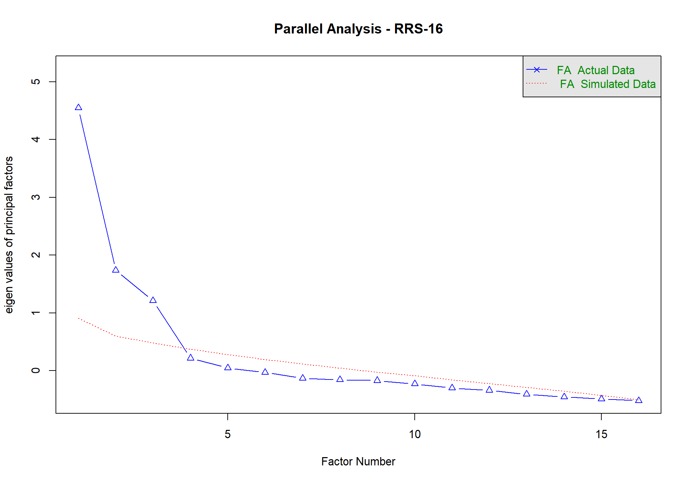
Figure S3.1. Parallel Analysis Scree Plot for the RRS-16 Pilot Sample (N = 107)
Note. Solid line with triangles = observed eigenvalues from the polychoric correlation matrix of the 16 RRS items (actual data); dotted line = mean eigenvalues from 500 parallel analyses on randomly generated data of the same sample size and number of variables (simulated data). Factors are retained when the observed eigenvalue exceeds the corresponding simulated eigenvalue; this criterion supports retention of three factors, consistent with the hypothesized F1–F2–F3 structure.
Factorability of the Correlation Matrix
Sampling adequacy and factorability were assessed prior to EFA. The Kaiser–Meyer–Olkin (KMO) measure of sampling adequacy was .81, exceeding the conventional threshold of .60–.70 for adequate factorability (Kaiser, 1974). Bartlett's test of sphericity was significant, χ²(120) = 755.33, p < .001, indicating that the correlation matrix was significantly different from an identity matrix and thus suitable for factor analysis.
Preliminary Exploratory Factor Analysis (Three-Factor Oblique Solution)
An exploratory factor analysis was conducted on the polychoric correlation matrix using minimum-residual (minres) extraction with oblimin (oblique) rotation, specifying three factors consistent with the theoretical model. As shown in Table S3.5, all 16 items loaded most strongly on their theoretically hypothesized factor, with no cross-loading exceeding .36 on a non-target factor. Primary loadings ranged from .39 to .84, with the majority exceeding .60. The three lowest primary loadings were rrs9 (.391), rrs13 (.401), and rrs6 (.405); for rrs6 and rrs9 this is consistent with the item-total findings reported above and with their prior designation as pre-specified monitoring items, whereas rrs13 was flagged here on empirical grounds only.
Table S3.5. Exploratory Factor Analysis: Pattern Loadings, Three-Factor Oblimin Solution (N = 107)
Item | F1 | F2 | F3
rrs1 | .694 | -.063 | .043
rrs2 | .843 | -.047 | -.052
rrs3 | .649 | .205 | .164
rrs4 | .834 | -.026 | -.010
rrs5 | .684 | .067 | -.056
rrs6 | .405 | .146 | .356
rrs7 | .058 | .707 | .106
rrs8 | -.001 | .787 | -.043
rrs9 | -.137 | .391 | .179
rrs10 | .085 | .804 | -.079
rrs11 | -.129 | .706 | .044
rrs12 | .024 | .045 | .760
rrs13 | .025 | .086 | .401
rrs14 | .066 | -.110 | .807
rrs15 | -.048 | .035 | .638
rrs16 | -.090 | .049 | .701
Note. Extraction method: minimum residual (minres); rotation: oblimin (oblique). F1 = Individual Adaptive Capacity; F2 = Support Seeking and Relational Resource Use; F3 = Service and Rights Navigation. Primary (target) loadings are shown in bold; all items loaded highest on their theoretically assigned factor. The rotated factor correlations from this solution were F1-F2 = .27, F1-F3 = .31, and F2-F3 = .34; they are used as a reference point for the population model of the target-sample-size simulation reported below.
Table S3.6. Consolidated Summary of Items Flagged During Pilot Analysis (N = 107)
Item | Factor | Empirical Flag(s) | Value(s) | Prior Theoretical Flag (pre-specified monitoring item) | Pilot-Stage Decision
rrs3 | F1 | Cross-loading on F2 | λ(F2) = .205; primary λ(F1) = .649 | None | Retained; monitor cross-loading in main-study CFA
rrs6 | F1 | Lowest primary loading in F1; largest cross-loading (on F3); highest ceiling % | λ(F1) = .405; λ(F3) = .356; ceiling = 16.82% | Yes — flagged as a belief/expectancy item, structurally different from the other F1 (behavioral-capacity) items | Retained; highest-priority item for continued monitoring in main-study CFA/EFA
rrs9 | F2 | Below-threshold CITC; lowest primary loading in F2; secondary loading on F3 marginally below the .18 flagging threshold | CITC = .284; λ(F2) = .391; λ(F3) = .179 | Yes — flagged as an absence-of-barrier item, conceptually distinct from the remaining F2 (presence-of-resource) items | Retained; highest-priority item for continued monitoring in main-study CFA/EFA
rrs11 | F2 | Comparatively low CITC (below .40) | CITC = .397 | None | Retained; no additional action at this stage
rrs13 | F3 | Comparatively low primary loading (below .50); comparatively low CITC (below .40) | λ(F3) = .401; CITC = .364 | None | Retained; no additional action at this stage
Note. CITC = corrected item-total correlation (polychoric-based). λ = primary or cross-loading from the three-factor exploratory factor analysis (minres extraction, oblimin rotation; Table S3.5). Conventional flagging thresholds applied: CITC < .30 (below-threshold) and CITC < .40 (comparatively low), primary loading < .50 (weak), cross-loading ≥ .18 (notable), floor/ceiling ≥ 15% (skewed response distribution). No item was removed at the pilot stage: the 16-item pool had already been fixed at the end of the modified Delphi and cognitive-interviewing process (S2), and these flags are therefore carried forward as monitoring information for the main-study analyses (S8-S10) rather than as inputs to a removal decision.
Summary and Implications for the Main Study
Taken together, the pilot findings provide preliminary support for the three-factor structure of the 16-item RRS: (a) the eigenvalue/parallel-analysis pattern supported retention of three factors, (b) the correlation matrix was adequately factorable (KMO = .81; Bartlett's test significant), and (c) internal consistency was good at the total-scale level (α = .857) and acceptable to good at the factor level (α = .799–.866). All 16 items loaded most strongly on their theoretically hypothesized factor; however, as summarized in Table S3.6, two items (rrs3 and rrs6) showed a cross-loading at or above the .18 threshold used here to flag a notable secondary loading on a non-target factor (λ = .205 and .356, respectively), and a third (rrs9) fell marginally below it (λ = .179); rrs6 and rrs9 additionally showed comparatively weaker primary loadings and/or corrected item-total correlations, consistent with their prior designation as pre-specified monitoring items. Because the 16-item pool was fixed a priori in S2 and the pilot sample (N = 107) is in any case underpowered for definitive item-level judgments, these flags are treated as monitoring information rather than as grounds for revisiting the pool; rrs6 and rrs9 are treated as the highest-priority items for continued empirical monitoring in the main study, while rrs3, rrs11, and rrs13 will be monitored without additional action required at this time. The target sample size for the main study, and the empirical rationale supporting it, will be reported following completion of the corresponding simulation-based analysis.
Target Sample Size Simulation
To empirically justify the target sample size for the main study, a Monte Carlo simulation was conducted to evaluate confirmatory factor analysis (CFA) performance for the three-factor RRS-16 model across a range of candidate sample sizes (N = 250 to 500). Simulation parameters were derived directly from the pilot study results (N = 107) rather than assumed values, to ensure the simulation reflected the empirical properties of the scale as closely as possible. Mean primary factor loadings were set to .685 (F1), .679 (F2), and .661 (F3), based on the pilot exploratory factor analysis (Table S3.5). To realistically model imperfect measurement, the simulated data-generating model incorporated the two cross-loadings identified in the pilot EFA together with rrs9's sub-threshold secondary loading (rrs3→F2 = .21, rrs6→F3 = .36, rrs9→F3 = .179; see Table S3.6) and three residual correlations reflecting item content overlap. Inter-factor correlations in the population model were fixed at the mean between-block polychoric item correlations observed in the pilot (F1-F2 = .17, F1-F3 = .20, F2-F3 = .19); these summarize the average item-level association between factor blocks and are lower than the corresponding rotated factor correlations from the pilot EFA (F1-F2 = .27, F1-F3 = .31, F2-F3 = .34; Table S3.5), so the simulated factors were somewhat more distinct than the pilot factor solution implied, and item response distributions were generated with a mild negative skew to reflect the pilot item distributions. For each candidate N, 500 datasets were simulated from this “true” misspecified model and fit with a WLSMV-estimated three-factor CFA that did not include the cross-loadings or residual correlations, so that the simulation captured the effect of realistic model misspecification rather than assuming a perfectly correctly specified model. A replication was counted as achieving acceptable fit when it met all four conventional cutoffs (CFI > .95, TLI > .95, RMSEA < .06, SRMR < .08); the target sample size was defined as the smallest evaluated N at which the proportion of replications meeting these criteria reached at least 80%. Table S3.7 presents the simulation results across all candidate sample sizes.

Table S3.7. Monte Carlo CFA Fit Performance Across Candidate Sample Sizes (500 Replications per N)
N | CFA success (%) | Mean CFI | Mean TLI | Mean RMSEA | Mean SRMR | Convergence (%)
250 | 84.2 | 0.984 | 0.981 | 0.046 | 0.069 | 100.0
300 | 84.0 | 0.983 | 0.980 | 0.048 | 0.067 | 100.0
350 | 81.0 | 0.981 | 0.978 | 0.050 | 0.065 | 100.0
400 | 79.2 | 0.980 | 0.976 | 0.052 | 0.064 | 100.0
450 | 82.8 | 0.980 | 0.977 | 0.052 | 0.062 | 100.0
500 | 81.2 | 0.980 | 0.976 | 0.053 | 0.061 | 100.0
Note. CFA success (%) = percentage of 500 replications meeting all four fit criteria (CFI > .95, TLI > .95, RMSEA < .06, SRMR < .08); convergence (%) = percentage of replications in which the WLSMV estimator converged to an admissible solution. Model: three-factor CFA (RRS-16), WLSMV estimator, fit to data simulated from a misspecified generating model with three cross-loadings, three residual correlations, and mildly negative skewed Likert responses (parameters derived from the pilot study, N = 107). Bold row indicates the recommended target sample size (N = 250), defined as the smallest evaluated N at which CFA success reached at least 80%. CFA success did not increase monotonically with N (e.g., N = 400 fell to 79.2%, narrowly below the 80% threshold), reflecting Monte Carlo sampling variability inherent to simulation-based sample size estimation rather than a substantive decline in model performance at larger N.
As shown in Table S3.7, the CFA success rate met or exceeded the 80% threshold at N = 250 (84.2%), N = 300 (84.0%), N = 350 (81.0%), N = 450 (82.8%), and N = 500 (81.2%), and fell narrowly below threshold at N = 400 (79.2%). Mean model fit indices were acceptable to excellent across the full range of candidate sample sizes (CFI = .980–.984, TLI = .976–.981, RMSEA = .046–.053, SRMR = .061–.069), and the WLSMV estimator converged to an admissible solution in 100% of replications at every candidate N. Because the 80% success threshold was already satisfied at the smallest evaluated sample size, the recommended target sample size for the main study was set at N = 250. The absence of a strictly monotonic increase in CFA success across N (with a dip at N = 400) is attributable to Monte Carlo sampling variability across the 500 replications per condition rather than to a genuine deterioration in model performance at larger sample sizes; all six candidate sample sizes produced comparably strong mean fit statistics. The realized main-study sample (N = 583 after exclusion screening; see Section S4) exceeds this target by a substantial margin, providing additional assurance of adequate statistical power for the confirmatory analyses.

S4. Main Study Data Quality Control
Refugee Resilience Scale (RRS): Adaptive Coping and Resource Mobilization in Forced Migration
This section reports the data quality control procedures applied to the main-study dataset prior to substantive analysis, including header/structure verification, range and format checks, and participant-level exclusion screening based on attention checks, missingness, response-pattern (straightlining), and completion time.
Structural and Range Verification
The raw main-study dataset (N = 592) was first verified for structural integrity. All 71 expected columns (the participant identifier and 6 demographic/background variables; 16 RRS items; 6 BRS, 10 GSE, 4 PSS-4, and 9 PHQ-9 validity-scale items; 2 attention-check items; completion time; and 16 test-retest items) were present, in the expected order, with no missing or unexpected columns. Participant identifiers (id) were fully non-missing, numeric, integer-valued, positive, and unique across all 592 rows (0 duplicates).
Range and format checks were conducted for all substantive variables against their expected response ranges (Table S4.1). No out-of-range or non-integer values were observed for any demographic variable, RRS item, or validity-scale item. The only variable showing out-of-range values was interviewer-recorded completion time (expected range: 5–90 minutes), for which 3 cases fell below the lower bound (2, 2, and 3 minutes, respectively); these cases are addressed in the participant-level exclusion screening below.
Table S4.1. Range and Format Verification Summary by Variable Group (N = 592)
Variable group | n items | Expected range | n out-of-range | n non-integer
Demographic/background (age, gender, education, origin, stay_duration, turkish_level) | 6 | Scale-specific (1–3 or 1–4) | 0 | 0
Attention-check items (ACI1, ACI2) | 2 | 1–5 | 0 | 0
Completion time | 1 | 5–90 minutes | 3 | n/a
RRS (rrs1–rrs16) | 16 | 1–5 | 0 | 0
BRS (brs1–brs6) | 6 | 1–5 | 0 | 0
GSE (gse1–gse10) | 10 | 1–4 | 0 | 0
PSS-4 (pss1–pss4) | 4 | 0–4 | 0 | 0
PHQ-9 (phq1–phq9) | 9 | 0–3 | 0 | 0
Test-retest (it1–it16) | 16 | 1–5 | 0 | 0
Note. n = 592 for all variable groups except test-retest items, which were administered only to a subsample (n = 141) approximately 2 weeks after the initial administration. Non-integer checks were not applicable (n/a) to completion time, which was recorded as a continuous variable.
Participant-Level Exclusion Screening
Four pre-specified exclusion criteria were applied to the 592 raw cases: (a) failing one or more of the two attention-check items (ACI1 ≠ 1 or missing; ACI2 ≠ 5 or missing); (b) a missing-response rate of 10% or greater across the 45 ordinal scale items (RRS, BRS, GSE, PSS-4, PHQ-9 combined); (c) straightlining, defined as selecting the same response option for 80% or more of answered ordinal items, among participants who answered at least 80% (36 of 45) of those items; and (d) an interviewer-recorded completion time outside the plausible range of 5–90 minutes.
A total of 9 participants (1.52% of the raw sample) met at least one exclusion criterion and were removed, yielding a final analytic sample of N = 583. Table S4.2 summarizes the number and percentage of cases flagged by each criterion; Table S4.3 details the three participants who failed multiple criteria simultaneously.
Table S4.2. Participant-Level Exclusion Summary (N = 592)
Criterion | Rule | Flagged n (%) | Retained n (%)
Attention checks | ≥1 ACI item failed/missing (expected values: ACI1 = 1, ACI2 = 5) | 7 (1.18%) | 585 (98.82%)
Missingness (ordinal items) | Missing rate ≥ .10 across 45 ordinal items | 3 (0.51%) | 589 (99.49%)
Straightlining (ordinal items) | Max. same-response proportion ≥ .80, among those answering ≥36/45 items | 2 (0.34%) | 590 (99.66%)
Completion time | Time missing or outside 5–90 minute range | 3 (0.51%) | 589 (99.49%)
Excluded (any criterion) | Any of the above rules = TRUE | 9 (1.52%) | —
Retained (final analytic sample) | Not excluded on any criterion | — | 583 (98.48%)
Note. Percentages are calculated relative to the raw main-study sample (N = 592). Because a participant may fail more than one criterion, the sum of criterion-specific flagged counts (7 + 3 + 2 + 3 = 15) exceeds the number of unique excluded participants (9); see Table S4.3 for the multiple-criterion cases.
Table S4.3. Participants Failing Multiple Exclusion Criteria Simultaneously
Participant ID | Criteria failed (n) | Attention checks | Missingness | Straightlining | Completion time
159 | 3 | Yes | Yes | No | Yes
244 | 3 | Yes | Yes | No | Yes
445 | 3 | Yes | Yes | No | Yes
Note. These three participants (all recorded completion times of 2–3 minutes) simultaneously failed the attention-check, missingness, and completion-time criteria, indicating disengaged or incomplete survey attempts; none failed the straightlining criterion because their high proportion of missing responses left too few answered items (0–7 of 45) to meet the minimum-answered threshold (36 items) required for straightlining evaluation. The remaining six excluded participants (IDs 7, 57, 146, 176, 289, 589) each failed exactly one criterion.
Summary
Following data quality screening, the main-study analytic sample was reduced from N = 592 to N = 583 (1.52% exclusion rate), with no structural, range, or identifier anomalies detected in the retained data. This cleaned dataset (data_cleaned.xlsx) serves as the basis for all subsequent main-study analyses reported in S5 onward.

S5. Main Study Sample Characteristics
Refugee Resilience Scale (RRS): Adaptive Coping and Resource Mobilization in Forced Migration
This section reports the demographic and background characteristics of the final main-study analytic sample (N = 583), following the data quality control and exclusion procedures described in S4.
Sample Characteristics
Table S5.1 presents the frequency distribution of six demographic and background variables: age group, gender, education level, country/region of origin, length of stay in Türkiye, and Turkish comprehension level. Valid-percentage denominators (n) are reported separately for each variable because item-level missingness varied slightly across variables (all missing-data rates were below 1%).
Table S5.1. Main Study Sample Demographic and Background Characteristics (N = 583)
Characteristic | n | %
Age group (n = 582)
18–35 | 187 | 32.1
36–50 | 197 | 33.8
51–65 | 122 | 21.0
66 and above | 76 | 13.1
Missing | 1 | 0.2
Gender (n = 580)
Female | 245 | 42.2
Male | 335 | 57.8
Other | 0 | 0.0
Missing | 3 | 0.5
Education level (n = 581)
No formal education / Primary school | 137 | 23.6
Secondary school / High school | 224 | 38.6
Bachelor's / Graduate degree | 220 | 37.9
Missing | 2 | 0.3
Country/region of origin (n = 581)
Syria | 289 | 49.7
Afghanistan | 161 | 27.7
Iraq | 131 | 22.5
Missing | 2 | 0.3
Length of stay in Türkiye (n = 580)
0–5 years | 140 | 24.1
6–10 years | 260 | 44.8
11 years and above | 180 | 31.0
Missing | 3 | 0.5
Turkish comprehension level (n = 579)
Moderate | 158 | 27.3
Good | 263 | 45.4
Very good | 158 | 27.3
Missing | 4 | 0.7
Note. Percentages are calculated relative to the number of valid (non-missing) responses for each variable, as indicated in each subheading (e.g., n = 582 for Age group); Missing-row percentages are calculated relative to the total analytic sample (N = 583). No participant selected the "Other" gender category (n = 0).
Summary
The main-study sample (N = 583) was drawn from forcibly displaced adults residing in Türkiye, originating predominantly from Syria (49.7%), followed by Afghanistan (27.7%) and Iraq (22.5%). The sample was slightly male-skewed (57.8% male, 42.2% female), spanned a broad age range with the largest concentration in the 18–50 bracket (66.0% combined), and was heterogeneous in education level and length of stay in Türkiye, with the majority (72.7%) reporting good to very good Turkish comprehension. Item-level missingness was minimal across all demographic variables (≤0.7%).

S6. Main Study Missing Data Analysis
Refugee Resilience Scale (RRS): Adaptive Coping and Resource Mobilization in Forced Migration
This section reports the missing data analysis conducted on the main-study dataset following participant-level exclusion screening (N = 583; see Section S4). Missingness was evaluated separately for the 45 baseline scale items administered to the full sample (RRS-16, BRS, GSE, PSS, and PHQ) and for the 16 retest RRS items, which were administered only to the subsample of participants who took part in the planned test-retest assessment. Attention-check items (aci1, aci2) and completion time (time) were not included, as these are procedural variables rather than substantive scale items.
Overall Missingness
Across the 45 baseline scale items (RRS-16 = 16 items, BRS = 6 items, GSE = 10 items, PSS = 4 items, PHQ = 9 items), item-level missingness was minimal. Of the 26,235 data points (583 participants x 45 items), 87 cells were missing, corresponding to an overall missing rate of 0.332%. Missingness ranged from 0.00% (7 items with no missing values) to a maximum of 0.858% (5 of 583 cases) for item rrs7. A total of 505 participants (86.6%) had complete data on all 45 baseline items. Table S6.1 presents the item-level missingness for all 45 baseline scale items, and Table S6.2 summarizes missingness by scale.
Table S6.1. Item-Level Missingness for the 45 Baseline Scale Items (N = 583)
Item | n miss | % miss | Item | n miss | % miss | Item | n miss | % miss
rrs7 | 5 | 0.858 | rrs9 | 3 | 0.515 | gse9 | 1 | 0.172
brs3 | 4 | 0.686 | brs2 | 2 | 0.343 | phq1 | 1 | 0.172
brs6 | 4 | 0.686 | brs4 | 2 | 0.343 | phq4 | 1 | 0.172
phq6 | 4 | 0.686 | gse1 | 2 | 0.343 | pss2 | 1 | 0.172
phq9 | 4 | 0.686 | gse4 | 2 | 0.343 | pss3 | 1 | 0.172
brs5 | 3 | 0.515 | phq3 | 2 | 0.343 | rrs12 | 1 | 0.172
gse3 | 3 | 0.515 | phq5 | 2 | 0.343 | rrs3 | 1 | 0.172
pss1 | 3 | 0.515 | phq7 | 2 | 0.343 | rrs8 | 1 | 0.172
rrs10 | 3 | 0.515 | pss4 | 2 | 0.343 | brs1 | 0 | 0.000
rrs11 | 3 | 0.515 | rrs14 | 2 | 0.343 | gse10 | 0 | 0.000
rrs13 | 3 | 0.515 | rrs5 | 2 | 0.343 | gse2 | 0 | 0.000
rrs15 | 3 | 0.515 | rrs6 | 2 | 0.343 | gse5 | 0 | 0.000
rrs16 | 3 | 0.515 | gse6 | 1 | 0.172 | phq2 | 0 | 0.000
rrs2 | 3 | 0.515 | gse7 | 1 | 0.172 | phq8 | 0 | 0.000
rrs4 | 3 | 0.515 | gse8 | 1 | 0.172 | rrs1 | 0 | 0.000
Note. n miss = number of missing values; % miss = percentage missing relative to N = 583. Items are ordered by descending percentage missing within each column. All 45 items showed missingness below 1%.

Table S6.2. Missingness by Scale/Block (N = 583)
Block | k | N | Missing cells | % missing | Complete-case n
RRS-16 (rrs1-rrs16) | 16 | 583 | 38 | 0.407 | 547
BRS (brs1-brs6) | 6 | 583 | 15 | 0.429 | 568
GSE (gse1-gse10) | 10 | 583 | 11 | 0.189 | 572
PSS (pss1-pss4) | 4 | 583 | 7 | 0.300 | 576
PHQ (phq1-phq9) | 9 | 583 | 16 | 0.305 | 567
Baseline 45 scale items (total) | 45 | 583 | 87 | 0.332 | 505
All retained dataset columns (excl. retest/ACI/time) | 52 | 583 | 102 | 0.336 | 492
Note. k = number of items in block; N = number of participants with at least one observed value (583 for all blocks); % missing = percentage of missing cells within the block; complete-case n = number of participants with fully observed data on all items in the block. The final row counts every retained dataset column other than the retest items, the attention checks and completion time, i.e. the 45 baseline scale items, the six demographic/background variables and the participant identifier (k = 52); the identifier is never missing, so excluding it leaves the 102 missing cells and the complete-case n of 492 unchanged and raises the corresponding percentage to 0.343%.
Patterns of Missingness
Figure S6.1. displays the number of missing values per baseline item, and Figure S6.2. displays the overall missing data pattern across the 45 baseline items. Missingness was distributed broadly across items rather than concentrated in a small subset, and no discernible block or sequential pattern was observed.
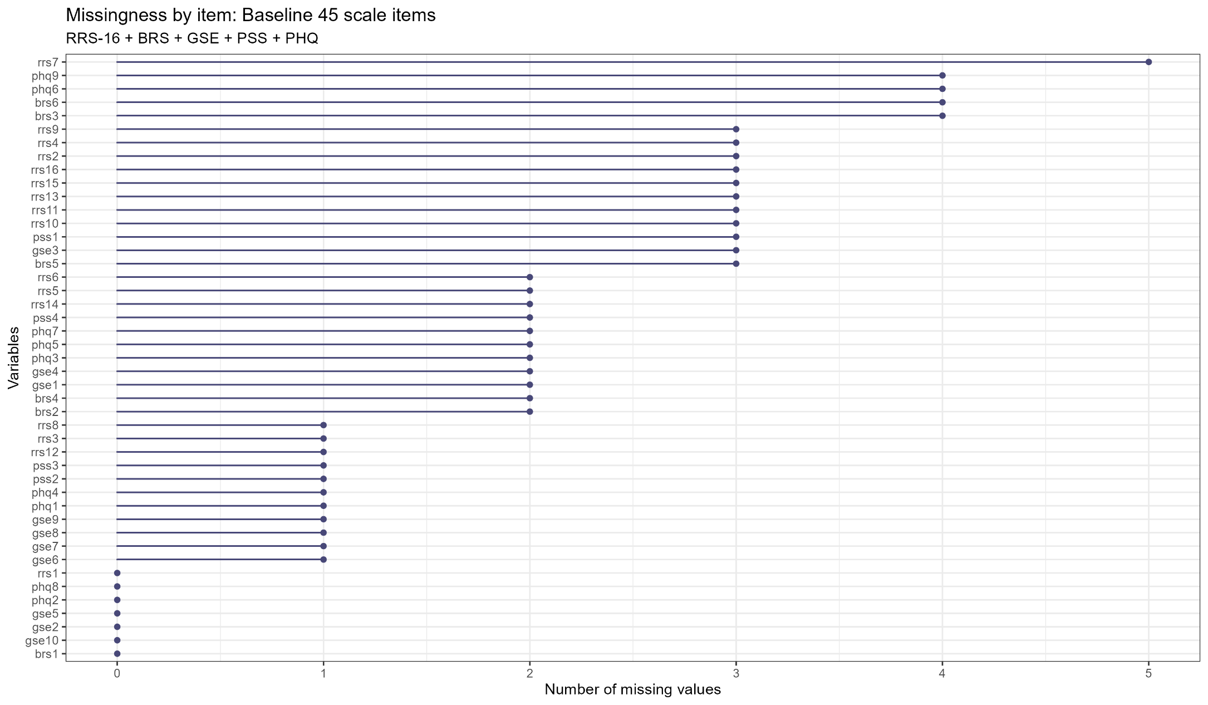
Figure S6.1. Missingness by Item: Baseline 45 Scale Items
Note. Bars represent the number of missing values (out of N = 583) for each of the 45 baseline scale items (RRS-16, BRS, GSE, PSS, PHQ), ordered by descending missingness.

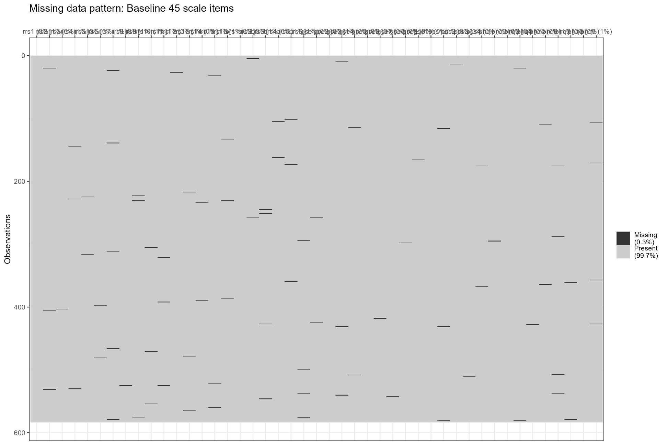
Figure S6.2. Missing Data Pattern: Baseline 45 Scale Items
Note. Dark cells indicate missing values (0.3% of all cells); light cells indicate observed values (99.7%). Rows represent participants (N = 583) and columns represent the 45 baseline scale items.

Person-Level Missingness
Person-level missing rates across the 45 baseline items were low and heavily concentrated at zero. Of the 583 participants, 505 (86.6%) had no missing baseline items, 78 (13.4%) had at least one missing item, and the maximum person-level missing rate was 4.44% (2 of 45 items). Figure S6.3 displays the distribution of person-level missing rates.
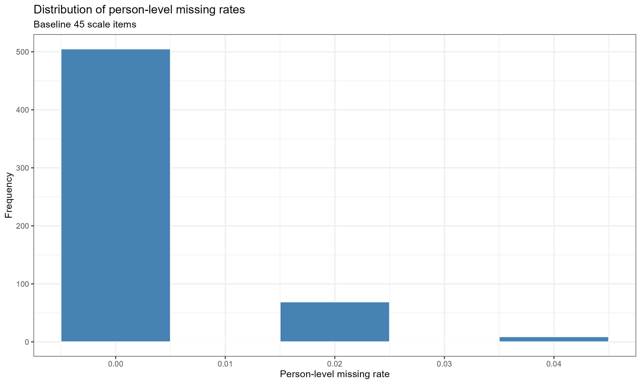
Figure S6.3. Distribution of Person-Level Missing Rates: Baseline 45 Scale Items
Note. Person-level missing rate = proportion of the 45 baseline scale items missing for each participant. The large majority of participants (86.6%) had no missing data on any baseline item.
Missingness Mechanism
Little's Missing Completely at Random (MCAR) test was conducted on the 45 baseline scale items to evaluate whether the pattern of missingness was consistent with an MCAR mechanism. The test was non-significant, chi-square(1971) = 1350.80, p = 1.000, indicating that the observed missingness pattern is consistent with MCAR. As a complementary check, a logistic regression predicting the presence of any missing data among the 45 baseline items from participant demographic and background characteristics (age group, gender, education level, country/region of origin, length of stay in Türkiye, and Turkish comprehension level) was conducted. None of the predictors reached statistical significance (all p > .10; Table S6.3), corroborating the conclusion that missingness was unrelated to observed participant characteristics.
Table S6.3. Logistic Regression Predicting Any Missing Data (Baseline 45 Items) from Demographic and Background Characteristics
Predictor | B | SE | p | OR | 95% CI
Intercept | -2.724 | 0.551 | <.001 | 0.066 | [0.022, 0.193]
Age group: 36-50 (ref. 18-35) | 0.520 | 0.321 | .105 | 1.683 | [0.897, 3.155]
Age group: 51-65 (ref. 18-35) | 0.377 | 0.392 | .337 | 1.457 | [0.675, 3.144]
Age group: 66 and above (ref. 18-35) | 0.599 | 0.431 | .165 | 1.820 | [0.782, 4.234]
Gender: Male (ref. Female) | 0.052 | 0.254 | .837 | 1.054 | [0.640, 1.734]
Education: Secondary school / High school (ref. No formal education / Primary school) | 0.180 | 0.339 | .596 | 1.197 | [0.616, 2.327]
Education: Bachelor's / Graduate degree (ref. No formal education / Primary school) | 0.343 | 0.360 | .341 | 1.409 | [0.695, 2.857]
Origin: Afghanistan (ref. Syria) | -0.512 | 0.351 | .145 | 0.599 | [0.301, 1.192]
Origin: Iraq (ref. Syria) | 0.250 | 0.296 | .399 | 1.284 | [0.719, 2.295]
Length of stay: 6-10 years (ref. 0-5 years) | 0.117 | 0.346 | .736 | 1.124 | [0.570, 2.216]
Length of stay: 11 years and above (ref. 0-5 years) | 0.471 | 0.366 | .198 | 1.602 | [0.782, 3.284]
Turkish level: Good (ref. Moderate) | 0.147 | 0.317 | .643 | 1.158 | [0.622, 2.155]
Turkish level: Very good (ref. Moderate) | 0.152 | 0.365 | .676 | 1.165 | [0.569, 2.383]
Note. N = 568. Fifteen of the 583 retained cases were dropped listwise because of missing values on the demographic predictors themselves (Turkish comprehension level 4, gender 3, length of stay 3, education 2, origin 2, age 1). Outcome: presence of any missing value among the 45 baseline scale items (0 = complete, 1 = at least one missing item). Reference categories: age 18-35, gender Female, education No formal education / Primary school, origin Syria, length of stay 0-5 years, Turkish comprehension level Moderate. Category labels follow the data codebook and are identical to those used in Table S5.1. OR = odds ratio; CI = confidence interval. No predictor reached statistical significance (all p > .10).
Retest Item Missingness (Descriptive Frequencies Only)
The 16 retest RRS items (it1-it16) were administered only to the subsample of participants who took part in the planned test-retest assessment. Consistent with this design, missingness on the retest items was substantially higher than for the baseline items: 141 of 583 participants (24.2%) provided retest data on most items, with individual item missingness ranging from 75.82% to 75.99%. This pattern reflects planned non-participation in the retest subsample rather than item-level nonresponse, and retest-item missingness was therefore not carried forward to the mechanism-level analyses (Little's MCAR test and logistic regression) reported above. Table S6.4 presents the descriptive missingness frequencies for the retest items.

Table S6.4. Missingness Frequency for the 16 Retest RRS Items (it1-it16, N = 583)
Item | n missing | n observed | % missing | % observed
it1 | 442 | 141 | 75.815 | 24.185
it2 | 442 | 141 | 75.815 | 24.185
it3 | 442 | 141 | 75.815 | 24.185
it4 | 442 | 141 | 75.815 | 24.185
it5 | 443 | 140 | 75.986 | 24.014
it6 | 443 | 140 | 75.986 | 24.014
it7 | 443 | 140 | 75.986 | 24.014
it8 | 442 | 141 | 75.815 | 24.185
it9 | 442 | 141 | 75.815 | 24.185
it10 | 442 | 141 | 75.815 | 24.185
it11 | 443 | 140 | 75.986 | 24.014
it12 | 442 | 141 | 75.815 | 24.185
it13 | 442 | 141 | 75.815 | 24.185
it14 | 442 | 141 | 75.815 | 24.185
it15 | 442 | 141 | 75.815 | 24.185
it16 | 442 | 141 | 75.815 | 24.185
Note. Retest items were completed only by the test-retest subsample (n = 141 respondents with at least one observed retest value). High missingness on these items reflects planned subsample administration and should not be interpreted as item-level nonresponse.
Summary
Missing data on the 45 baseline scale items were minimal (0.332% overall) and consistent with a missing-completely-at-random (MCAR) mechanism, as indicated by a non-significant Little's MCAR test and the absence of significant demographic or background predictors of missingness. Given the low overall missingness and the MCAR-consistent pattern, no imputation was performed; analyses relied on pairwise/available-case handling for descriptive and correlational analyses and WLSMV estimation for the confirmatory factor analyses, both of which make full use of available data without requiring imputation. Missingness on the retest items (it1-it16) reflected planned test-retest subsample administration rather than item nonresponse and was reported descriptively only.

S7. Cross-Validation and Subsample Size / Stability Analyses
Refugee Resilience Scale (RRS): Adaptive Coping and Resource Mobilization in Forced Migration
Split-Sample Design
To provide an independent test of the three-factor RRS-16 measurement model, the main-study sample (N = 583; see Section S4) was randomly split into calibration and validation subsamples using stratified random allocation (50/50) based on the joint distribution of gender and age group, to ensure balanced demographic composition across subsamples. Four participants with missing age or gender values could not be assigned to a stratum and were excluded from the split (retained in all other main-study analyses), yielding N = 579 participants available for splitting: n = 290 in the calibration subsample and n = 289 in the validation subsample. Table S7.1 presents the stratified split cell counts, and Figure S7.1 displays the resulting balance across strata.
Table S7.1. Stratified Split Cell Counts by Subsample (Gender x Age)
Stratum (gender_age) | Calibration n | Validation n | Total n | % calibration
2_2 | 59 | 59 | 118 | 50
2_1 | 53 | 53 | 106 | 50
1_1 | 40 | 40 | 80 | 50
1_2 | 39 | 39 | 78 | 50
2_3 | 35 | 35 | 70 | 50
1_3 | 26 | 26 | 52 | 50
2_4 | 20 | 20 | 40 | 50
1_4 | 18 | 17 | 35 | 51.4
Note. Strata are coded as gender_age (gender: 1 = Female, 2 = Male; age group: 1-4 = ordered age categories). Four participants with missing age or gender were excluded from the stratified split (N = 579 used for allocation). Near-equal cell counts across subsamples confirm that stratified allocation achieved the intended balance.
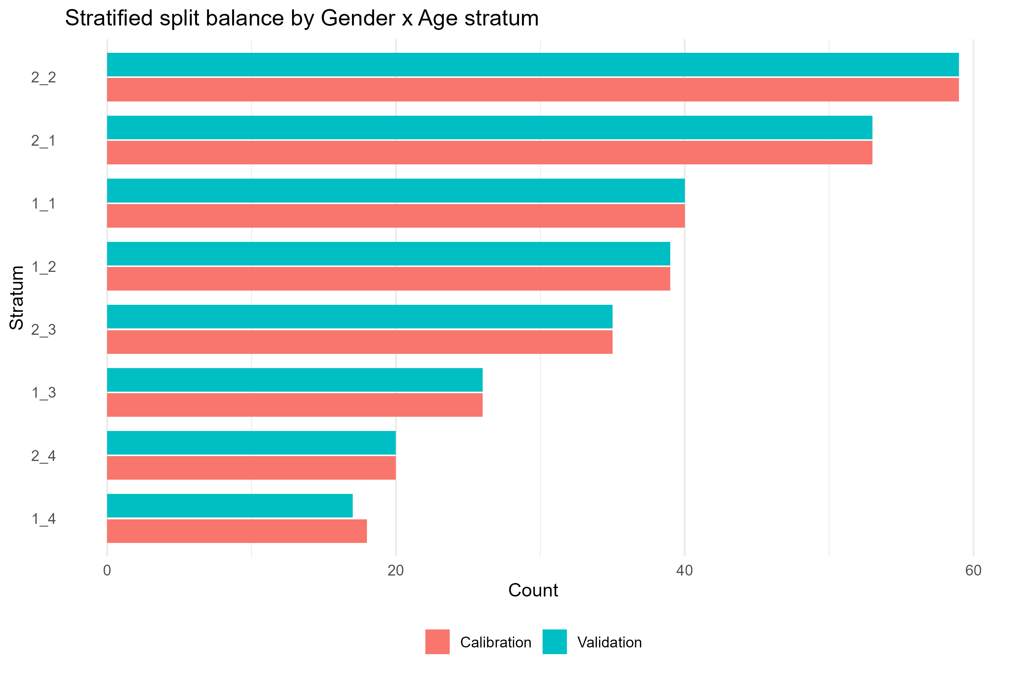
Figure S7.1. Stratified Split Balance Across Gender x Age Strata
Note. Grouped bar chart of calibration versus validation counts for each gender x age stratum. Bars of near-equal length within each stratum indicate balanced stratified allocation.
Subsample Equivalence Tests (Randomization Check)
To verify that stratified randomization produced comparable calibration and validation subsamples, equivalence tests were conducted on all demographic variables (age, gender, education, country/region of origin, length of stay in Türkiye, and Turkish comprehension level) and on scale-total scores (RRS-16, BRS, GSE, PSS, PHQ). Continuous scale totals were compared using Welch's t-test (Cohen's d); ordinal demographic variables were compared using the Wilcoxon rank-sum test (rank-biserial r); and the nominal variables gender and origin were compared using chi-square tests (Cramer's V). A Bonferroni-corrected significance threshold of alpha_Bonf = .05/12 = .00417 was applied; the divisor of 12 is one greater than the 11 equivalence tests actually reported and the correction is therefore conservative. Table S7.2 presents the full equivalence test results.
Table S7.2. Equivalence Tests Between Calibration and Validation Subsamples
Variable | Test | Statistic | p | Effect size | Sig. (Bonf.)
GSE total score | Welch t-test | t(563.7) = 2.55 | .011 | Cohen's d = 0.214 | No
PSS total score | Welch t-test | t(568.4) = -1.47 | .142 | Cohen's d = -0.123 | No
Education level | Wilcoxon rank-sum | W = 43549.5 | .302 | rank-biserial r = 0.046 | No
Country/region of origin | Chi-square | chi2(2) = 2.19 | .335 | Cramer's V = 0.062 | No
RRS-16 total score | Welch t-test | t(540.2) = -0.94 | .346 | Cohen's d = -0.081 | No
Turkish comprehension level | Wilcoxon rank-sum | W = 43000 | .367 | rank-biserial r = 0.040 | No
Length of stay in Türkiye | Wilcoxon rank-sum | W = 40987.5 | .794 | rank-biserial r = -0.012 | No
PHQ total score | Welch t-test | t(560.5) = 0.14 | .891 | Cohen's d = 0.012 | No
Age group | Wilcoxon rank-sum | W = 42031 | .948 | rank-biserial r = 0.003 | No
Gender | Chi-square | chi2(1) = 0 | .961 | Cramer's V = 0.002 | No
BRS total score | Welch t-test | t(555.5) = 0.03 | .974 | Cohen's d = 0.003 | No
Note. Bonferroni-corrected significance threshold: alpha_Bonf = .05/12 = .00417 (conservative; 11 tests reported). None of the 11 equivalence tests reached statistical significance after correction (all p_adj > .05), indicating that the calibration and validation subsamples did not differ systematically on any demographic or scale-total variable.
Table S7.3. Scale-Total Descriptives by Subsample
Scale | Subsample | n | M | SD | Range
RRS-16 | Calibration | 271 | 51.31 | 10.15 | 27-78
 | Validation | 272 | 52.12 | 9.81 | 25-77
BRS | Calibration | 284 | 18.17 | 4.04 | 8-30
 | Validation | 280 | 18.16 | 4.44 | 6-30
GSE | Calibration | 286 | 26.27 | 5.00 | 13-39
 | Validation | 282 | 25.24 | 4.62 | 12-38
PSS | Calibration | 288 | 7.77 | 2.81 | 1-14
 | Validation | 284 | 8.13 | 2.92 | 1-16
PHQ | Calibration | 283 | 12.42 | 4.31 | 1-24
 | Validation | 280 | 12.37 | 4.14 | 2-24
Note. Scale totals computed as row sums over cases with complete data on that scale's items (listwise per scale; no imputation applied), which is why n varies by scale and is lower than the subsample sizes of 290 and 289. M = mean; SD = standard deviation. Corresponding equivalence tests are reported in Table S7.2.
Calibration Sample: Ordinal EFA
An exploratory factor analysis was conducted in the calibration subsample (n = 290; n = 271 complete cases) on the polychoric correlation matrix of the 16 RRS items, using minimum-residual (MINRES) extraction with oblimin rotation and a fixed three-factor solution. Sampling adequacy was excellent (KMO = .896; Bartlett's test of sphericity, chi-square(120) = 2118.94, p < .001), and model fit was strong (RMSR = .026, TLI = .974, RMSEA = .038). The three extracted factors corresponded closely to the hypothesized RRS structure: rrs1-rrs6 loaded primarily on Factor 1 (Individual Adaptive Capacity), rrs7-rrs11 loaded primarily on Factor 2 (Support Seeking and Relational Resource Use), and rrs12-rrs16 loaded primarily on Factor 3 (Service and Rights Navigation), consistent with the pilot-study factor structure (Section S3). Table S7.4 presents the calibration EFA loadings.
Table S7.4. Calibration EFA Loadings (MINRES Extraction, Oblimin Rotation, n = 271)
Item | F1 (MR1) | F2 (MR3) | F3 (MR2) | h2
rrs1 | 0.833 | 0.057 | -0.058 | 0.699
rrs2 | 0.727 | -0.043 | 0.035 | 0.524
rrs3 | 0.766 | 0.016 | 0.006 | 0.603
rrs4 | 0.739 | 0.030 | 0.020 | 0.583
rrs5 | 0.751 | -0.039 | 0.068 | 0.586
rrs6 | 0.301 | 0.224 | 0.184 | 0.321
rrs7 | 0.027 | 0.600 | 0.070 | 0.414
rrs8 | -0.021 | 0.887 | -0.018 | 0.757
rrs9 | 0.011 | 0.398 | 0.253 | 0.306
rrs10 | -0.056 | 0.735 | 0.116 | 0.577
rrs11 | 0.169 | 0.702 | -0.110 | 0.570
rrs12 | 0.081 | 0.051 | 0.642 | 0.499
rrs13 | 0.265 | -0.096 | 0.392 | 0.275
rrs14 | -0.030 | 0.074 | 0.776 | 0.630
rrs15 | 0.051 | -0.057 | 0.801 | 0.647
rrs16 | -0.039 | 0.016 | 0.750 | 0.546
Note. n = 271 (complete cases). Primary loadings on the hypothesized factor are bolded. F1 = Individual Adaptive Capacity (rrs1-rrs6); F2 = Support Seeking and Relational Resource Use (rrs7-rrs11); F3 = Service and Rights Navigation (rrs12-rrs16). h2 = communality. Factor columns are labeled with their EFA extraction label (MR1/MR2/MR3) alongside the corresponding hypothesized factor.
Validation Sample: Ordinal CFA (WLSMV)
A confirmatory factor analysis specifying the three-factor structure was fit in the independent validation subsample (n = 289) using WLSMV estimation with theta parameterization. Model fit was acceptable: scaled CFI = .952, TLI = .942, RMSEA = .064 (90% CI [.052, .076]), SRMR = .063. The CFI criterion (> .95) was met, while TLI fell marginally below the .95 threshold and RMSEA fell marginally above the .06 threshold; overall the pattern indicates acceptable, though not excellent, fit for the three-factor model in an independent subsample. All 16 items loaded significantly and substantially on their hypothesized factor (standardized loadings ranging from .440 to .819). Table S7.5 presents the validation CFA fit indices, and Table S7.6 presents the standardized factor loadings.
Table S7.5. Validation CFA Fit Indices (WLSMV, Theta Parameterization, n = 289)
Metric set | chi2 | df | p | CFI | TLI | RMSEA | RMSEA 90% CI | SRMR
Scaled (primary) | 220.15 | 101 | <.001 | 0.952 | 0.942 | 0.064 | [0.052, 0.076] | 0.063
Unscaled (reference only) | 164.35 | 101 | <.001 | 0.988 | 0.986 | 0.047 | — | 0.063
Note. Scaled fit indices (robust to non-normality of ordinal indicators) are treated as primary; unscaled indices are reported for reference only. Model: three-factor CFA (RRS-16), WLSMV estimator, theta parameterization, validation subsample (n = 289).
Table S7.6. Validation CFA Standardized Factor Loadings
Factor | Item | Unstd. loading | Std. loading
F1: Individual Adaptive Capacity | rrs2 | 1.289 | 0.790
F1: Individual Adaptive Capacity | rrs5 | 1.111 | 0.743
F1: Individual Adaptive Capacity | rrs1 | 1.107 | 0.742
F1: Individual Adaptive Capacity | rrs4 | 1.012 | 0.711
F1: Individual Adaptive Capacity | rrs3 | 0.996 | 0.706
F1: Individual Adaptive Capacity | rrs6 | 0.729 | 0.589
F2: Support Seeking and Relational Resource Use | rrs8 | 1.283 | 0.789
F2: Support Seeking and Relational Resource Use | rrs7 | 1.146 | 0.753
F2: Support Seeking and Relational Resource Use | rrs10 | 1.105 | 0.742
F2: Support Seeking and Relational Resource Use | rrs11 | 1.079 | 0.734
F2: Support Seeking and Relational Resource Use | rrs9 | 0.636 | 0.537
F3: Service and Rights Navigation | rrs15 | 1.427 | 0.819
F3: Service and Rights Navigation | rrs16 | 1.135 | 0.750
F3: Service and Rights Navigation | rrs14 | 1.105 | 0.742
F3: Service and Rights Navigation | rrs12 | 1.019 | 0.714
F3: Service and Rights Navigation | rrs13 | 0.490 | 0.440
Note. Standardized loadings (std.all) from lavaan. All loadings statistically significant (p < .001). Items are ordered by descending standardized loading within each factor.
Cross-Sample Structural Agreement (EFA-CFA Congruence)
To quantify agreement between the calibration EFA loading pattern and the validation CFA loading pattern, Tucker's congruence coefficient was computed between the two loading matrices, with factors aligned using the linear sum assignment method to maximize correspondence. Agreement was excellent: the mean absolute aligned diagonal congruence was .97, with all three factors individually showing congruence of .97 and off-diagonal (cross-factor) congruence values of .07 or lower. This indicates that the three-factor structure identified in the calibration subsample replicated closely in the independent validation subsample. Table S7.7 presents the aligned congruence matrix, and Figure S7.2 displays it as a heatmap.
Table S7.7. Cross-Sample Loading Agreement (EFA vs. CFA): Aligned Congruence Matrix
EFA factor | F1 (CFA) | F3 (CFA) | F2 (CFA)
MR1 | 0.97 | 0.06 | 0.03
MR2 | 0.06 | 0.97 | 0.07
MR3 | 0.05 | 0.01 | 0.97
Note. Rows are calibration EFA factors (MR1, MR2, MR3); columns are validation CFA factors, aligned to their best-matching EFA counterpart. Bolded values indicate the aligned diagonal (matched factor pairs). Mean absolute aligned diagonal congruence = .97, indicating excellent cross-sample structural replication.
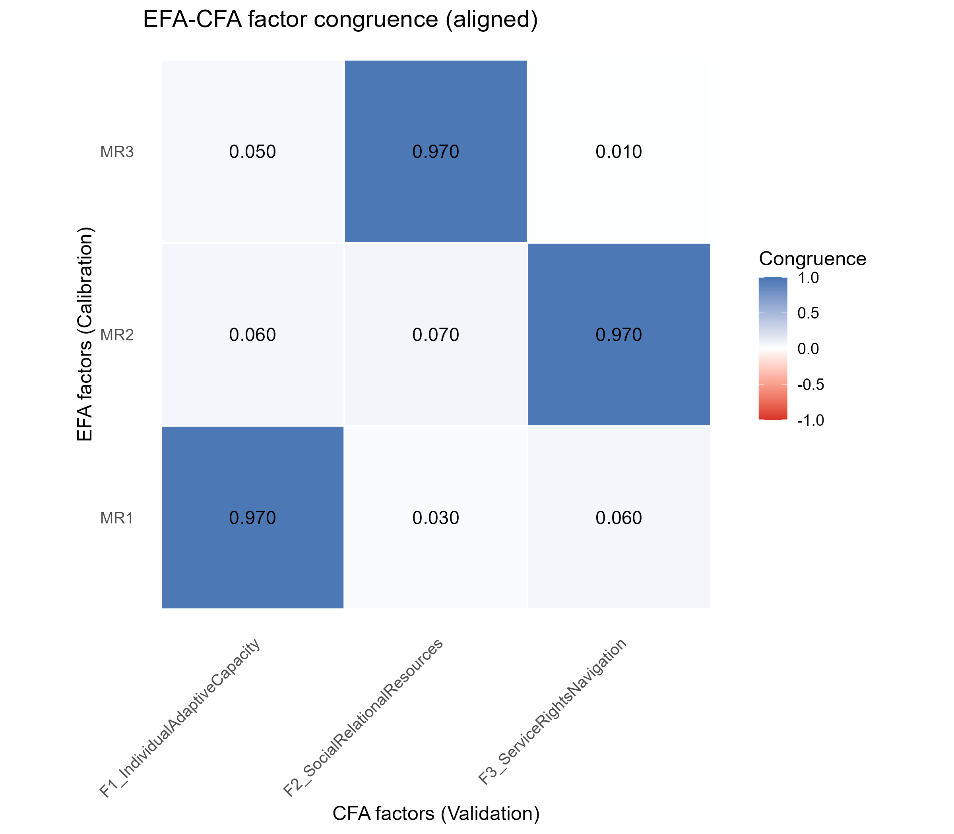
Figure S7.2. Cross-Sample Loading Agreement Heatmap (EFA vs. CFA, Aligned)
Note. Heatmap of the aligned Tucker congruence matrix between calibration EFA loadings and validation CFA loadings. Dark blue cells on the diagonal (.97) indicate strong cross-sample agreement for each of the three factors.
Bootstrap Stability Analyses
To evaluate the robustness of the factor structure to sampling variability, bootstrap resampling (R = 100 replications) was conducted separately for the calibration EFA and the validation CFA.
Calibration EFA bootstrap: All 100 replications converged (100%). Congruence between the original calibration EFA loadings and each bootstrap replication's loadings was consistently high (M = .989, SD = .005, range = .970-.997), indicating a highly stable factor pattern under resampling.
Validation CFA bootstrap: All 100 replications converged (100%). Scaled fit indices were stable but systematically poorer than the single-sample solution across replications (CFI: M = .930, SD = .017; TLI: M = .917, SD = .020; RMSEA: M = .079, SD = .009; SRMR: M = .073, SD = .006); judged against the cutoffs applied elsewhere in this section (CFI and TLI >= .95, RMSEA <= .06), the bootstrap means fall short on CFI, TLI and RMSEA and meet only the SRMR criterion. The bootstrap mean fit was somewhat lower than the single-sample validation fit reported in Table S7.5 (e.g., CFI .930 vs. .952), reflecting expected additional variability introduced by resampling with replacement rather than a substantive change in model adequacy. Standardized loadings were also stable across replications (bootstrap loading-stability output archived on OSF), with the lowest-loading item, rrs13, showing the greatest variability (M = .446, SD = .068).
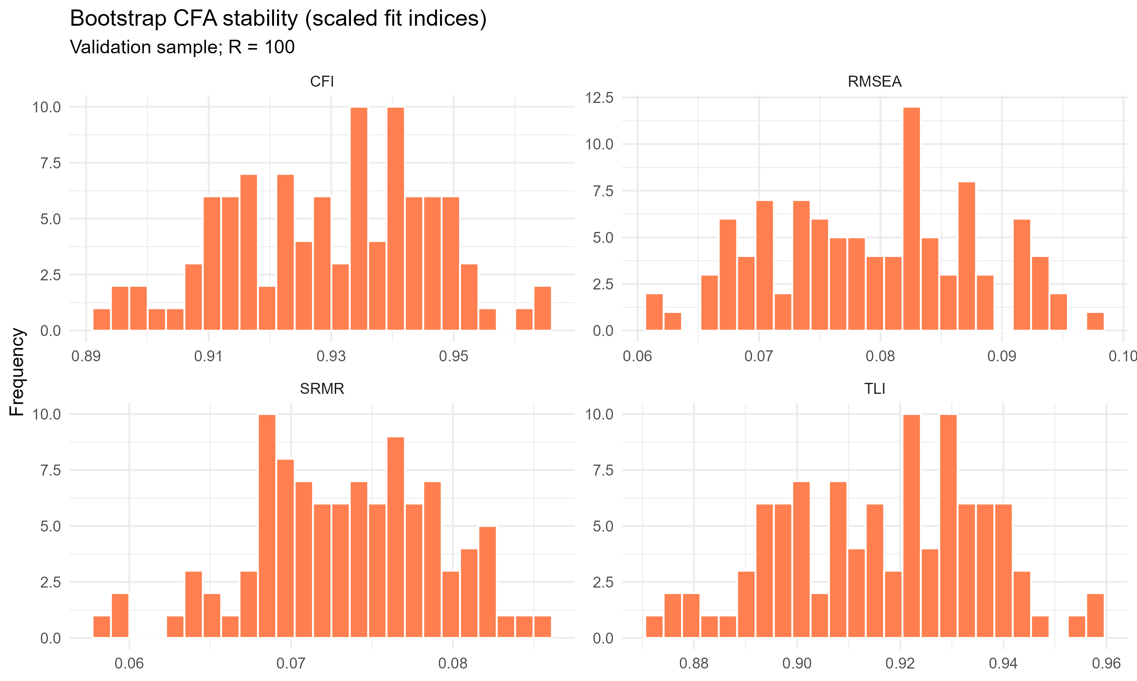
Figure S7.3. Bootstrap CFA Stability: Distributions of Scaled Fit Indices
Note. Histograms of CFI, RMSEA, SRMR, and TLI across 100 bootstrap refits of the validation CFA (resampling with replacement, n = 289 per replication). Distributions are unimodal and narrow, indicating stable model performance under resampling; note, however, that the bootstrap means for CFI, TLI and RMSEA fall short of the cut-offs applied elsewhere in this section (see the text above), so stability here refers to low dispersion across replications rather than to acceptable fit.
Validation-Sample-Size Sensitivity
To assess whether the validation sample size materially influenced CFA fit, subsamples of fixed target size N in {150, 200, 250} were drawn (100 random subsamples without replacement per target N) from the validation sample (N = 289) and re-fit with the same three-factor WLSMV CFA model. Target sizes of 300 and 350 could not be evaluated because they exceed the available validation sample size. Table S7.8 presents the subsample-size sensitivity summary, and Figure S7.4 displays mean fit indices across target sizes.
Table S7.8. CFA Subsample-Size Sensitivity Summary (Validation Subsamples)
Target N | Convergence (%) | Mean CFI | Mean TLI | Mean RMSEA | Mean SRMR | Reps (R)
150 | 100.0 | 0.954 | 0.945 | 0.063 | 0.073 | 100
200 | 100.0 | 0.954 | 0.945 | 0.063 | 0.068 | 100
250 | 100.0 | 0.952 | 0.943 | 0.064 | 0.065 | 100
Note. Validation subsample N = 289; target N = 300 and 350 could not be evaluated because they exceed the available validation sample size and were omitted from the grid. Convergence was 100% (100 of 100 replications) at every evaluated target N. Mean fit indices were stable across target sizes, indicating that CFA fit in the validation subsample was not driven by sample size within the range evaluated.
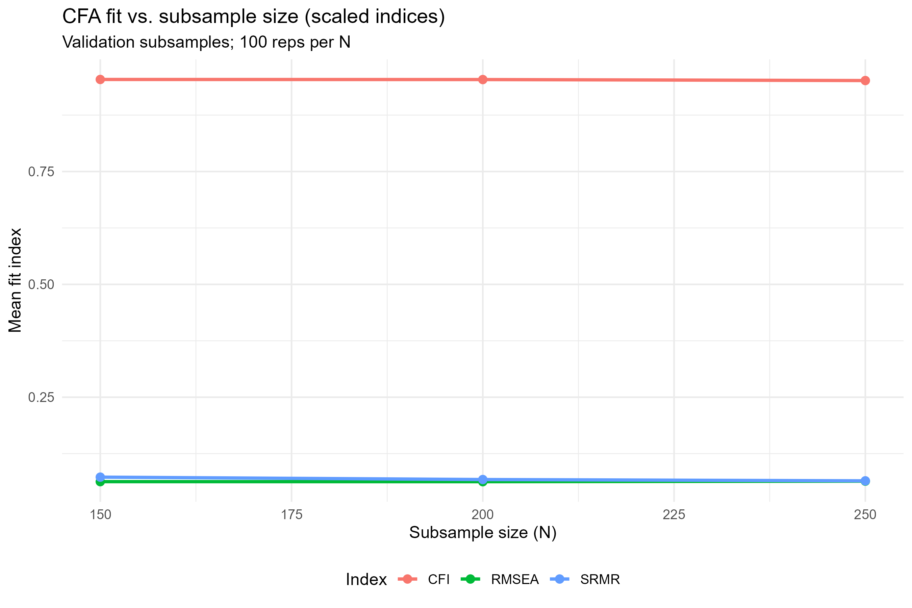
Figure S7.4. CFA Fit Versus Validation Subsample Size (Scaled Indices)
Note. Mean CFI, RMSEA, and SRMR plotted across target subsample sizes (150-250) drawn from the validation sample. Fit indices remained stable across the evaluated range, indicating that model fit was not sensitive to subsample size within this range.
Conclusion
The cross-validation analyses provide convergent evidence for the three-factor structure of the RRS-16. The factor pattern identified via EFA in an independent calibration subsample was confirmed via CFA in an independent validation subsample with acceptable fit (scaled CFI = .952, RMSEA = .064), and the two loading patterns showed excellent cross-sample agreement (mean aligned congruence = .97). Bootstrap resampling confirmed that both the calibration factor pattern and the validation model fit were stable under sampling variability (stability here denoting low dispersion across replications; the bootstrap mean CFI, TLI and RMSEA fall short of the cut-offs applied in this section, as reported above), and sensitivity analyses across validation subsample sizes (150-250) showed no evidence that model fit depended on sample size within this range. Taken together, these results support the structural validity and cross-sample generalizability of the three-factor RRS-16 measurement model.
S8. Exploratory Factor and Graph Analyses — Calibration Subsample
Refugee Resilience Scale (RRS): Adaptive Coping and Resource Mobilization in Forced Migration
This section reports the exploratory factor-analytic (EFA) and exploratory graph-analytic (EGA) evaluation of the RRS-16 item pool in the calibration subsample (n = 290; complete-case n = 271). The exploratory analyses serve to verify the theoretical three-factor structure (F1: Individual Adaptive Capacity, rrs1-rrs6; F2: Support Seeking and Relational Resource Use, rrs7-rrs11; F3: Service and Rights Navigation, rrs12-rrs16) and to evaluate individual item performance against two sets of pre-specified item-quality criteria: a main-study screening set (D0: primary loading < .40 and/or secondary loading >= .32), and an additional, stricter sensitivity criterion (primary loading < .60, Comrey & Lee, 1992; communality h2 < .42, adapted from Hair, Black, Babin, & Anderson, 2019; secondary loading >= .32 with primary-secondary difference < .20, Tabachnick & Fidell, 2019). The polychoric correlation matrix was computed using pairwise complete observations, and the EFA (together with the KMO and Bartlett diagnostics) was estimated from that matrix with n.obs = 290; EGA model estimation used complete-case observations (n = 271). The number of factors was fixed a priori at k = 3, corresponding to the theoretical model; statistical retention indices (parallel analysis, Velicer's MAP, scree, Kaiser, Hull) were used only as diagnostic checks. MINRES extraction with oblimin rotation was primary; ULS extraction and promax rotation served as sensitivity checks. EGA used the GLASSO network estimator with cor_auto correlations; Walktrap community detection was primary and Leiden served as a sensitivity check. Bootstrap stability analyses (B = 200) were performed for both EFA and EGA.
Missing Data and Factorability
Missing data on the 16 items were negligible: 271 of 290 participants (93.4%) had complete data on all items, 17 participants (5.9%) had exactly one missing item, and 2 participants (0.7%) had exactly two missing items; total missing cells amounted to 21 of 4,640 possible item responses (0.45%). Sampling adequacy for the polychoric correlation matrix was excellent, Kaiser-Meyer-Olkin (KMO) measure of sampling adequacy = .899 (item range .855-.951), and Bartlett's test of sphericity was significant, chi-square(120) = 2045.59, p < .001, confirming that the item correlation matrix was suitable for factor analysis.
Factor Retention
Three of four computable statistical retention indices converged on the theoretically expected three-factor solution: parallel analysis (k = 3), Velicer's MAP (k = 3), and Kaiser's eigenvalue > 1 criterion (k = 3); the automatic scree elbow suggested k = 4. The Hull method could not be computed due to a package-level limitation in EFAtools and is reported as unavailable rather than omitted.
Table S8.1. Sampling Adequacy and Factor-Retention Indices for the 16-Item RRS Pool (Calibration Subsample, N = 290; Complete-Case N = 271)
Indicator | Value
KMO (overall) | .899
KMO (item range) | .855-.951
Bartlett's chi-square(120) | 2045.59
Bartlett's p | < .001
Parallel analysis (suggested k) | 3
Velicer's MAP (suggested k) | 3
Kaiser criterion, eigenvalue > 1 (suggested k) | 3
Scree elbow, automatic detection (suggested k) | 4
Hull method (suggested k) | unavailable (EFAtools package limitation)
Theoretical / retained k | 3
Note. Three of four computable statistical indices (parallel analysis, Velicer's MAP, Kaiser criterion) agreed exactly with the a priori theoretical solution (k = 3); the scree elbow indicated one additional factor, a common pattern in scree-based detection that was not treated as disconfirming evidence given the convergence of the other three indices. KMO = Kaiser-Meyer-Olkin measure of sampling adequacy.
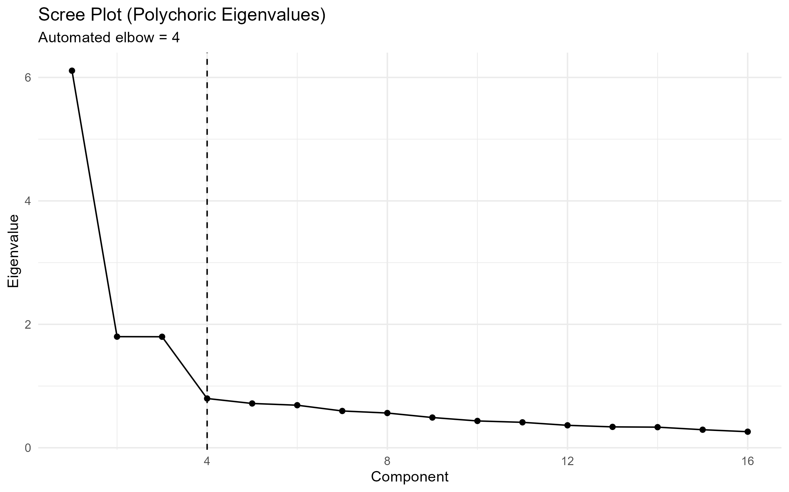
Figure S8.1. Scree Plot of Polychoric Eigenvalues (16-Item RRS Pool, Calibration Subsample)
Note. Eigenvalues 1-16 plotted in descending order; the dashed vertical line marks the automated elbow (k = 4). The first three eigenvalues are substantially larger than the remainder, consistent with the theoretical three-factor model, although the automated elbow itself falls one factor higher (see Factor Retention above).
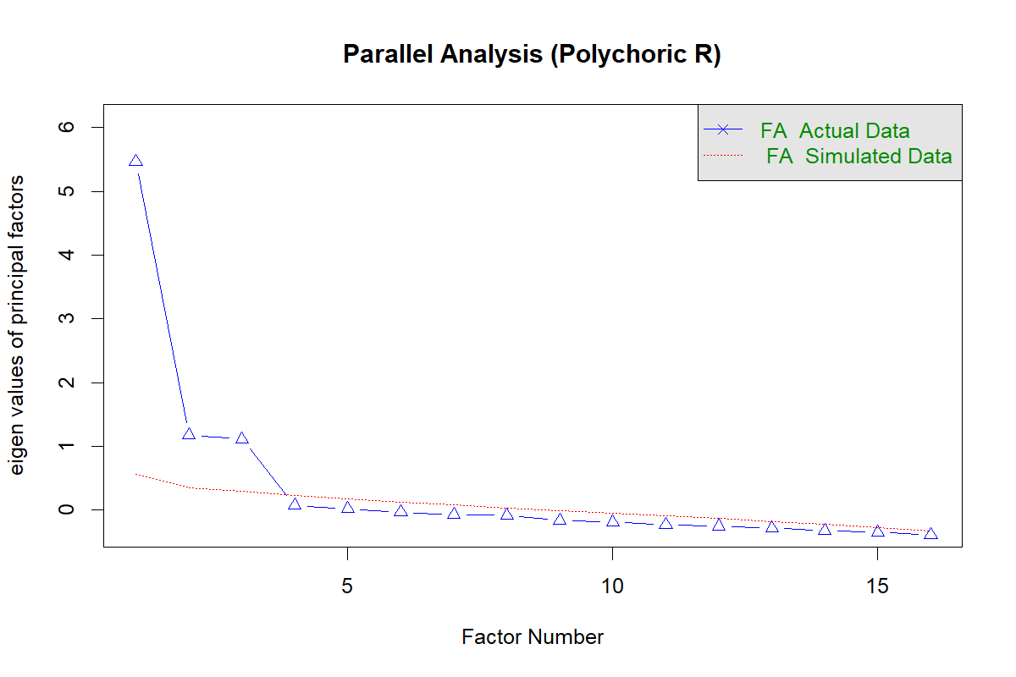
Figure S8.2. Parallel Analysis: Empirical vs. Simulated Eigenvalues (16-Item RRS Pool)
Note. Empirical eigenvalues (polychoric correlation matrix, blue) plotted against mean eigenvalues from randomly simulated data (red/green). The first three empirical eigenvalues exceed the corresponding simulated eigenvalues, while the fourth falls below the simulated threshold, supporting retention of three factors.
Exploratory Factor Analysis
The primary k = 3 solution (MINRES extraction, oblimin rotation) showed excellent fit: RMSEA = .034 [90% CI: .013, .051], TLI = .978, RMSR = .025. Thirteen of the 16 items loaded strongly and cleanly on their theoretically expected factor (primary loadings .588-.868), and two further items loaded on their theoretically expected factor but substantially more weakly (rrs9 = .408; rrs13 = .406). One item, rrs6 (theoretical F1), showed a weak and ambiguous loading pattern: its highest loading (.303) fell on its theoretical factor F1, but only marginally above its secondary loading on F2 (.203), and its communality was low (h2 = .303). This is the same item flagged at the pilot stage (S3, Table S3.6) for continued monitoring, providing a direct main-study replication of the pilot-stage concern. The scree plot and parallel-analysis plot for this solution are shown in Figures S8.1 and S8.2.
Note on S7-S8 numerical concordance. The calibration-subsample EFA fit indices and loadings reported here (S8) differ slightly from the preliminary values reported in S7 (e.g., KMO .899 vs. .896; RMSEA .034 vs. .038; TLI .978 vs. .974; Bartlett chi-square(120) 2045.59 vs. 2118.94; item loadings differing by up to .02-.03). Both analyses were run on the identical calibration subsample (N = 290; complete-case N = 271) but used different polychoric-correlation pipelines: S7 used psych::fa.poly(), whereas S8 used psych::polychoric(correct = .5) followed by cor.smooth() and psych::fa(). These two pipelines can yield slightly different polychoric correlation matrices from the same raw data, which propagates into small differences in fit indices and loadings. S8 is the primary, comprehensive exploratory analysis and is the version reported in the main text; S7 served only as a preliminary cross-validation check. This discrepancy does not affect any conclusion in the manuscript.
Table S8.2. Primary k = 3 EFA Pattern Matrix and Communalities, 16-Item RRS Pool (Calibration Subsample, MINRES Extraction, Oblimin Rotation, N = 290)
Item | Factor (theoretical) | Loading F1 (extracted factor 1) | Loading F3 (extracted factor 2) | Loading F2 (extracted factor 3) | h2
rrs1 | F1 | 0.829 | -0.069 | 0.070 | 0.695
rrs2 | F1 | 0.725 | 0.048 | -0.045 | 0.528
rrs3 | F1 | 0.780 | -0.005 | 0.010 | 0.612
rrs4 | F1 | 0.733 | 0.036 | 0.016 | 0.574
rrs5 | F1 | 0.750 | 0.065 | -0.040 | 0.582
rrs6 | F1 | 0.303 | 0.183 | 0.203 | 0.303
rrs7 | F2 | 0.037 | 0.070 | 0.588 | 0.406
rrs8 | F2 | -0.019 | -0.007 | 0.868 | 0.734
rrs9 | F2 | -0.039 | 0.253 | 0.408 | 0.289
rrs10 | F2 | -0.044 | 0.097 | 0.739 | 0.580
rrs11 | F2 | 0.141 | -0.112 | 0.712 | 0.556
rrs12 | F3 | 0.065 | 0.639 | 0.067 | 0.492
rrs13 | F3 | 0.238 | 0.406 | -0.090 | 0.268
rrs14 | F3 | -0.037 | 0.766 | 0.075 | 0.611
rrs15 | F3 | 0.029 | 0.808 | -0.054 | 0.642
rrs16 | F3 | 0.002 | 0.722 | 0.009 | 0.528
Note. Extraction: MINRES; rotation: oblimin; k = 3 factors specified a priori. Overall model fit: RMSEA = .034 [90% CI: .013, .051], TLI = .978, RMSR = .025. Bolded values indicate the primary loading on the hypothesized factor. Loading columns are labelled by the theoretical factor they represent; because the extraction order does not follow the theoretical order, extracted factor 2 corresponds to theoretical F3 (rrs12-rrs16) and extracted factor 3 to theoretical F2 (rrs7-rrs11). rrs6 shows a weak and ambiguous loading pattern (F1 = .303, F2 = .203). h2 = communality.
Item-Quality Flagging: D0 Main-Study Screen. Applying the pre-specified main-study screening criteria (D0; primary loading < .40 and/or secondary loading >= .32) to the main-study calibration loading matrix flagged one item: rrs6 (primary loading = .303, meeting the primary-loading criterion; secondary loading = .203, not meeting the cross-loading criterion). Items rrs3 and rrs9, both flagged for continued monitoring at the pilot stage (S3, Table S3.6), did not meet either main-study criterion: rrs3's primary loading (.780) was well above the .40 threshold, and rrs9's primary loading (.408) exceeded the .40 threshold with a secondary loading (.253) below the .32 cross-loading threshold. The D0 cut-offs are the values coded in the main-study analysis script and are not identical to the conventional descriptive thresholds used to compile the pilot-stage flag table (primary loading < .50, cross-loading >= .18; see the note to Table S3.6). D0 should therefore be read as a main-study screen applied to the items carried forward from the pilot, not as a re-application of the pilot rule; under the pilot's descriptive thresholds the same calibration matrix would additionally flag rrs9 (primary .408) and rrs13 (primary .406).
Table S8.3. Pilot Study (S3) versus Main-Study Calibration Comparison for rrs3, rrs6, and rrs9
Item | Pilot (S3) status | Pilot primary  loading | Pilot secondary  loading | Main-study  primary loading | Main-study  secondary loading | Main-study  n flags (D0 main-study screen)
rrs3 | Retained; monitor cross-loading in main-study CFA | .649 | .205 | .780 | .010 | 0
rrs6 | Retained; highest-priority item for continued monitoring in main-study CFA/EFA | .405 | .356 | .303 | .203 | 1
rrs9 | Retained; highest-priority item for continued monitoring in main-study CFA/EFA | .391 | .179 | .408 | .253 | 0
Note. Pilot-stage values are taken from Table S3.6 (pilot EFA, S3). Main-study values are from the calibration-subsample primary EFA reported in Table S8.2. rrs6 shows the most persistent cross-stage concern among the three previously flagged items; rrs3 shows a clean, well-defined loading in the main-study calibration sample despite its earlier pilot-stage flag; rrs9 passes the D0 screen but, as noted above, would still be flagged under the pilot's own descriptive thresholds (primary loading .408 < .50). This pattern is carried forward for independent evaluation against the confirmatory (CFA/ESEM) results from the validation subsample (S9) in the item-reduction synthesis (S10). See Table S8.4 for the supplementary strict-criteria flagging results.
Item-Quality Flagging: D1 Additional Strict Sensitivity Criteria. A stricter, supplementary set of item-quality criteria (labelled D1 to distinguish it from the D0 main-study screen above) -- not used at the pilot stage but applied here as an additional sensitivity check -- flagged four items. All four flagged items (rrs6, rrs13, rrs9, rrs7) met exactly two of the three strict criteria: a primary loading below .60 and a communality below .42. None met the third (cross-loading) criterion, which requires a secondary loading of at least .32; the largest secondary loading among the four was rrs9's .253, followed by rrs13's .238 and rrs6's .203. No other item met any strict criterion; the next-lowest primary loading among the remaining 12 items was .639 (rrs12), and the next-lowest communality was .492 (also rrs12), both comfortably above the strict thresholds.
Table S8.4. Items Flagged Under the D1 Strict Sensitivity Criteria (16-Item RRS Pool)
Item | Theoretical  factor | Primary  loading | h2 | Criteria met | n flags
rrs6 | F1 | .303 | .303 | Primary loading; h2 | 2
rrs13 | F3 | .406 | .268 | Primary loading; h2 | 2
rrs9 | F2 | .408 | .289 | Primary loading; h2 | 2
rrs7 | F2 | .588 | .406 | Primary loading; h2 | 2
Note. Strict criteria: primary loading < .60 (Comrey & Lee, 1992); communality (h2) < .42 (adapted from Hair, Black, Babin, & Anderson, 2019); secondary loading >= .32 with primary-secondary difference < .20 (Tabachnick & Fidell, 2019). These criteria are stricter than the D0 screening set on the primary-loading rule (.60 vs. .40) and add a communality rule; note that their cross-loading cut (.32) is more permissive than the .18 value used descriptively at the pilot stage (note to Table S3.6), so the three criterion sets are not ordered on a single strictness dimension. They are reported as a supplementary sensitivity check; no items were removed from the RRS-16 based on either criterion set at this exploratory stage. The pattern is retained for the item-reduction synthesis in S10.
Sensitivity and Bootstrap Stability (EFA). Sensitivity analyses across alternative extraction (ULS) and rotation (promax) combinations reproduced fit indices identical to the primary solution and showed perfect congruence with the primary loading matrix (Tucker's congruence coefficient = 1.000 in all three alternative configurations), indicating that the three-factor structure is fully invariant to these analytic choices. Bootstrap resampling (B = 200, all replications successful) confirmed very high structural stability: mean congruence with the original loading matrix was .988 (SD = .003, range .977-.997), with 100% of replications exceeding the conventional .95 threshold for structural equivalence and 99% exceeding .98.
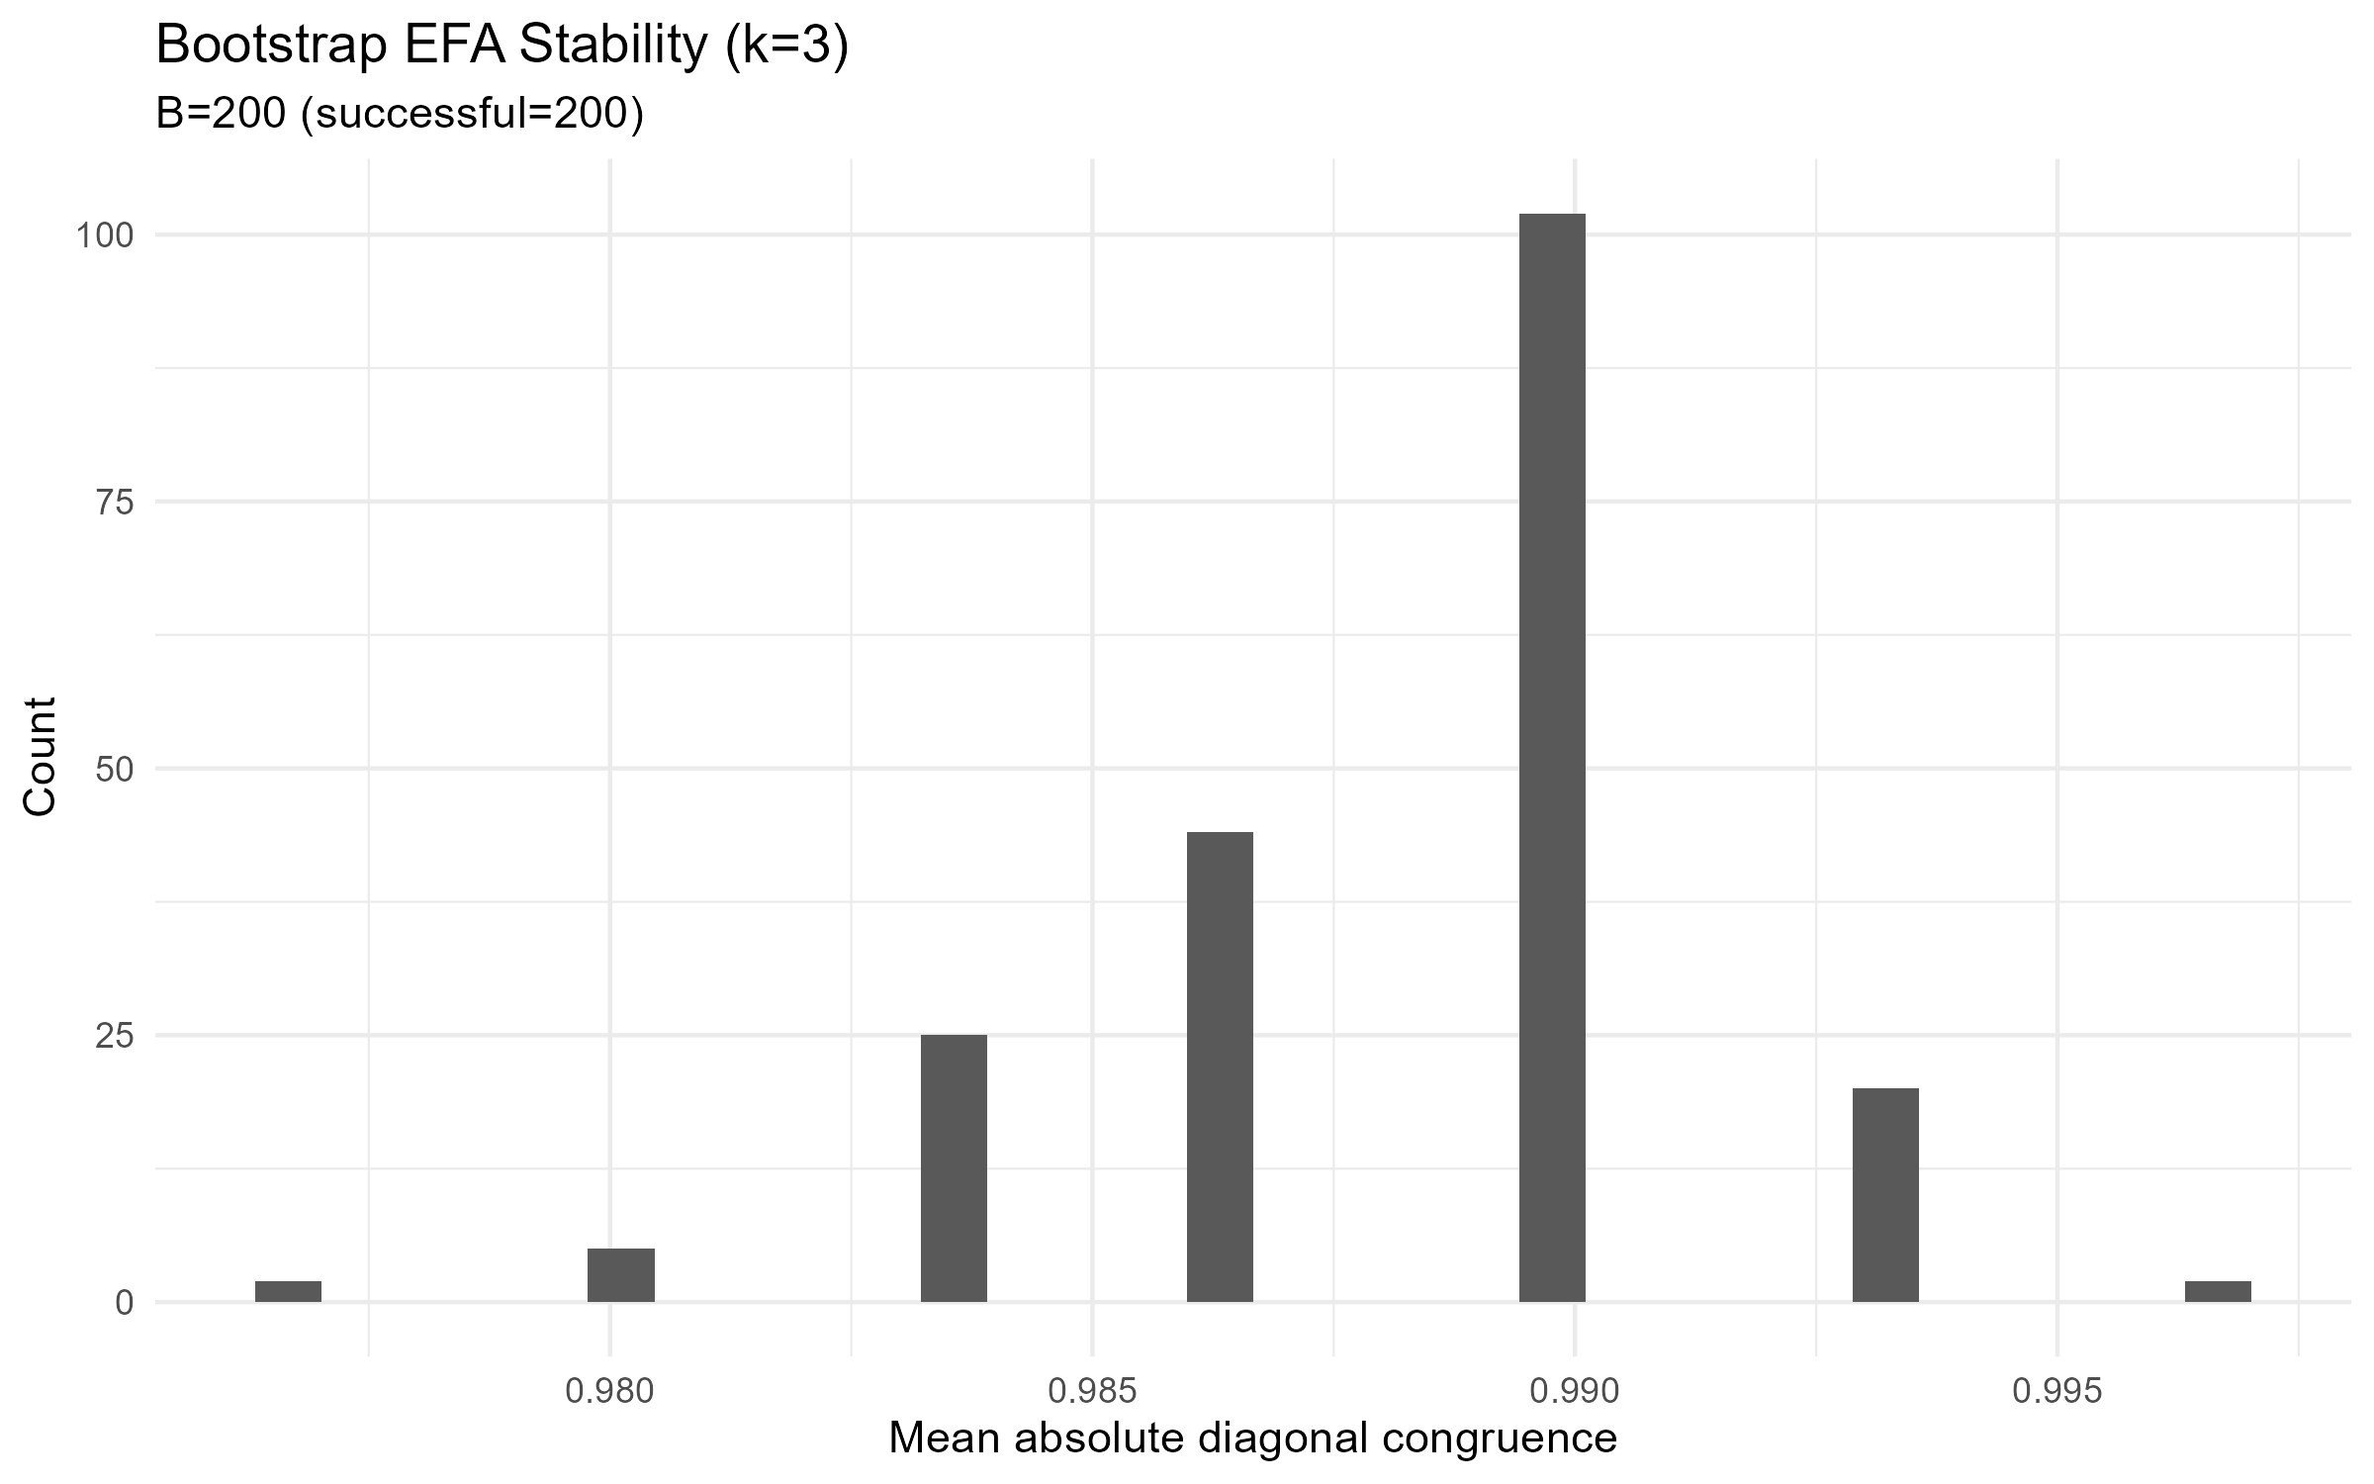
Figure S8.3. Bootstrap EFA Stability: Distribution of Tucker's Congruence Coefficients (16-Item Pool; B = 200)
Note. Histogram of congruence coefficients between the original loading matrix and 200 bootstrap-reestimated loading matrices; all 200 replications converged. The narrow, unimodal distribution concentrated near .99 indicates high structural stability of the three-factor solution.
Exploratory Graph Analysis
Exploratory graph analysis (GLASSO + Walktrap) produced a three-community solution. Fifteen of 16 items were assigned to the community matching their theoretical factor; rrs6 (theoretically F1) was instead assigned to the same community as the F2 items, mirroring the weak and ambiguous EFA loading reported above (Table S8.2) for this same item. The Leiden sensitivity algorithm recovered the same three-community solution but did not reproduce the partition item for item (Walktrap vs. Leiden agreement after Hungarian alignment = 93.75%, 15/16 items; the single disagreement was rrs6, which Leiden assigned to its theoretical F1 community rather than to the F2 community). The misallocation of rrs6 is therefore specific to the Walktrap algorithm and is not reproduced under Leiden. Bootstrap EGA (B = 200, nonparametric) recovered exactly k = 3 communities in 94.5% of replications (5.5% recovered k = 4); mean item-level bootstrap stability was .930 across all 16 items, with three items showing distinctly lower stability -- rrs6 (.318), rrs9 (.753), and rrs13 (.808) -- while the remaining 13 items showed stability >= .995 (rrs7 = .995; all other 12 items = 1.000). This is largely the same set of items identified by the EFA loadings and by the pilot-stage analysis (S3), now converging across three independent lines of evidence (EFA loadings, EGA community assignment, and bootstrap stability), with rrs6 showing the most consistent concern across all three lines of evidence.
Table S8.5. EGA Community Assignment (Walktrap, Primary) by Item
Item | Theoretical factor | EGA community (Walktrap)
rrs1 | F1 | 1
rrs2 | F1 | 1
rrs3 | F1 | 1
rrs4 | F1 | 1
rrs5 | F1 | 1
rrs6 | F1 | 2 (misallocated)
rrs7 | F2 | 2
rrs8 | F2 | 2
rrs9 | F2 | 2
rrs10 | F2 | 2
rrs11 | F2 | 2
rrs12 | F3 | 3
rrs13 | F3 | 3
rrs14 | F3 | 3
rrs15 | F3 | 3
rrs16 | F3 | 3
Note. Community 1 corresponds to the theoretical F1 block for 5 of 6 items; community 2 corresponds to the theoretical F2 block for all 5 F2 items plus the one misallocated F1 item (rrs6); community 3 corresponds exactly to the theoretical F3 block. GLASSO network estimator; cor_auto correlations.
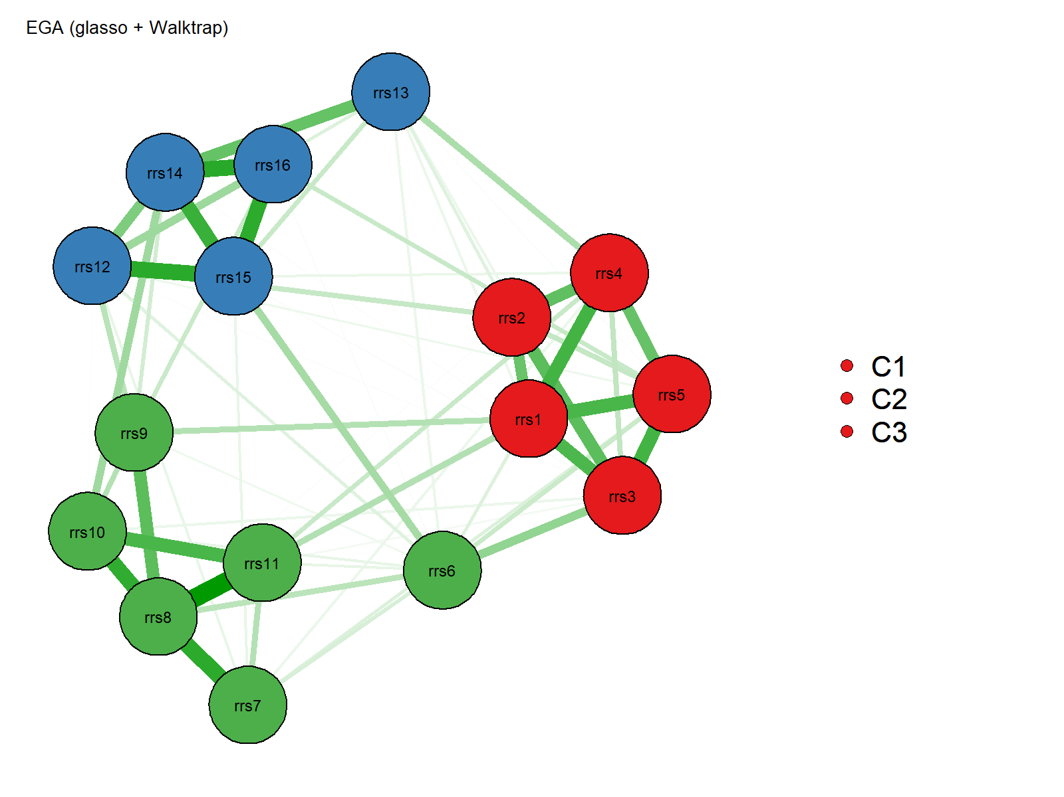
Figure S8.4. Primary EGA Network, 16-Item RRS Pool (GLASSO + Walktrap; Calibration Subsample)
Note. Node colors represent Walktrap communities (C1 = F1-aligned block, C2 = F2-aligned block plus the misallocated item rrs6, C3 = F3-aligned block). Three densely interconnected clusters are visible; rrs6 (red cluster in the theoretical F1 block) instead appears together with the F2 items (green cluster), consistent with its weak and ambiguous EFA loading (Table S8.2).
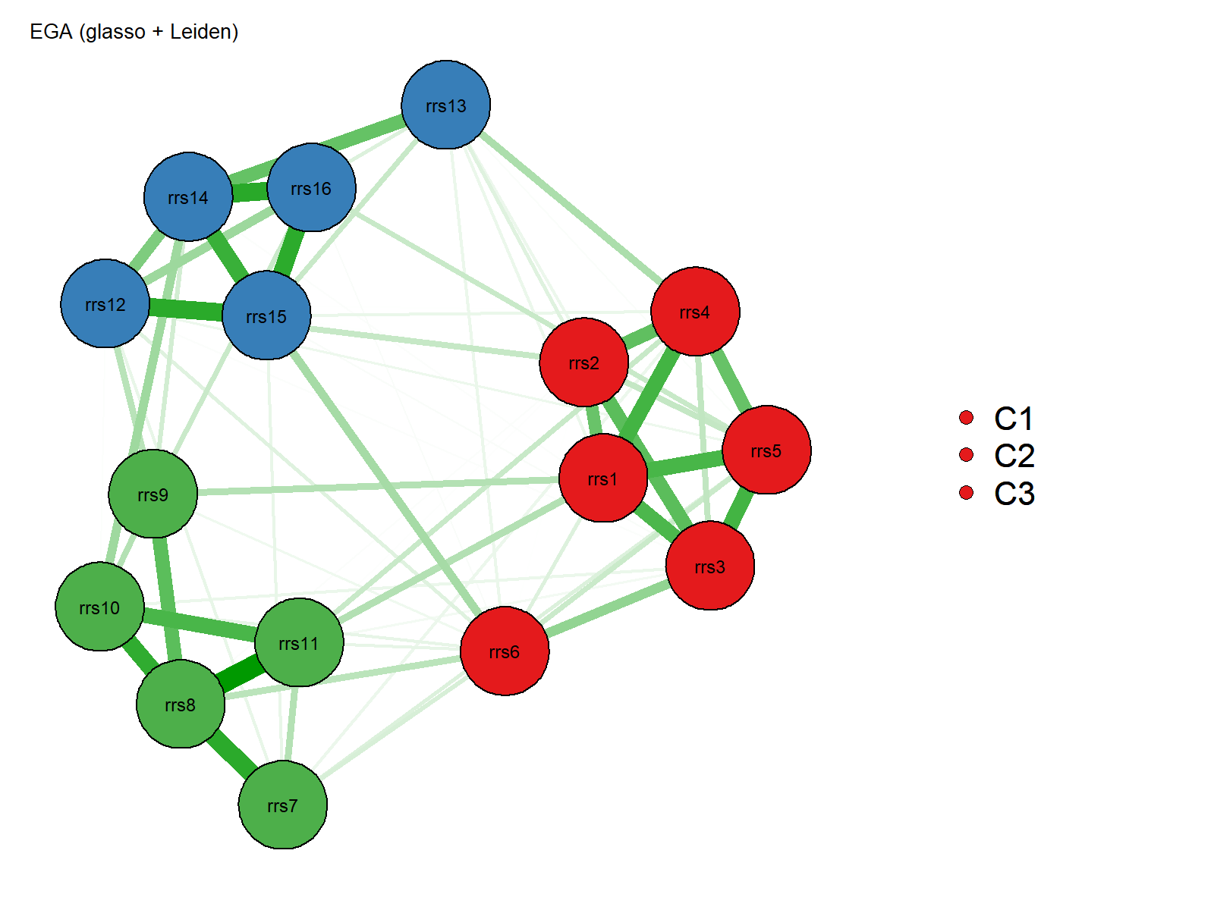
Figure S8.5. Sensitivity EGA Network, 16-Item RRS Pool (GLASSO + Leiden; Calibration Subsample)
Note. Node colors represent Leiden communities. Under Leiden, rrs6 is correctly grouped with its theoretical F1 block, unlike under the primary Walktrap solution (Figure S8.4), where it is grouped with the F2 items; this single item is the sole disagreement between the two algorithms (Walktrap-Leiden agreement after Hungarian alignment = 93.75%, 15/16 items).
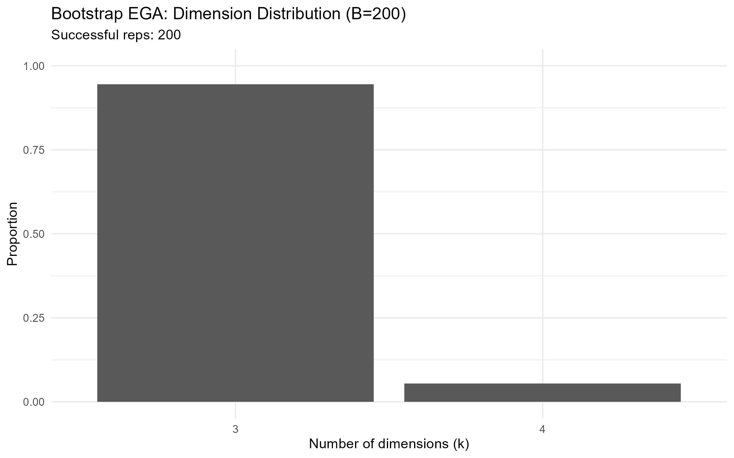
Figure S8.6. Bootstrap EGA: Dimension Distribution (B = 200)
Note. Proportion of 200 bootstrap replications recovering k = 3 or 4 communities. k = 3 was recovered in 94.5% of replications and k = 4 in 5.5%.
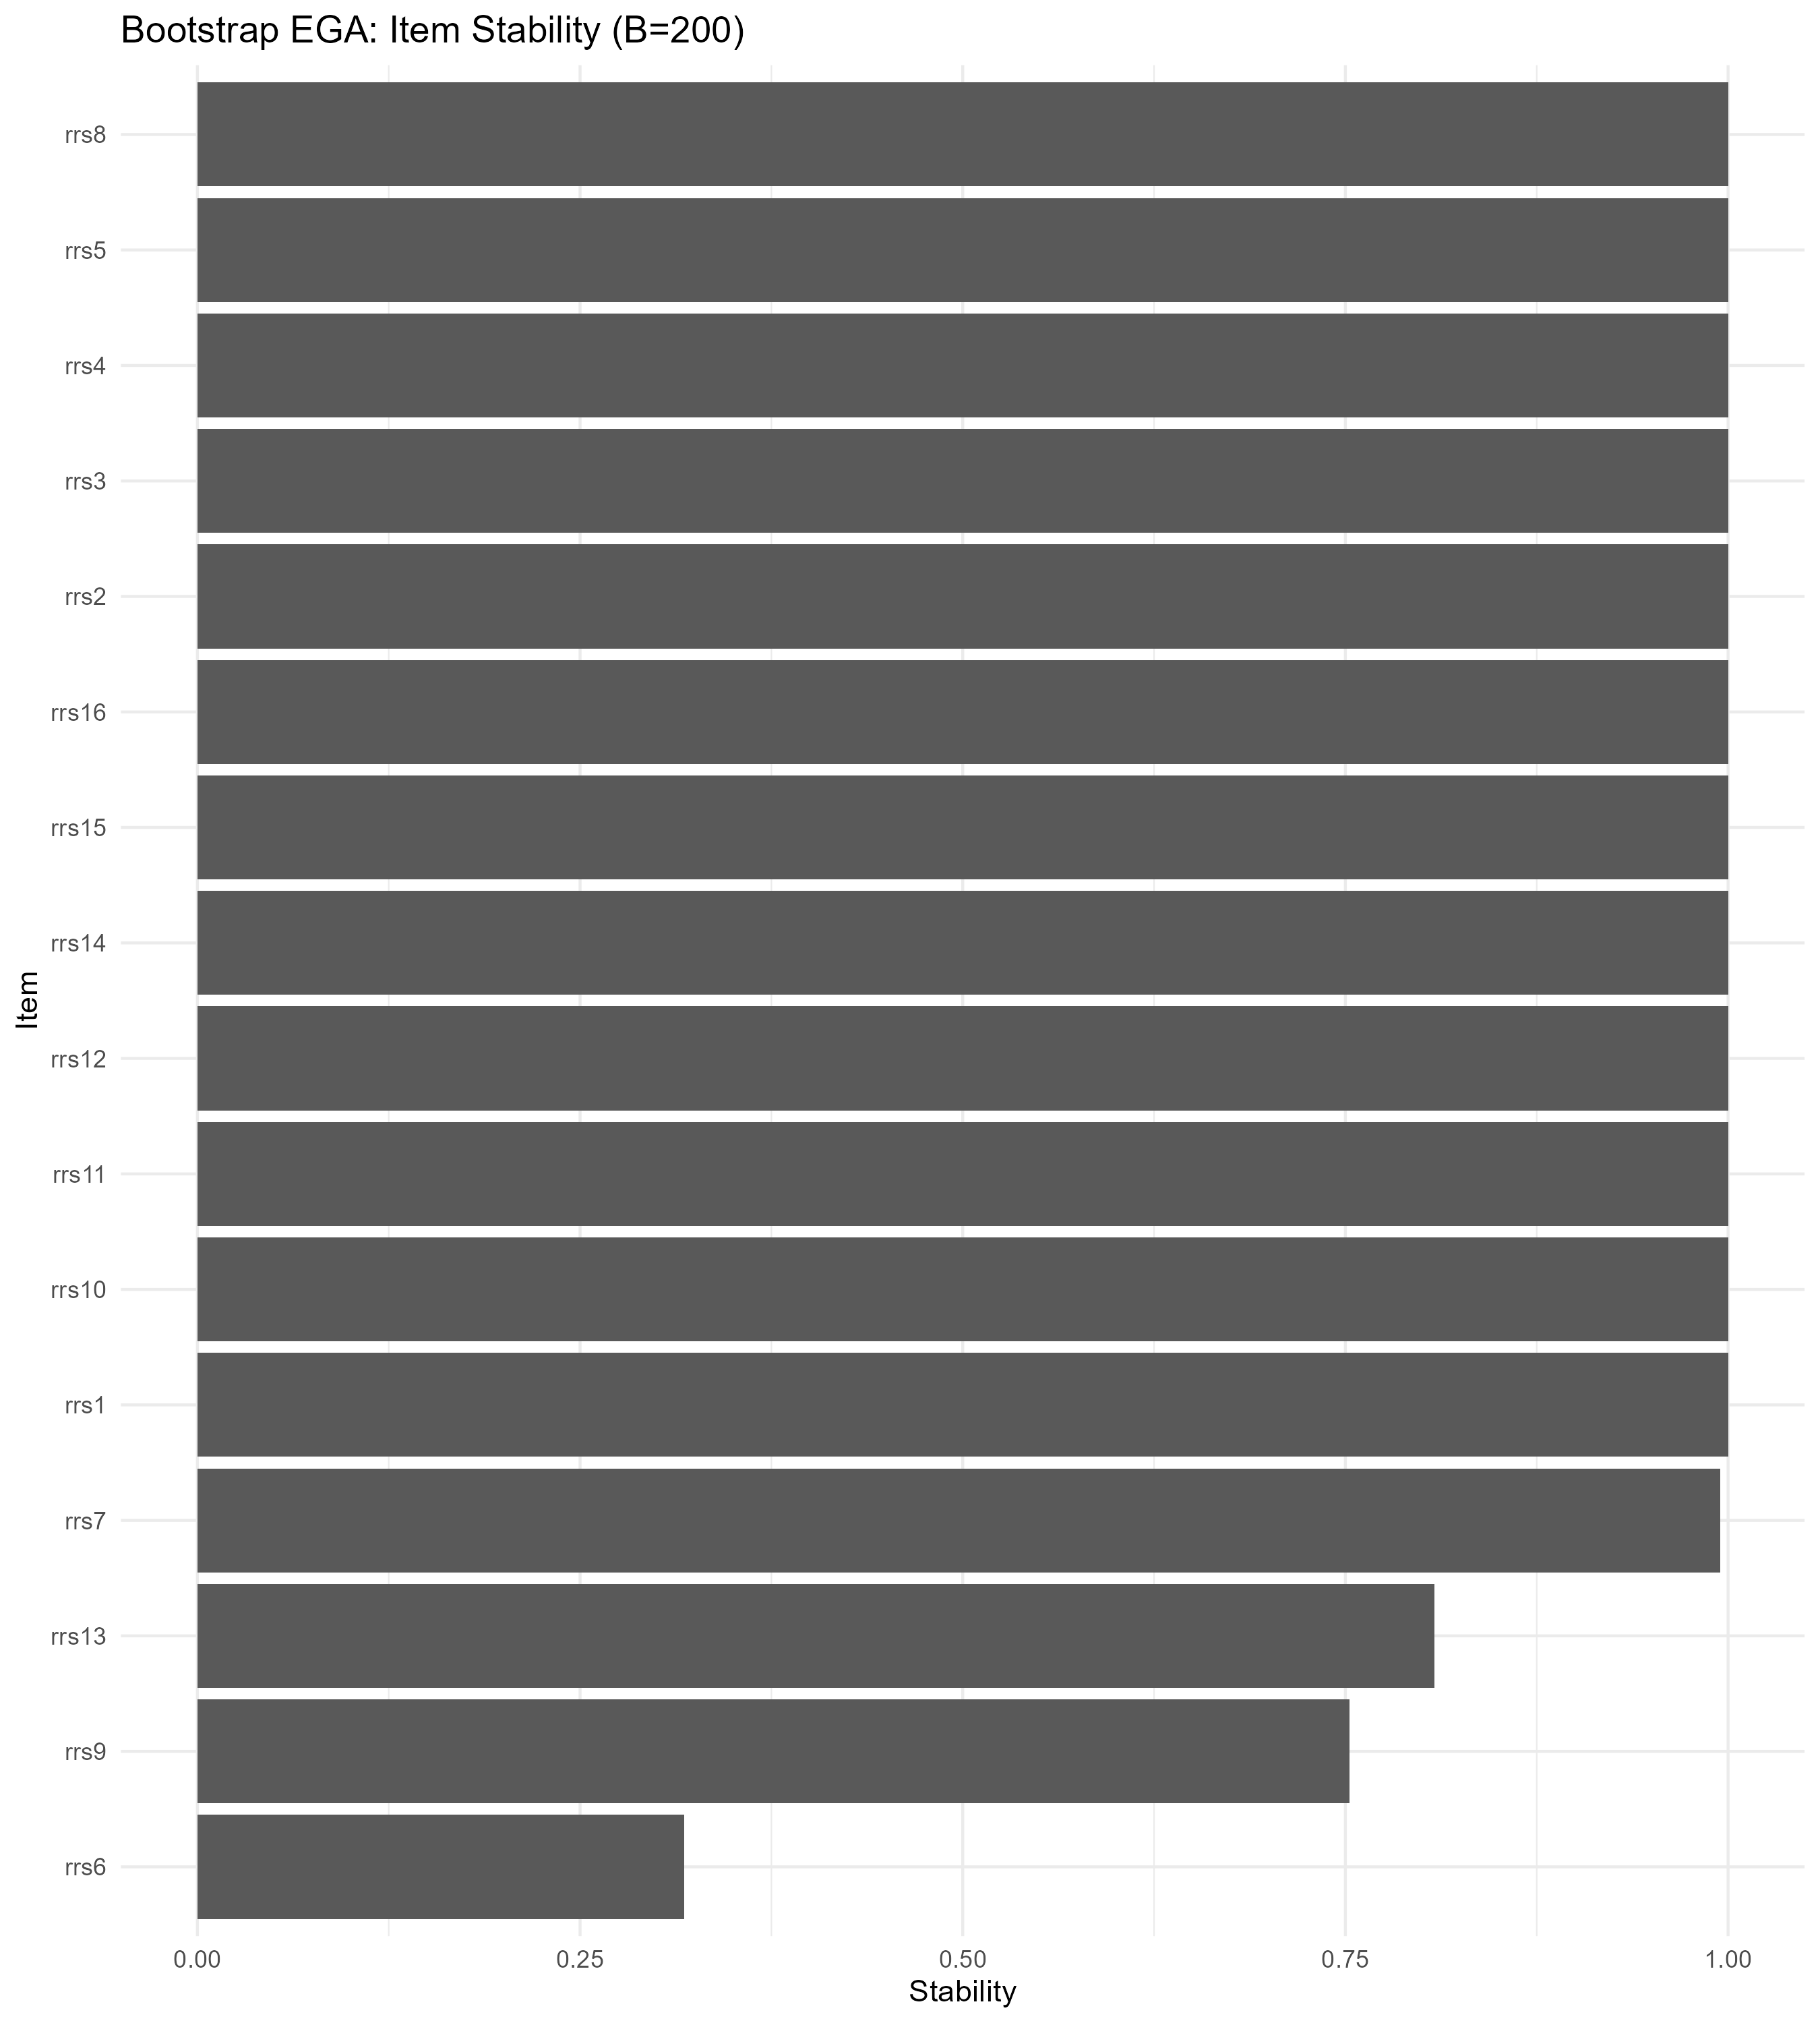
Figure S8.7. Bootstrap EGA: Item-Level Stability (B = 200)
Note. Proportion of bootstrap replications in which each item's community assignment matched its assignment in the original sample, ordered ascending. rrs6, rrs9, and rrs13 show markedly lower stability (.318, .753, and .808, respectively) than the remaining 13 items (all >= .995).
EFA-EGA Convergence
Agreement between the EFA factor assignment (based on each item's largest loading) and the EGA community assignment (Walktrap, Hungarian-aligned to the EFA solution) was excellent: 15 of 16 items (93.75%) showed identical classification across the two methods. The single disagreement was rrs6, which the EFA assigned to F1 (its nominally largest, though weak, loading) but the EGA assigned to the F2/community-2 grouping -- the same item flagged throughout this section as the RRS-16's primary item of concern at the exploratory stage.
Table S8.6. Summary of Structural-Stability Indicators (16-Item RRS Pool, Calibration Subsample)
Indicator | Value
EGA communities detected (k) | 3
EGA theoretical block correspondence | 15/16 items (93.75%); rrs6 misallocated
Walktrap-Leiden agreement (aligned) | 93.75% (15/16 items)
EGA bootstrap P(k = k_primary = 3) | 94.5% (189/200)
EGA mean item-level bootstrap stability | .930 (range .318-1.000)
EFA bootstrap mean congruence | .988 (SD = .003)
EFA-EGA item-level agreement (aligned) | 93.75% (15/16 items)
Note. EFA-EGA item-level agreement of 93.75% reflects that, after Hungarian alignment, 15 of 16 items' empirical EFA factor assignments (based on their larger loading) match their EGA community assignment; rrs6 is the sole item disagreeing across methods. This is a measure of cross-method consistency in classification, not of correspondence with the theoretical model. The reduced bootstrap indicators for rrs6 (and, to a lesser degree, rrs9 and rrs13) reflect the same item-level pattern identified throughout this section.
Summary
Taken together, the calibration-subsample exploratory results provide strong convergent support for the theoretical three-factor RRS-16 structure overall (KMO = .899; primary EFA RMSEA = .034, TLI = .978; EFA bootstrap mean congruence = .988), while also replicating the pilot-stage concern (S3) regarding item rrs6, whose loading, EGA community assignment, and bootstrap stability are each distinctly weaker than the remaining 15 items. Items rrs3 and rrs9, also flagged for monitoring at the pilot stage, passed the D0 main-study screen in the calibration sample; rrs3's loading was clean by any criterion, whereas rrs9 would still be flagged under the pilot's own descriptive thresholds (primary loading .408 < .50) and remained among the lower-stability items under the stricter sensitivity criteria and the EGA bootstrap. Because these exploratory results alone cannot determine whether item revision or removal is warranted for the final scale, this pattern is carried forward for independent evaluation against the confirmatory (CFA/ESEM) results from the validation subsample (S9) in the item-reduction synthesis (S10).

S9. Confirmatory Factor Analysis and Exploratory Structural Equation Modeling — Validation Subsample
Refugee Resilience Scale (RRS): Adaptive Coping and Resource Mobilization in Forced Migration
This section reports the confirmatory factor-analytic (CFA) and exploratory structural equation modeling (ESEM) evaluation of the 16-item RRS pool in the independent validation subsample (N = 289; complete-case n = 272). Because the RRS-16 is treated as a fixed item pool at this stage, having been finalized through the modified Delphi and cognitive-interviewing process before any psychometric data were analyzed (S2), a single confirmatory analytic sequence was carried out on the full 16-item, three-factor structure (F1: Individual Adaptive Capacity, rrs1-rrs6; F2: Support Seeking and Relational Resource Use, rrs7-rrs11; F3: Service and Rights Navigation, rrs12-rrs16); no item-reduced alternative model was tested at this stage. All CFA and ESEM models were estimated with WLSMV (diagonally weighted least squares with mean- and variance-adjustment) and theta parameterization, treating items as ordered-categorical indicators (missing = pairwise). Four competing structural models were tested: a one-factor model, the theoretically specified three-factor correlated model, a three-factor second-order model, and a three-factor bifactor model. ESEM used target rotation (primary), with Geomin rotation (sensitivity check) estimated using a defensive multi-attempt procedure to accommodate a lavaan version-specific rotation-argument incompatibility (see Table S9.5 note).
Missing Data and Sample
Missing data on the 16 items were negligible: 272 of 289 participants (94.1%) had complete data on all items, and 17 participants (5.9%) had exactly one missing item; no participant had more than one missing item. Item-level missingness ranged from 0% (rrs1, rrs6, rrs8, rrs15) to 0.69% (rrs2, rrs4, rrs7, rrs10, rrs11, 2 of 289 cases each). All 16 items retained their full 1-5 observed response range.
Competing Confirmatory Models
Table S9.1 compares the fit of the four competing structural models. The one-factor model fit poorly (scaled CFI = .699, RMSEA = .157), confirming that a single general factor does not adequately represent the item covariance structure. The theoretically specified three-factor correlated model showed acceptable fit: chi-square(101) = 220.15 (scaled), p < .001, CFI = .952, TLI = .942, RMSEA = .064 [90% CI: .052, .076], SRMR = .063. Under the standard cutoffs (CFI >= .95, RMSEA <= .06) the three-factor correlated model met the CFI criterion but not the RMSEA criterion; under the sample-size-adjusted dynamic cutoffs used elsewhere in this article (CFI >= .945, RMSEA <= .065; defined in the S9 row of Table S0.1), it met both criteria. The second-order model (GEN =~ F1 + F2 + F3, one general factor accounting for the three first-order factor correlations) showed fit statistics numerically identical to the correlated three-factor model to the reported precision: chi-square(101) = 220.15 (scaled), p < .001, CFI = .952, TLI = .942, RMSEA = .064 [90% CI: .052, .076], SRMR = .063 (Table S9.1 note explains why this equivalence is expected here, unlike in two-factor applications of the same model comparison). The bifactor model fit markedly better and met every conventional threshold: chi-square(88) = 136.53 (scaled), p < .001, CFI = .980, TLI = .973, RMSEA = .044 [90% CI: .029, .058], SRMR = .044, at the cost of substantially reduced parsimony (13 additional parameters relative to the correlated three-factor model). Descriptive information criteria from parallel MLR refits point in opposite directions on this trade-off: the bifactor model has the lowest AIC (12188.76 vs. 12209.61) but a higher BIC than the correlated three-factor model (12423.41 vs. 12396.60; Table S9.1).

Table S9.1. Competing CFA Model Fit Comparison (WLSMV, Scaled Statistics; 16-Item RRS Pool; Validation Subsample, N = 289)
Model | chi-square | df | p | CFI | TLI | RMSEA | 90% CI | SRMR | npar | AIC | BIC
One-factor | 842.84 | 104 | < .001 | .699 | .653 | .157 | [.147, .167] | .131 | 80 | 12745.53 | 12921.52
Three-factor correlated | 220.15 | 101 | < .001 | .952 | .942 | .064 | [.052, .076] | .063 | 83 | 12209.61 | 12396.60
Second-order (GEN =~ F1+F2+F3) | 220.15 | 101 | < .001 | .952 | .942 | .064 | [.052, .076] | .063 | 83 | 12209.61 | 12396.60
Bifactor | 136.53 | 88 | < .001 | .980 | .973 | .044 | [.029, .058] | .044 | 96 | 12188.76 | 12423.41
Note. Fit statistics are WLSMV robust (scaled) values. Unlike two-factor applications of the correlated-versus-second-order model comparison (where the second-order model estimates one fewer free correlation parameter than the number of second-order loadings, yielding a small df difference), a second-order model built on exactly three first-order factors is fit-equivalent to the correlated three-factor model: three second-order loadings (GEN to F1, F2, F3) exactly reproduce the three estimable first-order factor correlations with the same number of free parameters (npar = 83, df = 101 for both models here), so the two specifications are mathematically equivalent reparameterizations rather than competing models in this three-factor case. The second-order loadings (Table S9.4) show differentiated (not uniform) values (GEN to F1 = .666, GEN to F2 = .751, GEN to F3 = .644), consistent with the observed first-order factor correlations (F1-F2 = .500, F1-F3 = .429, F2-F3 = .484). AIC and BIC are not defined for WLSMV estimation and are therefore reported from the same four models refit by maximum likelihood with robust standard errors (MLR, missing = "fiml") purely as descriptive information criteria; they are not directly comparable with the WLSMV scaled fit statistics in the same row. The two criteria do not agree: the bifactor model has the lowest AIC (12188.76 vs. 12209.61 for the correlated three-factor model, a difference of 20.85) but a higher BIC than the correlated three-factor model (12423.41 vs. 12396.60), because BIC penalizes the bifactor model's 13 additional parameters more heavily. This AIC/BIC split is one of the considerations behind retaining the more parsimonious correlated three-factor model as the substantive scoring structure while reporting the bifactor solution for diagnostic purposes only. Standard cutoffs: CFI >= .95, RMSEA <= .06 (Hu & Bentler, 1999); dynamic (sample-size-adjusted) cutoffs used elsewhere in this article: CFI >= .945, RMSEA <= .065 (defined in the S9 row of Table S0.1). No convergence failures or improper (non-positive-definite) solutions occurred in any of the four models; under theta parameterization the latent-response residual variances are fixed to 1 by identification, so no item-level Heywood check applies; latent-covariance positive-definiteness and standardized loadings below unity were confirmed separately for all models.
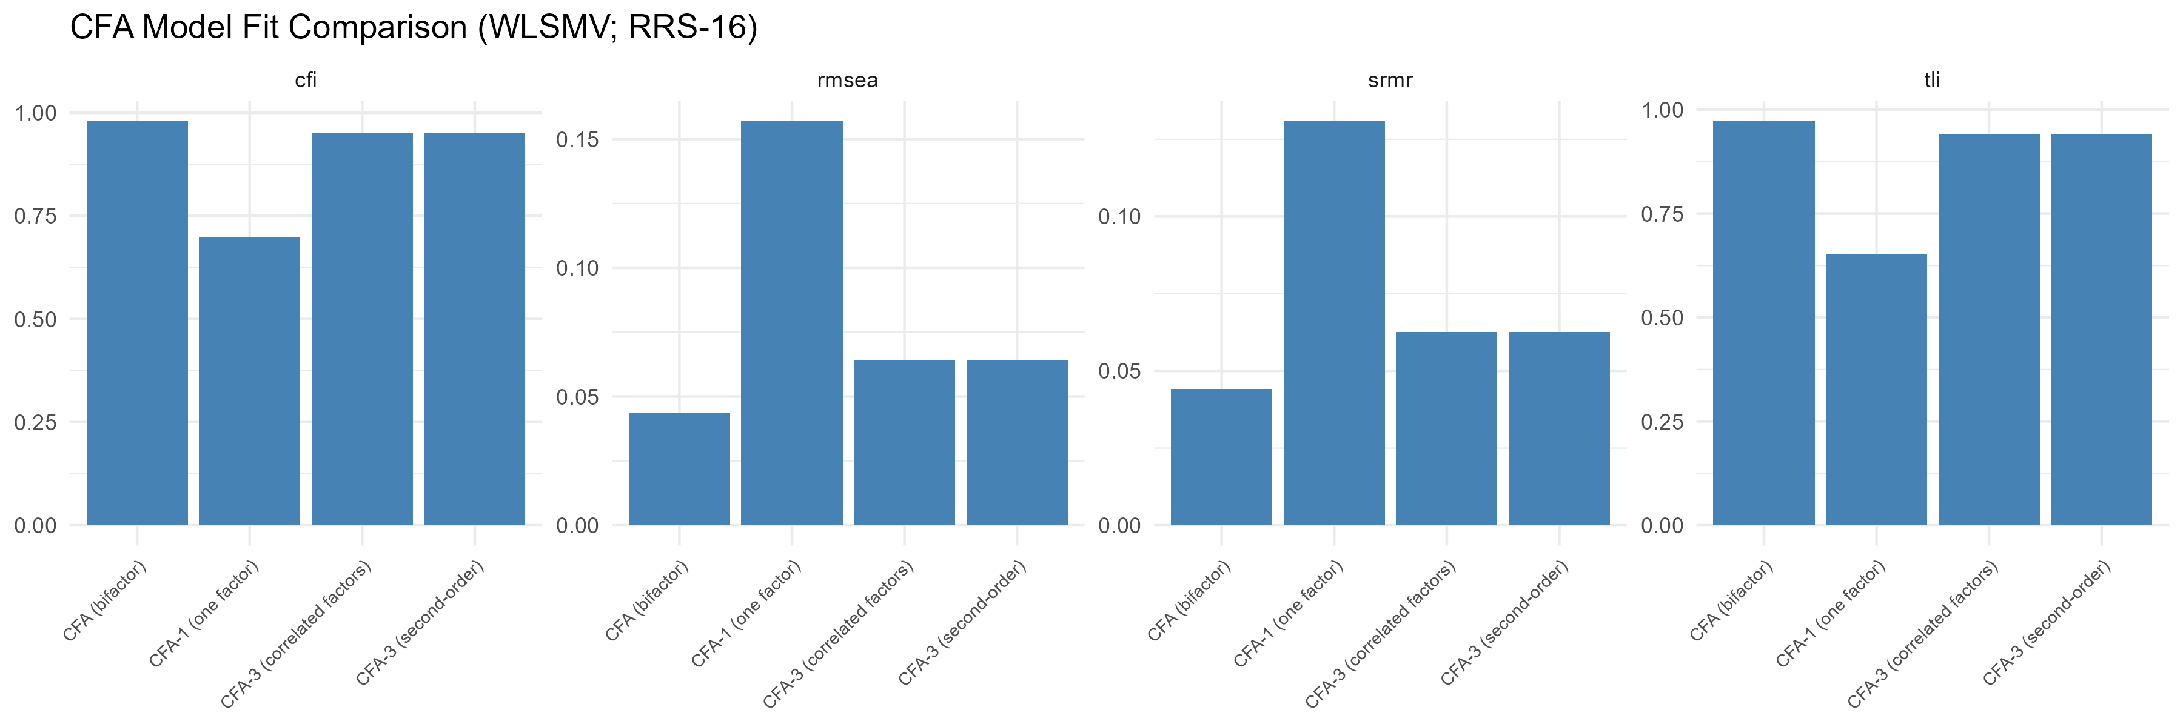
Figure S9.1. CFA Model Fit Comparison Across Competing Structural Models (16-Item RRS Pool; Validation Subsample, N = 289)
Note. Bars show CFI, TLI, RMSEA, and SRMR for the one-factor, three-factor correlated, and bifactor models (the second-order model, which is fit-equivalent to the correlated three-factor model in this three-factor application, is omitted here for visual clarity; see Table S9.1 note). The one-factor model is markedly worse on every index; the bifactor model shows the best point-estimate fit, followed by the three-factor correlated model, which meets the CFI criterion but falls short of the standard RMSEA threshold (though not the dynamic, sample-size-adjusted threshold; Table S0.1, S9 row).
Standardized Loadings, Three-Factor Correlated Model
All 16 standardized loadings on the three-factor correlated model were statistically meaningful, ranging from .440 (rrs13) to .819 (rrs15); no loading was negative or implausibly extreme. The three factor correlations were moderate (F1-F2 = .500, F1-F3 = .429, F2-F3 = .484), supporting discriminant validity among the three dimensions while confirming they are meaningfully related facets of a broader construct. Item rrs13 showed the lowest loading in the pool (.440 on its theoretical factor F3), and rrs9 was also comparatively lower (.537, F2) than the remaining 14 items (range .589-.819) -- both items previously flagged for continued monitoring in the exploratory analyses (S8), alongside rrs6 (.589 here), the item most consistently flagged across the pilot (S3) and exploratory (S8) stages.

Table S9.2. Standardized CFA Loadings and Factor Correlations, Three-Factor Correlated Model (16-Item RRS Pool; Validation Subsample, N = 289)
Item | Factor | Standardized loading
rrs15 | F3 | .819
rrs2 | F1 | .790
rrs8 | F2 | .789
rrs7 | F2 | .753
rrs16 | F3 | .750
rrs5 | F1 | .743
rrs1 | F1 | .742
rrs14 | F3 | .742
rrs10 | F2 | .742
rrs11 | F2 | .734
rrs12 | F3 | .714
rrs4 | F1 | .711
rrs3 | F1 | .706
rrs6 | F1 | .589
rrs9 | F2 | .537
rrs13 | F3 | .440
Note. All loadings significant at p < .001. Factor correlations: F1-F2 = .500, F1-F3 = .429, F2-F3 = .484. Free parameters = 83; N/parameter ratio = 3.48. HTMT (heterotrait-monotrait) ratios among the three factors ranged from .459 to .516, well below the conservative .85 threshold, supporting discriminant validity (see the Discriminant Validity (HTMT) subsection below). Items are ordered by loading magnitude, descending.
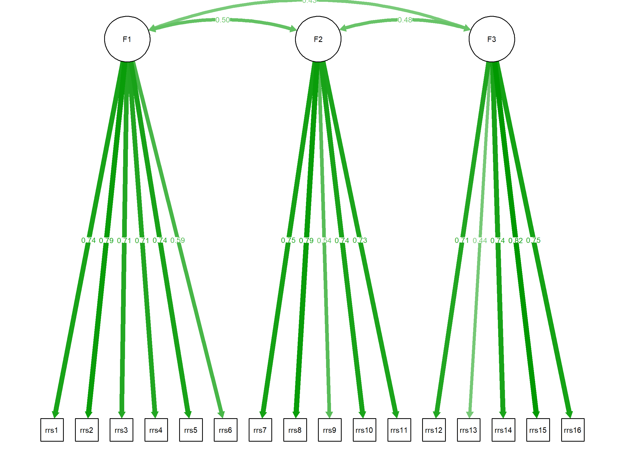
Figure S9.2. Standardized Path Diagram, Three-Factor Correlated CFA Model (16-Item RRS Pool; Validation Subsample, N = 289)
Note. Standardized loadings and the three factor correlations (F1-F2 = .50, F1-F3 = .43, F2-F3 = .48) are shown on each path. Item rrs13 shows the lowest loading in the model (.44); rrs9 is also comparatively lower (.54) than the remaining 14 items.
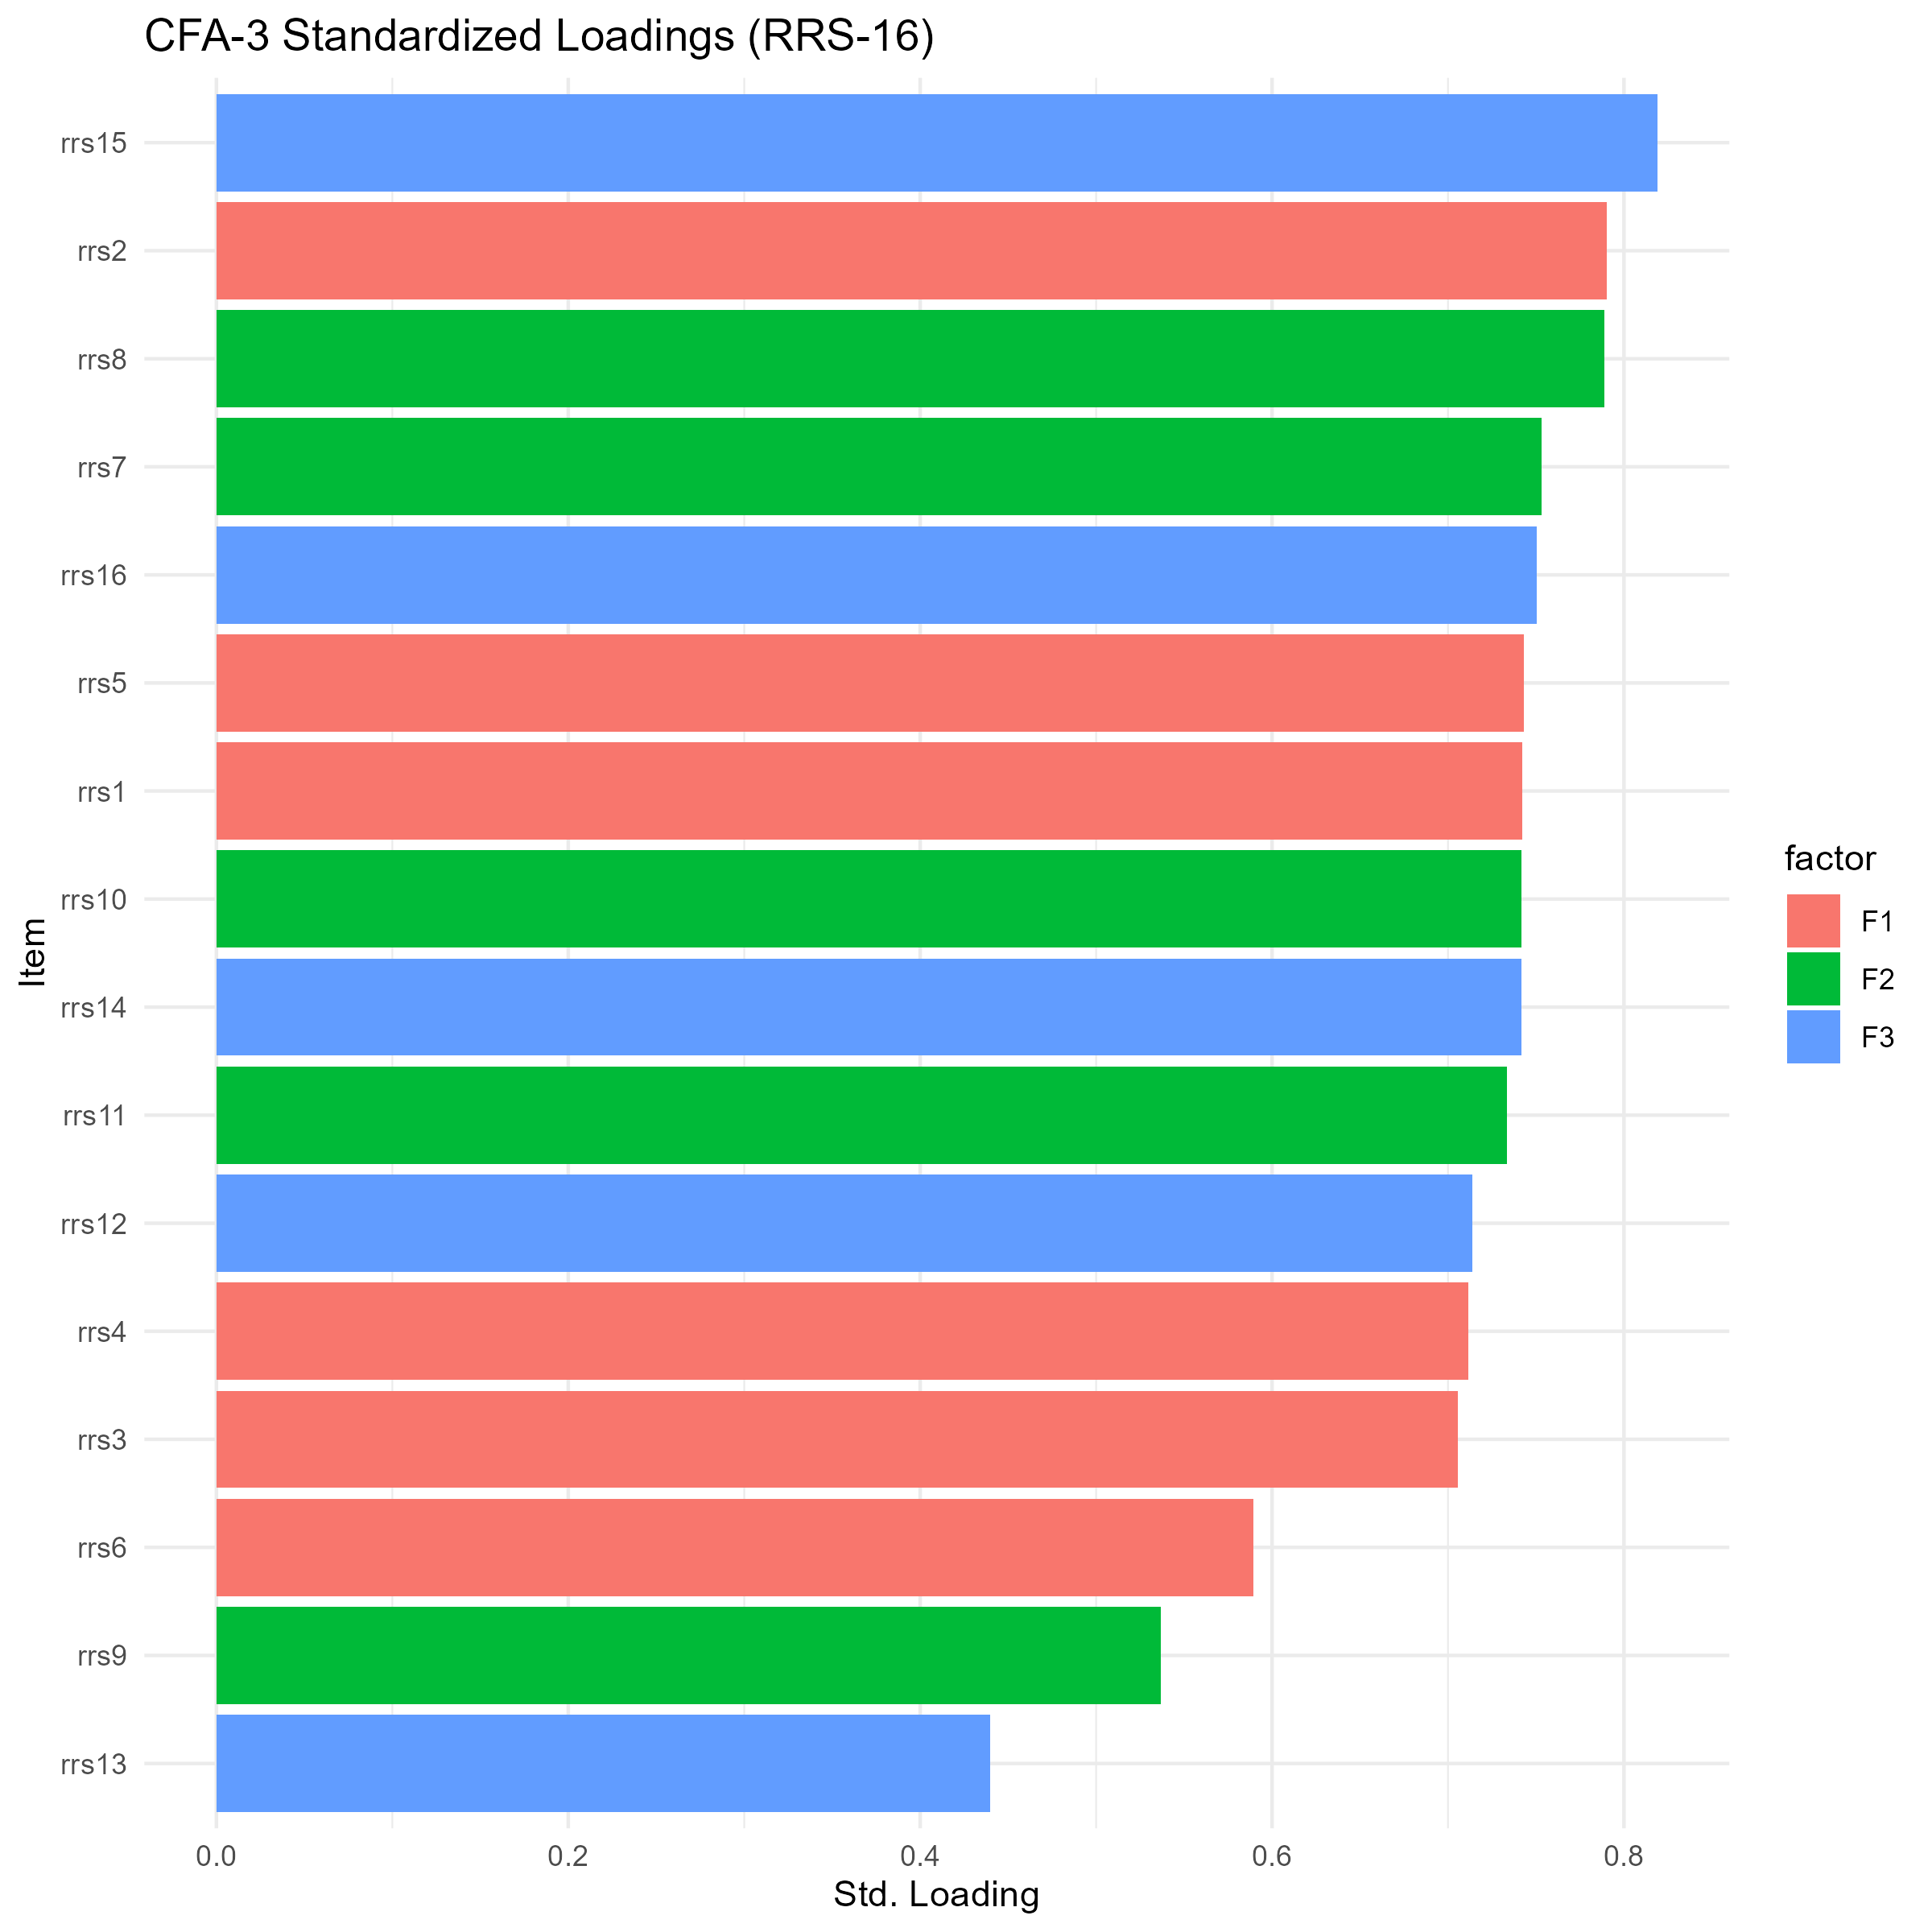
Figure S9.3. CFA-3 Standardized Loadings by Item, Ranked (16-Item RRS Pool; Validation Subsample, N = 289)
Note. Bars are colored by theoretical factor (F1, F2, F3) and ranked by loading magnitude. Items rrs13 and rrs9 form the two lowest loadings in the pool; rrs6 is also comparatively lower than the remaining 13 items, consistent with its flagging throughout the pilot (S3) and exploratory (S8) stages.
Local Fit: Residual Correlations
Local fit was further examined using SAFE residual correlations (observed polychoric minus model-implied correlations, computed directly to avoid a lavaan-version-specific function-name incompatibility affecting the built-in residual-diagnostic routine; see Table S9.3 note). Across the 120 item pairs, the mean absolute residual was .051 (median = .036), and 15.0% of pairs exceeded |r| = .10; no pair exceeded |r| = .20. The five largest residual correlations were rrs9-rrs15 (r = .194), rrs9-rrs12 (r = .193), rrs10-rrs14 (r = -.172), rrs6-rrs8 (r = .142), and rrs2-rrs13 (r = .142) -- the two largest residuals both involve rrs9 paired with an F3 item, and four of the five largest residuals involve at least one of the three items (rrs6, rrs9, rrs13) identified by the lower standardized loadings above and by the exploratory analyses in S8, providing partial convergent evidence from an independent analytic method (confirmatory residual diagnostics rather than exploratory loadings or EGA community structure) that these items carry disproportionate model-inconsistent covariance in the 16-item pool.
Table S9.3. SAFE Residual Correlation Summary (16-Item RRS Pool; Validation Subsample)
Indicator | Value
Mean absolute residual correlation | .051
Median absolute residual correlation | .036
Maximum absolute residual correlation | .194
% pairs |r| > .05 | 42.5%
% pairs |r| > .10 | 15.0%
% pairs |r| > .20 | 0%
Note. SAFE = observed polychoric correlation minus model-implied correlation, computed from the three-factor correlated CFA model. This manual computation was used because the script's built-in residual-diagnostic function (lavResidual) does not exist under the installed lavaan version (0.6-20; the function was renamed lavResiduals), which caused the built-in diagnostic to silently return missing values; the independently implemented SAFE calculation was verified against the raw polychoric and model-implied correlation matrices and is reported here as the primary local-fit diagnostic. No residual pair reached the |r| = .20 threshold conventionally used to flag serious local misfit. The five largest individual residual pairs are listed in the text preceding this table.
Second-Order and Bifactor Diagnostics
The second-order loadings from GEN to each first-order factor were differentiated (GEN to F1 = .666, GEN to F2 = .751, GEN to F3 = .644), consistent with the corresponding first-order factor correlations under the three-factor correlated model (F1-F2 = .500, F1-F3 = .429, F2-F3 = .484); as noted above (Table S9.1), this second-order specification is fit-equivalent to, rather than a distinct competing model relative to, the correlated three-factor model when exactly three first-order factors are specified. Bifactor diagnostics indicated a general factor that is substantial but does not dominate the common variance: ECV (explained common variance) = .464, omega-hierarchical = .669. The specific-factor omega values (omega_s,F1 = .451, omega_s,F2 = .336, omega_s,F3 = .441) indicate that the three first-order factors retain only modest reliable variance beyond the general factor, with F2 retaining less specific-factor reliability than F1 or F3.

Table S9.4. Second-Order and Bifactor Diagnostic Indicators (16-Item RRS Pool; Validation Subsample)
Indicator | Value
Second-order loading, GEN -> F1 | .666
Second-order loading, GEN -> F2 | .751
Second-order loading, GEN -> F3 | .644
ECV (explained common variance) | .464
omega-hierarchical | .669
omega-specific, F1 | .451
omega-specific, F2 | .336
omega-specific, F3 | .441
Note. ECV = .464 indicates that the general factor accounts for somewhat less than half of common variance, consistent with a correlated three-dimensional structure in which a broad general factor and three more specific facets each carry meaningful reliable variance. omega-hierarchical = .669 indicates that the general factor, although substantial, does not reach the .80 benchmark conventionally used to justify treating the total score as essentially unidimensional; the omega-hierarchical and omega-specific values reported here are the recomputed values described in the computation note to Table S12.5, which applies to this table as well; omega-specific values indicate that F1 and F3 retain more specific-factor reliability beyond the general factor than F2 does. GEN = general (second-order) factor.
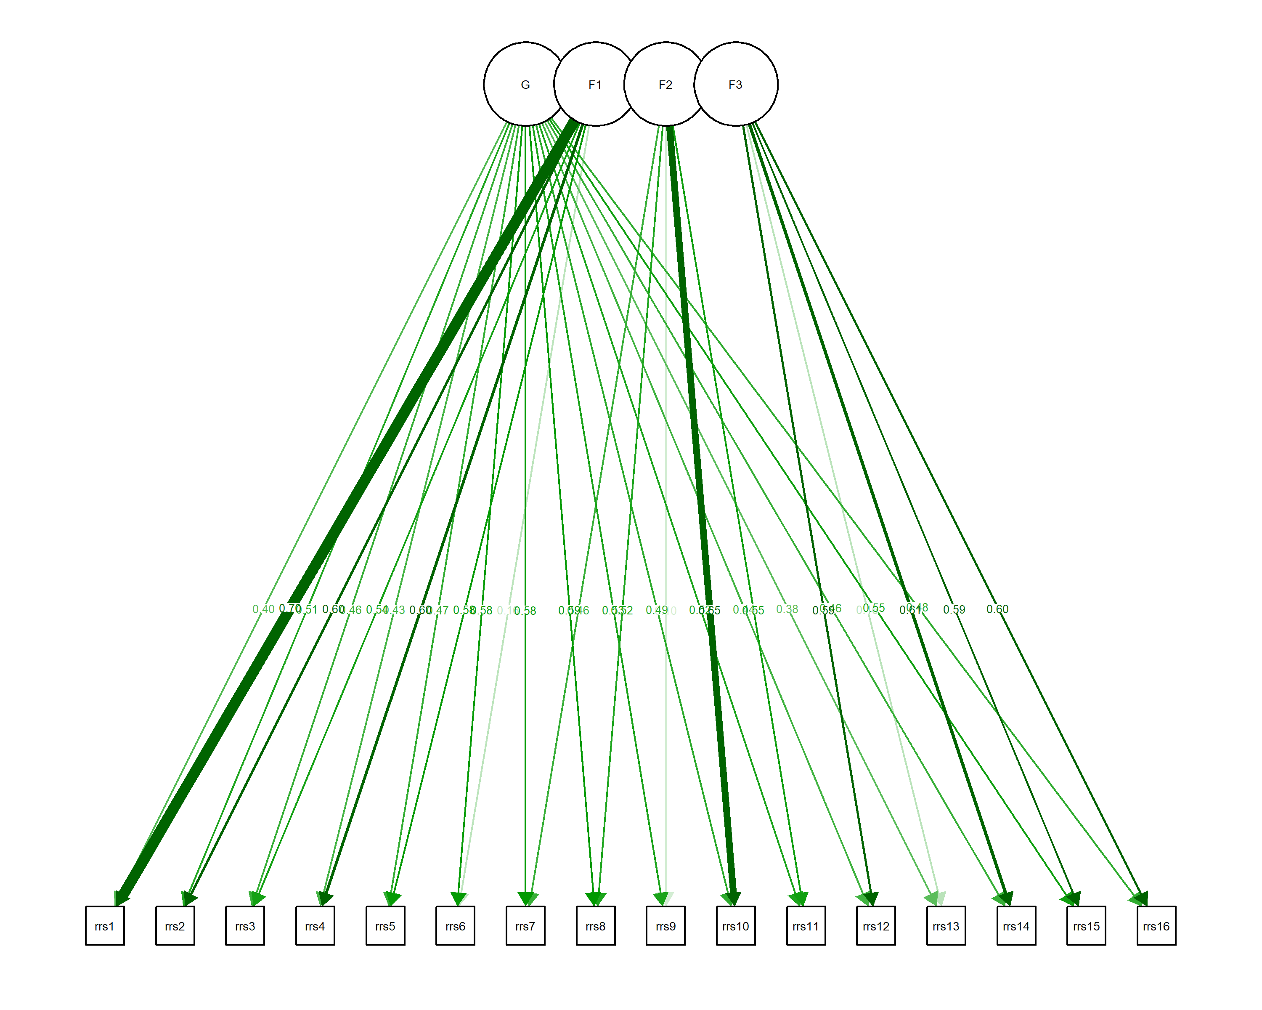
Figure S9.4. Bifactor Standardized Path Diagram (16-Item RRS Pool; Validation Subsample, N = 289)
Note. All 16 items load on the general factor (G) and on their respective theoretical specific factor (F1, F2, or F3), which are specified as orthogonal to G and to each other. Reported for diagnostic completeness (ECV, omega-hierarchical; Table S9.4), not as a competing substantive scoring model.
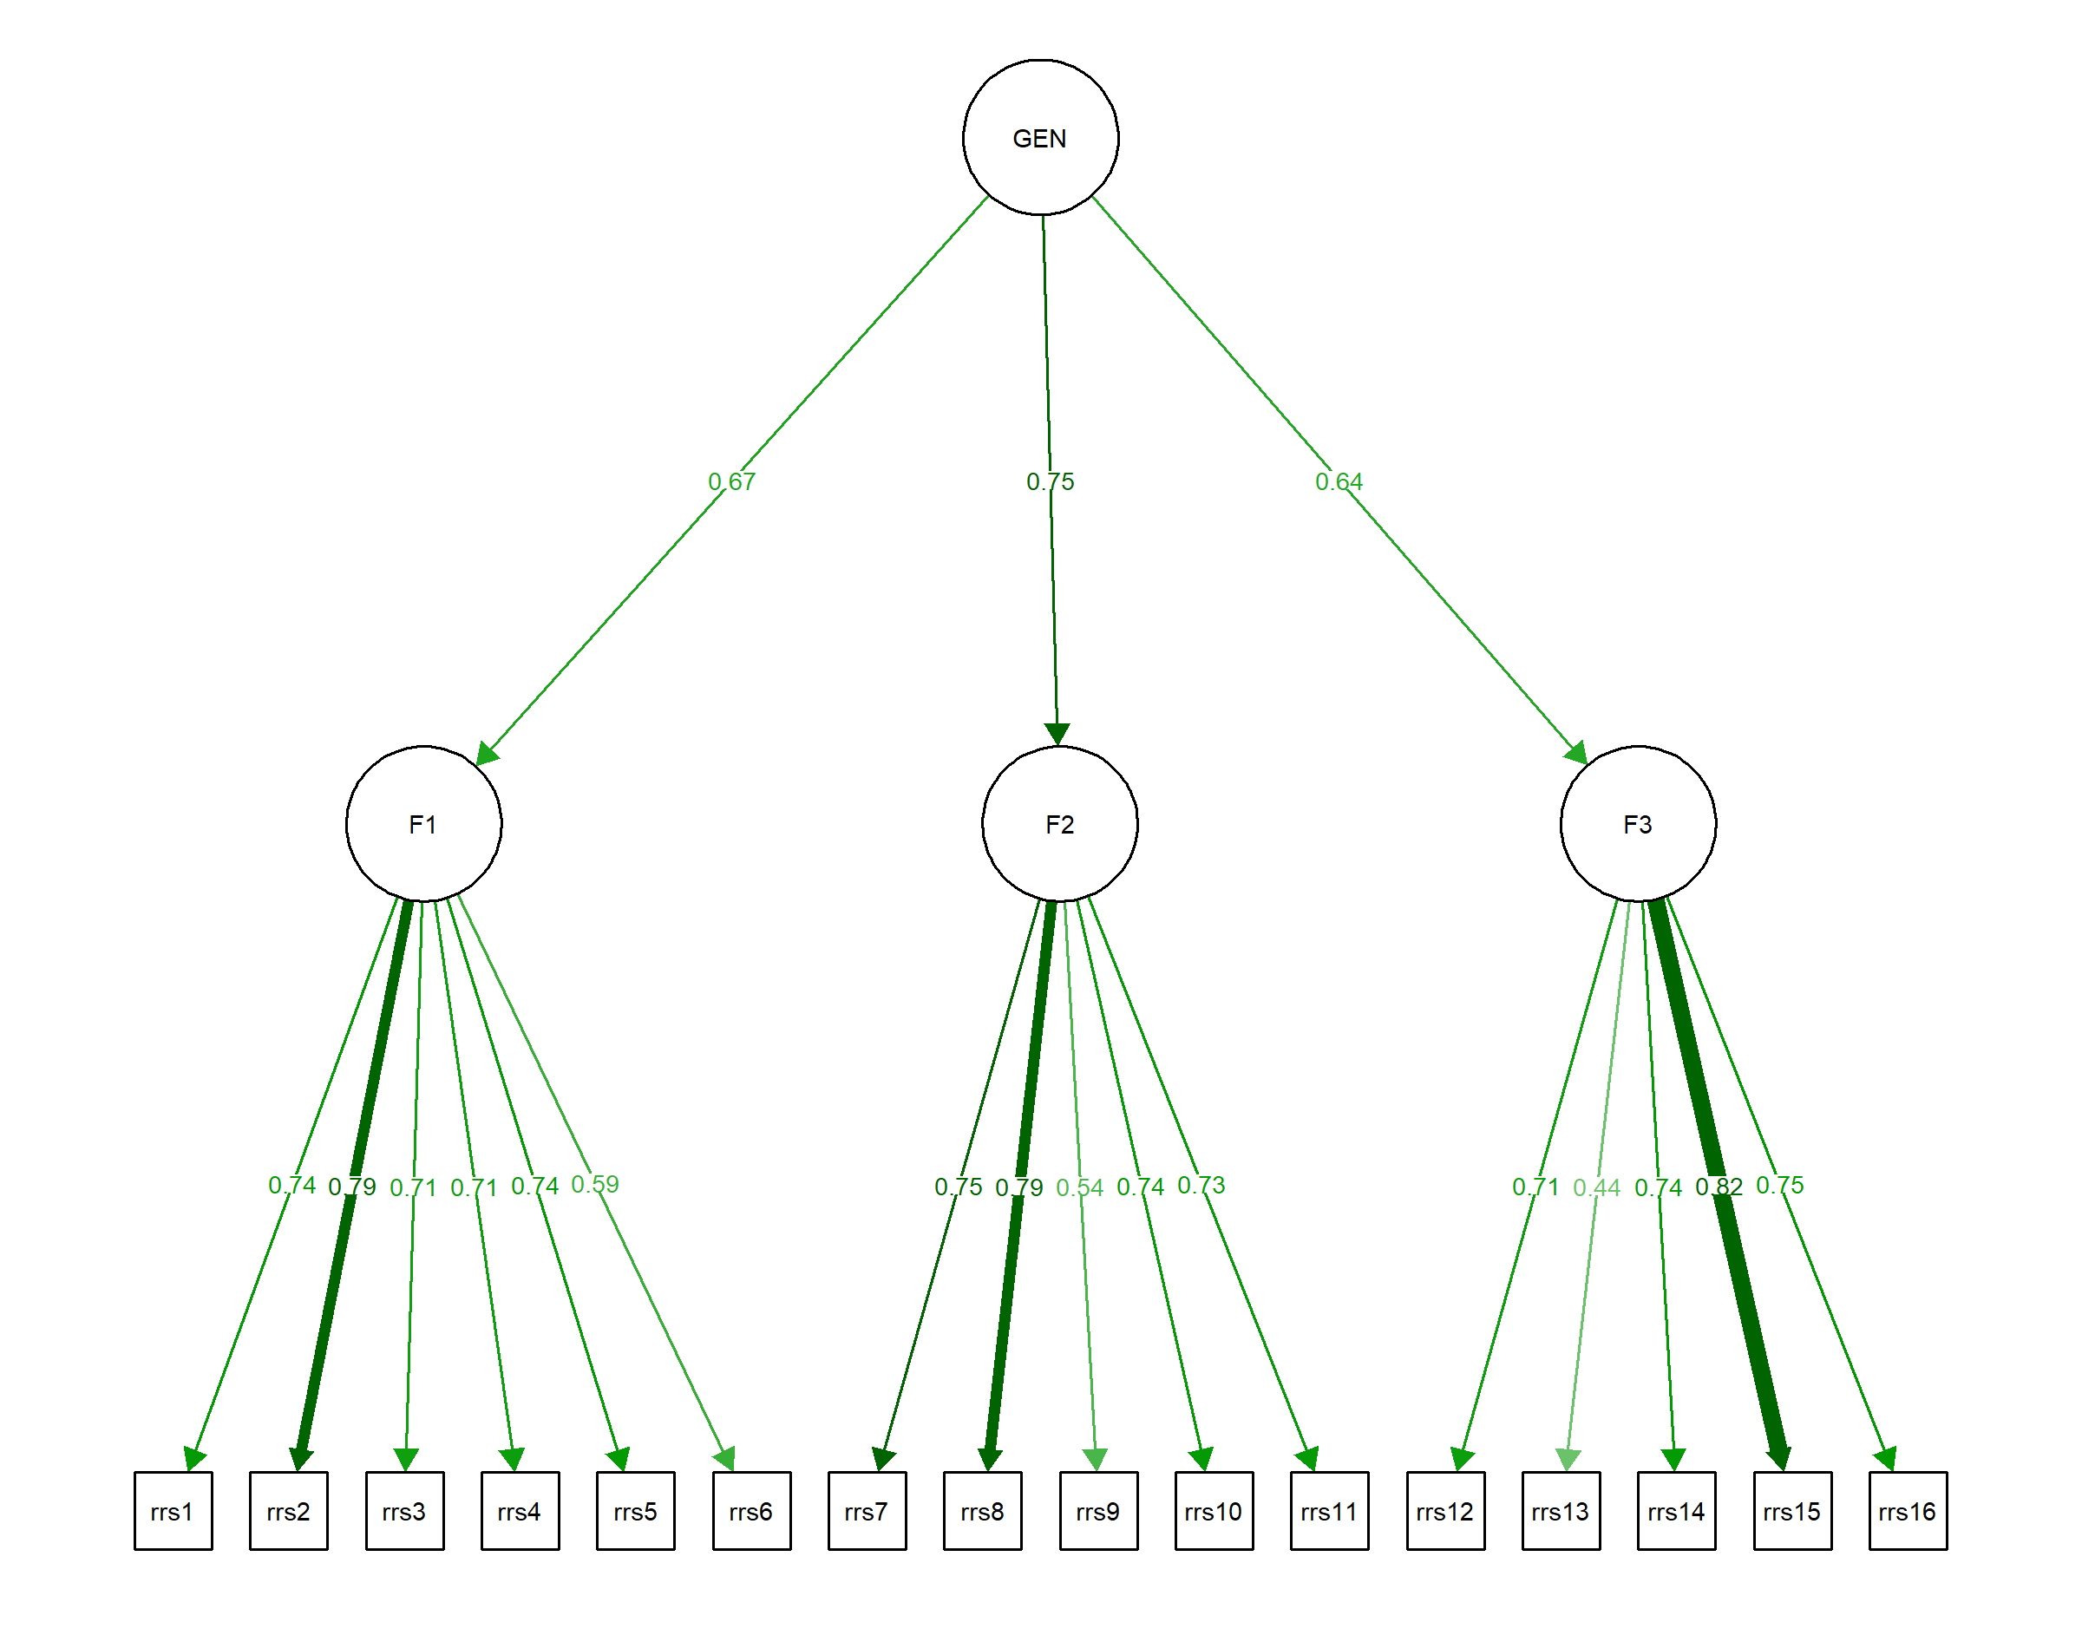
Figure S9.5. Second-Order Standardized Path Diagram (16-Item RRS Pool; Validation Subsample, N = 289)
Note. The second-order factor (GEN) loads differentially on F1, F2, and F3 (.67, .75, and .64, respectively), reproducing the first-order factor correlations of the correlated three-factor model (Figure S9.2) exactly, as this specification is a fit-equivalent reparameterization rather than a distinct competing model (Table S9.1 note); first-order loadings are identical to the correlated three-factor model.
Exploratory Structural Equation Modeling
ESEM with target rotation converged successfully and showed excellent fit: chi-square(75) = 86.00 (scaled), p = .181, CFI = .996, TLI = .993, RMSEA = .023 [90% CI: .000, .042], SRMR = .028 -- a substantial improvement over the CFA-3 correlated model on every fit index (CFI .996 vs. .952; RMSEA .023 vs. .064), consistent with the additional free (non-target) cross-loading parameters absorbing model-inconsistent covariance that the strictly simple-structure CFA could not accommodate. Two items showed a secondary (cross-)loading at or above .20 under target rotation: rrs6 (secondary = .237 on F2) and rrs9 (secondary = .327 on F3, essentially tied with its own primary/theoretical loading of .331 on F2, a difference of only .004); rrs9 was the only item exceeding the stricter .30 cross-loading threshold. Unlike in the reference two-factor case, rrs9's larger loading remained (narrowly) on its theoretical factor F2 under target rotation, though the near-equality of its two loadings indicates substantively meaningful cross-loading rather than a clean simple-structure pattern. The Geomin-rotated ESEM sensitivity model, which failed in an earlier analysis attempt because of a lavaan version-specific rotation-argument incompatibility, was successfully re-estimated using a defensive procedure that tried multiple rotation-argument specifications in sequence (geomin.epsilon, then epsilon, then no argument) and succeeded on the first attempt (geomin.epsilon); it converged to fit statistics identical to the Target rotation (CFI = .996, RMSEA = .023) and to a nearly identical cross-loading pattern, though under Geomin rotation rrs9's loading on F3 (.342) narrowly exceeded its loading on F2 (.325), reversing the theoretical assignment by a small margin.
Table S9.5. CFA-3 versus ESEM Fit Comparison and Rotation Status (16-Item RRS Pool; Validation Subsample)
Model | chi-square | df | p | CFI | TLI | RMSEA | SRMR
CFA-3 (correlated) | 220.15 | 101 | < .001 | .952 | .942 | .064 | .063
ESEM-3 (Target) | 86.00 | 75 | .181 | .996 | .993 | .023 | .028
ESEM-3 (Geomin) | 86.00 | 75 | .181 | .996 | .993 | .023 | .028
Note. ESEM-3 (Geomin) initially failed in a prior analysis attempt with an "unknown option" error concerning the rotation-argument name (a lavaan version-specific rotation-argument incompatibility). It was successfully re-estimated here using a defensive procedure that attempted, in order, the rotation-argument specifications geomin.epsilon, epsilon, and no argument, stopping at the first specification that produced a converged, proper (positive-definite) solution; geomin.epsilon succeeded on the first attempt. Both ESEM rotations converged to numerically identical fit statistics (to the reported precision) and closely matching loading patterns (Tables S9.6 note), consistent with the statistical expectation that different rotations of an identical ESEM model specification alter the loading matrix but not model-implied fit.
Table S9.6. ESEM Target-Rotation Standardized Loadings and Cross-Loading Diagnostics (16-Item RRS Pool; Validation Subsample, N = 289)
Item | Primary factor | Primary loading | Secondary factor | Secondary loading
rrs1 | F1 | .847 | F2 | -.126
rrs2 | F1 | .778 | F3 | .061
rrs3 | F1 | .698 | F2 | .017
rrs4 | F1 | .753 | F3 | -.090
rrs5 | F1 | .722 | F2 | .041
rrs6 | F1 | .319 | F2 | .237
rrs7 | F2 | .700 | F3 | .084
rrs8 | F2 | .782 | F1 | .021
rrs9 | F2 | .331 | F3 | .327
rrs10 | F2 | .836 | F3 | -.143
rrs11 | F2 | .765 | F3 | -.042
rrs12 | F3 | .745 | F2 | -.014
rrs13 | F3 | .277 | F1 | .195
rrs14 | F3 | .775 | F2 | -.074
rrs15 | F3 | .772 | F2 | .107
rrs16 | F3 | .744 | F2 | .033
Note. Rotation: target, with a near-zero target matrix reflecting the theoretical block structure. For rrs9, the primary (theoretical) loading on F2 (.331) and the secondary loading on F3 (.327) are nearly equal (difference = .004), indicating substantively meaningful cross-loading rather than a clean simple-structure pattern; under the Geomin sensitivity rotation (Figure S9.7), this near-tie reverses, with the F3 loading (.342) narrowly exceeding the F2 loading (.325). Two items (rrs6, rrs9) show a secondary loading >= .20; only rrs9 exceeds .30.
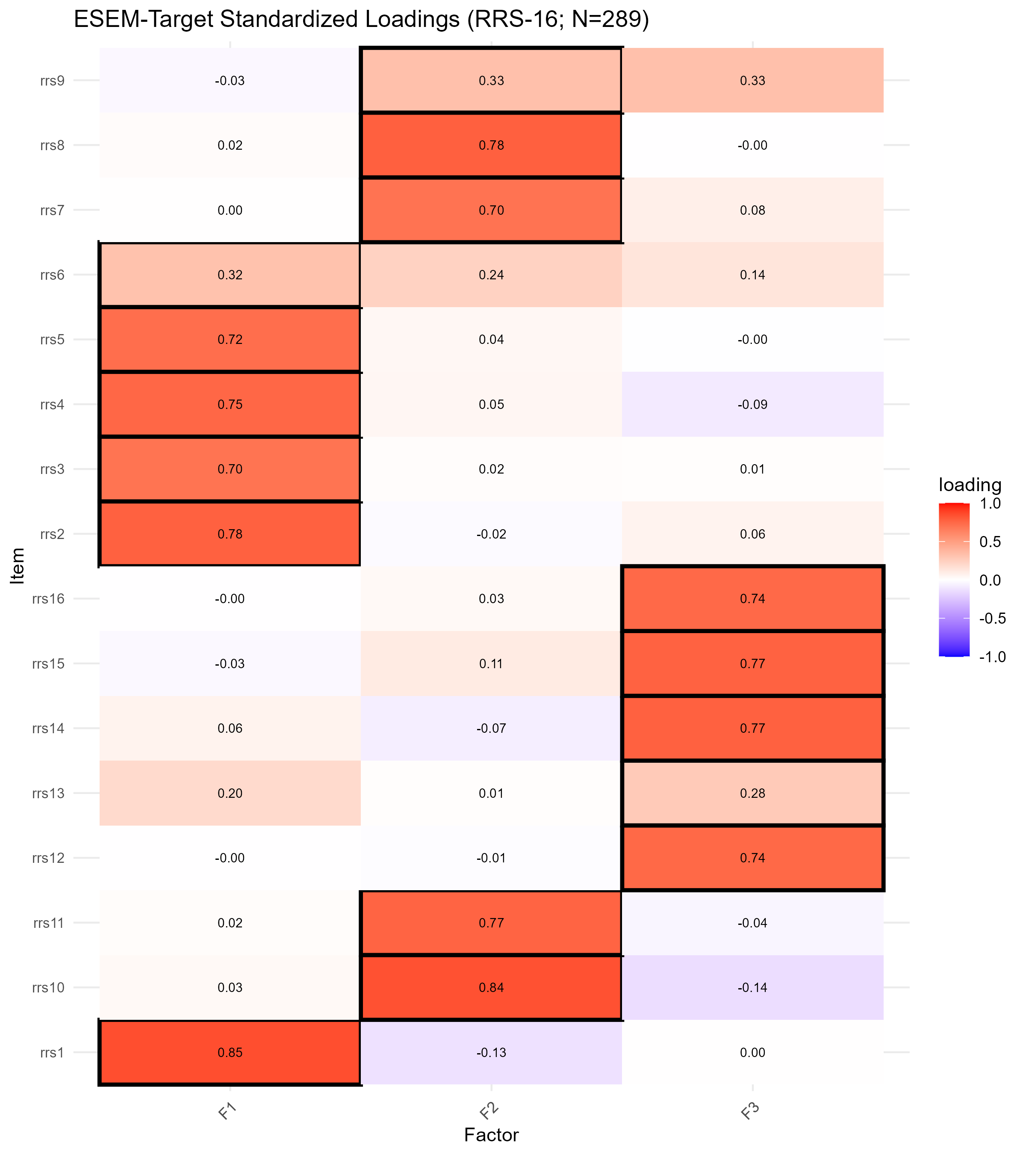
Figure S9.6. ESEM Target-Rotation Standardized Loadings by Item (16-Item RRS Pool; Validation Subsample, N = 289)
Note. Cell values are standardized ESEM loadings on F1, F2, and F3 under target rotation. Item rrs9 shows a visibly larger secondary-factor loading than the remaining 15 items, with its F2 (.33) and F3 (.33) loadings nearly indistinguishable in magnitude; rrs6 shows the second-largest secondary loading (.24 on F2) but its primary F1 loading (.32) remains the larger of the two.
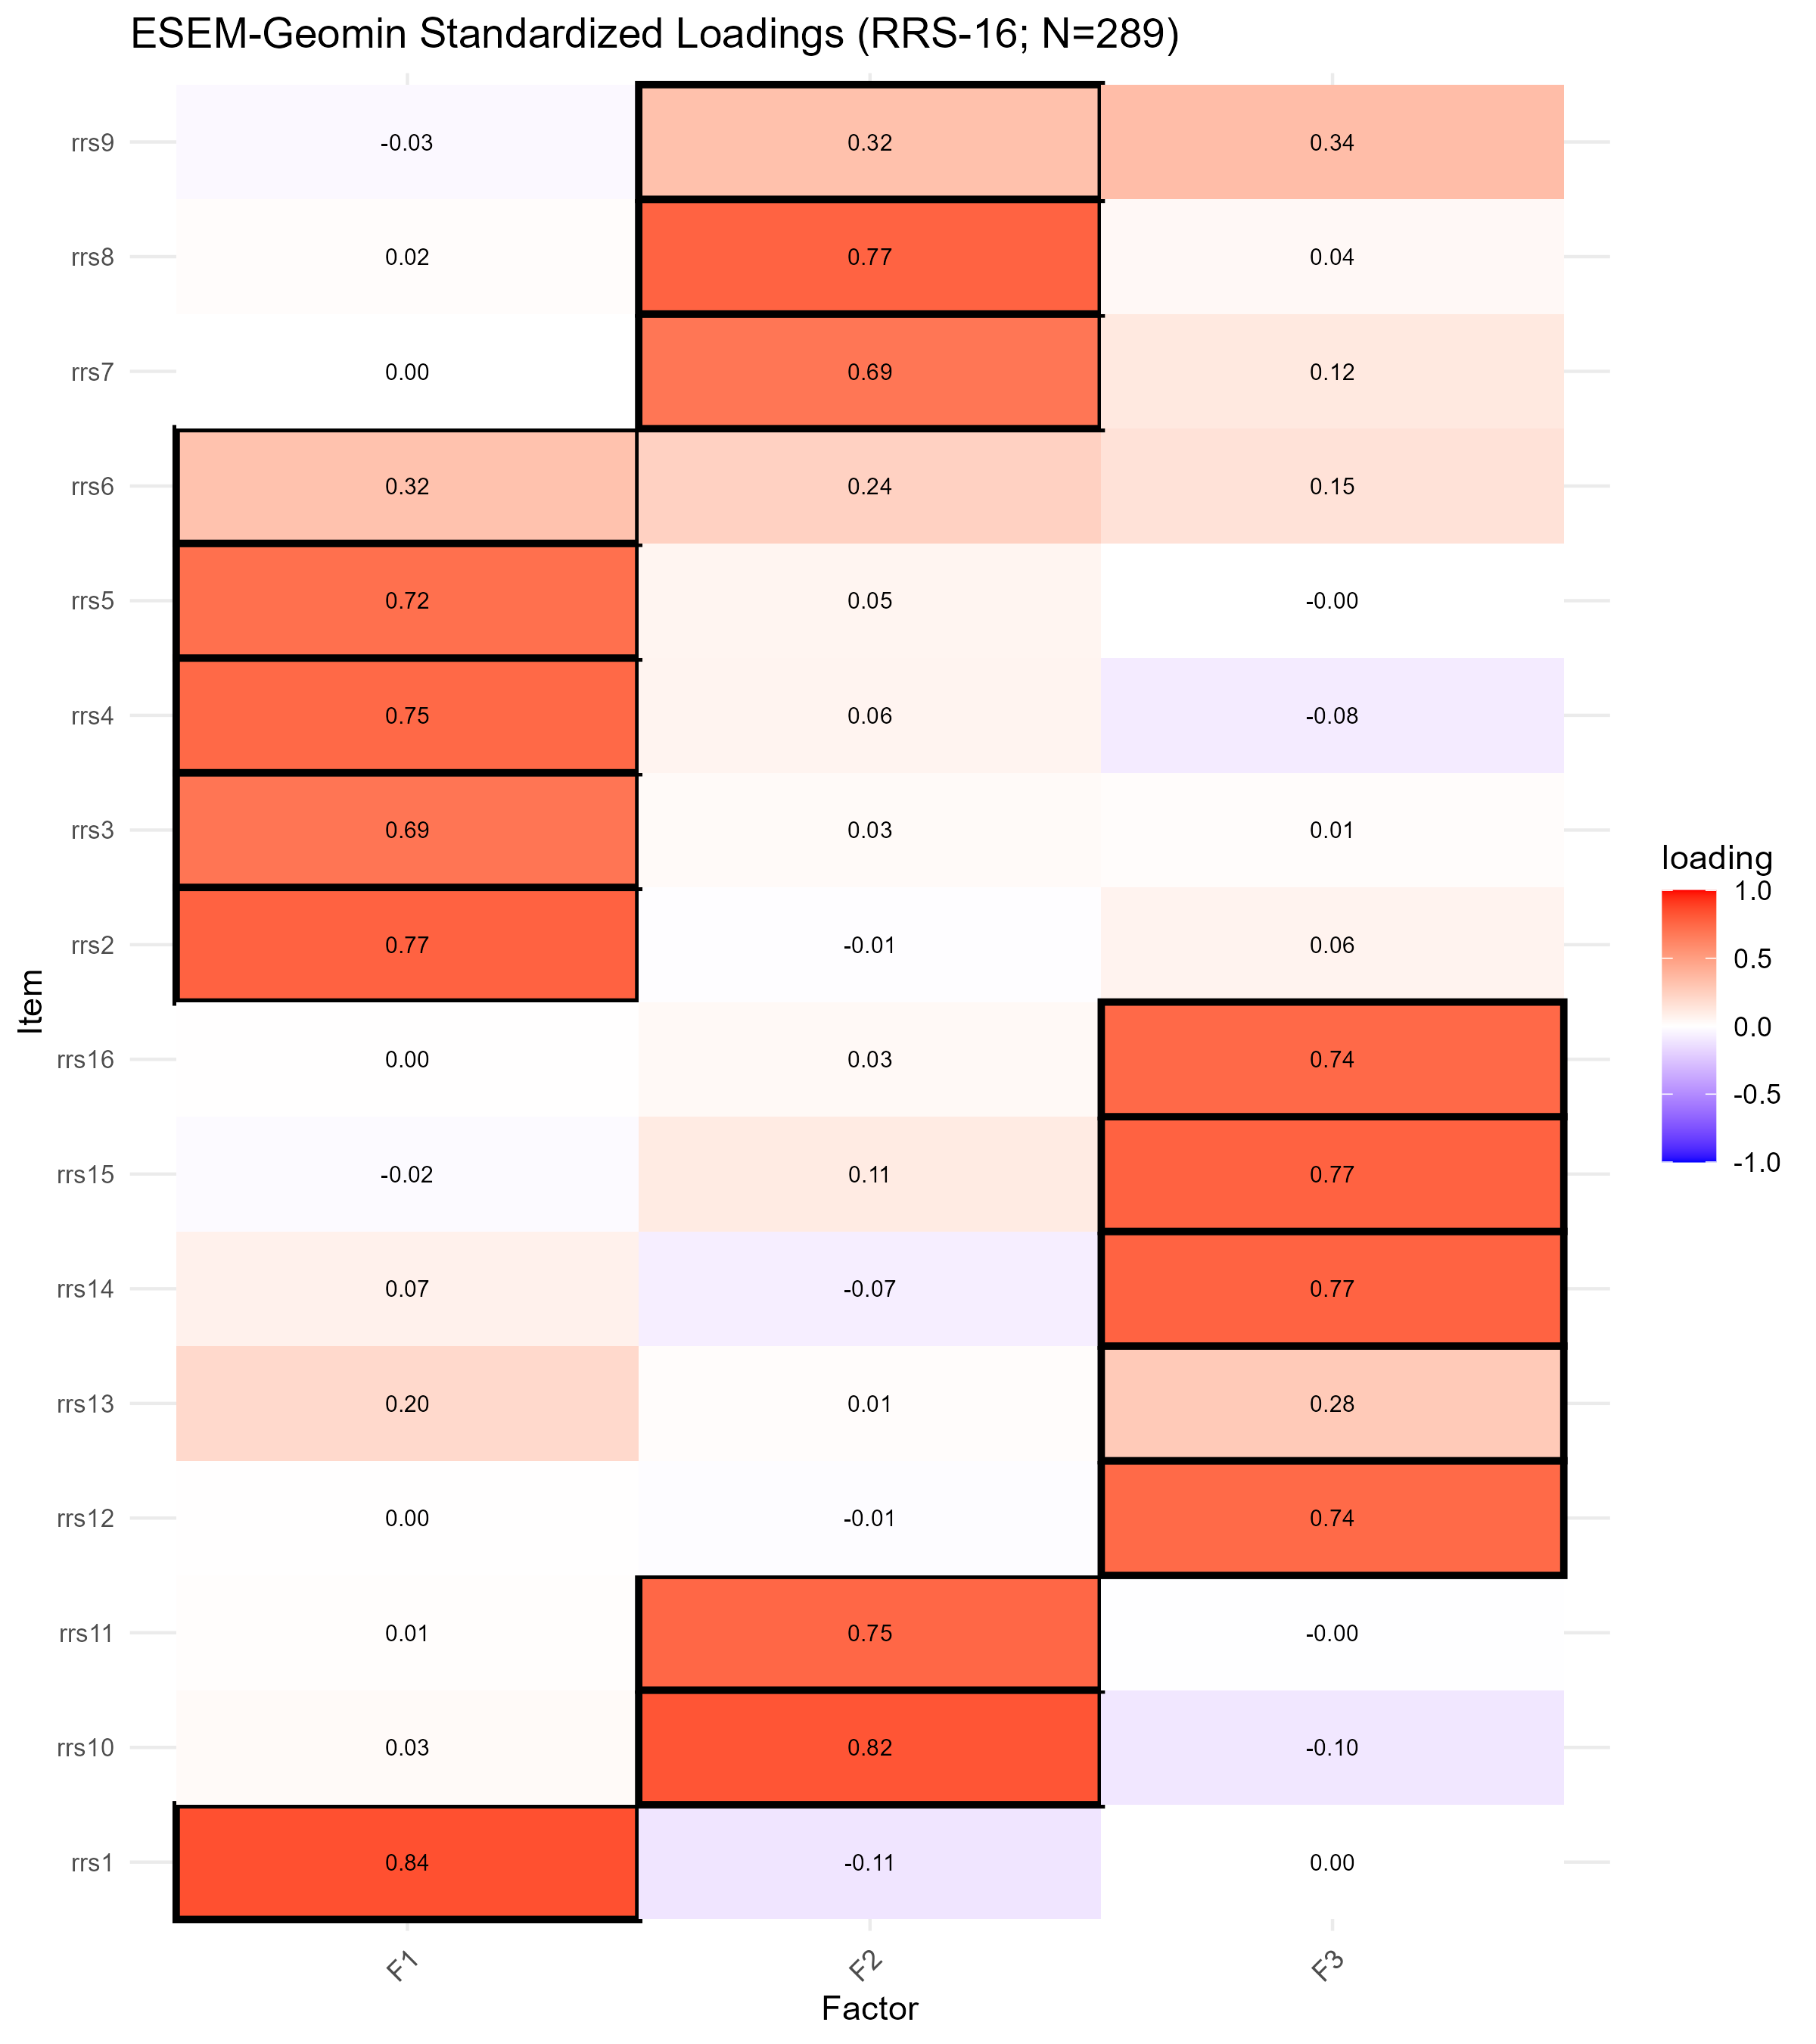
Figure S9.7. ESEM Geomin-Rotation Standardized Loadings by Item (16-Item RRS Pool; Validation Subsample, N = 289)
Note. Cell values are standardized ESEM loadings on F1, F2, and F3 under Geomin rotation, estimated using the defensive rotation.args procedure described in Table S9.5. The loading pattern closely replicates the Target-rotation solution (Figure S9.6), including the near-reversal for rrs9 (F2 = .325, F3 = .342).
Bootstrap Stability
Bootstrap resampling (B = 200) confirmed that model fit was not an artifact of a single sample draw: 100% of replications converged for both the CFA-3 and ESEM models. Mean bootstrap fit for the CFA-3 correlated model was CFI = .931 (SD = .018), RMSEA = .078 (SD = .010), SRMR = .073 (SD = .007); mean bootstrap fit for the ESEM-Target model was CFI = .975 (SD = .008), RMSEA = .054 (SD = .008), SRMR = .038 (SD = .003). The ESEM model showed both higher mean fit and lower fit variability than the CFA-3 model across all three indices, confirming that ESEM's fit advantage over strict simple-structure CFA generalizes beyond the single validation-sample draw.
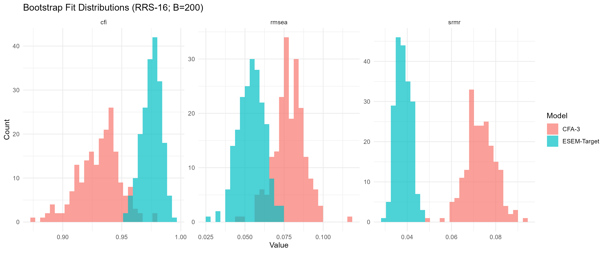
Figure S9.8. Bootstrap CFA-3 and ESEM-Target Fit Distributions (16-Item RRS Pool; B = 200)
Note. Histograms of CFI, RMSEA, and SRMR across 200 bootstrap resamples for the CFA-3 (correlated) and ESEM-Target models. The ESEM distributions are shifted toward better fit (higher CFI, lower RMSEA/SRMR) and are narrower than the corresponding CFA-3 distributions on all three indices, indicating that ESEM's advantage is stable across resamples rather than specific to the single validation-sample draw.
Discriminant Validity (HTMT)
The heterotrait-monotrait ratio of correlations (HTMT) among the three factors ranged from .459 (F1-F3) to .516 (F1-F2), with F2-F3 = .506; all three pairwise ratios fell well below both the conservative (.85) and liberal (.90) thresholds conventionally used to indicate discriminant-validity concerns (Henseler, Ringle, & Sarstedt, 2015), confirming that the three factors are empirically distinguishable despite their moderate latent correlations (F1-F2 = .500, F1-F3 = .429, F2-F3 = .484; Table S9.2).
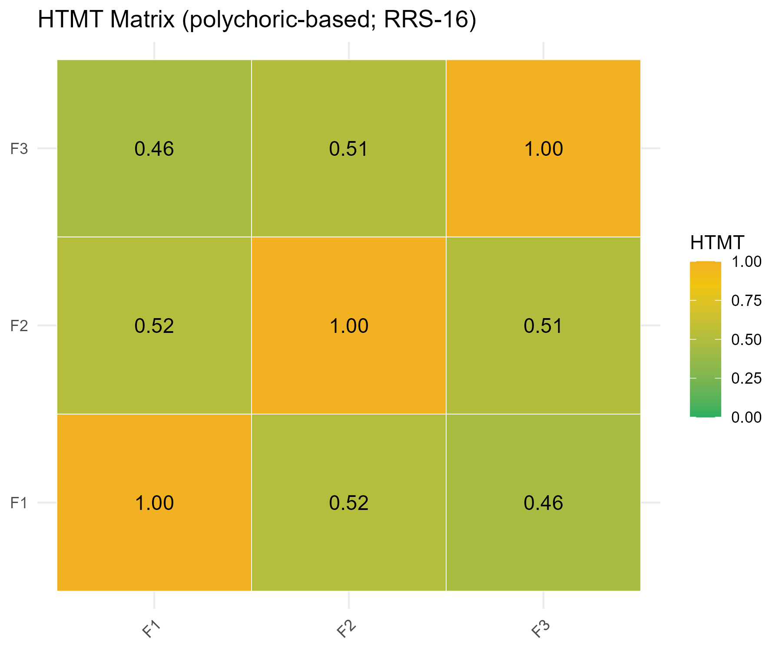
Figure S9.9. HTMT (Heterotrait-Monotrait) Matrix (16-Item RRS Pool; Validation Subsample, N = 289)
Note. Off-diagonal values are the HTMT ratios between factor pairs (F1-F2 = .516, F1-F3 = .459, F2-F3 = .506); diagonal values (1.00) are shown for completeness and are not interpreted. All off-diagonal values fall well below both the .85 and .90 discriminant-validity thresholds.
Summary of Confirmatory Results
Table S9.7 summarizes the confirmatory evidence from the validation subsample.
Table S9.7. Summary of Confirmatory Evidence (16-Item RRS Pool; Validation Subsample, N = 289)
Indicator | Value
CFA-3 correlated model fit (scaled) | CFI = .952, TLI = .942, RMSEA = .064, SRMR = .063
Bifactor model fit (scaled) | CFI = .980, TLI = .973, RMSEA = .044, SRMR = .044
ESEM-Target model fit (scaled) | CFI = .996, TLI = .993, RMSEA = .023, SRMR = .028
Lowest CFA-3 standardized loading | rrs13 = .440
Largest SAFE residual correlation | rrs9-rrs15 = .194
ESEM items with secondary loading >= .30 | 1 (rrs9)
HTMT range (three factor pairs) | .459-.516 (all < .85)
Bootstrap convergence (CFA-3 / ESEM) | 100% / 100% (B = 200)
Note. Across the confirmatory diagnostics -- standardized loadings, residual correlations, and ESEM cross-loadings -- rrs9 and rrs13 show the weakest and least model-consistent performance in the 16-item pool under confirmatory methods, while rrs6 (the item most consistently flagged in the pilot, S3, and exploratory, S8, stages) shows a moderate but not extreme CFA loading (.589) and a secondary ESEM loading below the stricter .30 threshold. This partial but not complete convergence across pilot, exploratory, and confirmatory evidence is addressed directly in the item-reduction synthesis (S10).
Taken together, the validation-subsample confirmatory results provide strong convergent support for the theoretical three-factor RRS-16 structure overall (ESEM CFI = .996, RMSEA = .023; bifactor CFI = .980; HTMT range .459-.516 supporting discriminant validity), while the strict simple-structure CFA-3 model meets the CFI but not the standard RMSEA criterion (though it meets both dynamic, sample-size-adjusted criteria; Table S0.1, S9 row). The confirmatory evidence identifies rrs9 and rrs13 as the items showing the most model-inconsistent performance under confirmatory methods, a pattern that partially, but not fully, overlaps with the items flagged in the exploratory analyses (S8: primarily rrs6, with rrs9 also flagged under stricter sensitivity criteria). This confirmatory evidence is combined with the exploratory (S8) and pilot-stage (S3) evidence for these items in the item-reduction synthesis that follows (S10).

S10. Item-Reduction Synthesis: Integrating Pilot, Exploratory, and Confirmatory Evidence
Refugee Resilience Scale (RRS): Adaptive Coping and Resource Mobilization in Forced Migration
This section synthesizes evidence from three independent analytic stages -- the pilot study (S3, N = 107), the exploratory factor- and graph-analytic evaluation of the calibration subsample (S8, N = 290), and the confirmatory factor-analytic and exploratory structural equation modeling evaluation of the validation subsample (S9, N = 289) -- to reach a single, evidence-based decision on whether any of the 16 RRS items should be revised, flagged for cautious interpretation, or removed. Five items (rrs3, rrs6, rrs9, rrs11, rrs13) were flagged at one or more analytic stages by at least one empirical criterion (item-total statistics, EFA/CFA loadings, EGA community assignment and bootstrap stability, or ESEM/residual diagnostics). A sixth item, rrs7, met two of the three stricter sensitivity criteria in the calibration subsample alone (Table S8.4) but was unflagged at the pilot stage and in the validation subsample, and is therefore not carried into the three-way synthesis below; it is noted here for completeness; of these, rrs6 and rrs9 additionally carried a prior theoretical flag as pre-specified monitoring items (see S10.2 for the provenance of that flag), designated before any quantitative data had been collected. Deferring this synthesis until confirmatory (S9) results were available -- rather than acting on the exploratory (S8) results alone -- avoided the circularity of flagging and removing items within the same sample and allowed the decision below to rest on independent-sample replication across three analytic stages.
Theoretical Flags Carried Forward as Pre-Specified Monitoring Items
Two items were designated on theoretical grounds as pre-specified monitoring items before the main study, and this prior flag is reproduced here as the starting point of the three-way synthesis. Both are recorded as special_items in the archived pilot analysis script (OSF, pilot.R); rrs9's concern is additionally documented in the content-validity phase (S2, note on the negatively worded structure of M15). Item rrs6 ("I believe I can improve my situation over time"; F1) was flagged as a belief/expectancy item, structurally different from the remaining F1 items, which are behavioral-capacity items. Item rrs9 ("When I need support, I do not have difficulty asking for it."; F2) was flagged as an absence-of-barrier item, conceptually distinct from the remaining F2 items, which are worded as the presence of a resource. Both concerns were reiterated empirically at the pilot stage (S3, Table S3.6): rrs6 showed the lowest primary EFA loading within its own factor (F1) in the pilot analysis (.405) and the largest cross-loading (.356, on F3); rrs9 showed a below-threshold corrected item-total correlation (CITC = .284) and the lowest primary loading in F2 (.391). No other item carried a prior theoretical flag; rrs3, rrs11, and rrs13 were flagged for the first time on purely empirical grounds during the pilot-stage analyses (S3, Table S3.6).
Three-Way Evidence Comparison
Table S10.1 consolidates the key diagnostic indicators for the five candidate items across the pilot (S3), exploratory calibration-subsample (S8), and confirmatory validation-subsample (S9) analyses. The pattern of evidence is only partially consistent across the three independent samples. Item rrs6 showed the most volatile trajectory: the lowest primary loading within F1 at the pilot stage (.405; the lowest primary loadings in the pilot pool overall were rrs9 = .391 and rrs13 = .401) and an even lower, weak and ambiguous loading in the calibration EFA (.303, meeting both the pilot-consistent and strict sensitivity flagging criteria in S8), together with EGA misallocation to the F2-aligned community and markedly low bootstrap stability (.318, the lowest of all 16 items); however, its validation-subsample CFA loading recovered substantially (.589), and its ESEM secondary loading (.237) remained below the stricter .30 threshold. Item rrs9 showed a comparatively milder but more consistent pattern: a below-threshold pilot CITC (.284), a moderate calibration EFA loading (.408, flagged only under the stricter sensitivity criteria in S8), and the lowest CFA loading in the validation subsample among these five items apart from rrs13 (.537), together with the single largest SAFE residual correlation in the entire item pool (rrs9-rrs15, r = .194) and the only ESEM secondary loading exceeding .30 (.327, essentially tied with its primary loading of .331). Item rrs13 showed a comparatively low but stable loading across all three stages (.401, .406, .440) without ever showing EGA misallocation, though its EGA bootstrap stability was reduced (.808) and it appeared in one of the five largest validation-subsample residual pairs (rrs2-rrs13, ranked fifth; the rrs3-rrs13 pair ranked eighth). Items rrs3 and rrs11, by contrast, showed only isolated, single-stage empirical flags (a modest pilot-stage cross-loading for rrs3; a comparatively low but above-threshold pilot CITC for rrs11) that did not recur in either the calibration or validation subsamples: both items' loadings recovered to at or above the pool average by the confirmatory stage (rrs3 = .706; rrs11 = .734) and neither showed EGA misallocation, a notable ESEM cross-loading, or a large residual correlation in S9.
Table S10.1. Three-Way Evidence Comparison for Items rrs3, rrs6, rrs9, rrs11, and rrs13: Pilot (S3), Exploratory Calibration (S8), and Confirmatory Validation (S9)
Item | Prior theoretical flag  (pre-specified monitoring item) | S3 pilot  primary loading | S8 calibration  primary loading | S8 EGA  community | S9 validation  CFA loading | S9 ESEM  secondary loading
rrs3 | None | .649 | .780 | 1 (correct) | .706 | .017
rrs6 | Yes (belief/expectancy item) | .405 | .303 | 2 (misallocated) | .589 | .237
rrs9 | Yes (absence-of-barrier item) | .391 | .408 | 2 (correct) | .537 | .327*
rrs11 | None | .706 | .712 | 2 (correct) | .734 | -.042
rrs13 | None | .401 | .406 | 3 (correct) | .440 | .195
Note. S3 values from the pilot EFA pattern matrix (Table S3.5) and the pilot flag summary (Table S3.6), N = 107; S8 values from Tables S8.2 and S8.5 (calibration subsample, N = 290; complete-case n = 271); S9 values from Tables S9.2 and S9.6 (validation subsample, N = 289). *rrs9's ESEM secondary loading (.327) is the only one among the five items exceeding the stricter .30 threshold and is essentially tied with its primary loading (.331, difference = .004); see S9 Table S9.6 note. "Misallocated" reflects EGA community assignment inconsistent with the theoretical factor, as defined in S8 (Table S8.5).
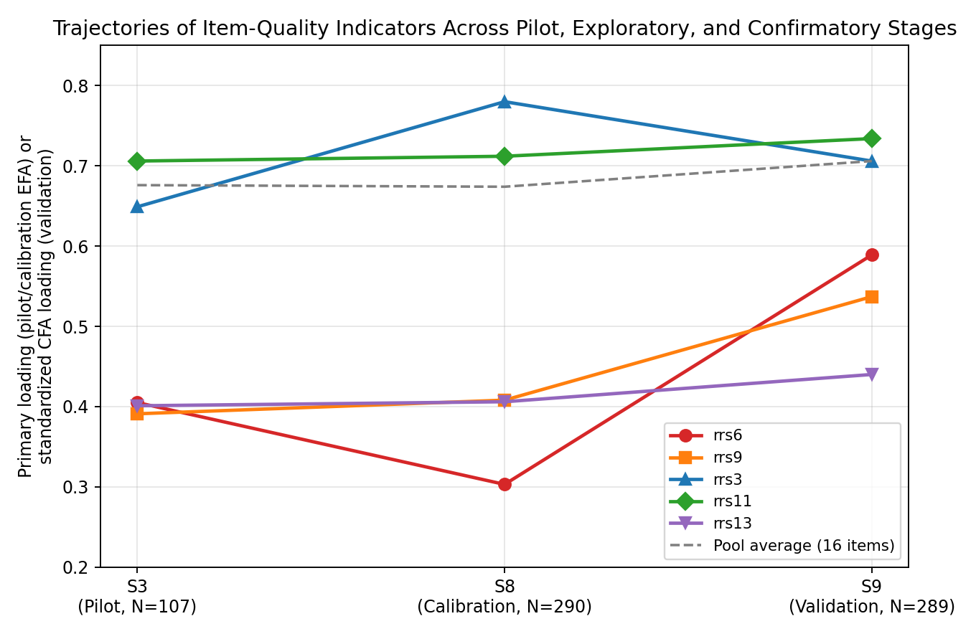
Figure S10.1. Trajectories of Item-Quality Indicators for rrs3, rrs6, rrs9, rrs11, and rrs13 Across the Pilot (S3), Exploratory Calibration (S8), and Confirmatory Validation (S9) Stages
Note. Primary/loading-type values (pilot EFA primary loading, calibration EFA primary loading, validation CFA standardized loading) are plotted for each of the five items across the three analytic stages, alongside the mean primary/standardized loading across all 16 items at each stage (dashed reference line). rrs3 and rrs11 converge toward or above the pool average by the validation stage; rrs6, rrs9, and rrs13 remain below the pool average at every stage, with rrs6 showing the most volatile trajectory (a pronounced dip in the calibration subsample followed by partial recovery in the validation subsample).
Item-Level Decision Rationale
Consistent with the fixed, already-finalized 16-item RRS pool established prior to the calibration/validation analyses (S8, S9), and in the absence of a pre-specified stopping rule authorizing post hoc item removal from a scale whose content-validity and cognitive-interviewing evidence (S1/S2) had already been established for all 16 items, no item is removed from the RRS-16 on the basis of the exploratory and confirmatory evidence reviewed here. This decision was reached by explicit consideration of the confirmatory (S9) evidence before finalizing any judgment about the exploratory (S8) flags, per the analytic sequence agreed upon at the outset of this synthesis. Three considerations support retaining all 16 items rather than trimming any of the five flagged items. First, none of the five items' CFA standardized loadings in the validation subsample (.440-.734) fell below conventionally used minimum-adequacy thresholds for retention (e.g., .30 or .32; Tabachnick & Fidell, 2019); even rrs13, the lowest-loading item in the entire 16-item pool under the confirmatory simple-structure model, remained well above this threshold. Under target-rotated ESEM, which frees all cross-loadings, the primary loadings of rrs13 (.277) and rrs6 (.319) do fall at or below these thresholds (Table S9.6); this is the expected consequence of redistributing an item's variance across all three factors when its content is not cleanly factor-specific, and it is one of the reasons these two items are designated for continued monitoring below rather than a basis for removing them from a fixed pool. Second, no residual correlation involving any of the five items exceeded |r| = .20 in the validation-subsample CFA (Table S9.3), the threshold conventionally used to indicate a serious local-fit problem warranting model revision; rrs9's largest residual pairing (rrs9-rrs15, r = .194) approached but did not reach this threshold. Third, removing items post hoc based on exploratory and confirmatory loadings alone, without an a priori removal criterion specified before data collection, risks capitalizing on chance, sample-specific characteristics of the data: MacCallum, Roznowski, and Necowitz (1992) demonstrated that data-driven model modifications made in response to a single sample's fit or loading pattern can be highly inconsistent across samples and often fail to generalize, precisely because such modifications are fitted to the idiosyncrasies of the sample at hand rather than to a stable population-level structure. This concern is elevated, rather than resolved, by the fact that the sensitivity analysis reported below was itself conducted post hoc, after observing rrs9's confirmatory performance; treating its results as sufficient grounds for removal would repeat the same capitalization-on-chance problem in a single additional pass over the same validation subsample rather than avoiding it. Consistent with recent best-practice guidance for scale development, which recommends weighing the psychometric benefits of item removal against the loss of theoretical coherence and content validity rather than applying statistical criteria in isolation (Stefana et al., 2025), and with the broader recommendation that expert-panel and target-population evidence gathered during content-validation should inform -- not be overridden by -- subsequent psychometric performance (Morgado, Meireles, Neves, Amaral, & Ferreira, 2017), removing rrs6 and rrs9 on the basis of the present evidence alone would compromise the content validity established during cognitive interviewing (S1/S2), where both were retained (not newly introduced) items already judged to capture conceptually distinct facets of the target constructs (belief/expectancy for rrs6; absence-of-barrier support-seeking for rrs9).
Recommended Handling of Flagged Items
Although no item is removed, the convergent evidence across the three stages distinguishes two items warranting continued monitoring from three items whose flags did not replicate consistently. Item rrs9 shows the most consistent cross-stage concern of the five items: it carried a prior theoretical flag as a pre-specified monitoring item, showed a below-threshold pilot CITC, and is the only item whose confirmatory ESEM secondary loading (.327) essentially ties its primary loading (.331) and is the only item in the pool exceeding the .30 cross-loading threshold; it is also involved in the two largest residual correlations in the validation-subsample CFA (rrs9-rrs15 and rrs9-rrs12). The near-equality of rrs9's primary and secondary ESEM loadings (a difference of only .004, and one that reverses under Geomin rotation; S9, Table S9.6) indicates weak factorial clarity for this item specifically, rather than a generically low but well-defined loading: rrs9 does not clearly belong to F2 more than to F3 in the ESEM solution, which is a qualitatively different and arguably more serious concern than a low but unambiguous primary loading. Item rrs6 shows the most volatile, stage-dependent pattern: it carried the same prior theoretical flag as a pre-specified monitoring item and showed the weakest exploratory performance of any item in the 16-item pool (lowest calibration EFA loading, EGA misallocation, lowest bootstrap stability), yet its confirmatory CFA loading recovered to a moderate, acceptable level (.589) and its ESEM cross-loading remained below the stricter .30 threshold; this pattern suggests that rrs6's exploratory-stage weakness may partly reflect calibration-subsample-specific variation rather than a stable structural problem, though its theoretical flag and volatile trajectory warrant continued monitoring rather than dismissal. Item rrs13 shows a stable but comparatively low loading across all three stages without EGA misallocation or a notable ESEM cross-loading; it is retained with a general monitoring recommendation but without the elevated priority given to rrs6 and rrs9. Items rrs3 and rrs11 showed only isolated, single-stage flags that did not replicate in either subsequent stage and are retained without additional qualification beyond the general monitoring recommendation below.
Sensitivity Analysis: Impact of Removing rrs9 and/or rrs13
Because the retention decision above rests on a judgment call rather than a statistical necessity -- no pre-specified removal threshold was reached, but rrs9 and rrs13 nonetheless showed the least model-consistent confirmatory performance of the five flagged items -- a post hoc sensitivity analysis was conducted to quantify how much removing these two items would actually change model fit and factor reliability, in the same validation subsample (N = 289) used for the confirmatory analyses reported above (S9). Three alternative three-factor CFA models were re-estimated using the identical WLSMV, theta-parameterization pipeline as the retained model: (a) rrs9 removed (F2 reduced to 4 items: rrs7, rrs8, rrs10, rrs11), (b) rrs13 removed (F3 reduced to 4 items: rrs12, rrs14, rrs15, rrs16), and (c) both items removed simultaneously (14-item model). All three alternative models converged without Heywood cases.
Removing rrs9 alone improved fit appreciably: CFI rose from .952 to .968 (Delta = +.016) and RMSEA improved from .064 to .055 (Delta = -.009), alongside a corresponding increase in F2's model-based reliability (omega from .808 to .824). Removing rrs13 alone had a negligible effect on fit -- CFI rose only marginally (.952 to .956, Delta = +.004) and RMSEA was essentially unchanged (.064 to .065, Delta = +.001, i.e., a trivial worsening) -- despite rrs13 being the lowest-loading item in the pool; however, F3's reliability still improved consistently with removal (omega from .798 to .822), since omega reflects average inter-item covariance within the factor independent of overall model fit. Removing both items simultaneously produced the best-fitting 14-item model of the four tested (CFI = .974, RMSEA = .052), an improvement of similar magnitude to removing rrs9 alone, indicating that the combined benefit is driven primarily by rrs9's removal rather than an additive or synergistic effect of removing both items together.
Table S10.2. Sensitivity Analysis: CFA Fit Comparison Across Item-Removal Scenarios (16-Item RRS Pool; Validation Subsample, N = 289)
Scenario | n items | chi-square | df | CFI | TLI | RMSEA | SRMR
Full 16-item (retained model) | 16 | 220.15 | 101 | .952 | .942 | .064 | .063
rrs9 removed | 15 | 162.18 | 87 | .968 | .961 | .055 | .056
rrs13 removed | 15 | 192.61 | 87 | .956 | .946 | .065 | .061
rrs9 + rrs13 removed | 14 | 132.10 | 74 | .974 | .968 | .052 | .052
Note. All models estimated with WLSMV and theta parameterization on the validation subsample (N = 289), using the identical estimation pipeline as the retained 16-item model (S9). Chi-square values are WLSMV robust (scaled) statistics; all four models converged without Heywood cases (non-positive-definite solutions). Removing rrs9 improved fit on every index; removing rrs13 alone had a negligible-to-slightly-unfavorable effect on RMSEA despite rrs13's low standardized loading (Table S9.2); the combined 14-item model's improvement is attributable primarily to rrs9's removal rather than an additive effect of removing both items.
Factor-level reliability (model-based omega, computed via semTools) showed a pattern consistent with the fit results: F2's omega improved from .808 (16-item model) to .824 when rrs9 was removed, while F3's omega improved from .798 to .822 when rrs13 was removed, and F1's omega (which does not involve either flagged item) remained essentially unchanged across all four scenarios (.835 in every scenario), confirming that the reliability gains are specific to the factor losing the flagged item rather than an artifact of overall model re-estimation. Neither removal altered the qualitative pattern of factor intercorrelations: all pairwise factor correlations remained in the moderate range (.40-.50) across all four scenarios, indicating that removing either or both items would not materially change the substantive interpretation of the three-factor structure.
Taken together, this sensitivity analysis indicates that removing rrs9 would yield a measurable, non-trivial improvement in both model fit and F2 reliability, whereas removing rrs13 would yield a reliability gain for F3 without a material fit improvement (Delta CFI = +.004, Delta TLI = +.004, Delta SRMR = -.002, Delta RMSEA = +.001). This asymmetry is informative for how rrs9 and rrs13 should be prioritized in continued psychometric monitoring of the RRS-16, rather than as grounds for revising the current item pool: a single item's removal would not constitute a new short-form version of the scale, and no such short-form is proposed here. Instead, rrs9's comparatively larger and more consistent impact on fit across three independent analytic stages (S3, S8, S9) marks it as the higher-priority item for continued quantitative monitoring in future independent samples, while rrs13's evaluation in any future psychometric re-assessment should be guided primarily by content-validity considerations (S1/S2) rather than fit statistics, since its removal here does not resolve a fit problem. Consistent with the decision rationale above, this sensitivity analysis is reported as additional transparency regarding the magnitude of the trade-off involved in retaining these items, and does not itself change the retention decision for the current 16-item RRS, since no pre-specified removal criterion was reached and the fit differences, while real, are modest in absolute terms.
Table S10.3. Final Item-Reduction Decision Summary
Item | Cross-stage pattern | Decision | Priority for future monitoring
rrs3 | Isolated pilot-stage flag; did not replicate in S8 or S9 | Retained | Standard
rrs6 | Prior theoretical flag (pre-specified monitoring item); weakest exploratory performance in the pool; partial confirmatory recovery | Retained | Elevated
rrs9 | Prior theoretical flag (pre-specified monitoring item); pilot-stage and validation-stage concern; in the calibration subsample flagged only under the stricter D1 sensitivity criteria (no D0 flag) | Retained | Elevated
rrs11 | Isolated pilot-stage flag (CITC only); did not replicate in S8 or S9 | Retained | Standard
rrs13 | Stable but comparatively low loading across all three stages; no EGA misallocation | Retained | Standard
Note. "Decision" reflects the outcome of the three-way synthesis in this section, not an isolated judgment based on any single stage. All 16 RRS items are retained in the final scale; rrs6 and rrs9 are additionally discussed as a limitation and priority for future psychometric re-evaluation (see main manuscript), reflecting their prior designation as pre-specified monitoring items combined with their empirical performance across the pilot, exploratory, and confirmatory stages.
In summary, the convergent evidence from three independent samples (pilot, calibration, validation) and multiple analytic methods (item-total statistics, EFA, EGA with bootstrap stability, CFA with residual diagnostics, and ESEM with cross-loading analysis) identifies five items (rrs3, rrs6, rrs9, rrs11, rrs13) as flagged at one or more analytic stages, but distinguishes among them in the consistency of that flagging. rrs9 and rrs6 -- the two items designated on theoretical grounds as pre-specified monitoring items -- show the most persistent (rrs9) and most volatile but theoretically grounded (rrs6) patterns of concern across the three stages, while rrs3 and rrs11 show only isolated, non-replicating pilot-stage flags, and rrs13 shows a stable but modest loading without misallocation. None of the five items, however, met a pre-specified, methodologically justified removal criterion in the confirmatory validation-subsample analysis (S9): all standardized loadings remained above conventional minimum-adequacy thresholds, and no residual correlation reached the level conventionally judged to indicate serious local misfit. The final RRS-16 therefore retains all 16 items, with rrs6's and rrs9's cross-stage patterns noted explicitly as a limitation and priority for continued psychometric monitoring in independent samples and future applications of the scale.
References
Comrey, A. L., & Lee, H. B. (1992). A first course in factor analysis (2nd ed.). Lawrence Erlbaum Associates.
Henseler, J., Ringle, C. M., & Sarstedt, M. (2015). A new criterion for assessing discriminant validity in variance-based structural equation modeling. Journal of the Academy of Marketing Science, 43(1), 115-135.
Hu, L., & Bentler, P. M. (1999). Cutoff criteria for fit indexes in covariance structure analysis: Conventional criteria versus new alternatives. Structural Equation Modeling, 6(1), 1-55.
Kaiser, H. F. (1974). An index of factorial simplicity. Psychometrika, 39(1), 31-36.
MacCallum, R. C., Roznowski, M., & Necowitz, L. B. (1992). Model modifications in covariance structure analysis: The problem of capitalization on chance. Psychological Bulletin, 111(3), 490-504.
Morgado, F. F. R., Meireles, J. F. F., Neves, C. M., Amaral, A. C. S., & Ferreira, M. E. C. (2017). Scale development: Ten main limitations and recommendations to improve future research practices. Psicologia: Reflexao e Critica, 30, Article 3.
Stefana, A., Damiani, S., Granziol, U., Provenzani, U., Solmi, M., Youngstrom, E. A., & Fusar-Poli, P. (2025). Psychological, psychiatric, and behavioral sciences measurement scales: Best practice guidelines for their development and validation. Frontiers in Psychology, 15, Article 1494261.
Tabachnick, B. G., & Fidell, L. S. (2019). Using multivariate statistics (7th ed.). Pearson.

S11. Measurement Invariance Analyses
Refugee Resilience Scale (RRS): Adaptive Coping and Resource Mobilization in Forced Migration
Measurement invariance of the RRS-16 three-factor model was tested across six sociodemographic and background grouping variables (age group, gender, education level, country/region of origin, length of stay in Türkiye, and Turkish comprehension level) using multi-group confirmatory factor analysis on the ordered categorical (ordinal) items with the WLSMV estimator (theta parameterization), consistent with the ordinal treatment used throughout this supplement (see S12, Table S12.4 note). Analyses used the full main-sample dataset (N = 583) rather than the calibration/validation split used in S8-S9, consistent with standard practice of testing invariance on the largest available sample. No imputation was performed: item-level missingness was handled via pairwise-present estimation inherent to the WLSMV estimator (missing = "pairwise"), and participants missing on a given grouping variable were excluded listwise from that variable's invariance test only. For each variable, configural, metric, and scalar invariance were tested sequentially. Model comparisons followed directional fit-index-change criteria (Delta CFI >= -.010, Delta RMSEA <= .015; Delta SRMR <= .030 for metric-configural and <= .010 for scalar-metric comparisons; Chen, 2007; Cheung & Rensvold, 2002). A minimum cell size of n = 50 per category was pre-specified; all six variables' categories met this threshold (smallest: age group's 66-and-above category, n = 76).
Group Sizes. Table S11.1 reports group sizes for the six grouping variables. No variable required category collapsing: every category across all six variables met or exceeded the pre-specified minimum cell size of n = 50, including the smallest category overall (age group 66-and-above, n = 76).
Table S11.1. Group Sizes for the Six Grouping Variables (N = 583)
Grouping variable | Category | n
Age group | 18-35 | 187
 | 36-50 | 197
 | 51-65 | 122
 | 66 and above | 76
Gender | Female | 245
 | Male | 335
Education level | No formal education / Primary school | 137
 | Secondary school / High school | 224
 | Bachelor's / Graduate degree | 220
Country/region of origin | Syria | 289
 | Afghanistan | 161
 | Iraq | 131
Length of stay in Türkiye | 0-5 years | 140
 | 6-10 years | 260
 | 11 years and above | 180
Turkish comprehension level | Moderate | 158
 | Good | 263
 | Very good | 158
Note. Category ns reflect complete (non-missing) responses on each grouping variable; total ns per variable therefore sum to slightly less than 583 where item-level missingness occurred (1-4 cases per variable). No categories were collapsed or merged for any of the six variables. All categories met the pre-specified minimum cell size of 50; the smallest category (age group 66-and-above, n = 76) is nonetheless the subgroup responsible for a data-availability limitation discussed below (Table S11.3).
Fit Indices
Table S11.2 reports configural, metric, and scalar fit indices for all six grouping variables. Five variables (Gender, Education Level, Country/Region of Origin, Length of Stay in Türkiye, Turkish Comprehension Level) produced converged, admissible solutions at all three invariance steps, with fit indices in the good range throughout (CFI = .959-.975; TLI = .951-.978; RMSEA = .042-.060). Age Group was not estimable at any of the three invariance steps; the underlying cause is reported in detail below.
Table S11.2. Configural, Metric, and Scalar Invariance Model Fit Indices (WLSMV, Scaled Statistics)
Grouping variable | Step | chi-square | df | CFI | RMSEA | SRMR
Age group | configural | -- | -- | -- | -- | --
 | metric | -- | -- | -- | -- | --
 | scalar | -- | -- | -- | -- | --
Gender | configural | 384.24 | 202 | .965 | .056 | .056
 | metric | 386.33 | 215 | .967 | .053 | .060
 | scalar | 430.98 | 247 | .965 | .051 | .058
Education level | configural | 471.05 | 303 | .968 | .054 | .062
 | metric | 464.37 | 329 | .974 | .046 | .066
 | scalar | 542.20 | 393 | .971 | .044 | .064
Country/region of origin | configural | 481.49 | 303 | .967 | .055 | .063
 | metric | 487.27 | 329 | .971 | .050 | .068
 | scalar | 569.86 | 393 | .967 | .048 | .066
Length of stay in Türkiye | configural | 453.92 | 303 | .972 | .051 | .062
 | metric | 465.84 | 329 | .974 | .047 | .068
 | scalar | 523.81 | 393 | .975 | .042 | .064
Turkish comprehension level | configural | 514.59 | 303 | .959 | .060 | .066
 | metric | 502.84 | 329 | .966 | .052 | .070
 | scalar | 576.03 | 393 | .965 | .049 | .067
Note. CFI = comparative fit index; RMSEA = root mean square error of approximation; SRMR = standardized root mean square residual. All models except Age Group converged normally (WLSMV, theta parameterization, missing = pairwise); the Age Group configural model was not admissible for the reason reported below (empty response category on item rrs14 within the 66-and-above subgroup), and its metric and scalar models were consequently not estimable. TLI values are omitted here for space (the full set is archived on OSF and ranges from .951 to .978 across all admissible models); the corresponding Delta TLI values are reported in Table S11.4, where they diverge in sign from Delta CFI at the scalar step for four of the five admissible variables (gender, education level, origin, and Turkish comprehension level).

Age Group: Empty-Cell Non-Convergence
The Age Group configural model failed with the diagnostic error "some categories of variable rrs14 are empty in group 4; frequencies are [11, 36, 22, 7, 0]" (lavaan reports frequencies for observed response categories first, followed by the empty category; the reported sequence corresponds to categories 2, 3, 4, 5, and 1, respectively). Direct inspection of the 66-and-above subgroup (n = 76) confirmed the cause: no participant in this subgroup selected response category 1 (the lowest response option, "Not at all true for me") on item rrs14, leaving that category empty (observed frequencies: category 1 = 0, category 2 = 11, category 3 = 36, category 4 = 22, category 5 = 7). Because polychoric correlation and threshold estimation under WLSMV requires every response category to be observed at least once within each group, this empty cell made the item-specific threshold structure for rrs14 inestimable in the 66-and-above subgroup, and the configural model -- the least constrained model in the invariance sequence -- could not be fit. Because the metric and scalar models are nested extensions of the configural model, both were consequently inestimable for the same reason; this is a data-availability limitation specific to one item (rrs14) in one subgroup (66-and-above, n = 76), not a substantive indication of non-invariance, a convergence failure attributable to model misspecification, or a problem affecting any other item or grouping variable. Every other item showed complete category coverage (all 5 response options observed) in the 66-and-above subgroup, and rrs14 showed complete category coverage in all other age-group subgroups (18-35, 36-50, 51-65) and in all other five grouping variables' subgroups.
Table S11.3. Item rrs14 Response-Category Frequencies by Age-Group Subgroup
Age group | n | 1 | 2 | 3 | 4 | 5
18-35 | 187 | 7 | 26 | 66 | 58 | 30
36-50 | 197 | 4 | 43 | 66 | 56 | 27
51-65 | 122 | 11 | 27 | 36 | 35 | 12
66 and above | 76 | 0 | 11 | 36 | 22 | 7
Note. Category labels correspond to the rrs14 response scale (1 = Not at all true for me; 5 = Completely true for me). The 66-and-above subgroup is the only subgroup, across all six grouping variables tested in this section, with an empty response category (category 1) on any of the 16 RRS items; the 18-35, 36-50, and 51-65 subgroups each observed all five response categories on rrs14. This is treated as a data-availability limitation of the Age Group invariance test specifically, not as evidence of non-invariance or of a broader psychometric problem with item rrs14, which showed adequate loadings and fit in the exploratory (S8) and confirmatory (S9) analyses reported elsewhere in this supplement (S9 standardized CFA loading = .742). Row frequencies sum to the number of observed rrs14 responses within each subgroup, not to the subgroup n: rrs14 has 2 missing values overall (Table S6.1), one in the 36-50 subgroup and one in the 51-65 subgroup, which is why those rows sum to 196 and 121 rather than to 197 and 122.
Nested Model Comparisons
Table S11.4 reports the directional Delta CFI/Delta TLI/Delta RMSEA/Delta SRMR fit-index changes for the five grouping variables with admissible configural, metric, and scalar models. All 10 comparisons (metric-vs-configural and scalar-vs-metric, across five variables) passed the pre-specified invariance criteria: every Delta CFI change was at or above -.010, every Delta RMSEA change was at or below .015, and every Delta SRMR change was within its respective threshold. Metric invariance was supported by a positive Delta CFI (loadings-equal model fitting as well as or better than the configural model) and a negative Delta RMSEA (improved parsimony-adjusted fit) for all five variables; scalar invariance was supported by small, threshold-consistent Delta CFI and Delta RMSEA changes for all five variables.

Table S11.4. Nested Model Comparisons (Directional Delta CFI/Delta TLI/Delta RMSEA/Delta SRMR Criteria)
Grouping variable | Comparison | Delta CFI | Delta TLI | Delta RMSEA | Delta SRMR
Gender | Metric vs. configural | .0021 | .0048 | -.0034 | .0037
 | Scalar vs. metric | -.0024 | .0024 | -.0017 | -.0022
Education level | Metric vs. configural | .0063 | .0099 | -.0074 | .0040
 | Scalar vs. metric | -.0027 | .0022 | -.0018 | -.0024
Country/region of origin | Metric vs. configural | .0038 | .0072 | -.0053 | .0056
 | Scalar vs. metric | -.0035 | .0021 | -.0016 | -.0027
Length of stay in Türkiye | Metric vs. configural | .0026 | .0055 | -.0044 | .0052
 | Scalar vs. metric | .0011 | .0056 | -.0049 | -.0036
Turkish comprehension level | Metric vs. configural | .0073 | .0118 | -.0078 | .0040
 | Scalar vs. metric | -.0018 | .0044 | -.0032 | -.0026
Note. Delta values computed as (more constrained model) minus (less constrained model), consistent with directional invariance criteria (Chen, 2007; Cheung & Rensvold, 2002); Delta CFI decreases and Delta RMSEA increases beyond threshold indicate non-invariance. Criteria: Delta CFI >= -.010, Delta RMSEA <= .015 (both comparisons); Delta SRMR <= .030 (metric-configural) and <= .010 (scalar-metric). All 10 comparisons across the five admissible grouping variables passed at both the metric and scalar levels. Age Group is omitted from this table because its configural model was not admissible (Table S11.3).
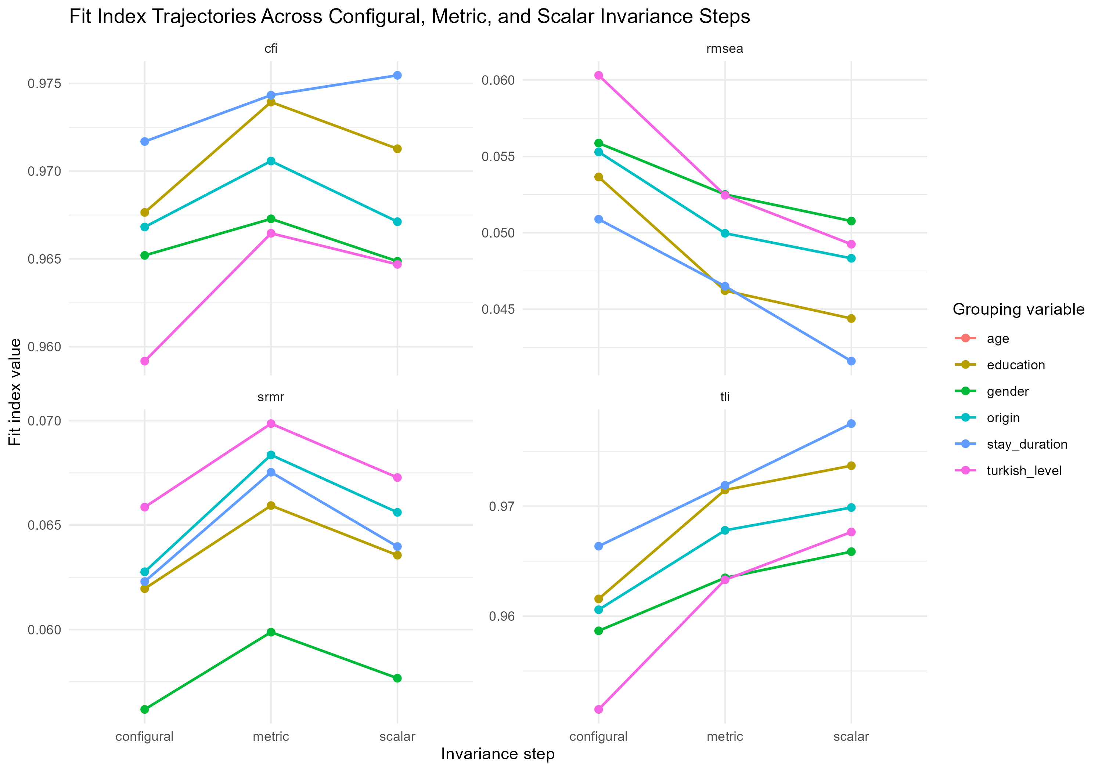
Figure S11.1. Fit Index Trajectories (CFI, TLI, RMSEA, SRMR) Across Configural, Metric, and Scalar Invariance Steps for the Six Grouping Variables
Note. Each line traces one grouping variable's fit index value across the three invariance steps; Age Group is omitted because its configural model was not admissible. RMSEA trends downward across increasing measurement constraints for all five plotted variables, while CFI declines slightly at the scalar step for four of the five (see the Delta CFI values in Table S11.4, all of which remain within the >= -.010 criterion); SRMR rises slightly at the metric step for every variable (by .004-.006) and then remains essentially flat at the scalar step, which is within the .030 metric-configural criterion applied in Table S11.4 and is consistent with supported invariance.
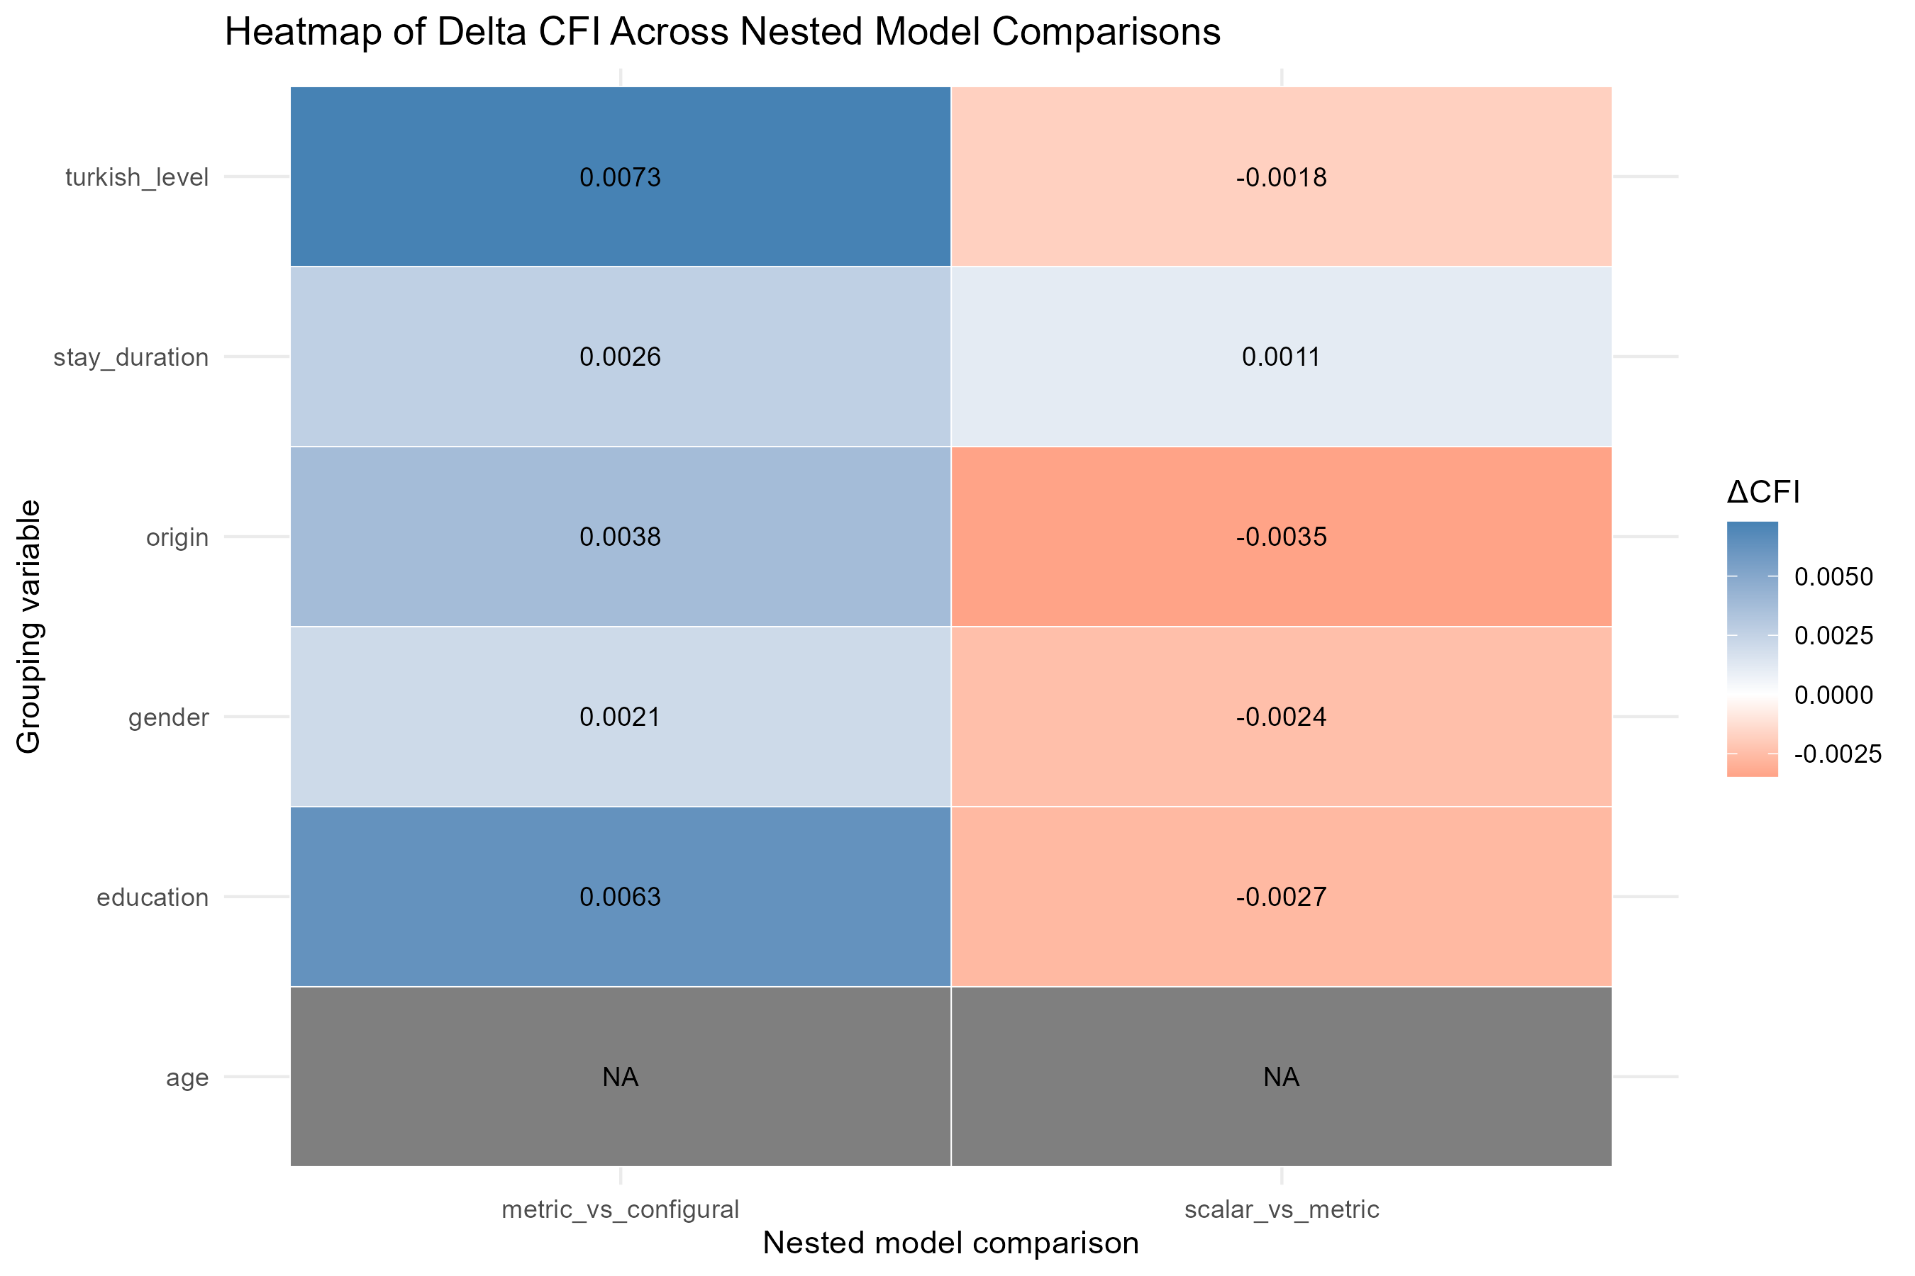
Figure S11.2. Heatmap of Delta CFI Across Nested Model Comparisons and Grouping Variables
Note. Cell values are Delta CFI (more constrained minus less constrained model, as in Table S11.4) for each grouping variable and comparison. All values across the five admissible variables fall within the >= -.010 invariance threshold. Age Group (gray, NA) is excluded because its configural model was not admissible.
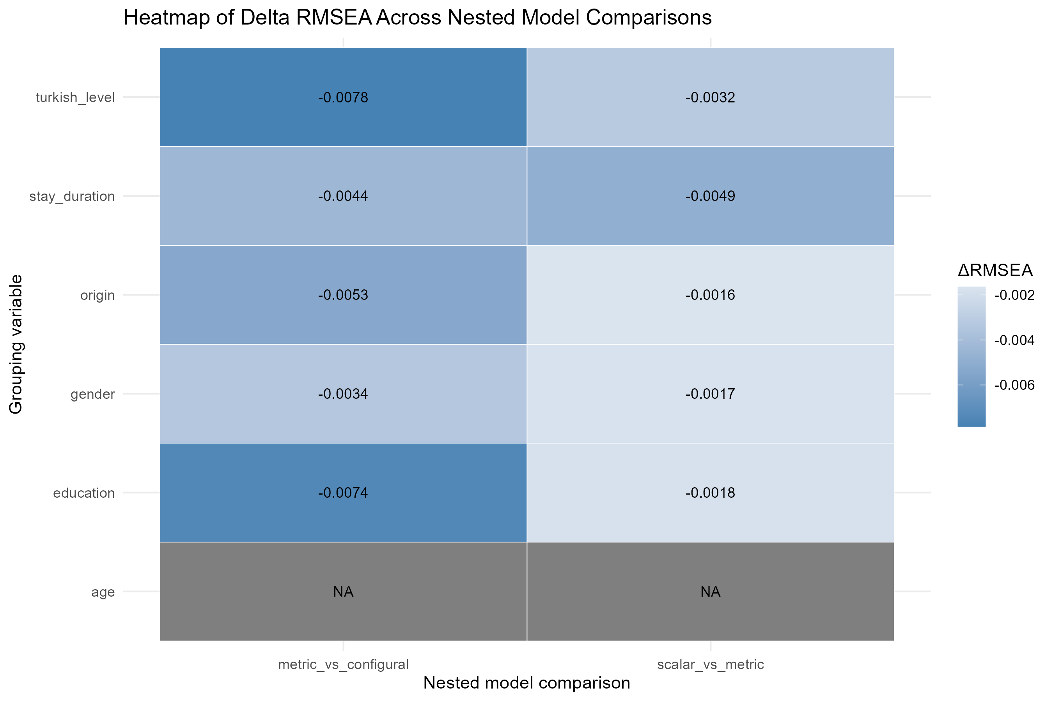
Figure S11.3. Heatmap of Delta RMSEA Across Nested Model Comparisons and Grouping Variables
Note. Cell values are Delta RMSEA (more constrained minus less constrained model, as in Table S11.4) for each grouping variable and comparison. All values are negative (improving fit under constraint) and well within the <= .015 invariance threshold. Age Group (gray, NA) is excluded because its configural model was not admissible.
Summary
Configural, metric, and scalar invariance were supported for five of the six grouping variables tested (Gender, Education Level, Country/Region of Origin, Length of Stay in Türkiye, Turkish Comprehension Level); no variable failed at any invariance step once a configural model was admissible. Age Group could not be evaluated because of an empty response category on item rrs14 within the 66-and-above subgroup (n = 76), a data-availability limitation rather than evidence of non-invariance. Taken together, these results indicate that the RRS-16 three-factor structure, its item loadings, and its item thresholds are consistent across gender, education level, country/region of origin, length of stay in Türkiye, and Turkish comprehension level, supporting the use of RRS-16 total and factor scores for meaningful between-group comparisons on these dimensions. Age-group invariance therefore remains untested in its four-category form and is noted as a limitation for future research, ideally with a larger or re-balanced 66-and-above subgroup that provides full response-category coverage on all items, or with a data-driven collapsing of the oldest age categories if theoretically defensible. Note that collapsing the two oldest categories does remove the empty cell: under the binary 18-50 versus 51+ contrast used for the known-groups analyses, the age-group configural, metric and scalar models are estimable and all invariance criteria are met (S13, Table S13.7).
References
Chen, F. F. (2007). Sensitivity of goodness of fit indexes to lack of measurement invariance. Structural Equation Modeling, 14(3), 464-504.
Cheung, G. W., & Rensvold, R. B. (2002). Evaluating goodness-of-fit indexes for testing measurement invariance. Structural Equation Modeling, 9(2), 233-255.

S12. Reliability Analyses
Refugee Resilience Scale (RRS): Adaptive Coping and Resource Mobilization in Forced Migration
Reliability of the RRS-16 three-factor correlated model (F1: Individual Adaptive Capacity, rrs1-rrs6; F2: Support Seeking and Relational Resource Use, rrs7-rrs11; F3: Service and Rights Navigation, rrs12-rrs16; N = 583) was evaluated at the item level and the scale level. No imputation was performed anywhere in this section: item-level missingness (0-5 cells per item, complete-case n = 578-583 across items) was handled via pairwise-complete polychoric correlations for alpha/omega/CITC indices and via pairwise-present estimation inherent to the WLSMV estimator (missing = "pairwise") for CFA-based indices (CR, AVE, bifactor diagnostics). Person-mean imputation was used solely to rank-order participants by total score for the upper/lower 27% discrimination analysis and did not alter any reported item response or enter any other analysis. Test-retest pairing (~2-week interval) used only respondents for whom both a T1 and a T2 score were computable under the minimum-completeness rule specified for this analysis (Table S0.1, S12 row); no missing item response was imputed; all 16 retest items (it1-it16) were retained, consistent with the fixed 16-item RRS-16 structure (S2). Retest administration differed in mode from the baseline assessment: baseline data were collected face-to-face in a paper-and-pencil format, whereas the retest was administered verbally by telephone to participants who had consented to be re-contacted. This mode difference is confounded with the retest interval and should be taken into account when interpreting the test-retest coefficients reported below, particularly the small statistically significant mean decrease observed for F3 (Table S12.6).
Item-Level Descriptives
Table S12.1. Item descriptives and floor/ceiling percentages (RRS-16, N = 583).
Item | N | M | SD | Skewness | Kurtosis | Floor % | Ceiling %
rrs1 | 583 | 3.31 | 1.04 | -0.25 | -0.42 | 5.32 | 12.52
rrs2 | 580 | 3.22 | 1.04 | -0.15 | -0.52 | 5.17 | 10.69
rrs3 | 582 | 3.25 | 1.05 | -0.16 | -0.59 | 4.98 | 11.86
rrs4 | 580 | 3.23 | 1.02 | -0.09 | -0.54 | 4.14 | 10.69
rrs5 | 581 | 3.31 | 1.03 | -0.14 | -0.63 | 3.44 | 12.57
rrs6 | 581 | 3.12 | 1.21 | 0.01 | -0.95 | 9.12 | 16.18
rrs7 | 578 | 3.24 | 1.03 | -0.08 | -0.59 | 3.98 | 11.42
rrs8 | 582 | 3.27 | 1.03 | -0.11 | -0.55 | 4.12 | 12.03
rrs9 | 580 | 3.05 | 1.15 | -0.03 | -0.81 | 9.66 | 11.55
rrs10 | 580 | 3.24 | 1.03 | -0.10 | -0.58 | 4.31 | 11.38
rrs11 | 580 | 3.20 | 1.03 | -0.14 | -0.56 | 5.00 | 10.00
rrs12 | 582 | 3.32 | 1.07 | -0.24 | -0.54 | 5.33 | 13.92
rrs13 | 580 | 3.03 | 1.12 | -0.11 | -0.70 | 10.35 | 9.31
rrs14 | 581 | 3.29 | 1.03 | -0.11 | -0.60 | 3.79 | 13.08
rrs15 | 580 | 3.33 | 1.05 | -0.20 | -0.58 | 4.31 | 13.79
rrs16 | 580 | 3.31 | 1.04 | -0.22 | -0.51 | 4.48 | 12.41
Note. M = mean; SD = standard deviation; Floor % = percentage of responses at the minimum scale value (1); Ceiling % = percentage at the maximum scale value (5). No item showed |skewness| >= 2 or |kurtosis| >= 7. Complete-case n was 578-583 across items
Item-Total Statistics
Table S12.2. Corrected item-total correlation, alpha-if-deleted, mean inter-item correlation, and discrimination (RRS-16).
Item | CITC | alpha if deleted | Mean IIC | Cohen's d (27%)
rrs1 | .581 | .876 | .351 | 1.769
rrs2 | .576 | .876 | .348 | 1.859
rrs3 | .573 | .876 | .347 | 1.944
rrs4 | .570 | .876 | .345 | 1.790
rrs5 | .574 | .876 | .347 | 2.015
rrs6 | .520 | .878 | .316 | 1.901
rrs7 | .527 | .878 | .320 | 1.795
rrs8 | .575 | .876 | .348 | 1.929
rrs9 | .444 | .881 | .272 | 1.439
rrs10 | .532 | .878 | .323 | 1.735
rrs11 | .527 | .878 | .320 | 1.784
rrs12 | .526 | .878 | .320 | 1.791
rrs13 | .387 | .883 | .238 | 1.265
rrs14 | .539 | .877 | .327 | 1.588
rrs15 | .560 | .877 | .339 | 1.889
rrs16 | .519 | .878 | .316 | 1.706
Note. CITC = corrected item-total correlation (polychoric-matrix-based). alpha if deleted = ordinal alpha if the item were removed (all values below the total-scale alpha of .884, indicating every item contributes positively to reliability). Mean IIC = mean polychoric inter-item correlation for the item. Cohen's d (27%) = standardized mean difference between upper and lower 27% total-score groups (person-mean-imputed ranking only; see text). No item met any problem-flag criterion on normality, floor or ceiling percentage (> 20%), CITC (< .30), discrimination (d < .80), alpha-if-deleted, or mean IIC (< .10); all 16 items were rated "Excellent" item quality, including rrs6, rrs9, and rrs13, which showed comparatively lower (but still adequate) CITC and mean IIC values, consistent with these same three items' recurring identification as comparatively atypical across the pilot, calibration, and validation analyses (Sections S3, S8-S10). The main-study floor/ceiling flag threshold is > 20%, which is more permissive than the >= 15% descriptive threshold used to compile the pilot-stage flag table; rrs6's ceiling percentage (16.18%, Table S12.1) therefore exceeds the pilot-stage descriptive threshold but not the main-study flag threshold.
Internal Consistency — Total Scale and Factors
Table S12.3. Ordinal alpha (with 95% bootstrap CI, B = 200), omega-total, and CITC range for the total scale and each factor.
Scale | k | alpha [95% CI] | omega total | Mean r | CITC range
RRS-16 (Total) | 16 | .884 [.868, .897] | .885 | .324 | .387-.581
F1 (Individual Adaptive Capacity) | 6 | .859 [.843, .874] | .864 | .505 | .441-.724
F2 (Support Seeking and Relational Resource Use) | 5 | .824 [.800, .841] | .830 | .483 | .426-.735
F3 (Service and Rights Navigation) | 5 | .816 [.792, .838] | .824 | .470 | .382-.690
Note. alpha = ordinal (polychoric-based) Cronbach's alpha; 95% CI from B = 200 nonparametric bootstrap resamples (all 200 replications valid for every scale/factor). omega total = McDonald's omega (one-factor polychoric model). Mean r = mean polychoric inter-item correlation. CITC range = minimum-maximum corrected item-total correlation within the scale/factor.
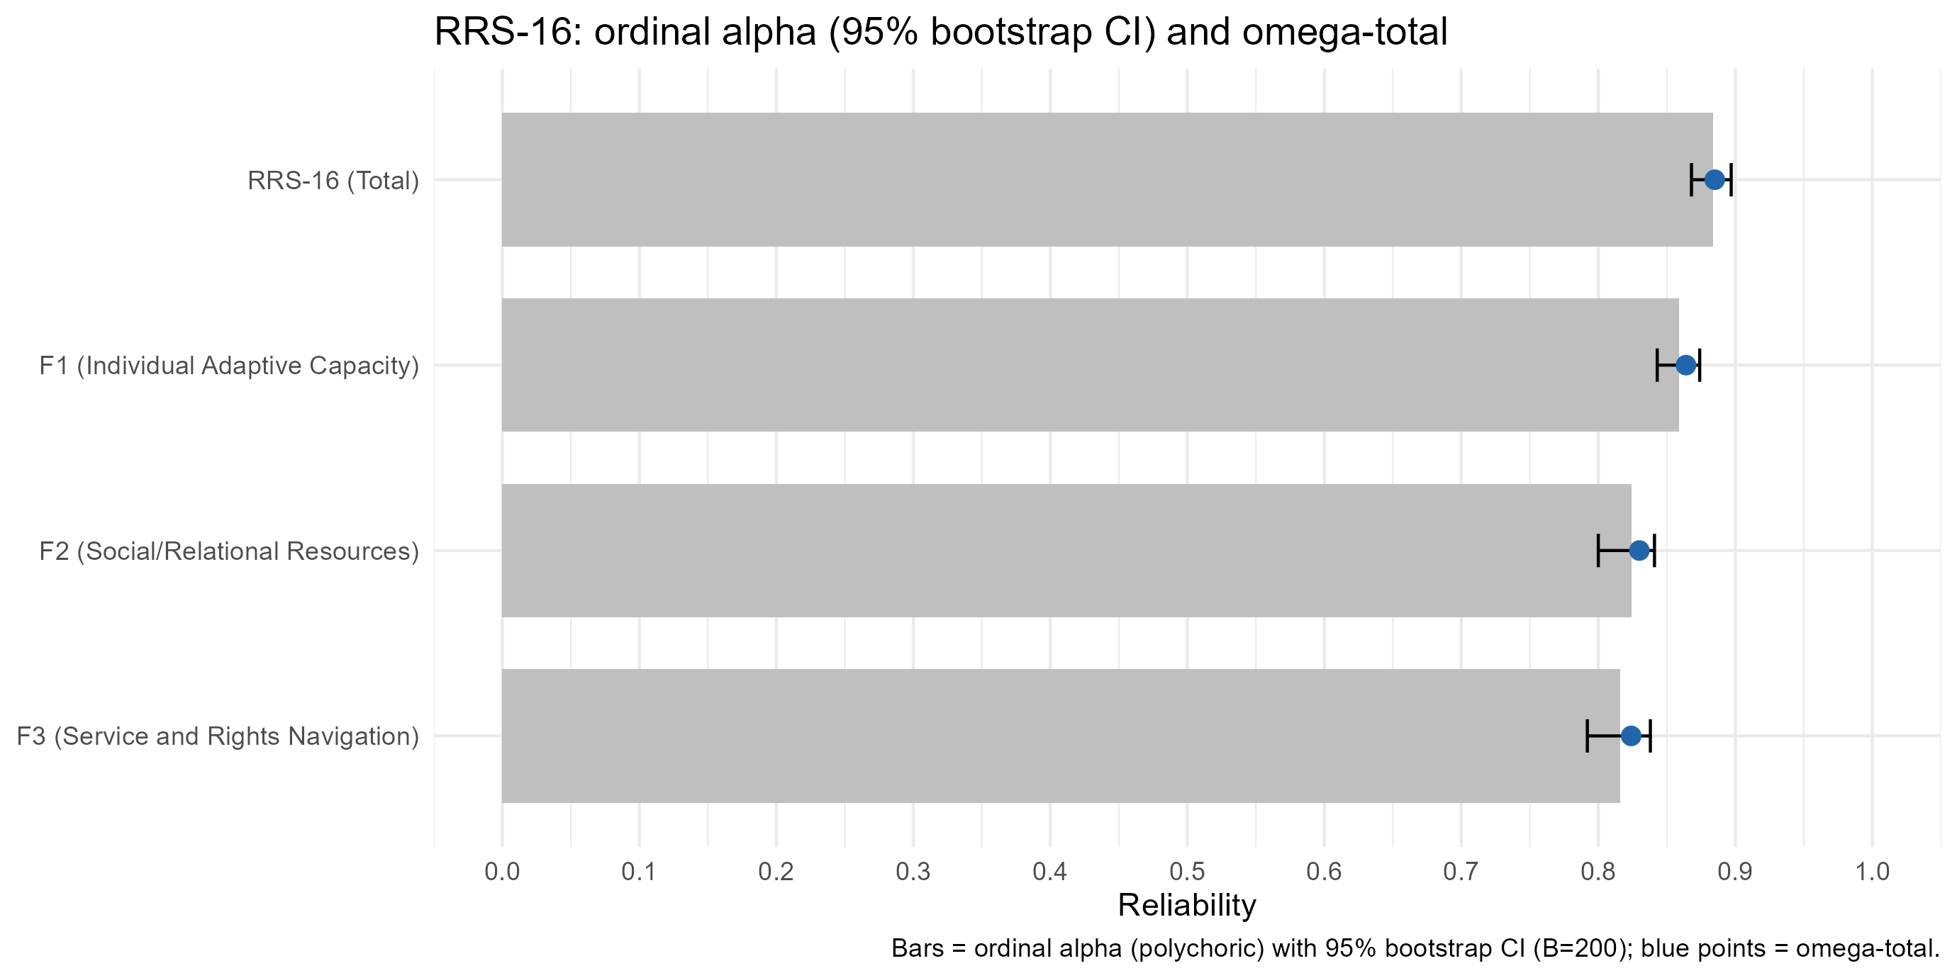
Figure S12.1. Ordinal alpha (with 95% bootstrap CI) and omega-total for the RRS-16 total scale and each factor.
Note. Error bars represent 95% bootstrap confidence intervals (B = 200 resamples) around the ordinal alpha estimate. Values correspond to Table S12.3.
CFA-Based Reliability: Composite Reliability and Average Variance Extracted
Table S12.4. Composite reliability (CR) and average variance extracted (AVE) from the three-factor correlated CFA (WLSMV, theta parameterization).
Factor | k | CR | AVE | Loading range
F1 (Individual Adaptive Capacity) | 6 | .868 | .524 | .587-.775
F2 (Support Seeking and Relational Resource Use) | 5 | .834 | .504 | .545-.802
F3 (Service and Rights Navigation) | 5 | .829 | .498 | .488-.790
Note. CR and AVE computed from standardized loadings and residual variances of the three-factor correlated CFA model (F1 =~ rrs1+rrs2+rrs3+rrs4+rrs5+rrs6; F2 =~ rrs7+rrs8+rrs9+rrs10+rrs11; F3 =~ rrs12+rrs13+rrs14+rrs15+rrs16; WLSMV, theta parameterization, ordered categorical indicators, missing = "pairwise"; identical specification to that used in Section S13). All three factors exceeded the conventional CR adequacy threshold (CR >= .70; Fornell & Larcker, 1981; Hair et al., 2019). F1's AVE (.524) and F2's AVE (.504) exceeded the conventional .50 threshold; F3's AVE (.498) fell marginally below it. The same values are reported again in Section S13 (Table S13.1), which reuses this fitted model rather than re-estimating it independently.
Bifactor Diagnostics
Table S12.5. Explained common variance (ECV), hierarchical omega, and specific omega from the bifactor model (general factor + 3 specific factors).
ECV | omega hierarchical | omega specific F1 | omega specific F2 | omega specific F3 | Mean |loading| (G / specific)
.496 | .694 | .371 | .376 | .412 | .508 / .486
Note. Estimated on the full main sample (N = 583); the corresponding bifactor diagnostics for the validation subsample (n = 289) are reported in S9, Table S9.4 (ECV = .464, omega hierarchical = .669), and the differences reflect the different samples rather than a different model specification. ECV = explained common variance attributable to the general factor. omega hierarchical = reliability of the general factor controlling for specific factors. omega specific = reliability of each specific factor controlling for the general factor. F1, F2, and F3 showed broadly comparable but modest specific-factor reliability (omega specific = .371-.412), indicating that each factor retains some, but only limited, reliable variance beyond the general resilience factor once that general factor is partialled out; subscale scores are therefore interpreted through their total reliabilities (omega = .824-.864, Table S12.3) rather than as general-factor-purified measures. ECV (.496) falls short of the .70 threshold sometimes used to justify unidimensional scoring, and together with the comparatively balanced specific-factor reliability across F1-F3, this pattern supports retaining and reporting the three correlated factors rather than a unidimensional total score alone, consistent with the confirmatory three-factor structure adopted throughout this supplement (Sections S8-S13). Computation note: omega-hierarchical and omega-specific reported here and in Table S9.4 were recomputed with the BifactorIndicesCalculator package (Dueber, 2017) from the same fitted bifactor models. An earlier version of the analysis script formed the specific-factor term of the omega denominator as the sum of squared loadings rather than as the square of the summed loadings within each specific factor, which inflated omega-hierarchical (to .848 in the full sample and .836 in the validation subsample) and omega-specific; ECV, model fit, factor loadings, and all other reported quantities were unaffected. The corrected values are reported throughout, and the corrected script is archived with the project files.
Test-Retest Reliability
Table S12.6. Test-retest reliability of the RRS-16 total score and three factors (~2-week interval; retest-eligible n = 141).
Score | Diff (T2-T1) | p | ICC(2,1) | SEM | MDC95 | 95% CI (ICC) | Pearson r | 95% CI (r)
RRS-16 Total | -.040 | .247 | .779 | .285 | .790 | [.705, .836] | .788 | [.716, .844]
F1 (Individual Adaptive Capacity) | .039 | .489 | .647 | .471 | 1.306 | [.540, .734] | .647 | [.540, .734]
F2 (Support Seeking and Relational Resource Use) | -.038 | .535 | .578 | .506 | 1.402 | [.457, .678] | .577 | [.456, .678]
F3 (Service and Rights Navigation) | -.131 | .021 | .643 | .477 | 1.322 | [.534, .731] | .650 | [.543, .736]
Note. Diff = mean T2 - T1 difference; p = p-value from paired t-test (bias test). ICC(2,1) = two-way random-effects, absolute-agreement, single-measures intraclass correlation. SEM = standard error of measurement (pooled T1/T2 SD x sqrt(1-ICC)). MDC95 = minimal detectable change at 95% confidence (1.96 x sqrt(2) x SEM). Pearson r is the T1-T2 product-moment correlation with its 95% confidence interval, reported alongside ICC(2,1) because r indexes relative rank-order stability only and, unlike ICC, is insensitive to systematic mean shifts; the two are numerically close for every score, which is itself evidence that no large systematic bias is present. The total score, F1, and F2 showed no statistically significant mean T1-T2 difference (p = .247, .489, and .535, respectively); F3 showed a small but statistically significant mean decrease at retest (mean diff = -0.131, p = .021), indicating a modest systematic drift on this factor that should be considered when using F3 for repeated-measures change detection. Four of the 141 retest respondents left one or more retest items unanswered (Table S6.4), but all 141 met the minimum-completeness rule for the total score and for each of the three factors, so n = 141 is the analysis n for every row of this table. The total score ICC (.779) was in the good range; the three factor-level ICCs (.578-.647) were in the moderate range (Koo & Li, 2016), reflecting the shorter item length of each factor relative to the total scale.
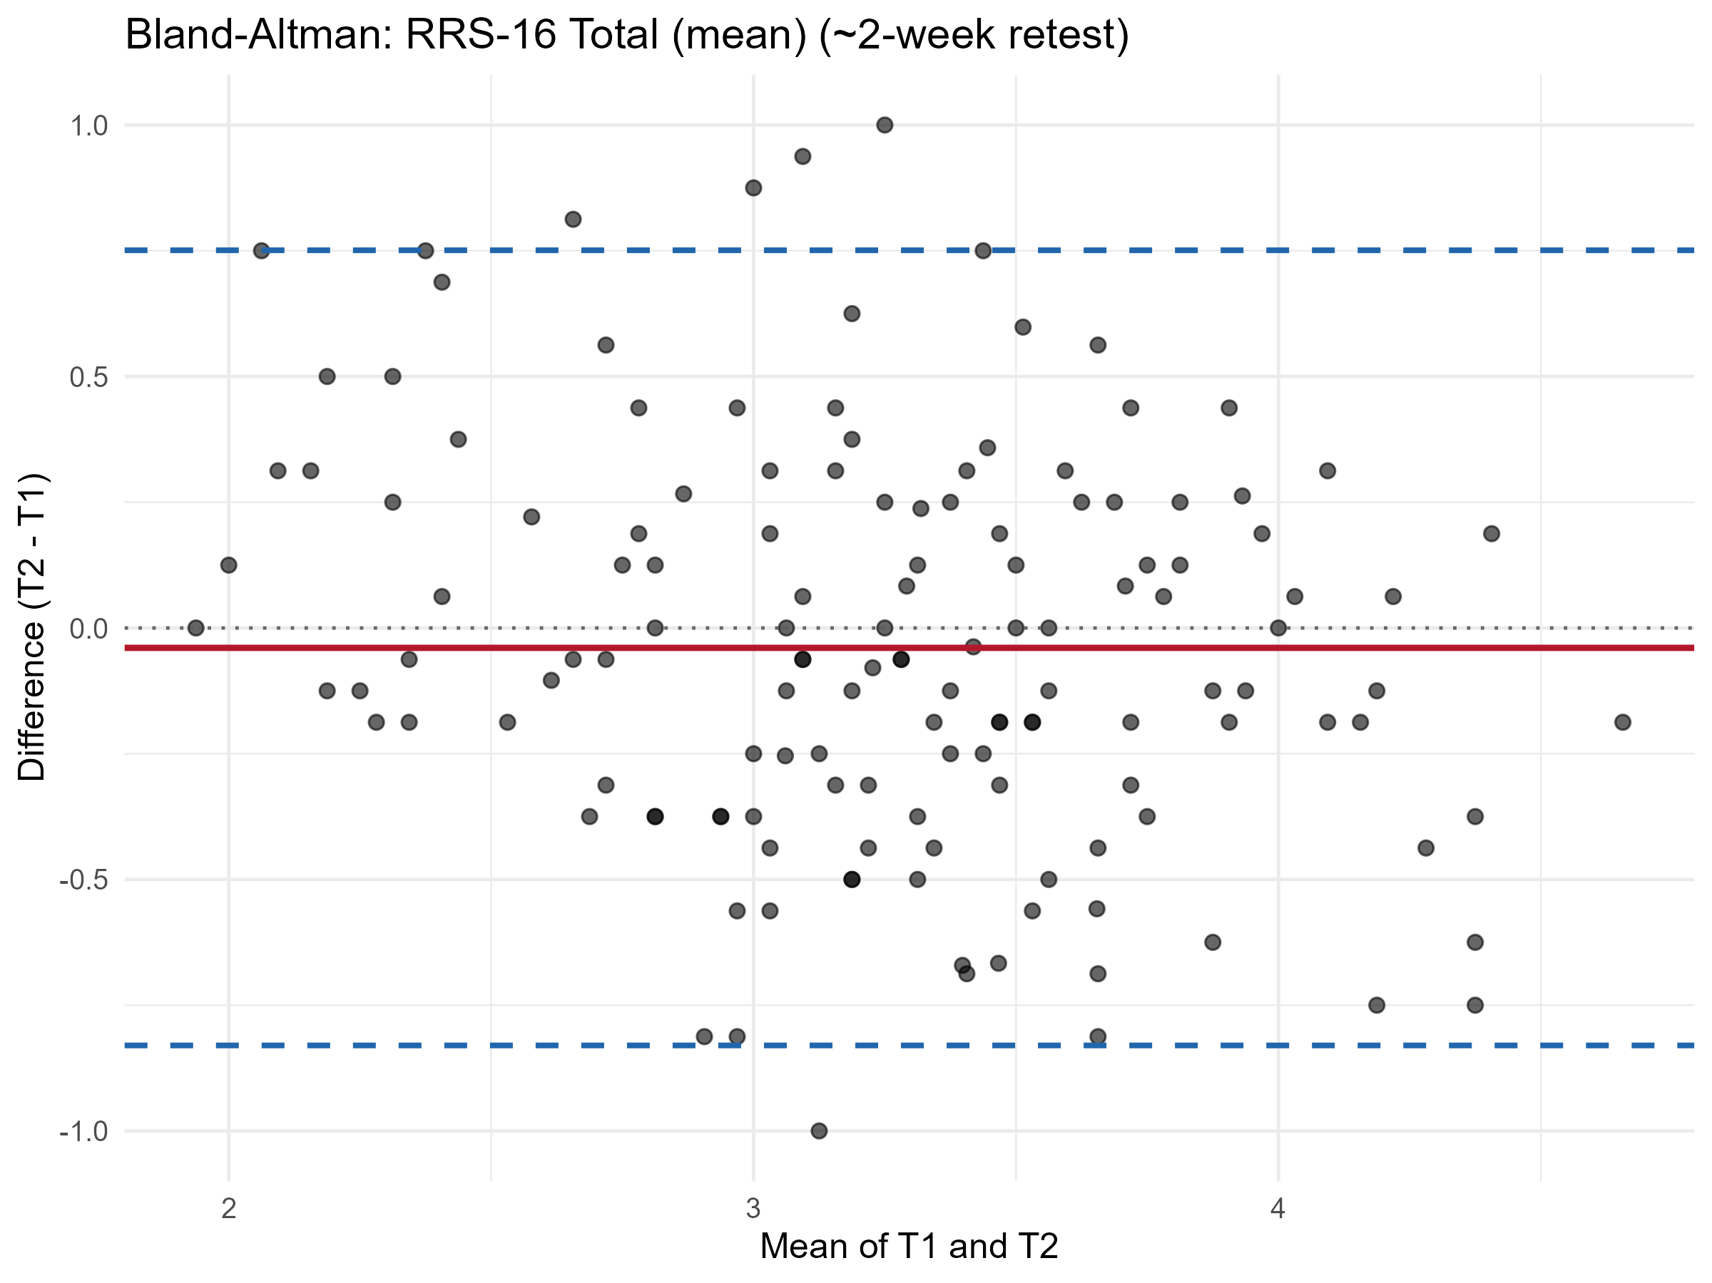
Figure S12.2. Bland-Altman plot of test-retest agreement for the RRS-16 total score.
Note. Horizontal axis: mean of T1 and T2 scores. Vertical axis: T2 minus T1 difference. Solid line = mean difference; dashed lines = 95% limits of agreement (mean difference +/- 1.96 SD). n = 141 retest-eligible participants.
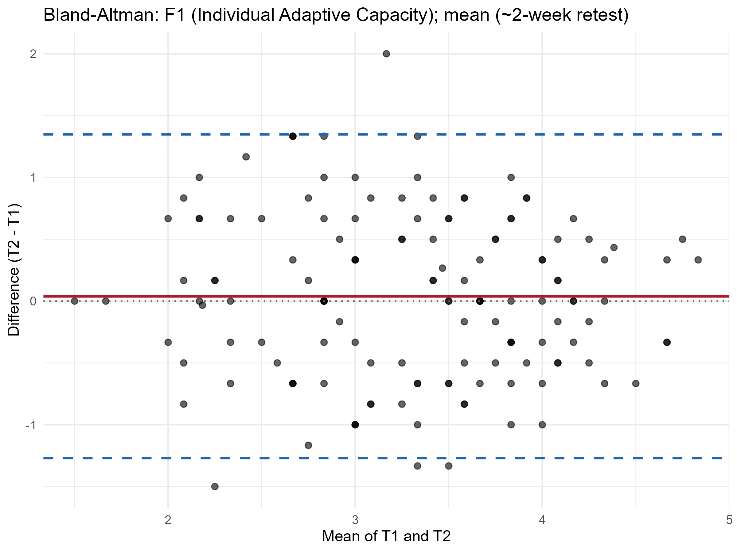
Figure S12.3. Bland-Altman plot of test-retest agreement for F1 (Individual Adaptive Capacity).
Note. Horizontal axis: mean of T1 and T2 F1 scores. Vertical axis: T2 minus T1 difference. Solid line = mean difference; dashed lines = 95% limits of agreement. n = 141 retest-eligible participants.
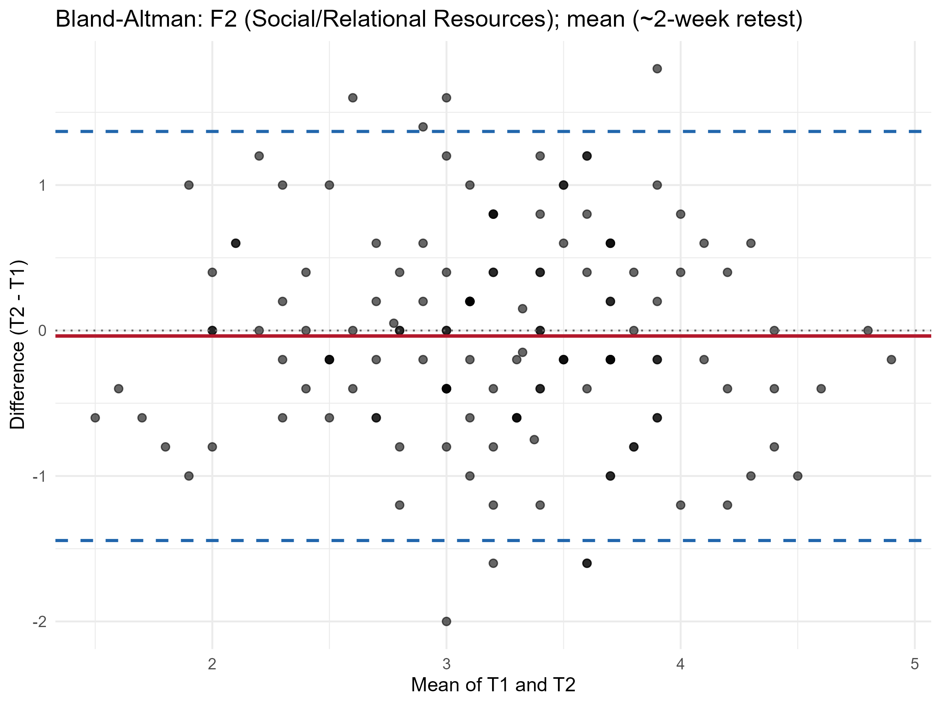
Figure S12.4. Bland-Altman plot of test-retest agreement for F2 (Support Seeking and Relational Resource Use).
Note. Horizontal axis: mean of T1 and T2 F2 scores. Vertical axis: T2 minus T1 difference. Solid line = mean difference; dashed lines = 95% limits of agreement. n = 141 retest-eligible participants.
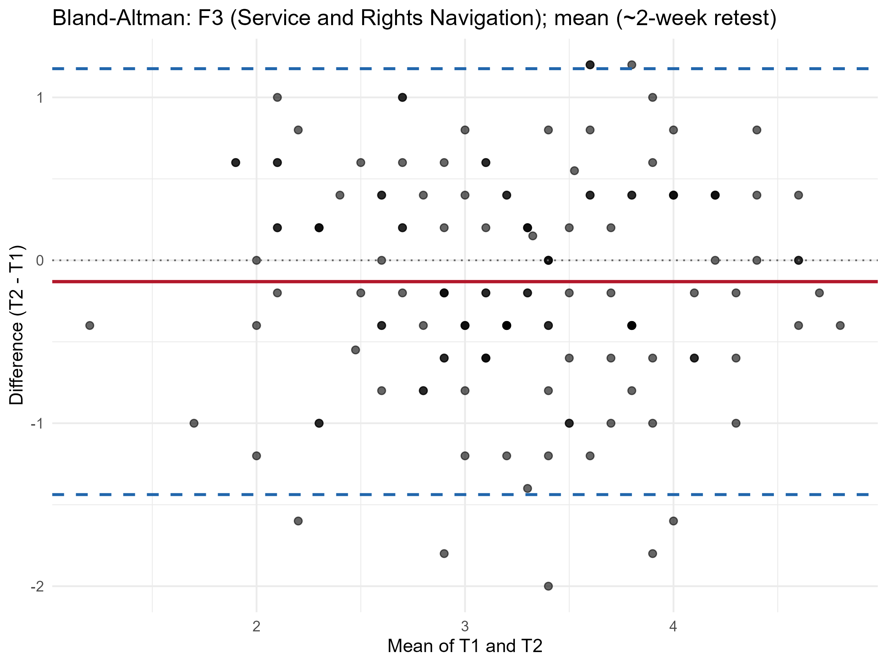
Figure S12.5. Bland-Altman plot of test-retest agreement for F3 (Service and Rights Navigation).
Note. Horizontal axis: mean of T1 and T2 F3 scores. Vertical axis: T2 minus T1 difference. Solid line = mean difference; dashed lines = 95% limits of agreement. The small negative shift visible here corresponds to the statistically significant mean retest decrease reported for F3 in Table S12.6 (p = .021). n = 141 retest-eligible participants.

External Scales — Internal Consistency
Table S12.7. Internal consistency of the external validity scales (BRS, GSE, PSS, PHQ).
Scale | k | alpha [95% CI] | omega total | Mean r
BRS (Brief Resilience Scale) | 6 | .789 [.756, .814] | .789 | .383
GSE (General Self-Efficacy Scale) | 10 | .819 [.795, .838] | .819 | .312
PSS (Perceived Stress Scale) | 4 | .715 [.677, .751] | .716 | .386
PHQ (Depression Screener) | 9 | .849 [.829, .863] | .849 | .385
Note. BRS = Brief Resilience Scale (Smith et al., 2008). GSE = General Self-Efficacy Scale (Schwarzer & Jerusalem, 1995). PSS = Perceived Stress Scale (Cohen et al., 1983). PHQ = depression screener (Patient Health Questionnaire item set; Kroenke et al., 2001). These four external scales are reported here for internal-consistency purposes only; their use in convergent/discriminant validity testing against the RRS-16 factors is reported separately in Section S13. All four external scales showed acceptable-to-good internal consistency in the present sample, with PSS showing the lowest (but still acceptable, alpha >= .70) reliability, consistent with its brevity (k = 4).
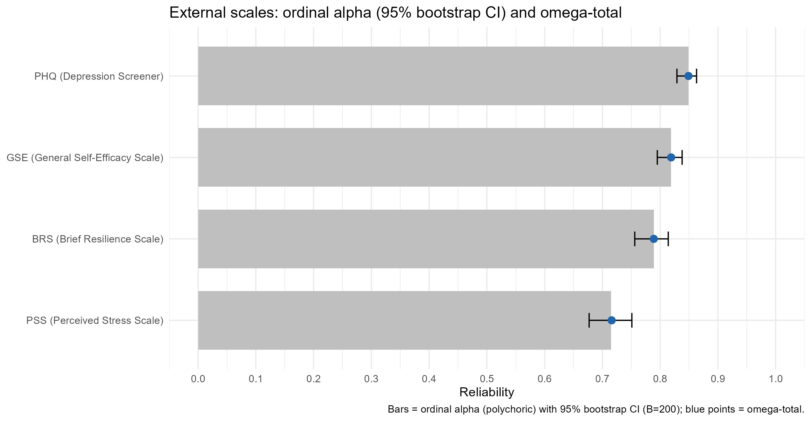
Figure S12.6. Ordinal alpha (with 95% bootstrap CI) and omega-total for the four external validity scale components.
Note. Error bars represent 95% bootstrap confidence intervals (B = 200 resamples) around the ordinal alpha estimate. Values correspond to Table S12.7.
Summary
RRS-16 showed strong internal consistency at both the total-scale level (ordinal alpha = .884, omega = .885) and the factor level (alpha = .816-.859, omega = .824-.864), with no item flagged on any item-total or discrimination criterion; all 16 items were rated "Excellent" item quality, although rrs6, rrs9, and rrs13 showed comparatively lower (but still adequate) CITC and mean inter-item correlation values, consistent with these same three items' recurring identification as comparatively atypical elsewhere in this supplement (Sections S3, S8-S10). CFA-based composite reliability (CR = .829-.868) exceeded the conventional threshold for all three factors, and average variance extracted was adequate for F1 (AVE = .524) and F2 (AVE = .504), while falling marginally below the conventional .50 threshold for F3 (AVE = .498); the same estimates are carried into Section S13, which reuses this fitted model. Bifactor diagnostics (ECV = .496; omega hierarchical = .694) indicated that common variance is roughly evenly shared between a general resilience factor and three comparatively balanced but modest specific factors (omega specific = .371-.412), supporting the retention of the three-factor scoring structure rather than a unidimensional total score alone. Test-retest reliability over approximately two weeks was good for the total score (ICC = .779) and moderate for the three individual factors (ICC = .578-.647), with no systematic retest bias for the total score, F1, or F2, but a small, statistically significant mean decrease at retest for F3 (p = .021) that warrants caution in repeated-measures use of that factor. The external validity scales administered alongside RRS-16 (BRS, GSE, PSS, and PHQ) each showed acceptable-to-good internal consistency in this sample.
References
Cohen, S., Kamarck, T., & Mermelstein, R. (1983). A global measure of perceived stress. Journal of Health and Social Behavior, 24(4), 385-396.
Dueber, D. M. (2017). Bifactor Indices Calculator: A Microsoft Excel-based tool to calculate various indices relevant to bifactor CFA models. University of Kentucky.
Fornell, C., & Larcker, D. F. (1981). Evaluating structural equation models with unobservable variables and measurement error. Journal of Marketing Research, 18(1), 39-50.
Hair, J. F., Black, W. C., Babin, B. J., & Anderson, R. E. (2019). Multivariate data analysis (8th ed.). Cengage.
Koo, T. K., & Li, M. Y. (2016). A guideline of selecting and reporting intraclass correlation coefficients for reliability research. Journal of Chiropractic Medicine, 15(2), 155-163.
Kroenke, K., Spitzer, R. L., & Williams, J. B. W. (2001). The PHQ-9: Validity of a brief depression severity measure. Journal of General Internal Medicine, 16(9), 606-613.
Schwarzer, R., & Jerusalem, M. (1995). Generalized Self-Efficacy scale. In J. Weinman, S. Wright, & M. Johnston, Measures in health psychology: A user's portfolio. Causal and control beliefs (pp. 35-37). NFER-NELSON.
Smith, B. W., Dalen, J., Wiggins, K., Tooley, E., Christopher, P., & Bernard, J. (2008). The brief resilience scale: Assessing the ability to bounce back. International Journal of Behavioral Medicine, 15(3), 194-200.

S13. Validity Analyses
Refugee Resilience Scale (RRS): Adaptive Coping and Resource Mobilization in Forced Migration
This section presents three complementary lines of validity evidence for the RRS-16 three-factor model (F1: Individual Adaptive Capacity, rrs1-rrs6; F2: Support Seeking and Relational Resource Use, rrs7-rrs11; F3: Service and Rights Navigation, rrs12-rrs16): (1) construct validity within the scale (convergent and discriminant validity among the three factors), (2) external validity against theoretically related constructs (resilience, general self-efficacy, perceived stress, and depressive symptoms), and (3) known-groups validity, testing hypotheses across six demographic and background variables, most of which were tested exploratorily given mixed or absent directional literature (see below). All models were estimated using WLSMV with theta parameterization and pairwise-present missing data handling (missing = "pairwise"), on the full main-sample dataset (N = 583) used throughout this supplement. No imputation was performed at any stage.
1. Construct Validity (Convergent and Discriminant)
Convergent validity was evaluated using average variance extracted (AVE) and composite reliability (CR), computed from the standardized loadings of the three-factor CFA model. AVE exceeded the conventional .50 threshold for F1 (.524) and F2 (.504) and was marginally below it for F3 (.498); composite reliability exceeded .82 for all three factors (F1 = .868, F2 = .834, F3 = .829), well above the recommended .70 minimum, indicating that although F3's average item-level variance extraction is marginally below the conventional convergent-validity benchmark, all three factors are measured with good internal consistency across their items. These values reproduce, by construction, the CR/AVE estimates already reported in Section S12 (Table S12.4), computed here from the same three-factor CFA specification.
Table S13.1. Average Variance Extracted (AVE) and Composite Reliability (CR) for the Three RRS-16 Factors
Factor | k | AVE | CR
F1 (Individual Adaptive Capacity) | 6 | .524 | .868
F2 (Support Seeking and Relational Resource Use) | 5 | .504 | .834
F3 (Service and Rights Navigation) | 5 | .498 | .829
Note. AVE = average variance extracted, computed as the mean of squared standardized loadings within each factor; CR = composite reliability (McDonald's omega), computed from the standardized loadings of the three-factor WLSMV CFA model. AVE for F3 (.498) falls marginally below the conventional .50 threshold; CR for all three factors substantially exceeds the .70 minimum recommended by Hair et al. (2019).
Discriminant validity was assessed using the Fornell-Larcker criterion, which compares the square root of each factor's AVE (diagonal) against the latent inter-factor correlations (off-diagonal); discriminant validity is supported when each diagonal value exceeds the corresponding off-diagonal correlations in its row and column.
Table S13.2. Latent Factor Correlations Among F1, F2, and F3 (Full Main Sample, N = 583)
Factor | F1 | F2 | F3
F1 | 1 | .523 | .493
F2 | .523 | 1 | .483
F3 | .493 | .483 | 1
Note. Latent correlations from the three-factor WLSMV CFA model (theta parameterization, std.lv = TRUE), full main sample (N = 583). All three inter-factor correlations are moderate and of similar magnitude (r = .483-.523), consistent with three related but empirically separable facets of refugee resilience.
Table S13.3. Fornell-Larcker Matrix (Diagonal = sqrt(AVE); Off-Diagonal = Latent Inter-Factor Correlation)
Factor | F1 | F2 | F3
F1 | .724 | .523 | .493
F2 | .523 | .710 | .483
F3 | .493 | .483 | .706
Note. Diagonal values (sqrt(AVE)) exceed the off-diagonal inter-factor correlations for all three factors (F1: sqrt(AVE) = .724 > r = .523 and .493; F2: sqrt(AVE) = .710 > r = .523 and .483; F3: sqrt(AVE) = .706 > r = .493 and .483), satisfying the Fornell-Larcker criterion for discriminant validity among all three RRS-16 factors.
2. External Validity (Convergent and Divergent)
External validity was evaluated by jointly modeling the three RRS-16 factors together with four external constructs measured in the same sample: the Brief Resilience Scale (BRS), the General Self-Efficacy Scale (GSE), the Perceived Stress Scale (PSS), and a depression screener (PHQ item set). All seven constructs (three RRS-16 factors plus four external constructs) were estimated as latent factors within a single WLSMV CFA model (chi-square [scaled] = 1059.91, df = 924, p = .001, CFI = .987, TLI = .986, RMSEA = .016, SRMR = .040), and latent correlations with standard errors, confidence intervals, and p-values were obtained directly from the model's standardized solution (parameterEstimates() with standardized = TRUE and ci = TRUE), i.e., using the delta-method-based inferential statistics native to the WLSMV estimator rather than a post hoc Fisher-z transformation, which is not appropriate for model-implied latent correlations of this kind.
BRS and GSE were selected as convergent measures: both index adaptive psychological capacities (recovery from adversity and confidence in one's own ability to manage challenges, respectively) that are conceptually proximal to refugee resilience as operationalized by RRS-16, and both were expected to correlate positively with all three RRS-16 factors. PSS and PHQ were selected as divergent measures: both index negative psychological states (perceived stress and depressive symptoms) that are theoretically expected to be inversely, and more modestly, related to resilience than the convergent measures are positively related to it.
Table S13.4. Latent Correlations Between RRS-16 Factors and External Validity Measures, With Inferential Statistics
RRS Factor | External scale | r | SE | 95% CI lower | 95% CI upper | p
F1 | BRS | .694 | .032 | .632 | .757 | <.001
F1 | GSE | .660 | .033 | .596 | .724 | <.001
F1 | PSS | -.325 | .047 | -.417 | -.234 | <.001
F1 | PHQ | -.286 | .046 | -.376 | -.196 | <.001
F2 | BRS | .541 | .041 | .460 | .621 | <.001
F2 | GSE | .460 | .042 | .377 | .542 | <.001
F2 | PSS | -.112 | .053 | -.215 | -.008 | .034
F2 | PHQ | -.167 | .048 | -.261 | -.073 | <.001
F3 | BRS | .382 | .045 | .294 | .469 | <.001
F3 | GSE | .565 | .038 | .491 | .638 | <.001
F3 | PSS | -.097 | .052 | -.199 | .006 | .064
F3 | PHQ | -.147 | .047 | -.240 | -.055 | .002
Note. r = model-implied latent correlation from the joint seven-factor WLSMV CFA model (theta parameterization, std.lv = TRUE, full main sample, N = 583); SE, 95% CI, and p-values obtained from parameterEstimates() with standardized = TRUE and ci = TRUE. All three RRS-16 factors correlated positively with both convergent measures (BRS, GSE) and negatively with both divergent measures (PSS, PHQ), fully consistent in direction with a priori expectations. F1 showed the strongest convergent correlations of the three factors (BRS r = .694, GSE r = .660) and the strongest divergent correlations (PSS r = -.325, PHQ r = -.286), indicating that F1 (Individual Adaptive Capacity) is the RRS-16 factor most closely aligned with general resilience and self-efficacy constructs as well as most strongly (inversely) related to stress and depressive symptoms. F3's correlation with PSS did not reach conventional statistical significance (r = -.097, p = .064; 95% CI included zero), the one exception to an otherwise consistent pattern of statistically significant, theory-consistent associations across all 12 factor-by-external-scale pairings.
The pattern of relative correlation magnitudes across the three RRS-16 factors and four external scales provides additional convergent/discriminant evidence beyond the Fornell-Larcker check reported above (Table S13.3). F1 (Individual Adaptive Capacity) showed its strongest external association with BRS and GSE, both of which index general individual-level adaptive capacity; F3 (Service and Rights Navigation) showed a comparatively larger association with GSE (r = .565) than with BRS (r = .382), a pattern consistent with GSE's emphasis on confidence in one's own capability to manage practical challenges, which overlaps conceptually with F3's focus on navigating services and rights; and the two divergent measures showed their weakest associations with F3 (Service and Rights Navigation; PSS r = -.097, the one non-significant correlation in the set, and PHQ r = -.147), followed by F2 (Support Seeking and Relational Resource Use; PSS r = -.112; PHQ r = -.167), consistent with the more contextual and relational (rather than individual-psychological) content of both factors relative to F1.
Table S13.5. Composite Reliability (omega) and AVE for All Seven Constructs in the External Validity Model
Construct | omega | AVE
F1 (Individual Adaptive Capacity) | .857 | .538
F2 (Support Seeking and Relational Resource Use) | .822 | .527
F3 (Service and Rights Navigation) | .819 | .523
BRS | .769 | .388
GSE | .786 | .317
PSS | .683 | .387
PHQ | .818 | .389
Note. omega = composite reliability (semTools::compRelSEM()); AVE = average variance extracted (semTools::AVE()), both computed within the joint seven-factor external validity model. Because these estimates come from the larger joint model rather than the standalone three-factor model, the RRS-16 values here differ slightly from Table S13.1 and Table S12.4 (e.g., F3 AVE = .523 here vs. .498 in the three-factor model); the .498 figure quoted as the convergent-validity caveat throughout this supplement is the three-factor-model value. The same applies to PSS, whose composite reliability is .683 here and .716 in Table S12.7. The three RRS-16 factors show good composite reliability (omega = .82-.86) within this joint model, closely reproducing their standalone omega estimates reported in Section S12, Table S12.3 (differences of .005-.008). PHQ's composite reliability is .818 here and .849 in Table S12.7, a difference of the same order as the PSS discrepancy noted above. BRS, GSE, PSS and PHQ show lower AVE within this joint model (.317-.389) than their standalone internal-consistency estimates would suggest (Table S12.7), which is expected given that AVE is sensitive to the number and diversity of indicators retained per construct within a large joint model; this is noted for transparency and does not affect the latent correlations reported in Table S13.4, which are the primary external validity evidence in this section.
3. Known-Groups Validity
Known-groups validity was evaluated for six demographic/background variables: age group, gender, education level, country/region of origin, length of stay in Türkiye, and Turkish language proficiency. Consistent with the principle that directional (one-tailed) hypotheses should be reserved for variables with strong, contextually relevant prior evidence, a directional hypothesis was pre-specified for only one variable -- Turkish language proficiency -- based on literature conducted specifically with Syrian refugees in Türkiye linking host-language proficiency to resilience-building, well-being, and reduced loneliness (Cinkara, 2017). The remaining five variables (age, gender, education, origin, length of stay) were tested exploratorily (non-directionally) because the available literature was either mixed in direction (gender, education), showed no consistent association with resilience specifically (age), or did not provide a directly comparable basis for this sample (origin, length of stay). Each variable was tested using multi-group CFA with sequential configural, metric (loadings), and scalar (loadings + thresholds) invariance models; under the scalar model, the latent factor means of the reference group were fixed at 0 and the corresponding means of the comparison group were freely estimated, yielding directly interpretable latent mean differences and Cohen's d effect sizes on the standardized factor metric. Education was operationalized as a binary contrast between the No formal education / Primary school category (n = 137, coded "Low") and the combined Secondary school / High school and Bachelor's / Graduate degree categories (n = 444, coded "High"), consistent with the three-category education variable used for measurement invariance testing in Section S11.
Table S13.6. Literature-Derived Hypotheses for the Known-Groups Variables
Variable | Comparison | Directional? | Expected direction
Age group | Older (51+) vs. Younger (18-50) | No (exploratory) | Not specified
Gender | Female vs. Male | No (exploratory) | Not specified
Education level | Low (No formal education / Primary school) vs. High (Secondary school / High school and above) | No (exploratory) | Not specified
Country/region of origin | Modal origin group (Syria, n = 289) vs. other (Afghanistan, Iraq) | No (exploratory) | Not specified
Length of stay in Türkiye | Longer vs. shorter (median split) | No (exploratory) | Not specified
Turkish language proficiency | Higher vs. lower (median split) | Yes | Higher proficiency -> higher RRS-16
Note. A directional (one-tailed) hypothesis was pre-specified only for Turkish language proficiency, the one variable with literature providing a sufficiently direct and contextually relevant basis (Syrian-refugee samples in Türkiye specifically) for a predicted direction; the remaining five variables, including education, were tested exploratorily without a directional hypothesis, consistent with mixed or absent supporting evidence for a specific direction in this sample and context (see main text above; Alduraidi, Dardas, & Price, 2020, found a significant education-resilience association among Syrian refugees in Jordan, but other migrant samples have reported the opposite direction, so no single direction was pre-specified here).
Table S13.7. Measurement Invariance Fit Indices for the Known-Groups Comparisons (Configural, Metric, Scalar Models)
Grouping variable | Step | chi-square | df | CFI | RMSEA | SRMR
Age group | configural | 375.17 | 202 | .967 | .054 | .057
 | metric | 360.01 | 215 | .972 | .048 | .059
 | scalar | 385.13 | 244 | .973 | .045 | .057
Gender | configural | 384.24 | 202 | .965 | .056 | .056
 | metric | 386.33 | 215 | .967 | .053 | .060
 | scalar | 426.86 | 244 | .965 | .051 | .058
Education level | configural | 372.79 | 202 | .967 | .054 | .056
 | metric | 355.31 | 215 | .973 | .048 | .058
 | scalar | 399.07 | 244 | .970 | .047 | .057
Country/region of origin | configural | 374.42 | 202 | .967 | .054 | .056
 | metric | 369.69 | 215 | .971 | .050 | .059
 | scalar | 400.74 | 244 | .970 | .047 | .057
Length of stay in Türkiye | configural | 382.08 | 202 | .964 | .056 | .057
 | metric | 372.04 | 215 | .969 | .050 | .060
 | scalar | 399.05 | 244 | .969 | .047 | .057
Turkish language proficiency | configural | 408.68 | 202 | .961 | .060 | .059
 | metric | 389.76 | 215 | .967 | .053 | .061
 | scalar | 418.50 | 244 | .967 | .050 | .059
Note. CFI = comparative fit index; RMSEA = root mean square error of approximation; SRMR = standardized root mean square residual. Configural, metric, and scalar invariance were supported for all six grouping variables under the dichotomized (two-group) operationalization used throughout this section; note that age group, tested in Section S11 with four categories, yielded an inadmissible configural model there, whereas the binary contrast used in this section is estimable. All six variables met the directional criteria at every step (Delta CFI >= -.010, Delta RMSEA <= .015, Delta SRMR within threshold; computed from Table S13.7), confirming that the RRS-16 three-factor structure, item loadings, and thresholds are equivalent across all six group comparisons, and that the latent mean and Cohen's d comparisons reported below (Table S13.8) are made on a common measurement scale. All six models produced small-eigenvalue (~1e-15) warnings regarding the estimated parameter variance-covariance matrix during fitting; these are consistent with the high degree of parameter constraint imposed by the scalar model combined with the number of freely estimated thresholds relative to sample size, and did not prevent model convergence or produce inadmissible fit indices; they are noted here for full transparency.
Delta indices. For all six variables, both metric-vs-configural and scalar-vs-metric comparisons met the directional invariance criteria (Delta CFI >= -.010, Delta RMSEA <= .015, Delta SRMR <= .030 for metric-configural and <= .010 for scalar-metric; Chen, 2007; Cheung & Rensvold, 2002); for the five variables for which Section S11 obtained an admissible solution (gender, education level, origin, length of stay, Turkish comprehension level), this reproduces the corresponding results already reported there (Table S11.4), estimated on the same full main sample, although the models are not numerically identical. Two differences apply. First, for education level, country/region of origin, length of stay and Turkish comprehension level, S11 tests the original three-category variables whereas this section tests binary contrasts, which lowers the degrees of freedom substantially at every step (for example, education: configural df = 303 in Table S11.2 versus df = 202 here). Second, for all six variables the latent factor means of the comparison group are freely estimated here in order to obtain latent mean differences, which S11 does not require; this accounts for a further 3 df at the scalar step (gender, already binary in S11: scalar df = 247 there versus 244 here). Fit indices consequently differ from Table S11.2 by up to .009 (SRMR) and .008 (CFI) without altering any invariance decision. Age group, which could not be estimated in S11 because of an empty response category in the 66-and-above subgroup, is estimable here under the binary 51+ versus 18-50 contrast used in this section and likewise met all invariance criteria at both the metric and scalar steps.
Table S13.8. Known-Groups Latent Mean Differences and Cohen's d Effect Sizes (Scalar Model; Reference Group Fixed at 0)
Variable | Factor | Reference | Comparison | Mean diff. | 95% CI (latent mean diff.) | Cohen's d | 95% CI (d) | Hypothesis
Age group | F1 | Younger (18-50) | Older (51+) | -.274 | [-.441, -.107] | -.274 | [-.446, -.102] | Exploratory
 | F2 | Younger (18-50) | Older (51+) | -.079 | [-.244, .087] | -.079 | [-.250, .093] | Exploratory
 | F3 | Younger (18-50) | Older (51+) | -.168 | [-.319, -.016] | -.168 | [-.339, .004] | Exploratory
Gender | F1 | Male | Female | -.037 | [-.197, .124] | -.037 | [-.201, .128] | Exploratory
 | F2 | Male | Female | .179 | [.028, .330] | .179 | [.014, .344] | Exploratory
 | F3 | Male | Female | -.040 | [-.195, .115] | -.040 | [-.205, .125] | Exploratory
Education level | F1 | High | Low | -.244 | [-.428, -.060] | -.244 | [-.436, -.052] | Exploratory
 | F2 | High | Low | -.057 | [-.240, .127] | -.057 | [-.248, .135] | Exploratory
 | F3 | High | Low | -.178 | [-.352, -.004] | -.178 | [-.370, .014] | Exploratory
Country/region of origin | F1 | Other origin | Modal origin group | -.061 | [-.217, .095] | -.061 | [-.224, .102] | Exploratory
 | F2 | Other origin | Modal origin group | .016 | [-.142, .175] | .016 | [-.146, .179] | Exploratory
 | F3 | Other origin | Modal origin group | .367 | [.214, .521] | .367 | [.203, .531] | Exploratory
Length of stay in Türkiye | F1 | Shorter stay | Longer stay | .002 | [-.172, .176] | .002 | [-.174, .178] | Exploratory
 | F2 | Shorter stay | Longer stay | .320 | [.138, .501] | .320 | [.143, .497] | Exploratory
 | F3 | Shorter stay | Longer stay | .422 | [.261, .583] | .422 | [.244, .599] | Exploratory
Turkish language proficiency | F1 | Lower proficiency | Higher proficiency | -.110 | [-.285, .065] | -.110 | [-.293, .073] | Not supported (direction reversed)
 | F2 | Lower proficiency | Higher proficiency | .131 | [-.049, .311] | .131 | [-.052, .314] | Direction consistent, not significant
 | F3 | Lower proficiency | Higher proficiency | .225 | [.051, .398] | .225 | [.041, .408] | Supported
Note. Latent mean differences and Cohen's d computed as (comparison group mean - reference group mean) / SD of the reference group's latent factor variance (model-implied, from the scalar invariance model), using each group's actual fitted sample size. For education, the reference group is High (Secondary school / High school and above, n = 444) and the comparison group is Low (No formal education / Primary school, n = 137), so a negative sign indicates the Low-education group scored lower than the High-education group. "Hypothesis" indicates whether the comparison was pre-specified as directional (Table S13.6); For Turkish language proficiency, the pre-specified direction (higher proficiency associated with higher RRS-16 scores) was evaluated separately for each factor: it was reversed for F1 (d = -.110, CI including zero), consistent in direction but not statistically significant for F2 (d = .131, CI including zero), and supported for F3 (d = .225, CI excluding zero). The hypothesis is therefore only partially supported under this median-split operationalization (see discussion below). All other comparisons, including education, were exploratory and are reported descriptively without a confirmatory determination. Two-tailed p-values for the latent mean differences, cited selectively in the text below, are: age group F1 = .001, F2 = .352, F3 = .030; gender F1 = .655, F2 = .020, F3 = .612; education F1 = .009, F2 = .546, F3 = .045; origin F1 = .444, F2 = .840, F3 < .001; length of stay F1 = .980, F2 < .001, F3 < .001; Turkish proficiency F1 = .218, F2 = .155, F3 = .011. The 95% CI on the latent mean difference is the delta-method Wald interval from parameterEstimates() and corresponds directly to these p-values; the 95% CI on Cohen's d is the large-sample interval based on the two group sizes. The two intervals can therefore disagree at the boundary: for age group F3 and education F3 the Wald interval excludes zero (p = .030 and .045) while the d interval includes zero. Both are reported so that such borderline, method-dependent results are transparent.
Older participants (51+) scored descriptively lower than younger participants on all three factors, reaching conventional statistical significance for F1 (d = -.274, 95% CI excluding zero). F2 showed no evidence of an age difference (d = -.079; latent mean difference p = .352). F3 was a borderline, method-dependent result of exactly the same form as the education comparison described below: the latent mean difference was statistically significant (p = .030, delta-method Wald CI [-.319, -.016] excluding zero) whereas its Cohen's d confidence interval [-.339, .004] included zero. This exploratory pattern runs in the opposite direction from the descriptive age pattern reported for a different construct in the literature review conducted for this section and is reported here descriptively rather than substantively over-interpreted, consistent with its non-directional, exploratory status. Gender differences were small on F1 and F3 (|d| <= .04, both CIs including zero) but women scored descriptively higher than men on F2 (d = .179, 95% CI excluding zero), consistent with F2's specifically relational content and with some prior literature associating female gender with greater relational-support orientation, though this comparison remains exploratory and was not pre-specified as directional. For education, participants in the Low-education group (No formal education / Primary school) scored descriptively lower than the High-education group (Secondary school / High school and above) on all three factors. F1 showed a clear, statistically significant difference on both the Cohen's d and latent mean difference tests (d = -.244, 95% CI excluding zero; latent mean difference p = .009). F3 showed a statistically significant latent mean difference (p = .045) but its Cohen's d confidence interval [-.370, .014] included zero, a discrepancy attributable to the different inferential methods underlying the two tests (delta-method Wald test on the latent mean parameter vs. the large-sample approximation used for the Cohen's d CI); F3 is therefore best characterized as a borderline, method-dependent result rather than an unambiguous significant effect. F2 showed no evidence of an education difference (d = -.057, 95% CI including zero; p = .546). This pattern is directionally consistent with Alduraidi, Dardas, and Price's (2020) finding of an education-resilience association among Syrian refugees in Jordan, although no directional hypothesis was pre-specified here given the mixed direction of this association across other migrant samples in the broader literature. For country/region of origin, the modal origin group scored descriptively higher than the comparison group specifically on F3 (d = .367, the second-largest effect observed among all known-groups comparisons), with negligible and non-significant differences on F1 and F2; because no directional hypothesis was pre-specified for origin and no directly comparable prior literature was identified, this F3-specific pattern is reported descriptively and flagged as a candidate for follow-up interpretation (e.g., differential familiarity with, or access to, service and rights-navigation systems across origin groups) rather than treated as confirmatory evidence.
Participants with a longer length of stay in Türkiye scored descriptively higher than those with a shorter length of stay on F2 (d = .320) and F3 (d = .422, the largest effect size observed among all known-groups comparisons in this section), with a negligible difference on F1 (d = .002); both the F2 and F3 confidence intervals excluded zero. Although length of stay was tested exploratorily (no directional hypothesis was pre-specified given mixed literature on duration of displacement and mental health), this pattern -- larger effects specifically on the two factors most dependent on host-society embeddedness (social/relational resources and service/rights navigation), and a negligible effect on the more individual-level F1 -- is substantively coherent with an acculturation-based account in which longer residence affords greater opportunity to build local social ties and navigate host-country systems, and is noted as a theoretically informative descriptive finding.
For Turkish language proficiency, the one variable with a pre-specified directional hypothesis, the predicted pattern (higher proficiency associated with higher RRS-16 scores on all three factors) was not confirmed as specified: under the median-split operationalization used here, the higher-proficiency group scored descriptively lower than the lower-proficiency group on F1 (d = -.110, 95% CI including zero) and descriptively higher on F2 (d = .131, 95% CI including zero) and F3 (d = .225, 95% CI excluding zero), so that only the F3 comparison reached statistical significance, and F1's direction was opposite to the a priori hypothesis (though its confidence interval included zero, so this is not a statistically significant reversal). This partial and directionally mixed pattern should be interpreted with caution rather than treated as evidence against the underlying hypothesis: self-rated Turkish proficiency is an ordinal three-category variable collapsed here into a median split (below- vs. at-or-above-median), which discards information and may not adequately capture the proficiency range over which language-related resilience benefits accrue; the F3 result (higher proficiency associated with better service and rights navigation, the RRS-16 factor most proximally related to language-mediated access to host-country systems) is, however, directionally consistent with the underlying theoretical rationale (Cinkara, 2017) even though the overall three-factor pattern does not uniformly confirm the hypothesis. This is noted as a limitation of the current operationalization rather than a definitive disconfirmation, and a finer-grained (three-category or continuous) treatment of Turkish proficiency is recommended for follow-up sensitivity analysis.
Table S13.9. Full Model-Implied Latent Correlation Matrix Among All Seven Factors (RRS-16 Factors and External Measures; Joint WLSMV CFA, N = 583)
Factor | F1 | F2 | F3 | BRS | GSE | PSS | PHQ
F1 | 1 | .522 | .492 | .694 | .660 | -.325 | -.286
F2 | .522 | 1 | .484 | .541 | .460 | -.112 | -.167
F3 | .492 | .484 | 1 | .382 | .565 | -.097 | -.147
BRS | .694 | .541 | .382 | 1 | .479 | -.168 | -.186
GSE | .660 | .460 | .565 | .479 | 1 | -.141 | -.180
PSS | -.325 | -.112 | -.097 | -.168 | -.141 | 1 | -.019
PHQ | -.286 | -.167 | -.147 | -.186 | -.180 | -.019 | 1
Note. Model-implied latent correlations from the same joint seven-factor WLSMV CFA (theta parameterization, std.lv = TRUE, full main sample, N = 583) used for Table S13.4; the twelve RRS-16-by-external correlations are reported there with standard errors, 95% confidence intervals, and p-values. This table adds the correlations among the external measures themselves, which are otherwise not reported. The three RRS-16 inter-factor correlations shown here (.522, .492, .484) come from the joint seven-factor model and therefore differ by up to .001 from the standalone three-factor estimates reported in Table S13.2 (.523, .493, .483); the Fornell-Larcker check in Table S13.3 uses the standalone estimates throughout. Two features are noted for transparency. First, the two convergent measures correlate moderately with each other (BRS-GSE = .479), i.e. less strongly than F1 correlates with either of them, consistent with their partially distinct content. Second, the two divergent measures are essentially uncorrelated in this sample (PSS-PHQ = -.019), which is unexpected given the usual positive association between perceived stress and depressive symptoms. This value was followed up with targeted diagnostics, reported at the end of this section; the divergent-validity evidence in this section should be read together with those results.

Follow-up diagnostic: the PSS-4 by PHQ-9 association
Table S13.9 records that the two divergent measures are essentially uncorrelated in this sample (latent r = -.019; manifest r = -.013, p = .763, N = 583). A near-zero association between perceived stress and depressive symptoms departs from what the literature on these two constructs would lead one to expect, and the explanation most commonly offered for a departure of this kind is an error in the scoring of reverse-keyed items. The value was therefore followed up with a set of targeted diagnostics before being accepted as a feature of the data. The results are reported here in full, so that the divergent-validity evidence in this section can be evaluated with the anomaly in view.
Four candidate explanations were examined.
Reverse-keying. PSS-4 items 2 and 3, and BRS items 2, 4 and 6, are reverse-keyed. If either set had been scored in the wrong direction, two consequences would follow: the directly keyed and reverse-keyed halves of the affected scale would relate to PHQ-9 with opposite signs, and the two halves would be negatively rather than positively intercorrelated. Neither occurs. Within PSS-4, the directly keyed half (items 1 and 4) and the reverse-keyed half (items 2 and 3) correlate at r = .529, and their correlations with PHQ-9 are r = -.026 and r = .001 respectively. Within BRS, the two halves correlate at r = .622 and relate to PHQ-9 at r = -.130 and r = -.128, that is, at effectively the same value. At item level, all 36 PSS-by-PHQ correlations fall between -.091 and +.049 (mean -.006; 17 positive, 19 negative), with no separation by keying direction. The scoring of the reverse-keyed items is not the source of the result.
Unreliability. Cronbach's alpha was .681 for PSS-4 and .813 for PHQ-9 in this sample. Correcting the manifest correlation for attenuation gives r = -.015, and the latent estimate from the joint seven-factor model (Table S13.9) is -.019. Measurement error does not account for the value.
A localized data-handling error. An error affecting part of the data file would confine the result to an identifiable subset of records. It does not. Computed within consecutive blocks of 60 records ordered by participant identifier, the correlation ranges from -.176 to +.296 across ten blocks. Computed within subgroups, it is -.007, -.014 and -.004 by country or region of origin; -.055 and +.017 by gender; -.074, -.008 and +.009 by education level; +.089, -.122 and +.078 by Turkish comprehension level; and +.029, -.046 and +.016 by length of stay. No block or subgroup value is significant at a Bonferroni-corrected level.
Careless or hurried responding. Computed within quartiles of completion time, the correlation is -.011, +.045, +.060 and -.112 from the fastest to the slowest quartile. The result is not concentrated among rapid responders.
Taken together, these diagnostics exclude scoring error, attenuation by unreliability, a localized data-handling error, and a careless-responding subgroup. They do not identify a positive cause, and none is claimed here: the origin of the near-zero association could not be determined from these data. Two further observations bear on interpretation. First, the attenuation is not specific to the PSS-PHQ pair. Both distress measures also relate weakly to the two convergent measures (BRS with PHQ-9 = -.186, GSE with PHQ-9 = -.180, BRS with PSS-4 = -.168; Table S13.9), so it attaches to the distress block as a whole rather than to a single pairing. Second, the response-style mechanisms usually invoked in such cases — acquiescent responding, socially desirable responding, and uniform extreme or midpoint response styles — would each be expected to raise the observed association between two scales keyed in the same direction rather than to eliminate it, and so none of them provides a ready account of the pattern.
The correlations between the RRS-16 factors and PSS-4 and PHQ-9 reported in Table S13.4 are accordingly reported descriptively, and are not treated in this supplement as decisive divergent-validity evidence. The discriminant-validity conclusions drawn for the RRS-16 rest instead on the heterotrait-monotrait ratios among its three factors (.518-.546; Section S16) and on the Fornell-Larcker comparison (Table S13.3), neither of which involves the external distress measures. Users of this deposit who wish to analyse the PSS-4 or PHQ-9 responses for purposes beyond the descriptive comparisons reported here should take this section into account.
Table S13.10. Follow-up diagnostics for the PSS-4 by PHQ-9 association
Diagnostic | Statistic | Value
Overall association | manifest r (N = 583) | -.013 (p = .763)
 | latent r, joint seven-factor model | -.019
 | manifest r corrected for attenuation | -.015
Internal consistency | Cronbach's alpha, PSS-4 | .681
 | Cronbach's alpha, PHQ-9 | .813
Reverse-keying check | PSS-4 directly keyed half (1, 4) with PHQ-9 | -.026
 | PSS-4 reverse-keyed half (2, 3) with PHQ-9 | +.001
 | between the two PSS-4 halves | +.529
 | BRS directly keyed half (1, 3, 5) with PHQ-9 | -.130
 | BRS reverse-keyed half (2, 4, 6) with PHQ-9 | -.128
 | between the two BRS halves | +.622
Item level | 36 PSS-by-PHQ item pairs, range | -.091 to +.049
 | 36 PSS-by-PHQ item pairs, mean | -.006
Localization | ten consecutive id blocks of 60, range | -.176 to +.296
 | five subgroup variables, range | -.122 to +.089
 | four completion-time quartiles, range | -.112 to +.060
Note. Scale scores are means of the available items; all coefficients are Pearson correlations computed on cases complete on both scale scores (N = 583; no missing values on either scale). The latent value is taken from the joint seven-factor WLSMV model reported in Table S13.9. The attenuation correction uses the two Cronbach's alpha values in this table. Subgroup variables are country or region of origin, gender, education level, Turkish comprehension level, and length of stay; blocks and subgroups with fewer than 25 cases were not computed. No block or subgroup coefficient reached significance at a Bonferroni-corrected level.
Summary
Taken together, these analyses provide multi-faceted support for the validity of the RRS-16: acceptable convergent validity under the primary WLSMV (theta) specification used throughout this section (CR > .82 for all three factors; AVE at or modestly below the conventional threshold for F3 only; the MLR-based values reported in S17, Part 4 are systematically lower, as explained there), clear discriminant validity among F1, F2, and F3 (Fornell-Larcker criterion satisfied for all three factors), and theoretically consistent external correlations with resilience, self-efficacy, stress, and depressive-symptom measures across all three factors (11 of 12 factor-by-external-scale correlations statistically significant and directionally consistent with a priori expectations; the sole exception, F3-PSS, showed the theoretically expected sign but did not reach significance). Known-groups results were more mixed: all six planned variables were estimable and measurement invariance was supported for all six, and several theoretically coherent, though mostly exploratory (non-pre-specified), patterns emerged -- notably larger effects of length of stay and country/region of origin specifically on F3 (Service and Rights Navigation), a gender difference specifically on F2 (Support Seeking and Relational Resource Use), and a robust education effect on F1 (Individual Adaptive Capacity) that is directionally consistent with prior literature in a comparable refugee population (Alduraidi et al., 2020). The one pre-specified directional hypothesis (higher Turkish proficiency associated with higher RRS-16 scores) was only partially and inconsistently supported under the median-split operationalization used here, reaching significance in the hypothesized direction for F3 only; this is noted as a priority for follow-up sensitivity analysis using a finer-grained language-proficiency measure.

References
Alduraidi, H., Dardas, L. A., & Price, M. M. (2020). Social determinants of resilience among Syrian refugees in Jordan. Journal of Psychosocial Nursing and Mental Health Services, 58(8), 31-38.
Chen, F. F. (2007). Sensitivity of goodness of fit indexes to lack of measurement invariance. Structural Equation Modeling, 14(3), 464-504.
Cheung, G. W., & Rensvold, R. B. (2002). Evaluating goodness-of-fit indexes for testing measurement invariance. Structural Equation Modeling, 9(2), 233-255.
Cinkara, E. (2017). The role of L+ Turkish and English learning in resilience: A case of Syrian students at Gaziantep University. Journal of Language and Linguistic Studies, 13(2), 190-203.
Cohen, S., Kamarck, T., & Mermelstein, R. (1983). A global measure of perceived stress. Journal of Health and Social Behavior, 24(4), 385-396.
Fornell, C., & Larcker, D. F. (1981). Evaluating structural equation models with unobservable variables and measurement error. Journal of Marketing Research, 18(1), 39-50.
Hair, J. F., Black, W. C., Babin, B. J., & Anderson, R. E. (2019). Multivariate data analysis (8th ed.). Cengage.
Kroenke, K., Spitzer, R. L., & Williams, J. B. W. (2001). The PHQ-9: Validity of a brief depression severity measure. Journal of General Internal Medicine, 16(9), 606-613.
Panter-Brick, C., Hadfield, K., Dajani, R., Eggerman, M., Ager, A., & Ungar, M. (2018). Resilience in context: A brief and culturally grounded measure for Syrian refugee and Jordanian host-community adolescents. Child Development, 89(5), 1803-1820.
Schwarzer, R., & Jerusalem, M. (1995). Generalized Self-Efficacy scale. In J. Weinman, S. Wright, & M. Johnston, Measures in health psychology: A user's portfolio. Causal and control beliefs (pp. 35-37). NFER-NELSON.
Siriwardhana, C., Abas, M., Siribaddana, S., Sumathipala, A., & Stewart, R. (2015). Dynamics of resilience in forced migration: A 1-year follow-up study of longitudinal associations with mental health in a conflict-affected, ethnic Muslim population. BMJ Open, 5(2), Article e006000.
Smith, B. W., Dalen, J., Wiggins, K., Tooley, E., Christopher, P., & Bernard, J. (2008). The brief resilience scale: Assessing the ability to bounce back. International Journal of Behavioral Medicine, 15(3), 194-200.

S14. Item Response Theory (IRT) Analyses
Refugee Resilience Scale (RRS): Adaptive Coping and Resource Mobilization in Forced Migration
Item response theory analyses were conducted separately for each of the three RRS-16 factors (F1: Individual Adaptive Capacity, rrs1-rrs6; F2: Support Seeking and Relational Resource Use, rrs7-rrs11; F3: Service and Rights Navigation, rrs12-rrs16; N = 583), consistent with the three-factor correlated structure established in S8-S9 and retained without item reduction in S10. No imputation was performed: mirt models used full-information maximum likelihood, which accommodates missing responses without imputing values; lavaan unidimensionality checks used pairwise deletion (WLSMV, missing = "pairwise"); Mokken (nonparametric IRT) diagnostics used listwise-complete cases within each factor block only, as documented in Table S14.1. Item-level missingness was minimal (0%-0.86% per item; complete-case n = 569-572 of 583 per factor block).
IRT Assumptions.
Table S14.1. Unidimensionality and Local Independence Checks by Factor
Factor | N | N complete | % missing | CFI | RMSEA | Expl. var. | Unidim. | Mean |Q3| | Max |Q3| | Q3 pairs >.20 | Loc. indep.
F1 (Individual Adaptive Capacity) | 583 | 572 | 1.89% | 1.000 | 0.000 | 52.0% | PASS | 0.165 | 0.301 | 5 | FAIL
F2 (Support Seeking and Relational Resource Use) | 583 | 569 | 2.40% | 1.000 | 0.015 | 50.2% | PASS | 0.196 | 0.375 | 5 | FAIL
F3 (Service and Rights Navigation) | 583 | 571 | 2.06% | 1.000 | 0.000 | 49.5% | PASS | 0.193 | 0.303 | 6 | FAIL
Note. CFI/RMSEA from a single-factor ordinal CFA per block (WLSMV, missing = "pairwise"); Expl. var. = mean R² across items. CFI = 1 and RMSEA = 0 reflect the boundary-value pattern of small, low-df single-group CFA models with strong fit (Bentler & Bonett, 1980; Steiger, 1990). This pattern arises here because each factor block is fitted as a separate 5- or 6-item unidimensional model; it does not occur elsewhere in this supplement, where all models are fitted on the full 16-item pool. Mean/Max |Q3| = mean/maximum absolute pairwise residual correlation (Yen, 1984); local independence was judged FAIL when any pair exceeded |Q3| = .20 (5 of 15 pairs in F1, 5 of 10 pairs in F2, 6 of 10 pairs in F3 exceeded this threshold), indicating a modest degree of local dependence beyond the common factor within each block, addressed further in the Model Fit and Local Dependence subsection below. As documented in the note to Table S14.5, Q3 carries a known negative bias in short item sets; the |Q3| counts and the FAIL verdicts in this table should therefore be read as an upper bound rather than as a bias-free indicator.
Table S14.2. Mokken Scalability (H) and Monotonicity Checks by Factor
Factor | Mokken H (SE) | Monotonicity
F1 (Individual Adaptive Capacity) | .478 (.019) | PASS
F2 (Support Seeking and Relational Resource Use) | .455 (.021) | PASS
F3 (Service and Rights Navigation) | .448 (.021) | PASS
Note. Mokken H >= .50 = strong scalability, .40-.49 = good, .30-.39 = moderate (Mokken, 1971; Sijtsma & Molenaar, 2002); no monotonicity violations were detected in any of the three blocks. Full item-level Mokken diagnostics (Hi range, AISP, IIO) are reported in Table S14.7.

Model Comparison: GRM vs. GPCM.
Table S14.3. Fit Comparison of the Graded Response Model (GRM) and the Generalized Partial Credit Model (GPCM) by Factor
Factor | k | AIC (GRM) | BIC (GRM) | AIC (GPCM) | BIC (GPCM) | ΔAIC (GRM−GPCM) | Best model
F1 (Individual Adaptive Capacity) | 6 | 9001.2 | 9132.3 | 8983.0 | 9114.1 | 18.2 | GPCM
F2 (Support Seeking and Relational Resource Use) | 5 | 7602.9 | 7712.1 | 7596.0 | 7705.3 | 6.9 | GPCM
F3 (Service and Rights Navigation) | 5 | 7656.6 | 7765.9 | 7649.5 | 7758.7 | 7.2 | GPCM
Note. GPCM showed lower AIC and BIC than GRM in all three factors and was retained as the best-fitting model throughout. ΔAIC = AIC(GRM) − AIC(GPCM); positive values favor GPCM. The delta is computed from unrounded information criteria and may therefore differ by 0.1 from the difference of the rounded values printed in the table. ΔBIC is not tabulated separately because GRM and GPCM estimate the same number of parameters within each block (BIC − AIC is identical for the two models in every block), so ΔBIC equals ΔAIC to within rounding. SE = sandwich (robust) standard errors, with an Oakes-identity fallback used automatically if the sandwich estimator failed to converge for a given block.
Item Parameters (GPCM).
Table S14.4. GPCM Discrimination (a) and Category Threshold (b1–b4) Parameters, With Robust SE for Discrimination
Item | Factor | a (SE) | b1 | b2 | b3 | b4
rrs1 | F1 | 1.804 (0.187) | -1.863 | -1.062 | 0.189 | 1.401
rrs2 | F1 | 1.417 (0.132) | -2.072 | -0.948 | 0.303 | 1.619
rrs3 | F1 | 1.379 (0.137) | -2.129 | -0.916 | 0.231 | 1.538
rrs4 | F1 | 1.444 (0.147) | -2.275 | -0.937 | 0.335 | 1.594
rrs5 | F1 | 1.468 (0.144) | -2.411 | -0.934 | 0.136 | 1.476
rrs6 | F1 | 0.465 (0.055) | -2.686 | -0.596 | 0.702 | 1.182
rrs7 | F2 | 1.133 (0.112) | -2.520 | -0.974 | 0.308 | 1.647
rrs8 | F2 | 2.018 (0.249) | -2.062 | -0.914 | 0.258 | 1.381
rrs9 | F2 | 0.488 (0.064) | -2.404 | -0.791 | 0.599 | 2.134
rrs10 | F2 | 1.560 (0.165) | -2.186 | -0.901 | 0.284 | 1.513
rrs11 | F2 | 1.369 (0.146) | -2.151 | -0.887 | 0.283 | 1.709
rrs12 | F3 | 1.230 (0.126) | -2.055 | -1.097 | 0.142 | 1.413
rrs13 | F3 | 0.417 (0.056) | -2.199 | -1.343 | 0.745 | 3.002
rrs14 | F3 | 1.583 (0.184) | -2.276 | -0.956 | 0.238 | 1.358
rrs15 | F3 | 1.751 (0.196) | -2.101 | -0.953 | 0.123 | 1.313
rrs16 | F3 | 1.401 (0.141) | -2.168 | -1.046 | 0.138 | 1.502
Note. a = discrimination parameter (SE in parentheses); b1–b4 = category threshold parameters (5-category items yield 4 thresholds). All discrimination parameters were positive, ranging from comparatively low (rrs13: a = 0.417; rrs6: a = 0.465; rrs9: a = 0.488) to moderate-to-high (a up to 2.018 for rrs8), and threshold parameters were ordered monotonically for every item, consistent with the absence of monotonicity violations reported in Table S14.2. Items rrs6, rrs9, and rrs13 showed the lowest discrimination in the pool, consistent with these same three items' recurring identification as comparatively weaker performers elsewhere in this supplement (Sections S3, S8-S10, S12).

Model Fit and Local Dependence.
Table S14.5. Overall Model Fit (C2 Statistic) and Item/Pair-Level Diagnostics (S-X² Item Fit, LD χ²) by Factor
Factor | Model | C2 | df | p | RMSEA (C2) | SRMR | S-X² items misfit (Bonf.) | LD pairs χ²>10 / total
F1 (Individual Adaptive Capacity) | GPCM | 15.63 | 9 | .0751 | 0.036 | 0.022 | 0 / 6 | 10 / 15
F2 (Support Seeking and Relational Resource Use) | GPCM | 10.45 | 5 | .0634 | 0.043 | 0.025 | 0 / 5 | 9 / 10
F3 (Service and Rights Navigation) | GPCM | 1.47 | 5 | .9166 | 0.000 | 0.012 | 0 / 5 | 4 / 10
Note. C2 = limited-information overall fit statistic for ordinal data, computed as mirt::M2(type = "C2"); it is the C2 member of the limited-information M2 family (Maydeu-Olivares & Joe, 2006) and is evaluated on bivariate margins only, which is why its degrees of freedom equal the number of within-factor item pairs minus the number of items. RMSEA (C2) and SRMR are its associated absolute fit indices, both in the excellent range for all three factors, and the C2 statistic itself was non-significant at the conventional .05 level for all three (F1: p = .0751; F2: p = .0634; F3: p = .9166), indicating no strong evidence of overall model misspecification, though F1 and F2 approached the .05 threshold. No item showed S-X² misfit after Bonferroni correction (0 of 16 items across all three factors). However, a majority of item pairs showed LD χ² > 10 in F1 and F2 and a substantial minority did so in F3 (10 of 15 pairs in F1, 9 of 10 in F2, 4 of 10 in F3), corroborating the Q3-based local dependence signal in Table S14.1; note that the two criteria order the factors differently, LD χ² being most pronounced in F1 and F2 while |Q3| >= .20 is most frequent in F3 (6 of 10 pairs). This pattern is consistent with the shared, closely related item wording within each theoretically-derived factor block and is common in short, homogeneous item sets (Chen & Thissen, 1997); given that overall model fit (C2) remained non-significant at the conventional threshold and item-level S-X² fit was unproblematic for every item, it does not indicate model misspecification at the overall-fit level, but suggests that reported standard errors and information functions may be marginally optimistic. This is discussed further in the Summary below. All pairwise Q3 residual correlations were negative in sign across all three factors (range: -0.04 to -0.38), a systematic pattern consistent with the well-documented tendency of Q3 to be biased toward small negative values in short unidimensional item sets (Marais & Andrich, 2008). This bias is approximately -1/(J - 1), i.e. -0.20 for F1 (J = 6) and -0.25 for F2 and F3 (J = 5), and the mean |Q3| observed in each block (F1 = 0.165; F2 = 0.196; F3 = 0.193) falls at or below that expectation. The magnitude criterion (|Q3| >= .20), which is what the assumption checks in Table S14.1 apply, is therefore not independent of this bias: applied to the raw values it flags 16 of the 35 within-factor pairs, whereas applying the same criterion to bias-corrected values (Q3 + 1/(J - 1)) flags 1 of 35 (F1: 0 of 15; F2: 1 of 10; F3: 0 of 10), the single surviving pair being rrs8-rrs9 in F2. The raw |Q3| counts reported in Table S14.1 should therefore be read as an upper bound on local dependence rather than as a bias-free indicator, and are reconciled in the Summary below with the independent full-sample residual-covariance screen reported in S17 (Part 5).
Test Information.
Table S14.6. Peak Test Information and the Latent Trait (θ) Range Over Which Conditional Reliability ≥ .70, by Factor
Factor | Peak θ | Peak information | θ range with reliability ≥ .70
F1 (Individual Adaptive Capacity) | -0.8 | 6.49 | [-2.6, 1.9]
F2 (Support Seeking and Relational Resource Use) | -0.1 | 5.22 | [-2.3, 1.7]
F3 (Service and Rights Navigation) | -0.6 | 5.26 | [-2.3, 1.5]
Note. Conditional reliability approximated as max(0, 1 − SEM²), where SEM = 1/√information. This is a theta-conditional (pointwise) precision index computed under the standard model identification (Var(theta) = 1) and differs in purpose from the single, sample-level EAP reliability coefficient reported in S17 (Table S17.10), which averages squared standard errors and normalizes by the empirical variance of estimated theta scores; the two indices are mathematically compatible, not contradictory, and serve different descriptive purposes (see S17 for the EAP reliability values and their relationship to CR and determinacy estimates). All three factors showed peak information at a slightly negative θ (i.e., modestly below the sample mean of the latent trait), and provided reliability ≥ .70 across an asymmetric range extending further into the lower (more vulnerable) than the higher end of the trait continuum, indicating that all three RRS-16 factors measure with the greatest precision among participants at or somewhat below the average level of adaptive capacity, resilience-relevant resources, and service/rights navigation in this sample, and progressively less precisely among the highest-resilience participants.
Mokken Nonparametric IRT.
Table S14.7. Mokken Scale Coefficient H, Item-Level Hi Range, Automated Item Selection Procedure (AISP), and Invariant Item Ordering (IIO) Diagnostics
Factor | Scale H (SE) | Item Hi range | H quality | AISP scales | Monotonicity violations | Listwise n
F1 (Individual Adaptive Capacity) | .478 (.019) | .358–.527 | Good | 1 | 0 | 572
F2 (Support Seeking and Relational Resource Use) | .455 (.021) | .345–.524 | Good | 1 | 0 | 569
F3 (Service and Rights Navigation) | .448 (.021) | .315–.492 | Good | 1 | 0 | 571
Note. Scale H >= .50 = strong scalability, .40-.49 = good, .30-.39 = moderate (Mokken, 1971). AISP scales = number of scales identified at lowerbound c = .30 (1 scale per factor block indicates all items form a single Mokken scale, consistent with unidimensionality within each block). Monotonicity violations = 0 in all three blocks, and the invariant item ordering (IIO) diagnostic returned zero total violations and zero items reaching the .80 crit-value threshold in every block, indicating invariant item ordering was fully supported for all three RRS-16 factors.
Figures.
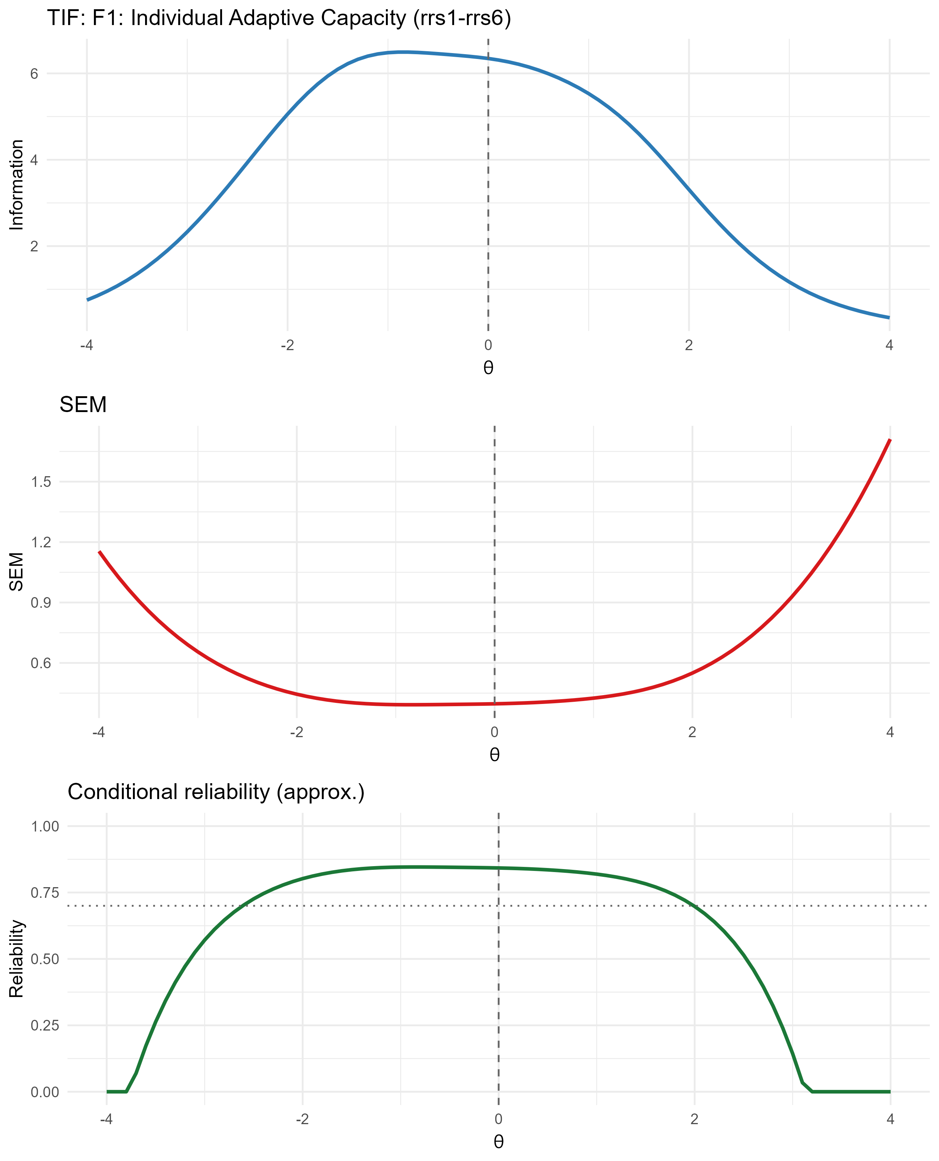
Figure S14.1. Test information function (TIF), standard error of measurement (SEM), and conditional reliability curves, F1 (Individual Adaptive Capacity).
Note. Peak information (6.49) occurs at θ = -0.8; conditional reliability exceeds .70 across θ = [-2.6, 1.9], consistent with Table S14.6.
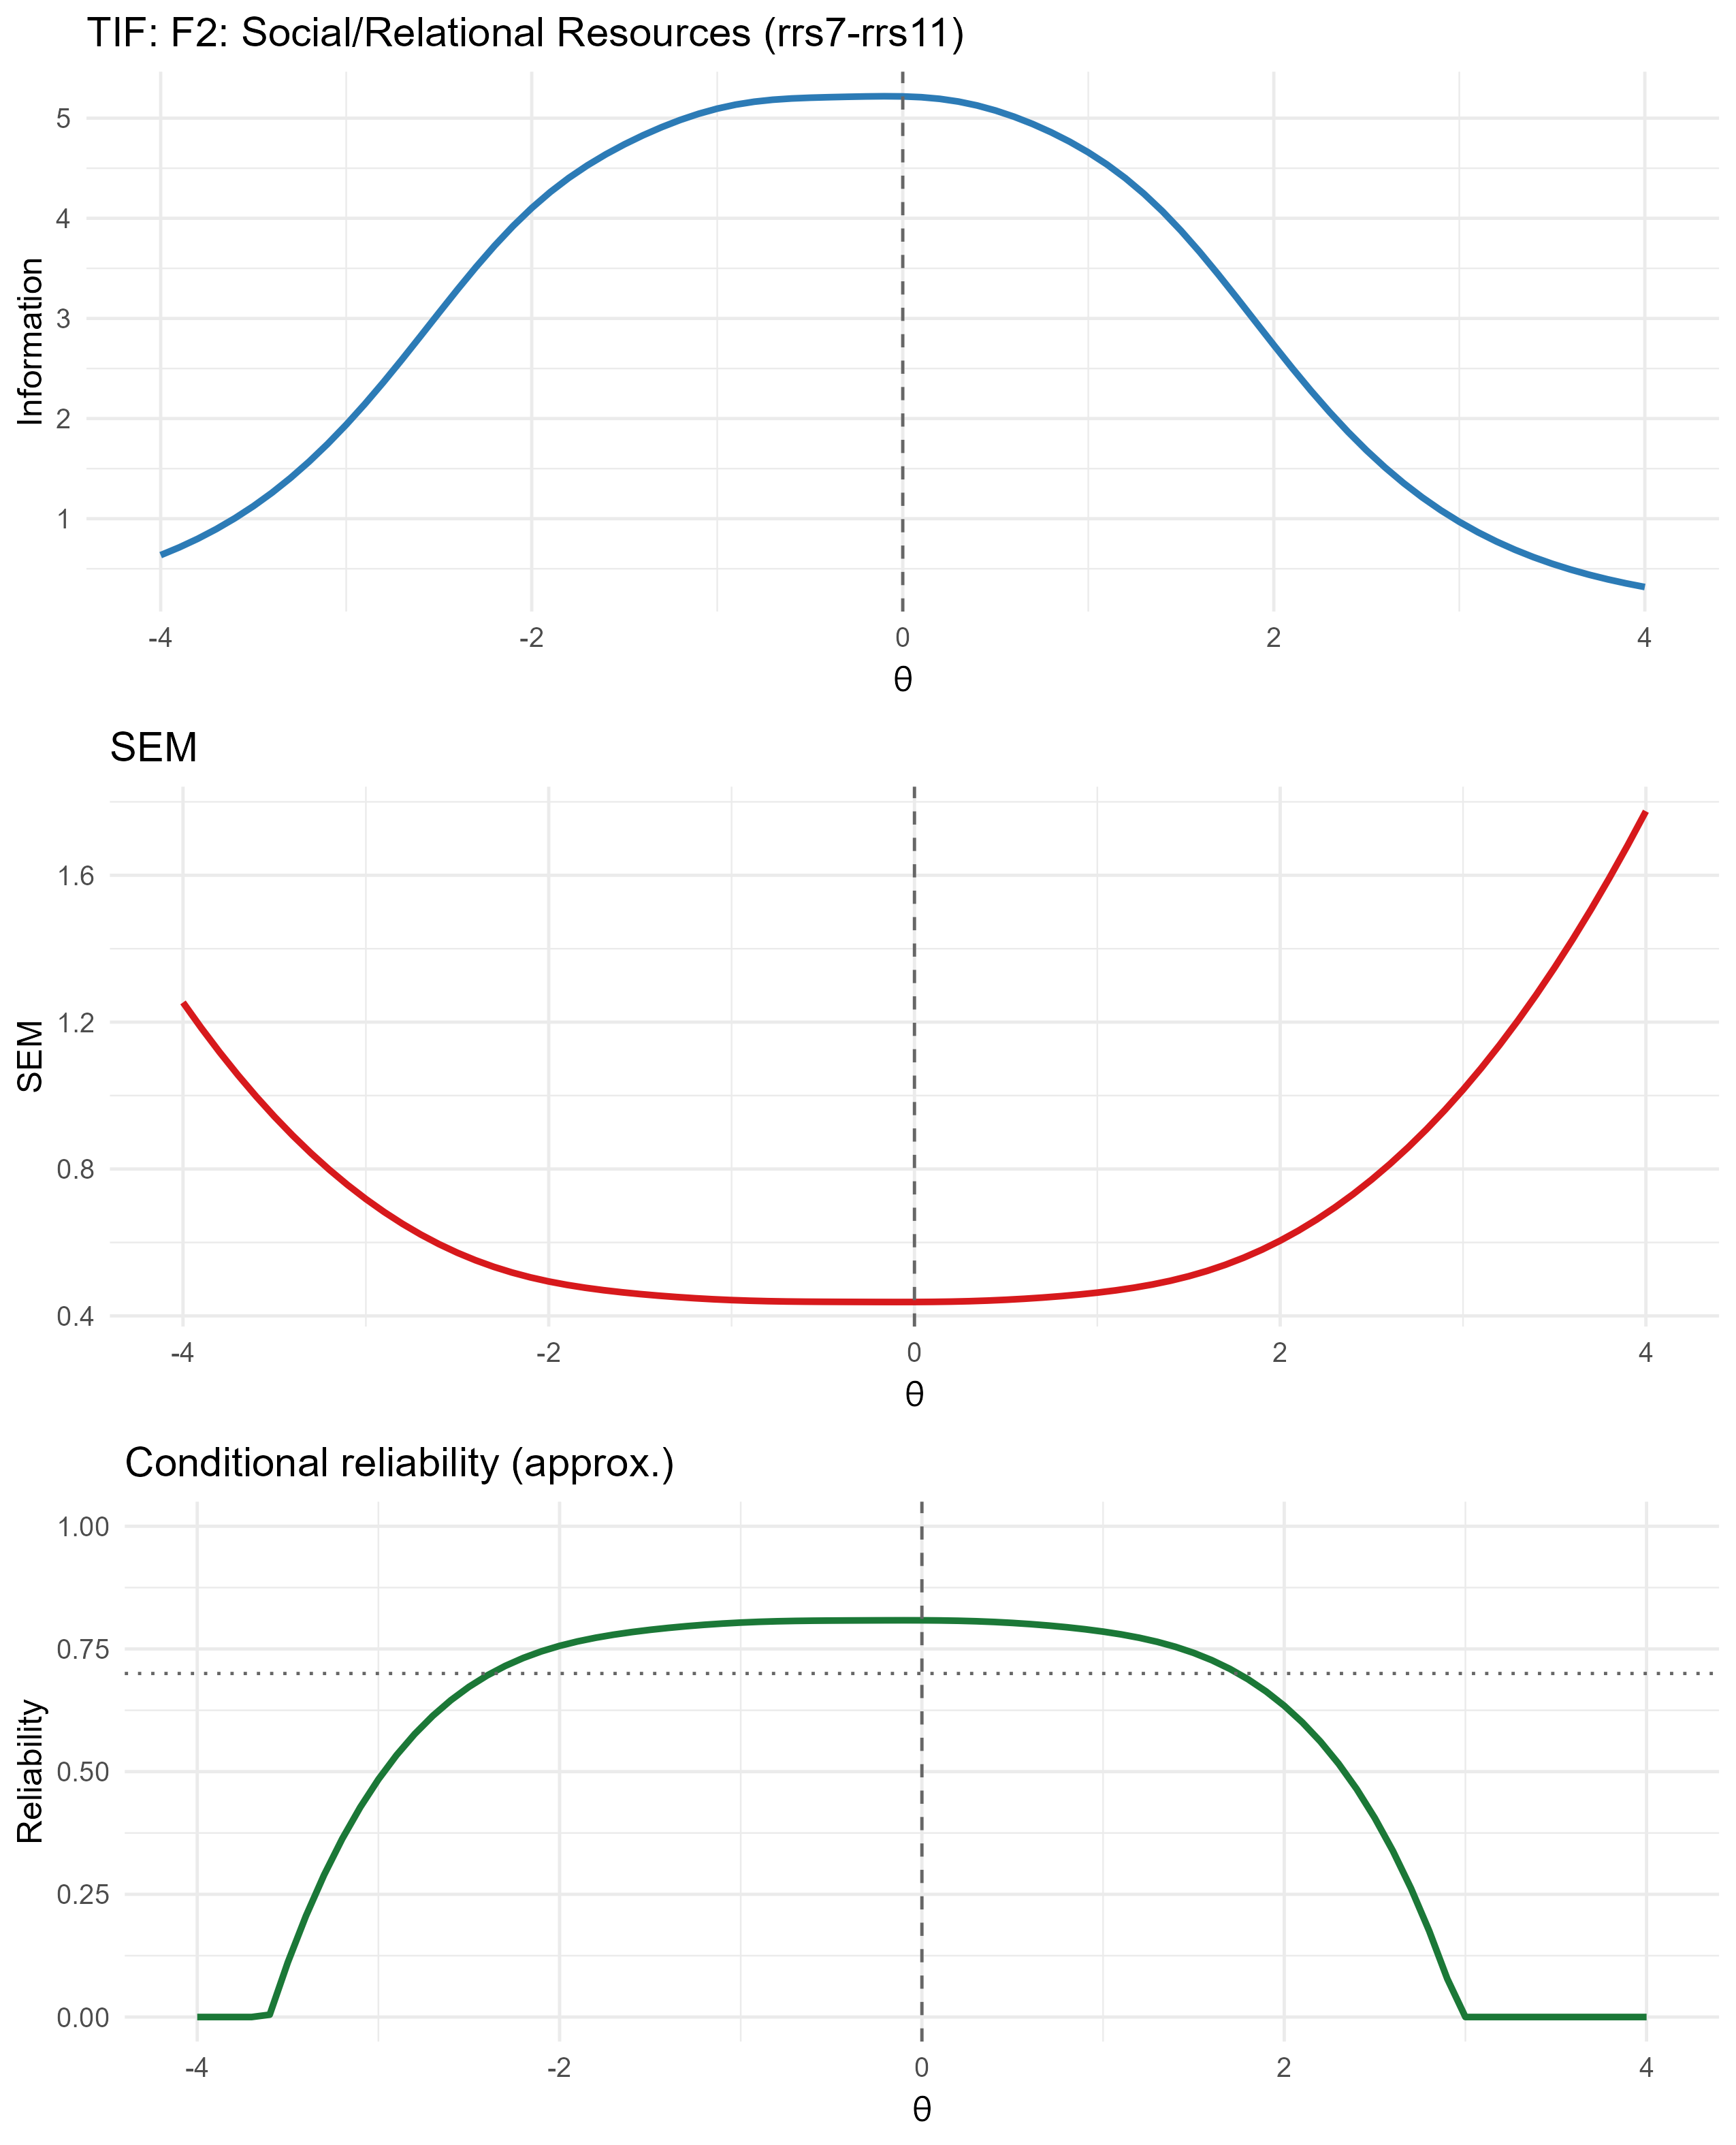
Figure S14.2. Test information function (TIF), standard error of measurement (SEM), and conditional reliability curves, F2 (Support Seeking and Relational Resource Use).
Note. Peak information (5.22) occurs at θ = -0.1; conditional reliability exceeds .70 across θ = [-2.3, 1.7], consistent with Table S14.6.
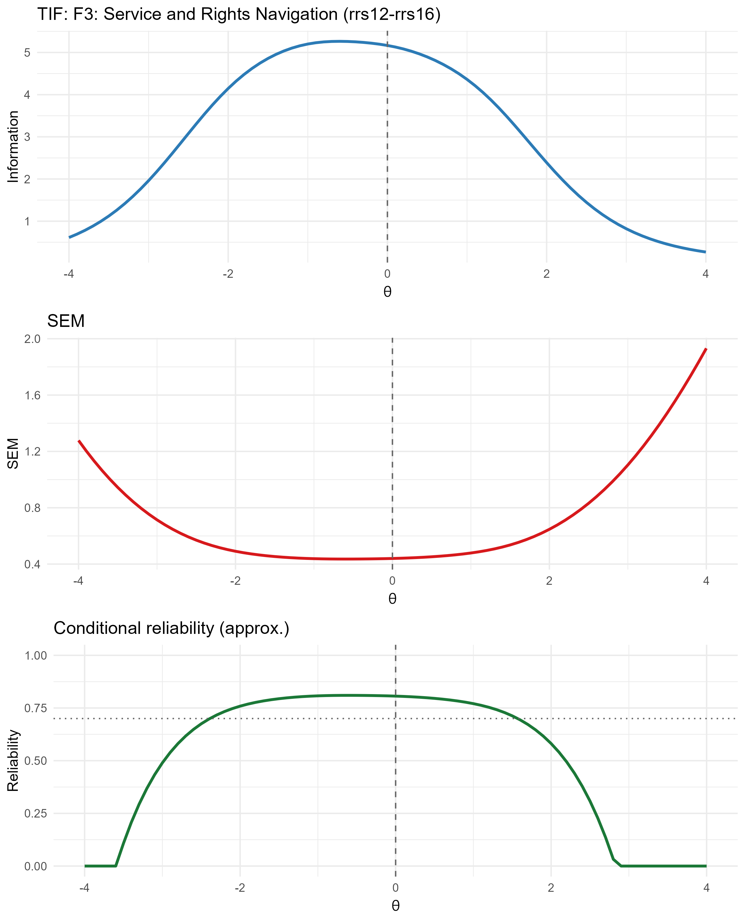
Figure S14.3. Test information function (TIF), standard error of measurement (SEM), and conditional reliability curves, F3 (Service and Rights Navigation).
Note. Peak information (5.26) occurs at θ = -0.6; conditional reliability exceeds .70 across θ = [-2.3, 1.5], consistent with Table S14.6.
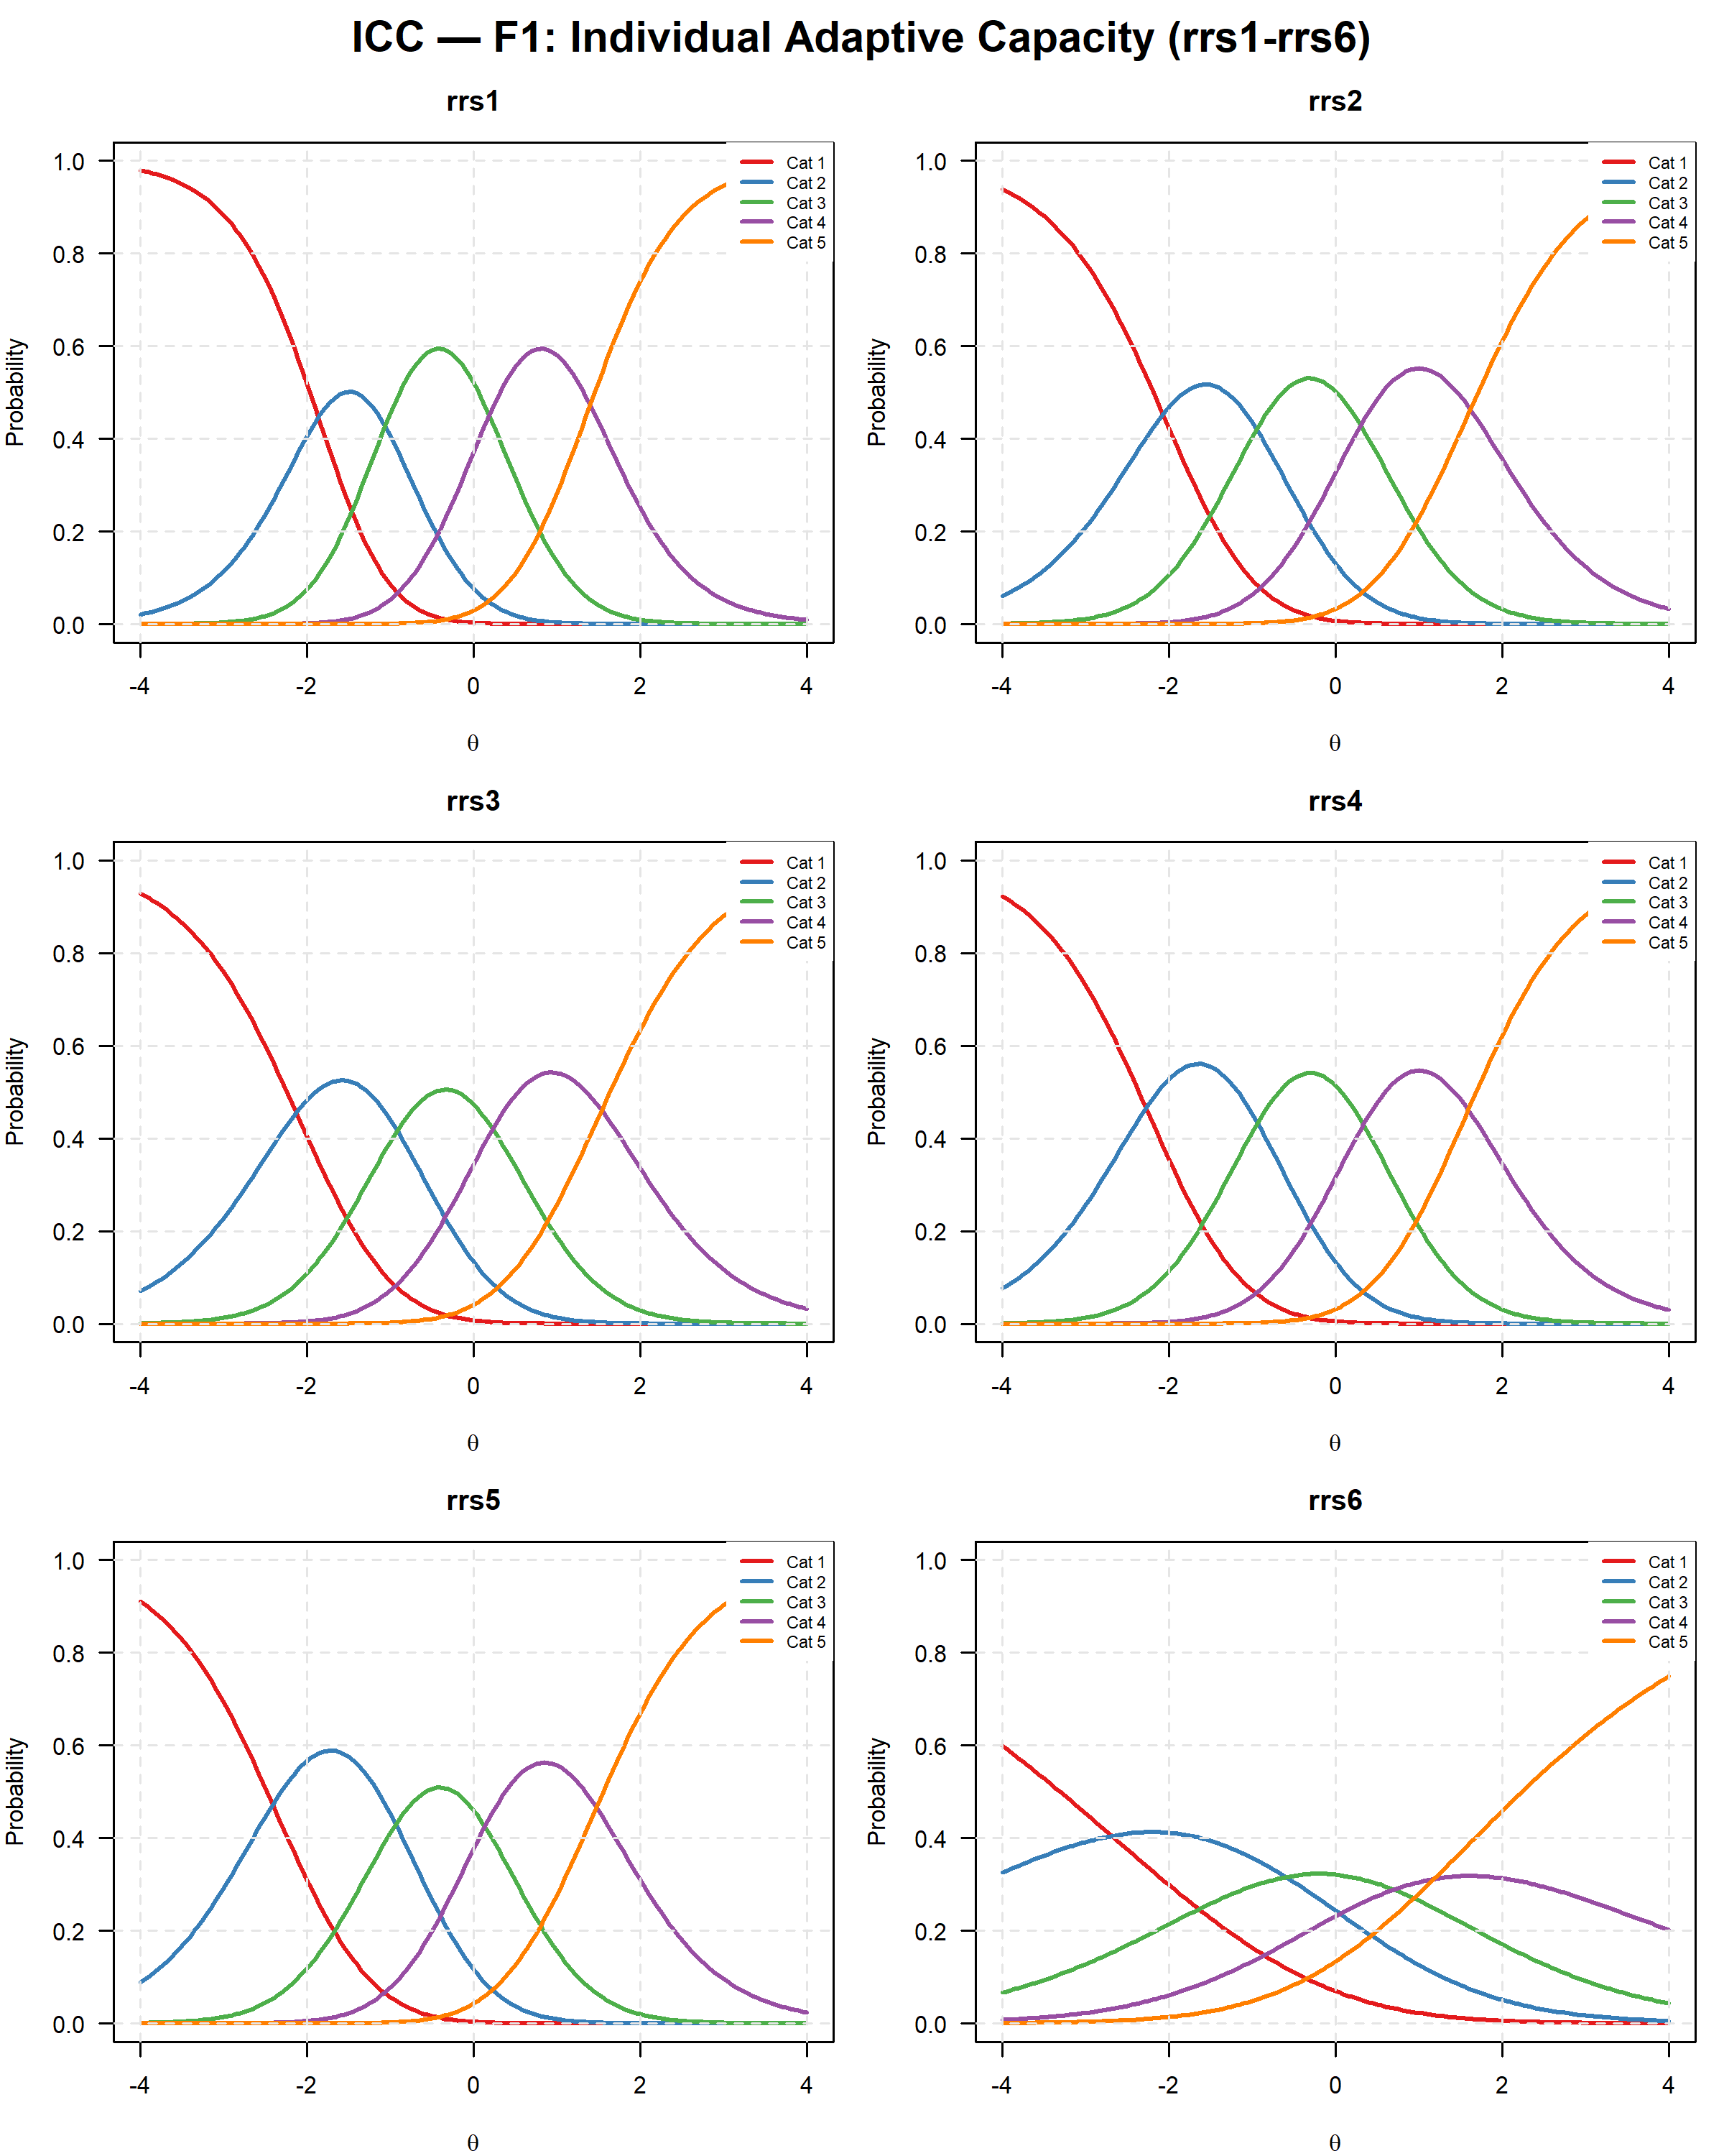
Figure S14.4. Category response curves (ICCs), F1 (rrs1, rrs2, rrs3, rrs4, rrs5, rrs6).
Note. Each panel shows the probability of endorsing each of the 5 response categories as a function of the latent trait θ. Item rrs6 shows a visibly flatter curve, consistent with its lower discrimination parameter reported in Table S14.4.
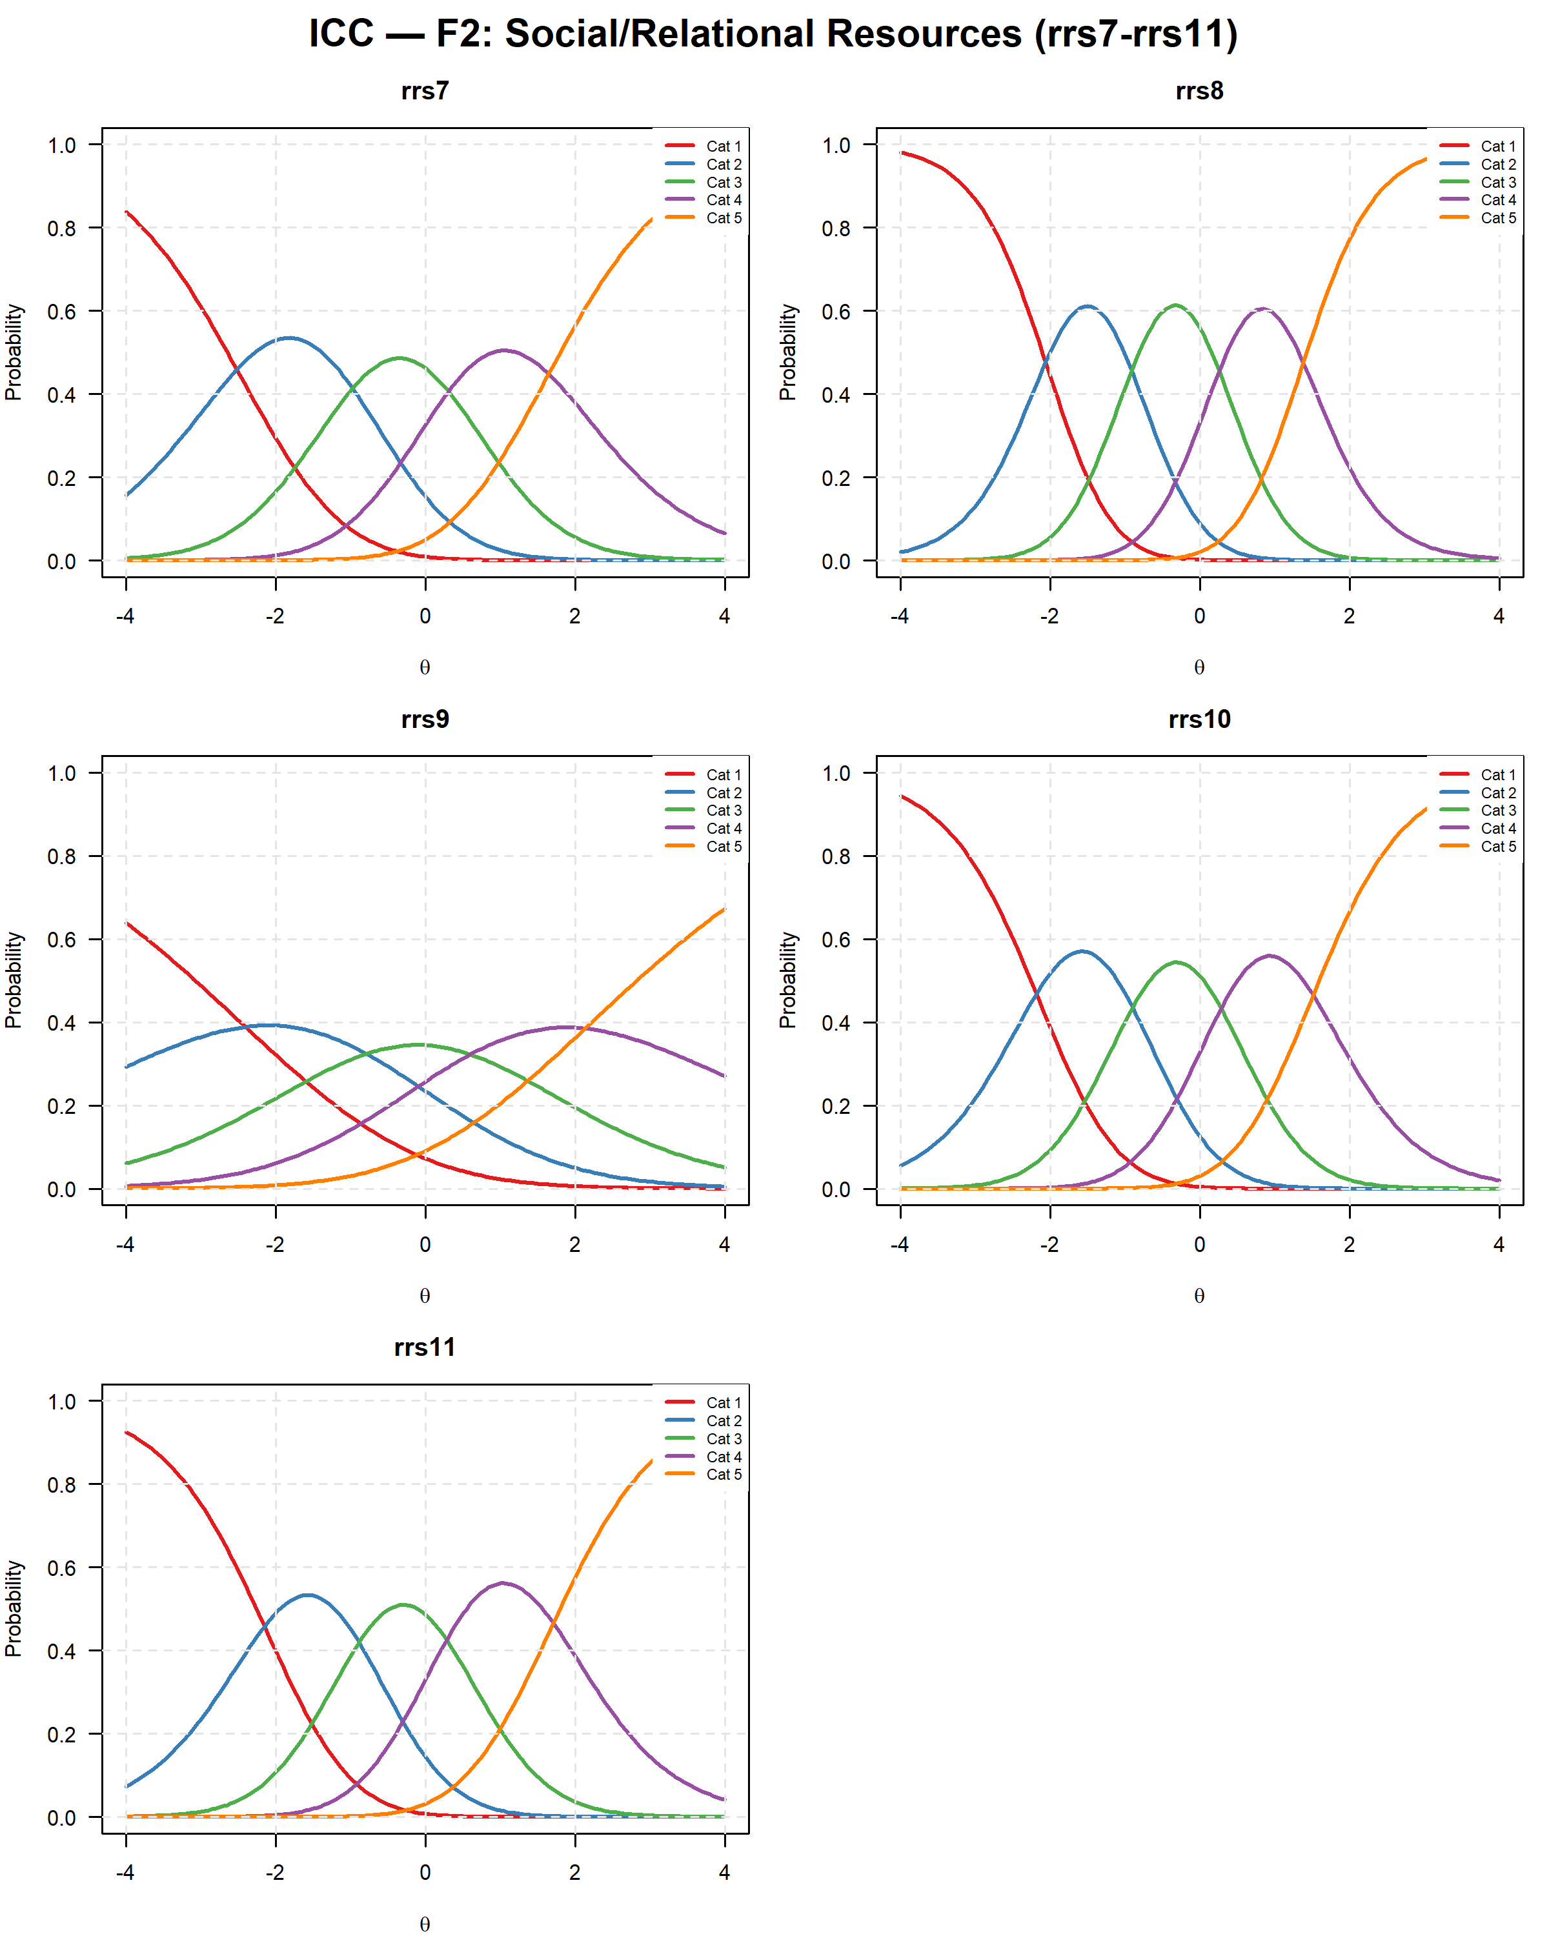
Figure S14.5. Category response curves (ICCs), F2 (rrs7, rrs8, rrs9, rrs10, rrs11).
Note. Each panel shows the probability of endorsing each of the 5 response categories as a function of the latent trait θ. Item rrs9 shows a visibly flatter curve, consistent with its lower discrimination parameter reported in Table S14.4.
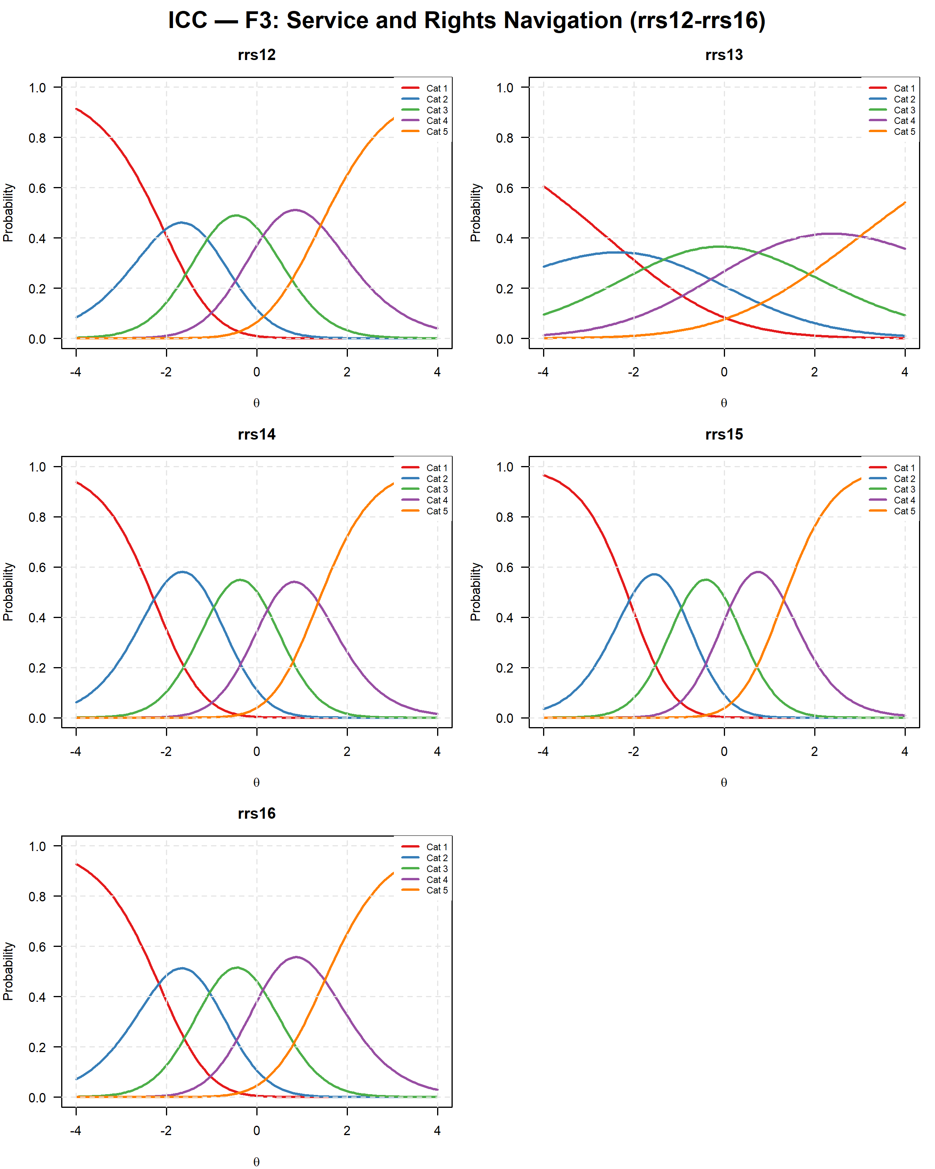
Figure S14.6. Category response curves (ICCs), F3 (rrs12, rrs13, rrs14, rrs15, rrs16).
Note. Each panel shows the probability of endorsing each of the 5 response categories as a function of the latent trait θ. Item rrs13 shows a visibly flatter curve, consistent with its lower discrimination parameter reported in Table S14.4.
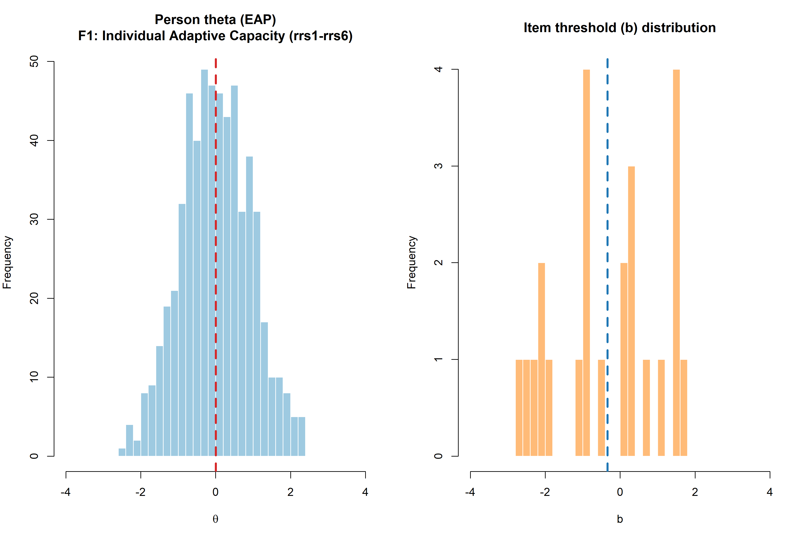
Figure S14.7. Wright map: person theta (EAP) distribution and item threshold distribution, F1 (Individual Adaptive Capacity).
Note. The left panel shows the distribution of person latent trait estimates (EAP); the right panel shows the distribution of item category thresholds (b parameters) across all 6 items in this factor.
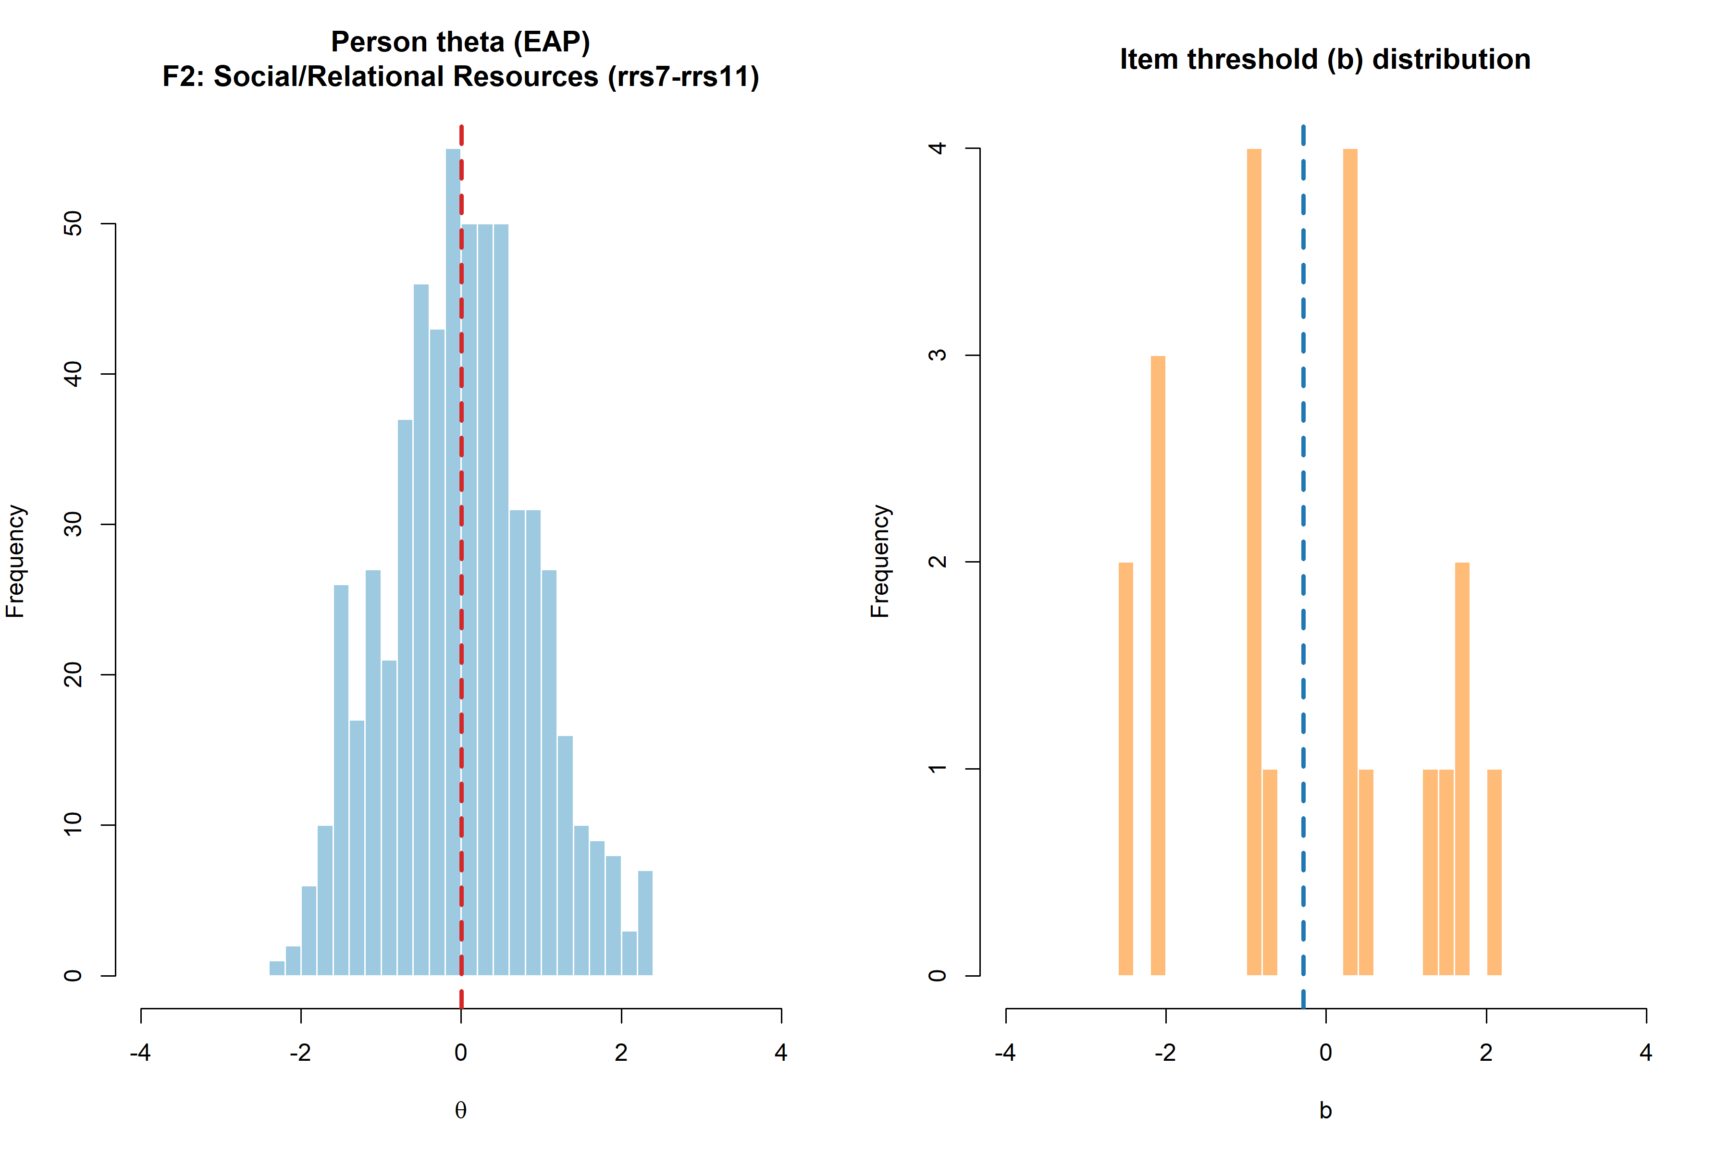
Figure S14.8. Wright map: person theta (EAP) distribution and item threshold distribution, F2 (Support Seeking and Relational Resource Use).
Note. The left panel shows the distribution of person latent trait estimates (EAP); the right panel shows the distribution of item category thresholds (b parameters) across all 5 items in this factor.
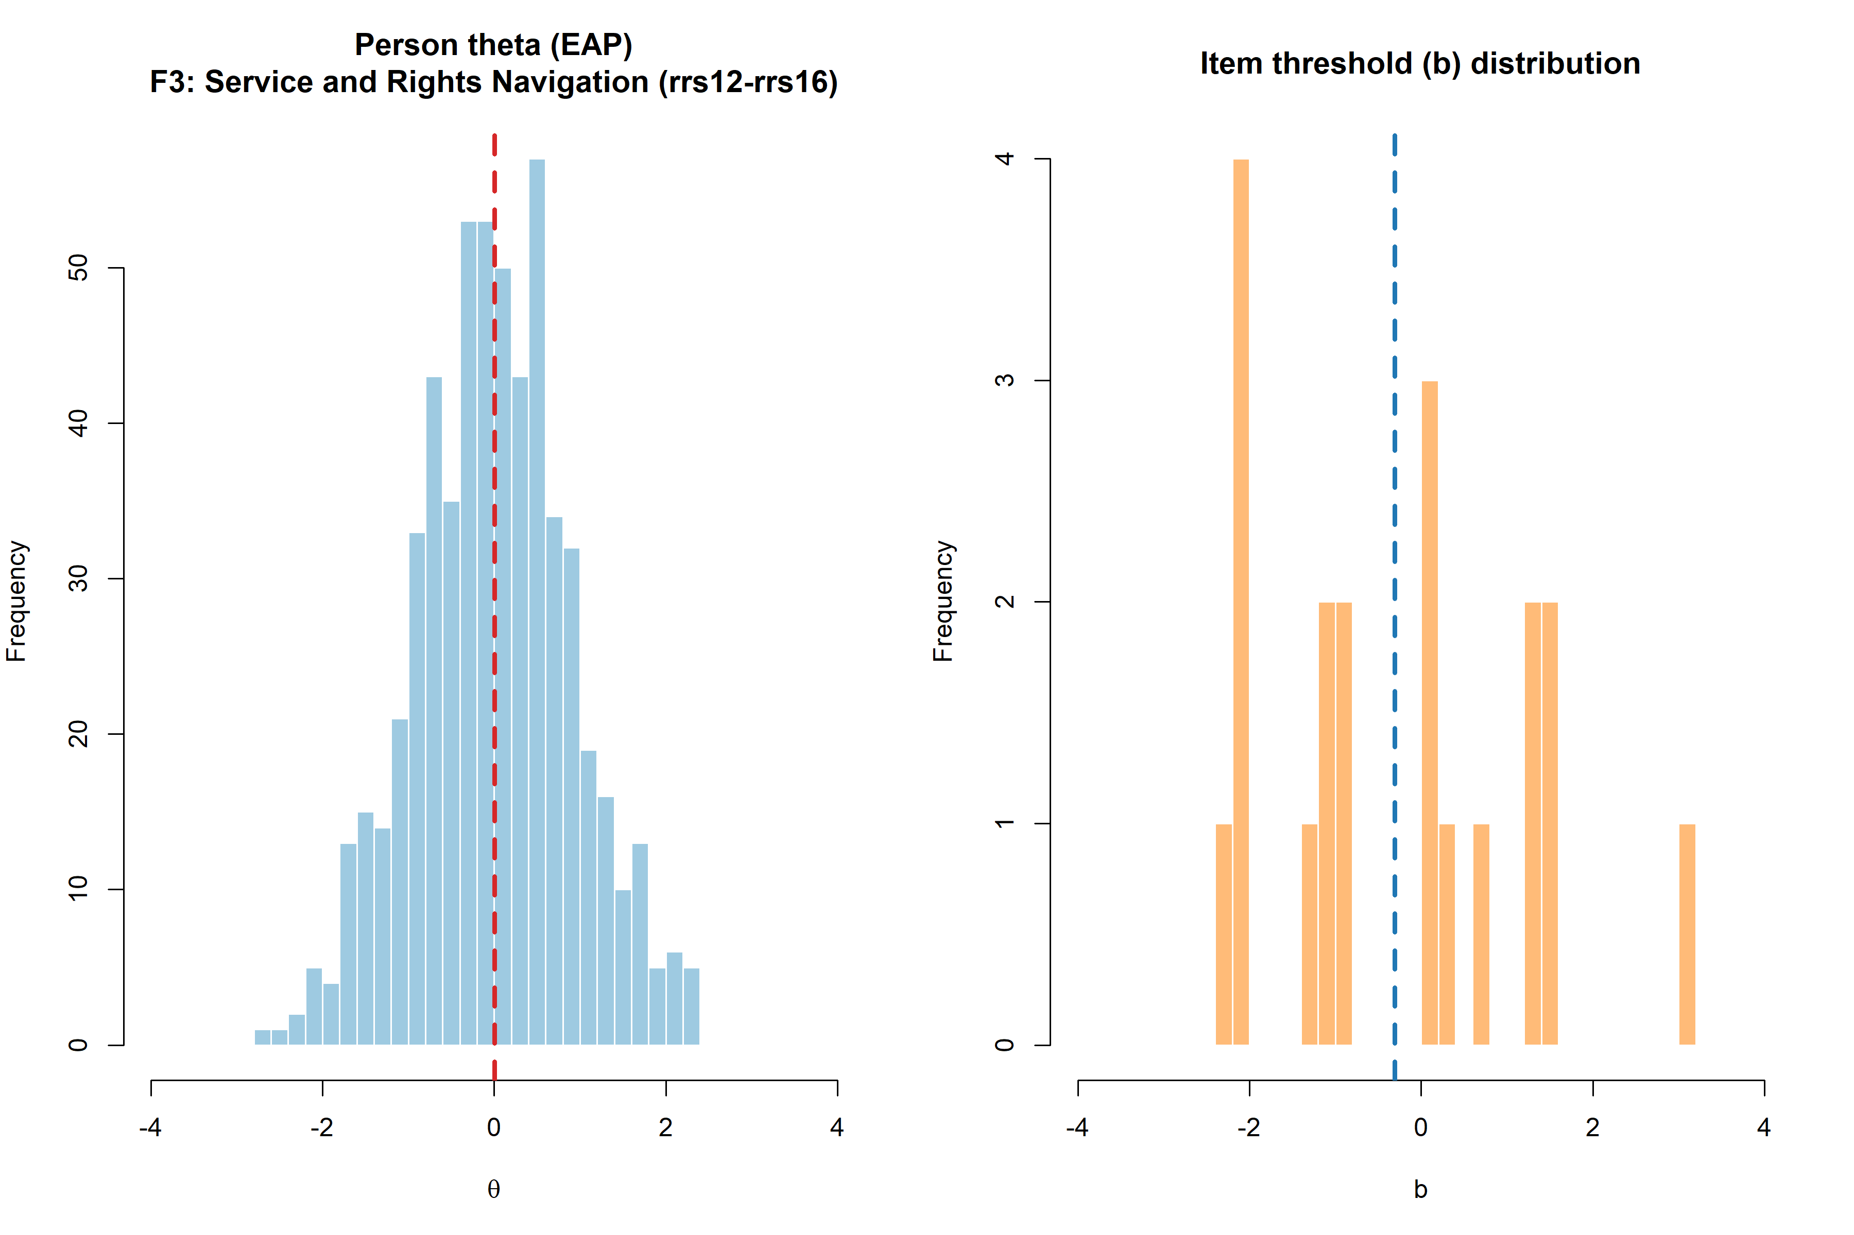
Figure S14.9. Wright map: person theta (EAP) distribution and item threshold distribution, F3 (Service and Rights Navigation).
Note. The left panel shows the distribution of person latent trait estimates (EAP); the right panel shows the distribution of item category thresholds (b parameters) across all 5 items in this factor.
Summary
GPCM provided a better fit than GRM for all three RRS-16 factors and was retained throughout. Discrimination parameters were positive in all 16 items, ranging from comparatively low (rrs6, rrs9, rrs13) to moderate-to-high (up to a = 2.018 for rrs8), and category thresholds were monotonically ordered for every item. The GPCM was retained as the better-fitting model for all three factors in this section; note that the independent IRT triangulation reported in S17 (Part 4) fits a graded response model instead, because that analysis targets EAP reliability rather than model selection. Overall model fit (C2) was non-significant at the conventional .05 level for all three factors, with no individual item flagged for misfit under S-X² after Bonferroni correction. Mokken scalability was good in all three factors (H = .448-.478), with zero monotonicity violations and fully invariant item ordering. Test information peaked at a slightly negative theta near the sample mean of the latent trait, providing reliability >= .70 across a comparatively wide, lower-skewed range of theta. One notable finding, reported transparently per project convention, is that pairwise local dependence diagnostics (Q3 and LD χ²) exceeded conventional thresholds for a substantial proportion of item pairs in all three factors, with the two criteria ordering the factors differently: |Q3| >= .20 was met by 5 of 15 pairs in F1, 5 of 10 in F2, and 6 of 10 in F3, whereas LD χ² > 10 was met by 10 of 15, 9 of 10, and 4 of 10 pairs, respectively. Given that overall model fit (C2) remained non-significant at the conventional threshold and item-level S-X² fit was unproblematic for every item, this pattern most plausibly reflects the shared, closely related item wording within each theoretically-derived factor block rather than a substantive violation of the unidimensional IRT model; it is noted here as a limitation affecting the precision (rather than the validity) of information-function and standard-error estimates, and should be considered when interpreting theta-level precision claims. The raw flagged proportions overstate this signal, however. Q3 carries a known negative bias of approximately -1/(J - 1), and applying the same |Q3| >= .20 criterion to bias-corrected values flags 1 of the 35 within-factor pairs rather than 16 (see the note to Table S14.5). This is consistent with the independent full-sample residual-covariance screen reported in S17 (Part 5), which flagged 2 of the same 35 pairs at a more lenient threshold (|resid r| >= .10) and found that freeing both produced only a marginal fit gain (Delta CFI = .005). IRT-based precision estimates (e.g., conditional reliability, standard errors) should therefore be interpreted with mild rather than substantial caution; it should also be noted that the CTT/CFA-based reliability indices reported in S12 are not immune to local dependence, since within-factor residual covariance inflates alpha, omega, and CR. Items rrs6, rrs9, and rrs13 -- already flagged in Sections S3, S8-S10, and S12 as comparatively weaker performers within their respective factors -- again showed the lowest IRT discrimination parameters of the item pool, converging with the reliability- and factor-analytic evidence reported elsewhere in this supplement regarding these three items, none of which were removed from the final 16-item measure per the retention decision documented in Section S10.
References
Bentler, P. M., & Bonett, D. G. (1980). Significance tests and goodness of fit in the analysis of covariance structures. Psychological Bulletin, 88(3), 588-606.
Chen, W.-H., & Thissen, D. (1997). Local dependence indexes for item pairs using item response theory. Journal of Educational and Behavioral Statistics, 22(3), 265-289.
Marais, I., & Andrich, D. (2008). Effects of varying magnitude and patterns of response dependence in the unidimensional Rasch model. Journal of Applied Measurement, 9(2), 105-124.
Maydeu-Olivares, A., & Joe, H. (2006). Limited information goodness-of-fit testing in multidimensional contingency tables. Psychometrika, 71(4), 713-732.
Mokken, R. J. (1971). A theory and procedure of scale analysis. Mouton.
Sijtsma, K., & Molenaar, I. W. (2002). Introduction to nonparametric item response theory. Sage.
Steiger, J. H. (1990). Structural model evaluation and modification: An interval estimation approach. Multivariate Behavioral Research, 25(2), 173-180.
Yen, W. M. (1984). Effects of local item dependence on the fit and equating performance of the three-parameter logistic model. Applied Psychological Measurement, 8(2), 125-145.

S15. Network Psychometrics Analyses
Refugee Resilience Scale (RRS): Adaptive Coping and Resource Mobilization in Forced Migration
Network psychometrics analyses examined the RRS-16 item structure as a system of mutually reinforcing resilience-relevant experiences rather than as reflective indicators of latent causes alone. A regularized partial correlation network (Gaussian Graphical Model, GGM) was estimated using the EBICglasso algorithm (γ = 0.5) on polychoric correlations (cor_auto), consistent with current best-practice recommendations for ordinal psychometric network estimation.
Note. No imputation was performed at any stage of this analysis. Of the 583 participants in the retained analytic sample, 547 (93.825%) had complete data on all 16 RRS-16 items and were retained for the network estimation (complete-case analysis). Only 38 of 9,328 total data cells (0.407%) were missing across the full sample; missingness was concentrated in a small number of items (rrs7, 0.858%; rrs2/rrs4/rrs9/rrs10/rrs11/rrs13/rrs15/rrs16, 0.515% each), each well below 1%. Given this negligible and apparently non-systematic missingness, complete-case deletion was judged preferable to model-based imputation for the network analyses.
Missing Data Summary
Table S15.1. Missing data overview for the network analysis sample.
Metric | Value
N (raw) | 583
N (complete cases) | 547
% complete cases | 93.825%
Total data cells (16 items × N) | 9,328
Missing cells | 38
% missing cells | 0.407%

Table S15.2. Item-level missing data summary.
Item | N valid | N missing | % missing
rrs1 | 583 | 0 | 0%
rrs2 | 580 | 3 | 0.515%
rrs3 | 582 | 1 | 0.172%
rrs4 | 580 | 3 | 0.515%
rrs5 | 581 | 2 | 0.343%
rrs6 | 581 | 2 | 0.343%
rrs7 | 578 | 5 | 0.858%
rrs8 | 582 | 1 | 0.172%
rrs9 | 580 | 3 | 0.515%
rrs10 | 580 | 3 | 0.515%
rrs11 | 580 | 3 | 0.515%
rrs12 | 582 | 1 | 0.172%
rrs13 | 580 | 3 | 0.515%
rrs14 | 581 | 2 | 0.343%
rrs15 | 580 | 3 | 0.515%
rrs16 | 580 | 3 | 0.515%
Note. N complete cases used for network estimation = 547. All 16 RRS-16 items had missingness below 1%; no item was excluded on missing-data grounds.
Network Structure
The estimated network retained 76 of 120 possible edges (sparsity = 0.367), with no thresholding applied (threshold = FALSE), consistent with recommendations to preserve sensitivity in networks estimated from moderate-to-large ordinal samples. A dense-network warning was returned by qgraph (λ < 0.10 × λ_max), indicating that the smallest edges should be interpreted with caution; primary interpretation therefore emphasizes the larger, more stable edges and the overall community structure rather than individual near-zero edges. Two edges (rrs4-rrs16 and rrs5-rrs13) were small and negative (both |w| ≤ .03); given their negligible magnitude and the dense-network warning, these are treated as estimation noise rather than substantive negative associations.
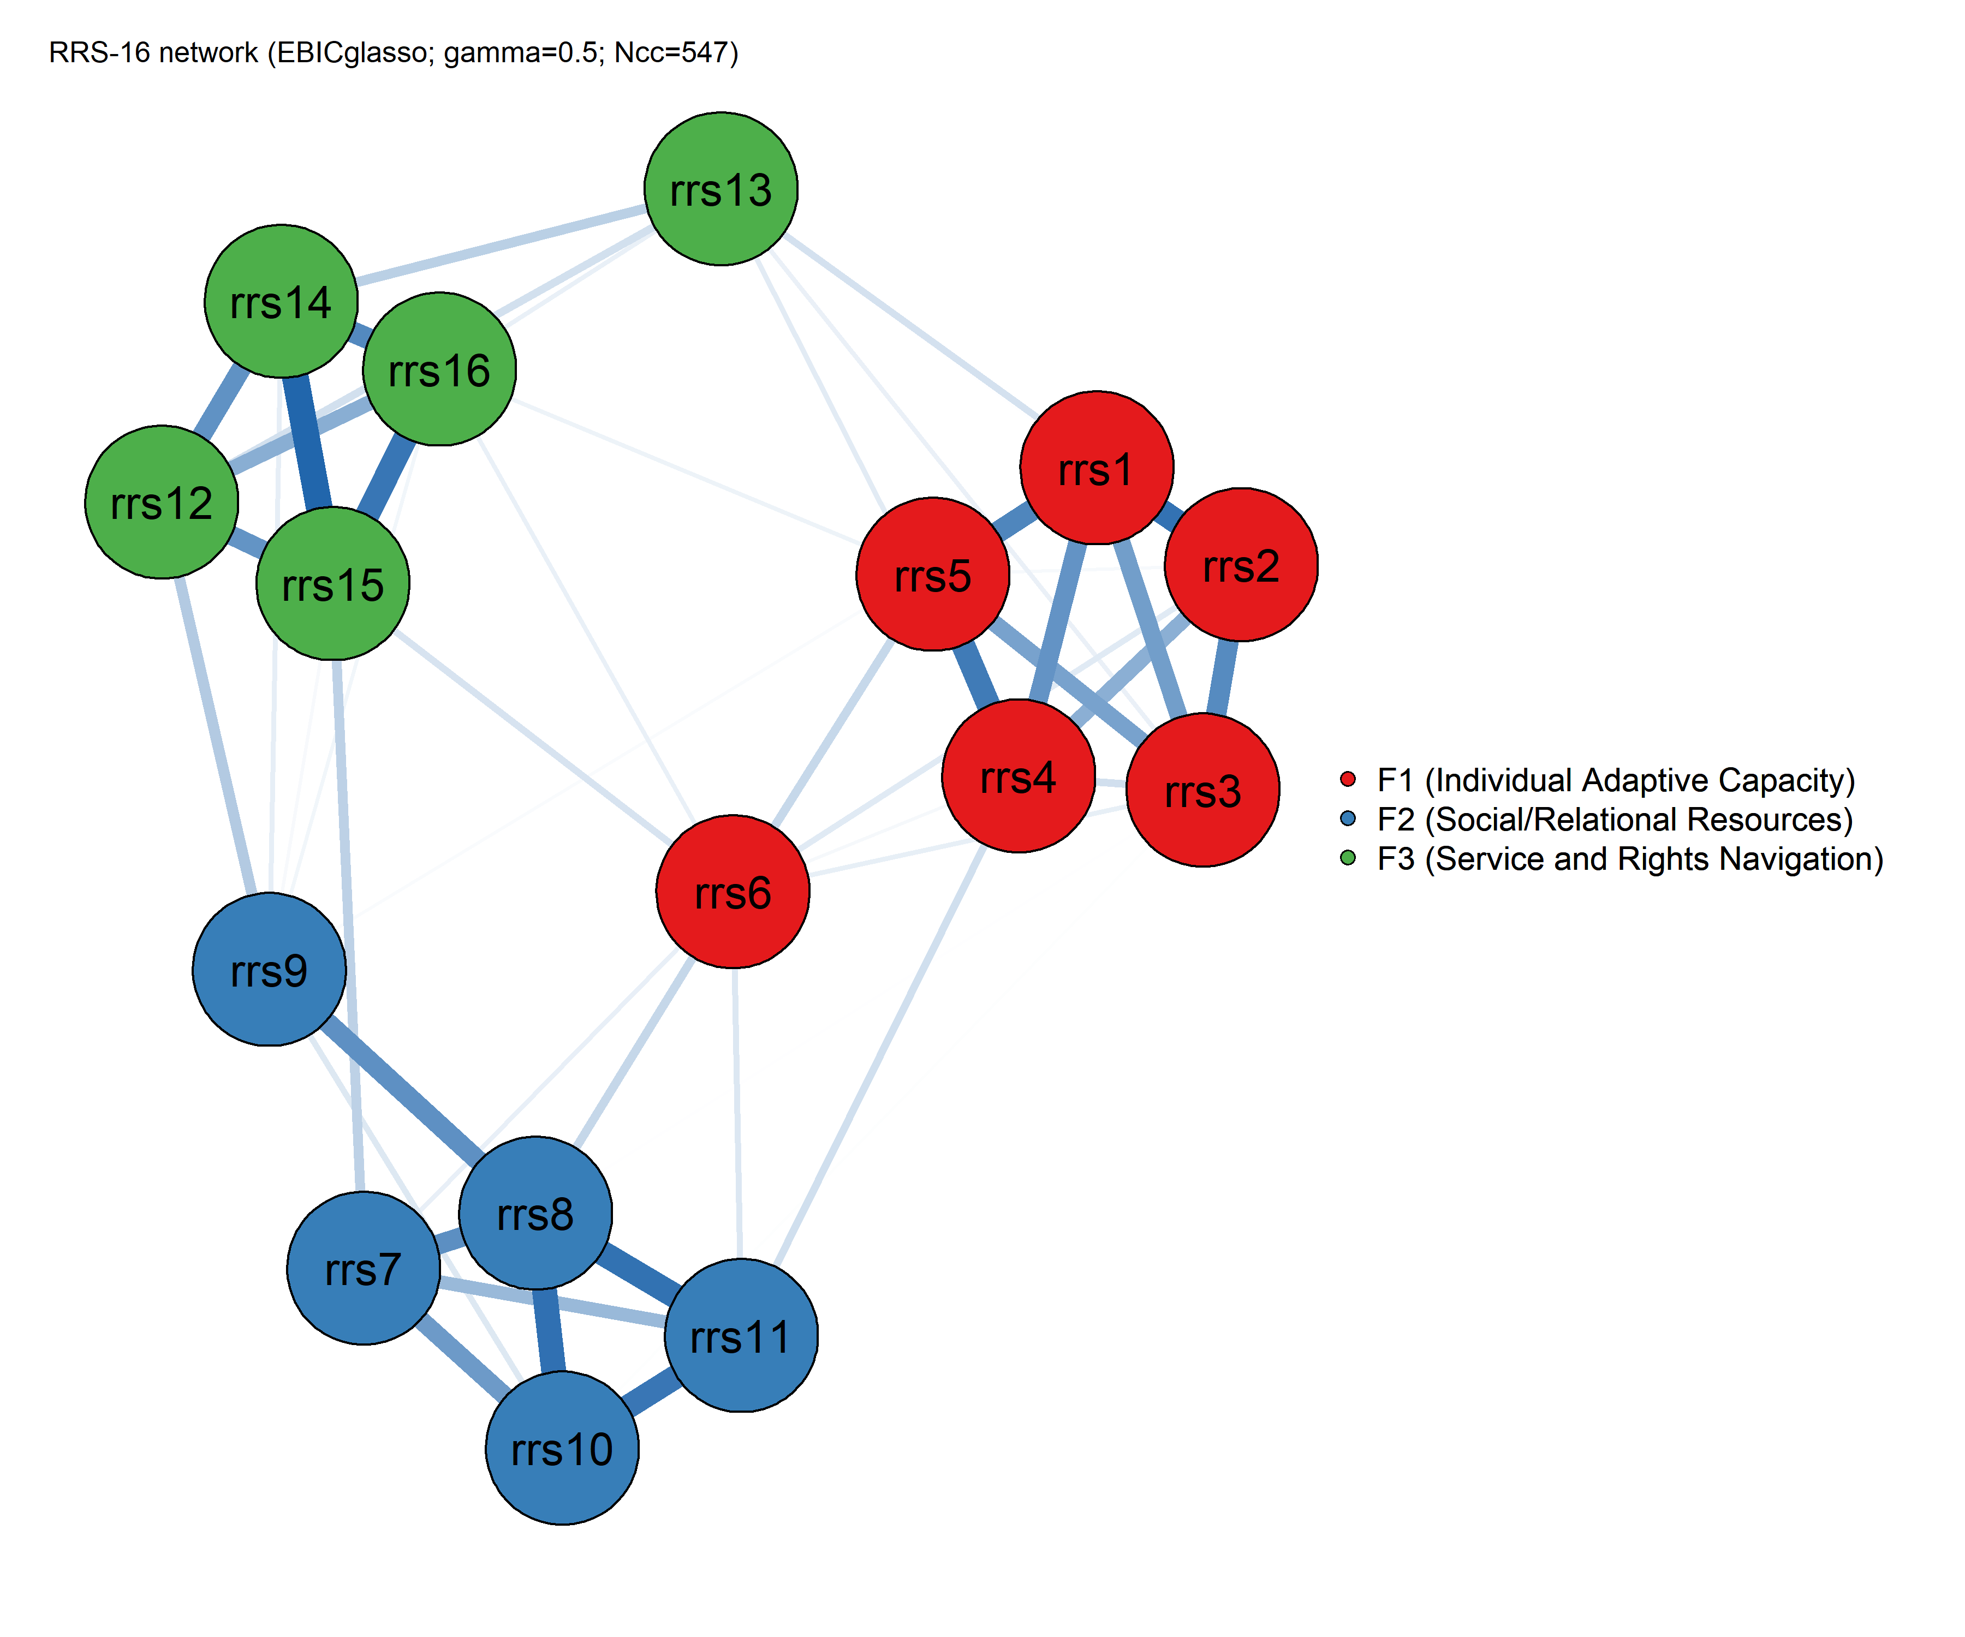
Figure S15.1. Regularized partial correlation network of the 16 RRS-16 items.
Note. Node color denotes the three CFA-derived factors (F1: Individual Adaptive Capacity; F2: Support Seeking and Relational Resource Use; F3: Service and Rights Navigation), used here as a priori communities for bridge-centrality analysis. Edge thickness and color saturation represent the magnitude of the partial correlation (blue = positive, red = negative). This and the other network plots in this section are drawn with the qgraph display threshold minimum = 0.03, so 25 of the 76 estimated edges are not shown; 22 of these are between-factor and 3 within-factor, which means the visual contrast between dense within-cluster and sparse between-cluster connectivity described below is more pronounced in the figure than in the full estimated network. The threshold affects the figures only; all reported edge counts, sparsity, centrality and bridge statistics are computed from the complete network. The network shows a clear three-cluster topology that closely mirrors the confirmatory factor structure: items within each factor (F1: rrs1-rrs6; F2: rrs7-rrs11; F3: rrs12-rrs16) are connected by dense, strong within-cluster edges, while between-cluster edges are comparatively sparser and weaker, with item rrs6 (F1) occupying a visually intermediate position bridging all three clusters. This convergence between the CFA-based factor structure and the data-driven network topology constitutes structural corroboration of the three-factor correlated model reported in the confirmatory analyses (see S9 and S12).
Centrality Indices
Node centrality was quantified using strength, closeness, betweenness, and expected influence. Item rrs8 (F2) showed the highest strength (1.130, z = 1.557) and expected influence (1.130, z = 1.566), indicating it is the most centrally embedded item in the network. Item rrs15 (F3) showed the second highest strength (1.060, z = 1.102) and expected influence (1.060, z = 1.130). Item rrs13 (F3) showed the lowest strength (0.566, z = -2.129) and expected influence (0.506, z = -2.345), followed by rrs9 (F2; strength = 0.627, z = -1.727) and rrs6 (F1; strength = 0.705, z = -1.222) -- the same three items identified as comparatively weaker performers on IRT discrimination (S14) and reliability/factor-analytic criteria (Sections S3, S8-S10, S12).
Table S15.3. Node centrality indices for the 16 RRS-16 items.
Item | Factor | Strength | Closeness | Betweenness | Expected Influence
rrs1 | F1 (Individual Adaptive Capacity) | 1.049 | 0.0039 | 1 | 1.049
rrs2 | F1 (Individual Adaptive Capacity) | 0.947 | 0.0039 | 6 | 0.947
rrs3 | F1 (Individual Adaptive Capacity) | 0.899 | 0.0035 | 0 | 0.899
rrs4 | F1 (Individual Adaptive Capacity) | 0.951 | 0.0042 | 22 | 0.918
rrs5 | F1 (Individual Adaptive Capacity) | 0.981 | 0.0041 | 15 | 0.921
rrs6 | F1 (Individual Adaptive Capacity) | 0.705 | 0.0045 | 4 | 0.705
rrs7 | F2 (Support Seeking and Relational Resource Use) | 0.807 | 0.0045 | 10 | 0.807
rrs8 | F2 (Support Seeking and Relational Resource Use) | 1.130 | 0.0047 | 14 | 1.130
rrs9 | F2 (Support Seeking and Relational Resource Use) | 0.627 | 0.0042 | 4 | 0.627
rrs10 | F2 (Support Seeking and Relational Resource Use) | 0.894 | 0.0044 | 0 | 0.894
rrs11 | F2 (Support Seeking and Relational Resource Use) | 0.874 | 0.0046 | 20 | 0.874
rrs12 | F3 (Service and Rights Navigation) | 0.892 | 0.0041 | 5 | 0.892
rrs13 | F3 (Service and Rights Navigation) | 0.566 | 0.0037 | 10 | 0.506
rrs14 | F3 (Service and Rights Navigation) | 0.981 | 0.0042 | 7 | 0.981
rrs15 | F3 (Service and Rights Navigation) | 1.060 | 0.0043 | 15 | 1.060
rrs16 | F3 (Service and Rights Navigation) | 0.904 | 0.0041 | 2 | 0.871
Note. Strength = sum of absolute edge weights connected to a node. Closeness = inverse of the sum of shortest distances to all other nodes. Betweenness = number of shortest paths between other node pairs that pass through the node. Expected Influence differs from Strength for rrs4, rrs5, rrs13, and rrs16 because these four items each carry one small negative edge, which offsets in the signed sum but not in the absolute sum; the network contains exactly two negative edges, rrs5-rrs13 and rrs4-rrs16, so the difference is 0.060 for rrs5 and rrs13 and 0.033 for rrs4 and rrs16 (twice the corresponding edge weight in each case). Expected Influence equals Strength for all other items because no other negative edges were observed in the estimated network.
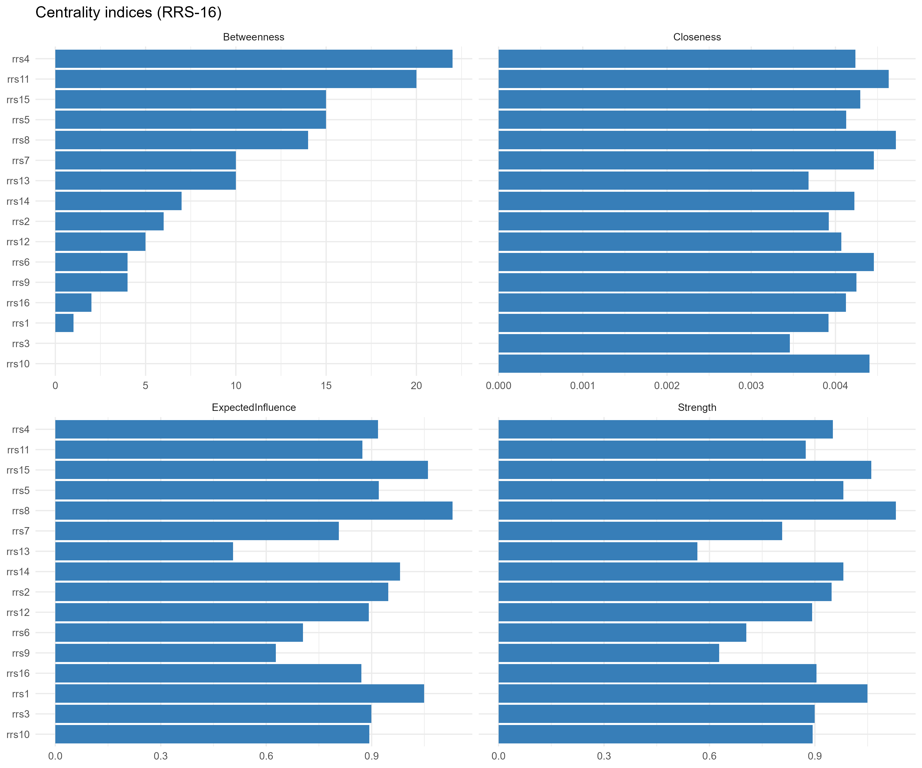
Figure S15.2. Node centrality indices for the RRS-16 network (strength, closeness, betweenness, expected influence).
Note. Item rrs8 shows the highest values on strength and expected influence, and item rrs4 shows the highest betweenness. Betweenness is displayed for completeness only and is not interpreted substantively, because its case-dropping stability was inadequate (CS = .049; Table S15.5). See Table S15.3 for exact values.
Bridge Centrality
Bridge centrality indices, computed using the three CFA-derived factors as a priori communities, identify items that connect the factor clusters and therefore carry the most cross-domain influence in the network. Item rrs6 (F1) showed by far the highest bridge strength (0.417) and bridge expected influence (0.417), suggesting it functions as the primary connector across the three resilience clusters, consistent with its visually intermediate position in Figure S15.1 and despite its low within-factor centrality noted above. Item rrs9 (F2; bridge strength = 0.320) and item rrs13 (F3; bridge strength = 0.291) were the next most prominent bridge nodes -- again the same three comparatively weaker-performing items identified throughout this supplement. Item rrs10 (F2) showed the smallest bridging role (bridge strength = 0.076).
Table S15.4. Bridge centrality indices (three RRS-16 factors treated as communities).
Item | Factor | Bridge Strength | Bridge Betweenness | Bridge Closeness | Bridge Exp. Influence
rrs1 | F1 (Individual Adaptive Capacity) | 0.097 | 0 | 0.045 | 0.097
rrs2 | F1 (Individual Adaptive Capacity) | 0.167 | 6 | 0.046 | 0.167
rrs3 | F1 (Individual Adaptive Capacity) | 0.136 | 0 | 0.040 | 0.136
rrs4 | F1 (Individual Adaptive Capacity) | 0.182 | 22 | 0.050 | 0.148
rrs5 | F1 (Individual Adaptive Capacity) | 0.154 | 11 | 0.047 | 0.094
rrs6 | F1 (Individual Adaptive Capacity) | 0.417 | 4 | 0.064 | 0.417
rrs7 | F2 (Support Seeking and Relational Resource Use) | 0.212 | 10 | 0.055 | 0.212
rrs8 | F2 (Support Seeking and Relational Resource Use) | 0.133 | 11 | 0.056 | 0.133
rrs9 | F2 (Support Seeking and Relational Resource Use) | 0.320 | 4 | 0.054 | 0.320
rrs10 | F2 (Support Seeking and Relational Resource Use) | 0.076 | 0 | 0.053 | 0.076
rrs11 | F2 (Support Seeking and Relational Resource Use) | 0.181 | 20 | 0.057 | 0.181
rrs12 | F3 (Service and Rights Navigation) | 0.202 | 5 | 0.050 | 0.202
rrs13 | F3 (Service and Rights Navigation) | 0.291 | 10 | 0.049 | 0.230
rrs14 | F3 (Service and Rights Navigation) | 0.121 | 5 | 0.051 | 0.121
rrs15 | F3 (Service and Rights Navigation) | 0.260 | 15 | 0.053 | 0.260
rrs16 | F3 (Service and Rights Navigation) | 0.176 | 2 | 0.051 | 0.143
Note. Bridge Expected Influence reported as 1-step (bridge_ei1), consistent with the networktools default for undirected GGM networks. Bridge Expected Influence differs from Bridge Strength for rrs4, rrs5, rrs13, and rrs16 for the same small-negative-edge reason noted in Table S15.3.
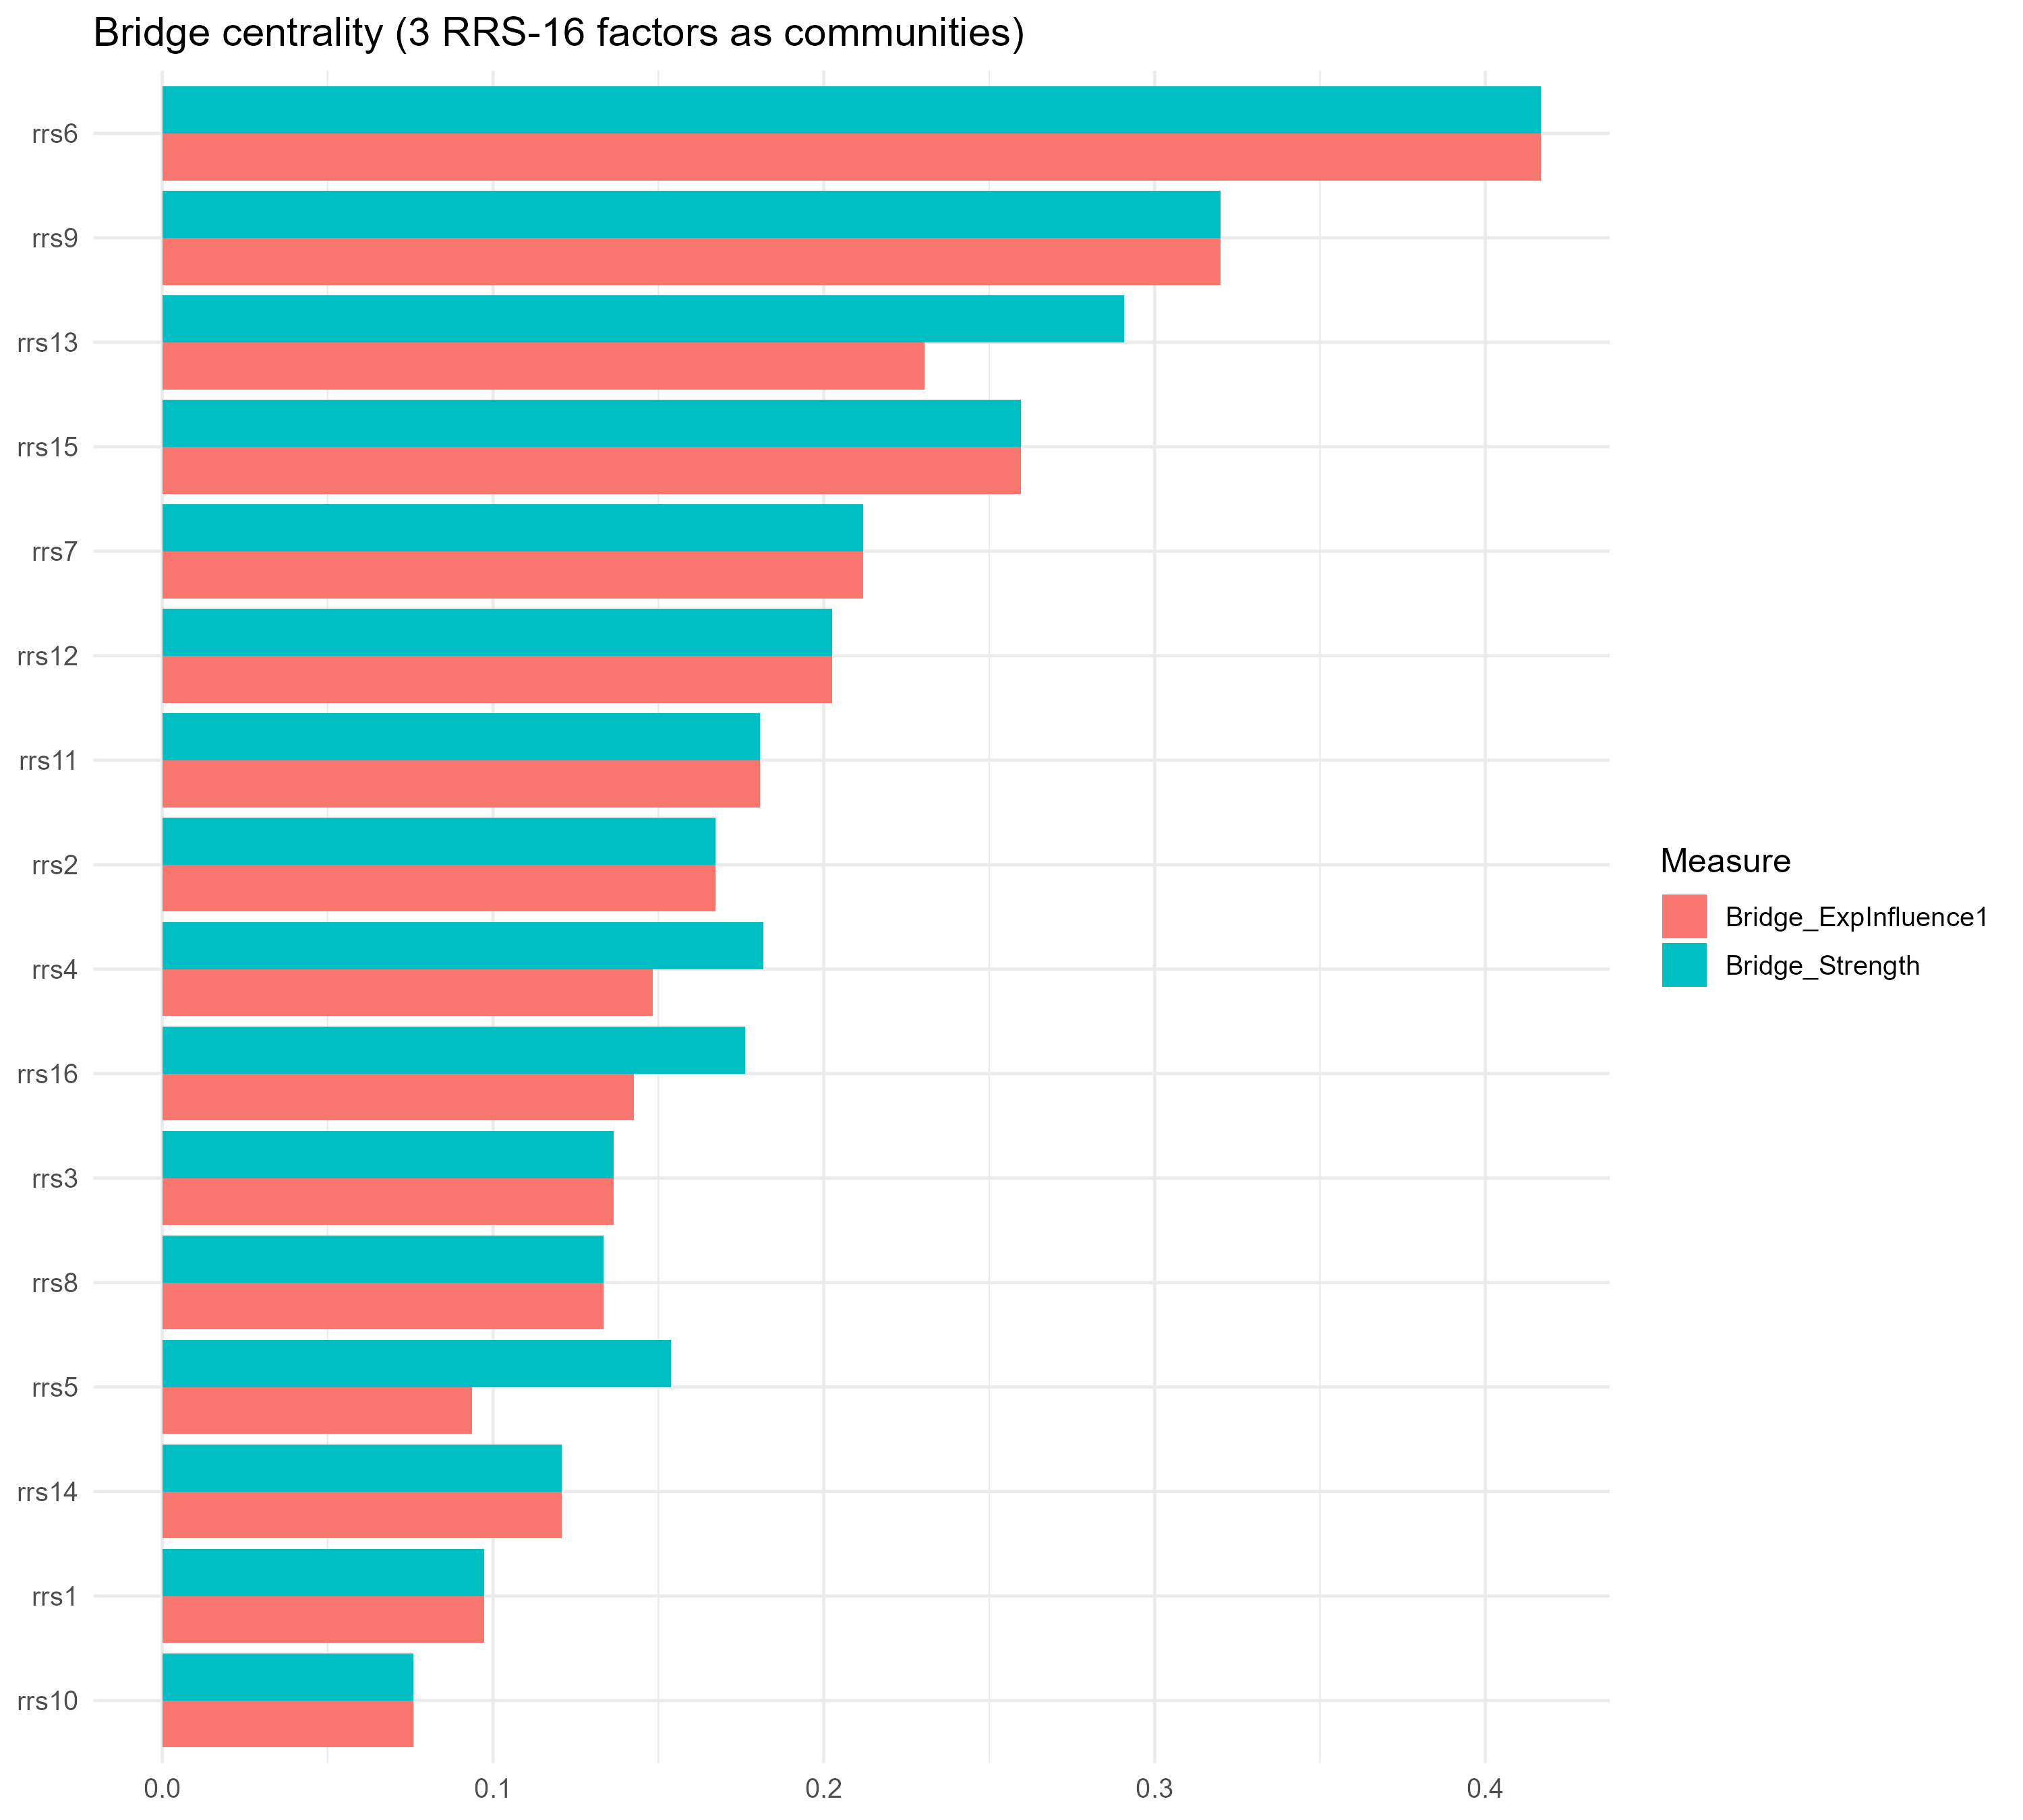
Figure S15.3. Bridge centrality indices (bridge strength and bridge expected influence) for the 16 RRS-16 items, using the three CFA-derived factors as a priori communities.
Note. Item rrs6 shows by far the highest bridge strength and bridge expected influence, indicating it functions as the primary connector across the three factor clusters, despite its comparatively low within-factor centrality.
Bootstrap Accuracy and Stability
Edge-weight accuracy was assessed via a non-parametric bootstrap (R = 200 samples), and centrality stability was assessed via a case-dropping subset bootstrap (R = 200), following Epskamp, Borsboom, and Fried's (2018) recommended procedures. Correlation stability (CS) coefficients indicate the maximum proportion of cases that can be dropped while retaining, with 95% probability, a correlation of at least 0.7 between the original and subset centrality estimates.
Table S15.5. Correlation stability (CS) coefficients for centrality indices (case-dropping bootstrap, R = 200).
Centrality measure | CS coefficient | ≥ .25 (min. acceptable) | ≥ .50 (preferred)
Strength | 0.750 | Yes | Yes
Closeness | 0.128 | No | No
Betweenness | 0.049 | No | No
Expected Influence | 0.750 | Yes | Yes
Note. CS coefficients ≥ .25 are considered the minimum acceptable threshold and ≥ .50 the preferred threshold for stable interpretation (Epskamp et al., 2018). Both strength (CS = .750) and expected influence (CS = .750) met the preferred threshold -- the maximum level tested -- and can be interpreted with confidence. Closeness (CS = .128) and betweenness (CS = .049) fell well below the minimum acceptable threshold; consistent with the wider literature on network stability in small-to-moderate item networks, these two indices are not interpreted substantively in this study and are reported for transparency only.
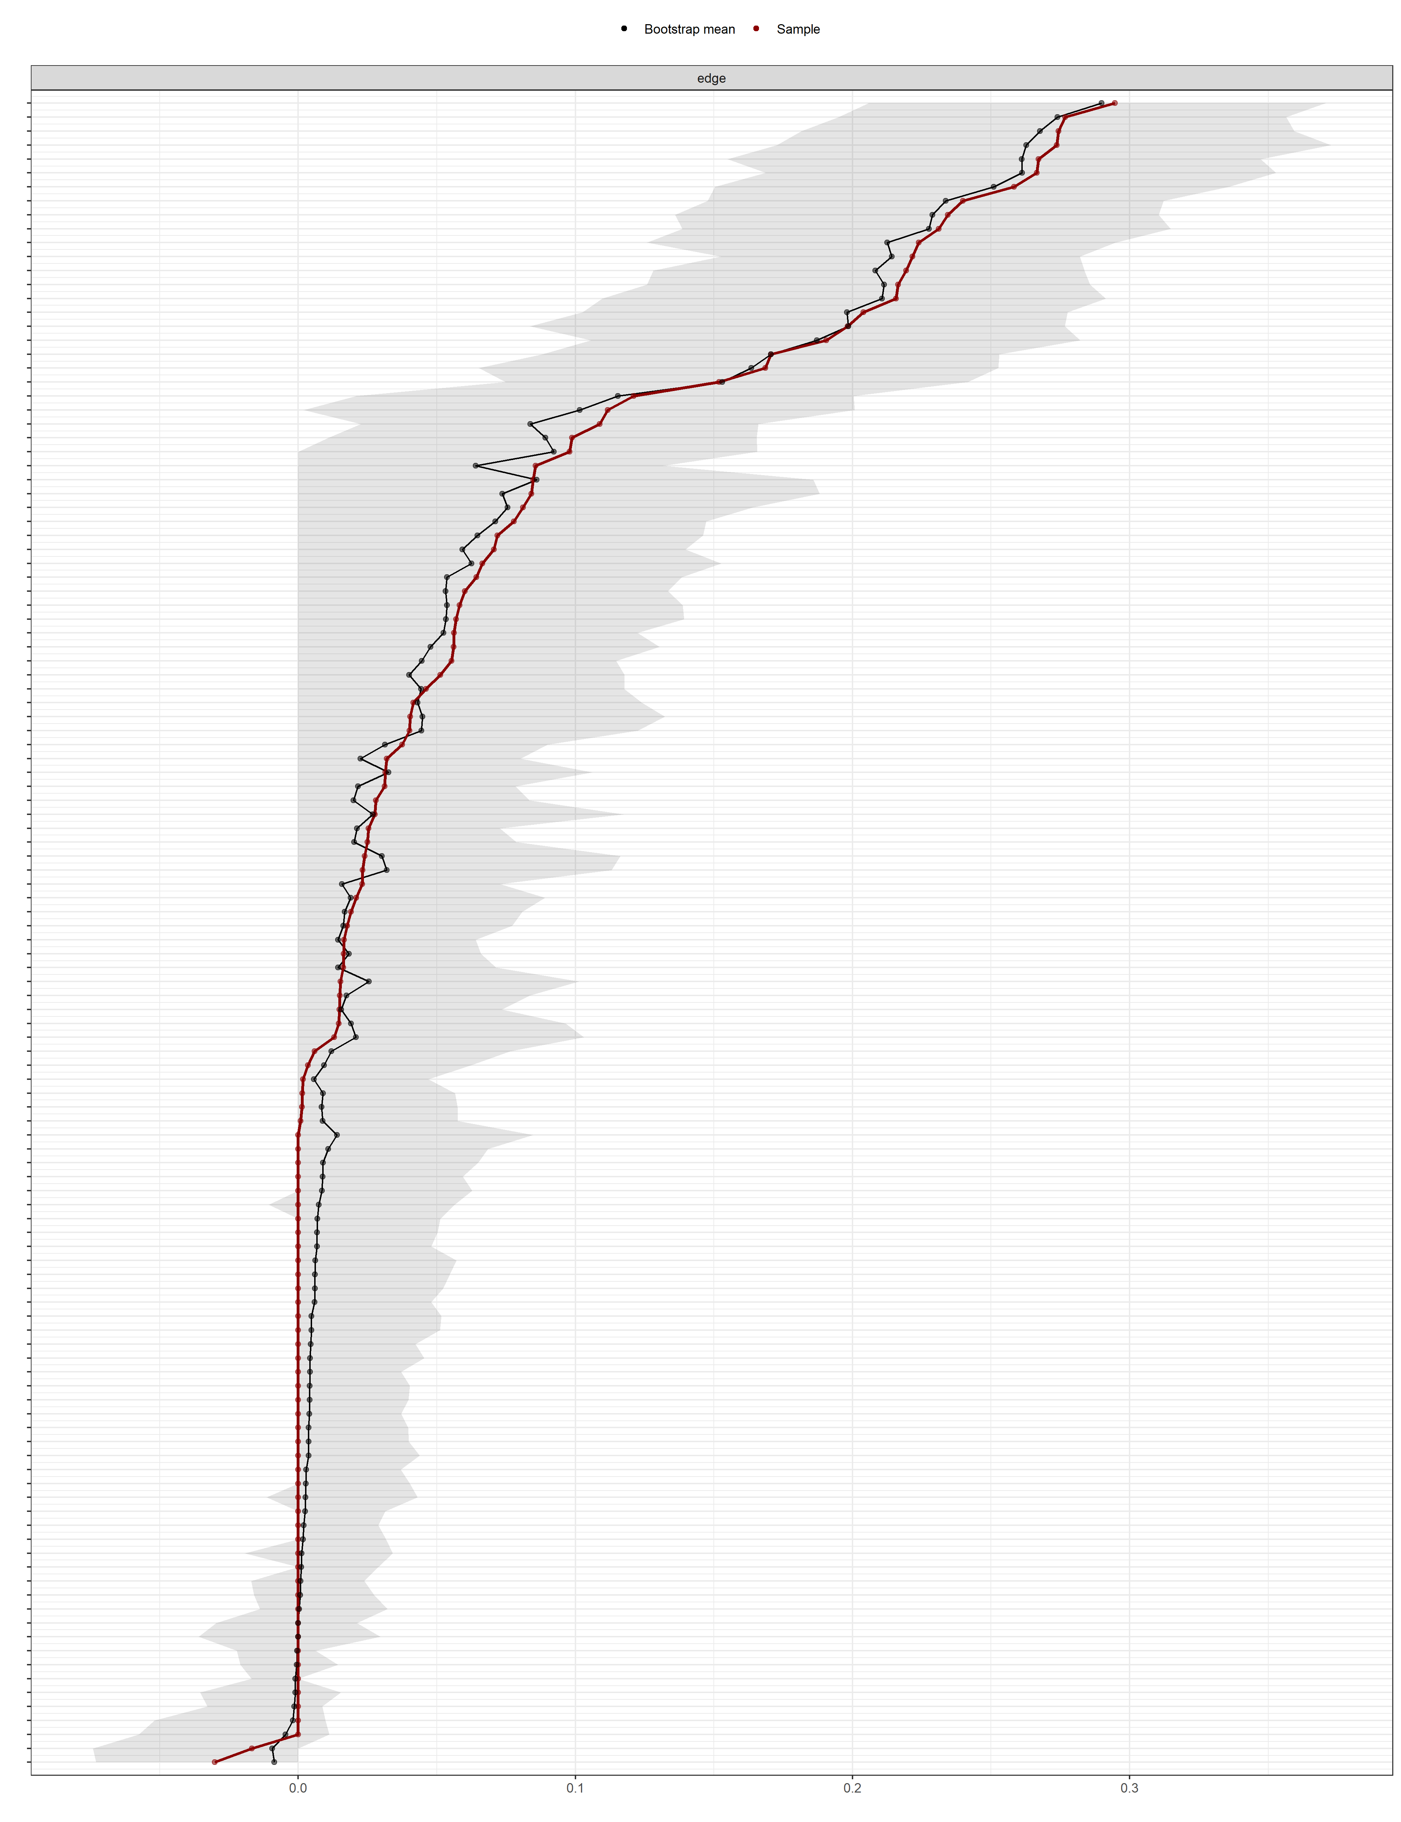
Figure S15.4. Bootstrapped edge-weight accuracy plot (non-parametric bootstrap, R = 200).
Note. Edges are ordered by estimated weight (red line = sample estimate, black line = bootstrap mean); shaded areas represent 95% bootstrapped confidence intervals. The relatively narrow confidence intervals for the largest edges indicate good estimation accuracy for the strongest connections in the network; wider intervals for near-zero edges reflect the estimation uncertainty typical of small partial correlations and should be interpreted with caution, consistent with the dense-network warning reported in the main text.
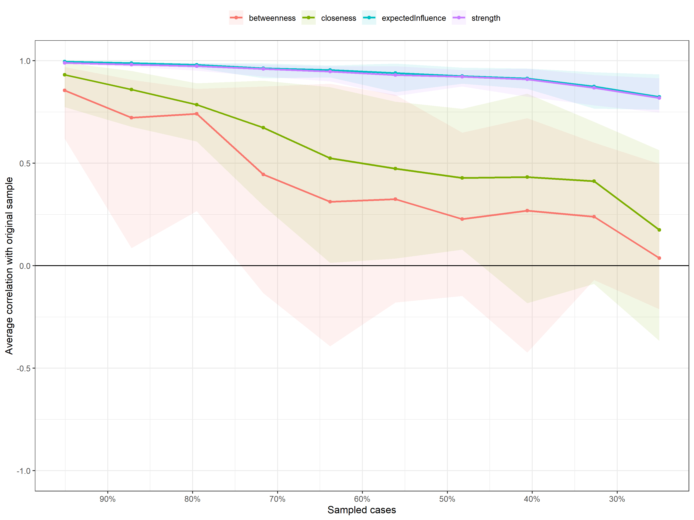
Figure S15.5. Case-dropping subset bootstrap: average correlation between centrality indices estimated on progressively smaller subsamples and the indices estimated on the full sample (R = 200 bootstrap samples).
Note. Expected influence and strength remain highly correlated with the full-sample estimates even after dropping a substantial proportion of cases, corresponding to the good CS-coefficients reported in Table S15.5 (CS = .750 for both). Closeness and betweenness degrade rapidly and should not be interpreted substantively, consistent with their low CS-coefficients.
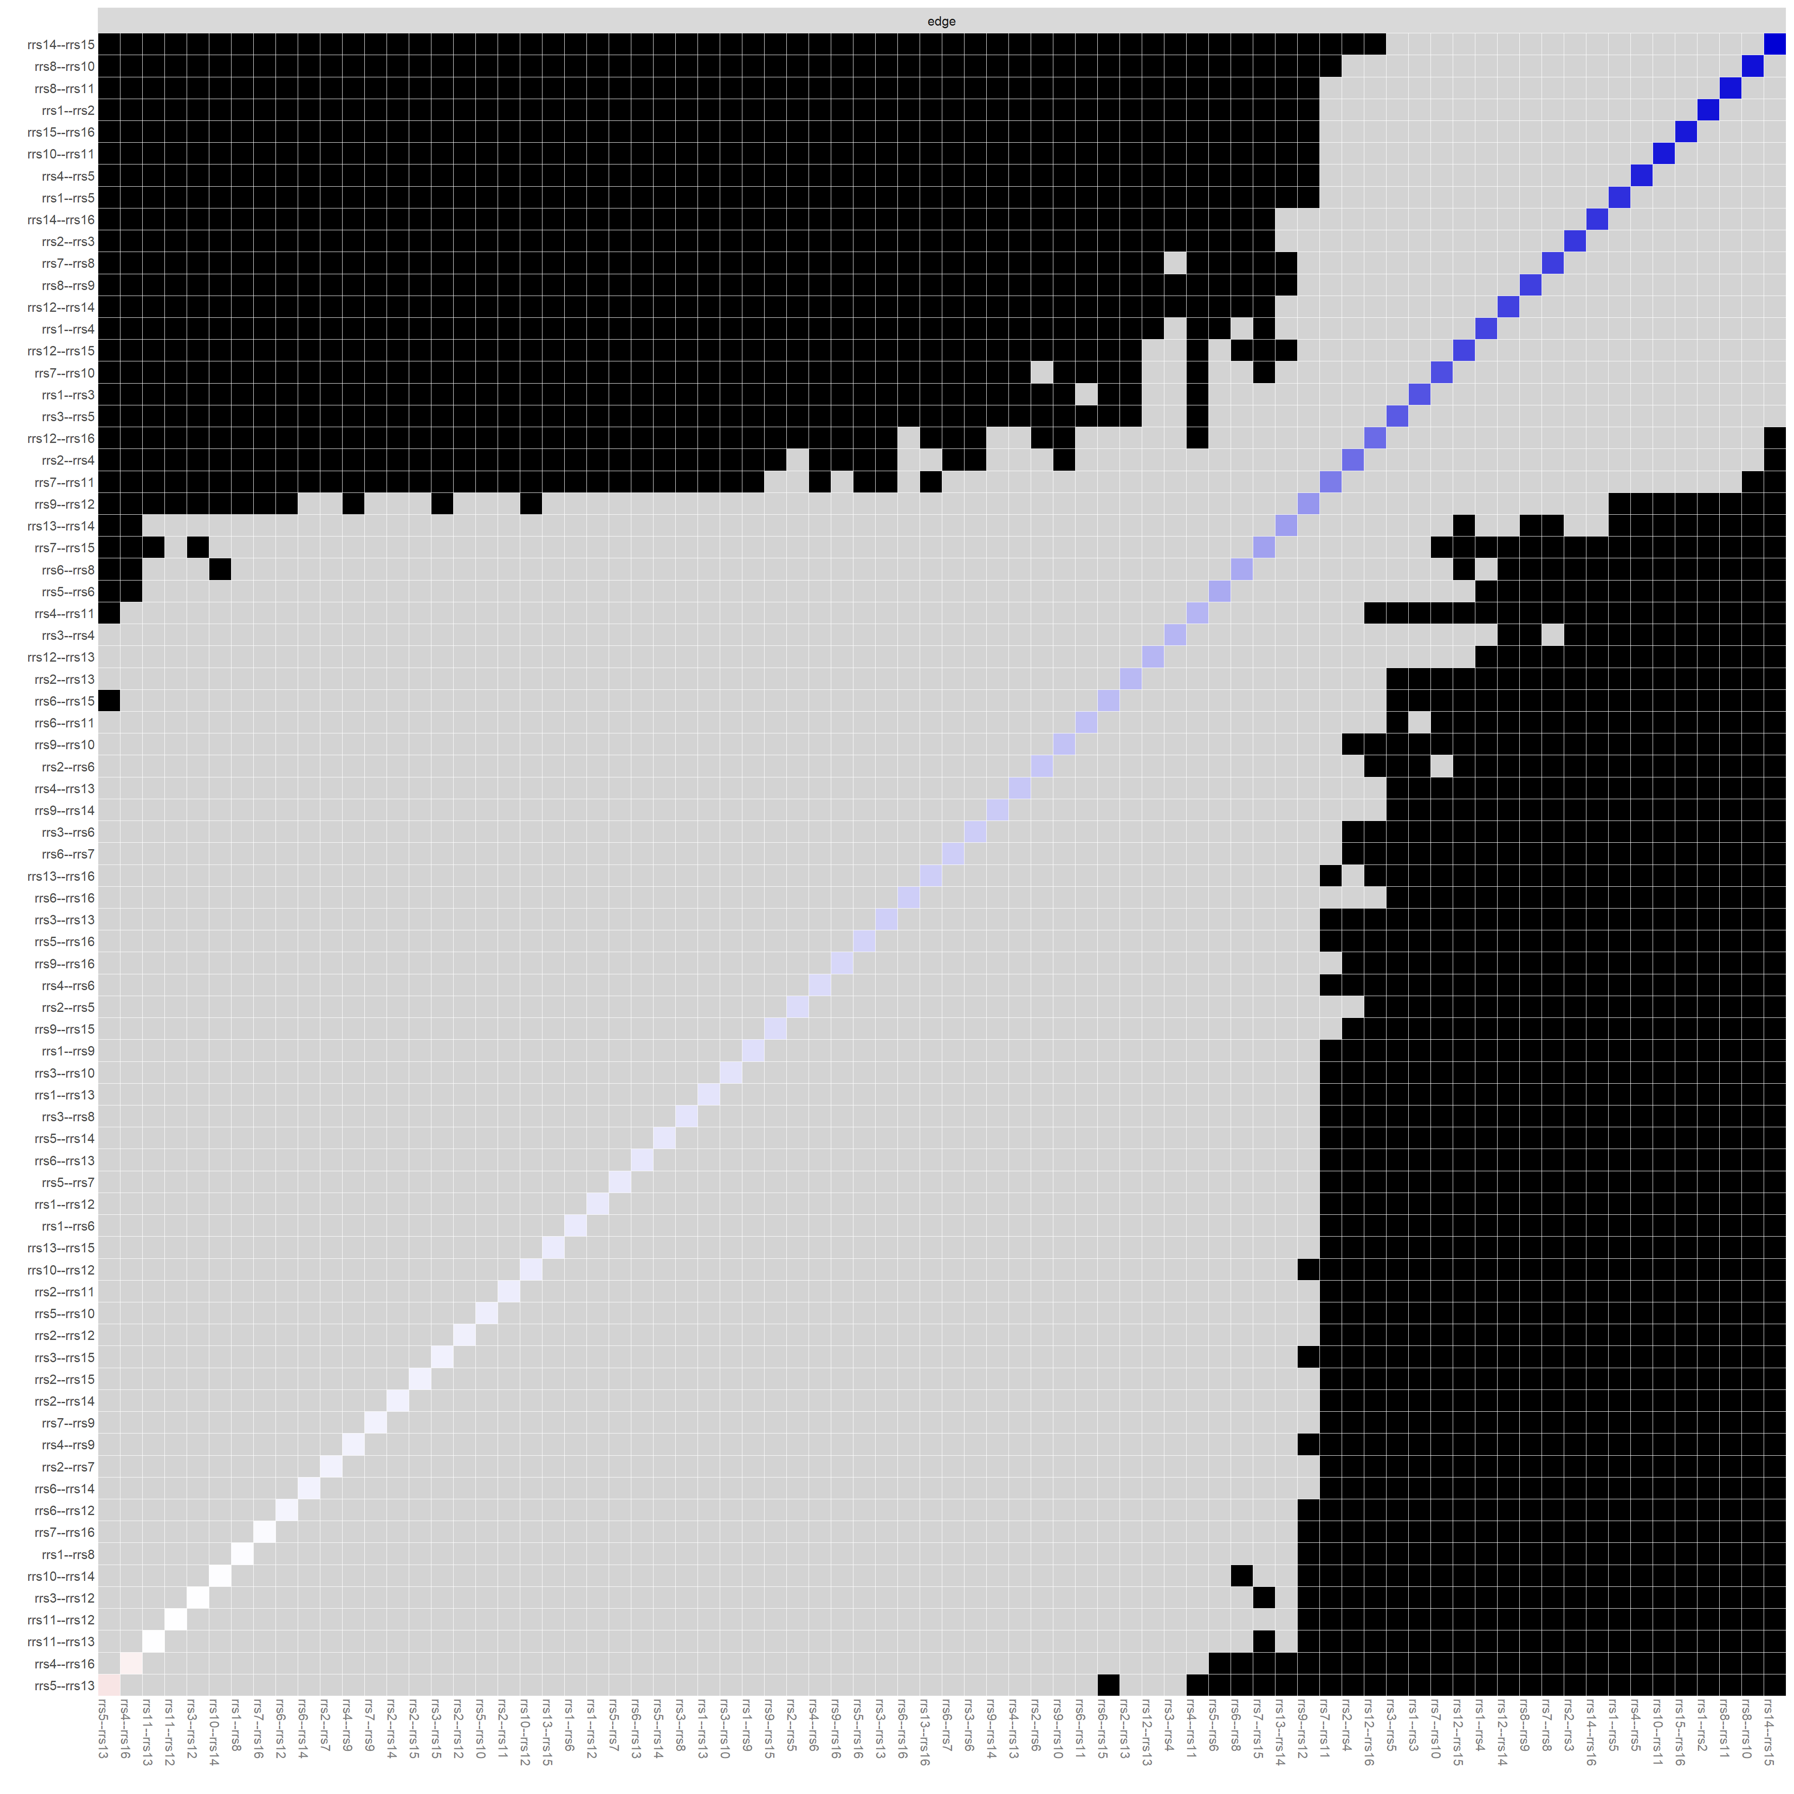
Figure S15.6. Bootstrapped edge-weight difference test matrix.
Note. Black cells indicate edge pairs whose weights differ significantly from one another (α ≈ .05); grey cells indicate non-significant differences; the diagonal (blue-shaded) represents each edge compared with itself. This matrix is used to determine which edges can be meaningfully distinguished from one another in terms of magnitude; the large black regions indicate that most of the largest within-factor edges differ significantly from the smaller, near-zero edges.
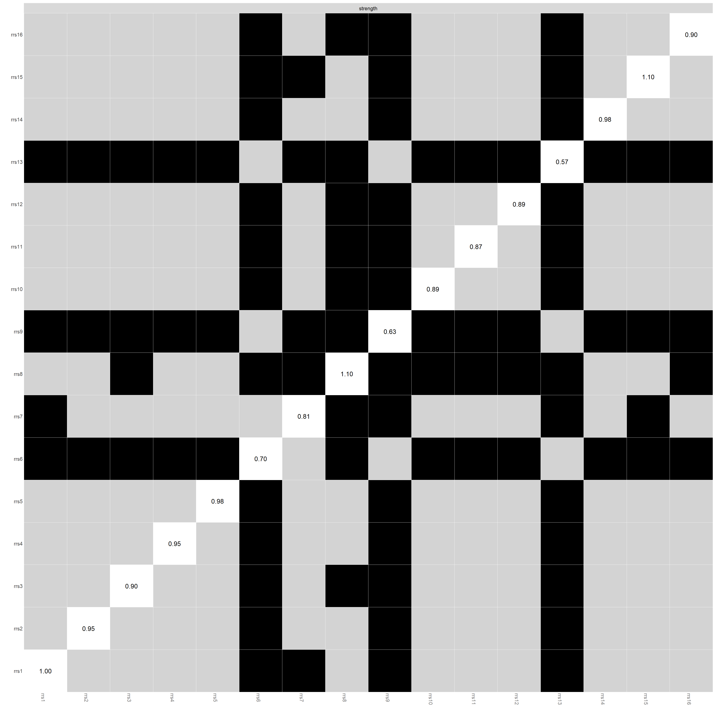
Figure S15.7. Bootstrapped node strength difference test matrix.
Note. Black cells indicate item pairs whose strength centrality differs significantly from one another; grey cells indicate non-significant differences; the diagonal represents each item's own strength value. Items with the most extreme strength values (rrs8, rrs15 at the high end; rrs13, rrs9 at the low end) differ significantly from most other items in the network, while items within the same factor cluster with similar strength values frequently do not differ significantly from one another.
Small-World Structure
Small-world properties were evaluated by comparing the empirical network's clustering coefficient (C) and average path length (L) to those of comparably sized and dense random networks (binary/unweighted metric).
Table S15.6. Small-world index for the RRS-16 network.
Metric | Value
Clustering coefficient (C) | 0.616
Average path length (L) | 1.367
Random network C | 0.629
Random network L | 1.367
Gamma (C / C_random) | 0.980
Lambda (L / L_random) | 1.000
Small-world index (σ = Gamma / Lambda) | 0.980
Number of connected components | 1
Note. The small-world index (σ = Gamma/Lambda = 0.980) reflects clustering essentially equivalent to comparable random networks (Gamma = 0.980, i.e., very slightly below 1) combined with an equivalent average path length (Lambda = 1.000), and the network formed a single connected component (no isolated nodes or subgraphs). The RRS-16 network's clustering did not exceed that of comparable random graphs of the same density, so its topology is best described as randomly-clustered with a fully connected, single-component structure rather than a clear small-world topology; this is noted as a descriptive observation rather than a concerning finding, since the diagnostic and inferential value of the network for this supplement lies in its centrality, bridge, and community-structure results rather than in the small-world index itself.
Predictability
Node predictability -- the accuracy with which each item's responses are recovered from all of its direct neighbors in the network -- was estimated using the Mixed Graphical Model (mgm) framework for categorical/ordinal data. Because the RRS-16 items are treated as categorical nodes, mgm returns the correct-classification rate (CC) rather than a proportion of explained variance; the values below are therefore classification accuracies, not R² values. Predictability values ranged from 0.283 (rrs6) to 0.651 (rrs1), with a network-wide range of approximately 28%-65% of responses correctly classified from neighboring items alone.
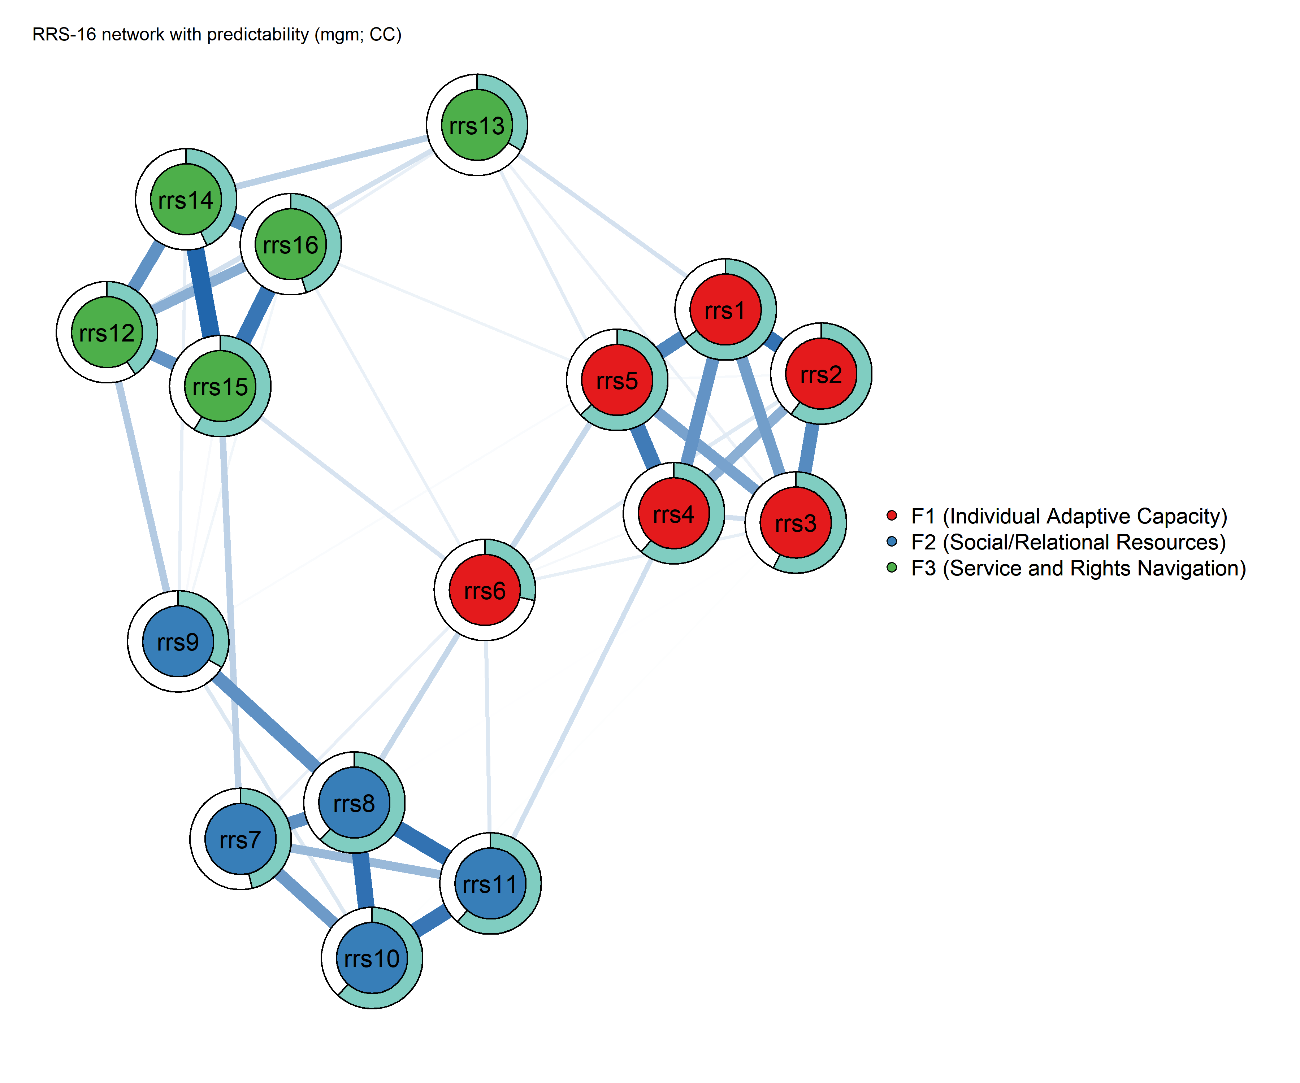
Figure S15.8. RRS-16 network with node-level predictability (mgm, correct-classification rate).
Note. The colored ring around each node represents the proportion of that item's responses correctly classified from its neighboring items in the network. Item rrs6 shows a visibly smaller colored ring, consistent with its low predictability value.
Table S15.7. Node predictability (mgm correct-classification rates).
Item | Factor | Predictability (CC)
rrs1 | F1 (Individual Adaptive Capacity) | 0.651
rrs2 | F1 (Individual Adaptive Capacity) | 0.603
rrs3 | F1 (Individual Adaptive Capacity) | 0.574
rrs4 | F1 (Individual Adaptive Capacity) | 0.612
rrs5 | F1 (Individual Adaptive Capacity) | 0.629
rrs6 | F1 (Individual Adaptive Capacity) | 0.283
rrs7 | F2 (Support Seeking and Relational Resource Use) | 0.464
rrs8 | F2 (Support Seeking and Relational Resource Use) | 0.618
rrs9 | F2 (Support Seeking and Relational Resource Use) | 0.336
rrs10 | F2 (Support Seeking and Relational Resource Use) | 0.618
rrs11 | F2 (Support Seeking and Relational Resource Use) | 0.614
rrs12 | F3 (Service and Rights Navigation) | 0.406
rrs13 | F3 (Service and Rights Navigation) | 0.333
rrs14 | F3 (Service and Rights Navigation) | 0.433
rrs15 | F3 (Service and Rights Navigation) | 0.587
rrs16 | F3 (Service and Rights Navigation) | 0.450
Note. CC = correct-classification rate for categorical/ordinal nodes under the mgm framework (the proportion of responses correctly recovered from a node's direct neighbors), not a proportion of explained variance. Higher predictability indicates an item whose responses are well accounted for by its immediate network neighbors. Items rrs6, rrs9, and rrs13 -- the three items already identified as bridge-relevant nodes with comparatively weak within-factor centrality and, separately, as the lowest-discrimination items under IRT (S14) and the weakest performers on reliability and factor-analytic criteria (Sections S3, S8-S10, S12) -- again showed the lowest predictability in the network, consistent with their content being only partly accounted for by their own factor block. The convergence of this fourth, structurally independent analytic framework on the same three items provides additional, model-independent corroboration of a genuine (rather than method-specific) psychometric signal for these items, although none were removed from the final 16-item measure per the retention decision documented in Section S10.
Item Redundancy (Goldbricker)
The goldbricker procedure (networktools) was used to screen for statistically redundant item pairs -- that is, pairs of items so highly correlated, relative to their correlations with all other items, that they may be capturing the same narrow content rather than distinct facets of the construct. No redundant item pairs were detected among the 16 RRS-16 items, supporting the retention of all 16 items as substantively distinct indicators.
Sensitivity Analyses
Two sensitivity checks were conducted to evaluate the robustness of the network structure: (a) re-estimation of the network across a range of EBICglasso tuning parameters (γ = 0.25, 0.50, 1.00), and (b) a split-half replication in which the sample was randomly divided into two independent subsamples and the network was re-estimated separately in each half.

Table S15.8. EBICglasso gamma sensitivity analysis.
EBIC gamma | Non-zero edges | Sparsity | Correlation with γ = 0.50 network
0.25 | 76 | 0.367 | 1.000
0.50 | 76 | 0.367 | 1.000
1.00 | 75 | 0.375 | 0.999

Table S15.9. Split-half replication of the network structure.
Split-half comparison | N | Non-zero edges | Value
Split 1 | 273 | 63 | —
Split 2 | 274 | 66 | —
Edge-weight correlation (Split 1 vs. Split 2) | — | — | 0.814
Note. The network structure was highly robust to the choice of EBIC hyperparameter: edge count and sparsity were nearly unchanged across γ = 0.25-1.00 (76 edges at γ = 0.25 and 0.50, 75 at γ = 1.00), and the network estimated at γ = 1.00 (the most conservative/sparse setting) correlated at r = .999 with the primary γ = 0.50 network. In the split-half replication, edge-weight correlation between the two independent subsamples (n = 273 and n = 274) was r = .814, indicating good replicability of the specific edge-weight pattern across independent halves of the sample, alongside a stable overall three-cluster community structure (see Figure S15.9), indicating good replicability of the RRS-16 network structure across independent halves of the sample.
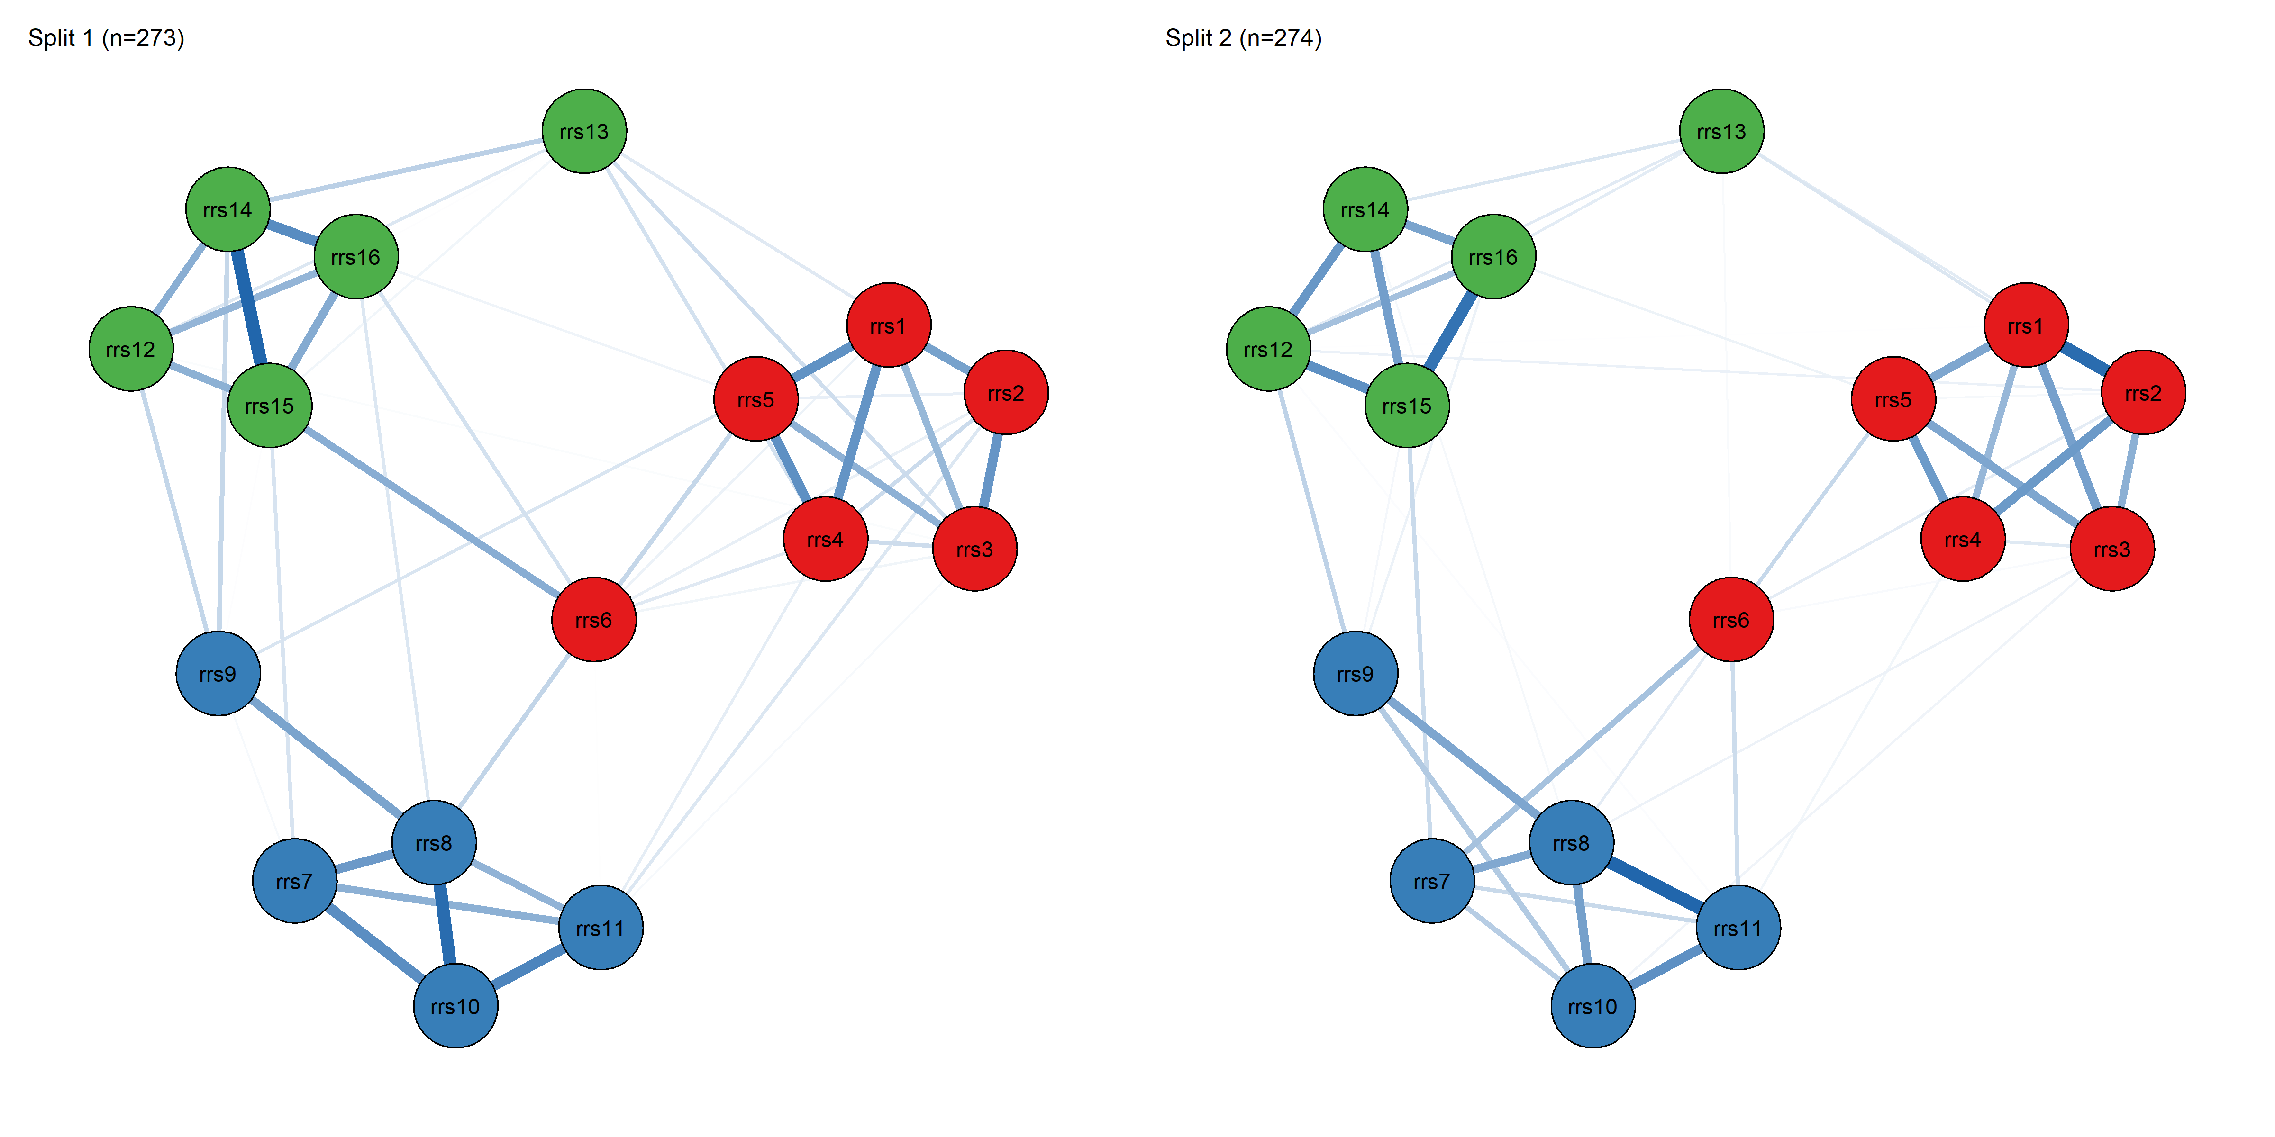
Figure S15.9. Split-half replication of the RRS-16 network structure.
Note. Networks estimated independently in two random halves of the sample (Split 1, n = 273; Split 2, n = 274) using identical EBICglasso settings (γ = 0.5). The three-cluster topology aligned with the F1/F2/F3 factor structure is preserved in both halves, including item rrs6's characteristic bridging position; edge-weight correlation between the two networks was r = .814.
Summary
The RRS-16 network comprised 16 nodes and 76 non-zero edges out of 120 possible (sparsity = 0.367), estimated via EBICglasso (γ = 0.5) with no imputation and no thresholding. The network topology closely reproduced the three-factor CFA structure, with dense within-factor edges and sparser between-factor edges. Item rrs8 showed the highest within-factor centrality (strength/expected influence), while item rrs6 -- despite low within-factor centrality -- emerged as by far the strongest bridge item connecting all three factors, followed by rrs9 and rrs13. Node predictability ranged from .283-.651, no redundant item pairs were detected, and the structure was highly robust to gamma choice (r = .999-1.000 across γ = 0.25-1.00) and well replicated across sample-splitting (r = .814). Centrality stability was good for both strength (CS = .750) and expected influence (CS = .750), meeting the preferred stability threshold at the maximum level tested, whereas closeness and betweenness fell well below the minimum acceptable threshold and should not be interpreted substantively in this dataset. The small-world index (σ = 0.980) indicated a randomly-clustered rather than small-world topology; this descriptive characteristic does not bear on the network's diagnostic value for this supplement. Taken together, these network findings converge with -- rather than contradict -- the three-factor latent structure established via CFA/ESEM (S9) and supported by the IRT analyses (S14): the same three groups of items identified as F1, F2, and F3 in the latent-variable framework show dense within-block and sparse between-block connectivity in the estimated network. Because the three factor blocks were supplied a priori as communities for the bridge-centrality analysis rather than recovered by a community-detection algorithm, this convergence constitutes descriptive structural corroboration rather than model-independent confirmation. The only data-driven community-detection analysis in this supplement (S8; EGA with Walktrap, calibration subsample) assigned 15 of 16 items to their theoretical block, with rrs6 the single exception (assigned to the F2 community under the primary Walktrap algorithm; the Leiden sensitivity algorithm placed rrs6 in its theoretical F1 community, so the misallocation is algorithm-specific -- see S8) -- a discrepancy consistent with rrs6's bridge strength (0.417) exceeding its within-factor strength (0.288) in the present network. Most notably, items rrs6, rrs9, and rrs13 -- already flagged as comparatively weaker performers across reliability (S12), validity, and IRT (S14) analyses -- were independently identified here as the network's three lowest-predictability items and, in the case of rrs6 particularly, as an unusually strong cross-factor bridge node, providing a fourth, structurally independent line of convergent evidence regarding these items' distinctive psychometric behavior.
References
Epskamp, S., Borsboom, D., & Fried, E. I. (2018). Estimating psychological networks and their accuracy: A tutorial paper. Behavior Research Methods, 50(1), 195-212.

S16. Common Method Variance (CMV) Assessment Analyses
Refugee Resilience Scale (RRS): Adaptive Coping and Resource Mobilization in Forced Migration
Overview.
Because all study variables (RRS-16, BRS, GSE, PSS, and PHQ) were collected in a single survey session using self-report ordered-categorical items, potential common method variance (CMV) was evaluated using complementary diagnostics recommended in the methodological literature (Podsakoff et al., 2003, 2012). Analyses were conducted on the main analytic sample (data_cleaned.xlsx; N = 583). Given small amounts of item-level missingness, each diagnostic used a missing-data handling approach appropriate to its estimation method: listwise-complete cases for polychoric-correlation-based procedures (Tests 1 and 4), and pairwise-present handling for ordinal CFA/CLF models estimated with WLSMV/theta parameterization (Tests 2 and 3).
Note. No imputation was performed at any stage of these CMV analyses. Test 1 (Harman, 45-item pool) used listwise-complete cases (N = 505, 86.621% of the sample). Tests 2-4 (CFA, CLF, HTMT on RRS-16) used either pairwise-present WLSMV estimation (Tests 2-3) or listwise-complete cases (Test 4; N = 547, 93.825%).
Analytic Strategy.
Four complementary diagnostics were applied. (1) Harman's single-factor test (unrotated principal axis factoring, PAF) was estimated on a polychoric correlation matrix computed from a 45-item session-wide pool: RRS-16 (rrs1-rrs16), BRS (brs1-brs6), GSE (gse1-gse10), PSS (pss1-pss4), and PHQ (phq1-phq9). A first factor explaining more than 50% of total variance is conventionally treated as a coarse CMV warning flag. (2) A one-factor ordinal CFA of RRS-16 was compared against the theorized correlated three-factor CFA model (F1: Individual Adaptive Capacity; F2: Support Seeking and Relational Resource Use; F3: Service and Rights Navigation) using WLSMV with theta parameterization and pairwise missing-data handling; substantial improvement in fit for the three-factor model would indicate that RRS-16 item covariation is not adequately explained by a single common factor alone. (3) A common latent factor (CLF) was added to the three-factor CFA model, loading equally (unstandardized) on all 16 RRS-16 items and constrained orthogonal to the three substantive factors; CLF results are treated as sensitivity evidence, since in a single-instrument item set a "common factor" can reflect substantive general resilience/adaptive-capacity variance as well as method-related variance. (4) HTMT ratios were computed from a polychoric correlation matrix among the three RRS-16 factors on listwise-complete cases; values well below conventional thresholds (.85/.90) would reduce concern that the inter-factor relations are dominated by a single method-driven factor.
Results.
Table S16.1. Missingness summary by CMV diagnostic test.
Diagnostic test | k | Total cells | Missing cells | N complete | N total | % complete
Test 1: Harman (45-item pool) | 45 | 26,235 | 87 | 505 | 583 | 86.621%
Test 2-3: CFA / CLF (RRS-16) | 16 | 9,328 | 38 | 547 | 583 | 93.825%
Test 4: HTMT (RRS-16) | 16 | 9,328 | 38 | 547 | 583 | 93.825%
Note. Missingness was low across all item pools. The 45-item Harman pool (Test 1) required listwise-complete cases due to the polychoric-correlation estimation method, yielding N = 505 (86.621% of the main sample). RRS-16-only diagnostics (Tests 2-4) retained a substantially higher effective sample: N = 547 (93.825%) for Test 4 (HTMT, listwise), and pairwise-present WLSMV estimation for Tests 2-3 (CFA/CLF), which uses all 583 cases with available data on each parameter.
Test 1: Harman's Single-Factor Test (PAF; 45 Items).
Table S16.2. Harman's single-factor test results (unrotated PAF; 45-item session-wide pool).
Harman statistic | Value
PAF variance explained by Factor 1 | 17.168%
First eigenvalue of polychoric R (reference) | 8.469
Eigenvalue / p (reference, %) | 18.820%
Note. The first (unrotated) PAF factor explained 17.168% of total variance, well below the conventional 50% heuristic threshold for a dominant single factor. As a descriptive reference point, the first eigenvalue of the 45x45 polychoric correlation matrix was 8.469, corresponding to 18.820% when expressed as eigenvalue/p. These results do not suggest that a single general method factor accounts for the majority of shared variance across the session-wide item pool comprising RRS-16 and the four external validity measures (BRS, GSE, PSS, PHQ).
Test 2: CFA Comparison (RRS-16; 1-Factor vs. CFA-3; WLSMV/Theta).
Table S16.3. CFA fit indices for the one-factor and theorized three-factor RRS-16 models (WLSMV, theta parameterization; scaled indices; full main sample, N = 583).
Model | χ² (scaled) | df | p | CFI | TLI | RMSEA | SRMR
RRS-16 1-factor | 1512.853 | 104 | <.001 | 0.729 | 0.687 | 0.153 | 0.119
RRS-16 CFA-3 (F1/F2/F3) | 299.686 | 101 | <.001 | 0.962 | 0.955 | 0.058 | 0.051
Table S16.4. Improvement in model fit: three-factor model relative to the one-factor model.
Comparison statistic | Value
ΔCFI (CFA-3 − 1-factor) [scaled] | 0.2329
RMSEA decrease (1-factor − CFA-3) [scaled] | 0.0944
Note. The RRS-16 one-factor model showed poor fit (CFI = .729; TLI = .687; RMSEA = .153; SRMR = .119), while the theorized correlated three-factor model fit the data very well and met conventional excellent-fit thresholds (CFI = .962; TLI = .955; RMSEA = .058; SRMR = .051; CFI ≥ .95, RMSEA ≤ .06). The improvement in fit was substantial (ΔCFI = .233; RMSEA decrease = .094), indicating that RRS-16 item covariation is not adequately captured by a single common factor and is instead well represented by the three-factor structure established in the primary confirmatory analyses (Section S9), providing stronger evidence against a dominant single factor than is typical in comparable CMV assessments.
Test 3: Common Latent Factor (CLF; Equal-Loading, Orthogonal; RRS-16 Sensitivity).
Table S16.5. Common latent factor (CLF) sensitivity model summary (RRS-16).
CLF statistic | Value
ΔCFI (CLF − CFA-3) [scaled] | 0.0264
ΔRMSEA (CLF − CFA-3) [scaled] | −0.0256
Mean |Δλ| (CFA-3 vs. CLF) | 0.153
Max |Δλ| (CFA-3 vs. CLF) | 0.344
m (unstandardized CLF loading) | 0.633
m p-value | p < .001
Mean CLF loading (std.all, descriptive) | 0.432
Note. The CLF model converged successfully. Adding an equal-loading CLF, constrained orthogonal to F1, F2, and F3, produced an improvement in global model fit relative to the three-factor baseline that exceeds the ΔCFI > .010 convention applied elsewhere in this supplement but is an order of magnitude smaller than the one-factor versus three-factor contrast in Test 2 (ΔCFI = .026 vs. .233; ΔRMSEA = −.026). Standardized substantive factor loadings changed moderately after adding the CLF (mean |Δλ| = .153; max |Δλ| = .344, observed for item rrs13 on F3, whose loading dropped from .488 in the three-factor baseline model to .143 after adding the CLF). The next-largest shifts were observed for rrs6 on F1 (|Δλ| = .330, from .587 to .257) and rrs9 on F2 (|Δλ| = .323, from .545 to .223) -- the same three items (rrs6, rrs9, rrs13) already identified throughout this supplement (Sections S3, S8-S10, S12, S14, S15) as comparatively weaker performers on reliability, IRT discrimination, and network predictability criteria. All |Δλ| values are computed from unrounded loadings and may differ by .001 from the difference of the three-decimal values printed here. The estimated equal unstandardized CLF loading was moderate (m = 0.633, p < .001), and the mean standardized CLF loading was .432 (descriptive). The corresponding average shared method variance -- the mean of the squared standardized CLF loadings, recovered from the model-implied equal-loading solution -- is 18.9%, below the 25% value sometimes used as an informal ceiling and far below the 50% at which a method factor would dominate. Because Test 3, unlike Tests 1 and 4, has no single conventional cut-off, the item-level criterion |Delta-lambda| >= .20 is also applied and reported explicitly here: 3 of the 16 items exceed it (the three listed above) while the remaining 13 fall between .056 and .164. Unlike a negligible-CLF pattern, this result indicates that a shared factor loading equally across all 16 RRS-16 items accounts for some common variance beyond the three substantive factors, though to a modest rather than substantial degree. Because CLF loadings are, by construction, confounded with any genuine general resilience/severity dimension in a single-instrument item set, this finding should be interpreted as an indication that some shared variance beyond F1/F2/F3 is present, without being conclusive on its own as to whether that shared variance is substantive (e.g., a general adaptive-capacity dimension cutting across all three facets) or method-related; it is weighed jointly with Tests 1, 2, and 4 in the Conclusion below.
Test 4: HTMT (RRS-16 Factors).
Table S16.6. Heterotrait-monotrait ratio (HTMT) among the three RRS-16 factors (polychoric correlations; listwise-complete cases, N = 547).
Factor | F1 | F2 | F3
F1 | — | 0.546 | 0.535
F2 | 0.546 | — | 0.518
F3 | 0.535 | 0.518 | —
Note. The HTMT ratios among the three RRS-16 factors were moderate and closely similar to one another (range: .518-.546; mean = .533), well below conventional thresholds for discriminant-validity concern (.85/.90), supporting discriminant evidence among F1, F2, and F3 and reducing concern that the inter-factor relations are dominated by a single method-driven factor. The largest ratio (F1-F2 = .546) is consistent with the moderate, substantively expected associations among the three RRS-16 factors documented in the construct validity analyses (Section S13, Table S13.2).
Conclusion.
Across four complementary diagnostics, the pattern of evidence was largely reassuring, with one residual consideration. Harman's unrotated single-factor solution accounted for a modest proportion of variance (17.168%) in the 45-item pool spanning RRS-16 and the four external validity measures, well below the 50% heuristic flag. Within RRS-16, the theorized three-factor CFA model fit dramatically better than a one-factor alternative (ΔCFI = .233) and itself met conventional excellent-fit benchmarks (CFI = .962, RMSEA = .058), indicating that the observed covariance structure is well captured by the three-factor structure rather than a single general factor. HTMT ratios supported discriminant distinctiveness among F1, F2, and F3 (all values .518-.546, well below .85/.90). The CLF sensitivity model converged with a moderate equal loading (m = .633) and moderate shifts in substantive factor loadings (mean |Δλ| = .153), most pronounced for items rrs13, rrs6, and rrs9 -- the same three items repeatedly flagged as comparatively weaker performers across reliability (S12), IRT (S14), and network (S15) analyses. Taken together, these results indicate that a single dominant method factor is not the primary driver of RRS-16's covariance structure: three of the four diagnostics (Tests 1, 2, and 4) converge clearly on this conclusion. The fourth, the CLF sensitivity model (Test 3), is not equally reassuring -- three of the 16 items exceed the |Δλ| ≥ .20 item-level criterion -- and it suggests that a small amount of shared variance beyond the three-factor structure remains, concentrated in the same three items (rrs6, rrs9, rrs13) already identified as comparatively weaker across independent psychometric frameworks throughout this supplement. This convergence across CMV, reliability, IRT, and network diagnostics on the same three items strengthens the case that their distinctive behavior reflects a genuine item-level property rather than an artifact of any single analytic method, while the overall pattern of evidence across all four CMV diagnostics supports the conclusion that common method variance is not a substantial threat to the validity of RRS-16 factor-level scores.
References
Podsakoff, P. M., MacKenzie, S. B., Lee, J.-Y., & Podsakoff, N. P. (2003). Common method biases in behavioral research: A critical review of the literature and recommended remedies. Journal of Applied Psychology, 88(5), 879-903.
Podsakoff, P. M., MacKenzie, S. B., & Podsakoff, N. P. (2012). Sources of method bias in social science research and recommendations on how to control it. Annual Review of Psychology, 63, 539-569.

S17. Additional Analyses
Refugee Resilience Scale (RRS): Adaptive Coping and Resource Mobilization in Forced Migration
This section reports five complementary robustness checks on the final 16-item RRS-16 structure (F1: Individual Adaptive Capacity, rrs1-rrs6; F2: Support Seeking and Relational Resource Use, rrs7-rrs11; F3: Service and Rights Navigation, rrs12-rrs16; N = 583): differential item functioning (DIF), score distributions and percentile reference values, estimator sensitivity (WLSMV vs. MLR), construct replicability and factor score quality, and local dependence / residual covariance sensitivity. No imputation was performed at any stage; each analysis used a missing-data handling approach appropriate to its estimation method, as documented in each subsection below. A post hoc item-exclusion sensitivity analysis targeting the two items whose removal was considered most plausible (rrs9, rrs13) was already reported in Section S10 and is not repeated here.
1. Differential Item Functioning (DIF)
Overview.
Differential item functioning (DIF) was evaluated for RRS-16 as an item-level complement to the known-groups validity results reported in Section S13. DIF testing addresses whether items function equivalently across groups after conditioning on an estimate of the underlying trait level (i.e., whether individuals at the same trait level but in different groups show systematically different response probabilities on specific items).
DIF was tested for the same six grouping variables used in the known-groups validity analyses (Section S13): age group (Younger vs. Older), gender (Female vs. Male), education (Low vs. High), origin (modal group vs. other), length of stay in Türkiye (Longer vs. Shorter, median split), and Turkish language proficiency (Higher vs. Lower, median split). Note that this binary age contrast (Younger vs. Older) differs from the four-category age-group variable used in the Section S11 measurement invariance analysis, whose configural model did not converge because of an empty response category in one age group; the binary recoding was adopted here, as in Section S13, specifically to avoid this empty-cell problem, and this DIF result should not be interpreted as a re-test of the same age operationalization that failed to converge in S11.
Rationale and Method.
DIF was tested using proportional-odds ordinal logistic regression (logit link) implemented in ordinal::clm. For each item and grouping variable, a domain-matched matching variable was computed as the mean of the other items in the same validated factor (factor mean excluding the focal item: F1, F2, or F3). This provides a trait-proxy aligned with item content while avoiding contamination from the focal item (item-excluded scoring). Because F1 (6 items), F2 (5 items), and F3 (5 items) each retain at least four other items for matching, no fallback to a total-score matching variable was required for any item.
For each item and grouping variable, three nested models were estimated: M0: item ~ matching; M1: item ~ matching + group (uniform DIF) -> likelihood-ratio test (LRT) of M0 vs. M1; M2: item ~ matching x group (non-uniform DIF) -> LRT of M1 vs. M2.

Missing Data Handling and Minimum Group-Size Rule.
Note. No imputation was performed at any stage. DIF was estimated using an item-specific complete-case rule: for each (grouping variable x item) test, the dataset was subset to complete cases on the grouping variable, the focal item, and the items needed to compute the matching score. Group levels with n < 30 within the item-specific subset were dropped for that item; in the event no level fell below this minimum in any test, so no level was dropped in any of the 96 tests (analytic N ranged from 565 to 571 per test) and all 16 RRS-16 items were estimable for all six grouping variables (16 x 6 = 96 item-by-group tests, all completed without exclusions).
Decision Criteria.
DIF decisions incorporated both statistical and practical criteria: (1) Holm-adjusted p-values within each grouping variable (uniform and non-uniform families adjusted separately), and (2) practical DIF magnitude using ΔMcFadden's pseudo R², flagged as practically meaningful at ΔR² ≥ .010.
Results.
Table S17.1. DIF summary by grouping variable (RRS-16; factor-matching; Holm-adjusted p; practical threshold ΔMcFadden R² ≥ .010).
Grouping variable | Items tested | Flagged (practical) | Max ΔR² (uniform) | Max ΔR² (non-uniform) | Min Holm p (either)
Age group (Younger vs. Older) | 16 | 0 | 0.006 | 0.002 | 0.019
Education (Low vs. High) | 16 | 0 | 0.002 | 0.002 | 1.000
Gender (Female vs. Male) | 16 | 0 | 0.003 | 0.004 | 0.094
Origin (Modal group vs. Other) | 16 | 0 | 0.003 | 0.002 | 0.320
Length of stay (Longer vs. Shorter) | 16 | 0 | 0.003 | 0.003 | 0.271
Turkish proficiency (Higher vs. Lower) | 16 | 0 | 0.005 | 0.002 | 0.051
Note. N (complete cases per item-by-group test) ranged from 565-571 across all 96 tests. "Flagged" counts the number of items meeting the ΔR² ≥ .010 practical-significance threshold for either uniform or non-uniform DIF within that grouping variable.
Across all six grouping variables, no RRS-16 items showed practically meaningful DIF under the prespecified magnitude criterion (ΔMcFadden R² ≥ .010). Uniform DIF (ΔR²) maxima ranged from .0018 (education) to .0064 (age group). Non-uniform DIF (ΔR²) maxima ranged from .0017 (Turkish proficiency) to .0044 (gender); all values remained substantially below the .010 practical threshold.
Table S17.2. Largest observed DIF magnitudes by grouping variable (diagnostic screen; factor-matching).
Grouping variable | Item | Factor | ΔR² (uniform) | ΔR² (non-uniform) | Holm p (uniform / non-uniform) | Signal
Age group | rrs1 | F1 | 0.006 | 0.000 | 0.019 / 1.000 | Largest uniform
Age group | rrs16 | F3 | 0.000 | 0.002 | 1.000 / 0.838 | Largest non-uniform
Education | rrs2 | F1 | 0.002 | 0.000 | 1.000 / 1.000 | Largest uniform
Education | rrs1 | F1 | 0.000 | 0.002 | 1.000 / 1.000 | Largest non-uniform
Gender | rrs4 | F1 | 0.003 | 0.003 | 0.439 / 0.333 | Largest uniform
Gender | rrs9 | F2 | 0.000 | 0.004 | 1.000 / 0.094 | Largest non-uniform
Origin | rrs4 | F1 | 0.003 | 0.001 | 0.320 / 1.000 | Largest uniform
Origin | rrs12 | F3 | 0.000 | 0.002 | 1.000 / 1.000 | Largest non-uniform
Length of stay | rrs14 | F3 | 0.003 | 0.000 | 0.271 / 1.000 | Largest uniform
Length of stay | rrs4 | F1 | 0.001 | 0.003 | 1.000 / 0.458 | Largest non-uniform
Turkish proficiency | rrs9 | F2 | 0.005 | 0.002 | 0.051 / 1.000 | Largest uniform
Turkish proficiency | rrs9 | F2 | 0.005 | 0.002 | 0.051 / 1.000 | Largest non-uniform
Note. Two rows are reported per grouping variable: the item carrying the largest uniform DIF signal and the item carrying the largest non-uniform signal. For Turkish proficiency these are the same item (rrs9), so the two rows share identical values; this is not a duplication. All Holm-adjusted p-values for the largest observed uniform and non-uniform signals exceeded .05, with a single exception (age group, item rrs1, uniform DIF, p = .019); the associated ΔR² (.0064) remained far below the prespecified practical threshold of .010, indicating a statistically detectable but practically negligible signal.
Conclusion.
Item-level DIF analyses provide convergent evidence, consistent with the known-groups validity results reported in Section S13, that RRS-16 items function similarly across age group, gender, education, origin, length of stay in Türkiye, and Turkish language proficiency. No items met the prespecified criterion for practically meaningful DIF (ΔMcFadden R² ≥ .010) for any of the six grouping variables, and the single statistically detectable signal (age group / rrs1) was of negligible practical magnitude. Accordingly, RRS-16 can be interpreted as item-level comparable across the examined grouping variables, supporting the legitimacy of group comparisons based on the scale without item removal or item-specific corrections.
2. Score Distributions and Percentile Values (RRS-16)
General Note.
The values below are descriptive reference values from the present analytic sample (N = 583; data_cleaned.xlsx; no imputation). They are intended to support interpretation and reporting and are not clinical cut-offs. Because RRS-16 is supported as a multidimensional instrument, factor score distributions (F1, F2, F3) are emphasized. Total-score distributions are provided descriptively for user guidance.
Scoring Metrics and Rules.
Scores are reported using two scoring metrics: the mean-score metric (1-5), which is comparable across factors regardless of item count, and the sum-score metric, which is commonly used in applied settings. RRS-16 items are coded 1-5. An approximate 80% completeness rule was applied, adapted to each factor's item count: F1 (6 items) required at least 5 non-missing items (83.3%); F2 (5 items) required at least 4 (80.0%); F3 (5 items) required at least 4 (80.0%); and the total score (16 items, descriptive) required at least 13 non-missing items (81.3%). In this dataset, missingness was sufficiently low that F1, F3, and the total score retained the full analytic sample (N = 583), while F2 retained N = 582 (one case fell below the minimum-completeness threshold for that factor).
Results.
Table S17.3. Score distributions and percentile values (mean-score metric; range 1-5).
Scale | N | P10 | Q1 | Median | Q3 | P90 | Mean | SD
F1: Individual Adaptive Capacity | 583 | 2.167 | 2.667 | 3.333 | 3.833 | 4.167 | 3.239 | 0.787
F2: Support Seeking and Relational Resource Use | 582 | 2.200 | 2.600 | 3.200 | 3.800 | 4.200 | 3.201 | 0.780
F3: Service and Rights Navigation | 583 | 2.200 | 2.750 | 3.250 | 3.800 | 4.200 | 3.260 | 0.781
TOTAL RRS-16 | 583 | 2.438 | 2.812 | 3.250 | 3.625 | 4.000 | 3.234 | 0.617

Table S17.4. Score distributions and percentile values (prorated sum-score metric).
Scale | N | P10 | Q1 | Median | Q3 | P90 | Mean | SD
F1: Individual Adaptive Capacity (6-30) | 583 | 13.0 | 16.0 | 20.0 | 23.0 | 25.0 | 19.44 | 4.72
F2: Support Seeking and Relational Resource Use (5-25) | 582 | 11.0 | 13.0 | 16.0 | 19.0 | 21.0 | 16.01 | 3.90
F3: Service and Rights Navigation (5-25) | 583 | 11.0 | 13.75 | 16.25 | 19.0 | 21.0 | 16.30 | 3.91
TOTAL RRS-16 (16-80) | 583 | 39.0 | 45.0 | 52.0 | 58.0 | 64.0 | 51.74 | 9.86
Note. Ranges (sum metric): F1 (6-30), F2 (5-25), F3 (5-25), Total (16-80). Sum scores are prorated (mean of the answered items multiplied by the item count) for respondents scored under the approximate 80% completeness rule, so sum scores and their percentiles may be non-integer even though raw item responses are integer-valued. This is why F3's Q1 (13.75) and median (16.25) are not integers: 12 respondents were scored on 4 of the 5 F3 items, and the corresponding order statistics fall on those prorated values.
To support interpretation in repeated-measures contexts (e.g., monitoring change), we report the standard error of measurement (SEM) and the minimal detectable change at 95% confidence (MDC95) on the 1-5 mean-score metric, computed from ordinal (polychoric) α: SEM = SD × √(1 − α); MDC95 = 1.96 × √2 × SEM. These values are interpretive aids and not clinical cut-offs.
Table S17.5. Measurement error (SEM) and minimal detectable change (MDC95) (mean-score metric; α-based).
Scale | n items | Ordinal α | SD (mean metric) | SEM | MDC95
F1: Individual Adaptive Capacity | 6 | 0.860 | 0.787 | 0.295 | 0.817
F2: Support Seeking and Relational Resource Use | 5 | 0.826 | 0.780 | 0.326 | 0.903
F3: Service and Rights Navigation | 5 | 0.817 | 0.781 | 0.334 | 0.926
TOTAL RRS-16 | 16 | 0.887 | 0.617 | 0.207 | 0.574
Note. The ordinal alpha values used here were computed by the scoring routine on its own complete-case subset and therefore differ from the corresponding values in Table S12.3 (.887 vs. .884 for the total scale; .860/.826/.817 vs. .859/.824/.816 for F1/F2/F3) by at most .003; the SEM and MDC95 figures follow from the unrounded alpha values underlying this table. Total SEM/MDC95 values are reported as practical aids for users who compute an overall RRS-16 mean score; primary interpretation is intended at the factor level. The alpha-based values in this table assume temporal stability of scores. S12 (Table S12.6) additionally reports test-retest-based SEM/MDC95 from the retest subsample (n = 141), which do not rest on that assumption and are larger (MDC95: Total 0.790; F1 1.306; F2 1.402; F3 1.322). For interpreting change across two administrations, use the test-retest-based values; the alpha-based values apply to a single administration.
Interpretive Snapshot (Descriptive).
RRS-16 scores were centered near the midpoint of the 1-5 scale. The total mean-score average was M = 3.234 (median = 3.250). Factor means were similar to one another (M = 3.201-3.260), with F3 (Service and Rights Navigation) showing a slightly higher mean than F1 and F2, though the differences were small. Variability was substantial (total P10-P90 = 2.438-4.000), indicating meaningful spread from relatively low to high endorsement levels. Observed minima and maxima show that some respondents endorsed consistently low levels (total minimum mean = 1.562), whereas others endorsed very high levels (total maximum mean = 4.875), indicating the scale captures a wide range of the response continuum in this sample.
For change monitoring, α-based MDC95 values on the mean metric were approximately 0.82-0.93 for factor means and 0.57 for the descriptive total mean, implying that smaller changes are more readily detectable at the total-score level than at factor level due to aggregation across a larger item pool. MDC95 values are computed from internal consistency (α) and assume temporal stability of scores; these values should be treated as approximate, sample-derived interpretive aids rather than validated clinical thresholds. An empirical test-retest estimate of measurement error is additionally available in S12 (Table S12.6; ~2-week interval, retest-eligible n = 141), which does not rest on the temporal-stability assumption and yields larger MDC95 values (Total 0.790; F1 1.306; F2 1.402; F3 1.322). Where the interpretive question concerns change across repeated administrations, the test-retest-based values are the appropriate reference; the alpha-based values above apply to a single administration.
3. Estimator Sensitivity (WLSMV vs. MLR)
Rationale.
The primary confirmatory factor analyses reported for RRS-16 (Sections S9, S11, S13) treat the five-point items as ordered-categorical and use the WLSMV estimator with theta parameterization, which is the recommended approach for ordinal Likert-type data with a limited number of categories. As a robustness check, we additionally fit the same three-factor model treating items as continuous (interval-level approximation) and estimated it with MLR (maximum likelihood with robust standard errors and a scaled test statistic), which uses full-information maximum likelihood (FIML) for missing data rather than the pairwise-present approach used under WLSMV. Comparing the two estimation approaches evaluates whether substantive conclusions about model fit and factor loading structure are dependent on the categorical-vs-continuous treatment of the response scale.
Method.
The three-factor correlated model (F1: rrs1-rrs6; F2: rrs7-rrs11; F3: rrs12-rrs16) was fit twice on the same analytic sample (N = 583): once with items declared ordered and estimated via WLSMV (parameterization = "theta", missing = "pairwise"), and once with items treated as numeric and estimated via MLR (missing = "fiml"). Standardized factor loadings were compared item-by-item between the two solutions.
Note. No imputation was performed. Both estimators were fit on the full main sample (N = 583) using their respective native missing-data handling approaches (WLSMV: pairwise-present; MLR: FIML), which is appropriate because each estimator's fit statistics and standard errors are designed to accommodate its own missing-data mechanism.
Results.
Table S17.6. Model fit: ordinal WLSMV vs. continuous-treatment MLR (three-factor RRS-16 model, N = 583).
Estimator | χ² | df | p | CFI | TLI | RMSEA | SRMR
WLSMV (ordinal; theta) | 299.686 | 101 | <.001 | 0.962 | 0.955 | 0.058 | 0.051
MLR (continuous-treatment; robust) | 190.562 | 101 | <.001 | 0.972 | 0.967 | 0.039 | 0.049
Note. WLSMV fit indices are scaled/robust values (chisq.scaled, cfi.scaled, tli.scaled, rmsea.scaled); MLR fit indices are robust values (cfi.robust, tli.robust, rmsea.robust). AIC/BIC are not defined for WLSMV (limited-information estimator); for MLR, AIC = 24385.918, BIC = 24608.695. Both estimators met conventional excellent-fit thresholds (CFI ≥ .95, RMSEA ≤ .06), with the MLR solution showing somewhat better approximate fit (CFI = .972, RMSEA = .039) than the WLSMV solution (CFI = .962, RMSEA = .058).
Table S17.7. Loading stability summary across estimators (WLSMV vs. MLR; standardized loadings; k = 16 items).
n items | Mean |Δλ| | Median |Δλ| | Max |Δλ| | n |Δλ| > .05 | n |Δλ| > .10 | r(λ_WLSMV, λ_MLR)
16 | 0.037 | 0.025 | 0.108 | 3 | 1 | 0.993
Note. Δλ = λ(MLR) − λ(WLSMV). r(λ_WLSMV, λ_MLR) is the Pearson correlation between the two sets of standardized loadings across all 16 items.
Table S17.8. Item-level standardized loading comparison, WLSMV vs. MLR (sorted by |Δλ|, descending; top 6 shown).
Item | Factor | λ (WLSMV) | λ (MLR) | Δλ (MLR − WLSMV)
rrs6 | F1 | 0.587 | 0.479 | −0.108
rrs9 | F2 | 0.545 | 0.463 | −0.082
rrs13 | F3 | 0.488 | 0.408 | −0.080
rrs7 | F2 | 0.704 | 0.667 | −0.037
rrs15 | F3 | 0.790 | 0.759 | −0.031
rrs12 | F3 | 0.723 | 0.692 | −0.031
Note. All loadings shown are standardized (std.all). MLR loadings were uniformly attenuated relative to WLSMV loadings (16 of 16 items showed a negative Δλ), consistent with the well-documented tendency of continuous-treatment ML-family estimators to attenuate loadings for ordinal items with a restricted number of categories. Item rrs6 showed the largest estimator-dependent shift (|Δλ| = .108), exceeding the .10 threshold; it remained salient (≥ .40) under both estimators. Items rrs9 and rrs13 showed the next-largest shifts (|Δλ| = .082 and .080, respectively), both below the .10 threshold but among the three largest observed.
Conclusion.
Factor loadings were highly stable across estimation approaches: the mean absolute loading difference was small (mean |Δλ| = 0.037, median = 0.025), the correlation between the two sets of standardized loadings was very high (r = .993), and the large majority of items (13 of 16) showed |Δλ| below .05. One item (rrs6, F1) exceeded the .10 practical threshold, indicating that estimator choice has a modest effect on its loading magnitude, though not on its factor membership. Notably, the three items showing the largest estimator-dependent shifts (rrs6, rrs9, rrs13) are the same three items previously identified as showing comparatively low network predictability (Section S15), comparatively low IRT discrimination (Section S14), and the largest common-latent-factor loading shifts (Section S16), which converges with the interpretation that these three items carry somewhat more estimator- and model-dependent measurement properties than the remaining 13 RRS-16 items. Overall model fit was similar and excellent under both estimators (both meeting CFI ≥ .95 and RMSEA ≤ .06), with MLR showing somewhat better approximate fit than WLSMV. These results support estimator-invariance of the RRS-16 three-factor structure and its substantive item loading pattern, with the previously identified item cluster (rrs6, rrs9, rrs13) again showing modestly greater sensitivity than the remaining items.
4. Construct Replicability and Factor Score Quality
Rationale.
Composite reliability (CR) and average variance extracted (AVE) indicate internal consistency and convergent validity at the construct level (reported previously in Sections S12 and S13), but they do not directly address two related questions relevant to applied use of RRS-16 factor scores: (1) how likely each factor is to be recovered as the same latent construct in an independent sample (construct replicability), and (2) how well an individual's observed factor score approximates their true, unobserved latent trait score (factor score determinacy). We report Hancock and Mueller's (2001) H coefficient as a construct-replicability index and factor score determinacy coefficients as a factor-score-quality index, triangulated with an independent item response theory (IRT)-based reliability estimate.
Method.
For each RRS-16 factor (F1: rrs1-rrs6; F2: rrs7-rrs11; F3: rrs12-rrs16), we computed: (1) CR and AVE from the three-factor MLR CFA (continuous-treatment; FIML), used here as the primary estimator; (2) Hancock and Mueller's H, computed as H = [Σ(λᵢ²/εᵢ)] / [1 + Σ(λᵢ²/εᵢ)], where λᵢ is the standardized loading and εᵢ is the standardized residual variance of item i, using the same MLR standardized estimates; (3) factor score determinacy, computed as det = √[diag(ΦΛ'Σ⁻¹ΛΦ) / diag(Φ)], where Λ is the loading matrix, Φ is the latent factor covariance matrix, and Σ is the model-implied covariance matrix -- reported under both the MLR (continuous-treatment; FIML) parameterization as the primary estimate and a WLSMV (ordinal; theta) parameterization as a sensitivity check; and (4) an independent IRT-based triangulation, fitting a separate graded response model (GRM) per factor and computing expected a posteriori (EAP) reliability as 1 − mean(SE²_EAP) / var(θ_EAP).
Note. No imputation was performed. CR, AVE, and H were computed from the MLR (FIML) CFA on the full analytic sample (N = 583). Factor score determinacy was computed under both MLR (FIML) and WLSMV (pairwise) on the same N = 583 sample. The independent GRM/EAP triangulation retained all cases with at least one observed item per factor.
Results.
Table S17.9. Composite reliability (CR), average variance extracted (AVE), and Hancock-Mueller H by factor (MLR primary parameterization).
Factor | n items | CR | AVE | H
F1: Individual Adaptive Capacity | 6 | 0.843 | 0.477 | 0.855
F2: Support Seeking and Relational Resource Use | 5 | 0.806 | 0.460 | 0.827
F3: Service and Rights Navigation | 5 | 0.799 | 0.453 | 0.823
Note. CR, AVE, and H were computed from the MLR standardized solution. H ≥ .80 is generally interpreted as indicating that a factor is likely to be well and consistently replicated (well-defined) across independent samples.
Table S17.10. Factor score determinacy (MLR primary and WLSMV sensitivity) and independent IRT (graded response model) EAP reliability, by factor.
Factor | Determinacy (MLR) | Determinacy (WLSMV) | EAP reliability (GRM)
F1 | 0.895 | 0.938 | 0.828
F2 | 0.887 | 0.926 | 0.789
F3 | 0.873 | 0.925 | 0.784
Note. Determinacy coefficients index the correlation between estimated and true factor scores; values ≥ .90 are conventionally considered excellent, and ≥ .80 adequate for individual-level score interpretation. EAP reliability from the per-factor GRM is a fully independent (IRT-based) reliability estimate, not derived from the CFA/determinacy framework.
All three RRS-16 factors showed H coefficients well above the conventional .80 benchmark for construct replicability (F1: H = .855; F2: H = .827; F3: H = .823), indicating that each factor is well-defined by its indicators and likely to replicate as the same latent construct across independent samples. This pattern converges with the CR values reported above (CR = .843, F1; .806, F2; .799, F3, MLR parameterization). The AVE values in Table S17.9 (.453-.477) are systematically lower than those reported in Sections S12 and S13 (.498-.524) because they are computed from the MLR parameterization used as the primary specification for this part, whereas S12 and S13 use the WLSMV (theta) specification adopted throughout the rest of this supplement; the primary convergent-validity evaluation is therefore the WLSMV-based one reported in S12 (Table S12.4) and S13 (Table S13.1), and the MLR values are reported here only for comparability with the MLR-based factor-score determinacy estimates in the same part.
Factor score determinacy was excellent under the WLSMV sensitivity parameterization (F1 = .938; F2 = .926; F3 = .925), exceeding the .90 excellent-quality threshold for all three factors, and adequate-to-excellent under the primary MLR parameterization (F1 = .895; F2 = .887; F3 = .873), just below the .90 threshold but well above the .80 adequate-quality threshold. This indicates that regressed factor scores computed from RRS-16 items closely approximate the underlying latent trait scores and are suitable for individual-level score interpretation and use in downstream analyses (e.g., correlational or predictive use of factor scores).
The independent IRT-based triangulation (GRM, EAP reliability) yielded somewhat lower but still good values (F1 = .828; F2 = .789; F3 = .784). This numerical gap relative to CR and determinacy is expected and does not indicate inconsistency: EAP reliability reflects a nonlinear, information-based definition of measurement precision that is typically more conservative than linear-model-based indices. The convergence in rank-ordering across all indices -- F1 performing marginally better than F2 and F3 across CR, H, determinacy, and EAP reliability alike -- provides coherent, methodologically triangulated evidence for the reliability and replicability of the three-factor RRS-16 structure.
Conclusion.
Across four complementary reliability and replicability indices -- composite reliability, Hancock-Mueller H, factor score determinacy (estimated under two different estimators), and independent IRT-based EAP reliability -- all three RRS-16 factors showed consistent evidence of good-to-excellent measurement quality. All indices agreed in ranking F1 as marginally more reliably measured than F2 and F3, though the differences among the three factors were small across every index. These converging results support the use of RRS-16 factor scores, whether computed as simple means/sums (Part 2 above) or as model-based regression factor scores, for both individual-level interpretation and group-level research applications.
5. Local Dependence / Residual Covariance Sensitivity
Rationale.
Standard CFA specifications assume local independence: conditional on the latent factor, item residuals are uncorrelated. Violations of this assumption (local dependence), often arising from shared item wording, redundant content, or method effects between specific item pairs within the same factor, can inflate composite reliability estimates and distort factor loadings. As a robustness check on the three-factor RRS-16 measurement model (Sections S9, S11, S13), we screened all within-factor item pairs for evidence of local dependence and evaluated whether freeing residual covariances would materially change model fit or loading estimates.
Method.
Using the baseline three-factor WLSMV CFA (ordinal; theta parameterization; missing = "pairwise"; identical specification to Section S13), we computed residual correlations for all within-factor item pairs as the difference between the observed polychoric correlation and the model-implied correlation (observed − implied). All C(6,2) = 15 within-factor pairs for F1, C(5,2) = 10 for F2, and C(5,2) = 10 for F3 were screened (35 pairs total; cross-factor pairs were not screened, consistent with the focus on local dependence within a single hypothesized factor). A pre-specified threshold of |residual r| ≥ .10 was used to flag pairs warranting a residual covariance sensitivity model; up to three flagged pairs would be freed (greedy selection, no item reused across pairs) and a sensitivity model re-fit for comparison against the baseline.
Note. No imputation was performed. The residual correlation screen and baseline model used the same pairwise-present WLSMV analytic sample as all primary analyses in this supplement (N = 583).
Results.
Table S17.11. Largest within-factor residual correlations (observed − implied polychoric correlation), out of 35 within-factor pairs screened.
Factor | Item pair | Residual r | Flagged (|r| ≥ .10)
F2 | rrs9-rrs11 | −0.114 | Yes
F1 | rrs1-rrs6 | −0.110 | Yes
F3 | rrs13-rrs15 | −0.079 | No
F1 | rrs4-rrs6 | −0.075 | No
F1 | rrs2-rrs6 | −0.073 | No
Note. Two within-factor pairs met or exceeded the pre-specified flagging threshold of |resid r| ≥ .10 (rrs9-rrs11 and rrs1-rrs6). Item rrs6 (F1) appears in multiple near-threshold pairs (rrs1-rrs6 = -.110, rrs4-rrs6 = -.075, rrs2-rrs6 = -.073, rrs3-rrs6 = -.072, rrs5-rrs6 = -.071); the latter four fall below the flagging threshold, but these five pairs are the five largest of the 15 within-F1 residual correlations, consistent with this item's comparatively distinctive measurement properties noted in Sections S14 (IRT discrimination), S15 (network predictability and bridge centrality), and Part 3 above (estimator sensitivity).
Because two pairs exceeded the |resid r| ≥ .10 threshold and did not share any item, both were freed for the sensitivity model under the greedy, non-overlapping selection rule (rrs9 ~~ rrs11 and rrs1 ~~ rrs6); no further eligible pair remained within the k = 3 budget.
Table S17.12. Baseline vs. residual-covariance-augmented three-factor CFA model fit (WLSMV; theta parameterization; N = 583).
Model | χ² | df | p | CFI | TLI | RMSEA | SRMR
Baseline (no residual covariances) | 299.686 | 101 | <.001 | 0.962 | 0.955 | 0.058 | 0.051
Sensitivity (+2 residual covariances) | 272.653 | 99 | <.001 | 0.967 | 0.960 | 0.055 | 0.048
Note. ΔCFI = +0.005; ΔRMSEA = −0.003; ΔSRMR = −0.002, relative to the baseline model (computed from unrounded fit values; recomputing from the three-decimal values printed in the table can differ by .001). Freeing the two flagged, non-overlapping residual covariances (rrs9 ~~ rrs11; rrs1 ~~ rrs6) produced only a marginal improvement in global fit and did not move either model across a conventional fit-quality threshold, as both models already met conventional excellent-fit benchmarks.
Table S17.13. Loading stability summary: baseline vs. residual-covariance-augmented model.
n pairs freed | n items | Mean |Δλ| | Max |Δλ|
2 | 16 | 0.008 | 0.032
Note. Δλ = λ(sensitivity model) − λ(baseline). Loadings were highly stable after freeing the two residual covariances (mean |Δλ| = .008, max |Δλ| = .032, observed for item rrs9 on F2), indicating that the modest fit improvement in Table S17.12 was not accompanied by any meaningful distortion of the substantive factor loading pattern. The next-largest shift was observed for rrs6 on F1 (|Δλ| = .026), the same item involved in the freed rrs1-rrs6 residual covariance.
Conclusion.
The residual correlation screen identified two within-factor item pairs meeting or exceeding the pre-specified |resid r| ≥ .10 threshold, with the largest within-factor residual correlation of −.114 (rrs9-rrs11, F2; cross-factor pairs, which are not screened here, reach |r| = .194 in the validation subsample, S9, Table S9.3), closely followed by rrs1-rrs6 (F1, r = −.110). Item rrs6 additionally appeared among several near-threshold F1 residual correlations. Freeing the two flagged, non-overlapping residual covariances (rrs9 ~~ rrs11; rrs1 ~~ rrs6) produced only a small improvement in global model fit (ΔCFI = .005; ΔRMSEA = −.003) and left standardized factor loadings essentially unchanged (mean |Δλ| = .008; max |Δλ| = .032). This count (2 of 35 within-factor pairs) is much smaller than the raw |Q3| >= .20 counts reported in the IRT analyses (16 of the same 35 pairs; S14, Table S14.1); as documented in the note to Table S14.5, the raw Q3 counts are inflated by Q3's known negative bias, and the bias-corrected count (1 of 35) is of the same order as the residual-correlation screen reported here. This indicates that while the three-factor correlated structure captures the great majority of shared variance among RRS-16 items, a modest degree of local dependence exists beyond the three specified factors, concentrated around items rrs6 and rrs9 -- consistent with these two items' atypical behavior already documented in the IRT (Section S14), network (Section S15), and estimator-sensitivity (Part 3 above) analyses in this supplement, and joining rrs13 as part of the same recurring cluster of comparatively weaker-performing items identified across independent psychometric frameworks throughout this supplement. This localized pattern does not undermine the overall three-factor structure but should be considered when interpreting item- and composite-level scores involving rrs6 and rrs9.
References
Hancock, G. R., & Mueller, R. O. (2001). Rethinking construct reliability within latent variable systems. In R. Cudeck, S. du Toit, & D. Sörbom (Eds.), Structural equation modeling: Present and future (pp. 195-216). Scientific Software International.

S18. Sensitivity and Robustness Analyses
Refugee Resilience Scale (RRS): Adaptive Coping and Resource Mobilization in Forced Migration
Overview and Purpose.
To evaluate the robustness of conclusions regarding the three-factor measurement structure of the 16-item Refugee Resilience Scale (RRS-16), we conducted a structured set of sensitivity and robustness analyses spanning multiple, complementary evidence streams. These checks were designed to address the main threats to inference in scale validation -- data integrity problems, missingness bias, overfitting, estimator dependence, sample-specific fit artifacts, cross-loading and localized-misfit sensitivity, group comparability (measurement invariance and DIF), common method variance (CMV), and convergence across distinct psychometric frameworks (factor-analytic, network, and item-response perspectives). Questionable measurement practices -- including undisclosed flexibility in item selection, model specification, or reporting -- represent a well-documented threat to the credibility of psychometric conclusions (Flake & Fried, 2020); the evidence map and traceability approach adopted in this section are intended to make every robustness claim explicitly auditable against a specific supplementary table.
Item Set Convention.
Unless otherwise stated, robustness checks in this section refer to the final 16-item RRS-16 structure: F1 (Individual Adaptive Capacity) = rrs1-rrs6 (6 items); F2 (Support Seeking and Relational Resource Use) = rrs7-rrs11 (5 items); F3 (Service and Rights Navigation) = rrs12-rrs16 (5 items). The RRS-16 item pool was fixed prior to the calibration/validation split via a three-round modified Delphi expert-panel process and cognitive interviewing (n = 12) (Section S2), reducing an initial 36-item pool to the final 16 items; the 16-item pool itself was not further reduced during the psychometric evaluation reported in Sections S3-S17. Five items (rrs3, rrs6, rrs9, rrs11, rrs13) were nonetheless flagged at one or more stages as showing comparatively weaker or less model-consistent performance; three of them (rrs6, rrs9, rrs13) recurred across multiple independent diagnostics, whereas rrs3 and rrs11 carried isolated flags raised at the pilot stage (S3) that did not recur in the calibration subsample (S8) or the validation subsample (S9); the three-way synthesis of this evidence (S10) concluded that no item should be removed from the fixed 16-item pool, while distinguishing rrs9 and rrs6 -- the two pre-specified monitoring items -- as the highest-priority items for continued monitoring. This flagging pattern recurs, and in several later analyses narrows specifically onto rrs6, rrs9, and rrs13, in several of the robustness checks summarized below and is carried through this section for reference.
Results.
Table S18.1 consolidates the key robustness evidence for RRS-16 across every major analytic stage reported in this supplement, linking each row to its primary supporting table(s) for traceability.
Table S18.1. Consolidated Sensitivity and Robustness Evidence Map (RRS-16).
Evidence stream | Key result(s) |  | Primary evidence location
Data integrity / missingness |  | 1.52% exclusion (9/592); 0.332% cell-level missingness on 45 baseline items; Little's MCAR chi-square(1971)=1350.80, p=1.000; no imputation performed at any stage, except person-mean substitution used solely to rank-order participants for the upper/lower-27% discrimination analysis (S12). | S4 (Tables S4.1-S4.3); S6 (Tables S6.1-S6.3); S12 (imputation exception)
Pilot-stage structure (N=107) |  | KMO=.81; Bartlett chi-square(120)=755.33, p<.001; 3-factor EFA supported; ordinal alpha=.857, omega=.905; five items flagged under the conventional pilot-stage thresholds (rrs3, rrs6, rrs9, rrs11, rrs13; Table S3.6), with rrs6 and rrs9 designated the highest-priority items for continued monitoring. | S3 (Tables S3.2-S3.6)
Target sample size justification |  | Monte Carlo CFA success 79.2%-84.2% across N=250-500 (>=80% at every simulated N except N=400, where it was 79.2%; see S3); mean CFI=.980-.984; realized N=583 exceeds recommended N=250. | S3 (Table S3.7)
Cross-validation (calibration vs. validation) |  | Calibration EFA (S7 preliminary pipeline; the primary values are KMO=.899, RMSEA=.034, TLI=.978 in S8, see the S7-S8 concordance note): KMO=.896, RMSEA=.038, TLI=.974. Validation CFA: CFI=.952, RMSEA=.064. Aligned Tucker congruence=.97 (all 3 factors). Bootstrap (B=100): 100% converged both stages. | S7 (Tables S7.4-S7.8)
Exploratory structure (calibration, n=290) |  | 3 of 4 retention indices favored k=3; primary EFA fit RMSEA=.034, TLI=.978; rrs6 flagged (loading=.303); EGA (Walktrap) misallocated rrs6, whereas Leiden reproduced the a priori assignment; EFA-EGA agreement=93.75% (15/16 items); bootstrap item stability lowest for rrs6 (.318), rrs9 (.753), rrs13 (.808). | S8 (Tables S8.1-S8.6)
Confirmatory structure (validation, N=289) |  | 3-factor CFA: CFI=.952, RMSEA=.064; ESEM-Target: CFI=.996, RMSEA=.023; bifactor: CFI=.980; HTMT=.459-.516. Loadings ranged .440(rrs13)-.819(rrs15); rrs9's ESEM cross-loading (.327) nearly tied its primary loading (.331). | S9 (Tables S9.1-S9.7)
Item-reduction synthesis and post hoc removal sensitivity |  | All 16 items retained (no pre-specified removal threshold reached). Removing rrs9 alone: CFI .952->.968, RMSEA .064->.055, F2 omega .808->.824. Removing rrs13 alone: CFI .952->.956 (negligible), F3 omega .798->.822. Both removed: CFI=.974, RMSEA=.052. | S10 (Tables S10.1, S10.2-S10.3)
Measurement invariance |  | Configural/metric/scalar invariance supported for 5 of 6 grouping variables (Gender, Education, Origin, Length of Stay, Turkish Comprehension; CFI=.959-.975, all Delta-CFI >= -.010, Delta-RMSEA <= .015). Age Group inestimable in its four-category form (empty response category, rrs14, 66+ subgroup, n=76); under the binary 18-50 vs. 51+ contrast it is estimable and all invariance criteria are met (S13, Table S13.7). | S11 (Tables S11.1-S11.4)
Reliability (internal, CFA-based, bifactor, test-retest) |  | Ordinal alpha=.884 (total), .816-.859 (factors); omega=.885 (total); CR=.829-.868; AVE=.498-.524 (F3 marginally below .50); bifactor ECV=.496, omega-hierarchical=.694; test-retest ICC=.779 (total), .578-.647 (factors), F3 showed small significant retest decrease (p=.021). | S12 (Tables S12.1-S12.7)
Validity (convergent, discriminant, external, known-groups) |  | AVE/CR as above; Fornell-Larcker satisfied for all 3 factors; 11 of 12 factor-by-external-scale correlations significant and theory-consistent; measurement invariance supported for all 6 known-groups variables; Turkish-proficiency directional hypothesis only partially supported (F3 only). | S13 (Tables S13.1-S13.9)
Item response theory (IRT) |  | GPCM preferred over GRM in all 3 factors; discrimination a=0.417(rrs13)-2.018(rrs8); rrs6(.465), rrs9(.488), rrs13(.417) lowest; C2 non-significant for all factors; Mokken H=.448-.478; local dependence (|Q3|>=.20) in 5/15 (F1), 5/10 (F2), 6/10 (F3) pairs; these are upper bounds: the raw Q3 values are not corrected for Q3's systematic negative bias, and the same criterion applied to bias-corrected values flags 1 of 35 pairs (S14, Table S14.5). | S14 (Tables S14.1-S14.7)
Network psychometrics |  | 76/120 edges (sparsity=.367); rrs8 highest centrality; rrs6 by far highest bridge strength (.417) despite low within-factor centrality; predictability range .283-.651, lowest for rrs6/rrs9/rrs13; CS=.750 (strength, expected influence); split-half r=.814; gamma-sensitivity r=.999-1.000. | S15 (Tables S15.1-S15.9)
Common method variance (CMV) |  | Harman 1-factor=17.168% variance (<50% flag); 1-factor vs. CFA-3 DeltaCFI=.233; HTMT=.518-.546; CLF sensitivity: m=.633, mean|Delta-lambda|=.153, largest shifts for rrs13(.344), rrs6(.330), rrs9(.323). | S16 (Tables S16.1-S16.6)
Additional analyses: DIF |  | 0/96 item-by-group tests met practical threshold (DeltaMcFadden R2>=.010) across 6 grouping variables; single statistically detectable signal (age/rrs1, Holm p=.019) of negligible practical magnitude. | S17, Part 1 (Tables S17.1-S17.2)
Additional analyses: score distributions and percentiles |  | Total mean=3.234 (P10-P90=2.438-4.000); factor MDC95=0.817-0.926 (mean metric; internal-consistency-based, cf. the test-retest-based set in S12); descriptive reference values only, not clinical cut-offs. | S17, Part 2 (Tables S17.3-S17.5)
Additional analyses: estimator sensitivity (WLSMV vs. MLR) |  | WLSMV: CFI=.962, RMSEA=.058. MLR: CFI=.972, RMSEA=.039. Loadings: r=.993, mean|Delta-lambda|=.037; only rrs6 exceeded .10 threshold (|Delta-lambda|=.108); rrs9(.082) and rrs13(.080) next largest. | S17, Part 3 (Tables S17.6-S17.8)
Additional analyses: construct replicability and factor score quality |  | H=.823-.855 (all >.80); factor score determinacy MLR=.873-.895, WLSMV=.925-.938 (all >.80; the three WLSMV values exceed .90, the three MLR values fall just below it); independent IRT EAP reliability=.784-.828. | S17, Part 4 (Tables S17.9-S17.10)
Additional analyses: local dependence / residual covariance sensitivity |  | 2 of 35 within-factor pairs exceeded |resid r|>=.10 (rrs9-rrs11=-.114; rrs1-rrs6=-.110); freeing both: DeltaCFI=+.005, DeltaRMSEA=-.003; loadings stable (mean|Delta-lambda|=.008, max=.032 for rrs9). | S17, Part 5 (Tables S17.11-S17.13)
Note. Each row links to at least one table in the supplement as primary evidence, to ensure traceability of robustness claims. As with any single-sample validation study, this evidence map documents genuine points of tension -- most consistently the recurring identification of rrs6, rrs9, and rrs13 as comparatively weaker performers -- rather than a uniformly clean robustness profile; these are synthesized narratively below.
Conclusions (RRS-16 Robustness).
1) Results are not attributable to data artifacts, and the retained sample carries a modest, disclosed exclusion rate. The main dataset showed strong structural integrity (1.52% excluded, 9 of 592; N = 583 retained) with no unresolved range/format anomalies after cleaning (S4, Tables S4.1-S4.2). Missingness in the 45-item baseline ordinal pool was low (overall cell-level missingness 0.332%; no item exceeded 0.858%; S6, Table S6.1). Little's MCAR test was consistent with MCAR (chi-square(1971) = 1350.80, p = 1.000; S6), and a logistic regression predicting missingness from demographic/background characteristics found no significant predictors (all p > .10; S6, Table S6.3). No imputation was performed at any stage in any section of this supplement for any reported item response, factor score, or substantive analysis, with one narrow, disclosed exception: person-mean imputation was used solely to rank-order participants for the upper/lower 27% extreme-groups discrimination analysis in S12, and did not alter any reported item response or enter into any other analysis (see S12). Given this profile, substantive conclusions are unlikely to be materially sensitive to missing-data handling decisions.
2) The three-factor structure receives consistent, though not uniformly excellent, support across independent subsamples and extraction methods, with a recurring cluster of three items repeatedly flagged. In the pilot study (N = 107), the three-factor solution was supported by eigenvalue/parallel-analysis evidence and an adequately factorable correlation matrix (KMO = .81; S3, Tables S3.4-S3.5), with five items flagged under the conventional pilot-stage thresholds (S3, Table S3.6) and rrs6 and rrs9 designated the weakest-performing, highest-priority items for continued monitoring. In the calibration subsample (n = 290), ordinal EFA reproduced excellent fit for the three-factor solution (RMSEA = .034, TLI = .978; S8, Table S8.2), but item rrs6 showed a weak, ambiguous loading pattern (primary loading = .303, only marginally above its secondary loading on F2 of .203) and was independently misallocated by exploratory graph analysis (GLASSO + Walktrap) to the F2 community (S8, Tables S8.2, S8.5). In the independent validation subsample (N = 289), the three-factor correlated CFA model showed acceptable but not uniformly excellent fit (CFI = .952, RMSEA = .064; S9, Table S9.1), clearly superior to a one-factor alternative (CFI = .699) and closely matched by an ESEM-Target solution with excellent fit (CFI = .996, RMSEA = .023; S9, Table S9.5). Items rrs9 and rrs13 showed the lowest standardized loadings in the pool (.537 and .440, respectively), and SAFE residual diagnostics found that 15.0% of the 120 item pairs exceeded |r| = .10, with the two largest residual pairs both involving rrs9 (S9, Table S9.3). Bootstrap resampling (B = 200) confirmed that fit was not an artifact of a single sample draw, but the bootstrap mean fit itself (CFI = .931 for CFA-3) was modestly lower than the single-sample estimate, consistent with expected resampling variability rather than an inflated point estimate.
3) The decision to retain all 16 items rests on a transparent, three-way synthesis that explicitly acknowledges continued item-level concerns rather than resolving them, and this decision was further stress-tested with a dedicated post hoc sensitivity analysis. The RRS-16 item set was fixed prior to the calibration/validation split through a modified Delphi expert-panel and cognitive-interviewing process (S2). Nonetheless, five items (rrs3, rrs6, rrs9, rrs11, rrs13) were flagged at one or more analytic stages -- pilot (S3), calibration EFA/EGA (S8), and validation CFA/ESEM (S9) -- and the three-way synthesis (S10) explicitly concluded that no item should be removed from the fixed pool while distinguishing rrs9 (the most persistent cross-stage concern) and rrs6 (the most volatile, stage-dependent pattern) as the two highest-priority items for continued monitoring. This flagging pattern recurred independently in later, methodologically distinct analyses conducted on the full main sample: items rrs6, rrs9, and rrs13 showed the lowest IRT discrimination parameters (S14), the lowest network predictability alongside rrs6's unusually high bridge centrality (S15), the largest common-latent-factor loading shifts in the CMV sensitivity check (S16), and the largest estimator-dependent loading shift for rrs6 specifically (S17, Part 3); rrs6 and rrs9 specifically (though not rrs13) each appear in one of the two flagged residual-covariance pairs in the full-sample local-dependence screen (rrs1-rrs6 and rrs9-rrs11; S17, Part 5). To evaluate the practical consequences of retaining rrs9 and rrs13 despite this recurring signal, a post hoc item-exclusion sensitivity analysis (S10, Table S10.2) fit three nested alternative models against the 16-item baseline: removing rrs9 alone improved fit appreciably (CFI .952->.968, RMSEA .064->.055) and raised F2's model-based reliability (omega .808->.824); removing rrs13 alone had a negligible effect on fit (CFI .952->.956, RMSEA .064->.065) despite raising F3's reliability (omega .798->.822); removing both simultaneously produced the best-fitting 14-item model (CFI = .974, RMSEA = .052), an improvement driven primarily by rrs9's removal rather than an additive effect of removing both items. This quantifies, rather than merely qualitatively reiterates, the atypical measurement contribution of rrs9 in particular: removing it measurably improves several fit and reliability indicators. Even so, because neither item exceeded a pre-specified statistical removal threshold in the original confirmatory analysis (S9: standardized loadings of .440-.734 for the five flagged items, residual correlations not exceeding |r| = .20), this sensitivity evidence is reported as transparent diagnostic information rather than as grounds for revising the finalized 16-item RRS-16 structure. The convergence of this flagging pattern across pilot, calibration, validation, IRT, network, CMV, estimator-sensitivity, and residual-dependence diagnostics -- each conducted independently and at different stages of the analytic pipeline -- constitutes a coherent, non-arbitrary signal rather than isolated noise, and should be considered when interpreting item- and composite-level scores involving rrs6, rrs9, and, to a lesser extent, rrs13.
4) Cross-loading and localized-misfit diagnostics converge across multiple independent points in the analytic pipeline on a consistent, non-trivial degree of local dependence beyond the three specified factors. In the validation subsample, target-rotated ESEM found that item rrs9's empirical loading pattern nearly tied between its theoretical factor F2 (.331) and F3 (.327), a difference of only .004 (S9, Table S9.6), and SAFE residual-correlation diagnostics found that 15.0% of all within-scale item pairs exceeded |r| = .10 (S9, Table S9.3). IRT local-dependence diagnostics (Q3), estimated on the full main sample (N = 583), found a substantial proportion of within-factor item pairs exceeding |Q3| = .20 in all three factors (5 of 15 in F1, 5 of 10 in F2, 6 of 10 in F3; S14, Table S14.1; upper bounds, uncorrected for the systematic negative bias of Q3). An independently conducted, full-sample (N = 583) within-factor residual-covariance screen later in this supplement (S17, Part 5) reached a convergent, though more contained, conclusion using the primary WLSMV specification: 2 of 35 within-factor item pairs reached the pre-specified |resid r| >= .10 threshold (rrs9-rrs11 = -.114; rrs1-rrs6 = -.110; S17, Table S17.11). Freeing the two largest non-overlapping residual covariances produced only a marginal improvement in global fit (DeltaCFI = .005) without materially altering the standardized loading pattern (mean |Delta-lambda| = .008). The consistency of this signal across the validation-subsample residual screen (S9), the IRT local-dependence diagnostics (S14), and the independently conducted, full-sample screen (S17) indicates that localized misfit involving rrs6 and rrs9 in particular is a genuine, reproducible feature of the item set rather than a single-sample artifact, even though it does not rise to a level that would justify freeing more than two residual covariances under the pre-specified decision rule.
5) Group comparability is supported for the large majority of tested groupings, and item-level bias (DIF) is practically negligible. Ordinal multi-group CFA supported configural, metric, and scalar invariance for five of the six grouping variables tested (Gender, Education Level, Country/Region of Origin, Length of Stay in Türkiye, Turkish Comprehension Level), with directional fit-index-change criteria met at every one of the 10 nested comparisons across these five variables (S11, Tables S11.2-S11.4). The sixth variable, Age Group, could not be evaluated at any invariance step, including the configural model, because the 66-and-above subgroup (n = 76) produced an empty response category on item rrs14 (no participant in this subgroup selected the lowest response option), rendering the item's threshold structure inestimable so that the model could not be fitted; this is a data-sparsity limitation specific to that grouping variable rather than evidence against invariance more broadly (S11, Table S11.3). Item-level DIF analyses for all six groupings (the S17 DIF analysis used a factor-mean matching approach independent of the invariance testing in S11, and separately tested Age Group) found no practically meaningful DIF under the pre-specified DeltaMcFadden R2 >= .010 criterion for any of the 16 items (96 item-by-group tests total); the single statistically detectable signal under Holm-adjusted p-values (age group/rrs1) was of negligible practical magnitude (S17, Part 1, Tables S17.1-S17.2). Together, measurement invariance and DIF evidence support legitimate group comparisons based on RRS-16 scores across the five groupings for which invariance could be estimated (and, per the DIF screen, additionally across age group at the item level), without item removal or item-specific corrections; latent-mean comparisons involving age group in its four-category form should be interpreted with caution; under the binary 18-50 versus 51+ contrast, however, the configural, metric and scalar models are estimable and all invariance criteria are met (S13, Table S13.7), so the known-groups age comparisons reported in S13 rest on established scalar invariance.
6) Reliability and construct replicability converge across independent frameworks and are generally strong, with AVE for F3 modestly below the conventional threshold. Composite reliability exceeded conventional thresholds for all three factors (CR = .868, F1; .834, F2; .829, F3; S12, Table S12.4), and average variance extracted was adequate for F1 (AVE = .524) and F2 (AVE = .504) but fell marginally below the conventional .50 threshold for F3 (AVE = .498), a pattern reproduced identically in S13, which reports the same fitted CFA specification rather than an independent re-estimation (Table S13.1). Item-level diagnostics in S12 (Tables S12.1-S12.2) found no item flagged on corrected item-total correlation, discrimination, or alpha-if-deleted criteria (all items rated "Excellent"), with items rrs6, rrs9, and rrs13 distinguished only by comparatively lower, though still adequate, CITC and mean inter-item correlation values, again converging with these same three items' recurring identification elsewhere in this supplement. Construct replicability, evaluated independently in S17 (Part 4) using Hancock and Mueller's (2001) H coefficient, showed all three factors above the conventional .80 benchmark (H = .855, F1; .827, F2; .823, F3), converging with the CR evidence from S12/S13. Factor score determinacy was adequate-to-excellent under the primary MLR parameterization (.873-.895) and excellent under the WLSMV sensitivity parameterization (.925-.938, all exceeding the .90 threshold), and an independent IRT-based (graded response model) EAP reliability triangulation, entirely outside the CFA/determinacy framework, yielded consistent, if more conservative, good values (.784-.828) with the same rank-ordering across factors (S17, Part 4, Tables S17.9-S17.10). A bifactor decomposition (general factor plus F1/F2/F3 as orthogonal specific factors; S12, Table S12.5) found ECV = .496 and omega-hierarchical = .694, with specific-factor omega values of .371-.412 for the three factors, indicating that common variance is roughly evenly shared between a general resilience factor and three comparatively balanced specific factors, supporting the three-factor scoring structure over a unidimensional total score alone. Test-retest (temporal stability) data, collected on a pre-specified subsample over an approximately 2-week interval (n = 141 retest-eligible), were analyzed in S12 (Table S12.6): the total score showed good temporal stability (ICC = .779) with no significant retest bias, F1 and F2 showed moderate ICCs (.578-.647, exact factor-specific values in Table S12.6) with no significant mean difference, while F3 showed a small but statistically significant mean decrease at retest (p = .021), indicating a modest systematic drift on this factor that warrants caution in repeated-measures use of F3 specifically.
7) Estimator choice has a modest but non-negligible effect on substantive conclusions, concentrated in the same item cluster flagged elsewhere. The primary WLSMV (ordinal, theta-parameterized) three-factor model was compared against an MLR (continuous-treatment, FIML) parameterization of the identical model on the full main sample (N = 583; S17, Part 3). Both estimators met conventional excellent-fit thresholds (CFI >= .95, RMSEA <= .06), with MLR showing somewhat better approximate fit (CFI = .972, RMSEA = .039) than WLSMV (CFI = .962, RMSEA = .058). Standardized loadings were highly stable overall (r = .993; mean |Delta-lambda| = .037), with only item rrs6 exceeding the threshold of .10 adopted for this check (|Delta-lambda| = .108), while rrs9 (.082) and rrs13 (.080) showed the next-largest, sub-threshold shifts (S17, Tables S17.6-S17.8). This indicates that the three-factor RRS-16 structure and the great majority of its item loadings are robust to the categorical-versus-continuous treatment of the response scale, but that conclusions specifically involving item rrs6, and to a lesser extent rrs9 and rrs13, should be treated with some caution regarding estimator dependence. Estimator dependence is also evident in convergent-validity indices: F3's average variance extracted was somewhat lower under the MLR parameterization used in S17, Part 4 (AVE = .453; Table S17.9) than under the primary WLSMV specification (AVE = .498; S12, Table S12.4; S13, Table S13.1), moving F3 further below the conventional .50 threshold under this alternative estimator and indicating that F3's convergent-validity strength, like several item-level loadings, is not fully estimator-invariant.
8) Common method variance diagnostics converge on the absence of a single dominant method factor, but one sensitivity test (CLF) did not yield a fully reassuring result. Across four complementary CMV diagnostics, of which only Test 1 was conducted on the pooled 45-item set (RRS-16 plus the four external validity measures: BRS, GSE, PSS, PHQ) while Tests 2-4 were conducted within RRS-16 (S16, Table S16.1), Harman's unrotated single-factor screen did not show a dominant first factor (17.168% of variance, well below the 50% heuristic; S16, Table S16.2), and a three-factor CFA fit substantially better than a pooled one-factor CFA within RRS-16 (DeltaCFI = .233; S16, Tables S16.3-S16.4), consistent with the confirmatory evidence in S9 and S12/S13. HTMT among F1, F2, and F3 (.518-.546) remained below conventional discriminant-validity thresholds (S16, Table S16.6). However, the common-latent-factor (CLF) sensitivity model -- the third CMV diagnostic (Test 3) -- converged with a moderate equal loading (m = .633) and produced moderate shifts in standardized factor loadings when added to the baseline model (mean |Delta-lambda| = .153, largest for items rrs13, rrs6, and rrs9; S16, Table S16.5). Because CLF loadings are, by construction, confounded with any genuine general resilience dimension in a single-instrument item set, this result does not by itself demonstrate that method variance is driving the three-factor structure, but it is not the uniformly reassuring pattern seen for the other three CMV diagnostics, and CMV should be regarded as a residual, non-trivial methodological consideration for RRS-16 rather than a fully ruled-out concern (see S16, Conclusion).
9) Complementary psychometric frameworks (network, IRT, external/known-groups validity) converge on a coherent, largely well-defined three-factor structure, while independently reproducing the same item-level signal noted above. Network psychometric analysis (regularized partial-correlation network, with the three CFA factor blocks supplied a priori as communities for bridge-centrality analysis; S15) recovered a topology that closely reproduced the three-factor CFA structure, with item rrs8 showing the highest within-network centrality and item rrs6 emerging as by far the strongest bridge item connecting all three factor clusters despite its comparatively low within-factor centrality -- the same item flagged repeatedly elsewhere in this section, followed by rrs9 and rrs13. Network centrality and expected-influence estimates were stable under case-dropping bootstrap (CS = .750 for both; S15, Table S15.5), and the network structure replicated across a split-half comparison (edge-weight correlation r = .814; S15, Table S15.9) and was highly robust to gamma-hyperparameter choice (r = .999-1.000 across gamma = 0.25-1.00; S15, Table S15.8). External validity evidence (S13) showed a theoretically consistent pattern of associations with resilience, self-efficacy, stress, and depressive-symptom measures (11 of 12 factor-by-external-scale correlations statistically significant and directionally consistent with a priori expectations), and known-groups comparisons substantively aligned with the forced-migration literature for education (F1), length of stay (F2, F3), and gender (F2), with the single pre-specified directional hypothesis (Turkish proficiency) only partially supported (significant for F3 only). IRT analyses (S14) additionally identified rrs6, rrs9, and rrs13 as the three lowest-discrimination items across all three factors (a = 0.465, 0.488, and 0.417, respectively), converging directly with the network, CMV, and estimator-sensitivity signals summarized in points 3, 4, 7, and 8 above.
Summary.
Across data integrity checks, missingness diagnostics, cross-validation, the item-flagging synthesis, competing confirmatory models, resampling and sample-size sensitivity checks, cross-loading and localized-misfit diagnostics (evaluated independently at three points in the analytic pipeline: validation-subsample residuals in S9, IRT local-dependence diagnostics in S14, and a full-sample residual-covariance screen in S17), measurement invariance and DIF evidence, reliability and construct-replicability indices (including an independent IRT-based triangulation), estimator sensitivity (WLSMV vs. MLR), a dedicated post hoc item-exclusion sensitivity analysis quantifying the consequences of removing the two items showing the least model-consistent confirmatory performance (rrs9 and rrs13), item-level, bifactor, and test-retest reliability diagnostics, common method variance diagnostics, and complementary network, IRT, and external/known-groups validity evidence, the evidence provides reasonably consistent, though not uniform, support for a replicable and interpretable three-factor measurement structure (F1: Individual Adaptive Capacity; F2: Support Seeking and Relational Resource Use; F3: Service and Rights Navigation) suitable for downstream correlational, structural, and group-comparison research applications under the invariance-supported grouping conditions tested in this dataset. Unlike a fully clean robustness profile, this evidence base includes several genuine, recurring points of tension -- most consistently centered on items rrs6, rrs9, and, to a lesser extent, rrs13, and on the CLF sensitivity result in the CMV assessment -- that converge across independent analytic stages and frameworks rather than appearing in isolation. These recurring signals do not overturn the overall three-factor structure, which receives support from every major confirmatory, exploratory, network, and IRT-based analysis reported in this supplement; the dedicated item-exclusion sensitivity check (S10, Table S10.2) confirms that removing rrs9, in particular, would measurably improve several fit and reliability indices without materially changing the substantive factor correlation pattern, but this improvement does not by itself justify departing from the a priori 16-item pool fixed in Section S2. A related point of tension specifically concerns F3 (Service and Rights Navigation): its AVE (.498) falls marginally below the conventional .50 threshold in both reports of that CFA specification (S12, S13), and it showed a small but statistically significant systematic decrease in scores at retest (S12, Table S12.6), a pattern not observed for F1 or the total score. Taken together, this indicates that RRS-16, as currently constituted, would benefit from continued psychometric monitoring of items rrs6, rrs9, and rrs13 specifically, from further scrutiny of F3's convergent-validity strength and temporal stability as a construct, and that CMV should be treated as an open rather than fully closed methodological question. As in any single-sample validation study, replication in independent samples and across different forced-migration contexts remains an important direction for future research (see Limitations, main manuscript).
References
Flake, J. K., & Fried, E. I. (2020). Measurement schmeasurement: Questionable measurement practices and how to avoid them. Advances in Methods and Practices in Psychological Science, 3(4), 456-465.
Hancock, G. R., & Mueller, R. O. (2001). Rethinking construct reliability within latent variable systems. In R. Cudeck, S. du Toit, & D. Sörbom (Eds.), Structural equation modeling: Present and future (pp. 195-216). Scientific Software International.

APPENDIX A. RRS-16 USER GUIDE AND SCORING
A1. Purpose
The Refugee Resilience Scale (RRS-16; Turkish abbreviation: MDÖ [Mülteci Dayanıklılık Ölçeği]) assesses adaptive coping and resource mobilization capacity in forcibly displaced adults, spanning three facets: individual adaptive capacity, support seeking and relational resource use, and service and rights navigation. Items were written to be context-generic at the wording level (items refer to experiences "following forced migration/displacement" rather than to a specific country of origin or hazard mechanism), but generalizability across displacement contexts must be empirically tested (S1).
Not a diagnostic instrument. RRS-16 does not diagnose any psychiatric disorder or clinical condition, and it does not measure refugee resilience as a holistic personality trait or comprehensive psychological construct. It provides dimensional ratings of adaptive coping and resource mobilization capacity, deliberately narrowed from broader resilience conceptualizations in the forced-migration literature (S1).
Validated structure used in this study. The recommended form (RRS-16) is a three-factor multidimensional instrument supported by pilot-sample exploratory analyses (S3), calibration-sample exploratory factor and graph analyses (S8), validation-sample confirmatory analyses (CFA with competing models and ESEM Target; S9), and complementary psychometric evidence on the full main sample (measurement invariance, reliability, validity, item response theory, network psychometrics, common method variance, and additional sensitivity/robustness analyses including estimator sensitivity, construct replicability, residual covariance sensitivity, and differential item functioning) (S11-S18).
A2. Target Population and Eligibility
Recommended eligible population
Adults (18+) who left their country of origin due to forced migration (war, disaster, or similar reasons) and who can read and understand the language of administration. In the present study, eligibility was defined with reference to forcibly displaced adults residing in Türkiye, originating predominantly from Syria, Afghanistan, and Iraq, who could read and understand Turkish (S2, S5).
Recommended screening / eligibility criteria (not scored)
I am 18 years of age or older.
I left my country due to forced migration (war, disaster, or similar reasons).
I can read and understand the language of administration (Turkish, in the present study).
If a respondent cannot affirm all of the above criteria, do not administer RRS-16 (or apply study-specific eligibility logic).
Cut-off scores
No clinical cut-off is recommended (no gold standard). Use distributional references/percentiles (A8).
A3. Administration Format
Self-administered (online/paper) or interviewer-assisted (neutral reading aloud permitted). In the present study the baseline assessment was administered face-to-face on paper and the test-retest assessment was administered verbally by telephone (S12); online self-administration is listed as a practical option but was not among the modes evaluated here, and mode equivalence was not formally tested; mixing administration modes within a study should therefore be avoided where score comparability matters.
Time anchor: approximately the past month, considering experiences following forced migration/displacement.
Response format (1-5): 1 = Not at all true for me ... 5 = Completely true for me.
Data-quality note: in the main study, automated header/range/format checks and pre-specified participant-level exclusion criteria (attention-check failure, excessive missingness, straightlining, implausible completion time) were used as exclusion thresholds for implausible response patterns (S4).
A4. Instructions (Recommended Wording)
Respondent instruction (English)
"Please respond to the following statements by thinking about your experiences following forced migration/displacement and during approximately the past month. Indicate how true each statement is for you. There are no right or wrong answers."
Language note
The instrument was developed/administered in Turkish; the English wording is for reporting and reference. For new languages, cross-cultural adaptation and re-validation are recommended.
A5. Item Sets and Wording (RRS-16 Final)
A5.1. RRS-16 (final psychometric form)
Fixed factors (reporting/scoring convention)
F1 (Individual Adaptive Capacity): rrs1, rrs2, rrs3, rrs4, rrs5, rrs6 (6 items)
F2 (Support Seeking and Relational Resource Use): rrs7, rrs8, rrs9, rrs10, rrs11 (5 items)
F3 (Service and Rights Navigation): rrs12, rrs13, rrs14, rrs15, rrs16 (5 items)
Note. Item numbering (rrs1-rrs16) is retained from the administered RRS questionnaire form for full traceability to the raw dataset and all supplementary analyses. Item labels in the original item-pool development documentation (S1, S2) used the prefix "M" (M1-M36); the final 16-item form corresponds to F1 = M1, M2, M3, M4, M6, M12; F2 = M13, M14, M15, M21, M22; F3 = M25, M26, M27, M30, M35, mapped in that order onto rrs1-rrs16. Attention-check items (ACI1, ACI2), embedded within the survey alongside the third-party validity measure blocks, were used as an additional data-quality screen and are not part of RRS-16.
Table A1. RRS-16 items (final administered Turkish wording with English reference translation; dataset codes rrs1–rrs16).
Item code | Factor | Original item-pool code | Final wording — English (reference translation) | Final administered wording — Turkish
rrs1 | F1 | M1 | When a new problem arises, I can find at least one practical step toward a solution. | Yeni bir sorun çıktığında işe yarar en az bir çözüm adımı bulabilirim.
rrs2 | F1 | M2 | Even when things are uncertain, I am able to make decisions for myself and my family. | Belirsizlik olsa bile kendim ve ailem için karar verebilirim.
rrs3 | F1 | M3 | When my plans fall through, I can make a new plan and adapt. | Planlarım bozulduğunda yeni bir plan yapıp uyum sağlayabilirim.
rrs4 | F1 | M4 | Even when I feel overwhelmed, I can focus on what I am able to do and keep going. | Çok bunalsam bile yapabileceğim şeylere odaklanıp devam edebilirim.
rrs5 | F1 | M6 | When I experience difficult emotions, I can find a way to calm myself. | Zor duygular yaşadığımda kendimi sakinleştirecek bir yol bulabilirim.
rrs6 | F1 | M12 | I believe I can improve my situation over time. | Zamanla durumumu iyileştirebileceğime inanıyorum.
rrs7 | F2 | M13 | There is at least one person I can share my troubles with. | Dertlerimi paylaşabileceğim en az bir kişi var.
rrs8 | F2 | M14 | In an emergency, there is at least one person I can rely on. | Acil bir durumda güvenebileceğim en az bir kişi var.
rrs9 | F2 | M15 | When I need support, I do not have difficulty asking for it. | İhtiyaç duyduğumda destek istemekte zorlanmam.
rrs10 | F2 | M21 | I can build relationships with people from different groups (even if I do not fully speak their language). | Farklı gruplardan insanlarla da ilişki kurabilirim (dil tam olmasa bile).
rrs11 | F2 | M22 | I can connect with my own community (compatriots/cultural circle). | Kendi topluluğumla (hemşehri/kültürel çevre) bağ kurabiliyorum.
rrs12 | F3 | M25 | I can find a way to access the information I need (rights, institutions, processes). | İhtiyacım olan bilgiye (haklar, kurumlar, süreçler) ulaşmanın bir yolunu bulurum.
rrs13 | F3 | M26 | When I need healthcare, I know where to go. | Sağlık hizmetine ihtiyaç duyduğumda nereye başvuracağımı bilirim.
rrs14 | F3 | M27 | I know where to get support for official procedures (institutions, municipalities, NGOs, etc.). | Resmî işlemler için destek alabileceğim yerleri bilirim (kurum, belediye, STK vb.).
rrs15 | F3 | M30 | I can complete tasks such as appointments, applications, and forms on my own or with support. | Randevu/başvuru/form gibi işlemleri tek başıma ya da destekle tamamlayabilirim.
rrs16 | F3 | M35 | When I want to benefit from a right, I know what steps to take. | Bir haktan yararlanmak istediğimde adımlarımı nasıl atacağımı bilirim.
Note. Wording shown is the final administered wording, reflecting the modified Delphi revisions documented in S2; item texts were frozen at the end of Delphi Round 3 and no item met an elimination criterion in the subsequent cognitive interviews, so that stage produced no further change. English wording is provided for reporting/reference; the instrument was developed and administered in Turkish. All 16 items are scored in the same direction; there are no reverse-scored items.
A5.2. RRS-36 (archival development pool; not administered in its full form to participants)
RRS-36 refers to the initial theory-driven development pool (S1) evaluated via modified Delphi expert review across three rounds (S2) and reduced to the final 16-item administered form RRS-16 through the Delphi process, then verified without modification in cognitive interviewing (n = 12), prior to the calibration/validation split (S2). Unlike scale-development pipelines in which an item pool is trimmed via post hoc exploratory diagnostics, the 16-item pool itself was fixed a priori and was not further reduced during the psychometric evaluation reported in Sections S3-S17; a dedicated post hoc item-exclusion sensitivity analysis (S10, Table S10.2) was nonetheless conducted afterward to transparently quantify the consequences of the two items (rrs9, rrs13) showing the least model-consistent confirmatory performance, without altering the finalized 16-item structure (S18).
A6. Scoring
A6.1. Response coding
Items are scored 1-5. Higher scores indicate greater individual adaptive capacity, more functional relational resource use, and stronger service/rights navigation capacity following forced migration/displacement; no items are reverse-scored (S1, S2).
A6.2. Recommended scoring (primary)
Factor means (1-5; recommended):
F1_mean = mean(rrs1, rrs2, rrs3, rrs4, rrs5, rrs6)
F2_mean = mean(rrs7, rrs8, rrs9, rrs10, rrs11)
F3_mean = mean(rrs12, rrs13, rrs14, rrs15, rrs16)
Factor sums (optional): F1 6-30; F2 5-25; F3 5-25.
A6.3. Total score (optional; descriptive aggregate, not a unidimensional measure)
RRS-16 is supported as a three-factor, correlated-factors instrument (latent inter-factor correlations = .483-.523; S13, Table S13.2); users may report:
Total_mean (1-5) = mean(rrs1-rrs16, 16 items)
Total_sum (16-80) = sum(rrs1-rrs16, 16 items)
Primary interpretation should still emphasize the three-factor profile. The total score is a descriptive aggregate only: bifactor diagnostics do not support treating it as an essentially unidimensional measure (full main sample: ECV = .496, omega-hierarchical = .694, S12, Table S12.5; validation subsample: ECV = .464, omega-hierarchical = .669, S9, Table S9.4), both falling below the benchmarks conventionally used for that purpose (ECV >= .70; omega-hierarchical >= .80).
A6.4. Reverse-coded items
None.
A7. Missing Responses (Recommended Applied Rule)
Approximate 80% rule (aligned with the S17, Part 2 scoring approach):
F1 (6 items): compute if >=5 answered (83.3%)
F2 (5 items): compute if >=4 answered (80.0%)
F3 (5 items): compute if >=4 answered (80.0%)
Total (16 items): compute if >=13 answered (81.3%)
Use the mean of available items; do not impute by default. Sum scores for respondents with missing items are prorated (mean of the answered items multiplied by the item count of the score being computed) so that they are placed on the same scale as fully complete respondents; prorated sums are therefore not necessarily integers.
A8. Interpretation Guidance (Distributional References and Change)
A8.1. Distributional references (full analytic sample; N=583; mean metric 1-5)
Table A2. Score distributions and percentile values (mean-score metric; range 1-5).
Scale | N | P10 | Q1 | Median | Q3 | P90 | Mean | SD
F1: Individual Adaptive Capacity | 583 | 2.167 | 2.667 | 3.333 | 3.833 | 4.167 | 3.239 | 0.787
F2: Support Seeking and Relational Resource Use | 582 | 2.200 | 2.600 | 3.200 | 3.800 | 4.200 | 3.201 | 0.780
F3: Service and Rights Navigation | 583 | 2.200 | 2.750 | 3.250 | 3.800 | 4.200 | 3.260 | 0.781
TOTAL RRS-16 | 583 | 2.438 | 2.812 | 3.250 | 3.625 | 4.000 | 3.234 | 0.617
Note. Values reproduced from S17, Part 2, Table S17.3 (mean-score metric). F1, F3, and the total score retained the full analytic sample (N = 583); F2 retained N = 582 because one case fell below the minimum-completeness threshold for that factor (S17, Part 2). These are descriptive reference values, not clinical cut-offs.
A8.2. Change interpretation (SEM/MDC95; mean metric)
Table A3. Measurement error (SEM) and minimal detectable change (MDC95) (mean-score metric; alpha-based).
Scale | n items | Ordinal alpha | SD (mean metric) | SEM | MDC95
F1: Individual Adaptive Capacity | 6 | 0.860 | 0.787 | 0.295 | 0.817
F2: Support Seeking and Relational Resource Use | 5 | 0.826 | 0.780 | 0.326 | 0.903
F3: Service and Rights Navigation | 5 | 0.817 | 0.781 | 0.334 | 0.926
TOTAL RRS-16 | 16 | 0.887 | 0.617 | 0.207 | 0.574
Note. Values reproduced from S17, Part 2, Table S17.5. SEM = SD x sqrt(1 - alpha); MDC95 = 1.96 x sqrt(2) x SEM. The ordinal alpha values used here were computed by the scoring script on its own complete-case subset and therefore differ from the corresponding values in Table S12.3 (.859, .824, .816, .884) by at most .003; the SEM and MDC95 figures above were computed from the unrounded alpha values underlying this table, so recomputing them from the three-decimal values printed here can differ by .001. Total SEM/MDC95 values are reported as practical aids for users who compute an overall RRS-16 mean score; primary interpretation is intended at the factor level. The alpha-based values in this table assume temporal stability of scores. S12 (Table S12.6) additionally reports test-retest-based SEM/MDC95 from the retest subsample (n = 141), which do not rest on that assumption and are larger (MDC95: Total 0.790; F1 1.306; F2 1.402; F3 1.322). For interpreting change across two administrations, use the test-retest-based values; the alpha-based values apply to a single administration.
Temporal stability of change scores. A test-retest subsample was administered to participants who had consented to be re-contacted (~2-week interval; retest-eligible n = 141), as documented in S12. Test-retest reliability of this subsample was analyzed in S12 (Table S12.6): the total score showed good temporal stability (ICC(2,1) = .779 [.705, .836]) with no statistically significant mean difference between test and retest (p = .247). F1 and F2 showed moderate ICCs (F1 = .647 [.540, .734], p = .489; F2 = .578 [.457, .678], p = .535), also with no statistically significant mean difference. F3 showed a comparable ICC (.643 [.534, .731]) but a small, statistically significant mean decrease at retest (mean difference = -0.131 on the mean-score metric, p = .021). This F3-specific drift is of modest size relative to F3's MDC95 under either estimate (alpha-based 0.926, Table A3; test-retest-based 1.322, Table S12.6) but indicates that repeated administrations of F3 over short intervals may reflect a small systematic downward shift in addition to measurement error, and this should be considered when interpreting apparent F3 score change over time. Full test-retest methodology (ICC model, SEM, MDC95, paired-t bias test) and results, including Bland-Altman agreement plots for the total score and each factor, are reported in S12 (Table S12.6, Figures S12.2-S12.5).

APPENDIX B. MAPPING TO REPORTING AND MEASUREMENT STANDARDS (RRS-16)
This Appendix provides alignment ("mapping") tables summarizing how the RRS-16 scale-development and psychometric-evaluation study corresponds to major reporting and measurement frameworks. The goal is transparency and auditability (i.e., enabling readers to locate evidence), not formal certification.
Evidence locations are referenced to the Supplementary Materials (SM; Sections S0-S18) and Appendix A (RRS-16 User Guide and Scoring), and -- when relevant -- to the main manuscript. Criteria whose evidence location depends on content of the main manuscript (e.g., Abstract, Introduction, Discussion, Data Availability Statement, Funding) are marked [MS] in the evidence-location column; these reflect the authors' documented publication plan at the time of writing and should be checked against the final manuscript text before submission.
Frameworks Mapped
AERA-APA-NCME Standards for Educational and Psychological Testing (2014) (validity argument, intended use, fairness)
APA JARS-Quant (2018) (quantitative reporting completeness)
TOP Guidelines (Nosek et al., 2015) (openness and transparency)
STROBE (von Elm et al., 2007) (cross-sectional reporting)
COSMIN (measurement properties of PROMs) (Mokkink et al., 2010; Terwee et al., 2018; Gagnier et al., 2021)
Core-Criteria Approach (Study Workflow)
Because these frameworks are broad, mapping focuses on study-relevant core criteria reflecting the implemented workflow: construct specification and initial item pool (S1) -> content validity (modified Delphi, three rounds) and response-process evidence (cognitive interviews) (S2) -> pilot study and sample-size rationale (S3) -> main-study data quality control (S4) -> main-sample descriptives (S5) -> missingness diagnostics (S6) -> split-sample cross-validation and stability checks (S7) -> exploratory structure (EFA/EGA, calibration subsample) (S8) -> confirmatory structure (competing CFA models + ESEM Target, validation subsample) (S9) -> item-reduction decision synthesis (S10) -> measurement invariance across six grouping variables (S11) -> reliability (internal consistency; test-retest ICC; SEM/MDC95) (S12) -> validity evidence (AVE/CR/Fornell-Larcker; external relations; known-groups) (S13) -> item response theory (IRT) analyses (S14) -> network psychometrics (S15) -> common method variance (CMV) diagnostics (S16) -> additional robustness analyses (differential item functioning; score distributions/percentiles; estimator sensitivity; construct replicability; residual covariance/local-dependence screen) (S17, Parts 1-5) -> consolidated sensitivity and robustness synthesis (S18) -> user guide/scoring (Appendix A).
Note. Sections are listed here in their documented order; readers should consult the Table of Contents at the start of the Supplementary Materials for the definitive section order and titles.
Scoring for the Mapping (Descriptive Only)
Each criterion is coded as:
Yes (1) = clearly addressed with traceable evidence
Partial (0.5) = addressed but incomplete or limited in scope (e.g., feasibility constraints or evidence that covers only part of the criterion)
No (0) = not addressed / not reported
Compliance % = (sum of points / number of criteria) x 100.
Table B1. AERA-APA-NCME Standards (2014): Core mapping and compliance. Focus: intended use, validity evidence, fairness (k = 14).
No. | Core criterion | Why it matters | Evidence location(s) | Status | Score
A1 | Intended use and purpose explicit | Frames the validity argument | SM S1 (purpose/scope; intended use); Appendix A (A1, Purpose; A2, use guidance) | Yes | 1
A2 | Construct definition + boundaries | Clarifies what is (and is not) measured | SM S1 (conceptual definition; F1/F2/F3 factor boundary definitions; excluded adjacent constructs) | Yes | 1
A3 | Domain blueprint / representation | Ensures content coverage | SM S1 (Tables S1.2-S1.5, factor definitions, initial item pool and factor-level theoretical source matrix; Table S1.1 compares related instruments) | Yes | 1
A4 | Content validity (expert judgment) | Relevance/coverage evidence | SM S2 (Modified Delphi, three rounds) | Yes | 1
A5 | Response-process evidence | Interpretability for respondents | SM S2 (cognitive interviewing) | Yes | 1
A6 | Internal structure evidence | Dimensionality support | SM S8 (EFA/EGA); S9 (CFA/ESEM); S10 (item-reduction synthesis) | Yes | 1
A7 | Competing models / robustness | Strengthens structural claim | SM S9 (competing CFA models; ESEM Target); S18 (Table S18.1) | Yes | 1
A8 | Relations to other variables | External validity evidence | SM S13 (latent correlations with external validity measures) | Yes | 1
A9 | Reliability evidence | Precision/consistency | SM S12 (ordinal alpha/omega; CR; test-retest ICC; Bland-Altman; Tables S12.1-S12.7) | Yes | 1
A10 | Measurement error & interpretability | Supports change interpretation | SM S12 (Table S12.6, test-retest SEM/MDC95); S17 (score distributions/percentiles); Appendix A (A8) | Yes | 1
A11 | Fairness / invariance across groups | Enables group comparisons | SM S11 (multi-group CFA; configural/metric/scalar invariance supported for five of six grouping variables, age group inestimable; Tables S11.1-S11.4); SM S17, Part 1 (DIF) | Yes | 1
A12 | DIF (item-level bias) | Item-level fairness check | SM S17, Part 1 (DIF; Tables S17.1-S17.2) | Yes | 1
A13 | Scoring & reporting rules | Standardized use | Appendix A (A5-A7; items, scoring, missing-data rules) | Yes | 1
A14 | Consequences of testing/use | Responsible use limits | Manuscript Introduction [MS] (explicit statement that the RRS-16 is not a screening or diagnostic instrument; narrowed-construct boundary); Manuscript Discussion [MS] (non-pathologizing framing; interpretive limits; absence of formal preregistration disclosed); Appendix A (A1, non-diagnostic note); SM S2 (methodological limitations) | Yes | 1
Note. Total: 14.0 / 14. Compliance: 100%. In the submitted manuscript the Introduction and the Discussion both state explicitly that the RRS-16 is not a screening or diagnostic instrument, and the Limitations section sets out the interpretive consequences and discloses that neither the study nor its analysis plan was formally preregistered, so criterion A14 (consequences of testing/use) is met.
Table B2. APA JARS-Quant (2018): Core mapping and compliance. Focus: quantitative reporting completeness (k = 20).
No. | Core criterion | Evidence location(s) | Status | Score
J1 | Clear aims and design | Manuscript Abstract/Introduction [MS] (aims and hypotheses); SM S1-S4 | Yes | 1
J2 | Participant characteristics | SM S5 (Table S5.1) | Yes | 1
J3 | Inclusion/exclusion criteria | SM S2 (eligibility criteria); S4 (QC rules, Table S4.2) | Yes | 1
J4 | Participant flow & final N | SM S4 (Tables S4.1-S4.2; N = 592 raw, N = 583 final) | Yes | 1
J5 | Measures and operationalization | SM S1-S2 (construct, items); Appendix A (Table A1, verbatim items, scoring) | Yes | 1
J6 | Scale development steps documented | SM S1-S3 | Yes | 1
J7 | Data-quality procedures | SM S4 (Tables S4.1-S4.2) | Yes | 1
J8 | Missingness rates/patterns reported | SM S6 | Yes | 1
J9 | Missingness mechanism diagnostics | SM S6 (missingness diagnostics) | Yes | 1
J10 | Missing handling rationale | SM S6 (no-imputation rationale); documented per-section throughout S7-S18 | Yes | 1
J11 | Sample size justification | SM S3 (Monte Carlo sample-size simulation; Table S3.7) | Yes | 1
J12 | Rationale for analytic choices | SM S7-S18 (ordinal WLSMV; EGA; network; CMV; robustness) | Yes | 1
J13 | Model specification details | SM S8-S11 (EFA/CFA/ESEM/MI; parameters; cutoffs) | Yes | 1
J14 | Competing models/comparisons | SM S9 (competing CFA models; ESEM Target); S18 (Table S18.1) | Yes | 1
J15 | Robustness/sensitivity analyses | SM S7-S10, S17 (Parts 1-5), S18 (Table S18.1) | Yes | 1
J16 | Uncertainty / effect sizes | SM S7 (subsample stability), S9 (fit indices with CIs), S12-S13 (CIs), S18 | Yes | 1
J17 | Software and reproducibility info | Manuscript Method [MS] (analysis scripts and complete outputs archived on OSF); SM cover page + OSF link | Yes | 1
J18 | Setting / administration detail | Manuscript Method [MS] (data collection dates, mode of administration, attention-check screening); Appendix A (A3, administration guidance) | Yes | 1
J19 | Data/code/material availability | Manuscript Data Availability Statement [MS] (OSF archive) | Yes | 1
J20 | Transparency of analytic Ns | SM S7-S9, S11, S14-S15 (analysis-specific N); QC exclusions in S4 | Yes | 1
Note. Total: 20.0 / 20. Compliance: 100%.
Table B3. TOP Guidelines (2015): Core mapping and compliance. Focus: openness/transparency (k = 10).
No. | TOP component | Evidence in this study | Status | Score
T1 | Citation standards | Standard scholarly citation throughout | Yes | 1
T2 | Data availability | Manuscript Data Availability Statement [MS] (OSF archive); SM cover page | Yes | 1
T3 | Code availability | OSF archive (analysis scripts noted in Manuscript Method [MS] and SM cover page) | Yes | 1
T4 | Materials availability | Appendix A (items/scoring) + OSF materials | Yes | 1
T5 | Design/analysis transparency | SM S1-S18 (pipeline; decision rules; thresholds) | Yes | 1
T6 | Transparent exclusions/QC rules | SM S4 (Tables S4.1-S4.2) | Yes | 1
T7 | Transparent missing-data reporting | SM S6 | Yes | 1
T8 | Study preregistration | Not performed for this study | No | 0
T9 | Analysis preregistration | Not performed for this study | No | 0
T10 | Replication facilitation | Split-sample CV (S7) + MI/DIF (S11; S17, Part 1) + multi-framework psychometrics (S14-S16) + OSF | Yes | 1
Note. Total: 8.0 / 10. Compliance: 80.0%. T8 and T9 are scored No: neither the study nor its analysis plan was formally preregistered. This is disclosed in the Limitations section of the submitted manuscript, which also states that the analysis plan, scripts, decision rules, and thresholds were archived on OSF [MS].
Table B4. STROBE (cross-sectional): Core mapping and compliance. Focus: observational reporting (k = 22 items; condensed item-level mapping). A complete sub-item checklist (32 entries, including items 1a–1b, 12a–12e, 13a–13c, 14a–14b, and 16a–16c) is provided as a separate file accompanying the submission.
No. | STROBE item (short) | Evidence location(s) | Status | Score
1 | Title/abstract indicate design | Manuscript title/Abstract [MS] (design stated explicitly as "cross-sectional") | Yes | 1
2 | Background/rationale | Manuscript Introduction [MS]; SM S1 | Yes | 1
3 | Objectives | Manuscript Introduction [MS] (aims and hypotheses) | Yes | 1
4 | Study design | Manuscript Method [MS] (design overview); SM S4, S7 | Yes | 1
5 | Setting | Manuscript Method [MS] (data collection dates, mode of administration, location context); SM S2 (eligibility) | Yes | 1
6 | Participants | Manuscript Method [MS] (eligibility criteria); SM S2 + S5 (Table S5.1) | Yes | 1
7 | Variables | Manuscript Method [MS]; Appendix A; SM S1 | Yes | 1
8 | Data sources/measurement | Appendix A; SM S2-S4 | Yes | 1
9 | Bias | SM S4 (QC), S16 (CMV), S11 (MI), S17, Part 1 (DIF) | Yes | 1
10 | Study size | SM S3 (target N via Monte Carlo) + S4 (achieved N) | Yes | 1
11 | Quantitative variables | Appendix A; SM S17 (score metrics) | Yes | 1
12 | Statistical methods | SM S0 (Table S0.1, detailed psychometric methods) + S7-S18 | Yes | 1
13 | Participant flow | SM S4 | Yes | 1
14 | Descriptive data | SM S5 | Yes | 1
15 | Outcome data | Manuscript Results [MS]; SM S8-S18 | Yes | 1
16 | Main results | Manuscript Results [MS]; SM tables | Yes | 1
17 | Other analyses | SM S14-S18 | Yes | 1
18 | Key results summary | Manuscript Discussion [MS] (overview of findings; conclusion) | Yes | 1
19 | Limitations | Manuscript Discussion [MS]; SM caveats (e.g., S2 methodological limitations; S12 F3 test-retest drift; S18 item-level flags) | Yes | 1
20 | Interpretation | Manuscript Discussion [MS] | Yes | 1
21 | Generalisability | Manuscript Discussion [MS] (single-country, single-language design discussed explicitly); SM S1 (context-generic wording caveat) | Yes | 1
22 | Funding | Manuscript Funding Statement [MS] | Yes | 1
Note. Total: 22.0 / 22. Compliance: 100% at the item level. Two sub-items are not applicable or were not used and are documented as such in the separate sub-item checklist: item 13(c), which recommends only that authors "consider" a participant flow diagram and for which numerical reporting of the two-stage flow was judged sufficient, and item 16(c), which applies only where relative-risk estimates are computed and is therefore not relevant to a measurement-property study. All items have been verified against the submitted manuscript text.
Table B5. COSMIN (PROM measurement properties): Core mapping and compliance. Focus: measurement properties (k = 12).
No. | COSMIN domain | Evidence location(s) | Status | Score
C1 | Construct & target population defined | SM S1; Appendix A | Yes | 1
C2 | Content validity (expert) | SM S2 (Modified Delphi, three rounds) | Yes | 1
C3 | Content validity (response process) | SM S2 (cognitive interviews) | Yes | 1
C4 | Structural validity | SM S8 (EFA/EGA) + S9 (CFA/ESEM) | Yes | 1
C5 | Internal consistency | SM S12 (Tables S12.1-S12.3) | Yes | 1
C6 | Reliability (test-retest) | SM S12 (Table S12.6; Bland-Altman figures) | Yes | 1
C7 | Measurement error | SM S17 (score distributions/SEM/MDC); Appendix A (A8.2) | Yes | 1
C8 | Cross-cultural validity / measurement invariance | Measurement invariance across sociodemographic grouping variables, including country of origin and Turkish comprehension level, was formally tested and supported in SM S11. However, all administration was in a single language in a single country; no cross-language adaptation study exists | Partial | 0.5
C9 | Criterion validity | No gold standard/cutoff validation exists for this novel construct (SM S13, external validity note) | No | 0
C10 | Hypothesis testing (relations) | SM S13 (latent correlations with external validity measures) | Yes | 1
C11 | Known-groups validity | SM S13 (latent mean differences under scalar invariance) | Yes | 1
C12 | Responsiveness | Not evaluated as intervention/longitudinal responsiveness | No | 0
Note. Total: 9.5 / 12. Compliance: 79.2%. C8 is scored Partial rather than No: measurement invariance across national-origin, settlement-history, and language-proficiency groups was formally tested and supported (SM S11), which addresses part of the COSMIN cross-cultural validity domain, but the absence of any non-Turkish language version means the domain cannot be considered fully satisfied. C9 and C12 were not evaluated: no gold-standard or criterion validation and no responsiveness or longitudinal-intervention study exist for the RRS-16 at the time of this supplement. C6 (test-retest reliability) is distinct from C12 (responsiveness): the former, reported in SM S12, indexes short-interval score stability in the absence of an intervention, whereas the latter would require a study of sensitivity to genuine change and was not conducted.
References
American Educational Research Association, American Psychological Association, & National Council on Measurement in Education. (2014). Standards for educational and psychological testing. American Educational Research Association.
Appelbaum, M., Cooper, H., Kline, R. B., Mayo-Wilson, E., Nezu, A. M., & Rao, S. M. (2018). Journal article reporting standards for quantitative research in psychology: The APA Publications and Communications Board task force report. American Psychologist, 73(1), 3-25.
Gagnier, J. J., Lai, J., Mokkink, L. B., & Terwee, C. B. (2021). COSMIN reporting guideline for studies on measurement properties of patient-reported outcome measures. Quality of Life Research, 30(8), 2197-2218.
Mokkink, L. B., Terwee, C. B., Patrick, D. L., Alonso, J., Stratford, P. W., Knol, D. L., Bouter, L. M., & de Vet, H. C. W. (2010). The COSMIN checklist for assessing the methodological quality of studies on measurement properties of health status measurement instruments: An international Delphi study. Quality of Life Research, 19(4), 539-549.
Nosek, B. A., Alter, G., Banks, G. C., Borsboom, D., Bowman, S. D., Breckler, S. J., Buck, S., Chambers, C. D., Chin, G., Christensen, G., Contestabile, M., Dafoe, A., Eich, E., Freese, J., Glennerster, R., Goroff, D., Green, D. P., Hesse, B., Humphreys, M., ... Yarkoni, T. (2015). Promoting an open research culture. Science, 348(6242), 1422-1425.
Terwee, C. B., Prinsen, C. A. C., Chiarotto, A., Westerman, M. J., Patrick, D. L., Alonso, J., Bouter, L. M., de Vet, H. C. W., & Mokkink, L. B. (2018). COSMIN methodology for evaluating the content validity of patient-reported outcome measures: A Delphi study. Quality of Life Research, 27(5), 1159-1170.
von Elm, E., Altman, D. G., Egger, M., Pocock, S. J., Gøtzsche, P. C., & Vandenbroucke, J. P., for the STROBE Initiative. (2007). The strengthening the reporting of observational studies in epidemiology (STROBE) statement: Guidelines for reporting observational studies. Annals of Internal Medicine, 147(8), 573-577.

