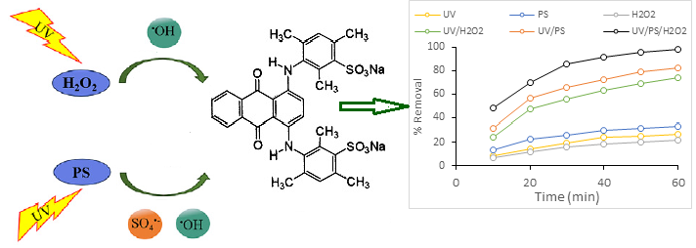

Acid blue 80 dye molecule

