Table S1: Result of MK Test (z-score) for annual, seasonal and monthly scale for the period between 1901-2022 without changepoint analysis

Regions | Index | January | February | March | April | May | June | July | August | September | October | November | December | Winter | Pre-Monsoon | Monsoon | Post Monsoon | Annual
Homogeneous Regions | Central Northeast region | -0.07 | -0.64 | 0.35 | 2.14 | 3.74 | -0.81 | -1.49 | -3.82 | 0.33 | 0.64 | 0.29 | 0.58 | -1.04 | 2.67 | -2.21 | 0.33 | -1.51
Homogeneous Regions | Hilly Region | -1.07 | 0.98 | 0.96 | 1.99 | 2.39 | 1.07 | -0.16 | -1.35 | -0.45 | -0.26 | 2.58 | -0.85 | -0.45 | 2.87 | -0.14 | 0.12 | 0.54
Homogeneous Regions | Northeast Region | -0.50 | -1.03 | -0.62 | -0.52 | -2.02 | -5.05 | -1.18 | -3.48 | 0.95 | 1.27 | -1.35 | 1.05 | -1.27 | -1.88 | -4.59 | 0.75 | -3.96
Homogeneous Regions | Northwest Region | -0.80 | 0.47 | 0.82 | 1.71 | 2.25 | 1.56 | 0.34 | 1.50 | 0.85 | 1.77 | 2.05 | -0.35 | -0.43 | 1.86 | 1.36 | 1.40 | 1.69
Homogeneous Regions | South Peninsular Region | -2.00 | -0.65 | -0.84 | 1.18 | -0.14 | -1.74 | 2.89 | 1.32 | 2.25 | 1.61 | -0.12 | 1.26 | -2.68 | -0.03 | 1.88 | 1.01 | 2.00
Homogeneous Regions | West Central Region | 0.48 | -0.95 | 0.47 | 0.07 | 0.61 | -0.16 | 0.20 | 2.25 | 0.49 | 1.72 | 0.09 | 0.21 | -0.53 | 0.41 | 1.34 | 1.15 | 1.43
Meteorological Subdivisions | Arunachal Pradesh | -1.36 | -1.06 | 0.22 | 1.24 | 0.36 | -3.44 | -0.41 | -2.12 | -0.46 | -0.11 | -1.14 | 1.15 | -1.63 | 0.63 | -3.46 | -0.28 | -2.51
Meteorological Subdivisions | Assam Meghalaya | -0.69 | -0.91 | -0.49 | -0.58 | -1.76 | -4.55 | -1.37 | -3.28 | 0.51 | 1.14 | -1.73 | 1.68 | -1.30 | -1.75 | -4.42 | 0.54 | -3.97
Meteorological Subdivisions | Bihar | 0.85 | -0.39 | 0.82 | 2.51 | 3.06 | -2.05 | -0.71 | -3.99 | -1.18 | 1.74 | 1.85 | 3.02 | -0.42 | 2.18 | -4.29 | 1.38 | -3.60
Meteorological Subdivisions | Chhattisgarh | 0.78 | -1.50 | -0.21 | 0.49 | 2.36 | -0.84 | -0.35 | -0.13 | 0.59 | 0.57 | -0.91 | 0.29 | -1.17 | 0.82 | -0.41 | 0.38 | -0.25
Meteorological Subdivisions | Coastal Andhra Pradesh | 0.40 | -0.08 | 0.38 | 0.76 | 1.34 | 1.05 | 1.73 | 2.05 | 1.08 | 1.07 | -0.35 | 1.02 | -0.08 | 1.10 | 2.83 | 0.54 | 2.78
Meteorological Subdivisions | Coastal Karnataka | -0.39 | 0.83 | -0.01 | 0.26 | -2.30 | -3.04 | 2.33 | 0.36 | 2.05 | 0.66 | -1.01 | 0.77 | -1.09 | -1.91 | 0.54 | -0.20 | 0.19
Meteorological Subdivisions | Eastern Madhya Pradesh | 0.35 | -1.10 | 0.36 | 0.17 | 1.93 | 0.11 | -2.20 | -0.63 | -0.40 | 0.36 | 0.51 | 0.77 | -0.54 | 0.67 | -1.06 | -0.84 | -1.12
Meteorological Subdivisions | Eastern Rajasthan | -0.87 | 0.37 | 1.30 | 1.83 | 1.82 | 1.47 | 0.23 | 1.85 | 0.17 | 1.70 | 1.42 | 0.13 | -0.64 | 2.34 | 1.19 | 0.94 | 1.52
Meteorological Subdivisions | Eastern UP | 0.20 | -0.18 | 0.37 | 2.01 | 3.89 | 0.59 | -1.76 | -4.22 | -0.71 | 0.43 | 0.83 | 0.87 | -0.35 | 2.60 | -2.47 | 0.29 | -2.25
Meteorological Subdivisions | Gangetic West Bengal | 0.13 | -0.84 | -0.03 | 1.75 | 1.54 | -1.33 | -0.06 | -0.89 | 1.64 | 1.51 | 1.07 | 2.17 | -0.23 | 1.04 | -0.54 | 1.40 | 0.44
Meteorological Subdivisions | Gujarat | 0.85 | -0.25 | 1.84 | 1.36 | 0.80 | 0.61 | -0.18 | 2.06 | 1.16 | 1.80 | 2.30 | 2.71 | -0.72 | 0.29 | 1.39 | 1.93 | 1.53
Meteorological Subdivisions | Haryana | -0.97 | 0.35 | 0.42 | 1.49 | 3.01 | 2.62 | 0.00 | -0.55 | 0.45 | 1.29 | 3.48 | -0.44 | -0.84 | 2.18 | 0.46 | 0.63 | 0.74
Meteorological Subdivisions | Himachal | -1.16 | 0.27 | 0.24 | 1.76 | 2.64 | 3.24 | -0.08 | -0.32 | 0.26 | 0.73 | 3.61 | -1.41 | -1.02 | 1.46 | 1.37 | -0.24 | 1.26
Meteorological Subdivisions | J&K | -0.35 | 1.91 | 1.65 | 2.11 | 1.45 | 3.32 | 2.28 | 1.21 | 0.29 | 1.04 | 3.58 | -0.50 | 1.09 | 2.85 | 2.94 | 2.09 | 4.49
Meteorological Subdivisions | Jharkhand | -0.02 | -1.08 | -0.21 | 2.06 | 2.27 | -1.46 | -1.19 | -3.35 | -0.03 | 1.71 | 1.30 | 2.59 | -1.35 | 1.37 | -3.12 | 1.35 | -2.43
Meteorological Subdivisions | Kerala | -2.13 | -0.25 | -1.47 | 0.95 | -1.03 | -2.44 | 1.90 | 0.92 | 2.12 | 0.00 | -0.08 | -0.19 | -1.95 | -0.38 | 0.82 | -0.25 | 0.45
Meteorological Subdivisions | Konkan Goa | -1.42 | -2.11 | 0.86 | -0.81 | -2.04 | -0.14 | 0.86 | 2.13 | 2.66 | 1.92 | -0.70 | 0.99 | -2.15 | -2.30 | 2.21 | 1.65 | 2.27
Meteorological Subdivisions | Madhya Maharashtra | 0.19 | -0.54 | 1.80 | -0.85 | -0.62 | 0.37 | 0.33 | 2.68 | 1.85 | 2.25 | -0.12 | 0.67 | -0.91 | -1.20 | 2.20 | 1.66 | 2.27
Meteorological Subdivisions | Marathwada | 1.63 | -0.41 | 1.95 | -0.07 | 1.51 | 0.05 | 1.05 | 3.20 | -0.04 | 3.07 | 1.15 | 0.83 | -0.94 | 1.14 | 2.06 | 2.33 | 2.47
Meteorological Subdivisions | NMMT | -0.28 | -1.40 | -0.73 | -2.16 | -3.49 | -5.71 | -1.12 | -2.90 | 0.99 | 0.97 | -2.00 | 0.10 | -1.34 | -3.42 | -4.99 | 0.27 | -4.78
Meteorological Subdivisions | North Interior Karnataka | 0.47 | 0.51 | 0.52 | 1.67 | -0.88 | 0.12 | 0.96 | 1.85 | 1.25 | 2.59 | -0.42 | 1.31 | -0.93 | -0.04 | 2.00 | 1.88 | 2.58
Meteorological Subdivisions | Orissa | 0.49 | -1.26 | 0.25 | 1.90 | 2.95 | -0.94 | 0.23 | 0.84 | 1.79 | 0.14 | 0.16 | 0.22 | -0.66 | 3.24 | 1.48 | -0.17 | 2.10
Meteorological Subdivisions | Punjab | -0.90 | 0.59 | 0.45 | 1.20 | 3.16 | 3.46 | 0.75 | 0.52 | 0.95 | 1.34 | 4.02 | -1.13 | -0.45 | 1.63 | 2.15 | 0.46 | 2.35
Meteorological Subdivisions | Rayalaseema | -2.17 | -0.01 | 0.80 | 2.47 | 2.18 | 3.78 | 2.59 | 2.20 | 0.61 | 2.27 | 0.01 | 1.62 | -2.83 | 2.84 | 3.40 | 1.67 | 3.92
Meteorological Subdivisions | Saurashtra Kutch | 1.25 | 0.08 | 1.57 | 1.35 | -0.43 | 0.95 | 0.44 | 1.77 | 1.46 | 1.55 | 3.79 | 1.68 | -0.90 | -0.73 | 1.80 | 1.97 | 1.97
Meteorological Subdivisions | South interior Karnataka | -2.42 | -0.05 | -0.54 | 1.58 | -0.88 | -1.38 | 2.89 | 1.04 | 2.16 | 0.85 | -0.26 | 1.08 | -2.32 | -0.14 | 2.11 | 0.37 | 1.83
Meteorological Subdivisions | Tamil Nadu | -2.15 | -0.44 | -0.51 | 0.02 | -0.72 | -0.54 | 2.57 | 0.79 | 1.29 | 1.52 | 0.37 | 1.71 | -2.82 | -0.47 | 2.01 | 1.41 | 1.31
Meteorological Subdivisions | Telangana | 1.54 | -0.91 | 0.06 | 0.34 | 1.11 | 0.36 | 1.50 | 2.86 | 0.53 | 2.43 | 0.04 | 0.90 | -0.27 | 1.18 | 2.87 | 2.17 | 3.41
Meteorological Subdivisions | Uttaranchal | -1.30 | -0.12 | -0.46 | 1.18 | 2.02 | 1.09 | -1.29 | -2.41 | -0.48 | -0.50 | 1.77 | -1.30 | -1.39 | 1.31 | -1.77 | -1.18 | -1.68
Meteorological Subdivisions | Vidarbha | 1.18 | -0.91 | 0.93 | -0.09 | 1.73 | -0.83 | 0.62 | 1.93 | -0.10 | 1.06 | 0.66 | -0.09 | -0.41 | 0.95 | 0.78 | 0.12 | 0.60
Meteorological Subdivisions | Western Madhya Pradesh | -0.35 | -0.63 | 1.51 | 0.67 | 1.51 | 0.61 | -0.42 | 2.84 | -0.37 | 0.77 | 0.25 | -0.08 | -0.54 | 1.78 | 0.82 | -0.45 | 0.95
Meteorological Subdivisions | Western Rajasthan | -0.84 | 0.44 | 1.14 | 2.16 | 2.12 | 2.05 | 0.05 | 0.46 | 0.54 | 1.70 | 1.60 | -0.48 | -0.11 | 1.93 | 0.72 | 1.17 | 1.22
Meteorological Subdivisions | West Bengal & Sikkim | 0.20 | -0.87 | -0.63 | 1.21 | 0.96 | -3.62 | -0.73 | -3.66 | -0.31 | 0.62 | -2.65 | -1.58 | 0.34 | 1.09 | -3.89 | 0.39 | -2.81
Meteorological Subdivisions | Western UP | -0.78 | 0.45 | 0.35 | 1.44 | 3.13 | 1.66 | -1.03 | -1.67 | -0.09 | 0.45 | 1.43 | -0.37 | -0.78 | 2.53 | -1.21 | 0.07 | -0.85

Table S2: Break year table for all HRs and MSDs. Bold values indicate those years in which h-value is 'True'.

Regions | Index | January | February | March | April | May | June | July | August | September | October | November | December | Winter | Pre-Monsoon | Monsoon | Post Monsoon | Annual
Homogeneous Regions | Central Northeast region | 1963 | 1950 | 1916 | 1942 | 1969 | 1923 | 1991 | 1968 | 1931 | 1928 | 1933 | 1977 | 1963 | 1969 | 1972 | 1915 | 1979
Homogeneous Regions | Hilly Region | 1963 | 1990 | 1948 | 1977 | 1948 | 1993 | 1996 | 2000 | 1965 | 1910 | 1957 | 1992 | 1955 | 1977 | 1937 | 1910 | 1948
Homogeneous Regions | Northeast Region | 1972 | 1951 | 1999 | 1950 | 2002 | 1971 | 1991 | 1959 | 1919 | 1945 | 1933 | 1973 | 1946 | 1957 | 1957 | 1945 | 1957
Homogeneous Regions | Northwest Region | 1963 | 1990 | 1978 | 1977 | 1970 | 1970 | 1919 | 1944 | 2005 | 1954 | 1976 | 1938 | 1962 | 1977 | 1942 | 1955 | 1942
Homogeneous Regions | South Peninsular Region | 1964 | 1963 | 1948 | 1928 | 1982 | 1997 | 1944 | 1995 | 2004 | 1990 | 1947 | 1962 | 1964 | 1924 | 1953 | 1991 | 2004
Homogeneous Regions | West Central Region | 1941 | 1948 | 1936 | 1964 | 1955 | 1906 | 1970 | 1953 | 2005 | 1928 | 1937 | 1962 | 1949 | 1933 | 2005 | 1927 | 1931
Meteorological Subdivisions | Arunachal Pradesh | 1960 | 1942 | 1940 | 1972 | 1963 | 1957 | 2005 | 2002 | 1953 | 1960 | 1939 | 1931 | 1946 | 1993 | 1956 | 1953 | 1956
Meteorological Subdivisions | Assam Meghalaya | 1972 | 1944 | 1940 | 1960 | 1960 | 1980 | 2000 | 1959 | 1994 | 1986 | 1933 | 1973 | 1946 | 1960 | 1957 | 1945 | 1957
Meteorological Subdivisions | Bihar | 1919 | 1950 | 1916 | 1942 | 1969 | 1957 | 1991 | 1968 | 1950 | 1928 | 1933 | 1977 | 1946 | 1969 | 1957 | 1928 | 1957
Meteorological Subdivisions | Chhattisgarh | 1919 | 1951 | 1971 | 1972 | 1969 | 1923 | 1922 | 1965 | 2010 | 1915 | 1999 | 1961 | 1949 | 1925 | 2010 | 1915 | 2010
Meteorological Subdivisions | Coastal Andhra Pradesh | 1978 | 1939 | 1991 | 2010 | 1989 | 1956 | 1944 | 1976 | 2004 | 1928 | 1949 | 1908 | 1978 | 1987 | 1954 | 1915 | 1954
Meteorological Subdivisions | Coastal Karnataka | 1949 | 1985 | 1923 | 1920 | 1987 | 1984 | 1958 | 1946 | 2005 | 1928 | 1981 | 1968 | 1987 | 1986 | 1953 | 1928 | 1946
Meteorological Subdivisions | Eastern Madhya Pradesh | 1941 | 1948 | 2005 | 1966 | 1986 | 2001 | 1970 | 1986 | 1964 | 1976 | 1937 | 1961 | 1949 | 1989 | 1965 | 2000 | 1964
Meteorological Subdivisions | Eastern Rajasthan | 1962 | 1970 | 1956 | 1977 | 1970 | 1970 | 2013 | 1942 | 1978 | 1954 | 1976 | 1938 | 1962 | 1977 | 1942 | 1954 | 1942
Meteorological Subdivisions | Eastern UP | 1963 | 1950 | 1916 | 1933 | 1969 | 1909 | 1971 | 1964 | 1987 | 1988 | 1933 | 1998 | 1963 | 1969 | 1965 | 1988 | 1986
Meteorological Subdivisions | Gangetic West Bengal | 2003 | 1949 | 1921 | 1976 | 1973 | 1923 | 1920 | 1945 | 1931 | 1936 | 1986 | 1973 | 1999 | 1973 | 1945 | 1945 | 1968
Meteorological Subdivisions | Gujarat | 1998 | 1943 | 2006 | 1977 | 1934 | 1909 | 1968 | 1953 | 2005 | 1927 | 1976 | 1962 | 1949 | 1970 | 2003 | 1927 | 2003
Meteorological Subdivisions | Haryana | 1963 | 1943 | 1916 | 1977 | 1964 | 1970 | 1986 | 1998 | 2005 | 1954 | 1978 | 1938 | 1963 | 1976 | 1942 | 1954 | 1942
Meteorological Subdivisions | Himachal | 1963 | 1943 | 1916 | 1977 | 1963 | 1970 | 2015 | 1979 | 1965 | 1954 | 1978 | 1938 | 1963 | 1977 | 2010 | 1991 | 1975
Meteorological Subdivisions | J&K | 1962 | 1965 | 1948 | 1956 | 1957 | 1986 | 1973 | 1973 | 1929 | 1953 | 1957 | 1991 | 1990 | 1955 | 1973 | 1951 | 1953
Meteorological Subdivisions | Jharkhand | 1919 | 1950 | 1921 | 1943 | 1969 | 1957 | 1991 | 1951 | 1979 | 1928 | 1933 | 1977 | 1950 | 1976 | 1957 | 1928 | 1950
Meteorological Subdivisions | Kerala | 1964 | 1927 | 1969 | 1929 | 1982 | 1997 | 1959 | 2017 | 2004 | 1989 | 1976 | 1974 | 1964 | 1982 | 1959 | 1947 | 2007
Meteorological Subdivisions | Konkan Goa | 1921 | 1985 | 2006 | 1981 | 1983 | 1984 | 2005 | 1945 | 2005 | 1927 | 1983 | 1962 | 1949 | 1983 | 2004 | 1927 | 2004
Meteorological Subdivisions | Madhya Maharashtra | 1927 | 1949 | 2005 | 1981 | 1979 | 1906 | 2005 | 1953 | 2005 | 1929 | 1983 | 1962 | 1949 | 1979 | 2004 | 1927 | 2004
Meteorological Subdivisions | Marathwada | 1927 | 1953 | 1954 | 1964 | 1949 | 2013 | 1931 | 1955 | 2005 | 1955 | 1937 | 1968 | 1951 | 1933 | 1947 | 1955 | 1931
Meteorological Subdivisions | NMMT | 1972 | 1951 | 1999 | 1953 | 2002 | 1971 | 1989 | 1960 | 1919 | 1945 | 1933 | 1973 | 1951 | 1957 | 1971 | 1945 | 1957
Meteorological Subdivisions | North Interior Karnataka | 1927 | 1989 | 1915 | 1929 | 1983 | 1927 | 1944 | 1946 | 2005 | 1993 | 1937 | 1968 | 1948 | 1983 | 1947 | 1993 | 1946
Meteorological Subdivisions | Orissa | 1919 | 1949 | 1939 | 1962 | 1988 | 1923 | 1925 | 1970 | 2005 | 1976 | 1999 | 1965 | 1949 | 1988 | 2006 | 1915 | 1925
Meteorological Subdivisions | Punjab | 1963 | 1990 | 1978 | 1977 | 1963 | 1970 | 1948 | 1955 | 2005 | 1954 | 1978 | 1938 | 1963 | 1977 | 1953 | 1955 | 1975
Meteorological Subdivisions | Rayalaseema | 1936 | 1948 | 1981 | 1934 | 1940 | 1956 | 1944 | 1946 | 1960 | 1953 | 1947 | 1962 | 1949 | 1951 | 1955 | 1991 | 1955
Meteorological Subdivisions | Saurashtra Kutch | 1998 | 1943 | 2006 | 1977 | 2005 | 1975 | 1992 | 1953 | 2005 | 1955 | 1957 | 2017 | 1999 | 2000 | 2003 | 1955 | 2003
Meteorological Subdivisions | South interior Karnataka | 1949 | 1980 | 1949 | 1920 | 1987 | 1962 | 1944 | 1932 | 1971 | 1928 | 1949 | 1962 | 1969 | 1982 | 2004 | 1997 | 2004
Meteorological Subdivisions | Tamil Nadu | 1964 | 1954 | 1923 | 1972 | 1973 | 1969 | 1947 | 2007 | 1971 | 1990 | 1976 | 1963 | 1964 | 1973 | 1960 | 1997 | 1997
Meteorological Subdivisions | Telangana | 1966 | 1951 | 1991 | 2004 | 1969 | 2012 | 1945 | 1953 | 2005 | 1971 | 1937 | 1990 | 1939 | 1987 | 1953 | 1971 | 1953
Meteorological Subdivisions | Uttaranchal | 1963 | 1943 | 1916 | 1977 | 1970 | 1970 | 1965 | 1977 | 1973 | 1986 | 1978 | 1938 | 1963 | 1977 | 1979 | 1987 | 1991
Meteorological Subdivisions | Vidarbha | 1978 | 1951 | 1936 | 1969 | 1956 | 1941 | 1931 | 1953 | 2005 | 1915 | 1949 | 1998 | 1949 | 1933 | 2005 | 1915 | 1931
Meteorological Subdivisions | Western Madhya Pradesh | 1940 | 1949 | 2005 | 1994 | 1986 | 1970 | 1960 | 1955 | 1965 | 1915 | 1983 | 1998 | 1940 | 1987 | 1931 | 1986 | 1931
Meteorological Subdivisions | Western Rajasthan | 2000 | 1990 | 1962 | 1994 | 1971 | 1970 | 1919 | 1907 | 1978 | 1954 | 1951 | 1930 | 2008 | 1977 | 2010 | 1955 | 2010
Meteorological Subdivisions | West Bengal & Sikkim | 1953 | 1951 | 1916 | 1974 | 1973 | 1957 | 1990 | 1967 | 1954 | 1945 | 1980 | 1977 | 1989 | 1973 | 1956 | 1945 | 1957
Meteorological Subdivisions | Western UP | 1963 | 1990 | 1944 | 1977 | 1969 | 1970 | 1982 | 1999 | 1965 | 1954 | 1976 | 1938 | 1963 | 1977 | 1979 | 1954 | 1979
Table S3: Result of pre change point MK Test (z score) for annual, seasonal and monthly scale for the period between 1901-2022.

Regions | Index | January | February | March | April | May | June | July | August | September | October | November | December | Winter | Pre-Monsoon | Monsoon | Post Monsoon | Annual
Homogeneous Regions | Central Northeast region | - | - | - | - | -0.98 | - | - | -0.17 | - | - | - | - | - | -0.71 | 0.69 | - | -
Homogeneous Regions | Hilly Region | - | - | - | -1.15 | - | - | - | - | - | - | - | - | - | 0.72 | - | - | -
Homogeneous Regions | Northeast Region | - | - | - | - | - | -1.34 | - | -0.29 | - | - | - | - | - | - | 0.03 | - | 1.05
Homogeneous Regions | Northwest Region | - | - | - | - | - | - | - | 0.00 | - | - | - | - | - | - | - | - | -
Homogeneous Regions | South Peninsular Region | -0.96 | - | - | - | - | - | -0.68 | 0.00 | 0.31 | - | - | - | -0.67 | - | - | - | -
Homogeneous Regions | West Central Region | - | - | - | - | - | - | 0.00 | 0.36 | 0.00 | - | - | - | - | - | - | - | -
Meteorological Subdivisions | Arunachal Pradesh | - | - | - | - | - | 0.34 | - | - | - | - | - | - | - | - | -0.12 | - | 0.57
Meteorological Subdivisions | Assam Meghalaya | - | - | - | - | 2.35 | -1.20 | - | -0.41 | - | - | - | - | - | - | 0.56 | - | 1.40
Meteorological Subdivisions | Bihar | - | - | - | - | -0.51 | 0.16 | - | -1.05 | - | - | - | -0.26 | - | -0.95 | -0.19 | - | -0.19
Meteorological Subdivisions | Chhattisgarh | - | - | - | - | - | - | - | - | - | - | - | - | - | - | - | - | -
Meteorological Subdivisions | Coastal Andhra Pradesh | - | - | - | - | - | - | - | 0.17 | - | - | - | - | - | - | - | - | -
Meteorological Subdivisions | Coastal Karnataka | - | - | - | - | 1.13 | -0.65 | - | - | -0.06 | - | - | - | - | 1.57 | - | - | -
Meteorological Subdivisions | Eastern Madhya Pradesh | - | - | - | - | - | - | 1.06 | - | - | - | - | - | - | - | - | - | -
Meteorological Subdivisions | Eastern Rajasthan | - | - | - | - | - | - | - | - | - | - | - | - | - | - | - | - | -
Meteorological Subdivisions | Eastern UP | - | - | - | - | -0.18 | - | 0.76 | 1.05 | - | - | - | - | - | - | 1.60 | - | 0.44
Meteorological Subdivisions | Gangetic West Bengal | - | - | - | - | - | - | - | - | - | - | - | - | - | - | - | - | -
Meteorological Subdivisions | Gujarat | - | - | - | - | - | - | - | - | - | - | - | - | - | - | - | - | -
Meteorological Subdivisions | Haryana | - | - | - | - | -0.62 | -0.32 | - | - | - | - | - | - | - | -0.49 | - | - | -
Meteorological Subdivisions | Himachal | - | - | - | - | -1.14 | -0.77 | - | - | - | - | - | - | - | - | - | - | -
Meteorological Subdivisions | J&K | - | - | 0.74 | - | - | 0.24 | - | - | - | - | 2.42 | - | - | 0.38 | -0.17 | 1.09 | 0.45
Meteorological Subdivisions | Jharkhand | - | - | - | - | - | - | - | 0.60 | - | - | - | 0.33 | - | - | 0.02 | - | 1.54
Meteorological Subdivisions | Kerala | -0.57 | - | - | - | - | - | - | - | 0.48 | - | - | - | - | - | - | - | -
Meteorological Subdivisions | Konkan Goa | - | - | - | - | 0.99 | - | - | - | 0.57 | - | - | - | - | 1.21 | - | - | -
Meteorological Subdivisions | Madhya Maharashtra | - | - | - | - | - | - | - | - | - | - | - | - | - | - | 0.23 | - | 0.50
Meteorological Subdivisions | Marathwada | - | - | - | - | - | - | - | -0.10 | - | - | - | - | - | - | - | - | -
Meteorological Subdivisions | NMMT | - | - | - | 1.45 | -0.38 | -1.70 | - | -0.04 | - | - | - | - | - | 1.96 | -0.50 | - | 1.14
Meteorological Subdivisions | North Interior Karnataka | - | - | - | - | - | - | - | - | - | 1.01 | - | - | - | - | - | - | 0.40
Meteorological Subdivisions | Orissa | - | - | - | - | -0.43 | - | - | - | -0.46 | - | - | - | - | 0.28 | - | - | -
Meteorological Subdivisions | Punjab | - | - | - | - | -0.59 | -0.69 | - | - | - | - | 0.71 | - | - | - | - | - | -
Meteorological Subdivisions | Rayalaseema | -0.56 | - | - | - | - | 0.20 | - | - | - | - | - | - | - | - | 0.30 | - | 0.22
Meteorological Subdivisions | Saurashtra Kutch | - | - | - | - | - | - | - | - | - | - | - | - | - | - | - | - | -
Meteorological Subdivisions | South interior Karnataka | -1.20 | - | - | - | - | - | - | - | - | - | - | - | - | - | - | - | -
Meteorological Subdivisions | Tamil Nadu | -0.70 | - | - | - | - | - | - | - | -1.64 | - | - | - | -0.54 | - | - | - | -
Meteorological Subdivisions | Telangana | - | - | - | - | - | - | - | -0.70 | - | - | - | - | - | - | 0.71 | - | 1.14
Meteorological Subdivisions | Uttaranchal | - | - | - | - | -0.43 | - | - | 0.57 | - | - | - | - | - | - | 0.51 | - | -
Meteorological Subdivisions | Vidarbha | - | - | - | - | - | - | - | - | - | - | - | - | - | - | - | - | -
Meteorological Subdivisions | Western Madhya Pradesh | - | - | - | - | - | - | - | 1.10 | - | - | - | - | - | - | - | - | -
Meteorological Subdivisions | Western Rajasthan | - | - | - | -0.14 | - | - | - | - | - | - | - | - | - | - | - | - | -
Meteorological Subdivisions | West Bengal & Sikkim | - | - | - | - | - | -0.83 | - | -1.00 | - | - | - | - | - | - | -0.19 | - | -0.05
Meteorological Subdivisions | Western UP | - | - | - | - | -0.37 | - | - | 0.36 | - | - | - | - | - | 0.22 | - | - | -
Table S4: Post changepoint Sen slope values for all MSDs and HRs for annual, seasonal and monthly scale

Regions | Index | January | February | March | April | May | June | July | August | September | October | November | December | Winter | Pre-Monsoon | Monsoon | Post Monsoon | Annual
Homogeneous Regions | Central Northeast region | -0.002 | -0.018 | 0.008 | 0.052 | 0.269 | -0.117 | -0.226 | -0.282 | 0.035 | 0.060 | 0.004 | 0.004 | -0.023 | 0.111 | -0.159 | 0.012 | -0.040
Homogeneous Regions | Hilly Region | -0.047 | 0.040 | 0.041 | -0.048 | 0.075 | 0.070 | -0.016 | -0.098 | -0.029 | -0.009 | 0.043 | -0.023 | -0.012 | -0.097 | -0.006 | 0.002 | 0.008
Homogeneous Regions | Northeast Region | -0.012 | -0.042 | -0.044 | -0.077 | -0.321 | -1.369 | -0.245 | -0.641 | 0.170 | 0.221 | -0.045 | 0.009 | -0.026 | -0.172 | -0.710 | 0.048 | -0.252
Homogeneous Regions | Northwest Region | -0.010 | 0.004 | 0.006 | 0.009 | 0.026 | 0.123 | 0.056 | 0.268 | 0.132 | 0.029 | 0.008 | -0.002 | -0.004 | 0.012 | 0.111 | 0.013 | 0.047
Homogeneous Regions | South Peninsular Region | 0.068 | -0.009 | -0.016 | 0.061 | -0.014 | -0.168 | 0.273 | 0.182 | -0.638 | 0.246 | -0.018 | 0.079 | 0.026 | -0.001 | 0.150 | 0.079 | 0.070
Homogeneous Regions | West Central Region | 0.006 | -0.013 | 0.009 | 0.001 | 0.021 | -0.018 | 0.026 | -0.205 | 0.063 | 0.160 | 0.002 | 0.001 | -0.006 | 0.007 | 0.115 | 0.040 | 0.047
Meteorological Subdivisions | Arunachal Pradesh | -0.027 | -0.037 | 0.012 | 0.105 | 0.047 | -0.142 | -0.070 | -0.313 | -0.069 | -0.013 | -0.025 | 0.013 | -0.031 | 0.033 | -0.262 | -0.014 | -0.007
Meteorological Subdivisions | Assam Meghalaya | -0.017 | -0.048 | -0.044 | -0.108 | -0.630 | -1.288 | -0.460 | -0.924 | 0.105 | 0.233 | -0.054 | 0.017 | -0.038 | -0.217 | -0.905 | 0.036 | -0.335
Meteorological Subdivisions | Bihar | 0.024 | -0.008 | 0.015 | 0.068 | 0.075 | -0.148 | -0.142 | 0.115 | -0.224 | 0.168 | 0.014 | -0.017 | -0.010 | 0.043 | -0.113 | 0.052 | -0.036
Meteorological Subdivisions | Chhattisgarh | 0.013 | -0.036 | -0.007 | 0.016 | 0.081 | -0.147 | -0.070 | -0.029 | 0.069 | 0.051 | -0.009 | 0.001 | -0.021 | 0.016 | -0.033 | 0.012 | -0.008
Meteorological Subdivisions | Coastal Andhra Pradesh | 0.002 | 0.000 | 0.003 | 0.027 | 0.116 | 0.110 | 0.223 | -0.217 | 0.149 | 0.269 | -0.040 | 0.025 | -0.001 | 0.043 | 0.215 | 0.057 | 0.107
Meteorological Subdivisions | Coastal Karnataka | 0.000 | 0.000 | 0.000 | 0.018 | 0.977 | -1.021 | 2.171 | 0.183 | -5.658 | 0.147 | -0.104 | 0.008 | -0.001 | 0.419 | 0.198 | -0.017 | 0.025
Meteorological Subdivisions | Eastern Madhya Pradesh | 0.011 | -0.030 | 0.008 | 0.003 | 0.039 | 0.018 | 0.677 | -0.123 | -0.071 | 0.016 | 0.002 | 0.005 | -0.016 | 0.011 | -0.134 | -0.025 | -0.052
Meteorological Subdivisions | Eastern Rajasthan | -0.011 | 0.002 | 0.006 | 0.009 | 0.031 | 0.134 | 0.044 | 0.440 | 0.037 | 0.023 | 0.004 | 0.000 | -0.006 | 0.020 | 0.126 | 0.012 | 0.050
Meteorological Subdivisions | Eastern UP | 0.006 | -0.005 | 0.005 | 0.020 | -0.013 | 0.095 | 0.076 | -0.315 | -0.126 | 0.032 | 0.002 | 0.006 | -0.007 | 0.032 | -0.403 | 0.008 | 0.154
Meteorological Subdivisions | Gangetic West Bengal | 0.001 | -0.029 | 0.000 | 0.122 | 0.184 | -0.284 | -0.011 | -0.141 | 0.328 | 0.256 | 0.015 | 0.002 | -0.007 | 0.064 | -0.063 | 0.086 | 0.018
Meteorological Subdivisions | Gujarat | 0.000 | 0.000 | 0.001 | 0.001 | 0.005 | 0.094 | -0.041 | 0.637 | 0.333 | 0.063 | 0.008 | 0.002 | -0.001 | 0.001 | 0.236 | 0.030 | 0.091
Meteorological Subdivisions | Haryana | -0.043 | 0.009 | 0.010 | 0.018 | 0.078 | -0.034 | -0.001 | -0.086 | 0.060 | 0.028 | 0.019 | -0.005 | -0.026 | -0.058 | 0.040 | 0.011 | 0.020
Meteorological Subdivisions | Himachal | -0.120 | 0.025 | 0.017 | 0.106 | -0.016 | 0.276 | -0.019 | -0.056 | 0.051 | 0.023 | 0.065 | -0.067 | -0.064 | 0.065 | 0.122 | -0.006 | 0.042
Meteorological Subdivisions | J&K | -0.015 | 0.069 | -0.115 | 0.086 | 0.053 | 0.059 | 0.116 | 0.067 | 0.010 | 0.015 | 0.056 | -0.011 | 0.028 | -0.068 | 0.043 | -0.037 | 0.022
Meteorological Subdivisions | Jharkhand | -0.001 | -0.035 | -0.007 | 0.062 | 0.152 | -0.250 | -0.199 | -0.109 | -0.003 | 0.145 | 0.011 | -0.041 | -0.040 | 0.048 | -0.054 | 0.048 | 0.000
Meteorological Subdivisions | Kerala | 0.043 | -0.008 | -0.077 | 0.138 | -0.200 | -0.835 | 0.861 | 0.289 | -1.680 | 0.000 | -0.017 | -0.021 | -0.054 | -0.037 | 0.155 | -0.032 | 0.033
Meteorological Subdivisions | Konkan Goa | 0.000 | 0.000 | 0.000 | -0.016 | 0.090 | -0.061 | 0.707 | 1.715 | -1.188 | 0.421 | -0.024 | 0.001 | 0.000 | -0.011 | 0.770 | 0.141 | 0.274
Meteorological Subdivisions | Madhya Maharashtra | 0.000 | 0.000 | 0.008 | -0.016 | -0.025 | 0.038 | 0.057 | 0.125 | 0.303 | 0.283 | -0.003 | 0.003 | -0.002 | -0.017 | -2.240 | 0.084 | -0.630
Meteorological Subdivisions | Marathwada | 0.006 | -0.001 | 0.022 | -0.001 | 0.044 | 0.007 | 0.178 | 0.147 | -0.009 | 0.300 | 0.031 | 0.004 | -0.007 | 0.018 | 0.198 | 0.094 | 0.091
Meteorological Subdivisions | NMMT | -0.007 | -0.069 | -0.076 | -0.002 | 1.073 | -1.167 | -0.298 | -0.633 | 0.155 | 0.166 | -0.104 | 0.001 | -0.040 | -0.481 | -0.890 | 0.023 | -0.441
Meteorological Subdivisions | North Interior Karnataka | 0.000 | 0.001 | 0.004 | 0.071 | -0.057 | 0.005 | 0.087 | 0.185 | 0.180 | -0.098 | -0.019 | 0.005 | -0.001 | -0.001 | 0.129 | 0.097 | -0.015
Meteorological Subdivisions | Orissa | 0.003 | -0.044 | 0.007 | 0.096 | 1.628 | -0.159 | 0.035 | 0.158 | -0.474 | 0.018 | 0.003 | 0.000 | -0.019 | 0.573 | 0.117 | -0.009 | 0.072
Meteorological Subdivisions | Punjab | -0.048 | 0.023 | 0.017 | 0.024 | 0.011 | 0.221 | 0.143 | 0.077 | 0.150 | 0.026 | 0.025 | -0.023 | -0.015 | 0.030 | 0.177 | 0.007 | 0.068
Meteorological Subdivisions | Rayalaseema | 0.002 | 0.000 | 0.006 | 0.086 | 0.143 | 0.208 | 0.199 | 0.245 | 0.071 | 0.319 | 0.003 | 0.066 | -0.020 | 0.069 | 0.150 | 0.106 | 0.116
Meteorological Subdivisions | Saurashtra Kutch | 0.001 | 0.000 | 0.000 | 0.000 | 0.000 | 0.099 | 0.129 | 0.339 | 0.226 | 0.019 | 0.004 | 0.000 | -0.001 | -0.001 | 0.212 | 0.015 | 0.076
Meteorological Subdivisions | South interior Karnataka | 0.000 | 0.000 | -0.010 | 0.103 | -0.081 | -0.155 | 0.577 | 0.166 | 0.298 | 0.151 | -0.025 | 0.021 | -0.012 | -0.007 | 0.191 | 0.030 | 0.066
Meteorological Subdivisions | Tamil Nadu | 0.216 | -0.011 | -0.014 | 0.001 | -0.047 | -0.020 | 0.165 | 0.094 | 0.029 | 0.288 | 0.064 | 0.213 | 0.073 | -0.017 | 0.102 | 0.139 | 0.039
Meteorological Subdivisions | Telangana | 0.003 | -0.004 | 0.001 | 0.010 | 0.055 | 0.054 | 0.315 | -0.060 | 0.096 | 0.301 | 0.001 | 0.002 | -0.001 | 0.028 | 0.133 | 0.102 | 0.063
Meteorological Subdivisions | Uttaranchal | -0.137 | -0.008 | -0.037 | 0.068 | -0.119 | 0.217 | -0.363 | -1.242 | -0.122 | -0.024 | 0.009 | -0.046 | -0.096 | 0.063 | 0.028 | -0.047 | -0.077
Meteorological Subdivisions | Vidarbha | 0.007 | -0.013 | 0.019 | -0.003 | 0.038 | -0.171 | 0.162 | 0.447 | -0.022 | 0.083 | 0.004 | 0.000 | -0.005 | 0.020 | 0.089 | 0.005 | 0.026
Meteorological Subdivisions | Western Madhya Pradesh | -0.006 | -0.004 | 0.010 | 0.003 | 0.023 | 0.075 | -0.080 | -0.164 | -0.088 | 0.027 | 0.001 | 0.000 | -0.007 | 0.014 | 0.098 | -0.014 | 0.035
Meteorological Subdivisions | Western Rajasthan | -0.004 | 0.002 | 0.006 | 0.056 | 0.023 | 0.078 | 0.006 | 0.055 | 0.039 | 0.008 | 0.001 | -0.001 | -0.001 | 0.013 | 0.034 | 0.005 | 0.021
Meteorological Subdivisions | West Bengal & Sikkim | 0.004 | -0.017 | -0.024 | 0.105 | 0.146 | -0.720 | -0.192 | -0.573 | -0.074 | 0.091 | -0.032 | -0.007 | 0.006 | 0.073 | -0.443 | 0.018 | -0.093
Meteorological Subdivisions | Western UP | -0.037 | 0.013 | 0.011 | 0.018 | 0.039 | 0.204 | -0.256 | 2.839 | -0.020 | 0.021 | 0.005 | -0.005 | -0.022 | -0.052 | -0.138 | 0.002 | -0.036
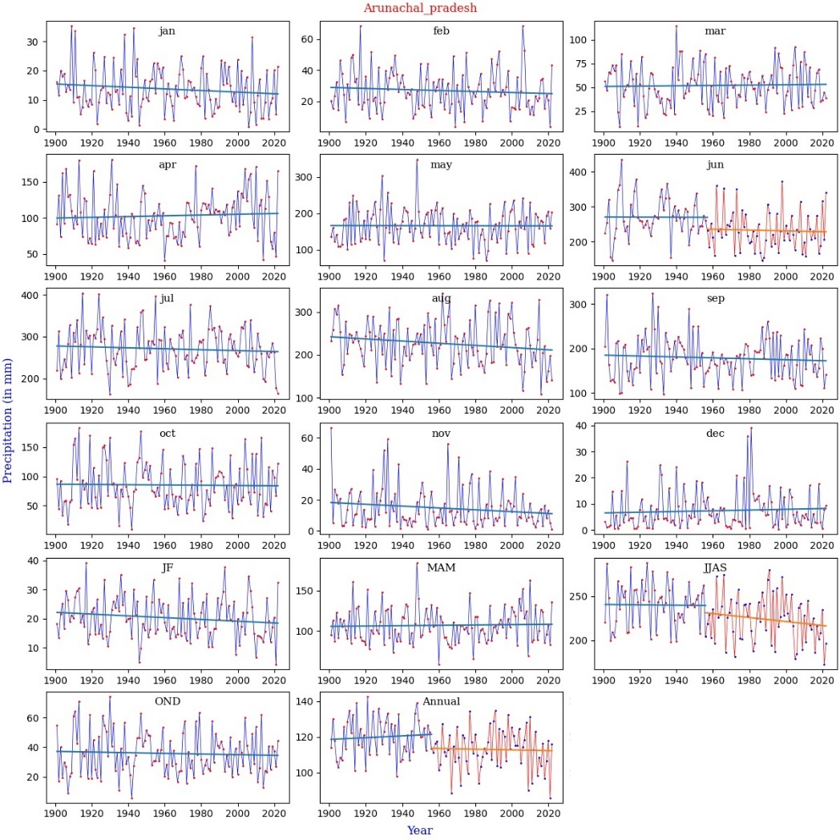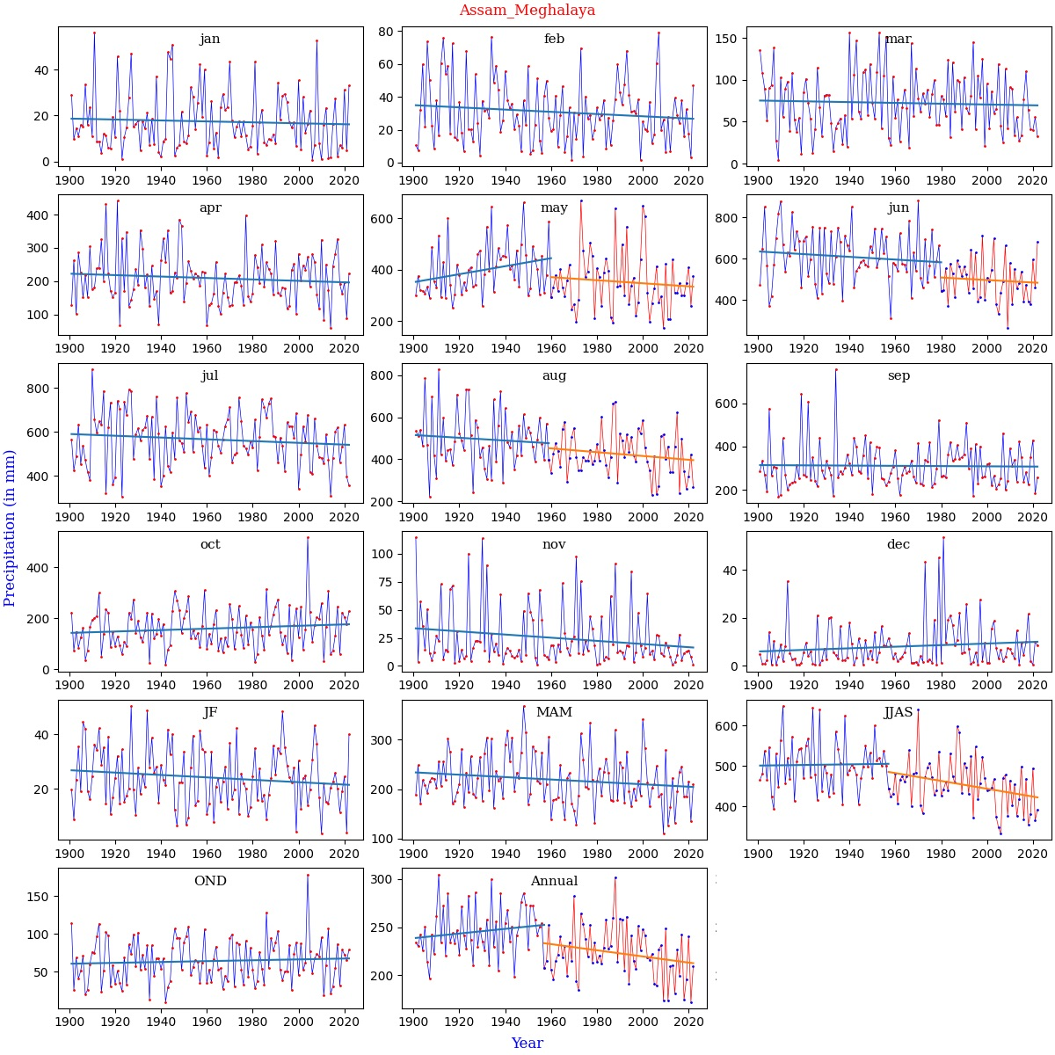
Fig. S1. Graphical representation of MK Test results of MSDs along with break points
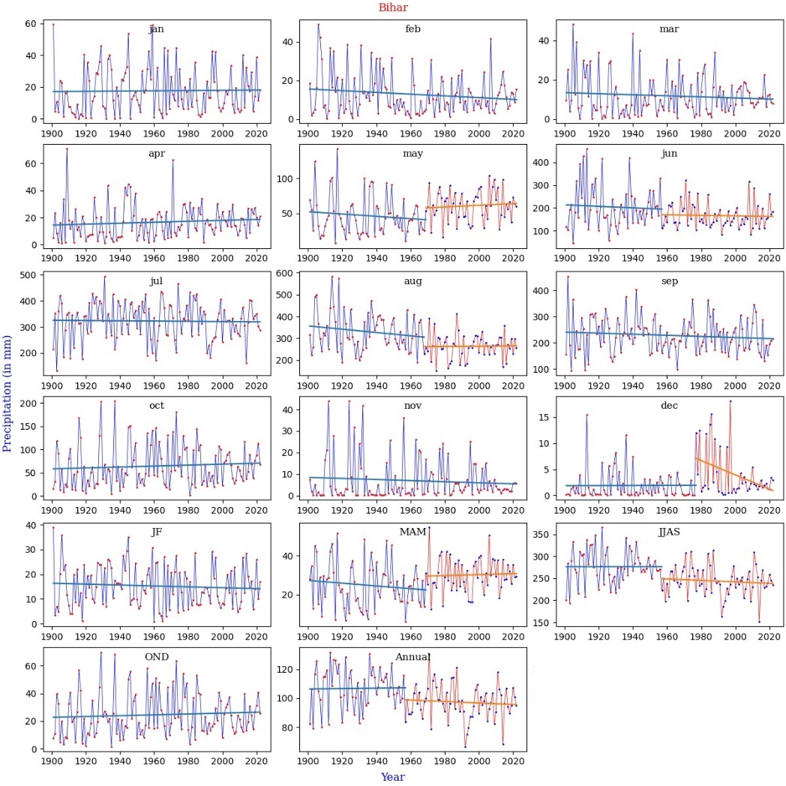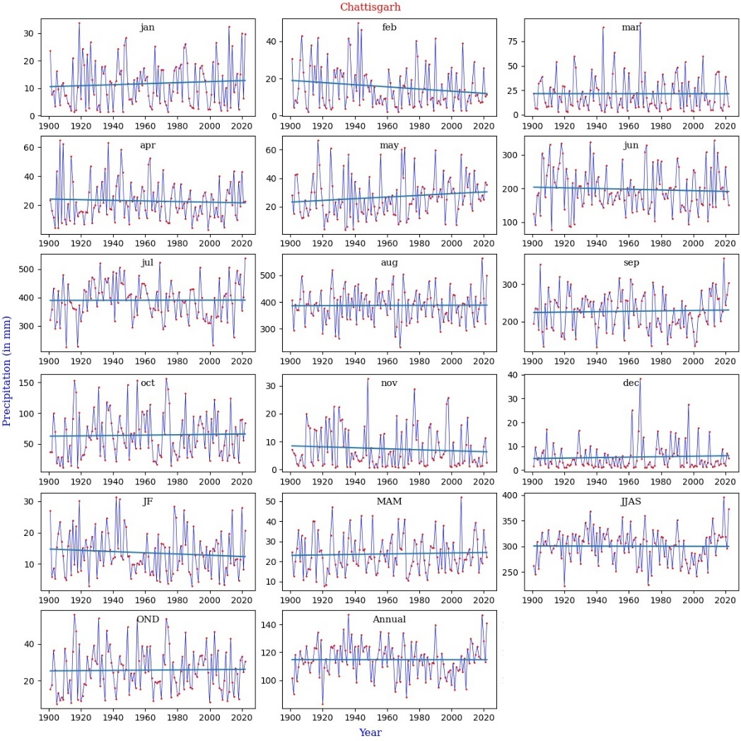
Fig. S1. Continued

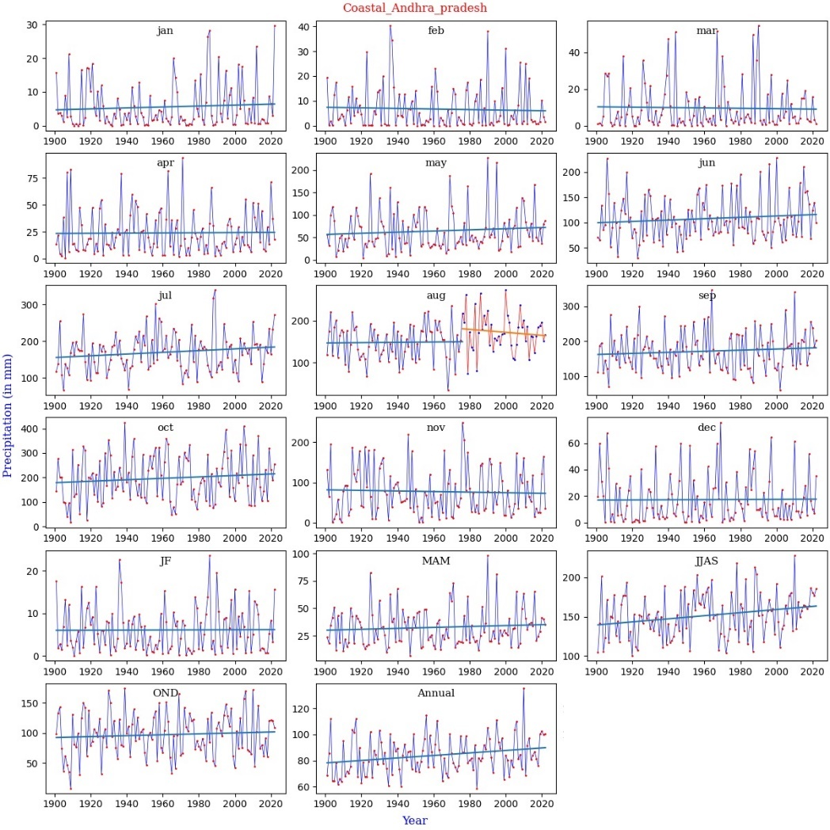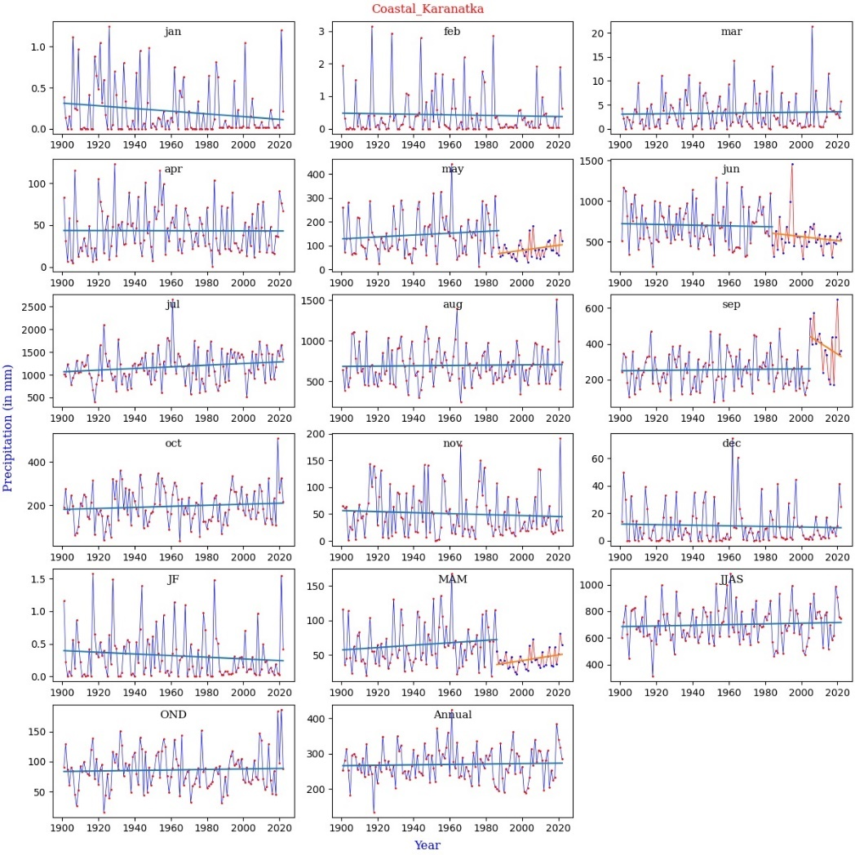
Fig. S1. Continued

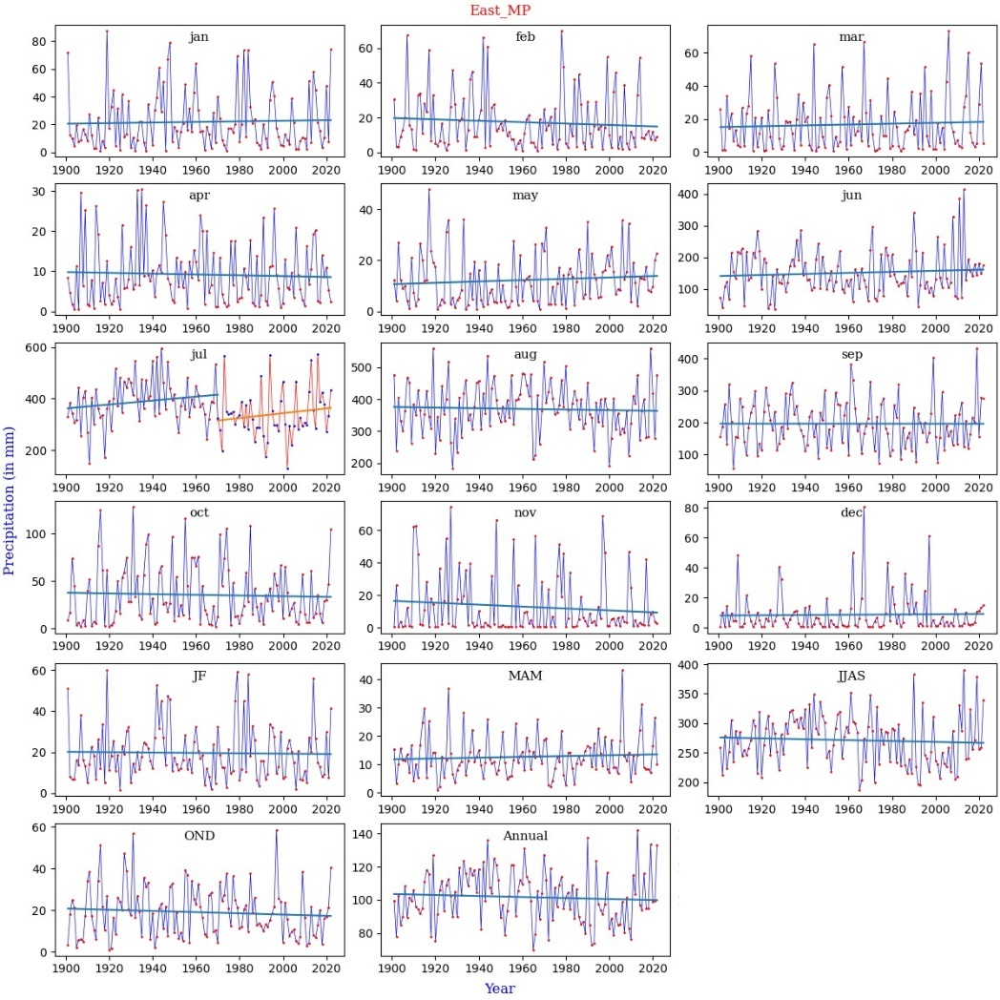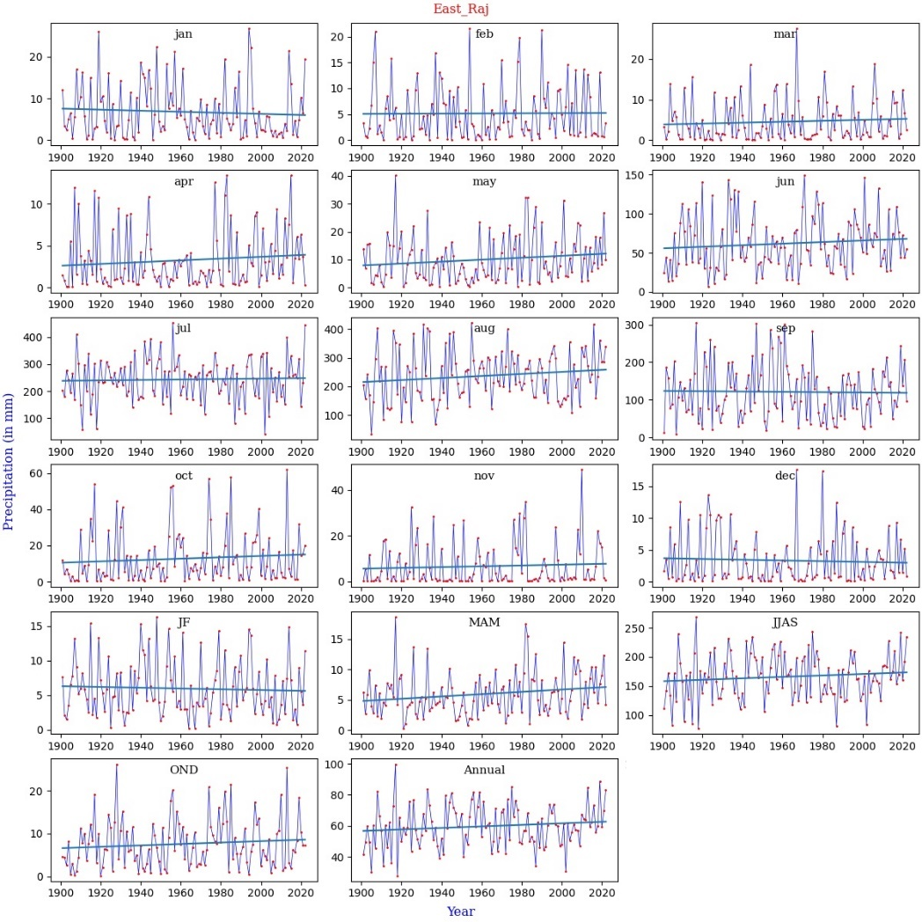
Fig. S1. Continued

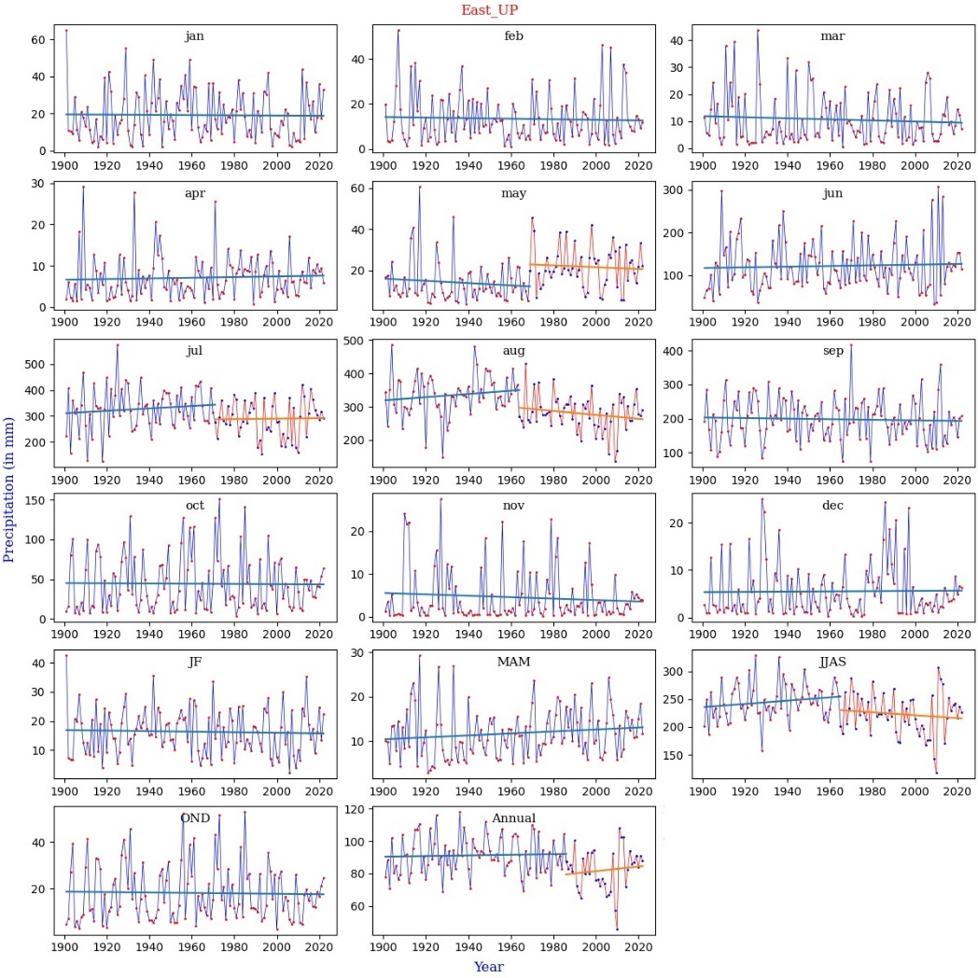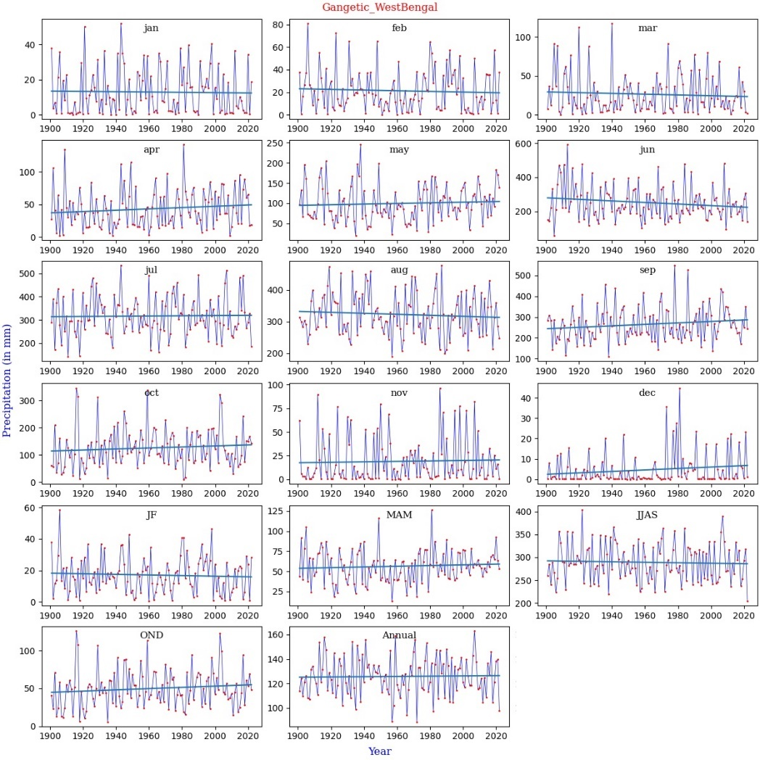
Fig. S1. Continued

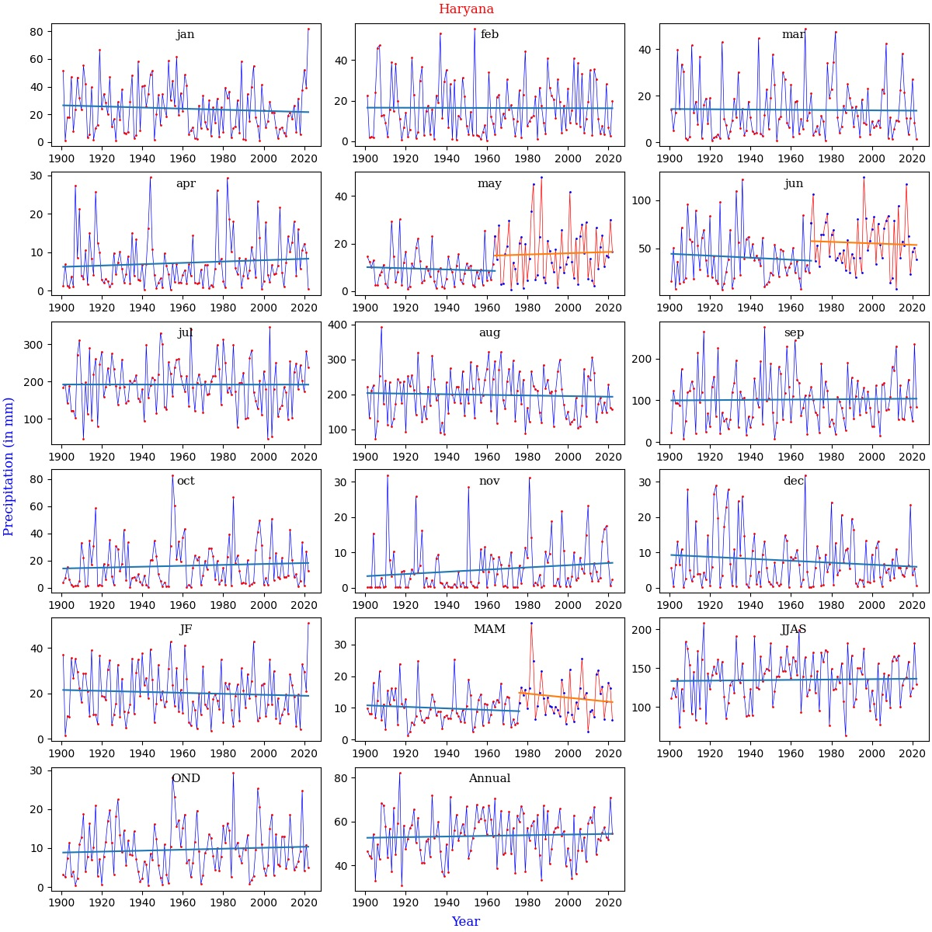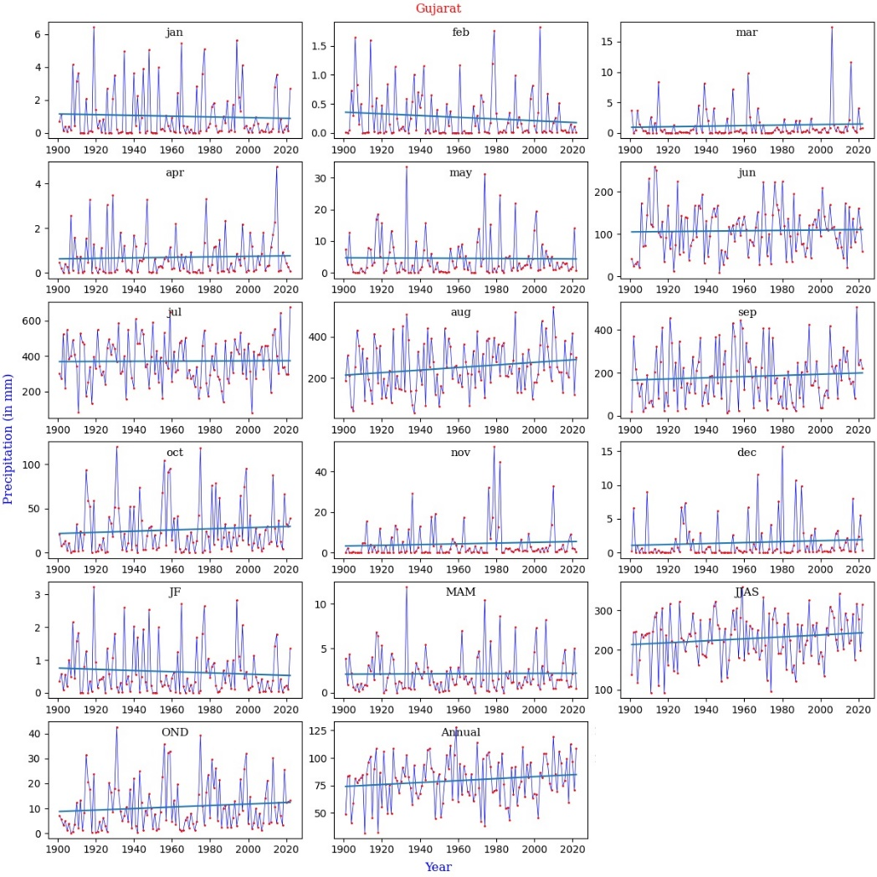
Fig. S1. Continued

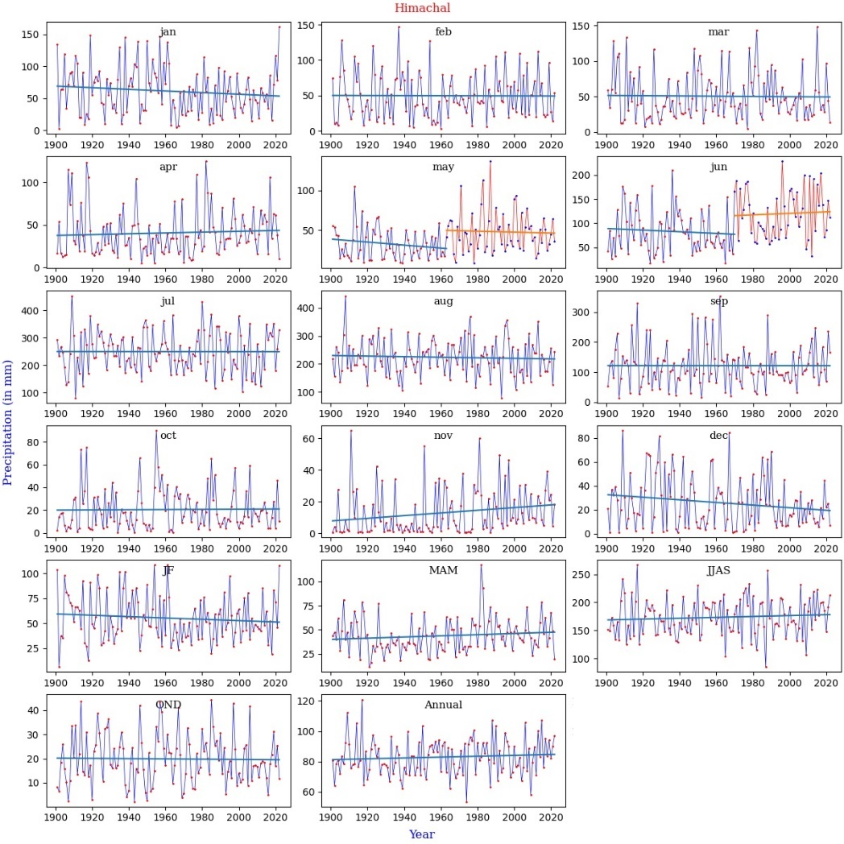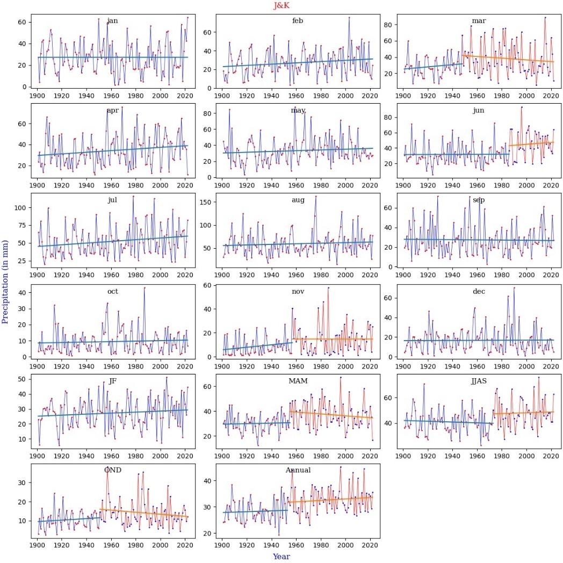
Fig. S1. Continued

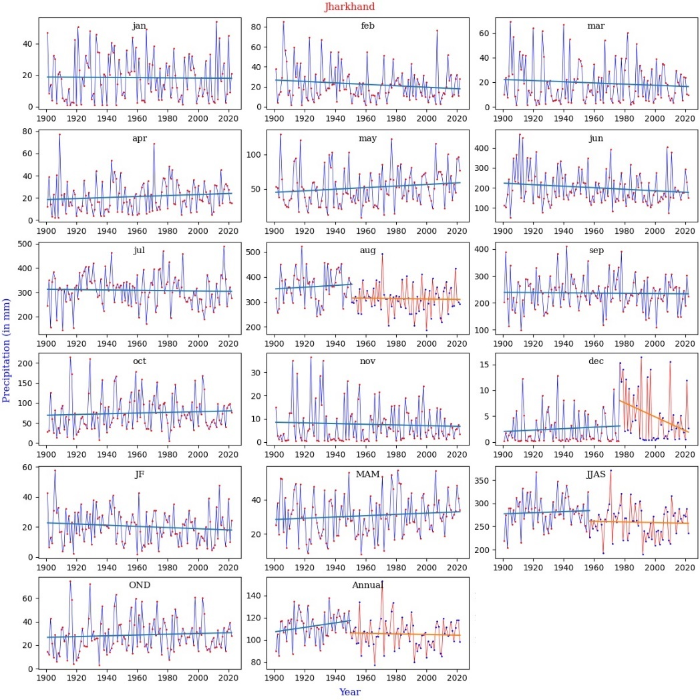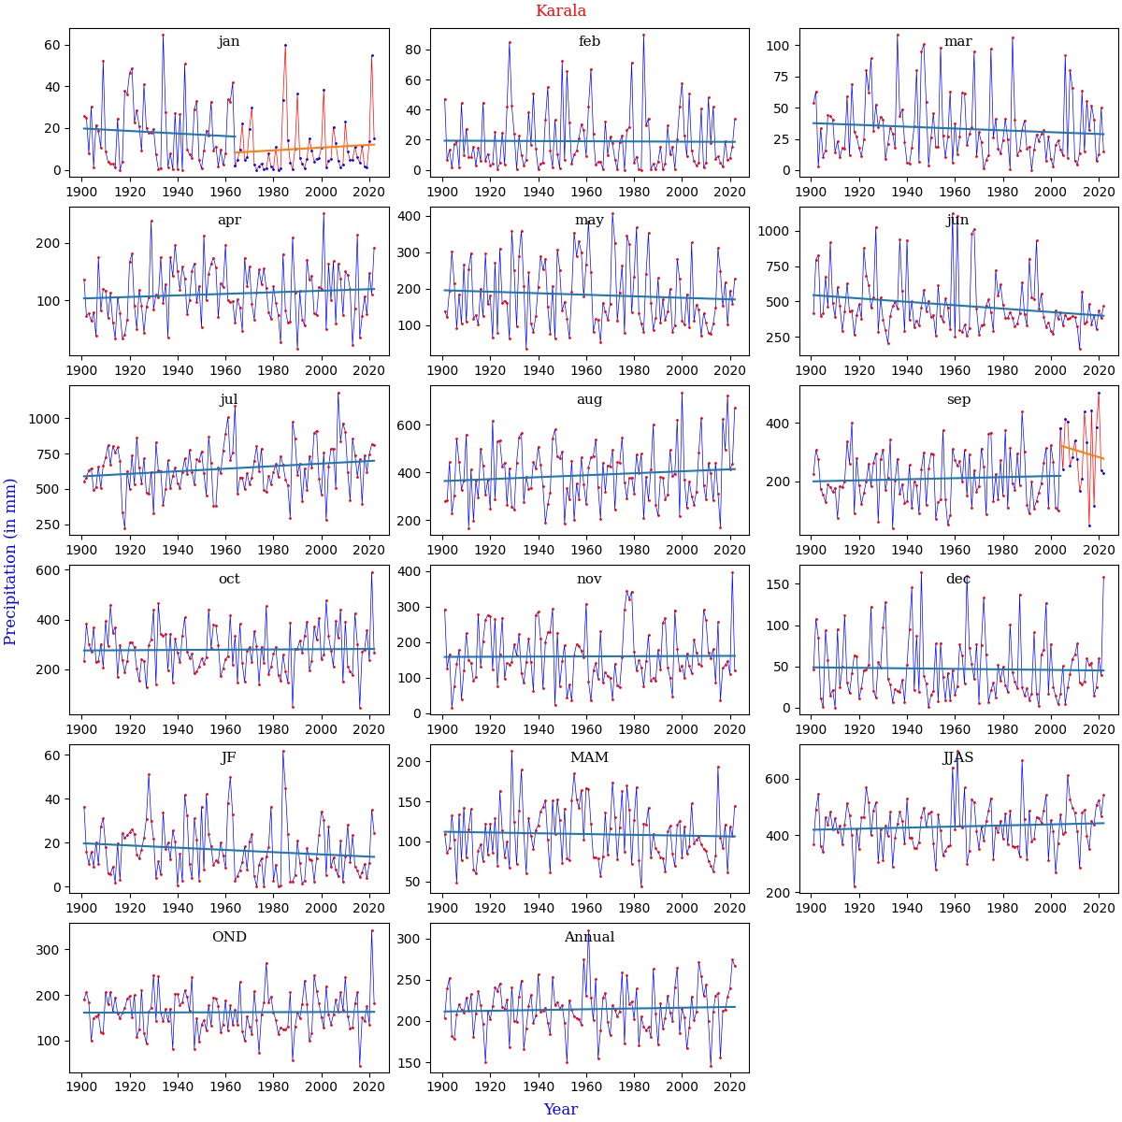
Fig. S1. Continued

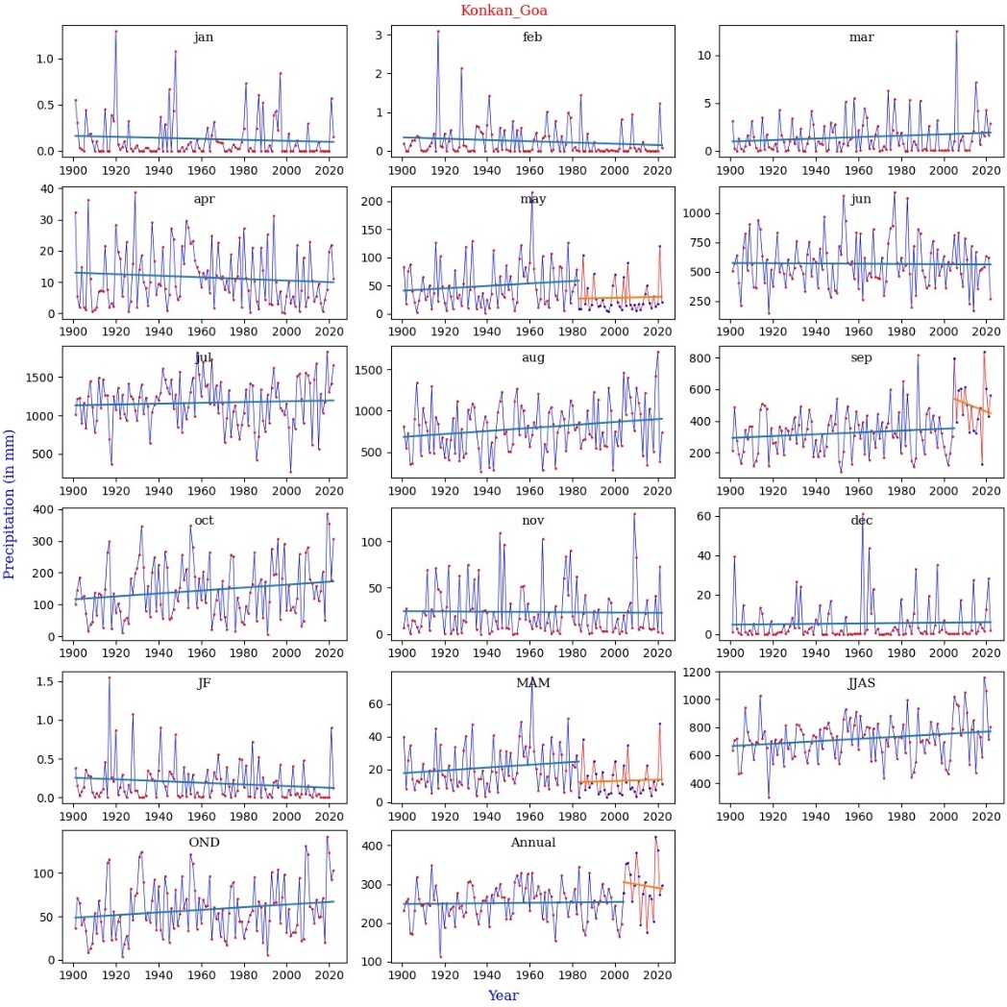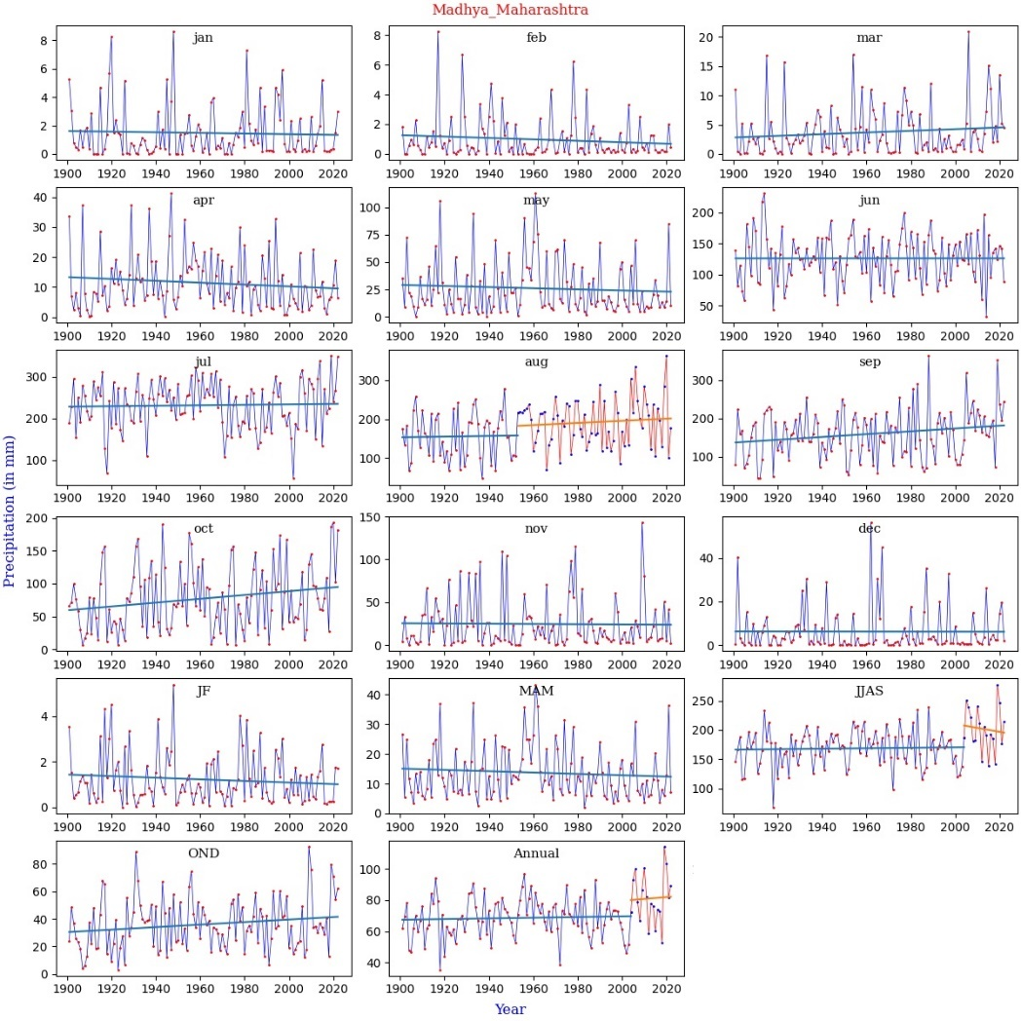
Fig. S1. Continued

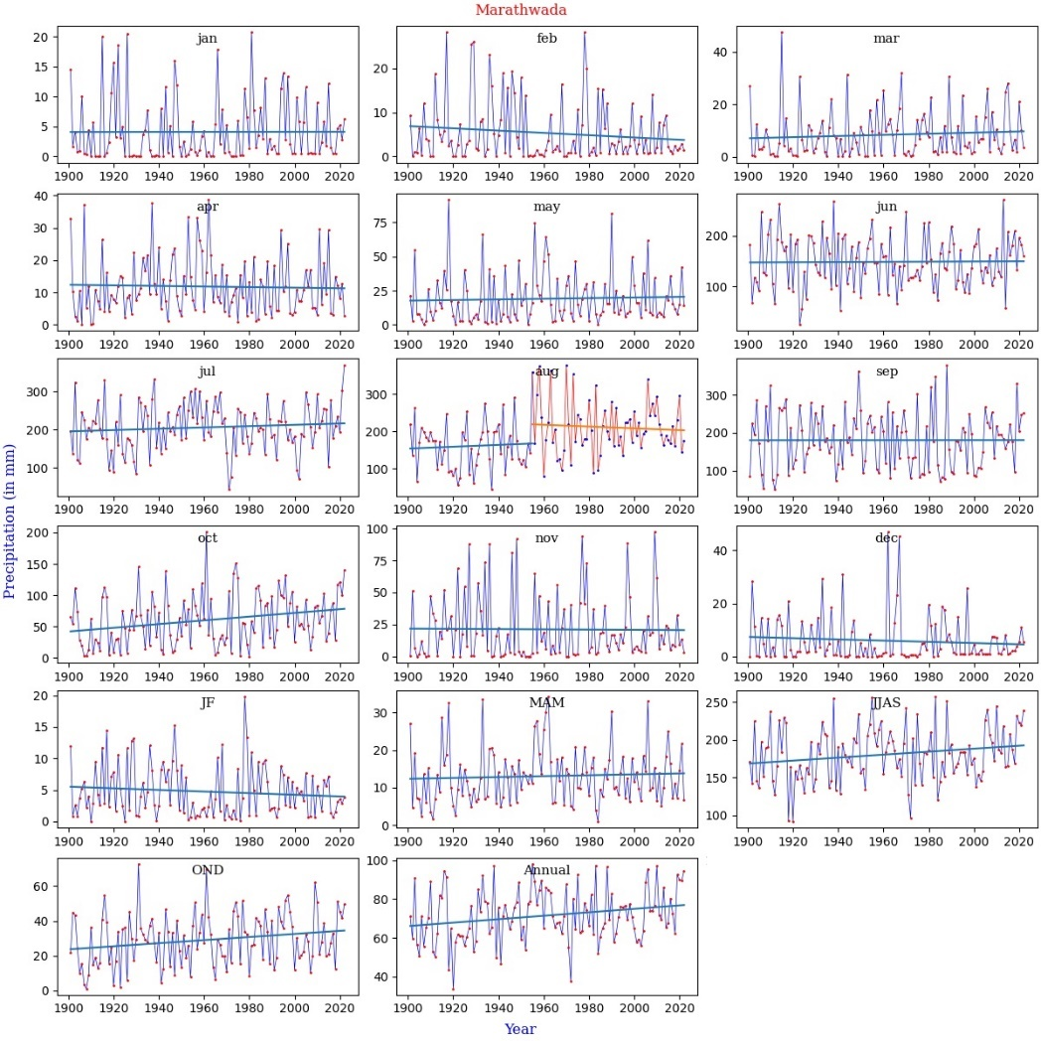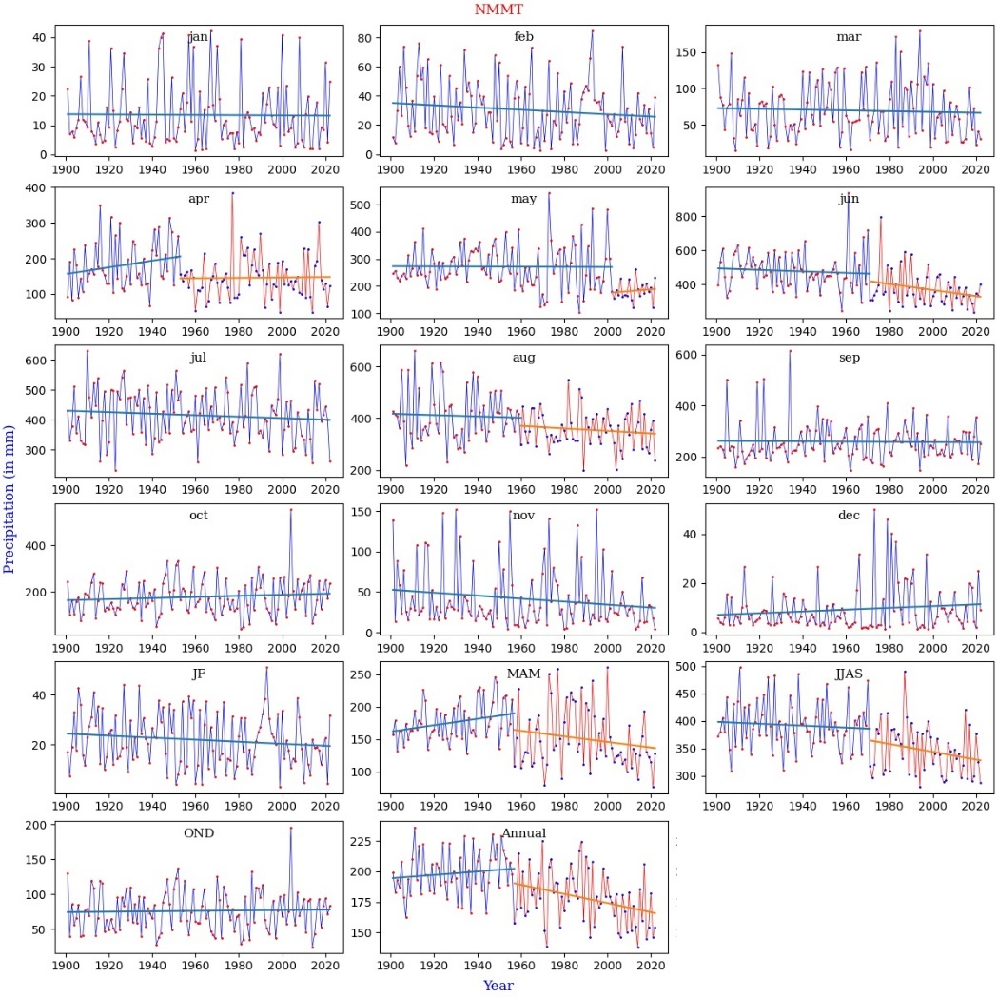
Fig. S1. Continued

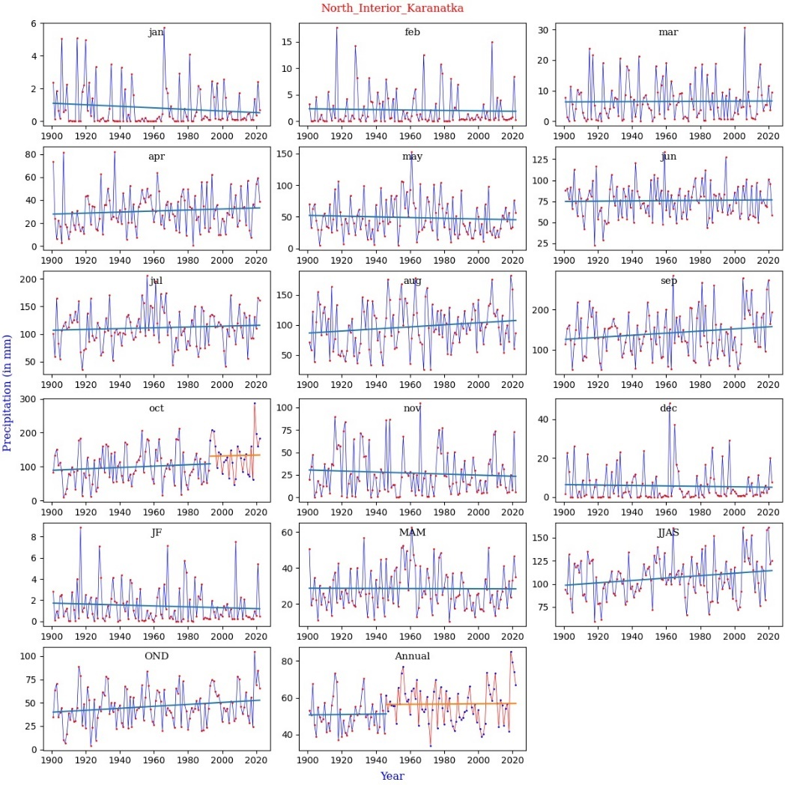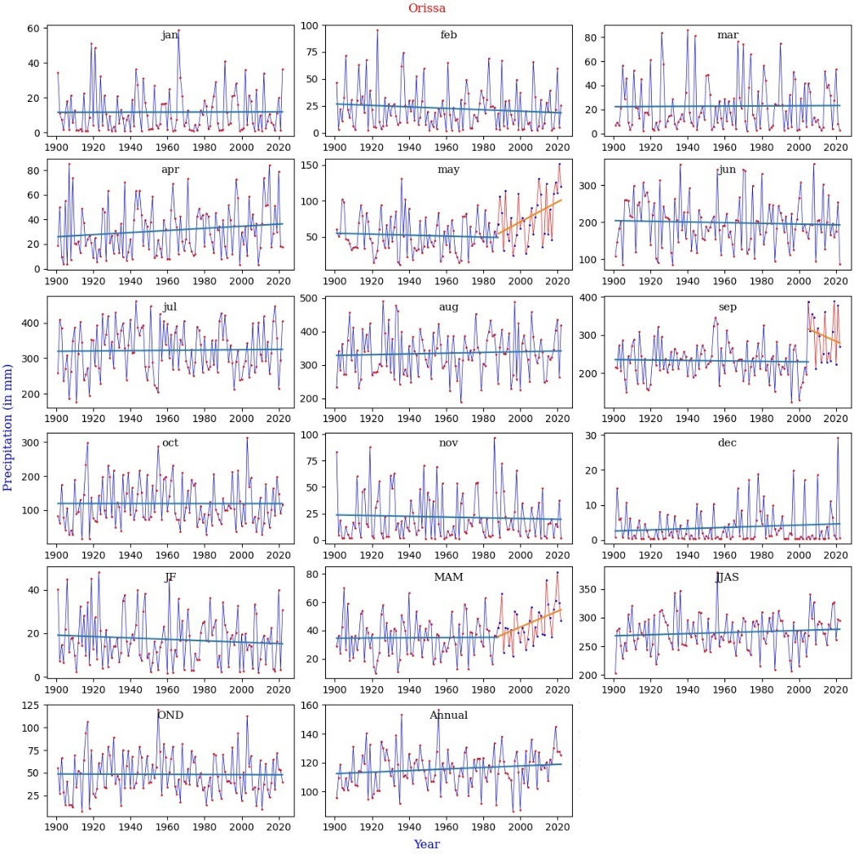
Fig. S1. Continued

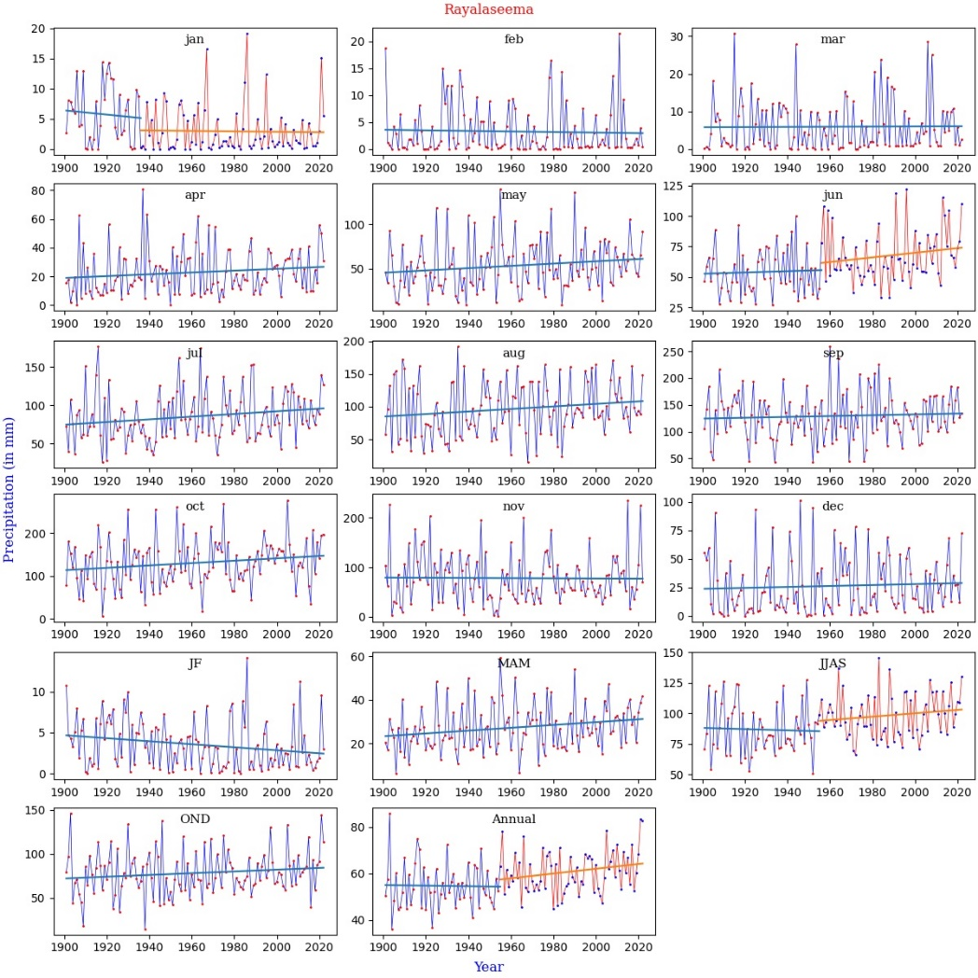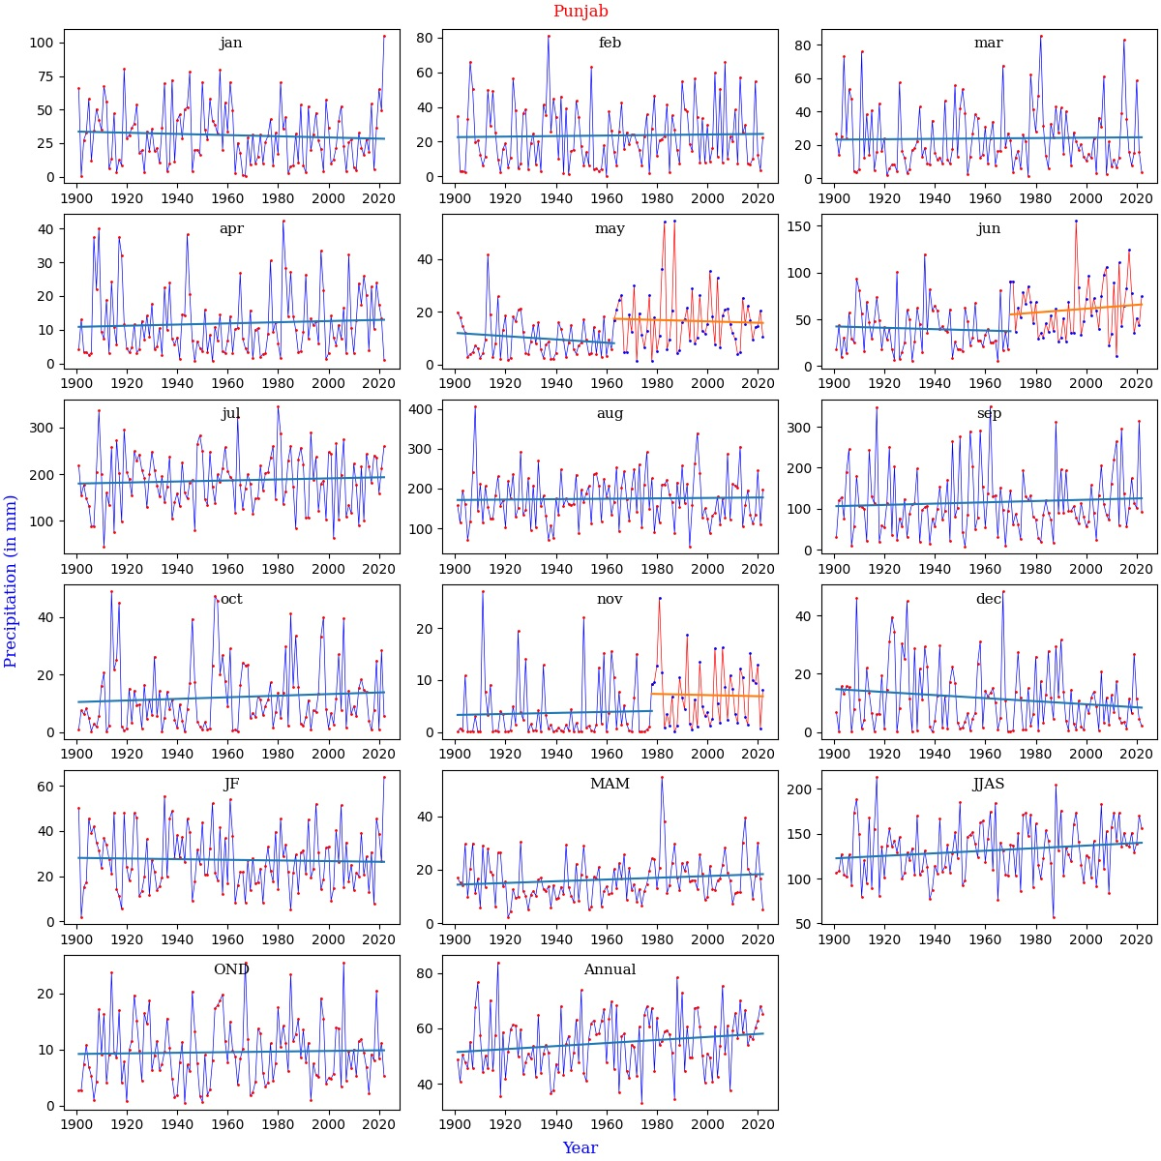
Fig. S1. Continued

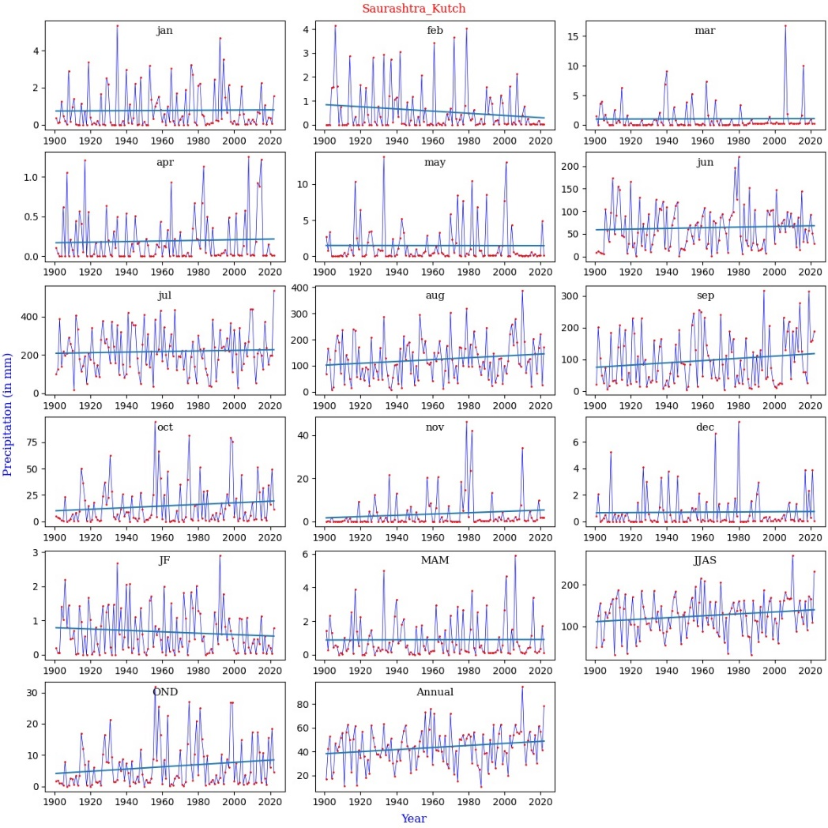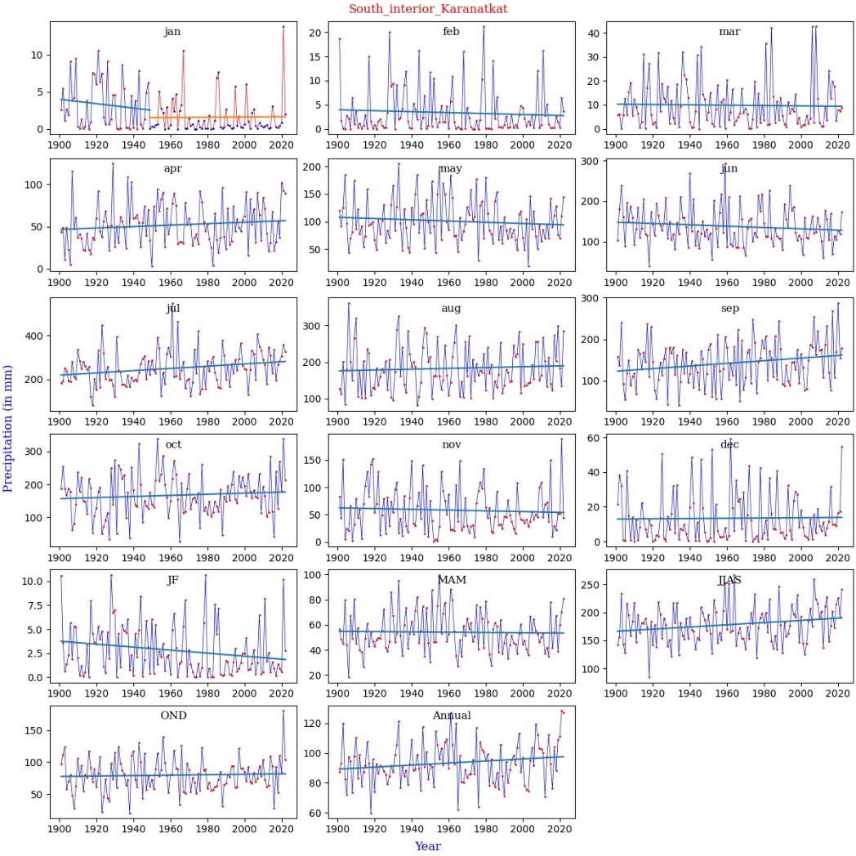
Fig. S1. Continued

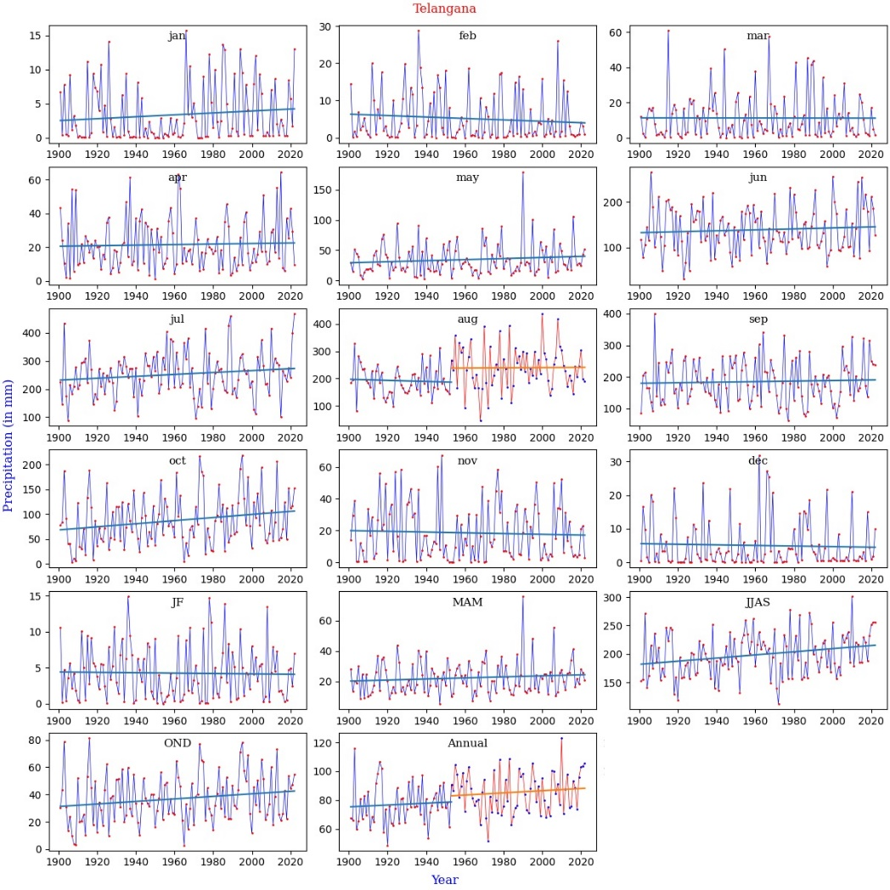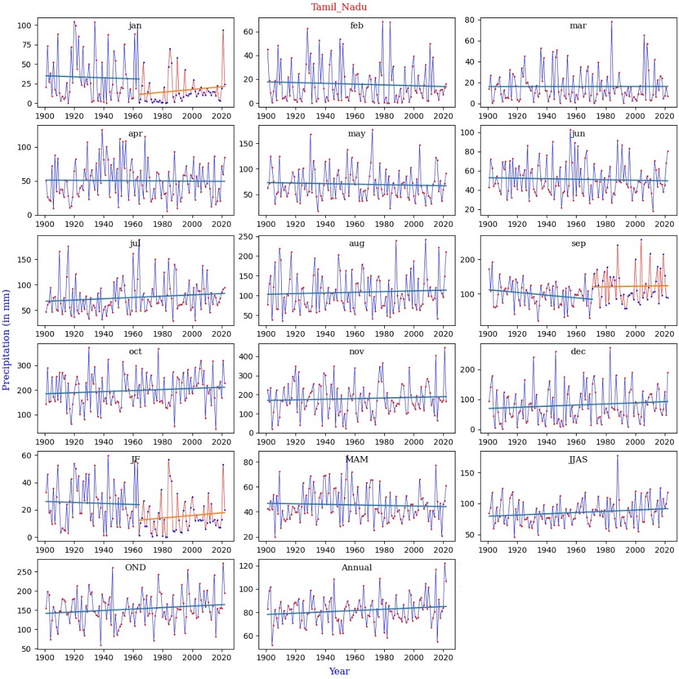
Fig. S1. Continued

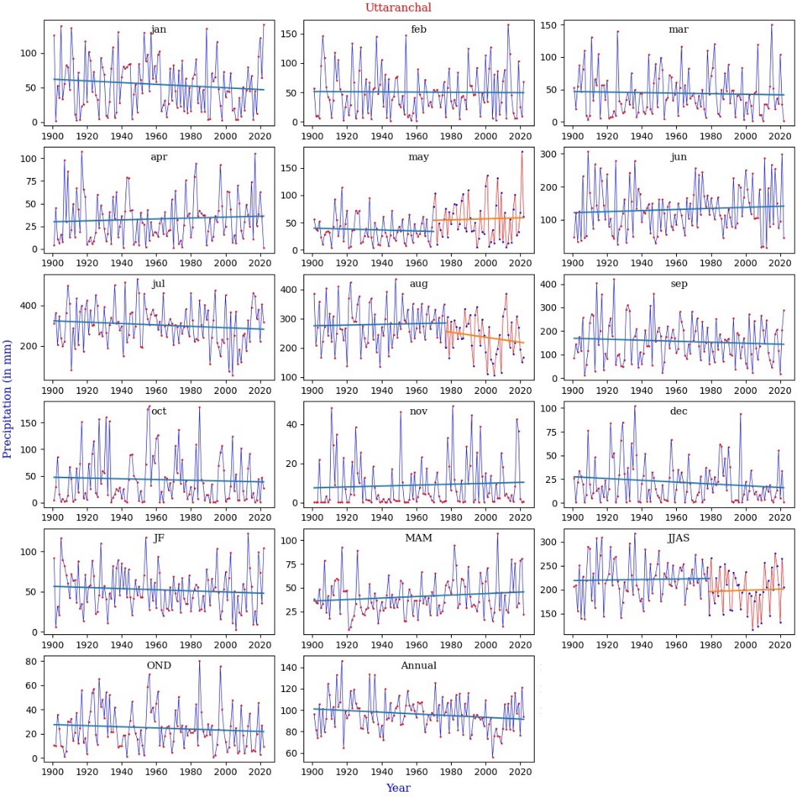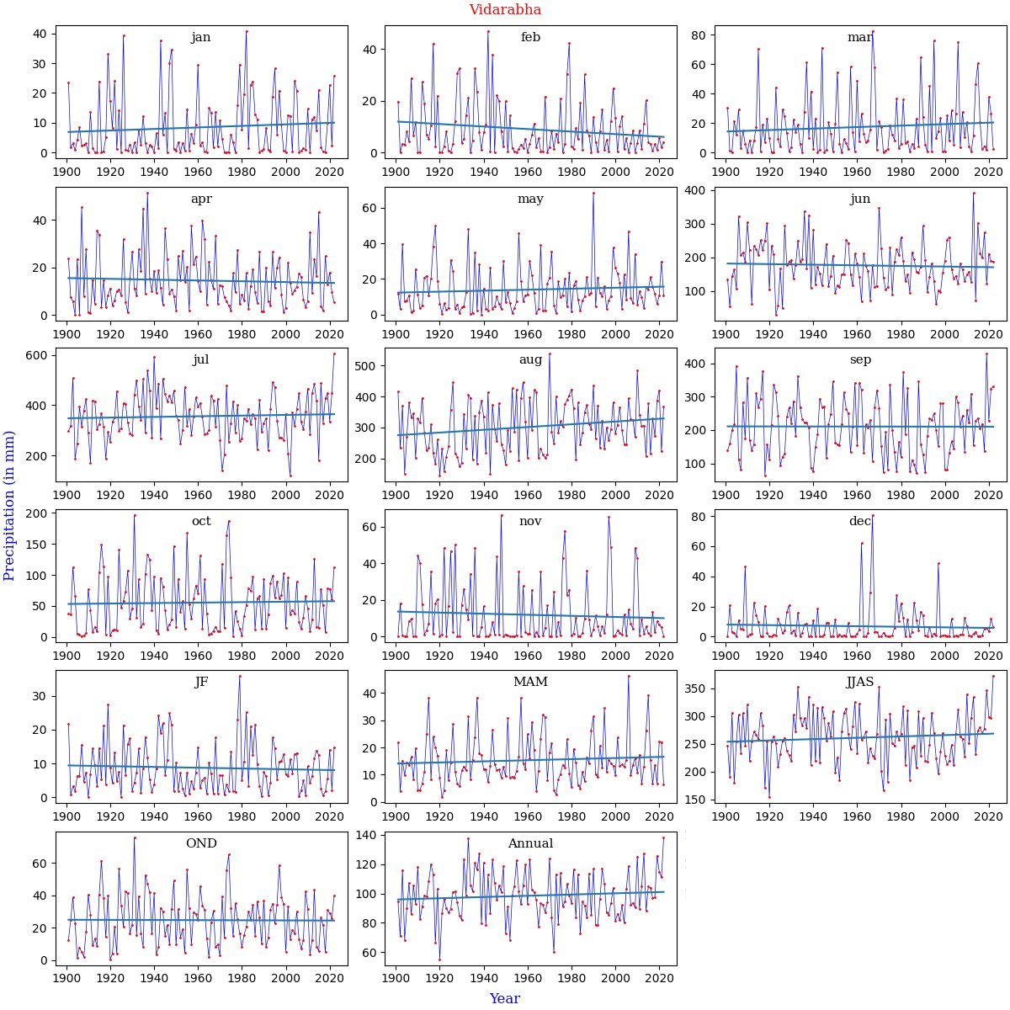
Fig. S1. Continued

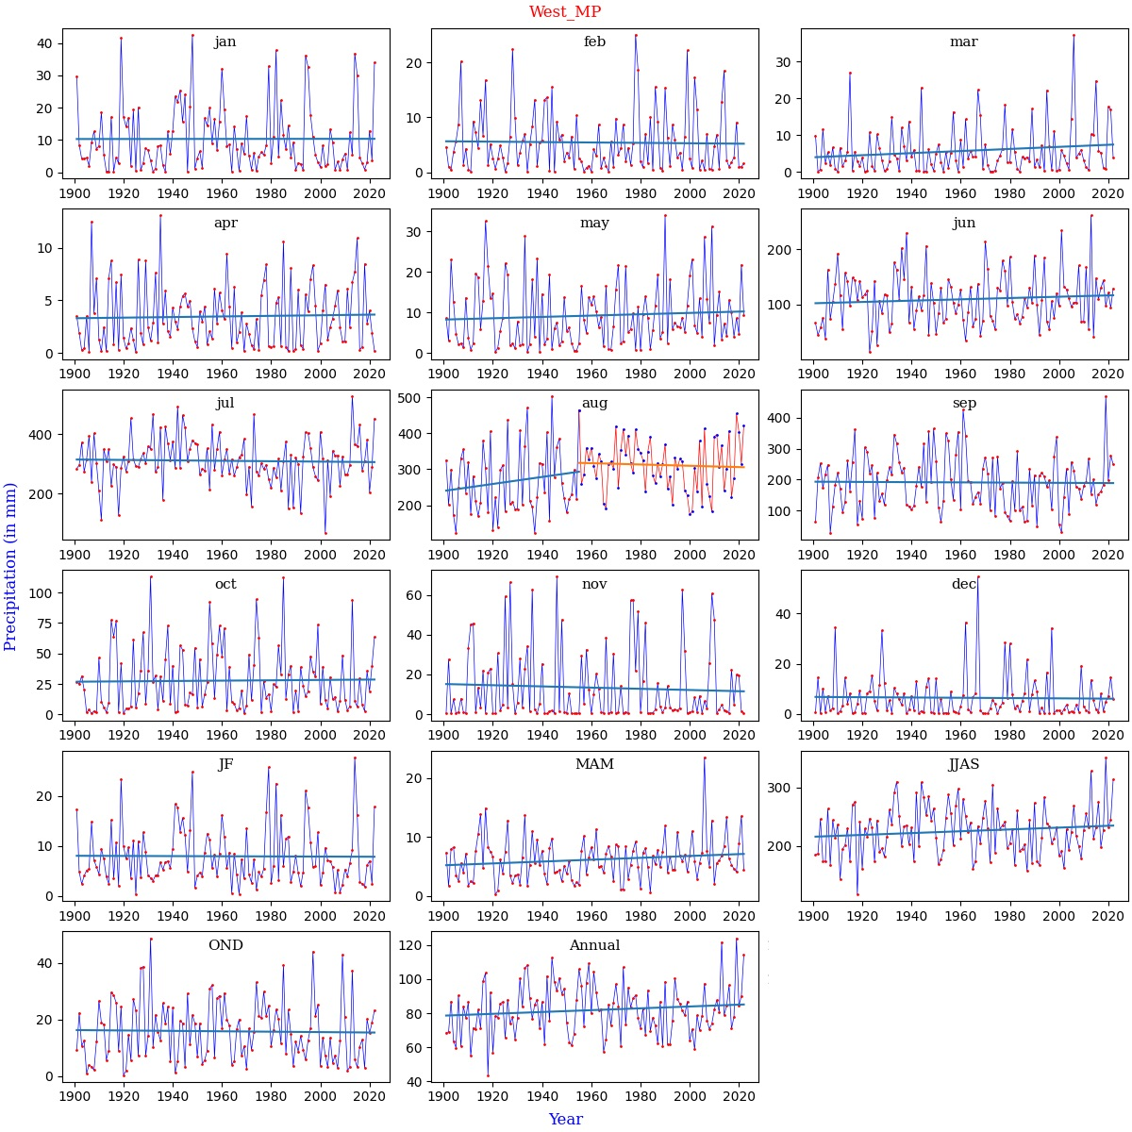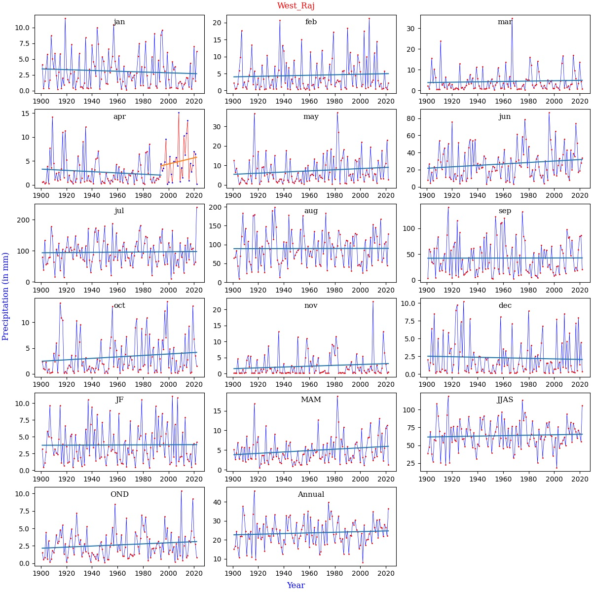
Fig. S1. Continued

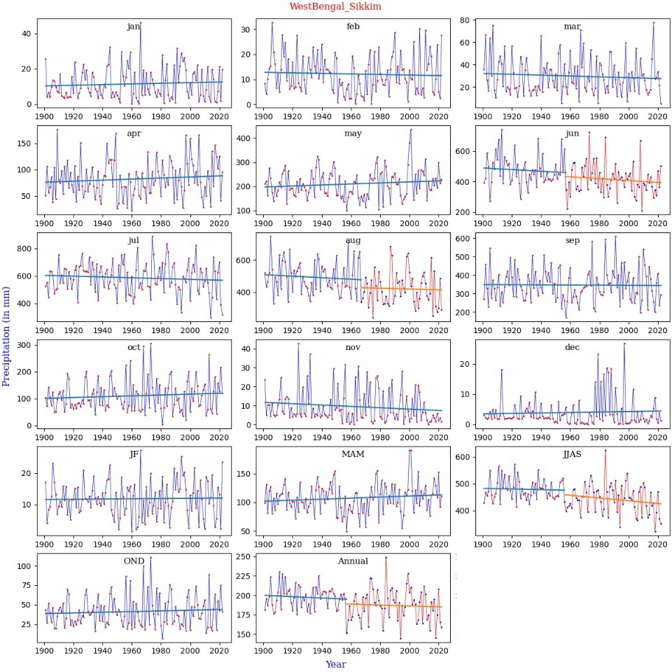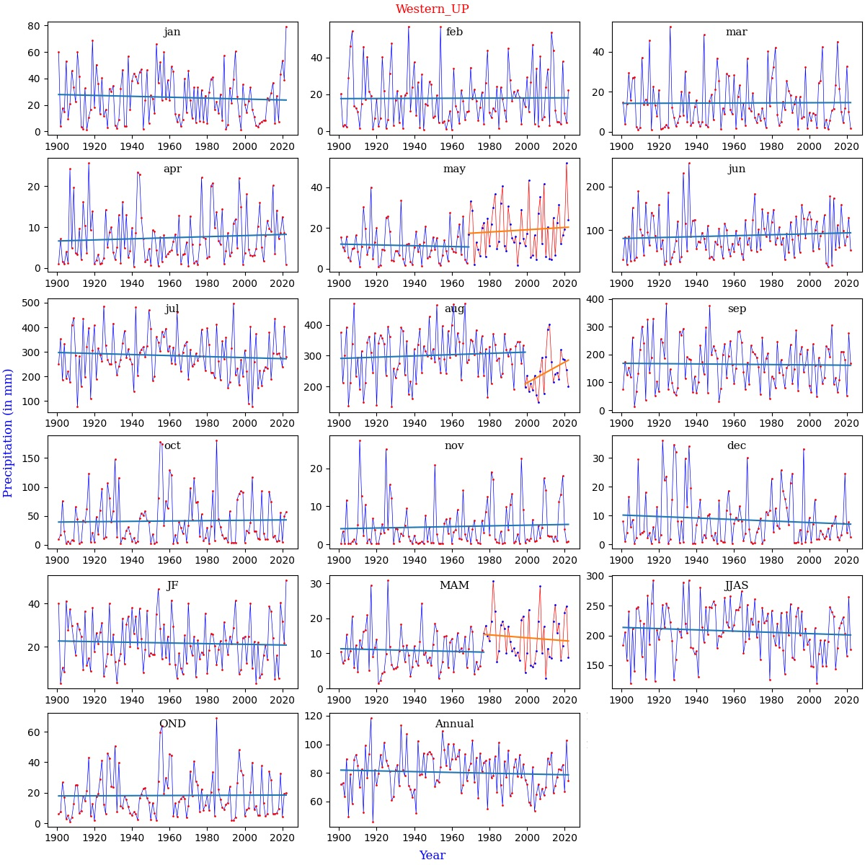
Fig. S1. Continued

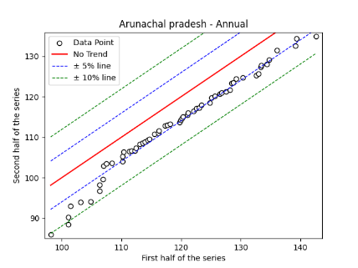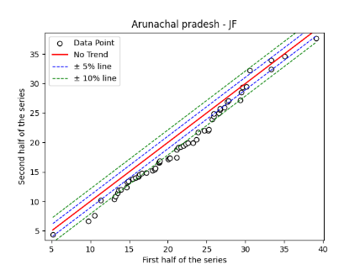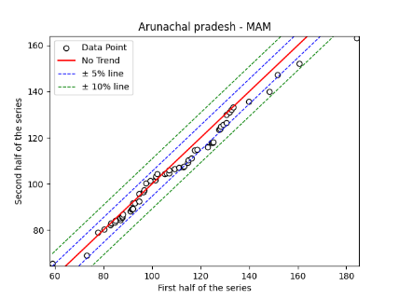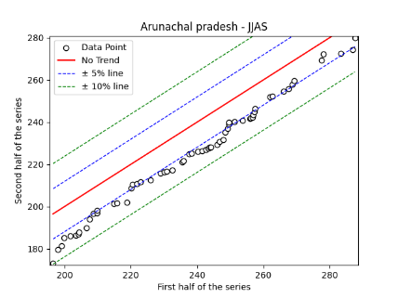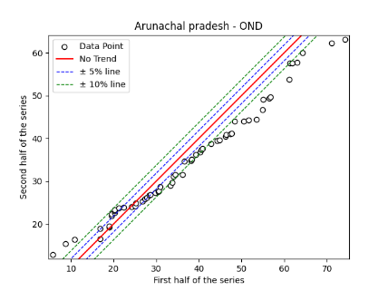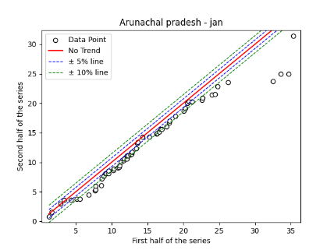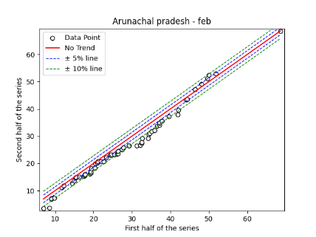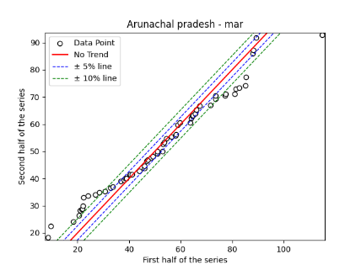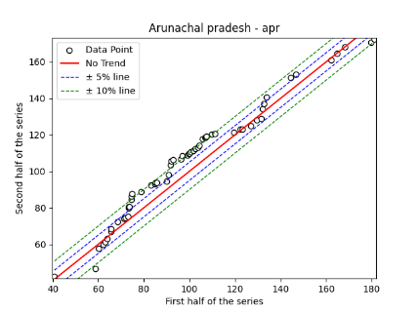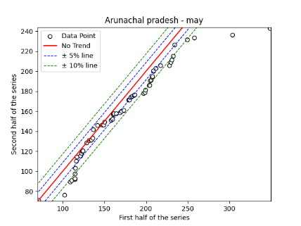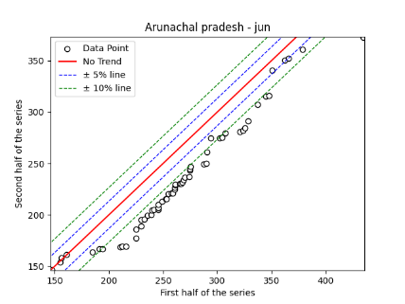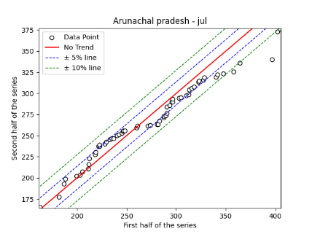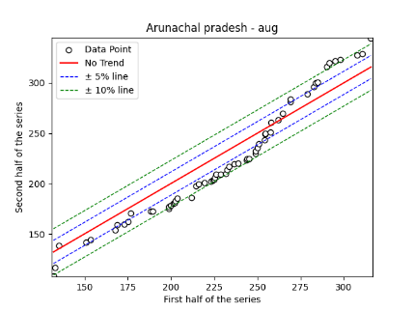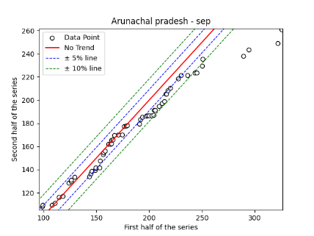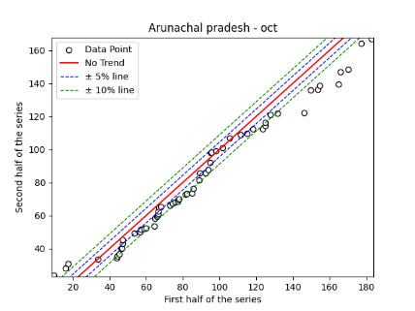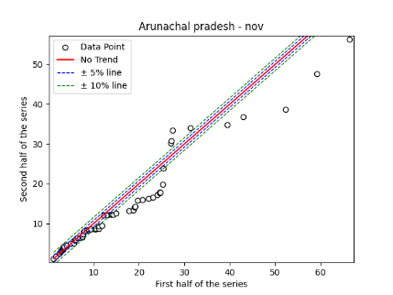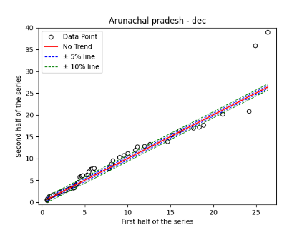
Fig. S2. Annual, Seasonal and Monthly ITA Graphs for Arunachal Pradesh Region

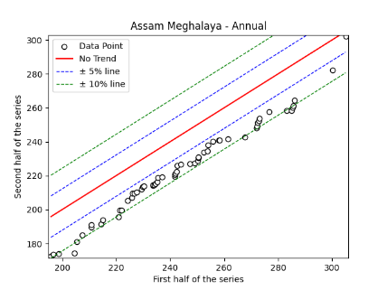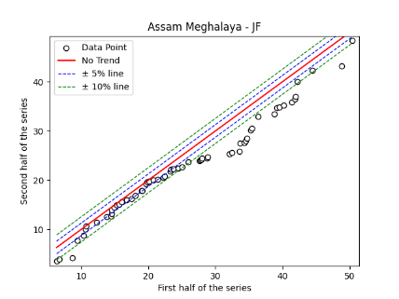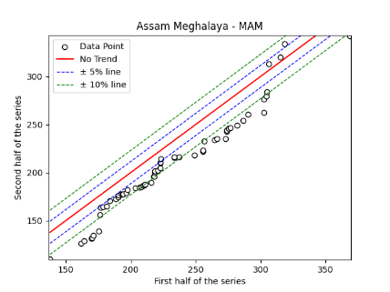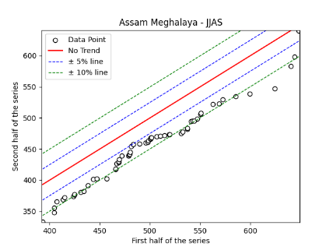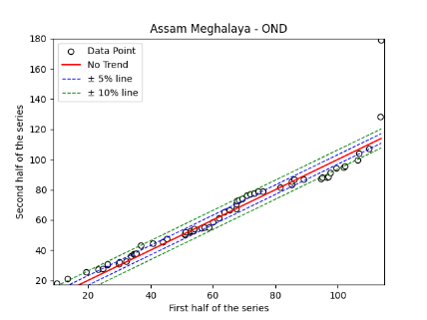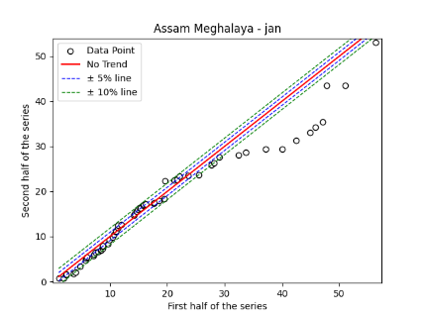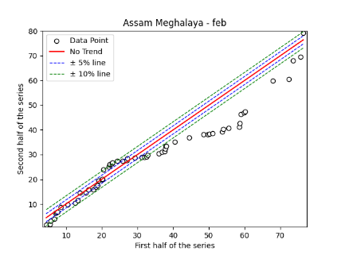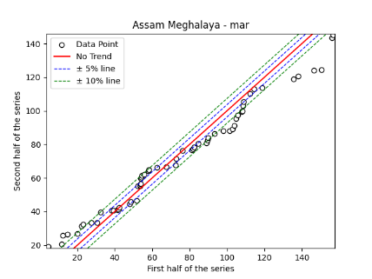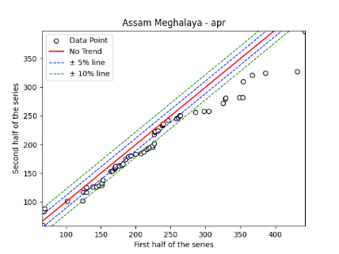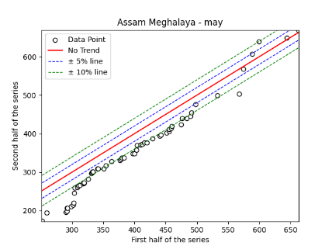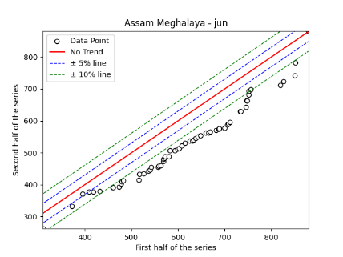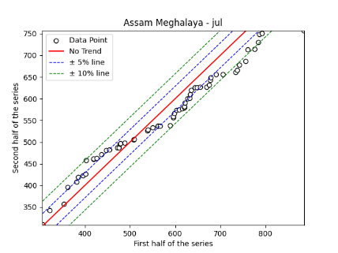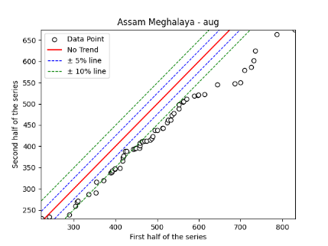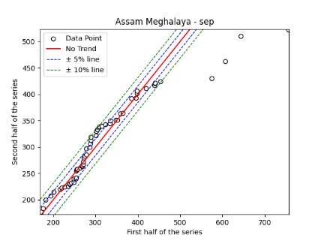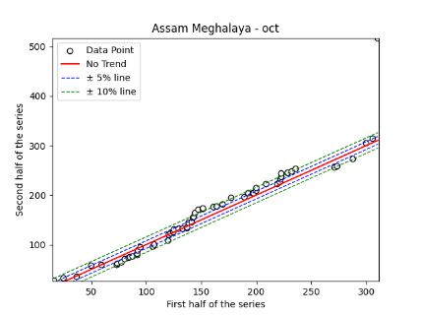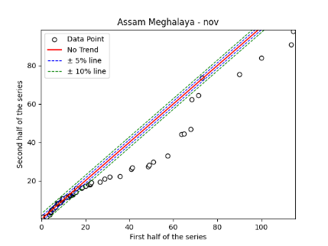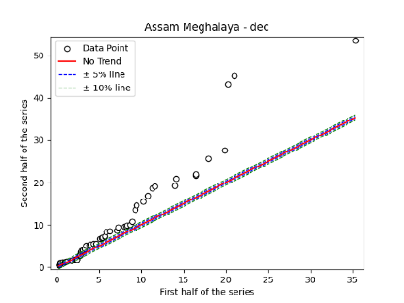
Fig. S3. Annual, Seasonal and Monthly ITA Graphs for Assam Meghalaya Region

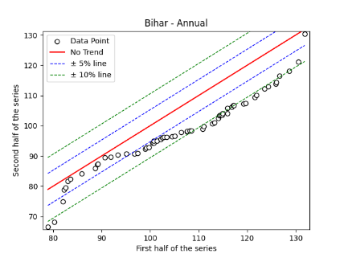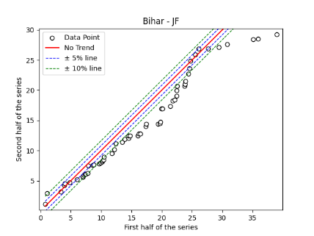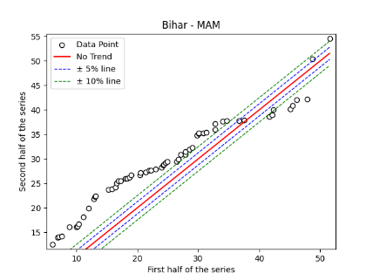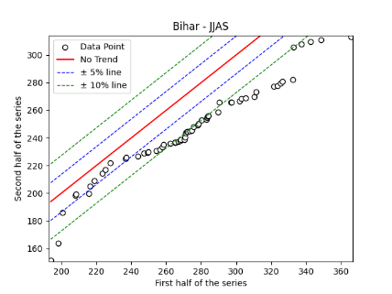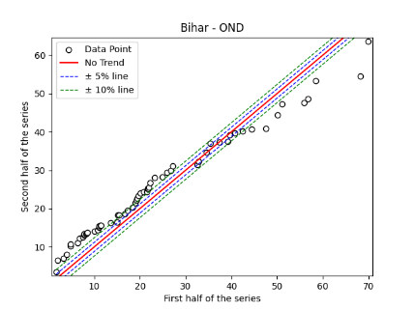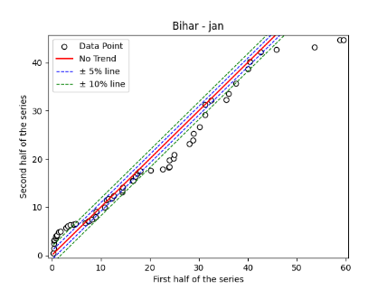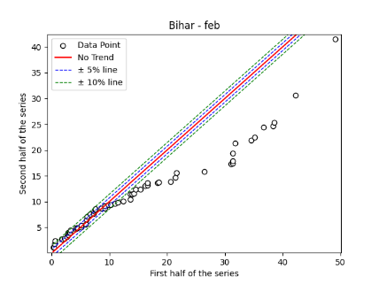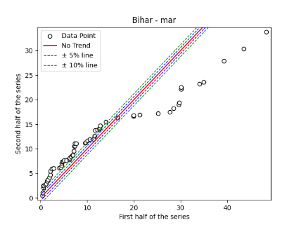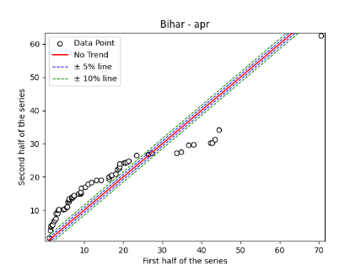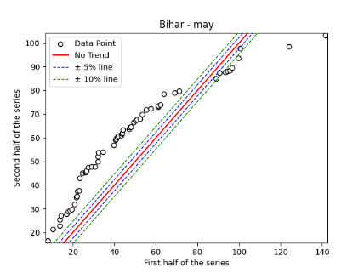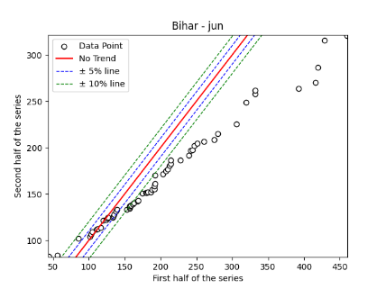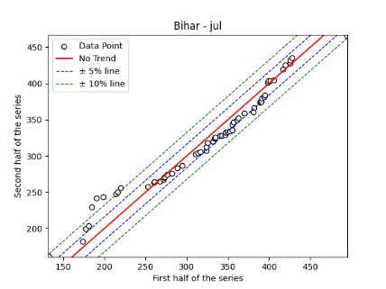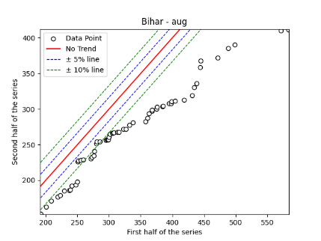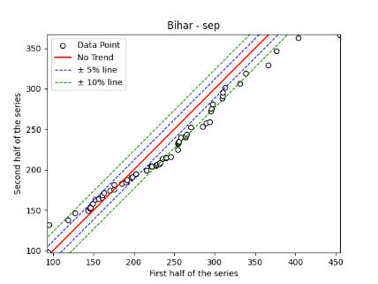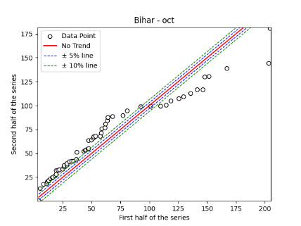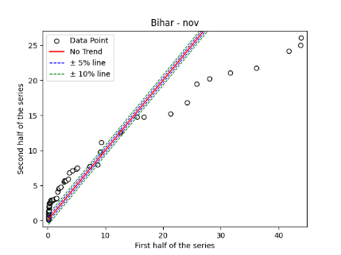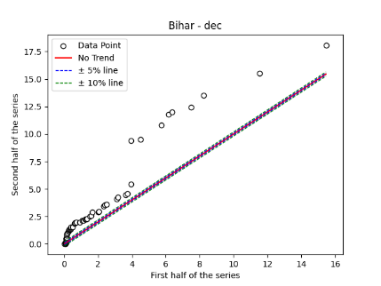
Fig. S4. Annual, Seasonal and Monthly ITA Graphs for Bihar Region

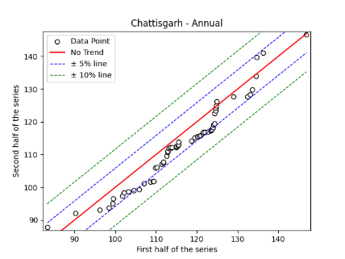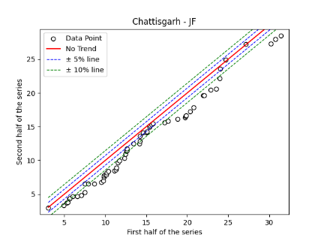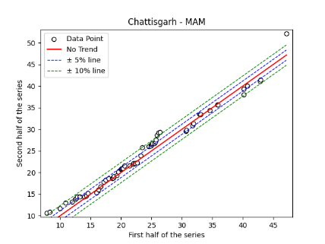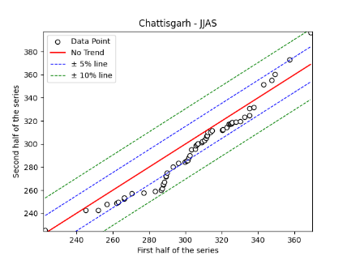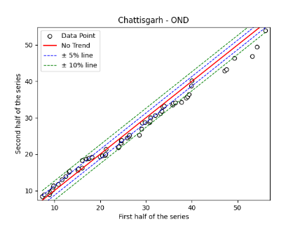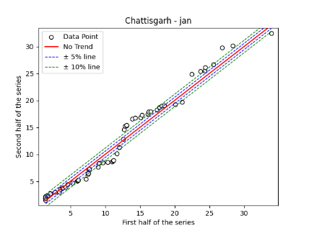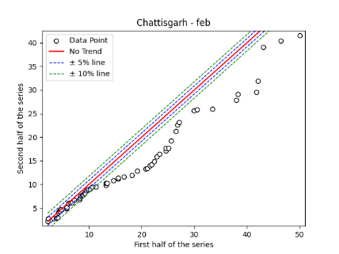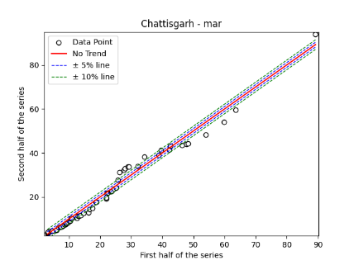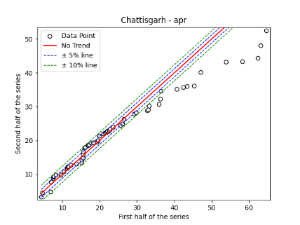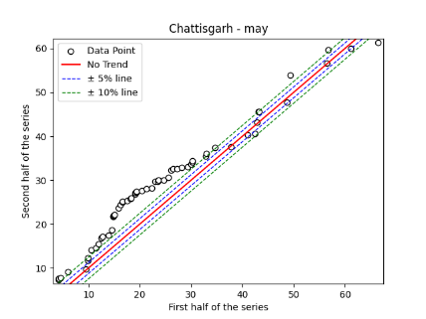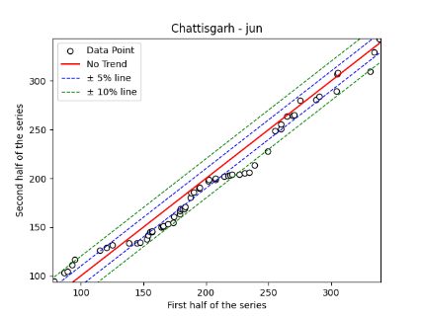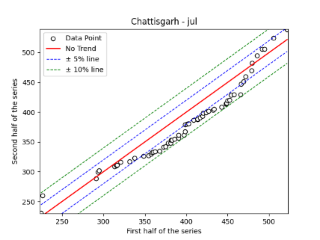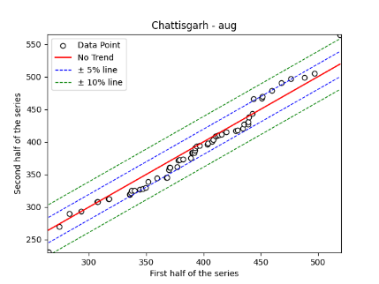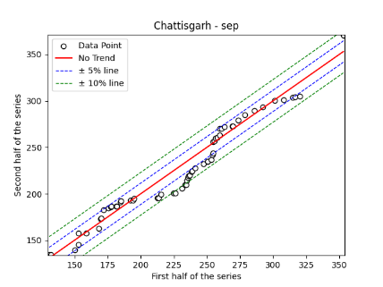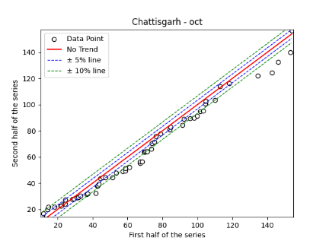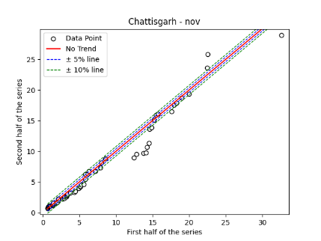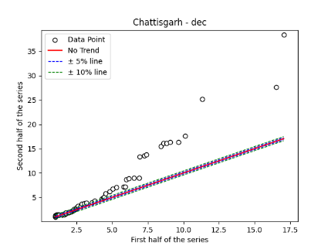

Fig. S5. Annual, Seasonal and Monthly ITA Graphs for Chhattisgarh Region

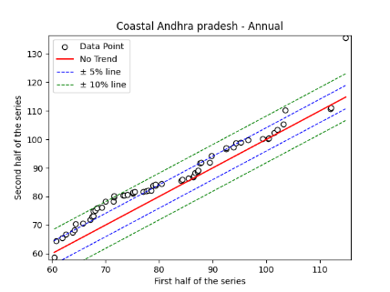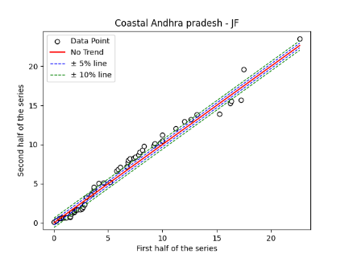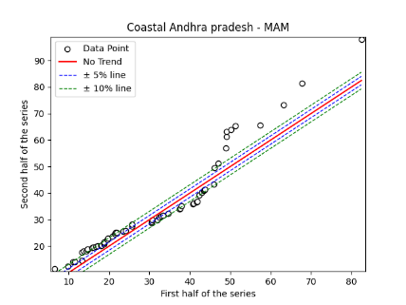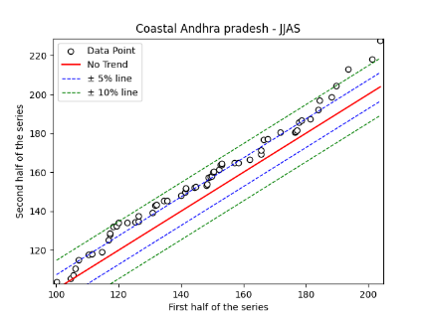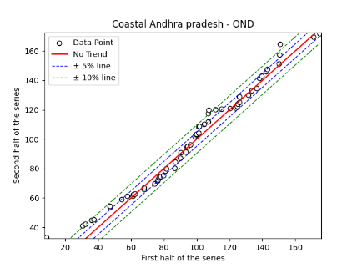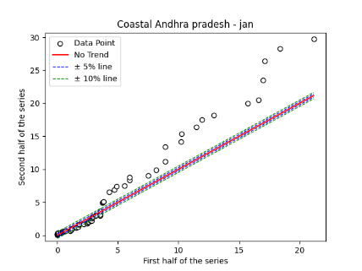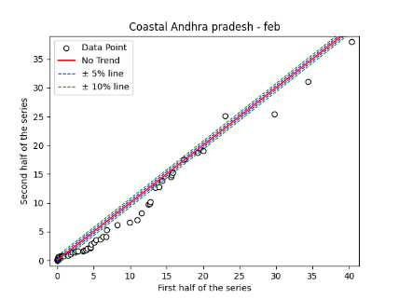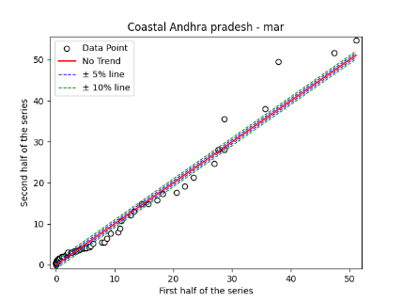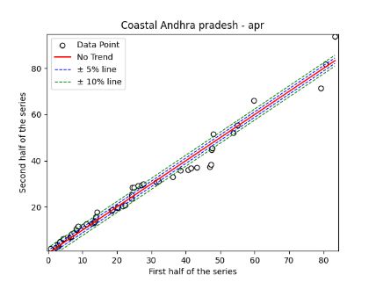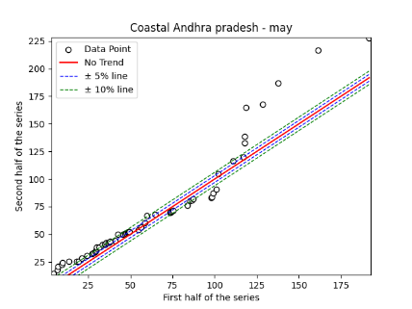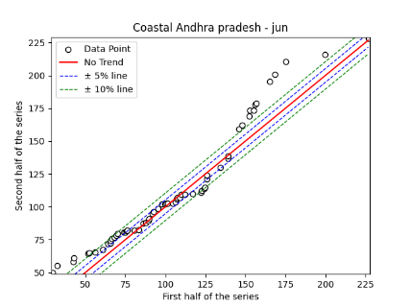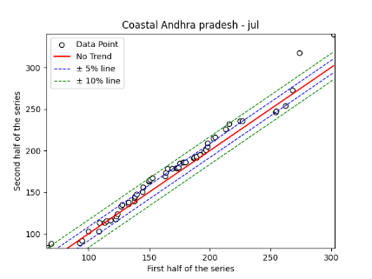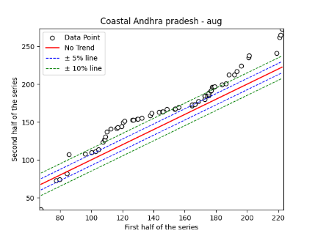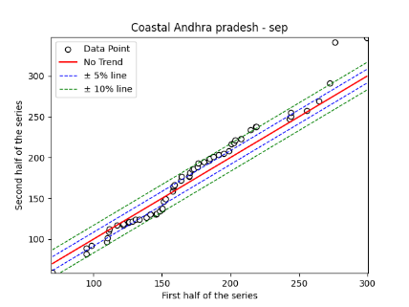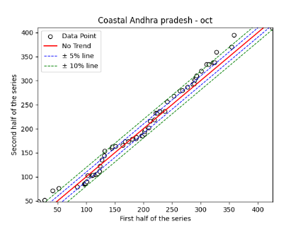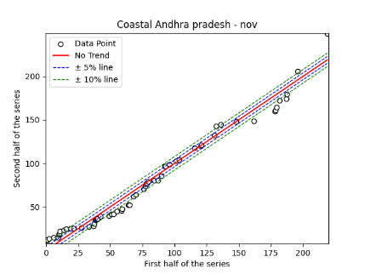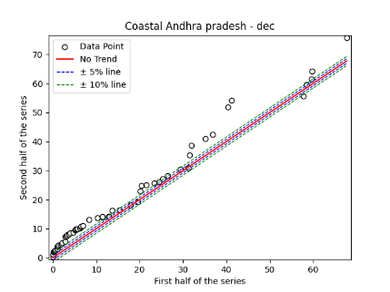

Fig. S6. Annual, Seasonal and Monthly ITA Graphs for Coastal Andhra Pradesh Region

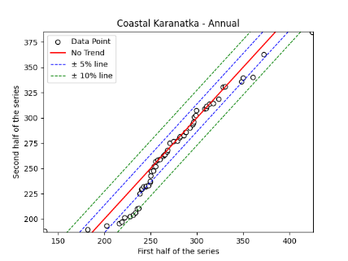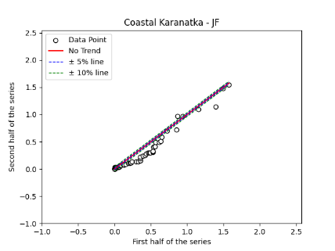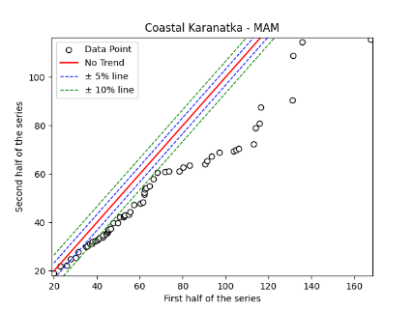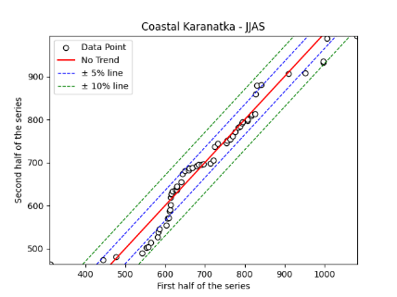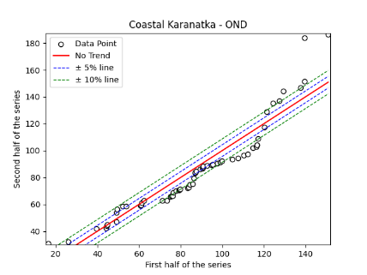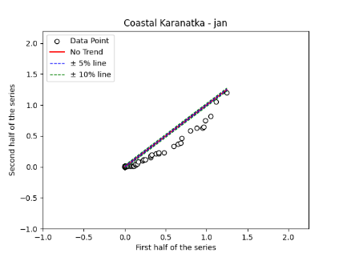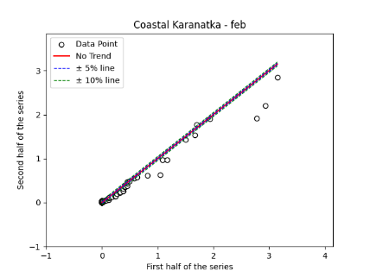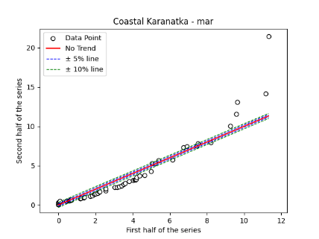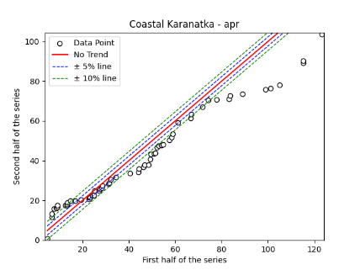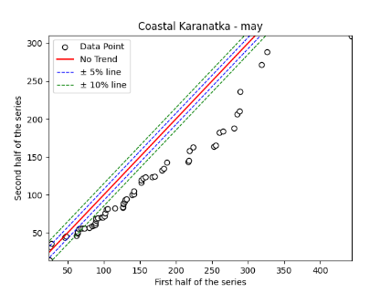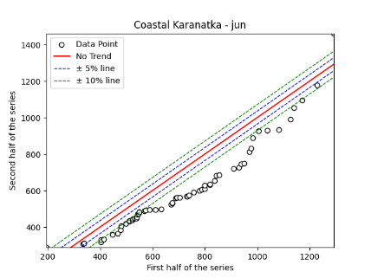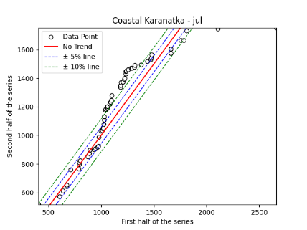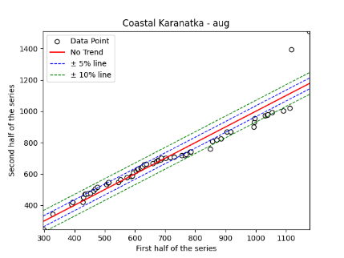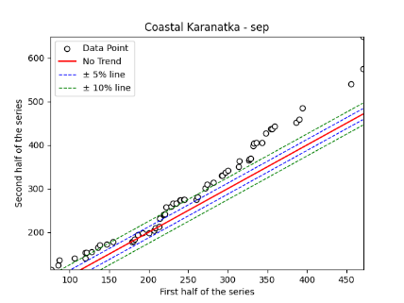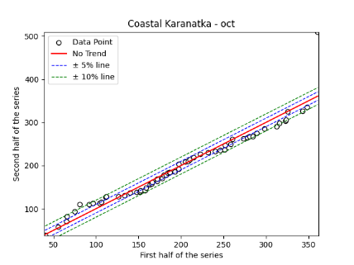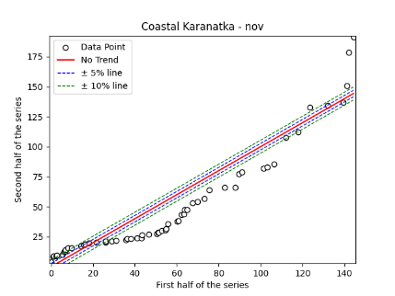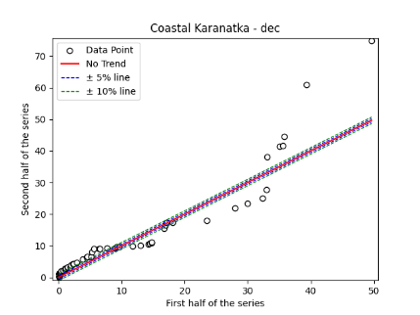

Fig. S7. Annual, Seasonal and Monthly ITA Graphs for Coastal Karnataka Region

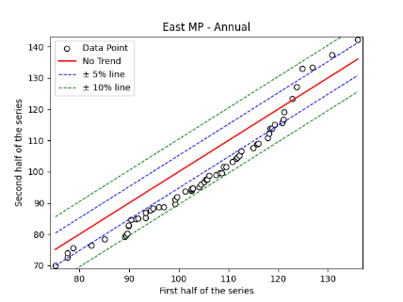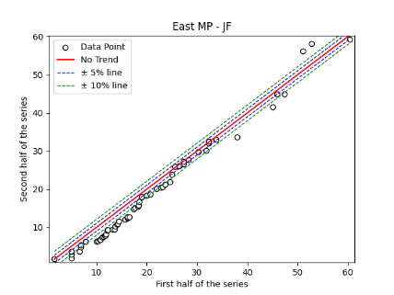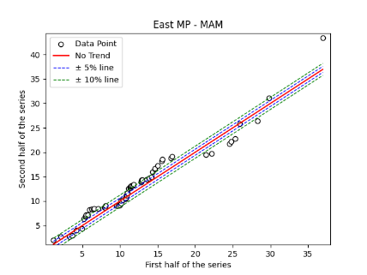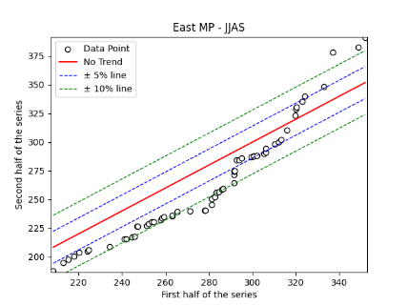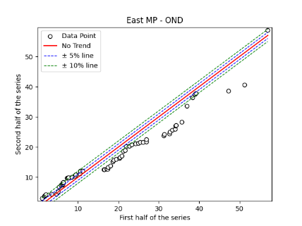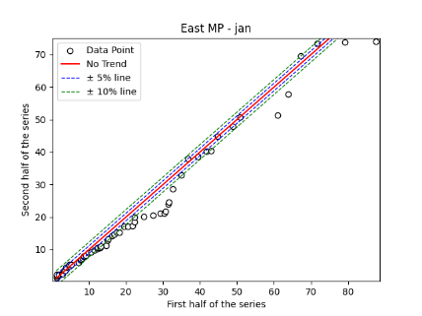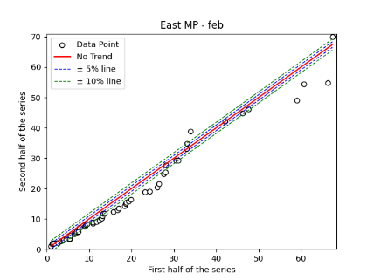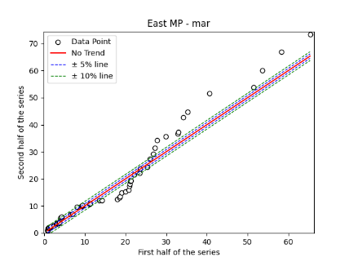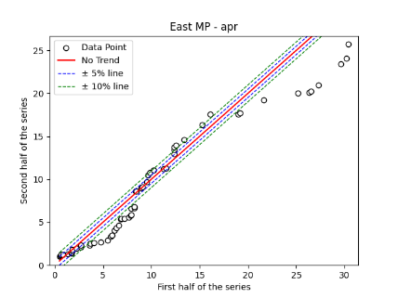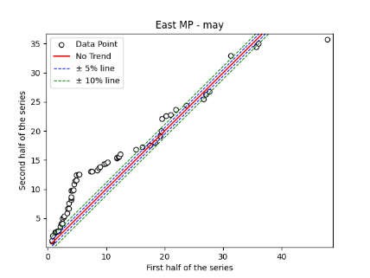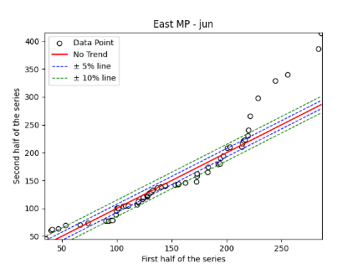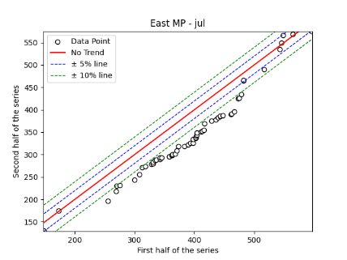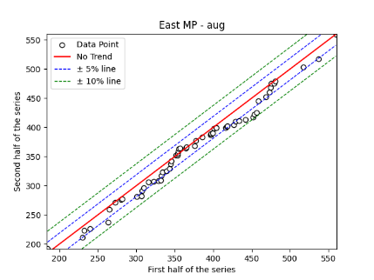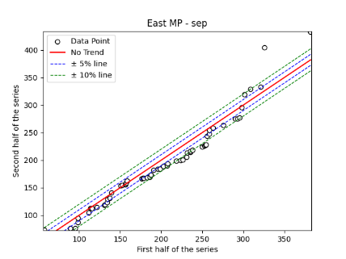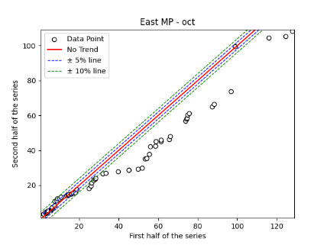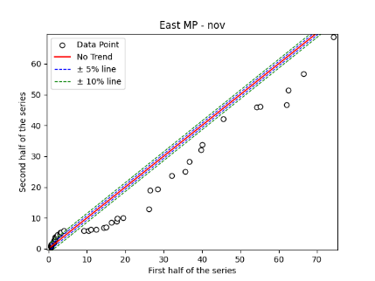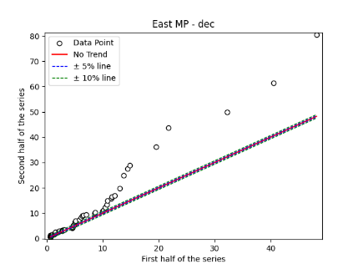
Fig. S8. Annual, Seasonal and Monthly ITA Graphs for Eastern Madhya Pradesh Region

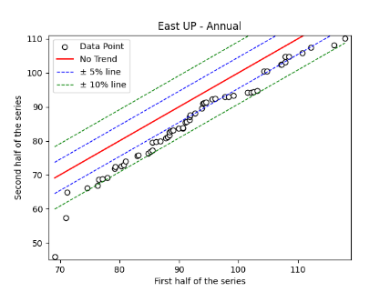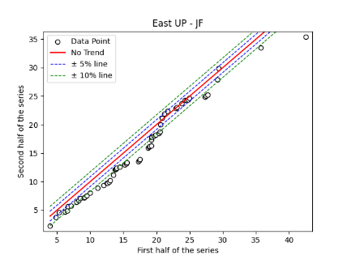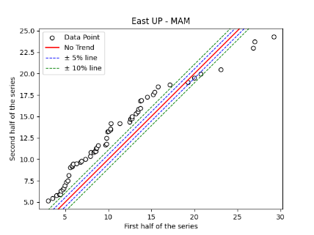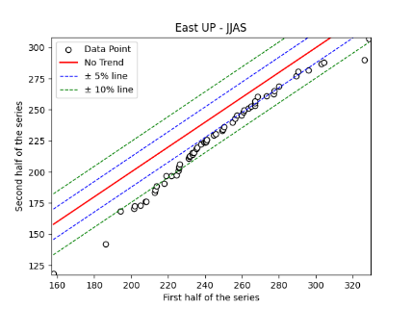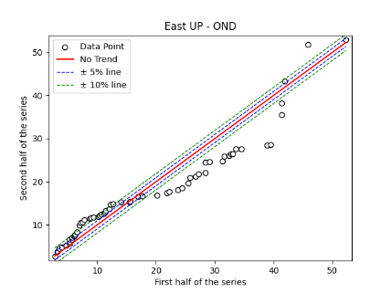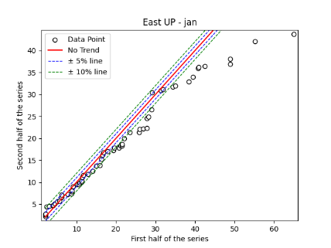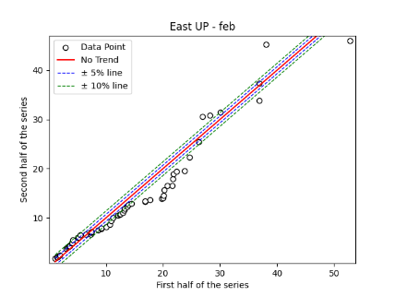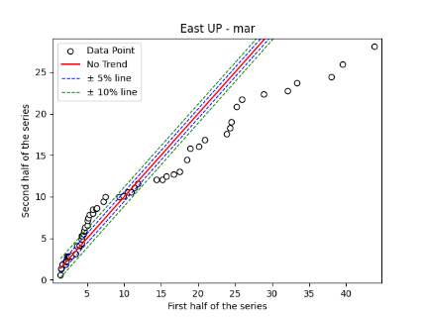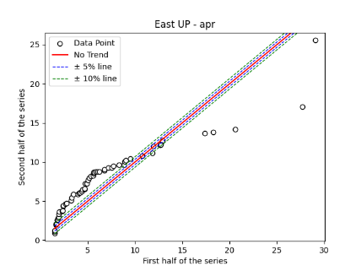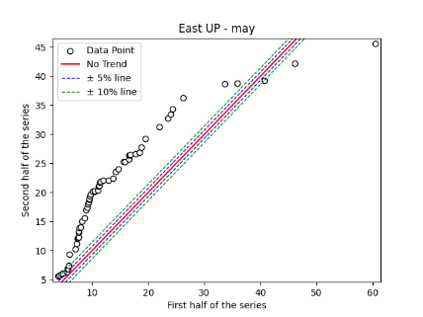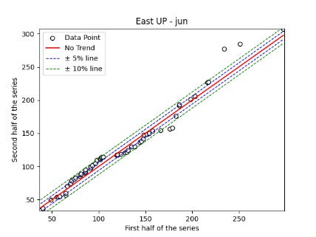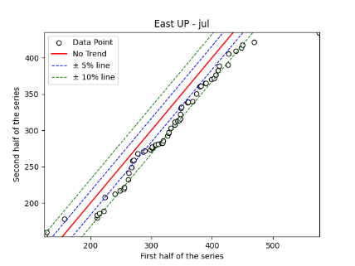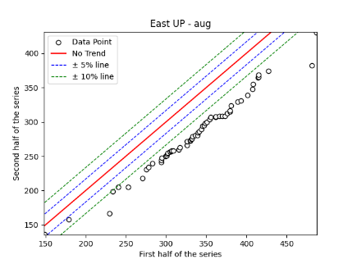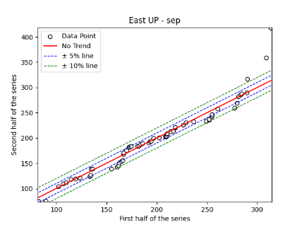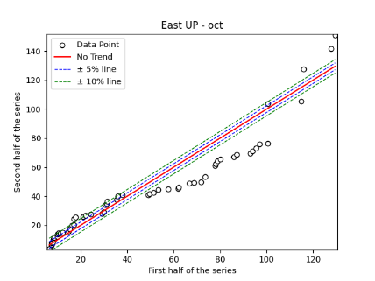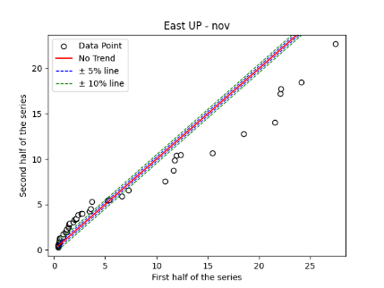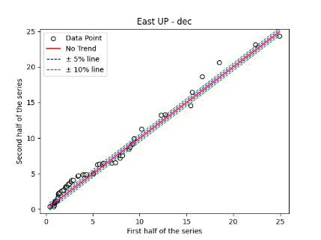

Fig. S9. Annual, Seasonal and Monthly ITA Graphs for Eastern Uttar Pradesh Region

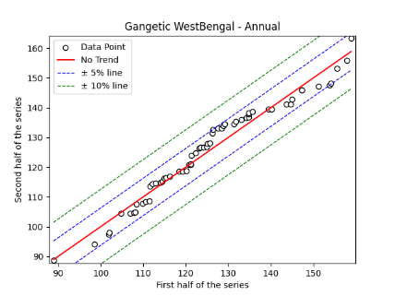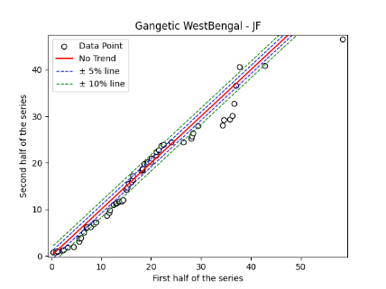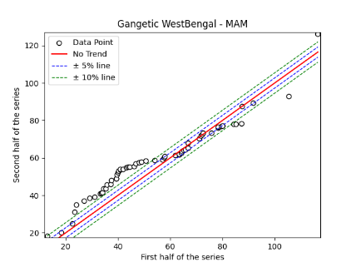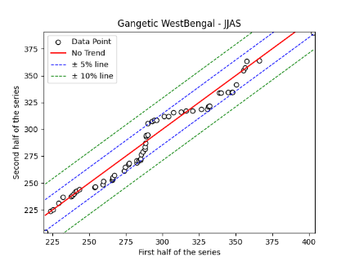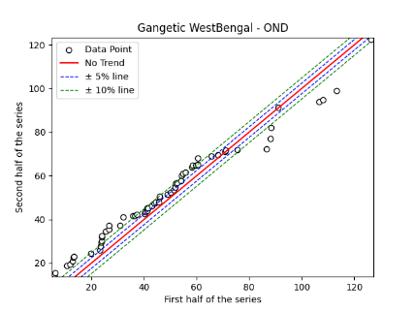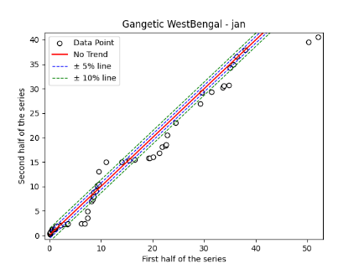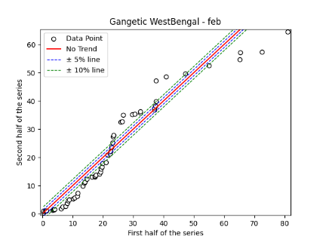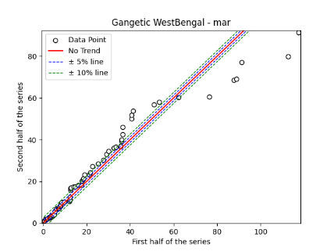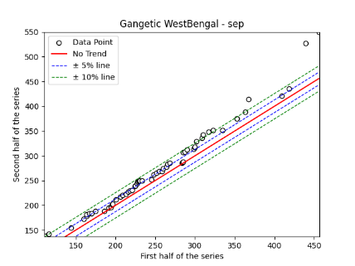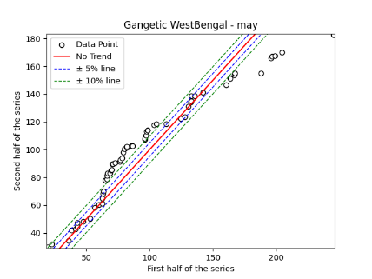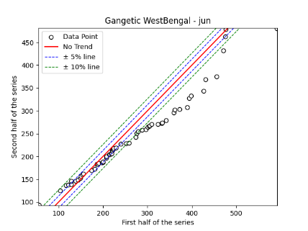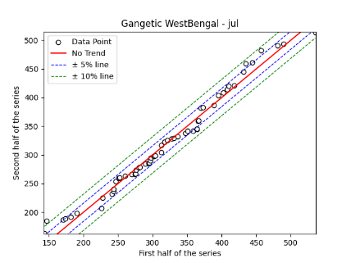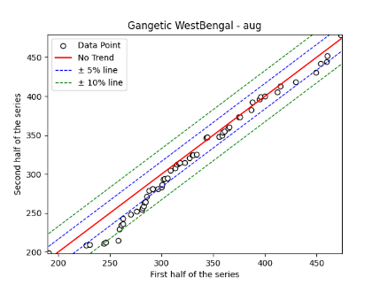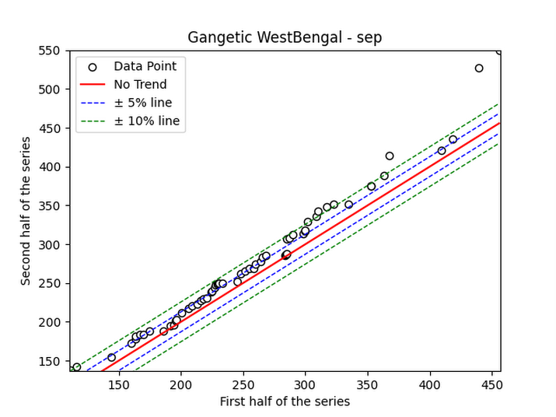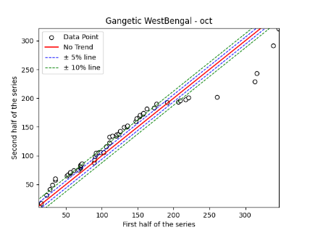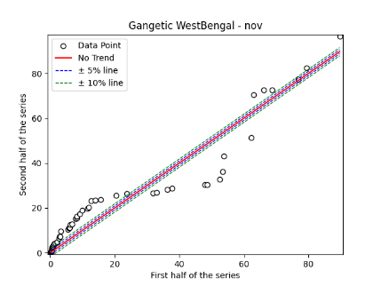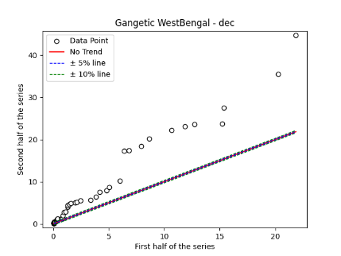

Fig. S10. Annual, Seasonal and Monthly ITA Graphs for Gangetic West Bengal Region

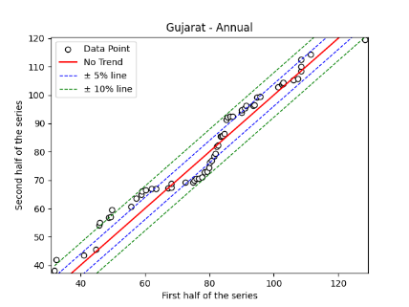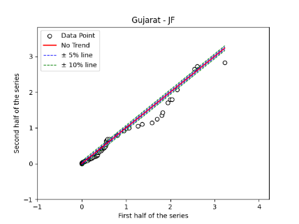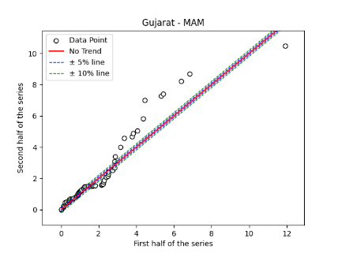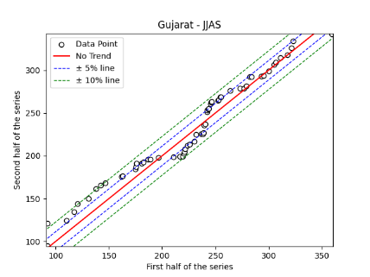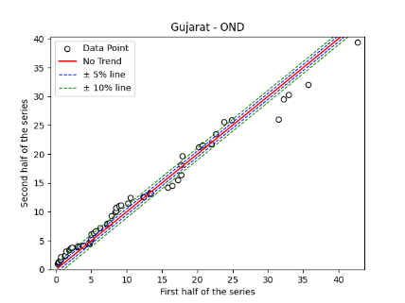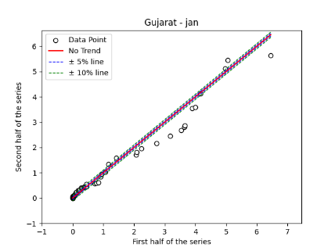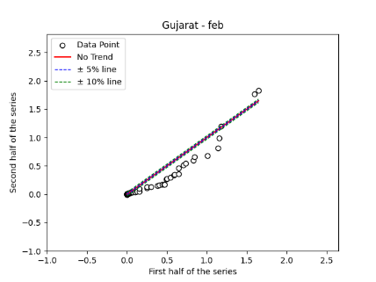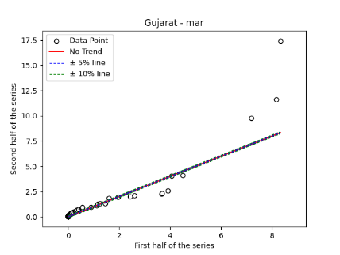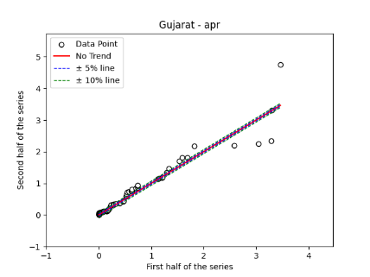
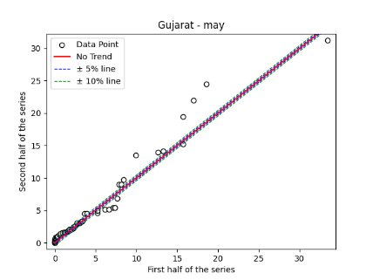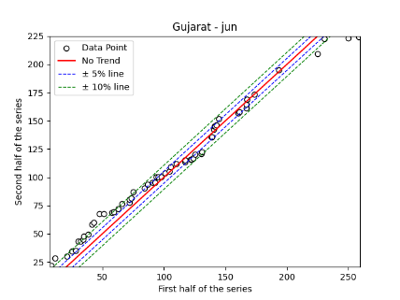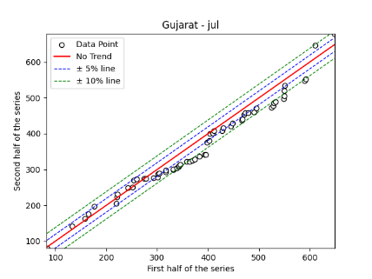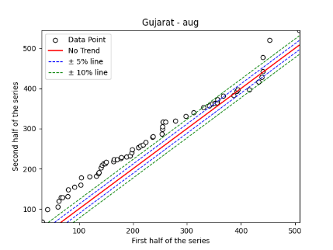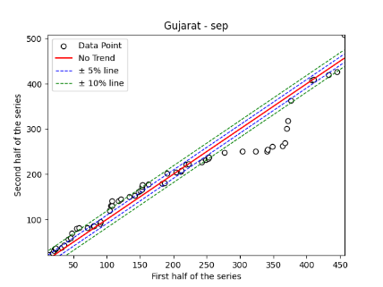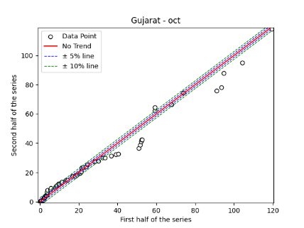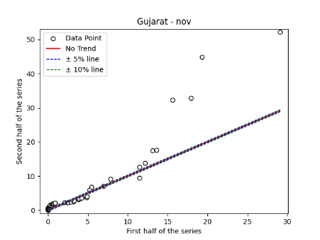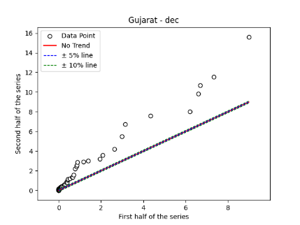
Fig. S11. Annual, Seasonal and Monthly ITA Graphs for Gujarat Region

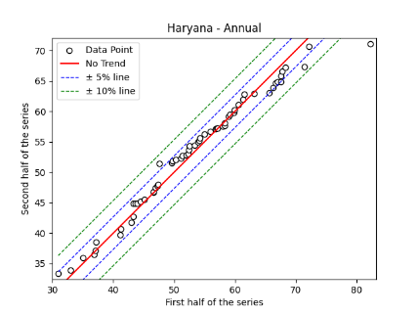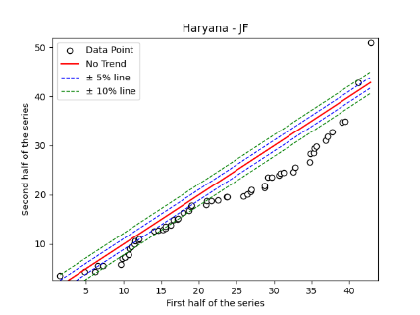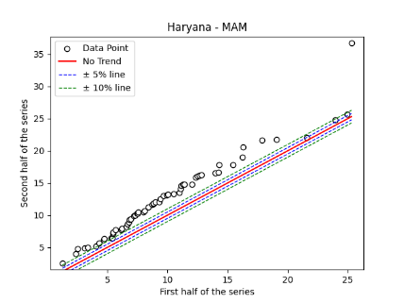
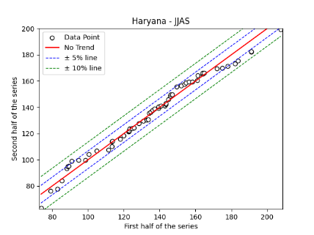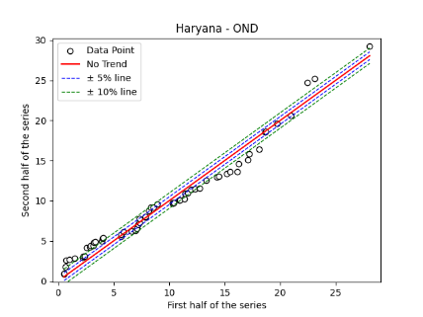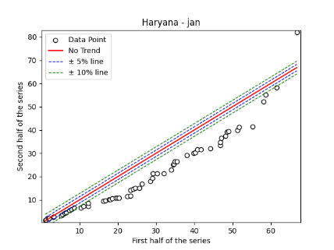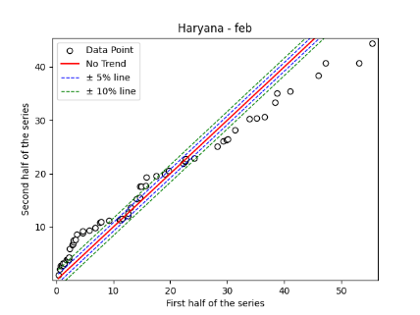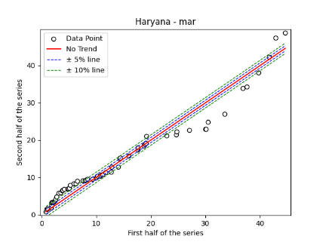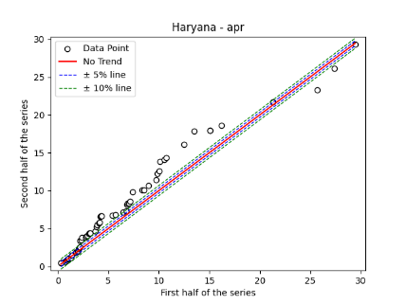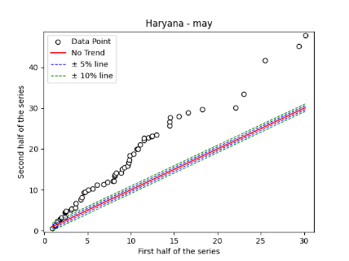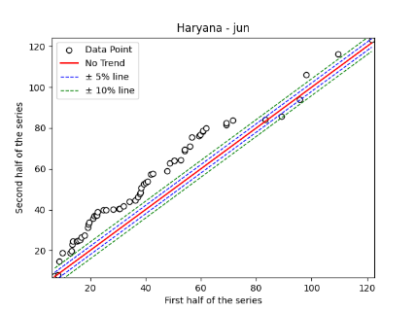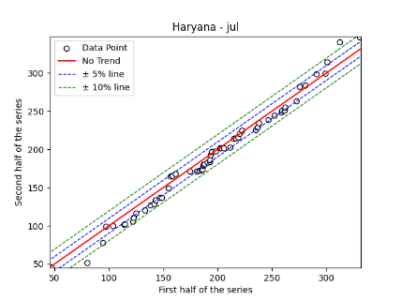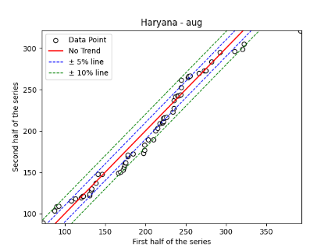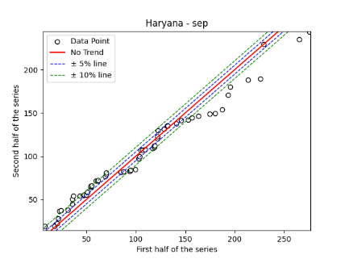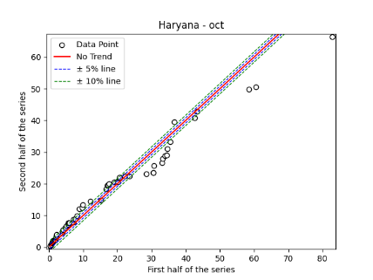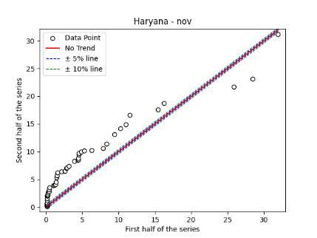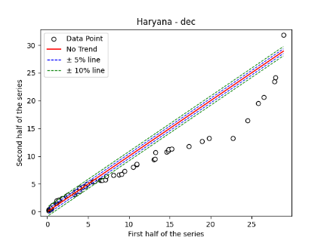
Fig. S12. Annual, Seasonal and Monthly ITA Graphs for Haryana Region

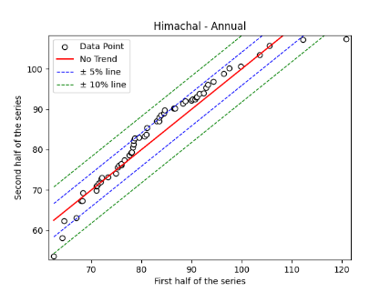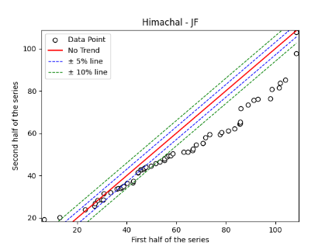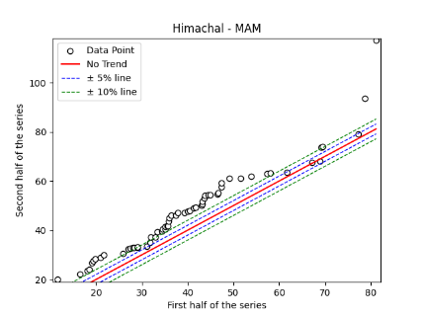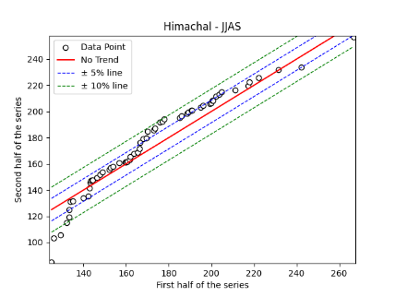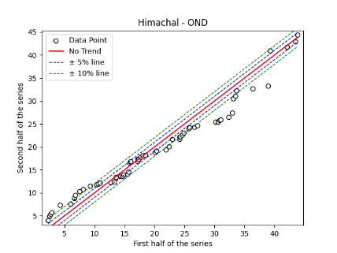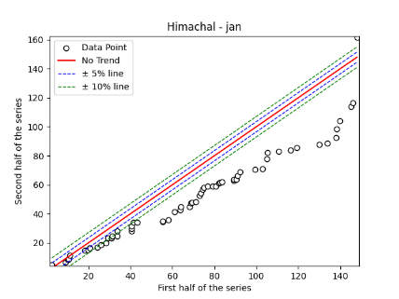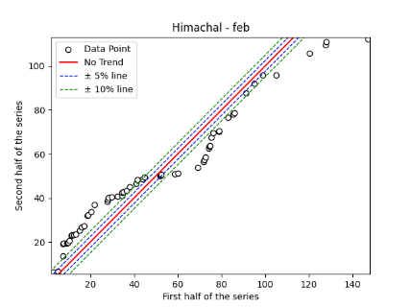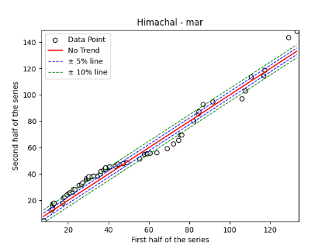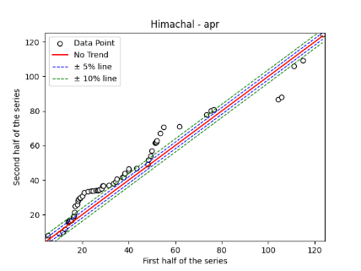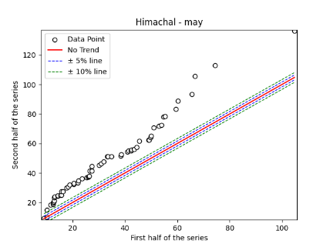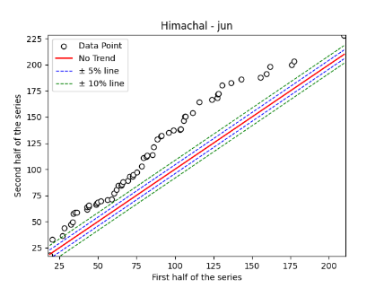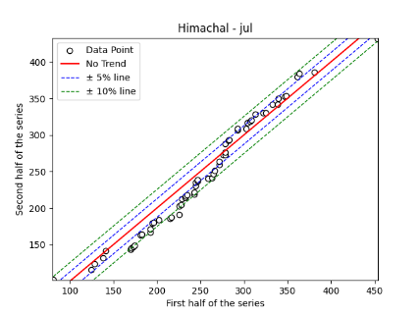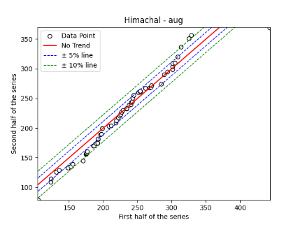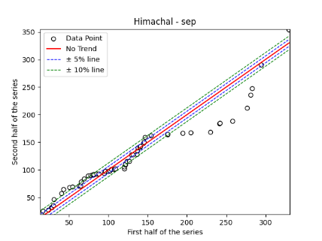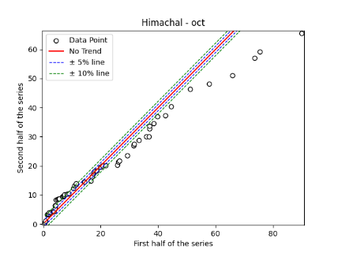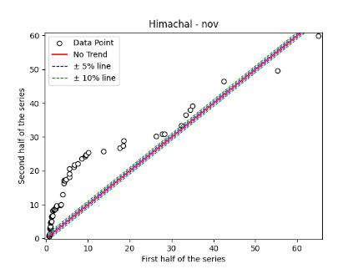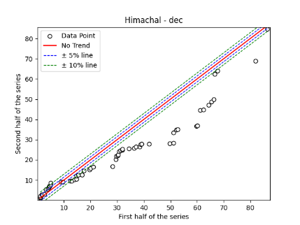

Fig. S13. Annual, Seasonal and Monthly ITA Graphs for Himachal Region

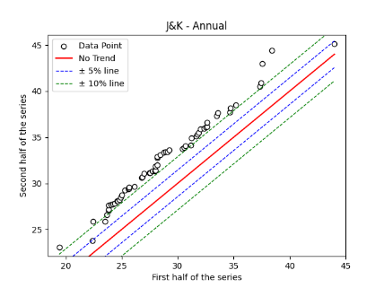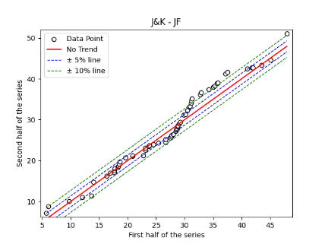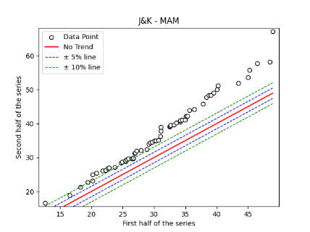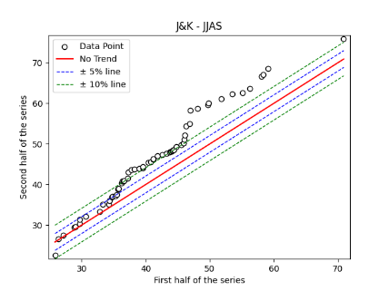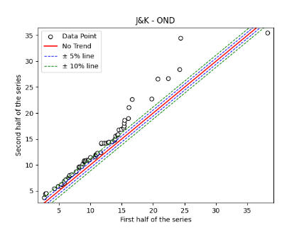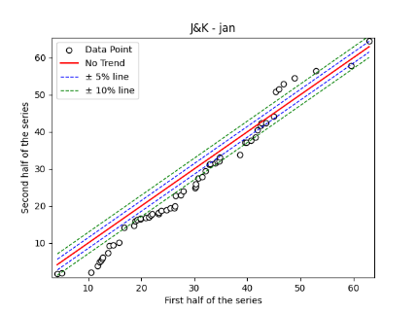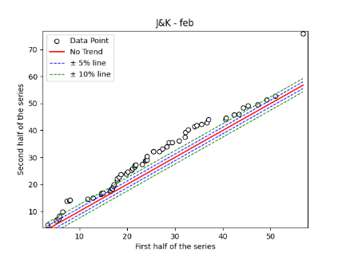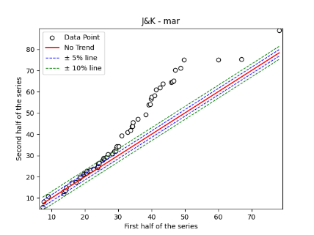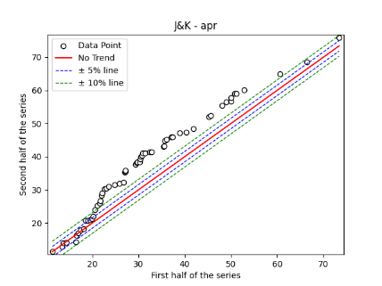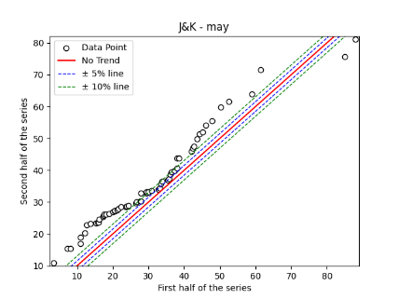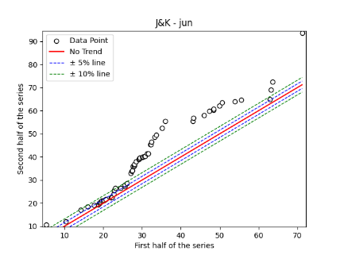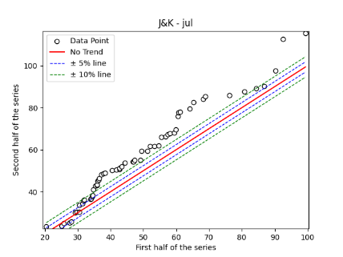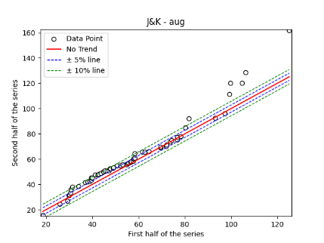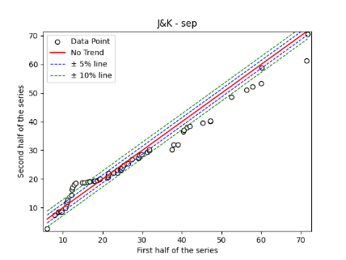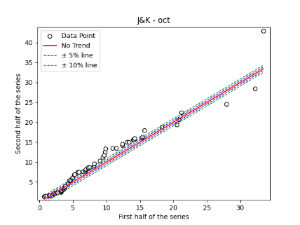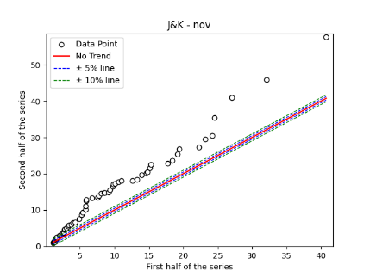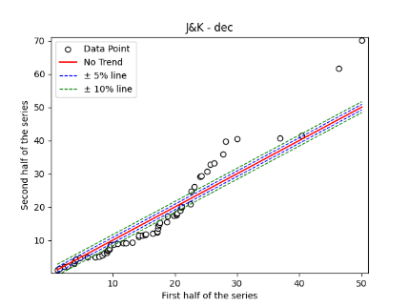
Fig. S14. Annual, Seasonal and Monthly ITA Graphs for Jammu & Kashmir Region

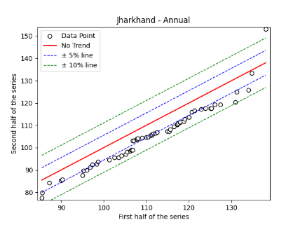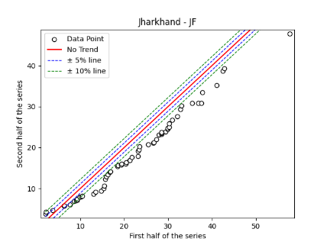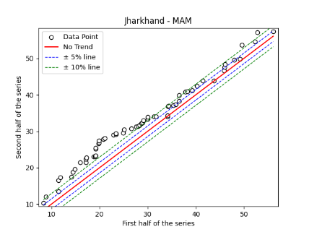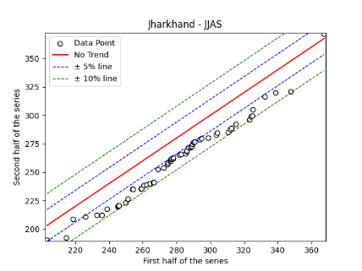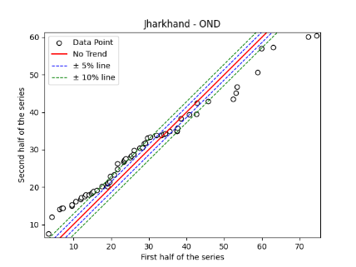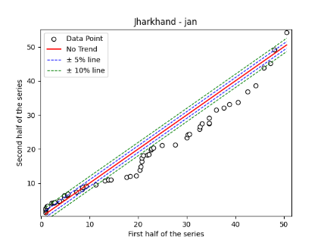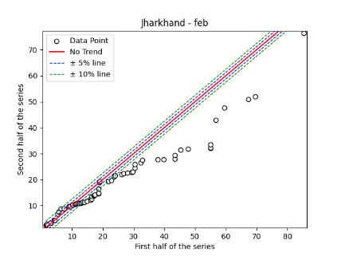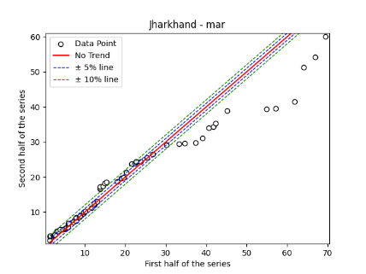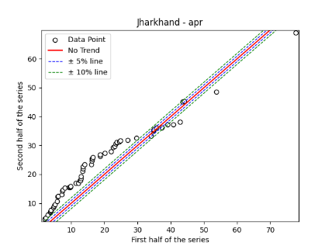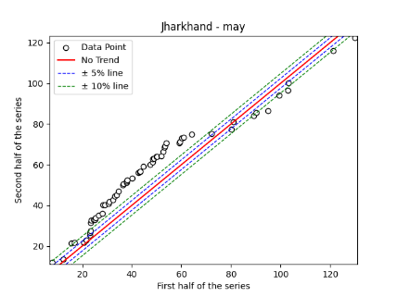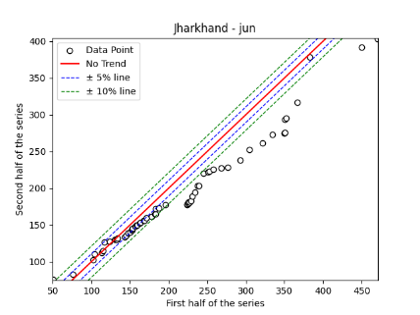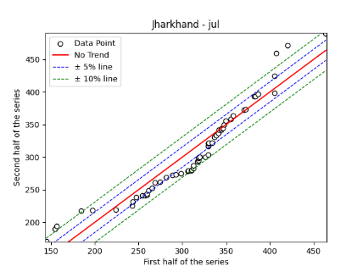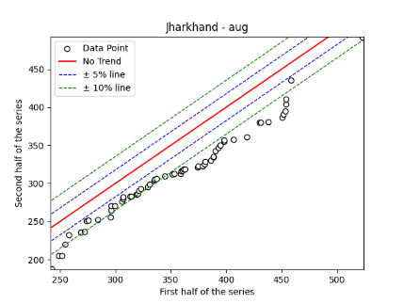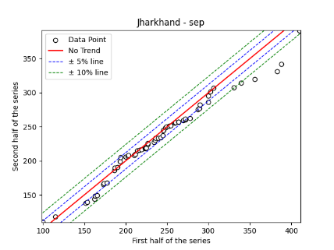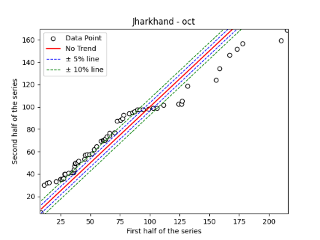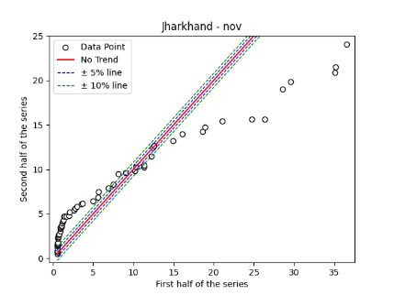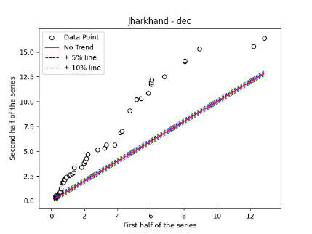

Fig. S15. Annual, Seasonal and Monthly ITA Graphs for Jharkhand Region

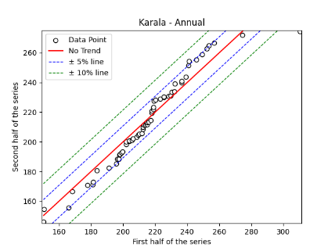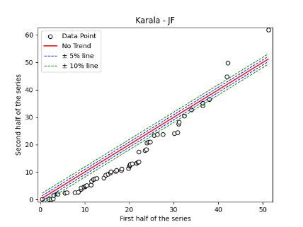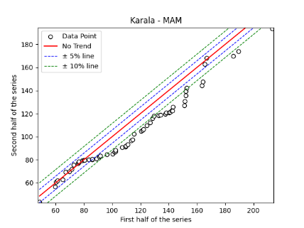
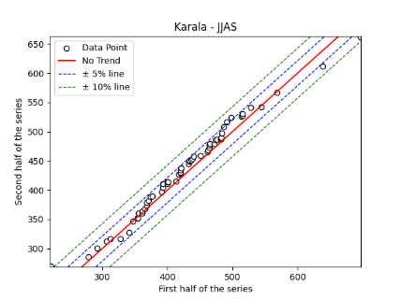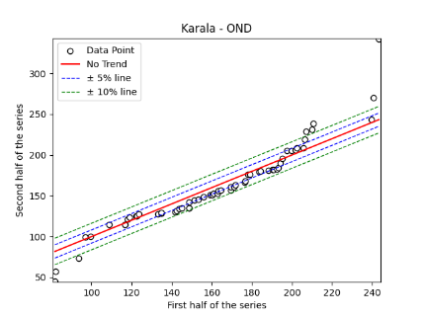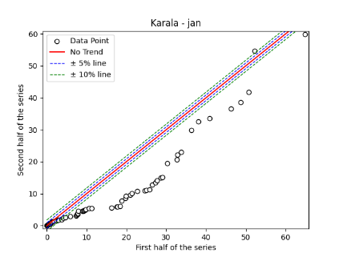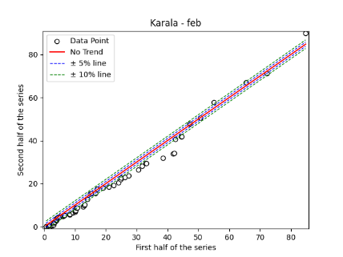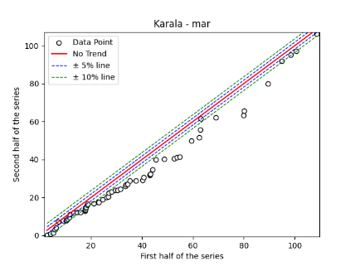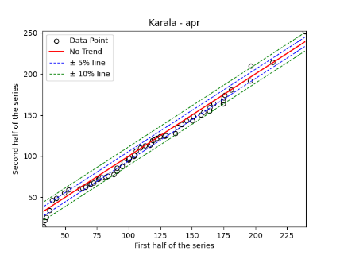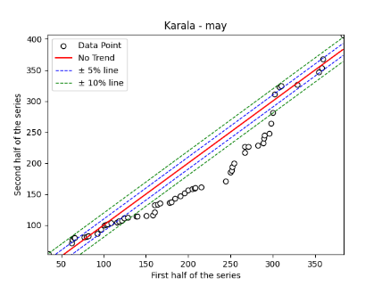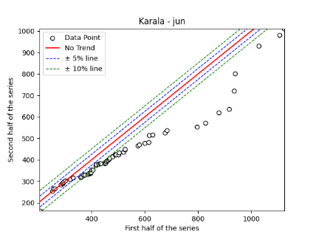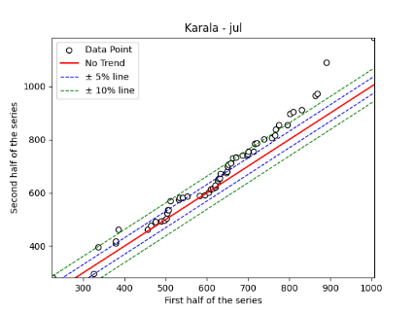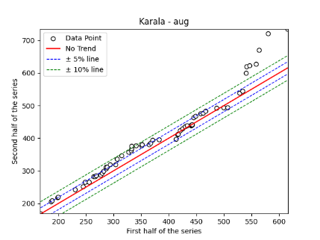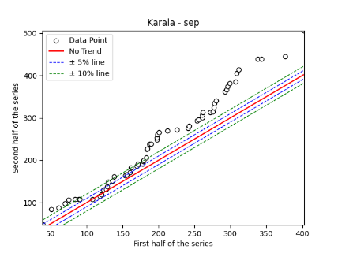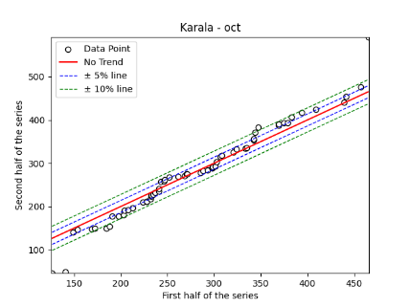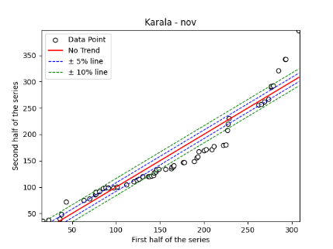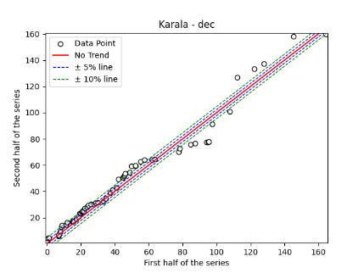

Fig. S16. Annual, Seasonal and Monthly ITA Graphs for Kerala Region

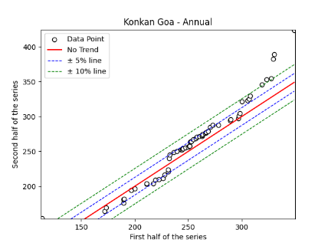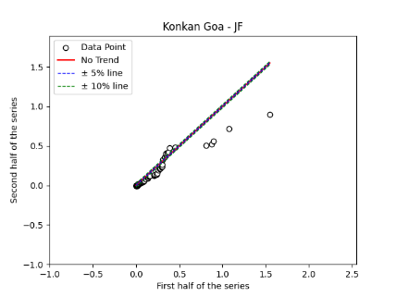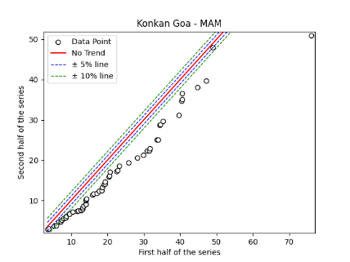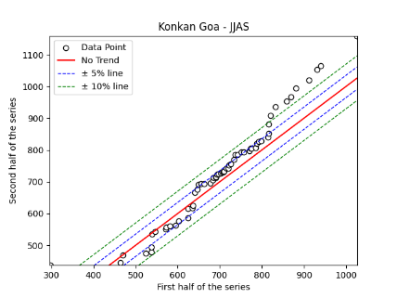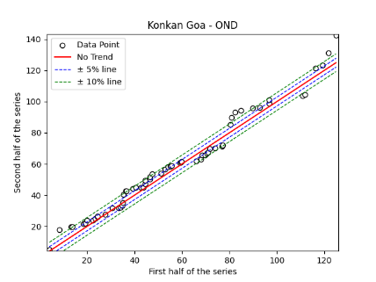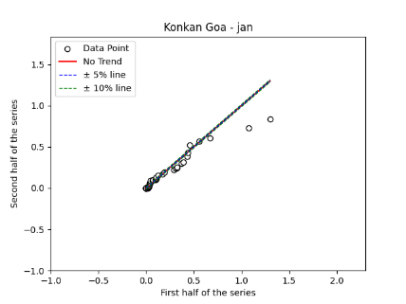
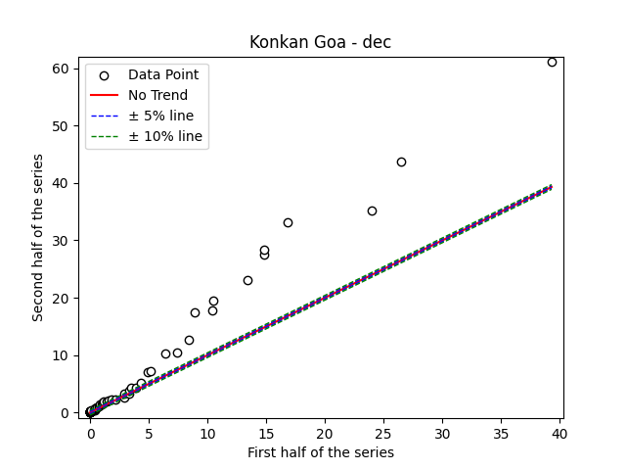
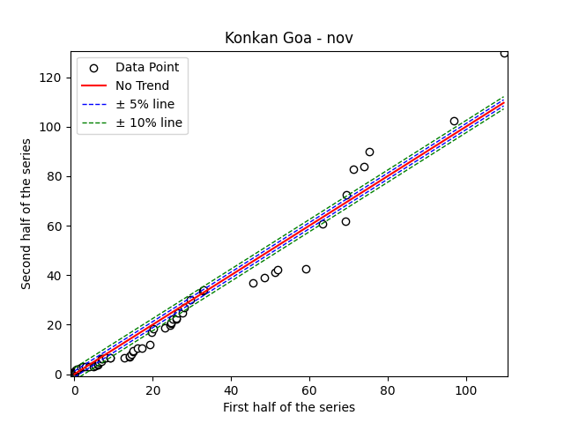
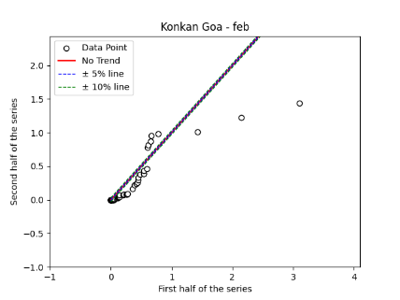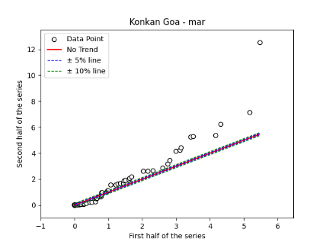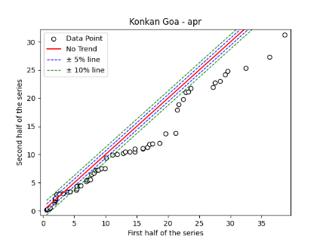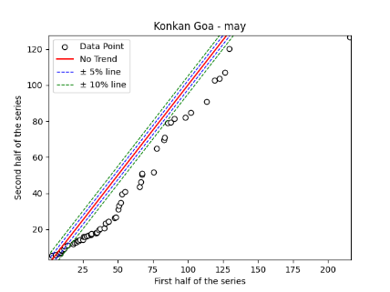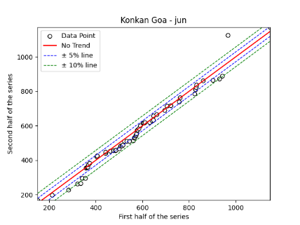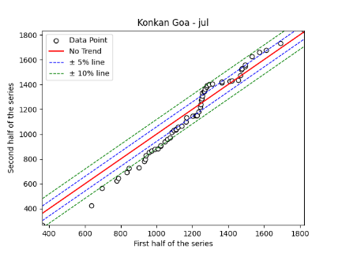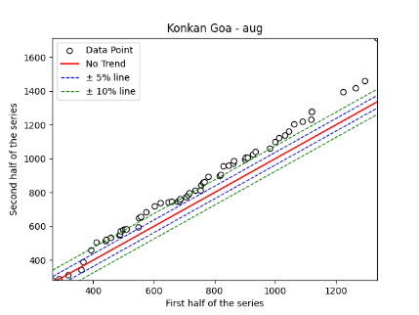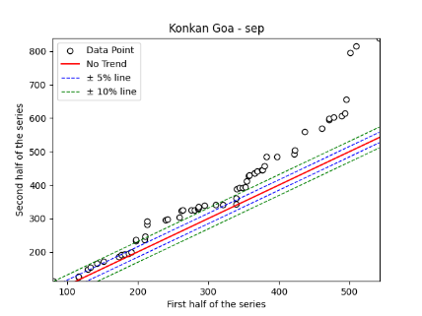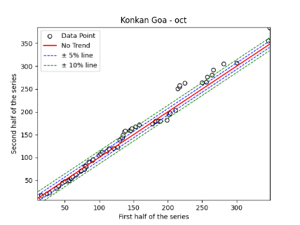
Fig. S17. Annual, Seasonal and Monthly ITA Graphs for Konkan Goa Region

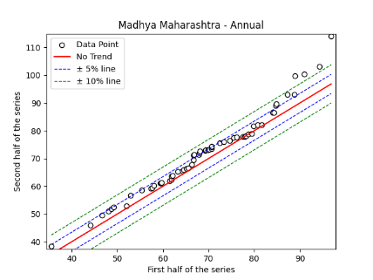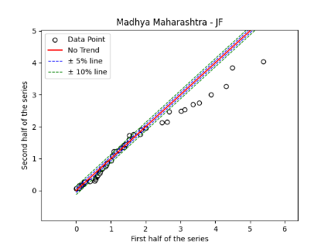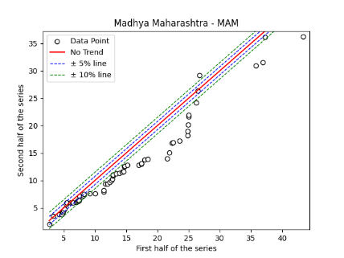

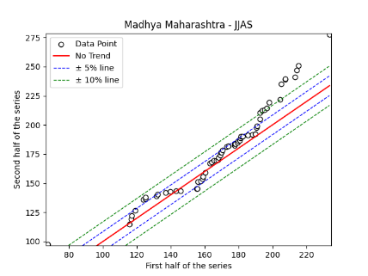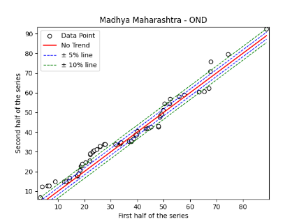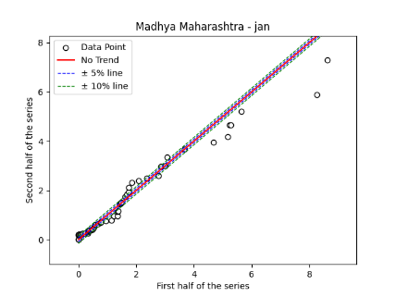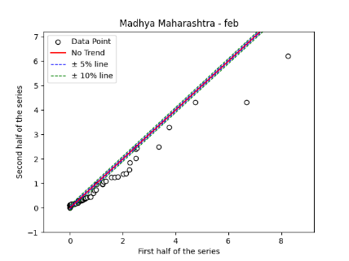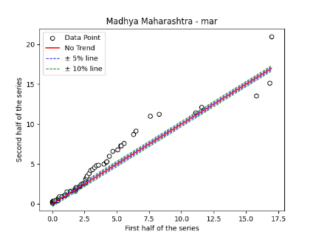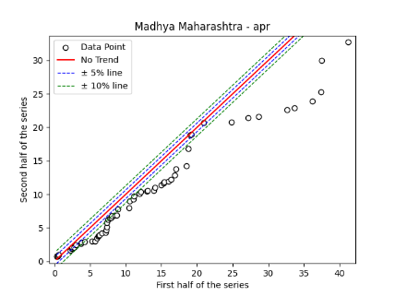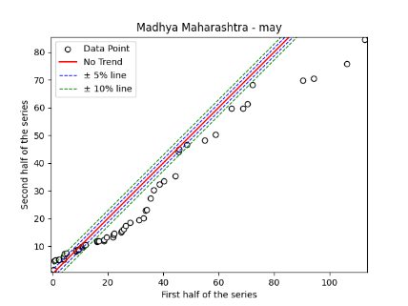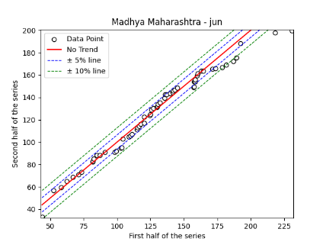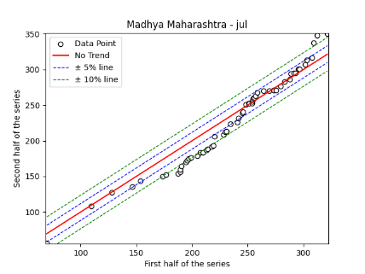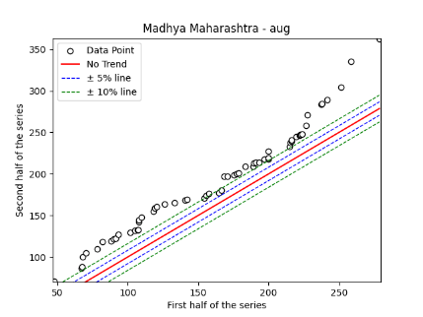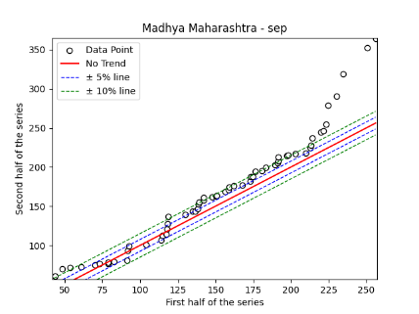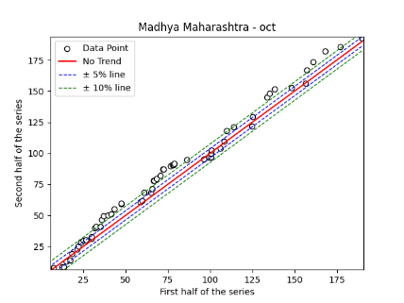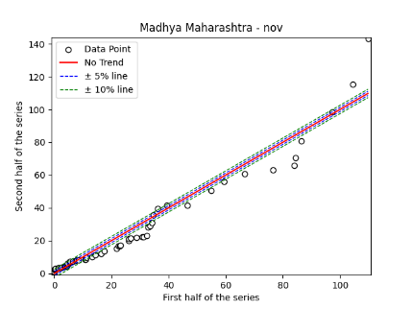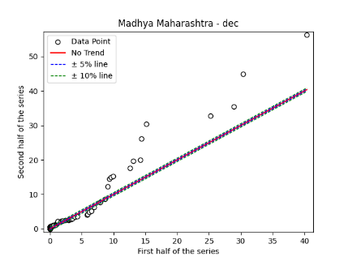
Fig. S18. Annual, Seasonal and Monthly ITA Graphs for Madhya Maharashtra Region

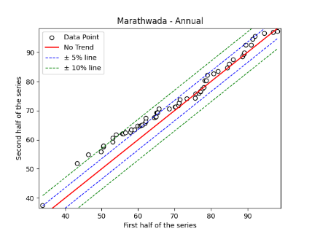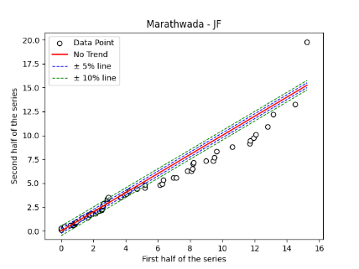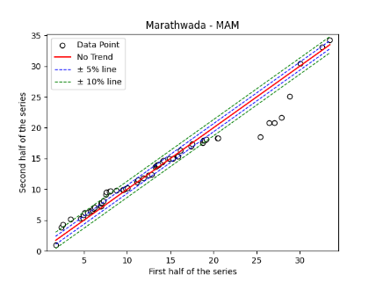
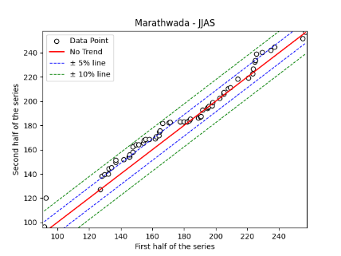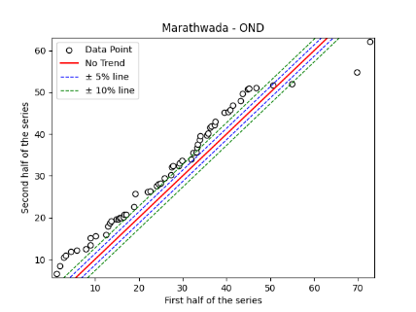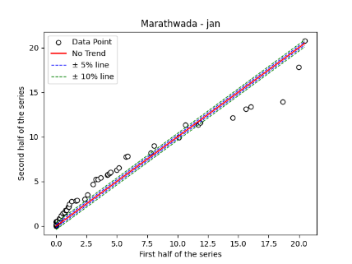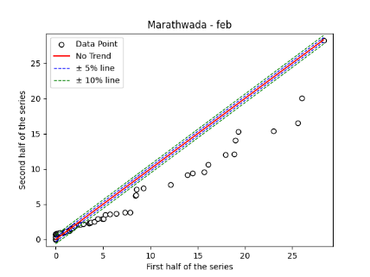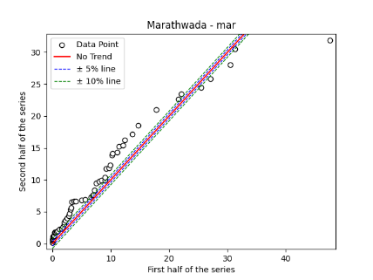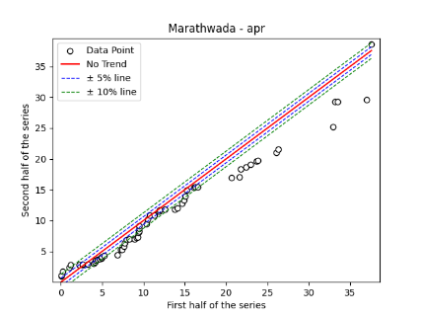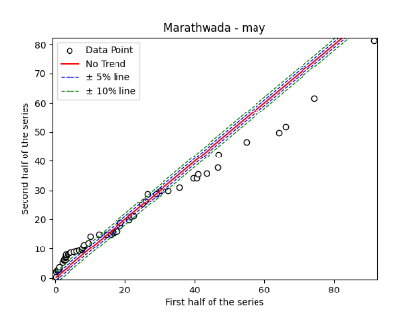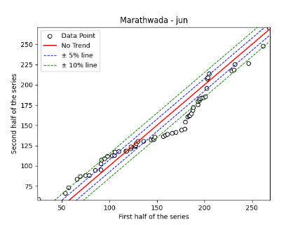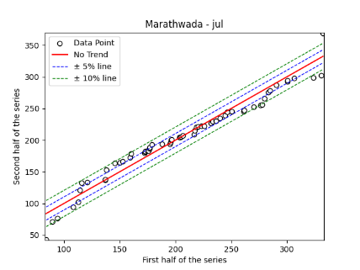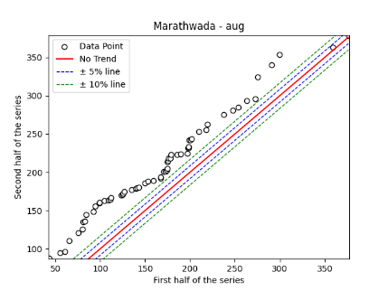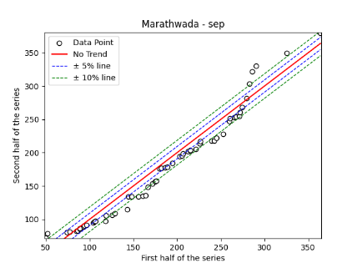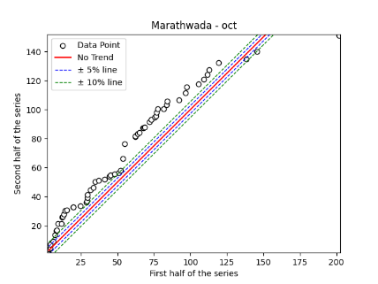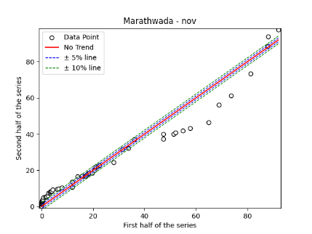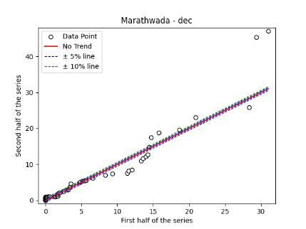
Fig. S19. Annual, Seasonal and Monthly ITA Graphs for Marathwada Region

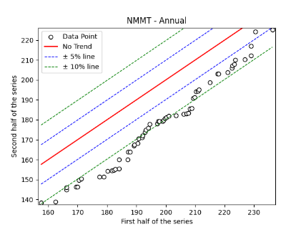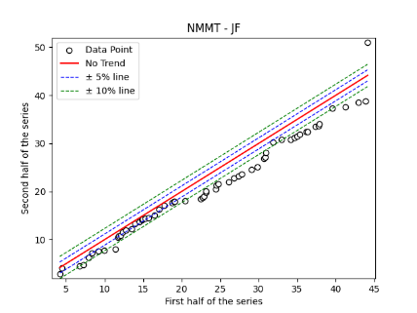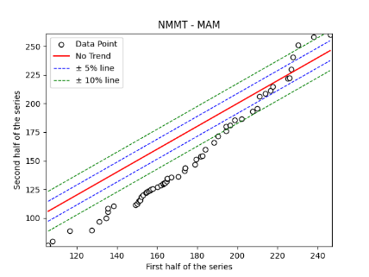

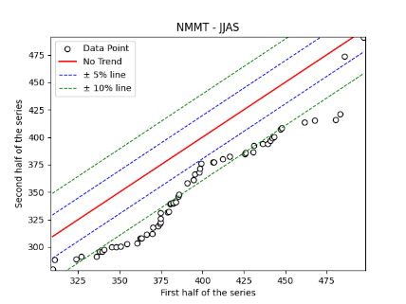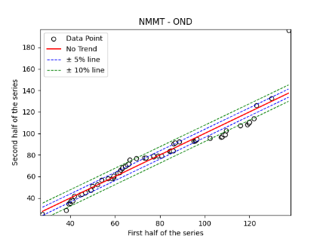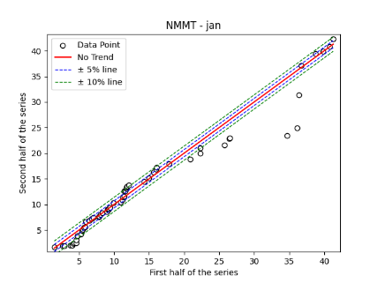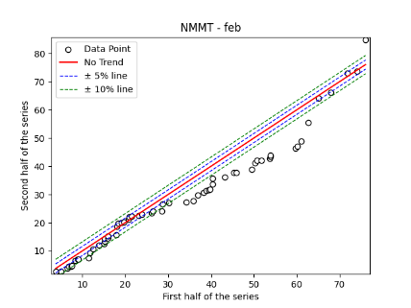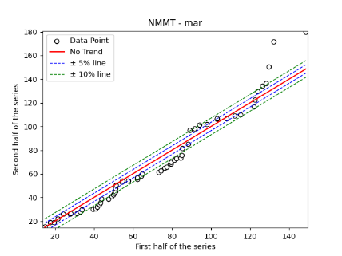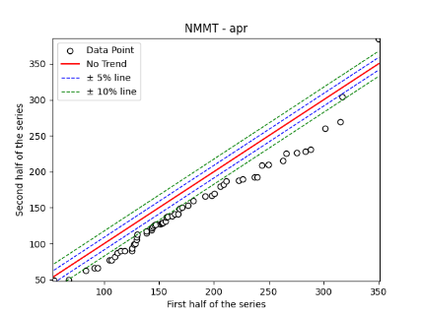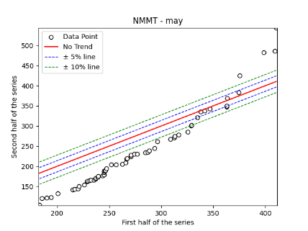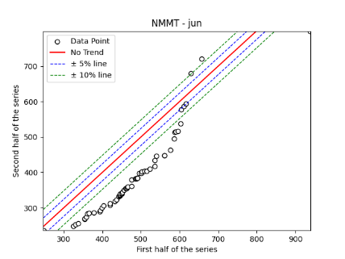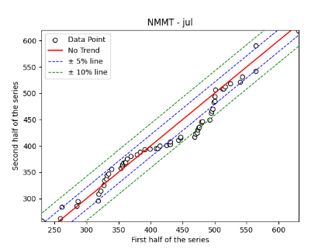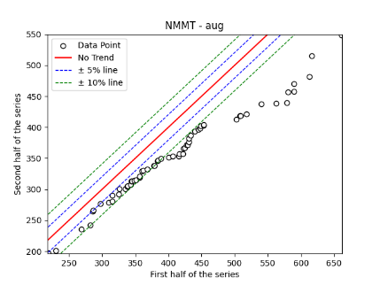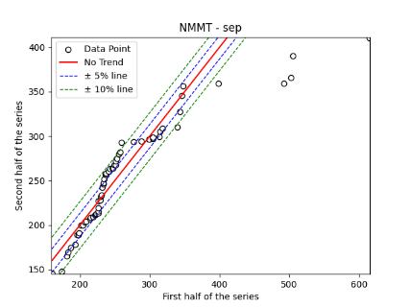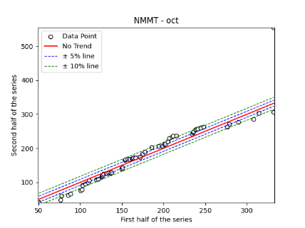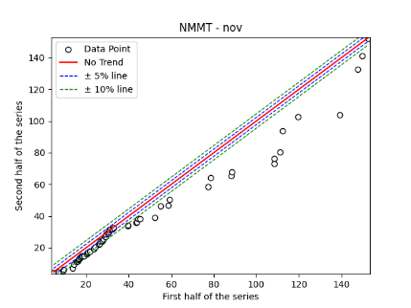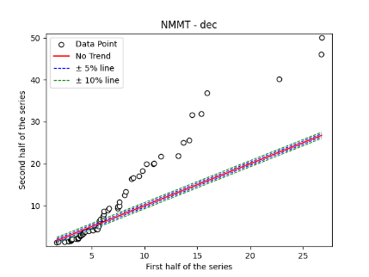
Fig. S20. Annual, Seasonal and Monthly ITA Graphs for NMMT Region

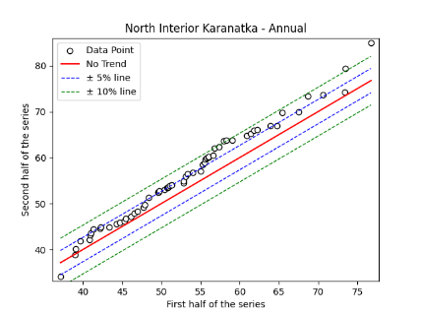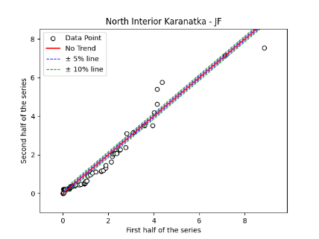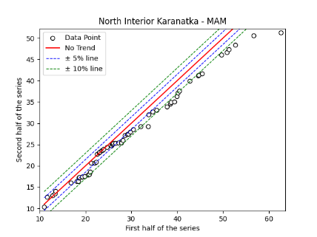
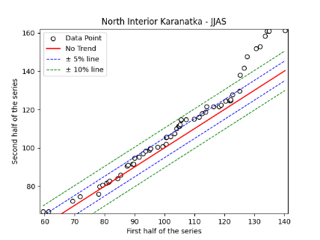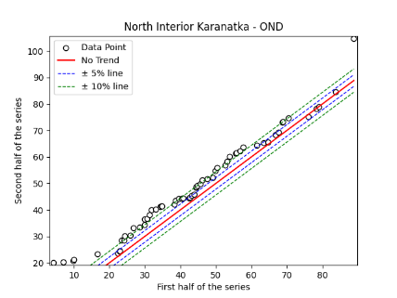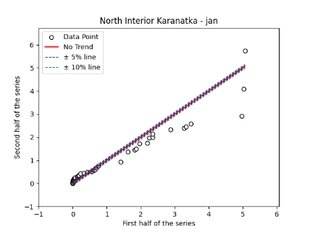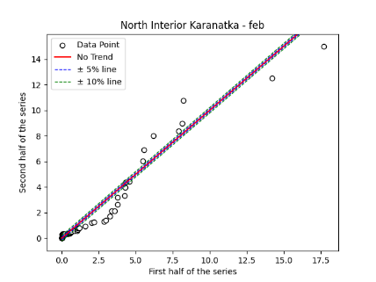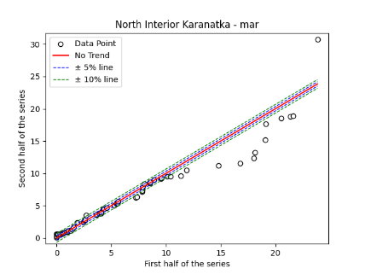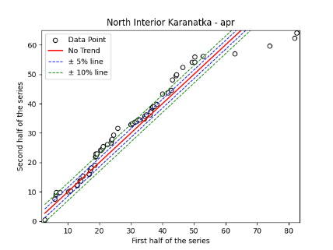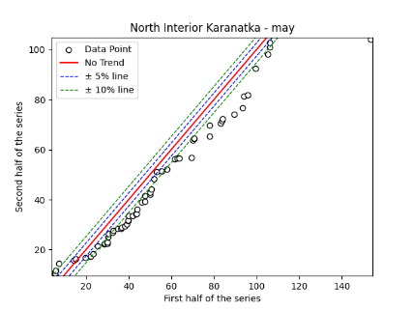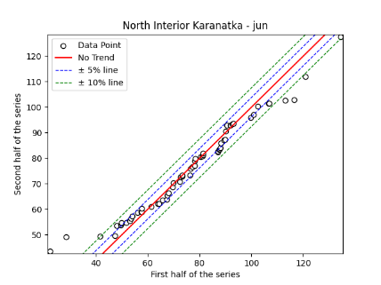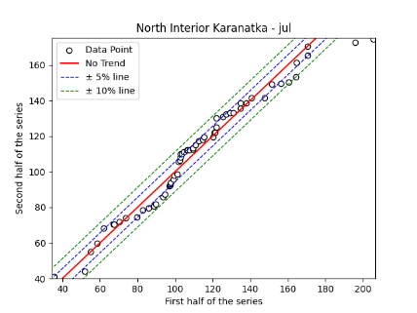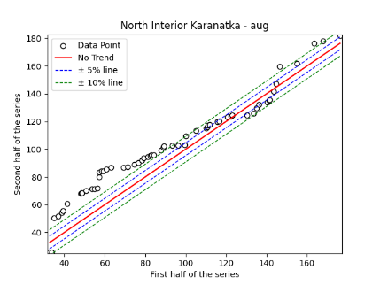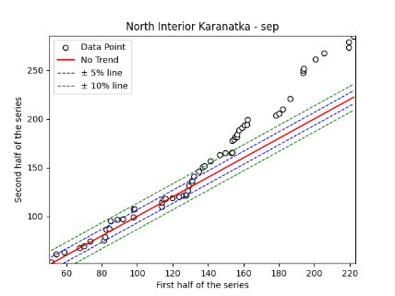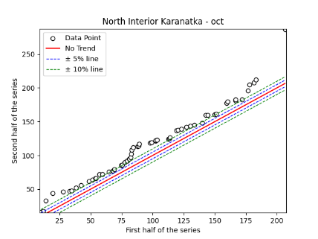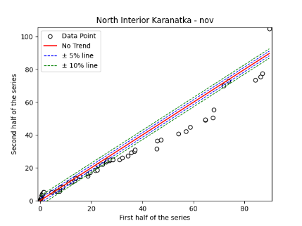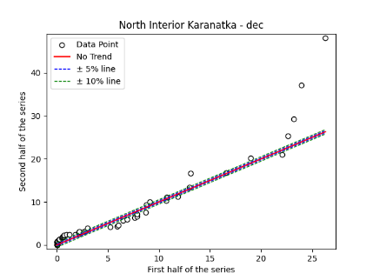
Fig. S21. Annual, Seasonal and Monthly ITA Graphs for North Interior Karnataka Region

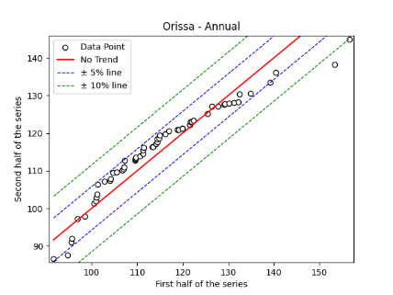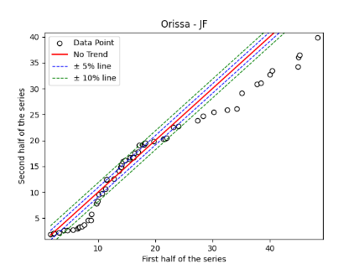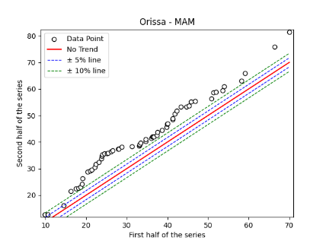
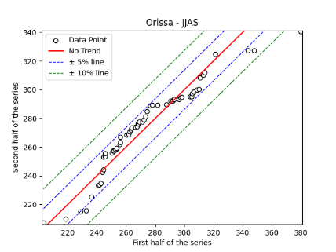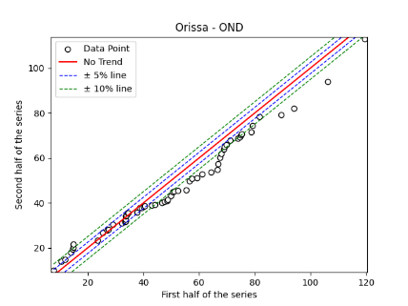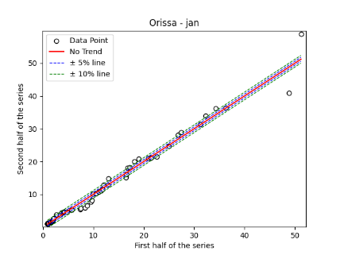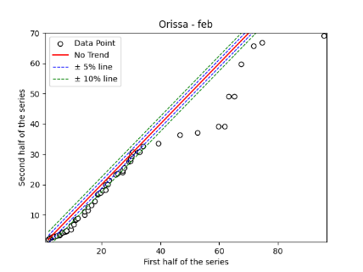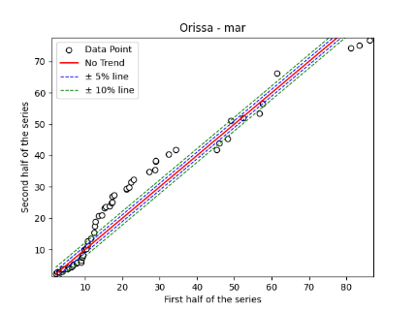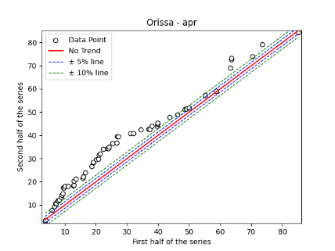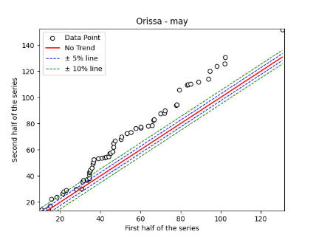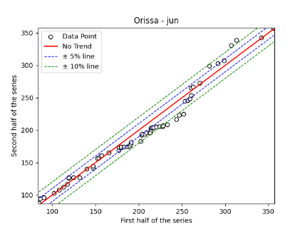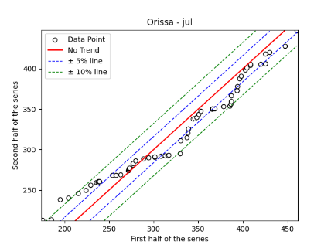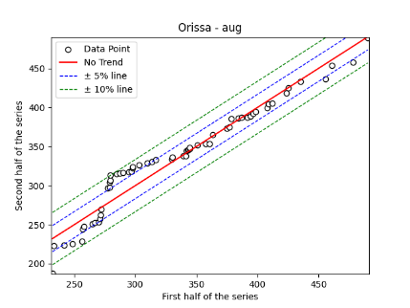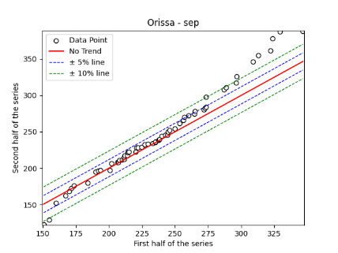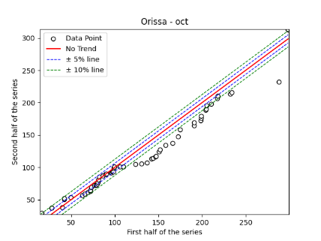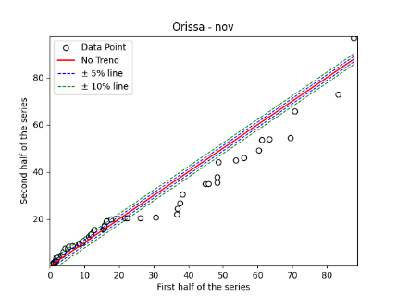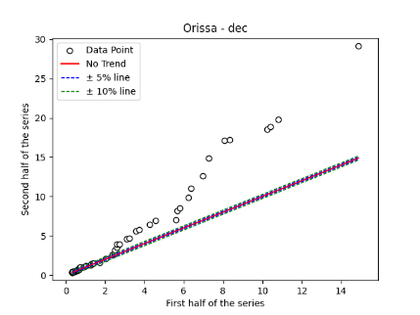
Fig. S22. Annual, Seasonal and Monthly ITA Graphs for Odisha Region

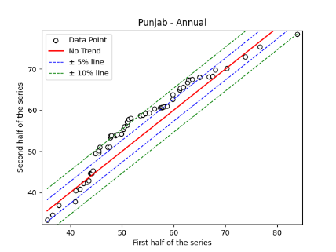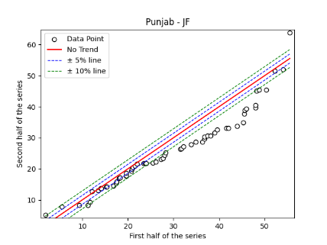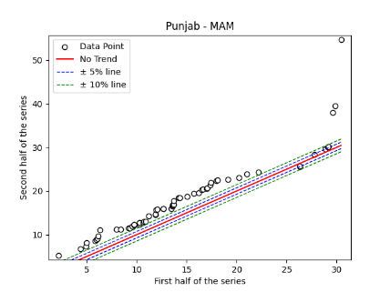
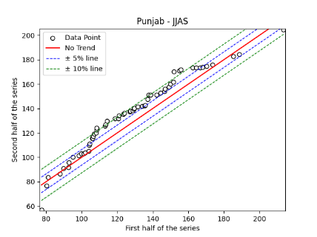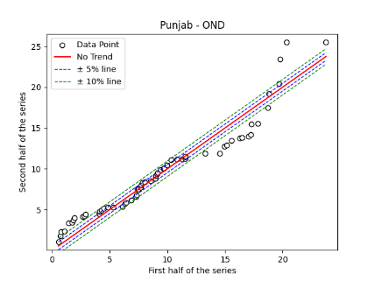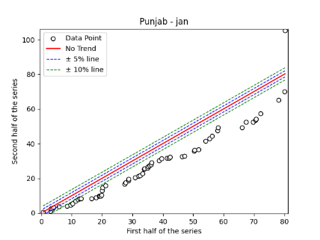
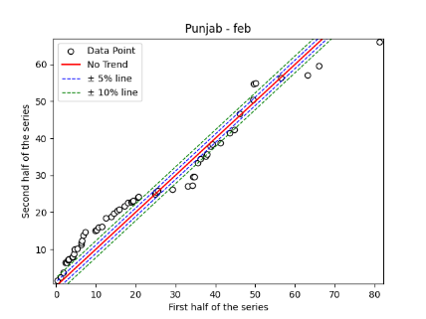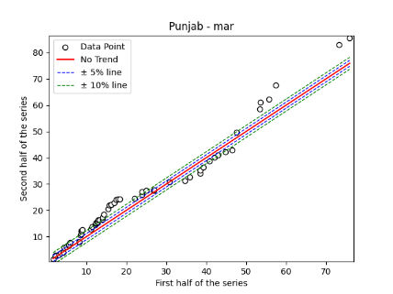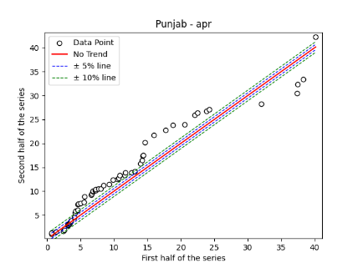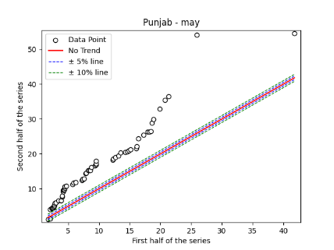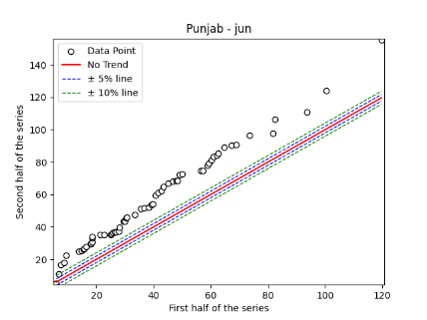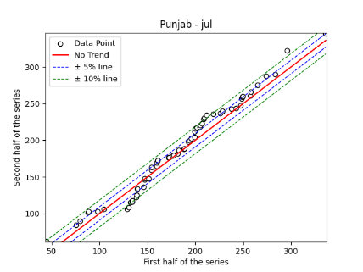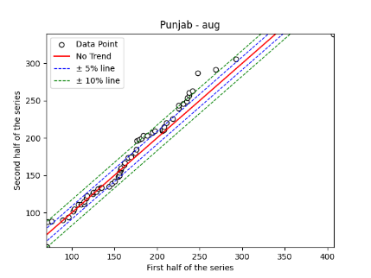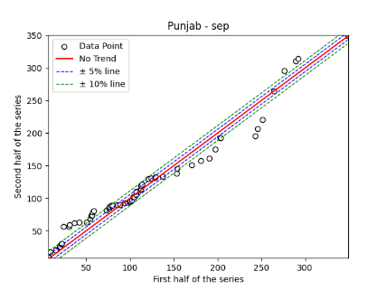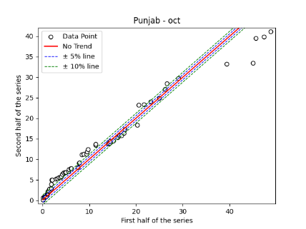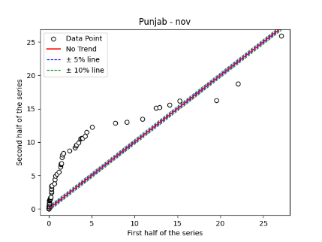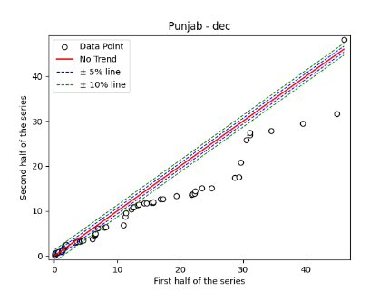
Fig. S23. Annual, Seasonal and Monthly ITA Graphs for Punjab Region
z
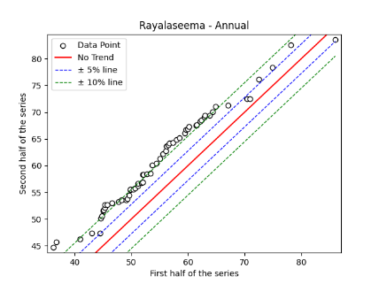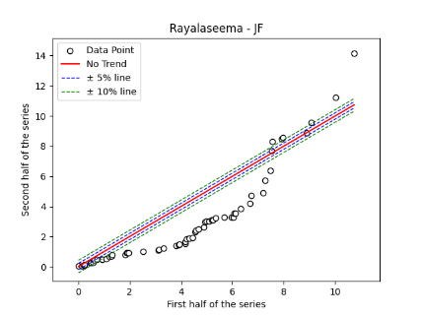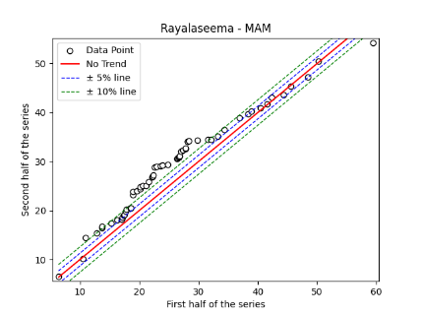

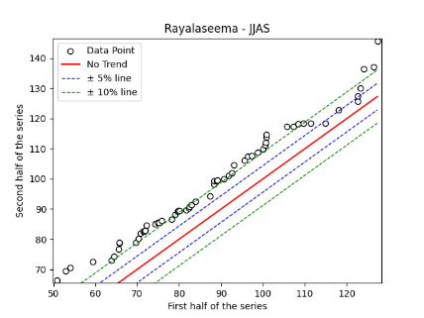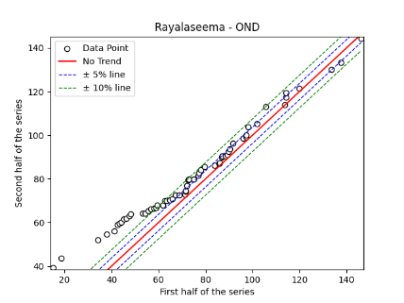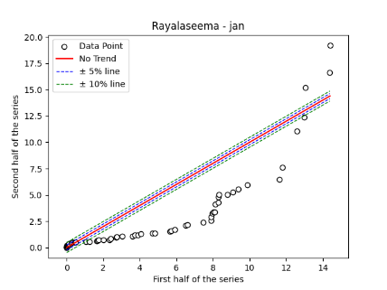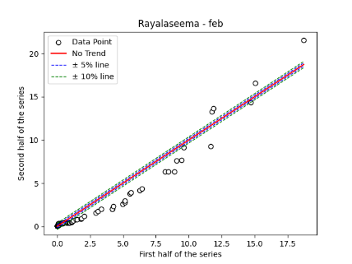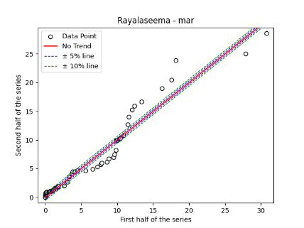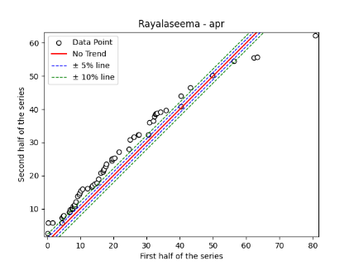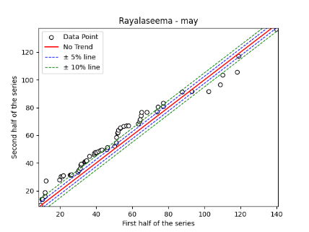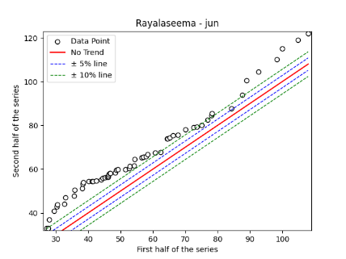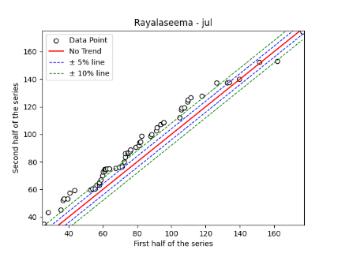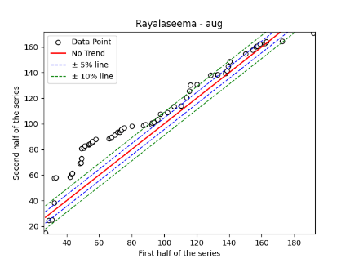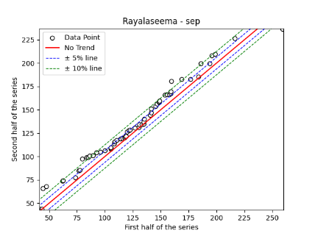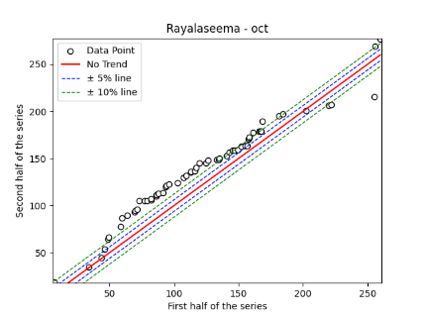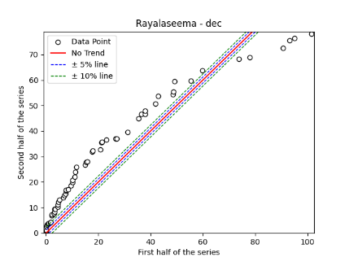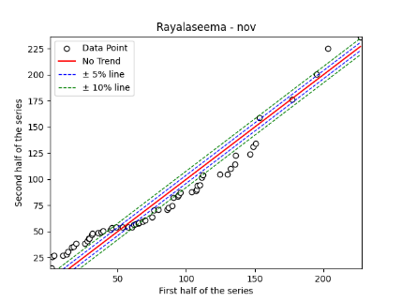
Fig. S24. Annual, Seasonal and Monthly ITA Graphs for Rayalaseema Region

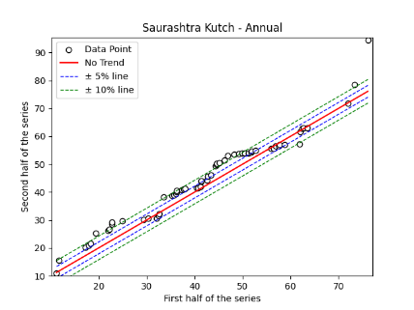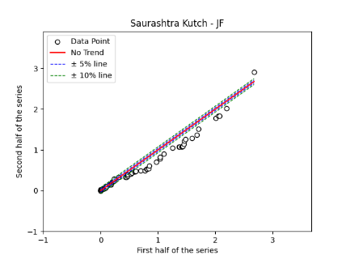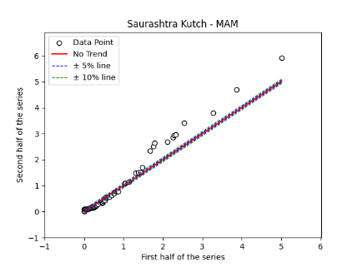
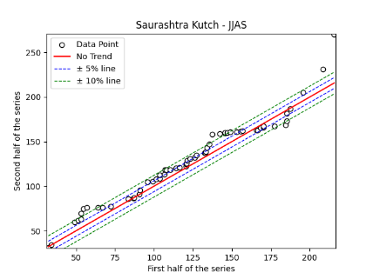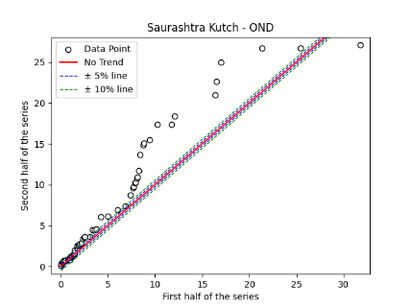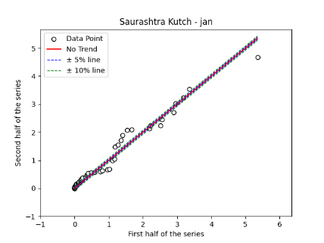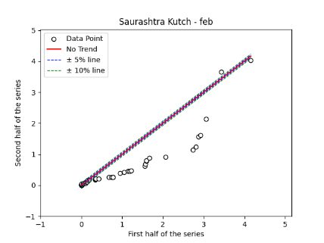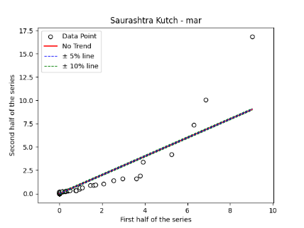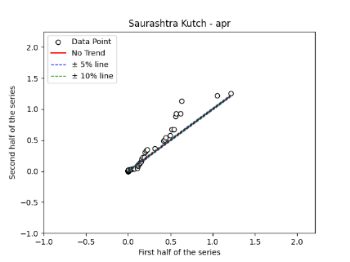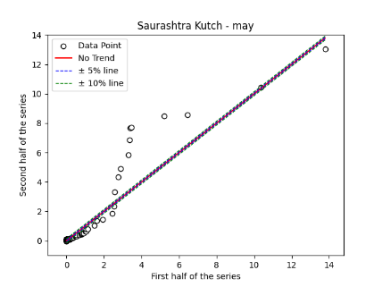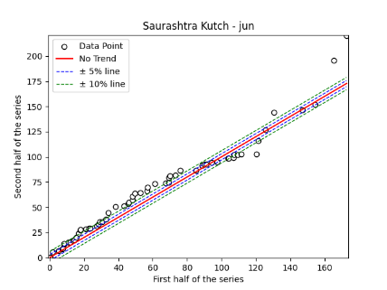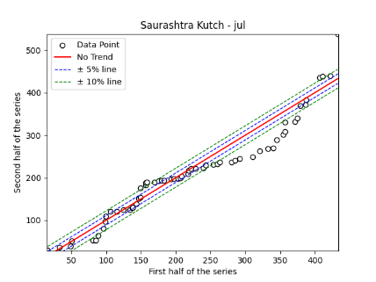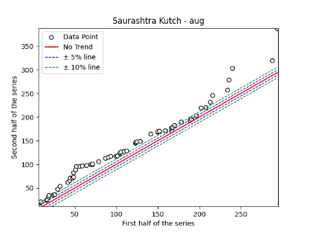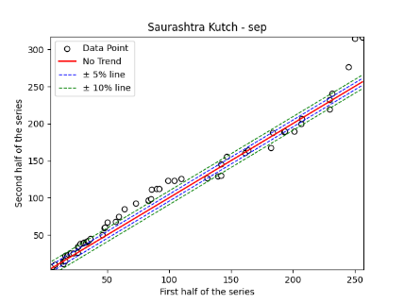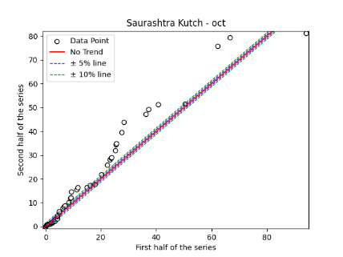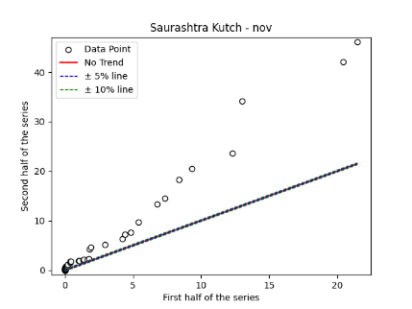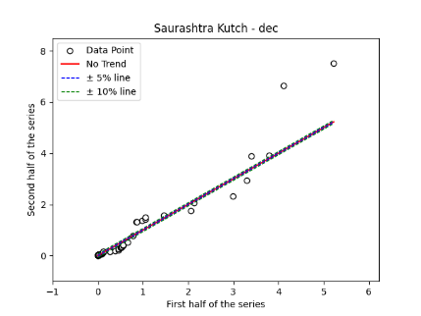
Fig. S25. Annual, Seasonal and Monthly ITA Graphs for Saurashtra Region

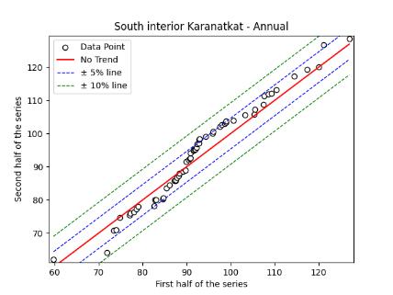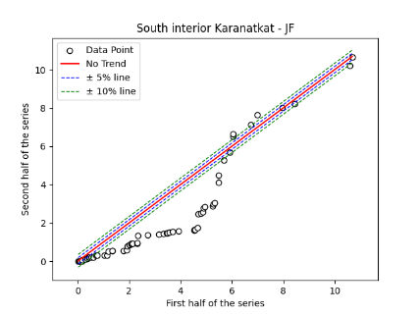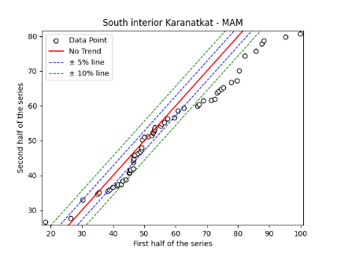
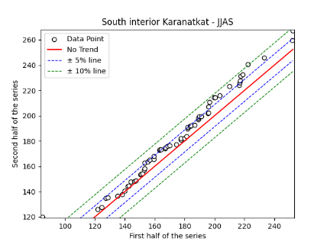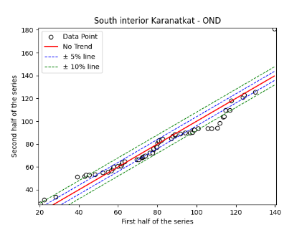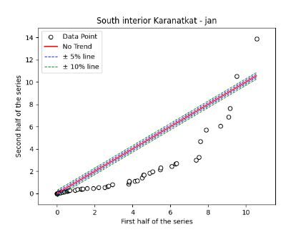
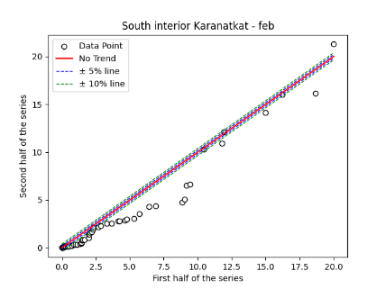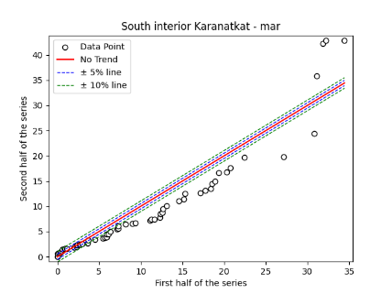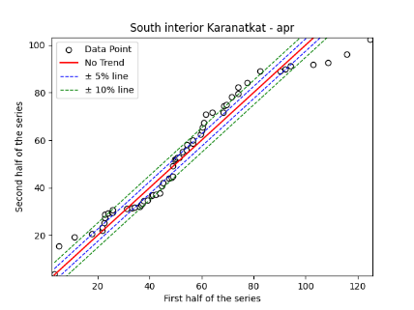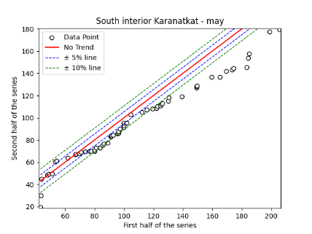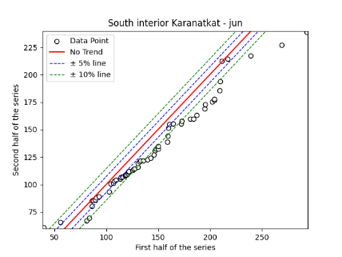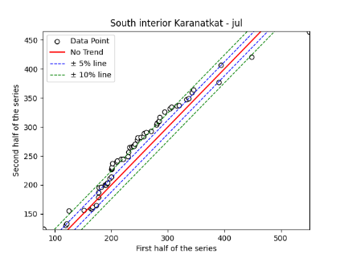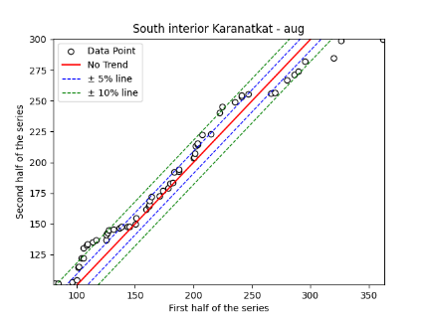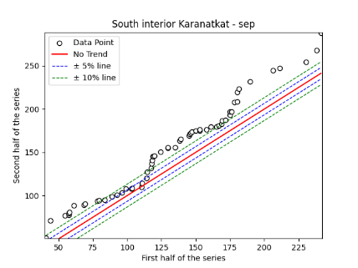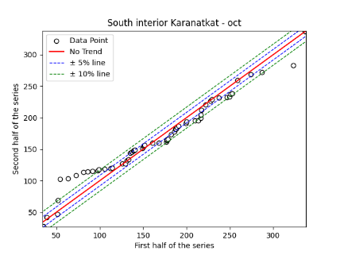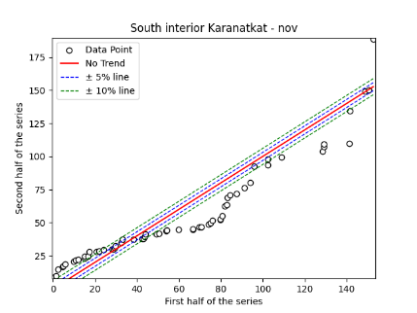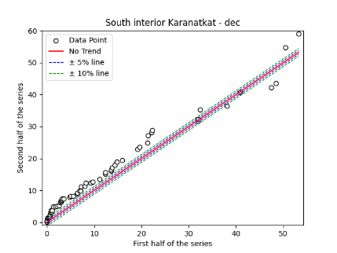
Fig. S26. Annual, Seasonal and Monthly ITA Graphs for South Interior Karnataka Region

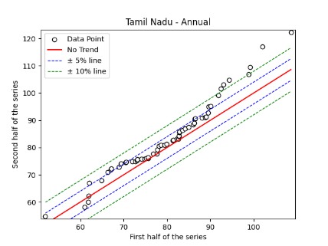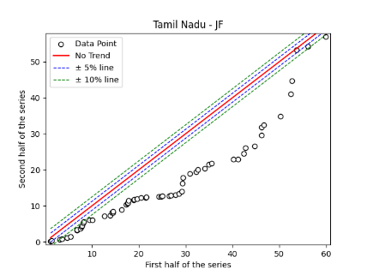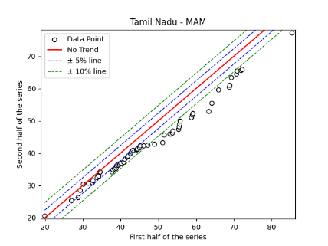
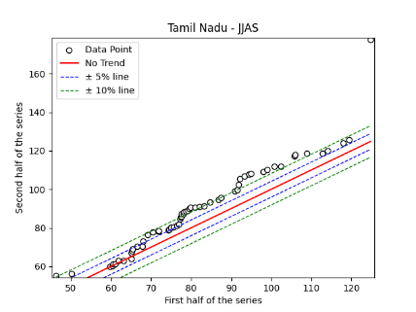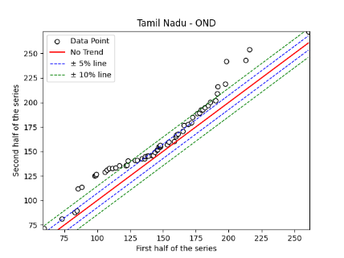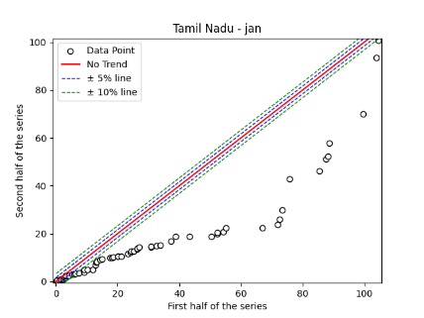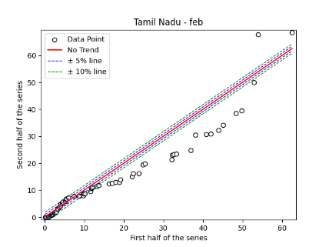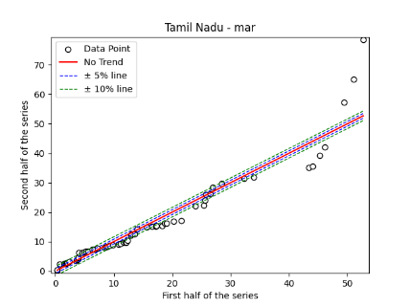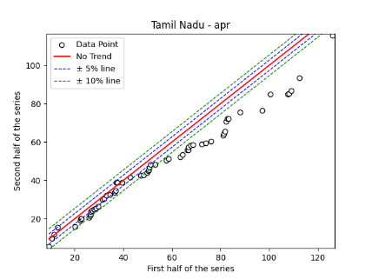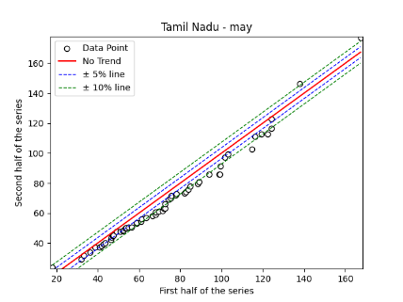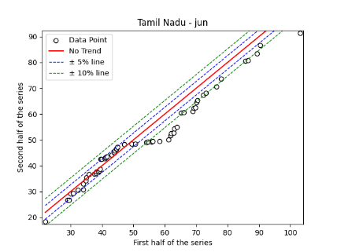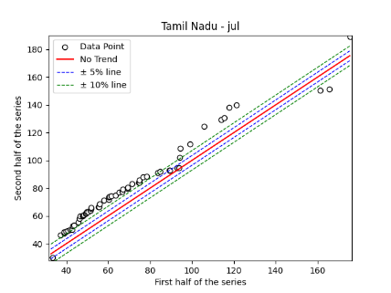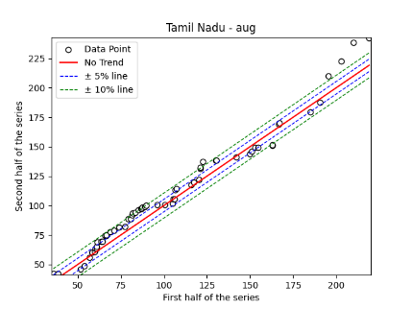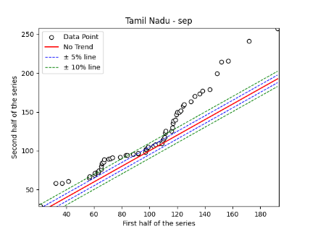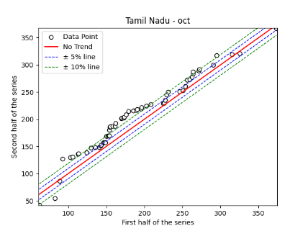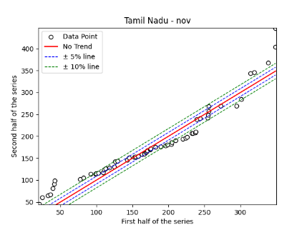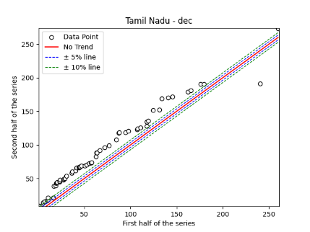
Fig. S27. Annual, Seasonal and Monthly ITA Graphs for Tamil Nadu Region

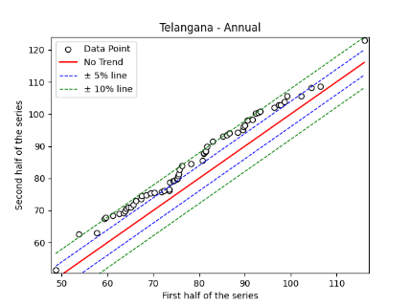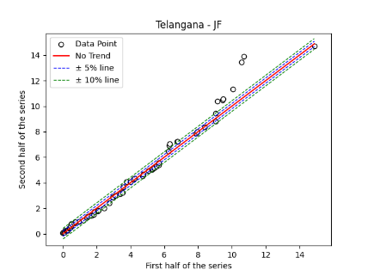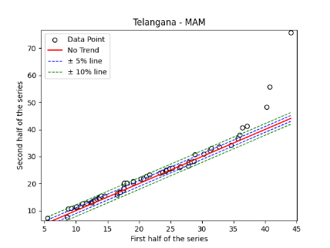
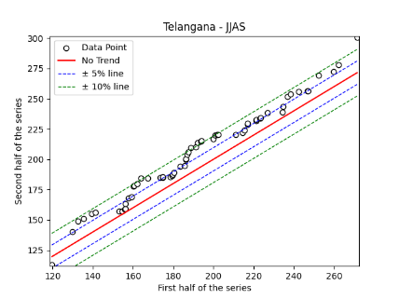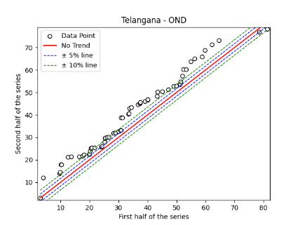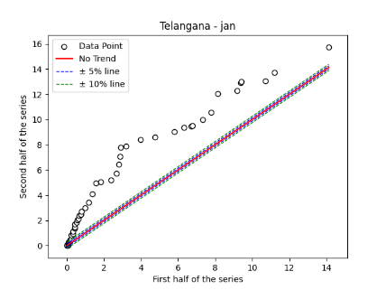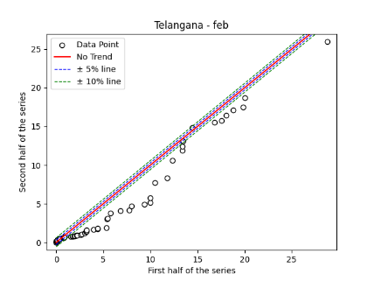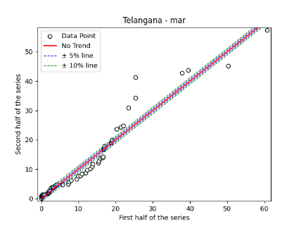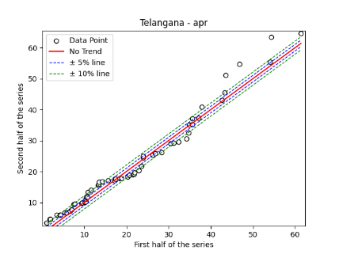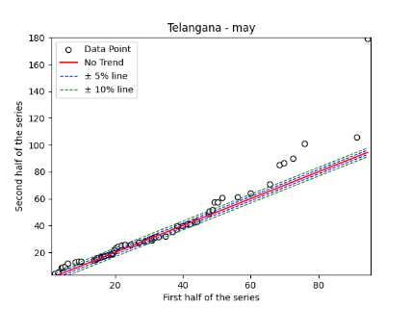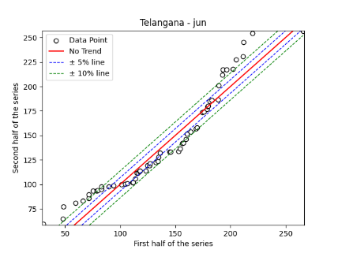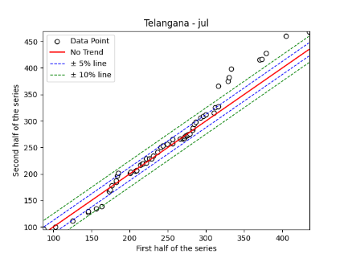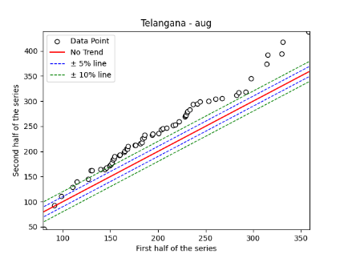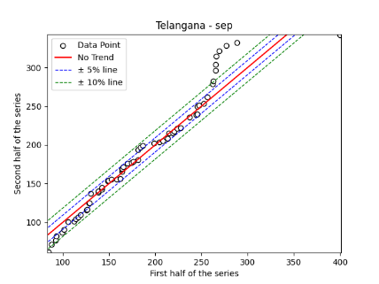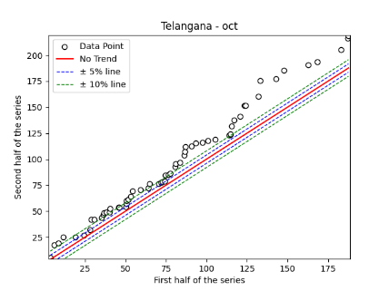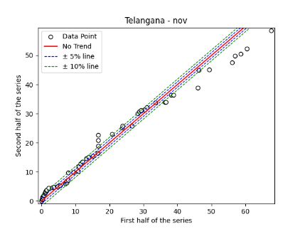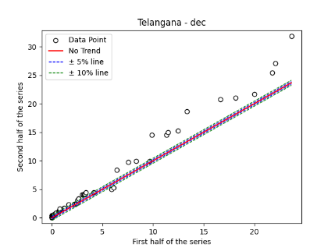
Fig. S28. Annual, Seasonal and Monthly ITA Graphs for Telangana Region

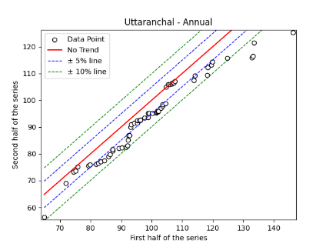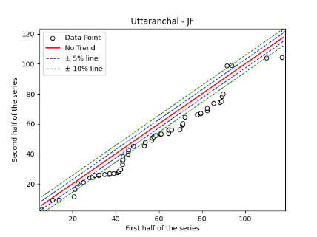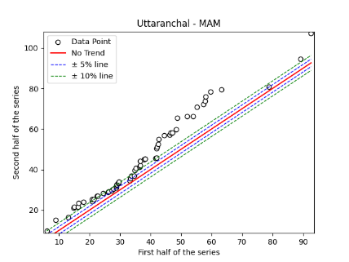
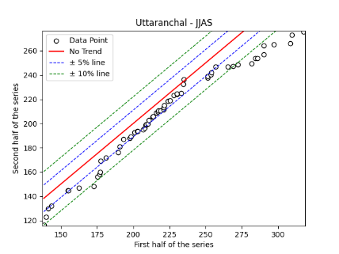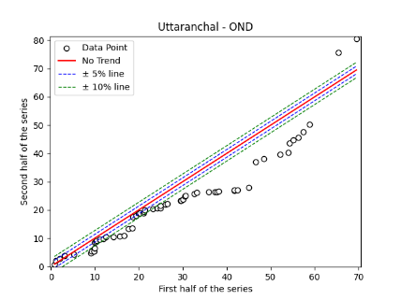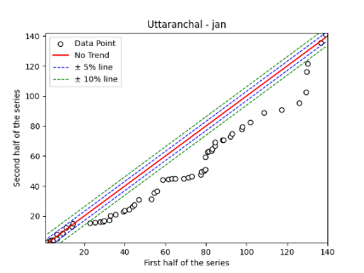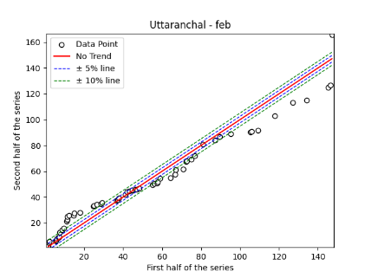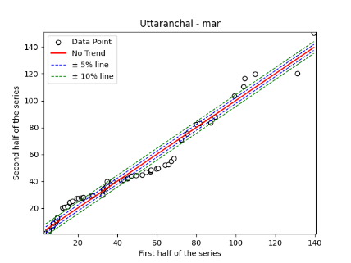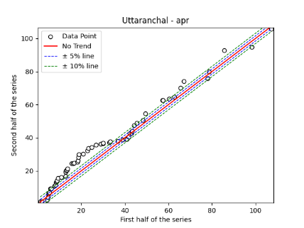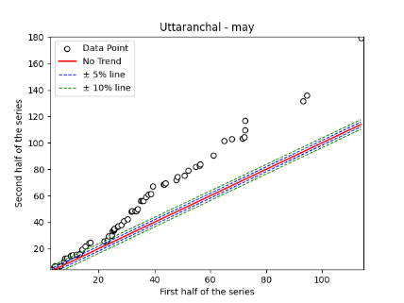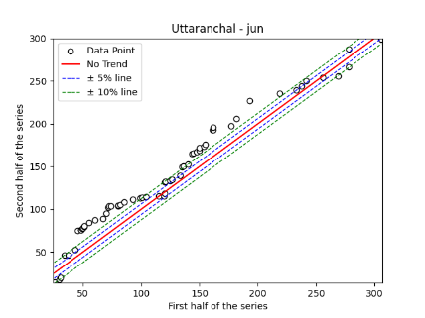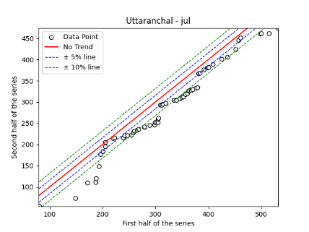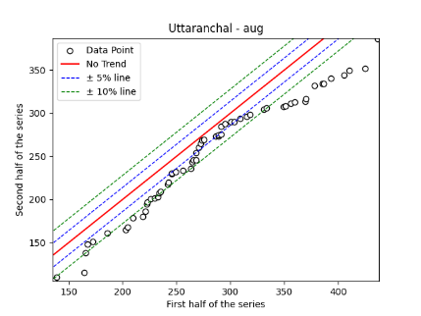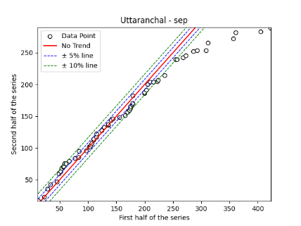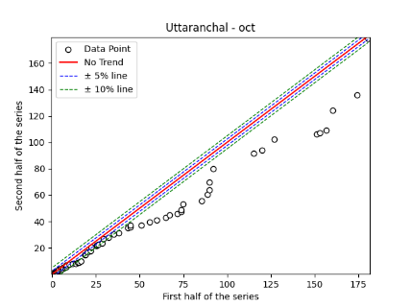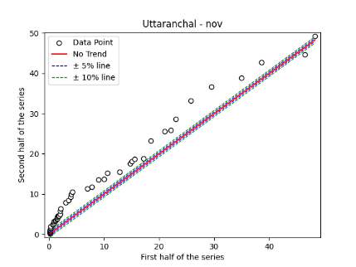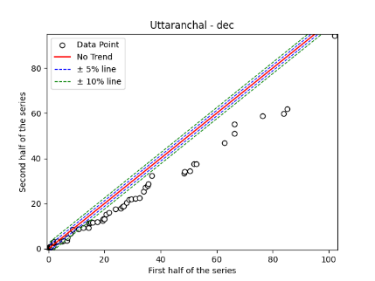
Fig. S29. Annual, Seasonal and Monthly ITA Graphs for Uttaranchal Region

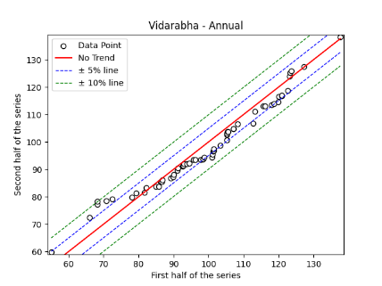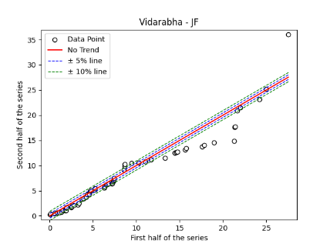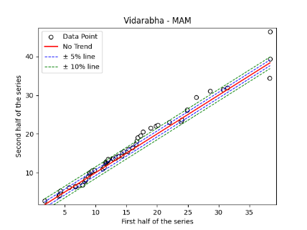
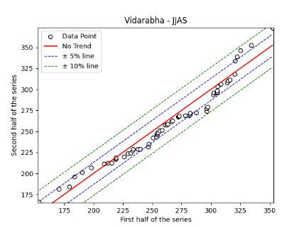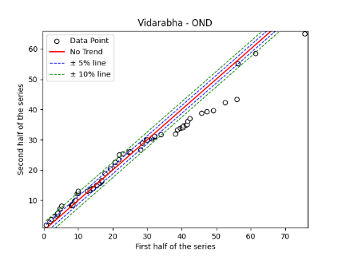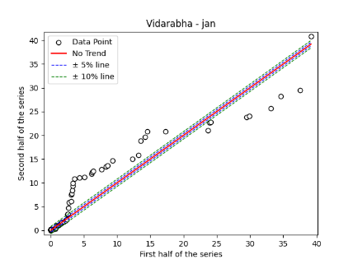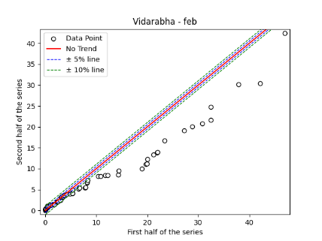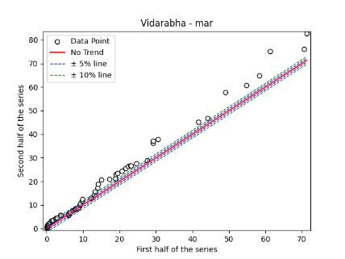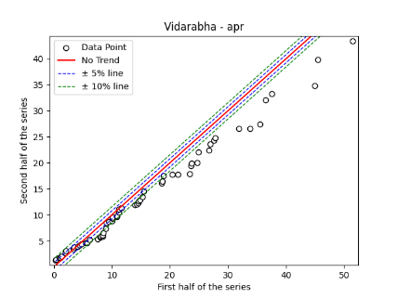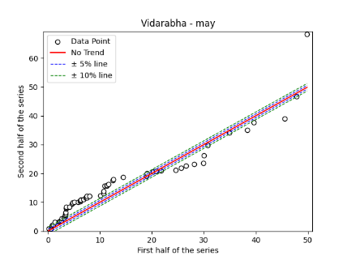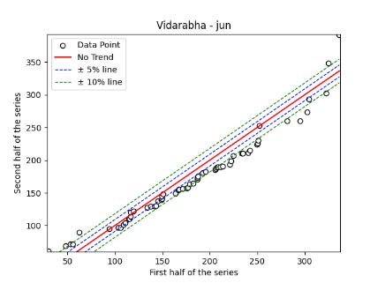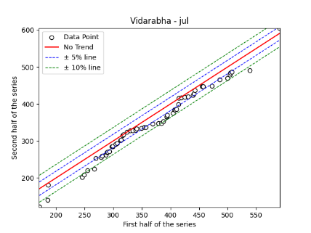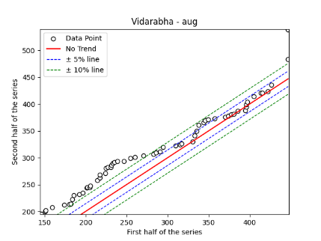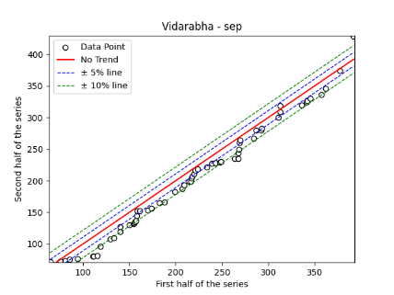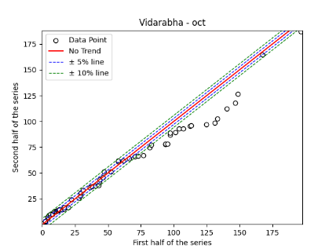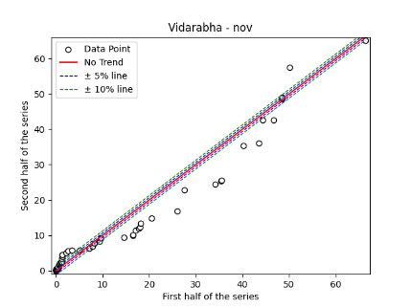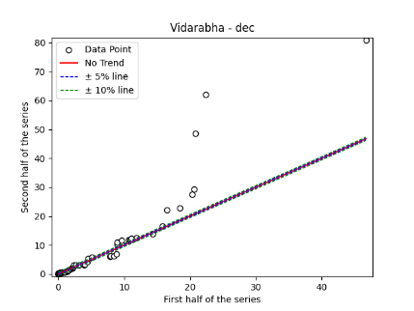
Fig. S30. Annual, Seasonal and Monthly ITA Graphs for Vidharabha Region

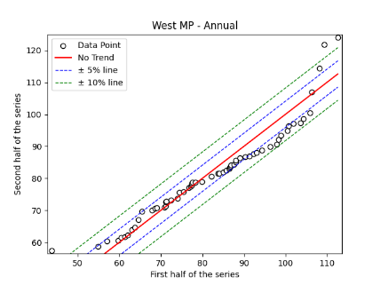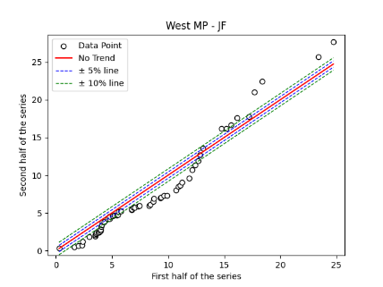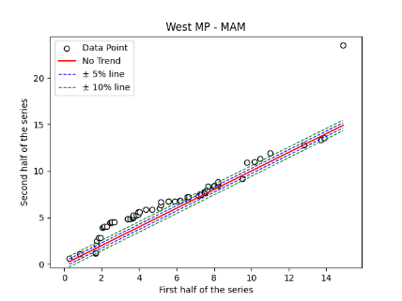
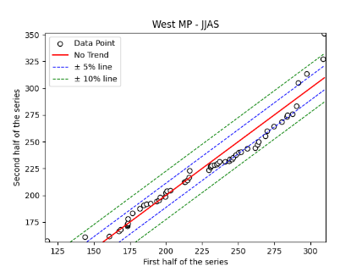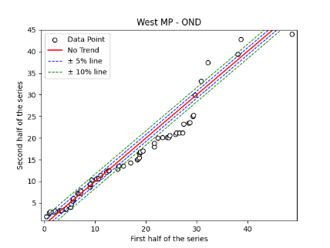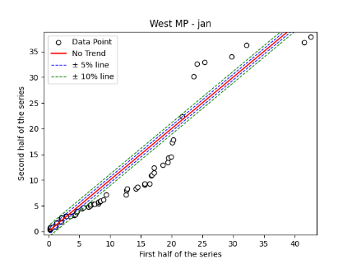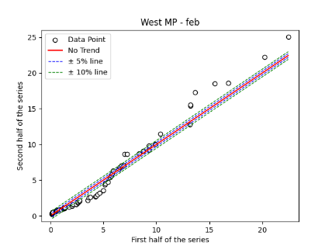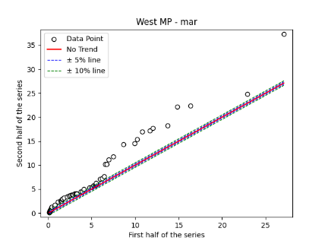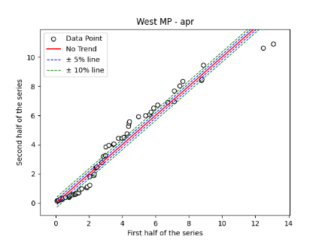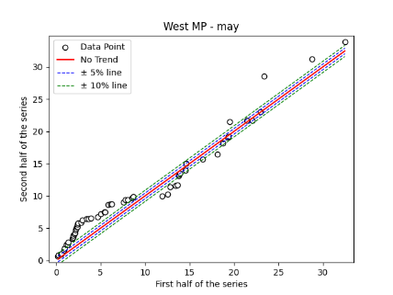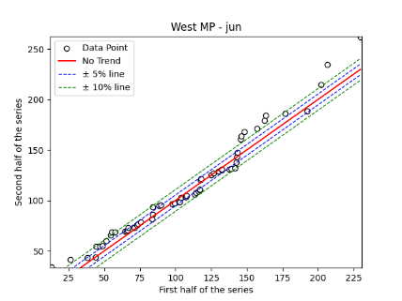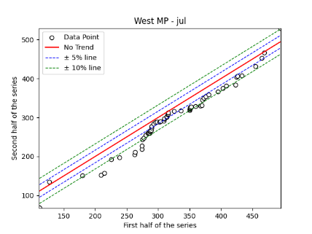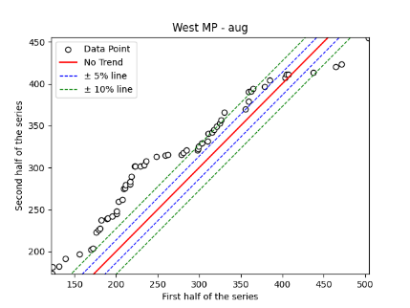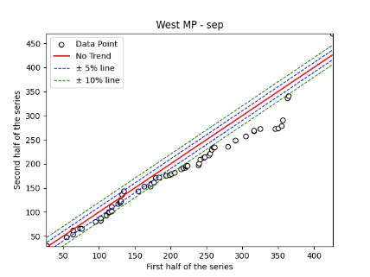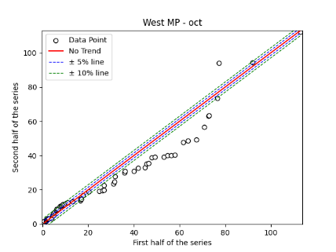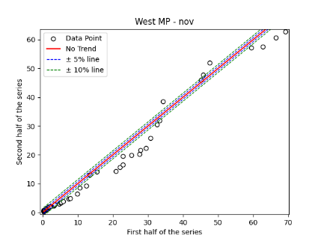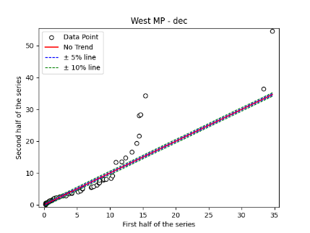
Fig. S31. Annual, Seasonal and Monthly ITA Graphs for Western Uttar Pradesh Region

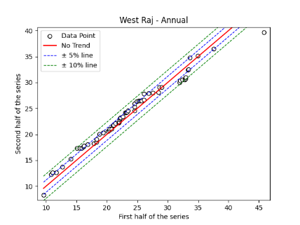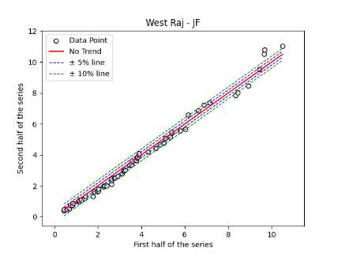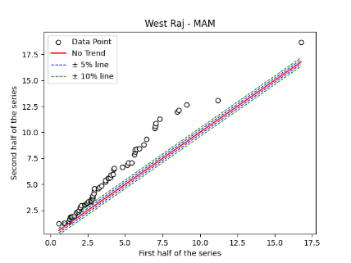

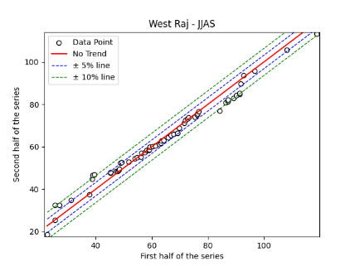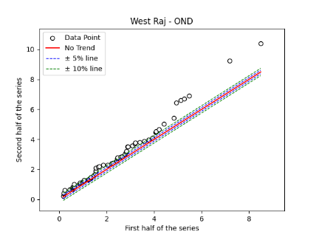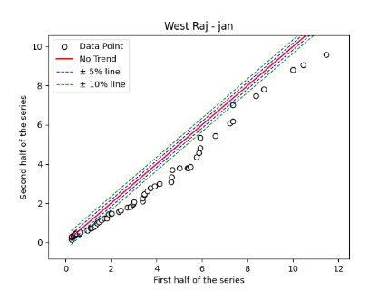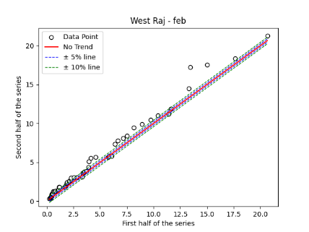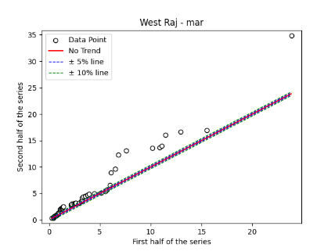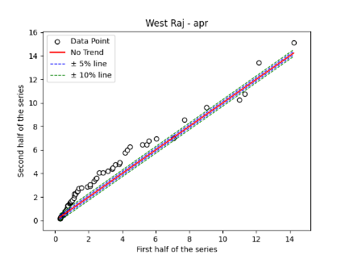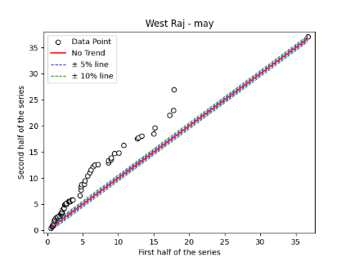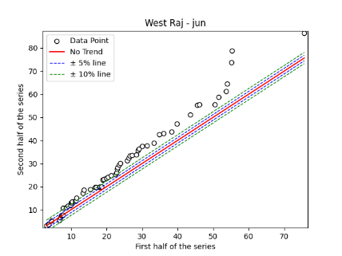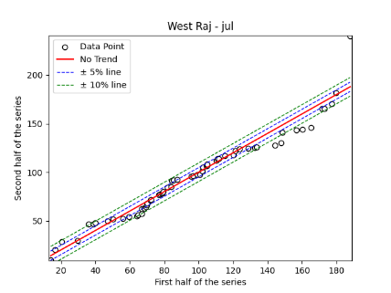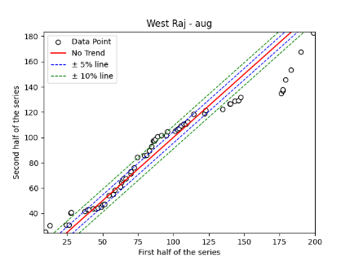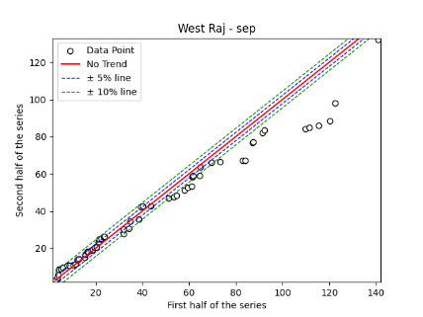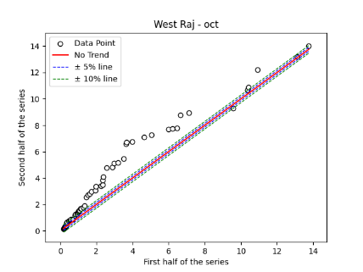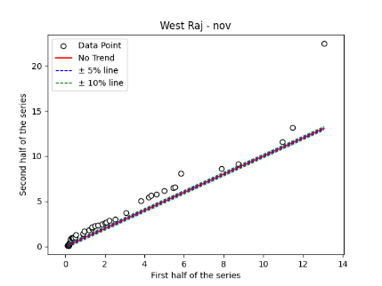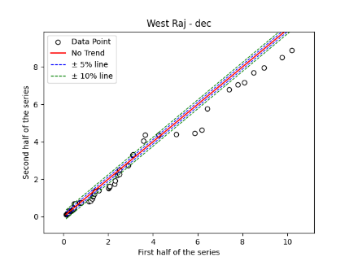
Fig. S32. Annual, Seasonal and Monthly ITA Graphs for Western Rajasthan Region

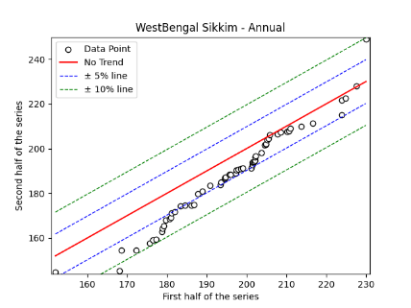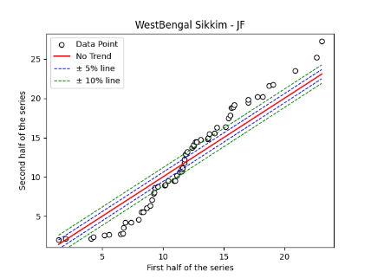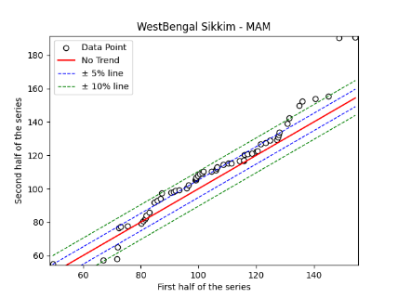
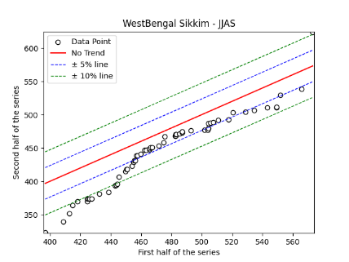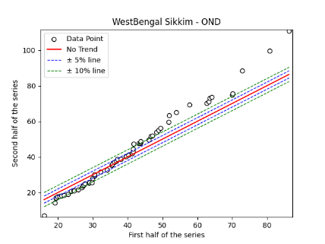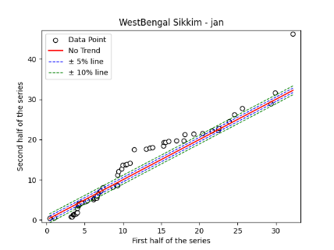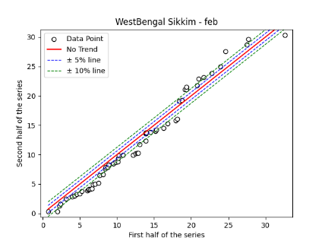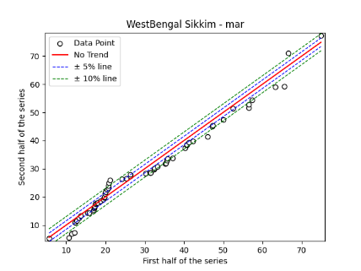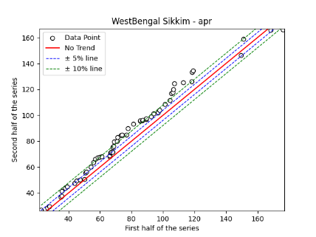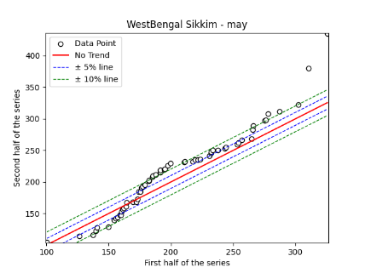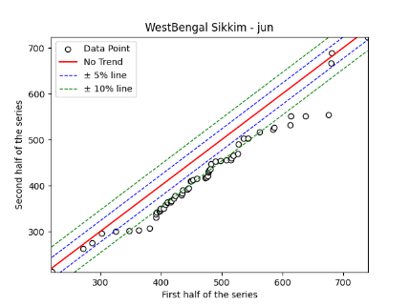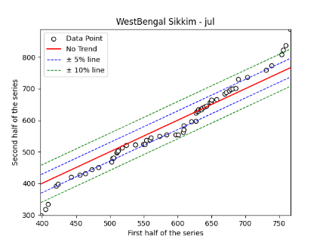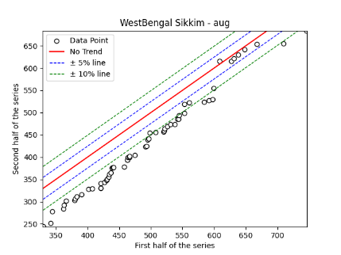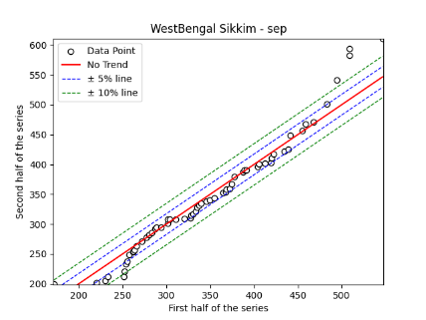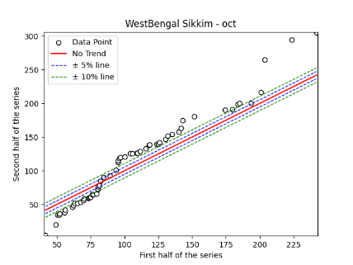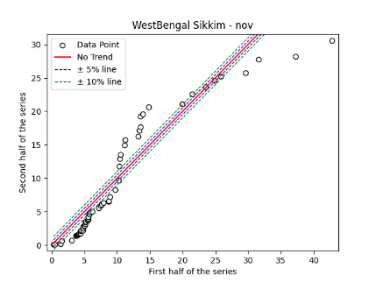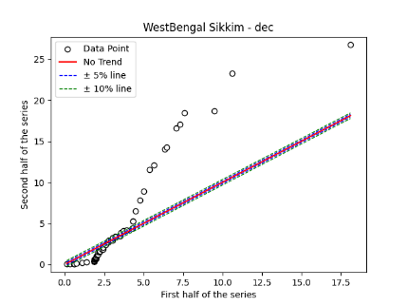
Fig. S33. Annual, Seasonal and Monthly ITA Graphs for West Bengal Sikkim Region

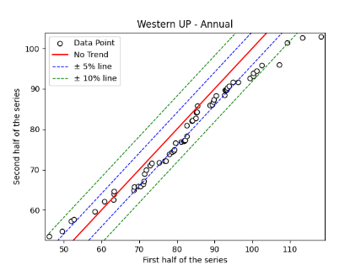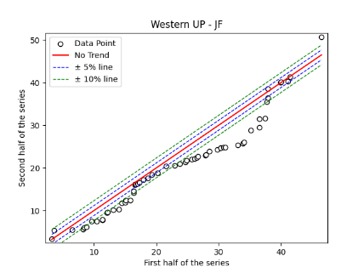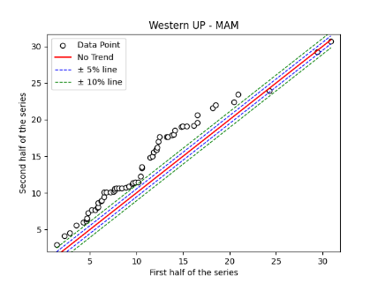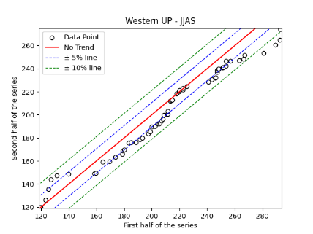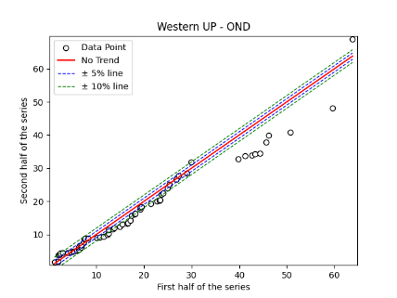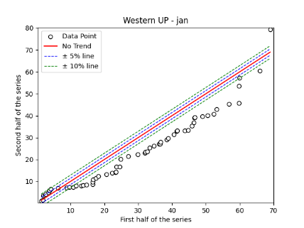

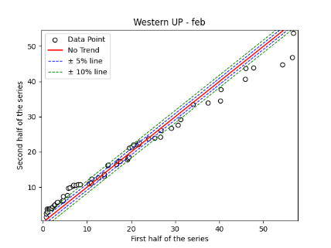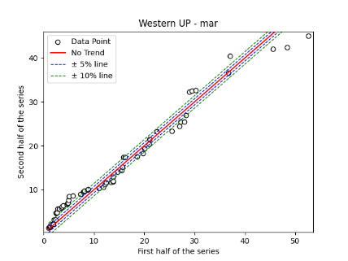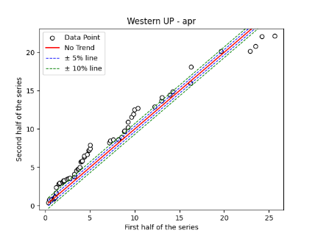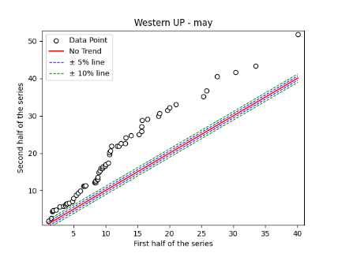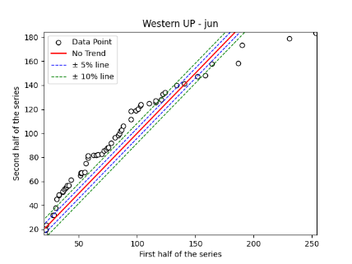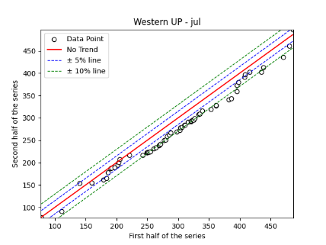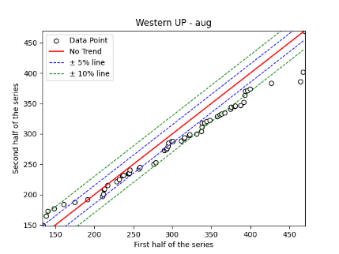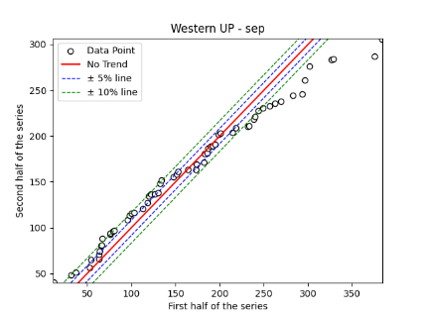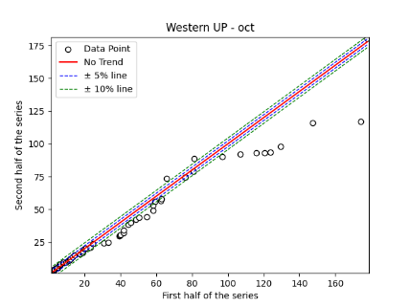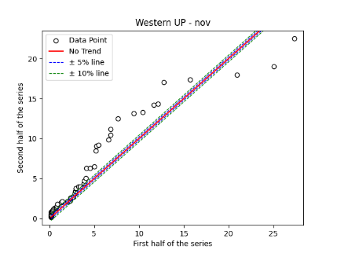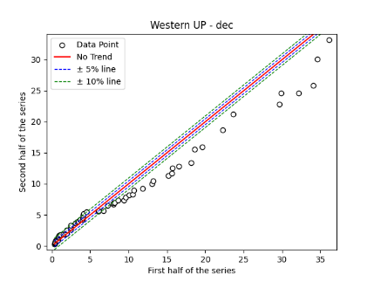
Fig. S34. Annual, Seasonal and Monthly ITA Graphs for Western Uttar Pradesh Region

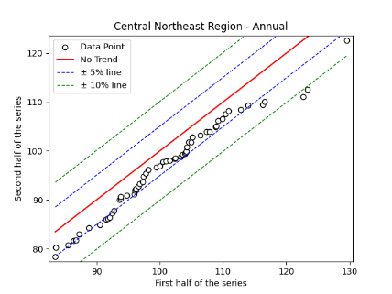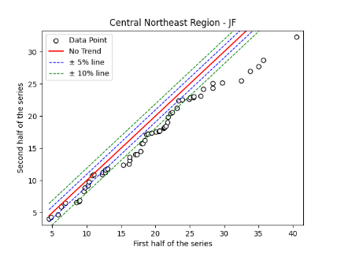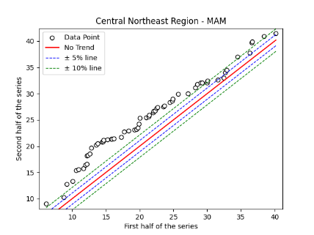
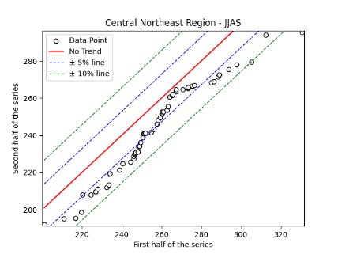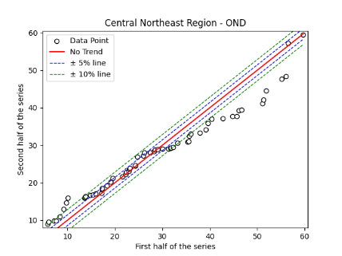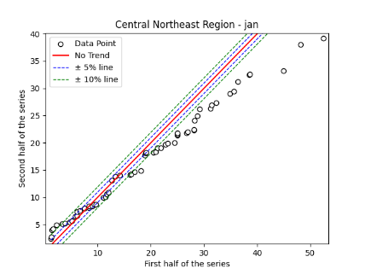
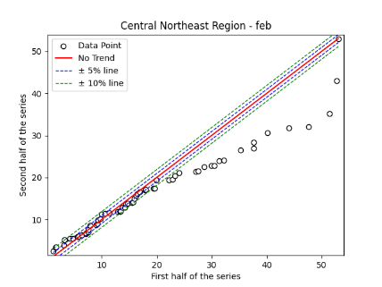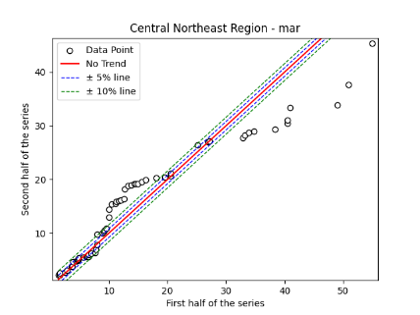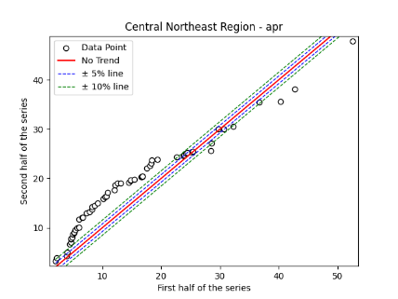
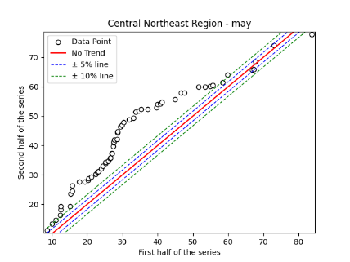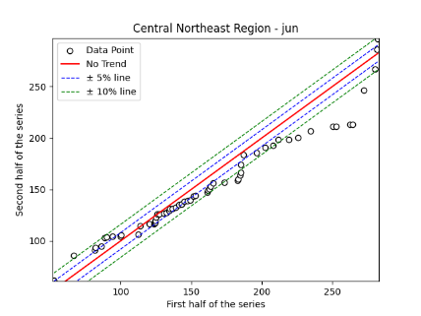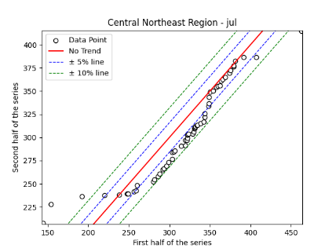
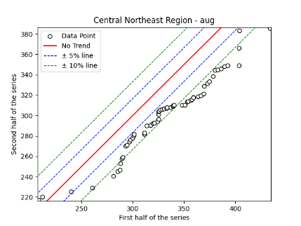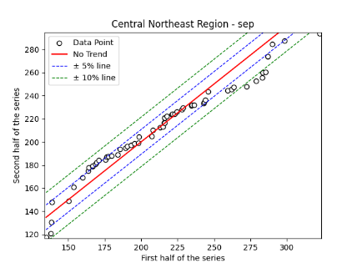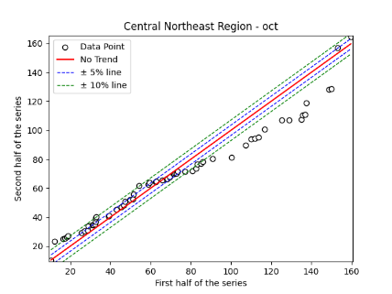
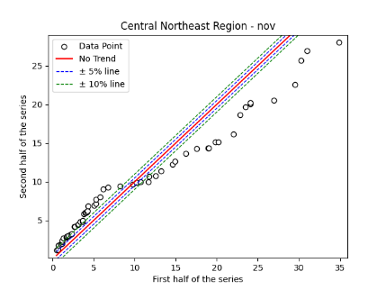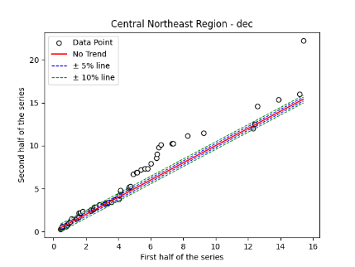
Fig. S35. Annual, Seasonal and Monthly ITA Graphs for Central Northeast Region

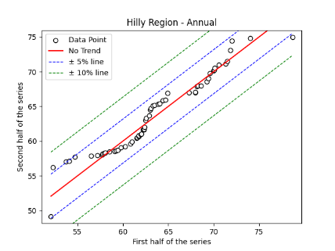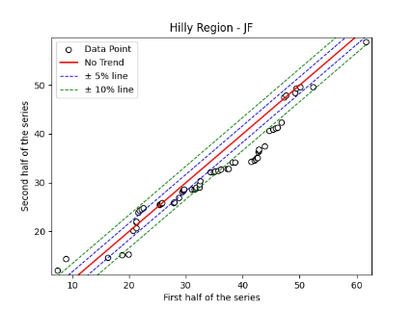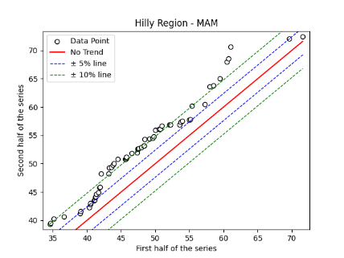
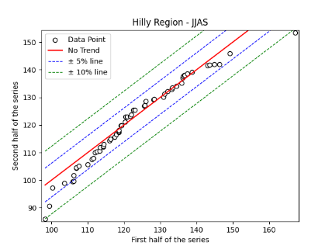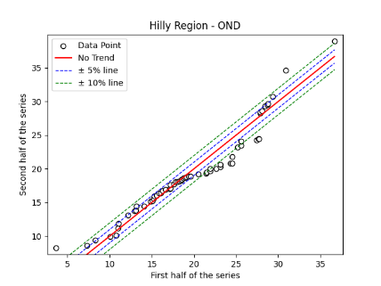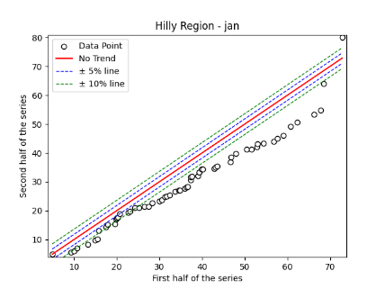
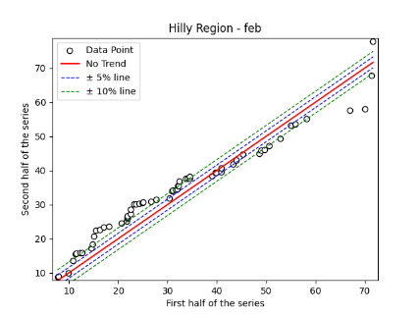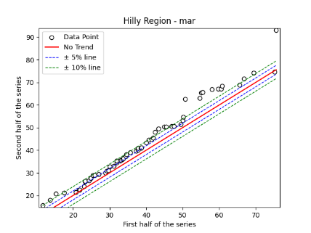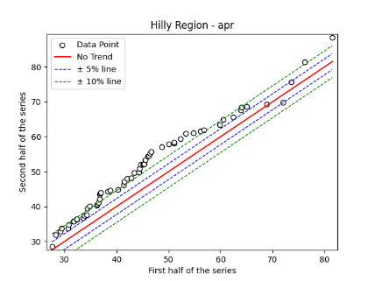
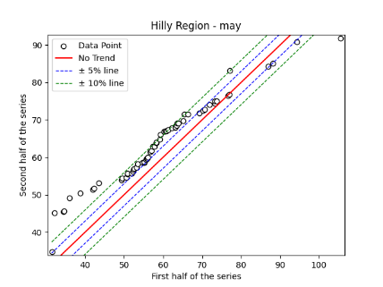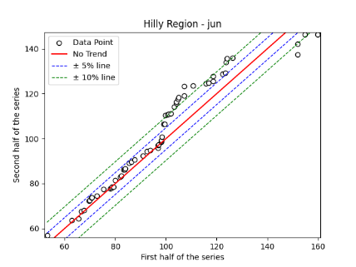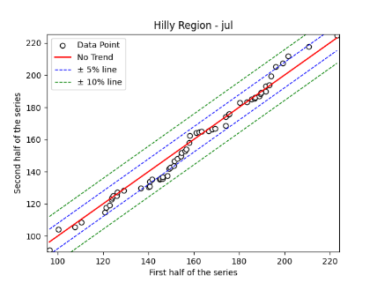
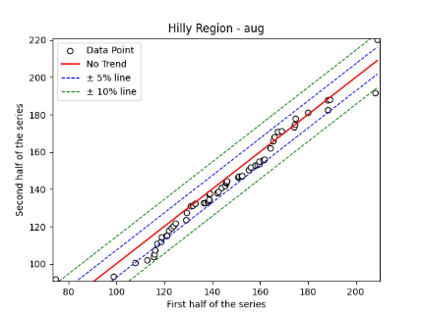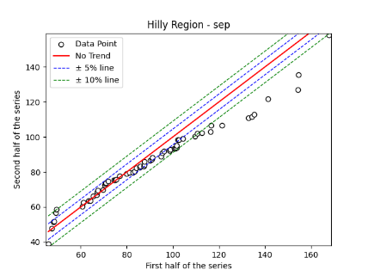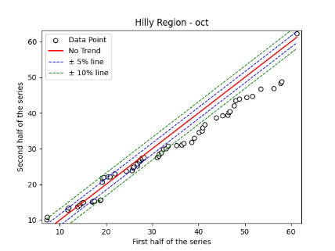
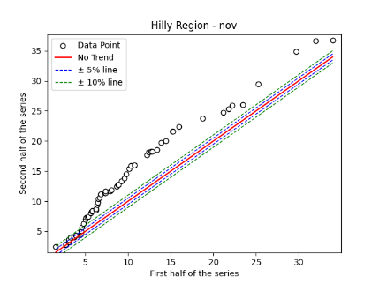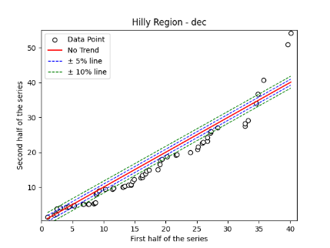
Fig. S36. Annual, Seasonal and Monthly ITA Graphs for Hilly Region

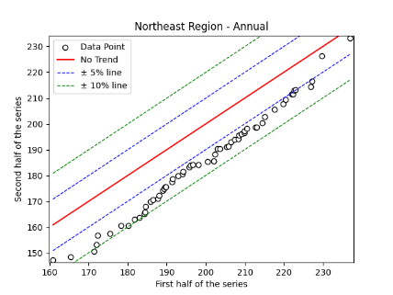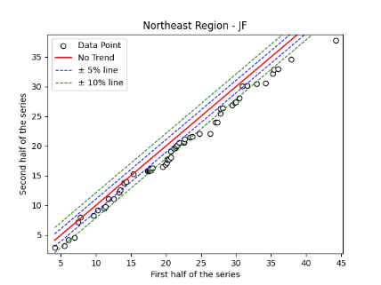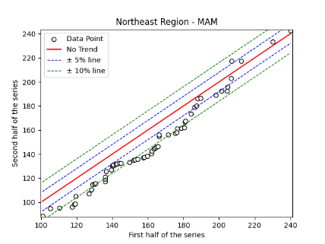
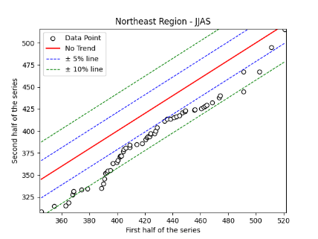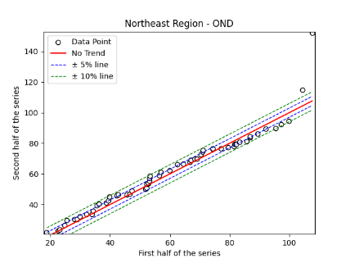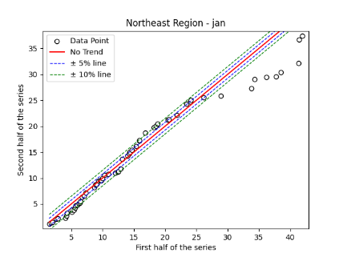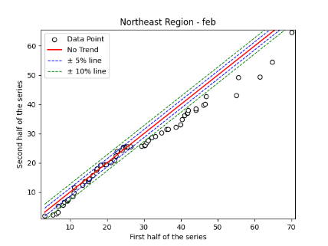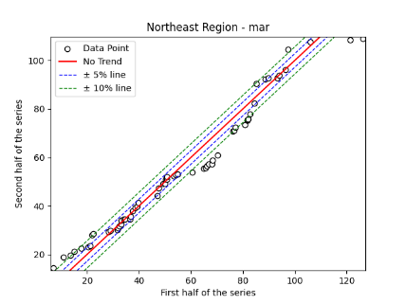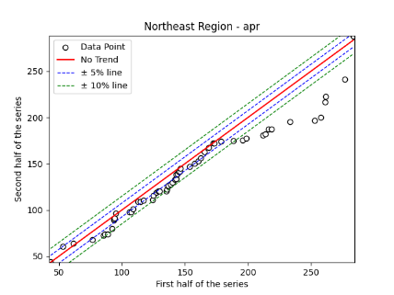
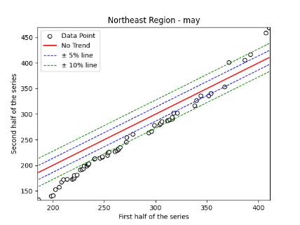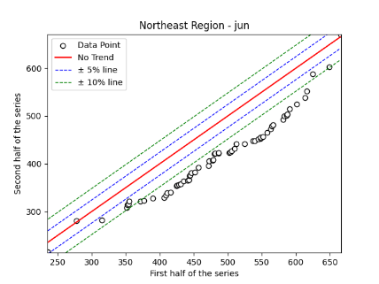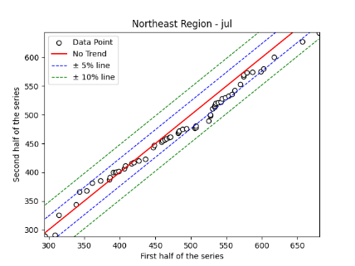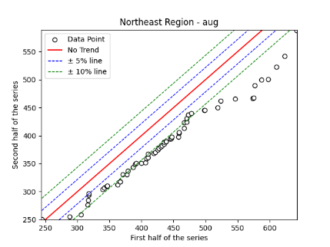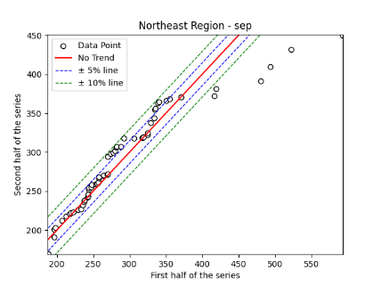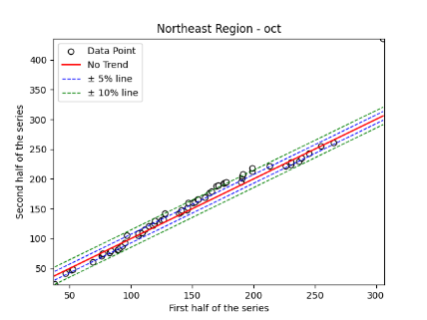
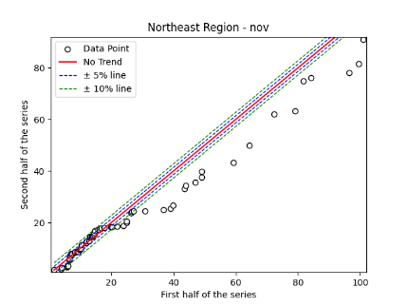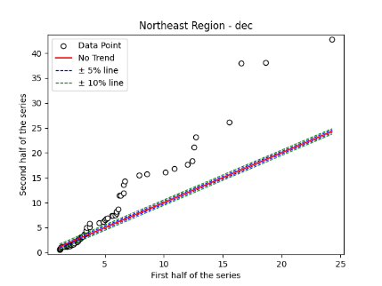
Fig. S37. Annual, Seasonal and Monthly ITA Graphs for Northeast Region

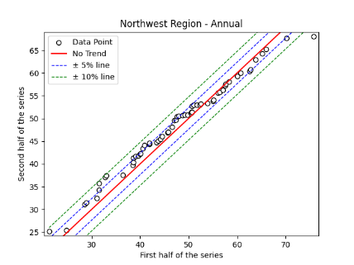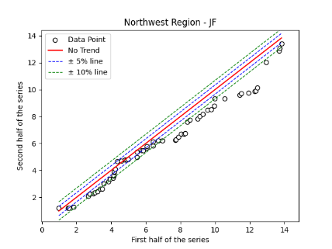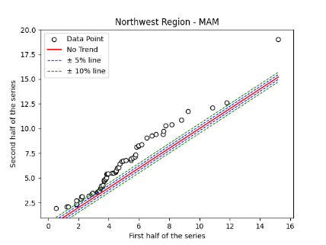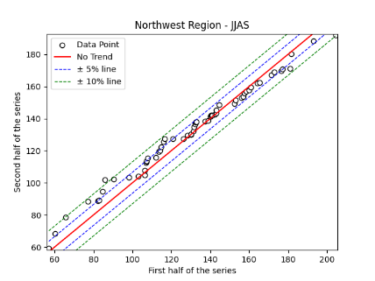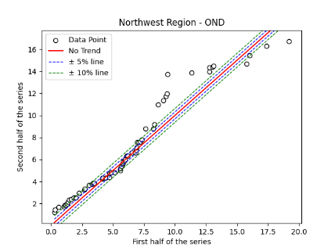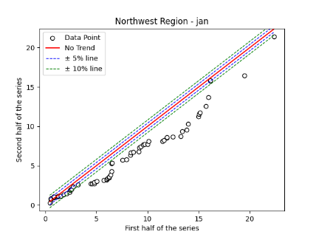
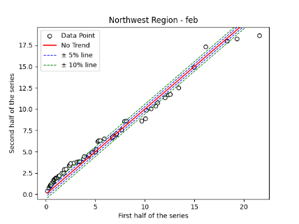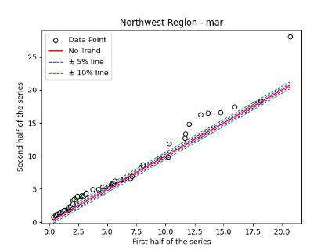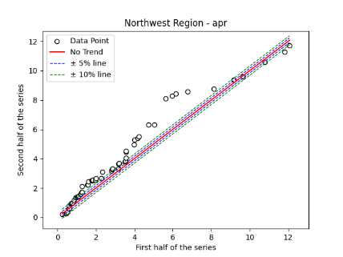
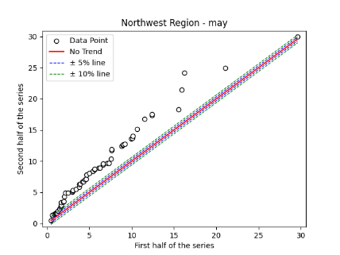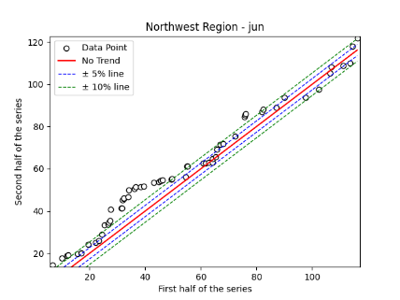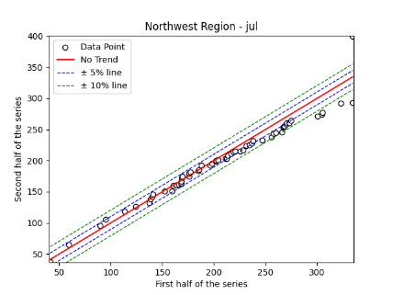
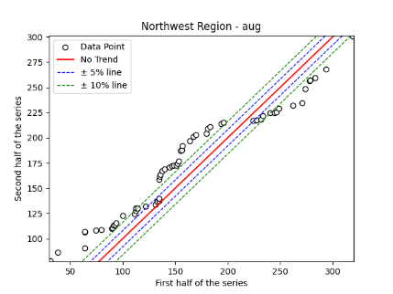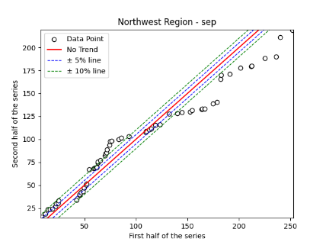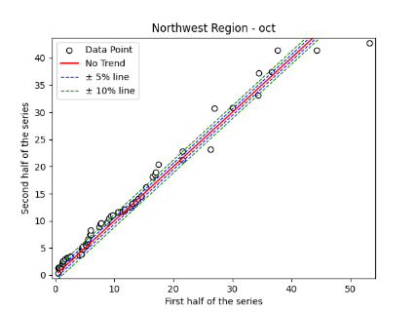
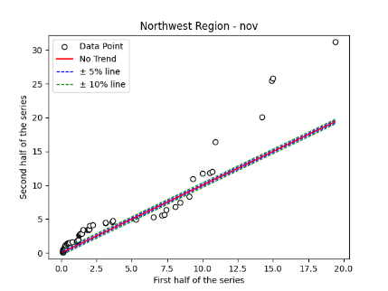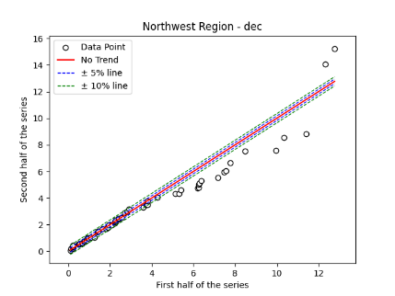
Fig. S38. Annual, Seasonal and Monthly ITA Graphs for Northwest Region

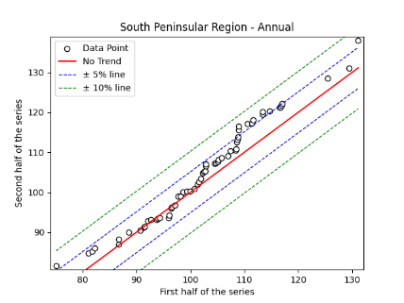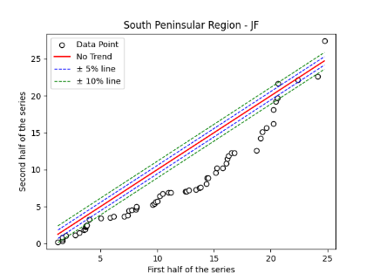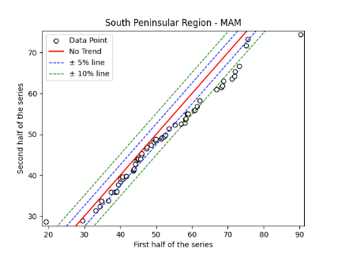
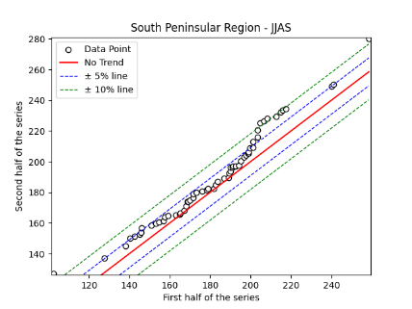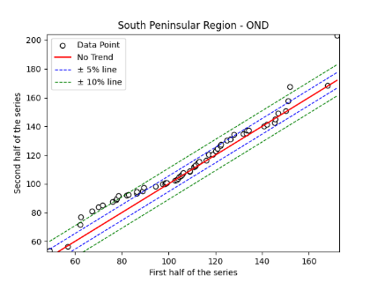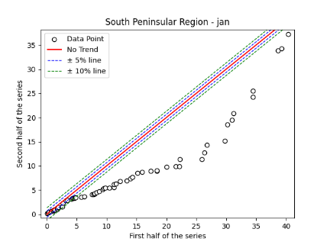
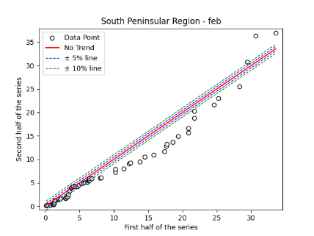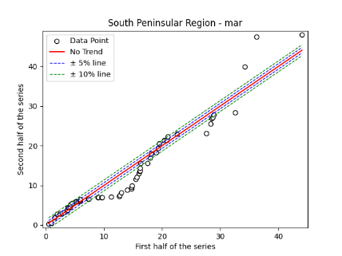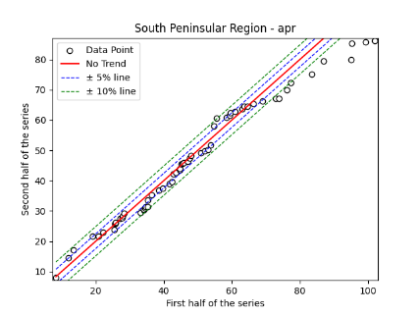
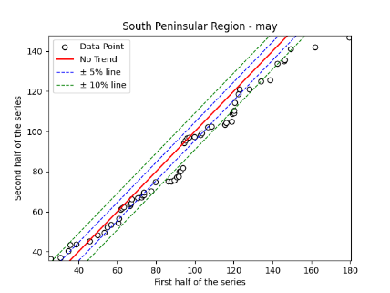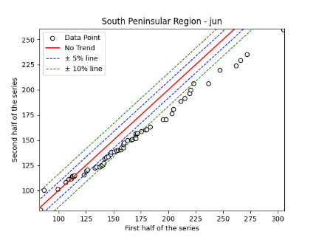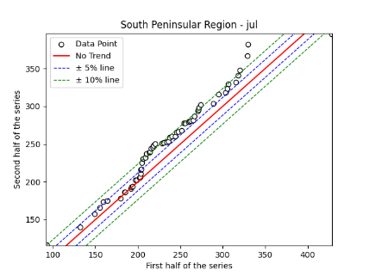
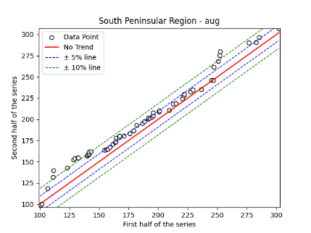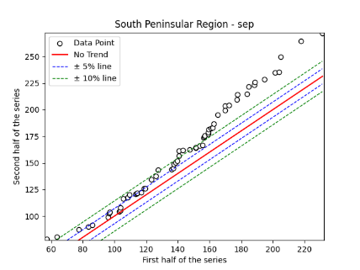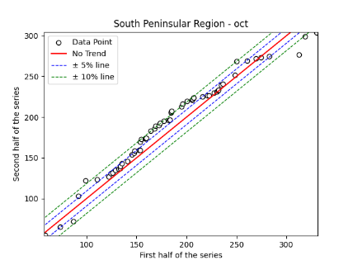
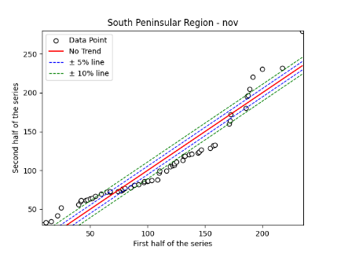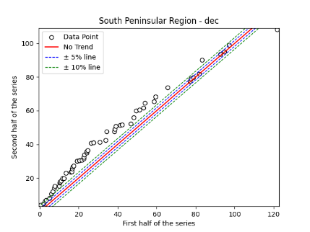
Fig. S39. Annual, Seasonal and Monthly ITA Graphs for South Peninsular Region

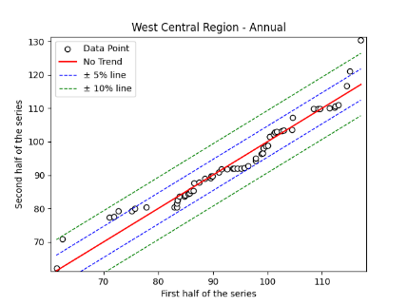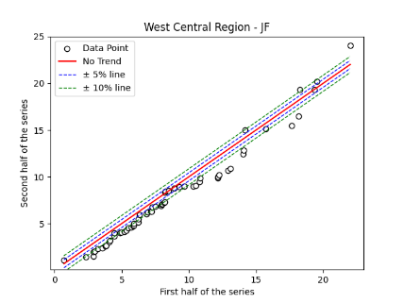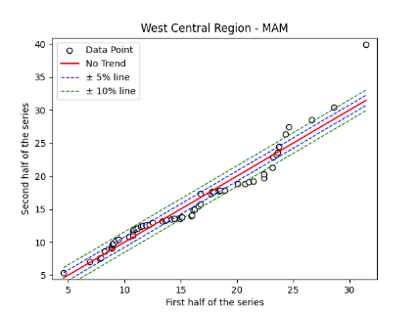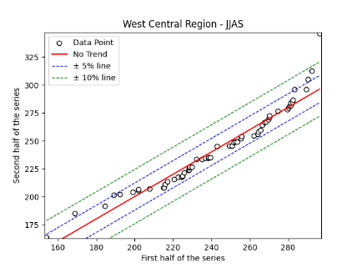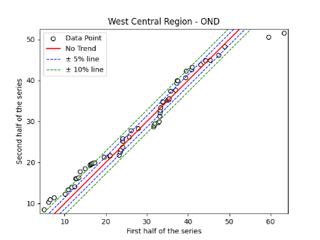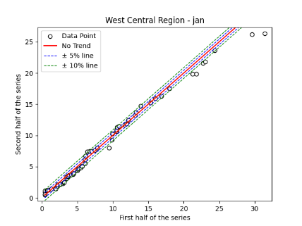
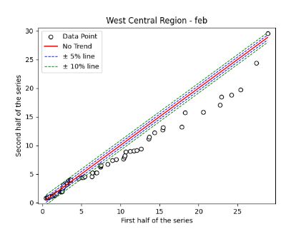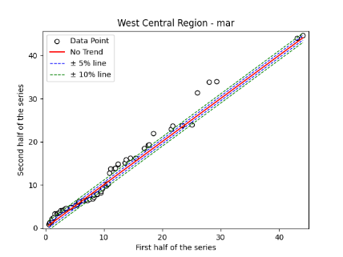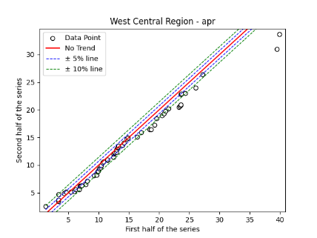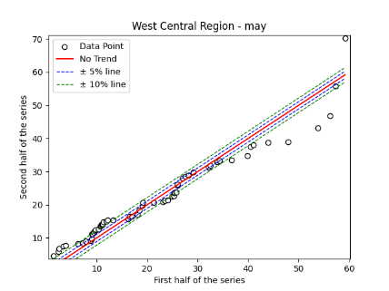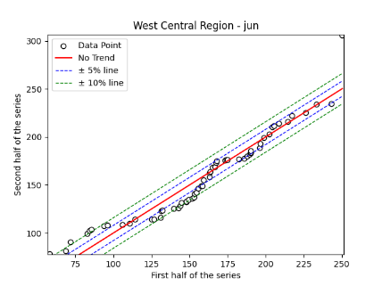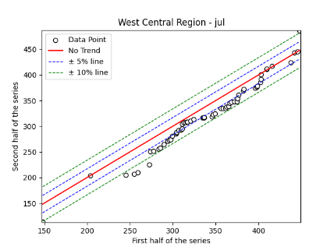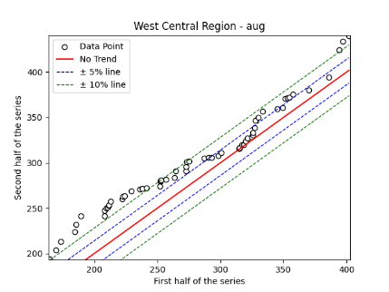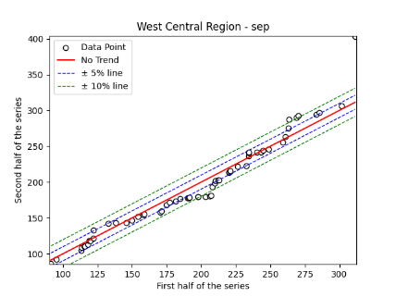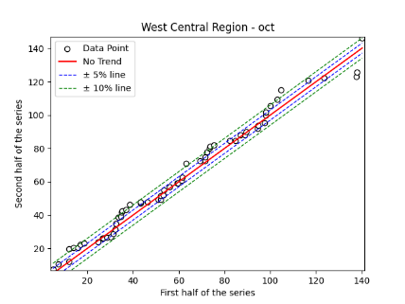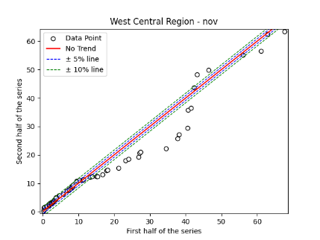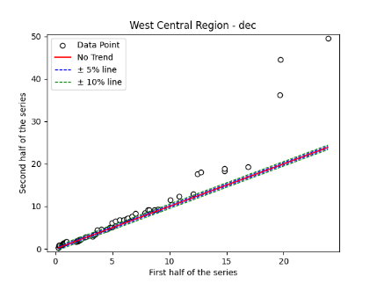
Fig. S40. Annual, Seasonal and Monthly ITA Graphs for West Central Region

Table S5. p-values of the ADF test and the values of p,d,q as identified by auto-arima
Region/Division | ADF Test p-Value | p | d | q
Homogenous Regions
Central Northeast | 6.20E-18 | 0 | 1 | 1
Hilly Regions | 1.47E-07 | 0 | 0 | 2
Northwest | 1.95E-21 | 0 | 0 | 0
Northeast | 1.81E-01 | 2 | 1 | 2
South Peninsular | 4.58E-08 | 0 | 0 | 0
West Central | 2.85E-07 | 2 | 0 | 2
Meteorological Subdivisions
Arunachal Pradesh | 3.4E-02 | 0 | 1 | 4
Assam & Meghalaya | 4.9E-02 | 1 | 1 | 1
Bihar | 8.8E-05 | 0 | 1 | 1
Chhattisgarh | 1.1E-07 | 0 | 0 | 0
Coastal Andhra Pradesh | 1.5E-18 | 4 | 1 | 1
Coastal Karnataka | 1.2E-06 | 0 | 0 | 0
Eastern Madhya Pradesh | 4.8E-18 | 0 | 0 | 0
Eastern Rajasthan | 1.6E-05 | 2 | 0 | 2
Eastern Uttar Pradesh | 1.3E-14 | 0 | 1 | 1
Gangetic West Bengal | 6.8E-18 | 0 | 0 | 1
Gujarat | 2.1E-22 | 0 | 0 | 0
Haryana | 9.6E-08 | 0 | 0 | 0
Himachal Pradesh | 4.0E-24 | 1 | 0 | 0
Jammu & Kashmir | 5.8E-01 | 0 | 1 | 1
Jharkhand | 1.8E-05 | 0 | 1 | 1
Kerala | 1.1E-02 | 0 | 0 | 0
Konkan & Goa | 2.2E-13 | 1 | 0 | 0
Madhya Maharashtra | 9.6E-13 | 1 | 0 | 0
Marathwada | 8.9E-08 | 0 | 1 | 1
Naga, Mani, Mizo & Tripura | 2.3E-01 | 1 | 1 | 1
North Interior Karnataka | 2.2E-11 | 1 | 0 | 0
Orissa | 2.4E-21 | 0 | 0 | 0
Punjab | 3.6E-04 | 0 | 1 | 1
Rayalaseema | 3.0E-08 | 0 | 1 | 1
Saurashtra & Kutch | 1.2E-19 | 0 | 0 | 0
South Interior Karnataka | 2.7E-07 | 0 | 0 | 3
Tamil Nādu | 1.5E-19 | 0 | 0 | 0
Telangana | 8.6E-18 | 0 | 1 | 1
Uttaranchal | 5.8E-05 | 0 | 0 | 0
Vidarbha | 5.9E-08 | 0 | 0 | 0
Western Madhya Pradesh | 1.6E-07 | 2 | 0 | 2
Western Rajasthan | 1.6E-19 | 0 | 0 | 0
West Bengal & Sikkim | 1.3E-14 | 0 | 1 | 1
Western Uttar Pradesh | 1.6E-06 | 2 | 0 | 2

Table S6. Rainfall Forecast up to 2050 using ARIMA
Sl. No | Meteorological Sub-Division | ARIMA Forecasting
1. | Arunachal Pradesh | 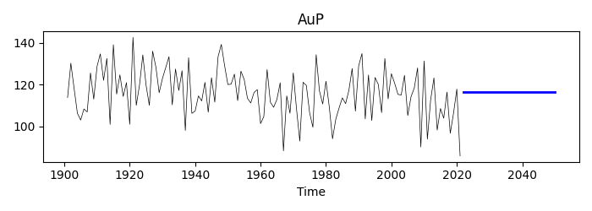
2. | Assam Meghalaya | 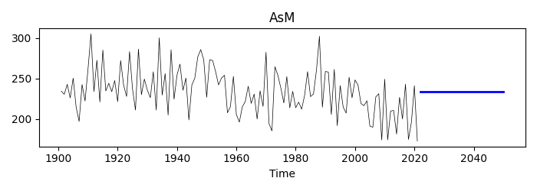
3. | Bihar | 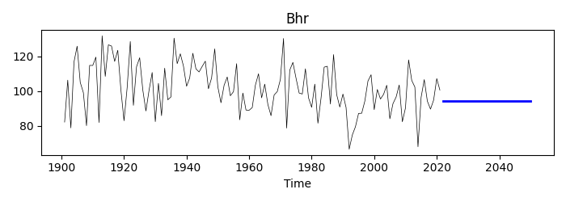
4. | Coastal Andhra Pradesh | 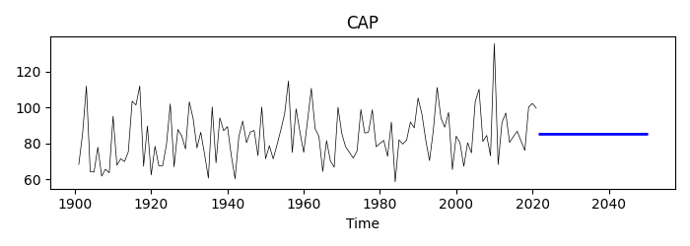
5. | Chhattisgarh | 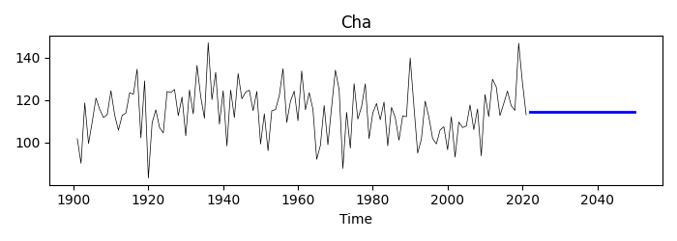
6. | Coastal Karnataka | 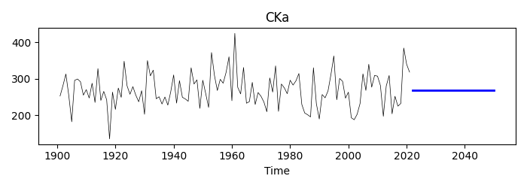
7. | East Madhya Pradesh | 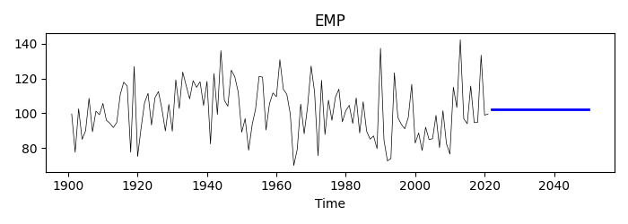
8. | Eastern Rajasthan | 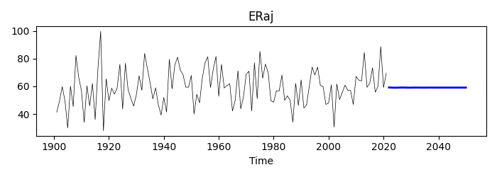
9. | Eastern UP | 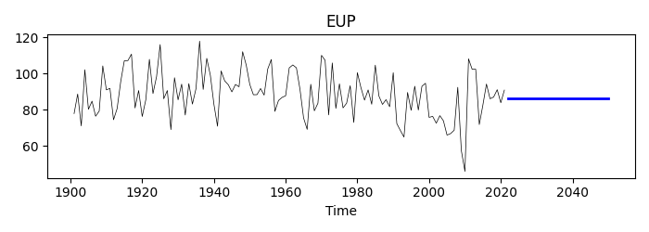
10. | Gujarat | 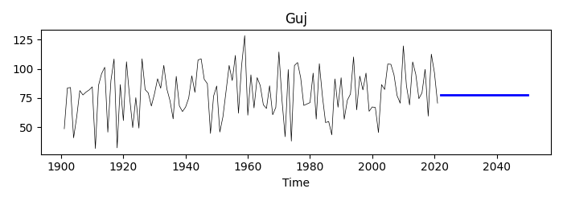
11. | Gangetic west Bengal | 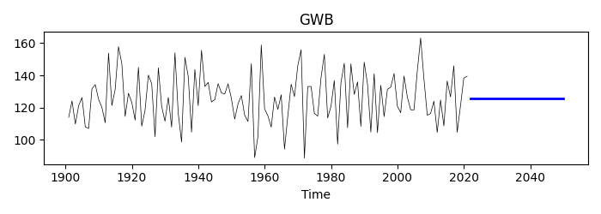
12. | Haryana | 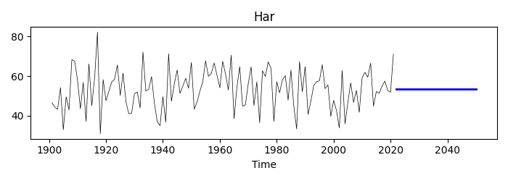
13. | Himanchal Pradesh | 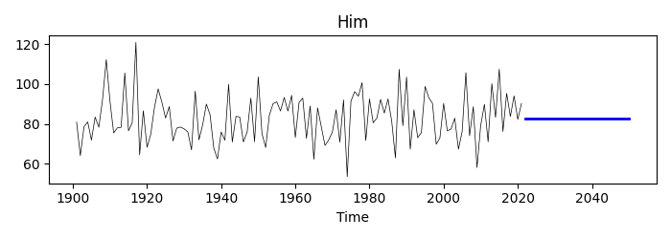
14. | Jammu and Kashmir | 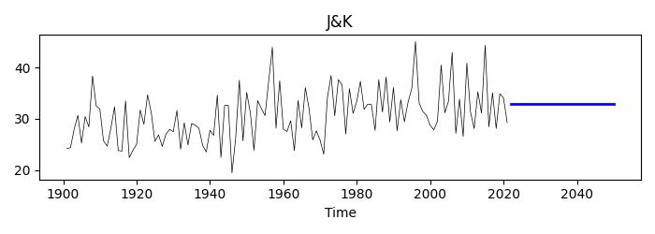
15. | Jharkhand | 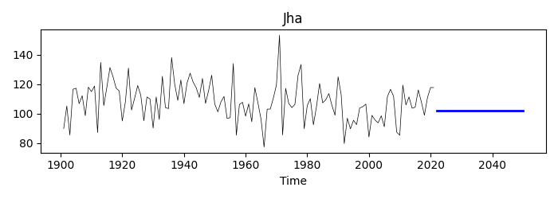
16. | Kerala | 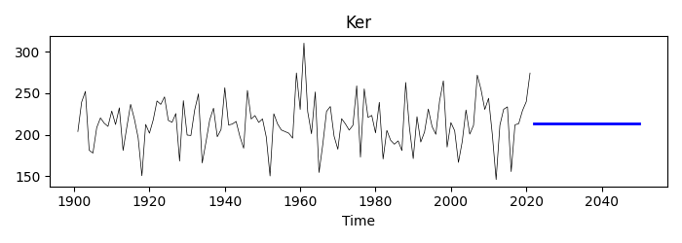
17. | Konkan goa | 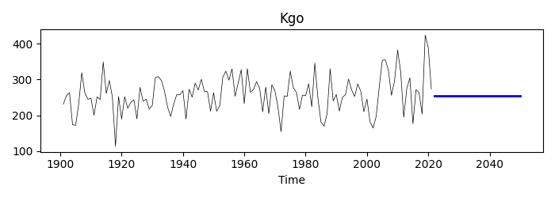
18. | Marathwada | 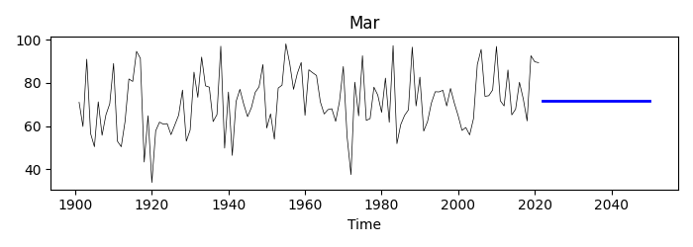
19. | Madhya Maharashtra | 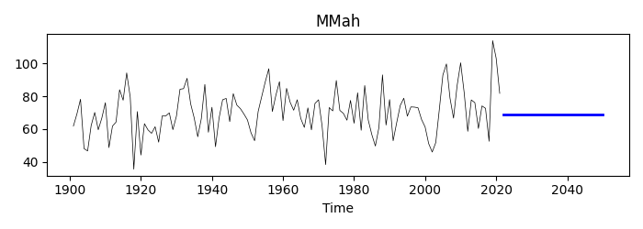
20. | North interior Karnataka | 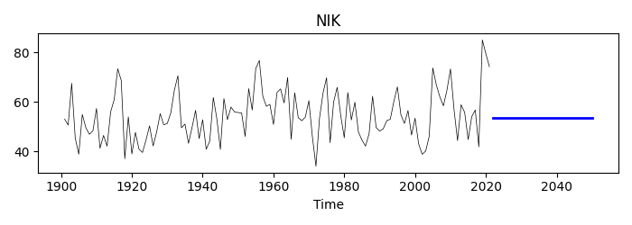
21. | NMMT | 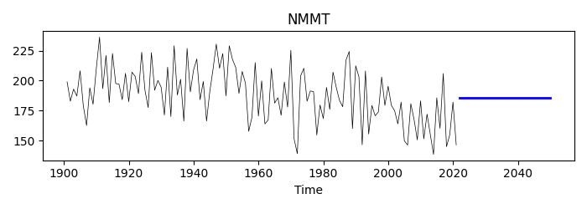
22. | Odisha | 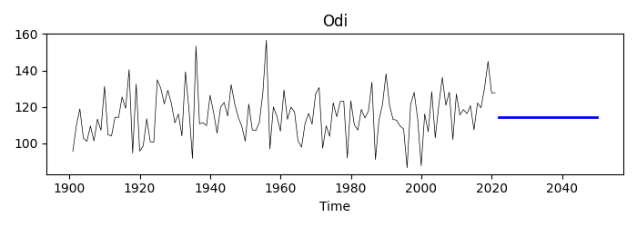
23. | Punjab | 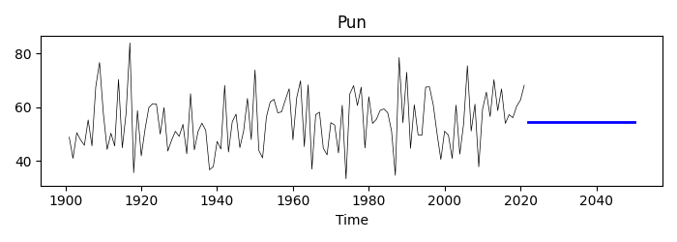
24. | Rayalaseema | 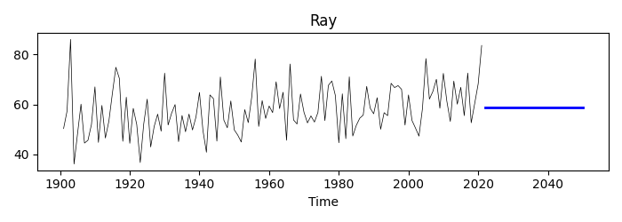
25. | Saurashtra Kutch | 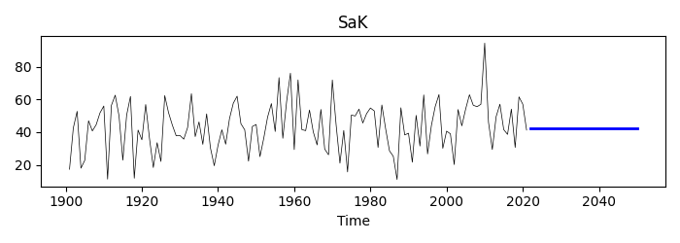
26. | South interior Karnataka | 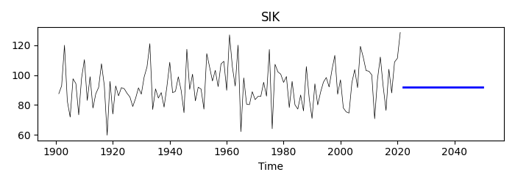
27. | Telangana | 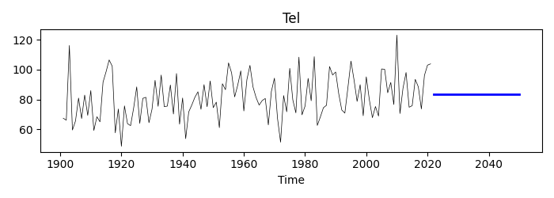
28. | Tamil nadu | 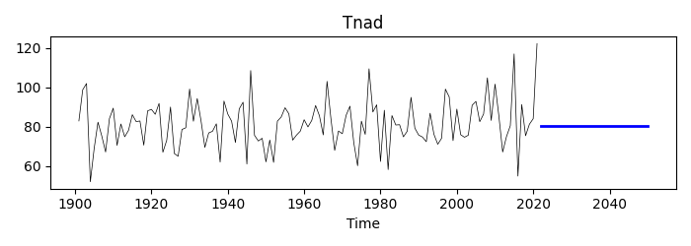
29. | Uttarakhand | 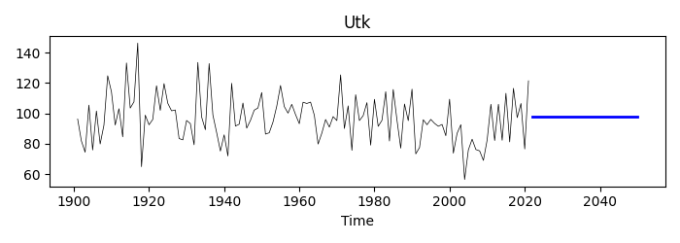
30. | Vidarbha | 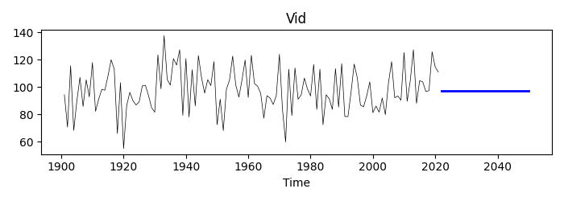
31. | West Bengal Sikkim | 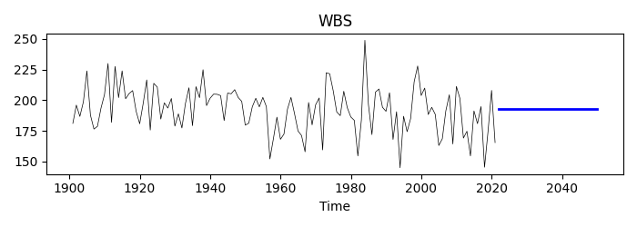
32. | Western Madhya Pradesh | 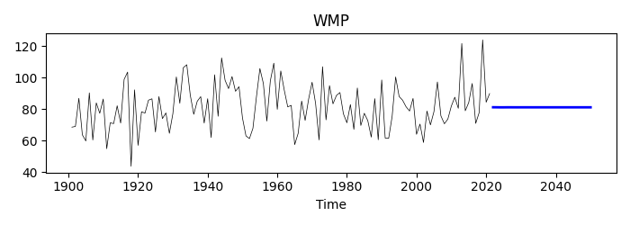
33. | Western Rajasthan | 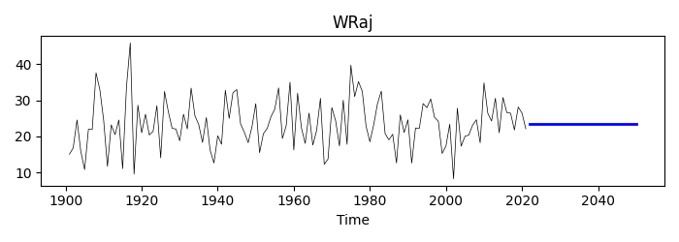
34. | Western UP | 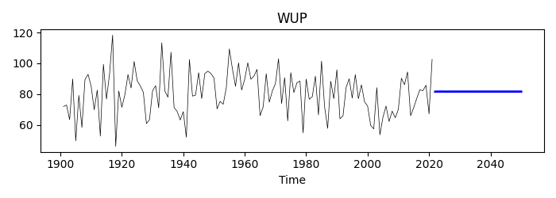

HOMOGENEOUS REGIONS
ARIMA RESULT

1. | Central northeast | 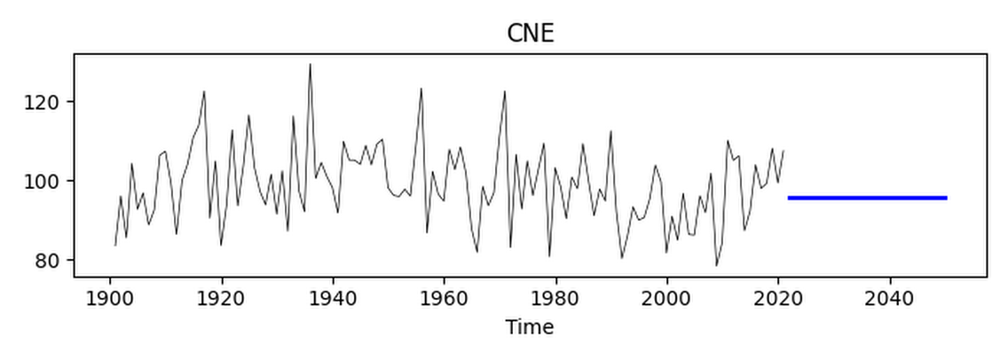
2. | Hilly regions | 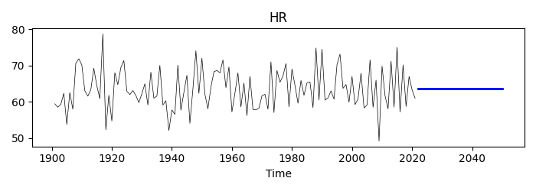
3. | Northeast | 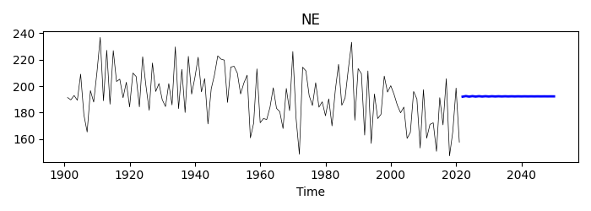
4. | Northwest | 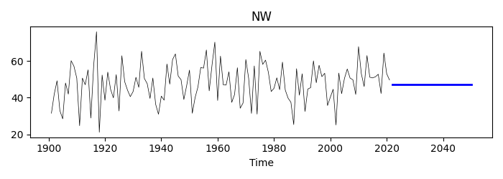
5. | South peninsular | 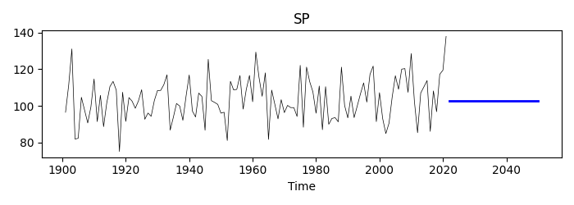
6. | West central | 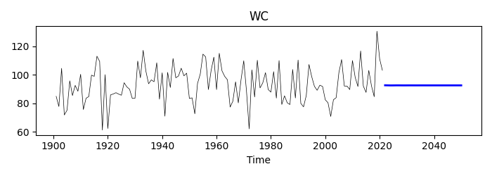

Table S7. Rainfall Forecast up to 2050 using ANN-MLP
Sl. No | Meteorological Sub-Division | ANN Forecasting | RMSE, MAE
1. | Arunachal Pradesh | 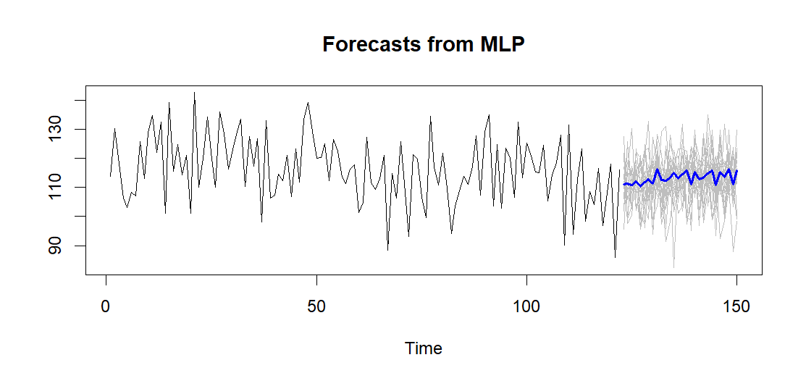 | 7.32482, 5.823699
2. | Assam & Meghalaya | 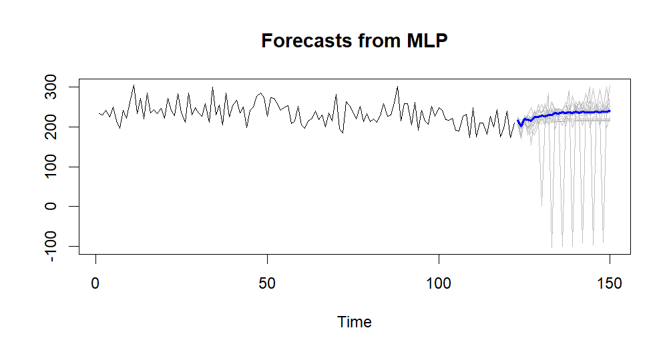 | 25.07557, 19.97715
3. | Bihar | 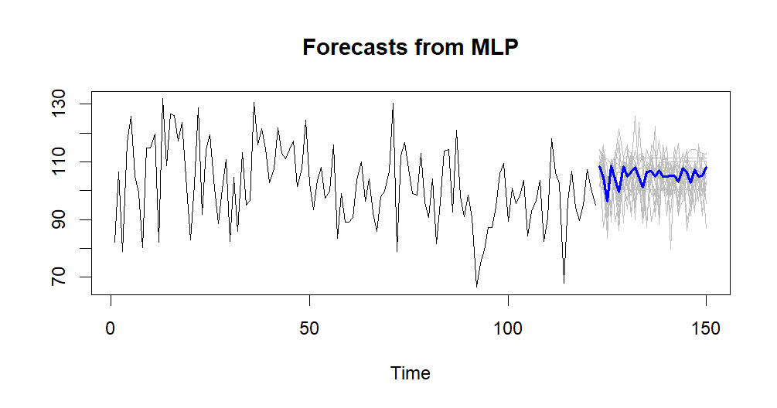 | 10.30539, 8.317737
4 | Chhattisgarh | 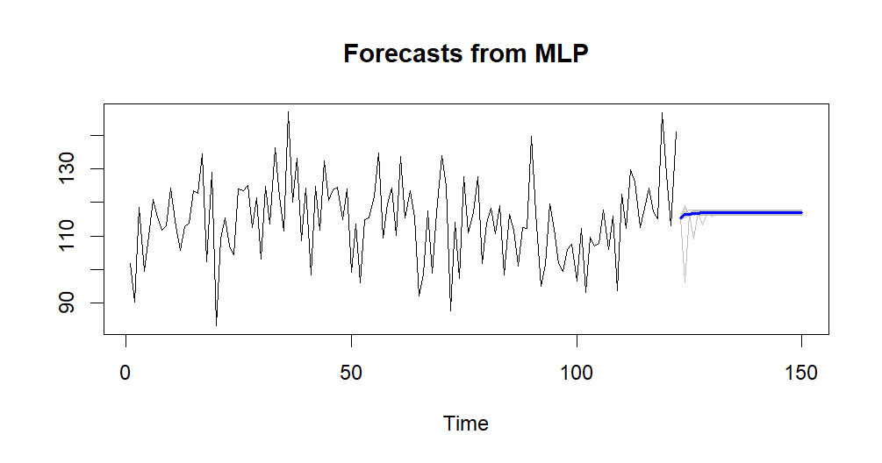 | 11.44806, 9.063777
5. | Coastal Andhra Pradesh | 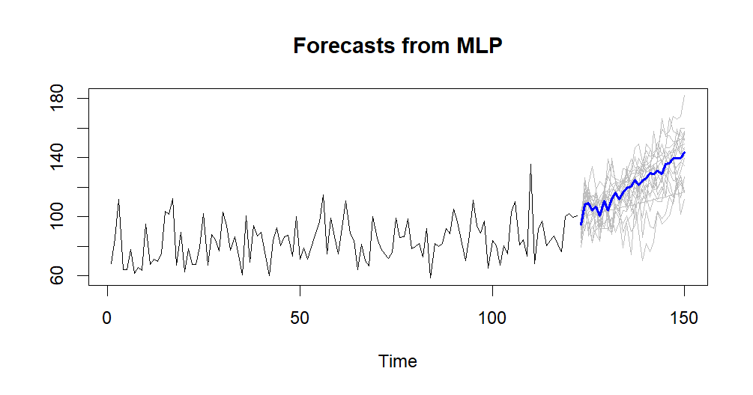 | 11.06768, 8.481585
6. | Coastal Karnataka | 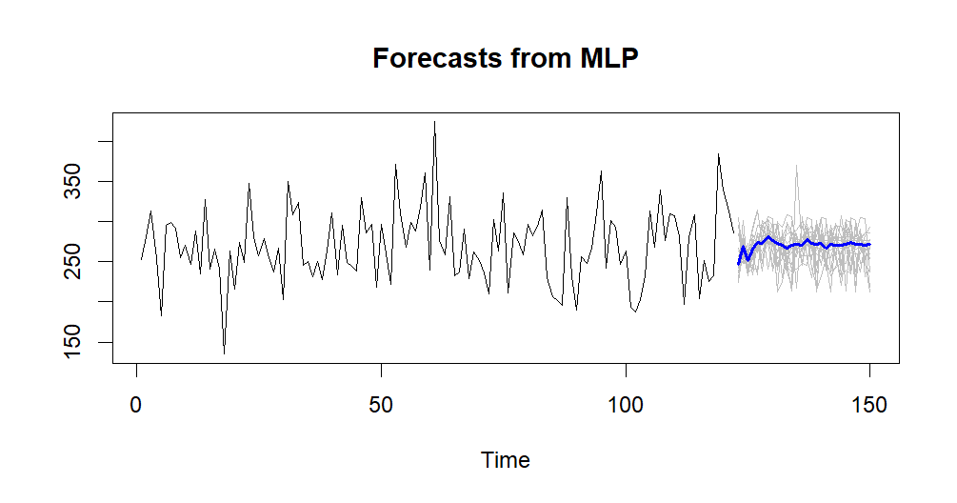 | 40.42534, 32.8455
7. | Eastern Madhya Pradesh | 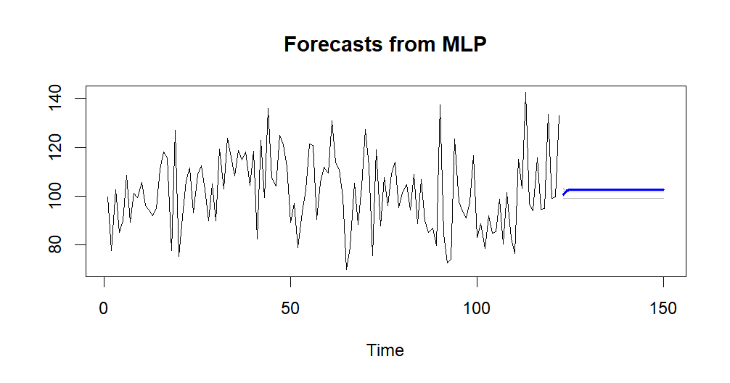 | 15.59138, 12.79201
8. | Eastern Rajasthan | 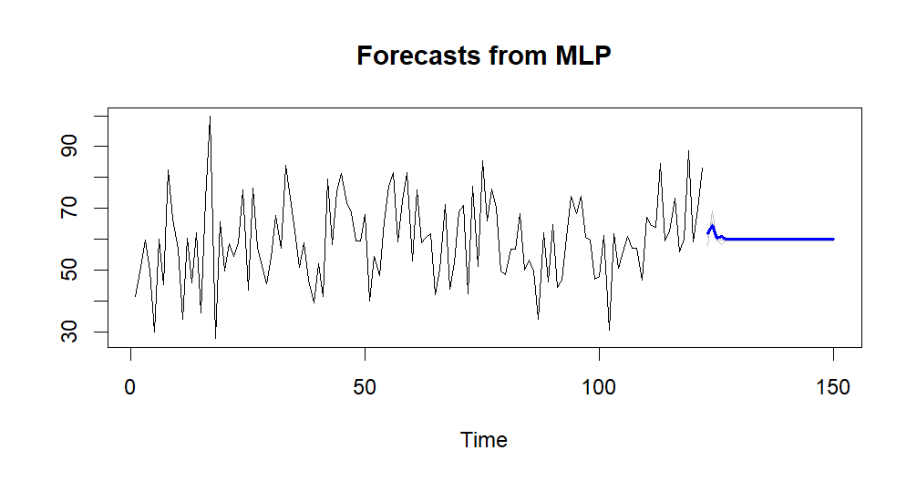 | 13.24988, 10.3598
9. | Eastern Uttar Pradesh | 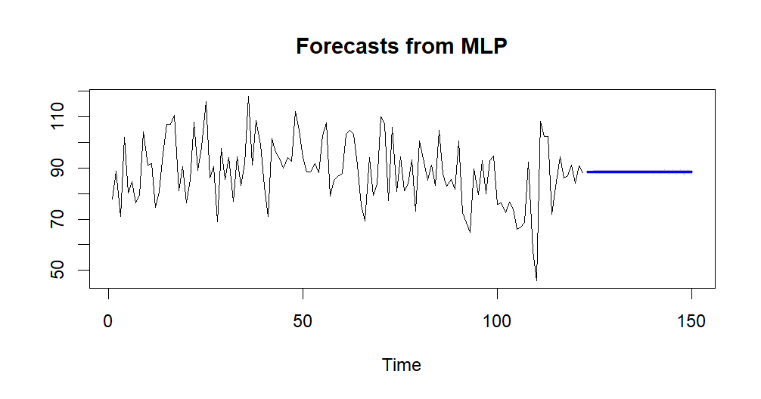 | 13.24988, 10.3598
10. | Gangetic West Bengal | 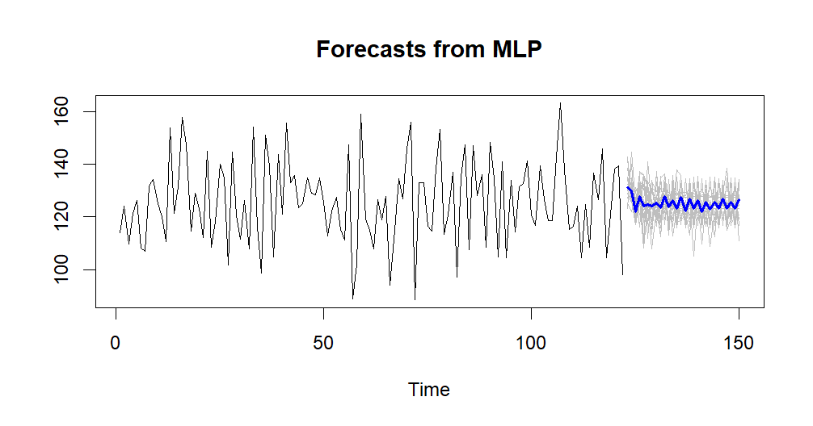 | 13.43176, 10.83052
11. | Gujarat | 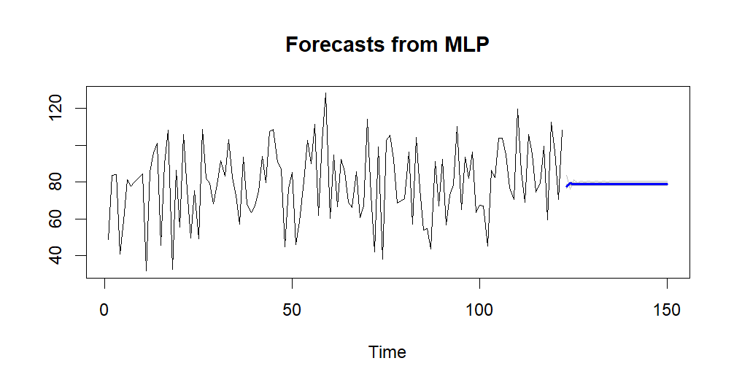 | 20.00238, 16.1644
12. | Haryana | 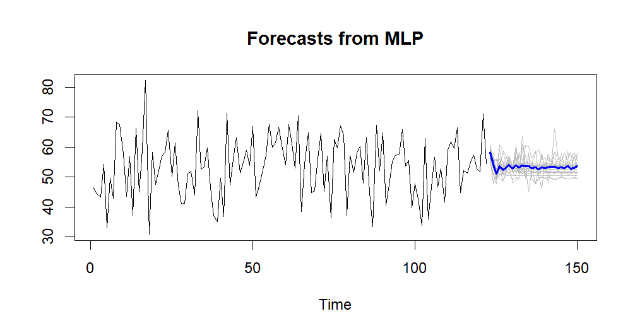 | 8.78441, 7.154583
13. | Himachal Pradesh | 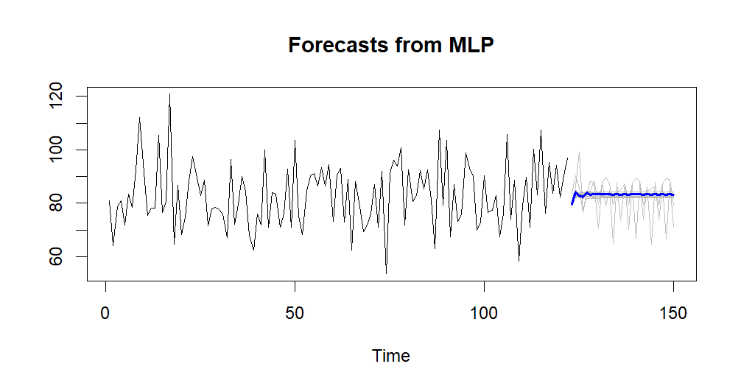 | 11.62054, 9.466065
14. | Jammu & Kashmir | 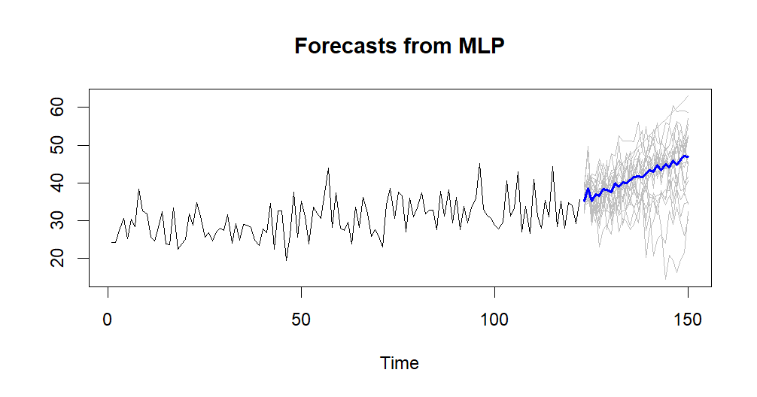 | 3.4674, 2.6574
15. | Jharkhand | 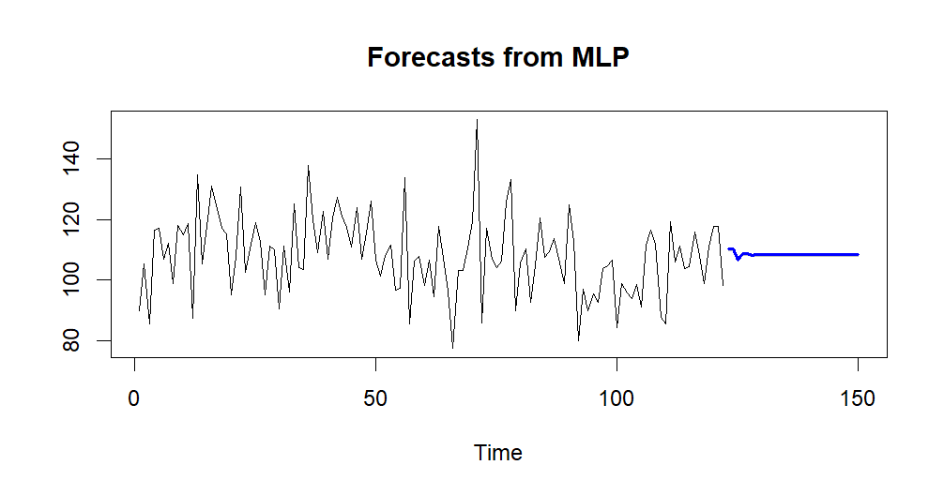 | 12.69006, 9.883177
16. | Kerala | 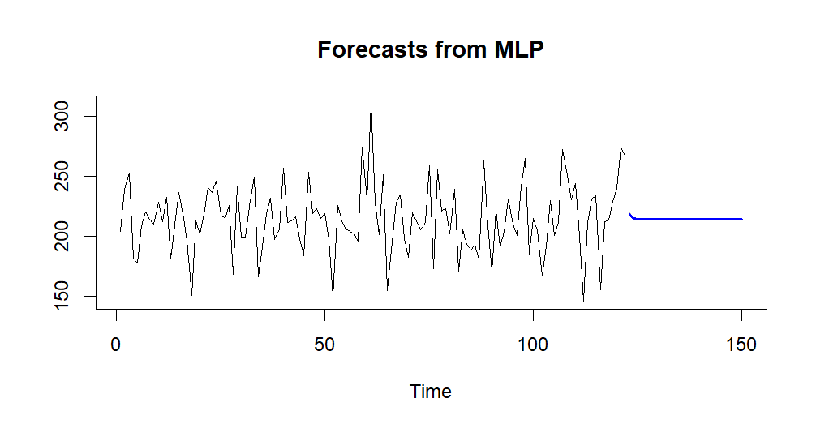 | 28.51209, 21.63772
17. | Konkan & Goa | 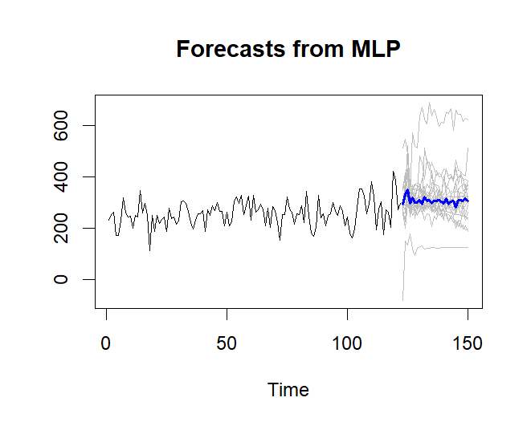 | 36.75647, 27.08131
18. | Madhya Maharashtra | 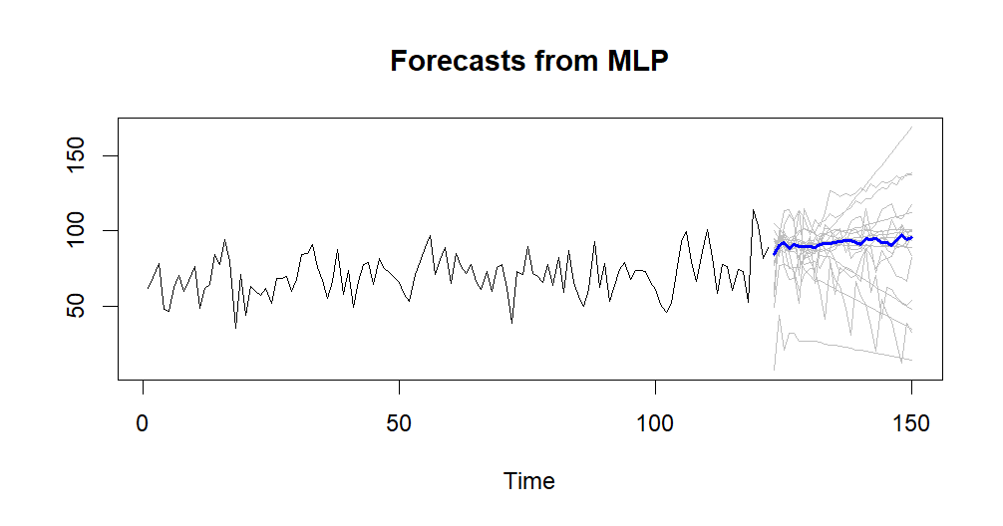 | 36.75647, 27.08131
19. | Marathwada | 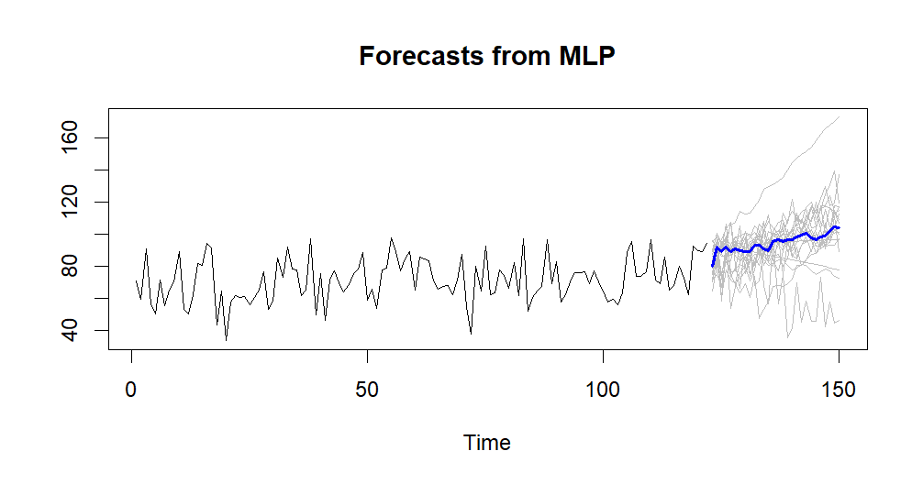 | 9.67187, 7.374785
20. | Naga, Mani, Mizo & Tripura (NMMT) | 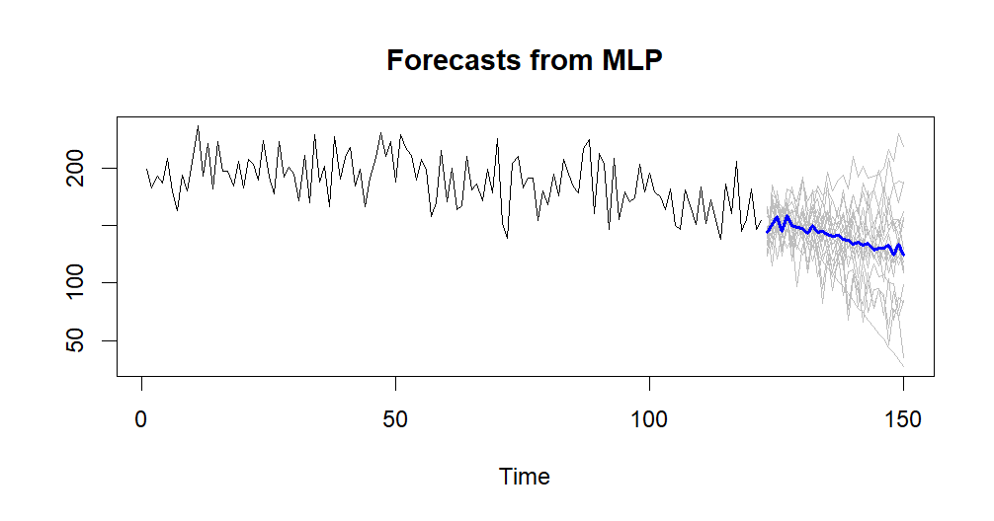 | 15.87681, 12.446
21. | North Interior Karnataka | 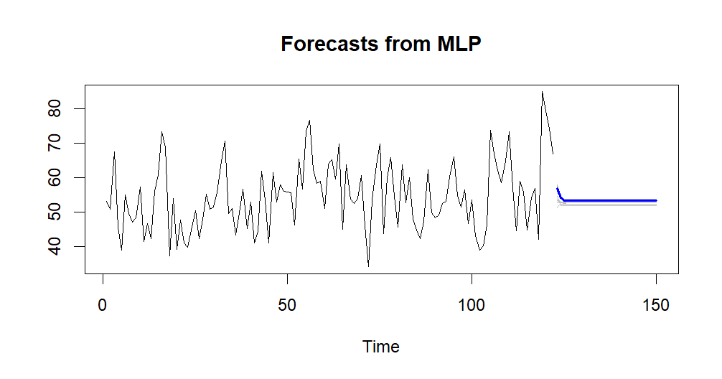 | 9.203175, 7.401717
22. | Orissa | 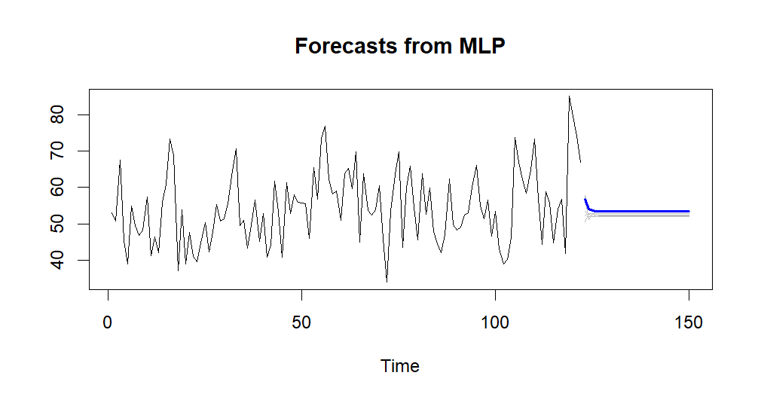 | 9.194918, 7.398941
23. | Punjab | 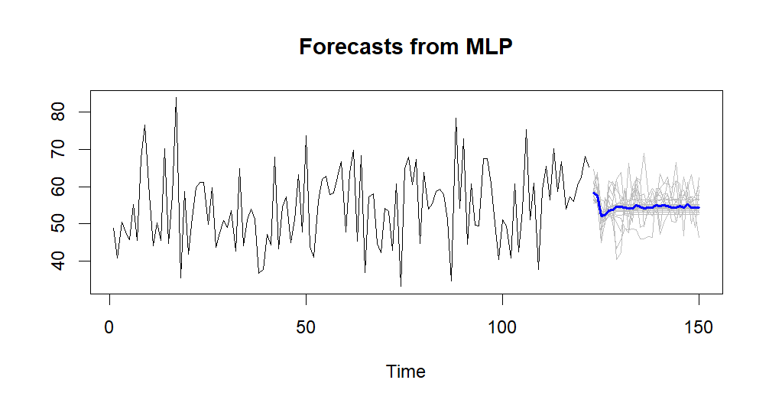 | 9.326381, 7.545235
24. | Rayalaseema | 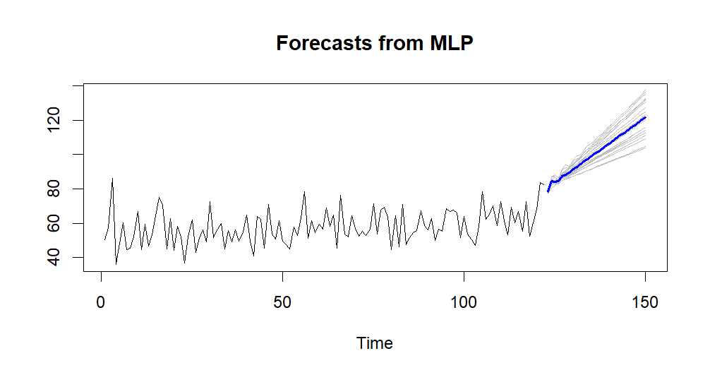 | 9.323674, 7.081542
25. | Saurashtra & Kutch | 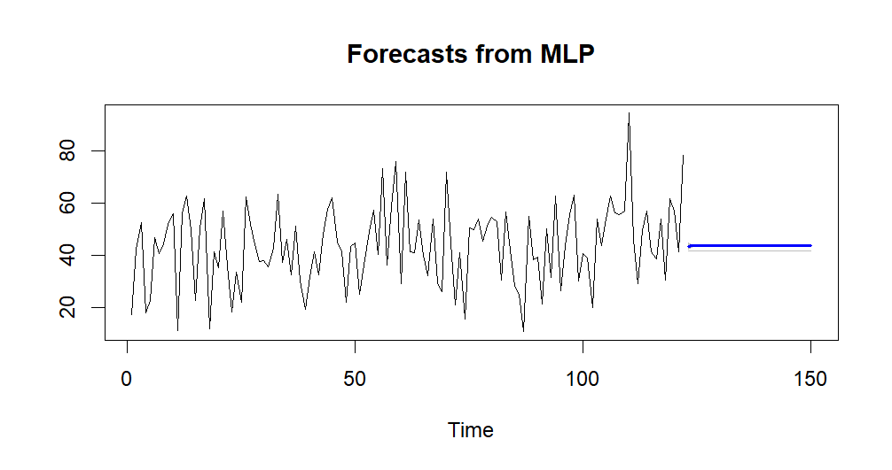 | 15.15865, 12.06129
26. | South Interior Karnataka | 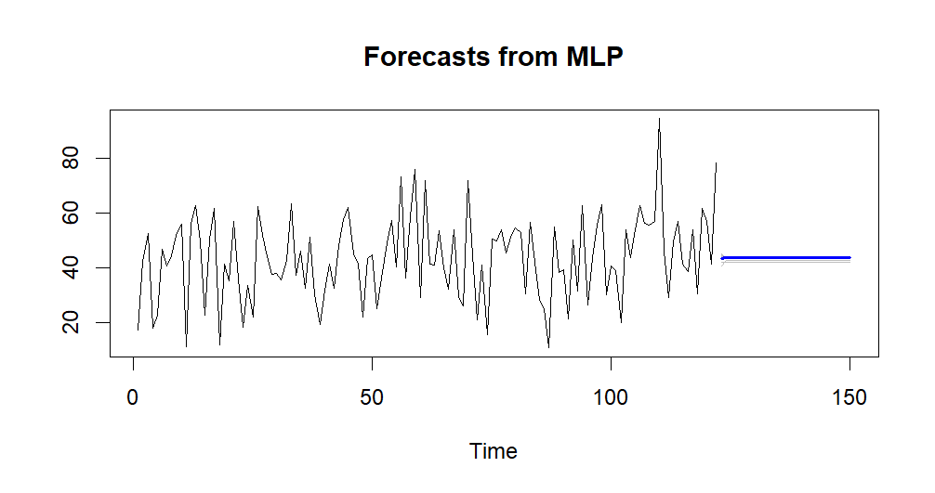 | 15.15332, 12.05633
27. | Tamil Nādu | 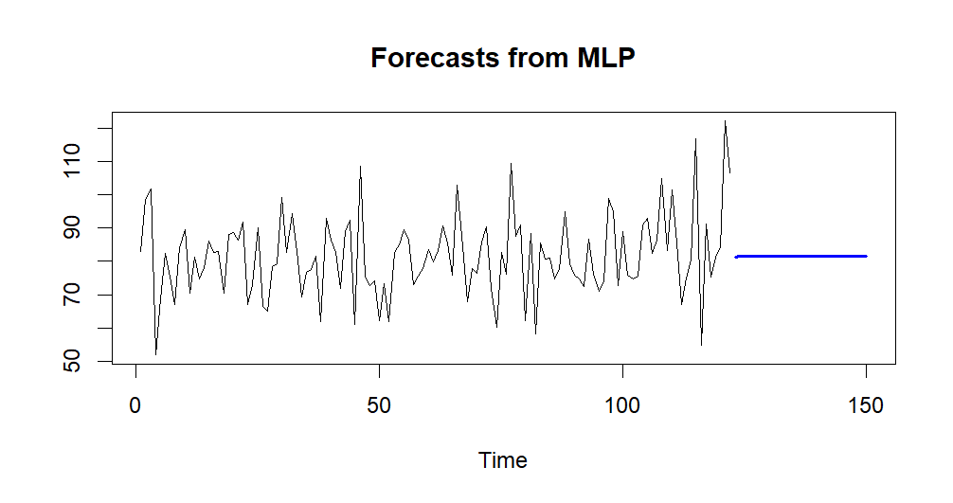 | 12.20249, 9.338111
28. | Telangana | 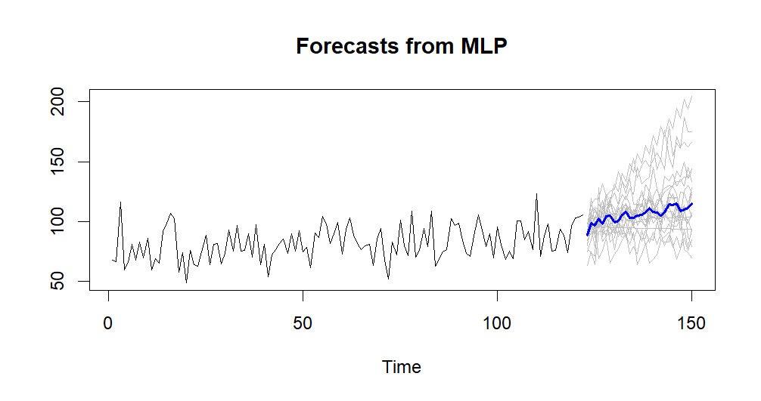 | 10.44877, 8.530362
29. | Uttaranchal | 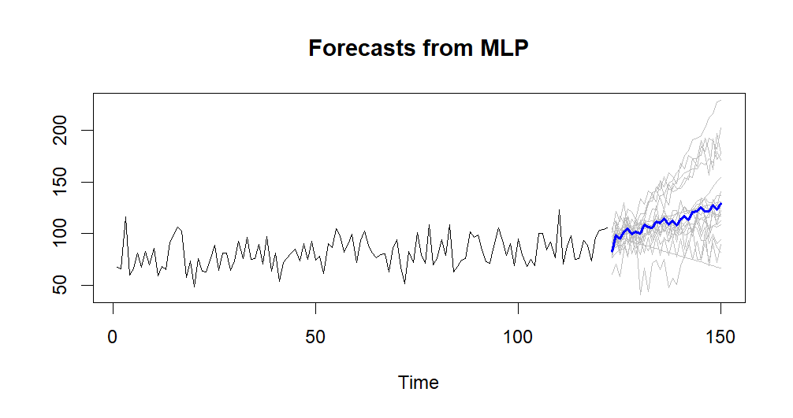 | 10.07828, 8.07331
30. | Vidarbha | 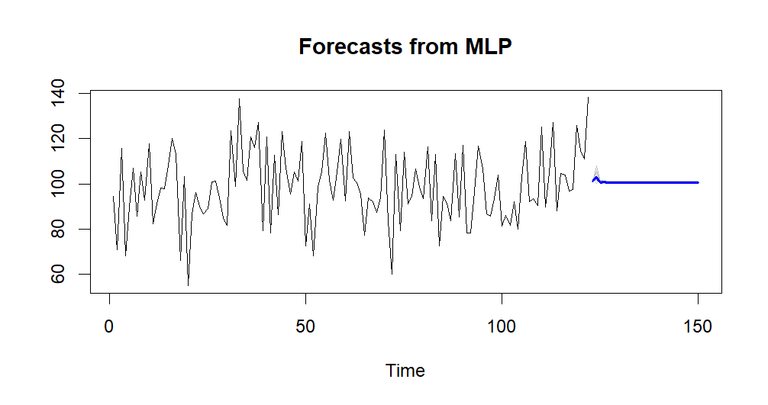 | 15.58555, 12.81424
31. | West Bengal_Sikkim | 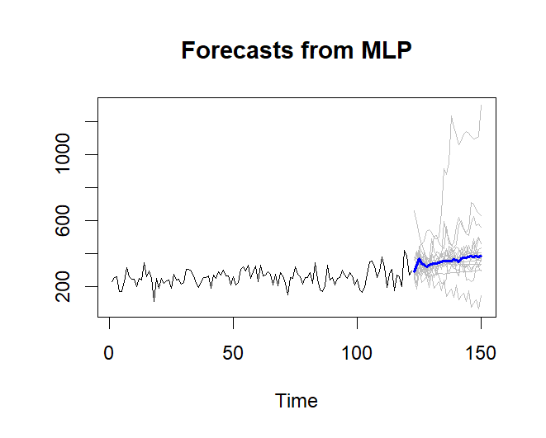 | 18.43353, 14.46784
32. | West MP | 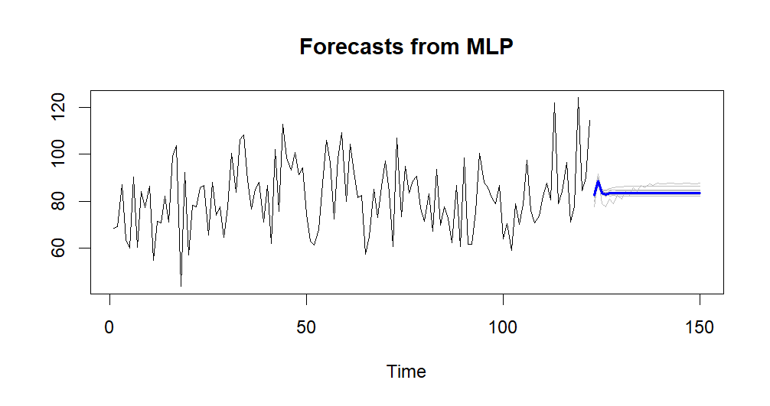 | 14.3962, 11.16007
33. | Western Rajasthan | 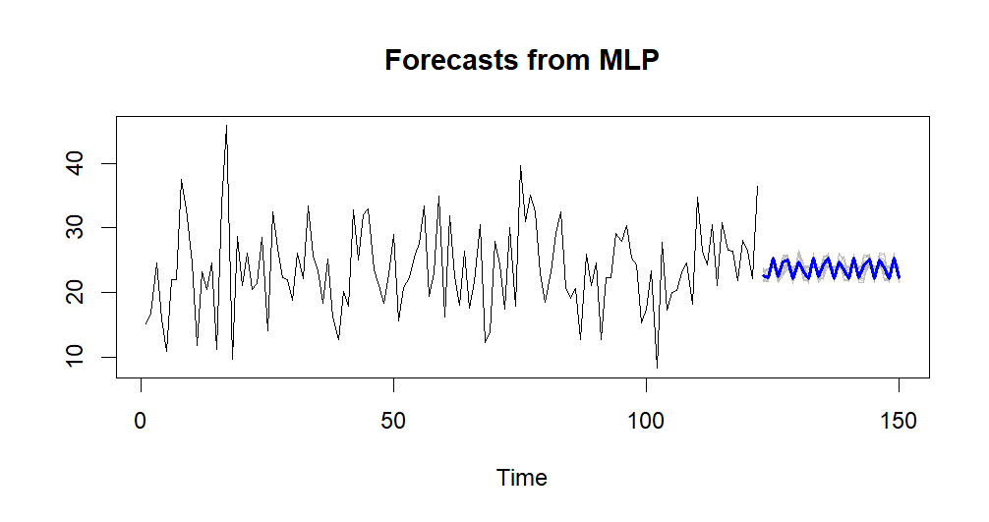 | 6.472813, 5.071201

34. | Western UP | 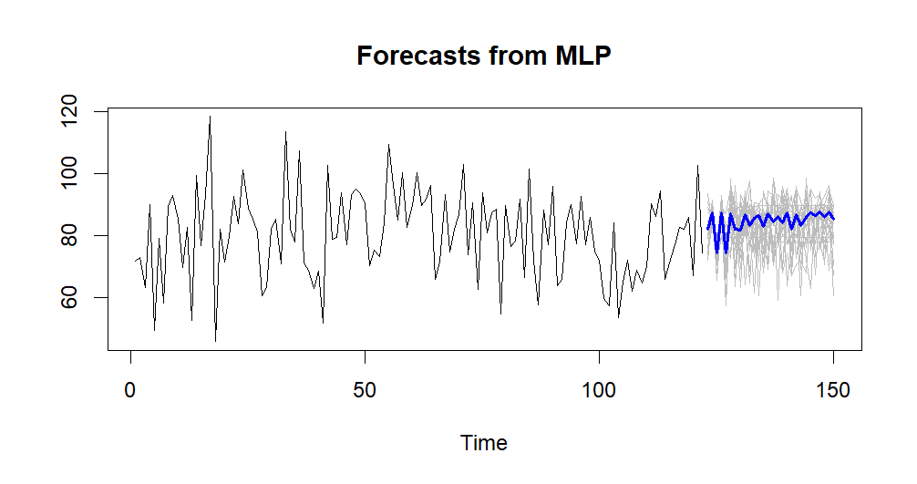 | 11.67591, 9.54098

HOMOGENEOUS REGIONS
ANN-MLP results
1. | Central Northeast | 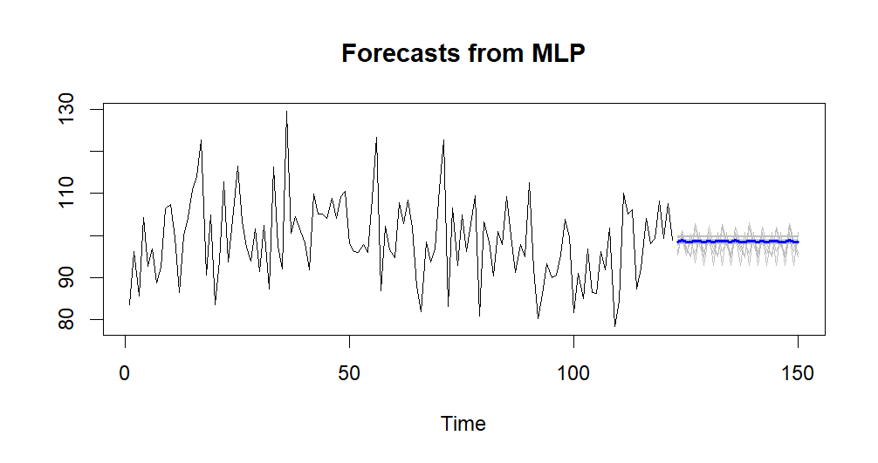 | 9.163126, 7.221911
2. | Hilly Regions | 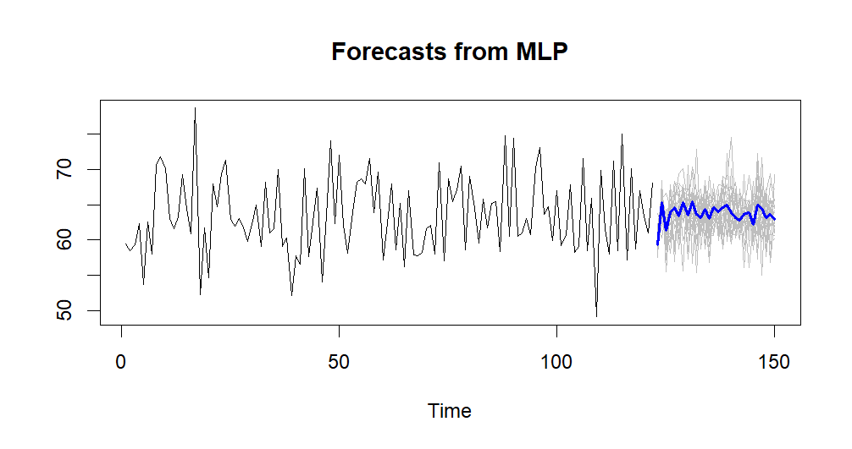 | 4.139384, 3.278479
3. | Northeast | 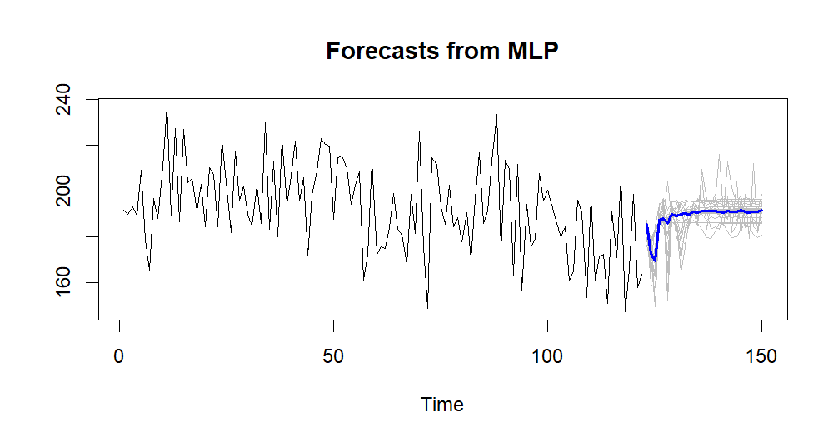 | 16.98779, 13.82554
4. | Northwest | 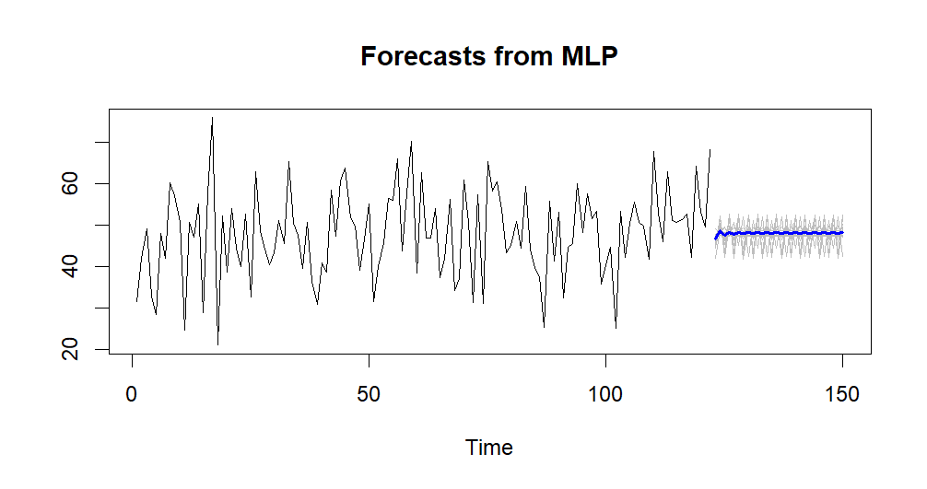 | 9.448999, 7.553318
5. | South Peninsular | 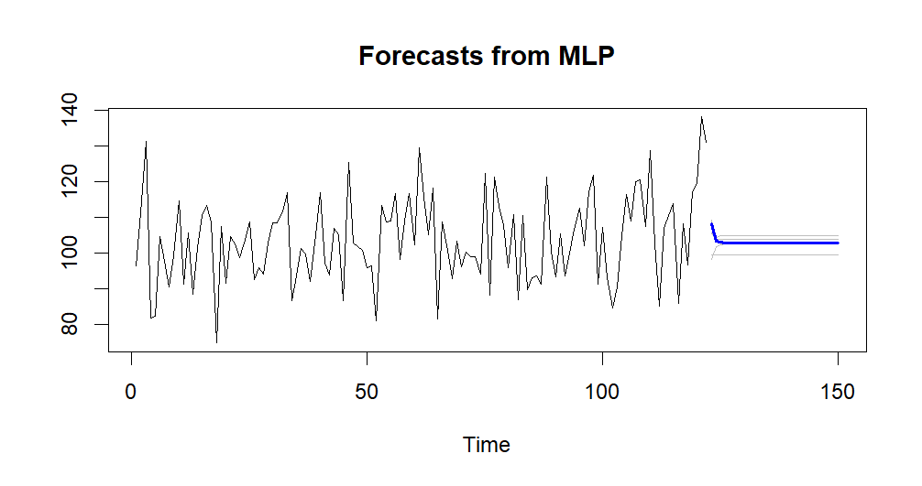 | 11.92331, 9.596806
6. | West Central | 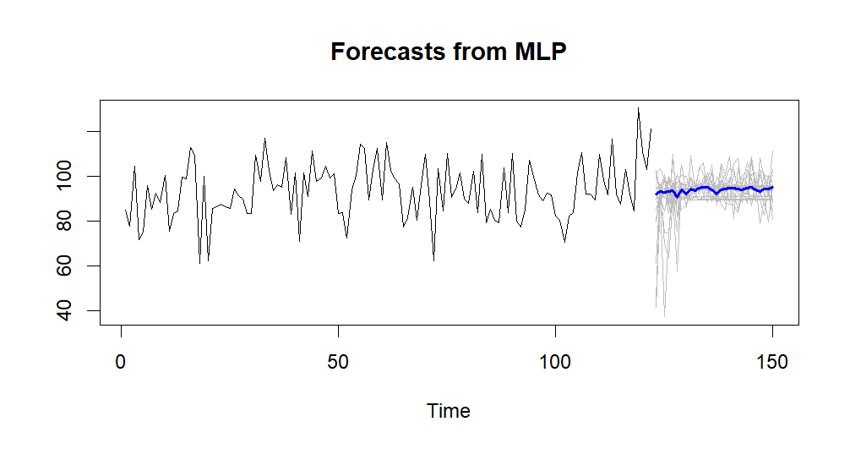 | 11.14691, 9.272241

