Garcinone E suppressed nasopharyngeal carcinoma by disrupting the endoplasmic reticulum–mitochondria–lysosome organelle network and modulating the FOXO1 signaling axis
Yiping Dai ^{a,b,#}, Wenya Zhao ^{a,b,#}, Yi Hong ^{a,b}, Chunlai Wang ^{a,b}, Dan Wei ^{a,c}, Aozhen Bi ª, Yizi He ª, and Fuqiang Yin ^{d,}*, Xia Liu ^{a,b,}*
ª Key Laboratory of Longevity and Aging Related Diseases of the Chinese Ministry of Education, Institute of Neuroscience and Guangxi Key Laboratory of Brain Science, School of Basic Medical Sciences, Guangxi Medical University, Nanning, Guangxi 530021, P. R. China
^{b} Guangxi Health Commission Key Laboratory of Basic Research on Brain Function and Disease, Key Laboratory of Human Development and Disease Research, Education Department of Guangxi Zhuang Autonomous Region, Nanning, Guangxi 530021, P. R. China
^{c} Center for Medical Genetics and Genomics, The Second Affiliated Hospital of Guangxi Medical University, Nanning, Guangxi 530021, P. R. China
^{d} Life Sciences Institute, Guangxi Medical University, Nanning, Guangxi 530021, P. R. China

# Yiping Dai and Wenya Zhao should be considered joint first authors.
* Fuqiang Yin and Xia Liu should be considered joint senior authors.

Other authors’ emails:
Yiping Dai, daiyiping2000@163.com
Wenya Zhao, 202320015@sr.gxmu.edu.cn
Yi Hong, ashleyhy49@163.com
Chunlai Wang, 18996076602@163.com
Dan Wei, DanWei419@163.com
Aozhen Bi, 202420304@sr.gxmu.edu.cn
Yizi He, 202520013@sr.gxmu.edu.cn
Fuqiang Yin, yinfq@mail2.sysu.edu.cn
Xia Liu, realliuxia@sina.com

Supplement materials
Fig. S1. Heatmap of differentially expressed genes in NPC cells treated with Garcinone E. RNA-seq was performed on HK1 and HONE1 cells treated with 0, 5, and 10 μM GE for 24 h. The heatmap shows the expression levels of significantly upregulated (red) and downregulated (blue) genes (|log2FC| ≥ 1, p < 0.05). Rows represent individual genes, and columns represent experimental replicates. The expression values were normalized to the Z score across each row. Hierarchical clustering was performed using Euclidean distance and the Ward distance. D2 method. The data are from three independent experiments.
Fig. S2. Mitochondrial membrane potential was evaluated via JC‑1 staining. Cells were treated with DMSO or Garcinone E (5,7.5,10 μmol/L) for 48 h. 20μmol/L CCCP treated cells were used as positive controls. Images were taken by a fluorescence microscope. Scale bar: 200 μm.
Fig. S3. Mitochondrial membrane potential was assessed by TMRE probe. Cells were treated with DMSO or Garcinone E (5,7.5 μmol/L) for 48 h. 20μmol/L CCCP treated cells were used as positive controls. Images were taken by a fluorescence microscope. Scale bar: 200 μm.
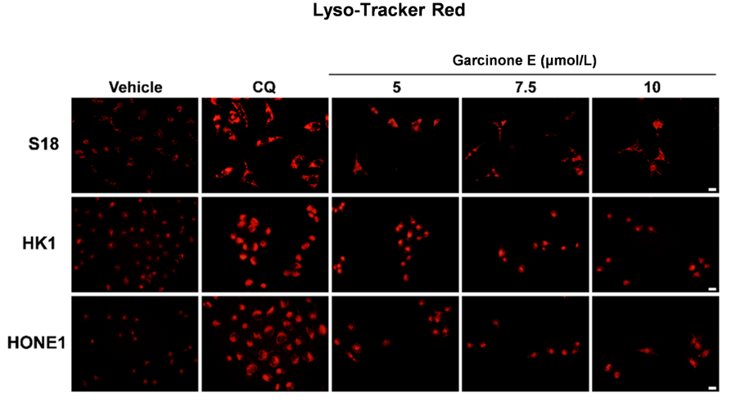
Fig. S4. Lysosomal content was assessed with Lyso-Tarcker Red probe. Cells were treated with DMSO or Garcinone E (5,7.5,10 μmol/L) for 48 h. 10μmol/L CQ treated cells were used as positive controls. Images were taken by a fluorescence microscope. Scale bar: 200 μm.
Fig. S5. Representative immunofluorescence images showing the nuclear translocation of FOXO1. Cells were treated with DMSO or Garcinone E (5 or 10 μmol/L) for 12 or 24 h. Images were taken by a confocal microscope. Scale bar: 20 μm. Statistical analysis of average nuclear and whole-cell fluorescence intensity. The data are shown as the mean ± SD (n = 3). Different lowercase letters denote significant differences between groups (p < 0.05, one-way ANOVA with the LSD test).
Table S1. The sequences of the RT‒qPCR primers used in this study
Genes | Sequence (5’-3’）
MT-ND2 | (F) CGTAAGCCTTCTCCTCACTCTC; （R）CGTGGTGCTGGAGTTTAAGTTG
MT-CYTB | (F) AATTCTCCGATCCGTCCCTAAC; （R）AGGTTAGAATGAGGAGGTCTGC
HSPA5 | (F) CAGATGAAGCTGTAGCGTATGG; （R）TCAGGGGTCTTTCACCTTCATA
ATF4 | (F) CTTAAGCCATGGCGCTTCTC; （R）GCCACCTCCAGGTAATCATCTA
ERN1 | (F) CGATCGTGAAGCAGTTAGAGAG; （R）GAATTTACGCAGGTCTGTCTGG
DDIT3 | (F) ACCTGAGGAGAGAGTGTTCAAG; （R）CCATCTCTGCAGTTGGATCAG
LAMP1 | (F) TGCTTTTGGAAGAGGACATACAC; （R）TCCACGTCTTGATTTCTTTGGAG
LAMP2 | (F) CACTCAGGATAAGGTTGCTTCAG; （R）ATGCTGATGTTCACTTCCTTCAG
LGALS3 | (F) GGCCACTGATTGTGCCTTAT; （R）GAAGCGTGGGTTAAAGTGGA
LGALS8 | (F) GGCCTAAGACTCTATGTTCCAGA; （R）CCACTTTTAGTACAACCGATGT
FOXO1 | (F) CTGAGGGTTAGTGAGCAGGTTA; （R）TCCAATGGCACAGTCCTTATCTA
β-globin | (F) CGTAAGCCTTCTCCTCACTCTC; （R）CGTGGTGCTGGAGTTTAAGTTG
GAPDH | (F) CAGCCTCAAGATCATCAGCAAT; （R）AGTCCTTCCACGATACCAAAGT

