Long term assessment of Saharan Dust Events in the Eastern Mediterranean by Optical and Microphysical Aerosol Metrics
K. Granakis^{1,2}, M. I. Gini¹, P. Fetfatzis¹, S. Vratolis¹, V. Vasilatou¹, A. Laoutaris¹, M.I Manousakas¹, C.G Tzanis² and K. Eleftheriadis¹
¹ENvironmental Radioactivity & Aerosol Technology for atmospheric & Climate ImpacT Lab, INRASTES, NCSR Demokritos, 15310 Ag. Paraskevi, Attica, Greece
²Climate and Climatic Change Group, Section of Environmental Physics and Meteorology, Department of Physics, National and Kapodistrian University of Athens, Athens, Greece
Correspondence to: K. Granakis and K. Eleftheriadis:
k.granakis@ipta.demokritos.gr and elefther@ipta.demokritos.gr

Table S1. Comparison of elemental ratios for Saharan (SD) and non-Saharan (nSD) dust transport events.
Metrics | Mean SDE | Std SDE | Mean nSDE | Std nSDE
Ca/Al | 3.17 | 12.46 | 9.26 | 23.11
(Ca+Mg)/Fe | 2.11 | 0.72 | 2.32 | 1.34
Zn/Al | 0.06 | 0.24 | 0.53 | 1.45
Fe/Al | 2.09 | 8.98 | 5.12 | 12.57
Al/Si | 0.70 | 0.18 | 2.41 | 7.20
Ti/Fe | 0.09 | 0.02 | 0.05 | 0.04
Fe/Si | 0.51 | 0.20 | 2.44 | 5.38

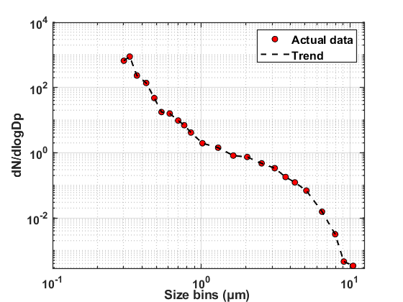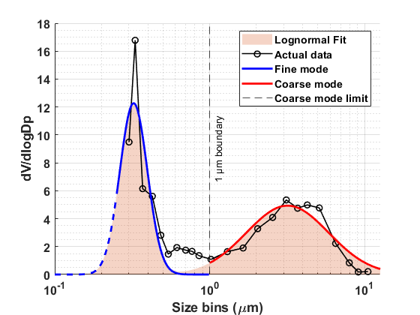
(b)
(a)
Figure S1: Number and volume size distributions of aerosols measured by the OPC. (a) Number size distribution (dN/dlogDp). (b) Volume size distribution (dV/dlogDp). Data are shown for all size bins measured; coarse mode defined as particles >1 μm.

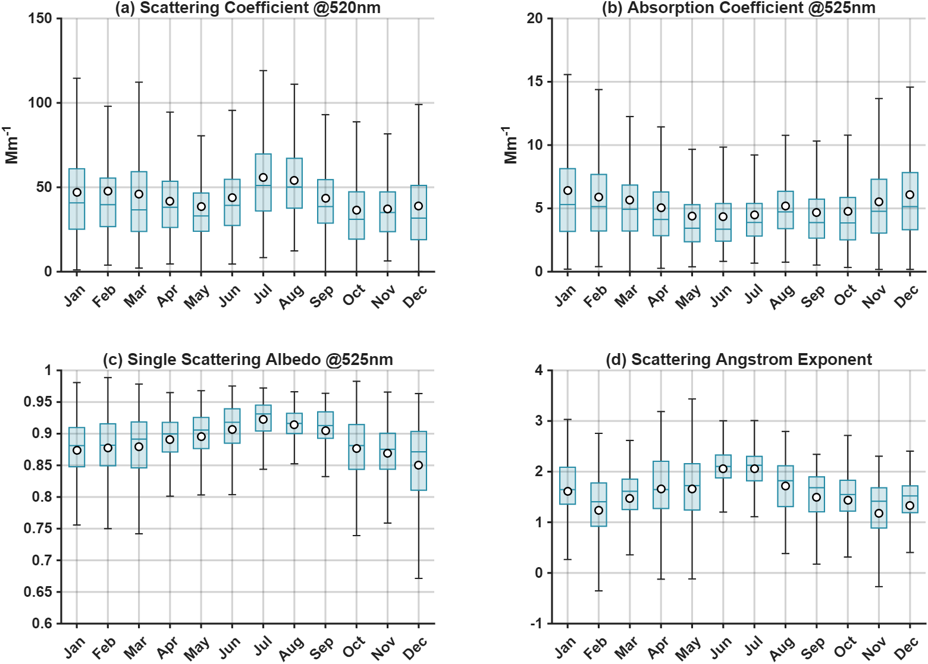
Figure S2: Monthly variation of the hourly mean values of scattering coefficient, absorption coefficient, SSA and SAE. The boxplot presents the median (red straight line), the 25th-75th (boxes) and 10th-90th percentiles (whiskers) of scattering coefficient at the central wavelength. The black diamond corresponds to the mean value.

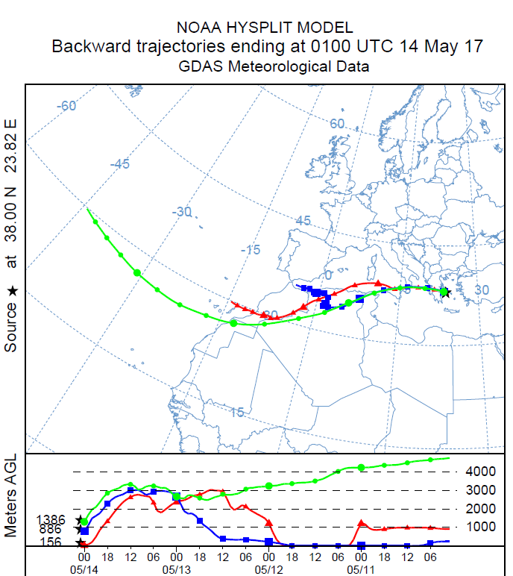
Figure S3. The 96-h backward trajectories for air masses reaching over Athens in the 14.05.2017 that took place the peak of SDE (13.05.2017 - 15.05.2017).

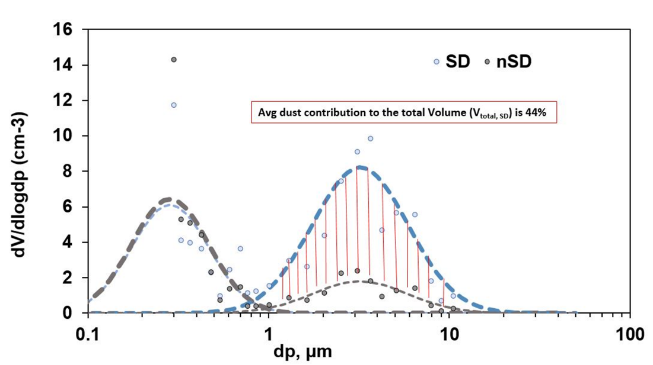
Figure S4. The average volume size distribution during SDE and nSDE, derived from OPC data and modal analysis of corresponding distribution.

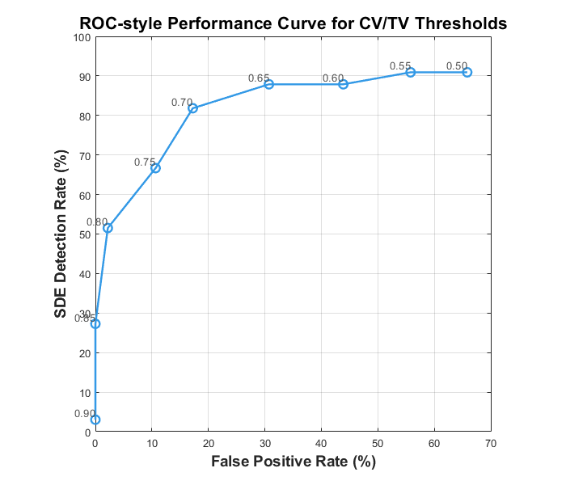
Figure S5: ROC-style performance curve for different CV/TV threshold values based on LAS data (2024). Each point corresponds to a distinct threshold level, showing the trade-off between the true detection rate and false positive rate of Saharan Dust Event (SDE) identification. The optimal performance is achieved near a CV/TV value of 0.70, which provides a high detection efficiency with minimal false positives.

