Table of contents
Supplementary Note 1 | Numerical simulation of CO₂ transport in porous architectures 7
Supplementary Fig. 1 | Modeling framework for CO₂ transport simulations 7
Supplementary Note 2 | Measurement of apparent CO₂ diffusion rate 10
Supplementary Note 3 | Construction of channel–substrate coupled models 11
Supplementary Note 4 | Force field and interaction potentials 13
Supplementary Note 5 | Molecular dynamics simulation protocol 14
Supplementary Note 6 | Gas transport and interfacial enrichment analysis 15
Supplementary Note 7 | Preparation of the IrO_{x}-modified ring electrode 16
Supplementary Note 8 | Measurement of pH on the catalyst surface using an IrO_{x}-modified RRDE 17
Supplementary Note 9 | Preparation of Cu-NW gas diffusion layer 19
Supplementary Note 10 | Density functional theory calculations 20
Supplementary Note 11 | Evaluation of electrochemical surface area (ECSA) 22
Supplementary Note 12 | Electrochemical CO₂ reduction measurements 23
Supplementary Note 13 | Calculations of Faradaic efficiency, partial current density, formation rate, and single-pass conversion efficiency 25
Supplementary Note 14 | Long-term stability evaluation under carbonate-free conditions 26
Supplementary Note 15 | In situ DEMS analysis of gaseous products during CO₂ electroreduction 27
Supplementary Note 16 | Construction of ATR-FTIR electrodes and in situ spectroelectrochemical measurements 28
Supplementary Fig. 2 | COMSOL simulated CO₂ diffusion in ordered nanowire channels under 15% CO₂ feed at different diffusion times 30
Supplementary Fig. 3 | COMSOL simulated CO₂ diffusion in ordered nanowire channels under 100% CO₂ feed at different diffusion times 31
Supplementary Fig. 4 | COMSOL simulated CO₂ diffusion in disordered pores under 15% CO₂ feed at different diffusion times 32
Supplementary Fig. 5 | COMSOL simulated CO₂ diffusion in disordered pores under pure CO₂ feed at different diffusion times 33
Supplementary Fig. 6 | Simulated outlet CO₂ concentrations at 2 μs under different feed CO₂ concentrations 34
Supplementary Fig. 7 | Schematic illustration of the in situ DEMS setup for evaluating apparent CO₂ diffusion rates using 28 BC or Cu-NW as the gas diffusion layer (GDL) 35
Supplementary Fig. 8 | CO₂ transport rates calculated from the slopes of the outlet concentration profiles under different feed CO₂ concentrations 36
Supplementary Fig. 9 | In situ DEMS analysis of 28 BC and Cu-NW used as gas diffusion layers (GDLs) under pure CO₂ and 15% CO₂ atmospheres 37
Supplementary Fig. 10 | Molecular dynamics models used to investigate CO₂ transport in confined carbon and Cu channels at initial state 38
Supplementary Fig. 11 | Molecular dynamics models used to investigate CO₂ transport in confined carbon and Cu channels after 1 ns 39
Supplementary Fig. 12 | Molecular dynamics models used to investigate CO₂ transport in confined carbon and Cu channels after 3 ns 40
Supplementary Fig. 13 | Molecular dynamics models used to investigate CO₂ transport in confined carbon and Cu channels after 5 ns 41
Supplementary Fig. 14 | Molecular dynamics simulations of CO₂ diffusion in confined channels after 1 ns diffusion 42
Supplementary Fig. 15 | Molecular dynamics simulations of CO₂ diffusion in confined channels after 3 ns diffusion 43
Supplementary Fig. 16 | Monitoring of the local pH near a glassy carbon disk electrode using an IrO_{x}-modified rotating ring-disk electrode (RRDE) 44
Supplementary Fig. 17 | Monitoring of the local pH near a Cu-NW disk electrode using an IrO_{x}-modified rotating ring-disk electrode (RRDE) 45
Supplementary Fig. 18 | Monitoring of local pH evolution during Zn electrodeposition on a Cu-NW disk electrode using a rotating ring-disk electrode (RRDE) 46
Supplementary Fig. 19 | SEM image measurement of Zn-shell 47
Supplementary Fig. 20 | Contact angle measurement of Zn-shell 48
Supplementary Fig. 21 | XPS spectra of (a) C 1s, (b) F 1s, and (c) O 1s for Zn-shell and Zn-leaf 49
Supplementary Fig. 22 | HAADF-STEM image and EDS elemental mapping of Zn-leaf 50
Supplementary Fig. 23 | Zn 2p XPS spectra of Zn foil, Zn-shell, and Zn-leaf 51
Supplementary Fig. 24 | High-resolution O 1s XPS spectra of Zn foil, Zn-shell, and Zn-leaf 52
Supplementary Fig. 25 | Cu 2p XPS spectra of Cu-NW, Zn-shell, and Zn-leaf 53
Supplementary Fig. 26 | Integrated peak areas of XRD reflections for different crystal facets of Zn foil 54
Supplementary Fig. 27 | Integrated peak areas of XRD reflections for different crystal facets of Zn-leaf 55
Supplementary Fig. 28 | Peak fitting analysis of the Cu (111) reflection for Cu-NW and the Cu (111) and Zn (101) reflections for Zn-leaf 56
Supplementary Fig. 29 | ECSA analysis of Zn foil, Zn-shell, and Zn-leaf 57
Supplementary Fig. 30 | Electrochemical impedance spectroscopy (EIS) and distribution of relaxation times (DRT) analysis of Zn foil, Zn-shell, and Zn-leaf 58
Supplementary Fig. 31 | SEM images of Zn-leaf prepared with different electrodeposition times 59
Supplementary Fig. 32 | CO₂RR performance of Zn-leaf prepared with different electrodeposition times at current densities ranging from −0.3 to −1.2 A cm⁻² 60
Supplementary Fig. 33 | CO₂RR performance of Zn-leaf in 1 M KHCO₃ electrolyte at current densities ranging from −0.3 to −3.0 A cm⁻² 61
Supplementary Fig. 34 | CO formation rates of Zn-leaf in 1 M KHCO₃ electrolyte at current densities ranging from −0.3 to −3.0 A cm⁻² 62
Supplementary Fig. 35 | Schematic illustration of the automatic electrolyte renewal system 63
Supplementary Fig. 36 | Long-term stability evaluation of Zn-leaf at a current density of −200 mA cm⁻² 64
Supplementary Fig. 37 | CO₂RR performance of Zn-leaf under different CO₂ concentrations at current densities ranging from −40 to −200 mA cm⁻² 65
Supplementary Fig. 38 | CO₂RR performance of Zn-leaf at different CO₂ flow rates measured at a current density of −0.2 A cm⁻² and pH 2 66
Supplementary Fig. 39 | CO₂RR performance of Zn-leaf under different CO₂ concentrations at current densities ranging from −0.3 to −1.5 A cm⁻² 67
Supplementary Fig. 40 | SEM image and contact angle measurement of Zn-leaf after long-term stability evaluation at a current density of −200 mA cm⁻² under 15% CO₂ conditions 68
Supplementary Fig. 41 | In situ ATR-FTIR spectra of Zn-leaf recorded under pure CO₂ and 10% CO₂ atmospheres at potentials ranging from −0.1 to −1.0 V versus RHE 69
Supplementary Fig. 42 | In situ ATR-FTIR spectra of Zn-leaf recorded under pure CO₂ and 10% CO₂ atmospheres at potentials ranging from −0.1 to −1.0 V versus RHE 70
Supplementary Fig. 43 | Comparison between the relative integrated peak area contributions of the ν(C–O) vibration associated with *COOH related intermediates and the 4-HB H₂O species under pure CO₂ and 10% CO₂ atmospheres derived from the in situ ATR-FTIR spectra of Zn-leaf 71
Supplementary Fig. 44 | Comparison between the relative integrated peak area contributions of the ν(C–O) vibration associated with *COOH related intermediates and free H₂O species under pure CO₂ and 10% CO₂ atmospheres derived from the in situ ATR-FTIR spectra of Zn-leaf 72
Supplementary Table 1 | Summary of in situ DEMS analysis for 28 BC and Cu-NW used as gas diffusion layers (GDLs) under pure CO₂ and 15% CO₂ atmospheres 73
Supplementary Table 2 | Summary of integrated peak areas of XRD reflections for different crystal facets of Zn foil and Zn-leaf 74
Supplementary Table 3 | Reaction coordinates and relative energies of CO₂ reduction on the Zn (002) facet 75
Supplementary Table 4 | Reaction coordinates and relative energies of CO₂ reduction on the Zn (100) facet 76
Supplementary Table 5 | Reaction coordinates and relative energies of CO₂ reduction on the Zn (101) facet 77
Supplementary Table 6 | Reaction coordinates and relative energies of CO₂ reduction on the Zn (102) facet 78
Supplementary Table 7 | Reaction coordinates and relative energies of CO₂ reduction on the Zn (103) facet 79
Supplementary Table 8 | Reaction coordinates and relative energies of CO₂ reduction on the Zn (110) facet 80
Supplementary Table 9 | Summary of CO₂RR performance of Zn-leaf at pH 2 81
Supplementary Table 10 | Summary of CO₂RR performance of Zn-leaf at pH 7 82
Supplementary Table 11 | Summary of CO₂RR performance of Zn-leaf at pH 14 83
Supplementary Table 12 | Summary of CO₂RR performance of Zn-leaf in 1 M KHCO₃ electrolyte 84
Supplementary Table 13 | Benchmark comparison of the Zn-leaf catalyst with representative state-of-the-art Zn catalysts for CO₂ electroreduction 85
Supplementary Table 14 | Summary of CO₂RR performance of Zn-leaf under 2% CO₂ at current densities ranging from −40 to −200 mA cm⁻² 86
Supplementary Table 15 | Summary of CO2RR performance of Zn-leaf under 5% CO₂ at current densities ranging from −40 to −200 mA cm⁻² 87
Supplementary Table 16 | Summary of CO₂RR performance of Zn-leaf under 10% CO₂ at current densities ranging from −40 to −200 mA cm⁻² 88
Supplementary Table 17 | Summary of CO₂RR performance of Zn-leaf under 20% CO₂ at current densities ranging from −40 to −200 mA cm⁻² 89
Supplementary Table 18 | Summary of CO₂RR performance of Zn-leaf under 30% CO₂ at current densities ranging from −40 to −200 mA cm⁻² 90
Supplementary Table 19 | Summary of CO₂RR performance of Zn-leaf under different CO₂ concentrations at current densities ranging from −0.3 to −1.5 A cm⁻² 91
Supplementary Table 20 | Summary of integrated peak areas of the *COOH related ν(C–O) vibration and interfacial H₂O δ(H–O–H) bending mode obtained from in situ ATR-FTIR spectra of Zn-leaf under pure CO₂ and 10% CO₂ atmospheres at potentials ranging from −0.1 to −0.4 V versus RHE 92
Supplementary Table 21 | Summary of integrated peak areas of 4-HB H₂O, 2-HB H₂O, and free H₂O species obtained from in situ ATR-FTIR spectra of Zn-leaf under pure CO₂ and 10% CO₂ atmospheres at potentials ranging from −0.1 to −0.4 V versus RHE 93
Supplementary Table 22 | Summary of the relative integrated peak area contributions of *COOH related species under pure CO₂ and 10% CO₂ atmospheres obtained from in situ FTIR spectra of Zn-leaf at potentials ranging from −0.1 to −0.4 V versus RHE 94
Supplementary Table 23 | Summary of the relative integrated peak area contributions of 2-HB H₂O species under pure CO₂ and 10% CO₂ atmospheres obtained from in situ FTIR spectra of Zn-leaf at potentials ranging from −0.1 to −0.4 V versus RHE 95
Supplementary Table 24 | Summary of the relative integrated peak area contributions of 4-HB H₂O species under pure CO₂ and 10% CO₂ atmospheres obtained from in situ FTIR spectra of Zn-leaf at potentials ranging from −0.1 to −0.4 V versus RHE 96
Supplementary Table 25 | Summary of the relative integrated peak area contributions of free H₂O species under pure CO₂ and 10% CO₂ atmospheres obtained from in situ FTIR spectra of Zn-leaf at potentials ranging from −0.1 to −0.4 V versus RHE 97
Reference 98

Supplementary Note 1 | Numerical simulation of CO₂ transport in porous architectures
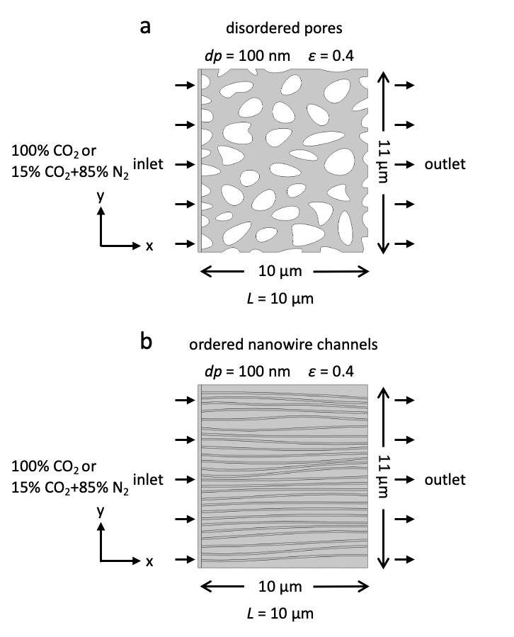
Supplementary Fig. 1 | Modeling framework for CO₂ transport simulations. Two-dimensional computational domains representing a disordered pores and ordered nanowire channels were constructed to evaluate the influence of pore morphology on gas transport. Both structures possessed identical porosity (ε = 0.4), average pore diameter (d_{p} = 100 nm), and diffusion distance (L = 10 μm). Gas transport was simulated using the Dusty–Gas Model coupled with Maxwell–Stefan diffusion, Knudsen diffusion, and Millington–Quirk tortuosity correction. Simulations were performed for pure CO₂ and a mixed gas composition containing 15% CO₂ and 85% N₂. The average outlet CO₂ concentration was used to evaluate transport performance.

COMSOL Multiphysics 6.3 was employed to investigate the influence of pore architecture on CO₂ transport behavior. Simulations were conducted in a two-dimensional computational domain with dimensions of 10 μm × 11 μm. Two representative porous structures were constructed, including an ordered vertical nanochannel architecture and a disordered porous network. The ordered structure consisted of parallel straight channels aligned with the diffusion direction, whereas the disordered structure was generated by randomly distributed solid regions, producing a tortuous diffusion pathway. To ensure a fair comparison, both structures were designed with identical porosity (0.4), average pore diameter (100 nm), and diffusion distance (10 μm).
Gas transport in porous domains was described using the Dusty–Gas Model (DGM), which combines molecular diffusion and Knudsen diffusion. Multicomponent diffusion was implemented using the Maxwell–Stefan formulation available in the Transport of Concentrated Species interface of COMSOL.
The applicability of Knudsen diffusion was evaluated using the Knudsen number:
$Kn=\frac{λ}{d_{p}}$ (S1)
where λ is the molecular mean free path and d_{p} is the pore diameter.
Under ambient conditions, the mean free paths of CO₂ and N₂ are approximately 40 and 65 nm, respectively. For a pore diameter of 100 nm, the corresponding Knudsen numbers are 0.40 and 0.65, indicating transport within the transition diffusion regime (0.1 < Kn < 10). Therefore, both intermolecular collisions and molecule–wall interactions were considered during transport calculations.
The Knudsen diffusivity was calculated according to:
$D_{Ki}=\frac{d_{p}}{3}\sqrt{\frac{8RT}{πM_{i}}}$ (S2)
where D_{Ki} is the Knudsen diffusivity of species i, R is the gas constant, T is the temperature, and M_{i} is the molecular weight of species i.
The resulting Knudsen diffusivities were calculated to be 1.98 × 10⁻⁷ m² s⁻¹ for CO₂ and 2.48 × 10⁻⁷ m² s⁻¹ for N₂.
To account for the influence of pore tortuosity on gas transport, the effective diffusivity was corrected using the Millington–Quirk model:
$D_{eff}=Dε^{4/3}$ (S3)
where D is the bulk diffusion coefficient and ε is the porosity.
The porosity of both porous structures was fixed at 0.4. Two gas compositions were investigated: pure CO₂ and a mixed gas containing 15% CO₂ and 85% N₂. The binary diffusion coefficient for the CO₂/N₂ mixture was set to 1.66 × 10⁻⁵ m² s⁻¹, while the diffusion coefficient for pure CO₂ was set to 1.20 × 10⁻⁵ m² s⁻¹.¹ All simulations were conducted at 298.15 K.
A fixed gas composition was applied at the inlet boundary, whereas the outlet boundary was defined as an open diffusion boundary. The initial CO₂ concentration throughout the computational domain was set to zero. Transient simulations were performed from 0 to 2 μs using the finite-element method. The average CO₂ concentration at the outlet boundary was monitored as a function of time and used to evaluate the transport performance of different porous architectures.
The computational mesh was refined near pore walls and narrow diffusion regions. A mesh-independence study was performed by progressively increasing mesh density. Further mesh refinement resulted in less than 2% variation in the calculated outlet CO₂ concentration, confirming numerical convergence of the simulation results.

Supplementary Note 2 | Measurement of apparent CO₂ diffusion rate
Apparent CO₂ diffusion rate measurements of gas diffusion layers were carried out using a custom-built system integrating a gas diffusion flow-cell reactor with a differential electrochemical mass spectrometry (DEMS, QMG 100) setup. A self-developed Cu-NW GDL and a representative commercial SGL-28 BC GDL were comparatively evaluated to investigate their apparent CO₂ diffusion behaviors. As schematically illustrated in Figure S7, the modified flow-cell reactor contained three gas ports: port A for gas inlet, port B for gas outlet, and port C for collection of the gas permeating through the GDL. Port C was directly connected to the capillary inlet of the DEMS system for real-time gas analysis. During all measurements, the gas flow rate was maintained at 50 sccm. Prior to each experiment, the entire gas line and reactor system were purged with high purity Ar until stable Ar and N₂ baseline signals were obtained in the DEMS spectra, ensuring complete removal of residual air from the system. Subsequently, the feed gas was switched to either pure CO₂ or a mixed gas containing 15% CO₂ balanced with N₂, while continuously monitoring the corresponding ion currents in real time. The monitored mass-to-charge ratios included m/z = 44 for CO₂, m/z = 28 for N₂, and m/z = 40 for Ar. Upon introduction of the target gas, CO₂ gradually diffused through the GDL and was detected at port C by DEMS. The apparent CO₂ diffusion rate was evaluated from the temporal response of the CO₂ ion current. To minimize fluctuations arising from transient gas switching and instrumental noise, the apparent diffusion behavior was quantified using the linear slope of the CO₂ ion current response within a stable 1000 s time window. Four sets of measurements were conducted, including Cu-NW GDL and SGL-28 BC GDL under pure CO₂ and 15% CO₂ conditions, respectively.

Supplementary Note 3 | Construction of channel–substrate coupled models
Two channel–substrate coupled models were established to investigate the confined transport behavior of CO₂/N₂ mixed gas and its interfacial enrichment near Zn surfaces. Each simulation system consisted of a bottom Zn(100) substrate, a vertical slit nanochannel, and an upper gas reservoir region.
The Zn substrate was constructed using a five-layer Zn(100) slab containing 900 Zn atoms with an in-plane dimension of 26.6 × 44.5 Å. The bottom two Zn layers were fixed to mimic bulk lattice constraints, while the upper three layers were allowed to relax freely during the simulations.
Two slit nanochannels with identical geometric confinement dimensions but different wall materials were constructed:
- Graphene channel: four graphene layers were constructed on each side of the slit nanochannel, containing a total of 38400 carbon atoms.
- Cu(111) channel: six Cu atomic layers were constructed on each side of the slit nanochannel, containing a total of 24000 Cu atoms.
The multilayer wall structures were introduced to maintain structural stability and suppress excessive thermal fluctuations during long time simulations. To further eliminate transport uncertainty induced by wall deformation, all channel wall atoms were treated as rigid throughout the simulations. All channel wall atoms were treated as rigid to maintain stable channel geometries and eliminate transport uncertainty induced by wall fluctuations, while preserving all wall gas interactions. The channel length and width were fixed at 50 nm and 1.5 nm, respectively. A gap of approximately 5 Å was reserved between the channel outlet and the Zn surface to avoid artificial wall–substrate contact while preserving sufficient free diffusion space near the interface region. A total of 180 CO₂ molecules and 1020 N₂ molecules were randomly packed into the upper gas reservoir region above the channel entrance, while the nanochannel region was initially free of gas molecules to establish an identical concentration gradient-driven transport process in both systems. Under the same initial concentration gradient, the differences observed between the two systems therefore originate primarily from the intrinsic transport characteristics of the channel materials. The gas molecule population was selected to ensure sufficient statistical sampling while avoiding unrealistically high gas density accumulation inside the ultra-confined slit nanochannels. Since the present work mainly focuses on the relative transport and interfacial enrichment behavior of different channel materials rather than reproducing macroscopic gas flow rates, identical gas compositions and molecule numbers were employed for all simulation systems to guarantee direct comparability. Excessive gas loading within the 1.5 nm confined channels could lead to artificial molecular crowding, abnormally frequent intermolecular collisions, and local pressure amplification, which may obscure the intrinsic wall mediated transport behavior. In addition, no continuous gas replenishment was introduced during the simulations because the present model does not involve subsequent gas consumption or interfacial reaction processes. Continuous gas injection could introduce additional pressure driven transport effects, which are beyond the scope of the present confined diffusion study.
Periodic boundary conditions were applied in the X and Y directions, whereas the Z direction was treated as non-periodic with sufficient vacuum thickness to eliminate artificial interactions between periodic images along the vertical direction.

Supplementary Note 4 | Force field and interaction potentials
All bonded and non-bonded atomic interactions were described using the COMPASS III all-atom force field,² which has been widely employed in simulations involving hybrid inorganic/organic systems and gas–surface interactions.
Van der Waals interactions were modeled using the 12–6 Lennard–Jones potential, while electrostatic interactions were described by Coulombic interactions. Long-range electrostatic interactions were calculated using the particle–particle particle–mesh (PPPM) method.³ The cutoff radius for both van der Waals and electrostatic interactions was set to 1.5 nm. Cross-interaction parameters between different atom species were determined using the standard Lorentz–Berthelot mixing rule.^{4,5}
Since the present work mainly focuses on confined gas transport and interfacial enrichment behavior rather than chemical reaction processes, classical force-field-based molecular dynamics simulations were considered sufficient to capture the dominant transport physics within the nanochannel systems.

Supplementary Note 5 | Molecular dynamics simulation protocol
All molecular dynamics simulations were carried out using a time step of 1 fs.⁶ The overall simulation procedure followed the sequence:
First, the steepest descent algorithm was employed for energy minimization to eliminate unfavorable atomic contacts and local structural distortion within the initial configurations.
Subsequently, annealing simulations were performed under the NVT ensemble with the temperature gradually increasing from 300 K to 600 K and then cooling back to 300 K, allowing sufficient structural relaxation and interfacial stress release.
After annealing, production simulations were conducted under the NVT ensemble at 298 K using the Nose–Hoover thermostat.³ The total production simulation time was 5 ns.
During the simulations, all graphene and Cu channel wall atoms remained rigid, while the bottom Zn layers were fixed and the upper Zn layers were fully flexible. Simulation trajectories were recorded at regular intervals for subsequent statistical analysis. Additional simulations with different initial gas distributions confirmed that the observed transport trends between graphene and Cu channels remained qualitatively consistent.

Supplementary Note 6 | Gas transport and interfacial enrichment analysis
The confined transport behavior of CO₂ and N₂ molecules was quantitatively analyzed through molecular trajectory analysis, spatial number density distribution, and interfacial enrichment statistics. The vertical number density distribution along the Z direction was calculated by dividing the simulation domain into bins with equal thickness and averaging the molecular population within each bin over the production simulation period. The interfacial enrichment behavior near the Zn surface was quantified by calculating the local molecular concentration within the interfacial region above the Zn substrate. The enrichment region was defined as the space within 5 Å above the top Zn atomic layer. The relative enrichment capability of different channel materials was evaluated by comparing the local CO₂ concentration near the Zn interface with the bulk gas concentration in the reservoir region. Molecular trajectories were further analyzed to identify material-dependent confined diffusion pathways and wall-mediated transport characteristics within the nanochannels.

Supplementary Note 7 | Preparation of the IrO_{x}-modified ring electrode
IrO_{x} precursor solution was prepared according to a previously reported method with minor modifications. Briefly, 0.14 g of IrCl₄ was dissolved in 100 mL of deionized water under magnetic stirring for 30 min. Subsequently, 1 mL of H₂O₂ aqueous solution was added and the mixture was further stirred for 10 min. Afterward, 0.50 g of oxalic acid dihydrate (C₂H₂O₄·2H₂O) was introduced, followed by an additional 10 min of stirring. The pH of the solution was then gradually adjusted to 10.5 by the dropwise addition of K₂CO₃. The resulting solution was stirred at room temperature for 48 h until a stable transparent dark purple precursor solution was obtained. IrO_{x} films were electrodeposited onto the Pt ring electrode of a rotating ring-disk electrode (RRDE) by cyclic voltammetry (CV). Prior to electrodeposition, the RRDE was sequentially polished with 1.0 μm alumina slurry and ultrasonically cleaned with deionized water. A conventional three-electrode configuration was employed using the RRDE as the working electrode, a Pt wire as the counter electrode, and a saturated Ag/AgCl electrode as the reference electrode. Before deposition, Ar was continuously purged into the precursor solution for at least 30 min to remove dissolved oxygen, and the Ar atmosphere was maintained throughout the electrodeposition process. Electrodeposition was carried out only on the Pt ring electrode within a potential window from −0.45 to 0.75 V versus Ag/AgCl, initiated from the negative direction. The potential was cycled for 300 scans at a scan rate of 1 V s⁻¹. During electrodeposition, the RRDE remained stationary while the precursor solution was continuously stirred using a magnetic stirrer. After deposition, the IrO_{x}-coated RRDE was stored in deionized water overnight prior to use.

Supplementary Note 8 | Measurement of pH on the catalyst surface using an IrO_{x}-modified RRDE
To investigate the evolution of the local chemical environment during Zn electrodeposition, the pH near the catalyst surface was monitored using an IrO_{x}-modified rotating ring–disk electrode (RRDE) following a previously reported method. ^{7,8} Briefly, IrO_{x} was electrodeposited onto the Pt ring electrode by cyclic voltammetry and served as a pH-sensitive probe due to its reversible proton-coupled redox behavior.
Prior to pH measurements, the IrO_{x}-modified ring electrode was calibrated in electrolytes with different pH values. To maintain a chemical environment consistent with that used for Zn electrodeposition, the calibration was performed using the same electrolyte composition as the Zn deposition bath. The electrolyte pH was adjusted by adding small amounts of NH₃·H₂O or H₂SO₄, and all measurements were conducted at 298 K. The open-circuit potential ($E_{oc}$) of the IrO_{x}-modified ring electrode was recorded after stabilization at each pH value. A linear relationship between $E_{oc}$ and pH was obtained (Figure S16), which can be expressed as:
${pH}_{ring}=a×(E_{oc}+b)$ (S4)
where $a$ and $b$ were determined by linear fitting of the calibration data.
To reproduce the actual Zn electrodeposition interface, a Cu-NW gas diffusion layer (GDL) with the same geometric area as the RRDE disk electrode was attached onto a glassy carbon disk using conductive Cu tape. This assembly was subsequently used as the working disk electrode for Zn deposition, enabling simulation of the interfacial environment employed during the preparation of Zn-leaf and Zn-shell electrodes.
During RRDE measurements, the $E_{oc}$ of the IrO_{x}-modified ring electrode was continuously monitored. The local pH at the ring electrode was first calculated from the measured $E_{oc}$ using the calibration relationship described above. The local pH at the disk electrode surface was then determined according to the RRDE collection-efficiency model proposed by the following equation:⁹
$$C_{H^{+},ring}-C_{{OH}^{-},ring}=N_{D}×\left(C_{H^{+},disk}-C_{{OH}^{-},disk}\right)+\left(1-N_{D}\right)×(C_{H^{+},bulk}-C_{{OH}^{-},bulk})$$
(S5)
﻿where $C_{H^{+},ring}$ and $C_{H^{+},disk}$ are the concentrations of H⁺ on the RE and DE, respectively, $C_{{OH}^{-},ring}$ and $C_{{OH}^{-},disk}$ are the concentrations of OH⁻ on the RE and DE, respectively, $C_{H^{+},bulk}$ and $C_{{OH}^{-},bulk}$ are the concentrations of H⁺ and OH⁻ in the bulk electrolyte, respectively, and ND = 0.37 is the collection efficiency of the RE.
The local pH evolution was monitored under different stages of Zn deposition, including cyclic voltammetry, constant current electrodeposition, and the subsequent relaxation process after deposition was terminated (Fig. 2 and Figures S17 and S18). By tracking the temporal variation of the local pH, the evolution of the interfacial alkalization environment during Zn nucleation and growth could be quantitatively evaluated.

Supplementary Note 9 | Preparation of Cu-NW gas diffusion layer
The Cu-NW gas diffusion layer (GDL) was prepared based on an optimized in situ electrooxidation strategy adapted from our previous report.^{10,11} A porous Cu foil was first immersed in 36 wt% HCl for 1 min to remove surface oxides, followed by sequential ultrasonication in acetone, ethanol, and deionized water for 5 min each to remove residual organic contaminants. The cleaned porous Cu foil (total geometric area: 10 cm²) was dried under a nitrogen stream and immediately used as the anode for electrooxidation. A Hg/HgO electrode and a Pt foil were employed as the reference and counter electrodes, respectively. Electrooxidation was carried out in 2 M KOH electrolyte under an ice bath maintained at 0 °C. A constant current density of 1.5 mA cm⁻² was applied for 7000 s, leading to the formation of densely and uniformly distributed Cu(OH)₂ nanowire arrays on the porous Cu substrate. Based on the in situ electrooxidation process, the anodic reactions can be described as follows:
$Cu→Cu^{2+}+2e^{-}$ (S6)
$Cu^{2+}+2OH^{-}→Cu(OH)_{2}$ (S7)
After electrooxidation, the obtained porous Cu(OH)₂ electrode was gently rinsed with deionized water and dried under flowing N₂ for 30 min. To preserve the nanowire morphology during the subsequent reduction process and maintain its porous gas diffusion structure, the porous Cu(OH)₂ was thermally treated under H₂ atmosphere using a mild heating program. Specifically, the temperature was gradually increased to 180 °C at a heating rate of 3 °C min⁻¹ and maintained for 1 h. The resulting sample was denoted as Cu-NW GDL.

Supplementary Note 10 | Density functional theory calculations
Density functional theory (DFT) calculations were performed using the Vienna Ab initio Simulation Package (VASP, version 6.4.3).^{12,13} The interaction between valence electrons and ionic cores was described using the projector augmented-wave (PAW) method.^{14,15} Exchange–correlation effects were treated using the Perdew–Burke–Ernzerhof (PBE) functional within the generalized gradient approximation (GGA).¹⁶ Van der Waals interactions were accounted for using the DFT-D3 dispersion correction method.
For structural optimization, the plane-wave energy cutoff was set to 450 eV. The electronic self-consistent field calculations were converged to 1 × 10⁻⁵ eV, while the atomic structures were relaxed until the residual Hellmann–Feynman forces on each atom were below 0.02 eV Å⁻¹.¹⁷ A vacuum layer of 18 Å was introduced along the surface normal direction to eliminate spurious interactions between periodically repeated slabs. Brillouin-zone integrations were performed using Monkhorst–Pack k-point meshes of 2 × 2 × 1 for all Zn surface models considered in this work.
To account for solvent effects under electrochemical conditions, the implicit solvation model VASPsol was employed throughout the calculations.¹⁸ The energetics of proton-coupled electron transfer (PCET) steps were evaluated using the computational hydrogen electrode (CHE) model.¹⁹ Within this framework, the chemical potential of a proton–electron pair (H⁺ + e⁻) was assumed to be equal to one-half of the energy of an H₂ molecule. Accordingly, each elementary electrochemical reaction step was treated as the transfer of one proton–electron pair from the electrolyte to the adsorbed intermediate on the catalyst surface.
The Gibbs free-energy change (ΔG) of each elementary reaction step was calculated according to:
$∆G=∆E+∆ZPE-T∆S$ (S8)
where ΔE is the reaction energy obtained directly from DFT calculations, ΔZPE is the zero-point energy correction, T is the temperature (298.15 K), and ΔS is the entropy change associated with the reaction. The entropy contribution was evaluated as the difference between the adsorbed and gas-phase states of the corresponding species.
Supplementary Note 11 | Evaluation of electrochemical surface area (ECSA)
The electrochemical surface area (ECSA) was evaluated by measuring the electrochemical double-layer capacitance (C_{dl}) in an Ar-saturated 0.1 M KHCO₃ electrolyte using an H-type cell. Prior to the measurements, the electrodes were cathodically pretreated at −0.6 V versus RHE for 5 min to obtain a stable surface state. Cyclic voltammetry (CV) measurements were conducted within a non-faradaic potential window from −1.30 to −1.25 V versus Ag/AgCl at scan rates of 20, 30, 40, and 50 mV s⁻¹ under continuous Ar purging. The anodic and cathodic current densities at −1.275 V versus Ag/AgCl were extracted, and the capacitive current density (Δj/2) was plotted as a function of the scan rate. The C_{dl} value was determined from the slope of the linear fitting curve.

Supplementary Note 12 | Electrochemical CO₂ reduction measurements
Electrochemical CO₂RR measurements were carried out in a gas diffusion flow-cell reactor (Gaoss Union, 101017-1.2) using a DH7002A electrochemical workstation (Donghua Testing Technology Co., Ltd). Zn-leaf or Zn-shell was used as the working electrode, while a Pt foil and a saturated Ag/AgCl electrode served as the counter and reference electrodes, respectively. The cathodic and anodic compartments were separated by a proton exchange membrane (Nafion 117). A 1 M KCl aqueous solution was used as the catholyte, while 1 M KOH was employed as the anolyte to maintain stable oxygen evolution during high current density CO₂RR operation. The catholyte was circulated through the cathode chamber at a flow rate of 10 mL min⁻¹, and CO₂ gas (99.999%) was continuously supplied to the cathode chamber at 50 mL min⁻¹. All potentials measured versus Ag/AgCl were converted to the reversible hydrogen electrode (RHE) scale according to:
$E_{RHE}=E_{Ag/AgCl}+0.209 V+0.0592×pH$ (S9)
Unless otherwise specified, 85% iR compensation was applied based on the uncompensated resistance determined by electrochemical impedance spectroscopy (EIS) under open-circuit conditions. The EIS measurements were conducted immediately after each CO₂RR experiment to ensure accurate resistance correction. The gaseous products from the cathode outlet were directly introduced into an online gas chromatograph (Fuli Instrument Co., Ltd., F60) equipped with thermal conductivity and flame ionization detectors (TCD and FID) for quantitative analysis. Gas products were analyzed after the electrochemical response reached a stable state at each applied current density. Each current density was independently measured at least three times. Liquid products were preliminarily analyzed using both proton nuclear magnetic resonance spectroscopy (¹H NMR, Bruker 400 MHz) and high-performance liquid chromatography (HPLC, Fuli Instrument Co., Ltd., LC5090 Plus). For NMR measurements, 2 mL of electrolyte was mixed with 1 mL of D₂O and 0.5 mL of dimethyl sulfoxide (DMSO) as the internal standard. Preliminary analyses showed that formate was the only detectable liquid product, with a Faradaic efficiency below 1% under representative CO₂RR conditions. Therefore, liquid products were considered negligible in the overall product distribution. Accordingly, the Faradaic efficiencies of CO and H₂ were normalized to a total value of 100% for subsequent analysis and comparison of gaseous products.

Supplementary Note 13 | Calculations of Faradaic efficiency, partial current density, formation rate, and single-pass conversion efficiency
The Faradaic efficiency (${FE}_{i}$) of gaseous product $i$was calculated according to:
$FE_{i}=\frac{nFC_{i}vP}{QRT}×100\%$ (S10)
where $n$is the number of electrons transferred for the formation of one molecule of product $i$, $F$is the Faraday constant, $C_{i}$is the concentration of product $i$quantified by gas chromatography, $v$is the outlet gas flow rate, $P$is the ambient pressure, $Q$is the total charge passed during electrolysis, $R$is the ideal gas constant, and $T$is the absolute temperature.
The partial current density ($j_{i}$) of product $i$was calculated using:
$j_{i}=\frac{I×FE_{i}}{S}$ (S11)
where $I$is the total current, $FE_{i}$is the Faradaic efficiency of product $i$, and $S$is the geometric area of the working electrode.
The formation rate ($FR_{i}$) of product $i$ was calculated according to:
$FR_{i}=\frac{Q×FE_{i}}{nFtS}$ (S12)
where $t$is the electrolysis time.
The single-pass conversion efficiency (SPCE) was calculated using:
$SPCE=\frac{∑C_{i}(NFR_{i})}{v/S}×100\%$ (S13)
where $N$is the number of carbon atoms in product $i$, and $FR_{i}$is the formation rate of product $i$.

Supplementary Note 14 | Long-term stability evaluation under carbonate-free conditions
For long-term stability evaluation under carbonate-free conditions, the catholyte was replaced with 1 M KCl aqueous solution and the separator membrane was changed to a proton exchange membrane (Nafion 117). The anolyte remained 1 M KOH to maintain stable oxygen evolution kinetics. All other operating parameters, including gas flow rate, electrolyte circulation rate, and electrolysis conditions, were kept identical to those used in the alkaline flow-cell configuration. During long-term electrolysis in the near neutral electrolyte, the catholyte pH gradually increased due to hydroxide accumulation near the cathode. To maintain a stable bulk electrolyte environment, an acidic solution consisting of 1 M KCl adjusted to pH 1 with HCl was continuously introduced into the catholyte using a peristaltic pump at a flow rate of 0.3 mL min^{–1}. The bulk electrolyte pH was monitored in real time using a calibrated pH meter and maintained at approximately pH 7 throughout electrolysis. A schematic illustration of the automatic electrolyte renewal system is provided in Figure S35. To minimize concentration gradients, the catholyte was continuously stirred during electrolysis. During the long-term stability measurements, gaseous products were periodically analyzed by online gas chromatography to monitor catalytic selectivity over time.

Supplementary Note 15 | In situ DEMS analysis of gaseous products during CO₂ electroreduction
In situ differential electrochemical mass spectrometry (DEMS) measurements were performed using a QMG 100 quadrupole mass spectrometer directly coupled to a gas-tight electrochemical cell. Volatile gaseous products generated during electrolysis permeated through a hydrophobic porous PTFE membrane into the vacuum chamber for real-time detection. A conventional three-electrode configuration was employed using Zn-leaf as the working electrode, a Pt mesh as the counter electrode, and a saturated Ag/AgCl electrode as the reference electrode. The electrolyte consisted of 0.1 M KHCO₃ aqueous solution saturated with either pure CO₂ or 10% CO₂ balanced with N₂. Prior to measurements, the electrolyte was continuously purged with the corresponding gas mixture at a flow rate of 50 sccm for at least 30 min to ensure complete saturation, and the gas flow was maintained throughout the measurements. Linear sweep voltammetry (LSV) was conducted at a scan rate of 5 mV s⁻¹ under continuous gas flow while the ion currents corresponding to selected mass-to-charge ratios were simultaneously recorded. The monitored signals included m/z = 2 for H₂ and m/z = 28 for CO. Background signals were collected prior to electrolysis and subtracted from the measured ion currents. The mass spectrometer was calibrated using standard gas mixtures before measurements to establish the relationship between ion current intensity and gas concentration. All potentials were converted to the reversible hydrogen electrode (RHE) scale according to Equation (S9).

Supplementary Note 16 | Construction of ATR-FTIR electrodes and in situ spectroelectrochemical measurements
In situ attenuated total reflection Fourier-transform infrared (ATR-FTIR) spectroscopy was performed using a Bruker INVENIO-R FTIR spectrometer equipped with a liquid-nitrogen-cooled MCT detector. A thin Au layer (~100 nm) was sputter coated onto a Si prism to serve as the conductive and infrared-enhancing substrate for ATR-FTIR measurements. To prepare the ATR-FTIR working electrode, the electrodeposited Zn catalyst was detached from the Cu-NW gas diffusion layer (GDL) and re-dispersed as a catalyst ink. Briefly, a clean glass vial was weighed and recorded as $m_{0}$. Zn-leaf was cut into small pieces and immersed in isopropanol, followed by ultrasonication to delaminate the Zn layer from the substrate. After sedimentation of the solid particles, the supernatant was decanted and the vial was dried in a desiccator at room temperature to remove residual solvent. The vial was subsequently reweighed ($m_{1}$), and the Zn loading was determined from the mass difference ($m_{1}-m_{0}$). Subsequently, 10 mg of the collected Zn catalyst was dispersed in a mixture containing 500 μL of isopropanol, 500 μL of deionized water, and 12.5 μL of Nafion solution (5 wt%), followed by ultrasonication for 2 h to obtain a homogeneous catalyst ink. The ink was drop cast onto the Au-coated Si prism in 2 μL increments to ensure conformal contact between the catalyst layer and the Au surface, with a total loading volume of 20 μL. After drying under ambient conditions, hydrophobic modification using PFD was further carried out following the procedure described above. The modified Au/Si prism was assembled into a custom-designed gas-tight spectro-electrochemical cell using a three-electrode configuration with an Ag/AgCl reference electrode and a Pt mesh counter electrode. Spectra were collected over the range of 600–4000 cm⁻¹ with a spectral resolution of 6 cm⁻¹, and 32 scans were averaged for each spectrum. The electrolyte consisted of 0.1 M KHCO₃ aqueous solution saturated with either pure CO₂ or 10% CO₂ balanced with N₂. Prior to measurements, the electrolyte was continuously purged with the corresponding gas mixture at a flow rate of 50 sccm for at least 30 min to ensure complete saturation, and the gas flow was maintained throughout the measurements. A background spectrum was collected at open-circuit potential (OCP) after stabilization. After applying each potential under potentiostatic control until a quasi-steady current was reached, the corresponding spectra were recorded. Difference spectra were obtained by subtracting the background spectrum from the spectra collected at each applied potential. All potentials were converted to the reversible hydrogen electrode (RHE) scale according to Equation (S9).

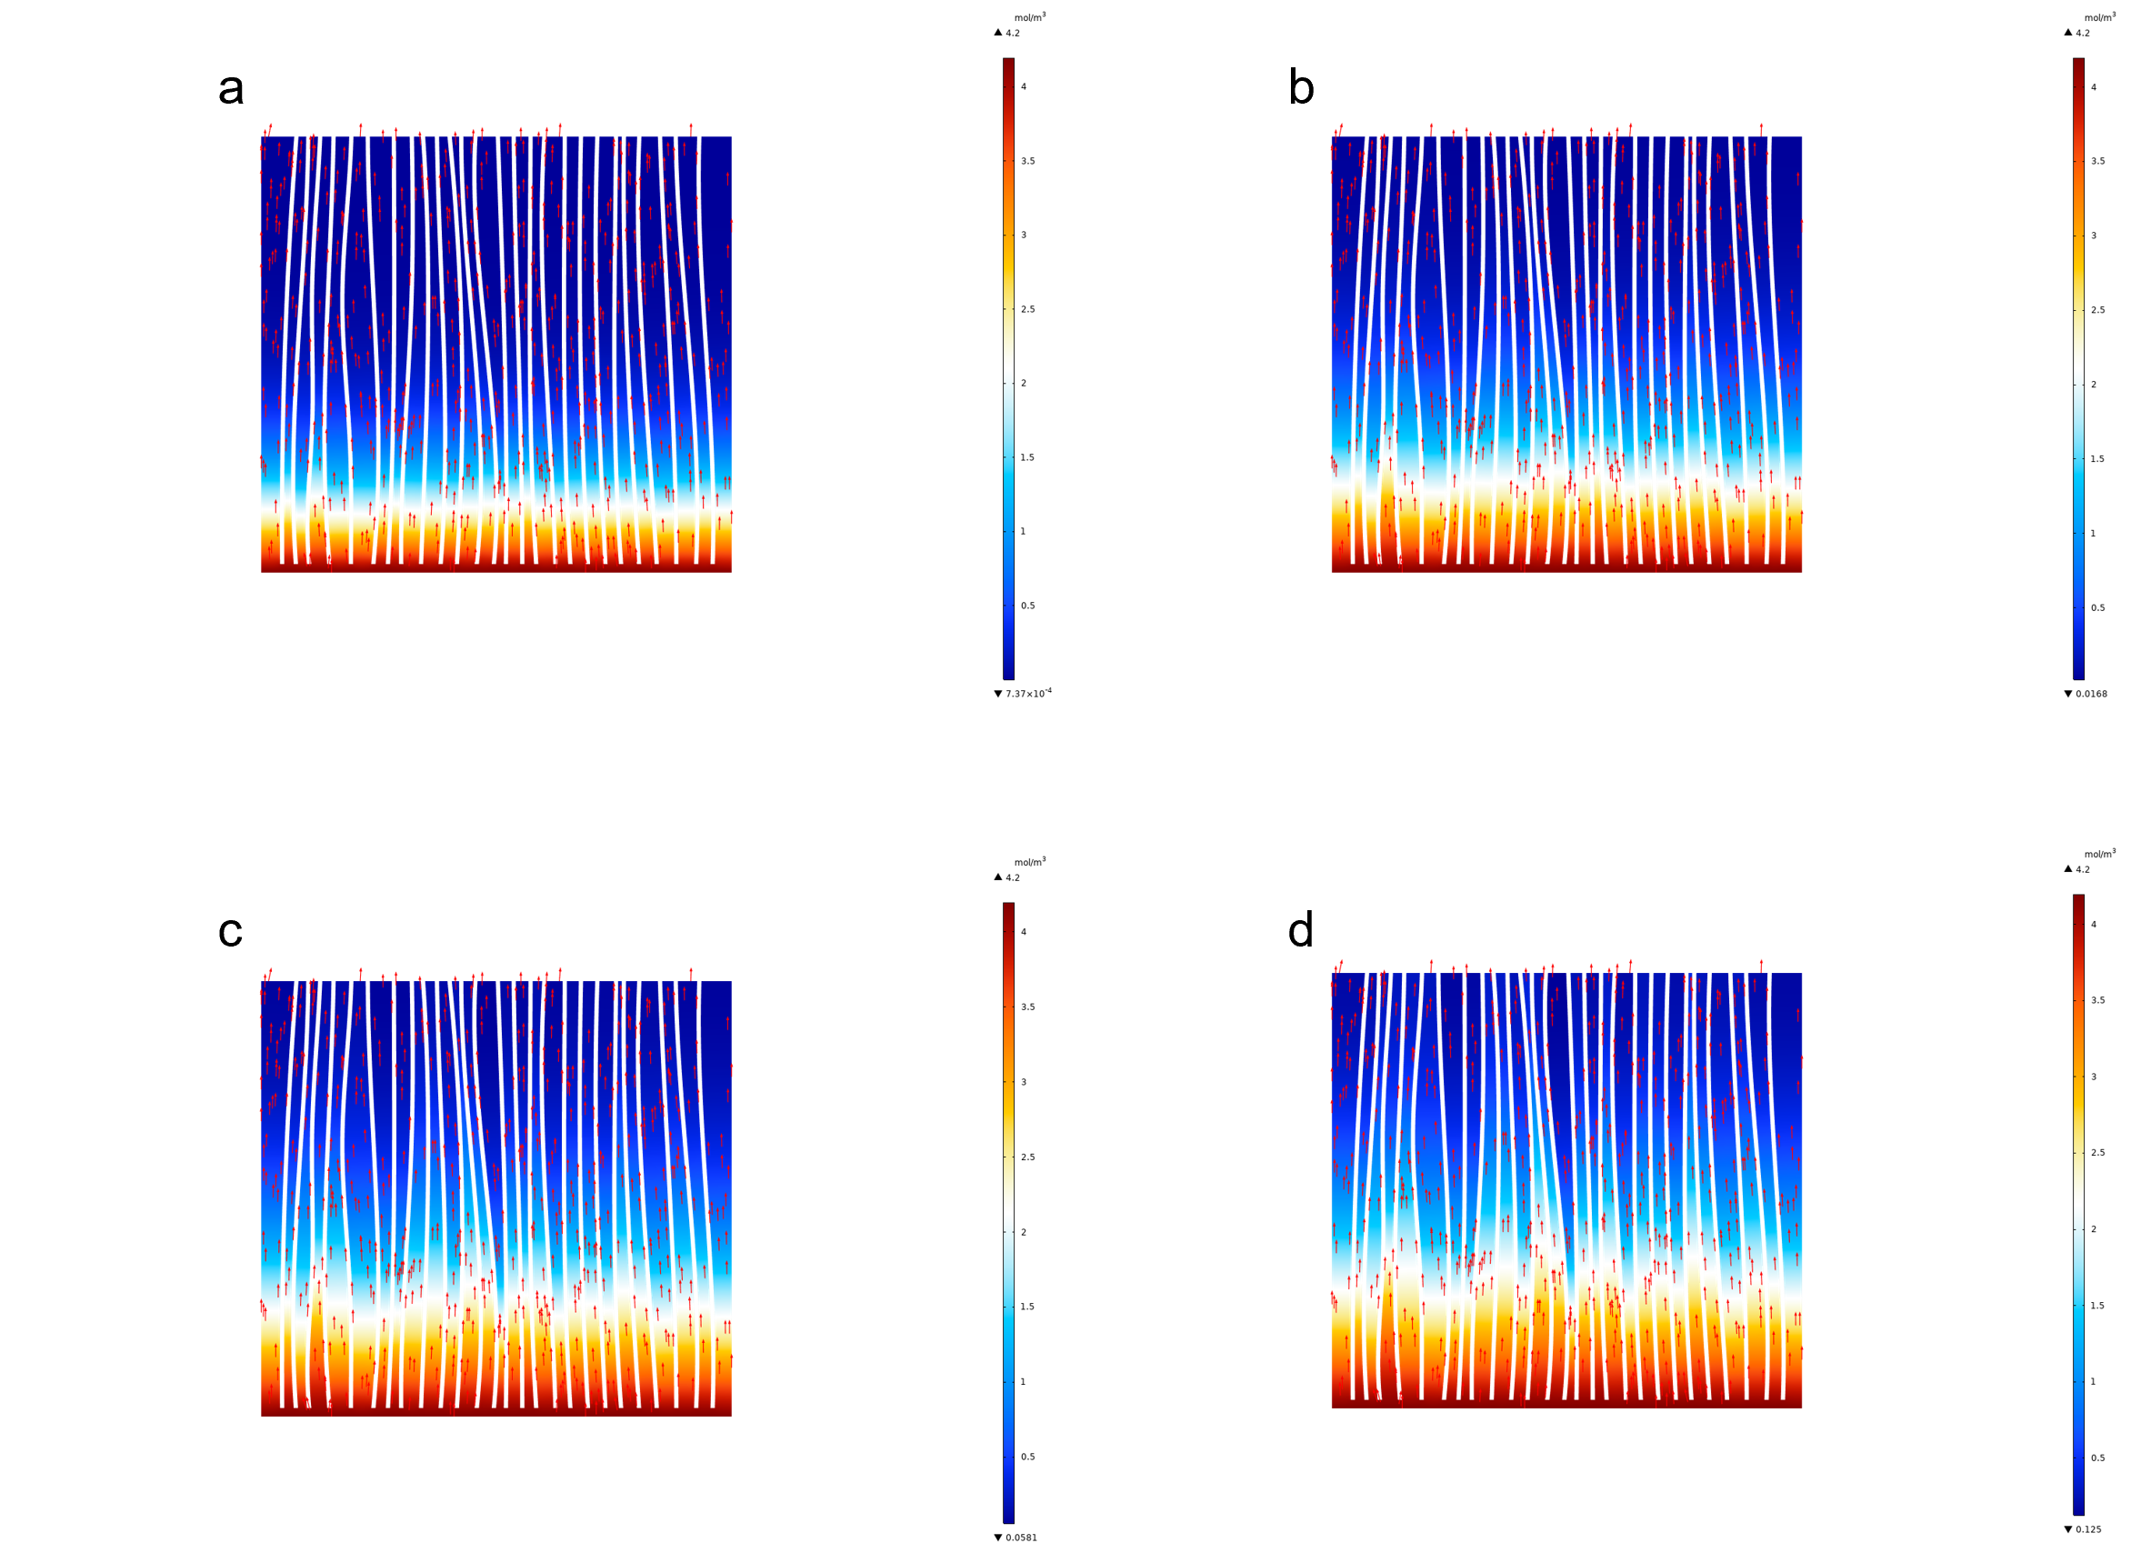
Supplementary Fig. 2 | COMSOL simulated CO₂ diffusion in ordered nanowire channels under 15% CO₂ feed at different diffusion times. (a) 0.5 μs; (b) 1.0 μs; (c) 1.5 μs; (d) 2.0 μs.

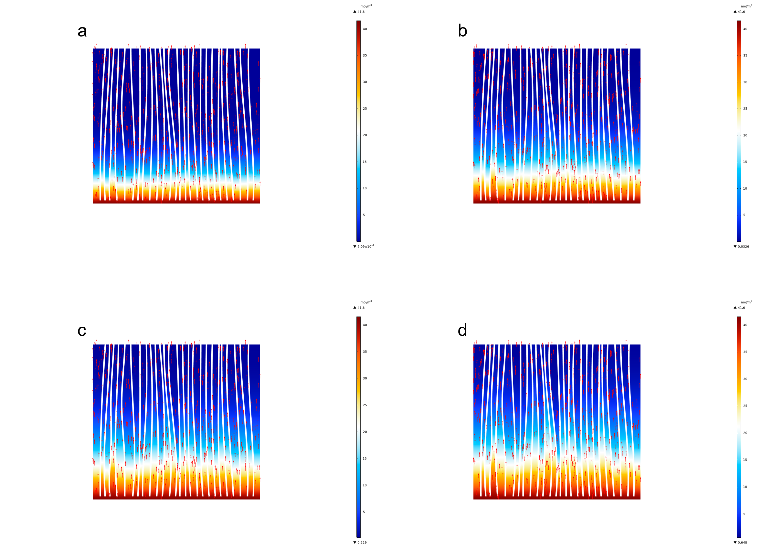
Supplementary Fig. 3 | COMSOL simulated CO₂ diffusion in ordered nanowire channels under 100% CO₂ feed at different diffusion times. (a) 0.5 μs; (b) 1.0 μs; (c) 1.5 μs; (d) 2.0 μs.

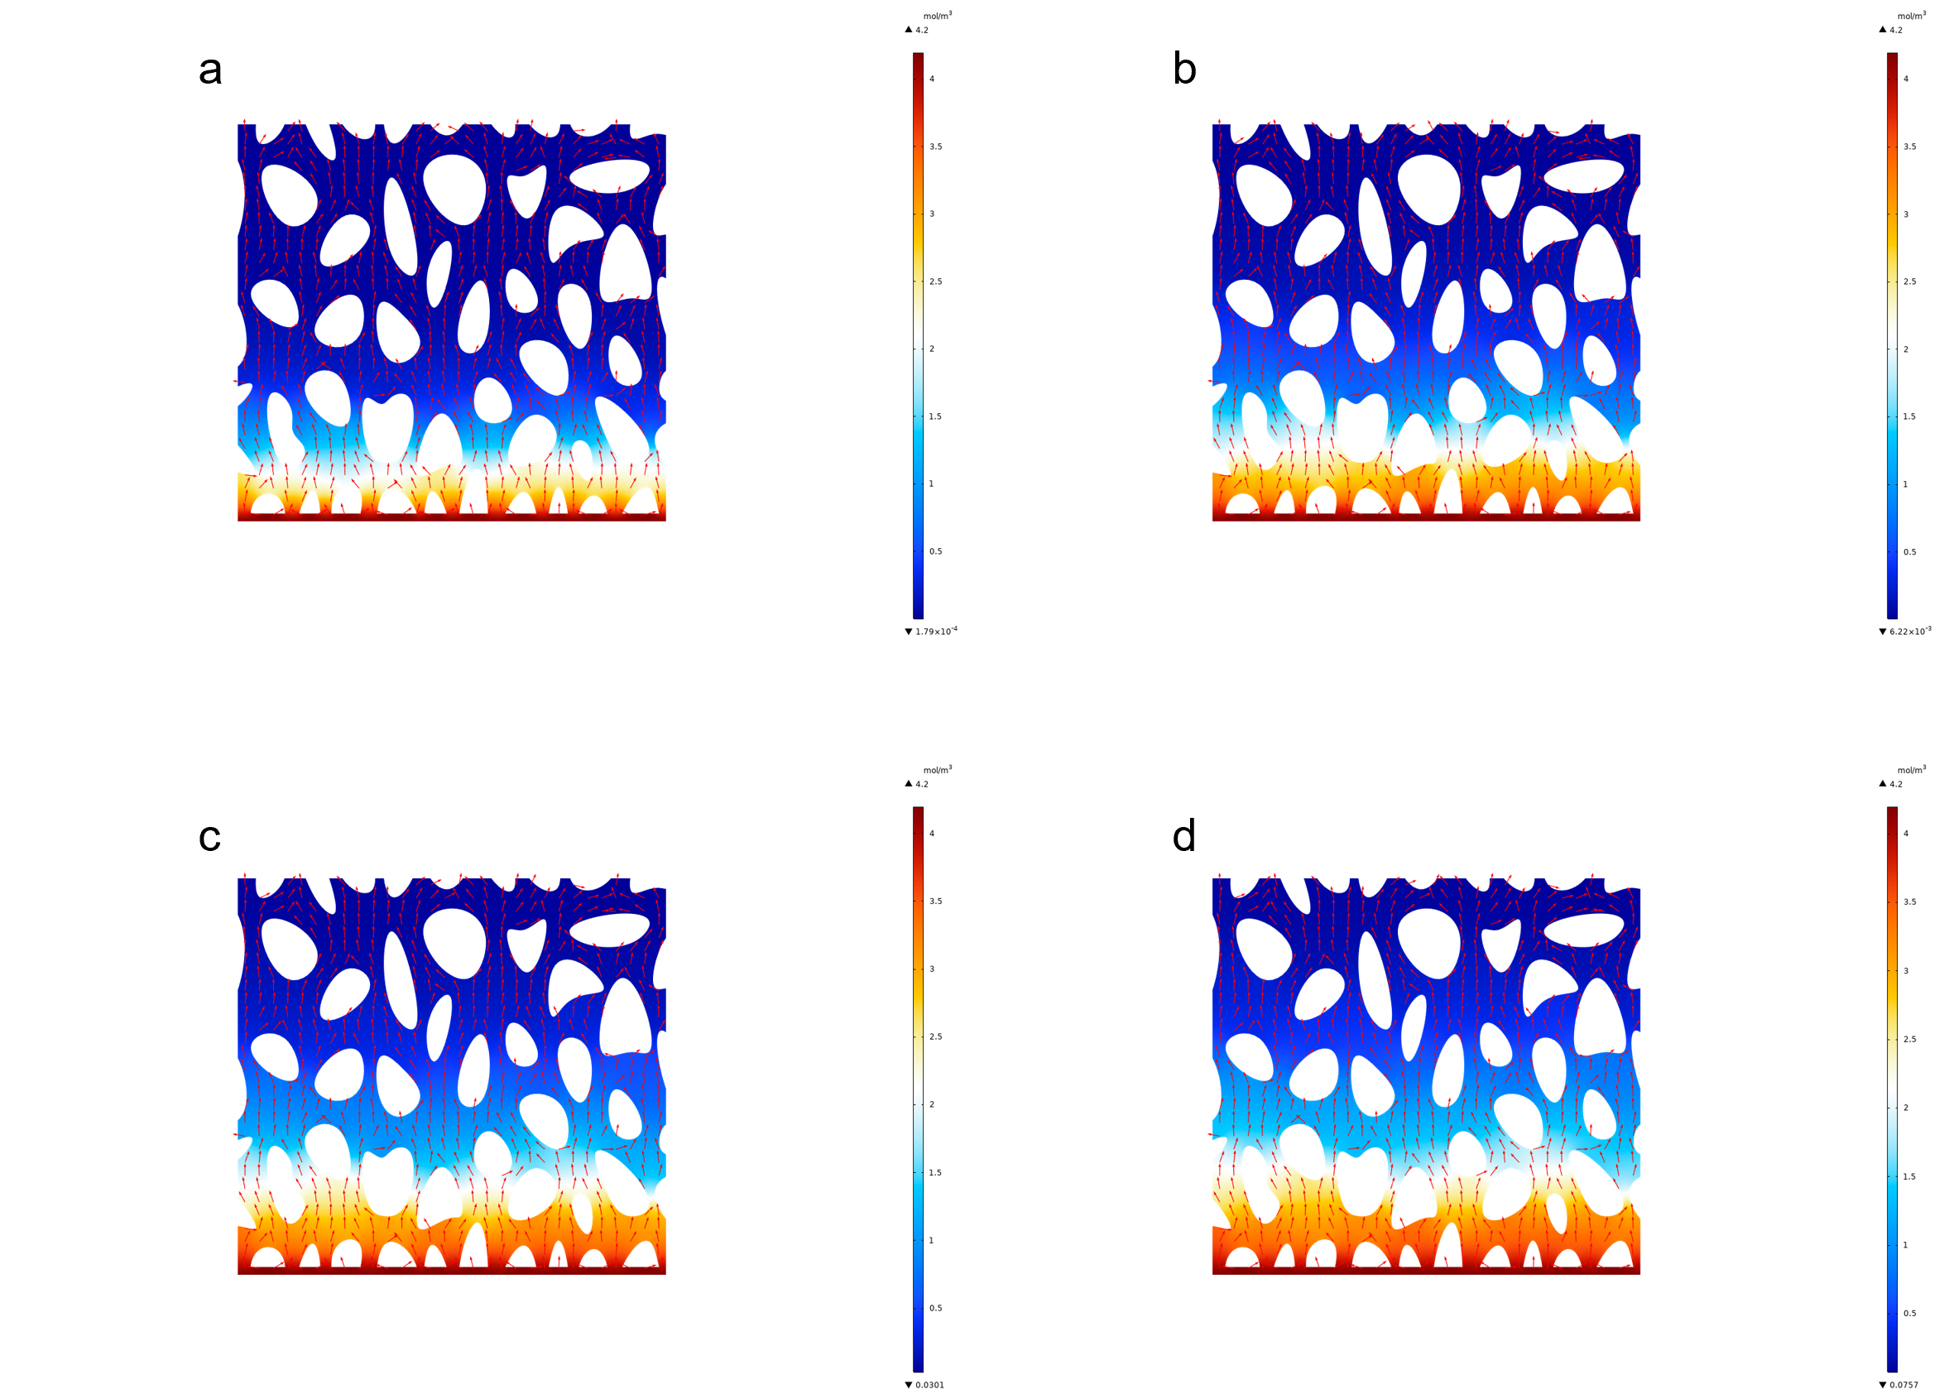
Supplementary Fig. 4 | COMSOL simulated CO₂ diffusion in disordered pores under 15% CO₂ feed at different diffusion times. (a) 0.5 μs; (b) 1.0 μs; (c) 1.5 μs; (d) 2.0 μs.

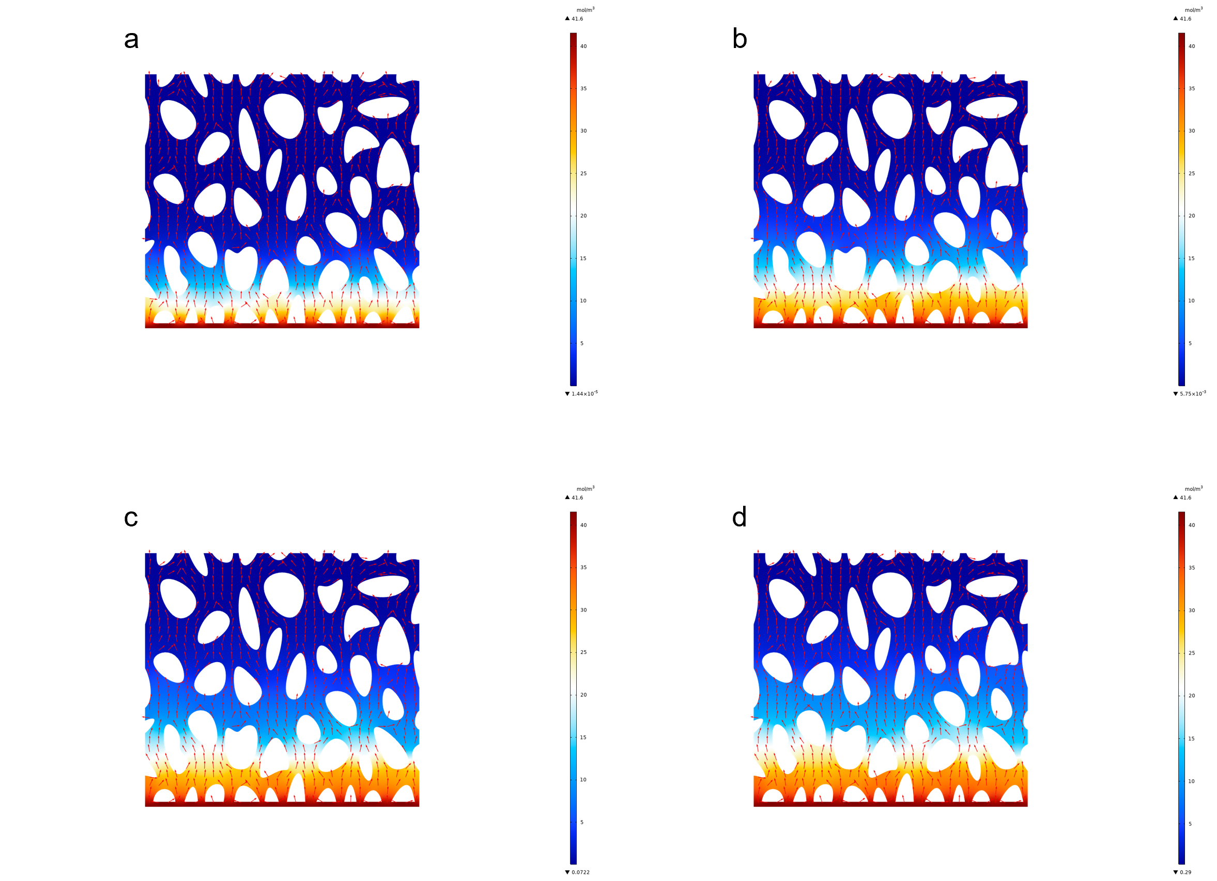
Supplementary Fig. 5 | COMSOL simulated CO₂ diffusion in disordered pores under pure CO₂ feed at different diffusion times. (a) 0.5 μs; (b) 1.0 μs; (c) 1.5 μs; (d) 2.0 μs.

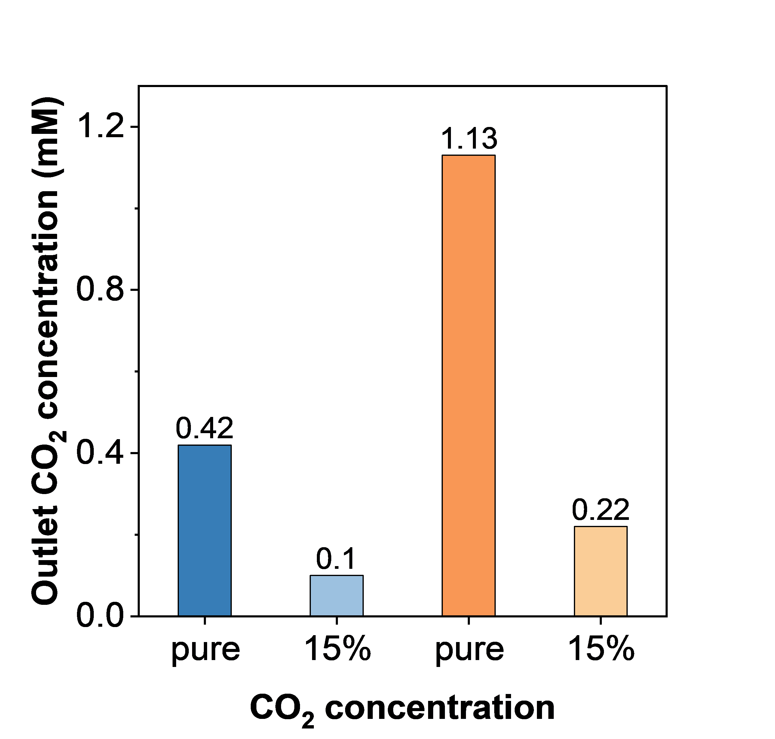
Supplementary Fig. 6 | Simulated outlet CO₂ concentrations at 2 μs under different feed CO₂ concentrations.

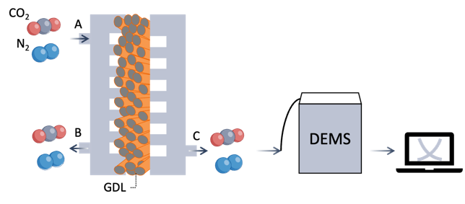
Supplementary Fig. 7 | Schematic illustration of the in situ DEMS setup for evaluating apparent CO₂ diffusion rates using 28 BC or Cu-NW as the gas diffusion layer (GDL).

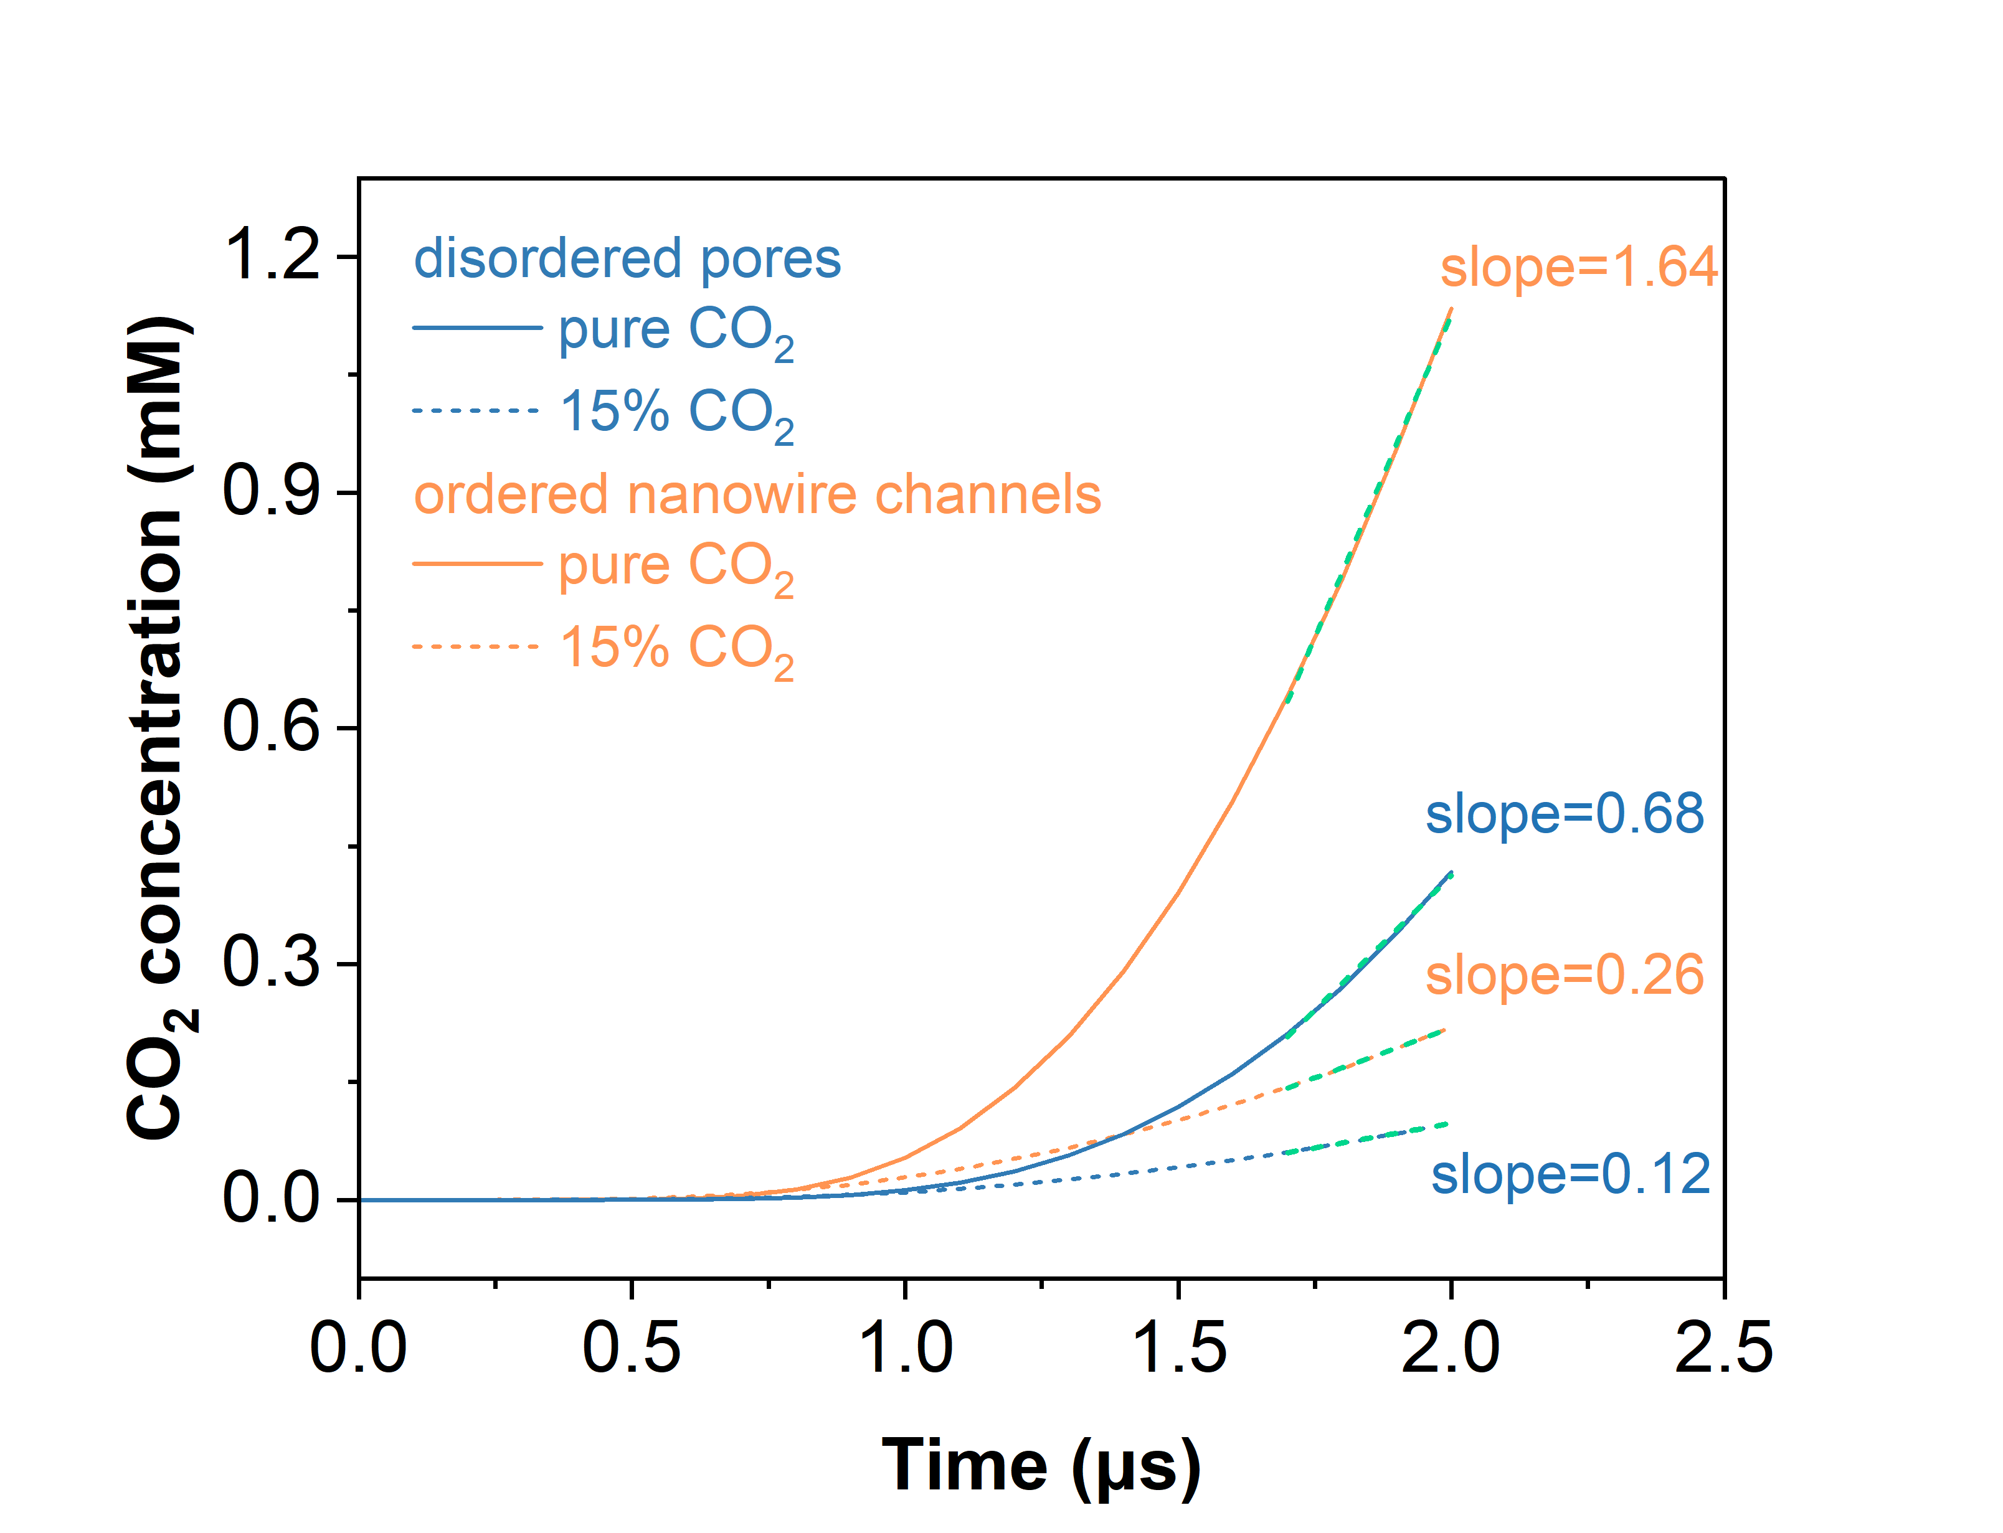
Supplementary Fig. 8 | CO₂ transport rates calculated from the slopes of the outlet concentration profiles under different feed CO₂ concentrations.

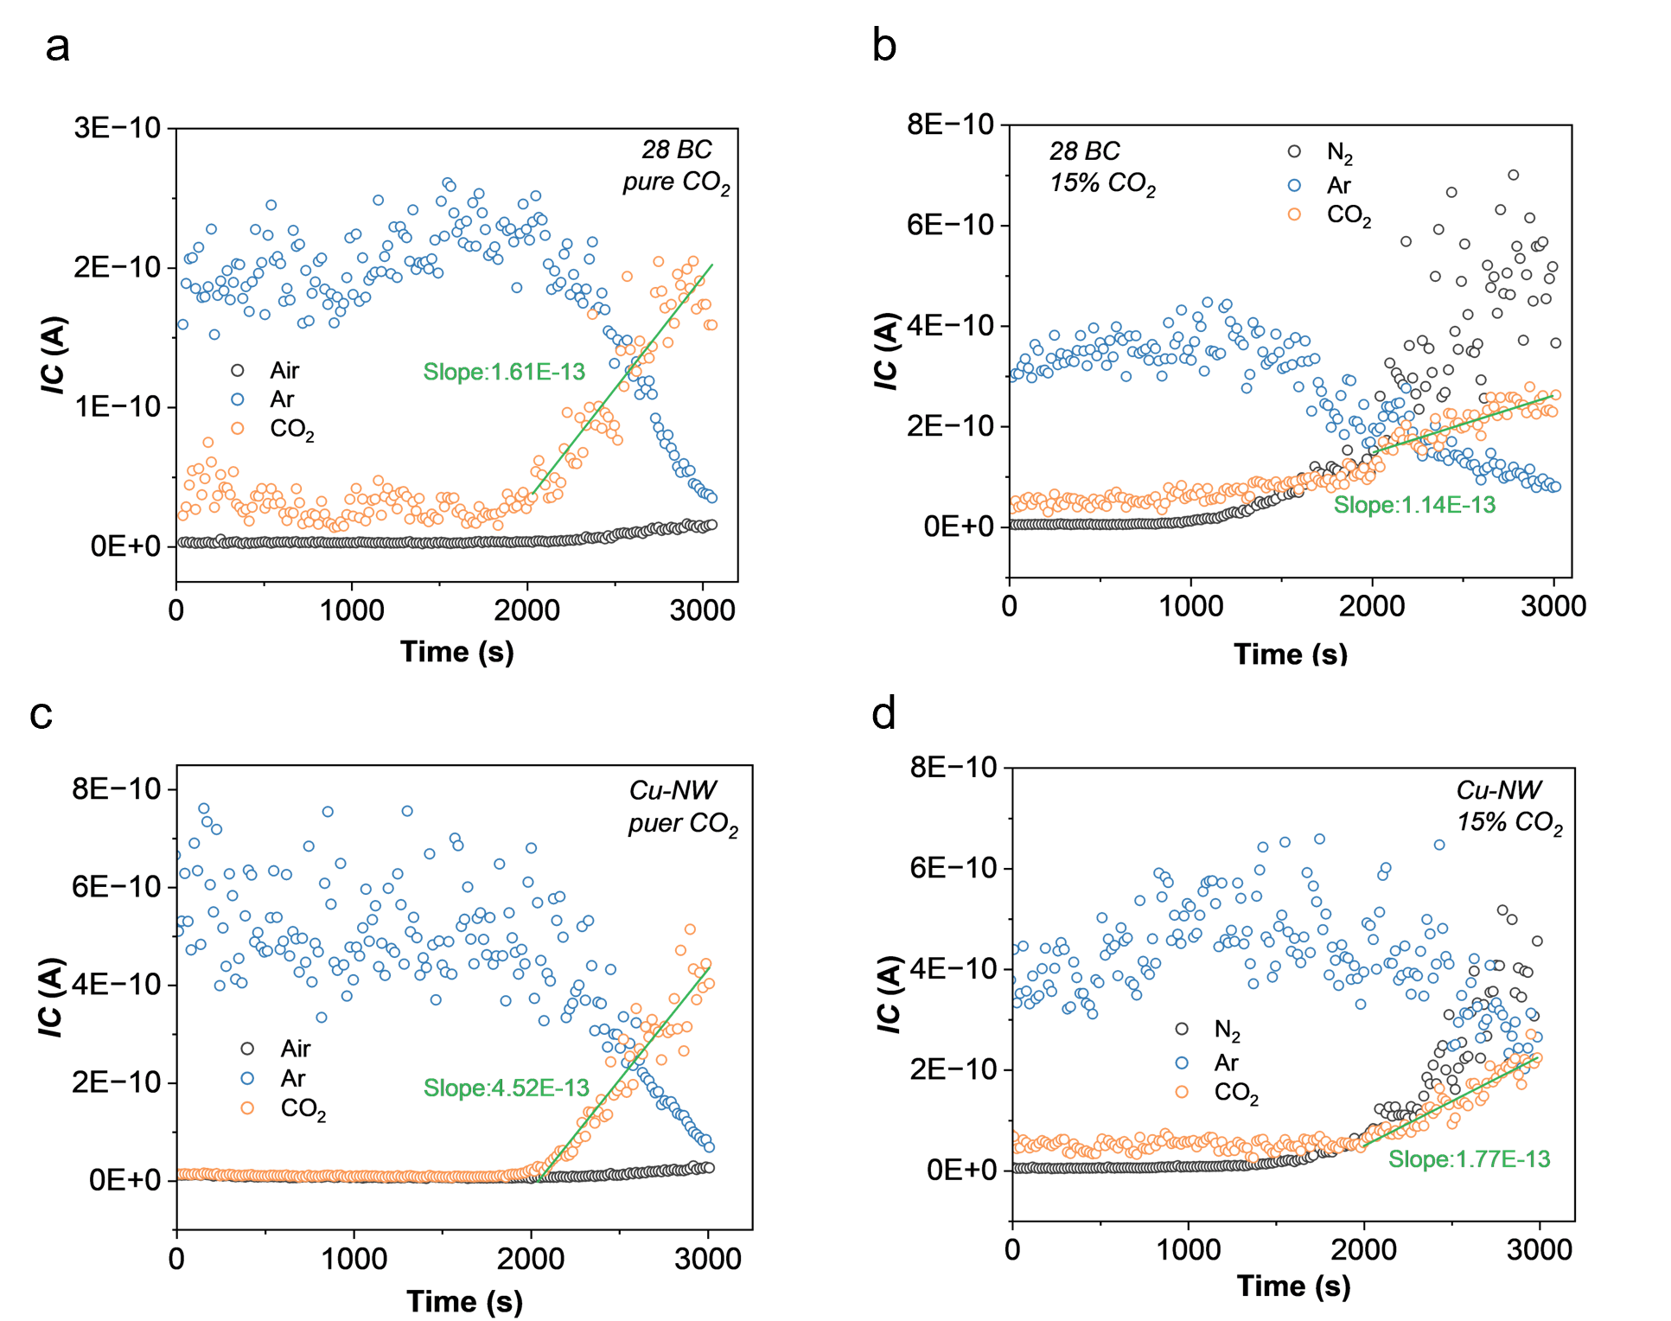
Supplementary Fig. 9 | In situ DEMS analysis of 28 BC and Cu-NW used as gas diffusion layers (GDLs) under pure CO₂ and 15% CO₂ atmospheres. The slope of the CO₂ ionic current (IC) response versus time was used to evaluate the apparent CO₂ diffusion rate. The diffusion rate of 28 BC under pure CO₂ conditions was normalized to 1. (a) 28 BC under pure CO₂, (b) 28 BC under 15% CO₂, (c) Cu-NW under pure CO₂, and (d) Cu-NW under 15% CO₂.

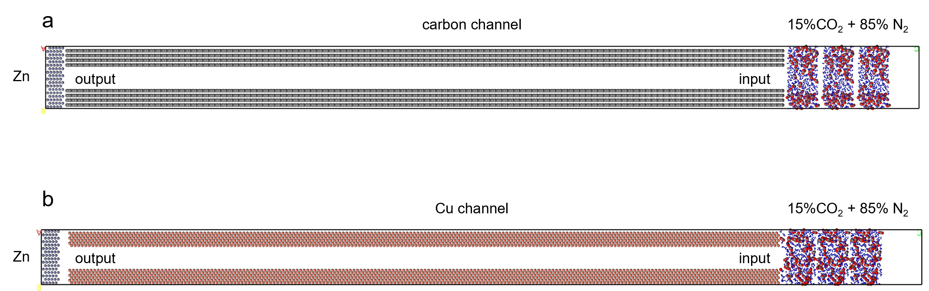
Supplementary Fig. 10 | Molecular dynamics models used to investigate CO₂ transport in confined carbon and Cu channels at initial state. (a) carbon channel. (b) Cu channel.

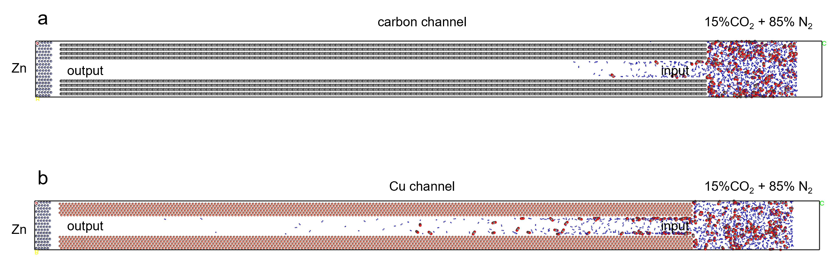
Supplementary Fig. 11 | Molecular dynamics models used to investigate CO₂ transport in confined carbon and Cu channels after 1 ns. (a) carbon channel. (b) Cu channel.

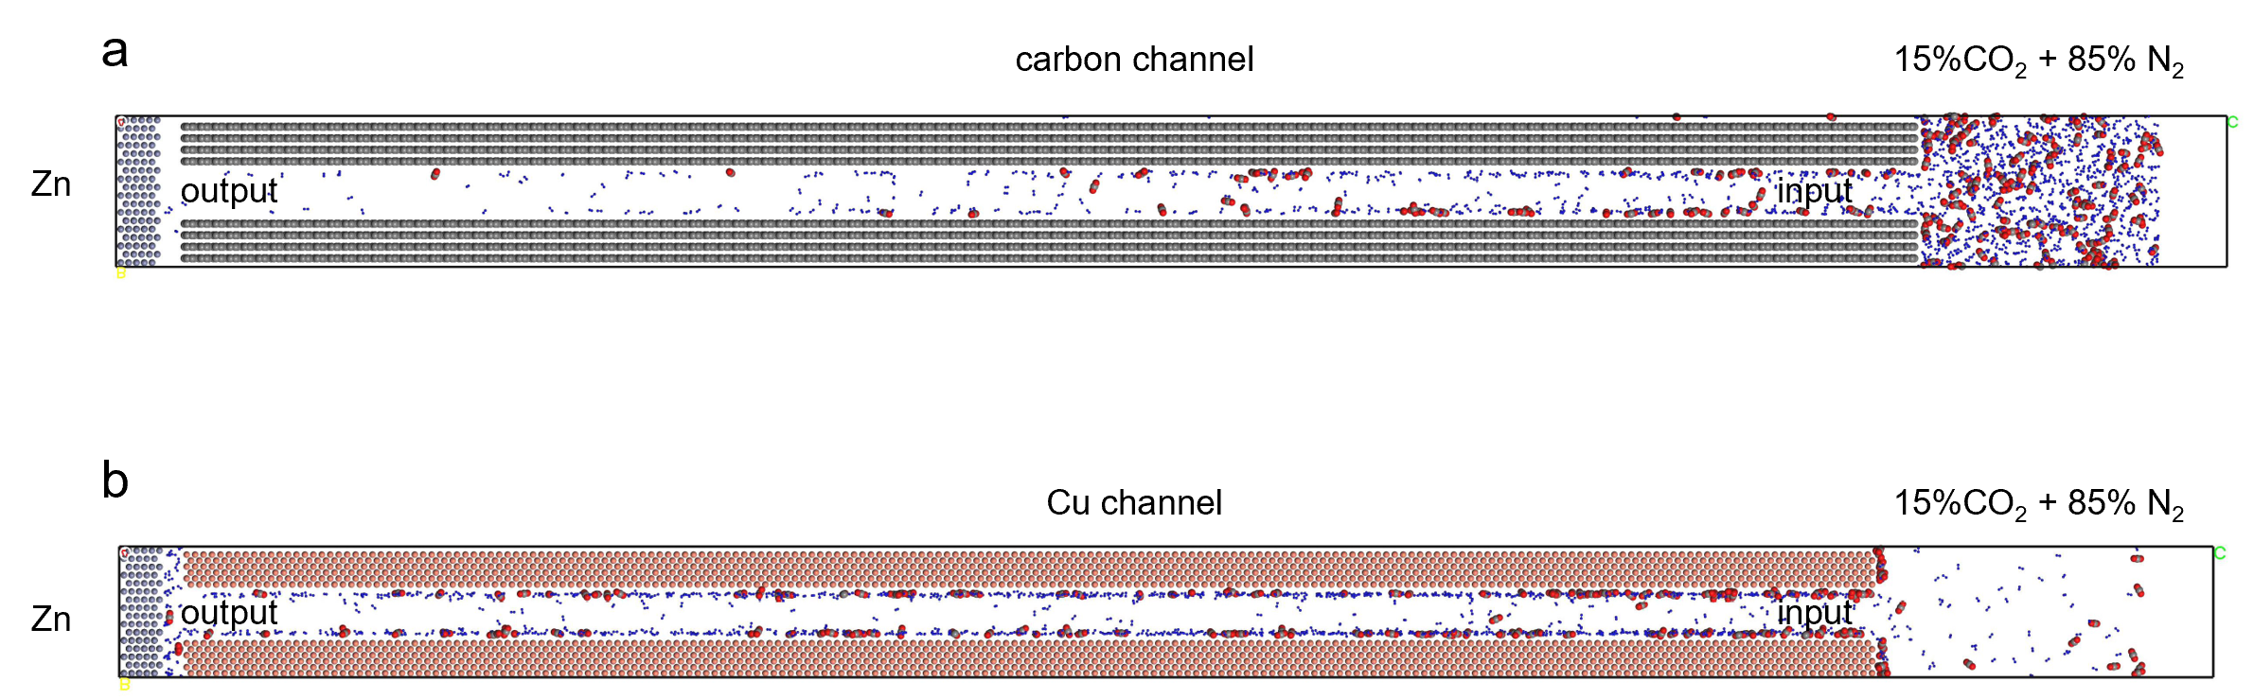
Supplementary Fig. 12 | Molecular dynamics models used to investigate CO₂ transport in confined carbon and Cu channels after 3 ns. (a) carbon channel. (b) Cu channel.

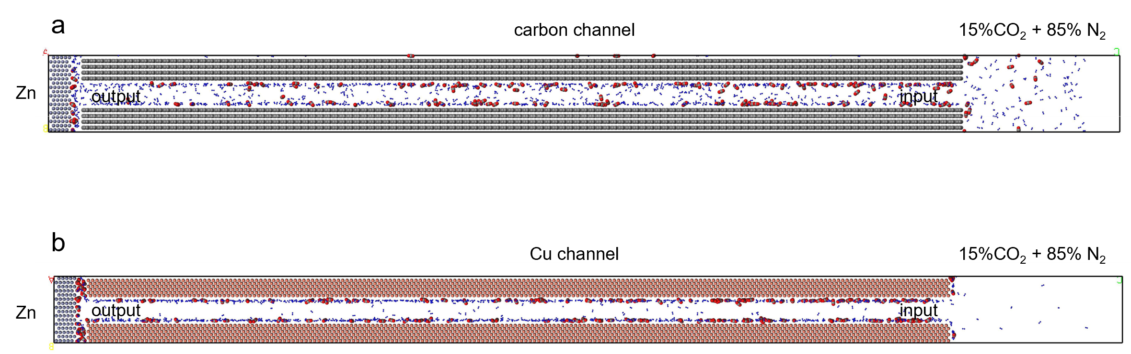
Supplementary Fig. 13 | Molecular dynamics models used to investigate CO₂ transport in confined carbon and Cu channels after 5 ns. (a) carbon channel. (b) Cu channel.

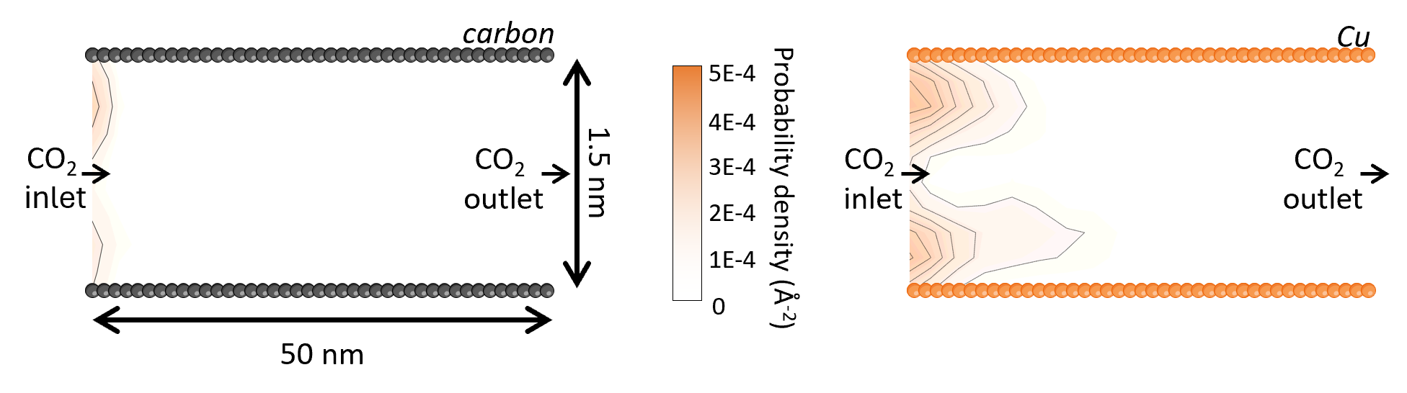
Supplementary Fig. 14 | Molecular dynamics simulations of CO₂ diffusion in confined channels after 1 ns diffusion. Left, carbon channel. Right, Cu channel.

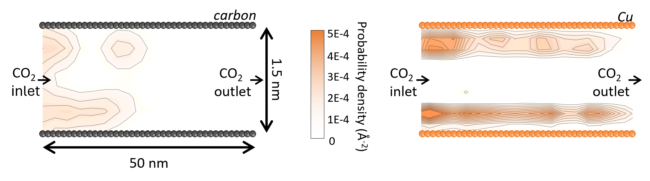
Supplementary Fig. 15 | Molecular dynamics simulations of CO₂ diffusion in confined channels after 3 ns diffusion. Left, carbon channel. Right, Cu channel.

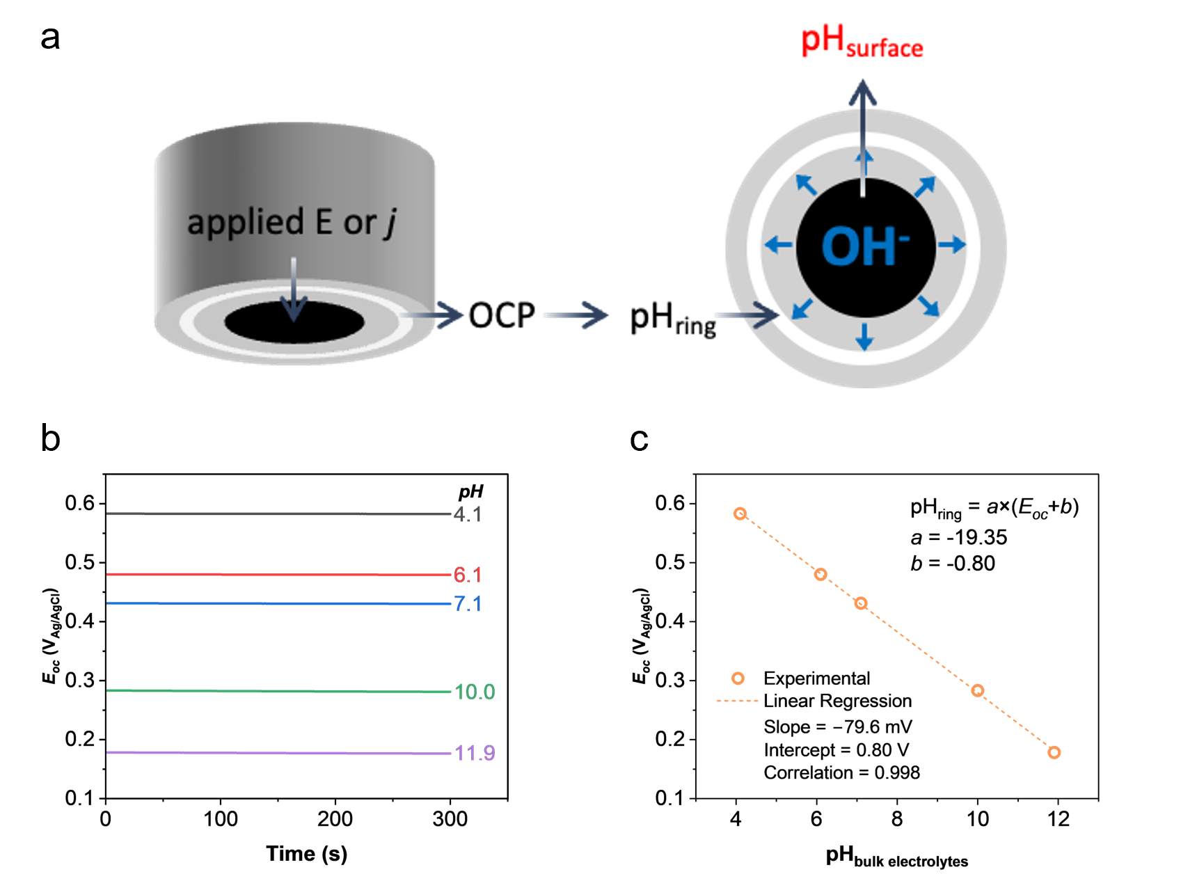
Supplementary Fig. 16 | Monitoring of the local pH near a glassy carbon disk electrode using an IrO_{x}-modified rotating ring-disk electrode (RRDE). The modification procedure of the ring electrode is described in the Methods section. (a) Schematic illustration of local pH monitoring using the IrOx-modified RRDE. During the measurement, OH⁻ generated at the glassy carbon disk electrode was transported by the radial electrolyte flow and detected by the IrO_{x}-modified ring electrode. (b,c) Open-circuit potential (E_{oc}) response of the IrO_{x}-electrodeposited Pt ring electrode as a function of (b) time and (c) pH. The measurements were conducted in ultrapure water, and the pH was adjusted by adding H₂SO₄ or KOH.

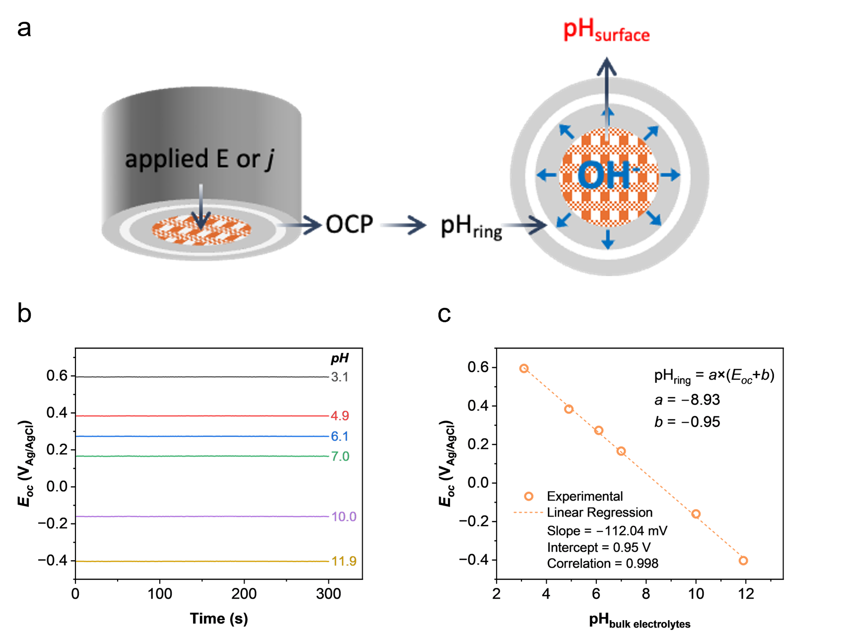
Supplementary Fig. 17 | Monitoring of the local pH near a Cu-NW disk electrode using an IrO_{x}-modified rotating ring-disk electrode (RRDE). The preparation of the Cu-NW disk electrode and the modification of the ring electrode are described in the Methods section. (a) Schematic illustration of local pH monitoring using the IrO_{x}-modified RRDE. During the measurement, OH⁻ generated at the Cu-NW disk electrode was transported by the radial electrolyte flow and detected by the IrO_{x}-modified ring electrode. (b,c) Open-circuit potential (E_{oc}) response of the IrO_{x}-electrodeposited Pt ring electrode as a function of (b) time and (c) pH. The measurements were conducted in the electrodeposition electrolyte containing Zn²⁺, SO₄²⁻, and NH⁴⁺, and the pH was adjusted by adding H₂SO₄ or NH₃·H₂O.

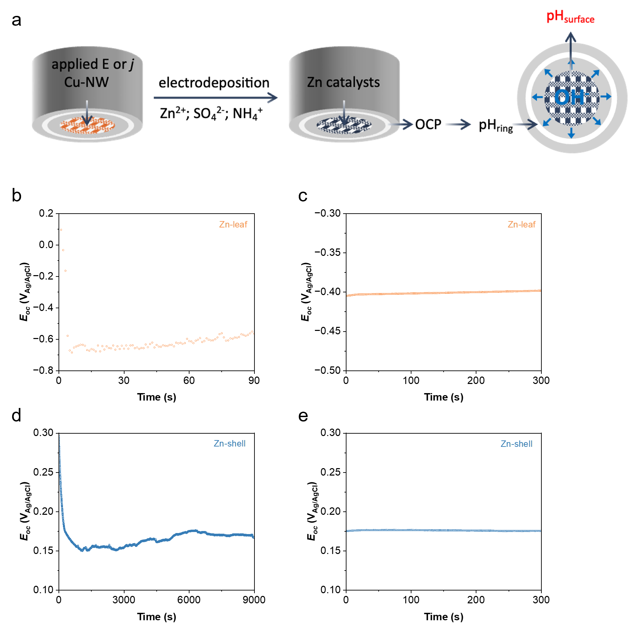
Supplementary Fig. 18 | Monitoring of local pH evolution during Zn electrodeposition on a Cu-NW disk electrode using a rotating ring-disk electrode (RRDE), where the disk electrode was Cu-NW and the ring electrode was an IrOx-modified Pt electrode. (a) Schematic illustration of local pH monitoring during Zn electrodeposition. During the measurement, OH⁻ generated at the disk electrode was transported by the radial electrolyte flow and detected by the IrO_{x}-modified ring electrode. (b) Open-circuit potential (E_{oc}) response of the ring electrode during Zn electrodeposition at −100 mA cm⁻² for 90 s. (c) E_{oc} response of the ring electrode as a function of resting time after electrodeposition at −100 mA cm⁻² for 90 s, demonstrating the stability of the locally generated alkaline microenvironment. (d) E_{oc} response of the ring electrode during Zn electrodeposition at −1 mA cm⁻² for 9000 s. (e) E_{oc} response of the ring electrode as a function of resting time after electrodeposition at −1 mA cm⁻² for 9000 s, demonstrating the stability of the locally generated alkaline microenvironment. The measurements were conducted in the electrodeposition electrolyte containing Zn²⁺, SO₄²⁻, and NH₄⁺.
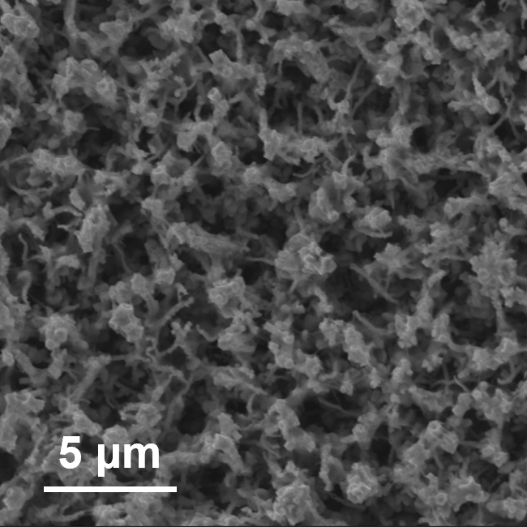
Supplementary Fig. 19 | SEM image measurement of Zn-shell.

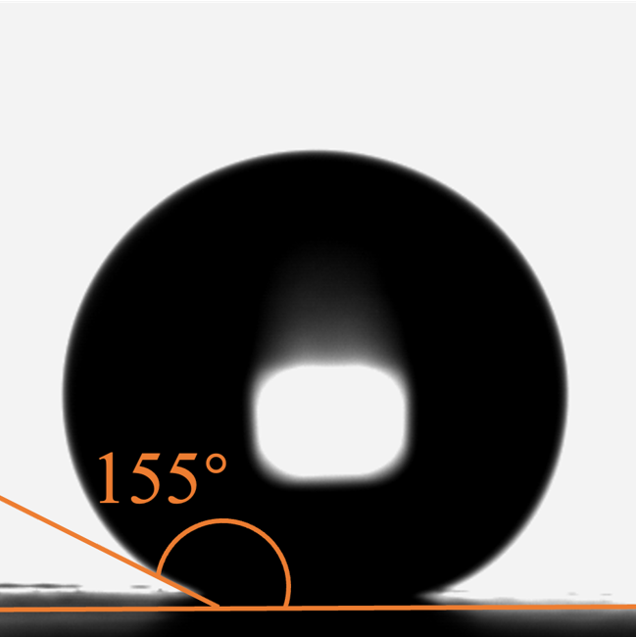
Supplementary Fig. 20 | Contact angle measurement of Zn-shell.

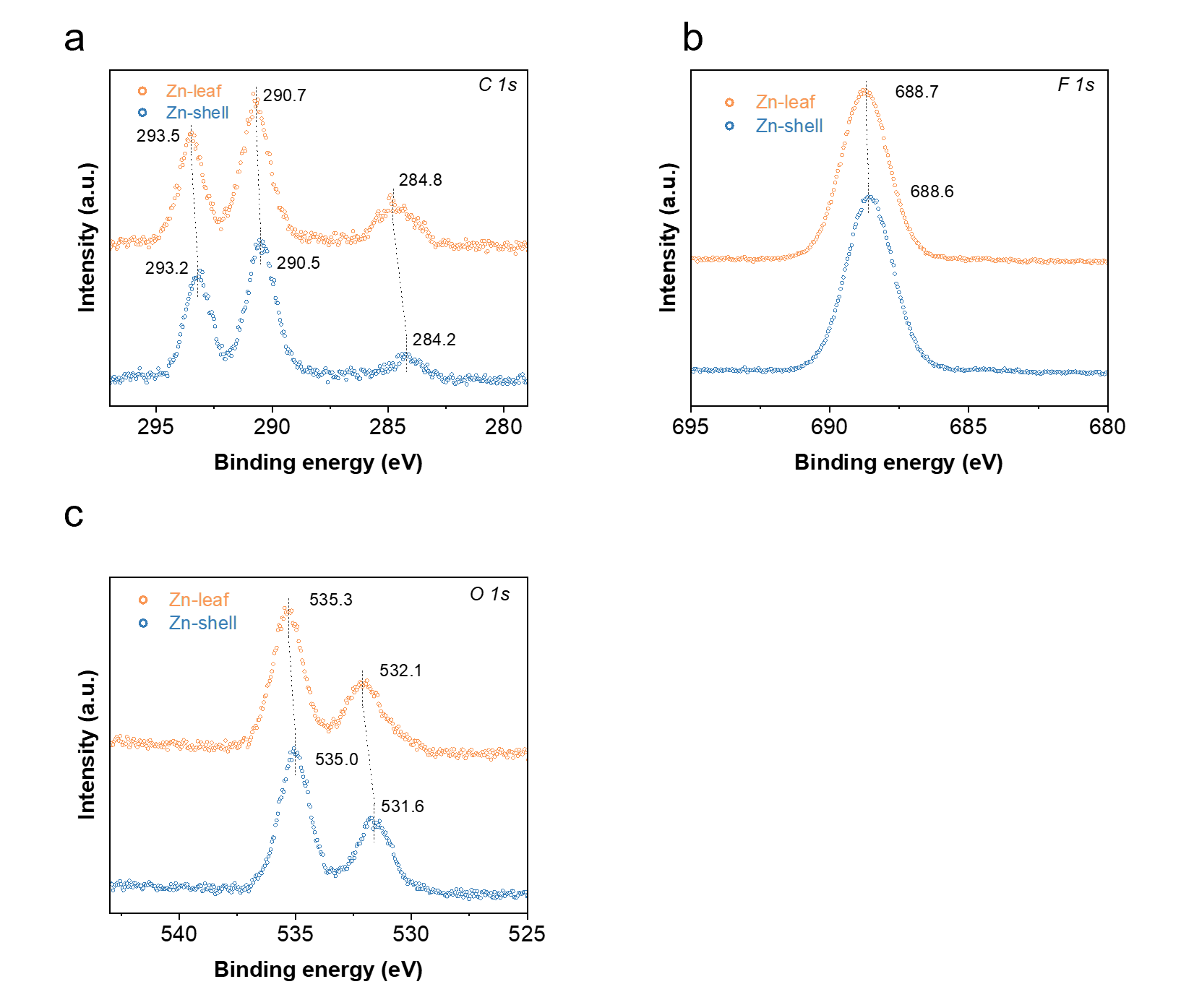
Supplementary Fig. 21 | XPS spectra of (a) C 1s, (b) F 1s, and (c) O 1s for Zn-shell and Zn-leaf.
The XPS results confirm the successful coating of the polymer on both Zn-shell and Zn-leaf surfaces. Compared with Zn-shell, Zn-leaf exhibited consistently higher binding energies in the C 1s, F 1s, and O 1s spectra, suggesting stronger interfacial interactions between the polymer and the preferentially exposed crystal facets of Zn-leaf.
A slight positive shift (0.1–0.5 eV) in the binding energies of Zn-leaf relative to Zn-shell was observed after PFD modification, which may arise from differences in surface electronic structures associated with their distinct crystallinity and hydroxyl coverage.

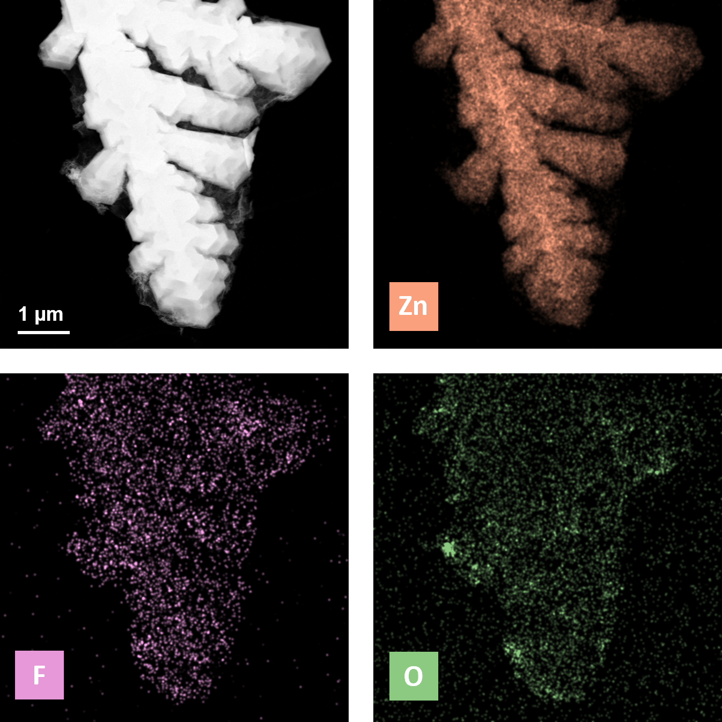
Supplementary Fig. 22 | HAADF-STEM image and EDS elemental mapping of Zn-leaf. Zn (orange), F (purple), and O (green).

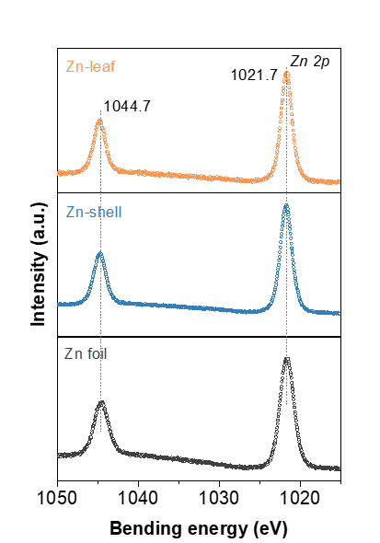
Supplementary Fig. 23 | Zn 2p XPS spectra of Zn foil, Zn-shell, and Zn-leaf.
No characteristic peaks associated with Zn oxides or Zn hydroxides were observed for Zn-shell and Zn-leaf, indicating that metallic Zn was the dominant surface species.

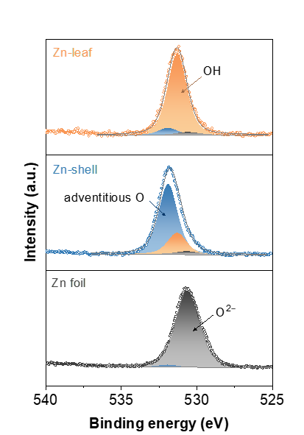
Supplementary Fig. 24 | High-resolution O 1s XPS spectra of Zn foil, Zn-shell, and Zn-leaf. The gray, blue, and orange peaks correspond to O²⁻, adventitious O, and OH species, respectively. Zn-shell and Zn-leaf refer to Zn electrodes without polymer modification.
Zn-leaf exhibited the highest proportion of OH species among the three electrodes, suggesting enhanced hydroxyl enrichment on the Zn-leaf surface, which may contribute to the formation of a locally alkaline microenvironment.

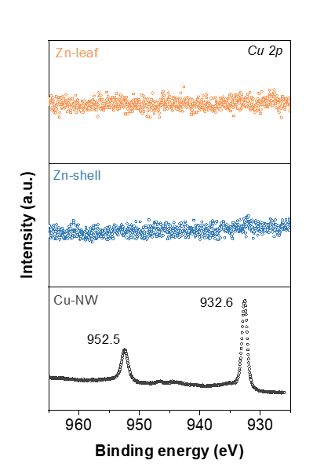
Supplementary Fig. 25 | Cu 2p XPS spectra of Cu-NW, Zn-shell, and Zn-leaf.
No detectable Cu-related peaks were observed for Zn-shell and Zn-leaf, indicating negligible surface exposure of Cu species after Zn deposition.

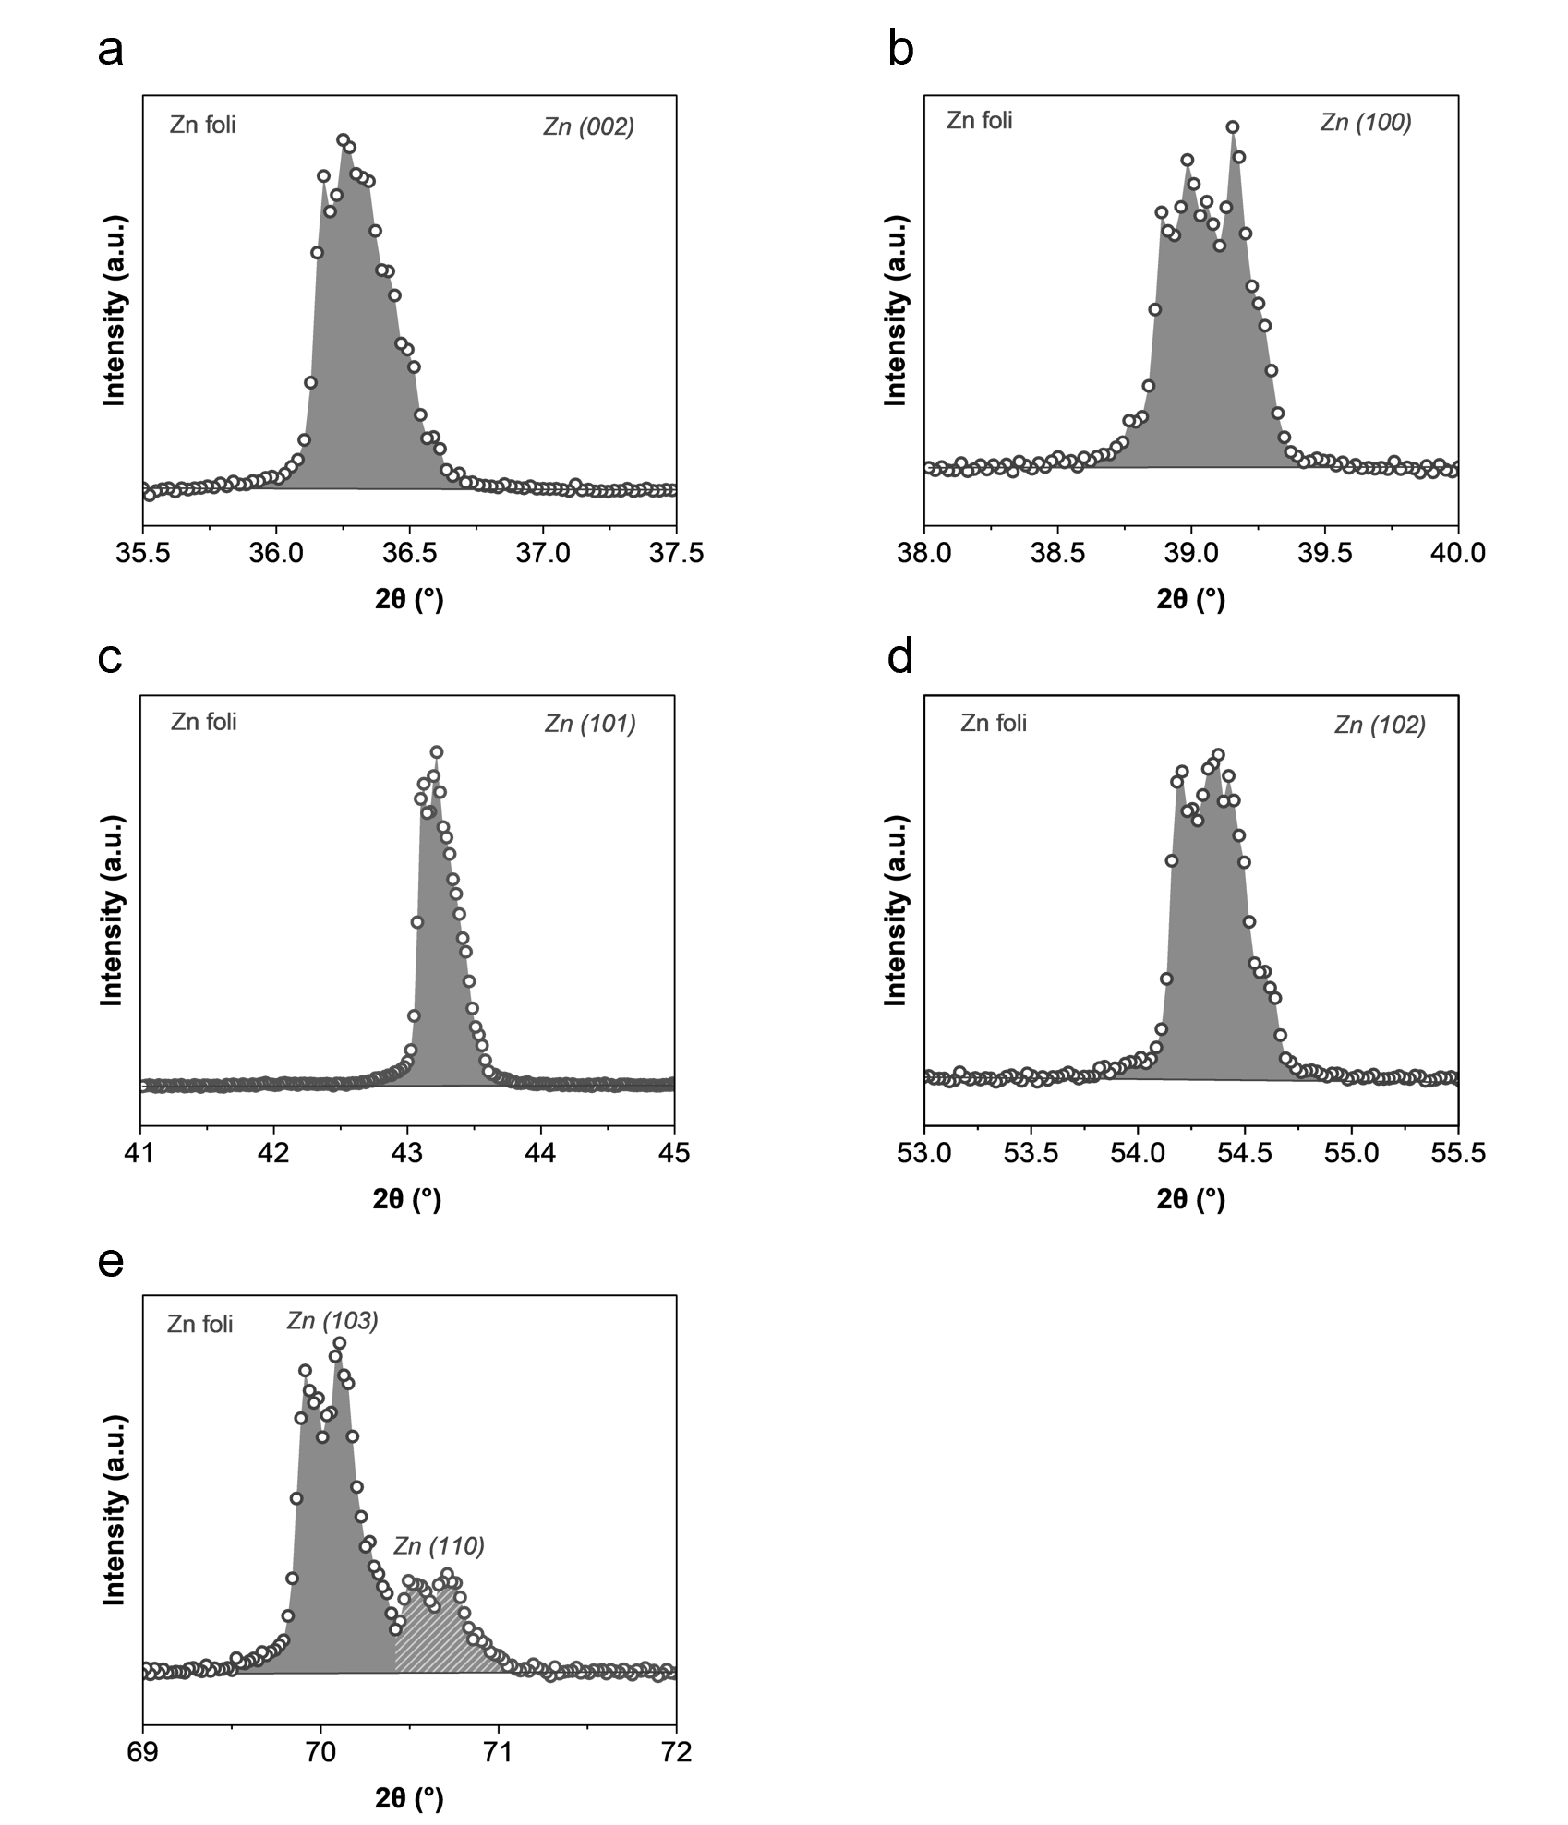
Supplementary Fig. 26 | Integrated peak areas of XRD reflections for different crystal facets of Zn foil. (a) (002), (b) (100), (c) (101), (d) (102), (e) (103), and (110).

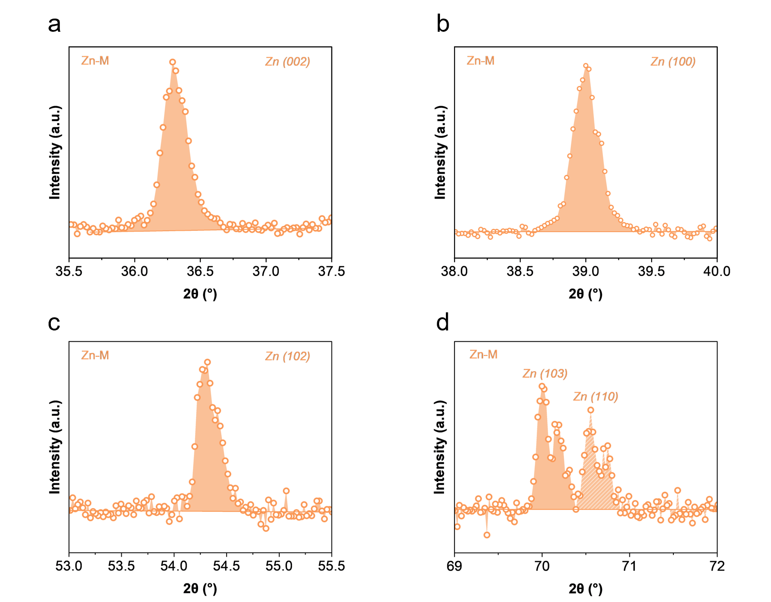
Supplementary Fig. 27 | Integrated peak areas of XRD reflections for different crystal facets of Zn-leaf. (a) (002), (b) (100), (c) (102), (d) (103), and (110).

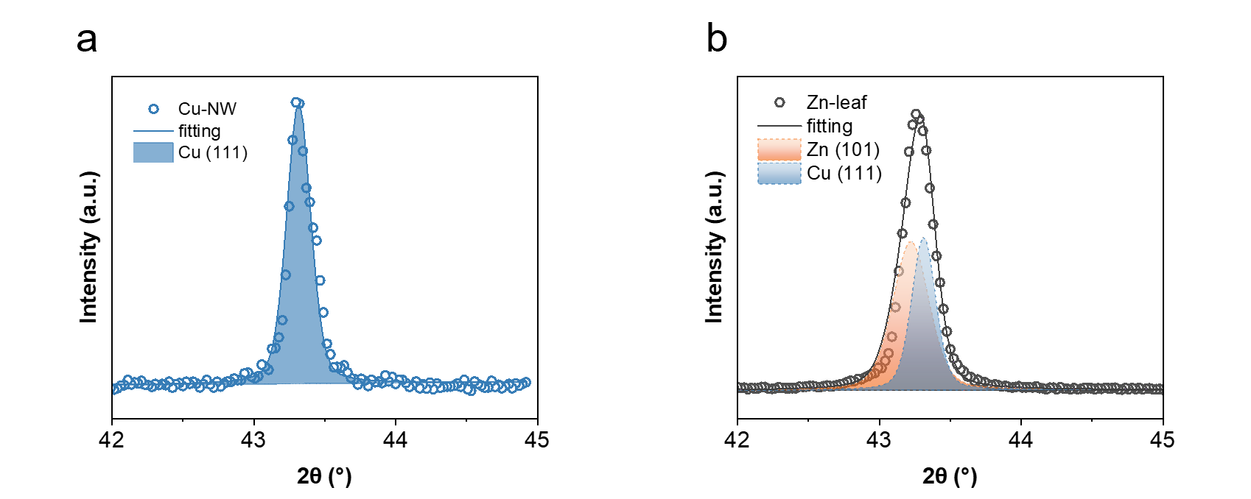
Supplementary Fig. 28 | Peak fitting analysis of the Cu (111) reflection for Cu-NW and the Cu (111) and Zn (101) reflections for Zn-leaf. The peak position and full width at half maximum (FWHM) of the Cu (111) reflection in Zn-leaf were constrained based on the fitting results of Cu-NW. (a) Cu-NW and (b) Zn-leaf.

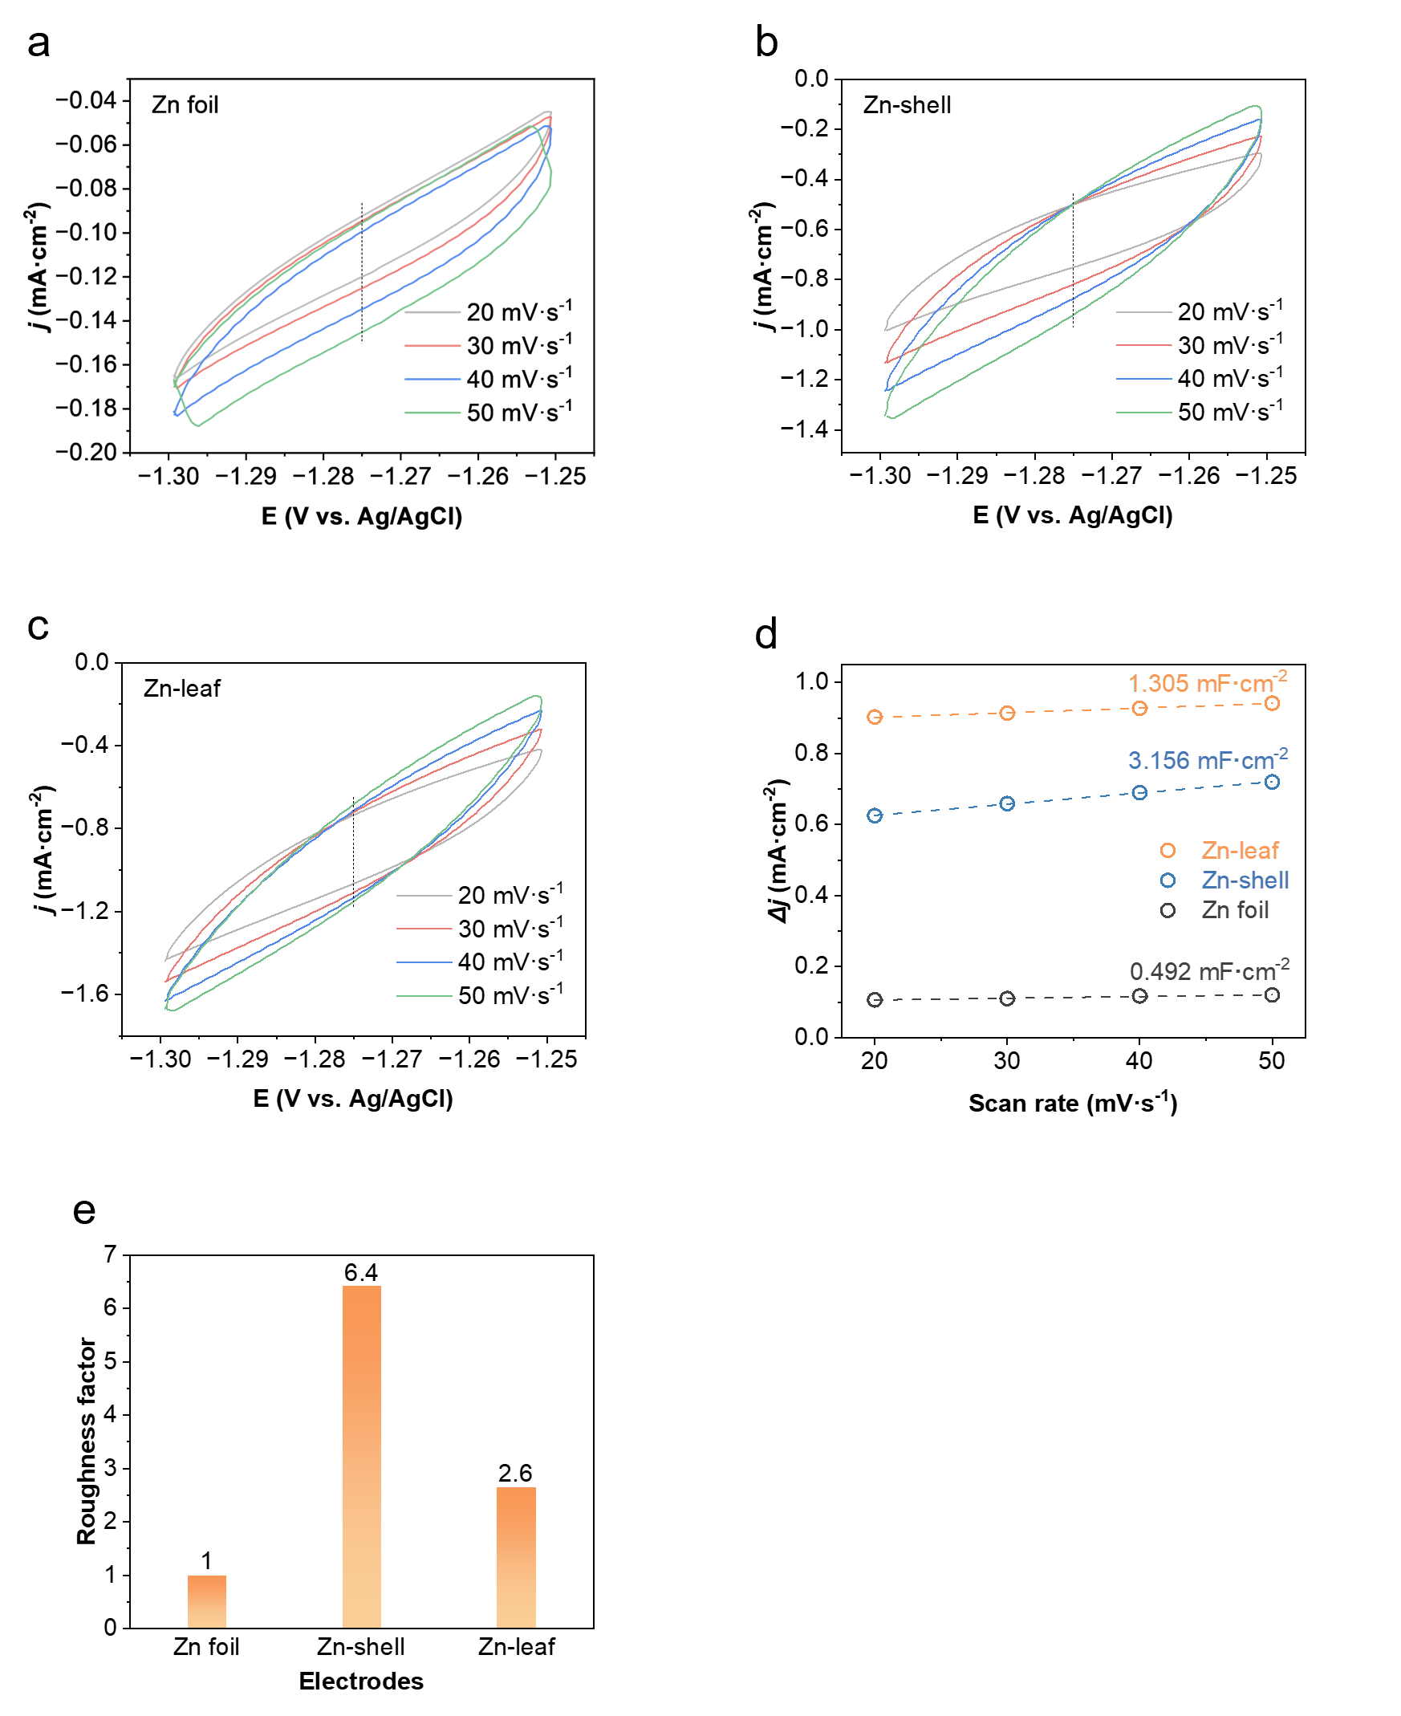
Supplementary Fig. 29 | ECSA analysis of Zn foil, Zn-shell, and Zn-leaf. Cyclic voltammetry (CV) curves of (a) Zn foil, (b) Zn-shell, and (c) Zn-leaf, together with (d) calculated ECSA values and (e) roughness factors.
The roughness factor was calculated by normalizing the double-layer capacitance slope to that of the Zn foil reference surface, whose roughness factor was defined as 1.
To exclude the possibility that the superior activity of Zn-leaf simply originates from an increased electrochemically active surface area, the double-layer capacitances of Zn foil, Zn-shell, and Zn-leaf were evaluated). Unexpectedly, Zn-leaf exhibits a significantly smaller ECSA (1.305 mF cm⁻²) than Zn-shell (3.156 mF cm⁻²), although both values are larger than that of Zn foil (0.492 mF cm⁻²). These results indicate that the enhanced CO₂RR performance of Zn-leaf cannot be attributed to a larger surface area or higher roughness factor, but instead originates from its unique microenvironment and facet-dependent catalytic properties.
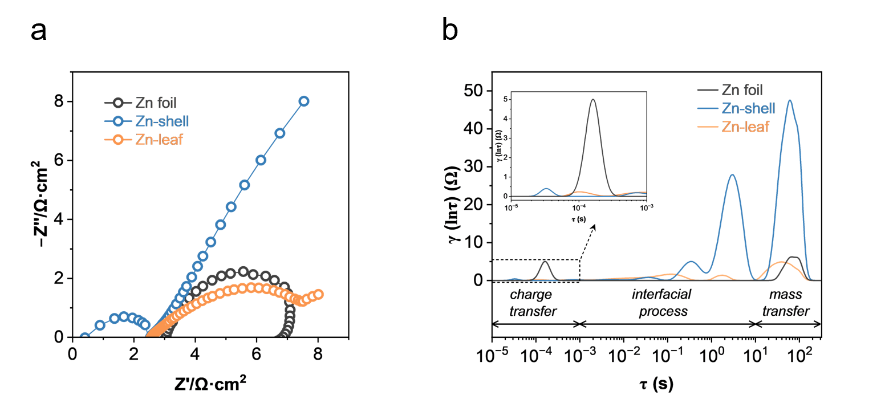
Supplementary Fig. 30 | Electrochemical impedance spectroscopy (EIS) and distribution of relaxation times (DRT) analysis of Zn foil, Zn-shell, and Zn-leaf. (a) EIS spectra and (b) DRT results.
EIS combined with DRT analysis was further employed to evaluate the kinetic characteristics of the different Zn electrodes. Compared with Zn foil and Zn-shell, Zn-leaf exhibits the smallest resistive contributions associated with charge transfer, interfacial processes, and mass transport. The simultaneously improved electron-transfer and mass-transport properties suggest that the moss-inspired Zn-leaf electrode provides a kinetically favorable environment for CO₂ reduction, which is expected to translate into superior catalytic performance under high current density operation.

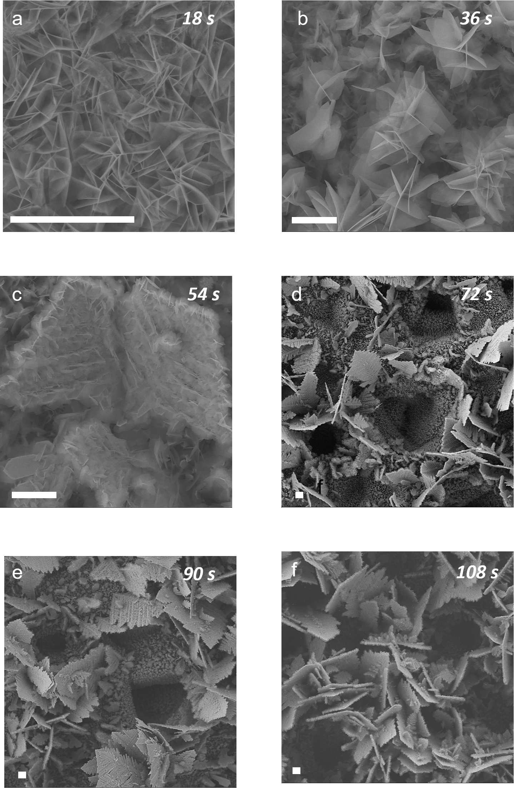
Supplementary Fig. 31 | SEM images of Zn-leaf prepared with different electrodeposition times. (a) 18 s, (b) 36 s, (c) 54 s, (d) 72 s, (e) 90 s, and (f) 108 s. Scale bars: 5 μm.

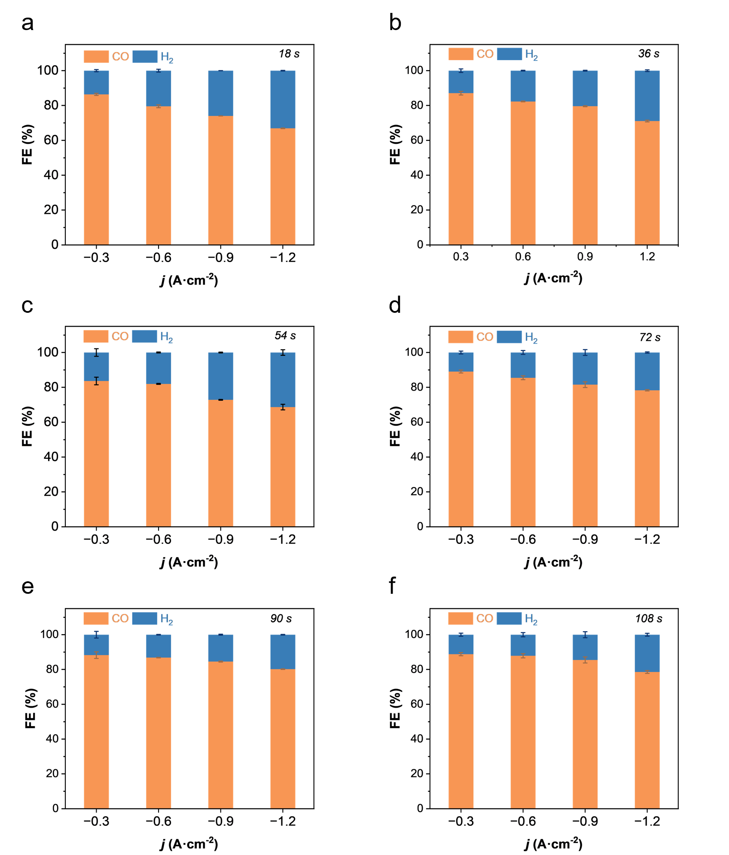
Supplementary Fig. 32 | CO₂RR performance of Zn-leaf prepared with different electrodeposition times at current densities ranging from −0.3 to −1.2 A cm⁻². (a) 18 s, (b) 36 s, (c) 54 s, (d) 72 s, (e) 90 s, and (f) 108 s.

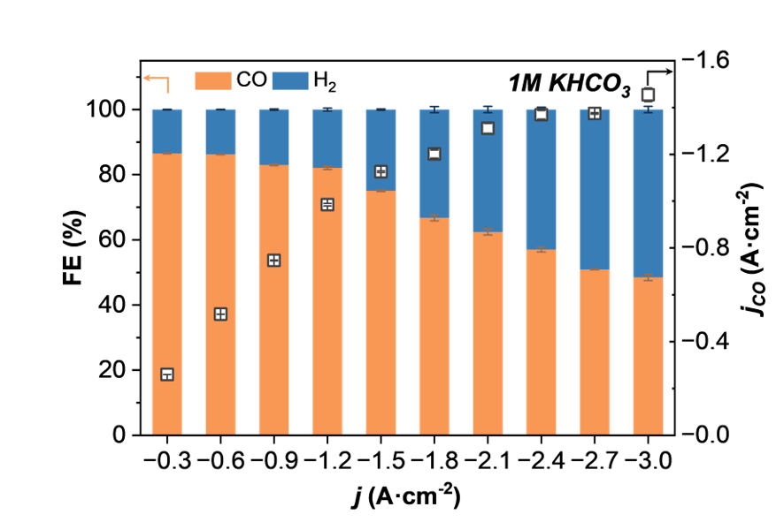
Supplementary Fig. 33 | CO₂RR performance of Zn-leaf in 1 M KHCO₃ electrolyte at current densities ranging from −0.3 to −3.0 A cm⁻².

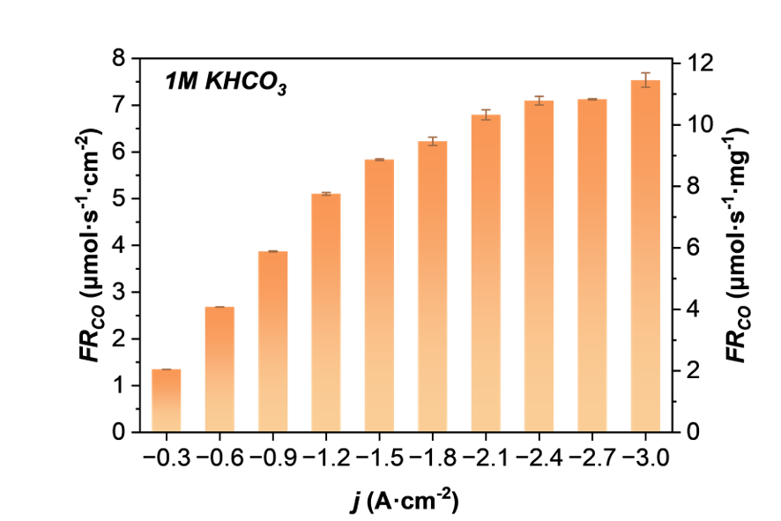
Supplementary Fig. 34 | CO formation rates of Zn-leaf in 1 M KHCO₃ electrolyte at current densities ranging from −0.3 to −3.0 A cm⁻².

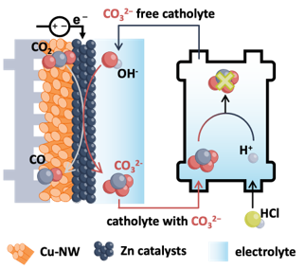
Supplementary Fig. 35 | Schematic illustration of the automatic electrolyte renewal system. The circulating electrolyte consisted of 1 M KCl and 1 M HCl, and the electrolyte pH was maintained at approximately pH 6 through adjustment of the electrolyte flow rates based on real-time pH monitoring.

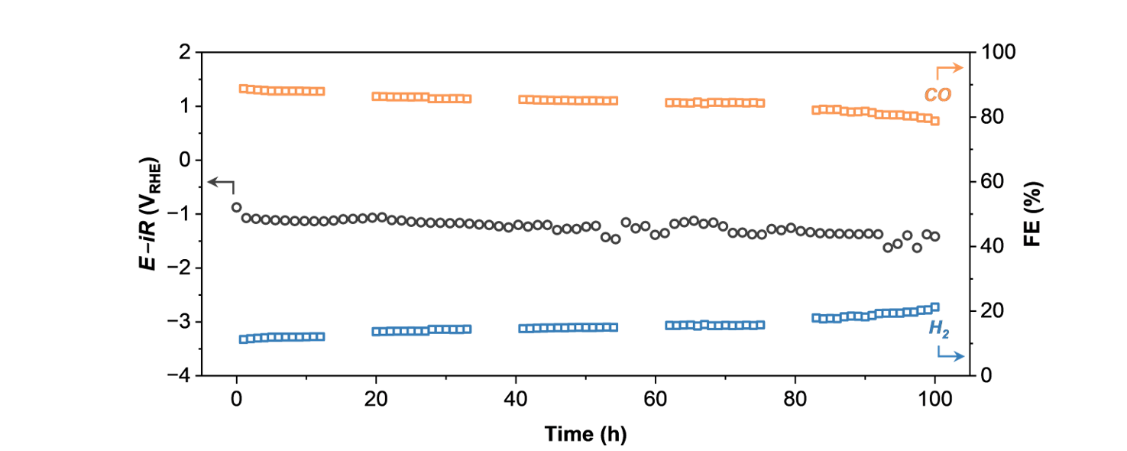
Supplementary Fig. 36 | Long-term stability evaluation of Zn-leaf at a current density of −200 mA cm⁻².

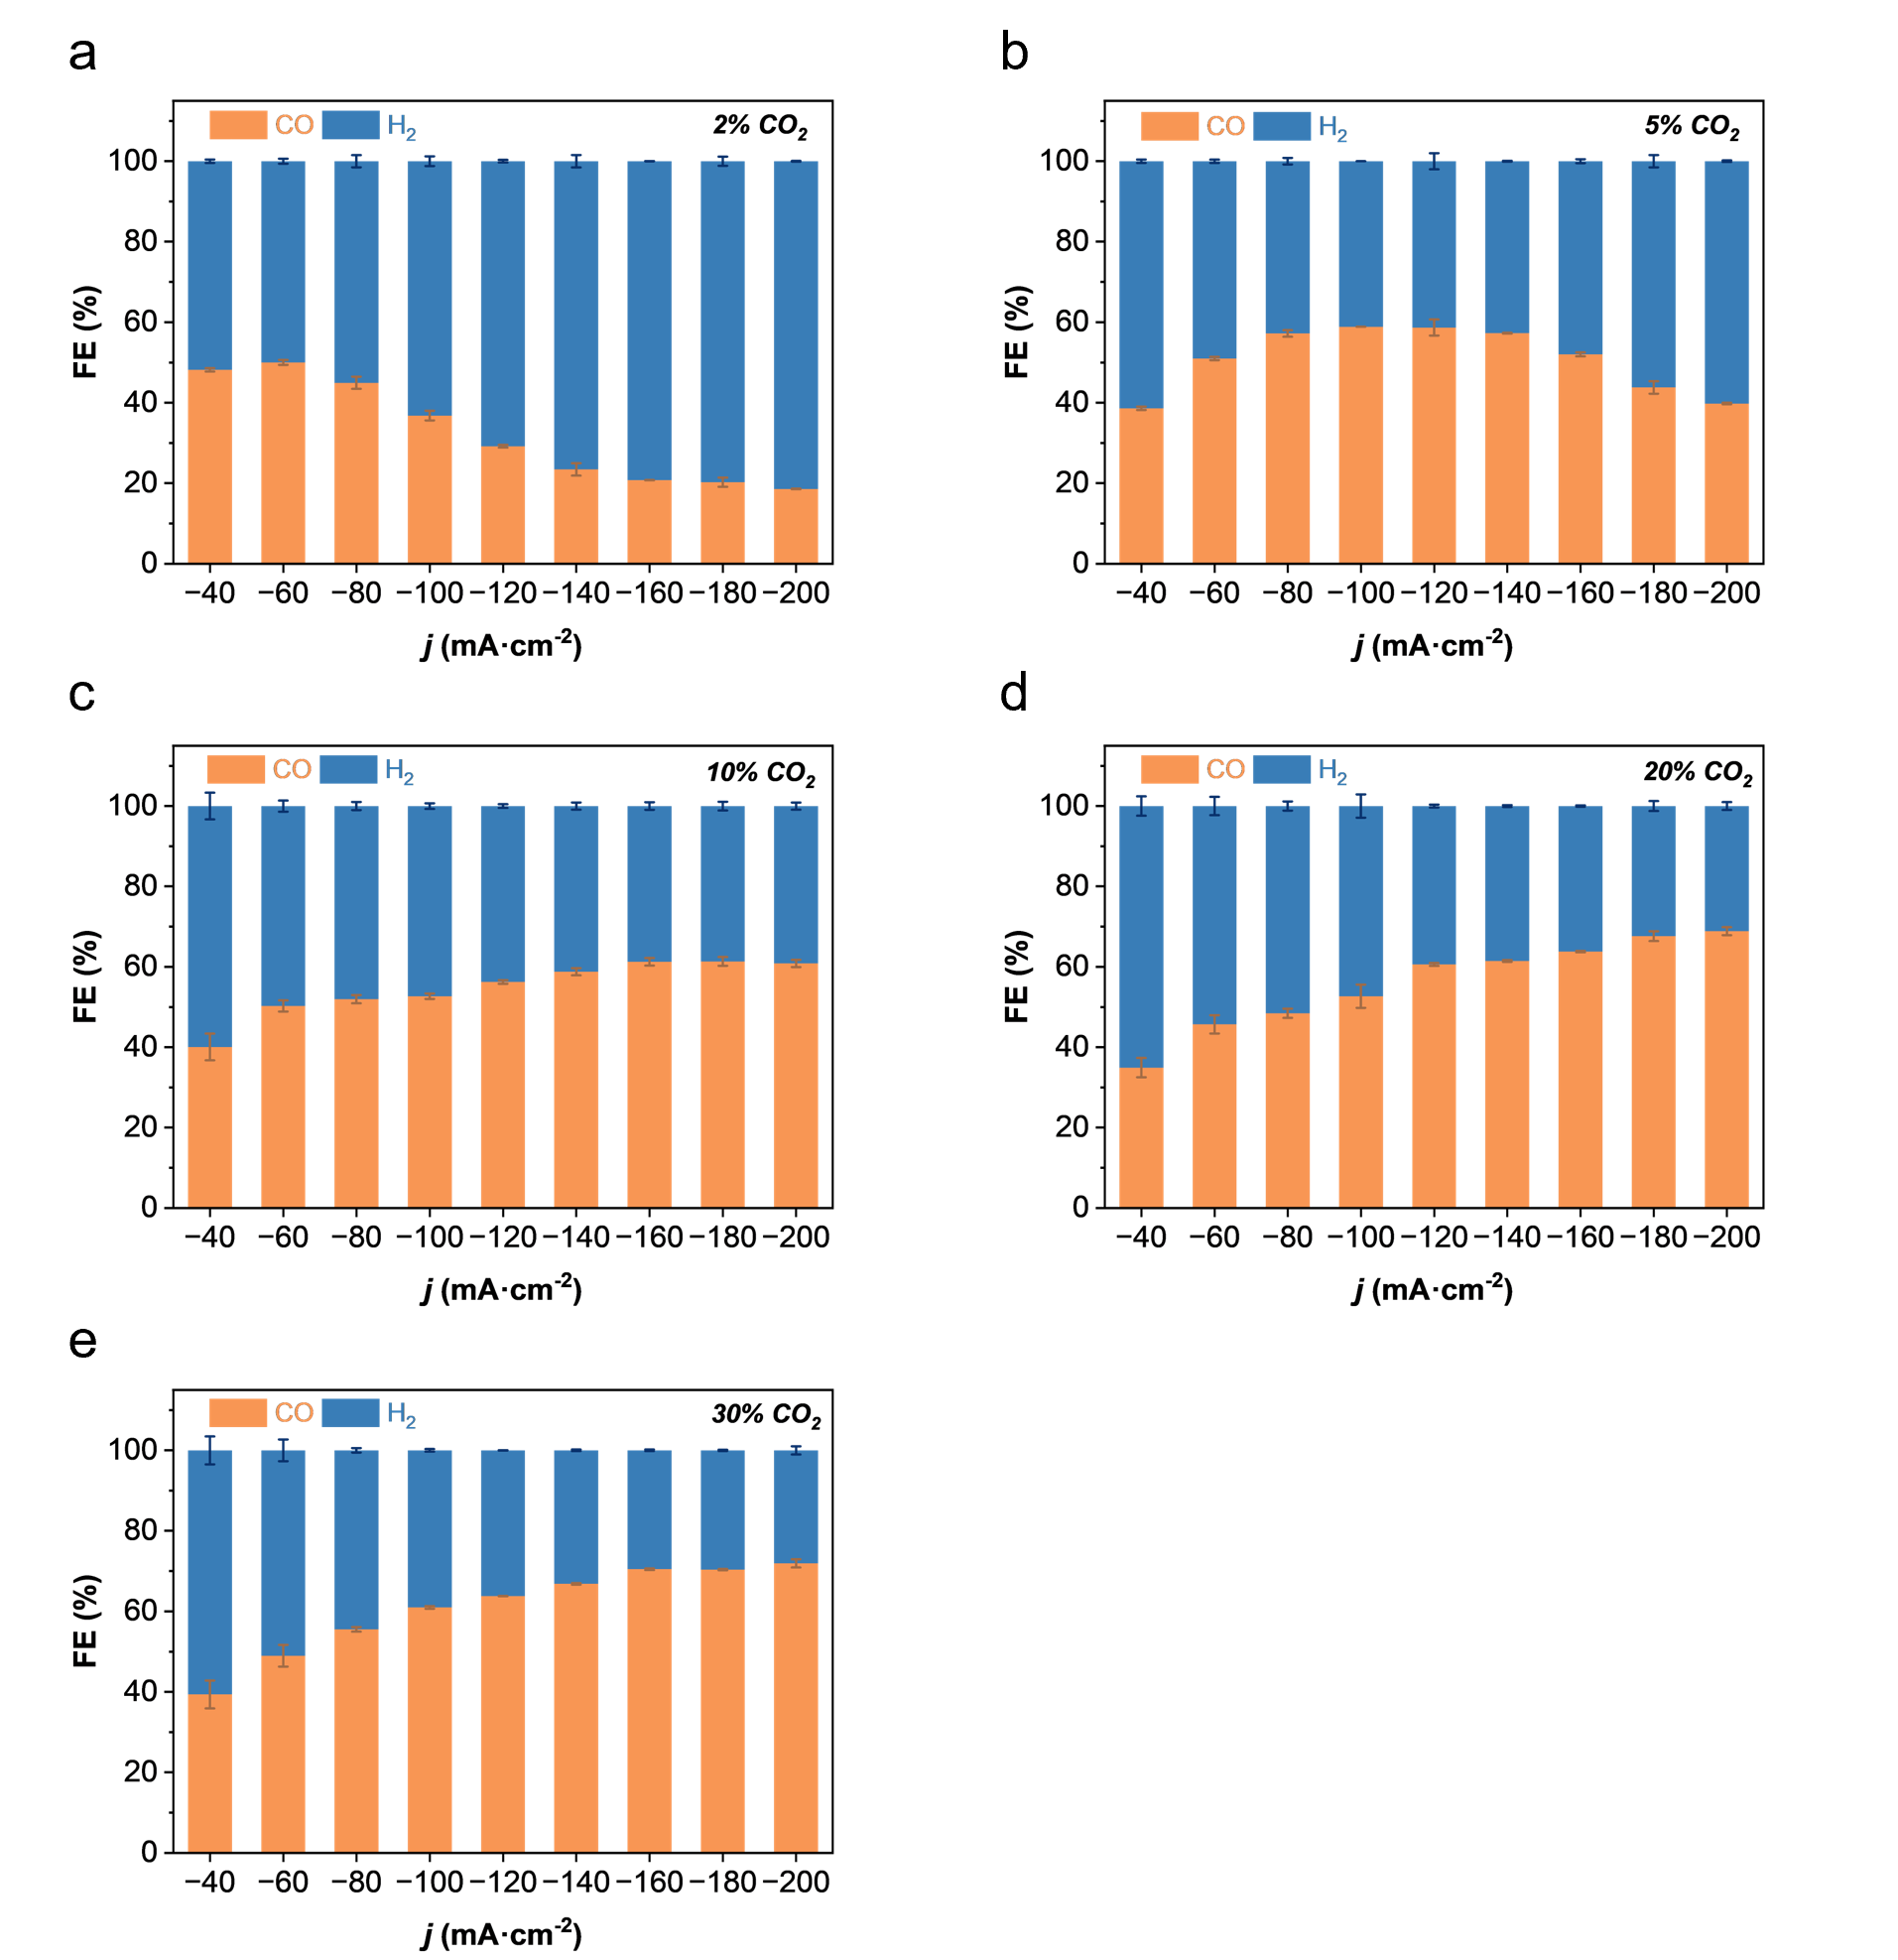
Supplementary Fig. 37 | CO₂RR performance of Zn-leaf under different CO₂ concentrations at current densities ranging from −40 to −200 mA cm⁻². (a) 2%, (b) 5%, (c) 10%, (d) 20%, and (e) 30% CO₂.

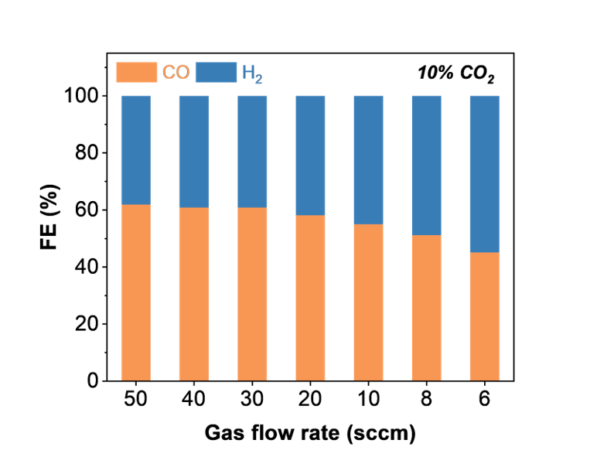
Supplementary Fig. 38 | CO₂RR performance of Zn-leaf at different CO₂ flow rates measured at a current density of −0.2 A cm⁻² and pH 2.

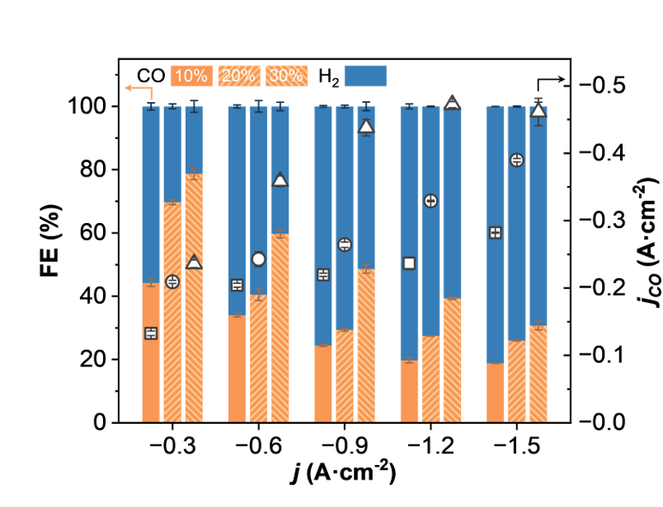
Supplementary Fig. 39 | CO₂RR performance of Zn-leaf under different CO₂ concentrations at current densities ranging from −0.3 to −1.5 A cm⁻².

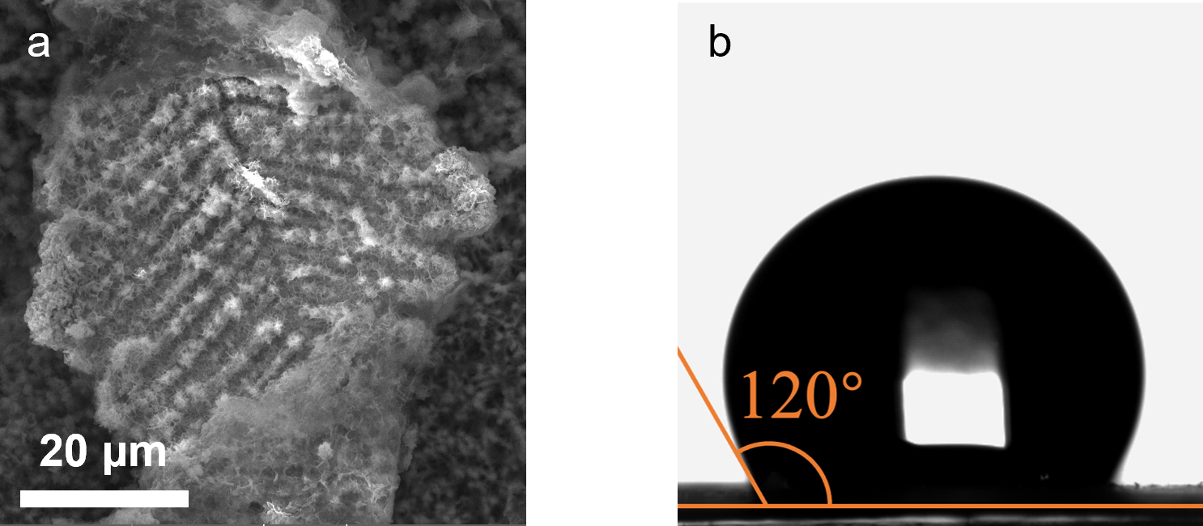
Supplementary Fig. 40 | SEM image and contact angle measurement of Zn-leaf after long-term stability evaluation at a current density of −200 mA cm⁻² under 15% CO₂ conditions. (a) SEM image and (b) contact angle measurement.

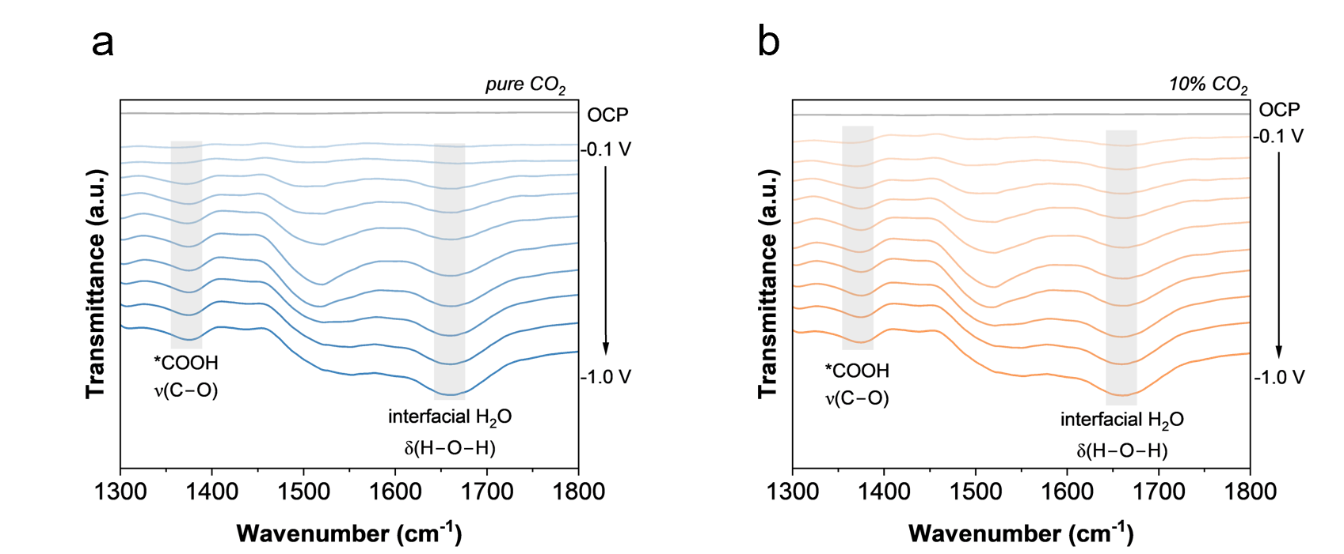
Supplementary Fig. 41 | In situ ATR-FTIR spectra of Zn-leaf recorded under pure CO₂ and 10% CO₂ atmospheres at potentials ranging from −0.1 to −1.0 V versus RHE. The band at ~1370 cm⁻¹ is assigned to the ν(C–O) vibration associated with *COOH related intermediates, while the band at ~1660 cm⁻¹ corresponds to the δ(H–O–H) bending mode of interfacial H₂O. (a) Pure CO₂ and (b) 10% CO₂.

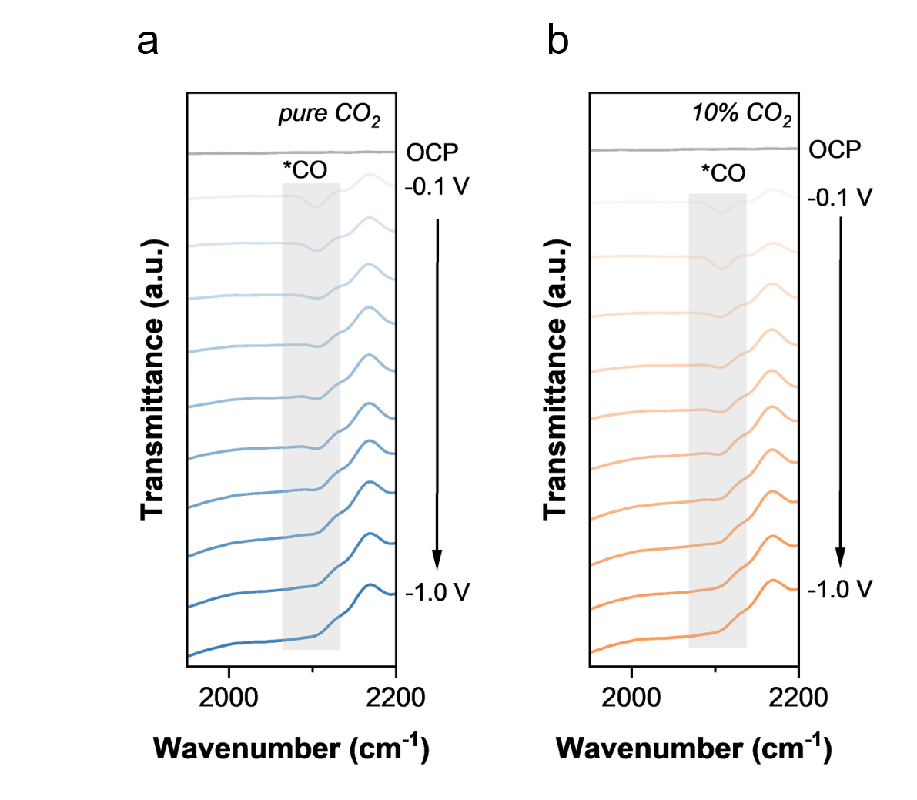
Supplementary Fig. 42 | In situ ATR-FTIR spectra of Zn-leaf recorded under pure CO₂ and 10% CO₂ atmospheres at potentials ranging from −0.1 to −1.0 V versus RHE. The band at ~2120 cm⁻¹ is assigned to the ν(C–O) vibration of adsorbed CO intermediates. (a) Pure CO₂ and (b) 10% CO₂.

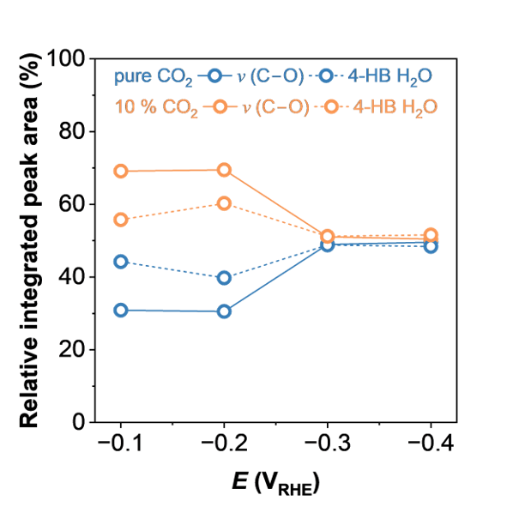
Supplementary Fig. 43 | Comparison between the relative integrated peak area contributions of the ν(C–O) vibration associated with *COOH related intermediates and the 4-HB H₂O species under pure CO₂ and 10% CO₂ atmospheres derived from the in situ ATR-FTIR spectra of Zn-leaf.

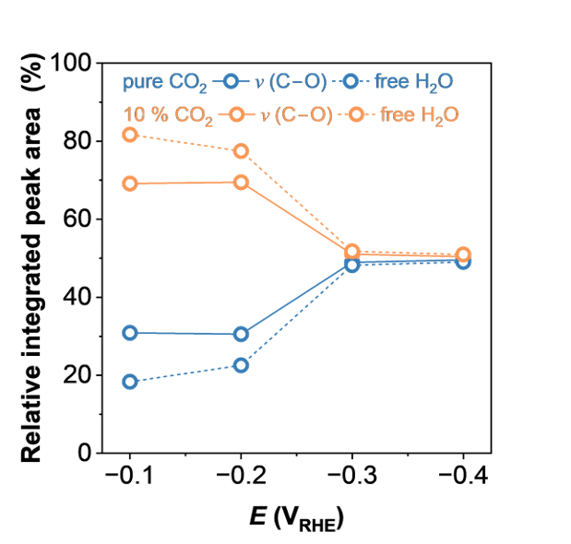
Supplementary Fig. 44 | Comparison between the relative integrated peak area contributions of the ν(C–O) vibration associated with *COOH related intermediates and free H₂O species under pure CO₂ and 10% CO₂ atmospheres derived from the in situ ATR-FTIR spectra of Zn-leaf.

Supplementary Table 1 | Summary of in situ DEMS analysis for 28 BC and Cu-NW used as gas diffusion layers (GDLs) under pure CO₂ and 15% CO₂ atmospheres. The apparent CO₂ diffusion rate was evaluated from the slope of the CO₂ ionic current response versus time and normalized to the value of 28 BC under pure CO₂ conditions.
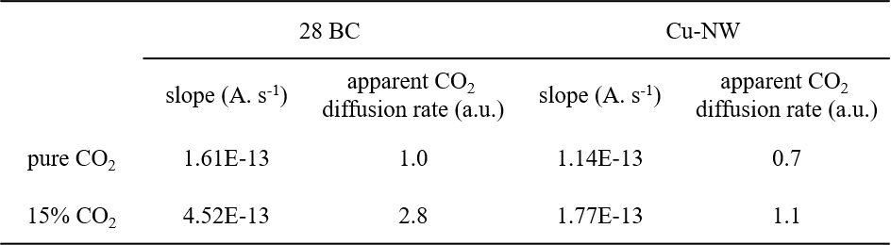

Supplementary Table 2 | Summary of integrated peak areas of XRD reflections for different crystal facets of Zn foil and Zn-leaf. Relative facet intensity ratios were calculated using the Zn (100) reflection as the reference.
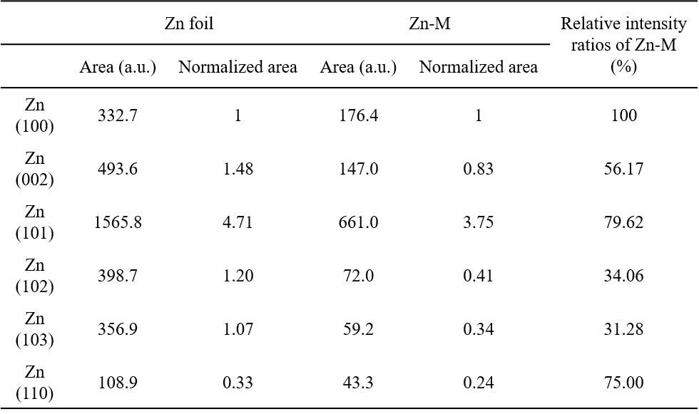

Supplementary Table 3 | Reaction coordinates and relative energies of CO₂ reduction on the Zn (002) facet, together with the optimized configurations of CO₂, *CO₂, *COOH, *CO, and CO intermediates adsorbed on Zn (002). Light gray, dark gray, red, and white spheres represent Zn, C, O, and H atoms, respectively.
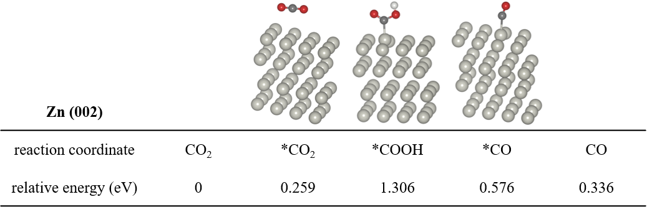

Supplementary Table 4 | Reaction coordinates and relative energies of CO₂ reduction on the Zn (100) facet, together with the optimized configurations of CO₂, *CO₂, *COOH, *CO, and CO intermediates adsorbed on Zn (100). Light gray, dark gray, red, and white spheres represent Zn, C, O, and H atoms, respectively.
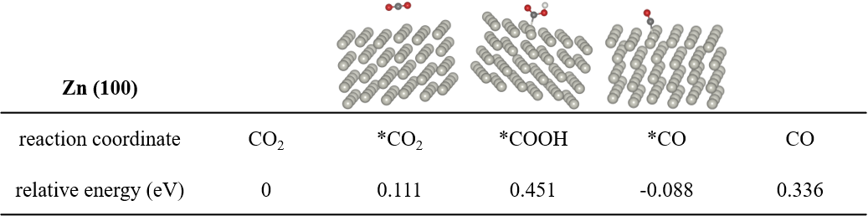

Supplementary Table 5 | Reaction coordinates and relative energies of CO₂ reduction on the Zn (101) facet, together with the optimized configurations of CO₂, *CO₂, *COOH, *CO, and CO intermediates adsorbed on Zn (101). Light gray, dark gray, red, and white spheres represent Zn, C, O, and H atoms, respectively.
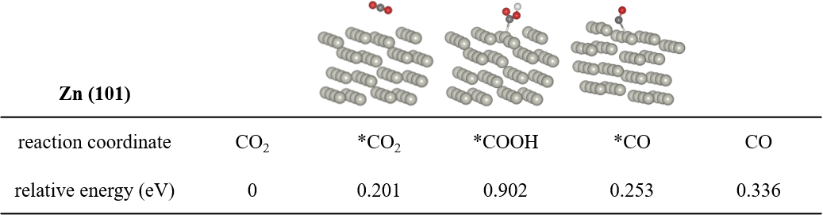

Supplementary Table 6 | Reaction coordinates and relative energies of CO₂ reduction on the Zn (102) facet, together with the optimized configurations of CO₂, *CO₂, *COOH, *CO, and CO intermediates adsorbed on Zn (102). Light gray, dark gray, red, and white spheres represent Zn, C, O, and H atoms, respectively.
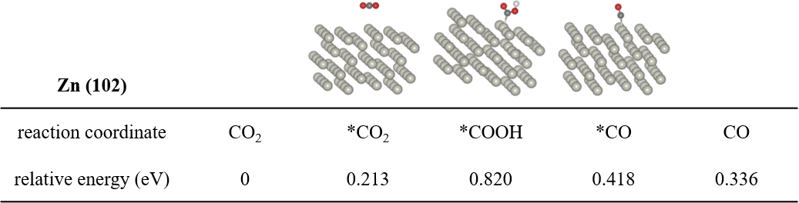

Supplementary Table 7 | Reaction coordinates and relative energies of CO₂ reduction on the Zn (103) facet, together with the optimized configurations of CO₂, *CO₂, *COOH, *CO, and CO intermediates adsorbed on Zn (103). Light gray, dark gray, red, and white spheres represent Zn, C, O, and H atoms, respectively.
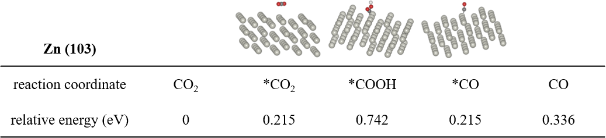

Supplementary Table 8 | Reaction coordinates and relative energies of CO₂ reduction on the Zn (110) facet, together with the optimized configurations of CO₂, *CO₂, *COOH, *CO, and CO intermediates adsorbed on Zn (110). Light gray, dark gray, red, and white spheres represent Zn, C, O, and H atoms, respectively.
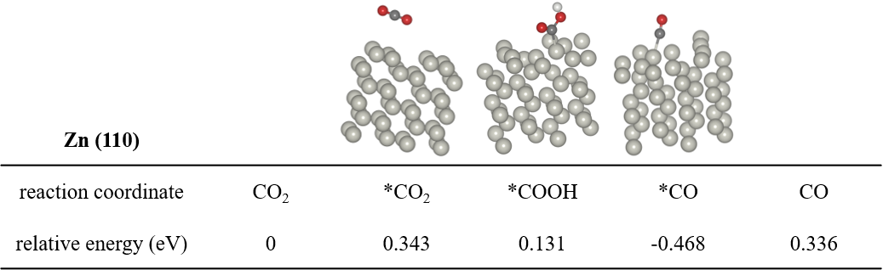

Supplementary Table 9 | Summary of CO₂RR performance of Zn-leaf at pH 2.
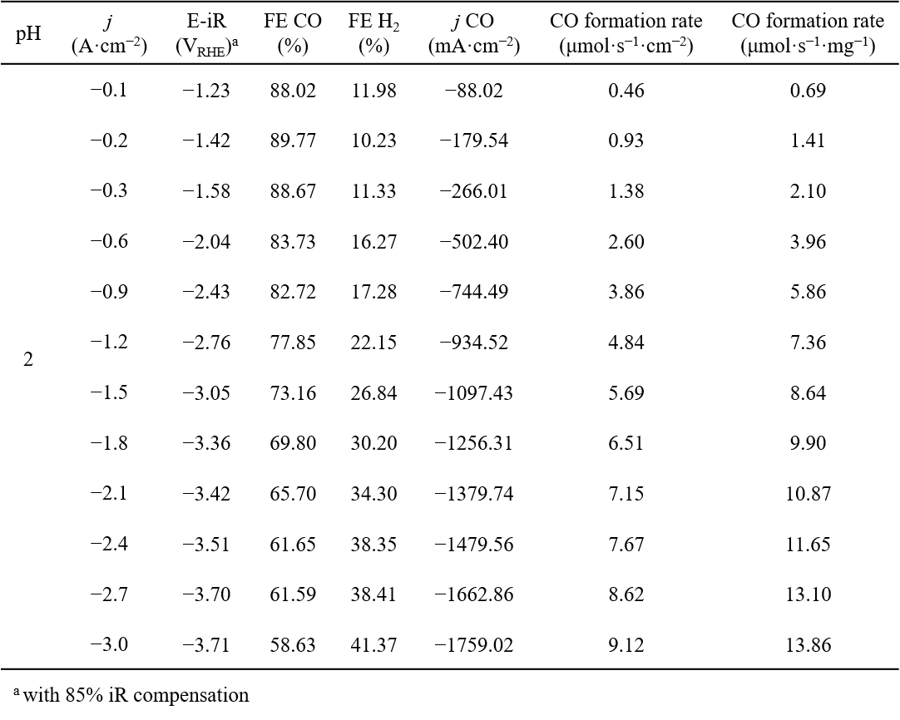

Supplementary Table 10 | Summary of CO₂RR performance of Zn-leaf at pH 7.
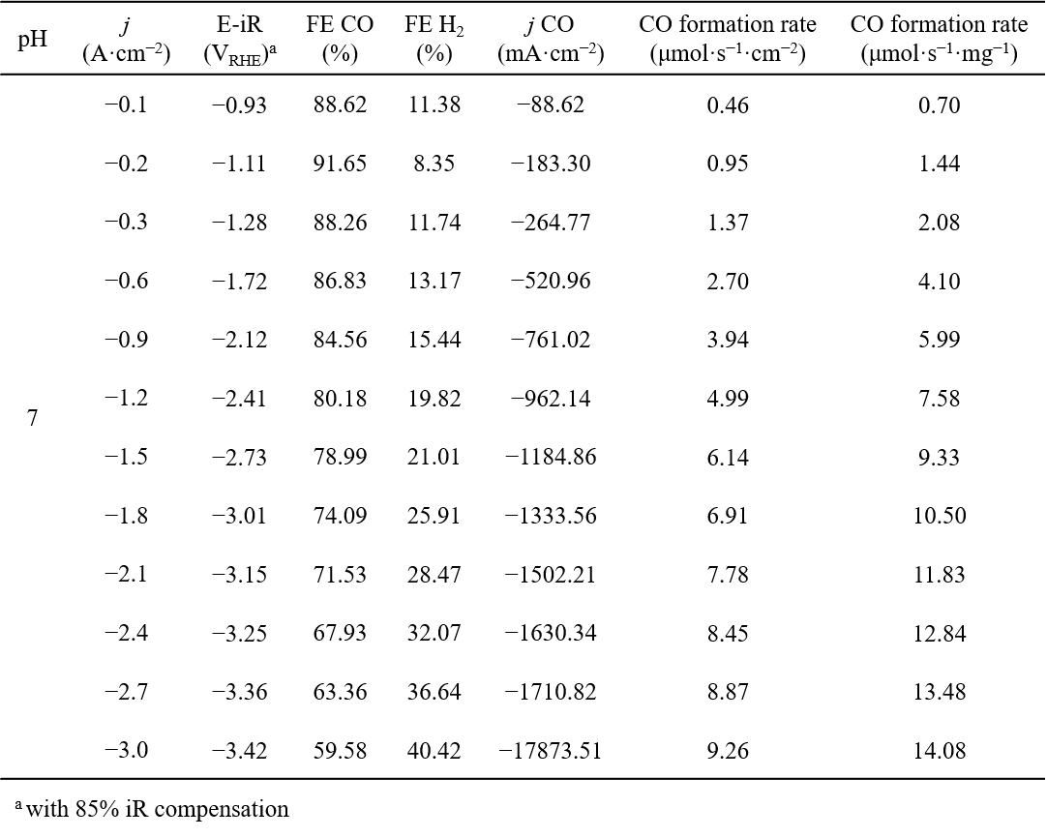

Supplementary Table 11 | Summary of CO₂RR performance of Zn-leaf at pH 14.
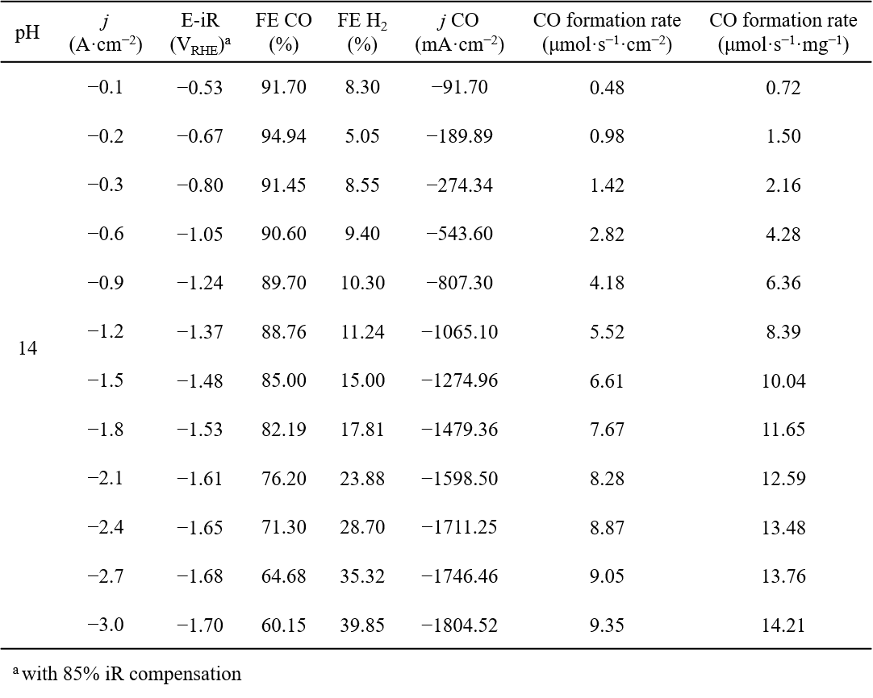

Supplementary Table 12 | Summary of CO₂RR performance of Zn-leaf in 1 M KHCO₃ electrolyte.
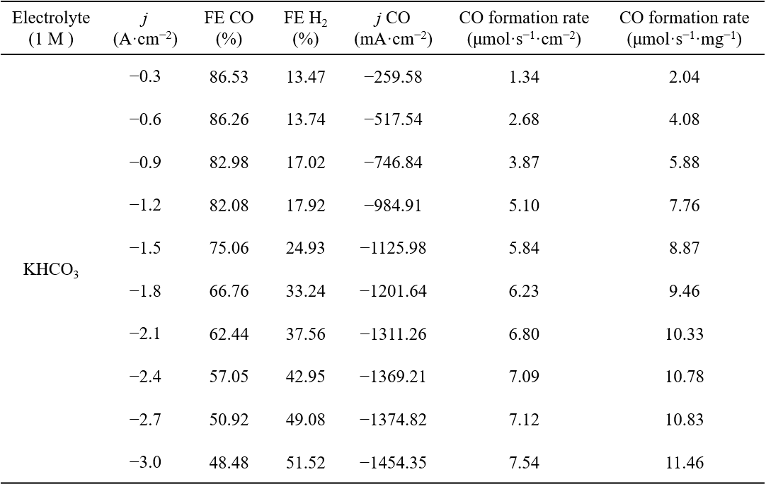

Supplementary Table 13 | Benchmark comparison of the Zn-leaf catalyst with representative state-of-the-art Zn catalysts for CO₂ electroreduction.²⁰⁻²⁴
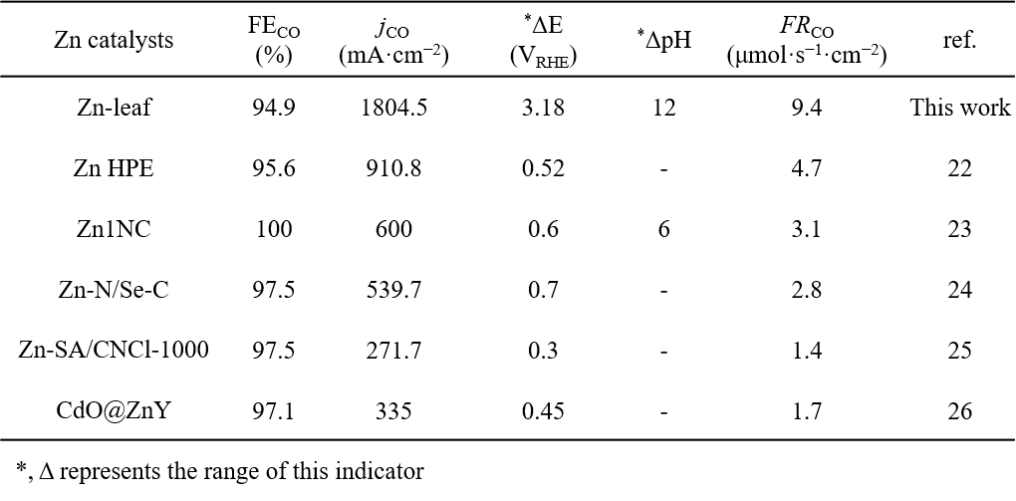

Supplementary Table 14 | Summary of CO₂RR performance of Zn-leaf under 2% CO₂ at current densities ranging from −40 to −200 mA cm⁻².
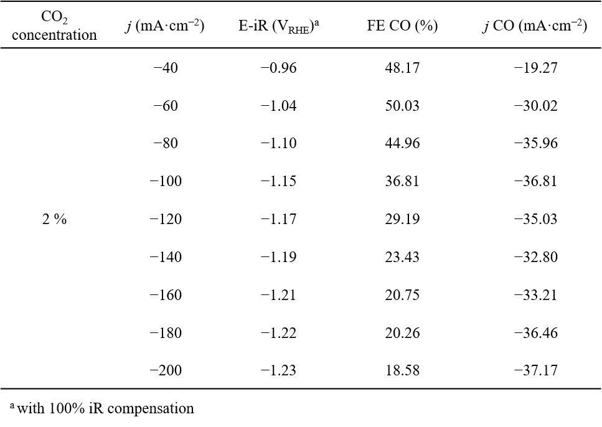

Supplementary Table 15 | Summary of CO2RR performance of Zn-leaf under 5% CO₂ at current densities ranging from −40 to −200 mA cm⁻².
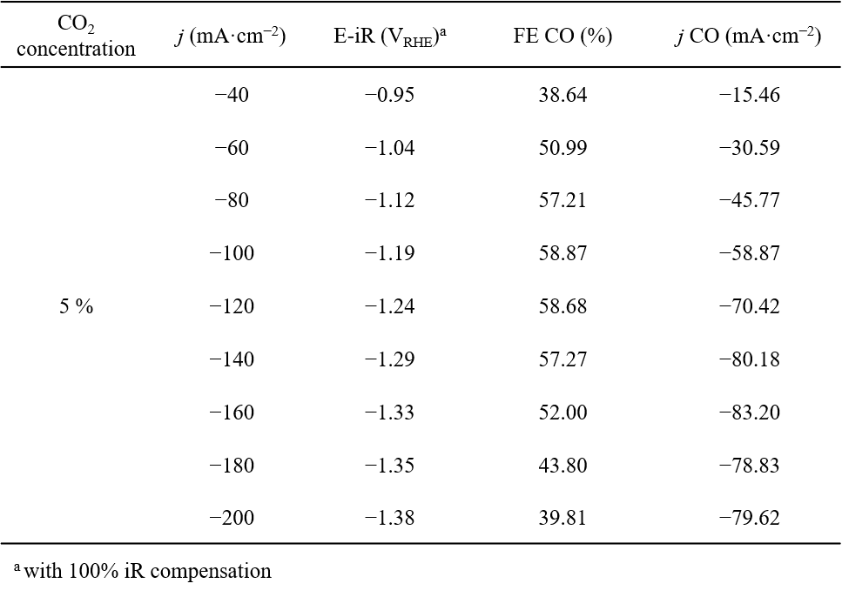

Supplementary Table 16 | Summary of CO₂RR performance of Zn-leaf under 10% CO₂ at current densities ranging from −40 to −200 mA cm⁻².
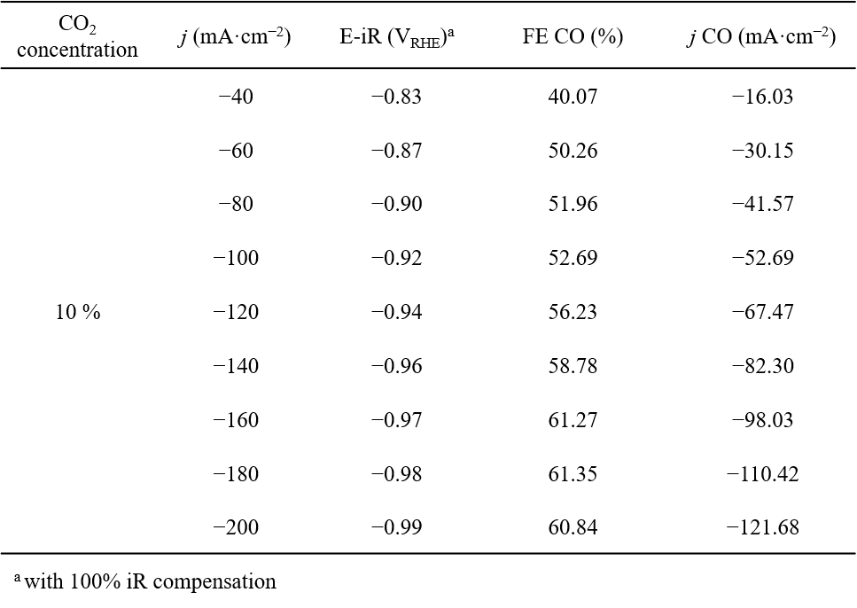

Supplementary Table 17 | Summary of CO₂RR performance of Zn-leaf under 20% CO₂ at current densities ranging from −40 to −200 mA cm⁻².
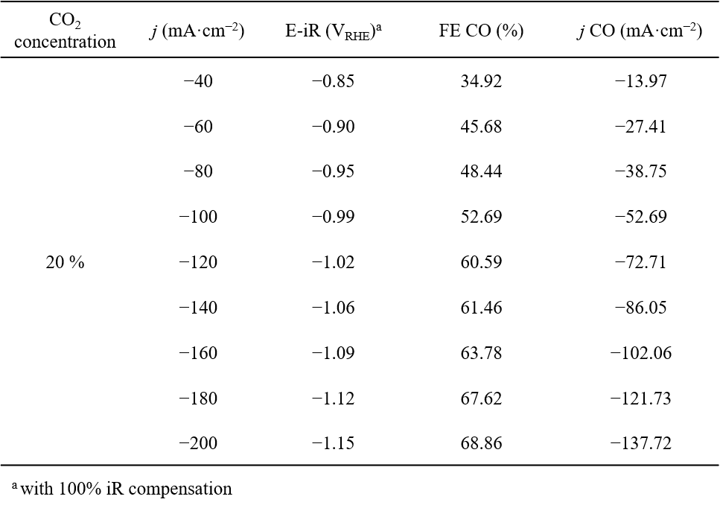

Supplementary Table 18 | Summary of CO₂RR performance of Zn-leaf under 30% CO₂ at current densities ranging from −40 to −200 mA cm⁻².
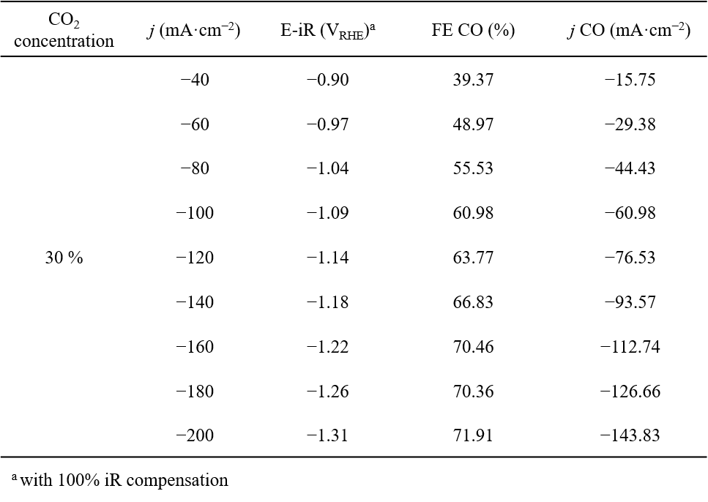

Supplementary Table 19 | Summary of CO₂RR performance of Zn-leaf under different CO₂ concentrations at current densities ranging from −0.3 to −1.5 A cm⁻².
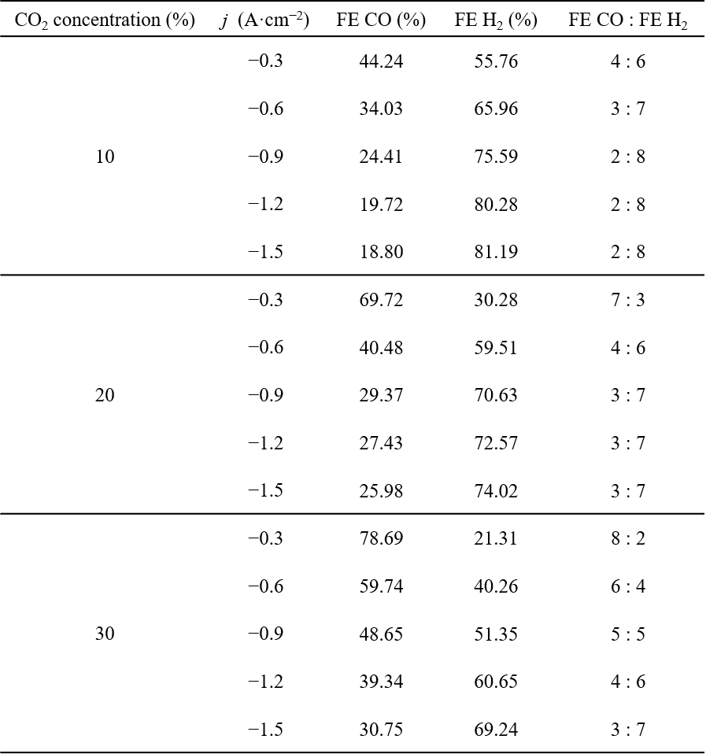

Supplementary Table 20 | Summary of integrated peak areas of the *COOH related ν(C–O) vibration and interfacial H₂O δ(H–O–H) bending mode obtained from in situ ATR-FTIR spectra of Zn-leaf under pure CO₂ and 10% CO₂ atmospheres at potentials ranging from −0.1 to −0.4 V versus RHE.
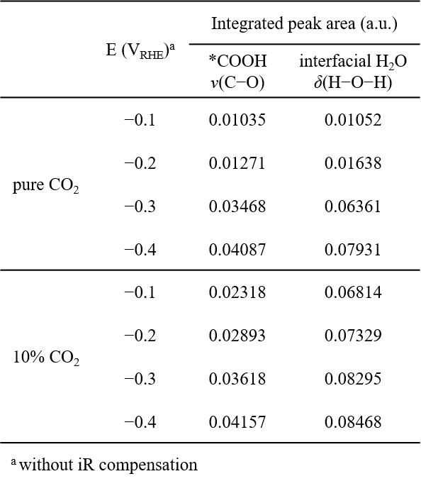

Supplementary Table 21 | Summary of integrated peak areas of 4-HB H₂O, 2-HB H₂O, and free H₂O species obtained from in situ ATR-FTIR spectra of Zn-leaf under pure CO₂ and 10% CO₂ atmospheres at potentials ranging from −0.1 to −0.4 V versus RHE.
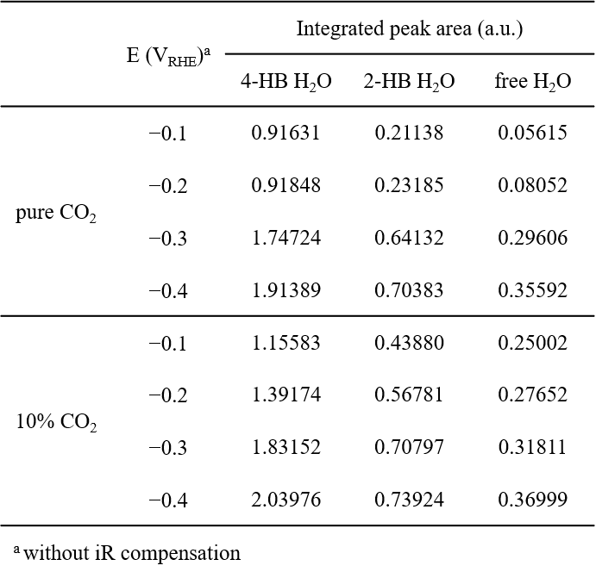

Supplementary Table 22 | Summary of the relative integrated peak area contributions of *COOH related species under pure CO₂ and 10% CO₂ atmospheres obtained from in situ FTIR spectra of Zn-leaf at potentials ranging from −0.1 to −0.4 V versus RHE.
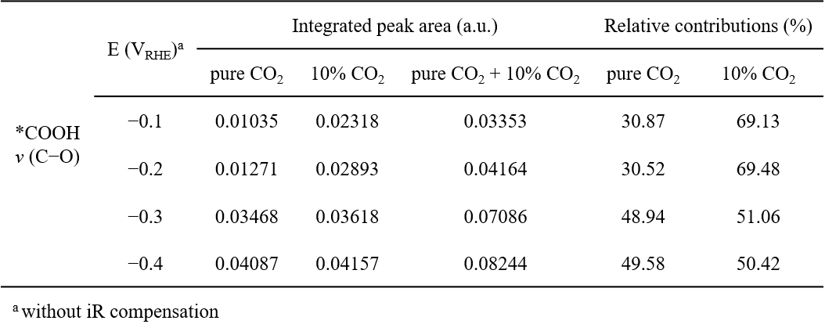

Supplementary Table 23 | Summary of the relative integrated peak area contributions of 2-HB H₂O species under pure CO₂ and 10% CO₂ atmospheres obtained from in situ FTIR spectra of Zn-leaf at potentials ranging from −0.1 to −0.4 V versus RHE.
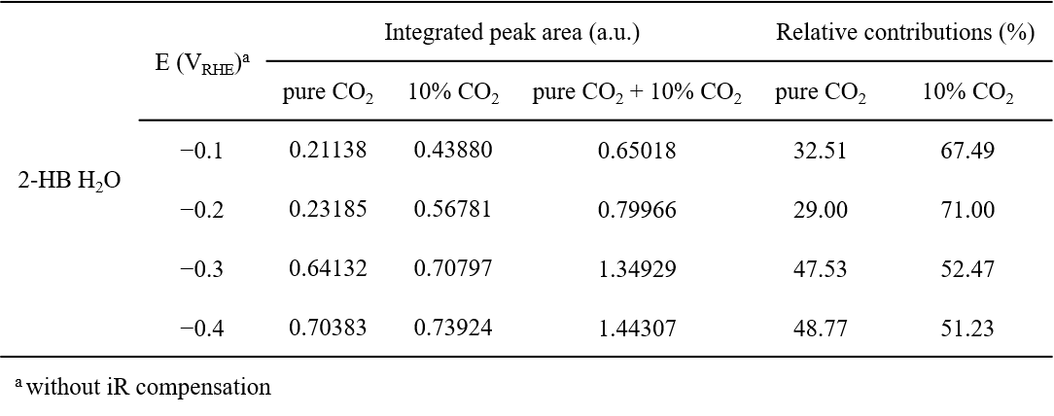

Supplementary Table 24 | Summary of the relative integrated peak area contributions of 4-HB H₂O species under pure CO₂ and 10% CO₂ atmospheres obtained from in situ FTIR spectra of Zn-leaf at potentials ranging from −0.1 to −0.4 V versus RHE.
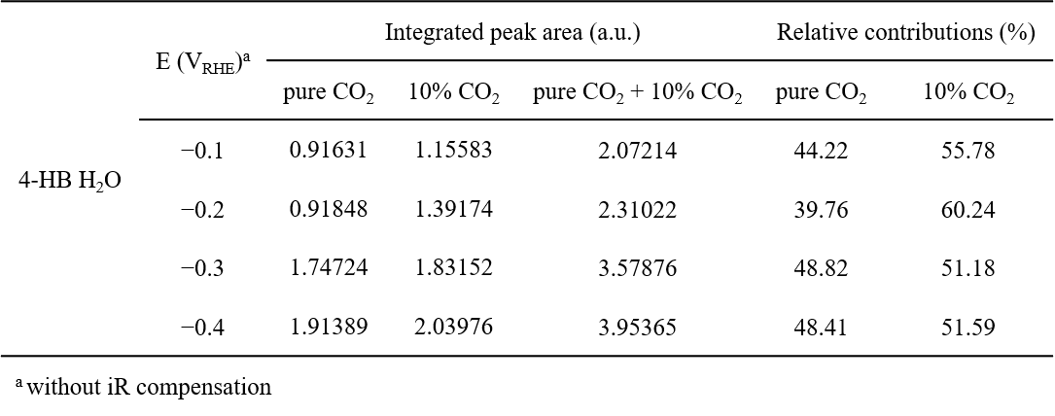

Supplementary Table 25 | Summary of the relative integrated peak area contributions of free H₂O species under pure CO₂ and 10% CO₂ atmospheres obtained from in situ FTIR spectra of Zn-leaf at potentials ranging from −0.1 to −0.4 V versus RHE.
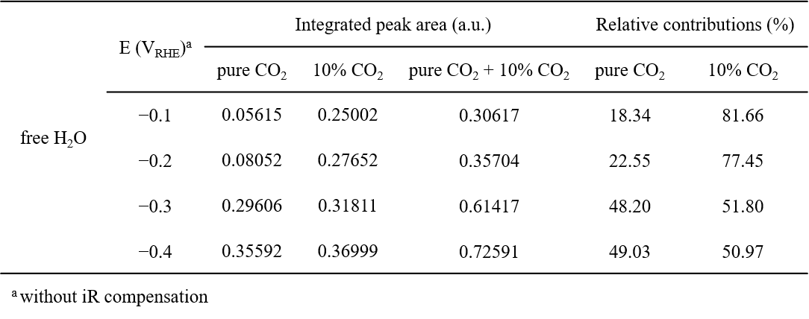

Reference
1 Burgess Jr, D. R. Self-diffusion and binary-diffusion coefficients in gases. (US Department of Commerce, NIST, 2024).
2 Akkermans, R. L., Spenley, N. A. & Robertson, S. H. COMPASS III: automated fitting workflows and extension to ionic liquids. Mol. Simul. 47, 540-551 (2021).
3 Luty, B. A., Davis, M. E., Tironi, I. G. & Van Gunsteren, W. F. A comparison of particle-particle, particle-mesh and Ewald methods for calculating electrostatic interactions in periodic molecular systems. Mol. Simul. 14, 11-20 (1994).
4 Lorentz, H. A. Ueber die Anwendung des Satzes vom Virial in der kinetischen Theorie der Gase. Annalen der physik 248, 127-136 (1881).
5 Li, P., Roberts, B. P., Chakravorty, D. K. & Merz Jr, K. M. Rational design of particle mesh Ewald compatible Lennard-Jones parameters for+ 2 metal cations in explicit solvent. J. Chem. Theory Comput. 9, 2733-2748 (2013).
6 Verlet, L. Computer" experiments" on classical fluids. I. Thermodynamical properties of Lennard-Jones molecules. Phys. Rev. 159, 98 (1967).
7 Yokoyama, Y. et al. In Situ Local pH Measurements with Hydrated Iridium Oxide Ring Electrodes in Neutral pH Aqueous Solutions. Chem. Lett. 49, 195-198 (2020).
8 Guo, J. et al. Direct seawater electrolysis by adjusting the local reaction environment of a catalyst. Nat. Energy (2023).
9 Albery, W. J. & Calvo, E. J. Ring–disc electrodes. Part 21.—pH measurement with the ring. J. Chem. Soc. Faraday Trans. 79, 2583-2596 (1983).
10 Sun, M. et al. In Situ Observation of Post-CO Intermediates to Decode C─C Coupling Pathways in CO₂ Electroreduction. Angew. Chem. Int. Ed., e202502740 (2025).
11 Sun, M., Cheng, J. & Yamauchi, M. Gas diffusion enhanced electrode with ultrathin superhydrophobic macropore structure for acidic CO₂ electroreduction. Nat. Commun. 15, 491 (2024).
12 Kresse, G. & Furthmüller, J. Efficiency of ab-initio total energy calculations for metals and semiconductors using a plane-wave basis set. Comput. Mater. Sci. 6, 15-50 (1996).
13 Kresse, G. & Hafner, J. Ab initio molecular-dynamics simulation of the liquid-metal–amorphous-semiconductor transition in germanium. Phys. Rev. B 49, 14251 (1994).
14 Blöchl, P. E. Projector augmented-wave method. Phys. Rev. B 50, 17953 (1994).
15 Perdew, J. P., Burke, K. & Ernzerhof, M. Generalized gradient approximation made simple. Phy. Rev. Lett. 77, 3865 (1996).
16 Hammer, B., Hansen, L. B. & Nørskov, J. K. Improved adsorption energetics within density-functional theory using revised Perdew-Burke-Ernzerhof functionals. Phys. Rev. B 59, 7413 (1999).
17 Von Barth, U. & Hedin, L. A local exchange-correlation potential for the spin polarized case. i. J. Phys. C: Solid State Phys. 5, 1629-1642 (1972).
18 Ren, B., Li, J., Wen, G., Ricardez− Sandoval, L. & Croiset, E. First-principles based microkinetic modeling of CO2 reduction at the Ni/SDC cathode of a solid oxide electrolysis cell. J. Phys. Chem. C 122, 21151-21161 (2018).
19 Grimme, S., Antony, J., Ehrlich, S. & Krieg, H. A consistent and accurate ab initio parametrization of density functional dispersion correction (DFT-D) for the 94 elements H-Pu. J. Chem. Phys. 132 (2010).
20 Hao, Q. et al. Universal Formation of Single Atoms from Molten Salt for Facilitating Selective CO₂ Reduction. Adv. Mater. 36, e2406380 (2024).
21 Liu, X. et al. Zinc Hollow-Fiber Penetration Electrode Promotes Ampere-Level CO₂ Electroreduction for Viable Applications. ACS Catal. 15, 4259-4269 (2025).
22 Chen, J. et al. Promoting Hydrogen Transfer in Electrochemical CO₂ Reduction via a Hydrogen on Demand Pathway. Angew. Chem. Int. Ed. 64, e202422775 (2025).
23 Wei, S. et al. Planar chlorination engineering induced symmetry-broken single-atom site catalyst for enhanced CO₂ electroreduction. Nat. Commun. 16, 1652 (2025).
24 Zhang, Z. et al. Selective and Scalable CO₂ Electrolysis Enabled by Conductive Zinc Ion-Implanted Zeolite-Supported Cadmium Oxide Nanoclusters. J. Am. Chem. Soc. 146, 6397-6407 (2024).

