Supplementary materials
Cathepsin B inhibition attenuates acute cerebral ischemia-reperfusion injury and suppresses associated apoptotic and neuroinflammatory responses
Zhigang Li^{1, #}, Jianing Wei^{2, #}, Jie Cao¹, Mingwei Guo¹, Haifa Dong¹, Songbing Zeng², Weisheng Ye³, Haoquan Fan², Jiahao Guo², Changlong Li⁴, Xinglong Wang^{4, *}, Rongrong Liu^{1, *}, Qiujiang Xi^{1, *}
¹Department of Neurology, First Affiliated Hospital of Gannan Medical University, Ganzhou, Jiangxi 341000, China
²School of the First Clinical Medicine，Gannan Medical University, Ganzhou, Jiangxi 341000, China
³Department of Neurology, Longnan Hospital, the First Affiliated Hospital of Gannan Medical University，Longnan, Ganzhou, Jiangxi 341700, China
⁴CAS Key Lab of Bio-Medical Diagnostics, Suzhou Institute of Biomedical Engineering and Technology, Chinese Academy of Sciences, 88 Keling Road, Suzhou 215004, China

#These authors contribute equally to this work.
*Corresponding author: Qiujiang Xi, Rongrong Liu, Xinglong Wang
Department of Neurology, First Affiliated Hospital of Gannan Medical University, Ganzhou, Jiangxi 341000, China
CAS Key Lab of Bio-Medical Diagnostics, Suzhou Institute of Biomedical Engineering and Technology, Chinese Academy of Sciences, 88 Keling Road, Suzhou 215004, China
Email:
Qiujiang Xi: xiqiujiang992437@sina.com
Rongrong Liu: liurongrongliu@qq.com
Xinglong Wang: wangxl@sibet.ac.cn

Supplementary figures and figure legends

Fig. S1 Monitoring of regional cerebral blood flow during the in vivo MCAO/R procedure
Regional cerebral blood flow was monitored in all rats during model establishment using laser speckle contrast imaging. For quantitative presentation, five rats from each group were randomly selected from the corresponding experimental cohorts. Data are expressed as percentages of the individual pre-ischemic baseline. After monofilament insertion, regional cerebral blood flow in the IRI, CBI, and JNKI groups decreased to less than 20% of baseline, meeting the prespecified criterion for successful middle cerebral artery occlusion. At 30 min after monofilament withdrawal, cerebral blood flow recovered to approximately 85% of baseline in the three ischemic groups. No significant differences were detected among the IRI, CBI, and JNKI groups during ischemia or early reperfusion. These findings reduce the likelihood that the observed outcome differences were primarily caused by unequal ischemic severity or early reperfusion hemodynamics. Data are presented as mean ± SD with individual values. n = 5 rats per group for quantitative presentation. P > 0.05 versus the IRI group.

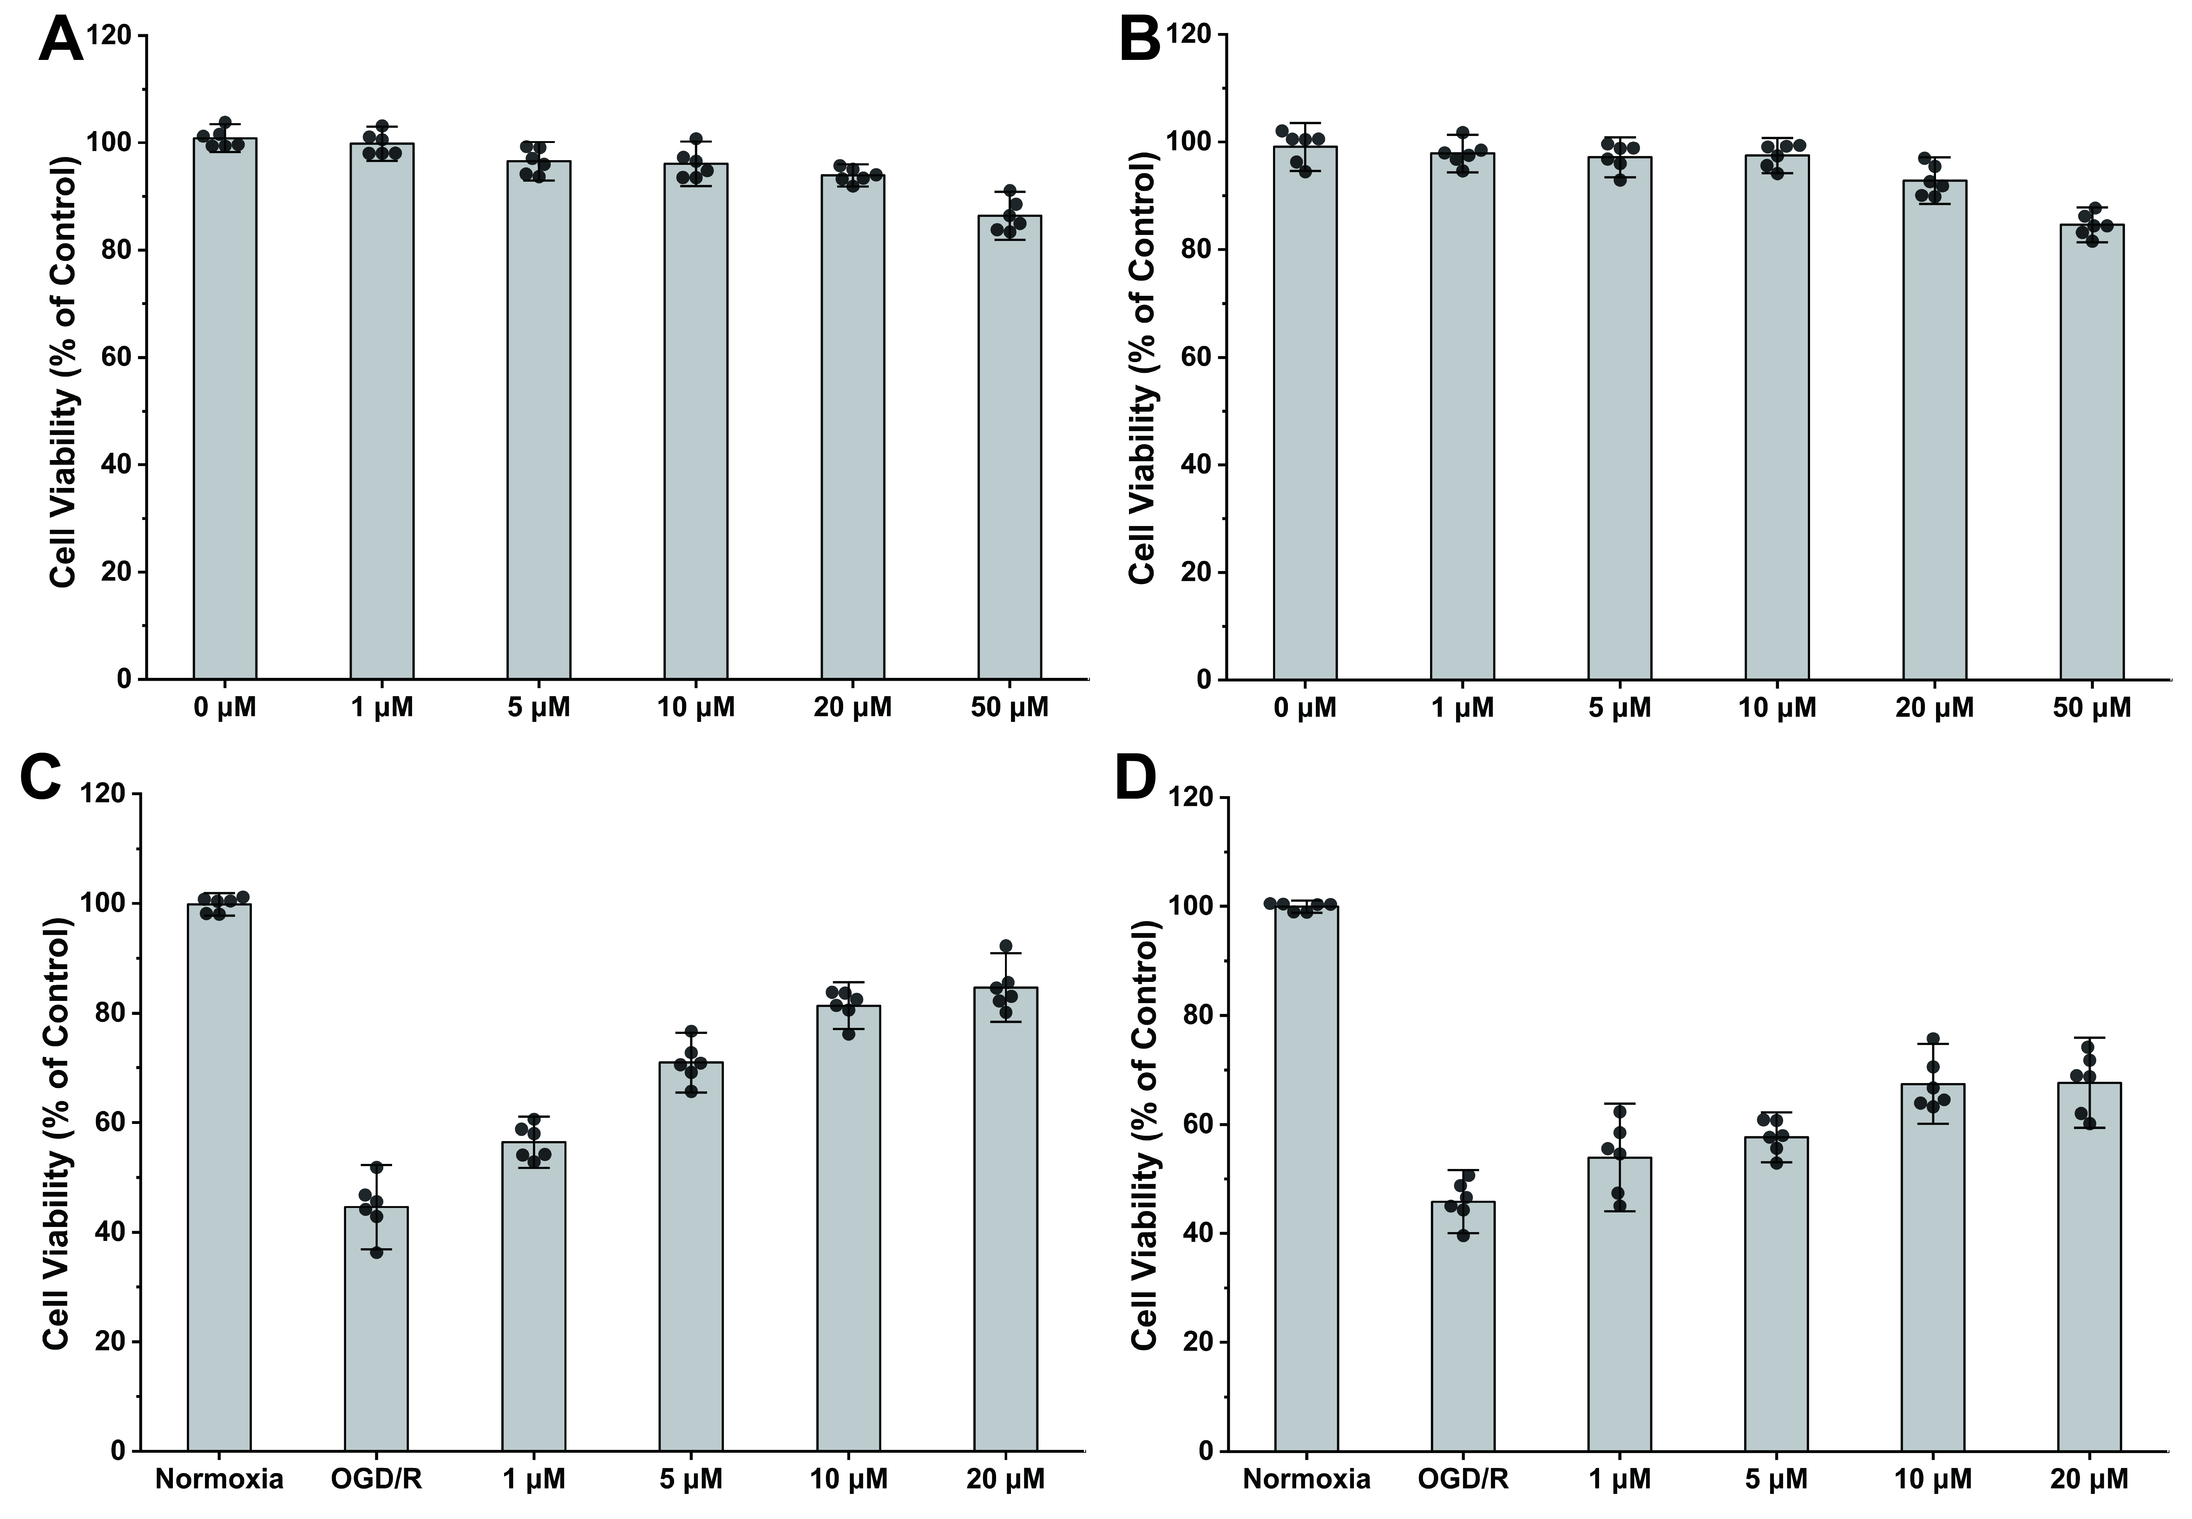

Fig. S2 Cytotoxicity screening and concentration-response assessment of pharmacological inhibitors in PC12 cells
(A) Cytotoxicity assessment of CA-074ME. Normal PC12 cells were treated with gradient concentrations of the inhibitor (0-50 μM) under normoxic conditions for 24 h, and cell viability was evaluated via CCK-8 assay. CA-074ME exhibited no significant cytotoxicity at concentrations up to 20 μM. (B) Cytotoxicity assessment of SP600125. Under identical normoxic conditions and CCK-8 evaluation, SP600125 similarly exhibited no significant cytotoxicity at concentrations up to 20 μM. (C) Dose-dependent neuroprotective efficacy of CA-074ME against OGD/R-induced injury. PC12 cells were pre-treated with indicated concentrations (1-20 μM) prior to the OGD/R challenge. Cell viability increased with increasing CA-074ME concentrations, and the protective response approached a plateau between 10 and 20 μM. (D) Dose-dependent neuroprotective efficacy of SP600125 against OGD/R-induced injury. Following the same OGD/R challenge and pretreatment paradigm, SP600125 increased cell viability in a concentration-dependent manner, with similar protective responses observed at 10 and 20 μM. Based on the substantial protective responses observed at 10 μM and the absence of detectable cytotoxicity at this concentration, 10 μM was selected as the lower effective concentration for subsequent in vitro experiments involving both compounds. Data are presented as mean ± SD (n = 6 independent experiments).

Fig. S3 Original uncropped images corresponding to Fig. 3
The original uncropped images corresponding to Fig. 3A–L are provided to document the source data used for band selection and densitometric analysis. Panels A–F show CTSB, JNK3, Bid, Caspase-3, Caspase-9, and Caspase-8 expression in rat brain tissues across the indicated early reperfusion time points. Panels G–I show CTSB, JNK3, and Bid expression in the untreated IRI and CA-074ME-treated groups at 6 h after reperfusion. Panels J–L show JNK3, CTSB, and Bid expression in the untreated IRI and SP600125-treated groups at the same time point. The corresponding β-actin loading controls are displayed adjacent to the respective target proteins. Protein identities are indicated beneath each image.

Fig. S4 Original uncropped images corresponding to Fig. 5
The original uncropped images corresponding to Fig. 5A and 5B are provided to document the source data used for band selection and densitometric analysis. The displayed proteins include NLRP3, Caspase-1 p20, and GSDMD, the inflammatory mediators NF-κB, COX2, iNOS, and TNF-α, and the antioxidant defense-related proteins Nrf2, HO-1, and GPx. Brain tissues were collected from the sham-operated, untreated IRI, CA-074ME-treated, and SP600125-treated groups at 24 h after reperfusion. GAPDH was used as the loading control. Protein identities are indicated beneath the respective images.

Supplementary tables

Table S1 Physiological parameters of rats in different experimental groups
Parameters | Time point | Sham (n=5) | IRI (n=5) | CBI (n=5) | JNKI (n=5)
pH | Baseline | 7.38 ± 0.03 | 7.39 ± 0.02 | 7.37 ± 0.04 | 7.38 ± 0.03
pH | Ischemia | 7.37 ± 0.04 | 7.36 ± 0.03 | 7.38 ± 0.02 | 7.36 ± 0.04
pH | Reperfusion | 7.39 ± 0.02 | 7.35 ± 0.04 | 7.37 ± 0.03 | 7.38 ± 0.02
pCO₂ (mmHg) | Baseline | 39.5 ± 2.1 | 40.1 ± 1.8 | 38.8 ± 2.3 | 40.5 ± 1.9
pCO₂ (mmHg) | Ischemia | 40.2 ± 1.9 | 41.3 ± 2.5 | 39.6 ± 2.0 | 41.0 ± 2.2
pCO₂ (mmHg) | Reperfusion | 39.8 ± 1.7 | 42.0 ± 2.8 | 40.3 ± 1.8 | 40.8 ± 2.1
pO₂ (mmHg) | Baseline | 95.2 ± 4.5 | 96.8 ± 3.9 | 94.5 ± 4.2 | 95.7 ± 4.1
pO₂ (mmHg) | Ischemia | 94.8 ± 3.8 | 92.5 ± 5.1 | 95.0 ± 3.6 | 93.8 ± 4.5
pO₂ (mmHg) | Reperfusion | 96.1 ± 3.5 | 91.8 ± 4.8 | 94.2 ± 4.0 | 94.5 ± 3.9
MABP (mmHg) | Baseline | 102 ± 6 | 105 ± 5 | 101 ± 7 | 103 ± 5
MABP (mmHg) | Ischemia | 100 ± 5 | 98 ± 8 | 102 ± 6 | 99 ± 7
MABP (mmHg) | Reperfusion | 103 ± 4 | 95 ± 9 | 100 ± 5 | 98 ± 6
Temp (°C) | Baseline | 37.1 ± 0.2 | 37.0 ± 0.1 | 37.1 ± 0.2 | 37.0 ± 0.2
Temp (°C) | Ischemia | 37.0 ± 0.1 | 36.9 ± 0.3 | 37.0 ± 0.2 | 37.1 ± 0.1
Temp (°C) | Reperfusion | 37.1 ± 0.2 | 37.0 ± 0.2 | 37.1 ± 0.1 | 37.0 ± 0.2
Note: Data are presented as mean ± SD with n = 5 per group. MABP indicates mean arterial blood pressure. pCO₂ indicates partial pressure of carbon dioxide. pO₂ indicates partial pressure of oxygen. Temp indicates core body temperature. Baseline refers to 15 min before ischemia. Ischemia refers to 60 min after the onset of middle cerebral artery occlusion. Reperfusion refers to 30 min after the withdrawal of the monofilament. Statistical analysis was performed using one-way ANOVA followed by Tukey’s post-hoc test. There were no significant differences in pH, pCO₂, pO₂, MABP, or core body temperature among the experimental groups at any monitored time point, with all P values > 0.05. These data indicate that the targeted pharmacological interventions and surgical procedures did not induce obvious systemic physiological confounding factors. Physiological parameters were assessed in a subset of five rats per group, whereas regional cerebral blood flow was monitored in all rats and was used to determine eligibility for the MCAO/R model.

Table S2 Key Reagents, Antibodies, and Biological Materials
Reagent / Antibody / Material | Target / Application | Dilution / Working Conc. | Catalog Number | Manufacturer
Primary Antibodies
Anti-Cathepsin B (CTSB) | WB, Co-IP, IF | WB 1:1000; IF 1:25 | Sc-365558 | Santa Cruz Biotechnology, USA
Anti-JNK3 | WB, Co-IP, IF | WB 1:1000; IF 1:25 | Sc-130075 | Santa Cruz Biotechnology, USA
Anti-Bid | WB, Co-IP, IF | WB 1:1000; IF 1:50 | 10988-1-AP | Proteintech, USA
Anti-NLRP3 | WB | 1:2000 | 68102-1-Ig | Proteintech, USA
Anti-GSDMD | WB | 1:5000 | 66387-1-Ig | Proteintech, USA
Anti-Caspase-1 p20 | WB | 1:2000 | 22915-1-AP | Proteintech, USA
Anti-Caspase-3 | WB | 1:1000 | 19677-1-AP | Proteintech, USA
Anti-Caspase-8 | WB | 1:1000 | 13423-1-AP | Proteintech, USA
Anti-Caspase-9 | WB | 1:1000 | 10380-1-AP | Proteintech, USA
Anti-TNF-α | WB | 1:1000 | ab307164 | Abcam, UK
Anti-iNOS | WB | 1:1000 | ab178945 | Abcam, UK
Anti-COX2 | WB | 1:1000 | 66351-1-Ig | Proteintech, USA
Anti-NF-κB | WB | 1:1000 | 10745-1-AP | Proteintech, USA
Anti-Nrf2 | WB | 1:1000 | 80593-1-RR | Proteintech, USA
Anti-HO-1 | WB | 1:1000 | 66743-1-Ig | Proteintech, USA
Anti-GPx | WB | 1:2000 | 29329-1-AP | Proteintech, USA
Anti-GAPDH | WB (Internal Control) | 1:10000 | ab181602 | Abcam, UK
Anti-β-actin | WB (internal reference) | 1:1000 | ab8226 | Abcam, UK
Normal IgG | Co-IP (Negative Control) | 2 μg / reaction | sc-2025 | Santa Cruz Biotechnology, USA
HRP Goat Anti-Rabbit IgG | WB | 1:2000 | ab205718 | Abcam, UK
HRP Goat Anti-Mouse IgG | WB | 1:2000 | ab205719 | Abcam, UK
CoraLite488-Conjugated | IF (Green fluorescence) | 1:500 | SA000013-2 | Proteintech, USA
CoraLite594-Conjugated | IF (Red fluorescence) | 1:500 | SA000013-3 | Proteintech, USA
Chemicals and Assays
CA-074ME | CTSB inhibitor | In vivo: 10 μg; In vitro: 10 μM | S7420 | Selleck Chemicals, USA
SP600125 | JNK pathway inhibitor | In vivo: 30 μg; In vitro: 10 μM | S1460 | Selleck Chemicals, USA
si-CTSB & si-NC | Gene knockdown | 50 nM | si-CTSB, A01004. si-NC, A06001 | GenePharma, Shanghai, China
CCK-8 Assay Kit | Cell viability | 10 μL / well | CK04 | Dojindo Molecular Technologies, Japan
TUNEL Reaction Mixture | In situ apoptosis | According to the manufacturer’s instructions | C1098 | Beyotime, China
TTC | Infarct volume staining | 2% | 60511ES | Yeasen Bio, Shanghai, China
Evans Blue (2%) | BBB permeability | 4 mL/kg | E2129 | Sigma-Aldrich, USA
Protein A/G Agarose Beads | Co-IP | 30 μL / reaction | P2012 | Beyotime, China
Bradford Protein Assay Kit | Protein quantification |  | P0006 | Beyotime, China
ECL Detection System | Western blot detection |  | WBKLS0500 | Millipore, USA
DAPI | Nuclear counterstain |  | C1002 | Beyotime, China
Lipofectamine 3000 | siRNA Transfection |  | L3000001 | Thermo Fisher Scientific, USA
PC12 Cell Line | In vitro OGD/R model | Not applicable | CRL-1721 | Cell Bank of the Chinese Academy of Sciences, Shanghai, China
Sprague-Dawley Rats | In vivo MCAO/R model | Male, 240-280 g | Not applicable | Sipeifu Biotechnology Co., Ltd., Beijing, China
Note: WB indicates Western blot. Co-IP indicates co-immunoprecipitation. IF indicates immunofluorescence. CTSB indicates Cathepsin B. JNK3 indicates c-Jun N-terminal kinase 3. NLRP3 indicates NOD-like receptor protein 3. GSDMD indicates gasdermin D. TNF-α indicates tumor necrosis factor-alpha. iNOS indicates inducible nitric oxide synthase. COX2 indicates cyclooxygenase-2. NF-κB indicates nuclear factor kappa B. Nrf2 indicates nuclear factor erythroid 2-related factor 2. HO-1 indicates heme oxygenase-1. GPx indicates glutathione peroxidase. GAPDH indicates glyceraldehyde 3-phosphate dehydrogenase. HRP indicates horseradish peroxidase. siRNA indicates small interfering RNA. CCK-8 indicates Cell Counting Kit-8. TUNEL indicates terminal deoxynucleotidyl transferase dUTP nick end labeling. TTC indicates 2,3,5-triphenyltetrazolium chloride. BBB indicates blood-brain barrier. OGD/R indicates oxygen-glucose deprivation/reoxygenation. MCAO/R indicates middle cerebral artery occlusion/reperfusion.

