A T2T genome assembly of subtropic maize inbred line CML312 with Nanopore simplex reads
Zonghai Qiu^{1,#}, Hanxue Zhang^{1,#}, Zhihui Lu^{1,#}, Pengfei Fu^{1,#}, Fuyan Jiang², Rui Zou¹, Yaru Zhang¹, Canting Wu¹, Xiaoyi Ma¹, Jing yuan¹, Xingming Fan², Shoudong Zhang^{1, ※}
- School of Agriculture, Yunnan University, Kunming, 650500
- Institute of Food Crops, Yunnan Academy of Agricultural Sciences, Kunming, 650205, China
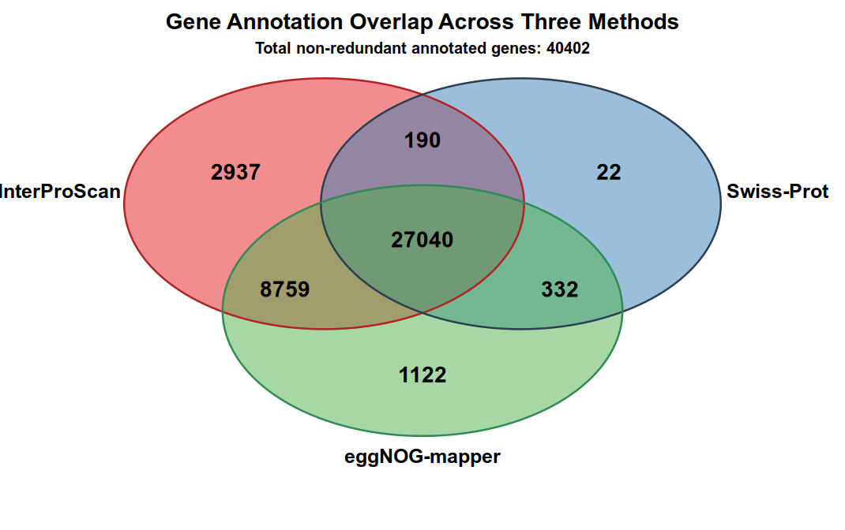
Fig S1. Overlap among functional annotation results for CML312 protein-coding genes.
Venn diagram showing the overlap among gene-level functional annotations obtained using InterProScan, eggNOG, and Swiss-Prot. Of the 44,758 predicted protein-coding genes in CML312, 40,402 genes (90.27%) were assigned at least one functional annotation. InterProScan, eggNOG, and Swiss-Prot annotated 38,926, 37,253, and 27,584 genes, respectively, with 27,040 genes annotated by all three resources. Numbers in the non-overlapping and intersecting regions indicate the numbers of genes uniquely or jointly annotated by the corresponding resources. Genes without annotations from any of the three resources (n = 4,356) are not shown.

Gene Type | Gene counts | Expressed gene counts | Expressed genes (%) | Mean TPM | Median TPM
Knob_genes | 211 | 31 | 14.69 | 0.27 | 0.00
Knob-upstream_gene | 3,623 | 2,693 | 74.33 | 21.82 | 1.01
Knob-downstream_gene | 4,342 | 3,286 | 75.68 | 23.60 | 1.35
Other | 36,582 | 26,121 | 71.40 | 22.36 | 0.70
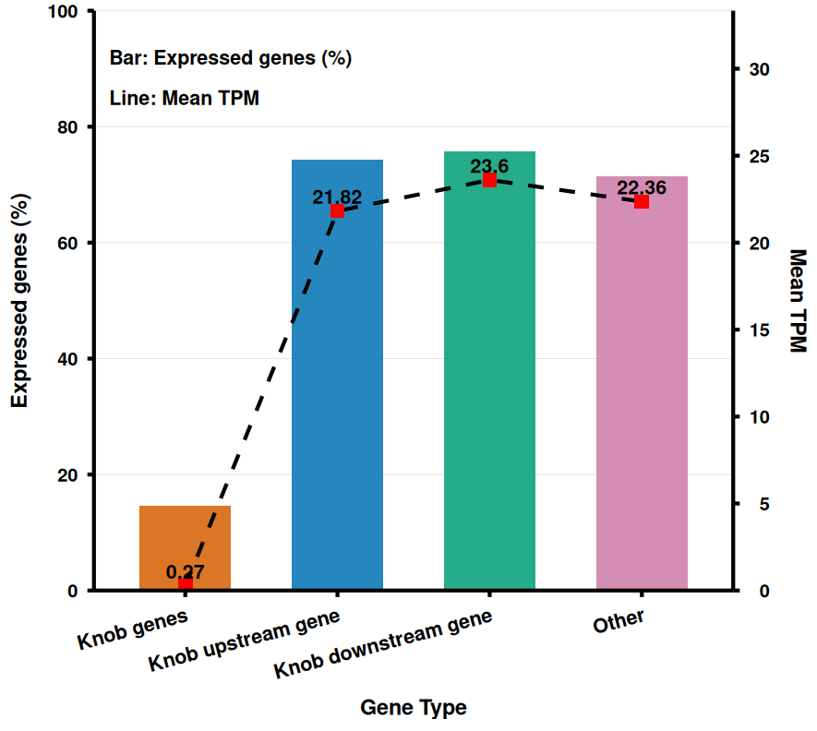
Fig S2. Expression characteristics of genes located within and adjacent to knob regions in CML312.
Comparison of gene expression among genes located within knob regions, genes located upstream or downstream of knob regions, and all other annotated genes in the CML312 genome. Bars represent the percentage of expressed genes in each category, and the dashed line represents the mean transcript abundance measured as transcripts per million (TPM). Among the 211 genes located within knob regions, 31 genes were expressed, corresponding to 14.69% of knob-associated genes, with a mean TPM of 0.27. In comparison, 74.33% of upstream genes, 75.68% of downstream genes, and 71.40% of other genes were expressed, with mean TPM values of 21.82, 23.60, and 22.36, respectively. The accompanying table summarizes the total number of genes, number and percentage of expressed genes, and mean and median TPM values for each category.

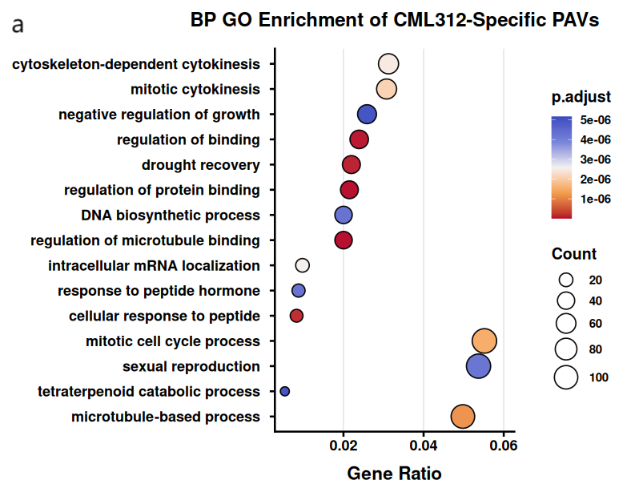

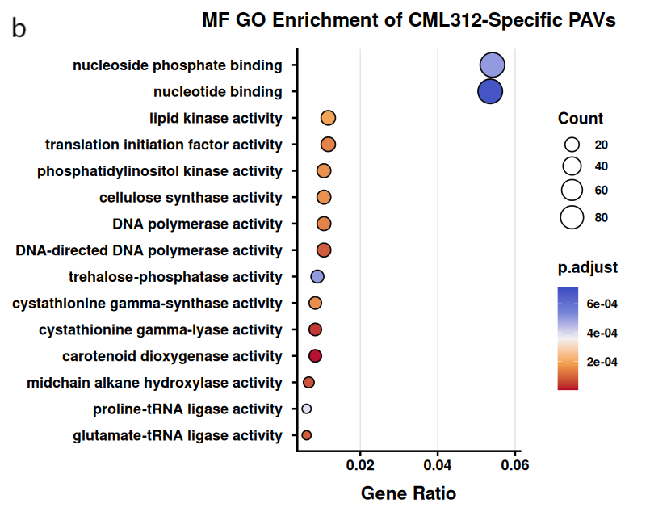

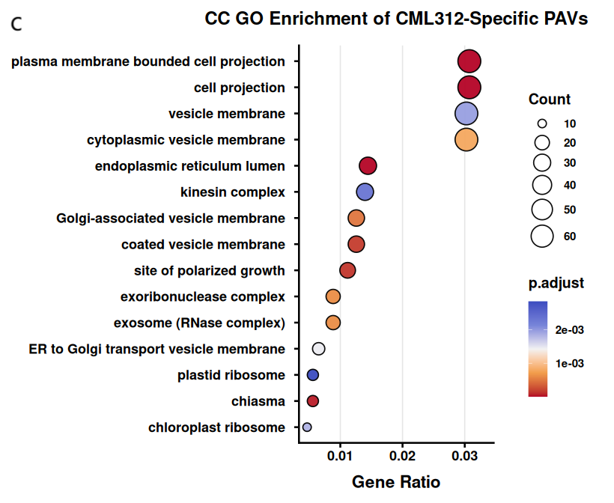
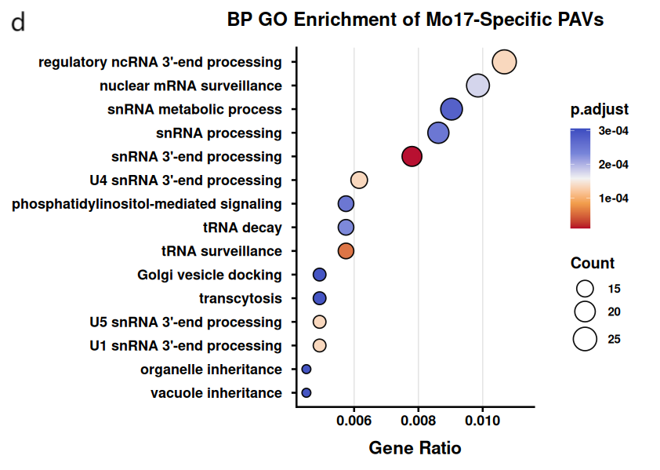
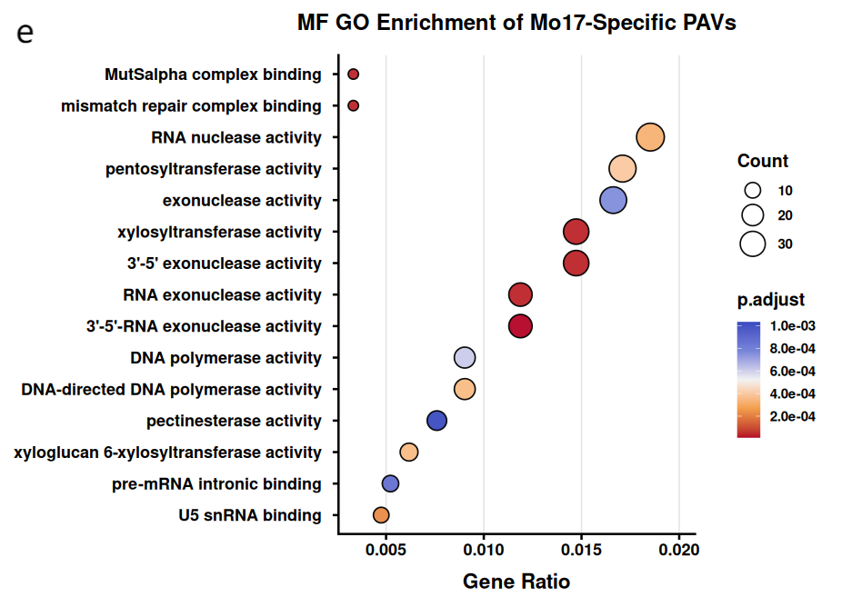

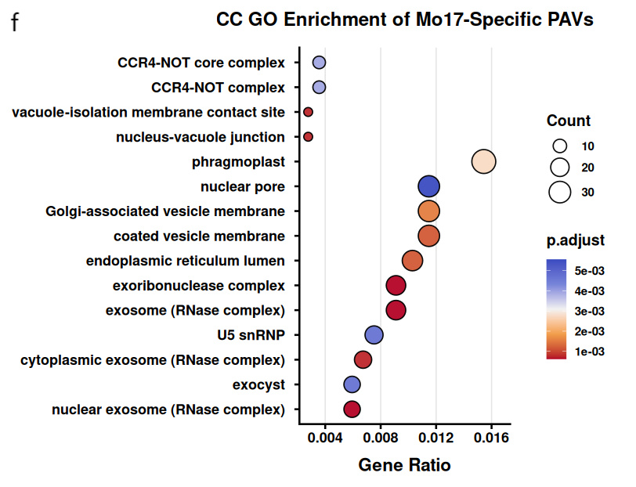
Fig S3. GO enrichment of genes associated with CML312- and Mo17-specific presence–absence variation regions.
Bubble plots showing significantly enriched Gene Ontology (GO) terms among genes located within or overlapping genome regions classified as presence-absence variations (PAVs) between CML312 and Mo17. Panels (a-c) show enrichment results for genes associated with CML312-specific PAV regions, including Biological Process (BP; a), Molecular Function (MF; b), and Cellular Component (CC; c) categories. Panels (d-f) show the corresponding enrichment results for genes associated with Mo17-specific PAV regions, including BP (d), MF (e), and CC (f) categories. The x-axis represents the gene ratio, calculated as the proportion of input PAV-associated genes assigned to each GO term. Bubble size indicates the number of genes associated with the corresponding term, and bubble color represents the adjusted P value. Only significantly enriched GO terms passing the applied multiple-testing correction threshold are shown.

