Supplementary Material
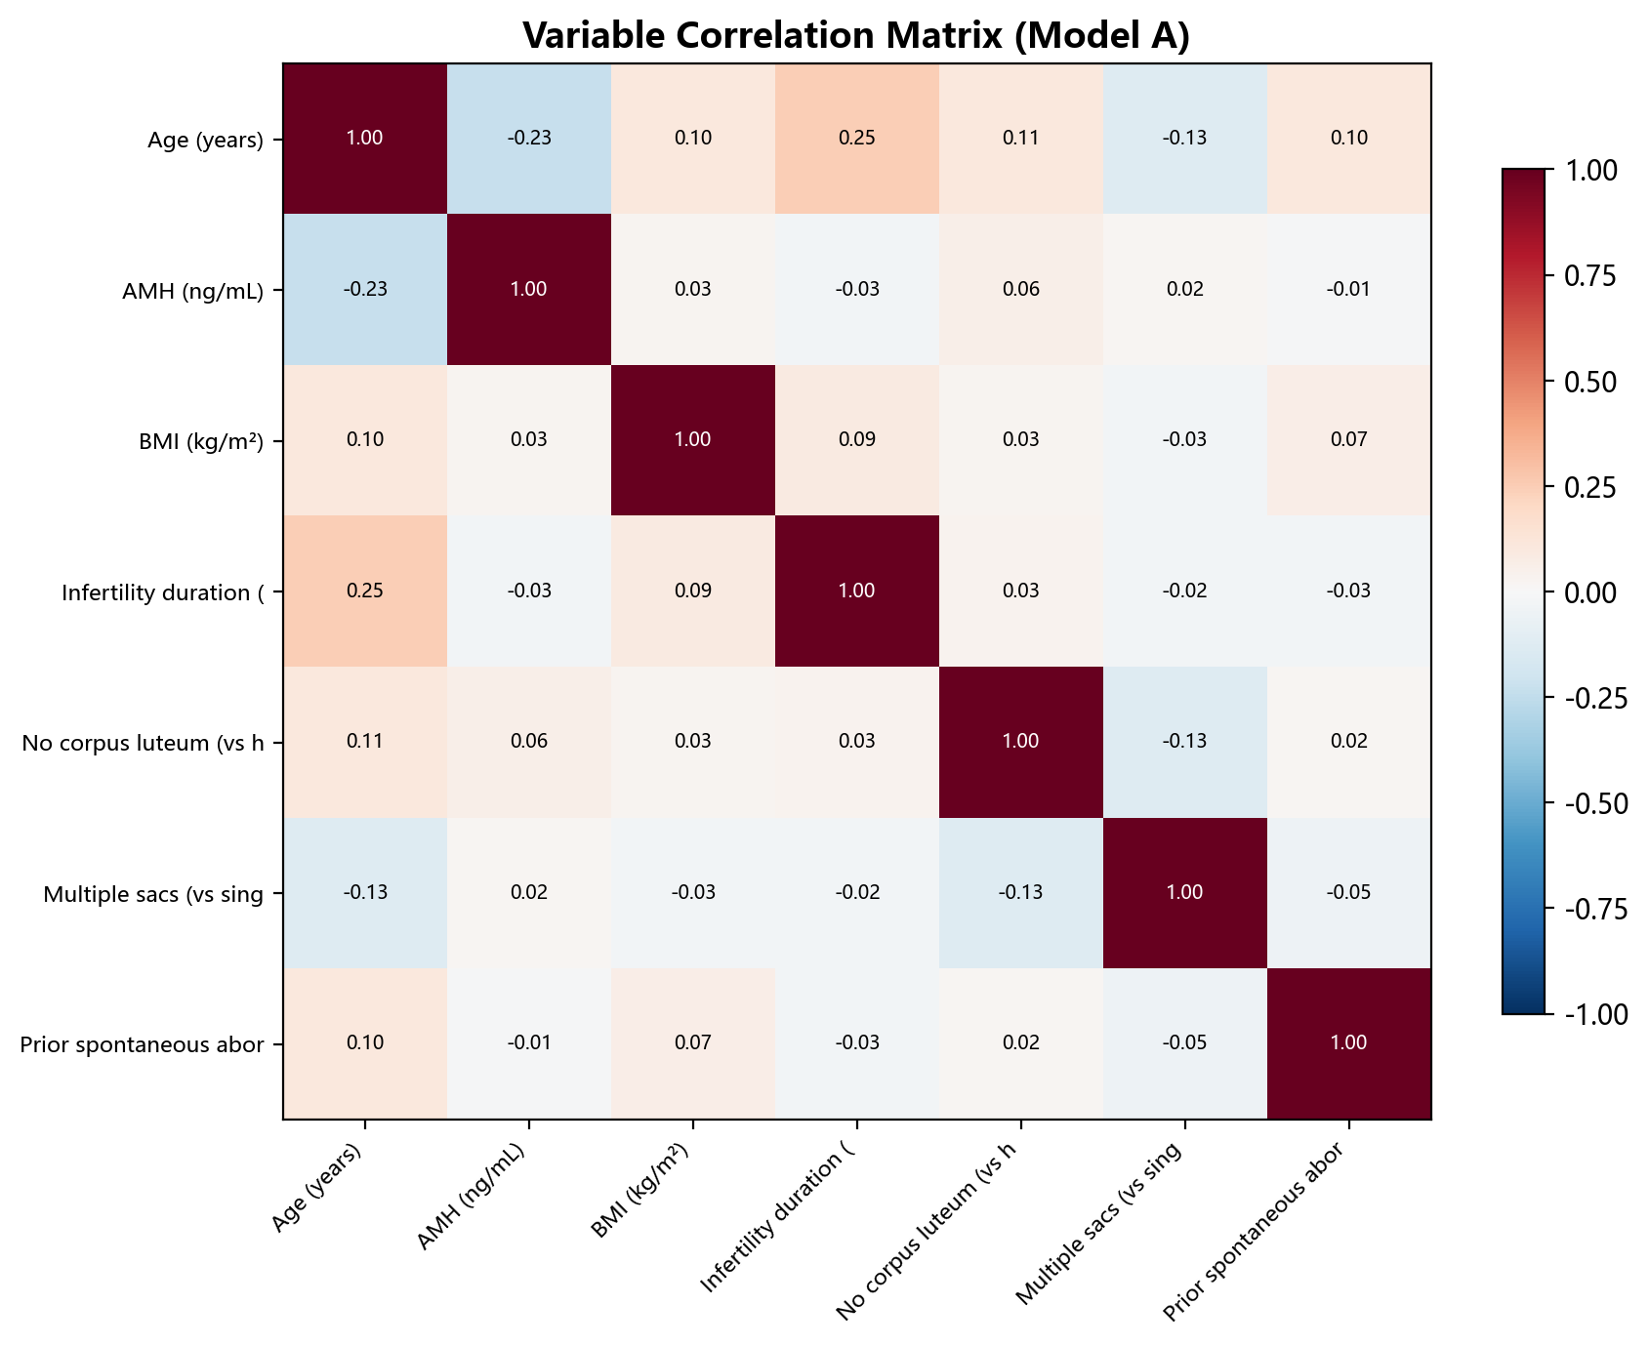
Figure S1 Variable correlation matrix (Model A, 7 variables)
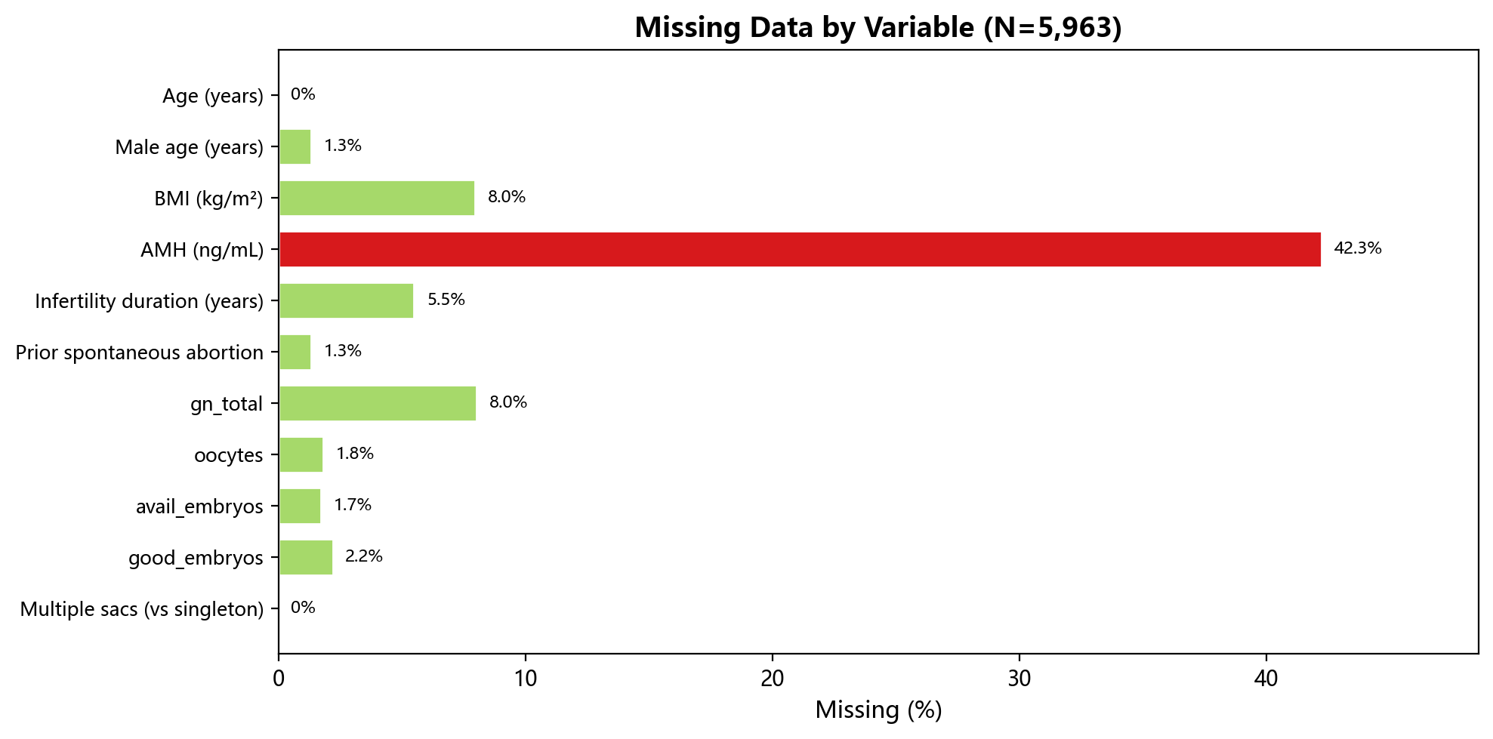
Figure S2 Missing data pattern
Table S1 Subgroup pregnancy loss rates
Subgroup variable | Subgroup | N | Pregnancy loss rate (%)
Age | <30 | 1722 | 12.0%
Age | 30-34 | 2584 | 15.8%
Age | 35-37 | 949 | 21.3%
Age | 38-40 | 343 | 25.1%
Age | >=40 | 267 | 46.4%
Cycle type | Fresh | 2406 | 14.9%
Cycle type | FET | 3459 | 19.4%
BMI | <18.5 | 522 | 14.4%
BMI | 18.5-23.9 | 3432 | 17.3%
BMI | 24-27.9 | 1150 | 19.9%
BMI | >=28 | 294 | 20.7%
AMH | Low | 1126 | 22.8%
AMH | Medium | 1146 | 17.5%
AMH | High | 1115 | 15.6%
Transfer type | cleavage | 4301 | 17.5%
Transfer type | blastocyst | 1523 | 17.9%
Transfer type | none | 41 | 7.3%
Pregnancy type | singleton | 1969 | 20.8%
Pregnancy type | twin | 306 | 7.2%
Embryo quality | No good embryo | 1806 | 16.7%
Embryo quality | ≥1 good embryo | 4059 | 17.9%
Period | 2012-2022 | 3979 | 16.7%
Period | 2022-2026 | 1886 | 19.2%
Oocyte yield | Low (≤5) | 579 | 25.2%
Oocyte yield | Medium (6-14) | 2851 | 18.7%
Oocyte yield | High (≥15) | 2328 | 14.4%
FET protocol | GnRHa+HRT | 1375 | 18.9%
FET protocol | Pure HRT | 1909 | 19.8%
Table S2 Sensitivity analyses
Analysis | N | AUC | Brier
Complete case analysis | 3381 | 0.648 | 0.153
Cross-validation on 2022–2026 data | 2283 | 0.639±0.029 | —
Table S2 Complete-case analysis excluded patients with missing AMH or BMI. Cross-validation (5×20-fold) was restricted to 2022–2026 data.
Table S3 Model comparison
Model | Variables | AUC (temporal) | Brier
Model A (7 variables) | 7 | 0.646 | 0.147
Model B (5 variables) | 5 | 0.628 | 0.148
Model C (13 variables) | 13 | 0.650 | 0.147
Table S3 Model A: primary 7-variable model. Model B: 5-variable compact model. Model C: 13-variable extended model.

