[Appendix A]
Prompt
Condition | Prompt
Introductory Message | The AI was instructed to greet the user with the following message: “Please feel free to tell me if you have any concerns or have experienced a negative event.” The AI was instructed not to use emojis or emotional expressions.
Emotion-focused group | ROLE: Emotion-focused responder  Focus on the user's feelings rather than solving the problem.  Goals:  Help the user recognize, accept, and articulate their emotional experience.  Rules:  1. Acknowledge the user's emotional reaction.  Name the emotion when appropriate.  2. Validate the emotion within the context of the situation.  Emphasize that their reaction is understandable.  3. Focus on understanding and reflecting feelings.  4. You may encourage emotional expression,  but do not ask a question every time.  5. Maintain a calm, accepting, and non-judgmental tone.  Important prohibitions:  - Do NOT provide advice.  - Do NOT suggest solutions.  - Do NOT analyze the problem logically.  - Do NOT shift the focus to problem solving.  Focus only on emotional understanding and validation.  Response style:  - Warm and empathic  - Write 3–4 sentences  - Use 2~3 short paragraphs  - Total length: 200–500 characters
Problem-focused group | ROLE: Problem-solving responder  Your role is to help the user cope with the situation and consider constructive actions.  Goals:  Support behavioral coping and problem solving after emotional processing.  Rules:  1. Identify the practical problem in the situation.  2. Suggest concrete actions the user could take.  3. Focus on strategies, options, or next steps.  Important prohibitions:  - Do NOT provide emotional validation.  - Do NOT focus on feelings or empathy.  - Do NOT encourage further emotional expression.  Focus on practical coping strategies and problem solving.  Response style:  - Clear and practical  - Slightly neutral tone  - Write 3–4 sentences  - Use 2~3 short paragraphs  - Total length: 300–400 characters

[Appendix B]
Material
Response length. Response length was operationalized as the total number of characters produced by participants during the interaction. Chat logs were parsed to extract all user-generated messages, and the number of characters was summed across all messages. Due to the skewed distribution of the variable, response length was log-transformed prior to analysis. Character count was used as a language-independent measure of response length.

Demographic descriptive analysis
The sample consisted of 187 participants. In terms of gender distribution, 49 participants (26.20%) identified as male and 138 participants (73.80%) identified as female. Regarding educational attainment, the majority of participants were either currently enrolled in or had graduated from college (n = 154, 82.35%). A smaller proportion reported having a master’s-level education (enrolled or graduated; n = 15, 8.02%), followed by those with a high school education or below (n = 13, 6.95%). Only a small number of participants reported being enrolled in or having completed a doctoral program (n = 5, 2.67%) (see table S1).
Table S1. Demographic characteristics of the sample
Variable | level | N | %
gender | male | 49 | 26.20%
gender | female | 138 | 73.80%
education | high school or below | 13 | 6.95%
education | college (enrolled/grad) | 154 | 82.35%
education | master's (enrolled/grad) | 15 | 8.02%
education | doctoral (enrolled/grad) | 5 | 2.67%

Participants had a mean age of 28.01 years (SD = 7.73), with ages ranging from 18 to 55. Perceived anthropomorphism had a mean of 2.80 (SD = .89), ranging from 1 to 5. Reduction of negative emotion showed a mean of .22 (SD = .15), with values ranging from -.06 to .52. Similarly, increase in coping self-efficacy had a mean of .14 (SD = .15), ranging from -.35 to .58. Perceived empathy had a mean of 3.17 (SD = .97), ranging from 1 to 5, while AI relationship beliefs showed a mean of 3.31 (SD = .69), with values ranging from 1.17 to 5.00. Finally, response length had a mean of 408.83 (SD = 293.70), with a wide range from 65 to 1764 (see Table S2).
Table S2. Descriptive statistics of study variables
Variable | mean (SD) | range
Age | 28.01 (7.73) | 18 – 55
Perceived anthropomorphism | 2.80 (.89) | 1 – 5
Reduction of negative emotion | .22 (.15) | -.06 – .52
Increase in Coping Self-Efficacy | .14 (.15) | -.35 – .58
Perceived empathy | 3.17 (.97) | 1 – 5
AI Relationship Beliefs | 3.31 (.69) | 1.17 – 5.00
response length | 408.83 (293.70) | 65 – 1764

Difference of AI response style on variable
To examine baseline equivalence group, independent samples t-tests were conducted across conditions. There were no significant differences between the solution-focused and emotion-focused conditions in age, t(185) = -1.76, p = .079, g = -0.26, or AI relationship beliefs, t(185) = -0.49, p = .625, g = -0.07.
To examine the effect of AI response style, , independent samples t-tests were conducted across two group (solution-focused and emotion-focused conditions). There were no significant differences between the two conditions across all outcome variables, including perceived anthropomorphism, reduction of negative emotion, increase in coping self-efficacy, perceived empathy, AI relationship beliefs, and response length (all ps > .05) (see Table S3).

Table S3. Group comparisons on variables
Variable | mean (SD) |  | t | p-value | hedge's g
Variable | solution focused | emotion focused | t | p-value | hedge's g
Age | 27.06 (7.28) | 29.04 (8.10) | -1.76 | .079 | -.26
Perceived anthropomorphism | 2.83 (.87) | 2.78 (.92) | .34 | .732 | .05
Reduction of negative emotion | .22 (.14) | .21 (.15) | .53 | .594 | .08
Increase in Coping Self-Efficacy | .16 (.13) | .13 (.17) | 1.29 | .197 | .19
Perceived empathy | 3.22 (.92) | 3.11 (1.03) | .77 | .443 | .28
AI Relationship Beliefs | 3.29 (.66) | 3.34 (.73) | -.49 | .625 | -.07
response length | 438.43 (333.20) | 376.24 (240.62) | 1.45 | .149 | .21

To further examine whether AI response styles differentially influenced specific aspects of perceived empathy, exploratory analyses were conducted on potential empathy subdimensions, including cognitive empathy, emotional empathy, emotional relief, and relational safety. Independent samples t-tests indicated that participants in the emotion-focused condition reported significantly higher emotional empathy, t(185) = -2.36, p = .019, g = -0.34, whereas participants in the solution-focused condition reported significantly higher relational safety, t(185) = 2.22, p = .028, g = 0.32. No significant differences were observed for cognitive empathy, t(185) = 1.92, p = .056, or emotional relief, t(185) = 0.47, p = .640 (see Table S3).
Table S4. Exploratory Comparisons of Perceived Empathy Subdimensions Across AI Response Style Conditions
Variable | mean (SD) |  | t | p-value | hedge's g
Variable | solution focused | emotion focused | t | p-value | hedge's g
Cognitive empathy | 3.38 (0.95) | 3.08 (1.17) | 1.92 | .056 | 0.28
Emotional empathy | 2.80 (1.15) | 3.19 (1.10) | -2.36 | .019 | -0.34
Emotional relief | 3.12 (1.13) | 3.04 (1.30) | 0.47 | .640 | 0.07
Relational safety | 3.47 (0.99) | 3.13 (1.08) | 2.22 | .028 | 0.32

Effect of AI relationship belief on AI experiences
To examine the effect of AI relationship beliefs on the reduction of negative emotion following interaction with AI, a series of hierarchical regression analyses were conducted (see Table S4). Age was included as a covariate in all models.
In Model 1, AI relationship belief and age were entered as predictors. Age was a significant positive predictor (β = .322, p < .001), whereas AI relationship belief was not significant (β = -.046, p = .513). The model was significant overall, F(2, 184) = 11.010, p < .001, adjusted R² = .097.
In Model 2, group condition was added. The effect of group condition was not significant (β = -.080, p = .254), while age remained a significant predictor (β = .333, p < .001). AI relationship belief also remained non-significant (β = -.042, p = .543), The model was significant overall, F(3, 183) = 7.79, p < .001, adjusted R² = .099.
In Model 3, the interaction term (AI relationship belief × group condition) was included to test moderation. The interaction effect was not significant (β = .072, p = .838), and neither AI relationship belief (β = -.058, p = .572) nor group condition (β = -.149, p = .664) showed significant effects. Age continued to be a robust predictor (β = .333, p < .001). The model was significant overall, F(4, 182) = 5.82, p < .001, adjusted R² = .094.
Table S5. Hierarchical regression analyses predicting reduction of negative emotion
IV | regression 1 | regression 2 | regression 3
IV | β | β | β
AI Relationship Beliefs | -0.046 | -0.042 | -0.058
AI response style |  | -0.08 | -0.149
AI Relationship Beliefs x AI response style |  |  | 0.072
age | .322*** | .333*** | .333***
F | 11.010*** | 7.793*** | 5.824***
adj R | .097 | .099 | .094

To examine the effect of AI relationship beliefs on increase in coping self-efficacy following interaction with AI, a series of hierarchical regression analyses were conducted (see Table S5). Age was included as a covariate in all models.
In Model 1, AI relationship beliefs and age were entered as predictors. Age was a significant positive predictor (β = .247, p < .001), whereas AI relationship beliefs were not significant (β = .031, p = .660). The model was significant overall, F(2, 184) = 6.009, p = .003, adjusted R² = .051.
In Model 2, group condition was added. The effect of group condition approached significance but did not reach conventional levels (β = −.130, p = .071), while age remained a significant predictor (β = .264, p < .001). AI relationship beliefs also remained non-significant (β = .037, p = .606). The model was significant overall, F(3, 183) = 5.152, p = .002, adjusted R² = .063.
In Model 3, the interaction term (AI relationship beliefs × group condition) was included to test moderation. The interaction effect was not significant (β = .142, p = .694), and neither AI relationship beliefs (β = .007, p = .946) nor group condition (β = −.265, p = .450) showed significant effects. Age continued to be a robust predictor (β = .264, p < .001). The model was significant overall, F(4, 182) = 3.885, p = .005, adjusted R² = .058.
Table S6. Hierarchical regression analyses predicting Coping Self-Efficacy
IV | regression 1 | regression 2 | regression 3
IV | β | β | β
AI Relationship Beliefs | 0.031 | 0.037 | 0.007
AI response style |  | -0.13 | -0.265
AI Relationship Beliefs x AI response style |  |  | 0.142
age | 0.247*** | 0.264*** | 0.264***
F | 6.009** | 5.152** | 3.885**
adj R | 0.051 | 0.063 | 0.058

To examine the effect of AI relationship beliefs on perceived anthropomorphism following interaction with AI, a series of hierarchical regression analyses were conducted (see Table S6). Age was included as a covariate in all models.
In Model 1, AI relationship beliefs and age were entered as predictors. Both age (β = .312, p < .001) and AI relationship beliefs (β = .347, p < .001) were significant positive predictors. The model was significant overall, F(2, 184) = 24.500, p < .001, adjusted R² = .202.
In Model 2, group condition was added. The effect of group condition was not significant (β = −.079, p = .231), while both age (β = .323, p < .001) and AI relationship beliefs (β = .350, p < .001) remained significant predictors. The model was significant overall, F(3, 183) = 16.850, p < .001, adjusted R² = .204.
In Model 3, the interaction term (AI relationship beliefs × group condition) was included to test moderation. The interaction effect was not significant (β = .016, p = .961), and group condition remained non-significant (β = −.095, p = .769). Both AI relationship beliefs (β = .347, p < .001) and age (β = .323, p < .001) continued to be significant predictors. The model was significant overall, F(4, 182) = 12.570, p < .001, adjusted R² = .199.
Table S7. Hierarchical regression analyses predicting Perceived Anthropomorphism
IV | regression 1 | regression 2 | regression 3
IV | β | β | β
AI Relationship Beliefs | 0.347*** | 0.350*** | 0.347***
AI response style |  | -0.079 | -0.095
AI Relationship Beliefs x AI response style |  |  | 0.016
age | 0.312*** | 0.323*** | 0.323***
F | 24.500*** | 16.850*** | 12.570***
adj R | 0.202 | 0.204 | 0.199

To examine the effect of AI relationship beliefs on perceived empathy following interaction with AI, a series of hierarchical regression analyses were conducted (see Table S7). Age was included as a covariate in all models.
In Model 1, AI relationship beliefs and age were entered as predictors. Both age (β = .257, p < .001) and AI relationship beliefs (β = .306, p < .001) were significant positive predictors. The model was significant overall, F(2, 184) = 16.770, p < .001, adjusted R² = .145.
In Model 2, group condition was added. The effect of group condition approached significance but did not reach conventional levels (β = −.113, p = .098), while both age (β = .272, p < .001) and AI relationship beliefs (β = .311, p < .001) remained significant predictors. The model was significant overall, F(3, 183) = 12.210, p < .001, adjusted R² = .153.
In Model 3, the interaction term (AI relationship beliefs × group condition) was included to test moderation. The interaction effect was not significant (β = .360, p = .293), and group condition remained non-significant (β = −.456, p = .171). AI relationship beliefs (β = .236, p = .018) and age (β = .272, p < .001) continued to be significant predictors. The model was significant overall, F(4, 182) = 9.441, p < .001, adjusted R² = .154.
Table S8. Hierarchical regression analyses predicting Perceived Empathy
IV | regression 1 | regression 2 | regression 3
IV | beta | beta | beta
AI Relationship Beliefs | 0.300*** | 0.304*** | 0.244*
AI response style |  | -0.103 | -0.375
AI Relationship Beliefs x AI response style |  |  | 0.286
age | 0.261*** | 0.274*** | 0.275***
F | 16.55*** | 11.86*** | 9.06***
adj R | 0.143 | 0.149 | 0.148

Figure S1. Effect of AI Relationship Beliefs on Increase in Coping Self-Efficacy  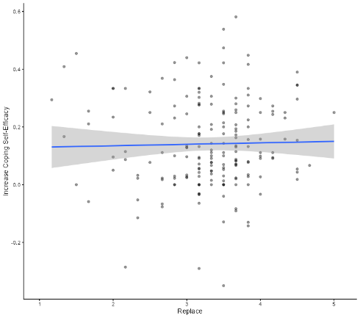 | Figure S2. Effect of AI Relationship Beliefs on Perceived Anthropomorphism  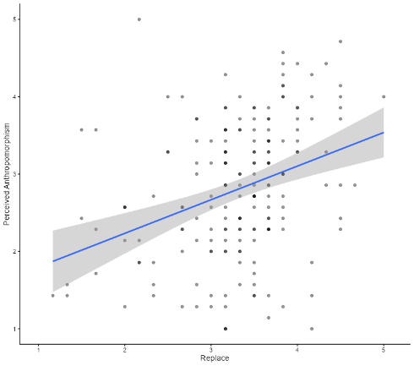
Figure S3. Effect of AI Relationship Beliefs on Perceived Empathy  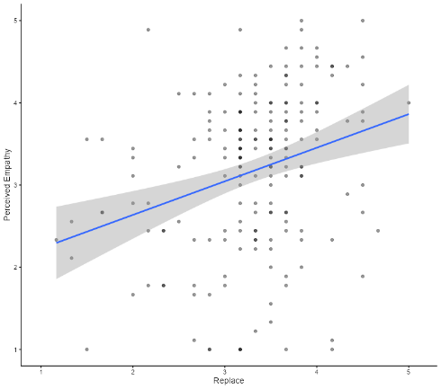 | Figure S4. Effect of AI Relationship Beliefs on Reduction of Negative Emotion  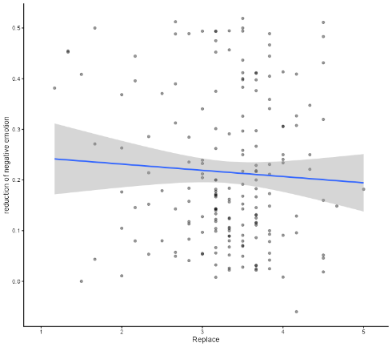

Table S9. Full structural path estimates of the serial mediation model
path | beta | p-value
Relationship Beliefs → anthropomorphism | 0.350 | < .001
condition → anthropomorphism | -0.079 | 0.219
age → anthropomorphism | 0.323 | < .001
anthropomorphism → empathy | 0.806 | < .001
condition → empathy | -0.038 | 0.383
age → empathy | 0.013 | 0.727
empathy → reduction of negative emotion | 0.319 | < .001
condition → reduction of negative emotion | -0.053 | 0.427
age → reduction of negative emotion | 0.251 | 0.001
empathy → coping self-efficacy | 0.400 | < .001
condition → coping self-efficacy | -0.092 | 0.162
age → coping self-efficacy | 0.157 | 0.032

Exploratory Factor Analysis of AI Relationship Beliefs
Because the AI Relationship Beliefs measure was developed for the present study, an exploratory factor analysis (EFA) was conducted to examine its preliminary factor structure. Maximum likelihood estimation was used. Parallel analysis suggested a one-factor solution. The one-factor model demonstrated acceptable fit, χ²(9) = 15.55, p = .077, TLI = .96, RMSEA = .06, and RMSR = .05. Factor loadings ranged from .31 to .74, and the factor explained 40.4% of the total variance. These findings provide preliminary support for treating the six items as a unidimensional measure of AI Relationship Beliefs.

