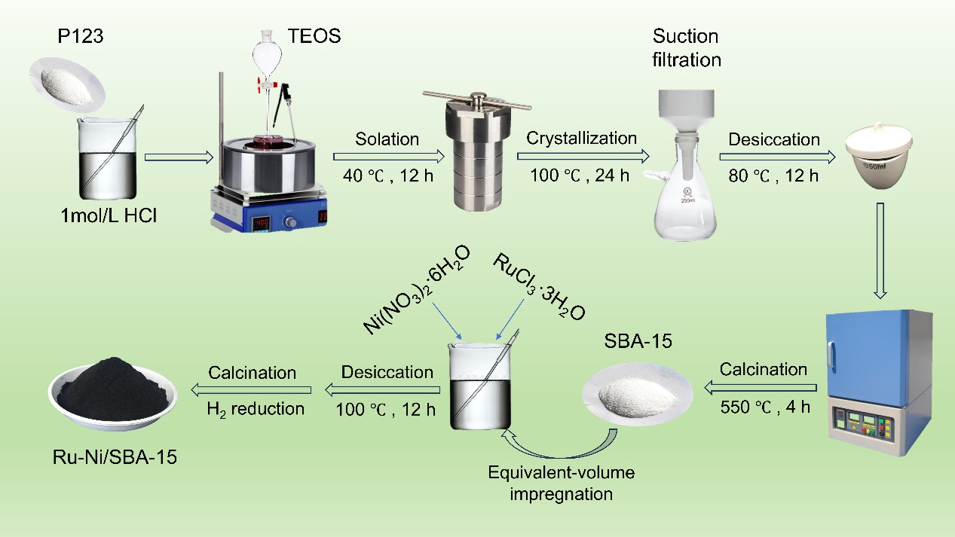
Scheme 1. Preparation process of catalyst Ru-Ni/SBA-15

