Additional file 1: Supplementary materials
Manuscript: Which disadvantaged students beat the odds in STEM? A design-consistent, fairness-audited machine learning study of 143,573 adolescents in 79 PISA 2022 education systems

Supplementary methods notes
S-Note 1. Senate weights. For all pooled analyses, the final trimmed student weight (W_FSTUWT) was rescaled within each system’s disadvantaged subsample to sum to 1,000: SENWT_i = W_FSTUWT_i × 1000 / Σ_c W_FSTUWT. Every system therefore contributes equally to pooled training and evaluation (“equal-system estimand”). Within-system statistics use W_FSTUWT.
S-Note 2. Country-grouped transport CV. The 79 systems were randomly partitioned (seed 20260714) into 8 groups; each group’s students were predicted by a model trained on the remaining ~69–70 systems, so every transported prediction comes from a model trained with no data from the target system. Agreement with strict leave-one-system-out was verified on 12 randomly sampled systems (11 estimable; r = .84, mean |Δ| = .010).
S-Note 3. Sampling-noise benchmark for hierarchy comparisons. Because within-system SHAP rankings are estimated from small samples (median n = 1,583), we constructed a noise floor: 30 subsamples of size 1,583 drawn from the pooled data (which by construction share the pooled hierarchy), refitted with the identical light configuration used for within-system models, each compared with the pooled ranking via Kendall’s τ. The resulting distribution (median .451, IQR .417–.492, min .357) bounds how low τ can fall from sampling noise alone; the observed cross-system median (.297) lies below this entire distribution.
S-Note 4. Reproducibility. The full pipeline was re-executed end-to-end (data re-downloaded from the OECD server; all stages rerun) after a compute-environment reset. All quantities reproduced exactly (identical per-fold AUCs, bootstrap intervals, and noise-floor statistics), as expected under the fixed-seed design.
S-Note 5. Rotated-module missingness. Eight scales with >40% missingness (ICTRES, PERSEVAGR, COOPAGR, EMPATAGR, ASSERAGR, STRESAGR, SDLEFF, FAMSUPSL) reflect PISA 2022 questionnaire rotation (missingness by design, approximately at random). Tree models handled these natively; excluding them changed AUC from 0.912 to 0.904 with an unchanged remaining hierarchy (Table 3, main text).

Table S0. Analysis variables and definitions
Variable | PISA source / label
AGE | Students’ age
GRADE | Grade compared to modal grade in country
ESCS | Index of economic, social and cultural status
ICTRES | ICT Resources (WLE)
EXERPRAC | Exercise or practice a sport before or after school
STUDYHMW | Studying for school or homework before or after school
WORKPAY | Working for pay before or after school
WORKHOME | Working in household/take care of family members before or after school
SKIPPING | Skipping classes or days of school
TARDYSD | Arriving late for school stricter definition
EXPECEDU | Highest expected educational level
MATHPREF | Preference of Math over other core subjects
MATHEASE | Perception of Mathematics as easier than other subjects
MATHMOT | Motivation to do well in mathematics
MATHEFF | Mathematics self-efficacy: formal and applied mathematics - response options reversed in 2022 (WLE)
MATHEF21 | Mathematics self-efficacy: mathematical reasoning and 21st century skills (WLE)
ANXMAT | Mathematics Anxiety (WLE)
MATHPERS | Effort and Persistence in Mathematics (WLE)
EFFORT1 | How much effort did you put into this test? (after cognitive assessment)
GROSAGR | Growth Mindset (WLE)
PERSEVAGR | Perseverance (agreement) (WLE)
CURIOAGR | Curiosity (agreement) (WLE)
COOPAGR | Cooperation (agreement) (WLE)
EMPATAGR | Empathy (agreement) (WLE)
ASSERAGR | Assertiveness (agreement) (WLE)
STRESAGR | Stress resistance (agreement) (WLE)
SDLEFF | Self-directed learning self-efficacy (WLE)
FAMSUPSL | Family support for self-directed learning (WLE)
BELONG | Sense of belonging (WLE)
BULLIED | Being bullied (WLE)
FEELSAFE | Feeling safe (WLE)
RELATST | Quality of student-teacher relationships (WLE)
FAMSUP | Family support (WLE)
DISCLIM | Disciplinary climate in mathematics (WLE)
TEACHSUP | Mathematics Teacher Support (WLE)
COGACRCO | Cognitive activation in mathematics: Foster reasoning Version B (WLE)
COGACMCO | Cognitive activation in mathematics: Encourage mathematical thinking Version B (WLE)
EXPOFA | Exposure to Formal and Applied Mathematics Tasks (WLE)
EXPO21ST | Exposure to Mathematical Reasoning and 21st century mathematics tasks (WLE)
SC001Q01TA | Which of the following definitions best describes the community in which your school is located? (school questionnaire)
STRATIO | Student-teacher ratio (school questionnaire)
SCHSIZE | School size (Sum) (school questionnaire)
MCLSIZE | Math class size (school questionnaire)
EDUSHORT | Shortage of educational material (WLE) (school questionnaire)
STAFFSHORT | Shortage of educational staff (WLE) (school questionnaire)
PROATCE | Proportion of all teachers fully certified (school questionnaire)
SCHSEL | School selectivity (school questionnaire)
SCHAUTO | School autonomy (WLE) (school questionnaire)
SMRATIO | Student-mathematics teacher ratio (school questionnaire)
FEMALE | Derived: ST004D01T == 1 (female)
REPEAT | Grade repetition
IMMIG2 | Derived: IMMIG == 2 (second-generation immigrant)
IMMIG3 | Derived: IMMIG == 3 (first-generation immigrant)
PRIVATE | Derived: SC013Q01TA == 2 (private school)
W_FSTUWT | FINAL TRIMMED NONRESPONSE ADJUSTED STUDENT WEIGHT
SENWT | Derived senate weight: W_FSTUWT × 1000 / Σ(W_FSTUWT) within system (disadvantaged subsample)
RES1–RES10 | Outcome per PV m: PVmMATH ≥ 482.38 AND PVmSCIE ≥ 484.14

Table S1. Per-system weighted STEM-resilience rates and transported AUC (79 systems)
CNT | rate | n | transported_AUC
ALB | 0.02 | 1357 | 0.75
ARE | 0.086 | 5556 | 0.861
ARG | 0.015 | 2628 | 0.91
AUS | 0.259 | 3181 | 0.847
AUT | 0.216 | 1427 | 0.86
BEL | 0.228 | 1901 | 0.864
BGR | 0.038 | 1455 | 0.799
BRA | 0.018 | 2530 | 0.866
BRN | 0.125 | 1403 | 0.878
CAN | 0.333 | 5783 | 0.816
CHE | 0.265 | 1620 | 0.828
CHL | 0.066 | 1210 | 0.828
COL | 0.016 | 1633 | 0.92
CZE | 0.198 | 1886 | 0.874
DEU | 0.23 | 1309 | 0.857
DNK | 0.267 | 1843 | 0.829
DOM | 0 | 1689 | 0.598
ESP | 0.221 | 6817 | 0.844
EST | 0.377 | 1481 | 0.821
FIN | 0.293 | 2756 | 0.858
FRA | 0.178 | 1770 | 0.875
GBR | 0.325 | 2864 | 0.85
GEO | 0.019 | 1497 | 0.9
GRC | 0.093 | 1530 | 0.865
GTM | 0.002 | 1271 | 0.834
HKG | 0.508 | 1369 | 0.82
HRV | 0.2 | 1530 | 0.856
HUN | 0.172 | 1373 | 0.892
IDN | 0.007 | 2772 | 0.824
IRL | 0.322 | 1357 | 0.826
ISL | 0.147 | 811 | 0.826
ISR | 0.135 | 1555 | 0.847
ITA | 0.194 | 2515 | 0.863
JAM | 0.033 | 950 | 0.911
JOR | 0.007 | 1867 | 0.826
JPN | 0.504 | 1474 | 0.788
KAZ | 0.07 | 4272 | 0.774
KHM | 0.001 | 1382 | 0.957
KOR | 0.426 | 1569 | 0.823
KSV | 0.01 | 1514 | 0.891
LTU | 0.207 | 1788 | 0.859
LVA | 0.267 | 1282 | 0.834
MAC | 0.62 | 1094 | 0.85
MAR | 0.01 | 1727 | 0.938
MDA | 0.045 | 1486 | 0.871
MEX | 0.025 | 1513 | 0.868
MKD | 0.027 | 1583 | 0.822
MLT | 0.212 | 711 | 0.885
MNE | 0.062 | 1398 | 0.838
MNG | 0.038 | 1762 | 0.838
MYS | 0.029 | 1702 | 0.842
NLD | 0.274 | 1243 | 0.894
NOR | 0.223 | 1550 | 0.834
NZL | 0.23 | 1106 | 0.842
PAN | 0.003 | 1048 | 0.993
PER | 0.017 | 1677 | 0.852
PHL | 0.002 | 1770 | 0.857
POL | 0.253 | 1368 | 0.836
PRT | 0.211 | 1622 | 0.875
PRY | 0.005 | 1214 | 0.976
PSE | 0.006 | 1904 | 0.852
QAT | 0.042 | 1830 | 0.869
QAZ | 0.034 | 1738 | 0.812
QUR | 0.109 | 836 | 0.814
ROU | 0.056 | 1594 | 0.908
SAU | 0.016 | 1684 | 0.896
SGP | 0.52 | 1667 | 0.831
SLV | 0.001 | 1443 | 0.976
SRB | 0.124 | 1590 | 0.839
SVK | 0.113 | 1336 | 0.878
SVN | 0.238 | 1838 | 0.845
SWE | 0.236 | 1457 | 0.838
TAP | 0.456 | 1671 | 0.835
THA | 0.037 | 1699 | 0.749
TUR | 0.181 | 1885 | 0.825
URY | 0.061 | 1608 | 0.86
USA | 0.213 | 1104 | 0.817
UZB | 0.008 | 1794 | 0.774
VNM | 0.209 | 1544 | 0.77
Note. rate = PV-averaged weighted share of disadvantaged students at Level 3+ in both mathematics and science; transported_AUC = mean held-out-system AUC (PVs 1–3) under country-grouped transport CV; blank where the outcome was too rare for stable estimation.

Table S2. Weighted descriptive statistics for all 53 predictors
var | miss_pct | mean | sd | mean_res | mean_non
AGE | 0 | 15.82 | 0.293 | 15.819 | 15.82
GRADE | 4.238 | -0.23 | 0.68 | -0.002 | -0.262
ESCS | 0 | -2.034 | 0.916 | -1.294 | -2.14
ICTRES | 41.236 | -1.684 | 1.268 | -0.612 | -1.799
EXERPRAC | 5.592 | 4.041 | 3.704 | 3.245 | 4.161
STUDYHMW | 5.167 | 5.58 | 3.449 | 4.779 | 5.7
WORKPAY | 7.135 | 1.71 | 3.022 | 0.606 | 1.878
WORKHOME | 5.546 | 5.57 | 3.73 | 4.705 | 5.701
SKIPPING | 3.73 | 0.319 | 0.466 | 0.236 | 0.332
TARDYSD | 5.21 | 0.583 | 0.714 | 0.384 | 0.613
EXPECEDU | 29.554 | 6.113 | 2.338 | 6.244 | 6.089
MATHPREF | 18.252 | 0.105 | 0.307 | 0.174 | 0.094
MATHEASE | 18.834 | 0.084 | 0.278 | 0.151 | 0.074
MATHMOT | 18.842 | 0.047 | 0.212 | 0.057 | 0.046
MATHEFF | 24.525 | -0.764 | 1.143 | -0.156 | -0.891
MATHEF21 | 22.801 | -0.125 | 0.976 | 0.032 | -0.152
ANXMAT | 23.727 | 0.387 | 1.114 | 0.031 | 0.469
MATHPERS | 20.074 | -0.106 | 1.12 | 0.074 | -0.136
EFFORT1 | 16.742 | 8.125 | 1.836 | 7.905 | 8.16
GROSAGR | 19.244 | 0.091 | 0.95 | 0.192 | 0.077
PERSEVAGR | 43.53 | -0.046 | 0.981 | 0.02 | -0.059
CURIOAGR | 18.746 | -0.015 | 0.982 | 0.081 | -0.026
COOPAGR | 54.296 | 0.03 | 1.062 | -0.073 | 0.054
EMPATAGR | 47.353 | -0.093 | 1.01 | -0.025 | -0.114
ASSERAGR | 49.898 | -0.159 | 0.972 | -0.078 | -0.18
STRESAGR | 52.296 | -0.09 | 0.974 | -0.012 | -0.111
SDLEFF | 47.68 | -0.258 | 0.957 | -0.202 | -0.268
FAMSUPSL | 46.472 | -0.057 | 1.05 | -0.506 | 0.027
BELONG | 7.936 | -0.237 | 0.848 | -0.132 | -0.253
BULLIED | 6.671 | -0.273 | 1.073 | -0.455 | -0.246
FEELSAFE | 14.989 | -0.307 | 0.957 | -0.15 | -0.326
RELATST | 19.288 | 0.072 | 1.022 | 0.096 | 0.067
FAMSUP | 24.354 | -0.262 | 1.139 | -0.293 | -0.257
DISCLIM | 12.112 | 0.061 | 1.016 | 0.378 | 0.011
TEACHSUP | 16.824 | 0.232 | 1.126 | 0.186 | 0.24
COGACRCO | 16.384 | -0.001 | 1.171 | 0.046 | -0.008
COGACMCO | 21.012 | 0.216 | 1.112 | -0.104 | 0.268
EXPOFA | 17.385 | -0.018 | 1.069 | -0.13 | 0
EXPO21ST | 18.836 | 0.123 | 1.095 | -0.074 | 0.157
SC001Q01TA | 5.799 | 2.901 | 1.292 | 3.36 | 2.835
STRATIO | 15.78 | 18.075 | 11.606 | 14.182 | 18.611
SCHSIZE | 12.91 | 939.192 | 1075.78 | 986.806 | 932.504
MCLSIZE | 14.867 | 30.746 | 10.059 | 29.062 | 30.978
EDUSHORT | 10.733 | 0.29 | 1.311 | -0.112 | 0.346
STAFFSHORT | 22.033 | 0.259 | 1.228 | 0.131 | 0.273
PROATCE | 17.286 | 0.761 | 0.357 | 0.883 | 0.744
SCHSEL | 7.049 | 2.151 | 0.885 | 2.169 | 2.148
SCHAUTO | 27.016 | -0.481 | 1.312 | -0.167 | -0.523
SMRATIO | 14.842 | 90.169 | 20.488 | 88.133 | 90.449
FEMALE | 0.017 | 0.532 | 0.499 | 0.458 | 0.543
REPEAT | 3.74 | 0.167 | 0.373 | 0.048 | 0.182
IMMIG2 | 6.02 | 0.086 | 0.281 | 0.17 | 0.075
IMMIG3 | 6.02 | 0.038 | 0.192 | 0.054 | 0.036
PRIVATE | 11.512 | 0.131 | 0.337 | 0.144 | 0.129

Table S3. Hyperparameter search trials (LightGBM inner grouped CV)
num_leaves | learning_rate | n_estimators | min_child_samples | feature_fraction | bagging_fraction | bagging_freq | inner_auc
31 | 0.05 | 300 | 50 | 0.8 | 0.8 | 1 | 0.908114
31 | 0.05 | 600 | 50 | 0.8 | 0.8 | 1 | 0.908845
31 | 0.05 | 300 | 200 | 0.8 | 0.8 | 1 | 0.908458
31 | 0.05 | 400 | 50 | 0.8 | 0.8 | 1 | 0.908403
31 | 0.05 | 400 | 200 | 0.8 | 0.8 | 1 | 0.90862
63 | 0.05 | 400 | 50 | 0.8 | 0.8 | 1 | 0.907738
63 | 0.05 | 400 | 200 | 0.8 | 0.8 | 1 | 0.907312
63 | 0.025 | 800 | 100 | 0.8 | 0.8 | 1 | 0.909679
127 | 0.08 | 300 | 200 | 0.8 | 0.8 | 1 | 0.905554
Note. Selection by the one-standard-error parsimony rule; two grid stages; inner two-fold school-grouped CV on a 50% school subsample of the first outer training partition (PV1).

Table S4. Complete PV-combined SHAP results (53 features)
feature | mean_abs | sd_abs | dir_corr
MATHEFF | 0.4624 | 0.0097 | 0.8523
ESCS | 0.3596 | 0.011 | 0.9102
ICTRES | 0.3359 | 0.0173 | 0.7355
STRESAGR | 0.2816 | 0.0175 | -0.0836
FEMALE | 0.2215 | 0.0088 | -0.9702
EXPECEDU | 0.199 | 0.0091 | 0.6249
WORKPAY | 0.1981 | 0.0075 | -0.8657
FAMSUPSL | 0.1821 | 0.0044 | -0.8733
EFFORT1 | 0.163 | 0.0056 | 0.5958
EXERPRAC | 0.1514 | 0.0063 | -0.8935
SCHSIZE | 0.1426 | 0.0057 | 0.7743
GRADE | 0.1412 | 0.0095 | 0.8934
COGACRCO | 0.1341 | 0.0108 | 0.5192
REPEAT | 0.1297 | 0.0094 | -0.9696
ANXMAT | 0.1257 | 0.007 | -0.8404
PERSEVAGR | 0.1219 | 0.0166 | 0.0612
COGACMCO | 0.121 | 0.0054 | -0.8783
COOPAGR | 0.1199 | 0.0098 | -0.5968
SKIPPING | 0.1158 | 0.0064 | -0.8576
TARDYSD | 0.1148 | 0.0062 | -0.5644
STAFFSHORT | 0.1062 | 0.0068 | 0.0094
CURIOAGR | 0.1054 | 0.0056 | 0.6445
BELONG | 0.0966 | 0.0071 | -0.493
DISCLIM | 0.0952 | 0.0115 | 0.8453
GROSAGR | 0.0938 | 0.004 | 0.6267
EXPO21ST | 0.0936 | 0.0091 | -0.5757
WORKHOME | 0.0852 | 0.0068 | -0.8448
STUDYHMW | 0.081 | 0.0063 | -0.5854
STRATIO | 0.0789 | 0.011 | -0.6074
SMRATIO | 0.0754 | 0.0057 | -0.5037
RELATST | 0.0692 | 0.0087 | 0.2265
SCHAUTO | 0.068 | 0.0063 | 0.7492
ASSERAGR | 0.0661 | 0.0042 | 0.2382
TEACHSUP | 0.064 | 0.0064 | -0.5426
EXPOFA | 0.0622 | 0.0054 | 0.4166
FAMSUP | 0.0618 | 0.0033 | -0.4268
MCLSIZE | 0.0605 | 0.0058 | 0.4682
MATHPERS | 0.0576 | 0.0079 | 0.5331
EDUSHORT | 0.0548 | 0.0066 | -0.8587
PROATCE | 0.0499 | 0.0085 | 0.6024
FEELSAFE | 0.049 | 0.0071 | 0.4629
SDLEFF | 0.0463 | 0.0042 | 0.4246
BULLIED | 0.0462 | 0.0042 | -0.378
MATHEF21 | 0.0459 | 0.0048 | -0.1642
EMPATAGR | 0.0442 | 0.0026 | 0.6162
SCHSEL | 0.0401 | 0.0091 | 0.8118
MATHPREF | 0.0377 | 0.0076 | 0.5278
AGE | 0.0373 | 0.0046 | 0.8526
MATHEASE | 0.0281 | 0.0056 | 0.7207
SC001Q01TA | 0.0179 | 0.0037 | 0.5772
IMMIG3 | 0.0129 | 0.0028 | -0.6732
PRIVATE | 0.0111 | 0.0034 | 0.5812
IMMIG2 | 0.0055 | 0.0016 | -0.1023
MATHMOT | 0.0025 | 0.0009 | 0.0101

Supplementary figures
Figure S1. Design-choice ablation.
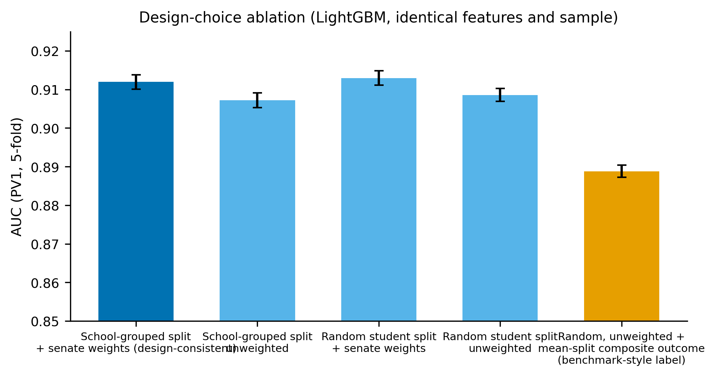
Figure S2. Importance-rank stability across the ten plausible values.
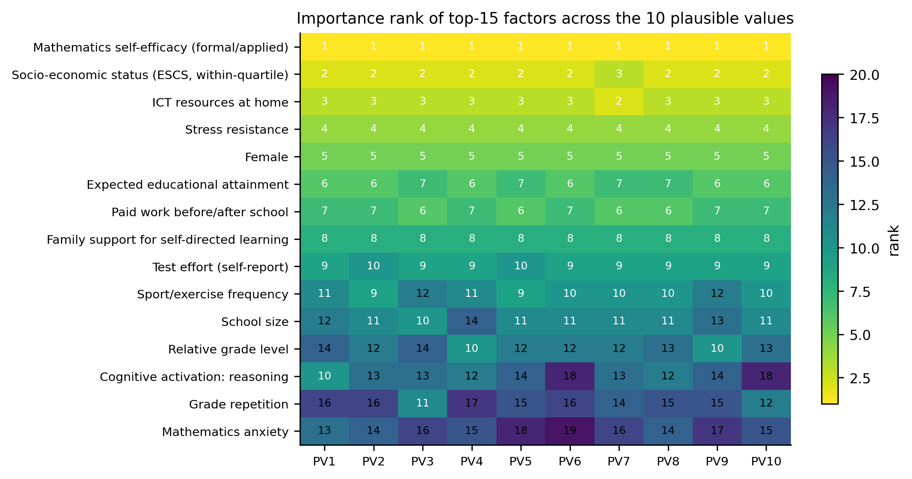

Figure S3. Outcome-definition sensitivity.
