Supplementary information
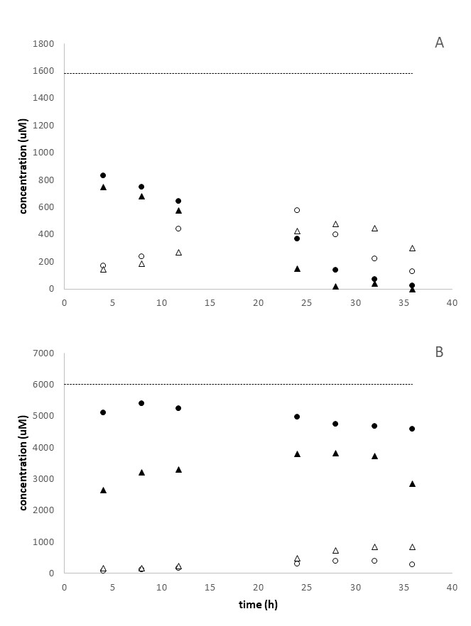
Figure SI-1: Example of reactor outflow concentrations of nitrate (filled symbols) nitrite (open symbols) over time at CR 3 for the duplicate reactors (triangles and circles). The concentrations of the input solutions are represented by the black dashed line for the nitrate input concentrations 1600 µM/1.6 mM (A) and 6000 µM/6 mM (B).

Station | NO₃⁻ input | Q | additions |  | NRR |  | NiPR |  | APR |  |  | NiPR:NRR | APR:NRR
 | (mM) | (ml h⁻¹) |  |  | (nmol cm⁻³ h⁻¹) |  |  |  |  |  |  | (%)
CR1 | 0.6 | 2.8 |  |  | 125.7 | 1.0 | 9.5 | 3.7 | 31.5 | 12.6 |  | 7.6 | 25.1
 | 1.4 |  |  |  | 252.6 | 22.7 | 117.5 | 20.4 | 27.4 | 12.6 |  | 7.6 | 10.8
 | 3.0 |  |  |  | 252.4 | 28.3 | 99.6 | 14.5 | 27.9 | 22.4 |  | 39.5 | 11.0
 | 6.0 |  |  |  | 373.7 | 61.2 | 200.2 | 33.6 | 32.3 | 17.4 |  | 53.6 | 8.7
CR2 | 0.7 |  |  |  | 137.8 | 4.7 | 6.5 | 6.9 | 58.9 | 4.6 |  | 4.7 | 42.7
 | 1.6 |  |  |  | 300.4 | 20.8 | 76.3 | 31.1 | 62.4 | 12.8 |  | 25.4 | 20.8
 | 3.0 |  |  |  | 277.7 | 69.3 | 90.8 | 33.4 | 100.7 | 45.3 |  | 32.7 | 36.2
 | 6.0 |  |  |  | 378.4 | 141.1 | 109.7 | 46.7 | 70.7 | 10.0 |  | 29.0 | 18.7
CR3 | 0.7 |  |  |  | 118.6 | 16.9 | 2.8 | 1.5 | 47.7 | 5.5 |  | 2.4 | 40.2
 | 1.9 |  |  |  | 169.9 | 23.9 | 11.1 | 8.2 | 30.8 | 4.5 |  | 6.5 | 18.1
 | 3.1 |  |  |  | 177.2 | 21.2 | 56.0 | 9.7 | 51.1 | 12.3 |  | 31.6 | 28.9
 | 6.0 |  |  |  | 218.8 | 104.2 | 63.7 | 7.4 | 41.6 | 7.6 |  | 29.1 | 19.0
CR2 | 6.1 | 0.5 |  |  | 147.5 | 15.9 | 16.9 | 2.3 | 22.1 | 1.5 |  | 11.5 | 15.0
 |  | 1.2 |  |  | 217.2 | 12.6 | 57.9 | 11.6 | 33.7 | 1.6 |  | 26.7 | 15.5
 |  | 2.6 |  |  | 258.4 | 50.7 | 63.3 | 28.0 | 38.3 | 8.9 |  | 24.5 | 14.8
 |  | 6.1 |  |  | 130.8 | 27.1 | 74.9 | 10.4 | 36.0 | 7.4 |  | 57.3 | 27.5
 |  | 9.3 |  |  | 225.4 | 29.6 | 106.4 | 10.7 | 44.7 | 10.8 |  | 47.2 | 19.8
CR2 | 6.2 | 2.7 | - |  | 165.1 | 44.6 | 38.2 | 8.0 | 36.1 | 14.5 |  | 23.1 | 21.9
 |  |  | Ac |  | 747.9 | 75.1 | 302.3 | 119.7 | 31.1 | 32.4 |  | 40.4 | 4.2
 |  |  | GL |  | 351.4 | 91.0 | 51.6 | 8.4 | 14.8 | 11.9 |  | 14.7 | 4.2
 |  |  | YL |  | 259.8 | 91.0 | 24.7 | 24.9 | 18.3 | 16.9 |  | 9.5 | 7.0
Table SI-1: Nitrate reduction rates, ammonium and nitrite production rates for the three stations based on the different nitrate concentrations provided by the sediment feed solution for each reactor and dissolved organic carbon released during incubations. Values are averages (n=14 for different nitrate input solutions, n= 16 for carbon additions, n = 8 for flow rate) standard deviations are indicated in italic

# Green leaves (GL) from Rhizophora mangle trees, the yellow leaves (YL) correspond to old senescent leaves, ready to fall.

Table SI-2: Characteristics of the incubated sediments and leaves.

Site | Date |  | C |  | N | C/N | δ¹³C | δ¹⁵N
 |  |  | % |  |  |  | ‰
CR1 | Nov 2016 | sediment |  | 26.3 | 1.4 | 22.3 | -27.4 | 9.0
CR2 |  |  |  | 30.2 | 1.3 | 26.6 | -28.5 | 2.5
CR3 |  |  |  | 34.7 | 1.5 | 27.5 | -27.8 | 1.2
CR2 | Oct 2017 | sediment |  | 37.2 | 1.6 | 27.1 | -28.0 | 3.6
 |  | Sediment + GL# |  | 43.8 | 1.4 | 35.5 | -28.1 | 3.5
 |  | Sediment + YL# |  | 39.9 | 1.1 | 42.7 | -28.8 | 4.3
 |  | GL# |  | 47.9 | 1.2 | 48.1 | -28.7 | 2.6
 |  | YL# |  | 46.6 | 0.6 | 90.6 | -28.7 | 6.5
# Green leaves (GL) from Rhizophora mangle trees, the yellow leaves (YL) correspond to old senescent leaves, ready to fall.

