SUPPLEMENTAL FILE
Supplemental Table 1
Proportions of Low Scores for Subscales and Coherence Total Score for PEREGRIN Mothers by Child Genomic Diagnosis Status
Scale | No Genomic Diagnosis | Genomic Diagnosis
Total Coherence | 8 (40.0%) | 21 (63.6%)
Focus | 1 (5.0%) | 4 (12.1%)
Elaboration | 1 (5.0%) | 2 (6.1%)
Separateness | 2 (10.0%) | 7 (21.2%)
Concern (High Concern) | 6 (30.0%) | 10 (30.3%)
Acceptance | 1 (5.0%) | 6 (18.2%)
Complexity | 2 (10.0%) | 13 (39.4%)
Note. Values are n (%). For Total Coherence, Focus, Elaboration, Separateness, Acceptance, and Complexity, values reflect low scores (1–4; high = 5–7). For Concern, values reflect high concern (scores 5–7; low concern = 1–4). No Genomic Diagnosis n = 20; Genomic Diagnosis n = 33.

Supplemental Table 2
Proportions of Low Scores for Subscales and Coherence Total Scale for Mothers and Fathers by Study Cohort
Subscale | PEREGRIN |  | NewFAMS
Subscale | Mothers | Fathers | Mothers | Fathers
Total Coherence | 11 (44.0%) | 13 (52.0%) | 14 (56.0%) | 9 (36.0%)
Focus | 0 (0.0%) | 5 (20%) | 0 (0.0%) | 2 (8.0%)
Elaboration | 1 (4.0%) | 2 (8.0%) | 4 (16.0%) | 3 (12.0%)
Separateness | 5 (20.0%) | 2 (8.0%) | 7 (28.0%) | 6 (24.0%)
Concern (High) | 6 (24.0%) | 9 (36.0%) | 6 (24.0%) | 3 (12.0%)
Acceptance | 2 (8.0%) | 3 (12.0%) | 8 (32.0%) | 2 (8.0%)
Complexity | 4 (16.0%) | 10 (40.0%) | 9 (36.0%) | 4 (16.0%)
Note. Values are n (%). For Total Coherence, Focus, Elaboration, Separateness, Acceptance, and Complexity, values reflect low scores (1-4; high = 5-7). For Concern, values reflect high concern (scores 5-7; low concern = 1-4). PEREGRIN n = 25 couples; NewFAMS n = 25 couples (100 parents).

Supplemental Figure 1 FMSS-Coherence Subscale and Total Coherence Means with 95% Confidence Intervals (CIs).
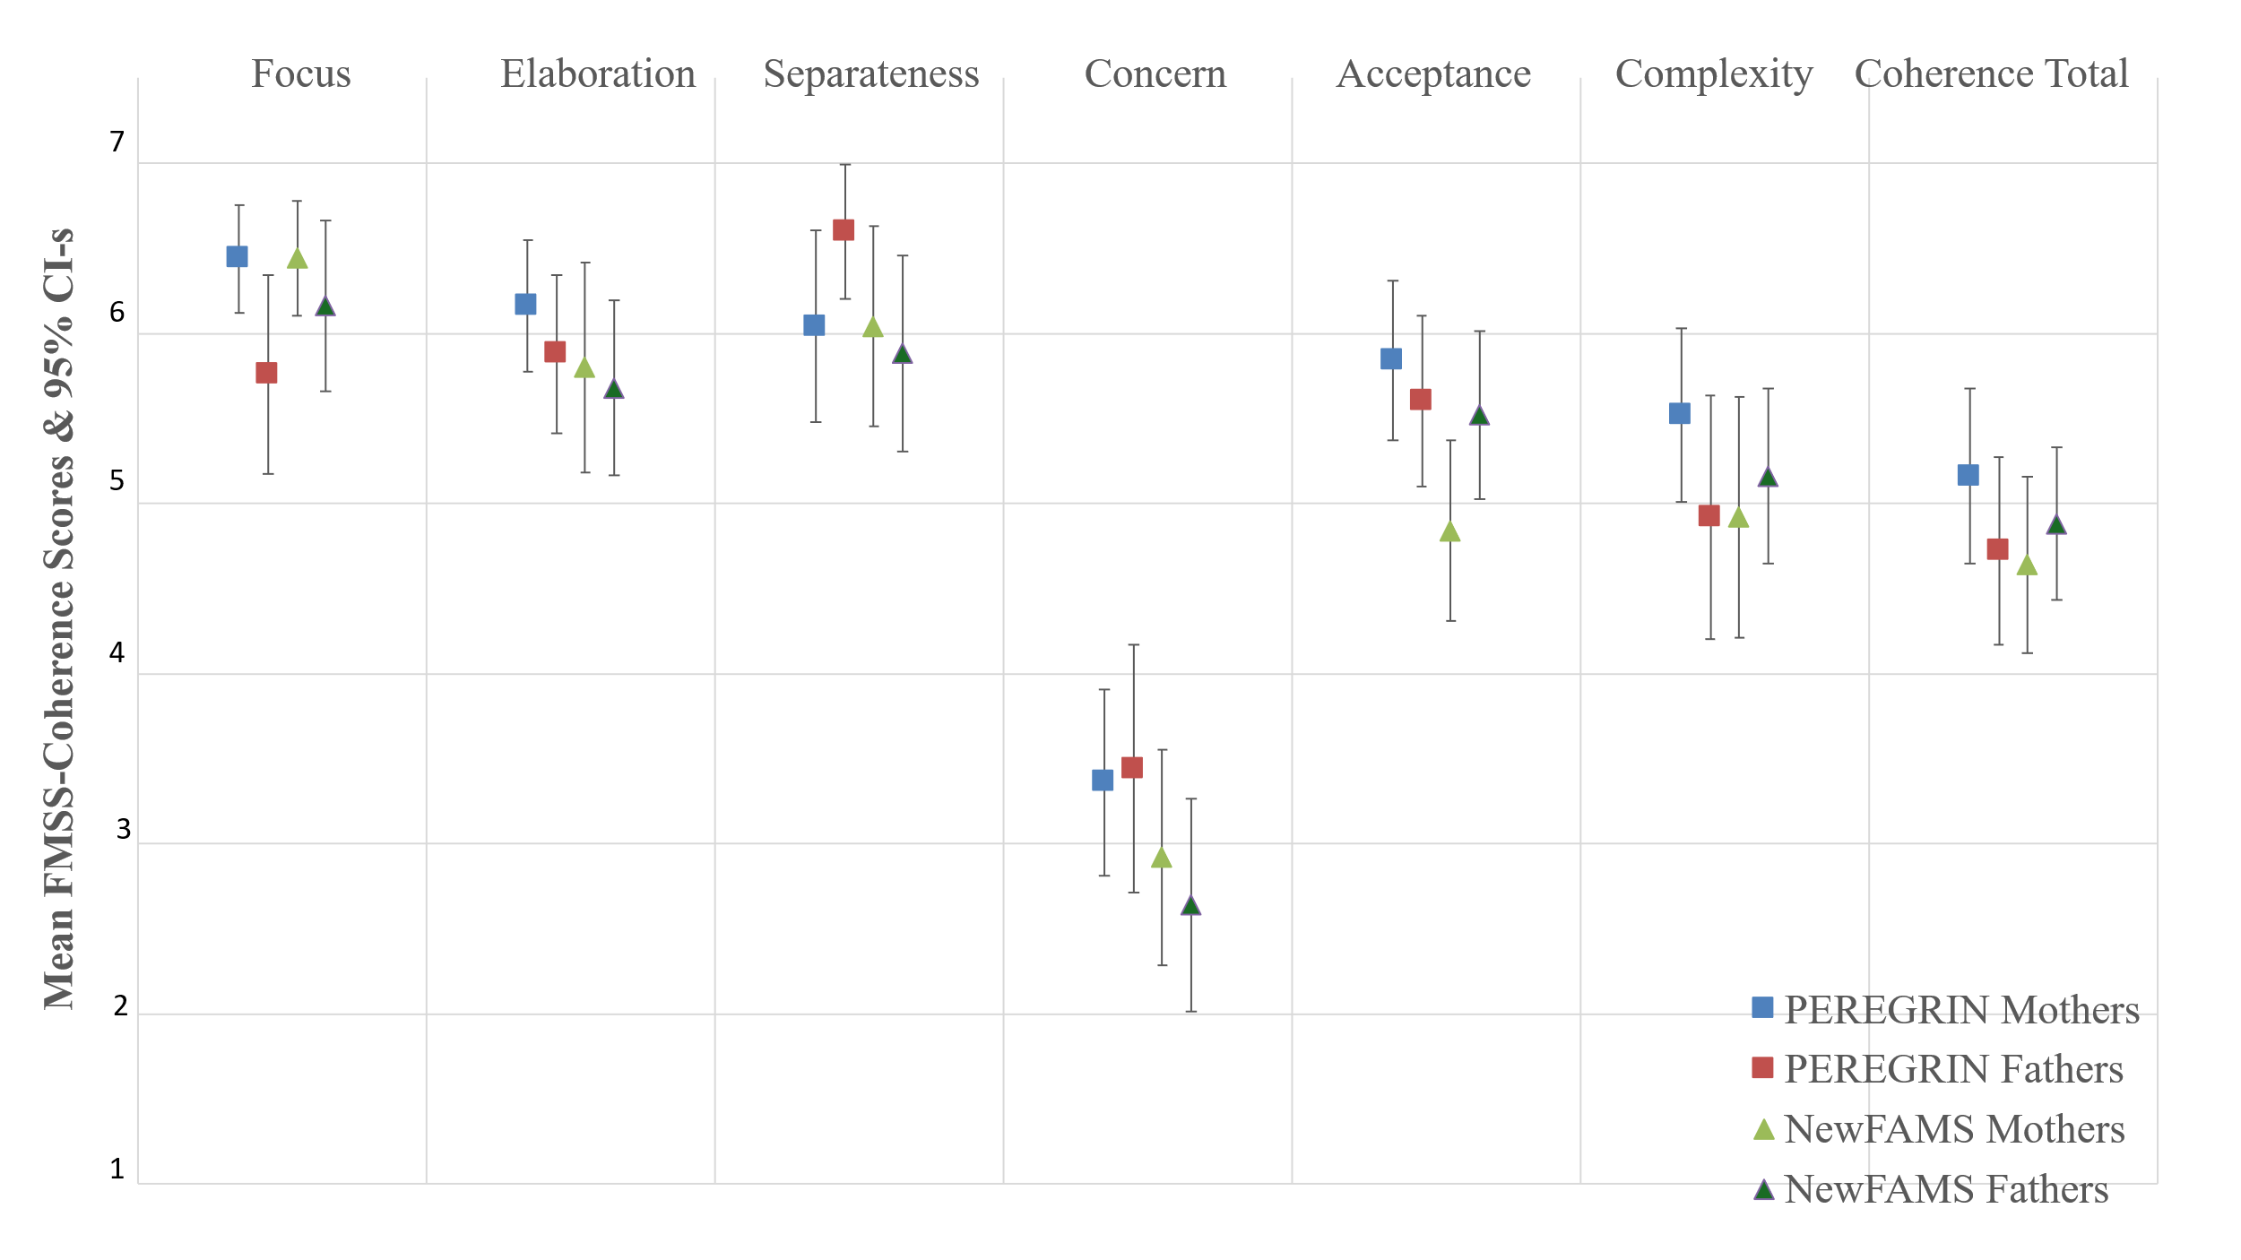
Note. Higher scores (5-7) indicate coherent narratives, except for Concern subscale where 1-4 express low and 5-7 high levels of concern. Minimum Boundary Dissolution (BD) score was 0, maximum 2 for both groups and for mothers and fathers.

