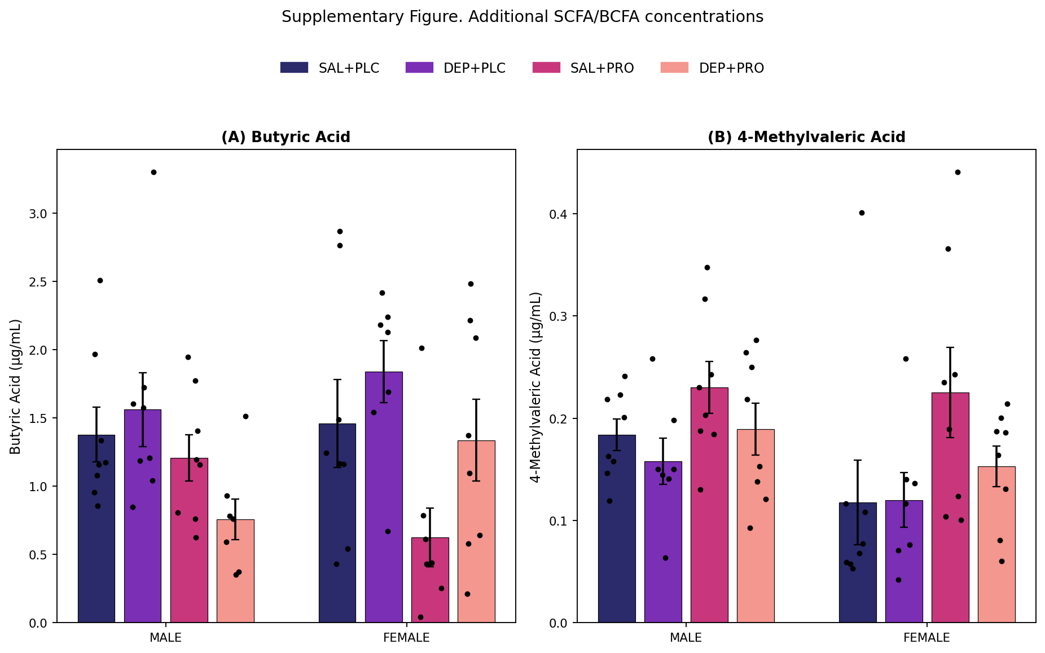
Figure S1. Nonsignificant short- and branched-chain fatty acid plasma concentrations across exposure, treatment, and sex. Circulating plasma concentrations of (A) butyric acid and (B) 4-methylvaleric acid in male and female C57BL/6 mice exposed to 35 µg diesel exhaust particles (DEP) suspended in saline or sterile saline control, administered 2×/week for 50 days, and treated with placebo (PLC) or probiotic (PRO). Data are presented as mean ± SEM with individual animals overlaid. Three-way ANOVA revealed a significant main effect of probiotic treatment for both butyric acid (F(1,54) = 11.36, p = 0.0014, ηp² = 0.17) and 4-methylvaleric acid (F(1,54) = 6.85, p = 0.0115, ηp² = 0.11); no other main effects or interactions reached significance.

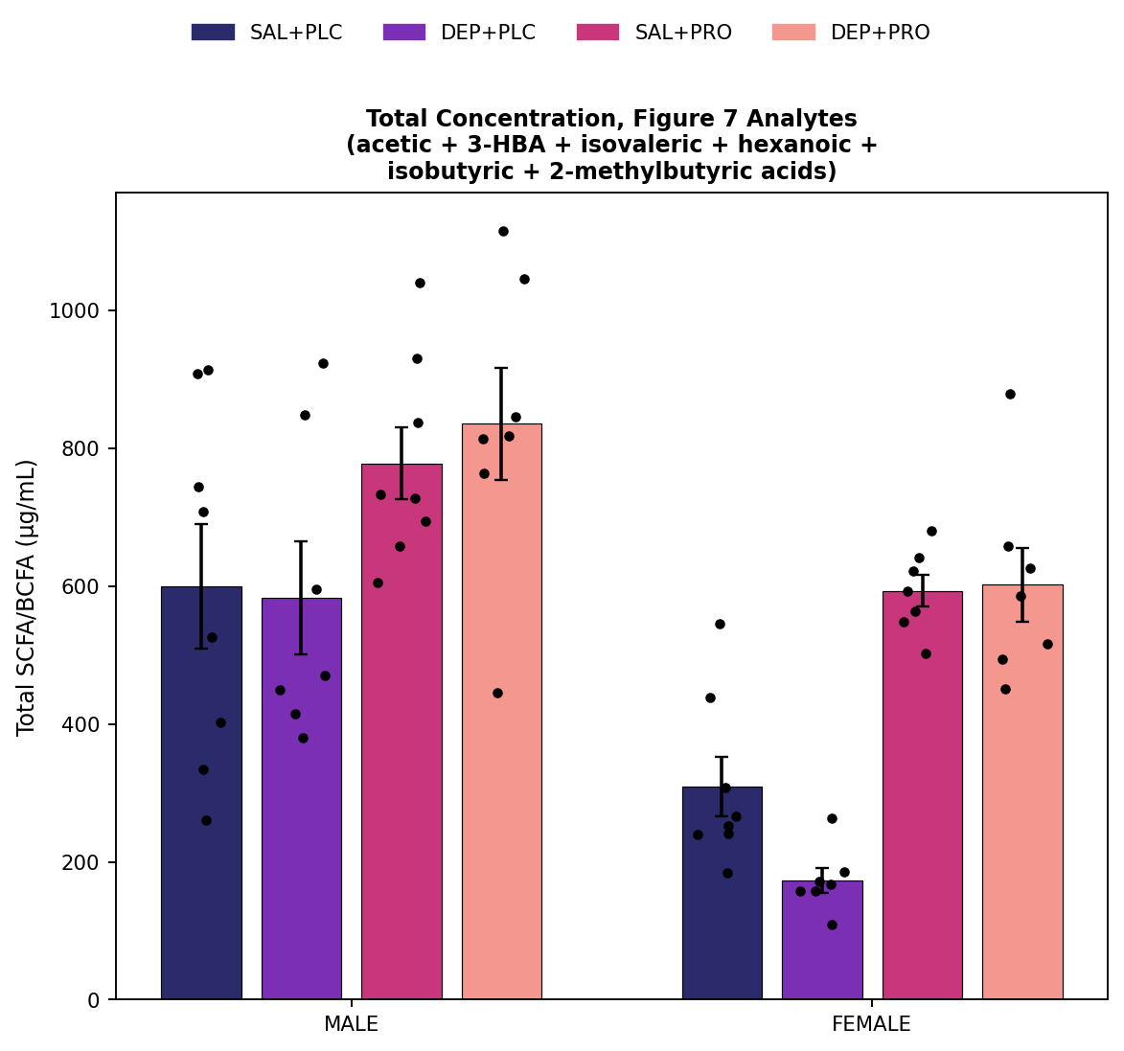
Figure S2. Total concentration of plasma short- and branched-chain fatty acid analytes across exposure, treatment, and sex. Total plasma concentration (sum of acetic acid, 3-hydroxybutyric acid, isovaleric acid, hexanoic acid, isobutyric acid, and 2-methylbutyric acid; i.e., the six analytes shown individually in Figure 7 and Figure S1) in male and female C57BL/6 mice exposed to 35 µg diesel exhaust particles (DEP) suspended in saline or sterile saline control, administered 2×/week for 50 days, and treated with placebo (PLC) or probiotic (PRO). Data are presented as mean ± SEM with individual animals overlaid. Because 3-hydroxybutyric acid circulates at substantially higher concentrations than the other five analytes, this composite total is numerically dominated by 3-hydroxybutyric acid and closely mirrors its pattern (Figure 7B); it is not a measure of true SCFA output and should be interpreted as a descriptive summary rather than a distinct biological endpoint. Three-way ANOVA revealed significant main effects of sex (F(1,51) = 40.87, p < 0.0001, ηp² = 0.45; higher in males) and probiotic treatment (F(1,51) = 42.64, p < 0.0001, ηp² = 0.46; higher with probiotic in both sexes); the main effect of exposure and all interaction terms were not significant (all p > 0.11).

