Supplementary Materials

Crowdsourcing to develop open-access learning resources on antimicrobial resistance
Eneyi E. Kpokiri*¹, Randall John*², Dan Wu¹, Noah Fongwen¹, Jehan W. Budak³, Christina C. Chang⁴, Jason J. Ong^{1,5}, Joseph D. Tucker^{1,6,7}
*Contributed equally
¹ Faculty of Infectious and Tropical Diseases, London School of Hygiene and Tropical Medicine, London, UK
² Department of Health Policy and Management, Gillings School of Global Public Health, University of North Carolina, Chapel Hill, NC
³ Department of Medicine, Division of Allergy & Infectious Diseases, University of Washington, Seattle, WA
⁴ Partners ID Images, Department of Infectious Diseases, Massachusetts General Hospital, Boston, MA
⁵ Central Clinical School, Monash University, Australia
⁶ Social Entrepreneurship to Spur Health (SESH), Guangzhou, China
⁷ Institute of Global Health and Infectious Diseases, University of North Carolina, Chapel Hill, NC

Corresponding author:
Eneyi E. Kpokiri, Faculty of Infectious and Tropical Diseases, London School of Hygiene and Tropical Medicine, Keppel St., Bloomsbury, London, WC1E 7HT, United Kingdom
eneyi.kpokiri@lshtm.ac.uk

Supplementary Figure 1. Sample Promotional Infographic.
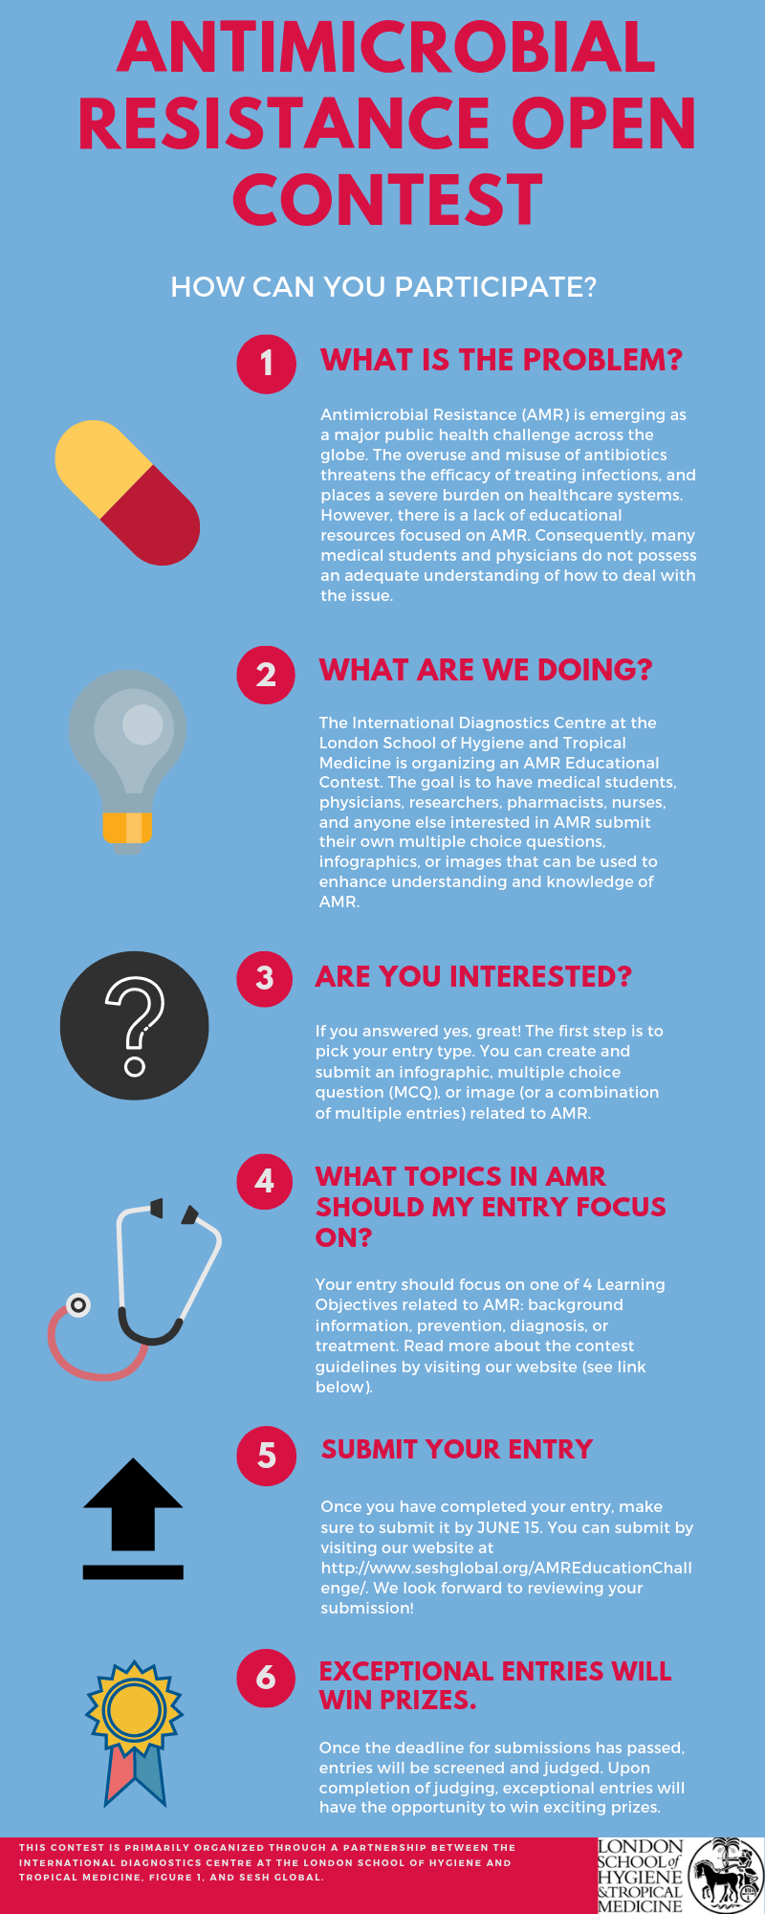

Supplementary Figure 2. Finalist Infographic 1.
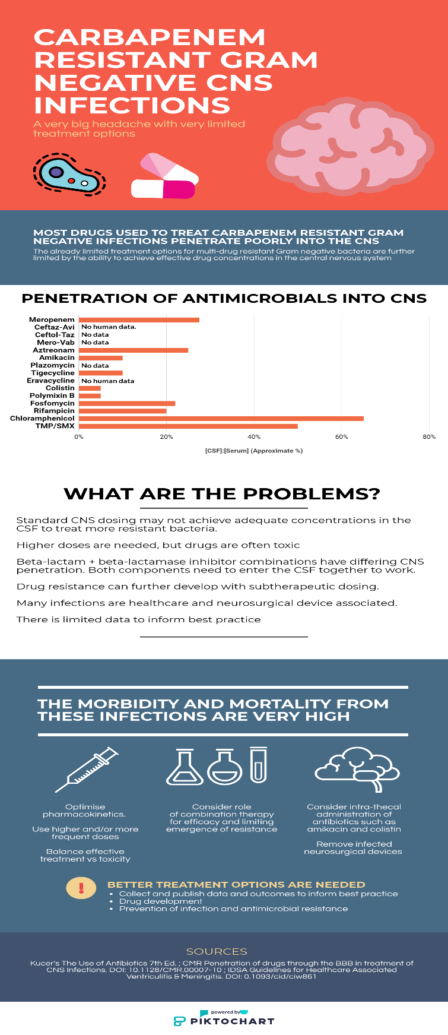

Supplementary Figure 3. Finalist Infographic 2.
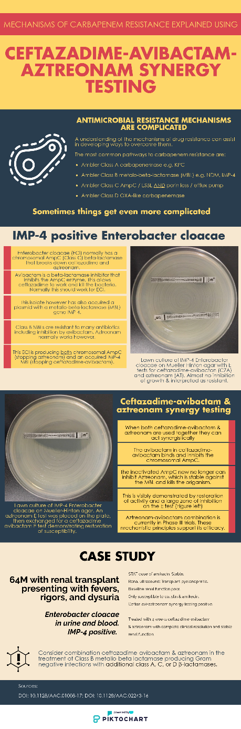

Supplementary Figure 4. Finalist Infographic 3.
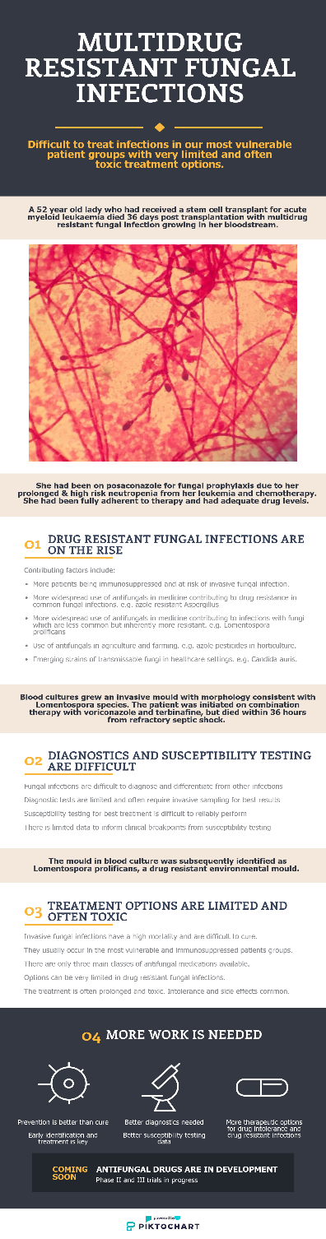
Supplementary Table 1. Finalist Infographic Explanatory Captions.
Infographic Number | Title | Explanatory Caption (Submitted by Finalists) | Country
Finalist Infographic 1  (Supplementary Figure 2) | Carbapenem Resistant Gram-Negative CNS Infections | The submitted infographic highlights the great difficulties in management of central nervous system infections from carbapenem resistant gram-negative organisms. It displays simplified data on CNS penetration of commonly used antimicrobials in treatment of MDR Gram negatives. This serves to highlight both the paucity of data to inform practice and the limited options available. It subsequently discusses key problems in the area and offers some important concepts in managing these difficult infections. | Australia
Finalist Infographic 2 (Supplementary Figure 3) | Ceftazidime-Avibactam-Aztreonam Synergy Testing | The submitted infographic outlines the use of combination ceftazadime-avibactam and aztreonam in the treatment of metallobetalactamse producing carbapenem resistant gram-negative infections with additional production of a Class A/C/D beta lactamase. It serves a dual purpose as mechanistically explains the pathways of resistance and how they are inhibited (serving an educational role in teaching mechanisms of resistance) as well as highlight a potential therapeutic option in difficult to treat MDR infections, especially MBL producing infections. It additionally highlights an area of clinical use of aztreonam-avibactam currently in Phase III studies. | Australia
Finalist Infographic 3 (Supplementary Figure 4) | Multidrug Resistant Fungal Infections | The infographic shows an often-forgotten aspect of antimicrobial resistant - drug resistant fungal infections. In line with the ever-increasing problem of antibacterial resistance, the rates of antifungal drug resistance are rising. These are occurring in our most vulnerable patient groups and have high morbidity and mortality. Treatment options are limited and toxic. The infographic highlights both a simple case of drug resistant fungal infection, as well as highlights some key issues in managing these infections. | Australia

Supplementary Table 2. Finalist Multiple-Choice Questions (MCQs).
MCQ Number | Question | Answer Choices | Correct Answer | Country
Finalist MCQ 1 | To make infection control effective in a health institution, the following measures should be put in place except: | - Patients harboring resistant organisms should be isolated | B | Nigeria
Finalist MCQ 1 |  | - Frequent turnover of health staff | B | Nigeria
Finalist MCQ 1 |  | - Good hand hygiene practices | B | Nigeria
Finalist MCQ 1 |  | - Surveillance to identify carriers of resistant organisms | B | Nigeria
Finalist MCQ 2 | ESKAPE organisms include: | - Escherichia coli, Salmonella typhi, Klebsiella pneumonia, Acinetobacter baumannii, Proteus mirabilis, Enterobacter spp | C | Nigeria
Finalist MCQ 2 | ESKAPE organisms include: | - Enterococcus fecium, Shigella spp, Klebsiella pneumonia, Acinetobacter baumannii, Pseudomonas aeruginosa, Enterobacter spp | C | Nigeria
Finalist MCQ 2 | ESKAPE organisms include: | - Enterococcus fecium, Staphylococcus aureus, Klebsiella pneumonia, Acinetobacter baumannii, Pseudomonas aeruginosa, Enterobacter spp | C | Nigeria
Finalist MCQ 2 | ESKAPE organisms include: | - Enterococcus fecium, Staphylococcus aureus, Klebsiella pneumonia, Acinetobacter baumannii, Pseudomonas aeruginosa, Escherichia coli | C | Nigeria
Finalist MCQ 3 | The following problems can be linked to poor utilization of antibiotics in animal farming: | a. Residues in foodstuffs | D | Cameroon
Finalist MCQ 3 |  | b. Antimicrobial resistance | D | Cameroon
Finalist MCQ 3 |  | c. Drugs in the environment | D | Cameroon
Finalist MCQ 3 |  | d. All of the above | D | Cameroon
Finalist MCQ 4 | If symptoms of an infection persist after initial treatment with antibiotics, what is the best option? | a. Increase the dose of the same antibiotic treatment | C | Cameroon
Finalist MCQ 4 |  | b. Prolong the duration of the same antibiotic treatment | C | Cameroon
Finalist MCQ 4 |  | c. Request a laboratory analysis (antibiogram)  d. Prescribe additional antibiotics | C | Cameroon
Finalist MCQ 4 |  | e. Change the antibiotic drug | C | Cameroon
Finalist MCQ 5 | The following are mechanisms of antimicrobial resistance EXCEPT: | a. Enzymatic inactivation | D | Cameroon
Finalist MCQ 5 |  | b. Target modification | D | Cameroon
Finalist MCQ 5 |  | c. Efflux pumps | D | Cameroon
Finalist MCQ 5 |  | d. Programmed cell death | D | Cameroon
Finalist MCQ 5 |  | e. Metabolic alterations | D | Cameroon

