Supplementary Information
Magnetic Nanocoagulation beyond Floc Growth
Supplementary Methods
Additional experimental details
The industrial wastewater was obtained from Micron Semiconductor Asia Operations Pte. Ltd. (Singapore), stored in sealed containers and sampled from one batch throughout. Commercial M20-M200 materials used in treatment experiments were obtained from XFNano (China; supplier-reported purity 99%; no declared organic stabilizer or surface-functionalization agent). In-house reference particles were used for TEM and BET characterization; the source assigned to each property is stated in Supplementary Table S1.
Reference particles were prepared by a polyol-assisted solvothermal route. FeCl₃·6H₂O and polyvinylpyrrolidone were dissolved in an ethylene glycol/diethylene glycol mixture, followed by anhydrous sodium acetate and treatment at approximately 200 °C. Size was regulated through the solvent ratio; products were magnetically collected, centrifuged, washed with ethanol and deionized water, and freeze-dried.
XRD patterns were collected using a Bruker D8 Advance diffractometer over a 2θ range of 10°-80°. FTIR spectra were collected using a Shimadzu IRPrestige-2 spectrometer. DLS was measured at 1 mg L⁻¹ in water, and comparative zeta potentials were measured at pH 7. Other instrument models and common sample-handling procedures are given in the main Methods.
Additional computational details
Calculations used the CASTEP setup described in the main Methods. Ferrimagnetic order was represented by antiparallel initial spins on tetrahedral and octahedral Fe sites. The self-consistent-field threshold was 1.0 × 10⁻⁶ eV per atom; optimization continued until the energy change was below 1.0 × 10⁻⁵ eV per atom, maximum force below 0.03 eV Å⁻¹, maximum stress below 0.05 GPa and maximum displacement below 0.001 Å.
Dual-surface model construction
The Fe₃O₄(001) interface used a (√2 × √2)R45° cell and a 13-layer slab containing seven B and six A layers. Confined-facing atoms were relaxed while selected inner layers were fixed; termination, constraints and initial spin configuration were identical across models.
Dual-surface confinement comprised two parallel, opposing Fe₃O₄(001) slabs and represents a local tangent-plane approximation of an assembled-particle contact. The confinement width, h, was defined by the separation between the average planes of the outermost oxygen atoms:
$$h=|{\overline{z}}_{O,upper}-{\overline{z}}_{O,lower}|$$
A 15 Å external vacuum region separated periodic images and was excluded from h. Initial widths of 5.000, 8.000 and 11.000 Å optimized to 5.374, 8.458 and 11.535 Å, respectively.
Each width included water dimer, trimer and two-dimensional network motifs containing two, three and six H₂O molecules, respectively, with and without a charge-neutral Ca-F unit. The unit represents a minimal local Ca-F-containing motif rather than an isolated aqueous molecule or an entire suspended particle. Adsorption energies and the Ca-F-induced energetic shift follow Eqs. (6)-(8) of the main text.
The external magnetic field was not included explicitly in the DFT Hamiltonian; the calculations describe hydrated structures within confinement geometries formed after magnetic assembly.
Supplementary Figures
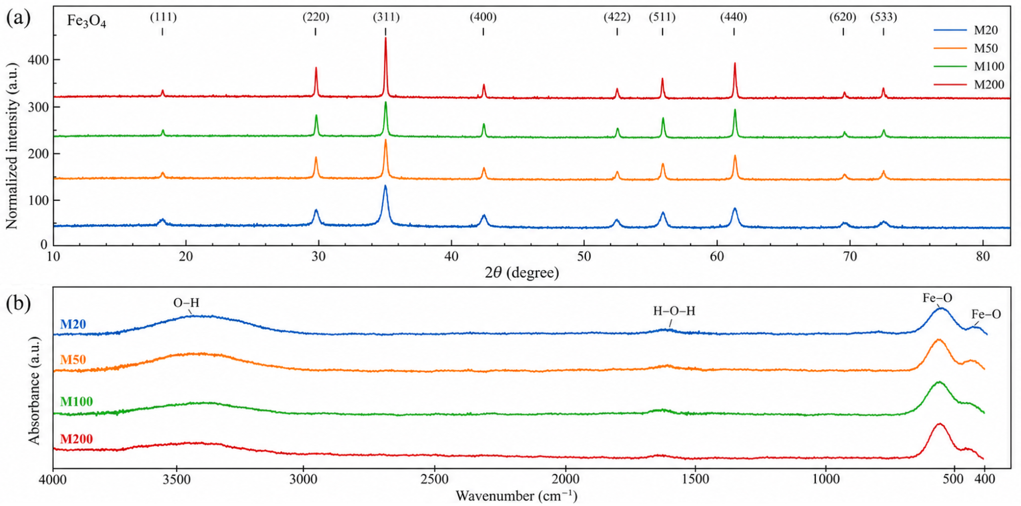
Supplementary Figure S1 | Crystalline and vibrational characterization of M20-M200. (a) XRD patterns indexed to inverse-spinel Fe₃O₄. (b) FTIR spectra; bands near 3400 and 1630 cm⁻¹ arise from surface-associated water and bands near 570 and 450 cm⁻¹ from Fe-O lattice vibrations. Spectra are vertically offset. XRD and FTIR measurements were performed using the commercial treatment batches.

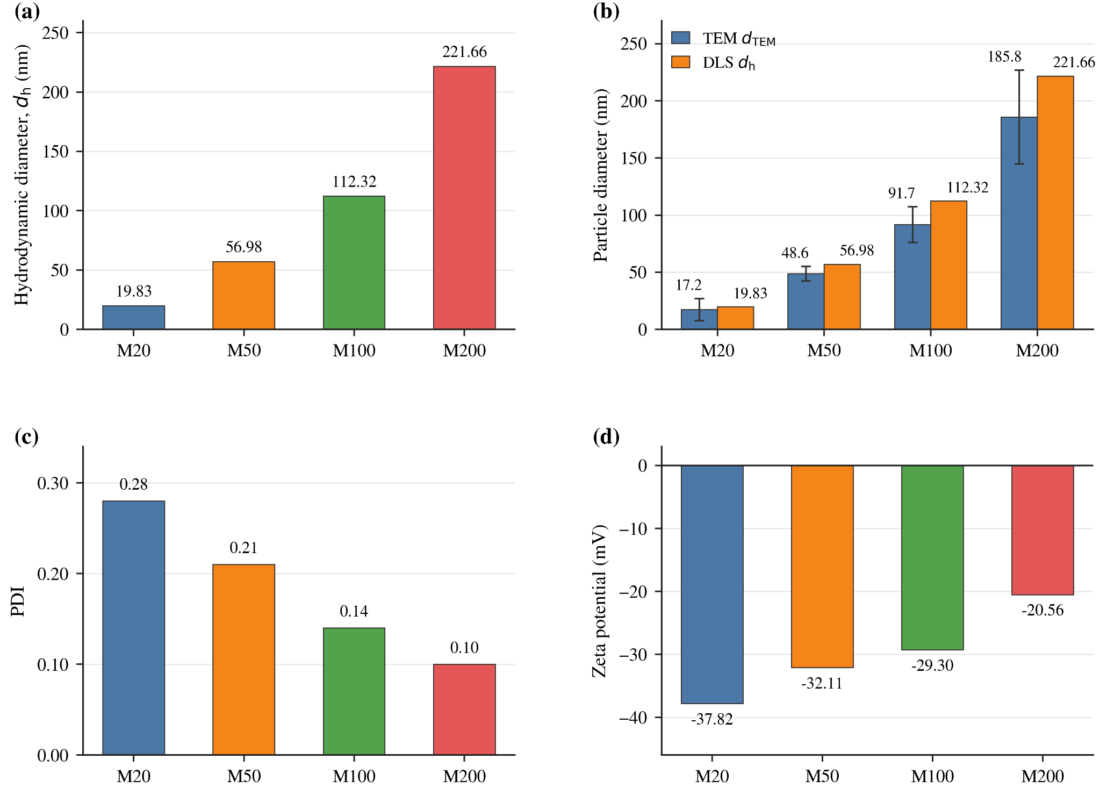
Supplementary Figure S2 | Aqueous size and electrokinetic properties of M20-M200. (a) DLS hydrodynamic diameter. (b) TEM and DLS size comparison; TEM bars show mean ± s.d. (n = 10). (c) Polydispersity index. (d) Zeta potential at pH 7.

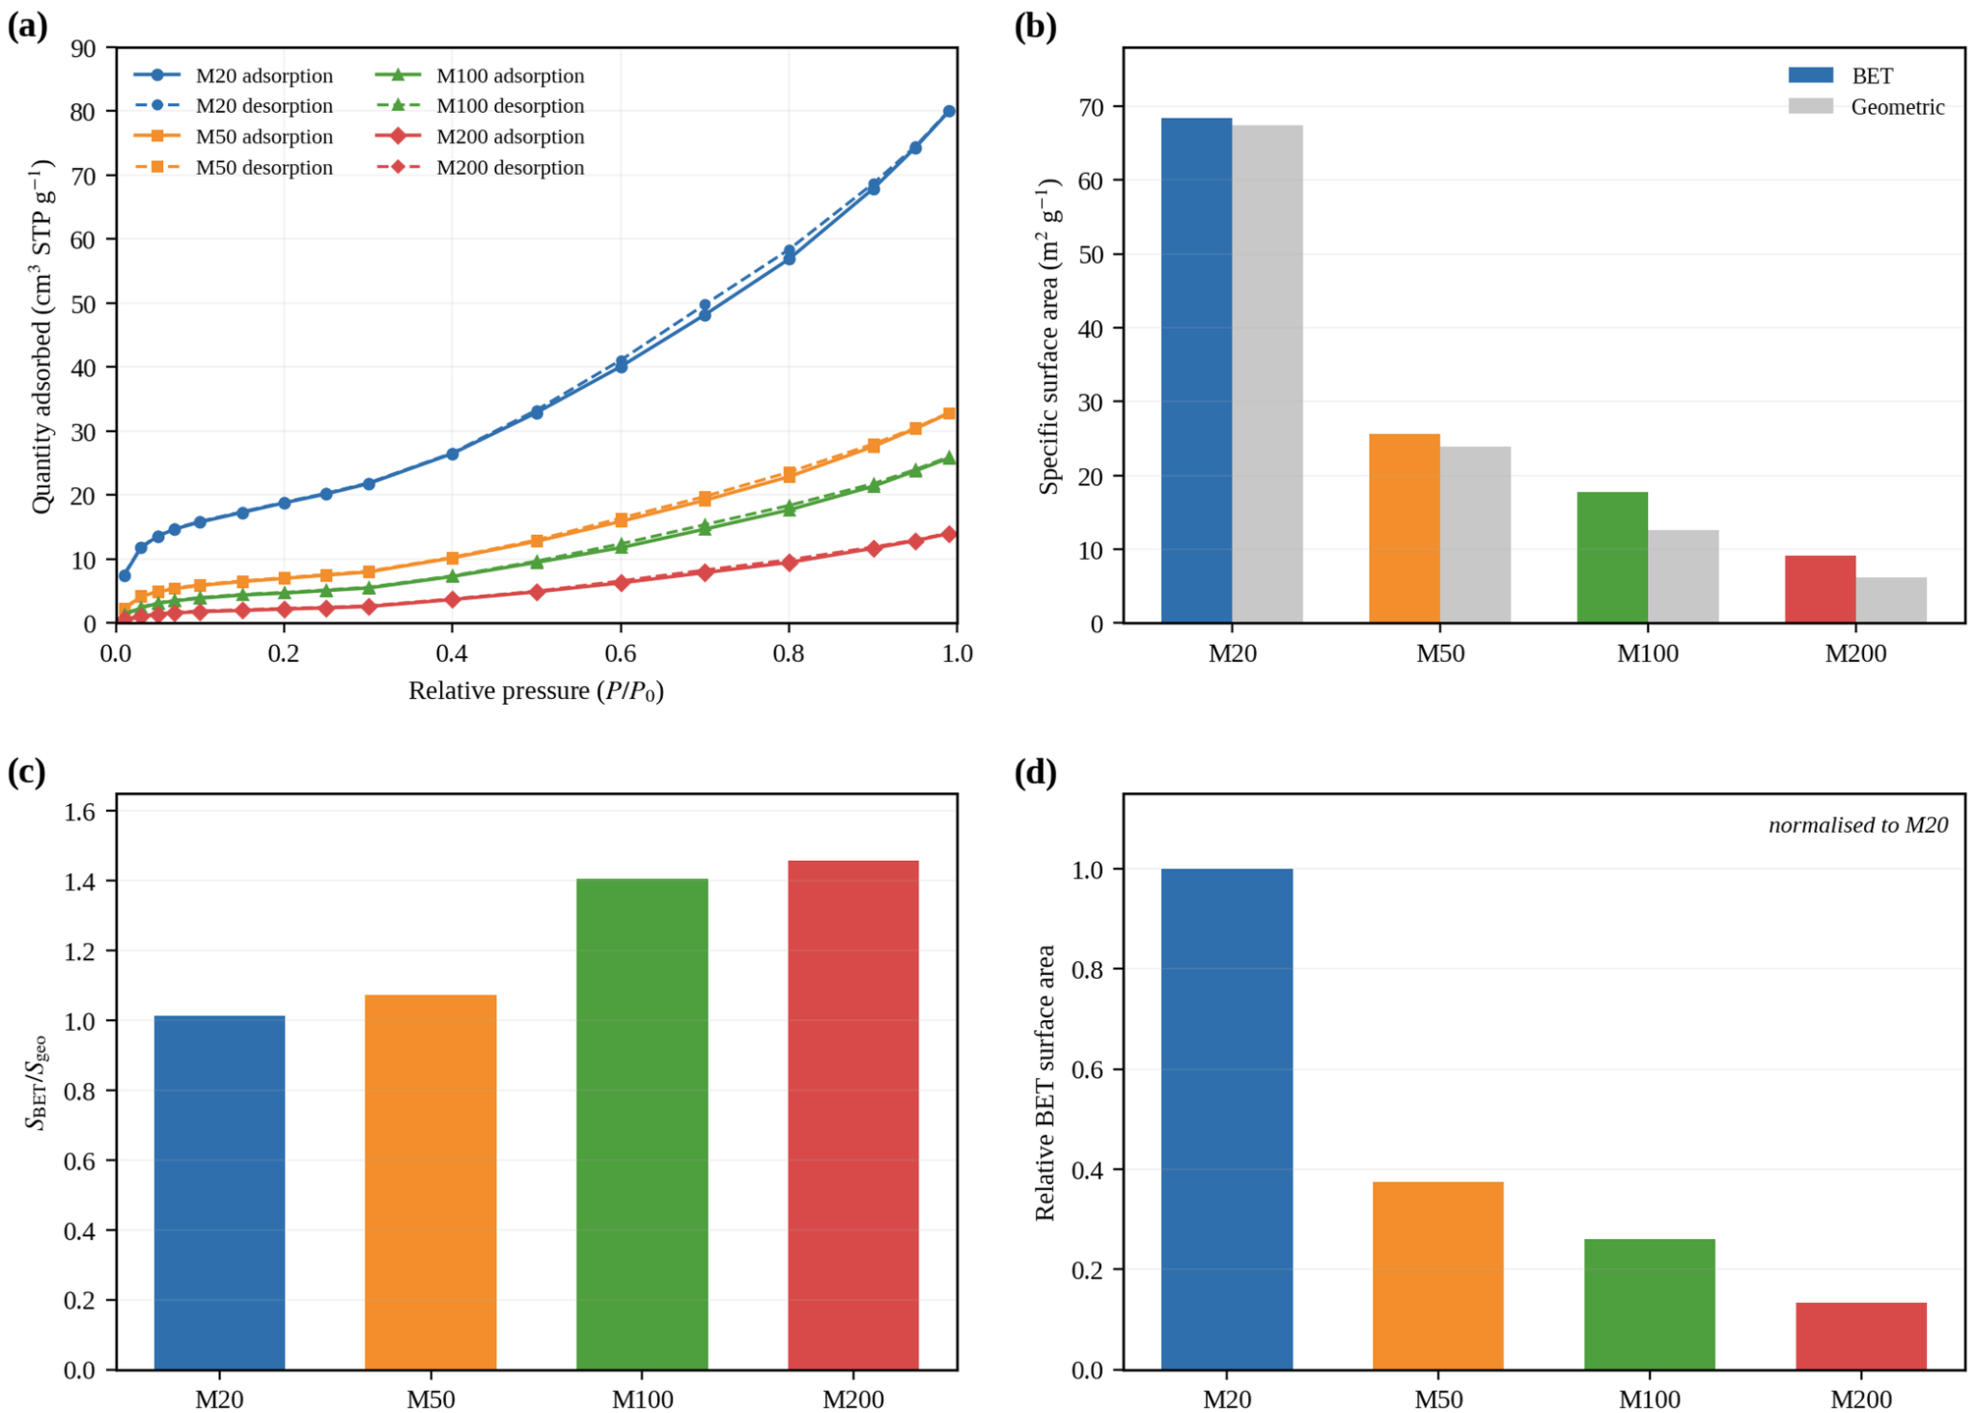
Supplementary Figure S3 | Nitrogen sorption and specific surface area. (a) N₂ adsorption-desorption isotherms. (b) BET and geometric specific surface areas. (c) BET/geometric area ratio. (d) BET area normalized to M20. Lines in (a) guide the eye.

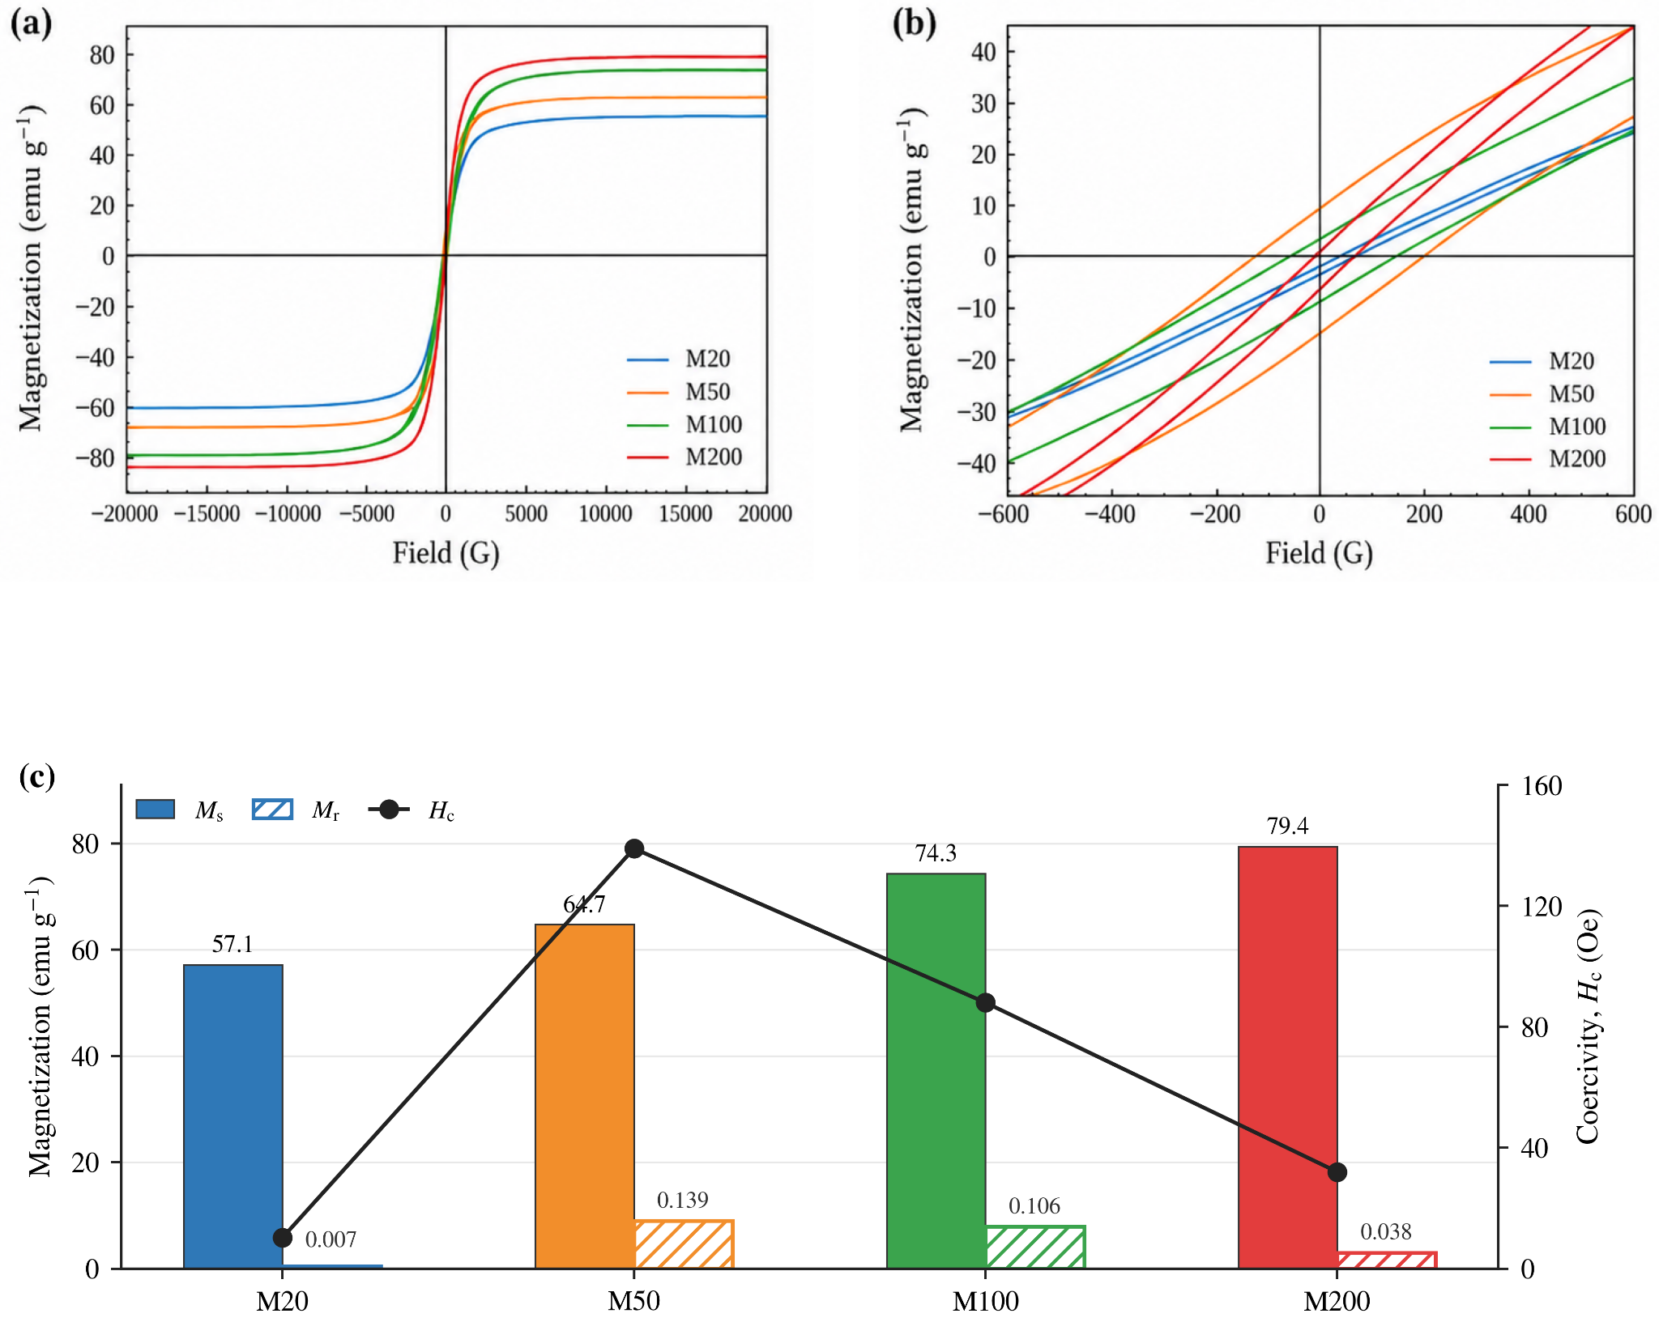
Supplementary Figure S4 | Magnetic properties of M20-M200. (a) Full magnetization-field curves. (b) Low-field hysteresis. (c) Saturation magnetization, remanence and coercivity.

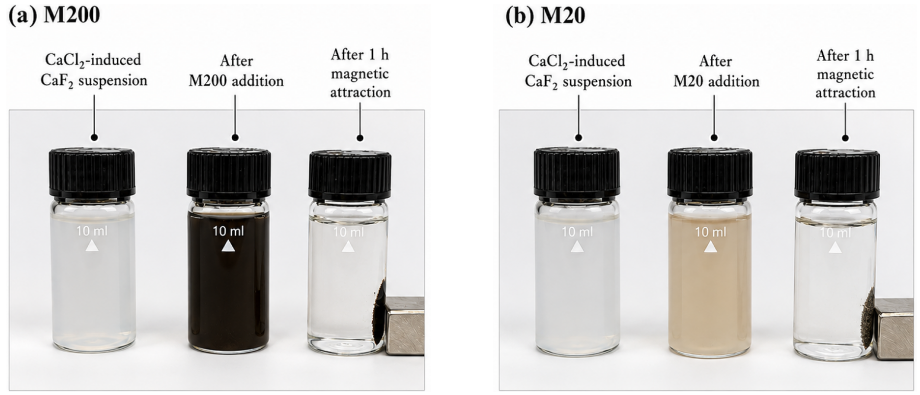
Supplementary Figure S5 | Photographic comparison of M200 and M20 during magnetic treatment of calcium-precipitated CaF₂ suspensions. (a,b) Appearance before nanocoagulant addition, after M200 or M20 addition, and after 1 h of magnetic attraction. The photographs provide a visual demonstration of magnetic collection; quantitative clarification endpoints were determined using the standard 10 min protocol.

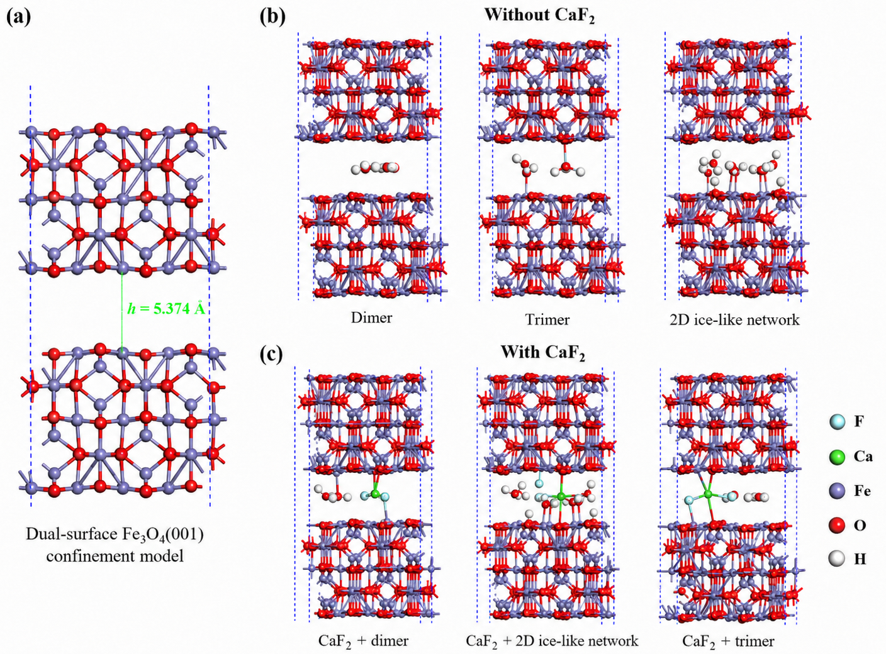
Supplementary Figure S6 | Dual-Fe₃O₄(001)-surface confinement model and representative optimized hydration configurations. (a) Strong-confinement geometry at h = 5.374 Å. (b) Representative optimized water dimer, trimer and two-dimensional network configurations without a Ca-F unit. (c) Representative configurations containing a charge-neutral Ca-F unit. These structures describe local hydrated contacts within confinement geometries formed after magnetic assembly; the external magnetic field was not explicitly included in the DFT Hamiltonian.

Supplementary Tables
Supplementary Table S1 | Physicochemical properties of the bare Fe₃O₄ size series.
Property | Unit | M20 | M50 | M100 | M200
Nominal size | nm | 10–30 | 50 | 100 | 200
TEM-derived external dimension, dTEM | nm | 17.2 ± 9.8 | 48.6 ± 6.3 | 91.7 ± 15.6 | 185.8 ± 40.9
Hydrodynamic diameter, dh | nm | 19.83 | 56.98 | 112.32 | 221.66
Hydrodynamic/TEM ratio, dh/dTEM | — | 1.153 | 1.172 | 1.225 | 1.193
Polydispersity index | — | 0.28 | 0.21 | 0.14 | 0.10
Zeta potential at pH 7 | mV | −37.82 | −32.11 | −29.30 | −20.56
BET specific surface area, SBET | m² g⁻¹ | 68.4 | 25.6 | 17.8 | 9.1
Geometric specific surface area, Sgeo | m² g⁻¹ | 67.47 | 23.88 | 12.66 | 6.25
BET/geometric area ratio, SBET/Sgeo | — | 1.01 | 1.07 | 1.41 | 1.46
Saturation magnetization, Ms | emu g⁻¹ | 57.1 | 64.7 | 74.3 | 79.4
Remanent magnetization, Mr | emu g⁻¹ | 0.4 | 9.0 | 7.9 | 3.0
Relative remanence, Mr/Ms | — | 0.007 | 0.139 | 0.106 | 0.038
Coercivity, Hc | Oe | 10.2 | 139.0 | 88.0 | 32.0
Notes: TEM dimensions are mean ± s.d. (n = 10). DLS was measured at 1 mg L⁻¹ in water and zeta potential at pH 7. Sgeo was calculated from dTEM using ρFe₃O₄ = 5.17 g cm⁻³; SBET/Sgeo indicates deviation from an ideal smooth, dense sphere.
TEM and BET data were obtained from in-house reference materials; DLS, zeta-potential and VSM data were obtained from the commercial materials used in treatment experiments.

Supplementary Table S2 | Size-dependent endpoint clarification performance of bare Fe₃O₄ nanocoagulants.
Sample | Final turbidity, mean (NTU) | Final turbidity, s.d. (NTU) | n | Apparent CaF₂ capture, mean ± s.d. (%) | Tukey HSD group
M20 | 21.40 | 1.15 | 3 | 79.89 ± 1.08 | a
M50 | 75.57 | 3.92 | 3 | 29.00 ± 3.68 | b
M100 | 66.83 | 5.62 | 3 | 37.20 ± 5.28 | b
M200 | 75.53 | 4.21 | 3 | 29.03 ± 3.96 | b
Notes: Values were obtained after 10 min fixed-field treatment at 50 mg L⁻¹ (mean ± s.d., n = 3). Apparent capture was calculated from the common 106.43 NTU pre-addition CaF₂ baseline.
One-way ANOVA for endpoint turbidity: F = 122.38, p < 0.001. Different letters indicate Tukey HSD groups (p < 0.05).
Supplementary Table S3 | pH-dependent baseline and M20-assisted clarification performance.
Actual pH | Initial CaF₂ turbidity (NTU) | M20-treated final turbidity (NTU) | Control-corrected capture, mean ± s.d. (%) | n
3.98 | 62.03 ± 1.86 | 44.77 ± 3.91 | 28.6 ± 6.6 | 3
5.03 | 85.37 ± 3.56 | 39.30 ± 1.31 | 53.7 ± 1.7 | 3
6.05 | 98.13 ± 2.30 | 33.67 ± 1.79 | 65.4 ± 2.7 | 3
6.99 | 103.30 ± 1.15 | 23.23 ± 1.35 | 77.2 ± 1.4 | 3
8.03 | 103.57 ± 1.88 | 24.07 ± 2.70 | 76.7 ± 2.8 | 3
8.97 | 105.30 ± 0.90 | 21.80 ± 1.75 | 79.2 ± 1.7 | 3
9.91 | 105.90 ± 1.21 | 22.50 ± 1.28 | 79.0 ± 1.4 | 3
Notes: Values are mean ± s.d. (n = 3). The suspension was adjusted after ageing, equilibrated for 1 min and treated with 50 mg L⁻¹ M20 for 10 min under the fixed-field configuration.
Capture was corrected using the corresponding nanocoagulant-free control at each pH.
M20-only residual turbidity was reported as 53.0-59.3 NTU across pH 4-10.

Supplementary Table S4 | Numerical source data underlying the quantitative panels of Figs. 1–4.
Fig. | Panel | Dataset | Condition / setting | x | Response | Replicate 1 / 2 / 3 | Mean ± s.d. or value
Figure 1, Wastewater composition
1 | a | Wastewater composition | Untreated wastewater | — | Fluoride concentration | — | 100 mg L⁻¹; reported value
1 | a | Wastewater composition | Untreated wastewater | — | Total organic carbon | — | 15.8 mg L⁻¹; reported value
1 | a | Wastewater composition | Untreated wastewater | — | pH | — | 5.23; reported value
Figure 1, Precipitation baseline
1 | a | Precipitation baseline | Untreated wastewater | — | Turbidity | — | 0.96 NTU; reported value; replicate-level record not supplied
1 | a,b | Precipitation baseline | After CaF₂ precipitation | Ca²⁺:F⁻ molar ratio: 2:1 | Turbidity at t = 0 | — | 106.43 ± 2.06 NTU (n = 3); reported mean and s.d.
Figure 1, Natural settling
1 | b | Natural settling | CaF₂ suspension without nanocoagulant | Time: 0 min | Turbidity | — | 106.43 ± 2.06 NTU (n = 3); reported mean and s.d.; replicate values not supplied
1 | b | Natural settling | CaF₂ suspension without nanocoagulant | Time: 0 min | T(t)/T(0) | — | 1; derived normalized value
1 | b | Natural settling | CaF₂ suspension without nanocoagulant | Time: 5 min | Turbidity | — | 104.23 ± 2.79 NTU (n = 3); reported mean and s.d.; replicate values not supplied
1 | b | Natural settling | CaF₂ suspension without nanocoagulant | Time: 5 min | T(t)/T(0) | — | 0.979; derived normalized value
1 | b | Natural settling | CaF₂ suspension without nanocoagulant | Time: 10 min | Turbidity | — | 103.8 ± 2.01 NTU (n = 3); reported mean and s.d.; replicate values not supplied
1 | b | Natural settling | CaF₂ suspension without nanocoagulant | Time: 10 min | T(t)/T(0) | — | 0.975; derived normalized value
1 | b | Natural settling | CaF₂ suspension without nanocoagulant | Time: 20 min | Turbidity | — | 105.03 ± 2.91 NTU (n = 3); reported mean and s.d.; replicate values not supplied
1 | b | Natural settling | CaF₂ suspension without nanocoagulant | Time: 20 min | T(t)/T(0) | — | 0.987; derived normalized value
1 | b | Natural settling | CaF₂ suspension without nanocoagulant | Time: 30 min | Turbidity | — | 105.73 ± 3.11 NTU (n = 3); reported mean and s.d.; replicate values not supplied
1 | b | Natural settling | CaF₂ suspension without nanocoagulant | Time: 30 min | T(t)/T(0) | — | 0.993; derived normalized value
1 | b | Natural settling | CaF₂ suspension without nanocoagulant | Time: 60 min | Turbidity | — | 108.23 ± 1.46 NTU (n = 3); reported mean and s.d.; replicate values not supplied
1 | b | Natural settling | CaF₂ suspension without nanocoagulant | Time: 60 min | T(t)/T(0) | — | 1.017; derived normalized value
1 | b | Natural settling | CaF₂ suspension without nanocoagulant | Time: 120 min | Turbidity | — | 106.6 ± 3.17 NTU (n = 3); reported mean and s.d.; replicate values not supplied
1 | b | Natural settling | CaF₂ suspension without nanocoagulant | Time: 120 min | T(t)/T(0) | — | 1.002; derived normalized value
1 | b | Natural settling | CaF₂ suspension without nanocoagulant | Time: 1440 min | Turbidity | — | 96.33 ± 3.71 NTU (n = 3); reported mean and s.d.; replicate values not supplied
1 | b | Natural settling | CaF₂ suspension without nanocoagulant | Time: 1440 min | T(t)/T(0) | — | 0.905; derived normalized value
1 | b | Natural settling | CaF₂ suspension without nanocoagulant | Time: 2880 min | Turbidity | — | 78.83 ± 3.3 NTU (n = 3); reported mean and s.d.; replicate values not supplied
1 | b | Natural settling | CaF₂ suspension without nanocoagulant | Time: 2880 min | T(t)/T(0) | — | 0.741; derived normalized value
Figure 1, Size-class properties
1 | d | Size-class properties | M20 | — | Hydrodynamic diameter | — | 19.83 nm; measured on commercial treatment batch
1 | d | Size-class properties | M20 | — | BET specific surface area | — | 68.4 m² g⁻¹; measured on in-house reference material
1 | d | Size-class properties | M20 | pH: 7 | Zeta potential | — | -37.82 mV; measured on commercial treatment batch
1 | d | Size-class properties | M20 | — | Saturation magnetization | — | 57.1 emu g⁻¹; measured on commercial treatment batch
1 | d | Size-class properties | M50 | — | Hydrodynamic diameter | — | 56.98 nm; measured on commercial treatment batch
1 | d | Size-class properties | M50 | — | BET specific surface area | — | 25.6 m² g⁻¹; measured on in-house reference material
1 | d | Size-class properties | M50 | pH: 7 | Zeta potential | — | -32.11 mV; measured on commercial treatment batch
1 | d | Size-class properties | M50 | — | Saturation magnetization | — | 64.7 emu g⁻¹; measured on commercial treatment batch
1 | d | Size-class properties | M100 | — | Hydrodynamic diameter | — | 112.32 nm; measured on commercial treatment batch
1 | d | Size-class properties | M100 | — | BET specific surface area | — | 17.8 m² g⁻¹; measured on in-house reference material
1 | d | Size-class properties | M100 | pH: 7 | Zeta potential | — | -29.3 mV; measured on commercial treatment batch
1 | d | Size-class properties | M100 | — | Saturation magnetization | — | 74.3 emu g⁻¹; measured on commercial treatment batch
1 | d | Size-class properties | M200 | — | Hydrodynamic diameter | — | 221.66 nm; measured on commercial treatment batch
1 | d | Size-class properties | M200 | — | BET specific surface area | — | 9.1 m² g⁻¹; measured on in-house reference material
1 | d | Size-class properties | M200 | pH: 7 | Zeta potential | — | -20.56 mV; measured on commercial treatment batch
1 | d | Size-class properties | M200 | — | Saturation magnetization | — | 79.4 emu g⁻¹; measured on commercial treatment batch
Figure 1, Equal-mass ideal scaling
1 | e | Equal-mass ideal scaling | M20 relative to M200 | Nominal diameters: 20 vs 200 nm | Particle-number ratio, (200/20)³ | — | 1000; idealized derived ratio
Figure 2, Fixed-field clarification kinetics
2 | b | Fixed-field clarification kinetics | M20 | Time: 0 min | Turbidity | 277.8 / 246.2 / 259.9 | 261.3 ± 15.846 NTU (n = 3); raw triplicates with calculated mean and s.d.
2 | b | Fixed-field clarification kinetics | M20 | Time: 1 min | Turbidity | 265.7 / 239.2 / 246.8 | 250.57 ± 13.646 NTU (n = 3); raw triplicates with calculated mean and s.d.
2 | b | Fixed-field clarification kinetics | M20 | Time: 2 min | Turbidity | 223.2 / 200.1 / 205.6 | 209.63 ± 12.067 NTU (n = 3); raw triplicates with calculated mean and s.d.
2 | b | Fixed-field clarification kinetics | M20 | Time: 5 min | Turbidity | 106.7 / 102.3 / 112.1 | 107.03 ± 4.908 NTU (n = 3); raw triplicates with calculated mean and s.d.
2 | b | Fixed-field clarification kinetics | M20 | Time: 10 min | Turbidity | 21.2 / 22.3 / 20.1 | 21.2 ± 1.1 NTU (n = 3); raw triplicates with calculated mean and s.d.
2 | b | Fixed-field clarification kinetics | M20 | Time: 20 min | Turbidity | 20.7 / 20.2 / 19.8 | 20.233 ± 0.451 NTU (n = 3); raw triplicates with calculated mean and s.d.
2 | b | Fixed-field clarification kinetics | M20 | Time: 30 min | Turbidity | 18.8 / 19.7 / 19.5 | 19.333 ± 0.473 NTU (n = 3); raw triplicates with calculated mean and s.d.
2 | b | Fixed-field clarification kinetics | M20 | Time: 60 min | Turbidity | 17.6 / 15.2 / 17.9 | 16.9 ± 1.48 NTU (n = 3); raw triplicates with calculated mean and s.d.
2 | b | Fixed-field clarification kinetics | M50 | Time: 0 min | Turbidity | 591.8 / 578.8 / 601.2 | 590.6 ± 11.248 NTU (n = 3); raw triplicates with calculated mean and s.d.
2 | b | Fixed-field clarification kinetics | M50 | Time: 1 min | Turbidity | 590.2 / 578.7 / 600.2 | 589.7 ± 10.759 NTU (n = 3); raw triplicates with calculated mean and s.d.
2 | b | Fixed-field clarification kinetics | M50 | Time: 2 min | Turbidity | 534.4 / 529.9 / 541.2 | 535.17 ± 5.689 NTU (n = 3); raw triplicates with calculated mean and s.d.
2 | b | Fixed-field clarification kinetics | M50 | Time: 5 min | Turbidity | 162.2 / 183.9 / 175.5 | 173.87 ± 10.942 NTU (n = 3); raw triplicates with calculated mean and s.d.
2 | b | Fixed-field clarification kinetics | M50 | Time: 10 min | Turbidity | 79.2 / 85.5 / 65.8 | 76.833 ± 10.061 NTU (n = 3); raw triplicates with calculated mean and s.d.
2 | b | Fixed-field clarification kinetics | M50 | Time: 20 min | Turbidity | 56.9 / 54.2 / 51.1 | 54.067 ± 2.902 NTU (n = 3); raw triplicates with calculated mean and s.d.
2 | b | Fixed-field clarification kinetics | M50 | Time: 30 min | Turbidity | 34.2 / 31.8 / 30.5 | 32.167 ± 1.877 NTU (n = 3); raw triplicates with calculated mean and s.d.
2 | b | Fixed-field clarification kinetics | M50 | Time: 60 min | Turbidity | 31.6 / 30.7 / 29.1 | 30.467 ± 1.266 NTU (n = 3); raw triplicates with calculated mean and s.d.
2 | b | Fixed-field clarification kinetics | M100 | Time: 0 min | Turbidity | 1366 / 1287 / 1299 | 1317.33 ± 42.572 NTU (n = 3); raw triplicates with calculated mean and s.d.
2 | b | Fixed-field clarification kinetics | M100 | Time: 1 min | Turbidity | 1346 / 1269 / 1278 | 1297.67 ± 42.099 NTU (n = 3); raw triplicates with calculated mean and s.d.
2 | b | Fixed-field clarification kinetics | M100 | Time: 2 min | Turbidity | 1075 / 988.2 / 1023 | 1028.73 ± 43.683 NTU (n = 3); raw triplicates with calculated mean and s.d.
2 | b | Fixed-field clarification kinetics | M100 | Time: 5 min | Turbidity | 106.6 / 123.9 / 148.8 | 126.43 ± 21.214 NTU (n = 3); raw triplicates with calculated mean and s.d.
2 | b | Fixed-field clarification kinetics | M100 | Time: 10 min | Turbidity | 60.1 / 72.2 / 78.9 | 70.4 ± 9.528 NTU (n = 3); raw triplicates with calculated mean and s.d.
2 | b | Fixed-field clarification kinetics | M100 | Time: 20 min | Turbidity | 58.7 / 70.8 / 75.6 | 68.367 ± 8.709 NTU (n = 3); raw triplicates with calculated mean and s.d.
2 | b | Fixed-field clarification kinetics | M100 | Time: 30 min | Turbidity | 55.6 / 60.7 / 69.9 | 62.067 ± 7.247 NTU (n = 3); raw triplicates with calculated mean and s.d.
2 | b | Fixed-field clarification kinetics | M100 | Time: 60 min | Turbidity | 50.2 / 51.2 / 61.2 | 54.2 ± 6.083 NTU (n = 3); raw triplicates with calculated mean and s.d.
2 | b | Fixed-field clarification kinetics | M200 | Time: 0 min | Turbidity | 2512 / 2499 / 2428 | 2479.67 ± 45.214 NTU (n = 3); raw triplicates with calculated mean and s.d.
2 | b | Fixed-field clarification kinetics | M200 | Time: 1 min | Turbidity | 2460 / 2323 / 2219 | 2334 ± 120.88 NTU (n = 3); raw triplicates with calculated mean and s.d.
2 | b | Fixed-field clarification kinetics | M200 | Time: 2 min | Turbidity | 1088 / 1065 / 1027 | 1060 ± 30.806 NTU (n = 3); raw triplicates with calculated mean and s.d.
2 | b | Fixed-field clarification kinetics | M200 | Time: 5 min | Turbidity | 78.6 / 82.2 / 77.1 | 79.3 ± 2.621 NTU (n = 3); raw triplicates with calculated mean and s.d.
2 | b | Fixed-field clarification kinetics | M200 | Time: 10 min | Turbidity | 70.2 / 76.9 / 71.8 | 72.967 ± 3.499 NTU (n = 3); raw triplicates with calculated mean and s.d.
2 | b | Fixed-field clarification kinetics | M200 | Time: 20 min | Turbidity | 65.1 / 67.2 / 61.3 | 64.533 ± 2.991 NTU (n = 3); raw triplicates with calculated mean and s.d.
2 | b | Fixed-field clarification kinetics | M200 | Time: 30 min | Turbidity | 64.1 / 67 / 59.9 | 63.667 ± 3.57 NTU (n = 3); raw triplicates with calculated mean and s.d.
2 | b | Fixed-field clarification kinetics | M200 | Time: 60 min | Turbidity | 62.3 / 66.2 / 58.1 | 62.2 ± 4.051 NTU (n = 3); raw triplicates with calculated mean and s.d.
Figure 2, Hill-model parameters
2 | b,d | Hill-model parameters | M20 | — | Fitted residual plateau, T∞ | — | 13.427 NTU; mean-profile nonlinear-fit output
2 | b,d | Hill-model parameters | M20 | — | Half-clarification time, t₅₀ | — | 3.767 min; mean-profile nonlinear-fit output
2 | b | Hill-model parameters | M20 | — | Hill exponent, n | — | 2.333; mean-profile nonlinear-fit output
2 | b | Hill-model parameters | M20 | — | Fit R² | — | 0.996; mean-profile nonlinear-fit output
Figure 2, Clarification-rate index
2 | d,e | Clarification-rate index | M20 | — | k₅₀ = 1/t₅₀ | — | 0.265 min⁻¹; derived from fitted t₅₀
Figure 2, Hill-model parameters
2 | b,d | Hill-model parameters | M50 | — | Fitted residual plateau, T∞ | — | 43.262 NTU; mean-profile nonlinear-fit output
2 | b,d | Hill-model parameters | M50 | — | Half-clarification time, t₅₀ | — | 3.647 min; mean-profile nonlinear-fit output
2 | b | Hill-model parameters | M50 | — | Hill exponent, n | — | 3.529; mean-profile nonlinear-fit output
2 | b | Hill-model parameters | M50 | — | Fit R² | — | 0.998; mean-profile nonlinear-fit output
Figure 2, Clarification-rate index
2 | d,e | Clarification-rate index | M50 | — | k₅₀ = 1/t₅₀ | — | 0.274 min⁻¹; derived from fitted t₅₀
Figure 2, Hill-model parameters
2 | b,d | Hill-model parameters | M100 | — | Fitted residual plateau, T∞ | — | 62.721 NTU; mean-profile nonlinear-fit output
2 | b,d | Hill-model parameters | M100 | — | Half-clarification time, t₅₀ | — | 2.616 min; mean-profile nonlinear-fit output
2 | b | Hill-model parameters | M100 | — | Hill exponent, n | — | 4.493; mean-profile nonlinear-fit output
2 | b | Hill-model parameters | M100 | — | Fit R² | — | 1; mean-profile nonlinear-fit output
Figure 2, Clarification-rate index
2 | d,e | Clarification-rate index | M100 | — | k₅₀ = 1/t₅₀ | — | 0.382 min⁻¹; derived from fitted t₅₀
Figure 2, Hill-model parameters
2 | b,d | Hill-model parameters | M200 | — | Fitted residual plateau, T∞ | — | 62.99 NTU; mean-profile nonlinear-fit output
2 | b,d | Hill-model parameters | M200 | — | Half-clarification time, t₅₀ | — | 1.848 min; mean-profile nonlinear-fit output
2 | b | Hill-model parameters | M200 | — | Hill exponent, n | — | 4.503; mean-profile nonlinear-fit output
2 | b | Hill-model parameters | M200 | — | Fit R² | — | 1; mean-profile nonlinear-fit output
Figure 2, Clarification-rate index
2 | d,e | Clarification-rate index | M200 | — | k₅₀ = 1/t₅₀ | — | 0.541 min⁻¹; derived from fitted t₅₀
Figure 2, 10-min endpoint performance
2 | c,e | 10-min endpoint performance | M20 | Fixed-field duration: 10 min | Final supernatant turbidity | — | 21.4 ± 1.15 NTU (n = 3); reported mean and s.d.; exact triplicates not supplied
2 | c,e | 10-min endpoint performance | M20 | Common CaF₂ baseline: 106.43 NTU | Apparent CaF₂ capture | — | 79.893 ± 1.081 % (n = 3); derived from reported turbidity summary
2 | c,e | 10-min endpoint performance | M50 | Fixed-field duration: 10 min | Final supernatant turbidity | — | 75.57 ± 3.92 NTU (n = 3); reported mean and s.d.; exact triplicates not supplied
2 | c,e | 10-min endpoint performance | M50 | Common CaF₂ baseline: 106.43 NTU | Apparent CaF₂ capture | — | 28.996 ± 3.683 % (n = 3); derived from reported turbidity summary
2 | c,e | 10-min endpoint performance | M100 | Fixed-field duration: 10 min | Final supernatant turbidity | — | 66.83 ± 5.62 NTU (n = 3); reported mean and s.d.; exact triplicates not supplied
2 | c,e | 10-min endpoint performance | M100 | Common CaF₂ baseline: 106.43 NTU | Apparent CaF₂ capture | — | 37.208 ± 5.28 % (n = 3); derived from reported turbidity summary
2 | c,e | 10-min endpoint performance | M200 | Fixed-field duration: 10 min | Final supernatant turbidity | — | 75.53 ± 4.21 NTU (n = 3); reported mean and s.d.; exact triplicates not supplied
2 | c,e | 10-min endpoint performance | M200 | Common CaF₂ baseline: 106.43 NTU | Apparent CaF₂ capture | — | 29.033 ± 3.956 % (n = 3); derived from reported turbidity summary
Figure 3, Control experiment
3 | a | Control experiment | Natural settling | Stage: Initial | Turbidity | — | 106.33 ± 1.6 NTU (n = 3); reported mean and s.d.; replicate values not supplied
3 | a | Control experiment | Natural settling | Stage: Endpoint | Turbidity | — | 105.57 ± 2.35 NTU (n = 3); reported mean and s.d.; replicate values not supplied
3 | a | Control experiment | Natural settling | — | Optical turbidity reduction | — | 0.72 % (n = 3); derived from reported means
3 | a | Control experiment | Fixed magnetic field without nanocoagulant | Stage: Initial | Turbidity | — | 108.37 ± 0.67 NTU (n = 3); reported mean and s.d.; replicate values not supplied
3 | a | Control experiment | Fixed magnetic field without nanocoagulant | Stage: Endpoint | Turbidity | — | 107.83 ± 0.7 NTU (n = 3); reported mean and s.d.; replicate values not supplied
3 | a | Control experiment | Fixed magnetic field without nanocoagulant | — | Optical turbidity reduction | — | 0.49 % (n = 3); derived from reported means
3 | a | Control experiment | M20 without magnetic field | Stage: Initial | Turbidity | — | 252.87 ± 33.92 NTU (n = 3); reported mean and s.d.; replicate values not supplied
3 | a | Control experiment | M20 without magnetic field | Stage: Endpoint | Turbidity | — | 226.4 ± 19.28 NTU (n = 3); reported mean and s.d.; replicate values not supplied
3 | a | Control experiment | M20 without magnetic field | — | Optical turbidity reduction | — | 10.47 % (n = 3); derived from reported means
3 | a | Control experiment | M20 with fixed magnetic field | Stage: Initial | Turbidity | — | 246.37 ± 26.75 NTU (n = 3); reported mean and s.d.; replicate values not supplied
3 | a | Control experiment | M20 with fixed magnetic field | Stage: Endpoint | Turbidity | — | 22.3 ± 0.96 NTU (n = 3); reported mean and s.d.; replicate values not supplied
3 | a | Control experiment | M20 with fixed magnetic field | — | Optical turbidity reduction | — | 90.95 % (n = 3); derived from reported means
Figure 3, Field-free persistence
3 | b | Field-free persistence | M20 | Time: 0 min | Mixed-suspension turbidity | — | 249.17 ± 28.49 NTU (n = 3); reported mean and s.d.; replicate values not supplied
3 | b | Field-free persistence | M20 | Time: 10 min | Mixed-suspension turbidity | — | 229.83 ± 23.85 NTU (n = 3); reported mean and s.d.; replicate values not supplied
3 | b | Field-free persistence | M20 | Time: 10 min | Retention fraction, Rff | — | 0.922 (n = 3); derived from reported means
3 | b | Field-free persistence | M20 | Time: 10 min | Field-free turbidity decrease | — | 7.76 % (n = 3); derived from reported means
3 | b | Field-free persistence | M50 | Time: 0 min | Mixed-suspension turbidity | — | 615.73 ± 27.91 NTU (n = 3); reported mean and s.d.; replicate values not supplied
3 | b | Field-free persistence | M50 | Time: 10 min | Mixed-suspension turbidity | — | 556.67 ± 44.5 NTU (n = 3); reported mean and s.d.; replicate values not supplied
3 | b | Field-free persistence | M50 | Time: 10 min | Retention fraction, Rff | — | 0.904 (n = 3); derived from reported means
3 | b | Field-free persistence | M50 | Time: 10 min | Field-free turbidity decrease | — | 9.59 % (n = 3); derived from reported means
3 | b | Field-free persistence | M100 | Time: 0 min | Mixed-suspension turbidity | — | 1274 ± 28.16 NTU (n = 3); reported mean and s.d.; replicate values not supplied
3 | b | Field-free persistence | M100 | Time: 10 min | Mixed-suspension turbidity | — | 1091.33 ± 29.74 NTU (n = 3); reported mean and s.d.; replicate values not supplied
3 | b | Field-free persistence | M100 | Time: 10 min | Retention fraction, Rff | — | 0.857 (n = 3); derived from reported means
3 | b | Field-free persistence | M100 | Time: 10 min | Field-free turbidity decrease | — | 14.34 % (n = 3); derived from reported means
3 | b | Field-free persistence | M200 | Time: 0 min | Mixed-suspension turbidity | — | 2524 ± 38.69 NTU (n = 3); reported mean and s.d.; replicate values not supplied
3 | b | Field-free persistence | M200 | Time: 10 min | Mixed-suspension turbidity | — | 1518.33 ± 46.07 NTU (n = 3); reported mean and s.d.; replicate values not supplied
3 | b | Field-free persistence | M200 | Time: 10 min | Retention fraction, Rff | — | 0.602 (n = 3); derived from reported means
3 | b | Field-free persistence | M200 | Time: 10 min | Field-free turbidity decrease | — | 39.84 % (n = 3); derived from reported means
Figure 3, pH-dependent M20 treatment
3 | c | pH-dependent M20 treatment | M20–CaF₂ suspension | Measured pH: 3.98 | Initial CaF₂ turbidity | — | 62.03 ± 1.86 NTU (n = 3); reported mean and s.d.; exact triplicates not supplied
3 | c | pH-dependent M20 treatment | M20–CaF₂ suspension | Measured pH: 3.98 | M20-treated final supernatant turbidity | — | 44.77 ± 3.91 NTU (n = 3); reported mean and s.d.; exact triplicates not supplied
3 | d | pH-dependent M20 treatment | M20–CaF₂ suspension | Measured pH: 3.98 | Control-corrected apparent capture efficiency | — | 28.6 ± 6.6 % (n = 3); reported mean and s.d.; exact triplicates not supplied
3 | c | pH-dependent M20 treatment | M20–CaF₂ suspension | Measured pH: 5.03 | Initial CaF₂ turbidity | — | 85.37 ± 3.56 NTU (n = 3); reported mean and s.d.; exact triplicates not supplied
3 | c | pH-dependent M20 treatment | M20–CaF₂ suspension | Measured pH: 5.03 | M20-treated final supernatant turbidity | — | 39.3 ± 1.31 NTU (n = 3); reported mean and s.d.; exact triplicates not supplied
3 | d | pH-dependent M20 treatment | M20–CaF₂ suspension | Measured pH: 5.03 | Control-corrected apparent capture efficiency | — | 53.7 ± 1.7 % (n = 3); reported mean and s.d.; exact triplicates not supplied
3 | c | pH-dependent M20 treatment | M20–CaF₂ suspension | Measured pH: 6.05 | Initial CaF₂ turbidity | — | 98.13 ± 2.3 NTU (n = 3); reported mean and s.d.; exact triplicates not supplied
3 | c | pH-dependent M20 treatment | M20–CaF₂ suspension | Measured pH: 6.05 | M20-treated final supernatant turbidity | — | 33.67 ± 1.79 NTU (n = 3); reported mean and s.d.; exact triplicates not supplied
3 | d | pH-dependent M20 treatment | M20–CaF₂ suspension | Measured pH: 6.05 | Control-corrected apparent capture efficiency | — | 65.4 ± 2.7 % (n = 3); reported mean and s.d.; exact triplicates not supplied
3 | c | pH-dependent M20 treatment | M20–CaF₂ suspension | Measured pH: 6.99 | Initial CaF₂ turbidity | — | 103.3 ± 1.15 NTU (n = 3); reported mean and s.d.; exact triplicates not supplied
3 | c | pH-dependent M20 treatment | M20–CaF₂ suspension | Measured pH: 6.99 | M20-treated final supernatant turbidity | — | 23.23 ± 1.35 NTU (n = 3); reported mean and s.d.; exact triplicates not supplied
3 | d | pH-dependent M20 treatment | M20–CaF₂ suspension | Measured pH: 6.99 | Control-corrected apparent capture efficiency | — | 77.2 ± 1.4 % (n = 3); reported mean and s.d.; exact triplicates not supplied
3 | c | pH-dependent M20 treatment | M20–CaF₂ suspension | Measured pH: 8.03 | Initial CaF₂ turbidity | — | 103.57 ± 1.88 NTU (n = 3); reported mean and s.d.; exact triplicates not supplied
3 | c | pH-dependent M20 treatment | M20–CaF₂ suspension | Measured pH: 8.03 | M20-treated final supernatant turbidity | — | 24.07 ± 2.7 NTU (n = 3); reported mean and s.d.; exact triplicates not supplied
3 | d | pH-dependent M20 treatment | M20–CaF₂ suspension | Measured pH: 8.03 | Control-corrected apparent capture efficiency | — | 76.7 ± 2.8 % (n = 3); reported mean and s.d.; exact triplicates not supplied
3 | c | pH-dependent M20 treatment | M20–CaF₂ suspension | Measured pH: 8.97 | Initial CaF₂ turbidity | — | 105.3 ± 0.9 NTU (n = 3); reported mean and s.d.; exact triplicates not supplied
3 | c | pH-dependent M20 treatment | M20–CaF₂ suspension | Measured pH: 8.97 | M20-treated final supernatant turbidity | — | 21.8 ± 1.75 NTU (n = 3); reported mean and s.d.; exact triplicates not supplied
3 | d | pH-dependent M20 treatment | M20–CaF₂ suspension | Measured pH: 8.97 | Control-corrected apparent capture efficiency | — | 79.2 ± 1.7 % (n = 3); reported mean and s.d.; exact triplicates not supplied
3 | c | pH-dependent M20 treatment | M20–CaF₂ suspension | Measured pH: 9.91 | Initial CaF₂ turbidity | — | 105.9 ± 1.21 NTU (n = 3); reported mean and s.d.; exact triplicates not supplied
3 | c | pH-dependent M20 treatment | M20–CaF₂ suspension | Measured pH: 9.91 | M20-treated final supernatant turbidity | — | 22.5 ± 1.28 NTU (n = 3); reported mean and s.d.; exact triplicates not supplied
3 | d | pH-dependent M20 treatment | M20–CaF₂ suspension | Measured pH: 9.91 | Control-corrected apparent capture efficiency | — | 79 ± 1.4 % (n = 3); reported mean and s.d.; exact triplicates not supplied
Figure 3, M20-only pH control
3 | d | M20-only pH control | M20 without CaF₂ | Measured pH range: 4–10 | Residual turbidity range | — | 53.0–59.3 NTU; reported pH-wide range; pointwise values not supplied
Figure 4, Dual-surface DFT energy landscape
4 | b-d | Dual-surface DFT energy landscape | Dimer | Optimized confinement width: 5.374 Å | Water molecules in motif | — | 2 count; static DFT output; no experimental replicates
4 | b-d | Dual-surface DFT energy landscape | Dimer | Optimized confinement width: 5.374 Å | Adsorption energy without CaF₂ | — | -0.15 eV; static DFT output; no experimental replicates
4 | b-d | Dual-surface DFT energy landscape | Dimer | Optimized confinement width: 5.374 Å | Average adsorption energy without CaF₂ | — | -0.075 eV H₂O⁻¹; static DFT output; no experimental replicates
4 | b-d | Dual-surface DFT energy landscape | Dimer | Optimized confinement width: 5.374 Å | Adsorption energy with CaF₂ | — | -1.43 eV; static DFT output; no experimental replicates
4 | b-d | Dual-surface DFT energy landscape | Dimer | Optimized confinement width: 5.374 Å | Average adsorption energy with CaF₂ | — | -0.715 eV H₂O⁻¹; static DFT output; no experimental replicates
4 | b-d | Dual-surface DFT energy landscape | Dimer | Optimized confinement width: 5.374 Å | CaF₂-induced energy shift, ΔE | — | -1.28 eV; static DFT output; no experimental replicates
4 | b-d | Dual-surface DFT energy landscape | Trimer | Optimized confinement width: 5.374 Å | Water molecules in motif | — | 3 count; static DFT output; no experimental replicates
4 | b-d | Dual-surface DFT energy landscape | Trimer | Optimized confinement width: 5.374 Å | Adsorption energy without CaF₂ | — | -1.07 eV; static DFT output; no experimental replicates
4 | b-d | Dual-surface DFT energy landscape | Trimer | Optimized confinement width: 5.374 Å | Average adsorption energy without CaF₂ | — | -0.357 eV H₂O⁻¹; static DFT output; no experimental replicates
4 | b-d | Dual-surface DFT energy landscape | Trimer | Optimized confinement width: 5.374 Å | Adsorption energy with CaF₂ | — | -4.5 eV; static DFT output; no experimental replicates
4 | b-d | Dual-surface DFT energy landscape | Trimer | Optimized confinement width: 5.374 Å | Average adsorption energy with CaF₂ | — | -1.5 eV H₂O⁻¹; static DFT output; no experimental replicates
4 | b-d | Dual-surface DFT energy landscape | Trimer | Optimized confinement width: 5.374 Å | CaF₂-induced energy shift, ΔE | — | -3.43 eV; static DFT output; no experimental replicates
4 | b-d | Dual-surface DFT energy landscape | 2D ice-like network | Optimized confinement width: 5.374 Å | Water molecules in motif | — | 6 count; static DFT output; no experimental replicates
4 | b-d | Dual-surface DFT energy landscape | 2D ice-like network | Optimized confinement width: 5.374 Å | Adsorption energy without CaF₂ | — | -2.26 eV; static DFT output; no experimental replicates
4 | b-d | Dual-surface DFT energy landscape | 2D ice-like network | Optimized confinement width: 5.374 Å | Average adsorption energy without CaF₂ | — | -0.377 eV H₂O⁻¹; static DFT output; no experimental replicates
4 | b-d | Dual-surface DFT energy landscape | 2D ice-like network | Optimized confinement width: 5.374 Å | Adsorption energy with CaF₂ | — | -3.89 eV; static DFT output; no experimental replicates
4 | b-d | Dual-surface DFT energy landscape | 2D ice-like network | Optimized confinement width: 5.374 Å | Average adsorption energy with CaF₂ | — | -0.648 eV H₂O⁻¹; static DFT output; no experimental replicates
4 | b-d | Dual-surface DFT energy landscape | 2D ice-like network | Optimized confinement width: 5.374 Å | CaF₂-induced energy shift, ΔE | — | -1.63 eV; static DFT output; no experimental replicates
4 | b-d | Dual-surface DFT energy landscape | Dimer | Optimized confinement width: 8.458 Å | Water molecules in motif | — | 2 count; static DFT output; no experimental replicates
4 | b-d | Dual-surface DFT energy landscape | Dimer | Optimized confinement width: 8.458 Å | Adsorption energy without CaF₂ | — | -0.23 eV; static DFT output; no experimental replicates
4 | b-d | Dual-surface DFT energy landscape | Dimer | Optimized confinement width: 8.458 Å | Average adsorption energy without CaF₂ | — | -0.115 eV H₂O⁻¹; static DFT output; no experimental replicates
4 | b-d | Dual-surface DFT energy landscape | Dimer | Optimized confinement width: 8.458 Å | Adsorption energy with CaF₂ | — | -1.89 eV; static DFT output; no experimental replicates
4 | b-d | Dual-surface DFT energy landscape | Dimer | Optimized confinement width: 8.458 Å | Average adsorption energy with CaF₂ | — | -0.945 eV H₂O⁻¹; static DFT output; no experimental replicates
4 | b-d | Dual-surface DFT energy landscape | Dimer | Optimized confinement width: 8.458 Å | CaF₂-induced energy shift, ΔE | — | -1.66 eV; static DFT output; no experimental replicates
4 | b-d | Dual-surface DFT energy landscape | Trimer | Optimized confinement width: 8.458 Å | Water molecules in motif | — | 3 count; static DFT output; no experimental replicates
4 | b-d | Dual-surface DFT energy landscape | Trimer | Optimized confinement width: 8.458 Å | Adsorption energy without CaF₂ | — | -1.33 eV; static DFT output; no experimental replicates
4 | b-d | Dual-surface DFT energy landscape | Trimer | Optimized confinement width: 8.458 Å | Average adsorption energy without CaF₂ | — | -0.443 eV H₂O⁻¹; static DFT output; no experimental replicates
4 | b-d | Dual-surface DFT energy landscape | Trimer | Optimized confinement width: 8.458 Å | Adsorption energy with CaF₂ | — | -3.29 eV; static DFT output; no experimental replicates
4 | b-d | Dual-surface DFT energy landscape | Trimer | Optimized confinement width: 8.458 Å | Average adsorption energy with CaF₂ | — | -1.097 eV H₂O⁻¹; static DFT output; no experimental replicates
4 | b-d | Dual-surface DFT energy landscape | Trimer | Optimized confinement width: 8.458 Å | CaF₂-induced energy shift, ΔE | — | -1.96 eV; static DFT output; no experimental replicates
4 | b-d | Dual-surface DFT energy landscape | 2D ice-like network | Optimized confinement width: 8.458 Å | Water molecules in motif | — | 6 count; static DFT output; no experimental replicates
4 | b-d | Dual-surface DFT energy landscape | 2D ice-like network | Optimized confinement width: 8.458 Å | Adsorption energy without CaF₂ | — | -3.02 eV; static DFT output; no experimental replicates
4 | b-d | Dual-surface DFT energy landscape | 2D ice-like network | Optimized confinement width: 8.458 Å | Average adsorption energy without CaF₂ | — | -0.503 eV H₂O⁻¹; static DFT output; no experimental replicates
4 | b-d | Dual-surface DFT energy landscape | 2D ice-like network | Optimized confinement width: 8.458 Å | Adsorption energy with CaF₂ | — | -6.97 eV; static DFT output; no experimental replicates
4 | b-d | Dual-surface DFT energy landscape | 2D ice-like network | Optimized confinement width: 8.458 Å | Average adsorption energy with CaF₂ | — | -1.162 eV H₂O⁻¹; static DFT output; no experimental replicates
4 | b-d | Dual-surface DFT energy landscape | 2D ice-like network | Optimized confinement width: 8.458 Å | CaF₂-induced energy shift, ΔE | — | -3.95 eV; static DFT output; no experimental replicates
4 | b-d | Dual-surface DFT energy landscape | Dimer | Optimized confinement width: 11.535 Å | Water molecules in motif | — | 2 count; static DFT output; no experimental replicates
4 | b-d | Dual-surface DFT energy landscape | Dimer | Optimized confinement width: 11.535 Å | Adsorption energy without CaF₂ | — | -0.52 eV; static DFT output; no experimental replicates
4 | b-d | Dual-surface DFT energy landscape | Dimer | Optimized confinement width: 11.535 Å | Average adsorption energy without CaF₂ | — | -0.26 eV H₂O⁻¹; static DFT output; no experimental replicates
4 | b-d | Dual-surface DFT energy landscape | Dimer | Optimized confinement width: 11.535 Å | Adsorption energy with CaF₂ | — | -1.32 eV; static DFT output; no experimental replicates
4 | b-d | Dual-surface DFT energy landscape | Dimer | Optimized confinement width: 11.535 Å | Average adsorption energy with CaF₂ | — | -0.66 eV H₂O⁻¹; static DFT output; no experimental replicates
4 | b-d | Dual-surface DFT energy landscape | Dimer | Optimized confinement width: 11.535 Å | CaF₂-induced energy shift, ΔE | — | -0.8 eV; static DFT output; no experimental replicates
4 | b-d | Dual-surface DFT energy landscape | Trimer | Optimized confinement width: 11.535 Å | Water molecules in motif | — | 3 count; static DFT output; no experimental replicates
4 | b-d | Dual-surface DFT energy landscape | Trimer | Optimized confinement width: 11.535 Å | Adsorption energy without CaF₂ | — | -2.37 eV; static DFT output; no experimental replicates
4 | b-d | Dual-surface DFT energy landscape | Trimer | Optimized confinement width: 11.535 Å | Average adsorption energy without CaF₂ | — | -0.79 eV H₂O⁻¹; static DFT output; no experimental replicates
4 | b-d | Dual-surface DFT energy landscape | Trimer | Optimized confinement width: 11.535 Å | Adsorption energy with CaF₂ | — | -2.33 eV; static DFT output; no experimental replicates
4 | b-d | Dual-surface DFT energy landscape | Trimer | Optimized confinement width: 11.535 Å | Average adsorption energy with CaF₂ | — | -0.777 eV H₂O⁻¹; static DFT output; no experimental replicates
4 | b-d | Dual-surface DFT energy landscape | Trimer | Optimized confinement width: 11.535 Å | CaF₂-induced energy shift, ΔE | — | 0.04 eV; static DFT output; no experimental replicates
4 | b-d | Dual-surface DFT energy landscape | 2D ice-like network | Optimized confinement width: 11.535 Å | Water molecules in motif | — | 6 count; static DFT output; no experimental replicates
4 | b-d | Dual-surface DFT energy landscape | 2D ice-like network | Optimized confinement width: 11.535 Å | Adsorption energy without CaF₂ | — | -5.28 eV; static DFT output; no experimental replicates
4 | b-d | Dual-surface DFT energy landscape | 2D ice-like network | Optimized confinement width: 11.535 Å | Average adsorption energy without CaF₂ | — | -0.88 eV H₂O⁻¹; static DFT output; no experimental replicates
4 | b-d | Dual-surface DFT energy landscape | 2D ice-like network | Optimized confinement width: 11.535 Å | Adsorption energy with CaF₂ | — | -5.23 eV; static DFT output; no experimental replicates
4 | b-d | Dual-surface DFT energy landscape | 2D ice-like network | Optimized confinement width: 11.535 Å | Average adsorption energy with CaF₂ | — | -0.872 eV H₂O⁻¹; static DFT output; no experimental replicates
4 | b-d | Dual-surface DFT energy landscape | 2D ice-like network | Optimized confinement width: 11.535 Å | CaF₂-induced energy shift, ΔE | — | 0.05 eV; static DFT output; no experimental replicates
Figure 4, Strong-confinement geometry
4 | d | Strong-confinement geometry | Dimer; Without CaF₂ | Optimized confinement width: 5.374 Å | Water-O–surface-Fe distance | — | 1.988 Å; optimized DFT geometry
4 | d | Strong-confinement geometry | Trimer; Without CaF₂ | Optimized confinement width: 5.374 Å | Water-O–surface-Fe distance | — | 2.32 Å; optimized DFT geometry
4 | d | Strong-confinement geometry | 2D ice-like network; Without CaF₂ | Optimized confinement width: 5.374 Å | Water-O–surface-Fe distance | — | 2.28 Å; optimized DFT geometry
4 | d | Strong-confinement geometry | Dimer; With CaF₂ | Optimized confinement width: 5.374 Å | Water-O–surface-Fe distance | — | 2.26 Å; optimized DFT geometry
4 | d | Strong-confinement geometry | Trimer; With CaF₂ | Optimized confinement width: 5.374 Å | Water-O–surface-Fe distance | — | 2.329 Å; optimized DFT geometry
4 | d | Strong-confinement geometry | 2D ice-like network; With CaF₂ | Optimized confinement width: 5.374 Å | Water-O–surface-Fe distance | — | 1.877 Å; optimized DFT geometry
Notes: Exact triplicate values are shown where they were present in the supplied source files. Entries marked as reported mean and s.d. retain the published summary because the corresponding pointwise replicates were not available and were not reconstructed. Apparent capture values are turbidity-based operational indices calculated from the common post-precipitation baseline of 106.43 NTU. For the Hill analysis, k₅₀ = 1/t₅₀, consistent with the manuscript definition. DFT entries are static electronic-energy outputs and therefore have no experimental replicate count. Raw microscopy images, spectral and sorption arrays, magnetometry files, and CASTEP input/output files are not reducible to this numerical table and should accompany the submission separately or be made available under the Data availability statement.

