Supplementary Tables and Figures
Table S1. Cross-validated comparison of age-prediction algorithms in the NHANES training data.
All models used the same 14 audiometric thresholds as inputs and the same five-fold cross-validation partition (n = 13,331). MAE, mean absolute error across all held-out folds; MAE SD, standard deviation of fold-level MAE; r, Pearson correlation between predicted and chronological age; mean error, mean of predicted minus chronological age. The gradient boosting model used for the final hearing age estimator is shown in bold.
Algorithm | MAE, years | MAE SD across folds | r | R-squared | Mean error, years
Linear regression | 9.80 | 0.13 | 0.692 | 0.480 | +0.00
LASSO (standardised) | 9.80 | 0.13 | 0.692 | 0.479 | +0.00
Random forest | 8.58 | 0.19 | 0.763 | 0.582 | -0.02
Gradient boosting (current model) | 8.51 | 0.20 | 0.766 | 0.586 | -0.01
XGBoost | 8.69 | 0.21 | 0.754 | 0.567 | -0.01

Table S2. Characteristics of participants included in versus excluded from the extended adjustment model (Model 3)
Characteristic | Included in Model 3 (n = 7,902) | Excluded from Model 3 (n = 5,429)
Age at examination, years, mean (SD) | 45.6 (15.7) | 49.4 (17.8)
Men, % | 47.7 | 50.7
Race and ethnicity, %
Mexican American | 19.2 | 11.2
Other Hispanic | 9.2 | 8.7
Non-Hispanic White | 40.1 | 40.0
Non-Hispanic Black | 20.5 | 26.4
Non-Hispanic Asian | 4.0 | 3.2
Other or multiracial | 7.0 | 10.5
Body mass index, kg/m², mean (SD) | 29.2 (6.9) | 29.0 (6.9)
Ever smoked, % | 45.0 | 45.1
Diabetes, % | 11.8 | 12.9
Hypertension, % | 31.1 | 37.5
PTA4 in the better ear, dB HL, mean (SD) | 12.7 (12.6) | 14.9 (15.2)
Hearing loss (PTA4 > 25 dB HL), % | 11.1 | 17.1
Hearing age gap, years, mean (SD) | 0.5 (10.6) | -0.7 (10.8)
Survey cycle, %
2001-2002 | 21.7 | 2.8
2003-2004 | 21.0 | 2.0
2005-2006 | 0.0 | 7.8
2009-2010 | 0.0 | 11.1
2011-2012 | 0.0 | 70.8
2015-2016 | 51.1 | 4.8
2017-2018 | 6.2 | 0.8
Follow-up, years, median (IQR) | 4.7 (3.7 to 16.3) | 8.0 (7.4 to 8.8)
Deaths during follow-up, n (%) | 528 (6.7) | 707 (13.0)
Model 3 additionally adjusts for lifetime noise exposure, ototoxic medication use, cardiovascular medication use and log10 C-reactive protein. Excluded participants were concentrated in the 2011-2012 cycle, in which C-reactive protein was not measured, and in the 2005-2010 cycles, in which noise exposure items were not administered to adults aged 20-69 years. The missingness is therefore structural, driven by survey cycle design, rather than individual non-response. Values are unweighted. IQR, interquartile range; SD, standard deviation.

Table S3. Elastic-net Cox feature selection across penalty strengths (n = 12,129; 763 deaths; 31 candidate variables; L1 ratio 0.9)
Penalty strength | Variables selected, n (of 31) | Hearing age gap | PTA4 | 8 kHz (right ear) | 8 kHz (left ear)
0.5 | 31 | Yes | Yes | Yes | Yes
0.8 | 31 | Yes | Yes | Yes | Yes
1.2 | 30 | Yes | No | Yes | Yes
2.0 | 28 | Yes | No | Yes | Yes
3.0 | 27 | Yes | No | No | Yes
5.0 | 27 | Yes | No | No | Yes
8.0 | 24 | Yes | No | No | Yes
A variable is counted as selected when its penalised coefficient exceeded 1e-4. The hearing age gap was retained at every penalty strength examined. PTA4 was eliminated from a penalty of 1.2 upwards, and the right-ear 8 kHz threshold from 3.0 upwards. The gap was likewise retained in an extended 40-variable pool that additionally included routine laboratory measures (n = 3,747; 269 deaths).

Table S4. Unpenalised survey-weighted Cox refit including all 31 candidate variables simultaneously (n = 12,129; 763 deaths)
Variable | HR per SD (95% CI) | P value
Age | 2.524 (1.699 to 3.749) | <0.001
Male sex | 1.129 (1.042 to 1.223) | 0.003
Education | 0.806 (0.709 to 0.917) | 0.001
Ever smoked | 1.344 (1.266 to 1.427) | <0.001
Body mass index | 0.944 (0.857 to 1.040) | 0.24
Diabetes | 1.268 (1.219 to 1.318) | <0.001
Hypertension | 1.238 (1.190 to 1.289) | <0.001
Lifetime noise exposure | 1.059 (0.993 to 1.130) | 0.08
Ototoxic medication use | 1.079 (1.058 to 1.100) | <0.001
Cardiovascular medication use | 1.013 (0.963 to 1.065) | 0.62
PTA4 | 0.987 (0.882 to 1.104) | 0.82
Hearing age gap | 1.221 (1.035 to 1.440) | 0.018
0.5 kHz (R) | 1.154 (1.106 to 1.205) | <0.001
1 kHz (R) | 0.917 (0.874 to 0.963) | <0.001
2 kHz (R) | 0.940 (0.832 to 1.062) | 0.32
3 kHz (R) | 1.141 (1.086 to 1.199) | <0.001
4 kHz (R) | 0.967 (0.948 to 0.986) | <0.001
6 kHz (R) | 0.829 (0.723 to 0.950) | 0.007
8 kHz (R) | 1.018 (1.011 to 1.025) | <0.001
0.5 kHz (L) | 1.068 (0.963 to 1.185) | 0.21
1 kHz (L) | 1.104 (1.053 to 1.156) | <0.001
2 kHz (L) | 0.957 (0.915 to 1.000) | 0.050
3 kHz (L) | 0.815 (0.770 to 0.862) | <0.001
4 kHz (L) | 1.165 (0.888 to 1.529) | 0.27
6 kHz (L) | 1.097 (0.911 to 1.319) | 0.33
8 kHz (L) | 1.088 (0.799 to 1.482) | 0.59
Other Hispanic | 1.101 (1.068 to 1.135) | <0.001
Non-Hispanic White | 1.159 (1.121 to 1.198) | <0.001
Non-Hispanic Black | 1.279 (1.248 to 1.311) | <0.001
Non-Hispanic Asian | 1.016 (0.982 to 1.052) | 0.37
Other or multiracial | 0.887 (0.785 to 1.002) | 0.05
All variables were standardised; hazard ratios are per 1 standard deviation. For the hearing age gap (SD 10.7 years), the estimate corresponds to HR 1.019 (95% CI 1.003 to 1.035, p = 0.018) per 1-year greater gap. Race and ethnicity categories are relative to Mexican American. Models used scaled examination weights with robust standard errors clustered on primary sampling units.
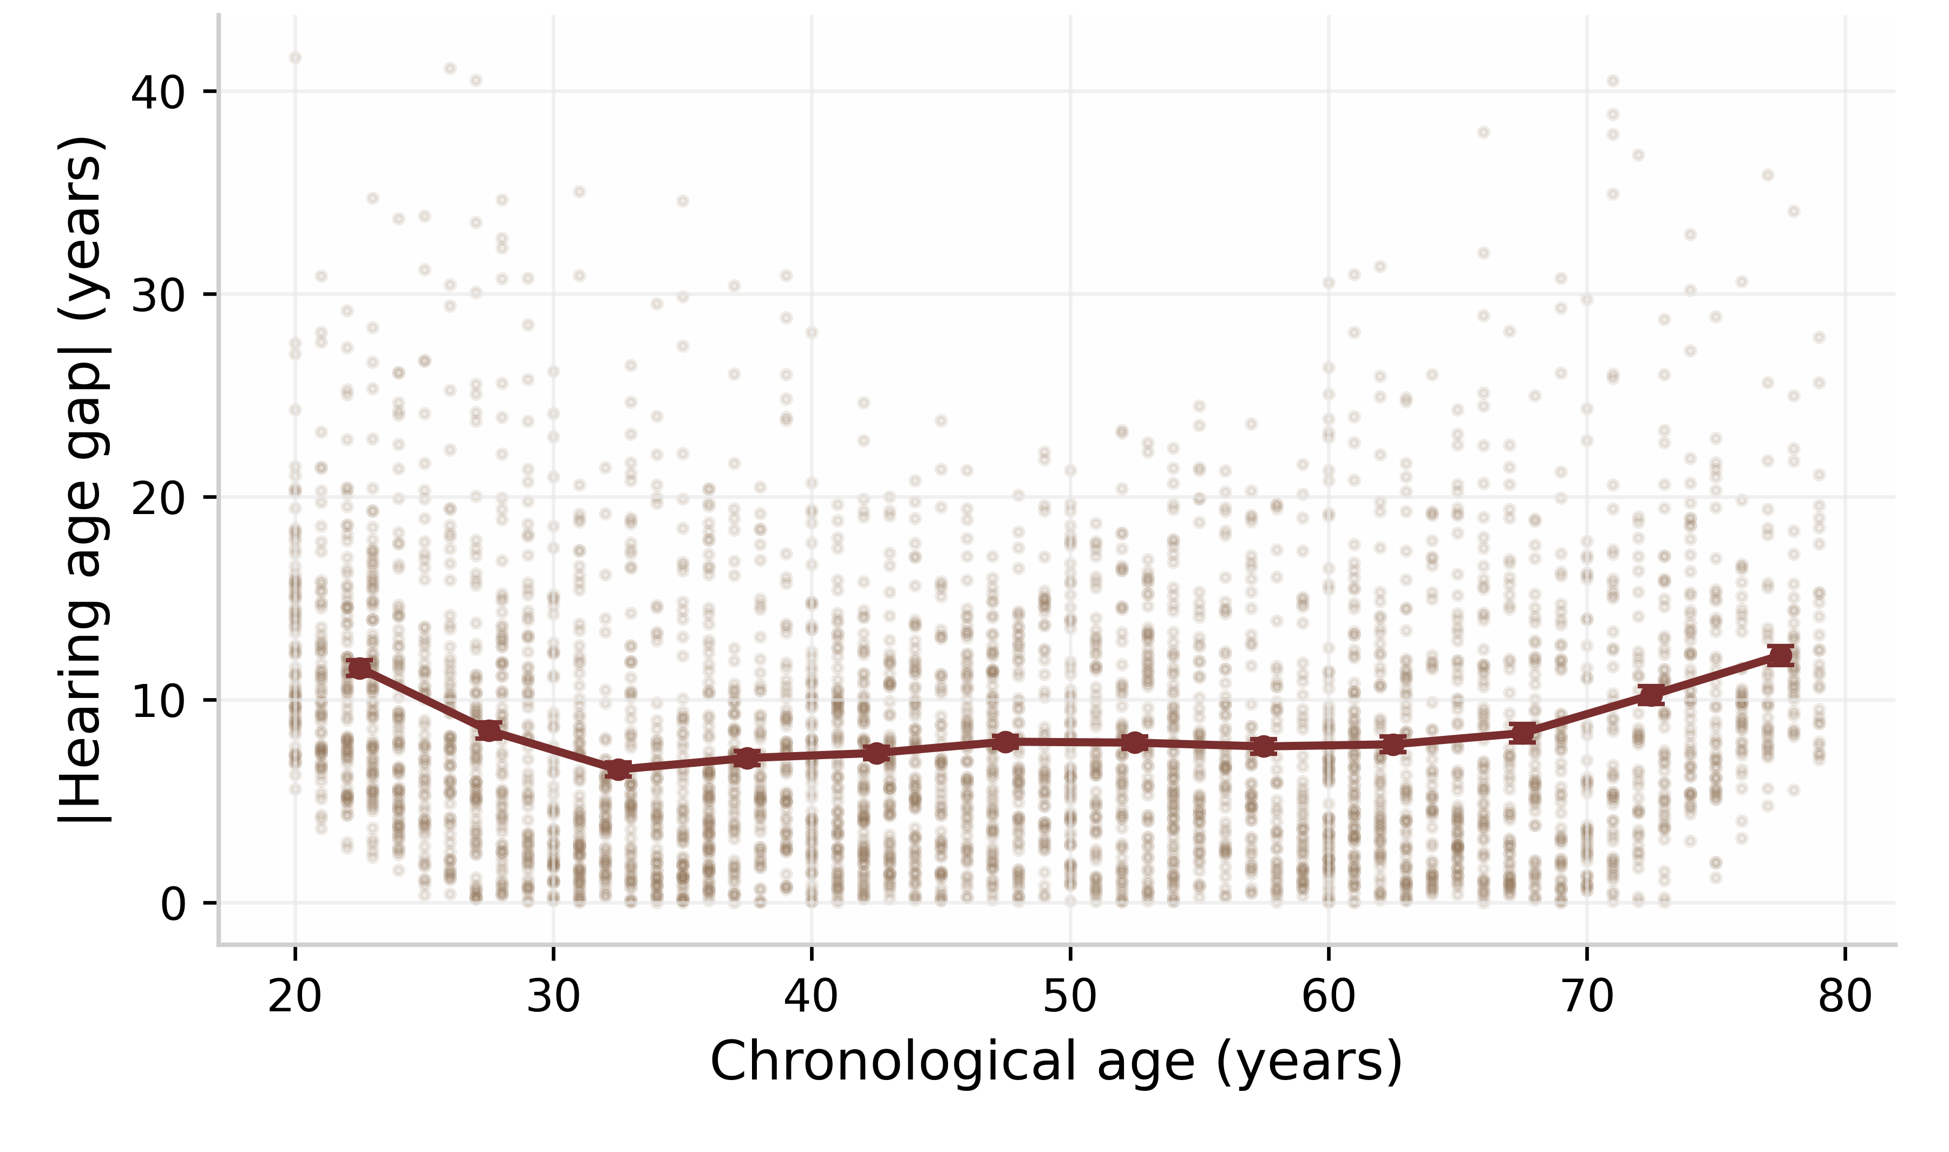
Figure S1. Absolute error of the hearing age model across chronological age. Points show 4,000 randomly sampled participants; the red line shows the mean absolute error with 95% confidence intervals in 5-year age bins. Prediction error is stable across adulthood, with a modest increase at the oldest ages.
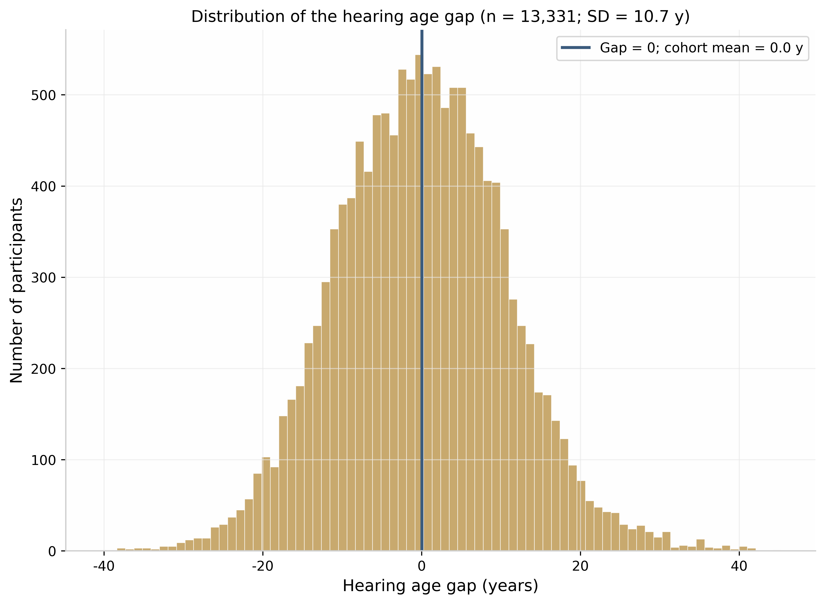
Figure S2. Distribution of the hearing age gap in the analytic cohort. The dashed red line marks a gap of zero (hearing age equal to chronological age); the blue line marks the cohort mean.

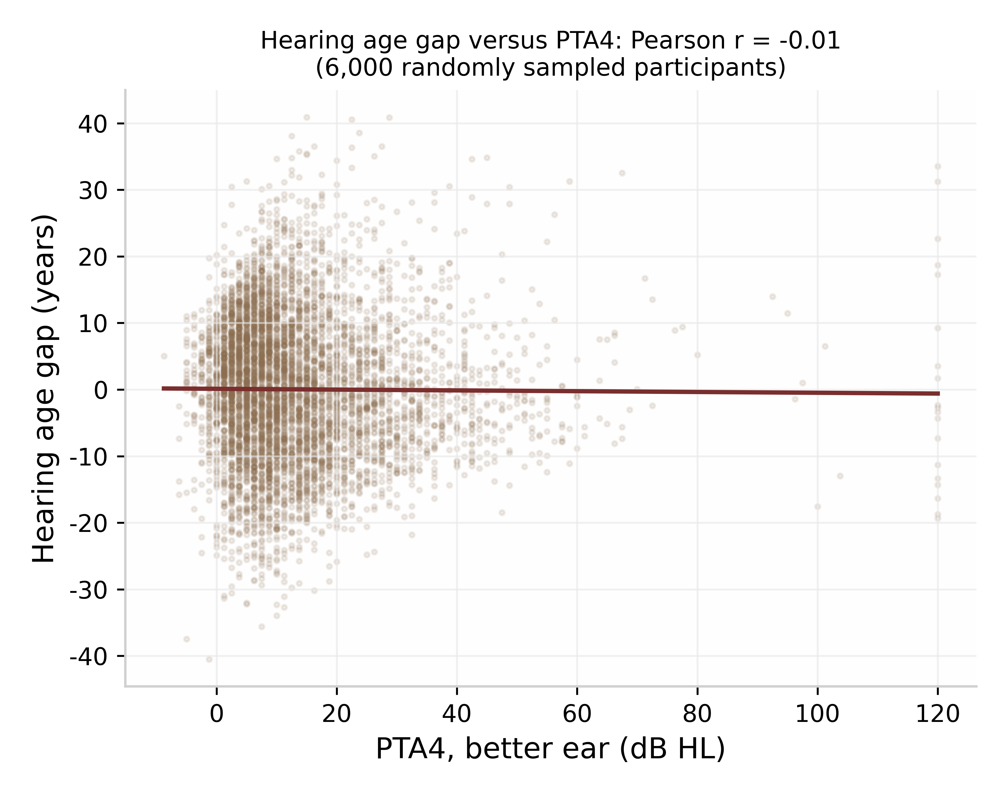
Figure S3. Hearing age gap versus the four-frequency pure-tone average (PTA4) of the better ear. The two measures were essentially uncorrelated (Pearson r = -0.01), indicating that the gap captures the configuration of the audiogram rather than its overall level.
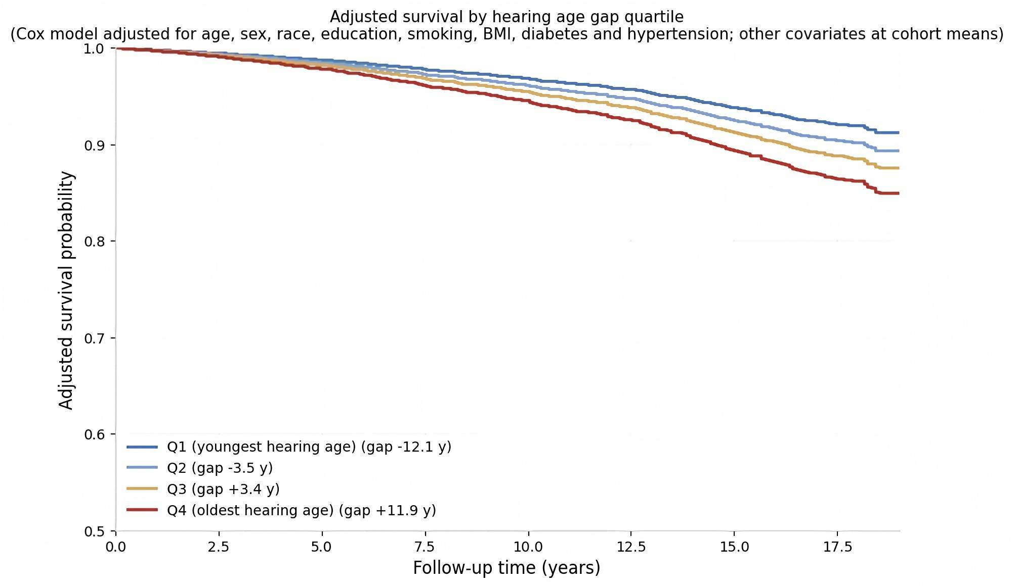
Figure S4. Adjusted survival curves by hearing age gap quartile, estimated from a survey-weighted Cox model adjusted for age, sex, race, education, smoking, body mass index, diabetes and hypertension, with covariates held at cohort means and the gap set to the quartile median.

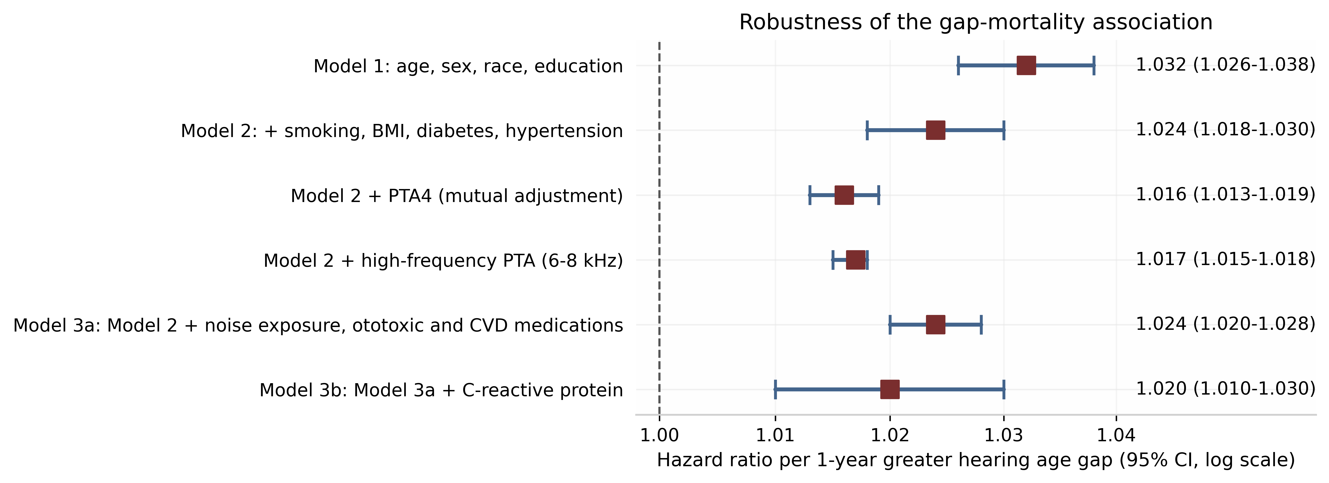
Figure S5. Hazard ratios for all-cause mortality per 1-year greater hearing age gap across progressively richer adjustment sets, including mutual adjustment for PTA4 and high-frequency PTA. The association remained statistically significant in all specifications.
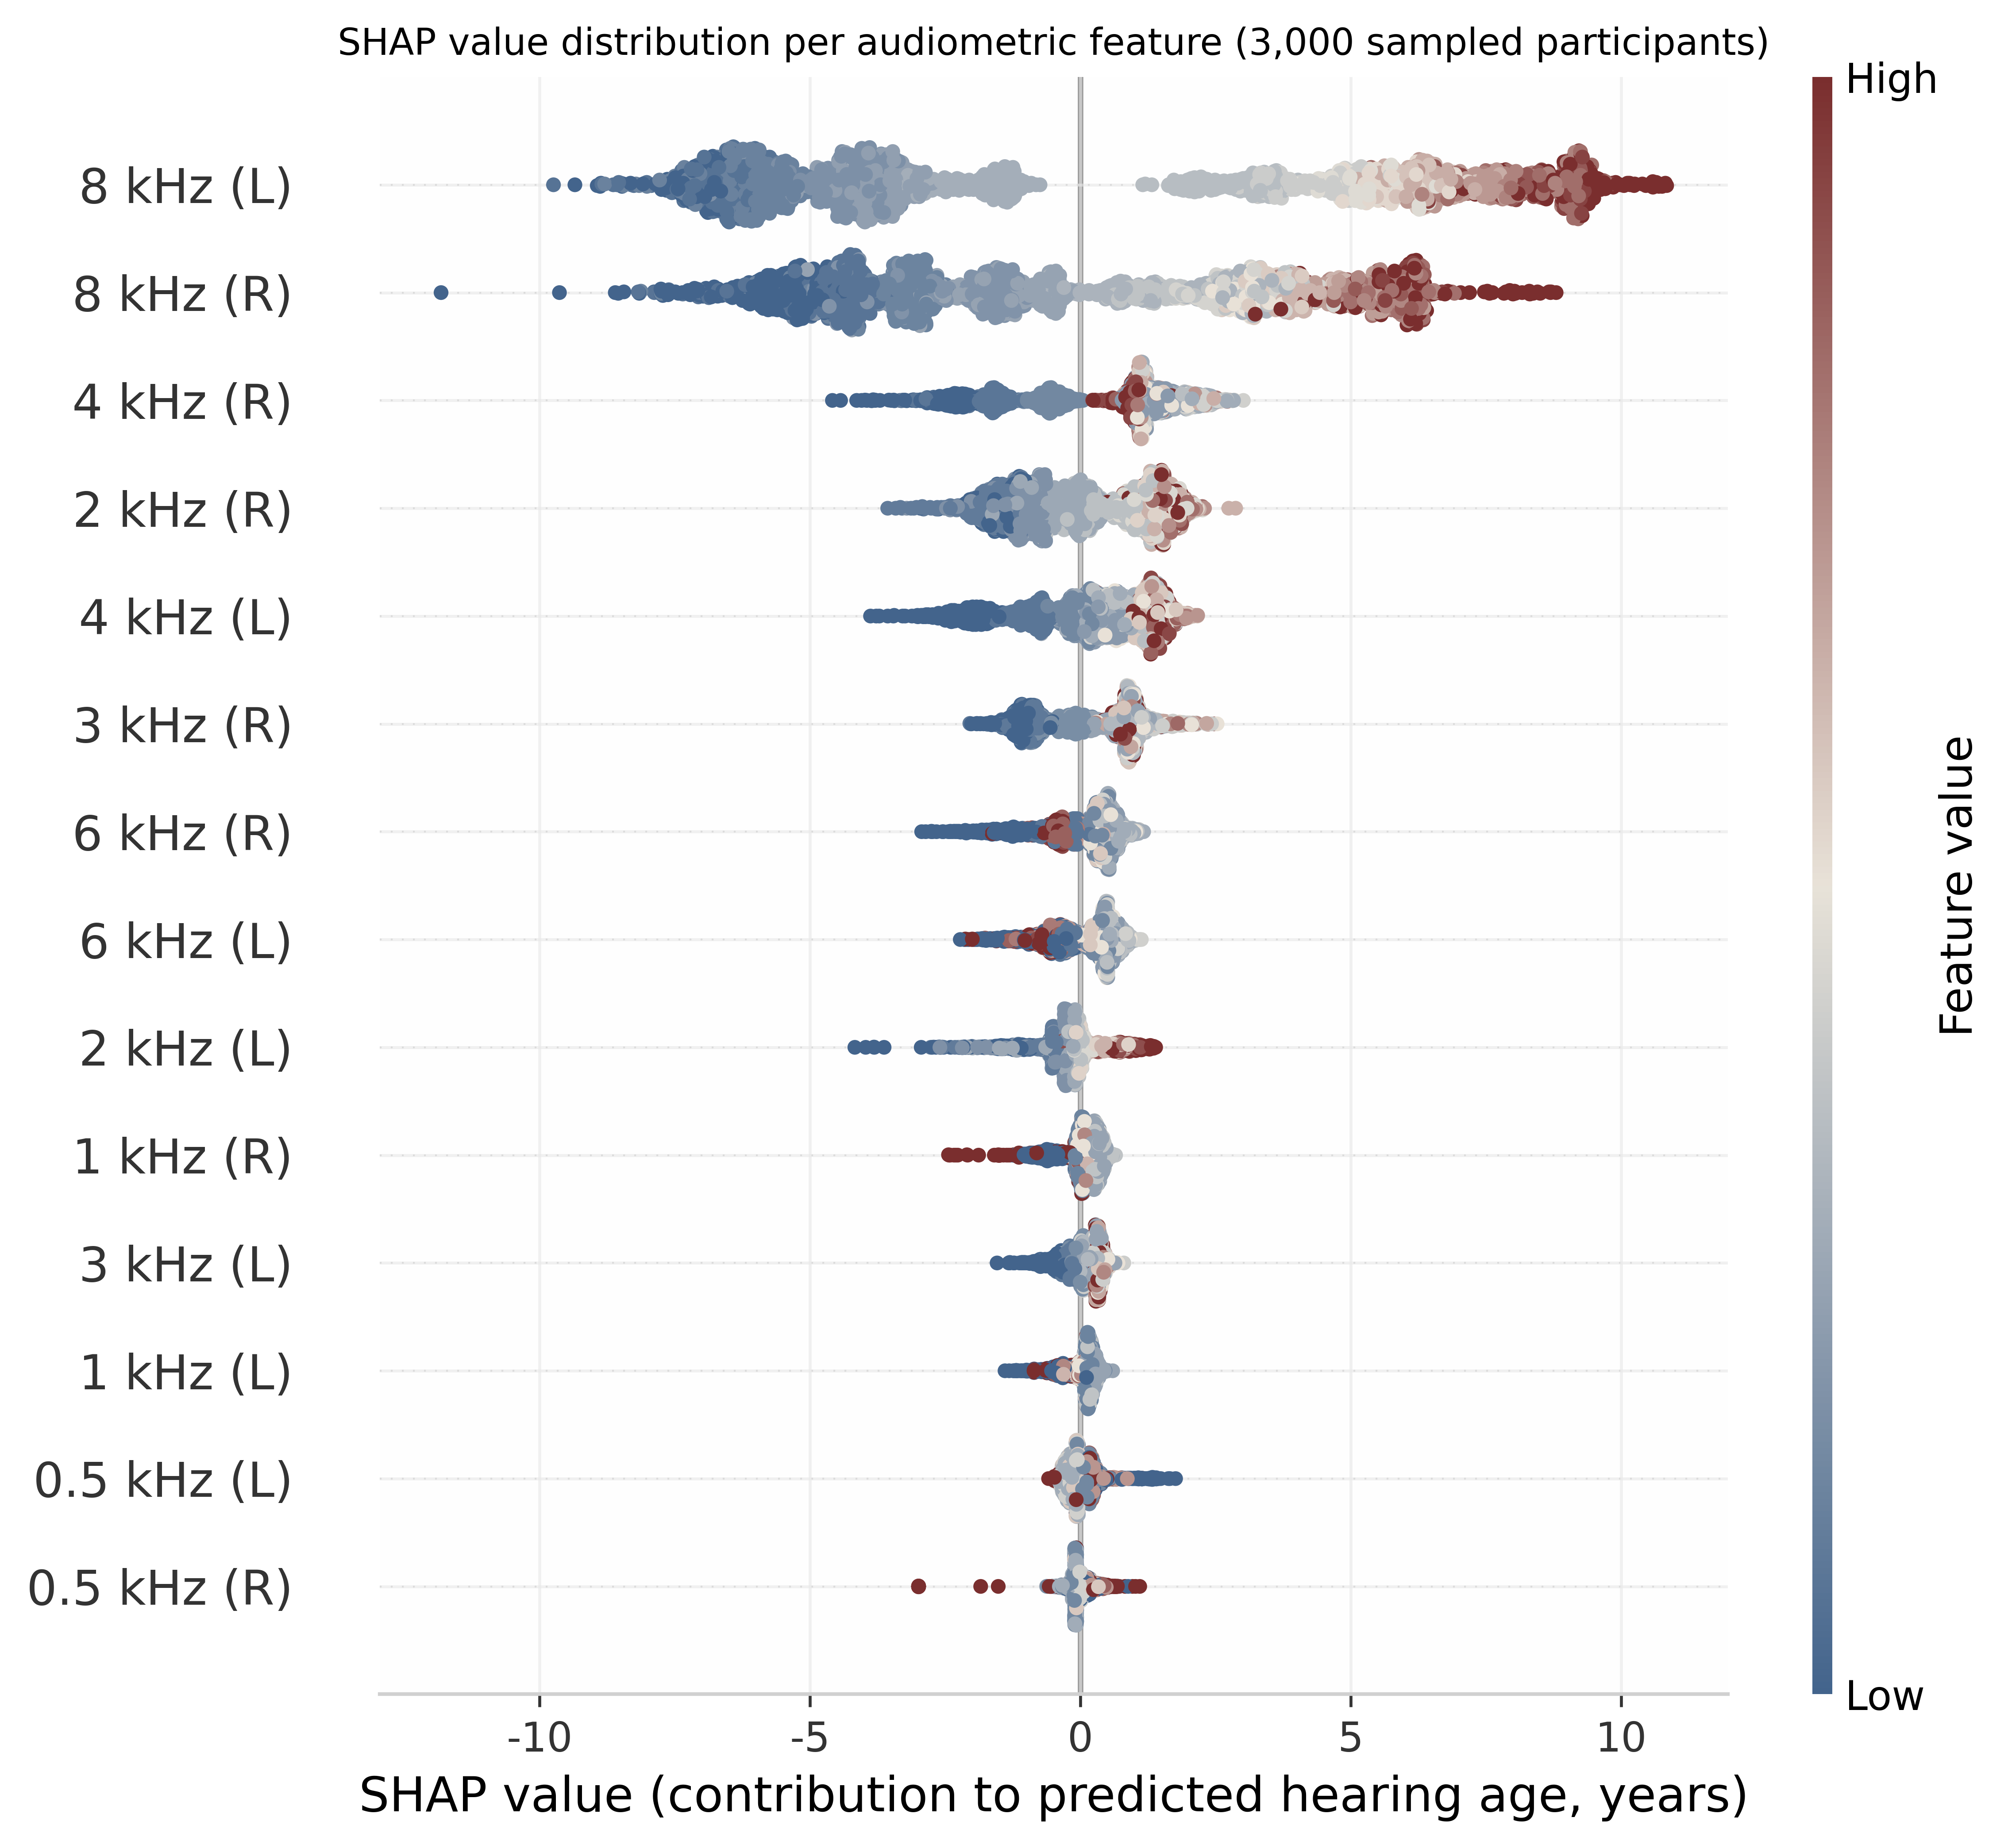

Figure S6. SHAP value distribution for each audiometric feature in the hearing age model, computed on 3,000 randomly sampled participants. Each point is one participant; color indicates the threshold value (red = poorer hearing). Extended high-frequency thresholds (8 kHz) contributed the largest share of the predicted hearing age.

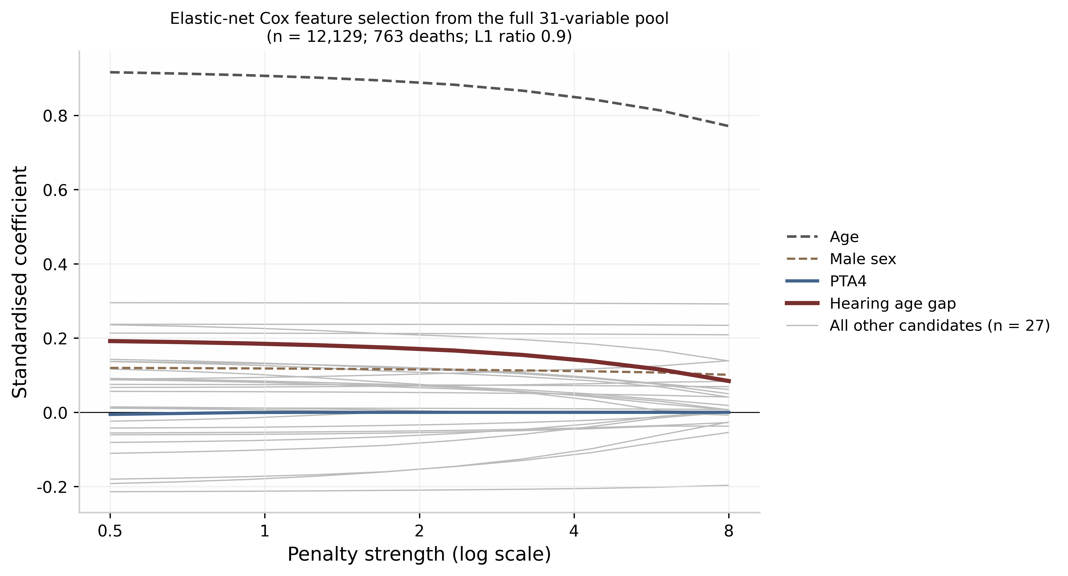
Figure S7. Elastic-net Cox feature selection from the full pool of 31 candidate variables (n = 12,129; 763 deaths; L1 ratio 0.9). Each line traces the standardised coefficient of one candidate variable across increasing penalty strengths. The hearing age gap (red) was retained at every penalty examined, whereas PTA4 (blue) and the individual 8 kHz thresholds were eliminated at stronger penalties. Age (dashed grey) and male sex (dashed brown) are shown for reference; all other candidates are shown in light grey.
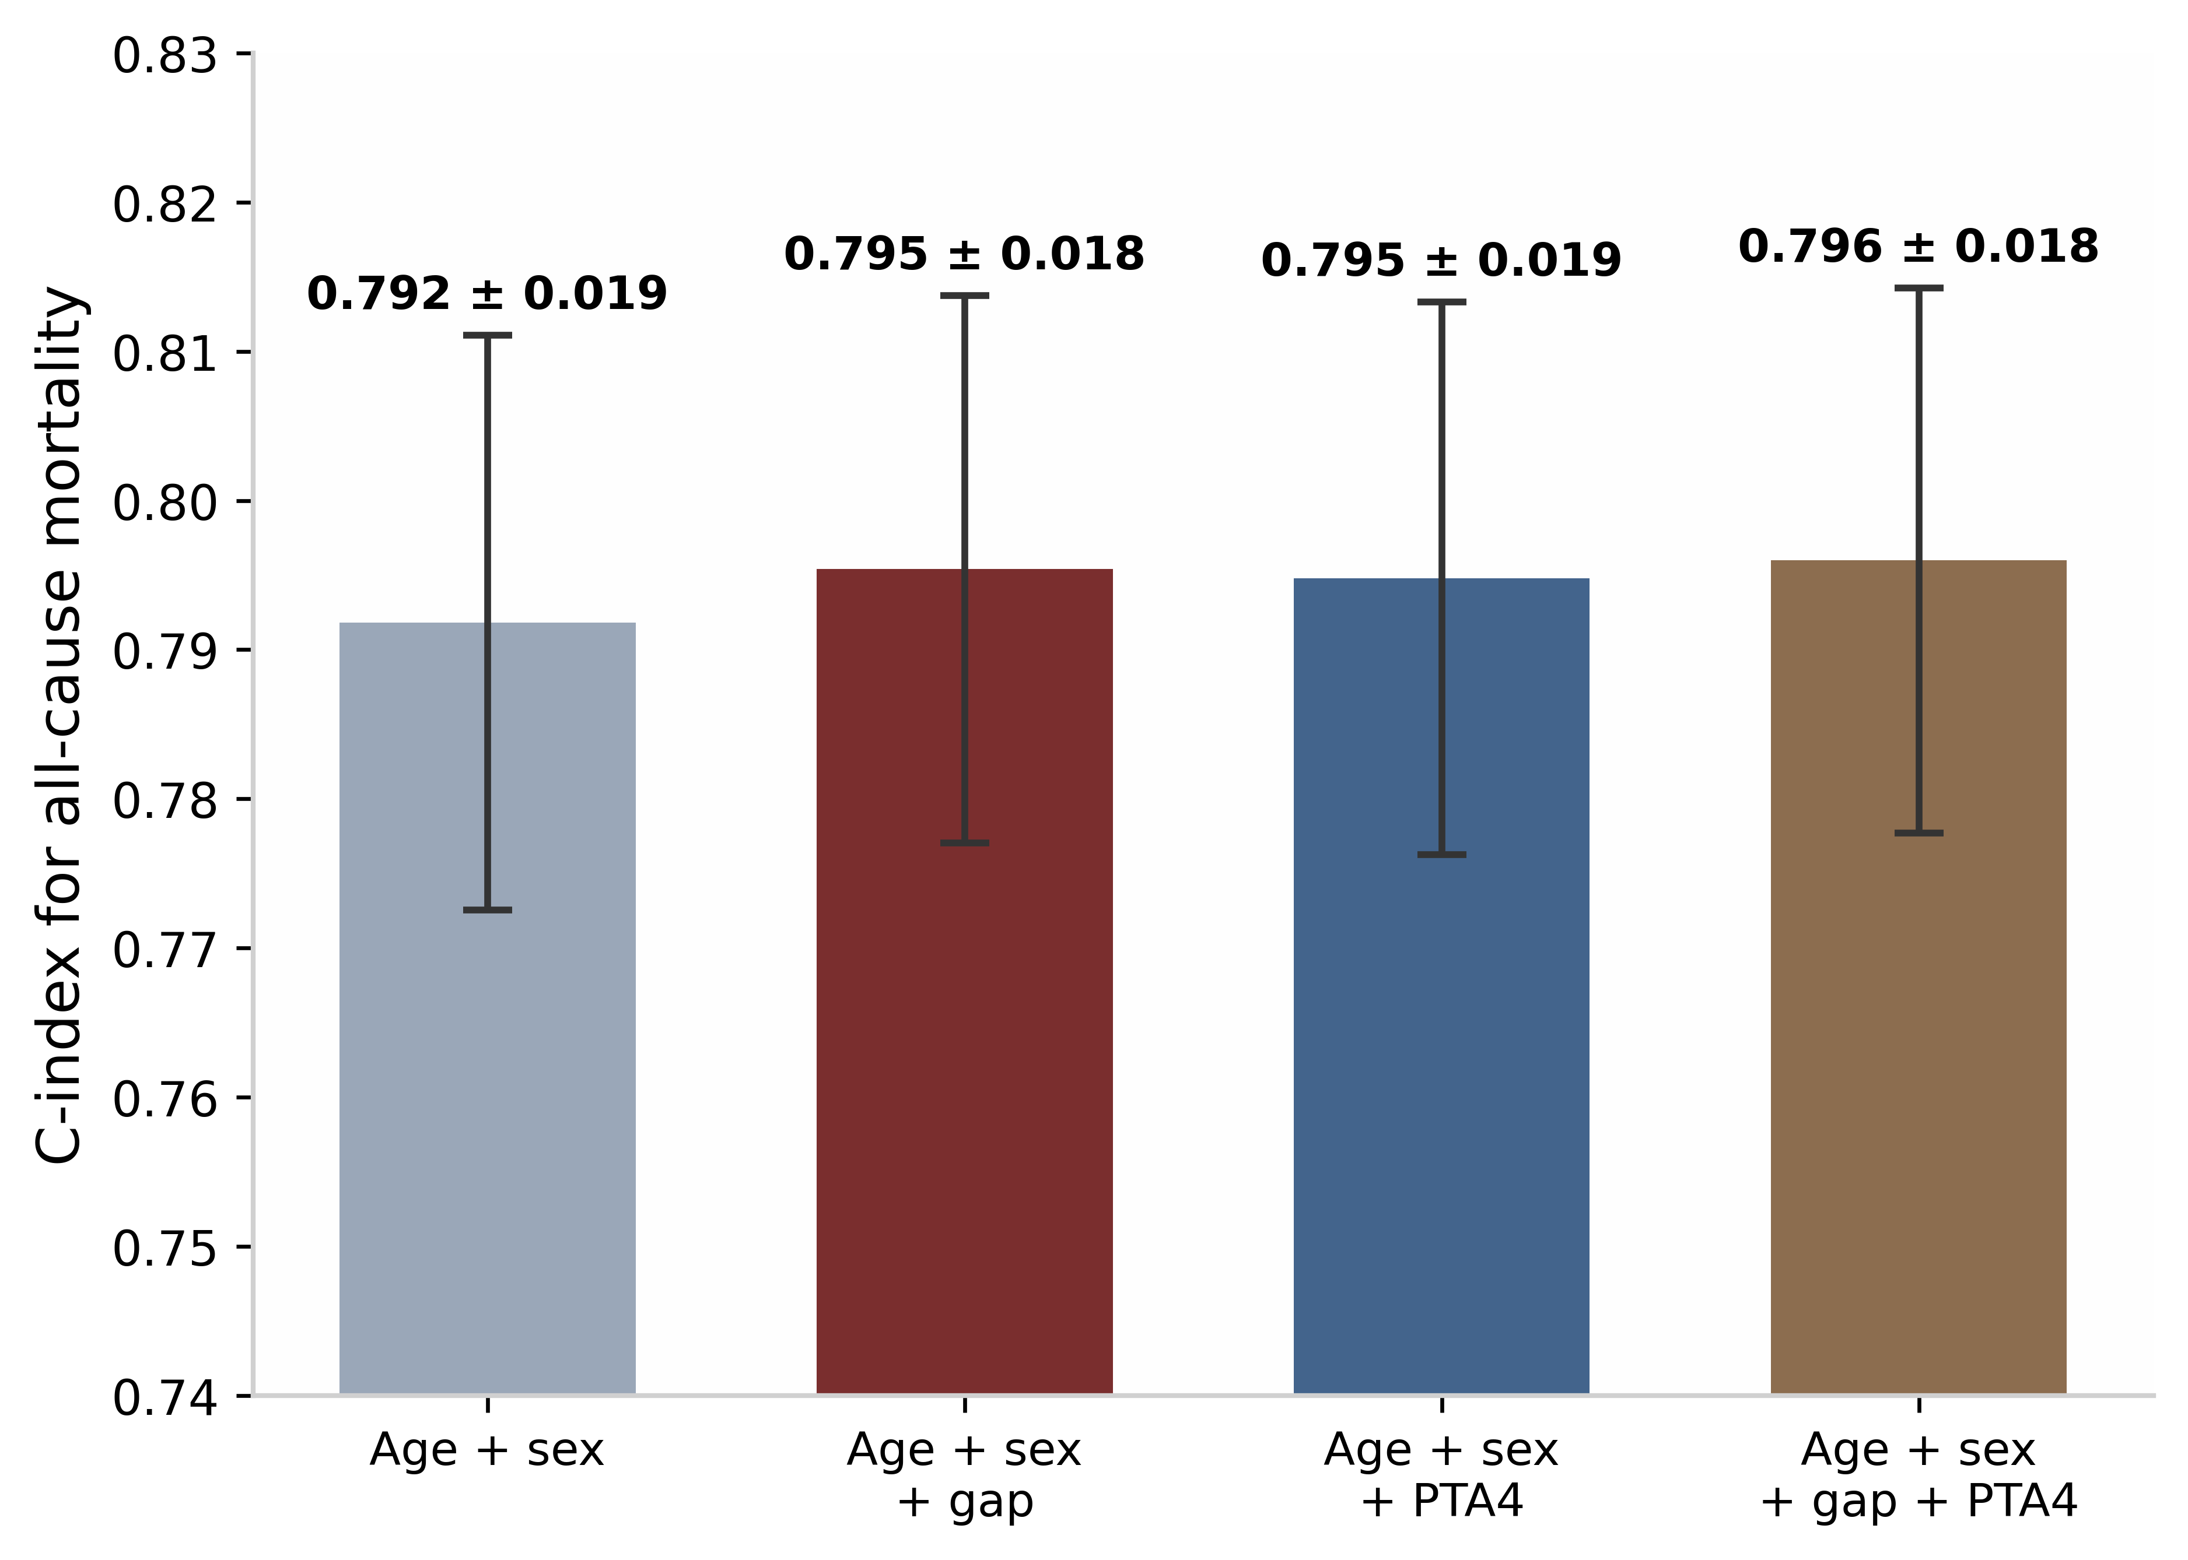
Figure S8. C-index of survey-weighted Cox models for all-cause mortality. Adding the hearing age gap to age and sex improved discrimination comparably to adding PTA4; the model containing both achieved the highest C-index (0.797).
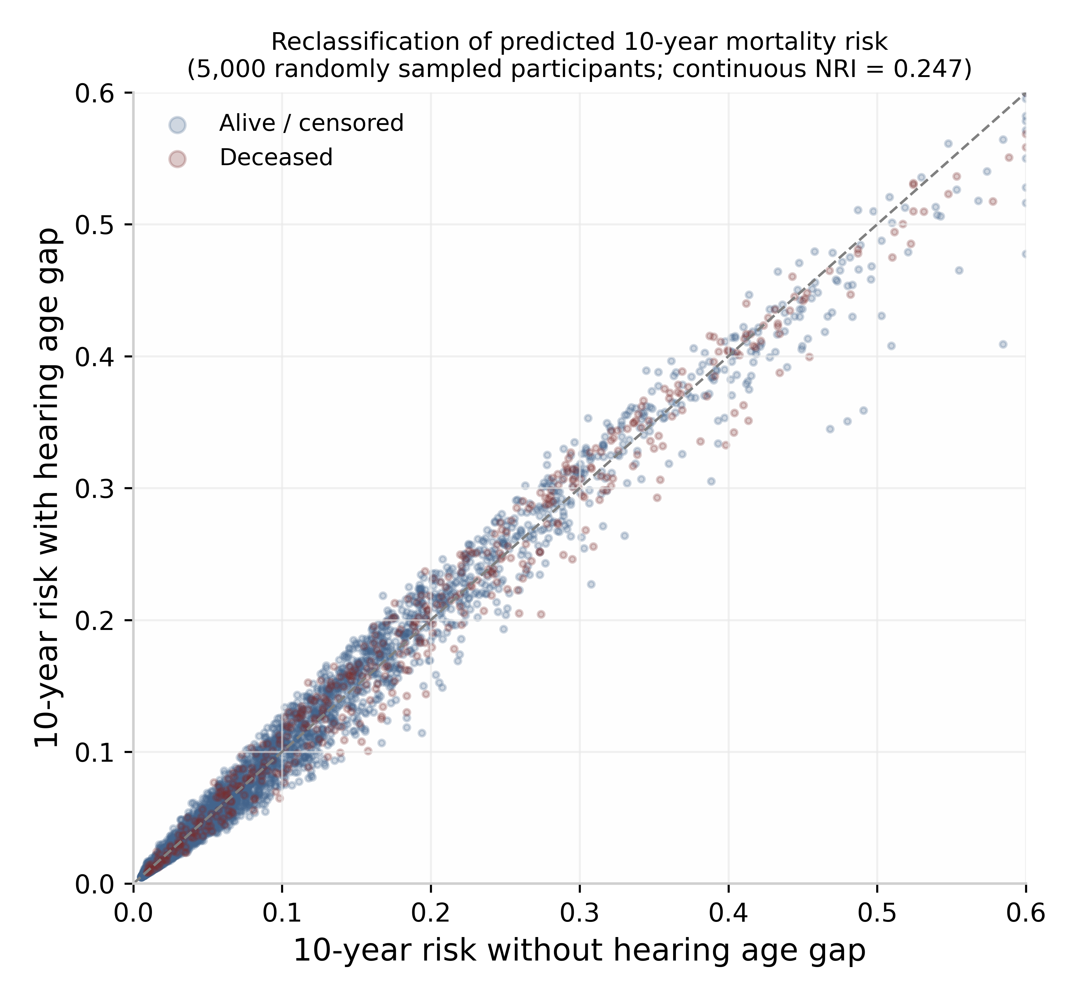
Figure S9. Reclassification of predicted 10-year mortality risk when the hearing age gap is added to a model containing age, sex, and PTA4. Each point is one of 5,000 randomly sampled participants; deceased participants (red) lie predominantly above the identity line, indicating appropriate upward reclassification (continuous NRI = 0.247).

