Supplementary material
Public support for national comprehensive smoke-free legislation and its setting-specific components: a multijurisdiction cross-sectional survey in China
Supplementary Table S1A. Setting-specific support among adult general supporters (n=3,119)
Rank | Indoor setting | Support, n (%) | Strongly support, n (%)
1 | Indoor workplaces | 2,961 (94.9) | 2,406 (77.1)
2 | Healthcare facilities | 2,954 (94.7) | 2,532 (81.2)
3 | Libraries/museums | 2,940 (94.3) | 2,508 (80.4)
4 | Primary/secondary schools and kindergartens | 2,938 (94.2) | 2,555 (81.9)
5 | Public transport | 2,929 (93.9) | 2,446 (78.4)
6 | Shopping malls/supermarkets | 2,904 (93.1) | 2,223 (71.3)
7 | Government buildings | 2,890 (92.7) | 2,227 (71.4)
8 | Transport terminals | 2,865 (91.9) | 2,289 (73.4)
9 | Indoor sports/swimming venues | 2,855 (91.5) | 2,214 (71.0)
10 | Universities/colleges | 2,842 (91.1) | 2,230 (71.5)
11 | Restaurants | 2,804 (89.9) | 2,115 (67.8)
12 | Hotels | 2,614 (83.8) | 1,793 (57.5)
13 | Bars/karaoke venues/cinemas | 2,332 (74.8) | 1,490 (47.8)
Support combines ratings 4 and 5 on the five-point scale; strong support is rating 5. Rank is based on the support percentage.
Supplementary Table S1B. Setting-specific support among all adults (N=3,187)
Rank | Indoor setting | Support, n (%) | Strongly support, n (%)
1 | Indoor workplaces | 3,009 (94.4) | 2,433 (76.3)
2 | Healthcare facilities | 3,009 (94.4) | 2,575 (80.8)
3 | Libraries/museums | 2,997 (94.0) | 2,553 (80.1)
4 | Primary/secondary schools and kindergartens | 2,993 (93.9) | 2,601 (81.6)
5 | Public transport | 2,985 (93.7) | 2,485 (78.0)
6 | Shopping malls/supermarkets | 2,954 (92.7) | 2,257 (70.8)
7 | Government buildings | 2,934 (92.1) | 2,258 (70.9)
8 | Transport terminals | 2,913 (91.4) | 2,322 (72.9)
9 | Indoor sports/swimming venues | 2,905 (91.2) | 2,250 (70.6)
10 | Universities/colleges | 2,887 (90.6) | 2,261 (70.9)
11 | Restaurants | 2,839 (89.1) | 2,133 (66.9)
12 | Hotels | 2,636 (82.7) | 1,805 (56.6)
13 | Bars/karaoke venues/cinemas | 2,352 (73.8) | 1,500 (47.1)
These estimates include all 3,187 adults, regardless of their response to the general-support item, and are shown for comparison with the supporter-restricted primary analyses.
Supplementary Table S2. Descriptive prevalence of complete setting-specific support among adult general supporters
Characteristic | Category | Complete support / total | Complete support, %
Smoking status | Never smoker | 1,415 / 2,071 | 68.3
 | Previous smoker | 444 / 716 | 62.0
 | Current smoker | 184 / 332 | 55.4
Jurisdiction status | Comparison jurisdiction | 1,051 / 1,561 | 67.3
 | Qualifying-law jurisdiction | 992 / 1,558 | 63.7
Prior awareness | No | 269 / 476 | 56.5
 | Yes | 1,774 / 2,643 | 67.1
Clear secondhand-smoke knowledge | No | 164 / 322 | 50.9
 | Yes | 1,879 / 2,797 | 67.2
Clear thirdhand-smoke knowledge | No | 766 / 1,350 | 56.7
 | Yes | 1,277 / 1,769 | 72.2
Recent information exposure | None | 315 / 476 | 66.2
 | One medium | 468 / 878 | 53.3
 | Multiple media | 1,260 / 1,765 | 71.4
Sex | Male | 967 / 1,570 | 61.6
 | Female | 1,076 / 1,549 | 69.5
Age group | 18-24 years | 287 / 545 | 52.7
 | 25-59 years | 1,403 / 1,981 | 70.8
 | >=60 years | 353 / 593 | 59.5
Denominator is adult respondents who supported national comprehensive smoke-free legislation (n=3,119). Recent information exposure was checked against the original three response options (never / one medium / multiple media); no missing or uncertain category was present. Its non-monotonic association was not interpreted as a focal result.
Supplementary Table S3. Operational definitions of policy-support indicators
Indicator | Analytic population | Operational definition
Prompted general support | All adults | Binary support after the standardized preamble.
Direct core-domain endorsement | Adult general supporters | Selected the multiple-response summary option covering indoor public places, public transport, and indoor workplaces.
Setting-specific support | Adult general supporters | Rating 4 or 5 for a specified indoor setting.
Strong setting-specific support | Adult general supporters | Rating 5 for a specified indoor setting.
Complete setting-specific support | Adult general supporters | Rating 4 or 5 in all 13 specified indoor settings; primary all-setting summary outcome.
Number of settings supported | Adult general supporters | Count of the 13 settings rated 4 or 5; range 0-13.
'Smoking room' preference | Adult general supporters | Binary support for the separately described 吸烟室 option; analyzed separately because location was not explicitly indoor/outdoor.
Exploratory Article 8-oriented combined criterion | Adult general supporters | Complete setting-specific support plus opposition to the smoking-room option; interpretation depends on whether respondents understood 吸烟室 as indoor.
The indicators were constructed for policy interpretation rather than as psychometric scales. The all-13 outcome is deliberately stringent.
Supplementary Table S4A. Audit of jurisdictions classified as qualifying comprehensive smoke-free legislation at the 31 October 2022 cut-off
Jurisdiction | Vehicle | Legal instrument | Qualifying year | Key textual basis / audit note | Later external check
Beijing | Dedicated tobacco-control | 北京市控制吸烟条例 (Beijing Smoking Control Regulation) | 2015 | Art. 9: indoor public places, indoor workplaces, public transport | Corroborated in 2026 23-city inventory
Shanghai | Dedicated tobacco-control | 上海市公共场所控制吸烟条例 (Shanghai Public Places Smoking Control Regulation) | 2017 | 2016 amendment established comprehensive indoor prohibition; current law | Corroborated in 2026 inventory
Shenzhen | Dedicated tobacco-control | 深圳经济特区控制吸烟条例 (Shenzhen SEZ Smoking Control Regulation) | 2014; rev. 2019 | Art. 8: indoor workplaces, indoor public places, public transport | Corroborated in 2026 inventory
Xi'an | Dedicated tobacco-control | 西安市控制吸烟管理办法 (Xi’an Smoking Control Measures) | 2018 | Art. 11: comprehensive indoor scope | Corroborated in 2026 inventory
Lanzhou | Dedicated tobacco-control | 兰州市公共场所控制吸烟条例及2018实施细则 (Lanzhou regulation + 2018 implementation rules) | 2018 | 2018 rules established qualifying scope at survey cut-off | Rules expired 30 Nov 2023; excluded from 2026 inventory
Qingdao | Dedicated tobacco-control | 青岛市控制吸烟条例 (Qingdao Smoking Control Regulation) | 2013 | Arts. 6-7: comprehensive indoor scope; no smoking rooms/areas in prohibited venues | Corroborated in 2026 inventory
Qinhuangdao | Dedicated tobacco-control | 秦皇岛市控制吸烟办法 (Qinhuangdao Smoking Control Measures) | 2019 | Art. 11: comprehensive indoor scope | Corroborated in 2026 inventory
Zhangjiakou | Dedicated tobacco-control | 张家口市公共场所控制吸烟条例 (Zhangjiakou Public Places Smoking Control Regulation) | 2020 | Art. 11: comprehensive indoor scope | Corroborated in 2026 inventory
Wuhan | Dedicated tobacco-control | 武汉市控制吸烟条例 (Wuhan Smoking Control Regulation) | 2020 | Core scope provision covers indoor public/workplaces and public transport | Corroborated in 2026 inventory
Hangzhou | Dedicated tobacco-control | 杭州市公共场所控制吸烟条例 (Hangzhou Public Places Smoking Control Regulation) | 2022 comprehensive phase | 2021 amendment / 2022 phase removed remaining indoor exceptions | Corroborated in 2026 inventory
Xining | Dedicated tobacco-control | 西宁市控制吸烟条例 (Xining Smoking Control Regulation) | 2015 | Core scope provisions establish comprehensive indoor protection | Corroborated in 2026 inventory
Changchun | Patriotic health | 长春市爱国卫生条例 (Changchun Patriotic Health Regulation) | 2017 | Art. 22: indoor public places, workplaces, public transport | Corroborated in 2026 inventory
Yangquan | Patriotic health | 阳泉市爱国卫生条例 (Yangquan Patriotic Health Regulation) | 2019 | Art. 23: indoor public places, workplaces, public transport | Corroborated in 2026 inventory
Zhoukou | Civilization promotion | 周口市文明行为促进条例 (Zhoukou Civilization Promotion Regulation) | 2021 | Art. 11(1): indoor public places, workplaces, public transport | Corroborated in 2026 inventory
Chenzhou | Civilization promotion | 郴州市文明行为促进条例 (Chenzhou Civilization Promotion Regulation) | 2021 | Smoke-free clause covers all three Article 8 domains | Corroborated in 2026 inventory
Xinyang | Civilization promotion | 信阳市文明行为促进条例 (Xinyang Civilization Promotion Regulation) | 2020 | Smoke-free clause covers all three Article 8 domains | Corroborated in 2026 inventory
Hainan Province | Patriotic health / province-level | 海南省爱国卫生管理条例 (Hainan Patriotic Health Regulation), 2020 revision | 2020 | Province-level prohibition used in design-stage coding; not directly comparable with city-only inventories | Special unit; Hainan-exclusion sensitivity performed
Dandong | Civilization promotion | 丹东市文明行为促进条例 (Dandong Civilization Promotion Regulation) | 2021 | Study coding confirmed comprehensive indoor scope | Corroborated in 2026 inventory
Putian | Civilization promotion | 莆田市文明行为促进条例 (Putian Civilization Promotion Regulation) | 2021 | Art. 42 cross-references smoking in indoor public/workplaces/public transport | Corroborated in 2026 inventory
Hanzhong | Civilization promotion | 汉中市文明行为促进条例 (Hanzhong Civilization Promotion Regulation) | 2022 | Smoke-free clause covers all three Article 8 domains | Corroborated in 2026 inventory
Nanping | Civilization promotion | 南平市文明行为促进条例 (Nanping Civilization Promotion Regulation) | 2022 | Art. 11(6): no smoking in indoor public places, workplaces, public transport | Corroborated in 2026 inventory
Yulin (Shaanxi) | Civilization promotion | 榆林市文明行为促进条例 (Yulin Civilization Promotion Regulation) | 2022 | Study coding confirmed comprehensive indoor scope | Corroborated in 2026 inventory
Hebi | Civilization promotion | 鹤壁市文明行为促进条例 (Hebi Civilization Promotion Regulation) | 2019 | Study coding confirmed comprehensive indoor scope | Corroborated in 2026 inventory
Xinxiang | Civilization promotion | 新乡市文明行为促进条例 (Xinxiang Civilization Promotion Regulation) | 2022 | Core smoke-free clause covers all three Article 8 domains | Corroborated in 2026 inventory
Study classification required complete prohibition in all indoor public places, all indoor workplaces, and public transport, without indoor smoking rooms. Two graduate researchers independently reviewed the legal texts at the 2022 cut-off and reached the same classifications. The later cross-check used Chen et al. (2026), which analyzed cities identified by the Healthy China Smoke-Free Legislation platform. Twenty-two of the 24 city-level qualifying jurisdictions in the present sampling frame appear in that 2026 inventory. Lanzhou is a time-specific exception: its 2018 implementation rules met the study criterion at the survey cut-off but expired on 30 November 2023. Hainan is the only province-level unit and is examined separately in sensitivity analysis. Where an article number was not retained in the archived study files, the table reports the legal basis that could be recovered and leaves the article number unspecified.
Supplementary Table S4B. Comparison jurisdictions in the 2022 sampling frame
Jurisdiction | Design-stage classification
Tianjin | Comparison jurisdiction
Nanjing | Comparison jurisdiction
Guangzhou | Comparison jurisdiction
Zhengzhou | Comparison jurisdiction
Hohhot | Comparison jurisdiction
Jinan | Comparison jurisdiction
Xingtai | Comparison jurisdiction
Hengshui | Comparison jurisdiction
Chongqing | Comparison jurisdiction
Shenyang | Comparison jurisdiction
Ningbo | Comparison jurisdiction
Yinchuan | Comparison jurisdiction
Datong | Comparison jurisdiction
Xuchang | Comparison jurisdiction
Zhuzhou | Comparison jurisdiction
Zhumadian | Comparison jurisdiction
Xiamen | Comparison jurisdiction
Liaoyang | Comparison jurisdiction
Longyan | Comparison jurisdiction
Baoji | Comparison jurisdiction
Sanming | Comparison jurisdiction
Ordos | Comparison jurisdiction
Puyang | Comparison jurisdiction
Anyang | Comparison jurisdiction
These jurisdictions did not meet the study's strict qualifying definition at the 31 October 2022 cut-off. This does not mean that they lacked tobacco-control rules; some had partial or venue-specific smoke-free provisions.
Supplementary Table S5. Distribution of the number of indoor settings supported among adult general supporters (n=3,119). The distribution is also shown in Supplementary Figure S1.
Number of settings supported (0-13) | n | %
0 | 80 | 2.6
1 | 13 | 0.4
2 | 5 | 0.2
3 | 5 | 0.2
4 | 7 | 0.2
5 | 13 | 0.4
6 | 24 | 0.8
7 | 34 | 1.1
8 | 57 | 1.8
9 | 70 | 2.2
10 | 157 | 5.0
11 | 232 | 7.4
12 | 379 | 12.2
13 | 2,043 | 65.5
Supplementary Table S6. Full modified Poisson model for complete setting-specific support
Characteristic | aPR | 95% CI | P value
Smoking: previous vs never | 0.918 | 0.862-0.978 | 0.008
Smoking: current vs never | 0.828 | 0.744-0.923 | <0.001
Qualifying-law jurisdiction | 0.941 | 0.889-0.996 | 0.037
Prior awareness | 1.091 | 0.981-1.213 | 0.109
Clear secondhand-smoke knowledge | 1.119 | 1.013-1.236 | 0.027
Clear thirdhand-smoke knowledge | 1.205 | 1.129-1.286 | <0.001
Recent information: one medium vs none | 0.827 | 0.744-0.919 | <0.001
Recent information: multiple media vs none | 1.014 | 0.933-1.102 | 0.736
Female sex | 1.052 | 1.002-1.103 | 0.040
Age 25-59 vs 18-24 | 1.290 | 1.186-1.404 | <0.001
Age >=60 vs 18-24 | 1.101 | 0.993-1.221 | 0.067
College diploma vs high school/lower | 1.003 | 0.926-1.087 | 0.941
Bachelor+ vs high school/lower | 0.984 | 0.917-1.057 | 0.662
Rural vs urban | 0.986 | 0.937-1.037 | 0.574
Urban-rural fringe vs urban | 1.088 | 0.985-1.202 | 0.097
No multiplicity adjustment was applied; interpretation focuses on effect estimates and confidence intervals. Recent-information coding was checked against the original three response options and contained no missing/unknown category. The exact estimates for current smoking and one-medium exposure differ despite rounding to the same 0.83 (0.74-0.92) in the main text. The full model is also shown in Supplementary Figure S2.
Supplementary Table S7. Sensitivity analyses addressing sampling and outcome specification
Sensitivity analysis | Estimate | Result | Comment
Targeted current-smoking calibration: 2018 sex-specific margins | Prompted general support | 96.7% | Male current smoking 50.5%; female 2.1%
 | Complete all-13 support among prompted supporters | 64.3% | Primary unweighted estimate 65.5%
Targeted current-smoking calibration: 2024 sex-specific margins | Prompted general support | 96.9% | Male current smoking 43.9%; female 1.8%
 | Complete all-13 support among prompted supporters | 64.6% | Primary unweighted estimate 65.5%
Poisson count model (0-13 settings) | Current smoking vs never | IRR 0.956 (0.931-0.982) | p=0.001
 | Clear secondhand-smoke knowledge | IRR 1.038 (1.005-1.071) | p=0.022
 | Clear thirdhand-smoke knowledge | IRR 1.028 (1.010-1.045) | p=0.002
 | Qualifying-law jurisdiction | IRR 0.998 (0.977-1.019) | p=0.814
Calibration altered current versus non-current weights within sex while retaining the sample sex distribution. Full age-sex-smoking-status raking was not performed because the survey's previous-smoking category is not directly comparable with standard former-smoker surveillance categories.
Supplementary Table S8. Cluster and jurisdiction robustness checks
Check | Parameter | Result
Leave-one-jurisdiction-out cluster jackknife | Previous smoking vs never | aPR 0.918 (approx. 95% CI 0.861-0.980)
 | Current smoking vs never | aPR 0.828 (0.741-0.926)
 | Clear secondhand-smoke knowledge | aPR 1.119 (1.009-1.240)
 | Clear thirdhand-smoke knowledge | aPR 1.205 (1.127-1.289)
Excluding Hainan Province (47 jurisdictions; n=3,052 supporters) | Previous smoking vs never | aPR 0.922 (0.865-0.983)
 | Current smoking vs never | aPR 0.843 (0.760-0.935)
 | Qualifying-law jurisdiction | aPR 0.942 (0.889-0.999)
 | Clear secondhand-smoke knowledge | aPR 1.119 (1.010-1.239)
 | Clear thirdhand-smoke knowledge | aPR 1.216 (1.140-1.297)
GEE exchangeable working correlation | Within-jurisdiction correlation | approximately 0.008
The low GEE working correlation indicates little residual clustering for the modeled outcome within this online quota sample and should not be generalized to population-level jurisdictional similarity. Leave-one-jurisdiction-out intervals use a cluster jackknife approximation. Key estimates across specifications are shown in Supplementary Figure S3.
Supplementary Table S9. Multicollinearity diagnostics
Diagnostic | Value
Prior awareness | 1.10
Clear secondhand-smoke knowledge | 1.12
Clear thirdhand-smoke knowledge | 1.21
Maximum VIF across all model predictors | 2.11
All variance inflation factors were below 2.2. Pairwise correlations among prior awareness, clear secondhand-smoke knowledge, and clear thirdhand-smoke knowledge were small; no material multicollinearity was detected.

Supplementary figures
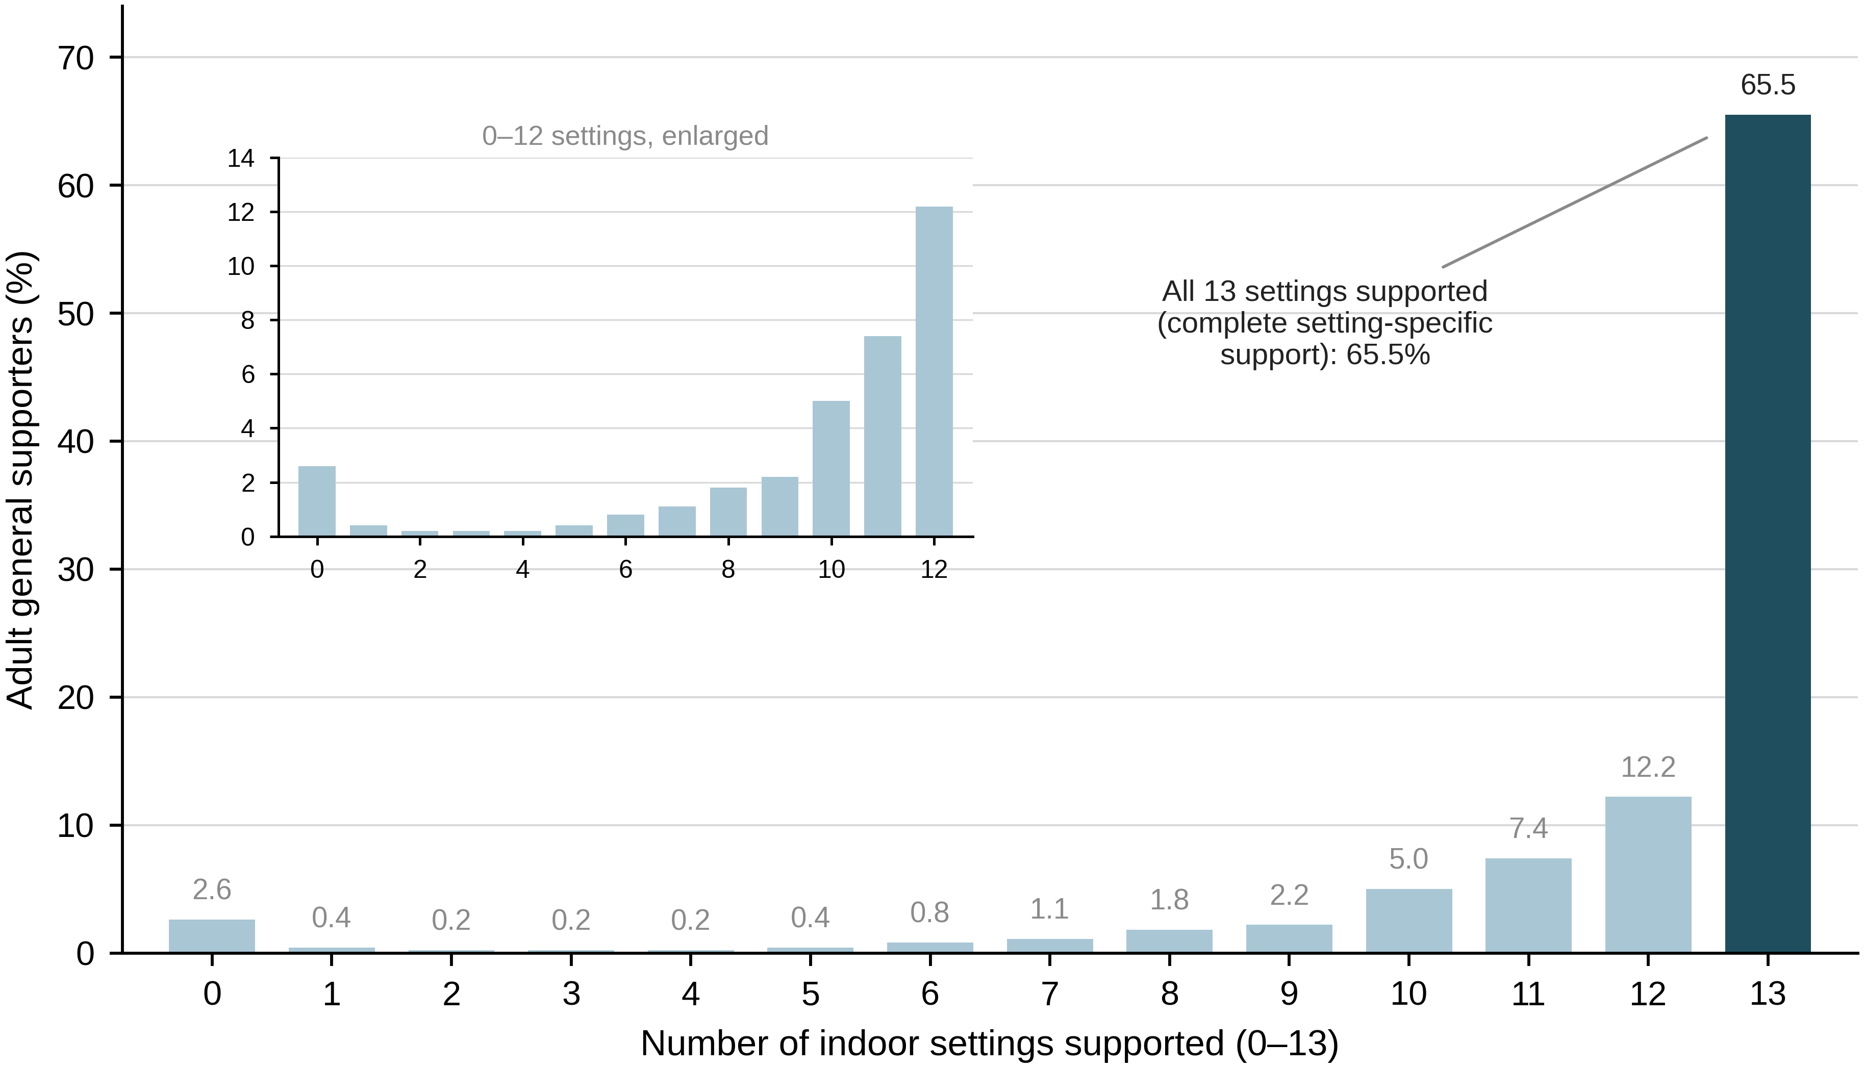Supplementary Figure S1. Distribution of the number of indoor settings supported (0-13) among adult general supporters (n=3,119).

Percentage of adult general supporters by the number of specified indoor settings rated 4 or 5. The dark bar identifies complete setting-specific support (13/13 settings; 2,043/3,119, 65.5%). The inset enlarges the distribution for 0-12 settings. Shading identifies the primary all-setting outcome and does not imply that 13 is a normatively correct response.
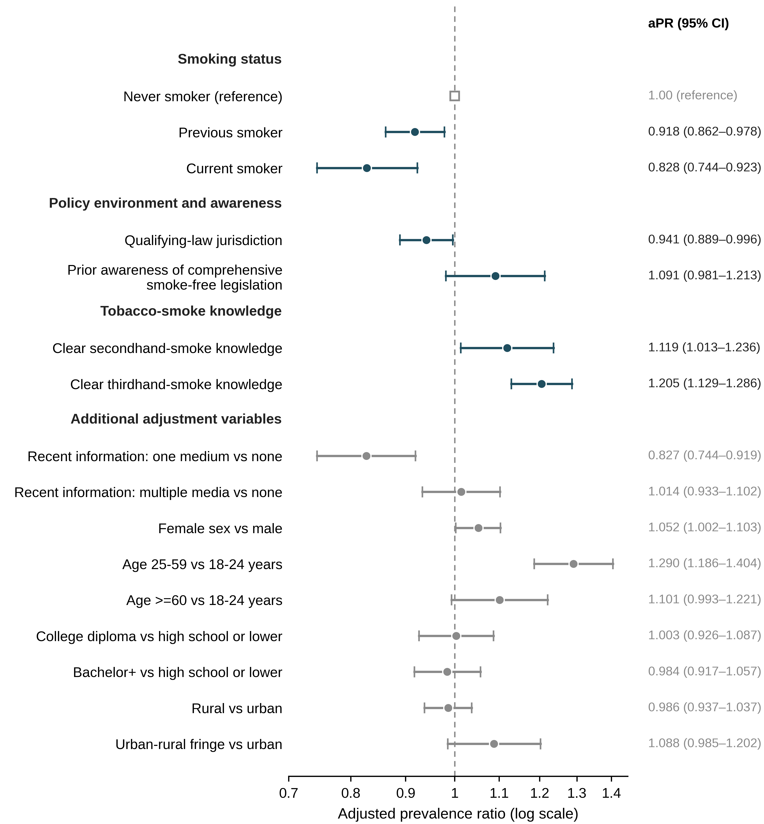Supplementary Figure S2. Full modified Poisson model for complete setting-specific support among adult general supporters (n=3,119).

Adjusted prevalence ratios with 95% confidence intervals for all variables included simultaneously in the model. Focal correlates are shown in dark blue; additional adjustment variables are shown in grey. The open square marks the reference category, the dashed vertical line marks the null value of 1.0, and the x-axis is logarithmic. Associations are cross-sectional and are not interpreted causally.
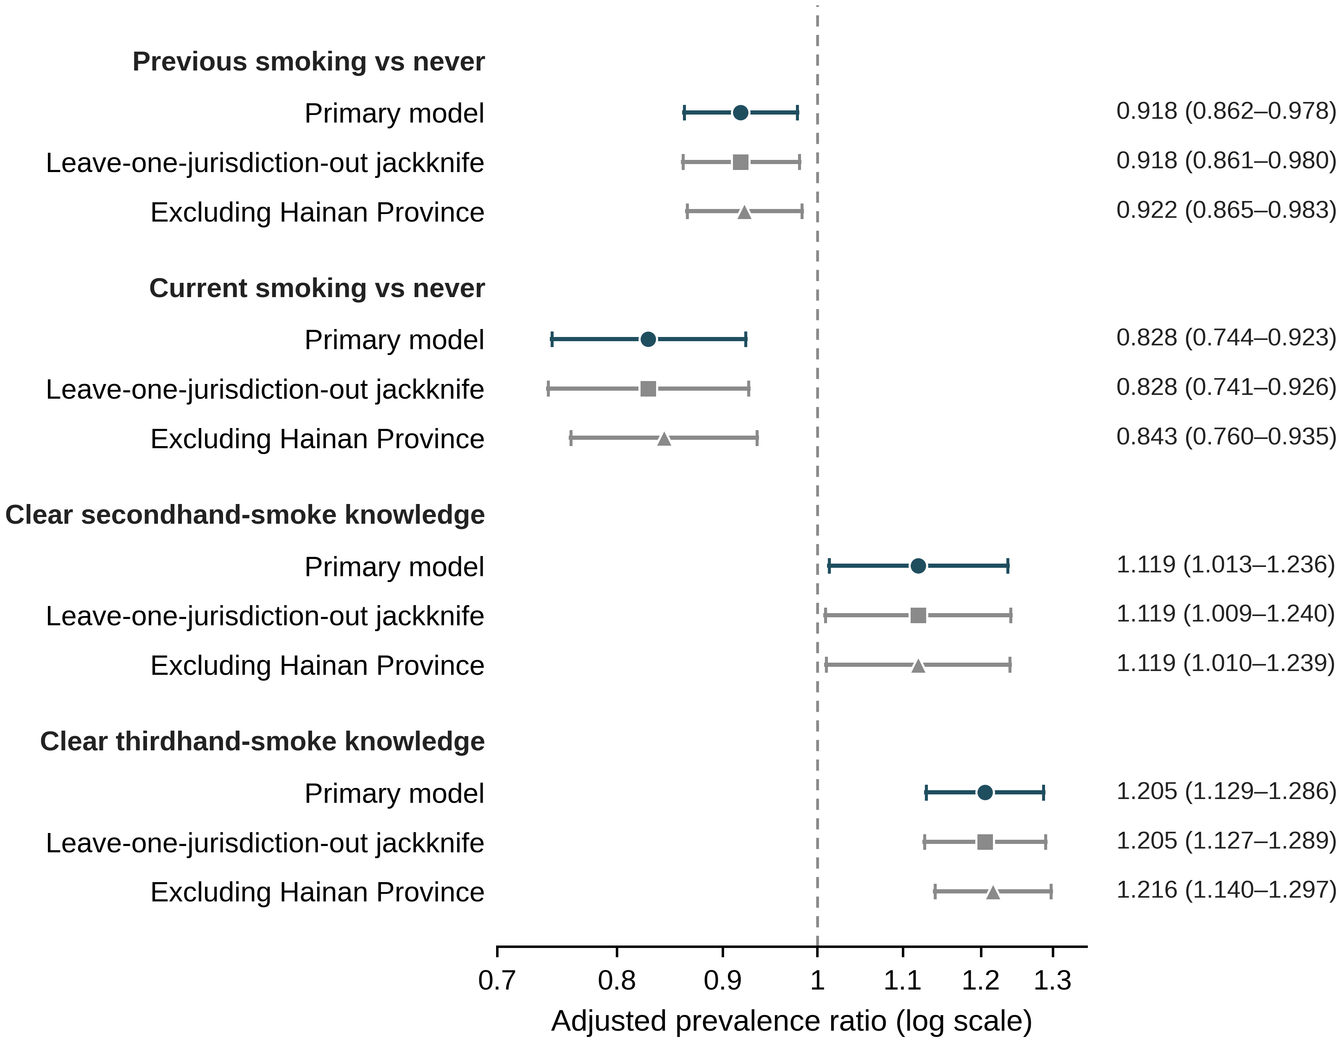Supplementary Figure S3. Robustness of key adjusted prevalence ratios across model specifications.

Adjusted prevalence ratios with 95% confidence intervals for four key correlates under the primary model, a leave-one-jurisdiction-out cluster jackknife, and a model excluding Hainan Province (47 jurisdictions; n=3,052 supporters). Leave-one-jurisdiction-out intervals use a cluster jackknife approximation. The dashed vertical line marks the null value of 1.0 and the x-axis is logarithmic. No formal statistical comparison between specifications is implied.

Supplementary Appendix S1. Fielded Chinese wording and English translation of questionnaire items used in this analysis
Chinese wording is reproduced for the key items, particularly Q6 and Q45. English translations are functional translations used for the manuscript; response-order randomization is described in Methods.
Item | Fielded Chinese wording | English translation / analytic note
Opening preamble | 全面无烟立法是指应通过立法，完全禁止在全部室内公共场所、公共交通工具、室内工作场所吸烟，包括不能设置吸烟室。我国二手烟暴露率高达68.1%，但至今仍未有全国无烟立法。 | "Comprehensive smoke-free legislation" means legislation completely prohibiting smoking in all indoor public places, public transport, and indoor workplaces, including no smoking rooms. The preamble also stated that secondhand-smoke exposure in China was high and that national comprehensive legislation was absent.
Q1 | 您是否支持我国在全国层面进行全面无烟立法？ 选项：支持；不支持。 | Do you support national comprehensive smoke-free legislation in China? Support / Do not support.
Q2 | 您支持在以下哪类场所全面禁止吸烟（可多选）？关键选项：全面无烟立法规定的场所（室内公共场所、公共交通工具、室内工作场所）。 | In which types of places do you support complete smoking prohibition? Multiple response. Key option: places covered by comprehensive smoke-free legislation (indoor public places, public transport, indoor workplaces).
Q3 | 对于在以下具体室内公共场所全面禁烟，您有多支持，请打分（5分为强烈支持，4分为比较支持，3分为都可以，2分为比较反对，1分为强烈反对）。 | Rate support for complete smoking prohibition in each specified indoor setting on a 1-5 scale (5 strongly support to 1 strongly oppose).
Q6 | 您是否支持在禁止吸烟的公共场所设置吸烟室？ 选项：支持；不支持，全面禁烟就不能设置吸烟室。补充说明：符合消防安全要求；设置明显的标识；与非吸烟室、非吸烟区隔离；远离人员密集区域和行人必经的主要通道。 | Do you support setting up a smoking room in public places where smoking is prohibited? Support / Do not support (complete prohibition should not allow smoking rooms). Additional description: meets fire-safety requirements; clear signage; separated from nonsmoking rooms/areas; away from crowded areas and major pedestrian routes.
Q15 | 您是否知道什么是二手烟？ 选项：明确知道；听说过但概念较模糊；完全没听过。 | Do you know what secondhand smoke is? Clearly know / Heard of it but concept is vague / Never heard of it.
Q17 | 您是否知道什么是三手烟？ 选项：明确知道；听说过但概念较模糊；完全没听过。 | Do you know what thirdhand smoke is? Clearly know / Heard of it but concept is vague / Never heard of it.
Q18 | 在本次调查前，你是否听说过全面无烟立法？ 选项：听说过；没有听过。 | Before this survey, had you heard of comprehensive smoke-free legislation? Yes / No.
Q45 | 您的吸烟情况：A. 当前吸烟（现在每天或偶尔吸烟），烟龄为____年；B. 以前吸烟（过去一年或一年以前吸烟，现在已戒烟），以前共吸烟____年，已戒烟____年；C. 从未吸烟。 | Smoking status: A. Current smoking (now smokes daily or occasionally); B. Previous smoking (smoked previously, whether within the past year or earlier, and has now quit); C. Never smoked. No lifetime-consumption threshold was specified.
Q47 | 在过去30天内，您是否在电视、手机、报纸或杂志、街边广告牌、社区宣传栏等地方中见到有关吸烟危险、鼓励戒烟或宣传在公共场所禁烟的信息？ 选项：从未见到过；在一种媒介中见到过；在多种媒介中见到过。 | In the past 30 days, have you seen information about smoking harms, cessation, or smoke-free public places? Never / In one type of medium / In multiple media.

Supplementary references
1. Chen Y, Zhao X, Chen Z, Zhang X, Li J, Lan J, et al. A comparative analysis of smoke-free regulations in 23 Chinese cities, 2015-2022. Tob Induc Dis. 2026;24(July):131. doi:10.18332/tid/221923.
2. Chinese Center for Disease Control and Prevention. 2018 China Adult Tobacco Survey: Executive Summary. Beijing: Chinese Center for Disease Control and Prevention; 2019.
3. Zeng X, Liu S, Liu Y, Xiao L. Smoking prevalence in urban and rural areas - China, 2024. China CDC Wkly. 2025;7(22):751-759. doi:10.46234/ccdcw2025.124.

