Supporting Information
Studies on Biological Activity of Amide Derivatives Derived from Natural Product Waltherione F

Hongbin Fang¹, Zhanfang Chen¹, Xuewen Hua¹*, Wenrui Liu¹, Chenmeng Xue¹, Yi Liu¹, Xiaohe Zhu¹, Man Yuan¹, Shuang Cheng¹, Bingxiang Wang²*, Jing Ru³, Dzmitry Bazhanau¹, Yanhong Cui⁴*

¹ College of Agriculture, Liaocheng University, Liaocheng 252000, China
² College of Pharmacy, Liaocheng University, Liaocheng 252000, China
³ College of Chemistry and Chemical Engineering, Liaocheng University, Liaocheng 252000, China
⁴ College of Chemical Engineering and Materials Science, Zhejiang University of Technology, Hangzhou 310014, China
е-mail: huaxuewen@lcu.edu.cn, wangbingxiang@lcu.edu.cn,

* Address correspondence to author at College of Agriculture, Liaocheng University, No. 1, Hu’nan Road, Dongchangfu District, Liaocheng 252000, China (Tel: 0086-06358239295; E-mail: huaxuewen906@163.com, wangbingxiang@lcu.edu.cn, cuiyanhong@ zjut.edu.cn)

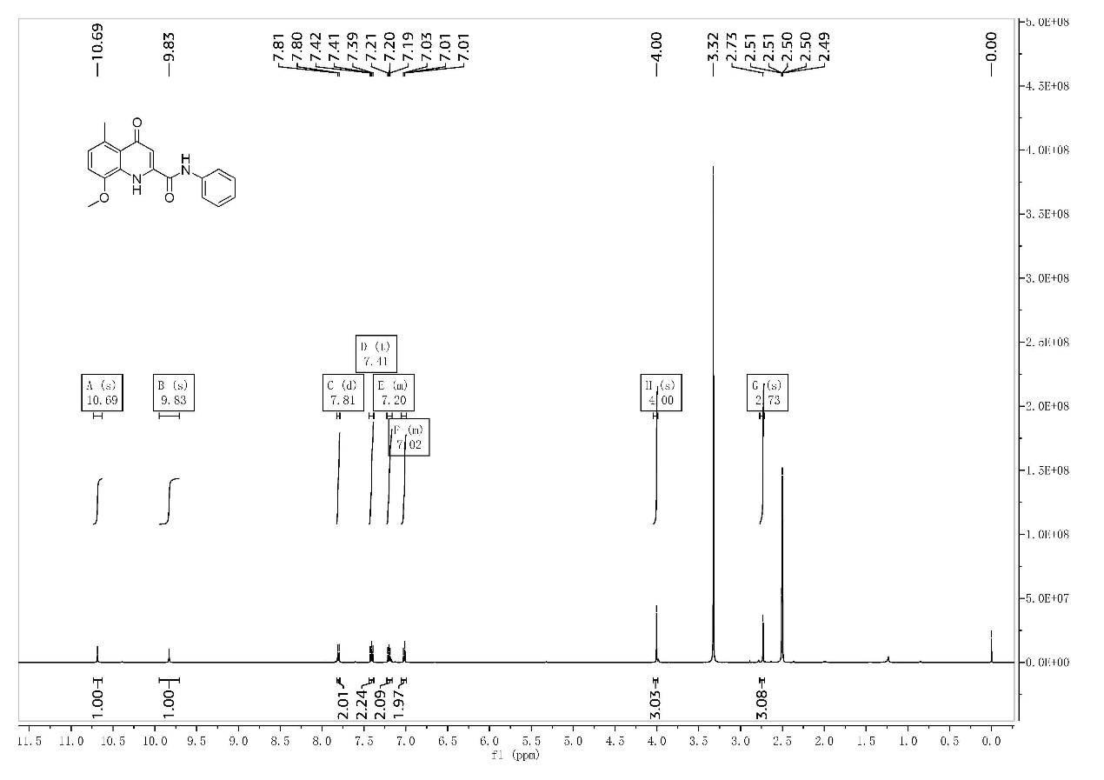
S1-1 ¹H-NMR of the compound I-1
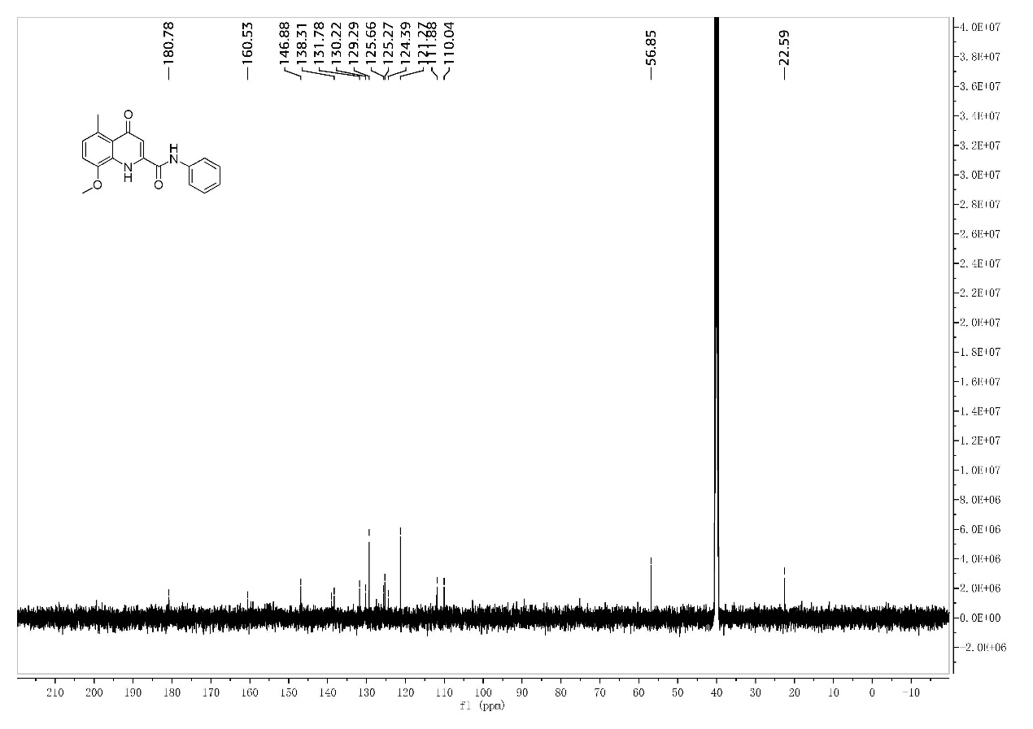
S1-2 ¹³C-NMR of the compound I-1
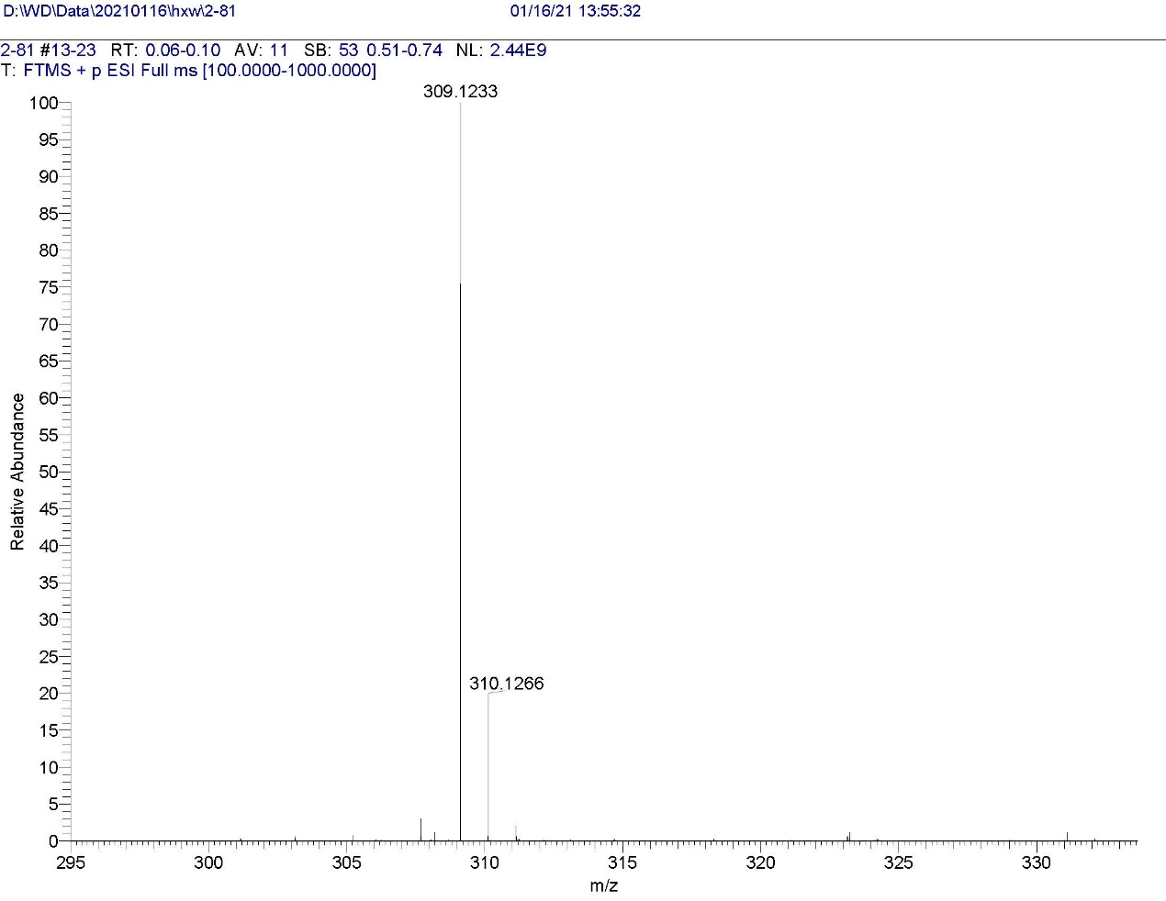
S1-3 HRMS of the compound I-1
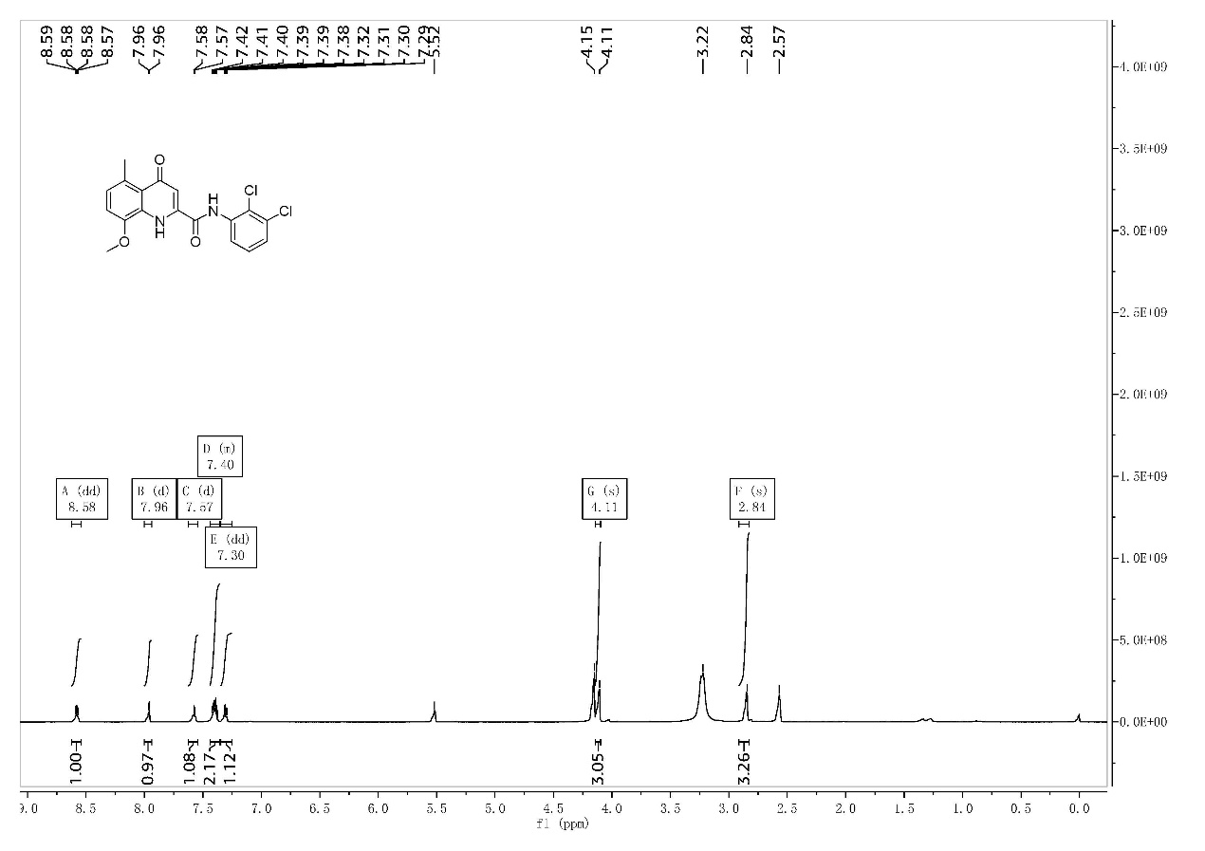
S2-1 ¹H-NMR of the compound I-2
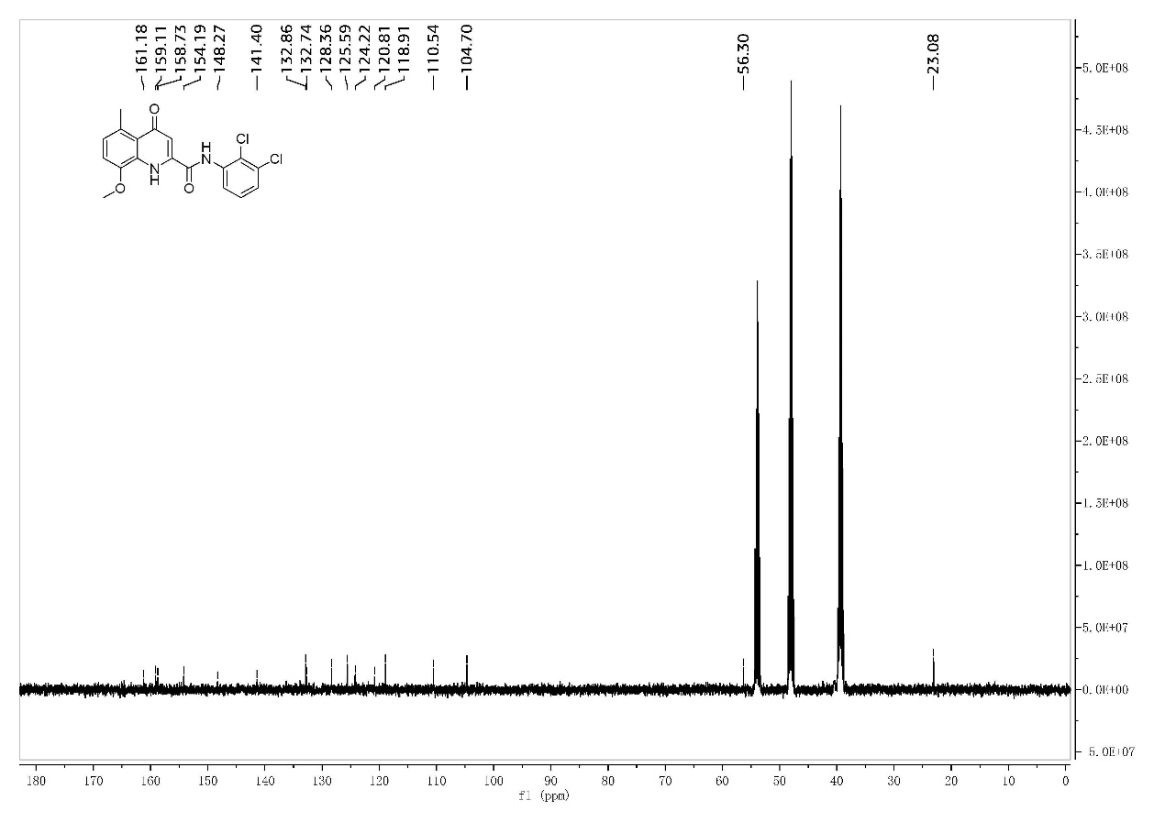
S2-2 ¹³C-NMR of the compound I-2
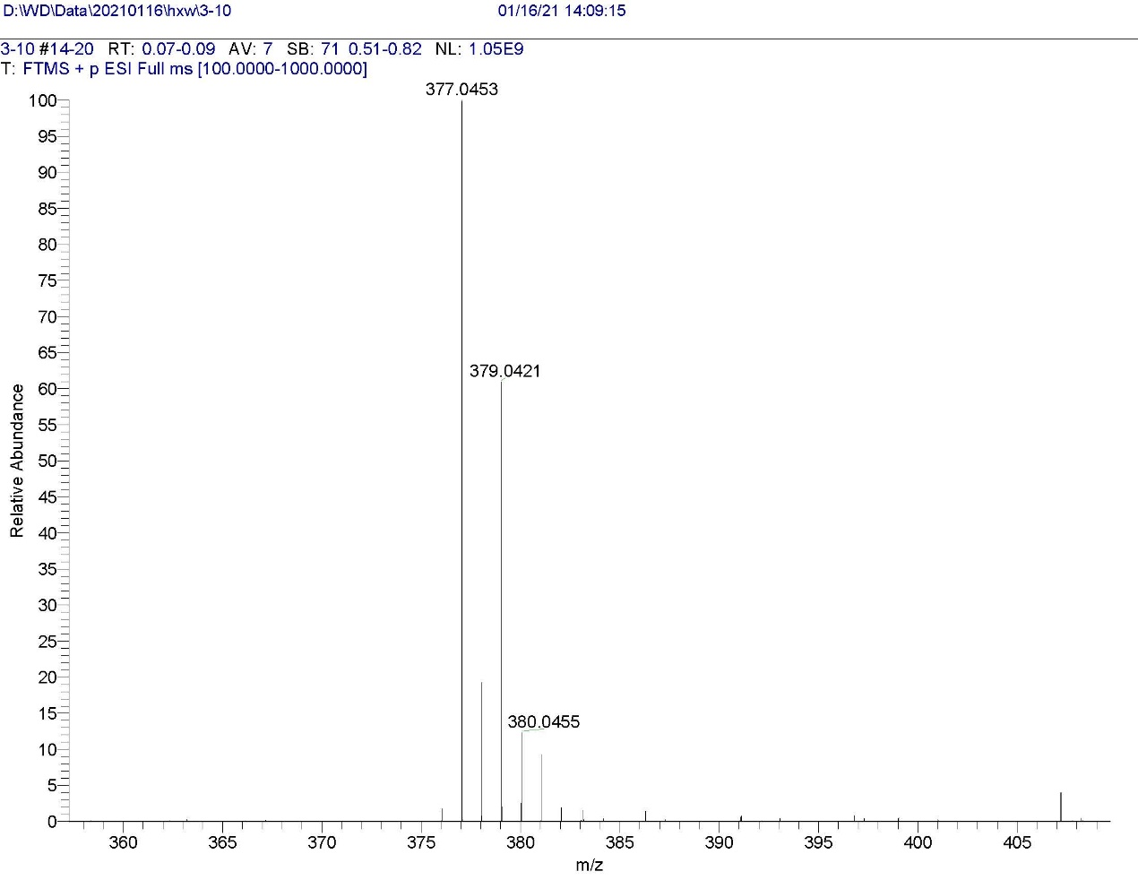
S2-3 HRMS of the compound I-2
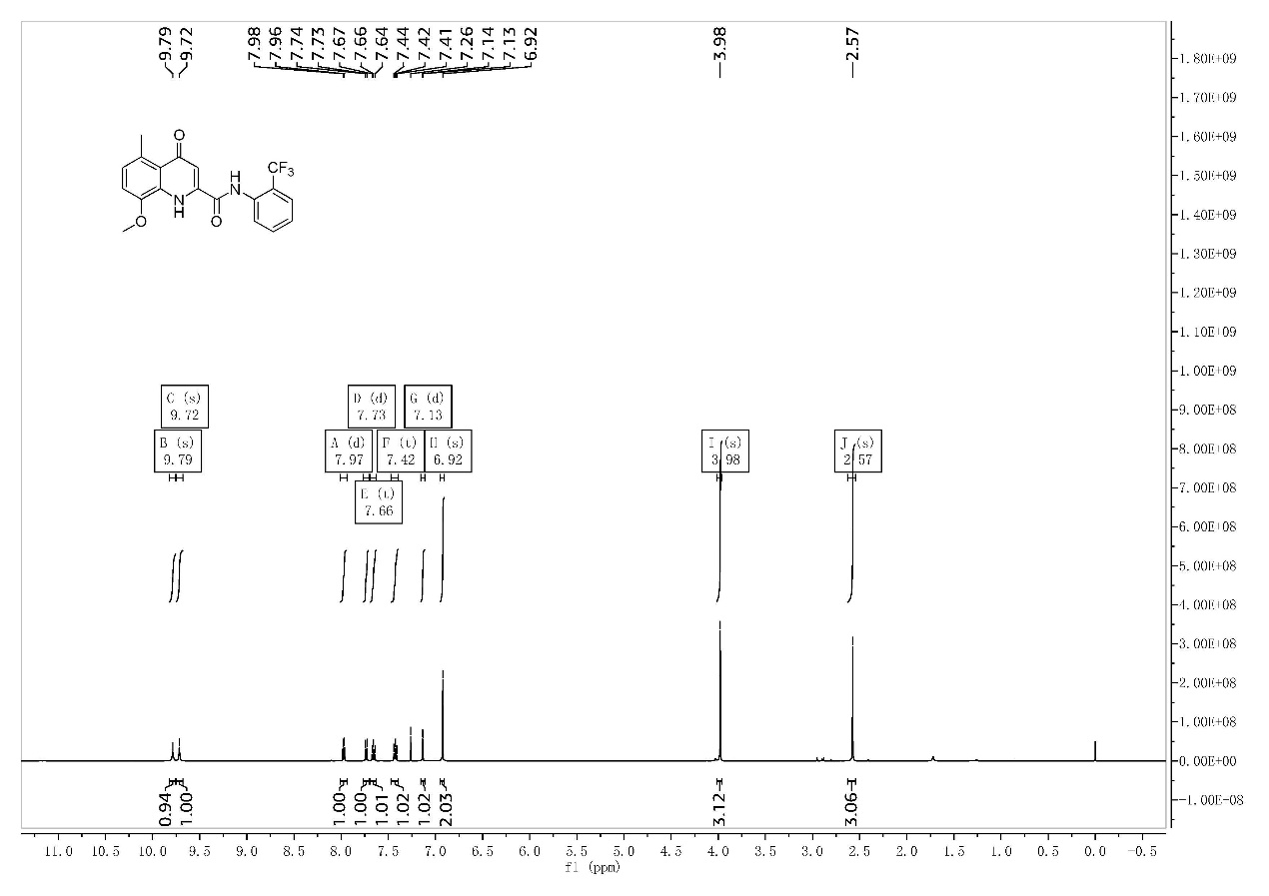
S3-1 ¹H-NMR of the compound I-3
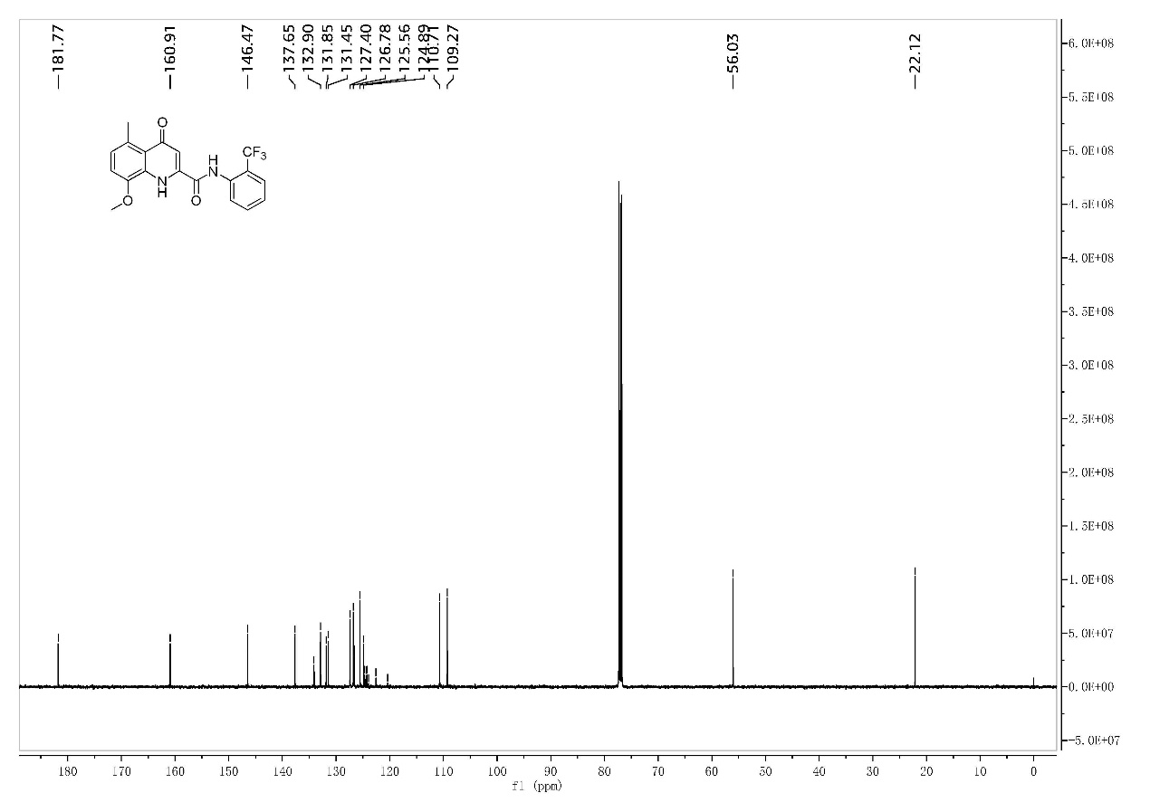
S3-2 ¹³C-NMR of the compound I-3
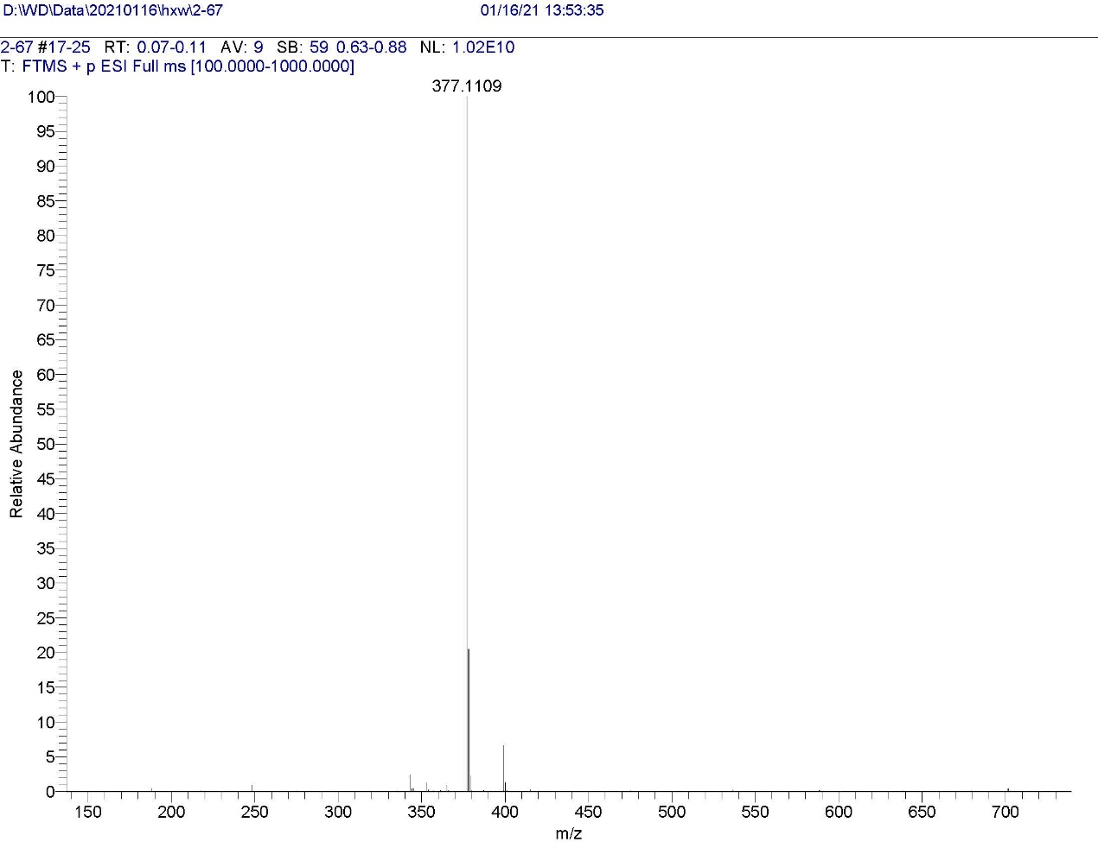
S3-3 HRMS of the compound I-3
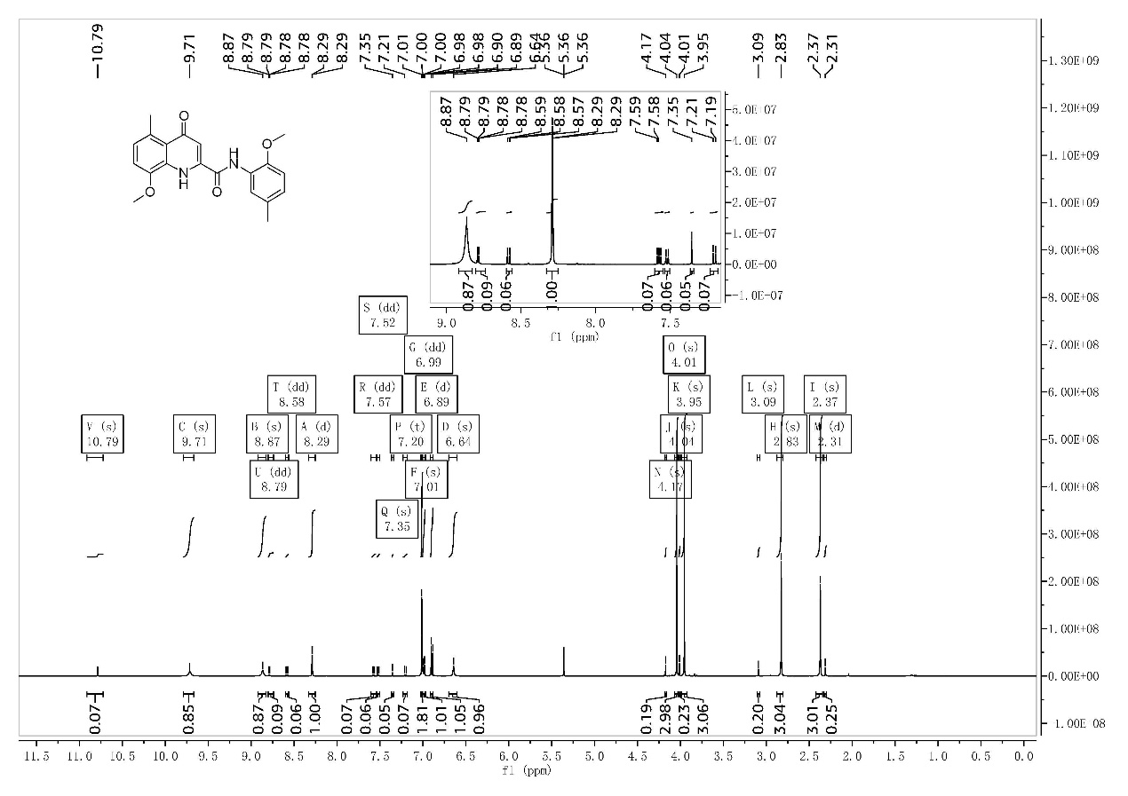
S4-1 ¹H-NMR of the compound I-4
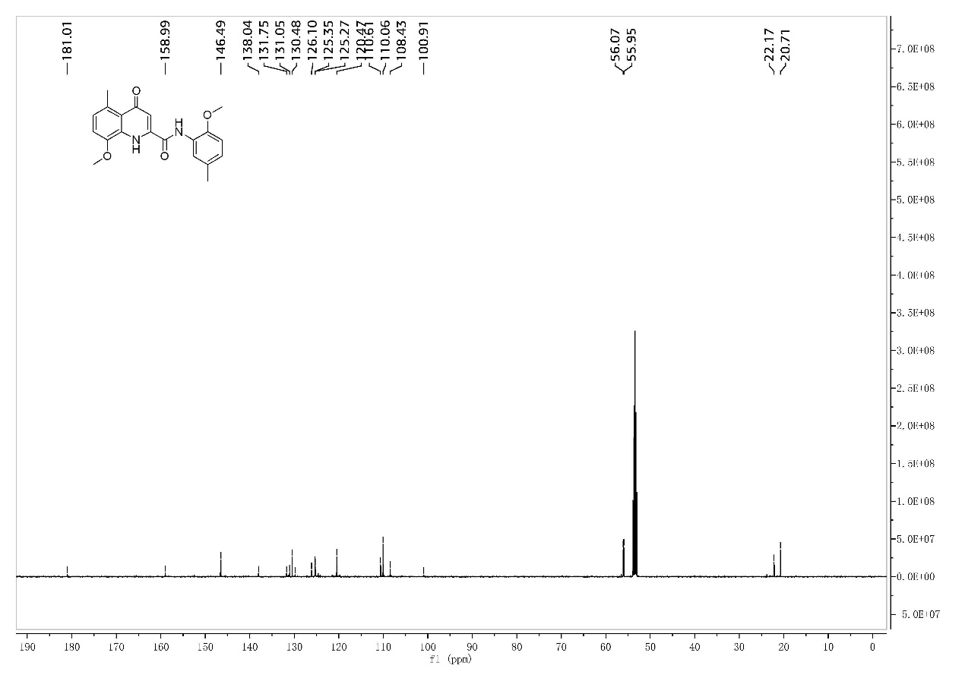
S4-2 ¹³C-NMR of the compound I-4
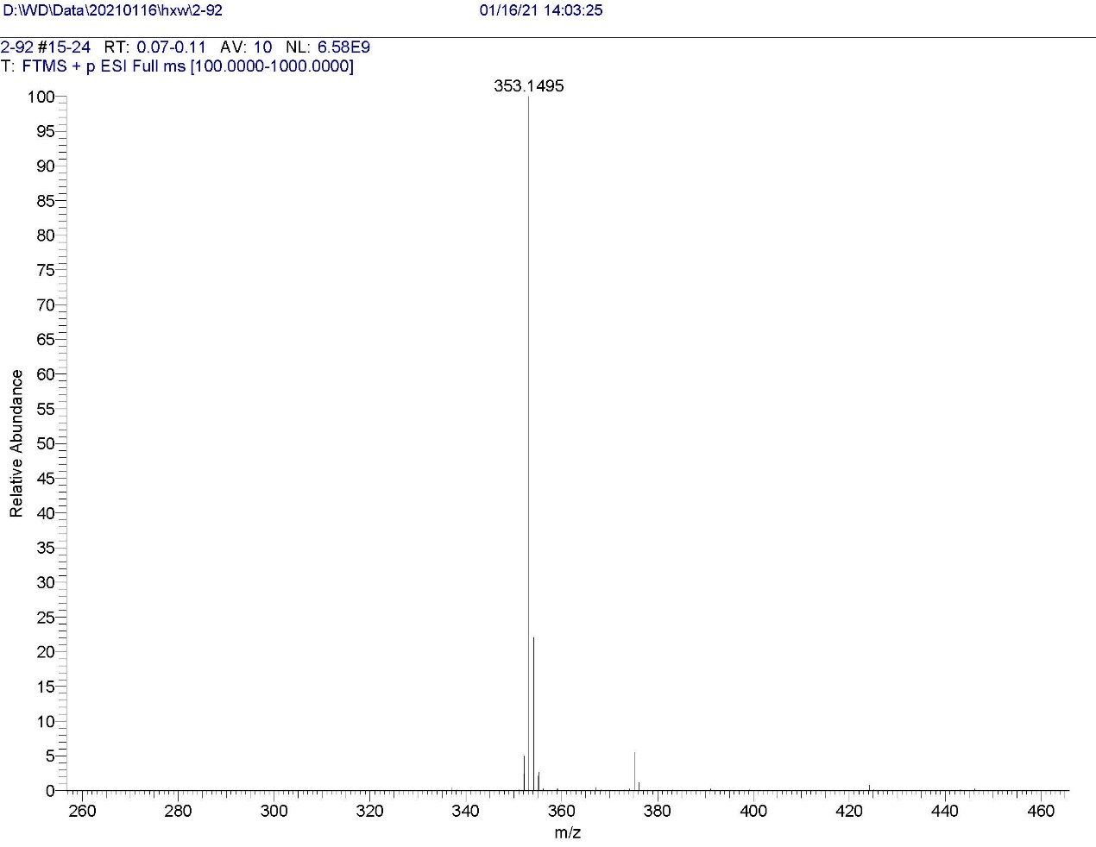
S4-3 HRMS of the compound I-4
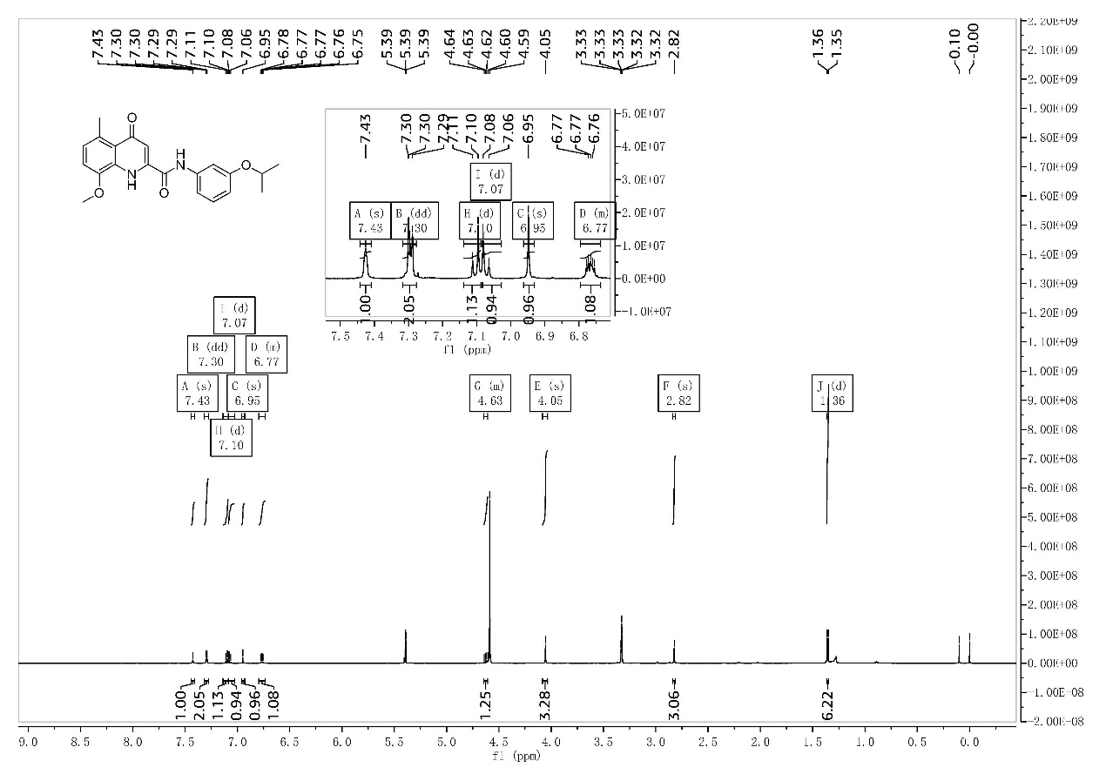
S5-1 ¹H-NMR of the compound I-5
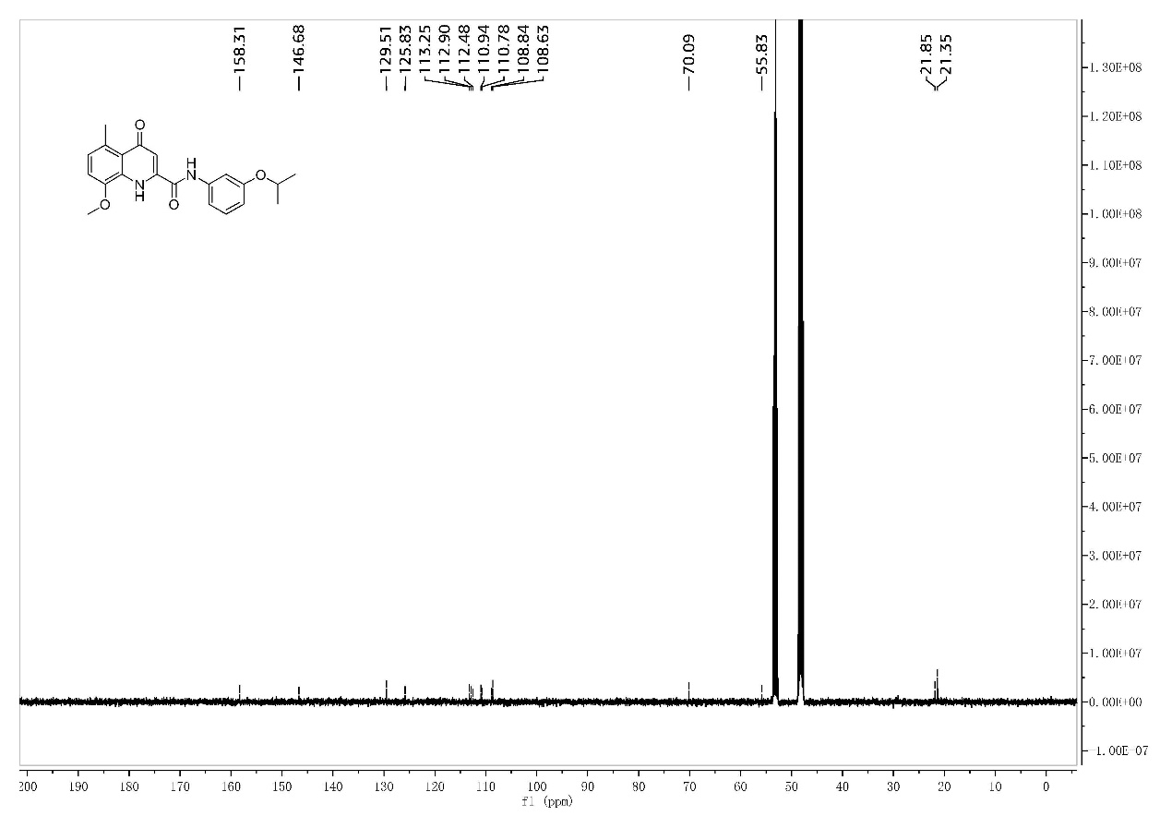
S5-2 ¹³C-NMR of the compound I-5
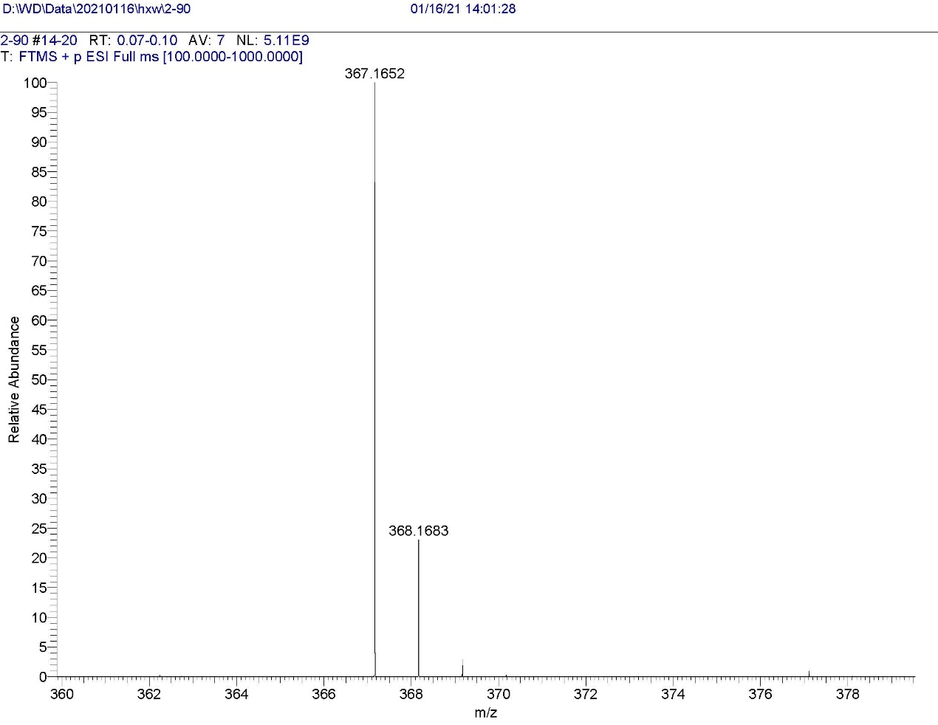
S5-3 HRMS of the compound I-5
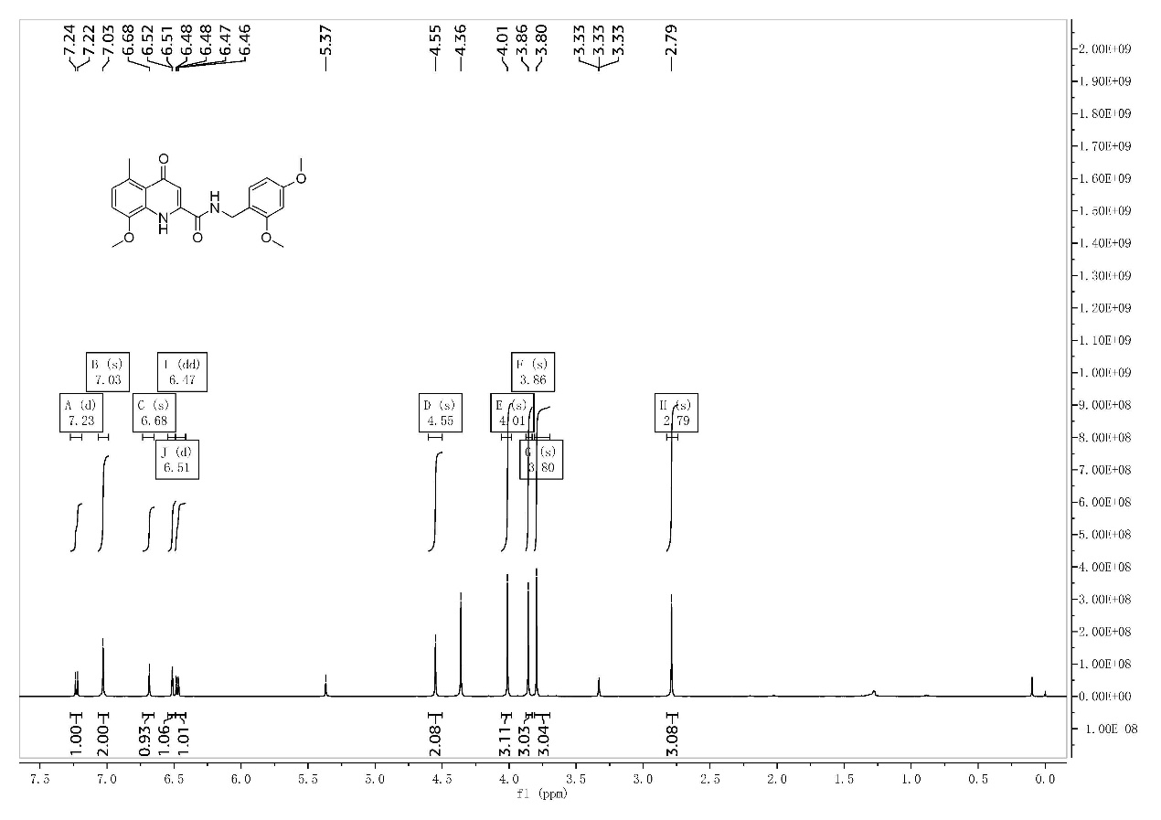
S6-1 ¹H-NMR of the compound I-6
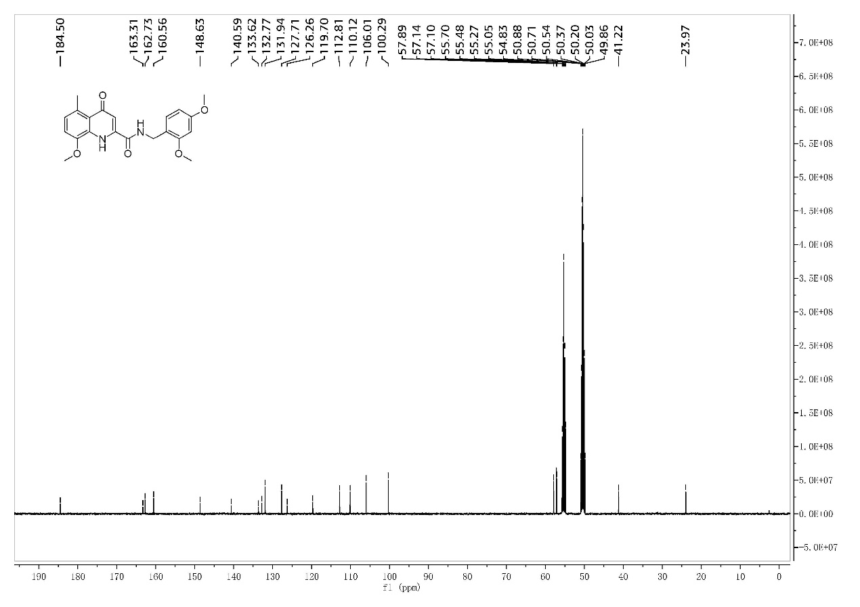
S6-2 ¹³C-NMR of the compound I-6
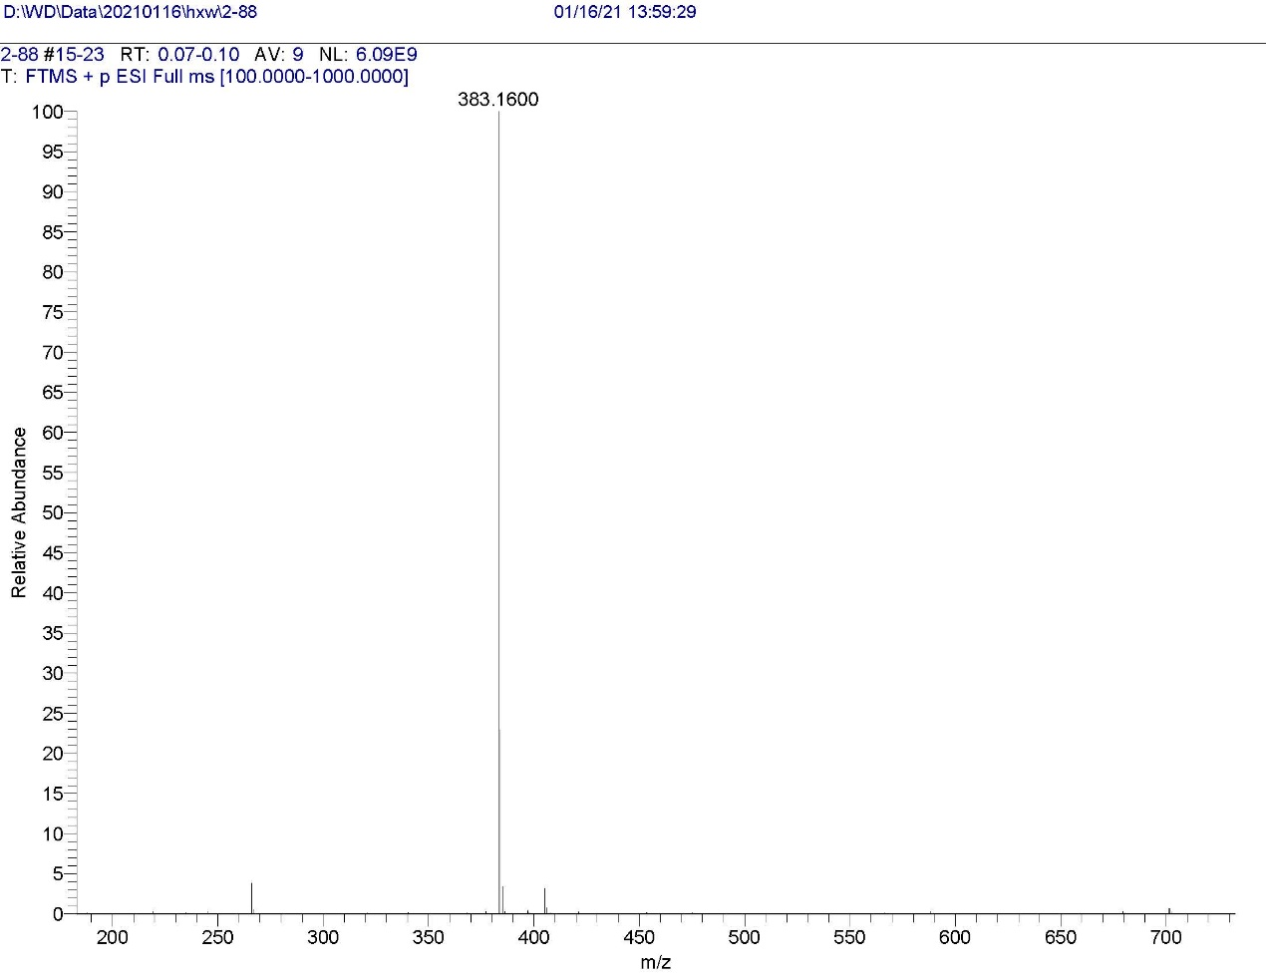
S6-3 HRMS of the compound I-6
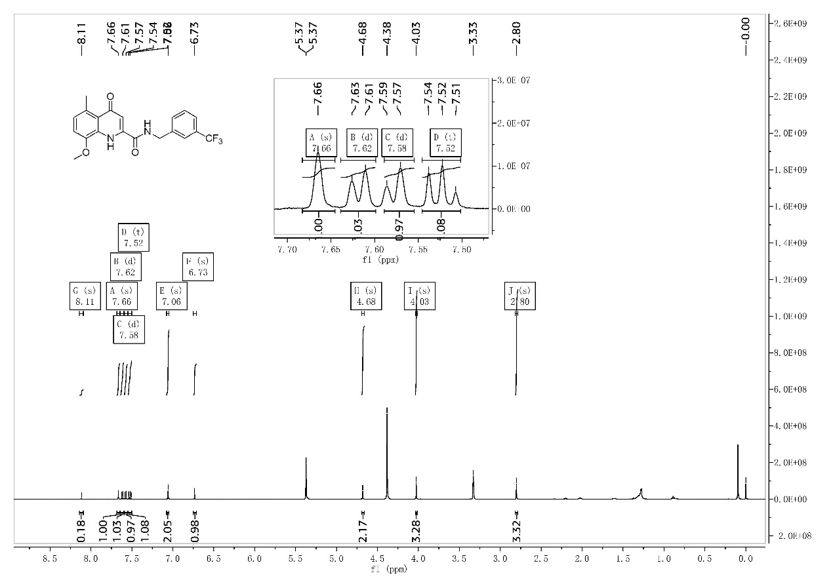
S7-1 ¹H-NMR of the compound I-7
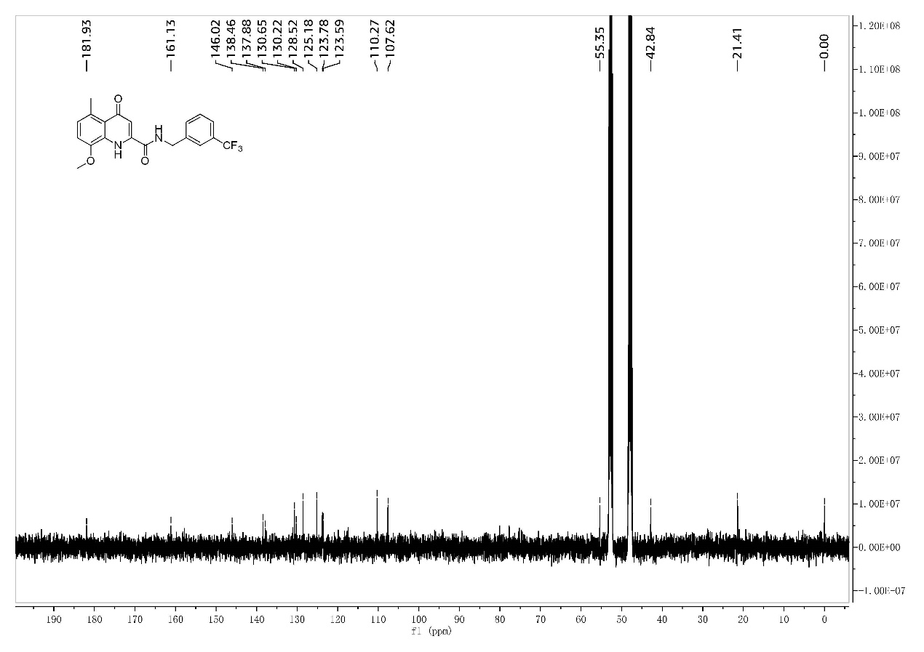
S7-2 ¹³C-NMR of the compound I-7
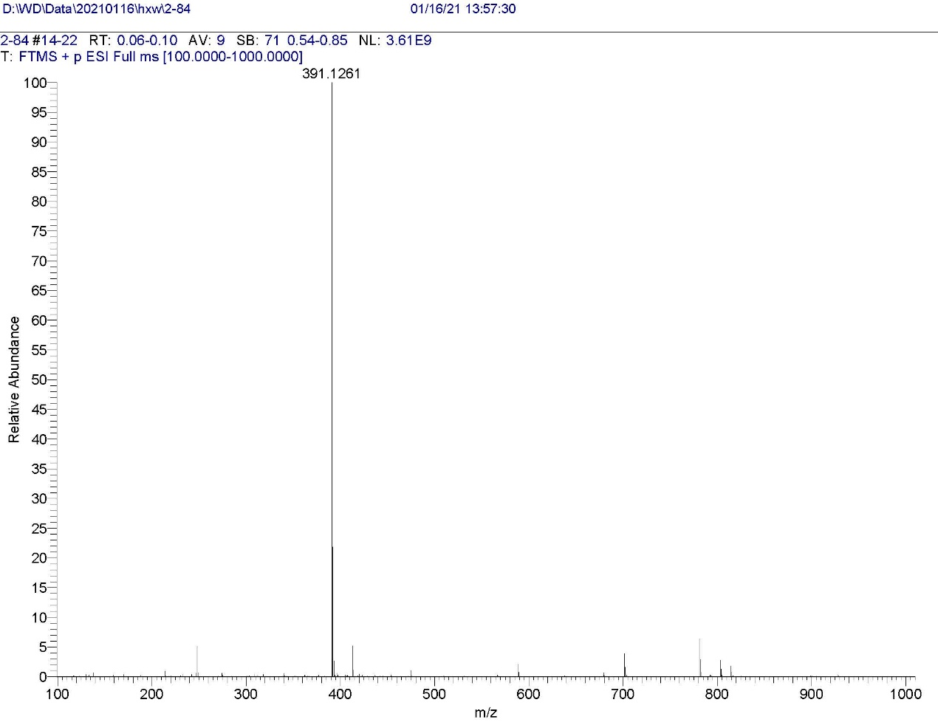
S7-3 HRMS of the compound I-7
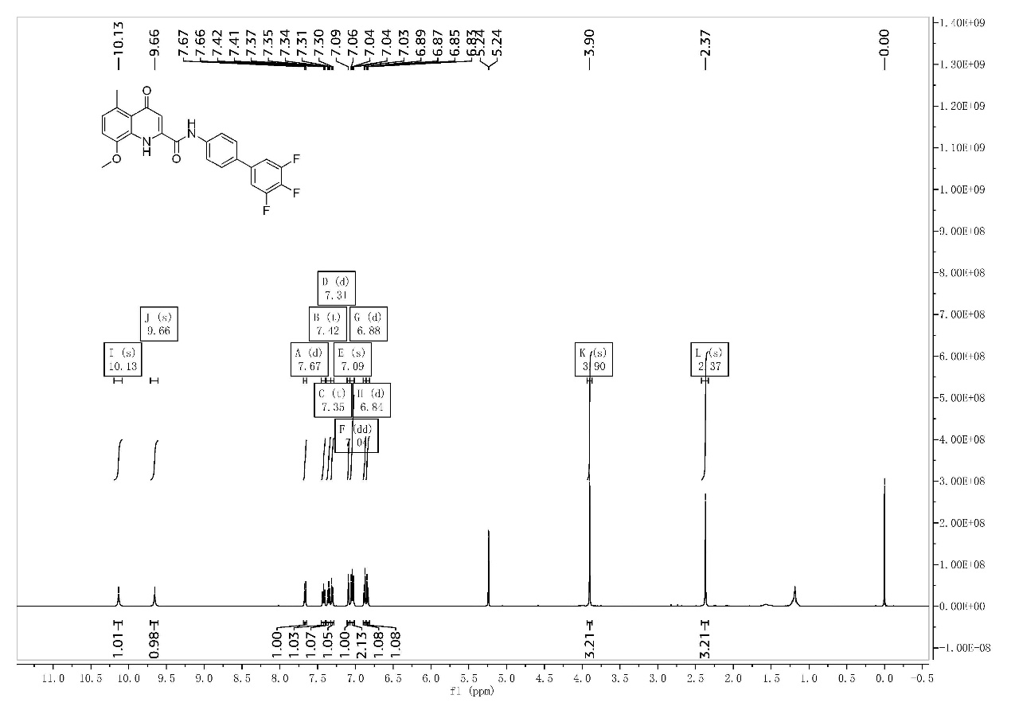
S8-1 ¹H-NMR of the compound I-8
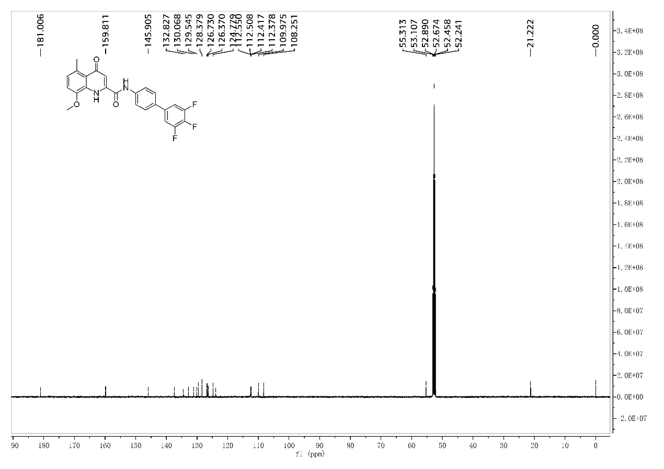
S8-2 ¹³C-NMR of the compound I-8
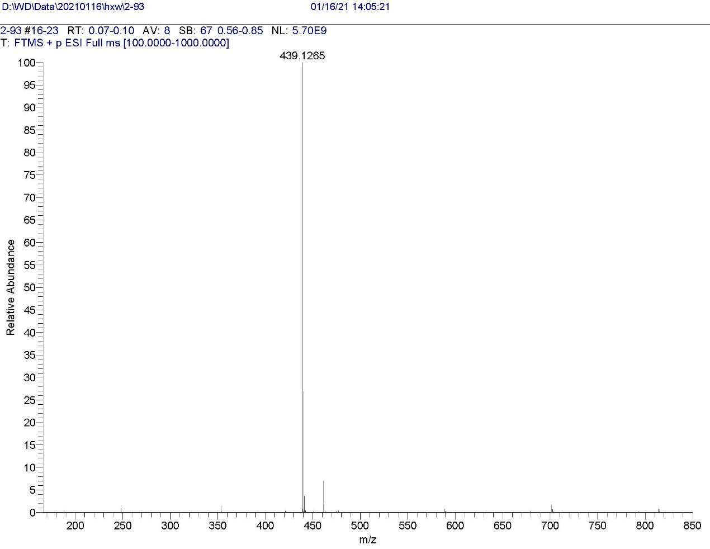
S8-3 HRMS of the compound I-8
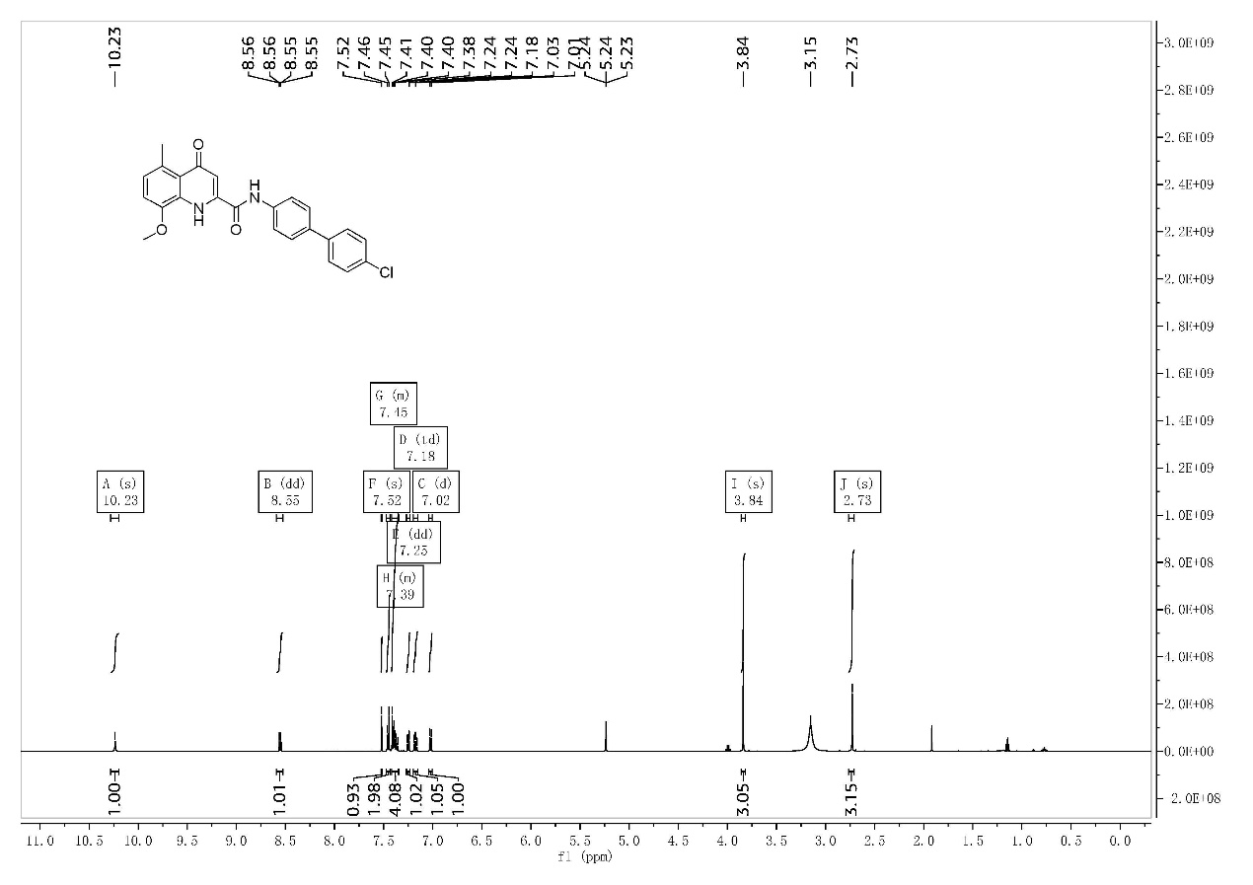
S9-1 ¹H-NMR of the compound I-9
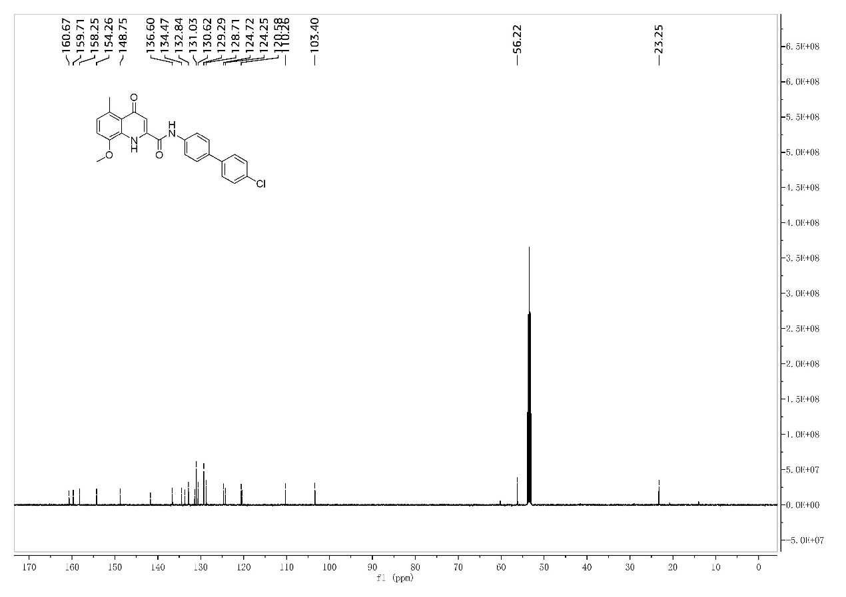
S9-2 ¹³C-NMR of the compound I-9
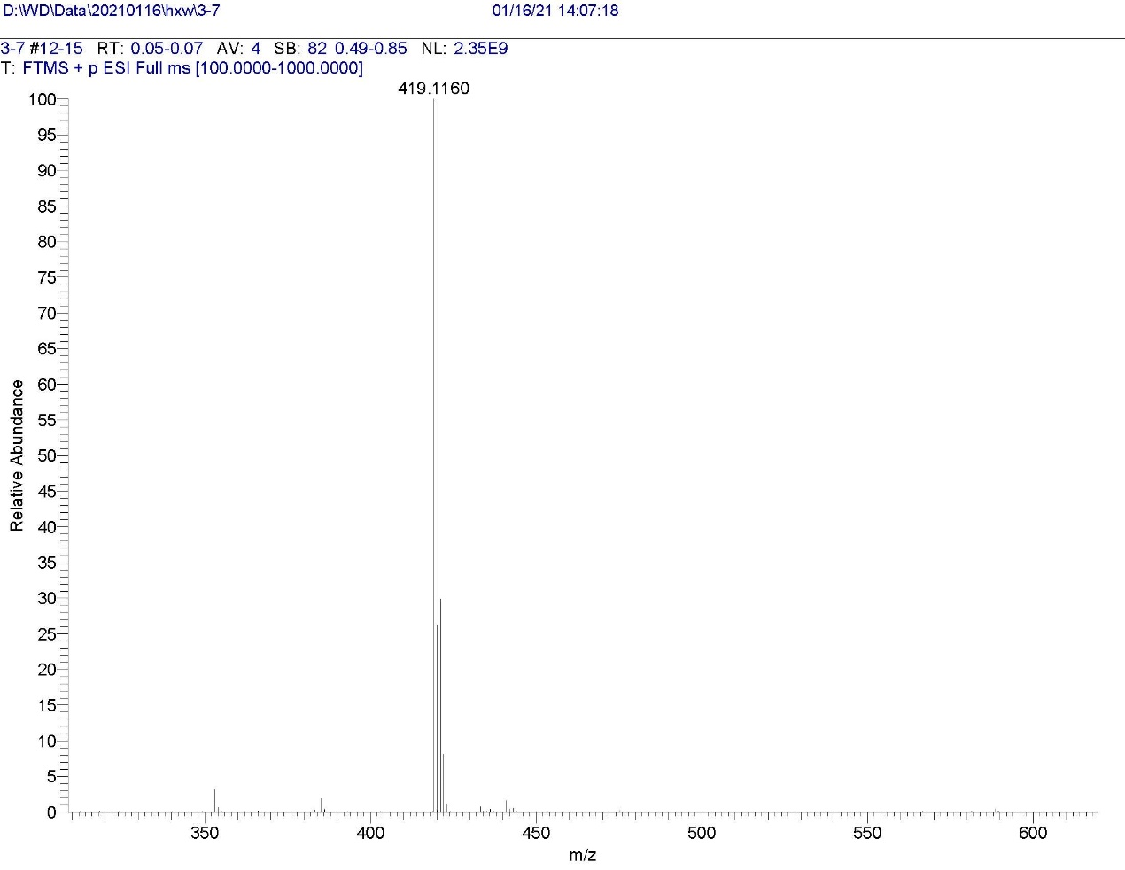
S9-3 HRMS of the compound I-9
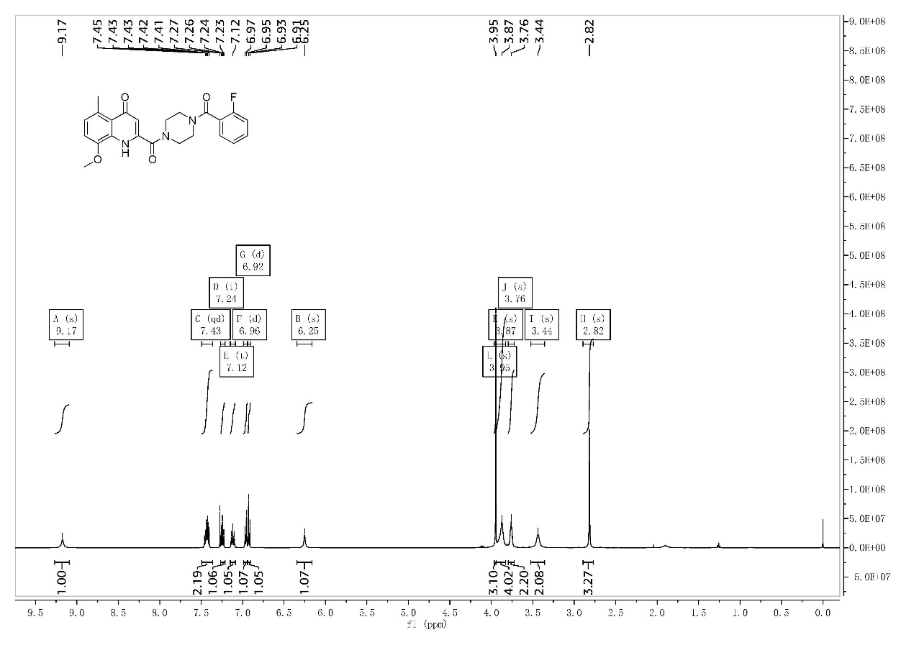
S10-1 ¹H-NMR of the compound II-1
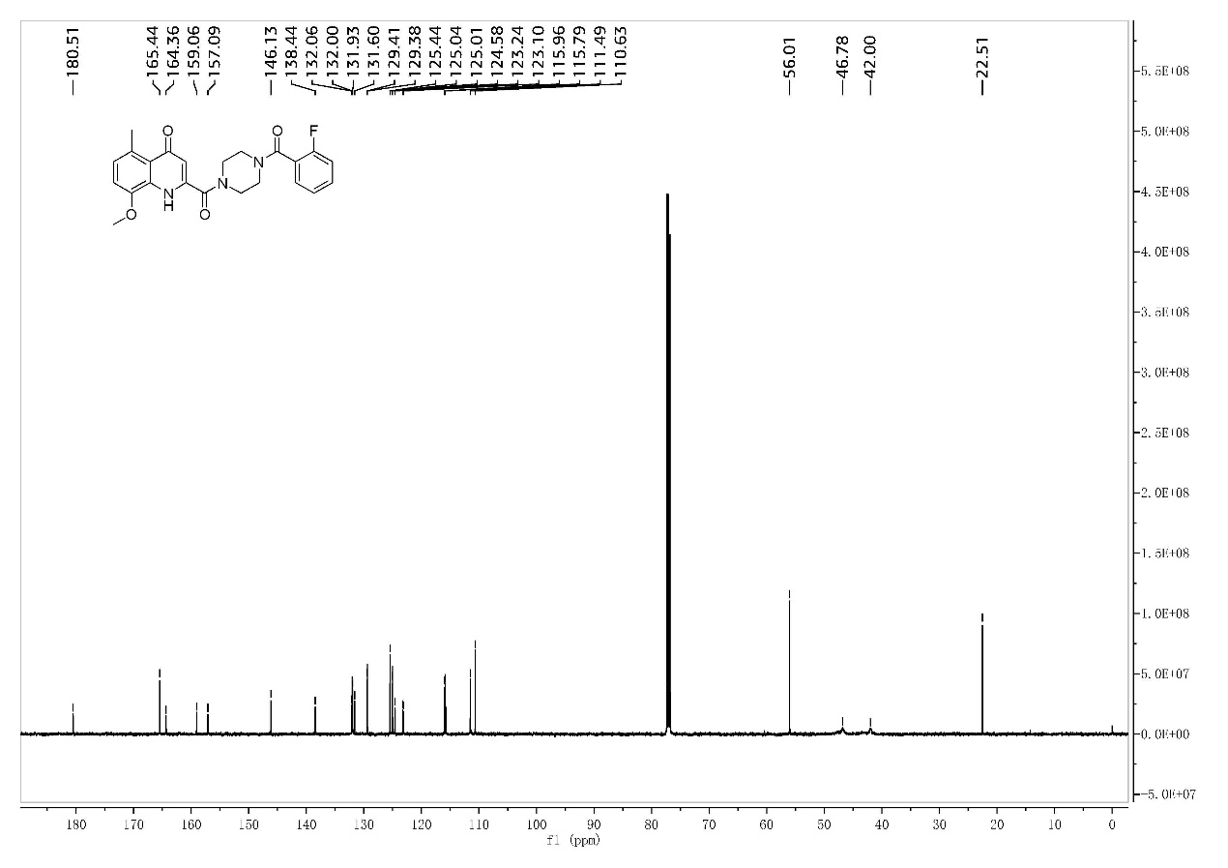
S10-2 ¹³C-NMR of the compound II-1
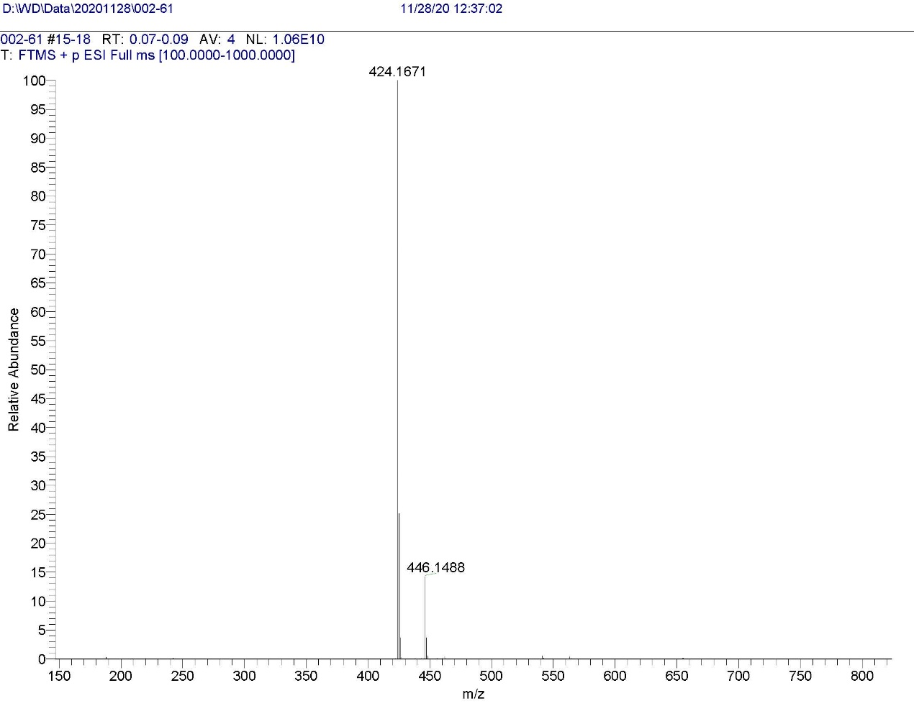
S10-3 HRMS of the compound II-1

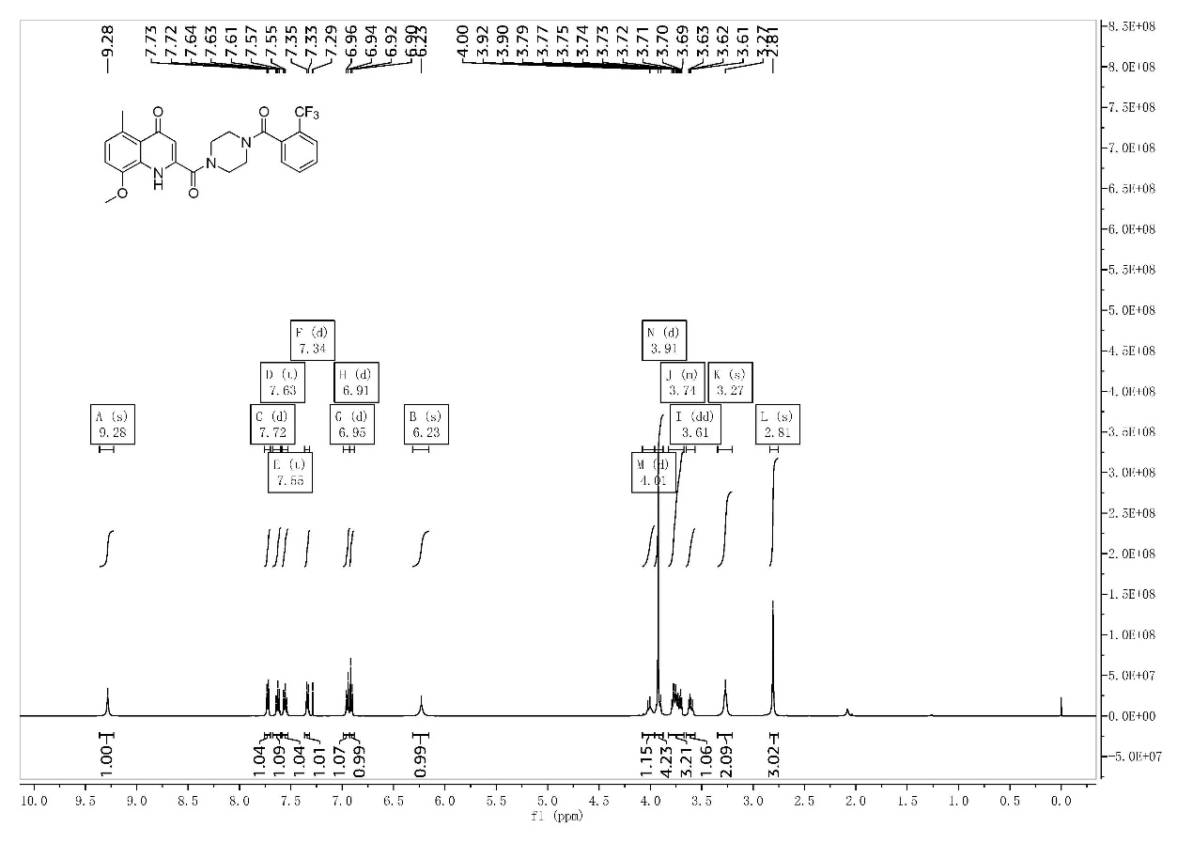
S11-1 ¹H-NMR of the compound II-2
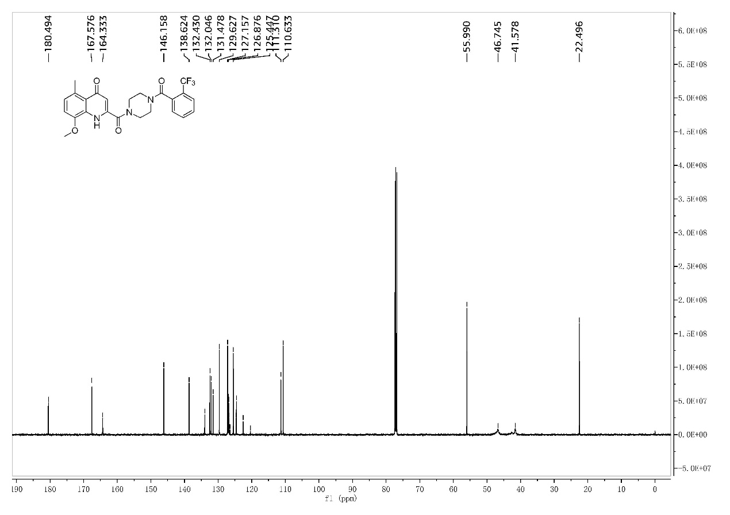
S11-2 ¹³C-NMR of the compound II-2
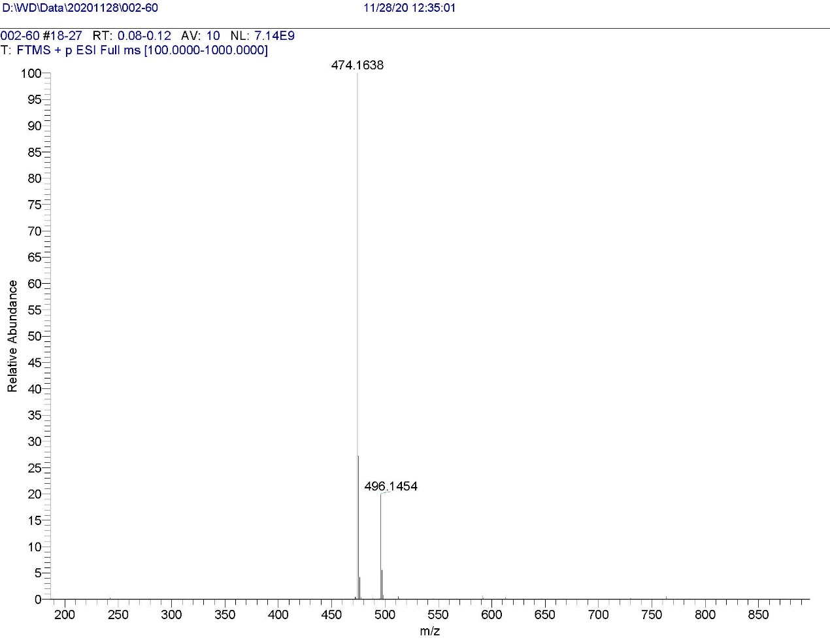
S11-3 HRMS of the compound II-2
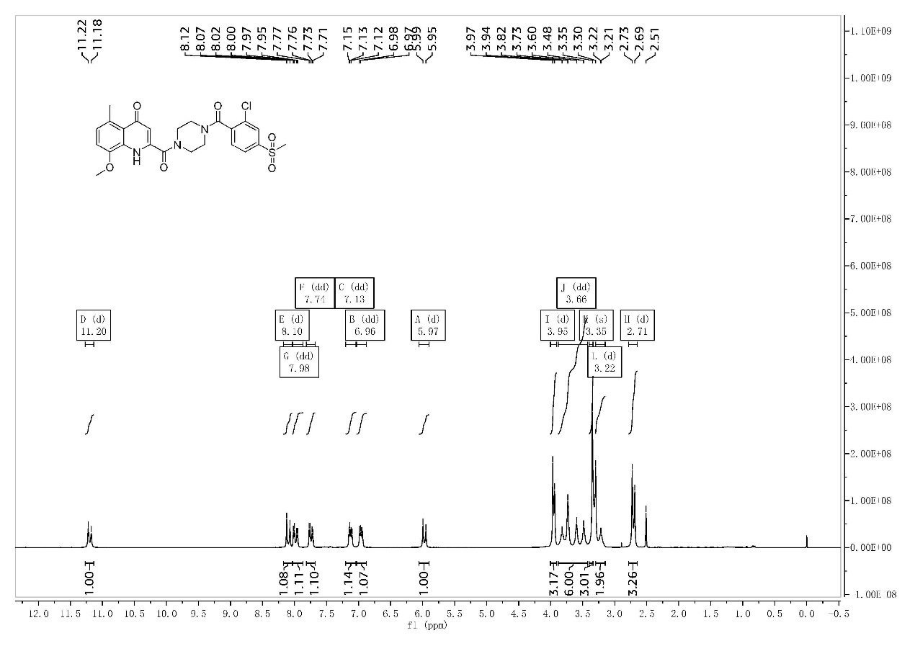
S12-1 ¹H-NMR of the compound II-3
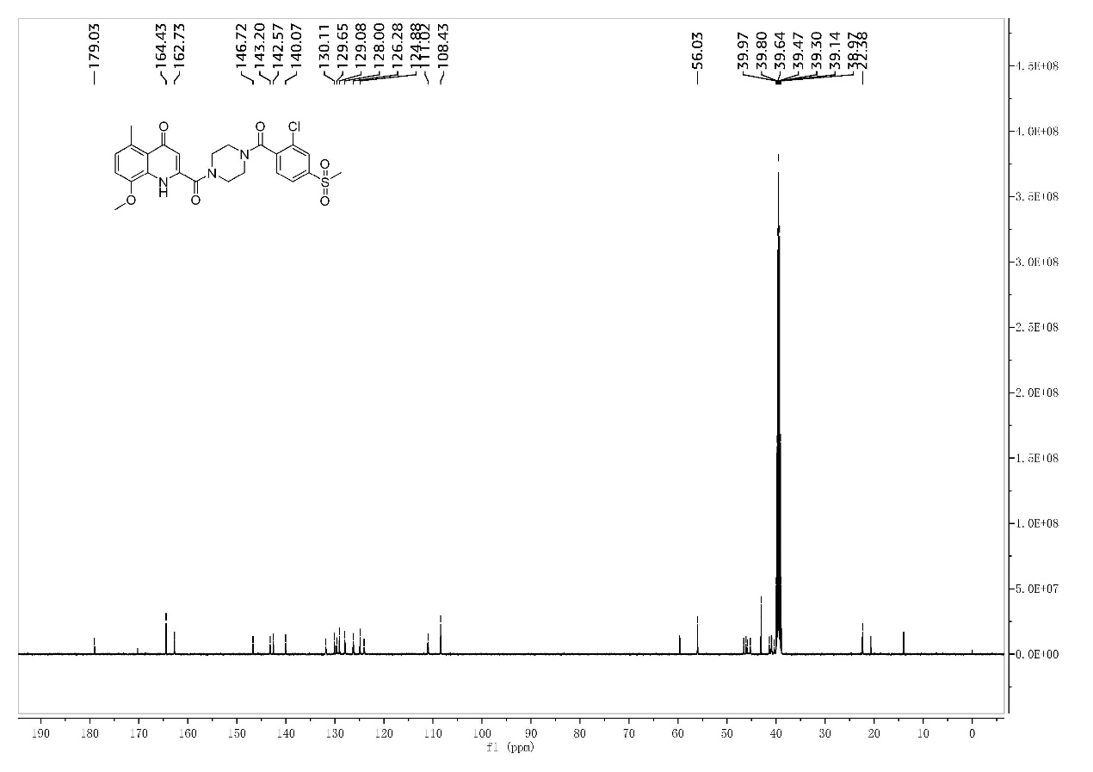
S12-2 ¹³C-NMR of the compound II-3
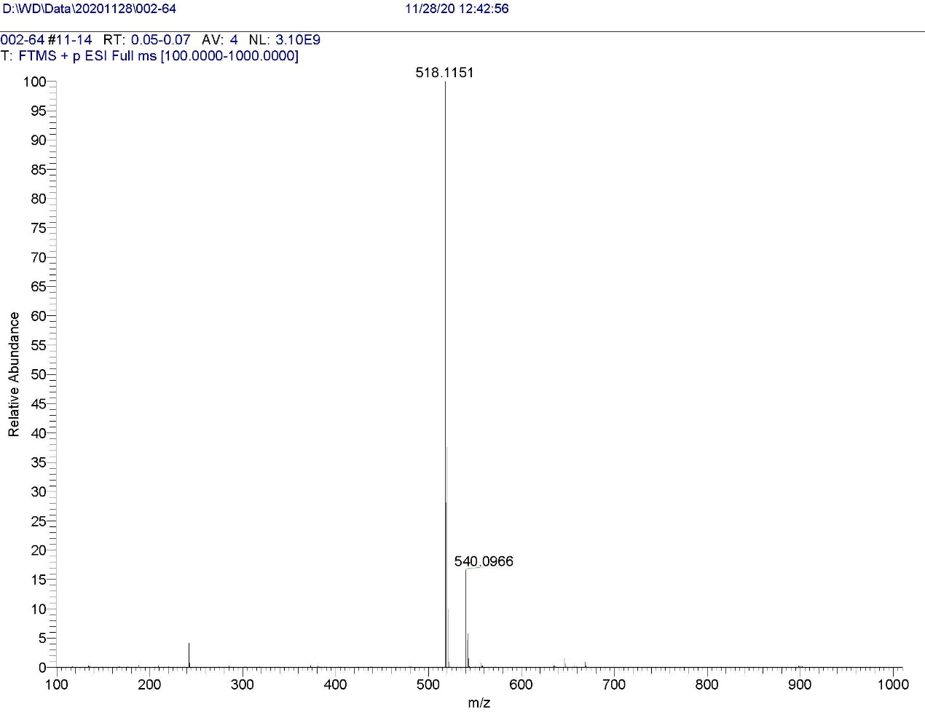
S12-3 HRMS of the compound II-3
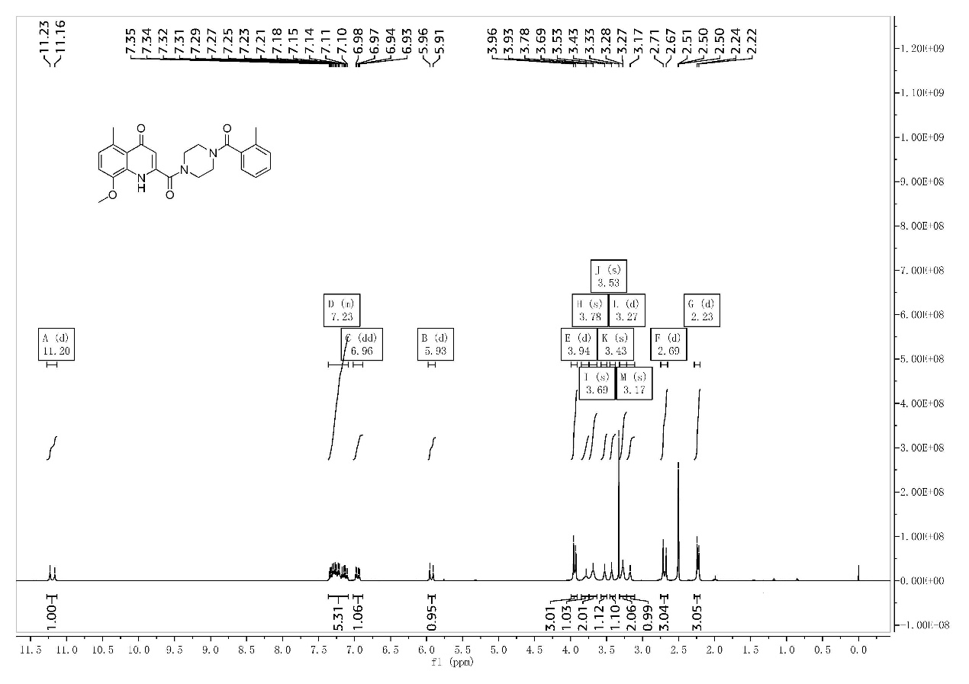
S13-1 ¹H-NMR of the compound II-4
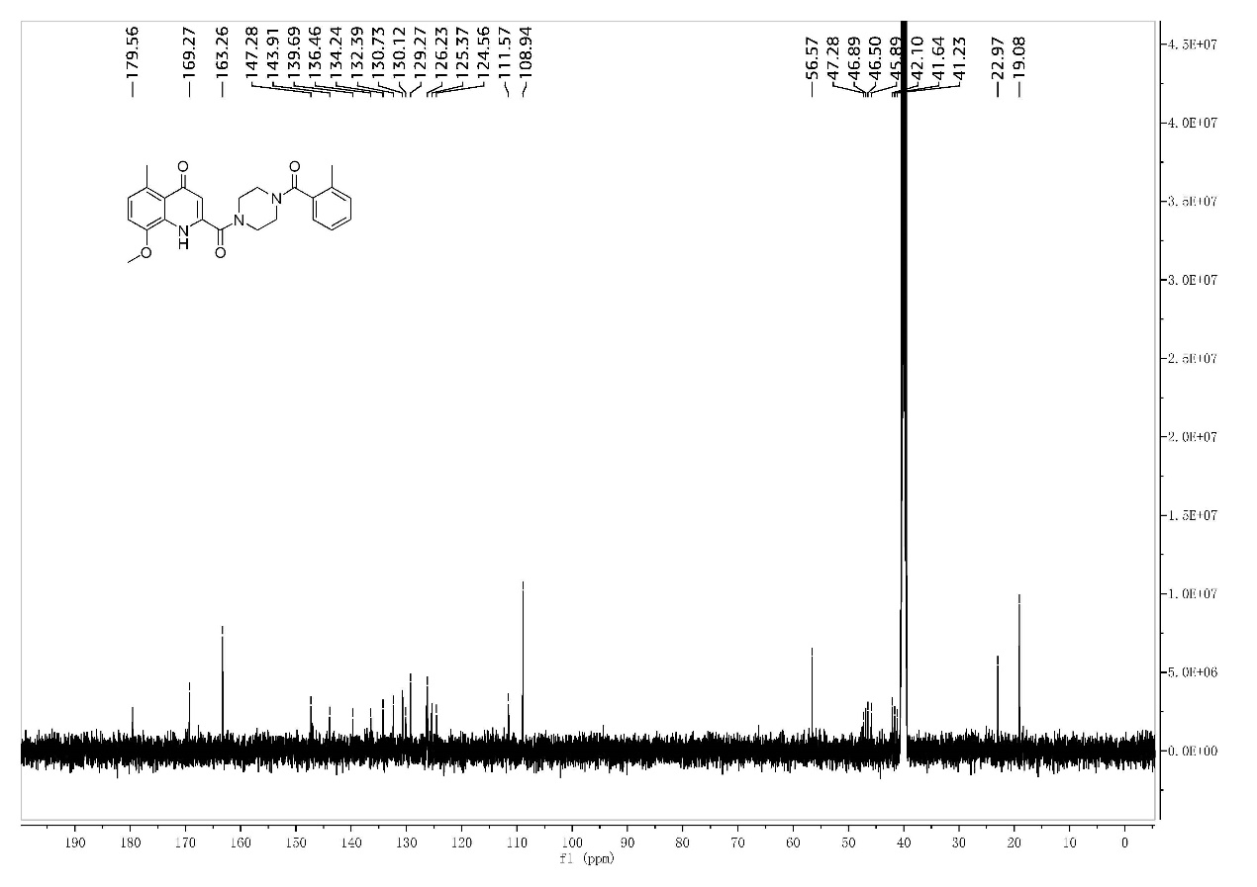
S13-2 ¹³C-NMR of the compound II-4
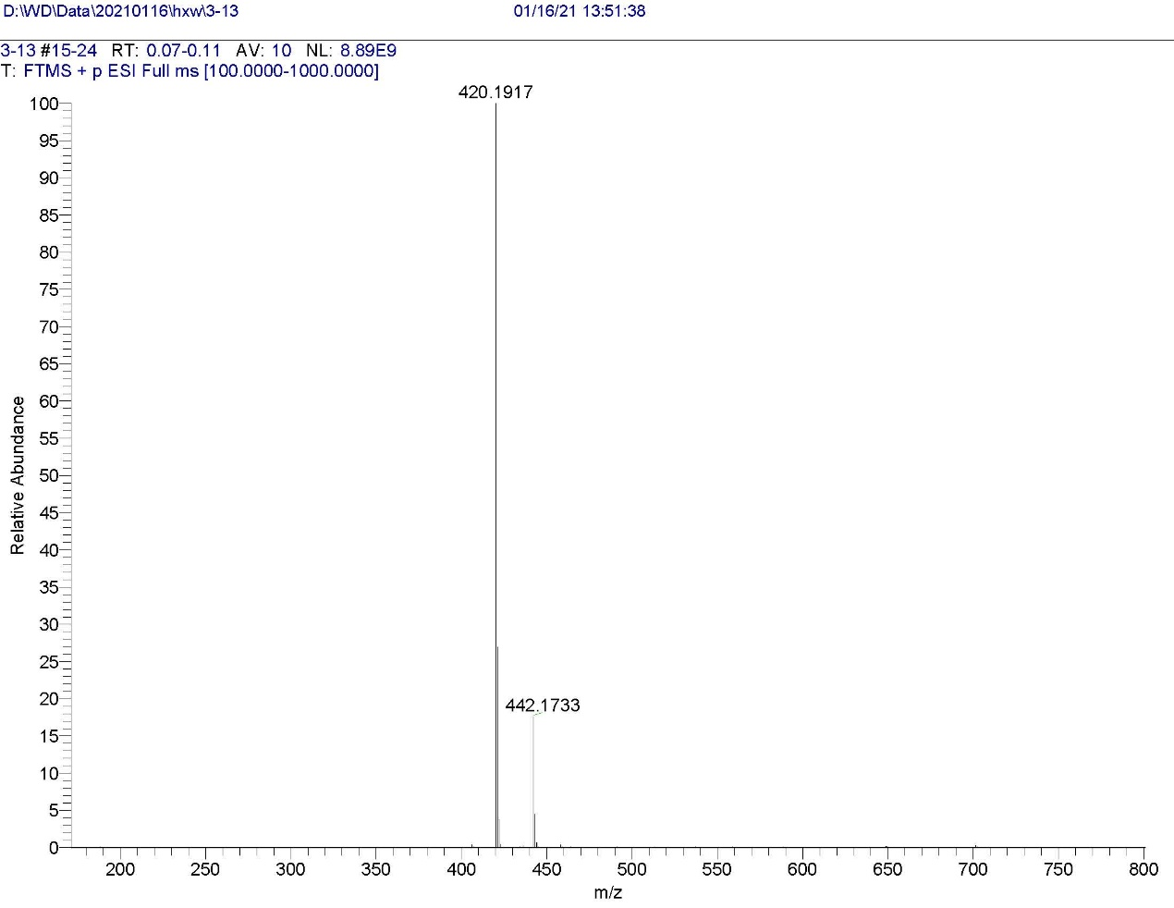
S13-3 HRMS of the compound II-4
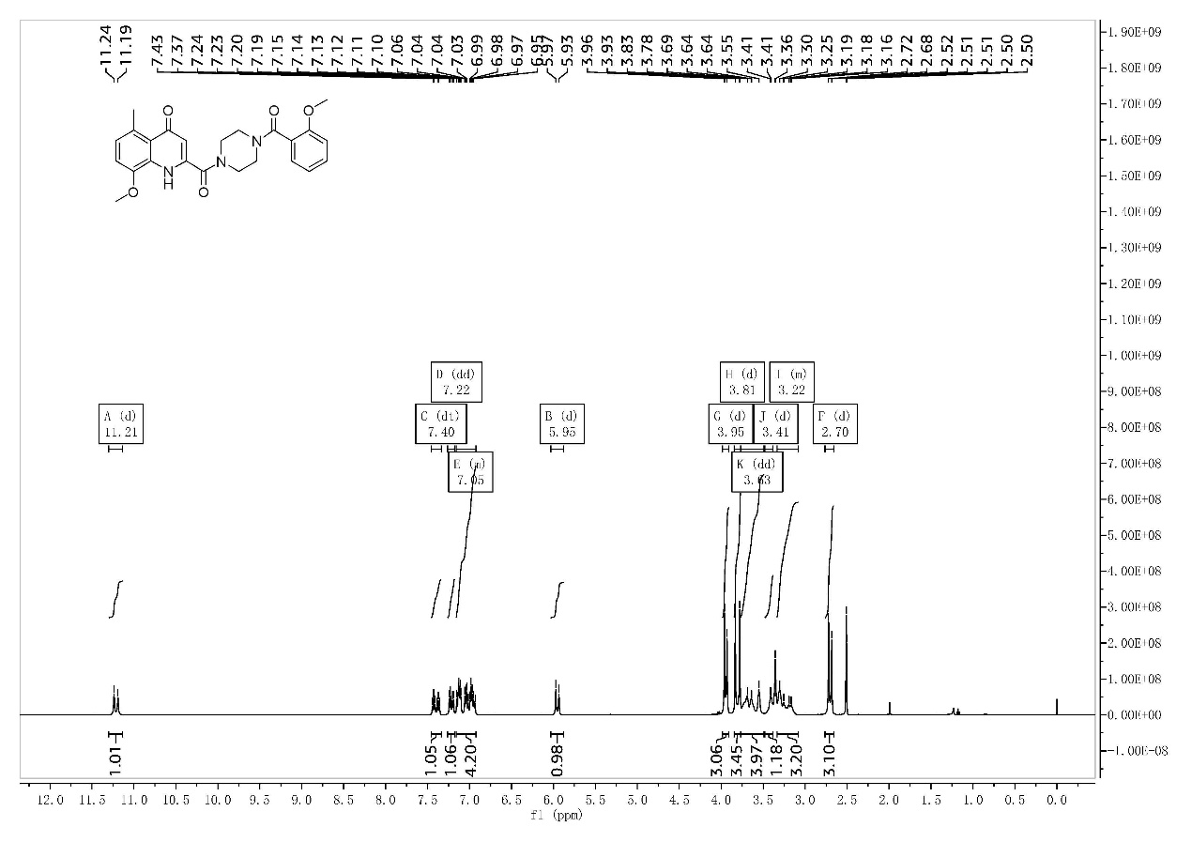
S14-1 ¹H-NMR of the compound II-5
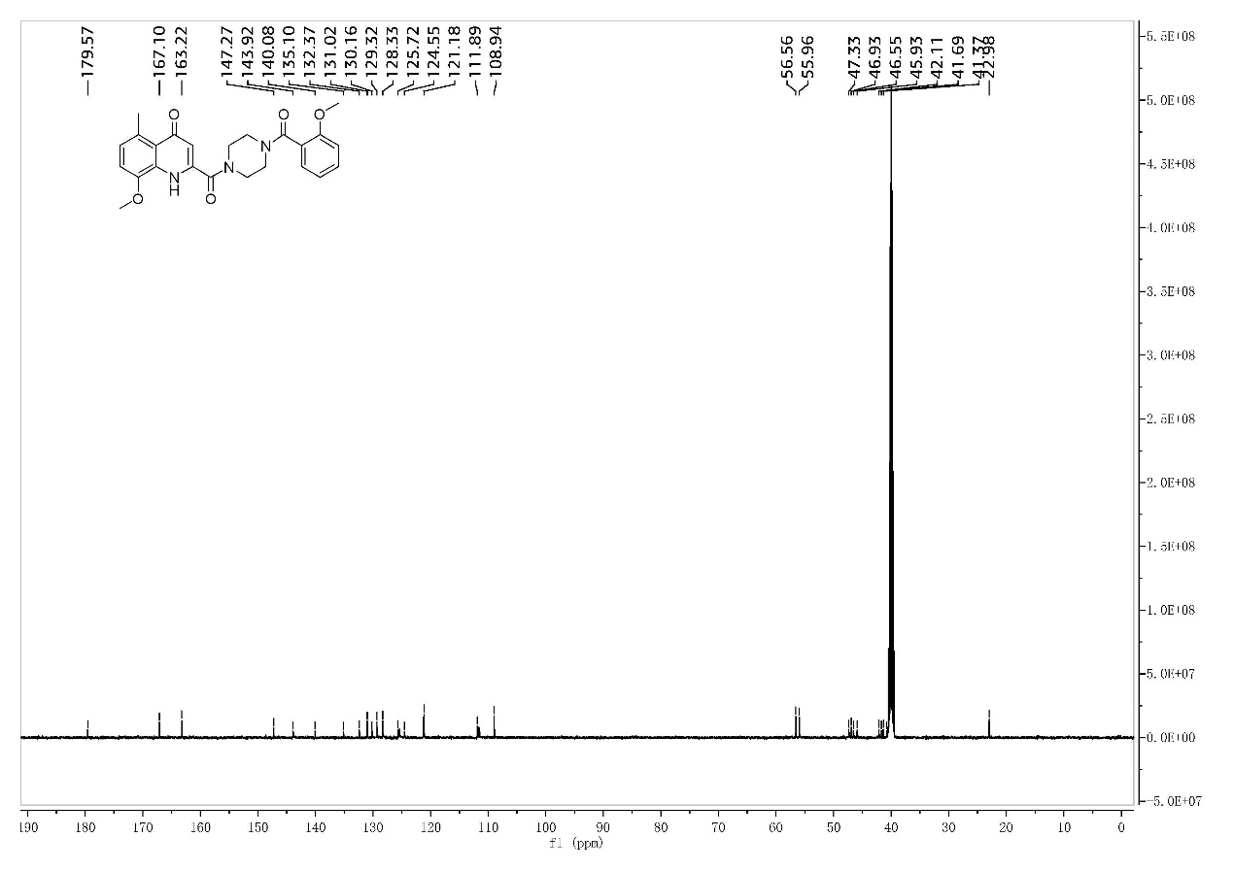
S14-2 ¹³C-NMR of the compound II-5
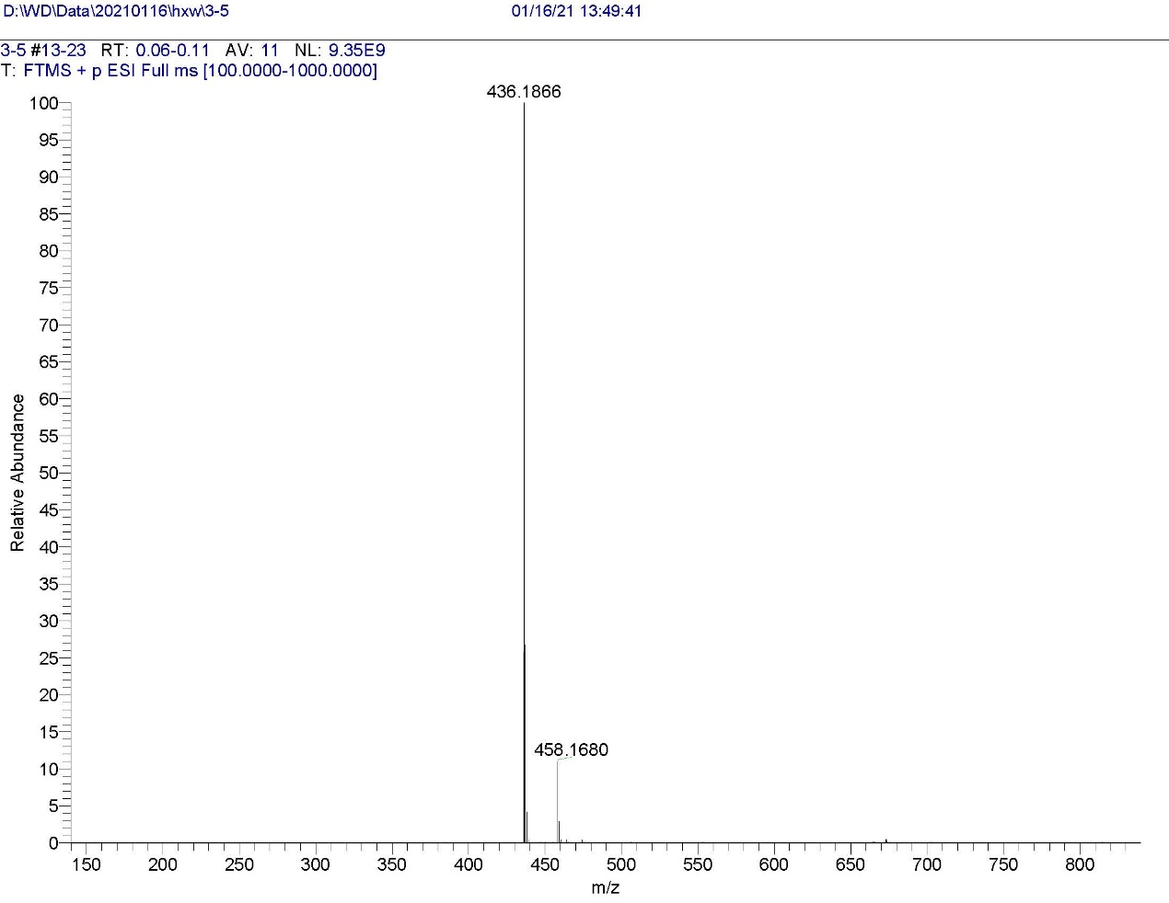
S14-3 HRMS of the compound II-5
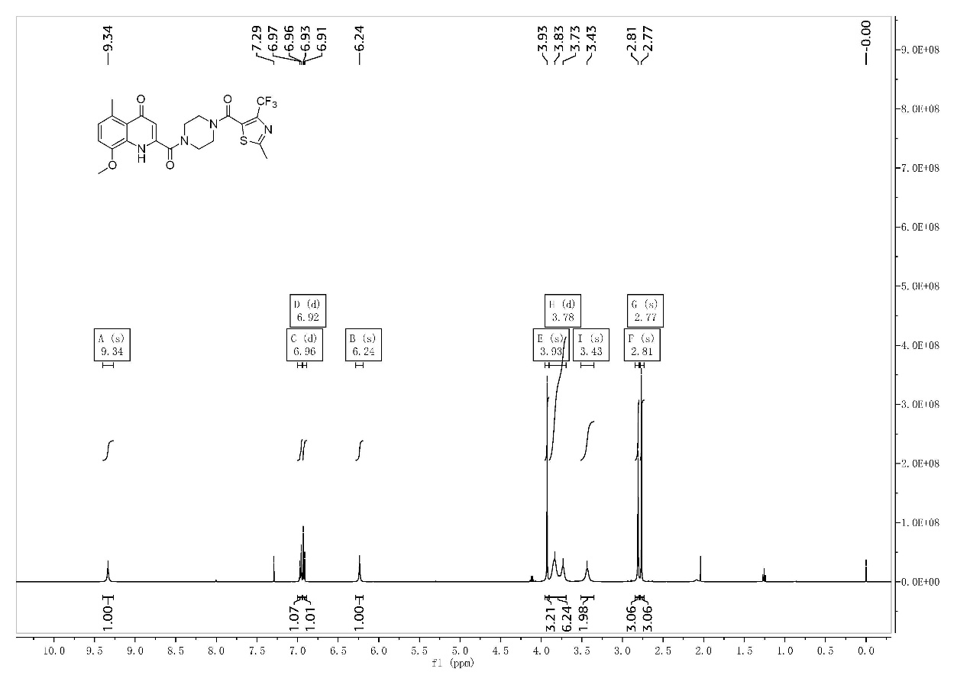
S15-1 ¹H-NMR of the compound II-6
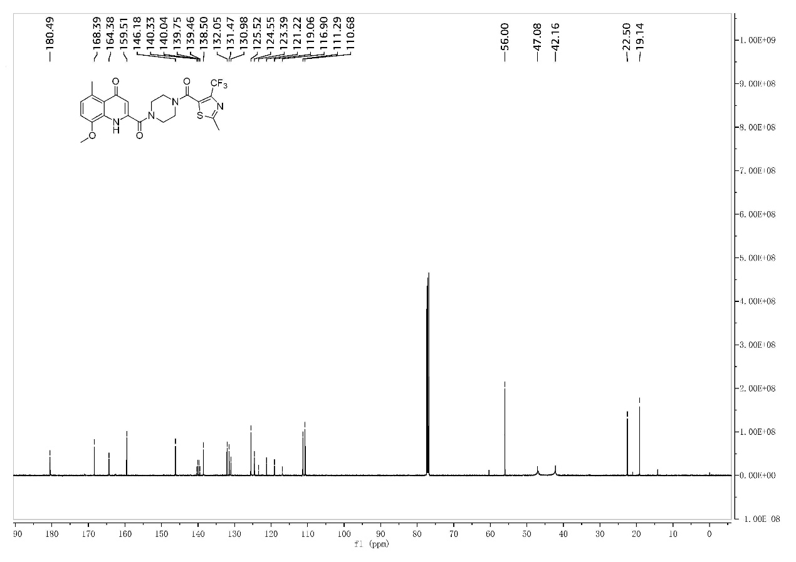
S15-2 ¹³C-NMR of the compound II-6
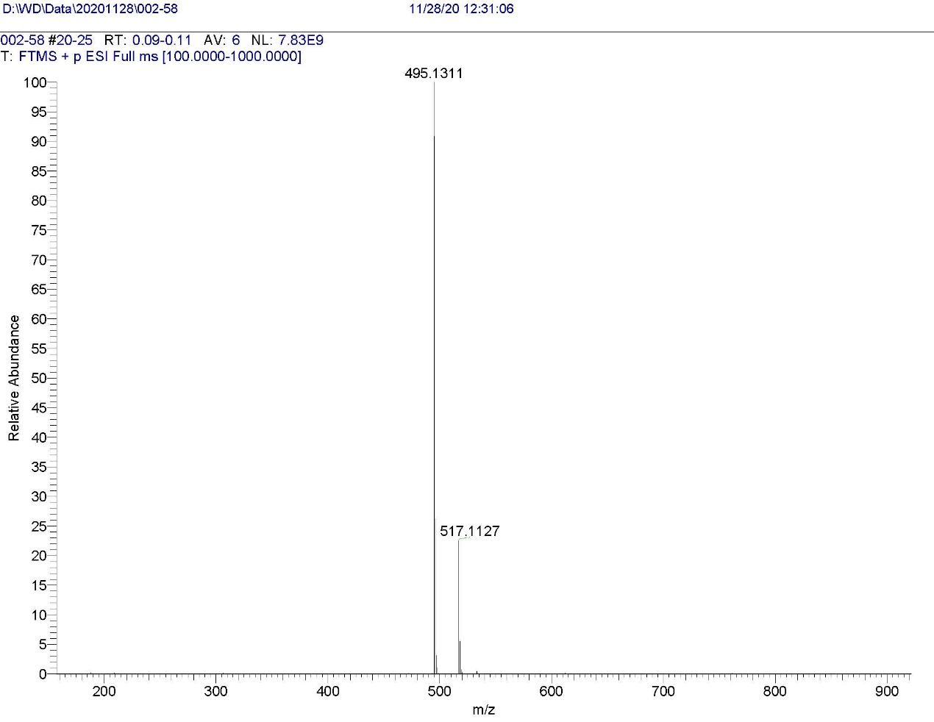
S15-3 HRMS of the compound II-6
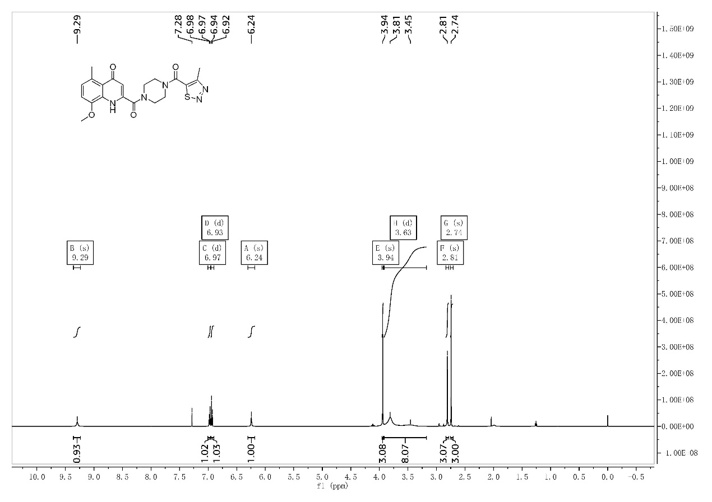
S16-1 ¹H-NMR of the compound II-7
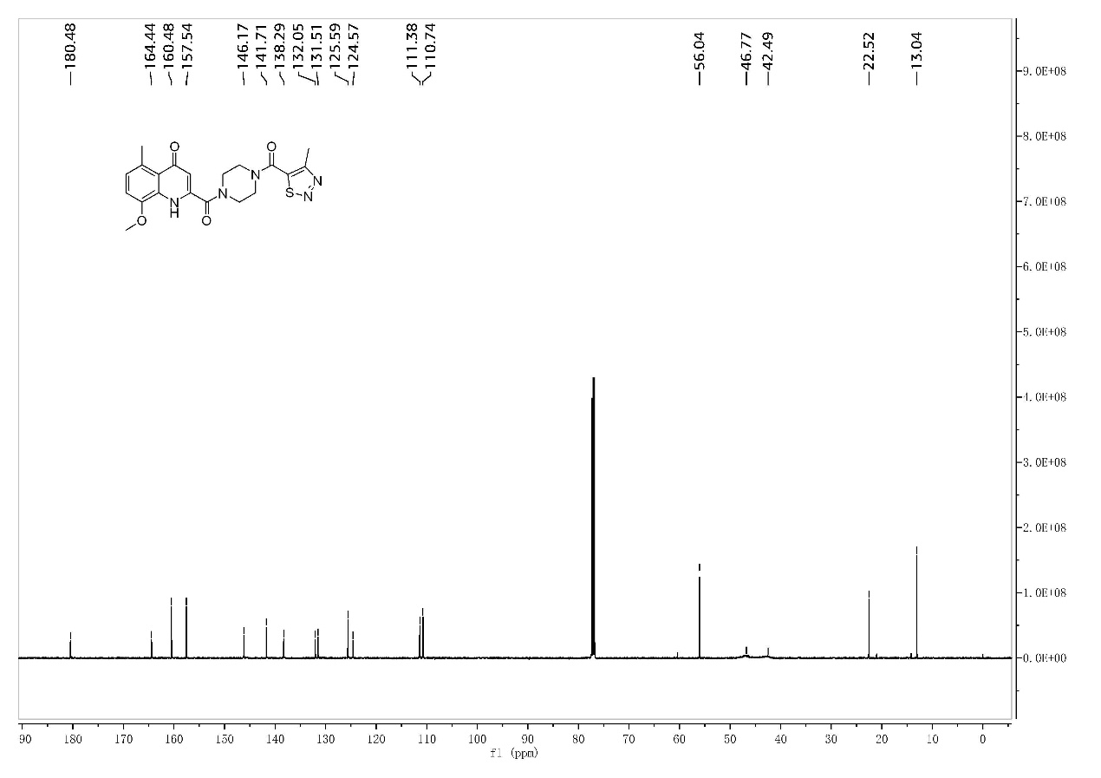
S16-2 ¹³C-NMR of the compound II-7
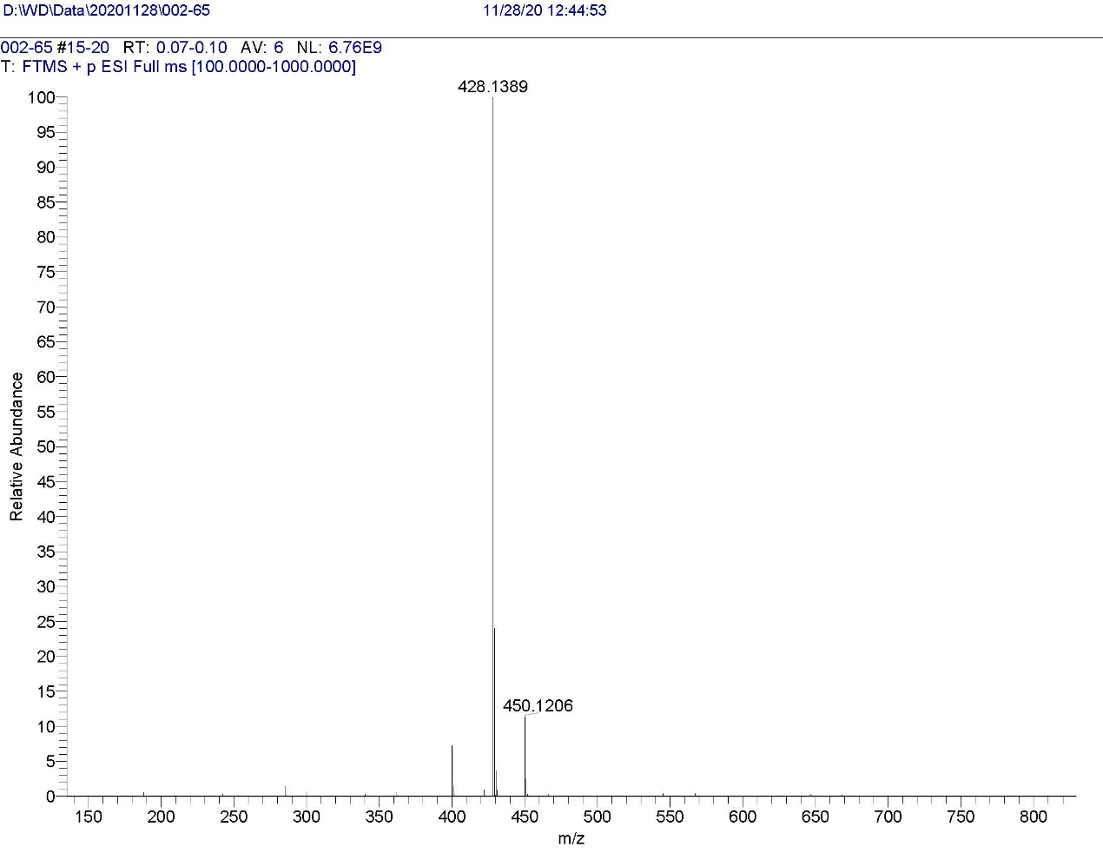
S16-3 HRMS of the compound II-7
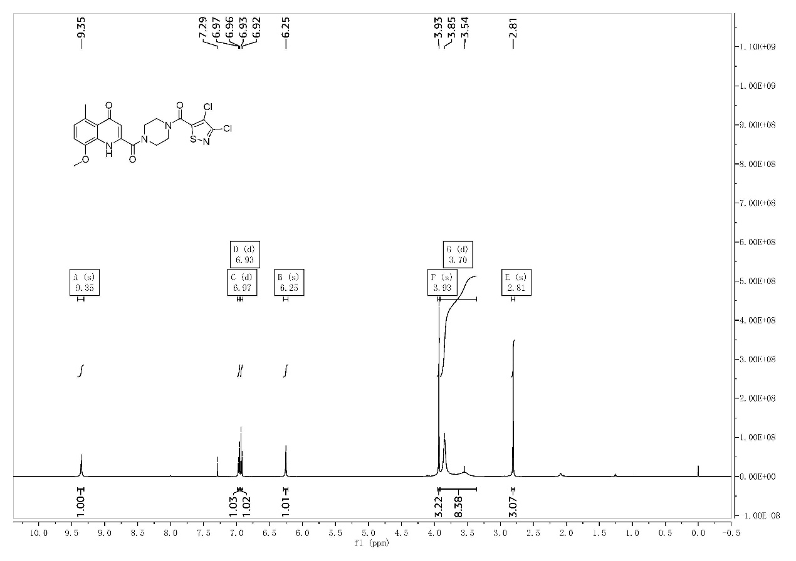
S17-1 ¹H-NMR of the compound II-8
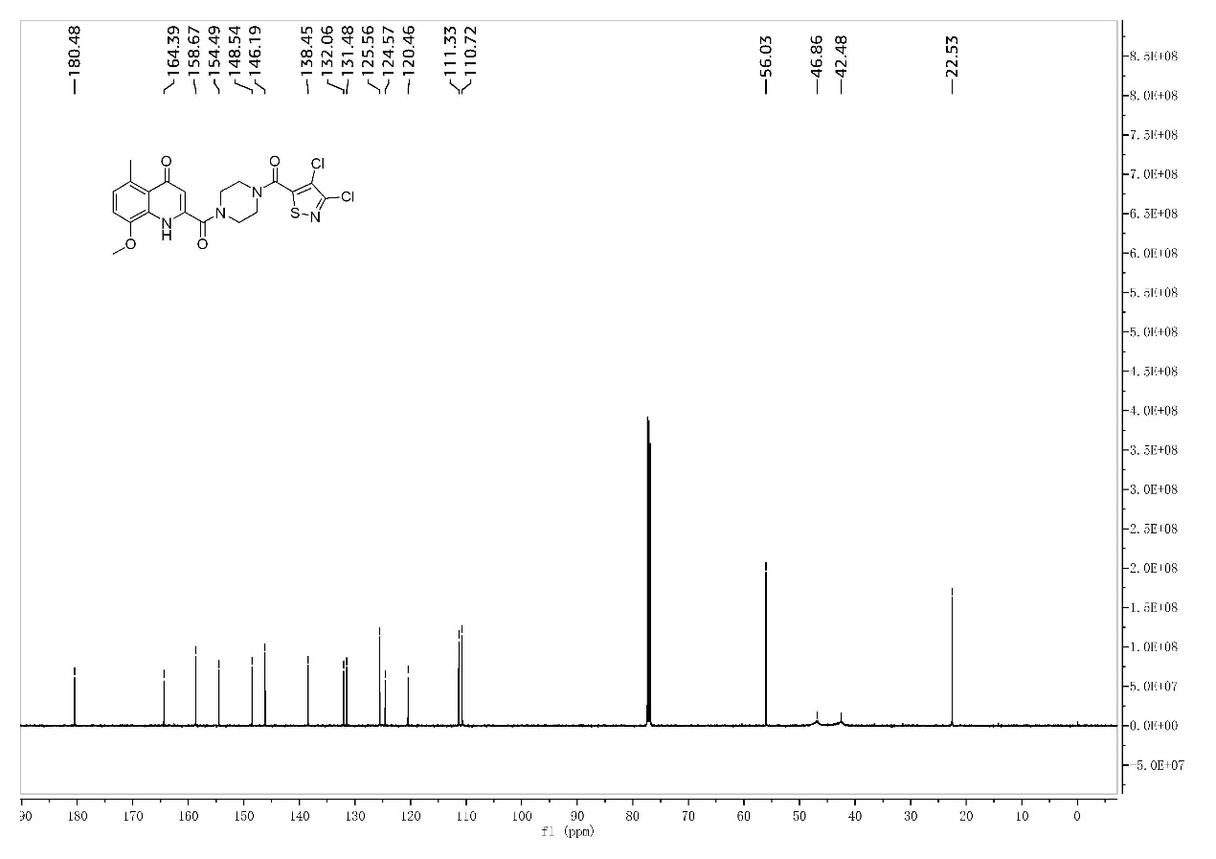
S17-2 ¹³C-NMR of the compound II-8
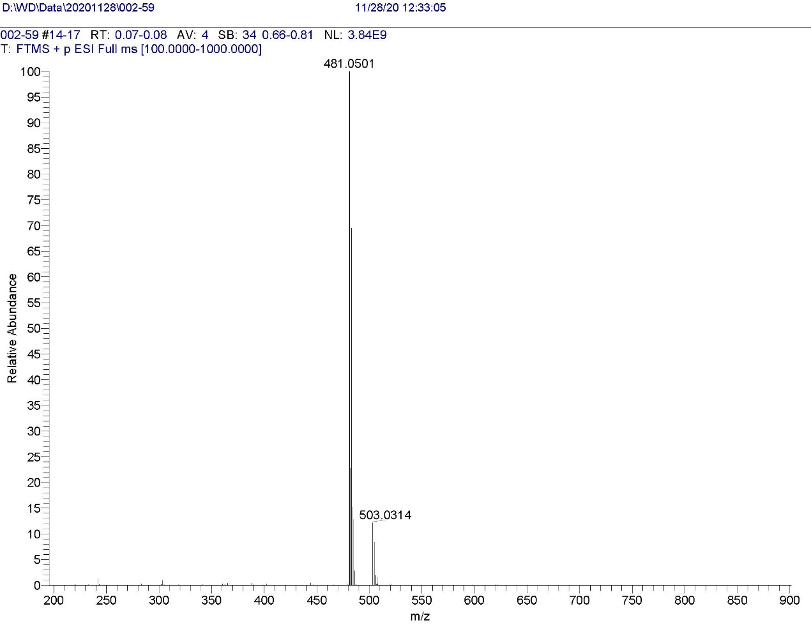
S17-3 HRMS of the compound II-8
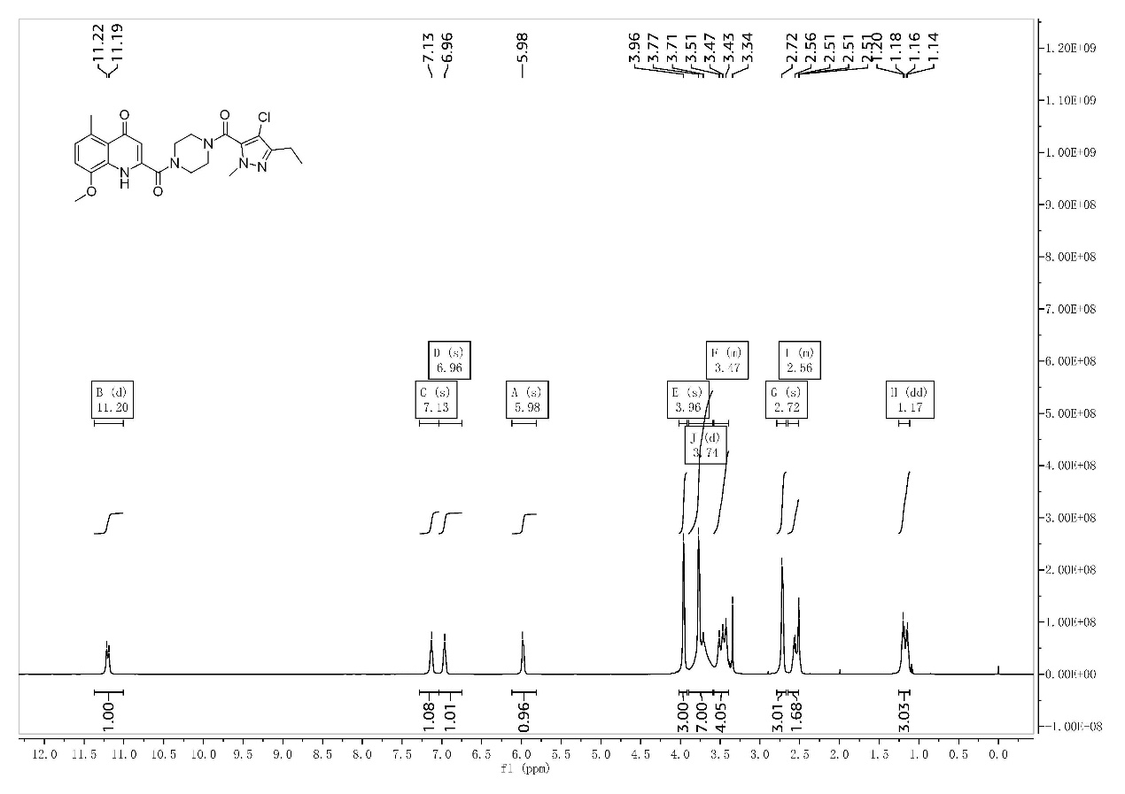
S18-1 ¹H-NMR of the compound II-9
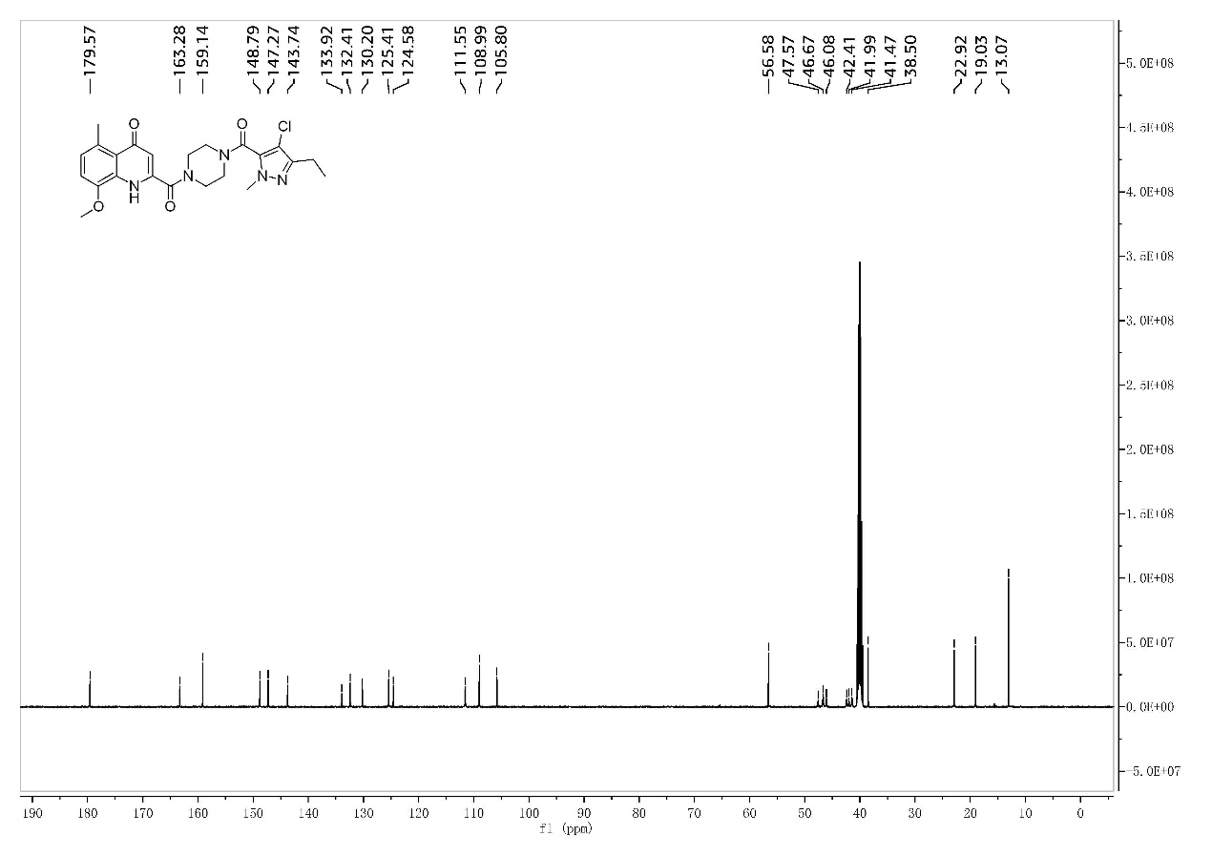
S18-2 ¹³C-NMR of the compound II-9
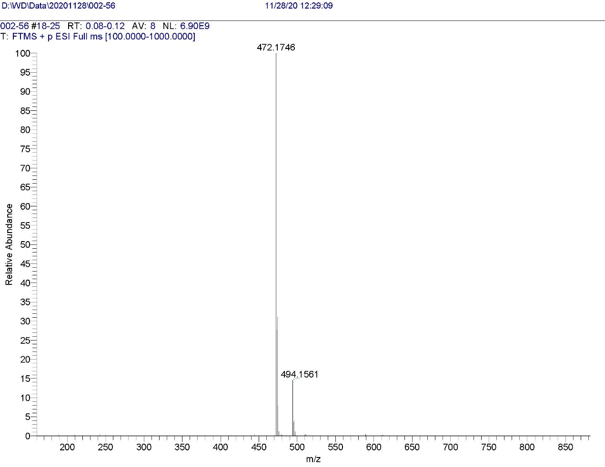
S18-3 HRMS of the compound II-9
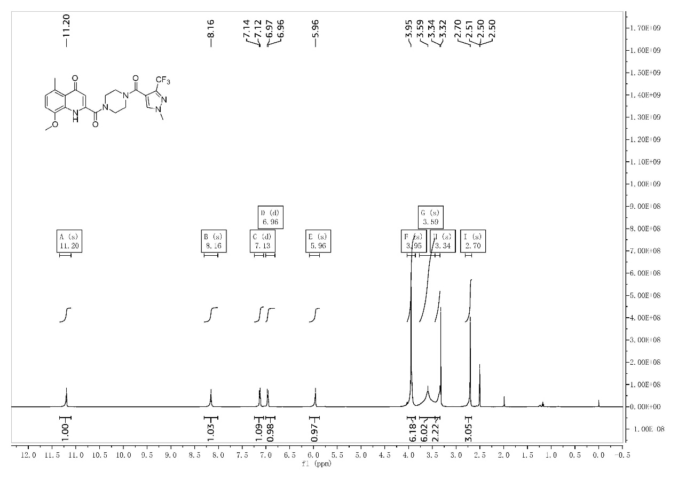
S19-1 ¹H-NMR of the compound II-10
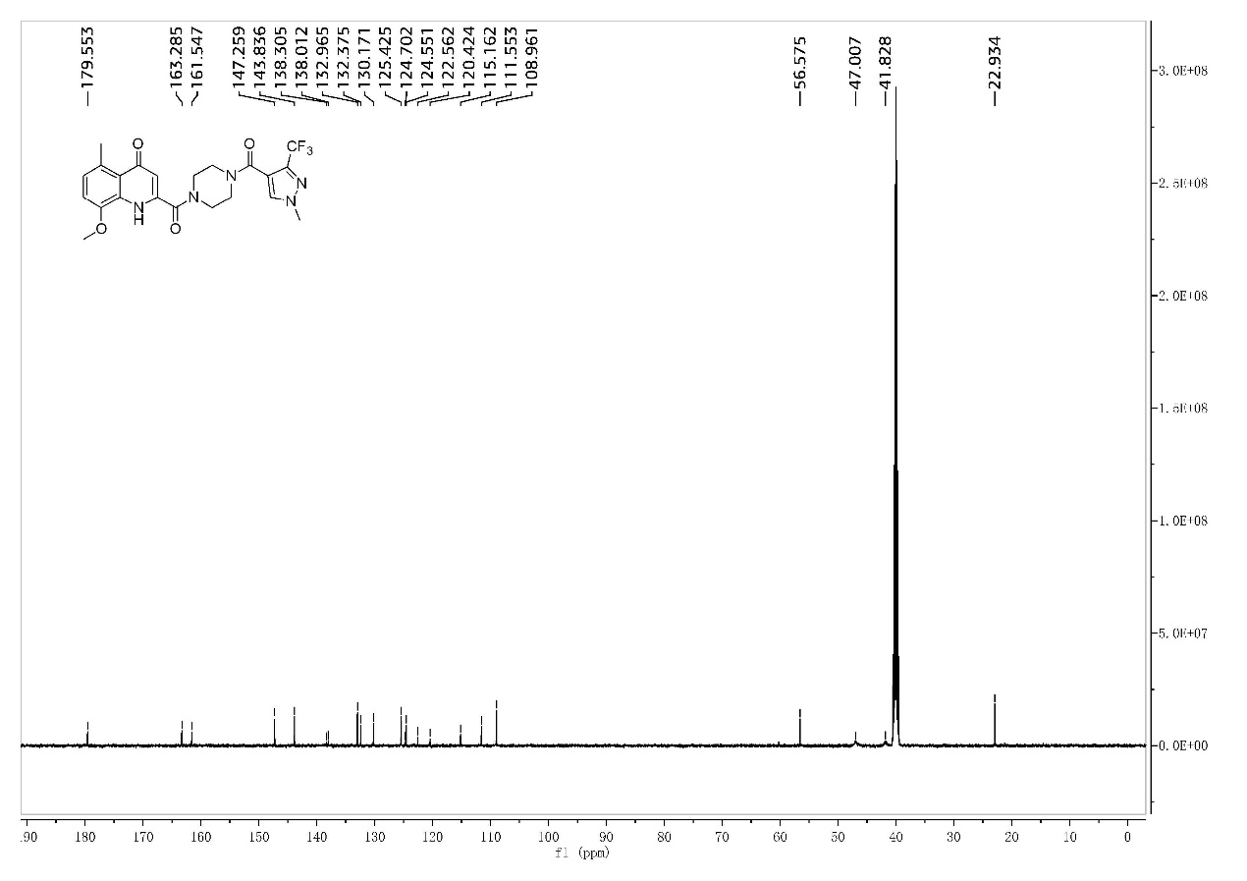
S19-2 ¹³C-NMR of the compound II-10
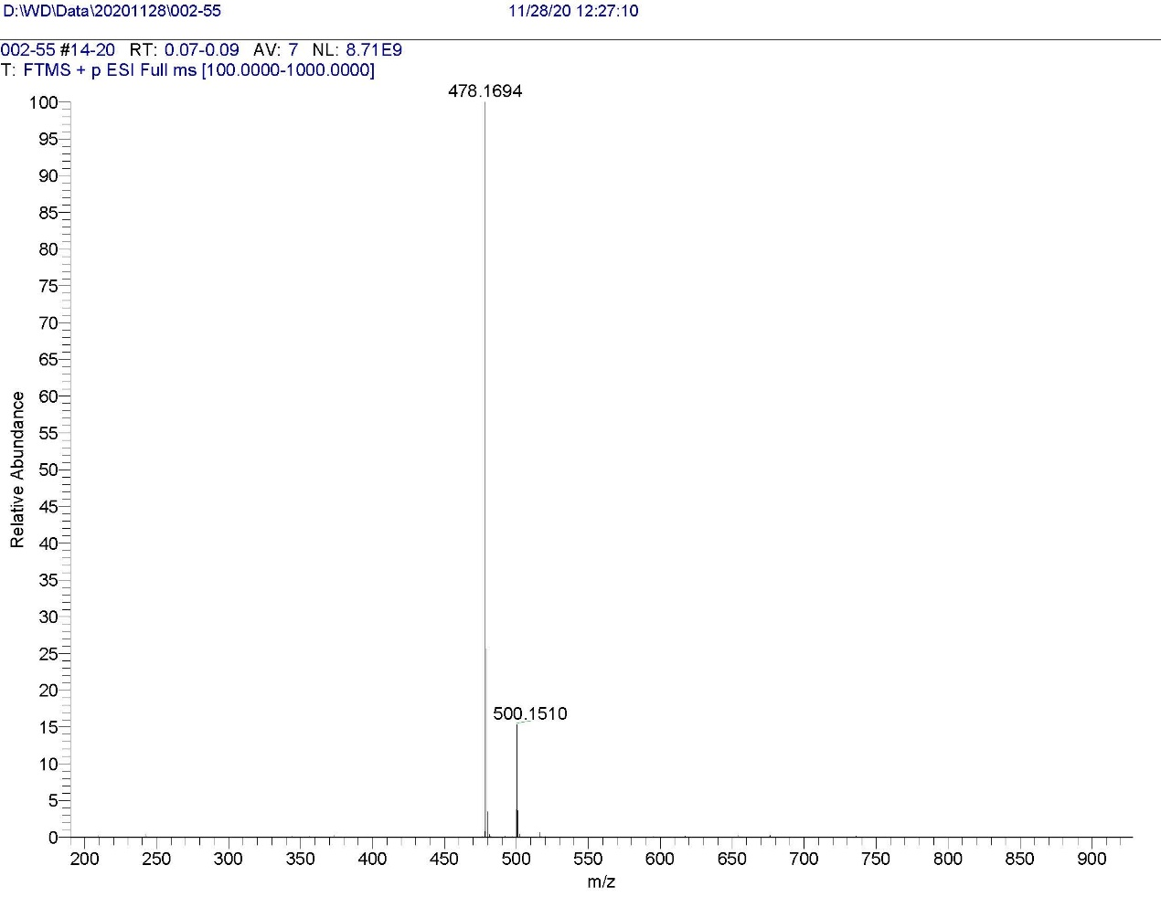
S19-3 HRMS of the compound II-10
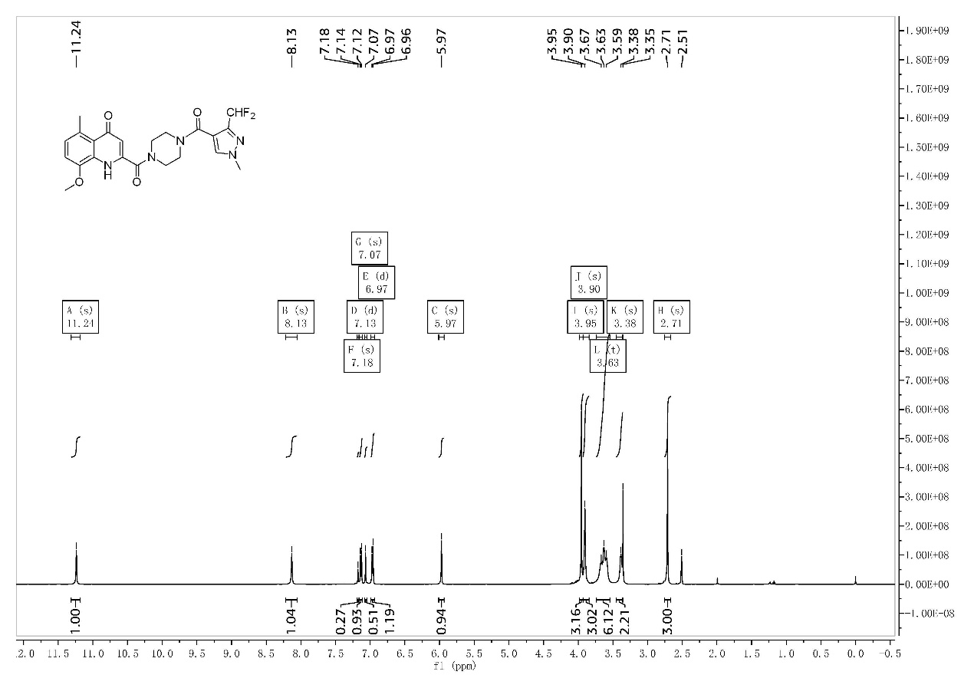S20-1 ¹H-NMR of the compound II-11
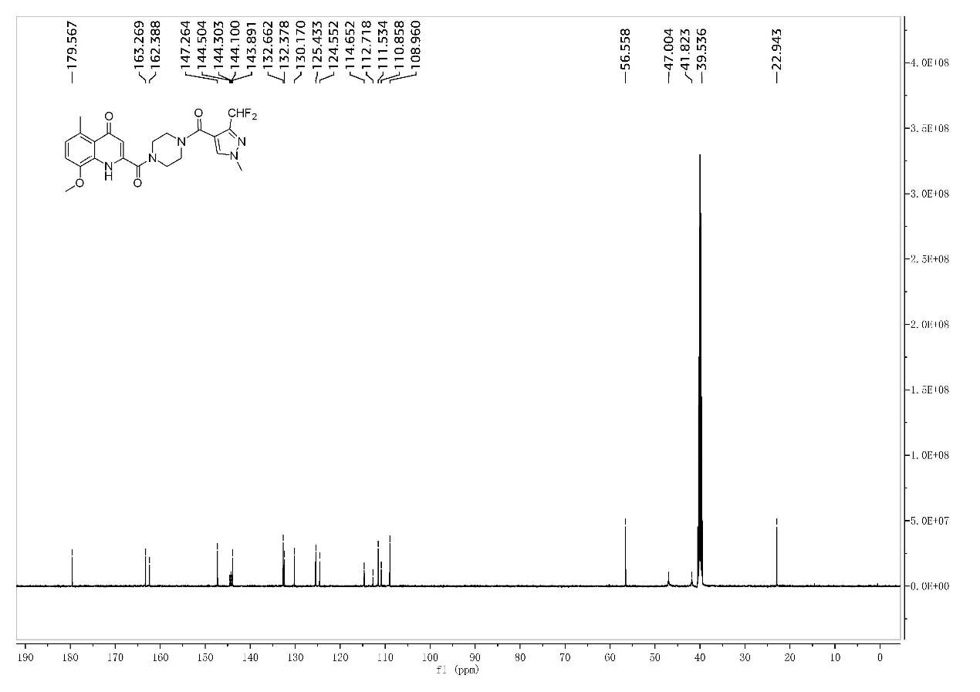
S20-2 ¹³C-NMR of the compound II-11
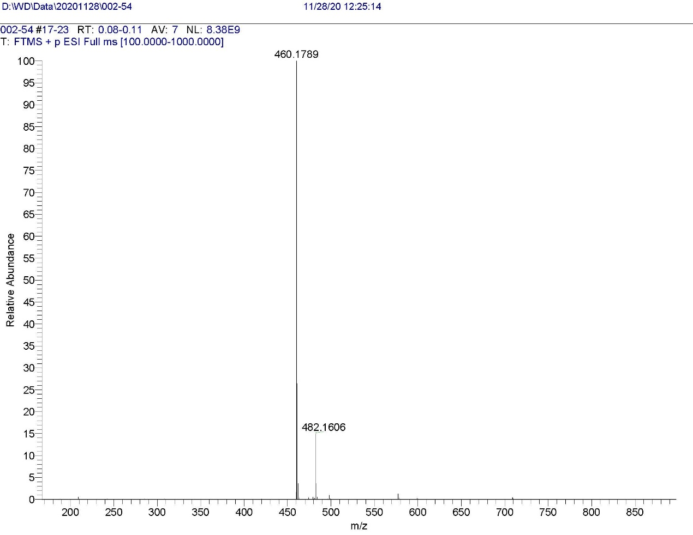
S20-3 HRMS of the compound II-11
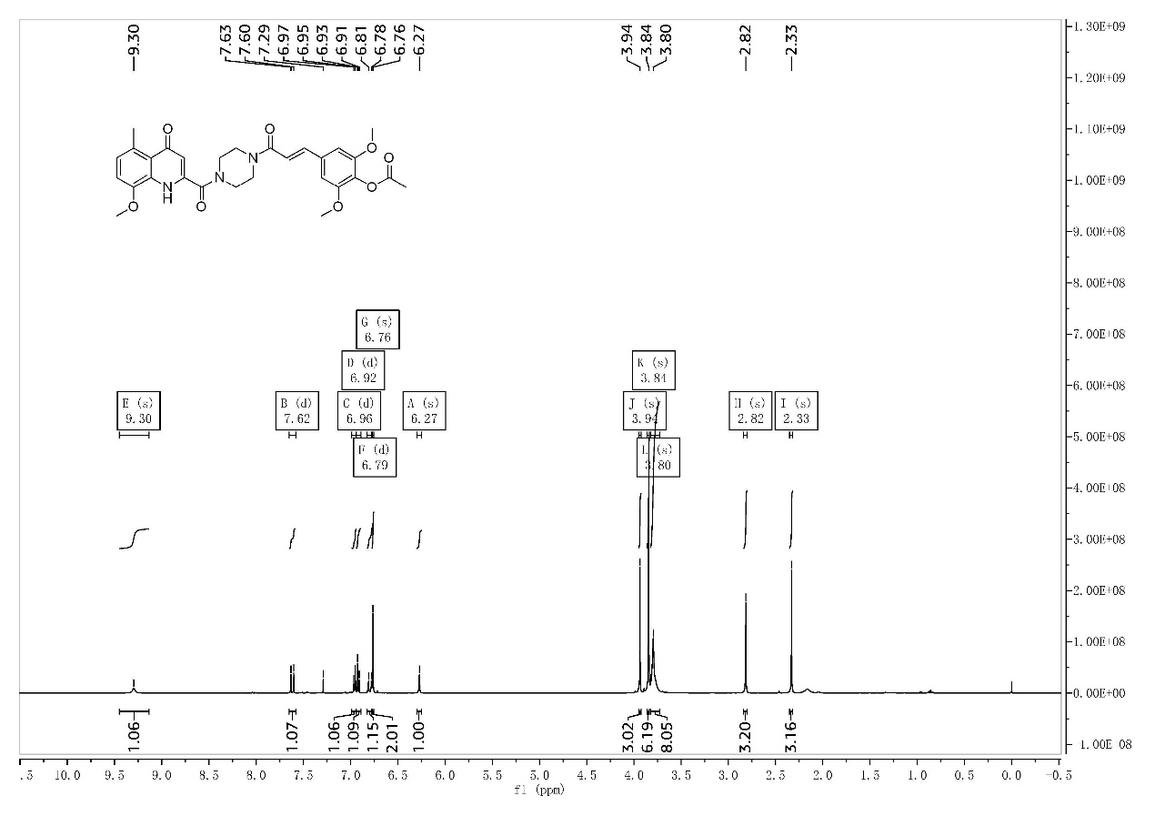
S21-1 ¹H-NMR of the compound II-12
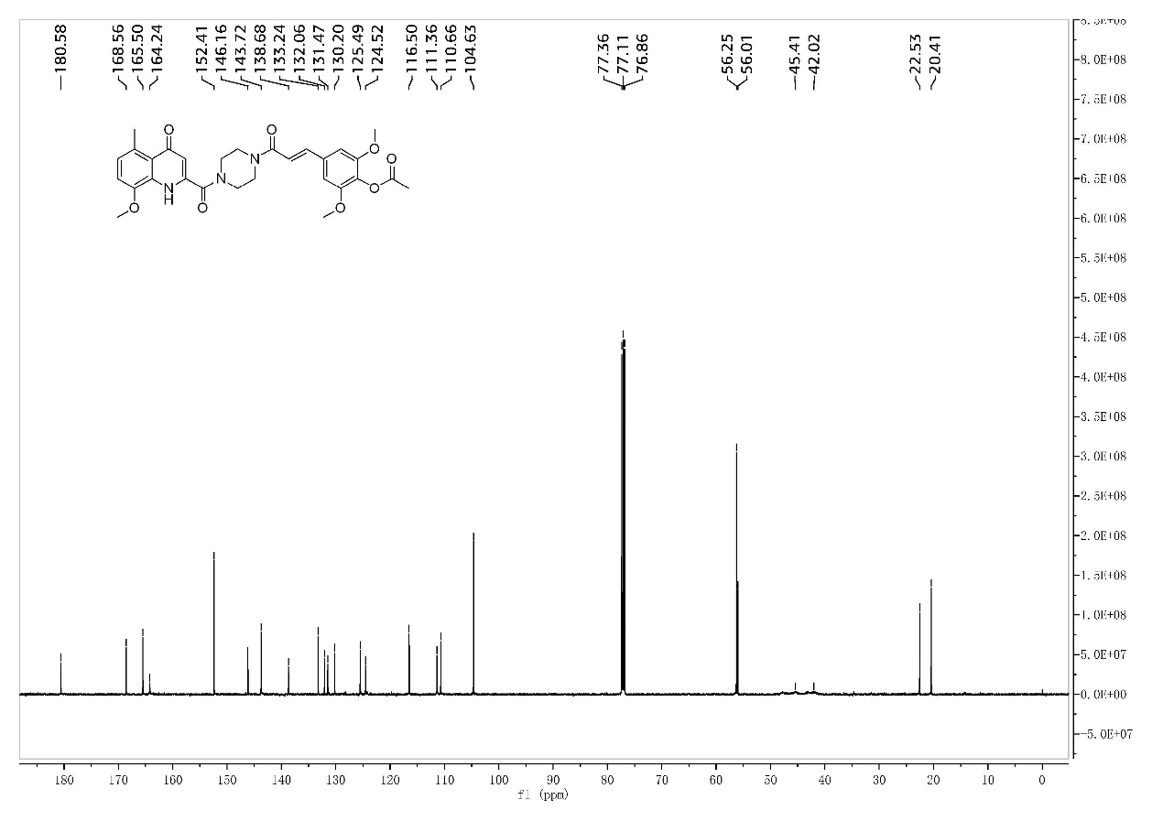
S21-2 ¹³C-NMR of the compound II-12
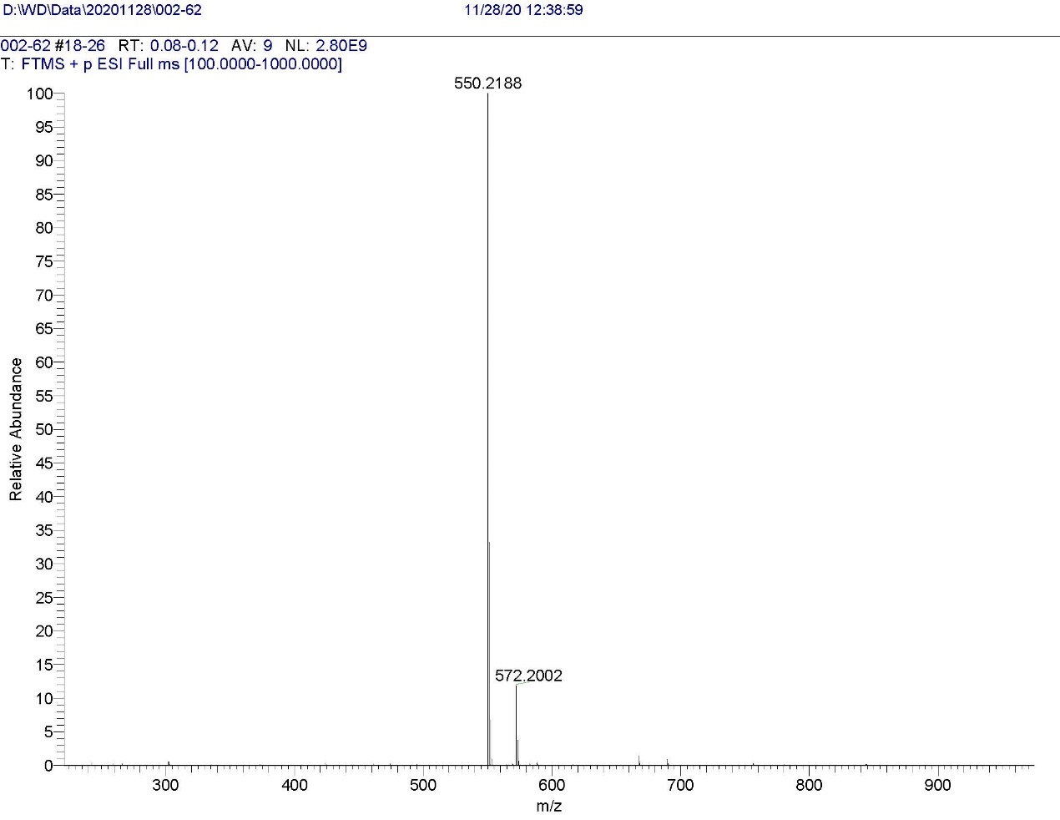
S21-3 HRMS of the compound II-12
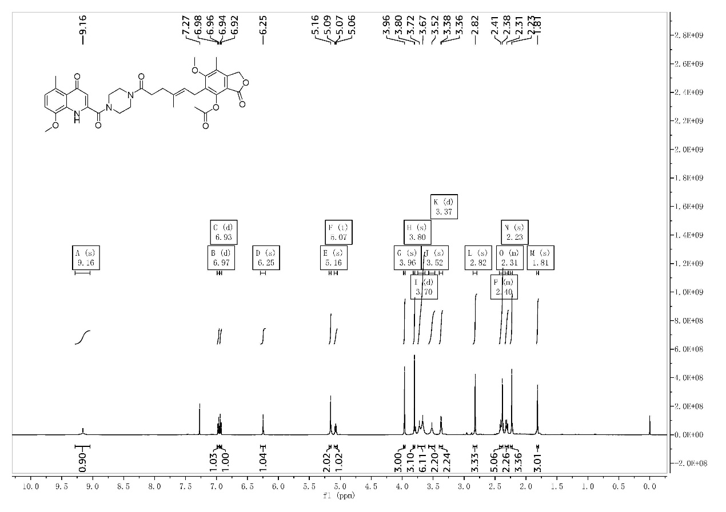
S22-1 ¹H-NMR of the compound II-13
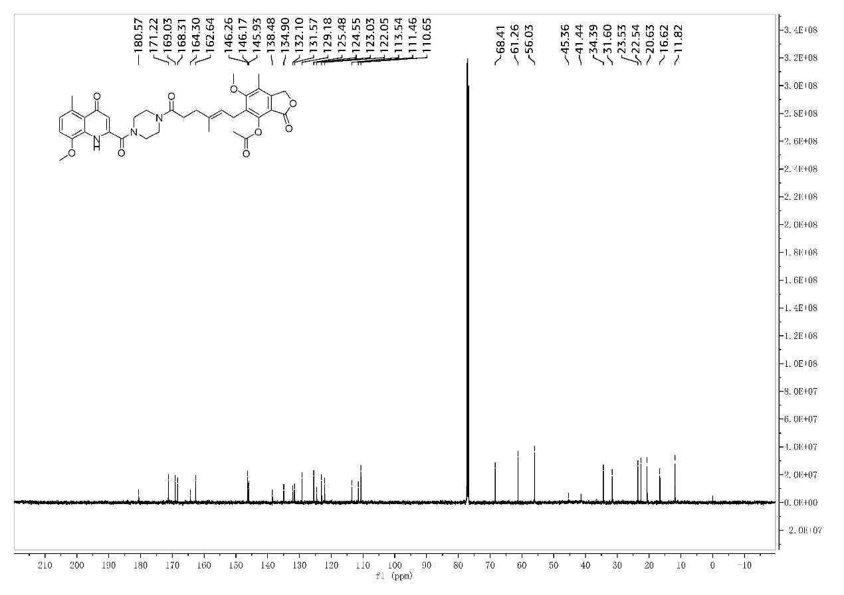
S22-2 ¹³C-NMR of the compound II-13
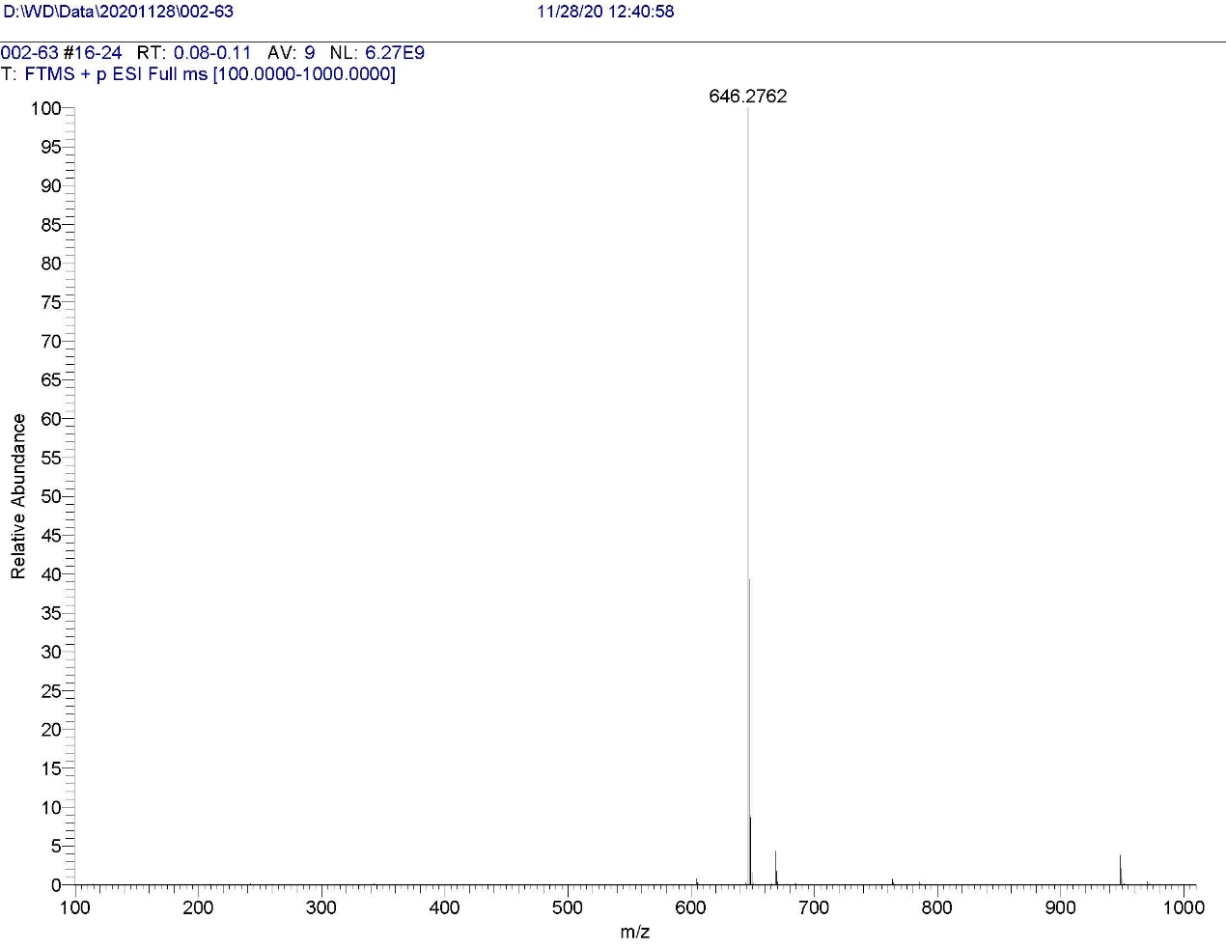
S22-3 HRMS of the compound II-13

