Supplementary Figure S1. Covariate balance before and after propensity score matching
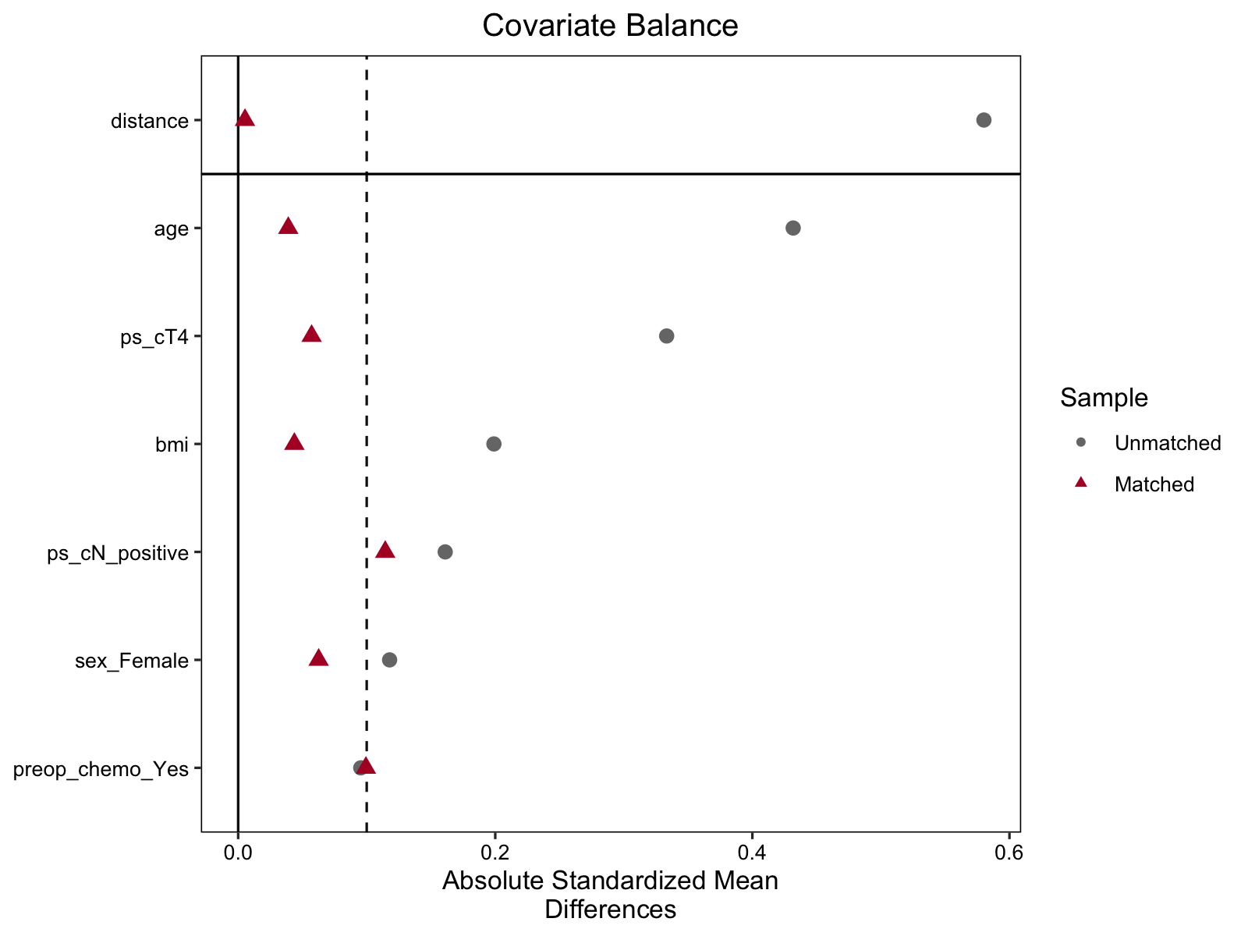
Love plot showing absolute standardized mean differences before and after propensity score matching. The dashed vertical line indicates the prespecified balance threshold of 0.10. PS, propensity score; BMI, body mass index; cT4, clinical T4 disease; cN-positive, clinically node-positive disease.

