Supplementary Material for “Biases in subtropical low clouds traced to weak sensitivity to surface winds”. Joaquín E. Blanco and Rodrigo Caballero

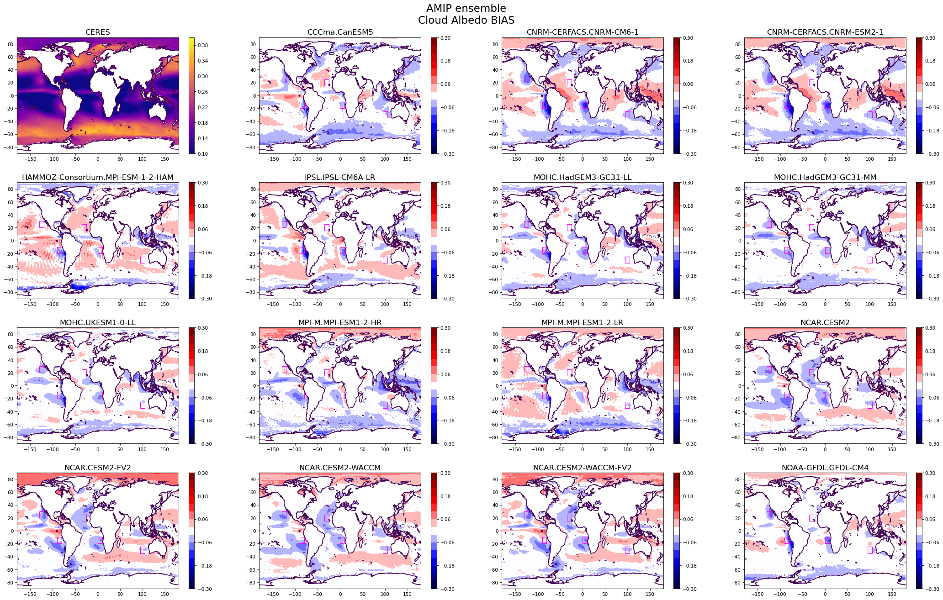
Figure S1 (cont.)
Figure S1: Cloud albedo bias (CERES–AMIP): individual model performance

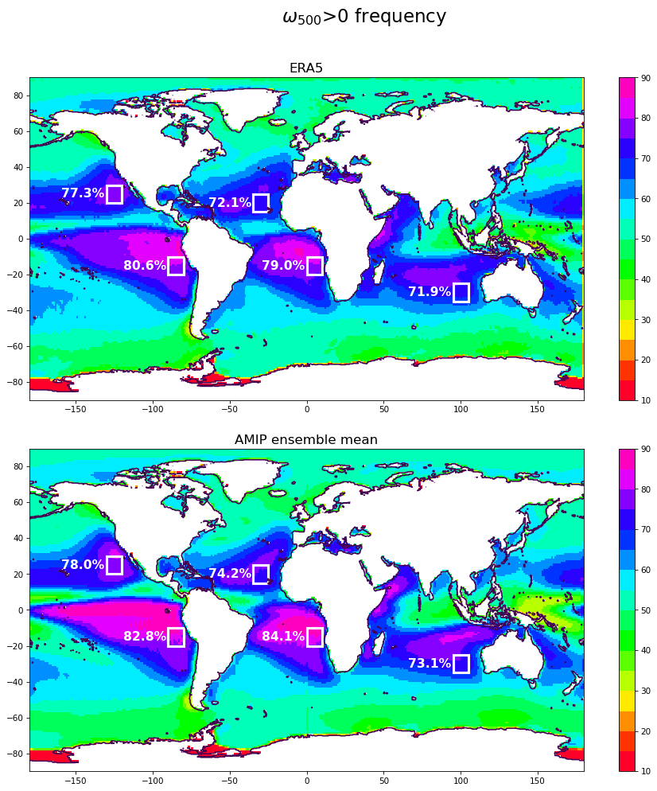
a)
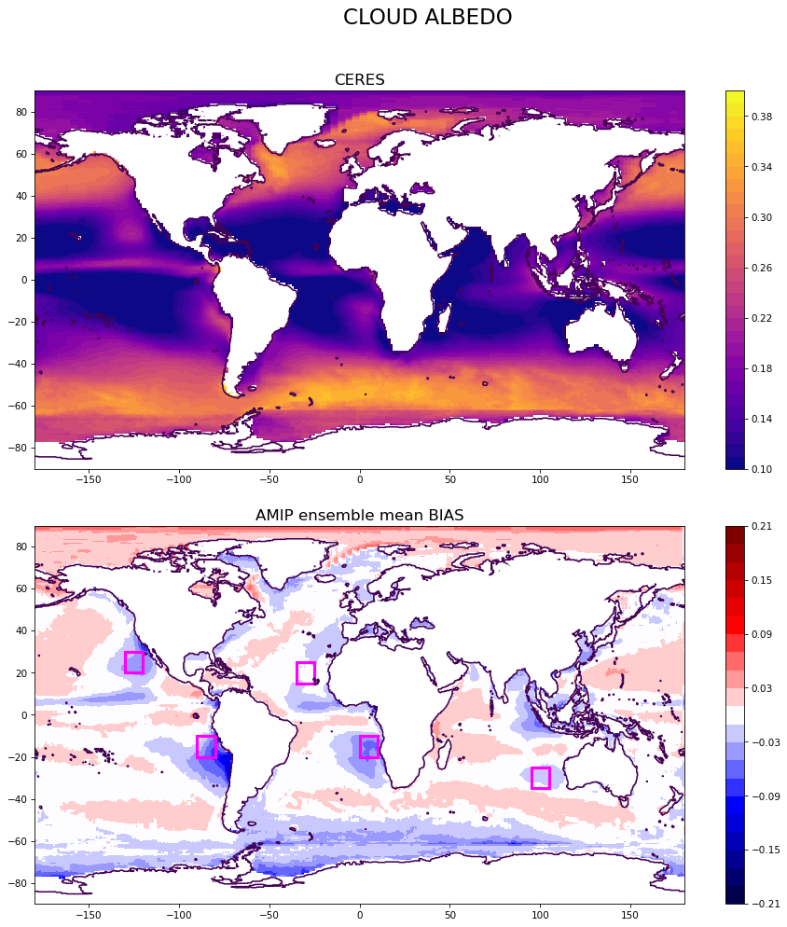
b)
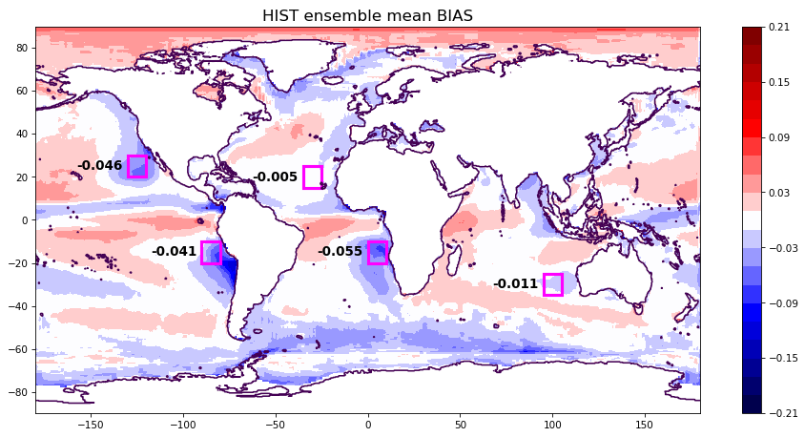
Figure S2: Frequency of positive midlevel vertical velocity for AMIP ensemble mean (a), and cloud albedo biases for HIST ensemble mean (b).

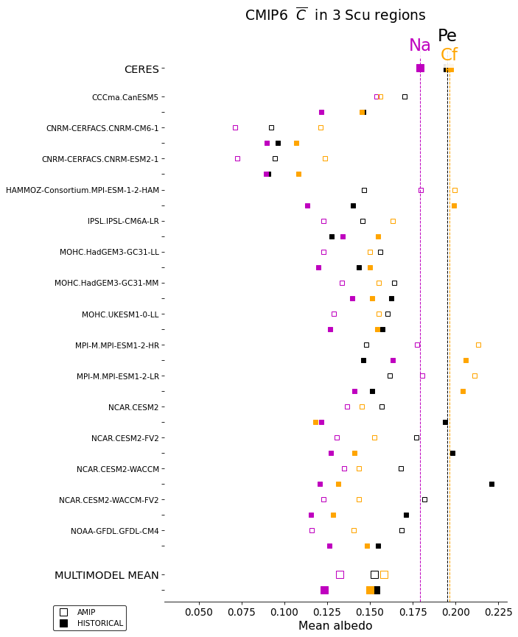
Figure S3: Annual mean $\overline{C}$ values in the Peruvian, Californian and Namibian regions, computed as area-weighted averages for the respective oceanic areas. Each CMIP6 model is shown in pairs, first for AMIP (empty square) and below for HIST (filled) model. Biases in all cases can be estimated directly by comparison with CERES values (first row and vertical lines). Last two rows show ensemble mean for each experiment.

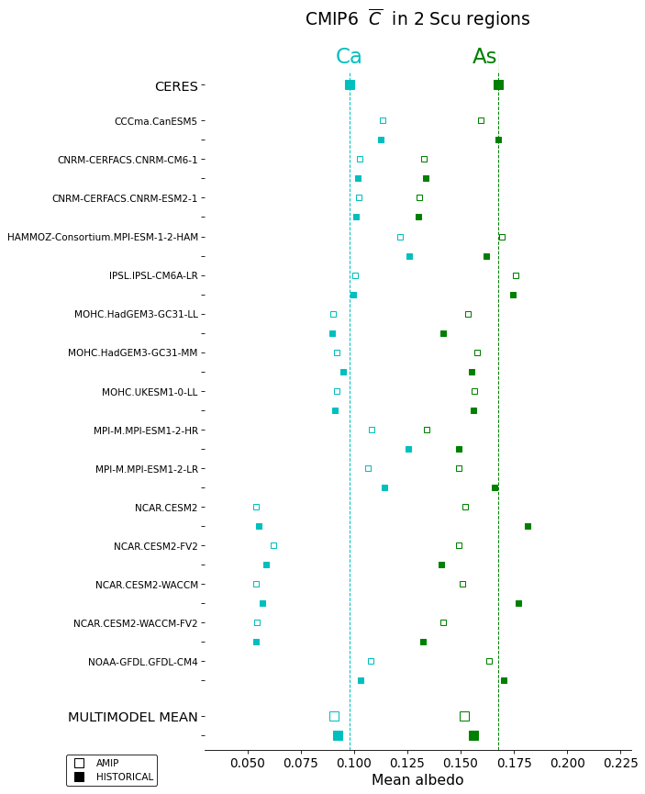
Figure S4: As in Fig. S3 but for the Canarian and Australian regions.

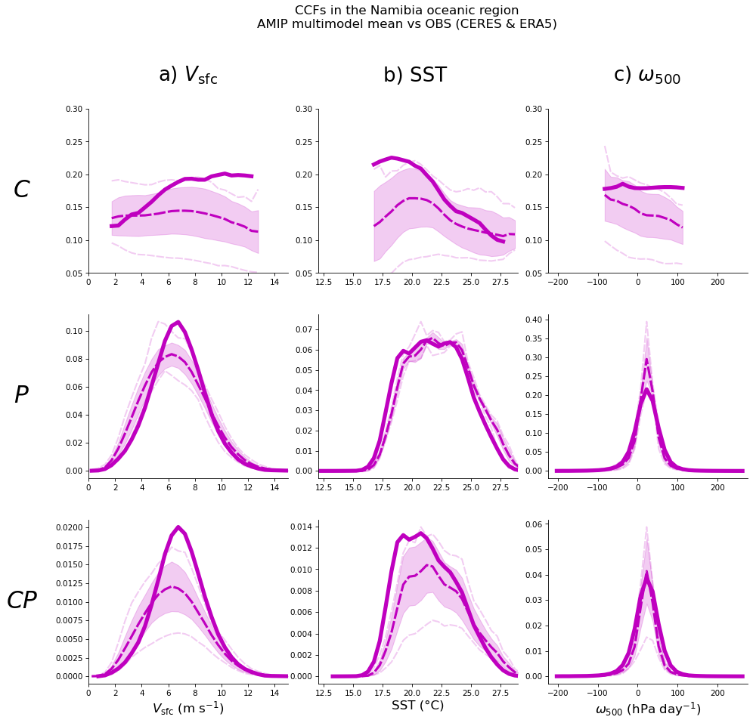
Figure S5: As in Fig. 4 but for the Namibian region.

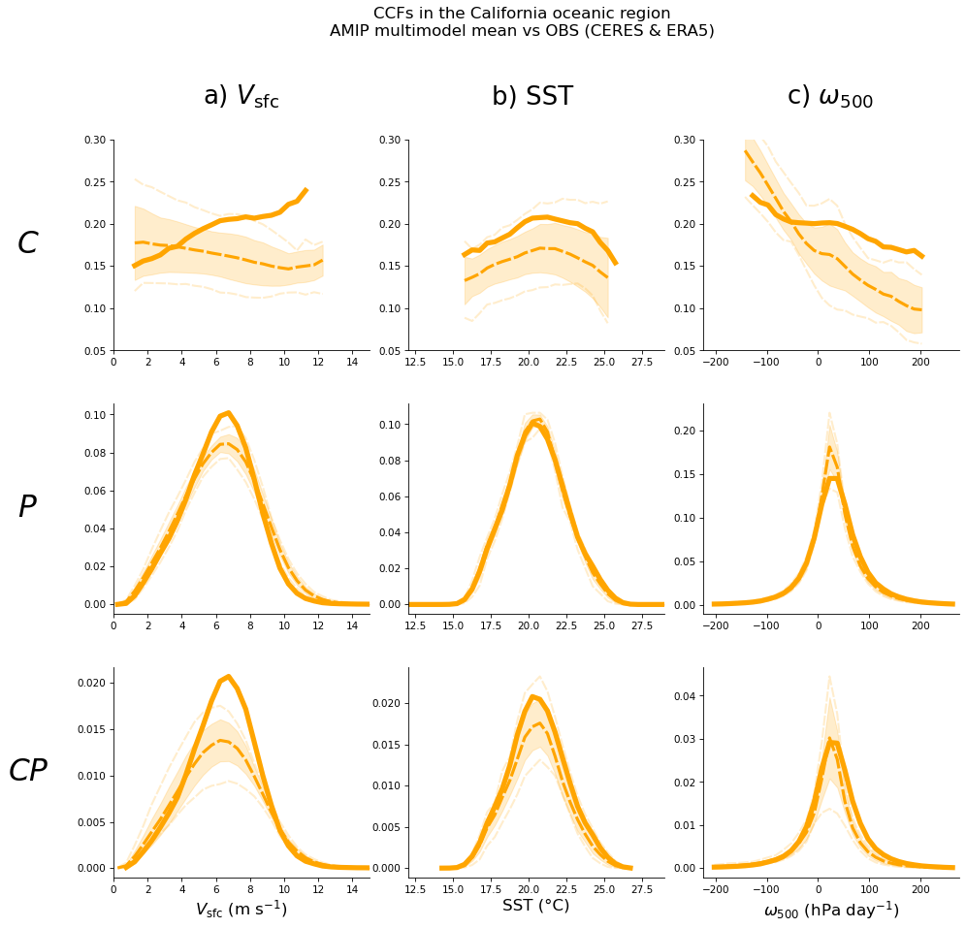
Figure S6: As in Fig. S5 for the Californian region.

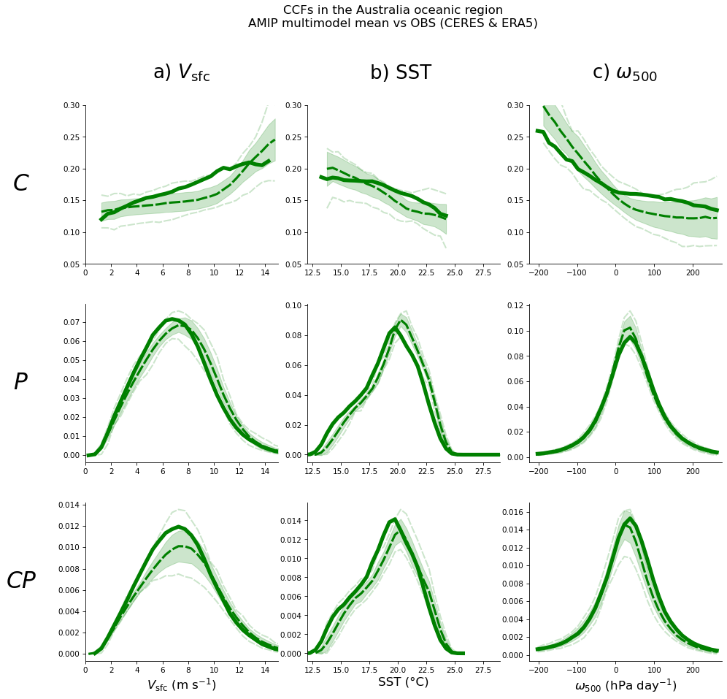
Figure S7: As in Fig. S5 for the Australian region.

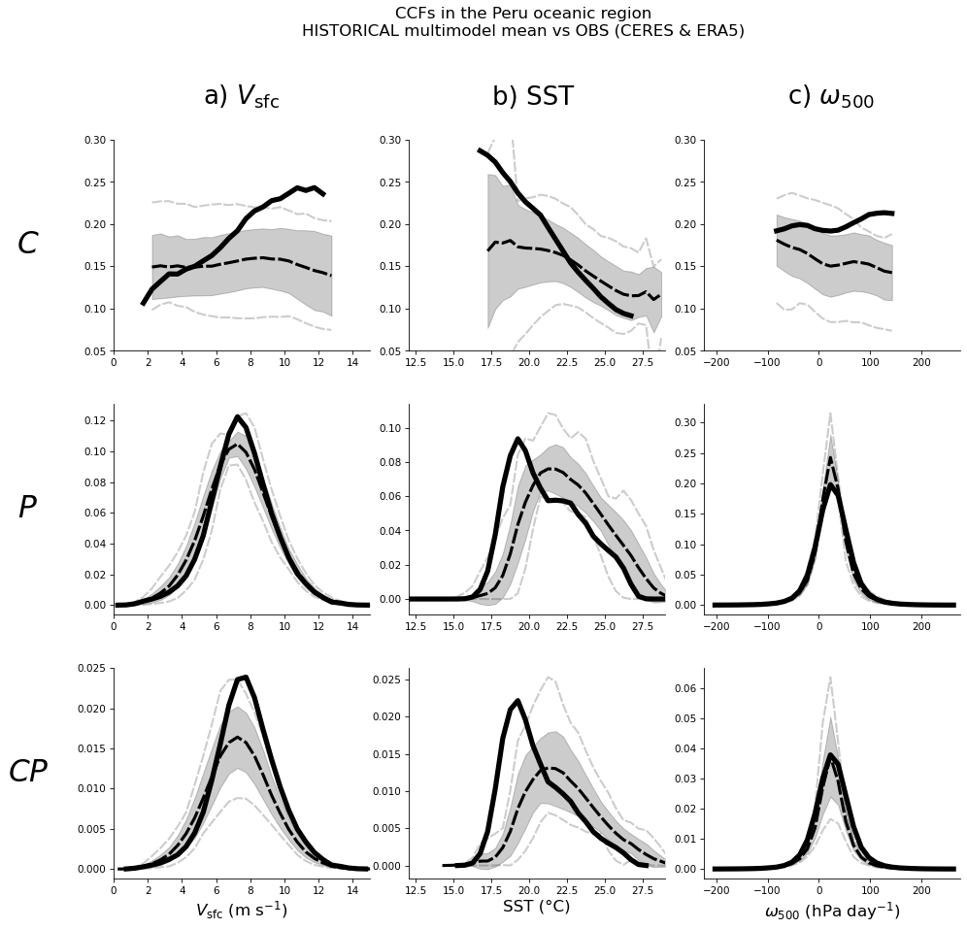
Figure S8: As in Fig. 4 but for the HIST ensemble.

 | a) | b) | c)
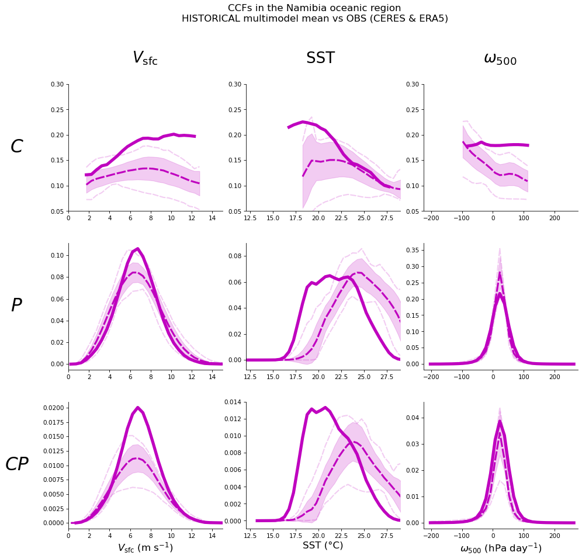 |  | 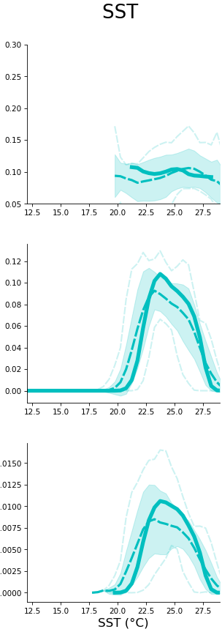 | 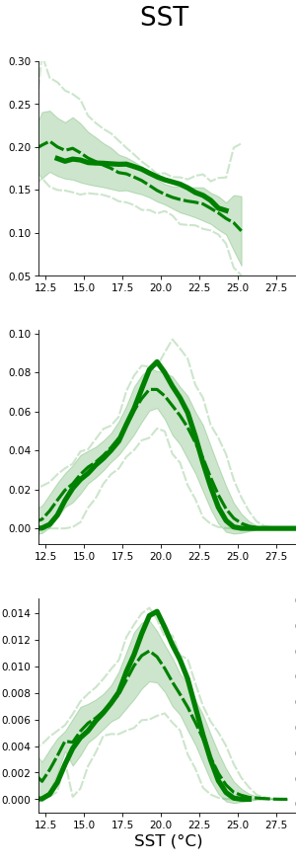
Figure S9: C, P and CP vs SST for the HIST ensemble at the Namibian (a), Canarian (b) and Australian (c) regions.

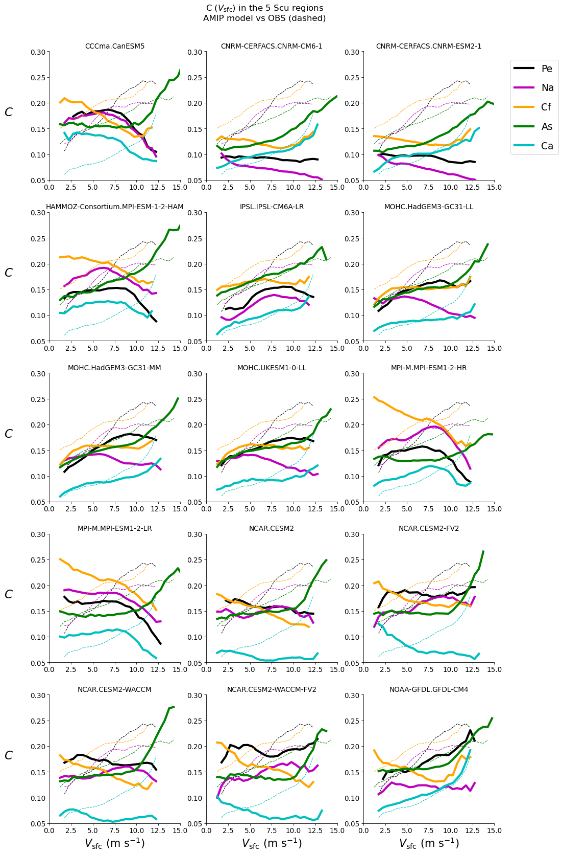
Figure S10: As in Fig. 6 but reversing the grouping order (1: region; 2: model). Light-dotted lines correspond to CERES & ERA5.

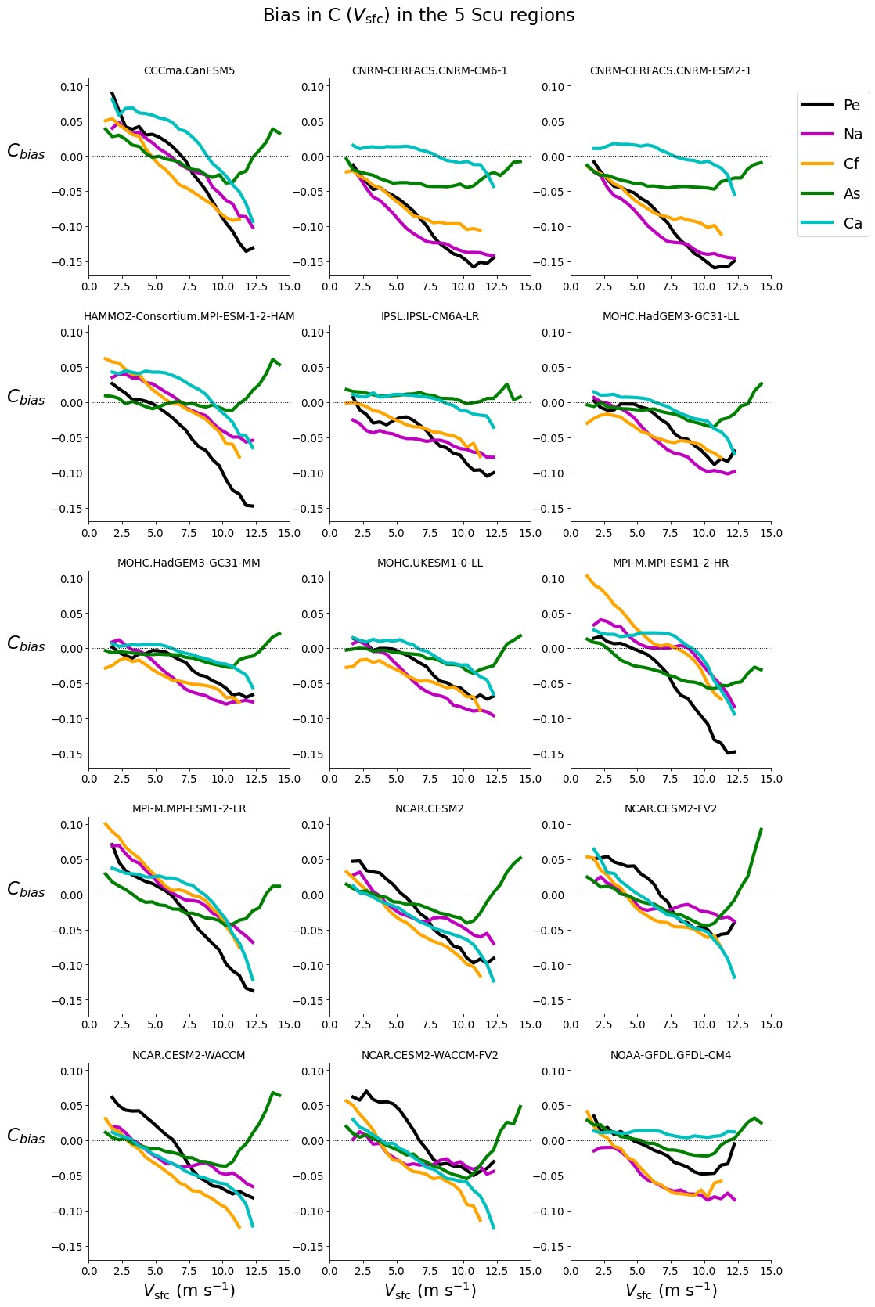
Figure S11: As in Fig. S10, but for biases in each model and region.

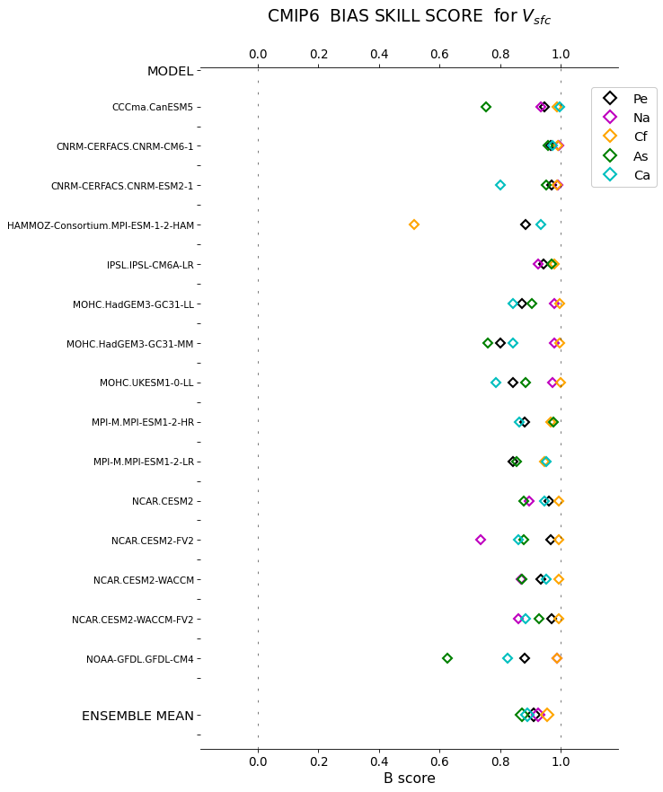
Figure S12: Bias skill score B for AMIP simulations applied to surface wind. We note that if a score exceeds unity by a $δ$ amount, it is shown here as $1-δ$ so that the maximum possible value (B=1) corresponds to the limiting $P_{x}^{M}=P_{x}^{OBS}$ case.

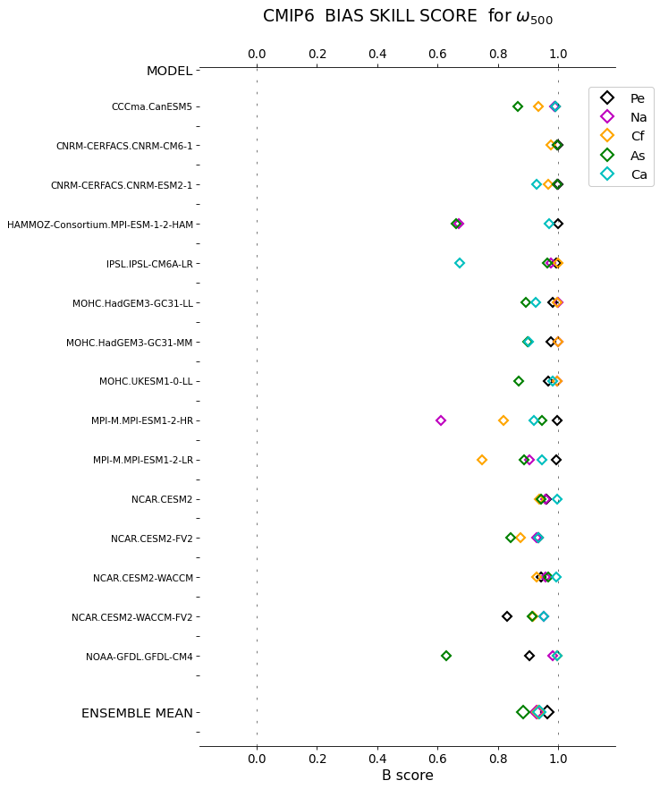
Figure S13: As in Fig. S12 for midlevel pressure velocity.

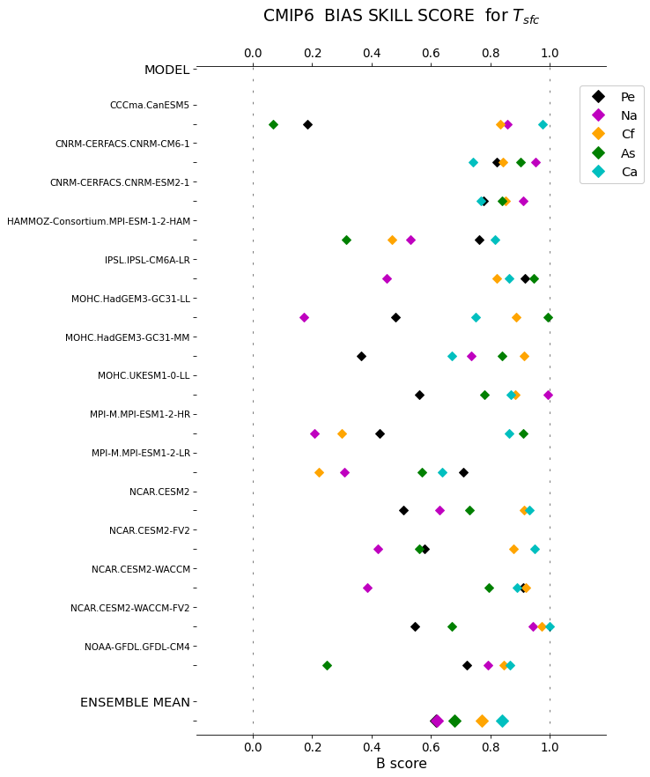
Figure S14: As in Fig. S12 for SST of HISTORICAL simulations.

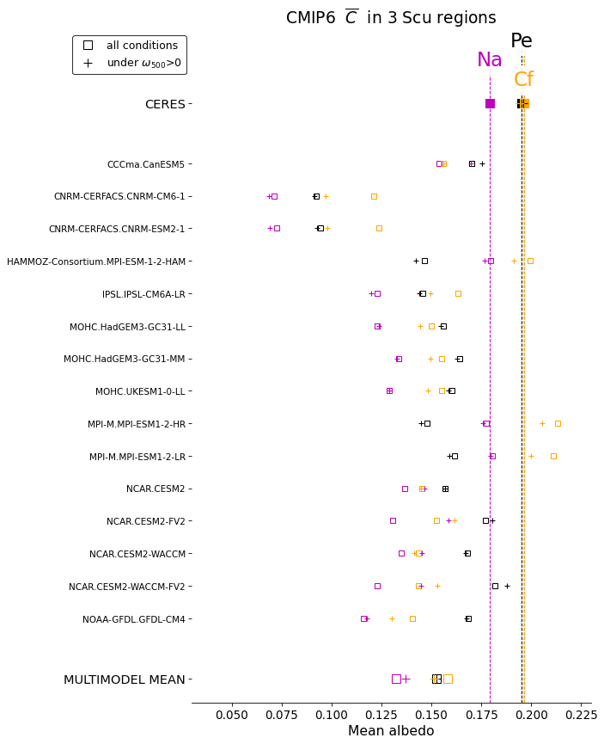
Figure S15: As in Fig. 7 but for the Peruvian, Namibian and Californian regions.

