Anticoagulants do not affect pleural effusion biochemistries
Running title: Anticoagulants in pleural effusion
Yue Gao^{1,2,3,*}，Xu-Lei Hao^{1,4*}，Mei-Ying Wang^{1,2,3}，Lei Zhang^{1,2,3}，Rui Niu^{1,4}，Qiu-Fen Tian^{1,4}，Lu Tong⁴，Ya-Ning Shi⁴，Li Yan^{2,5}，Zhi-De Hu^{2,4#}，Wen-Qi Zheng^{1,2,3#}

¹ Department of Laboratory Medicine, the Affiliated Hospital of Inner Mongolia Medical University, Hohhot 010010, China.
² Key Laboratory for Biomarkers, Inner Mongolia Medical University, Hohhot 010010, China.
³Department of Parasitology, the Basic Medical Sciences College of Inner Mongolia Medical University, Hohhot 010050, China.
⁴ Center for Clinical Epidemiology Research, the Affiliated Hospital of Inner Mongolia Medical University, Hohhot 010010, China
⁵ Department of Respiratory and Critical Care Medicine, the Affiliated Hospital of Inner Mongolia Medical University, Hohhot 010010, China.

*These authors contributed equally as co-first authors.
#These authors contributed equally as co-corresponding authors.

Corresponding authors:
Zhi-De Hu, Center for Clinical Epidemiology Research, the Affiliated Hospital of Inner Mongolia Medical University, Hohhot 010010, China. Email: hzdlj81@163.com; huzd@immu.edu.cn
Wen-Qi Zheng, Department of Laboratory Medicine, the Affiliated Hospital of Inner Mongolia Medical University, Hohhot 010010, China. Email: zhengwenqi2011@163.com

Supplementary Figures.
Supplementary Figure 1. Passing-Bablok regression analysis for effusion biochemistries treated with different anticoagulants.
Supplementary Figure 2. Deming regression analysis for effusion biochemistries treated with different anticoagulants.

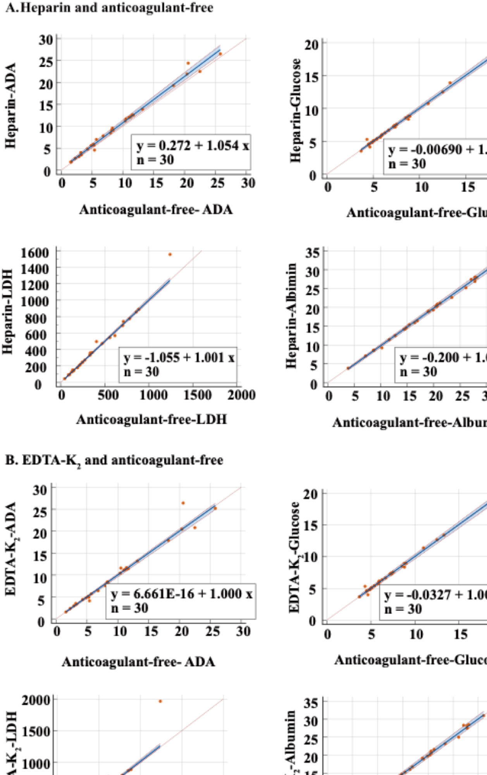
Supplementary Figure 1: Passing-Bablok regression analysis for effusion biochemistries treated with different anticoagulants.
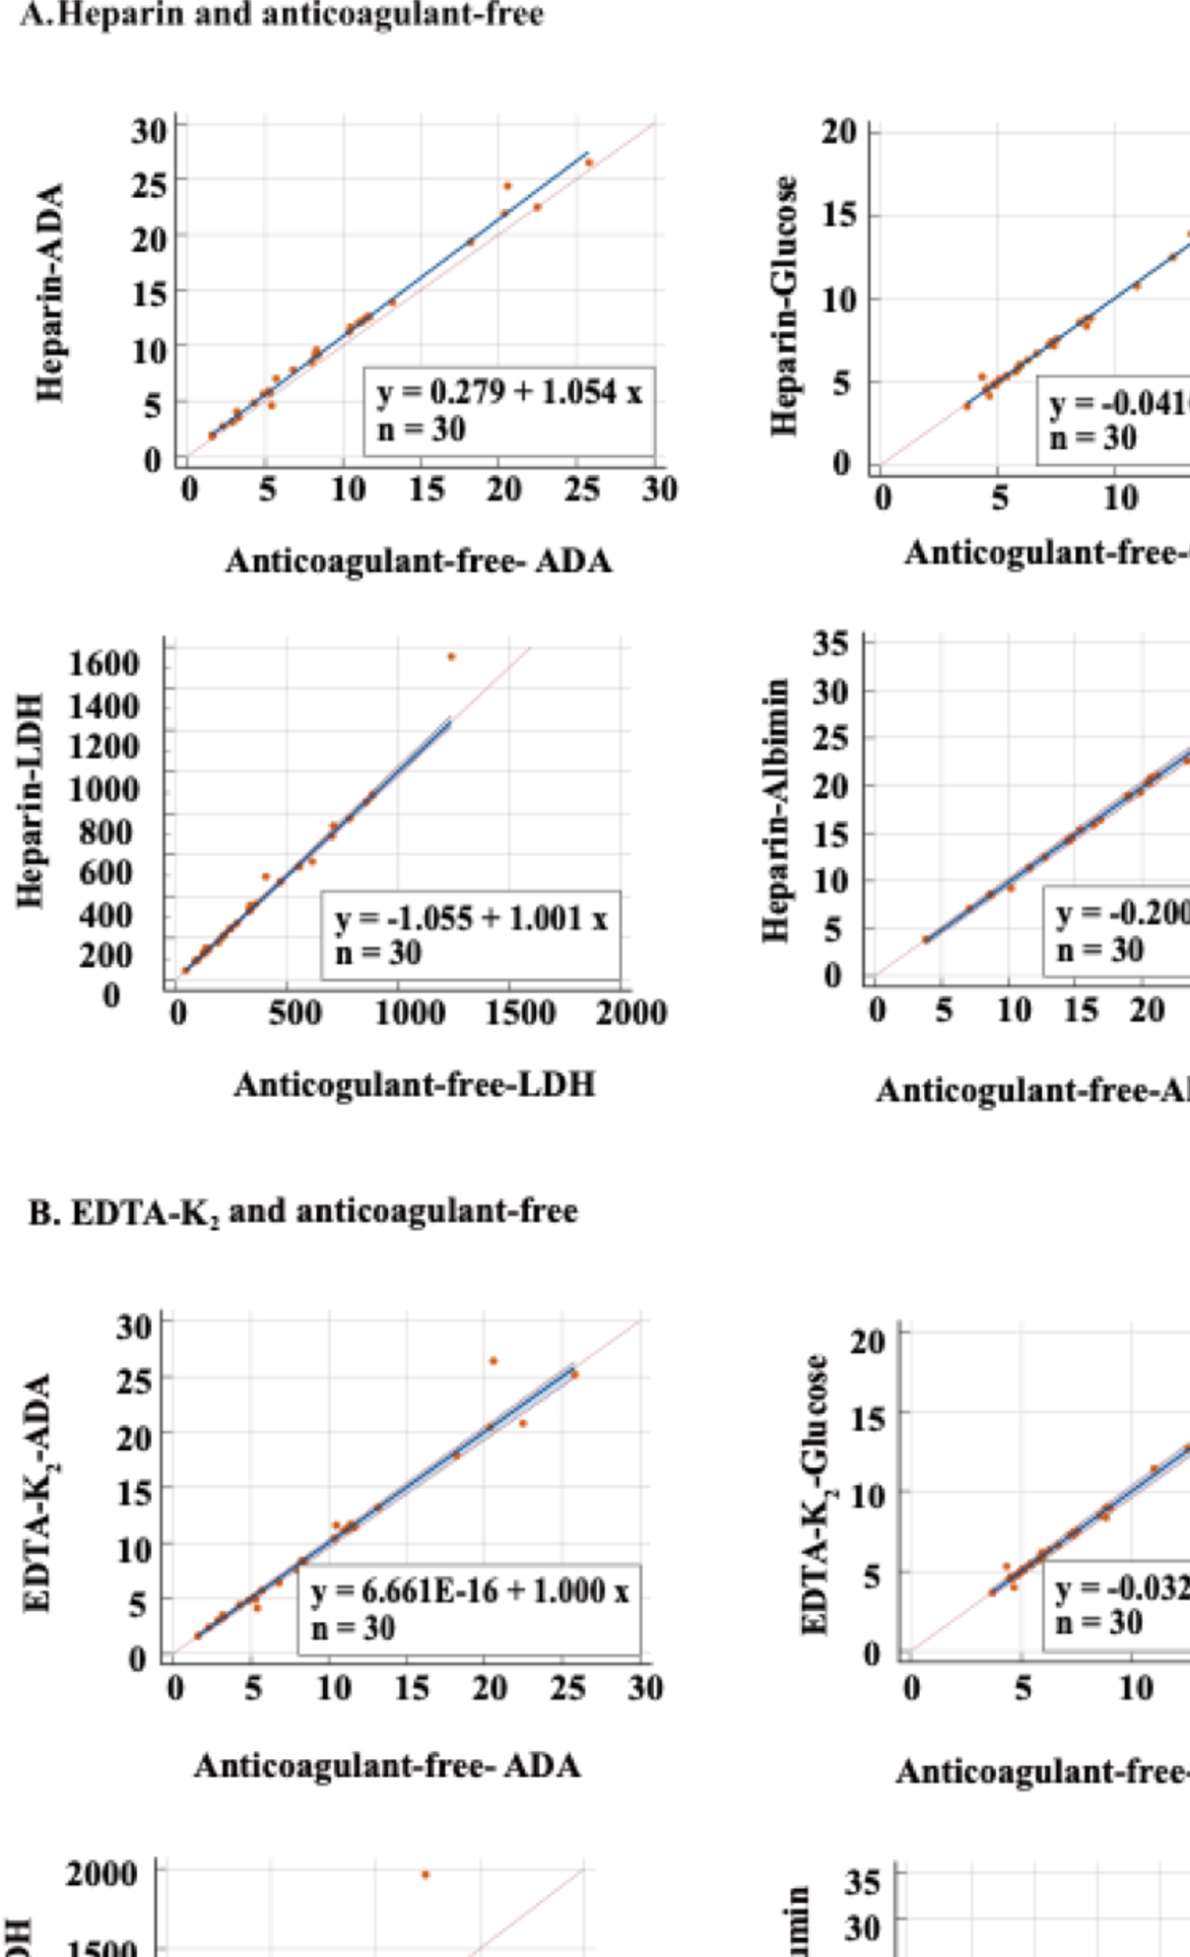Supplementary Figure 2: Deming regression analysis for effusion biochemistries treated with different anticoagulants.

