Supplemental files
Methods
Patient selection
All work history, including any previous work, was collected by questionnaire for all patients. Our hospital is the largest occupational disease prevention center in our city, 20 kilometers away from the asbestos products factory opened from 1950s to 1970s. The duration of exposure (number of years) was determined due to the lack of atmospheric measurements and detailed information on the frequency of exposure to asbestos for each job.

Supplemental figures
Supplemental figure 1 Representative case of asbestosis in a 66-year-old woman (weaver by occupation). Chest HRCT showing (A) interlobular septal thickening, ground-glass opacities, and mosaic attenuation, (B) pleural thickening with calcification.
HRCT: high-resolution computed tomography

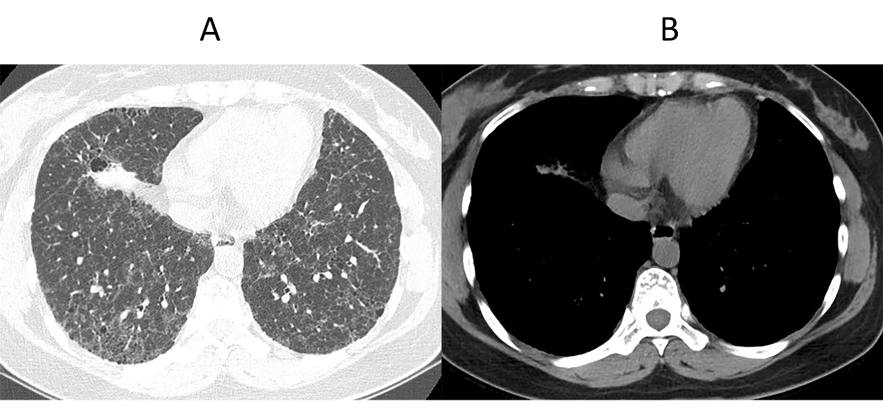
Supplemental figure 2 FHP in a 36-year-old woman, who grew corn at home and participated in the annual harvest. Chest HRCT showing (A) multiple thin-walled cystic cavities, interlobular septal thickening, intralobular interstitial thickening, ground-glass opacities, diffuse rounded opacities, with a centrilobular distribution, and “three-density pattern”, (B) the right plural is thickening.
FHP: fibrotic hypersensitivity pneumonitis, HRCT: high-resolution computed tomography

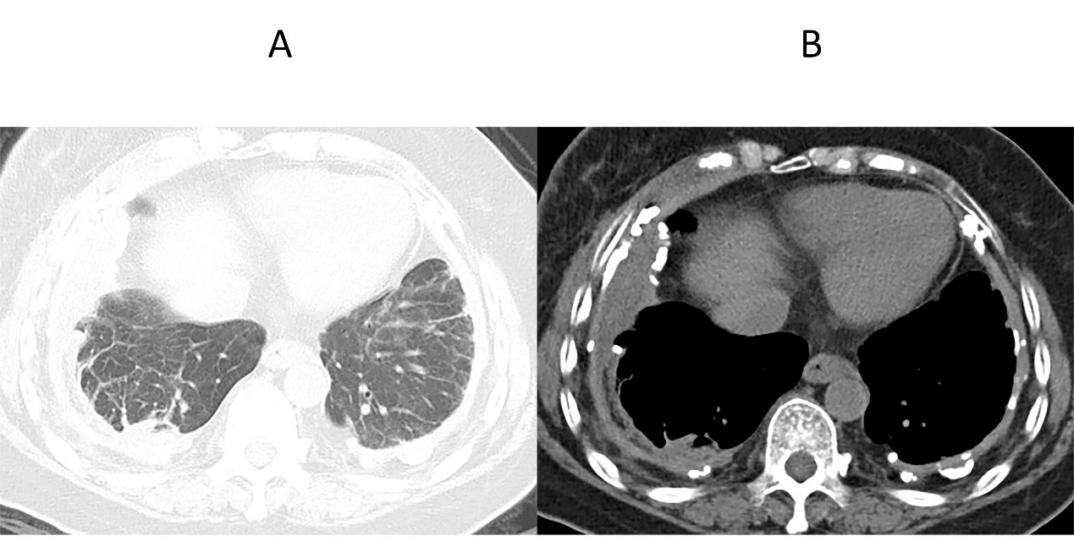
Supplemental figure 3 Asbestosis in a 64-year-old woman (weaver by occupation). Chest HRCT showing (A) interlobular septal thickening with rounded atelectasis and, (B) diffuse pleural thickening with calcification.
HRCT: high-resolution computed tomography

Supplemental Table 1 Demographics of the enrolled population
 | Asbestosis | FHP | P value *
n | 204 | 74
Age (years) | 68.9±9.0 | 55.4±11.7 | <0.001
Female (n, %) | 122 (59.8) | 43 (58.1) | 0.903
BMI (kg/m²) | 25.5±3.5 | 24.0±3.3 | 0.382
Smoking status
Current smokers, (n, %) | 50 (24.5) | 21 (28.4) | 0.513
Cumulative pack-years | 17.5(7.13,31.25) | 20(12.5,30) | 0.415
Smokers≥20 pack-years, (n, %) | 25(12.3) | 13(16.3) | 0.445
Duration of exposure (years) | 14 (6,22) | 10 (1,15) | <0.001
Latent period (years) | 49 (40,54) | 10 (1.5,16) | <0.001
Date was presented as mean ± SD, median (IQR) or n (%).
Abbreviations: BMI, body mass index; FHP, fibrotic hypersensitivity pneumonitis.
*P value：Asbestosis vs FHP.

