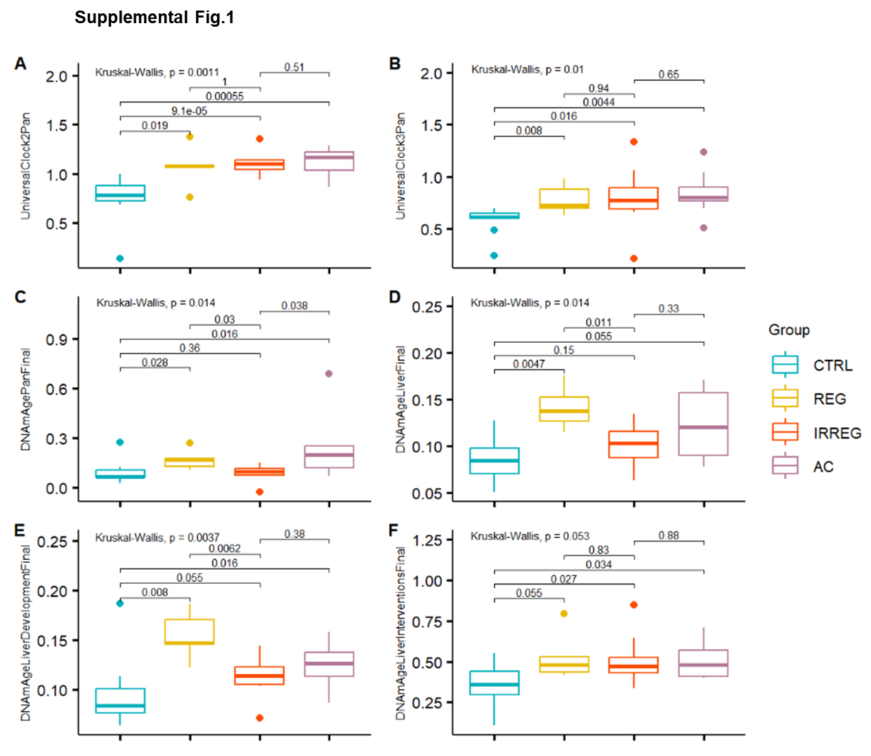
Supp.Fig.1 Epigenetic age comparison between rats at 4 different stages of reproductive senescence: young, 6 months old rats, that corresponds to human early premenopausal stage (CTRL), 9 months old rats, regularly cycling, correspond to human premenopausal stage (REG), 9 months old rats, irregularly cycling, correspond to human perimenopausal stage (IRREG), 9 months old rats, after cessation of cycles, corresponding to human post-menopausal stage (AC). Epigenetic age calculated with: A) Universal Mammalian Clock 2 Pan-Tissue, B) Universal Mammalian Clock Pan-Tissue, C) final DNAmAge Pan-Tissue rat clock, D) final DNAmAge rat liver, E) DNAmAge rat liver for CpG that changes during development, F) DNAmAge rat liver for CpG that changes during anti-aging interventions

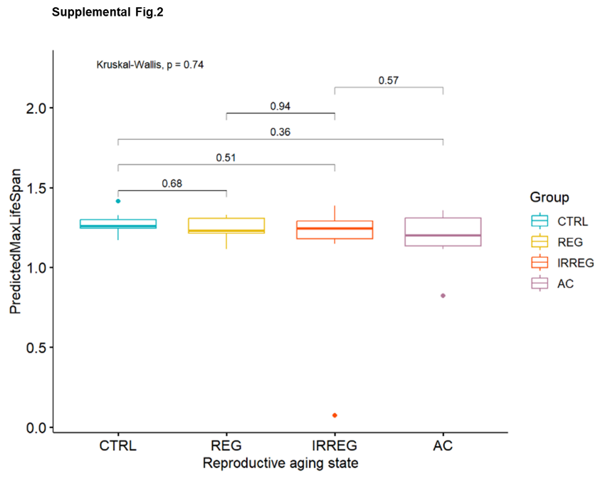
Supp.Fig.2 Maximum lifespan predicted for rats at 4 different stages of reproductive senescence: young, 6 months old rats, that corresponds to human early premenopausal stage (CTRL), 9 months old rats, regularly cycling, correspond to human premenopausal stage (REG), 9 months old rats, irregularly cycling, correspond to human perimenopausal stage (IRREG), 9 months old rats, after cessation of cycles, corresponding to human post-menopausal stage (AC).

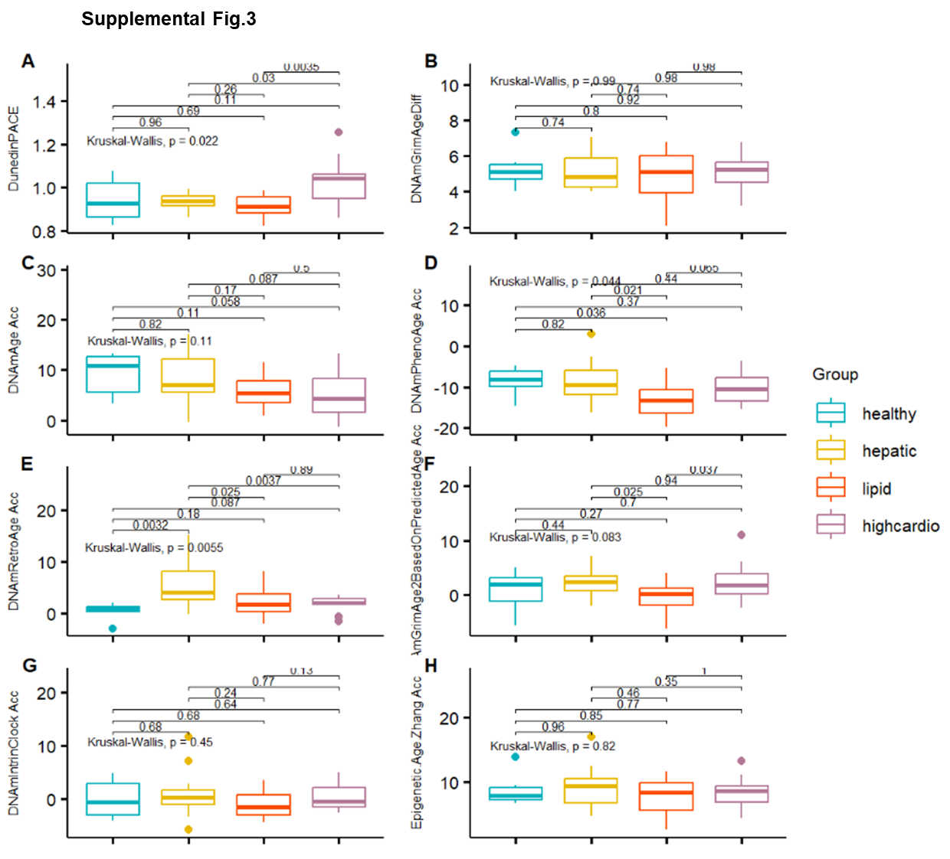
Supp.Fig.3 Comparison of the pace of epigenetic aging between 4 health groups in post-menopausal women: healthy, hepatic, lipid, highcardio. Pace of epigenetic aging calculated with: A) DunedinPACE, B) DNAmGrimAge, F) DNAmGrimAge based on predicted age and calculated as the difference between the chronological age and: C) DNAmAge clock, D) DNAmPhenoAge, E) DNAmRetro Age, G) DNAmIntrin Clock, H) Epigenetic Age developed by Zhang et al.
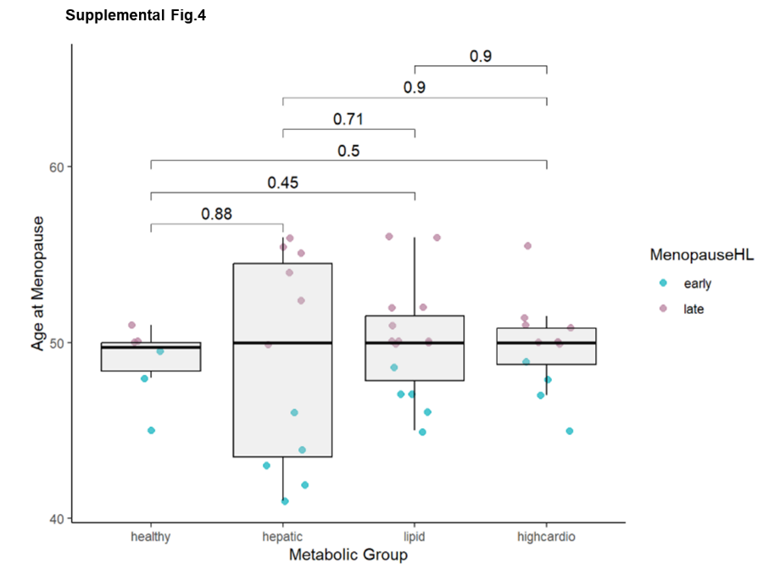
Supp.Fig.4 Age at menopause in women belonging to 4 health groups: healthy, hepatic, lipid, highcardio.
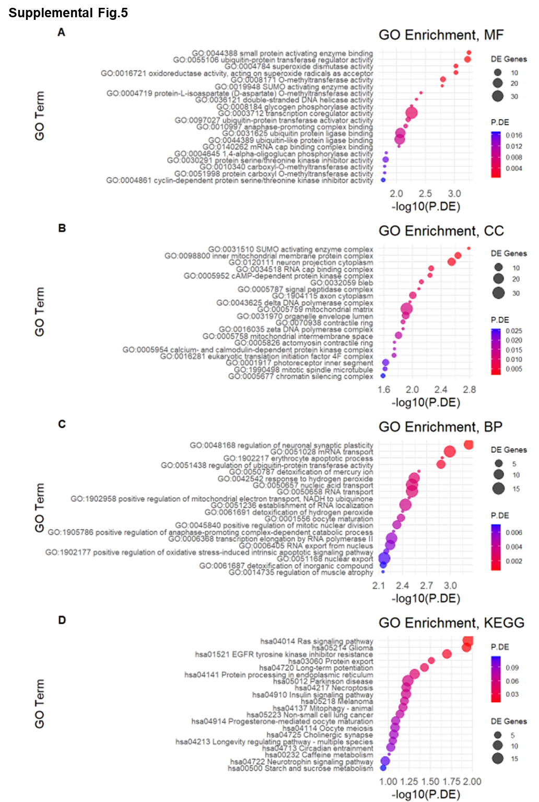
Supp.Fig.5 20 most significantly enriched GO terms of the differentially methylated genes between post-menopausal women that transitioned to menopause below the age of 50, and post-menopausal women that transitioned to menopause at 50 years old or older. A) Molecular Function, B) Cellular Component, C) Biological Process, D) KEGG GO category

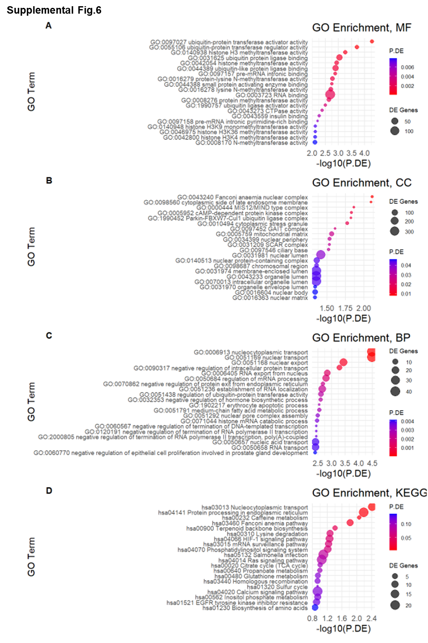
Supp.Fig.6 20 most significantly enriched GO terms of hypermethylated genes between post-menopausal women that transitioned to menopause below the age of 50, and post-menopausal women that transitioned to menopause at 50 years old or older. A) Molecular Function, B) Cellular Component, C) Biological Process, D) KEGG GO category

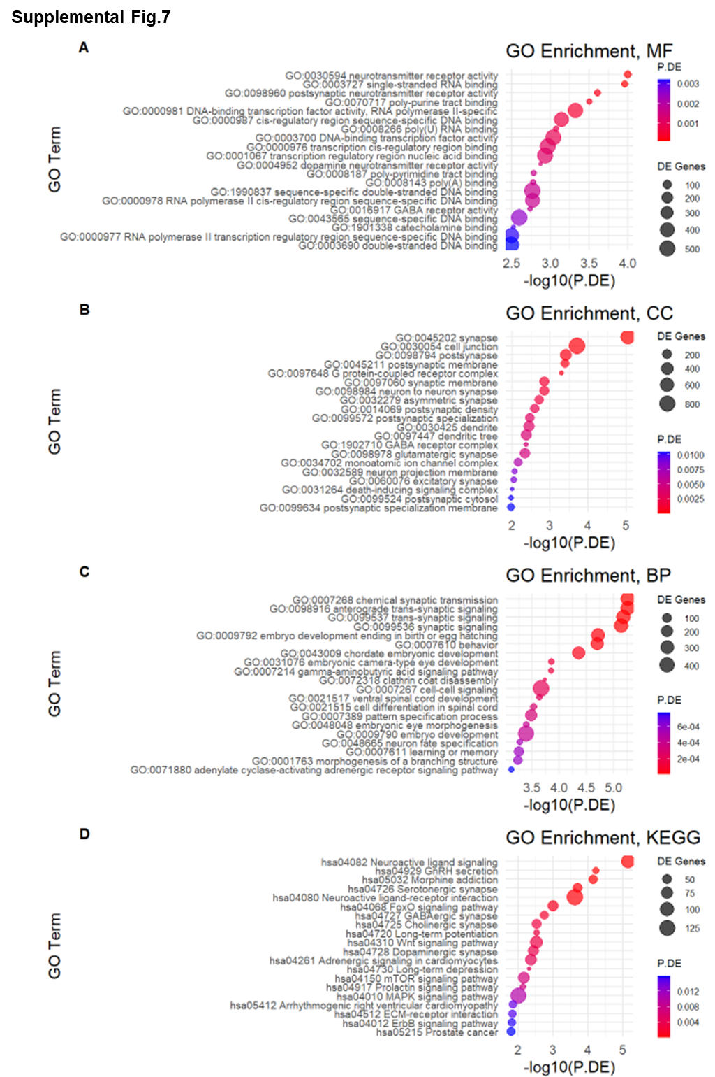
Supp.Fig.7 20 most significantly enriched GO terms of hypomethylated genes between post-menopausal women that transitioned to menopause below the age of 50, and post-menopausal women that transitioned to menopause at 50 years old or older. A) Molecular Function, B) Cellular Component, C) Biological Process, D) KEGG GO category

