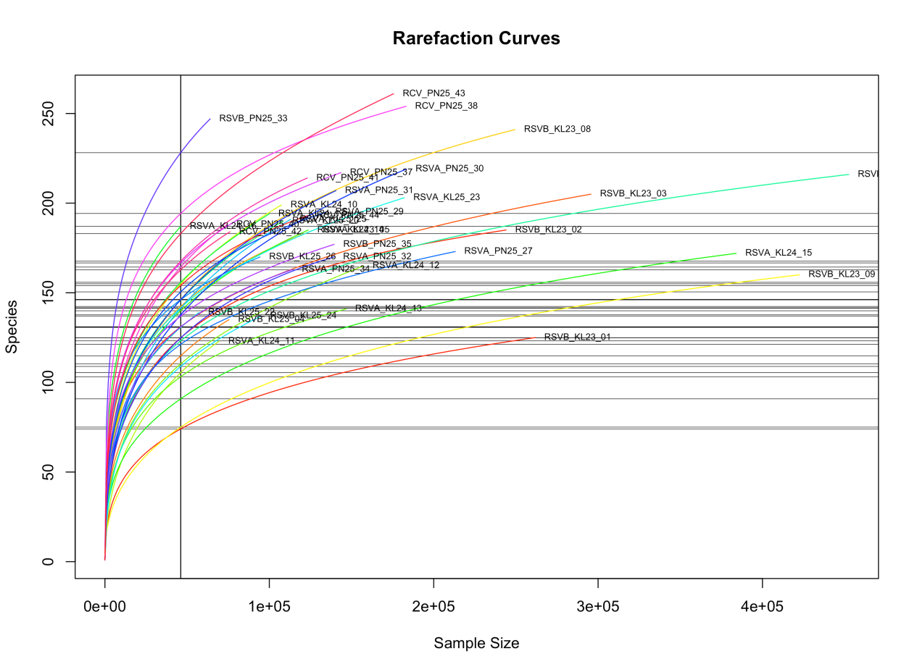

Supplementary Figure S1: Rarefaction curves of respiratory microbiome samples. Rarefaction analysis demonstrating the relationship between sequencing depth and observed bacterial richness across all samples. Curves approached saturation for the majority of specimens, indicating adequate sequencing coverage for downstream taxonomic and diversity analyses. Each line represents an individual sample.

Supplementary Figure S2-S4: Shannon alpha diversity across demographic and sample characteristics. Boxplots showing the Shannon diversity index of the nasal microbiome stratified by age group (Child, Infant, Neonate, and Toddler), sample type (combined throat–nasopharyngeal, nasopharyngeal, and throat), and sex (Female and Male). Each point represents an individual sample. The center line indicates the median, the box represents the interquartile range (IQR), and whiskers extend to 1.5 × IQR. P values were calculated using the Kruskal–Wallis test and are displayed on each panel.

