Supplementary Information for

Cellulose–protein supramolecular entangled networks enable bioplastics with ultrahigh strength and broad-temperature stability
Jiying Chu^{1,#}, Minxin Wang^{1,#}, Changhong Lin¹, Geyuan jiang¹, Suqing Zeng², Guanglei Chen^{3,*}, Dawei Zhao^{1,2*}, Haipeng Yu^{2,*}
- Key Laboratory on Resources Chemicals and Materials of Ministry of Education, Shenyang University of Chemical Technology, Shenyang 110142, P. R. China
- Key laboratory of Bio-based Material Science and Technology of Ministry of Education, Northeast Forestry University, Harbin 150040, P. R. China
- Department of Oncology, Shengjing Hospital of China Medical University, Shenyang 110022, P. R. China
# J.C. and M.W. contributed equally to this work
*Corresponding authors:
daweizhao@syuct.edu.cn;
yuhaipeng20000@nefu.edu.cn;
glchen@cmu.edu.cn;

This supplementary information file includes:
• Supplementary Methods
• Supplementary Figures 1 to 16
• Supplementary Tables 1 to 2
• Supplementary References

Supplementary Methods
Characterizations. The microstructure of samples was observed using a JSM-IT800 scanning electron microscope (SEM) (JEOL, Tokyo, Japan) at an operating voltage of 10 kV. Super-depth microscope images were captured by a 3D digital microscope (model DMS1000, Ningbo Sunny Instruments Co., Ltd.). Raman spectra of the samples were acquired using an HR Evolution spectrometer (HORIBA JY, France). Measurements were performed with a 532 nm excitation laser, with spectral data collected over the range of 500–4000 cm⁻¹.The FTIR spectra of the samples were obtained using a Nicolet iS50 FTIR instrument (Thermo Fisher Scientific Inc., Waltham, MA, USA). All spectra were measured in ATR mode, with data recorded in the range of 500–4000 cm⁻¹. The 2D FTIR spectra of samples were obtained by a Nicolet iN10 Microscopic confocal infrared spectrometer IR (Thermo Fisher Scientific Inc., Waltham, MA, USA). Data for cellulose–Soy protein isolate (C–SPI) gel and entirely bio-based supramolecular bioplastic (BS–bioplastic) were collected through surface scanning. X-ray photoelectron spectroscopy (XPS) spectra were obtained using a Shimadzu Model Axis Supra (Japan) equipped with a monochromatic Al-Kα X-ray source. The small-angle X-ray scattering (SAXS) and wide-angle X-ray scattering (WAXS) were performed using a Xeuss 3.0 instrument with Cu-Kα X-ray radiation. The detector was an Eiger2R 1M with a pixel edge length of 75 microns. The XRD patterns of samples were measured using a D/max 2200 X-ray diffractometer (Rigaku, Tokyo, Japan) equipped with Ni-filtered Cu-Kα radiation (λ = 0.154 nm). The samples were scanned within 5–90° 2θ at a scanning rate of 2°·min⁻¹.
Nanoindentation experiments. Quasi-static nanoindentation tests were performed on BS–bioplastic, ABS, PMMA, PVC and PLA using a Nano Indenter G200 (Agilent, USA) with a displacement resolution of 0.01 nm. The samples had dimensions of 20 × 20 × 1 mm and were tested at the peak load of 50 mN. The indentation hardness was averaged over three indentations and the results were presented with associated ± standard deviation.
Mechanical property tests. The tensile tests were performed on C–SPI gel, BS–bioplastic, PLA, PMMA, ABS, PET, and PVC using a UTM2503 electromechanical universal testing machine (Shenzhen SUNS Technology Stock Co., Ltd., China). The specimens were tested at a tensile speed of 10 mm·min⁻¹ at room temperature. Flexural stress-strain tests were conducted through a three-point bending setup with a span of 40 mm between two support points. The specimens were tested at a constant speed of 5 mm·min⁻¹ at room temperature. The impact resistance test was conducted by using a DTM1302 plastic plate drop hammer impact testing machine (Shenzhen SUNS Technology Stock Co., Ltd., China). Impact energies of BS–bioplastic and other plastics were measured by varying the drop height. Puncture tests were conducted using a specialized mold. BS–bioplastic and other commercial plastics were tested at a speed of 5 mm·min⁻¹ at room temperature.
Dynamic mechanical analysis (DMA). DMA was performed using a NETZSCH DMA instrument equipped with a 50 N specification (Germany). The samples were tested in tensile mode under an air atmosphere. The temperature was ramped from −50 to 160 °C at a frequency of 5 Hz and a heating rate of 5 °C·min⁻¹.
Molecular dynamics (MD) simulations. Classical MD simulations were performed using the GROMACS 2019.4 software package to investigate the interactions between Soy protein isolate and cellulose under different solvent conditions (water or ethanol). In this study, due to the complex composition of Soy protein isolate (SPI), we constructed a simplified model by selecting glutamic acid, which is the most abundant amino acid in SPI, as the representative monomeric unit. Specifically, each cellulose molecular chain consists of 10 repeating glucose units, while each SPI model chain comprises 10 repeating glutamic acid units. The initial configurations of the cellulose and SPI chains in water and ethanol were generated using the Packmol program.
Cytotoxicity test for human skin tissue cells. For cytotoxicity assessment, an extraction method was employed. Following 30-minute UV sterilization, the samples were immersed in cell culture medium for 24 hours to obtain extracts. These extracts were then added at varying concentrations to experimental groups for cytotoxicity evaluation. The specific steps are as follows: Human skin tissue cells (NHDF) were quickly removed from the liquid nitrogen tank and shaken in a 37 °C water bath until completely thawed. The cell suspension was quickly added to the pre-warmed media, transferred to a centrifuge tube and centrifuged at 1,000 rpm for 5 min. The centrifuge tube was removed, and the supernatant was discarded. The cell suspension was added to a culture dish and incubated at 37 °C in a 5% CO₂ atmosphere. NHDF cells in the logarithmic growth phase and in good growth condition were seeded 4 × 103 cells per well into a 96-well cell culture plate, and 1 × 105 cells per well into a confocal culture dish and incubated overnight in a 37 °C, 5% CO₂ incubator.
Sterile PBS (10 μl) was added to the surrounding wells of the plate. The wells were arranged as follows: The well plate was set up with the control group and experimental group: sample 1 (freestanding device) at 200, 100, 50, 25, and 12.5 μg ml⁻¹, with 3 replicate wells per group. There were 2 control groups, 10 experimental groups, and 1 blank group in this experiment. The culture time was set at 24 h. After culturing NHDF cells for 24 h, the supernatant was removed, and 100 μL of medium containing 10% CCK-8 was added. The cells were then incubated in a 5% CO₂ incubator at 37 °C for an additional 1 hour. The medium to be tested was transferred to a new 96-well plate, and the absorbance was measured at 450 nm by a microplate reader and the cell survival rate was calculated.
Supplementary Figures

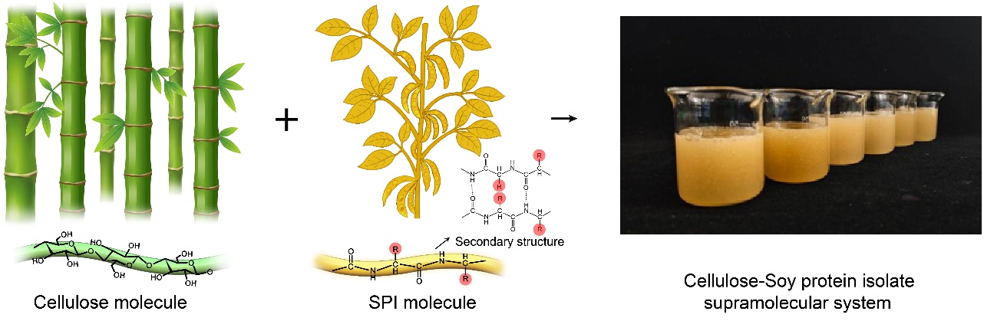
Supplementary Figure 1. The preparation of the cellulose-Soy protein isolate (SPI) supramolecular system.

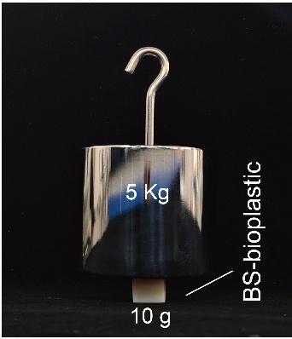
Supplementary Figure 2. A demonstration of the mechanical robustness exhibited by BS–bioplastic, which has a quality of 10g.

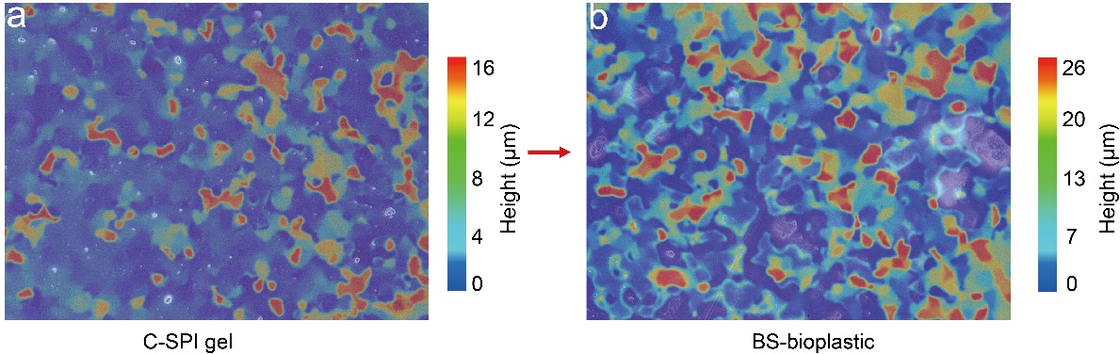
Supplementary Figure 3. The super depth microscope images of a C–SPI gel and b BS–bioplastic.

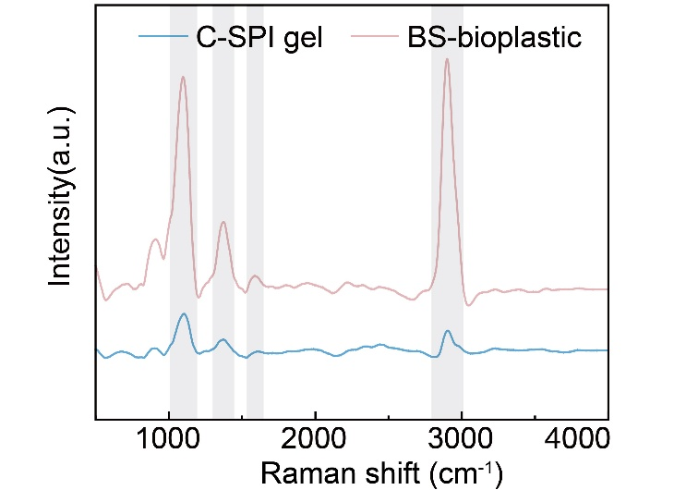
Supplementary Figure 4. Raman curves of C–SPI gel and BS–bioplastic.
As shown in Supplementary Figure 4, the characteristic peaks at 1095 cm⁻¹ (cellulose C–O–C), 2897 cm⁻¹ (cellulose C–H stretching), 1371 cm⁻¹ (C–H bending of SPI and cellulose), and 1591 cm⁻¹ (SPI C=O) were enhanced. This indicates that upon ethanol induction, the cellulose molecular chains and SPI molecular chains are intertwined, and the interaction between them is significantly enhanced.

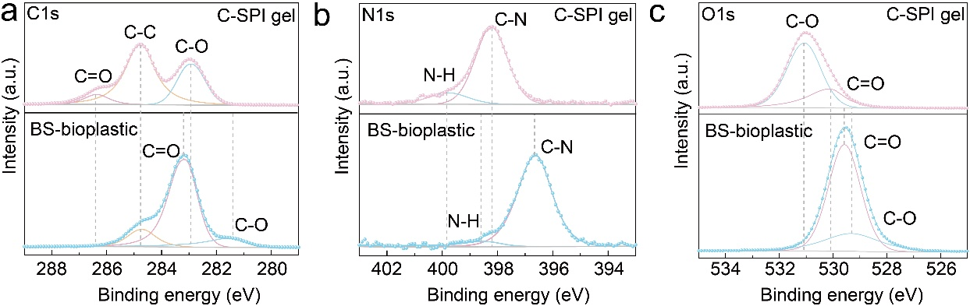
Supplementary Figure 5. XPS analysis of C–SPI gel and BS–bioplastic a XPS spectrum of C1s. b XPS spectra of N1s. c XPS spectra of O1s.

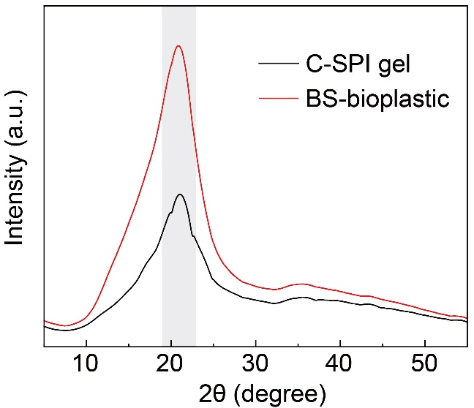
Supplementary Figure 6. The XRD curves of C–SPI gel and BS–bioplastic.

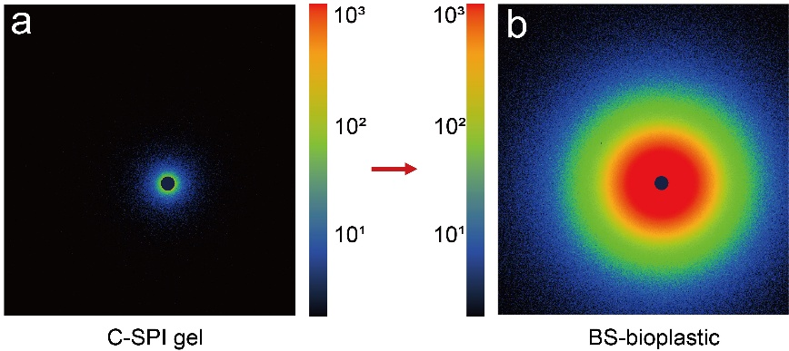
Supplementary Figure 7. Comparison of 2D SAXS patterns between a C–SPI gel and b BS–bioplastic.

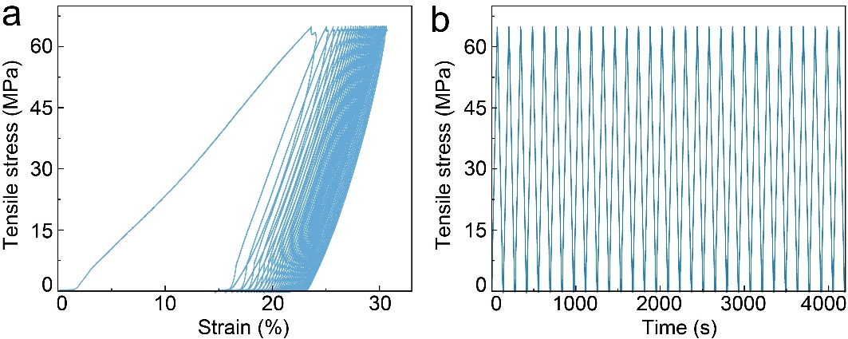
Supplementary Figure 8. Fatigue test of BS–bioplastic with a tensile stress of 65 MPa for 30 consecutive cycles. a Tensile stress-strain cycle curve of BS–bioplastic. b Tensile stress-time cycle curve of BS–bioplastic.
As shown in Supplementary Figure 8, BS–bioplastic shows good fatigue resistance. In 30 cyclic tensile tests, tensile stress of BS–bioplastic remains stable with increasing cycles. And it still maintains structural integrity after the cyclic tensile test is completed, indicating the internal structure stabilizes during repeated loading, demonstrating excellent durability and fatigue resistance.

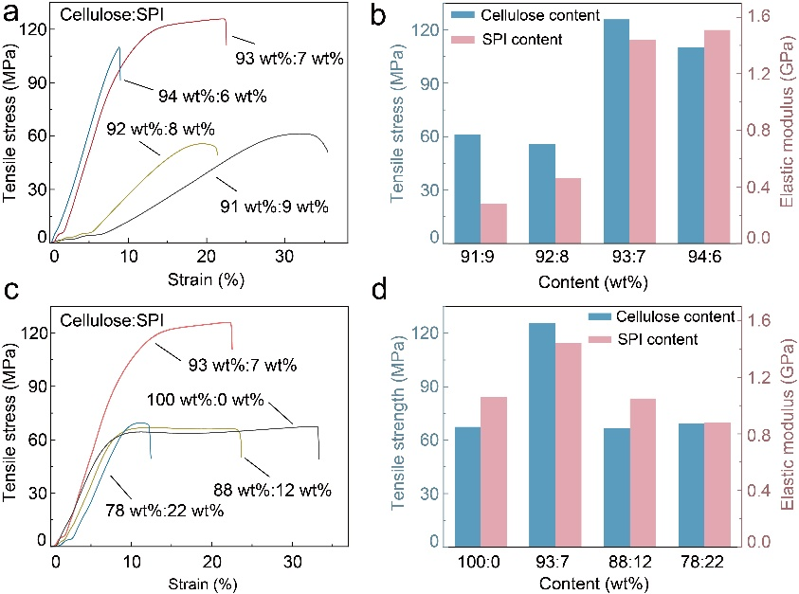
Supplementary Figure 9. Investigating the mechanical tensile properties of BS–bioplastic with different cellulose and SPI content. a Tensile stress-strain curves of various BS–bioplastics. b Tensile strength and elastic modulus of BS–bioplastics with different cellulose and SPI content. c Tensile stress-strain curves of various BS–bioplastics. d Tensile stress-strain curves of various BS–bioplastics.
The tensile strength and elastic modulus of BS–bioplastic prepared with different proportions of cellulose and SPI were compared (Supplementary Figure 9). Based on a comprehensive comparison, it was found that the mechanical properties are optimal when the content of cellulose and SPI is 93 wt% and 7 wt%, respectively.

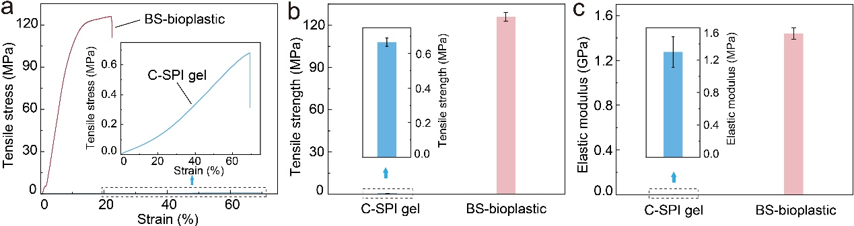
Supplementary Figure 10. Comparison of tensile properties between C–SPI gel and BS–bioplastic. a Tensile stress-strain curves, b tensile strength and c elastic modulus of C–SPI gel and BS–bioplastic.
As shown in the Supplementary Figure 10, the tensile strength and elastic modulus of C–SPI gel are 0.67 ± 0.02 MPa and 1.3 ± 0.19 MPa, respectively. The tensile strength and elastic modulus of BS–bioplastic are 125.85 ± 3.16 MPa and 1.44 ± 0.05 GPa, respectively. Therefore, the tensile strength and elastic modulus of BS–bioplastic are higher than those of C–SPI gel, which provides direct evidence for ethanol-induced structural reconfiguration.

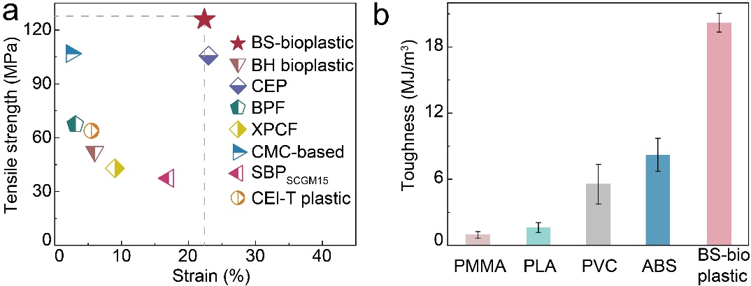
Supplementary Figure 11. a Investigating the tensile strength between BS–bioplastic and several other previously reported bioplastics¹⁻⁷. b The mechanical toughness of ABS, PLA, PMMA, PVC and BS–bioplastic.
Compared with other previously reported plastics (Supplementary Figure 11), including biomatter-hybrid (BH) bioplastic, cellulosic engineering plastic (CEP), bioplastic film (BPF), xylan-based polyester-reinforced cellulose fibers (XPCF), carboxymethyl cellulose (CMC) based bioplastic, starch-based bioplastic (SBP_{SCG15}) and cellulosic bioplastic (Cel-T plastic), the tensile strength of BS–bioplastic is higher. In addition, the toughness of BS–bioplastic (20.2 ± 0.85 MJ·m⁻³) is higher than some commercial plastics such as ABS (8.16 ± 1.5 MJ·m⁻³), PMMA (0.95 ± 0.3 MJ·m⁻³), PLA (1.58 ± 0.45 MJ·m⁻³) and PVC (5.55 ± 1.79 MJ·m⁻³), indicating its excellent mechanical properties.

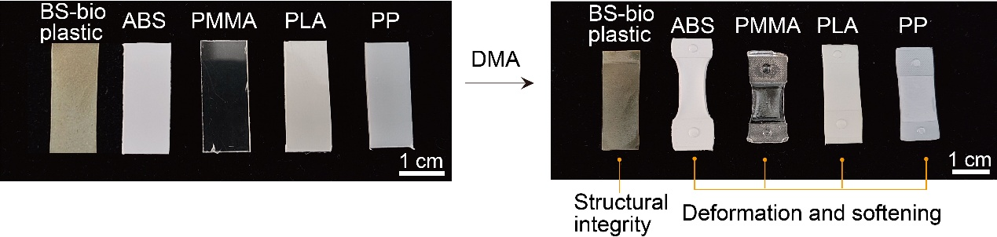
Supplementary Figure 12. Changes in BS–bioplastic, ABS, PMMA, PLA, PP before and after DMA testing.
As shown in Supplementary Figure 12, digital photographs taken before and after DMA testing show that BS–bioplastic maintains structural integrity over a broad temperature range of −50 to 160 °C. In contrast, plastics such as ABS and PMMA are observed to undergo deformation and softening under the same conditions. These results confirm that BS–bioplastic exhibits stability within this temperature range.

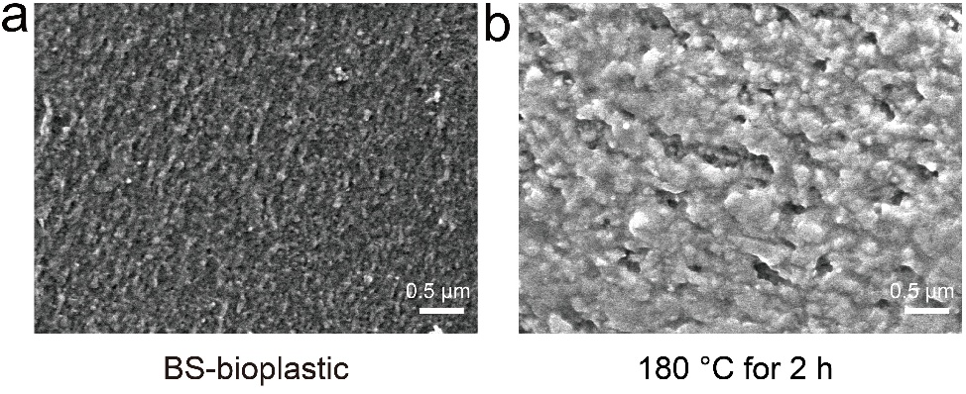
Supplementary Figure 13. SEM images of BS–bioplastic before and after elevated-temperature treatment. a Untreated BS–bioplastic. b BS–bioplastic of being exposed to 180 °C for 2 h.
As shown in Supplementary Figure 13, the microstructure of BS–bioplastic remained largely unchanged before and after being exposed to 180 °C for 2 h. This indicates that elevated temperature does not affect its supramolecular structure, and also reflects the thermal stability of BS–bioplastic.

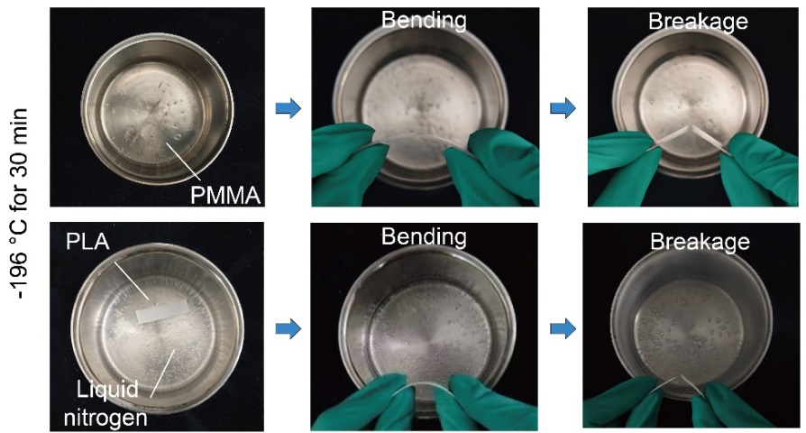
Supplementary Figure 14. Optical images of PMMA and PLA were exposed to liquid nitrogen (−196°C) for 30 min.

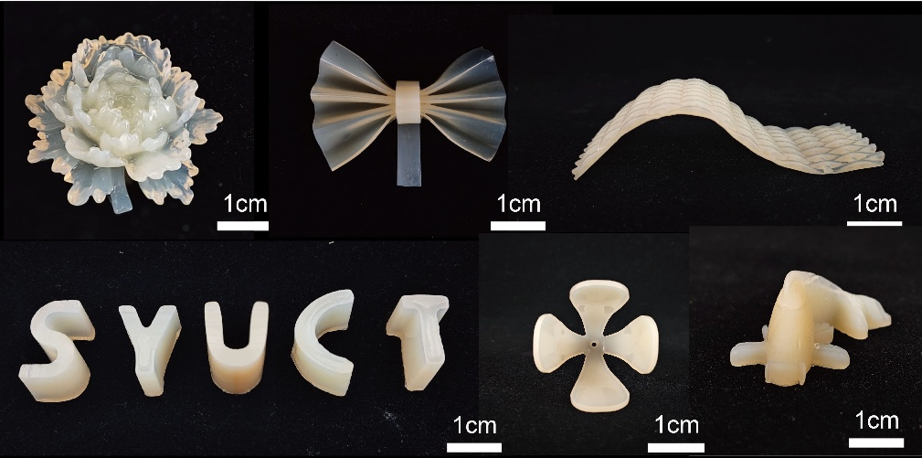
Supplementary Figure 15. Formability of recycled BS–bioplastic (re–BS–bioplastic) for diverse products.

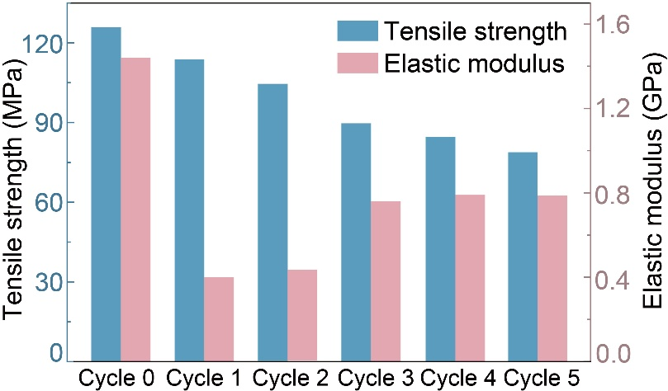
Supplementary Figure 16. Tensile strength and elastic modulus of BS–bioplastic cycled 0 to 5 times.
The tensile strength and elastic modulus of BS–bioplastic were tested over five cycles (Supplementary Figure 16). we demonstrated that after the fifth cycle, the tensile strength and the elastic modulus of BS–bioplastic were 78.81 MPa and 786.65 MPa, respectively. Comparison of the data indicates that BS–bioplastic can retain more than 50% of its mechanical properties after five cycles

Supplementary Table 1. Comparative prices among PMMA, ABS, PP, PVC, PLA and BS–bioplastic.
Materials | Price ($/t) | Source
ABS | 1500 | https://www.alibaba.com/product-detail/ABS-Chi-Mei-ABS-Taiwan-ABS_1601820849700.html?spm=a2700.find_similar_products.normal_offer.d_image.170867af4Fhvw9&priceId=b8b0b2d429824569ba6f4eb79294f173
PP | 1050 | https://www.alibaba.com/product-detail/Polypropylene-pp-Jumbo-1ton-Plastic-Granule_1601519495438.html?spm=a2700.galleryofferlist.topad_classic.d_image.107413a0kmM7Uo&priceId=c7e734ccf90f4f8eb76a4505436b8a3f
PVC | 1580 | https://www.alibaba.com/product-detail/High-Quality-Pvc-Transparent-Sheet-Rigid_1601830859392.html?spm=a2700.galleryofferlist.normal_offer.3.71e613a0Dto7MN&priceId=e091f8d6369842a29b3397a8a12ed551
PMMA | 2100 | https://www.alibaba.com/product-detail/High-Quality-Poly-Methyl-Methacrylate-Sheet_1600161027202.html?spm=a2700.galleryofferlist.normal_offer.d_title.513b13a0dM6ujY&priceId=21696ffde62a45d39acc2c1867ffee00
PLA | 2850 | https://www.alibaba.com/product-detail/ZOVGOV-100-BioPlastic-Compostable-PLA-Resin_1601028302759.html?spm=a2700
BS–bioplastic | 3174.75 | This work

Supplementary Table 2. Price estimation for BS–bioplastic after 5 cycles. Each cycle is involving loss 17.4 wt% [Bmim]Cl.
Feedstocks | Price ($/t) | Consumption  (t) | Cost  ($) | Source
Bamboo fiber | 800 | 0.15 | 120 | https://www.alibaba.com/product-detail/Soft-High-Quality-5D-51MM-Bamboo_1600713413991.html?spm=a2700.galleryofferlist.normal_offer.d_image.319613a07ZMOih&priceId=871bb0f2bc704a599e023344ec10ff00
Soy protein  isolate | 990 | 0.01 | 9.9 | https://www.alibaba.com/product-detail/High-quality-Isolated-Soy-Protein-Powder_11000028860235.html?spm=a2700.galleryofferlist.normal_offer.d_image.1d3013a05gf6Vh&priceId=3ca6cd8a3fe24fcfbf282150858e6d73
[Bmim]Cl | 2000 | 0.85 | 1700 | https://www.alibaba.com/product-detail/1-Butyl-3-methylimidazolium-Chloride-CAS_1601300481883.html?spm=a2700
Water | 0.34 | 5.08 | 1.73 | https://scj.shenyang.gov.cn/zwgk/fdzdgknr/gsgg/202503/t20250331_4829895.html
Ethanol | 800 | 1.58 | 1264 | https://chinese.alibaba.com/product-detail/Ethanol-Alcohol-Perfume-Used-High-Quality-10000014052937.html?spm=a27aq
Electricity | 0.07 | 1130.2 | 79.12 | https://scj.shenyang.gov.cn/zwgk/fdzdgknr/gsgg/202503/t20250331_4829895.html
Total cost | 3174.75

Supplementary References

1. Zeng, S., et al., Cellulosic Engineering Plastic with High Shapeability, Recyclability, Lightweight and High-Strength Properties. Adv. Mater. 38, e73129 (2026).
2. Zhou, J., et al., Biodegradable, Thermally Stable, and Programmable Cellulosic Bioplastics Enabled by Supramolecular Stimulated Mediation. Research. 9, 1098 (2026).
3. Qiu, Y., et al., Coassembly of hybrid microscale biomatter for robust, water-processable, and sustainable bioplastics. Sci. Adv. 11, eadr1596 (2025).
4. Xie, D., et al., Nacre-inspired starch-based bioplastic with excellent mechanical strength and electromagnetic interference shielding. Carbohydr. Polym. 331, 121888 (2024).
5. Liang, Y., et al., A robust and biodegradable carboxymethyl cellulose-based bioplastic inspired by nacre. Int. J. Biol. Macromol. 310, 143513 (2025).
6. Wang, C., et al., Sustainable and versatile bioplastics toward large-scale industrialization. Chem. Eng. J. 521, 167070 (2025).
7. Xia, Q., et al., Photosynthesis-Inspired Enhancement of Cellulose Bioplastics Using Hemicellulose-Derived Biodegradable Polyesters. Adv. Funct. Mater. 35, 2417076 (2025).

