Supplementary material

Table S1 Neutral loss of modified group information
Modification | NL structure | Neutral Loss
Indole acetylation  Malonylation  Propionylation  Crotonylation  Succinylation  Butyrylation  Glutaryllation  Methylation  Acetylation  Rhamnosidation  Glucuronidation  Glycosidation  Glucose-Glucose  Phosphorylation  Hydroxylation  Ribosylation  Pentose-Glucose  Pentose-Pentose  Sulfonation | -C₁₀H₇NO | 157.05276
 | -C₃H₂O₃ | 86.00039
 | -C₃H₄O | 56.02621
 | -C₄H₄O | 68.02621
 | -C₄H₄O₃ | 100.01604
 | -C₄H₆O | 70.04186
 | -C₅H₆O₃ | 114.03169
 | -CH₂ | 14.01565
 | -C₂H₂O | 42.01056
 | -C₆H₁₀O₄ | 146.05791
 | -C₆H₈O₆ | 176.03209
 | -C₆H₁₀O₅ | 162.05282
 | -C₁₂H₂₀O₁₀ | 324.10565
 | -HO₃P | 79.96633
 | -O | 15.99491
 | -C₅H₈O₄ | 132.04226
 | -C₁₁H₁₈O₉ | 294.09508
 | -C₁₀H₁₆O₈ | 264.08452
 | -O₃S | 79.95681

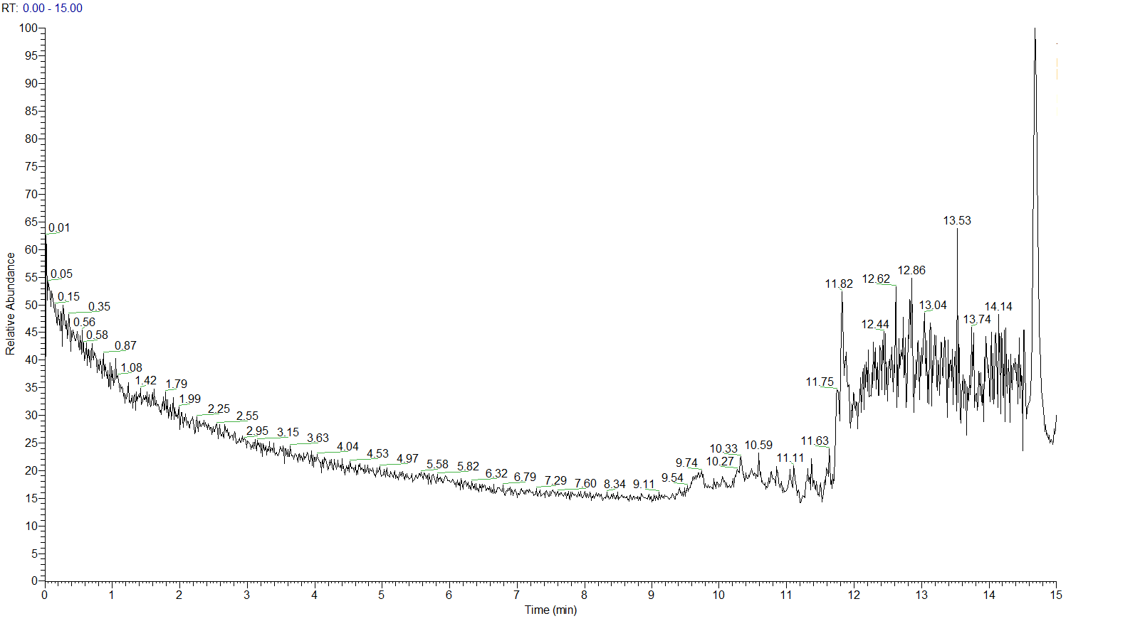
Fig.S1 Blank sample TIC Diagram
No obvious chromatographic peaks were observed in the blank solvent, demonstrating that sample cross-contamination and residual carryover were effectively controlled..

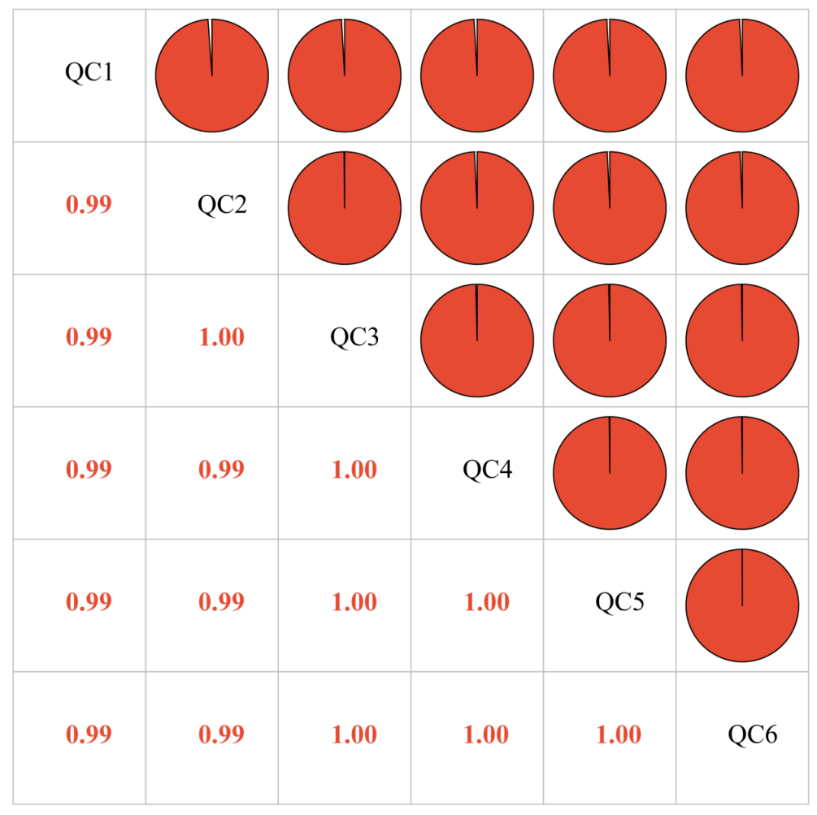
Fig.S2 QC Sample Correlation Analysis
The numbers in the figure represent the correlation coefficients between different QC samples, where the number 0.99 in the first column of the second row indicates that the correlation coefficient between QC1 and QC2 is 0.99.

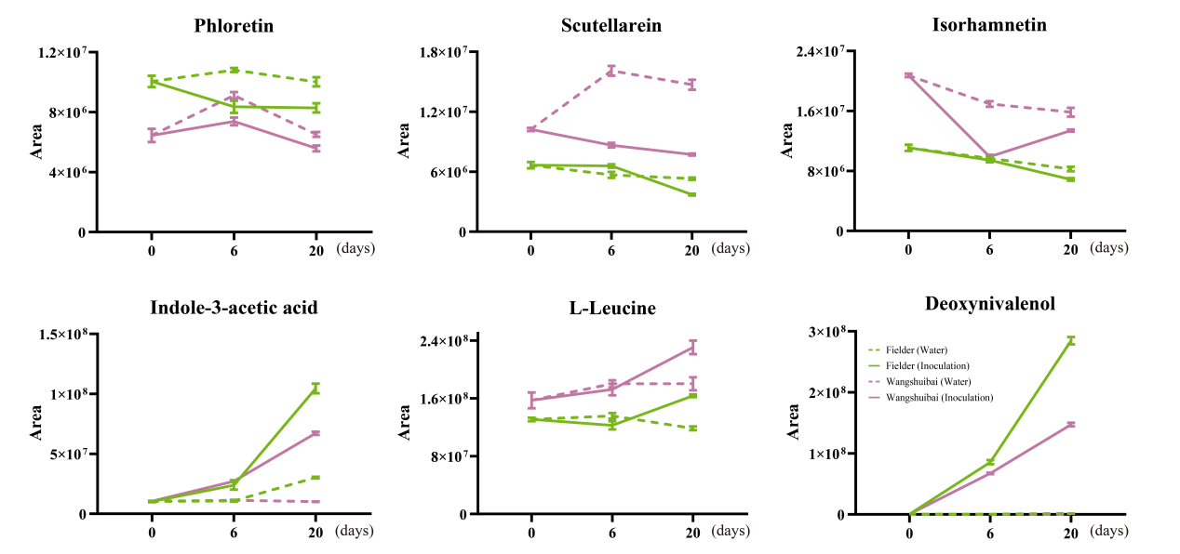
Fig.S3 Dynamic regulation of corresponding aglycones/backbone of the six key modified metabolites
Time-course line charts illustrate the accumulation of six corresponding aglycones/backbone metabolites in Wangshuibai and Fielder cultivars under inoculation (solid lines) and water control (dashed lines) at 0, 6, and 20 dpi.

Table S2 Quantity of different metabolites in each group
Decorative category | FI6 vs F0 | F20 vs FI6 | FI6 vs FM6 | FI20 vs FM20 | Total
* Acetylation | 92 | 135 | 75 | 125 | 367
Propionylation | 42 | 48 | 42 | 49 | 128
Butyrylation | 41 | 46 | 33 | 41 | 112
Malonylation | 29 | 51 | 21 | 39 | 131
Crotonylation | 13 | 13 | 12 | 17 | 44
Succinylation | 17 | 26 | 15 | 27 | 72
Glutaryllation | 26 | 36 | 21 | 34 | 86
Indole acetylation | 12 | 13 | 12 | 14 | 16
* Glycosidation | 87 | 122 | 81 | 123 | 361
Rhamnosidation | 21 | 28 | 16 | 32 | 69
Ribosylation | 28 | 46 | 24 | 44 | 106
Glucose-Glucose | 21 | 34 | 19 | 44 | 72
Pentose-Pentose | 10 | 29 | 12 | 23 | 74
Pentose-Glucose | 11 | 18 | 10 | 17 | 48
* Glutathionylation | 174 | 235 | 144 | 212 | 433
Sulfonation | 36 | 22 | 26 | 44 | 87
Methylation | 9 | 9 | 10 | 13 | 23
Hydroxylation | 30 | 33 | 31 | 45 | 79
Phosphorylation | 3 | 7 | 3 | 11 | 23
Glucuronidation | 25 | 24 | 18 | 32 | 69
FI6vsF0: 6 dpi versus 0 dpi of Fielder; FI20vsF6: 20 dpi versus 6 dpi of Fielder; FI6vsFM6: 6 dpi versus 6 days mock treatment by water of Fielder; FI20vsFM20: 20 dpi versus 20 days mock treatment by water of Fielder.

Table S3 Comparison of different metabolites in different groups
Comparison Groups | Up-regulation | Down-regulation | Non-significant
FI6 vs F0 | 422 | 129 | 1140
FI20 vs FI6 | 521 | 198 | 972
FI6 vs FM6 | 321 | 144 | 1226
FI20 vs FM20 | 504 | 216 | 971
WI6 vs FI6 | 325 | 229 | 1137
WI20 vs FI20 | 216 | 293 | 1182
FI6vsF0: 6 dpi versus 0 dpi of Fielder; FI20vsF6: 20 dpi versus 6 dpi of Fielder; FI6vsFM6: 6 dpi versus 6 days mock treatment by water of Fielder; FI20vsFM20: 20 dpi versus 20 days mock treatment by water of Fielder; WI6 vs FI6: 6 dpi of Wangshuibai versus 6 dpi of Fielder; WI20 vs FI20: 20 dpi of Wangshuibai versus 20 dpi of Fielder.

