Supplementary Materials
Bioluminescence and fluorescence in littoral earthworms
Teerapong Seesamut¹, Daichi Yano¹, José Paitio¹, Ikuhiko Kin¹, Somsak Panha^{2, 3}, Yuichi Oba^{1*}

¹ Department of Environmental Biology, Chubu University, Kasugai 487-8501, Japan
² Animal Systematics Research Unit, Department of Biology, Faculty of Science, Chulalongkorn University, Bangkok 10330, Thailand
³ Academy of Science, The Royal Society of Thailand, Bangkok 10300, Thailand

*Corresponding Author: Yuichi Oba
Email address: yoba@isc.chubu.ac.jp

Supplementary Materials legends
Supplementary Figure S1. Full-length gel images of SDS-PAGE.
Supplementary Video 1. Observation of the predation of littoral earthworm Pontodrilus litoralis by the littoral earwig Anisolabis maritima. (NOTE: full size is of this video is 1.25 GB, but as we could not upload the full size on submission website, here we upload shorten and lower quality version for reviewing)
Supplementary Video 2. Anisolabis maritima struggled to remove the gluey luminescent mucus by frequent grooming. (NOTE: full size is of this video is 136 MB, but as we could not upload the full size on submission website, here we upload shorten and lower quality version for reviewing)

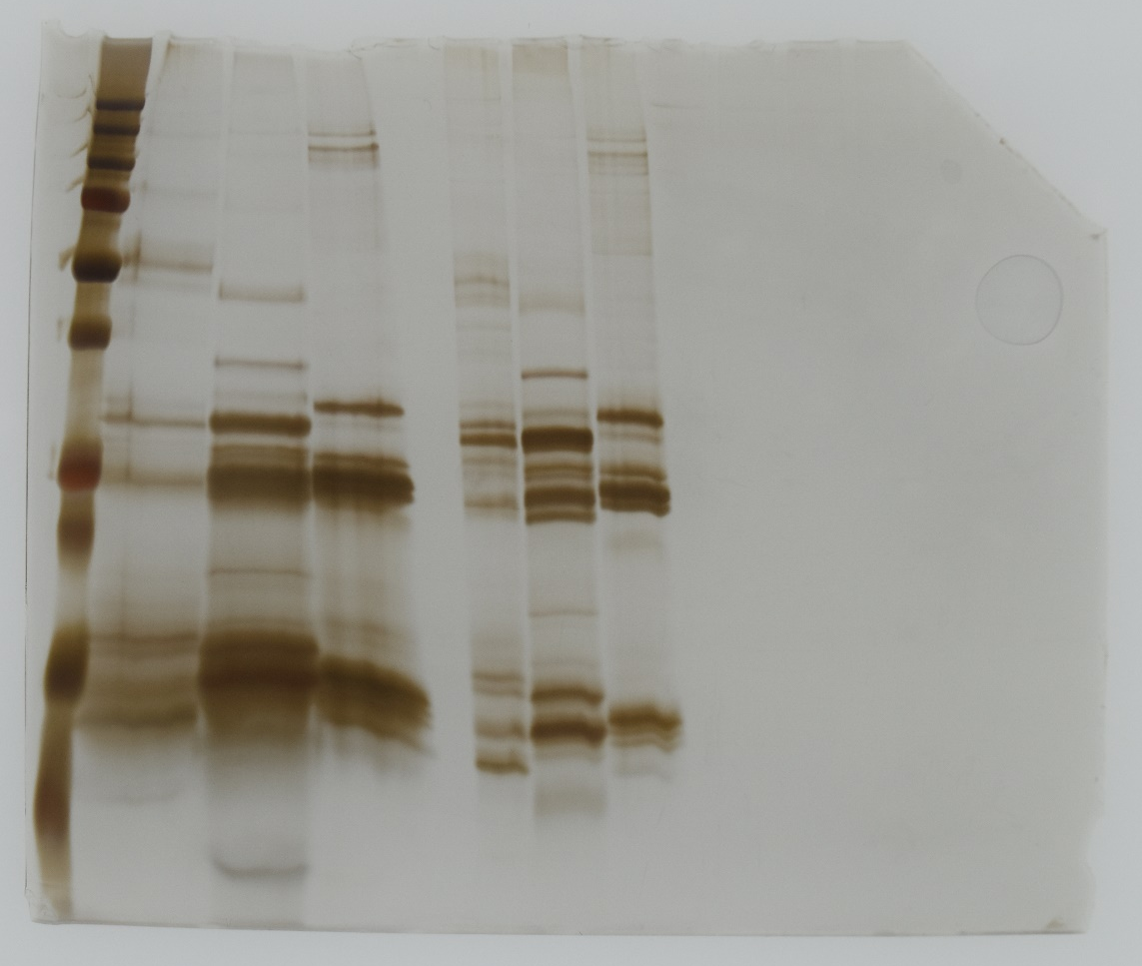
Supplementary Figure 1. Full-length gel images of SDS-PAGE.

