Supporting Information for:
A Nanoscale Pixel Architecture for High-Efficiency AlGaN Ultraviolet-C (UV-C) Light-Emitting Diodes

Section S1. X-ray diffraction studies on AlN/NPSS templates and UV-C LED on AlN/NPSS templates.
Figure S1. (a) Schematic of MOCVD-grown AlN template on nanopatterned sapphire substrate (NPSS). epitaxial structure. (b) Normalized XRD rocking curves of the AlN template on NPSS over which the UV-C LED heterostructure is grown. (c) Schematic of MOCVD-grown AlGaN UV-C LED heterostructure on AlN/NPSS template. (d) High-resolution XRD 2θ−ω scan spectra of the (0002) plane of UV-C LED heterostructure on AlN/NPSS template.
We conducted a comprehensive characterization on the crystalline quality of the AlN template as well as the UV-C LED heterostructure grown on nanopatterned sapphire substrates (NPSS). The X-ray diffraction (XRD) measurements were performed using Panalytical X'pert Pro diffractometer with monochromatic beam Cu Kα₁ radiation (0.154060 nm). The X-ray diffraction (XRD) rocking curve analysis of the AlN templates on NPSS provides detailed insights into their crystal quality, which directly influences the performance of the subsequently grown UV-C LED device epilayers. Figure S1 (a) shows the schematic of the AlN template grown on NPSS substrate. The measurement results of the XRD rocking curve analysis of the AlN template is plotted in Figure S1 (b). The full width at half-maximum (FWHM) values of (0002) and (101̅2) planes XRD rocking curves of the template are ~91 and ~330 arcsec, respectively. Based on the FWHM values, we estimate the threading dislocation density of the AlN template on NPSS to be ~6.26 × 10⁸/cm², which indicates good crystalline quality¹.
Further, Figure S1 (c) shows the schematic heterostructure of the AlGaN UV-C LED grown on the AlN/NPSS template. Figure S1 (d) shows the high-resolution XRD spectra of the full UV-C LED heterostructure incorporating Al_{0.42}Ga_{0.58}N multiple quantum wells (MQW) and Al_{0.52}Ga_{0.48}N barriers. The (0002) diffraction peaks of GaN and AlN are found at 34.56° and 36.03°, respectively². The intermediate AlGaN layers exhibit peak positions between these values, depending on composition. The broadening of the GaN-related peak can be attributed to surface non-uniformity in the p-type GaN capping layer. We can infer that the prominent peak centered at ~35.2° majorly comes from the n-type Al_{0.6}Ga_{0.4}N layer. Moreover, the asymmetry is due to the satellite peaks (zeroth order) arising from Al_{0.52}Ga_{0.48}N MQW and Al_{0.42}Ga_{0.58}N barriers as well as diffraction profile from the p-type Al_{0.53}Ga_{0.47}N layer. Furthermore, first-, second-, and third-order satellite peaks associated with the MQW periodicity are observed between 32° and 34°. A distinct, single symmetric peak at 35.6° is attributed to the p-type Al_{0.84}Ga_{0.16}N electron blocking layer.
Section S2. Detailed top-down UV-C nanoscale pixelation process flow
Figure S2. The schematic process flow for the nanoscale pixelation of UV-C LED heterostructure. (a) as-grown heterostructure diced in [1×1] cm² and cleaned (b) PMMA A4 electron-beam resist spinning for subsequent electron beam lithography (exposure, and development) of ultra-dense nanoholes with ~400 nm diameter with 700 nm pitch arranged in a [20×20] $μ$m² square lattice (c) 80 nm of Ni metal mask deposition via electron beam evaporation and subsequent lift-off (d) ICP-RIE dry etching of the EBL patterned UV-C LED heterostructure for mesa isolation and nanoscale pixelation (d’) shows the tilt-view SEM image of the various fabricated nanoscale pixel arrays in the sample (d’’) magnified top-view SEM of the UV-C nanopixels, with a top diameter of ~400 nm (d’’’) magnified tilt-view SEM images of the UV-C nanopixel showing the tapered geometry plasma-induced damage and dry etch.

Section S3. Device fabrication process flow

Figure S3. The schematic process and corresponding SEM images for fabricating the top-down ultra-dense nanoscale pixel array LED devices. (a) hot potassium hydroxide (KOH) wet etching of the UV-C nanoscale pixels to effectively etch away the amorphous sidewall regions; and (a’) shows the corresponding SEM images of the UV-C nanopixels after the KOH wet etching. (b) spin-on glass (SOG) layer for effective sidewall passivation as well as for planarizing the nanopixels; and (b’) shows the corresponding SEM image of the SOG planarized UV-C nanopixel array. (c) etch-back step to etch away the SOG layer, while revealing the p-type GaN layer; and (c’) showing the corresponding SEM image of the etched back nanopixel array revealing the p-type GaN layer. (d) p- and n-type device metal contact deposition for the nanopixel arrays.
Section S4. Device-to-device current-density voltage characteristics in UV-C nanopixel devices.
Figure S4. The current density–voltage (J–V) characteristics, of the 14 devices that were fabricated and characterized. All measurements were performed at continuous wave (CW) biasing conditions and at room temperature (~300 K) without any heat sink or active cooling.
Figure S4 presents the current density–voltage (J–V) characteristics of various fabricated UV-C emitting nanopixel devices, as depicted in Figure S2 (d’). The observed variations in forward and leakage currents across the 14 devices are primarily attributed to the nonuniform planarization of the spin-on glass (SOG) layer, which is intrinsic to the spin-coating and planarization process and affects high-aspect-ratio nanostructures, which create thickness inconsistencies. Spatial nonuniformities in SOG thickness result in a variable local resistance profile across the nanopixel array and hence the different devices, leading to inhomogeneous current injection. Additionally, current leakage paths are expected at specific nanopixels due to ‘overexposed’ p-GaN regions in the nanopixel. Residual surface openings between the p-GaN nanopixels and surrounding SOG, as shown in the inset of Figure 5 (b) in the main manuscript, further could contribute to current leakage/shorting. Such resistance variations and leakage pathways in the devices could also result in nonuniform electroluminescence (EL) intensity across the device, as certain nanopixels may experience elevated voltages or current densities.
Section S5. Device-to-device EQE characteristics in UV-C nanopixel devices.
Figure S5. Measured external quantum efficiency (EQE) curves with respect to injected current density, of the best performing devices that were fabricated and characterized. All measurements were performed at continuous wave (CW) biasing conditions, on-wafer and at room temperature (~300 K) without any heat sink or active cooling.
Section S6. EQE measurement setup and schematic.
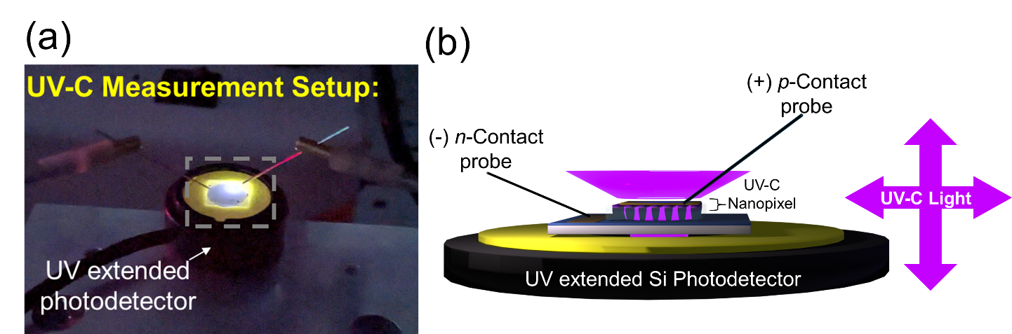
Figure S6. (a) UV-C measurement setup: the UV-C emitting nanopixel device is mounted directly on top of a photodiode. UV-C light is collected from the backside through the rough sapphire substrate while the device is probed from the top. (b) Schematic illustration of light emission from the UV-C nanopixel, showing scattered non-directional emission. However, only the light emitted through the backside is collected, while a significant portion of the emitted light is lost. As a result, the calculated EQE represents an underestimation of the actual device performance.
Section S7. Benchmarking figure of various state-of-art [20$μ$m]² UV-C LED devices and devices in this work
(+) p-Contact probe
Figure S7. Reported EQE values of various state-of-the-art UV-C LED devices with [20 $μ$m]² pixel dimensions, based on recent literature. The reported values are benchmarked against the on-wafer EQE performance of our fabricated micropixel and nanopixel array devices.

Section S8. Monte Carlo simulation of dislocation density in nanopixels
Figure S8. Statistical Monte Carlo simulation model of the percentage of dislocation-free pixels as a function of pixel diameter, two different initial dislocation densities (AlN on NPSS : 6×10⁸ cm⁻² and AlN on Sapphire: 6×10⁹ cm⁻²), to highlight the impact of top-down nanoscale pixelation of UV-C heterostructures across different epilayer/substrate qualities.

Section S9. 2D FDTD of thinfilm UV-C micrpixels

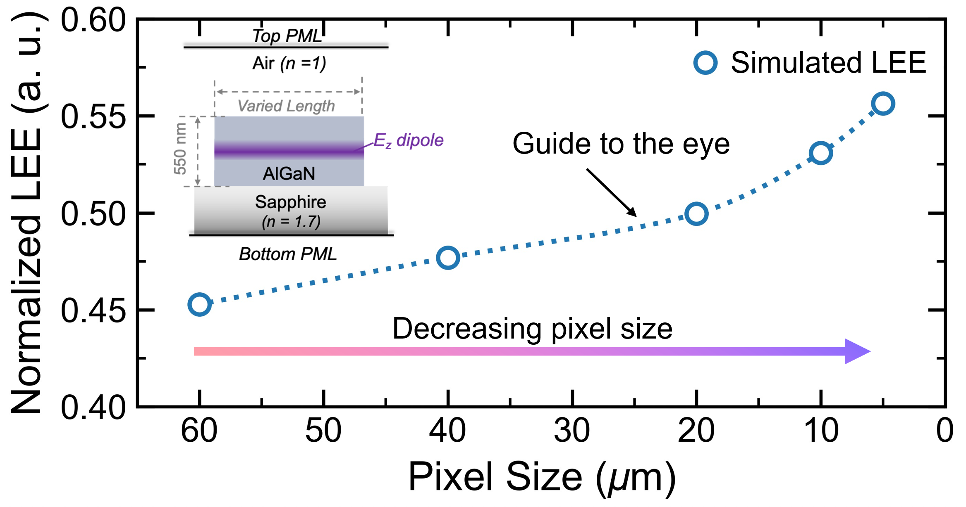
Figure S9. 2-D FDTD simulations. Simulated LEE of planar AlGaN UV-C micropixels as a function of lateral pixel size using a 2D FDTD model at 275 nm. The model includes the AlGaN layer on sapphire substrate, and air boundaries. The calculated LEE increases with decreasing pixel size because guided photons travel a shorter lateral distance before reaching sidewall for extraction. The dotted line is included as a guide to the eye. The calculated values represent relative trends because the 2D model does not reproduce the complete 3D device geometry.

REFERENCES
(1) Deng, G.; Zhang, Y.; Yu, Y.; Yan, L.; Li, P.; Han, X.; Chen, L.; Zhao, D.; Du, G. Significantly improved surface morphology of N-polar GaN film grown on SiC substrate by the optimization of V/III ratio. Applied Physics Letters 2018, 112 (15). DOI: 10.1063/1.5022237.
(2) Mohd Yusoff, M. Z.; Mahyuddin, A.; Hassan, Z.; Abu Hassan, H.; Abdullah, M. J.; Rusop, M.; Mohammad, S. M.; Ahmed, N. M. AlN/GaN/AlN heterostructures grown on Si substrate by plasma-assisted MBE for MSM UV photodetector applications. Materials Science in Semiconductor Processing 2015, 29, 231-237. DOI: 10.1016/j.mssp.2014.03.041.

