Figure S1. Each pie chart shows the percentage composition of rare taxa traits within a treatment (Dispersed–Low, Dispersed–High, clustered–Low, clustered–High, and All treatments), with sensitivity (A.; red = Sensitive, teal = Intermediate), respiration (B.; red = Cutaneous, teal = Gilled), and EPT status (C.; red = Non-EPT, teal = EPT); percent values indicate the proportion of rare taxa belonging to each trait category.

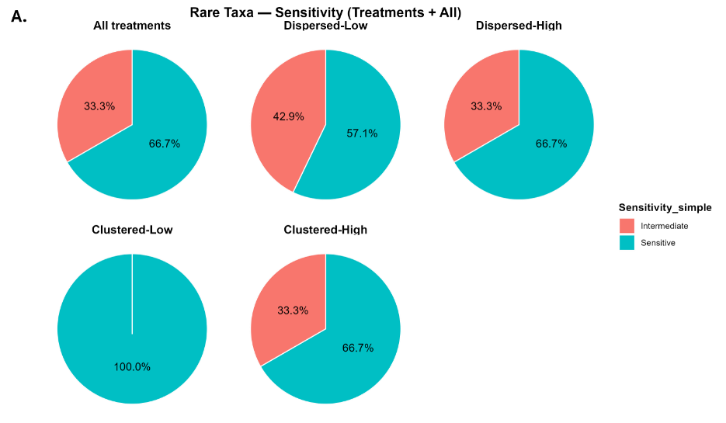

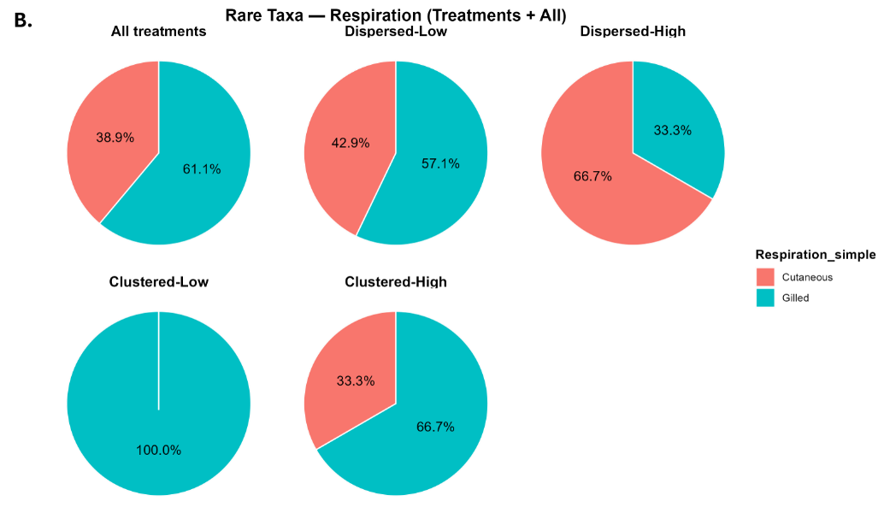

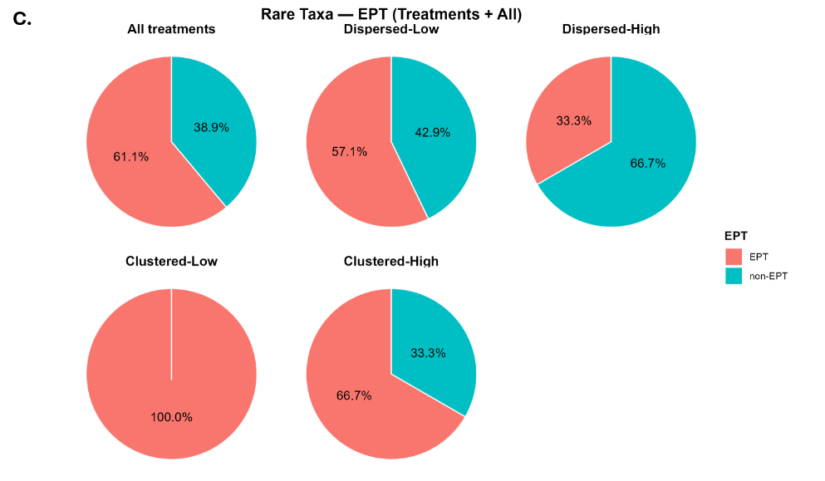

Figure S2. Each pie chart shows the percentage composition of common taxa traits within a treatment (Dispersed–Low, Dispersed–High, clustered–Low, clustered–High, and All treatments), with sensitivity (A.; red = Sensitive, teal = Intermediate), respiration (B.; red = Cutaneous, teal = Gilled), and EPT status (C.; red = Non-EPT, teal = EPT); percent values indicate the proportion of taxa belonging to each trait category.
